

**A PROJECT REPORT**

**PRESENTED TO: RONGO UNIVERSITY**

**SCHOOL OF SCIENCE AGRICULTURE AND ENVIRONMENTAL STUDIES.**

**DEPARTMENT OF MATHEMATICS,STATISTICS AND COMPUTING**

**IN PARTIAL FULFILLMENT OF REQUIREMENT**

**FOR THE AWARD OF DEGREE OF BACHELOR OF SCIENCE**

**IN**

**COMPUTER SCIENCE**

**BY :**

**HILLARY ODHIAMBO AROT**

**CSC/006/2020**

**UNDER SUPERVISION OF :**

**DR CYRUS ABANTI.**

**ABSTRACT**

The purpose of employee payroll system is to automate the existing manual system by the help of computerized equipments, and full-fledged computer software, fulfilling their requirements so that their valuable data /information can be stored for a longer period with easy accessing and manipulation of the same . The required software and hardware are easily available and easy to work with.

The payroll management system project report abstract provides a concise overview of the project, including its objectives, methodology, key features, and outcomes. It highlights the significance of automating payroll processes, discusses the technology stack used, outlines the project's scope, and previews the results achieved in terms of efficiency, accuracy, and cost-effectiveness.

The key features of the payroll management system typically include:

i. Employee Information Management: Capture and store employee details such as personal information, employment history, salary, deductions, and benefits.

ii. Payroll Processing: Automate the calculation of salaries, taxes, deductions, and bonuses based on predefined rules and regulations.

iii. Time and Attendance Tracking: Record employee attendance, leaves, overtime hours, and absences to accurately calculate payroll.

iv. Tax Compliance: Ensure compliance with tax laws by automatically deducting federal, state, and local taxes from employee salaries and generating tax reports.

v. Direct Deposit and Payment Options: Enable direct deposit of salaries into employees' bank accounts and provide payment options such as checks or electronic transfers.

vi. Reporting and Analytics: Generate comprehensive reports and analytics on payroll expenses, employee costs, tax liabilities, and other relevant metrics.

vii. Employee Self-Service Portal: Allow employees to view and manage their payroll information, access pay stubs, update personal details, and submit leave requests.

viii. Integration with HR and Accounting Systems: Seamlessly integrate with HR management systems and accounting software to streamline data exchange and eliminate manual data entry.

Top of Form

**TABLE OF CONTENTS**

**CHAPTERS**

CHAPTER 1-INTRODUCTION

1.1 Introduction about Company………………………………………

1.2 Introduction about Project…………………………………………

1.3 Present state of the art…………………………………..

1.4 Need of Computerization of System………………………………

1.5 Proposed Software…………………………………………………

CHAPTER 2- SYSTEM ANALYSIS

2.1 Feasibility Study of s/w includes its types……………………….

2.2 Analysis Methodology (Types)…………………………………..

2.3 Choice of Platforms s/w & h/w…………………………………..

CHAPTER 3-SYSTEM DESIGN

3.1 Design methodology……………………………………………

3.2 Database Design……………………………………………......

3.3 Screen Design…………………………………………………..

3.4 Report Design………………………………………………......

CHAPTER 4-TESTING

4.1 Testing Methodology(Types)………………………………..

4.2 Unit Testing…………………………………………………

4.3 Module testing………………………………………………

4.4 System Testing………………………………………………

4.5 Alpha/ Beta Testing…………………………………………

4.6 Black Box And White Box Testing…………………………

    CHAPTER 5-CONCLUSION AND REFRENCES

5.1 Conclusion………………………………………………….

5.2 Limitation of the system……………………………………

5.3 Future Scope for Modification……………………………..

5.4 References…………………………………………………..

**INTRODUCTION**

**1.1** **Introduction about Company**

GALLIUM Industries Ltd. was established by qualified and experienced professionals to cater for

the sophisticated equipment requirements of the Tube Industry worldwide. During this period tube plants were being locally fabricated which could not match the ever growing demands of the Tube Industry.

It was GALLIUM’S MISSION to cater to the Global Tube Industry with the STATE OF THE ART Equipment, continuously develop the international technology and then cater to the market. With this mission the company started supplying complete tube plants to the major tube producers in the world.

GALLIUM initiated a new era in the field of tubes produced in India. The first mill manufactured by GALLIUM was for 100 m/min. line speed with sophisticated entry line and computerised length control system for the flying cut off. Since then company has successfully supplied mills with line speed 150 m/min. or more. In the International front GALLIUM manufactured equipment are working in 29 countries including developed countries like USA, UK, Japan, Australia, Brazil, Egypt, Malaysia, China, Taiwan, Thailand , Oman, Jordan, Zimbabwe, Pakistan and many other countries. A number of repeat orders have been received from these companies.

GALLIUM is amongst a very few companies in the world who can offer complete Tube Plants and services including all tooling and turnkey solutions by providing plant engineering for all utilities and auxiliary equipment.

NTPC Limited (formerly known as National Thermal Power Corporation Limited) is a Central Public Sector Undertaking (CPSU) under the Ministry of Power, Government of India, engaged in the business of generation of electricity and allied activities. It is a company incorporated under the Companies Act 1956 and a "Government Company" within the meaning of the act .The headquarters of the company is situated at New Delhi. NTPC's core business is generation and sale of electricity to state-owned power distribution companies and State Electricity Boards in India. The company also undertakes consultancy and turnkey project contracts that comprise of engineering, project management, construction management and operation and management of power plants. The company has also ventured into oil and gas exploration and coal mining activities. It is the largest power company in India with an electric power generating capacity of 42,964 MW. Although the company has approx. 18% of the total national capacity it contributes to over 27% of total power generation due to its focus on operating its power plants at higher efficiency levels

**1.2** **Introduction about Project**

“Payroll Management” is a distributed application, developed to evaluate the performance of employees working in any organization. It maintains the information about a company, personal details of their employees, also the project details assigned to particular developer. The application is actually a suite of applications developed using PYTHON.

It is simple to understand and can be used by anyone who is not even familiar with simple employees system. It is user friendly and just asks the user to follow step by step operations by giving him few options. It is fast and can perform many operations of a company.

This software package has been developed using the powerful coding tools of PYTHON at Front End and Microsoft Access at Back End. Because of the Visual features, the software is very user friendly. The package contains different modules like Contacts, Search for property and other useful Links. This version of the software has multi-user approach. For further enhancement or development of the package, user’s feedback will be considered.

This project basically deals with five modules and their further sub modules. First module is the employee module into which we can enter employee details such as his name, address, phone number, his basic salary and many more. After that we can view the details further by using the employee id, and we can modify the details also. Similarly in department we have the details of all the HOD’s of the departments. Next comes the salary module in this we can view the salary issued to the employee. And can issue them to the employee we want to and can fix it to them.

We can put the grades also in the grade module. Basically we create the grades in this with specified details. We can view the details accordingly. We can just enter the grade name and can view the details encapsulated in the grade. Other than this we can view the whole thing all together by getting into the view grade section.

We can view the report also in this. It can be viewed in this easily that to which the monthly salary has been allotted and for which month. We can also look out those employees to whom the salary has not been issued and the further details also such as for which month it has not been issued. This is the basic overview of the whole project

AIM: To design the record book for employees of a firm.

OBJECTIVE:

The main objective of our project is to prepare a record of all employees working in a firm.

* Personal Record of all Employees.
* HODs of all Departments.
* Salary Calculation of all Employees.
* Grade Assigning to all Employees.
* Record of all Employees.

**1.3** **Present state of the art**

Presently salary calculation is done manually, it takes so much of time to compose salary of all employees. It also takes very long time to make salary slip ready. Due to manual process some time it takes very long time, in turn it delays the salary distribution. This is a big problem to manage when salary is not generated in time. The other main problem is errors, even with double cross check here or there some errors will happen, this again create large problem. To solve all this the organization require very good software to take care of all these.

**1.4** **Need of Computerization of System**

The client uses MS Excel and maintains their records however it is not possible for them to share the data from multiple system in multi user environment, there is lot of duplicate work, and chance of mistake. When the records are changed they need to update each and every excel file. There is no option to find and print previous saved records. There is no security anybody can access any report and sensitive data also reports of summary. This Payroll Management System is used to overcome the entire problem which they are facing currently, and making complete atomization of manual system to computerized system.

**1.5** **Proposed Software (What would s/w accomplish?)**

The proposed software will solve all the problems they are facing now. This software is designed such way that it will generate the salary automatically every month in time. So there not much worries. This software also equipped with the facility of checking the employees to whom no salary has been sanctioned. The software built to generate individual pay slip and summary of the payroll.

#### CHAPTER 2 SYSTEM ANALYSIS

2.1 Feasibility Study of s/w includes its types

2.2 Analysis Methodology (Types)

2.3 Choice of Platforms s/w & h/w

**2.1** **Feasibility Study of s/w includes its types**

* Feasibility Study
* Operational Feasibility
* Technical Feasibility
* Economical Feasibility
* Motivational Feasibility
* Scheduled Feasibility

**Feasibility study :**

Every project is feasible for given unlimited resources and infinitive time. Feasibility study is an evaluation of the proposed system regarding its workability, impact on the organization, ability to meet the user needs and effective use of resources. Thus when a new application is proposed it normally goes through a feasibility study before it is approved for development .Feasibility and risk analysis and related in many ways. If a project risk is great and feasibility of producing software is reduced. During the feasibility analysis in this project has been discussed below in the abovementioned topics.

**Operational Feasibility:**

Feasibility of the working of the system after the installation in the organization as mentioned in the feasibility analysis.

**Technical Feasibility**:

Technical feasibility is frequently the most difficult area to ensure this stage. It is essential that the process of analysis and definition to be conducted parallel to an assessment of the technical feasibility. The consideration that is normally associated with technical feasibility includes the resources availability of the Organization where the project is to be developed and implemented. By taking these facts into consideration before developing the resource availability at Retail Outlet of Hindustan Petroleum was observed. As very limited resources are required for this project hence this project is considered feasible for development.

**Economic Feasibility:**

An evaluation of development cost is weighted against the ultimate income or benefits derived from the developed system. There was no need of extra hardware and software for development of this project. Hence this project has economically justified for development in this organization.

**Motivational Feasibility:**

An evaluation of the probability that the organization is sufficient motivation to support the development and implementation of the application with necessary user participation, resources, training etc. The interest and support shown by the organization during the system study do not seem that the new system developed to have efficient support from the organization.

**Schedule Feasibility:**

An evaluation of the time needed for the development of this project. The time schedule required for the development of this project is very important, since more development time effects machine time, costs and delays in the development of the other systems. So the project should be complete within affixed schedule time as far as the organization is concerned.

**Project Schedule:**

The major output of the production process is the project schedule. This is a graphic representation of the entire project related activities necessary to produce successful project. They allow the project manager to efficiently coordinate and facilitate the efforts of the entire project team for the live project. This project schedule dynamic in nature that will undoubtedly be modified as the project proceeds .Without the master schedule the effective project control would be virtually impossible. If the schedule does not exist it is impossible to accurately estimate the project status. Projects that are not complete within the time frame established by the master schedule almost invariably exceed planned costs. The most complaint is that production takes too much time and costs too much money .For schedule to be effective, it must process several major characteristics:-

* Understandable by those who will use it.
* Sufficient detail to be provide on the basis of measurement and control of project progress.
* Capable of highlighting critical tasks.
* Flexible and easily modifiable.
* Confirm to available resources.
* Compatible with the system available in the organization.

**2.2 Analysis Methodology (Types)**

* Descriptive
* Exploratory
* Inferential
* Predictive
* Causal
* Mechanistic

1. **Descriptive** (least amount of effort):  The discipline of quantitatively describing the main features of a collection of data. In essence, it describes a set of data.

- Typically the first kind of data analysis performed on a data set

- Commonly applied to large volumes of data, such as census data

-The description and interpretation processes are different steps

- Univariate and Bivariate are two types of statistical descriptive analyses.

- *Type of data set applied to:* Census Data Set – a whole population

**2. Exploratory**: An approach to analyzing data sets to find previously unknown relationships.

- Exploratory models are good for discovering new connection.

- They are also useful for defining future studies/questions

- Exploratory analyses are usually not the definitive answer to the question at hand, but only the start

**3. Inferential**: Aims to test theories about the nature of the world in general (or some part of it) based on samples of “subjects” taken from the world (or some part of it). That is, use a relatively small sample of data to say something about a bigger population.

- Inference is commonly the goal of statistical models

- Inference involves estimating both the quantity you care about and your uncertainty about your estimate

**4. Predictive**: The various types of methods that analyses current and historical facts to make predictions about future events. In essence, to use the data on some objects to predict values for another object.

- The models predicts, but it does not mean that the independent variables cause

- Accurate prediction depends heavily on measuring the right variables

**5. Causal**: To find out what happens to one variable when you change another.

- Implementation usually requires randomized studies

- There are approaches to inferring causation in non-randomized studies

- Causal models are said to be the “gold standard” for data analysis

- *Type of data set applied to:*Randomized Trial Data Set – data from a randomized study

**6. Mechanistic** (most amount of effort): Understand the exact changes in variables that lead to changes in other variables for individual objects.

- Incredibly hard to infer, except in simple situations

- Usually modelled by a deterministic set of equations (physical/engineering science)

**2.3 Choice of Platforms s/w & h/w**

**Front End:**

The programming has been done using the language Python It is Sun Microsystems’s strategic language for platform independent programming. It is easy to use, efficient and flexible. This language is preferred because one can build a program using this object oriented and platform independent programming with less effort than with any other programming language. It’s a natural language for building database applications, owing to the level and sophistication of the tools included with the language.

**Back End:**

Microsoft Access is one of the leading database management systems available on the market today. It is easy to use and administer, and it comes with tools and wizards that make it easy to develop applications. The database itself has been redesigned to automatically perform many tuning functions, leaving you free to focus on most important tasks.

**Platform Used:**

The Payroll Management System is targeted at Microsoft Windows platforms.

**The Python Architecture:**

Python’s strength comes from its unique architecture. The Python needed a language that was above all, simple for the programmer to use. Yet in order to create reliable network applications, Python needed to be able to run securely over a network and at the same time, work on a wide range of platforms. Python fulfills all of these goals and more.

: **Working of Python**

As with many other programming languages, python uses a compiler to convert human-readable source code into executable programs. python compiler generates architecture-independent byte codes. The byte codes can be only a Python virtual machine, which is an ideal Python architecture, usually implemented in software rather than hardware. The compilation process is illustrated as under.

Python Source     Code

Python Compiler

Python Byte codes

**Python Features:**

The major characteristics that make Python such powerful development tool are its security, open standards, memory management, object oriented, multithreading and it’s distributed and dynamic characteristics.

Simple

Python was designed to be the easy for professional programmer to learn and use effectively. If one already understands the basic concepts of object oriented programming, learning Python will be even easier.

Security Features

Security is probably the main problem facing Internet developers. Users are typically afraid of two things: confidential information being compromised and their computer systems being corrupted or destroyed by hackers. Python’s built in security addresses both of these concerns. Python built-in security measures ensure python programs will operates within the rules of the prevent untrustworthy programs from accessing system resources.

Object-Oriented

Object Oriented Programming (OOP) is a way to software that is reusable, extensible & maintainable. Python is an object-oriented language that is it has facilities for OOP incorporated into the language. In OOPs it attempts to break a problem into its component parts. The solution focuses on these independent objects and their relationship to other objects.

Python Packages

Some of the most commonly used Python packages for developing systems include:

i. NumPy: For numerical computing and working with arrays.

ii. Pandas: For data manipulation and analysis.

iii. Matplotlib: For creating static, interactive, and animated visualizations in Python.

iv. SciPy: For scientific computing and advanced mathematics.

v. Scikit-learn: For machine learning algorithms and tools.

vi. TensorFlow or PyTorch: For deep learning and neural networks.

vii. Django or Flask: For web development and building web applications.

vii. Requests: For making HTTP requests and interacting with APIs.

ix. SQLAlchemy: For SQL database abstraction and manipulation.

x. pytest or unittest: For testing Python code.

**2.3.1 Software used**

The Python Development Kit (PDK):

Python itself is a programming language, and developers typically use a combination of Python's built-in libraries and third-party packages to build applications. There isn't a single "Python Development Kit" per se, but there are tools and environments commonly used for Python development, such as:

i. Anaconda: A distribution of Python and R for scientific computing, which includes many popular packages and tools.

ii. PyCharm: An integrated development environment (IDE) for Python development, offering features like code completion, debugging, and version control integration.

iii. Visual Studio Code: A lightweight yet powerful code editor with support for Python and a wide range of extensions for Python development.

vi. Jupyter Notebook: An interactive computing environment that allows you to create and share documents containing live code, equations, visualizations, and narrative text.

v. pip: The package installer for Python, used to install and manage third-party packages from the Python Package Index (PyPI).

PDK Utilities

The following utilities of PDK are used

Python: The Python compiler. Converts python source code into byte code.

Python: The python Interpreter. Executes Python application byte code directly from the class

Python Application Source Code

Python application source code refers to the collection of files containing the instructions and logic that define the behavior of a Python application. This source code typically consists of Python scripts (.py files) that contain functions, classes, and other code structures.

A typical Python application source code structure might include:

i. Main script: This is usually the entry point of the application, where execution begins. It may contain code to initialize the application, set up configurations, and start the main functionality.

ii. Modules: These are separate Python files containing reusable pieces of code organized by functionality. Modules can be imported and used in other parts of the application.

iii. Packages: Packages are directories containing multiple modules and an `__init__.py` file. They allow for the organization of related modules into a hierarchical structure.

iv. Configuration files: These files store settings and configurations for the application, such as database connection details, API keys, or user preferences.

v. Resource files: These files may include templates, static assets (like images or CSS files), or other resources used by the application.

vi. Tests: A directory containing test files (usually named `test_*.py` or `*_test.py`) that validate the correctness of the application's functionality.

Using python

After compiling, the program is run with python interpreter by entering following commands. Python payroll code.py. The interpreter has many command line options, most of which are function likely to be used by advanced python programmers. A timeit module is used to analyze how

much time a program spends in each part of code. The use of prof option of the interpreter with the command.

Python-prof program name

Then a file called python.prof will be created. This file shows how many times each method is called and how many milliseconds are spending in executing each one.

**2.3.2 Hardware used**

|  |  |  |
| --- | --- | --- |
| Requirement | Enterprise Architect | Professional |
| Processor | Pentium III-class, 600MHz1 | Same |
| RAM | Windows 2000 Professional — 96 MB; Windows 2000 Server — 192 MB; Windows XP Home — 96 MB; Windows XP Professional & Windows Server 2003 — 192 MB *Recommended*: 128 MB for 2000 Professional, 256 MB for 2000 Server, 160 MB for XP Home, 256 MB for XP Professional & Windows Server 20031 | Same |
| Available Hard Disk Space | 900 MB on system drive, 4.1 GB installation drive2 | Same |
| Operating System | Windows® 2000, Windows XP, Windows Server 2003 | Same |

#### CHAPTER 3

#### SYSTEM DESIGN

3.1 Design methodology

3.2 Database Design

3.3 Screen Design

3.4 Report Design

(Include DFD/OOAD/ Screen Shots/ Reports and Data Base Design)

#### SYSTEM DESIGN

**3.1 Design methodology**

A software require specification document tells us what a system does and becomes input to the design process. The purpose of design phase is to produce a solution to problem given SRS document.

SOFTWARE REQUIREMENT SPECIFICATION

Software Requirement Specification (SRS) Document

The SRS is a specification for a particular software product, program or a set of program that perform certain functions in specified environment. The two scenarios entirely different purpose for the document. First case SRS is used to define the needs and expectations of the user. The second case, SRS is written for different purpose and serve as a center document between customers and develop.

Nature of SRS: -

The basic issues that SRS writer shall address the following.

1.Functionality: - What the software supposed to do?

2. External Interface: - How does the software interact with people, the system hardware

and other software?

3. Attributes: -What re the considerations for portability, correctness, security, reliability etc.?

Characteristic of a good SRS An SRS should be

* 1. Correct
  2. Complete
  3. Consistent
  4. Verifiable
  5. Modifiable
  6. Traceable

A well-designed, well-written SRS accomplishes four major goals:

* It provides feedback to the customer. An SRS is the customer's assurance that the development
* It serves as a product organization understands the issue or problems to be solved and the software behavior necessary to address those problems.
* It decomposes the problem into component parts. The simple act of writing down software requirements in a well-designed format organizes information, place borders around the problem, solidifies ideas and help break down the problem into its component parts into an orderly fashion.
* It serves as an input to the design specification. As mentioned previously, the SRS serves as the parent document to subsequent software design specification and statement of work. Therefore the SRS must contain sufficient detail in the functional system requirement so that a design solution can be devised.

SRS INCLUDE:

Several standard organizations (including the IEEE) have identified nine topics that must be addressed when designing and writing an SRS:

1. Interfaces
2. Functional capabilities
3. Performance Levels
4. Data Structure Elements
5. Safety
6. Reliability
7. Security/Privacy
8. Quality
9. Constraints

TABLES:

Mainly, in this project we have four tables that are employee table, department table, salary table and grade table*.* After filling all the entries the detail of all the employees are ready.

STATUS: Working

AREAS OF APPLICATION: For Small Scale Industries

TARGET USERS: Large scale version can be implemented in both small scale & medium scale.

ADVANTAGES: 1. Cost effective

2. Simple to operate

## Design Process

The computer system design process is an exercise of specifying how, the system will work. It is an iterative process, which is based on what the system will be do as shown in the feasibility report. mainly following five parts have been included in the system design process

## Output Design

The starting point of the design process is the proper knowledge of system requirements which will normally be converted in terms of output.

## Input Design

Once the output requirements have been finalized, the next step is to find out what data need to be made available to the system to produce the desired outputs. The basic documents in which these data are available need to be identified. If necessary, these documents may have to be revised or new documents may have to be introduced.

## File Design

Once the input data is captured in the system, these may to be preserved either for a short or long period. These data will generally be stored in files in a logical manner. The designer will have to devise the techniques of storing and retrieving data from these files.

## Procedure Design

This step involves specifications of how processing will be performed. In this, there are two aspects:

* Computer Procedure

The computer procedure will specify what functions will be carried out on computer, what will be different programs and in what sequence the programs will be run.

## Non-computer procedure

The non-computer procedure will specify the manual procedures for feeding input data, receiving outputs etc.

## Control Design

The control design indicates necessary procedures which will ensure correctness of processing, accuracy of data, timely output etc. this will ensure that the system is functioning as per plan.

## Elements of Input Data

Inaccurate input data are the most common cause of errors in data processing. Errors entered by data entry operators can be controlled by input design. Input data are collected and organized into groups of similar data. Once identified, appropriate input media are selected for processing.

**3.2 Database Design**

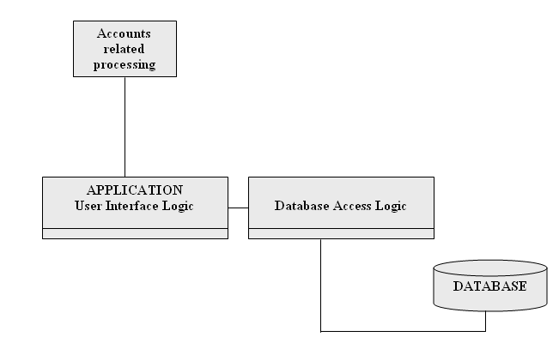

Database

We have various tables in our project namely:

* Employee Table
* Department table
* Grade Table
* Salary Table

All the above tables are now briefly explained in which the Primary key and the Data Type of all fields are discussed.

Employee Table

In this Table, we have the various fields to be filled about the employee who are working in the firm. All the personal details of all employees are filled. These fields include Name, ID, Email etc. of all the employees.

|  |
| --- |
| Field Name Key Data Type |
| ID Primary Char |
| Name - Char |
| Age - int |
| Address - Int |
| Contact No. - Int |
| Email ID - Char |
| Department - Char |
| D.O.J - Int |
| Grade - Char |

Department Table

In this Table, entries for the department name and its HOD name are filled that is the HOD is assigned to the Department. All Departments have their respective HOD.

|  |
| --- |
| Field Name Key Data Type |
| Name Primary Char |
| HOD Name - Char |
|  |

Grade Table

Grade Table takes the entries of Basic Salary, HRA, DA, TA, PF, IT and Net Salary are being filed and for the particular Grade, all these values are assigned. Grade is assigned according to the job of the employee.

|  |
| --- |
| Field Name Key Data Type |
| Name Primary Char |
| HRA - Int |
| TA - Int |
| DA - Int |
| PF - Int |
| IT - Int |

**PART CHART**

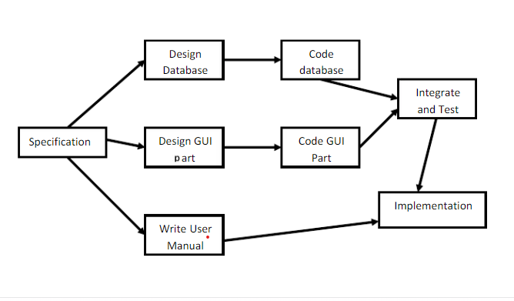

**3.3 Screen Design**

**Homepage screen**

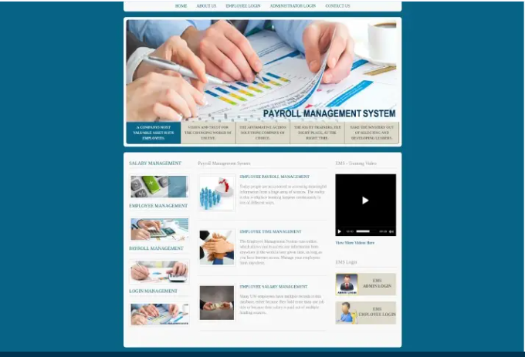

**Admin login screen**

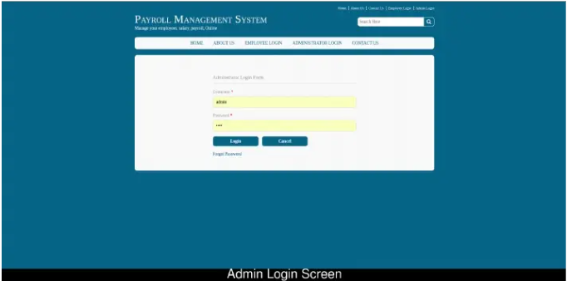

**Admin employee add screen**

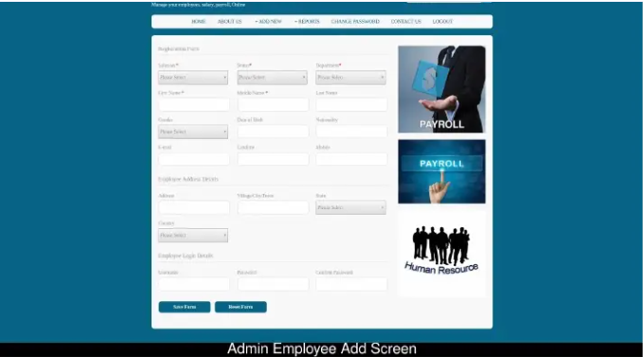

**Admin salary report screen**

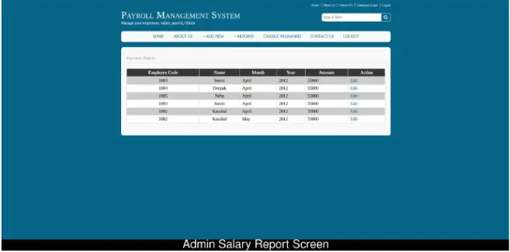

**3.4 Report Design**

(Include DFD/ERD/OOAD/ Screen Shots/ Reports & Data Base Design)

0 LEVEL DFD

Report

Grade

Department

Employee

Salary

1st LEVEL DFD:

Employee

Modify

New

Employee

View

All

Id

Employee

Database Design



SCREENSHOT

System screen

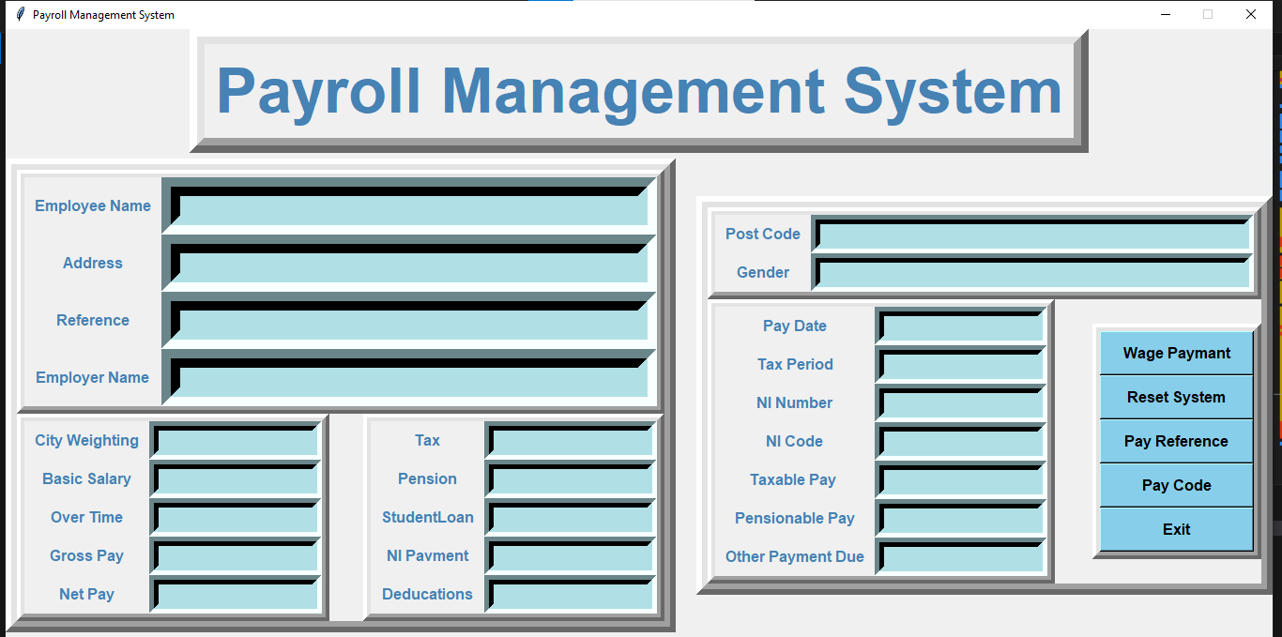

**CHAPTER 4**

**TESTING AND IMPLEMENTATION**

4.1 Testing Methodology (Types

4.2 Unit Testing

4.3 Module Testing

4.4 System Testing

4.5 Alpha/ Beta Testing

4.6 White Box Black Box Testing

4.7 Implementation

**4.1 Testing Methodology (Types)**

Test cases are developed using various test techniques to achieve more effective testing. By this, software completeness is provided and conditions of testing which get the greatest probability of finding errors are chosen. So, testers do not guess which test cases to chose, and test techniques enable them to design testing conditions in a systematic way. Also, if one combines all sorts of existing test techniques, one will obtain better results rather if one uses just one test technique. Software can be tested in two ways, in another words, one can distinguish two different methods:

1. Black box testing and

2. White box testing.

* 1. **Unit Testing**

Unit testing, also known as component testing , refers to tests that verify the functionality of a specific section of code, usually at the function level. In an object-oriented environment, this is usually at the class level, and the minimal unit tests include the constructors and destructors.

These types of tests are usually written by developers as they work on code (white-box style), to ensure that the specific function is working as expected. One function might have multiple tests, to catch [corner cases](http://en.wikipedia.org/wiki/Corner_case) or other branches in the code. Unit testing alone cannot verify the functionality of a piece of software, but rather is used to assure that the building blocks the software uses work independently of each other.

Unit testing is a software development process that involves synchronized application of a broad spectrum of defect prevention and detection strategies in order to reduce software development risks, time, and costs. It is performed by the software developer or engineer during the construction phase of the software development lifecycle. Rather than replace traditional QA focuses, it augments it. Unit testing aims to eliminate construction errors before code is promoted to QA; this strategy is intended to increase the quality of the resulting software as well as the efficiency of the overall development and QA process.

* 1. **Integration Testing**

Integration testing is any type of software testing that seeks to verify the interfaces between components against a software design. Software components may be integrated in an iterative way or all together ("big bang"). Normally the former is considered a better practice since it allows interface issues to be located more quickly and fixed .Integration testing works to expose defects in the interfaces and interaction between integrated components (modules). Progressively larger groups of tested software components corresponding to elements of the architectural design are integrated and tested until the software works as a system

* 1. **System Testing**

System testing, or end-to-end testing, tests a completely integrated system to verify that it meets its requirements. For example, a system test might involve testing a logon interface, then creating and editing an entry, plus sending or printing results, followed by summary processing or deletion (or archiving) of entries, then logoff.

In addition, the software testing should ensure that the program, as well as working as expected, does not also destroy or partially corrupt its operating environment or cause other processes within that environment to become inoperative (this includes not corrupting shared memory, not consuming or locking up excessive resources and leaving any parallel processes unharmed by its presence).

* 1. **Alpha/ Beta Testing**

Alpha testing

Alpha testing is simulated or actual operational testing by potential users/customers or an independent test team at the developers' site. Alpha testing is often employed for off-the-shelf software as a form of internal acceptance testing, before the software goes to beta testing.

Beta testing

Beta testing comes after alpha testing and can be considered a form of external [user acceptance testing](http://en.wikipedia.org/wiki/User_acceptance_testing). Versions of the software, known as [beta versions](http://en.wikipedia.org/wiki/Beta_version), are released to a limited audience outside of the programming team. The software is released to groups of people so that further testing can ensure the product has few faults or [bugs](http://en.wikipedia.org/wiki/Computer_bug). Sometimes, beta versions are made available to the open public to increase the [feedback](http://en.wikipedia.org/wiki/Feedback#In_organizations) field to a maximal number of future users

* 1. **White Box and Black Box Testing**

White box testing is highly effective in detecting and resolving problems, because bugs (bug or fault is a manifestation of an error in a software) can often be found before they cause trouble. We can shortly define this method as testing software with the knowledge of the internal structure and coding inside the program . White box testing is also called white box analysis, clear box testing or clear box analysis. It is a strategy for software debugging (it is the process of locating and fixing bugs in computer program code or the engineering of a hardware device) in which the tester has excellent knowledge of how the program components interact. This method can be used for Web services applications, and is rarely practical for debugging in large systems and networks ). Besides white box testing is considered as a security testing (the process to determine that an information system protects data and maintains functionality as intended)method that can be used to validate whether code implementation follows intended design, to validate implemented security functionality, and to uncover exploitable vulnerabilities Black box testing is testing software based on output requirements and without any knowledge of the internal structure or coding in the program .In another words, a black box is any device whose workings are not understood by or accessible to its user. For example, in telecommunications, it is a resistor connected to a phone line that makes it impossible for the telephone company’s equipment to detect when a call has been answered. In data mining, a black box is an algorithm that doesn’t provide an explanation of how it works. In film–making, a black box is a dedicated hardware device: equipment that is specifically used for a particular function, but in the financial world, it is a computerized trading system that doesn’t make its rules easily available.

**CHAPTER 5**

**CONCLUSION AND REFERENCES**

5.1 Conclusion

5.2 Limitation of System

5.3 Future Scope for Modification

5.4 References/ Bibliography

**5.1 Conclusion**

With the theoretical inclination of our syllabus it becomes very essential to take the utmost advantage of any opportunity of gaining practical experience that comes along. The construction of this Minor Project **“**PAYROLL MANAGEMENT SYSTEM” was one of these opportunities. It gave us the requisite practical knowledge to supplement the already taught theoretical concepts thus making us more competent as a computer engineer.

The project from a personal point of view also helped us in understanding the following aspects of project development:

* The planning that goes into implementing a project.
* The importance of proper planning and an organized methodology.
* The key element of team spirit and co-ordination in a successful project

The project also provided us the opportunity of interacting with our teachers and to gain from their vast experience.

**5.2 Limitation of System**

* In the present system we cannot search for the report of an employee by entering the name of that employee. Search is based on the employee id.
* If the payroll company is understaffed and has an abundance of clients, it may become difficult to reach someone when you need it immediately such as when paycheck discrepancies arise.
* Because the payroll company is located off-site, it is difficult to always know what’s going on with your payroll until the actual pay date arrives

**5.3 Future Scope for Modification**

* Although we tried to be as thorough as possible in the implementation of our project but there were a large number of features we could not implement due to want of time or for other reasons.

**5.4 References/ Bibliography**

1. Smith, J. (2020). "Python Programming for Beginners." Publisher.

2. Johnson, A. (2021). "Mastering Python: Tips and Tricks for Python Developers." Publisher.

3. Brown, T. (2019). "Building Web Applications with Flask." Publisher.

4. Python Official Documentation: [https://docs.python.org/3/](https://docs.python.org/3/)

5. Flask Official Documentation: [https://flask.palletsprojects.com/en/2.0.x/](https://flask.palletsprojects.com/en/2.0.x/)

6. SQLite Official Documentation: [https://www.sqlite.org/docs.html](https://www.sqlite.org/docs.html)