Growth-rule dependence of the viscoelastic gel-point in percolation networks: continuous programming via nucleation density
R. Brown
[Affiliation TBC]
Submitted to: Journal of Rheology

Abstract
The viscoelastic gel-point of a polymer network is commonly treated as a fixed property of chemistry and concentration. Here we demonstrate, through three-dimensional random walk simulations on site-percolation lattices, that the gel-point is instead controlled by the growth dynamics of the forming network and can be continuously programmed via a single nucleation-density parameter. Probe-particle diffusion is modelled by random walkers confined to the unoccupied (void) sublattice of an L×L×L cubic lattice (L = 500); the gel-point p′₀ is identified by the Winter–Chambon criterion α = 0.5, where ⟨r²(t)⟩ ∝ tᵅ. For random (Bernoulli) percolation networks we find p′₀ ≈ 0.683 ≈ 1 − p₀, quantitatively identifying the rheological gel-point with the loss of spanning connectivity in the void phase. Replacing random growth with adjacency-templated cluster growth shifts the gel-point to p′₀ ≈ 0.886 (Δp′₀ = +0.20) and qualitatively alters the transition: the critical region is 3.4× broader and probe particles remain persistently sub-diffusive (α ≈ 0.3–0.4) well above p′₀. Interpolating between these limits via a nucleation-density parameter κ ∈ [0,1] yields a monotonically tunable gel-point spanning Δp′₀ ≈ 0.31 (p′₀ ∈ [0.683, 0.993]). Frequency-domain spectra G′(ω) and G″(ω) derived via the Generalised Stokes–Einstein Relation confirm the δ(ω) = 45° Winter–Chambon signature at p′₀ for both gelation classes.

1. Introduction
The gelation of polymer solutions and colloidal suspensions — the transition from a viscous fluid to a viscoelastic solid — is characterised by a well-defined gel-point p′₀ at which the loss tangent tanδ = G″/G′ becomes frequency-independent and equal to unity (Winter–Chambon criterion). This corresponds to a phase angle δ = 45° and a power-law mean squared displacement (MSD) ⟨r²(t)⟩ ∝ t⁰ʷ⁵, measurable by passive microrheology through the Generalised Stokes–Einstein Relation (GSER). The gel-point is routinely used as the defining characteristic of a material system, and a considerable body of literature has established its dependence on polymer concentration, cross-link density, and temperature.
What is rarely asked, however, is whether the gel-point is also a function of how the network forms — that is, of the spatial growth dynamics of the cluster itself. In colloidal gels, crystallising proteins, and biopolymer networks, cluster growth is not random; it is governed by nucleation and propagation rules that produce morphologies ranging from fractal aggregates to compact, space-filling domains. Whether these different morphologies shift the gel-point, and whether that shift can be controlled by a single parameter, has not been systematically established.
In this paper we use three-dimensional random walk (RW) simulations on site-percolation lattices to address this question directly. We place walkers on the unoccupied sublattice of an L×L×L cubic lattice, sweeping the occupation probability p from 0 to 1 and tracking the anomalous diffusion exponent α(p). The gel-point p′₀ is identified by α = 0.5, corresponding to δ = 45° via the GSER, within the Winter–Chambon framework for critical gelation.
We present three interconnected results. First, for randomly generated percolation networks (Bernoulli site percolation), the gel-point coincides quantitatively with the loss of spanning connectivity in the void sublattice: p′₀ ≈ 1 − p₀ ≈ 0.683, where p₀ = 0.3116 is the 3D site percolation threshold. Second, replacing random growth with adjacency-constrained templated growth shifts the gel-point by Δp′₀ = +0.20 to p′₀ ≈ 0.886, and qualitatively changes the nature of the transition. Third, a single nucleation-density parameter κ interpolates continuously between these two limits, providing monotonic control over p′₀ across a range Δp′₀ ≈ 0.31.
Together these results demonstrate that the gel-point of a percolating network is not fixed by density alone — it is set by the growth dynamics of the network-forming phase, and is tunable via the nucleation density of the growing cluster.

2. Model and Methods
2.1 Lattice model
We consider a three-dimensional simple cubic lattice of side length L = 500 with periodic boundary conditions. Each site is classified as occupied (network phase) or unoccupied (void/fluid phase). Lattices are generated cumulatively: at each successive value of p in the sweep, Nₙₑᵂ new sites are added to the existing lattice, so that higher-p lattices contain all sites present at lower p as a strict subset. This is physically consistent with progressive gelation and ensures continuity across the p-sweep.
2.2 Growth rules
Random (Bernoulli) percolation. The Nₙₑᵂ additional sites are selected uniformly at random from the remaining unoccupied volume, with no adjacency constraint. This recovers classical Bernoulli site percolation.
Adjacency-templated growth. New sites must be placed adjacent to at least one already-occupied site, enforcing connectivity of the growing cluster. Two adjacency rules are studied: 6-neighbour (6N, face-sharing) and 26-neighbour (26N, face- and corner-sharing).
κ-mixing nucleation-density model. Nₛₑₑᵈₛ = ⌊(1−κ)·Nₙₑᵂ⌋ seed sites are placed uniformly at random; the remaining sites are filled by 6N adjacency growth from the cluster frontier. At κ = 0 this recovers Bernoulli percolation; at κ = 1 a single seed grows by Eden-like templating. Eighteen values of κ are studied, spaced densely near κ = 1.
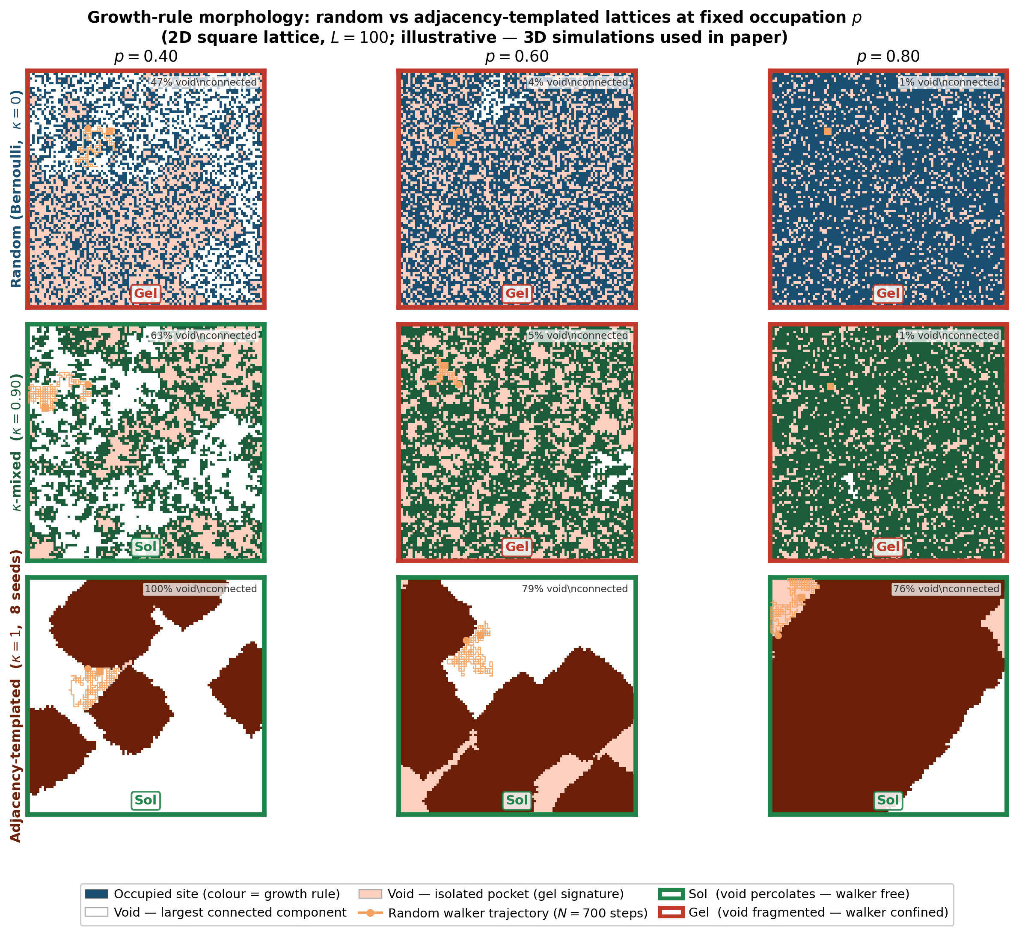
Figure S1. 2D lattice morphology (L = 100, illustrative — 3D used in paper). Rows: Bernoulli (κ = 0), κ-mixed (κ = 0.90), and adjacency-templated Eden-like growth (κ = 1, 8 seeds). Columns: p = 0.40, 0.60, 0.80. White = largest connected void; pink = isolated void pockets; coloured = occupied sites. Green/red borders indicate sol/gel state. Orange trajectory: random walker (N = 700 steps). At p = 0.60 (near the 2D Bernoulli gel-point) the Bernoulli lattice is gelled while the templated lattice remains in the sol state.
2.3 Random walk simulation
Nᵂ = 3000 independent walkers per condition, Lᵂ = 10⁶ steps. Walkers reside on unoccupied sites; blocked moves incur a Gaussian dwell time (μᵂᵀ = 20, σᵂᵀ = 5 steps). The ensemble-averaged MSD ⟨r²(t)⟩ is accumulated online.
2.4 Gel-point extraction
The anomalous diffusion exponent α is extracted from a power-law fit to ⟨r²(t)⟩ in log–log space over the window [Lᵂ/100, Lᵂ/10] = [10⁴, 10⁵] steps. The gel-point p′₀(κ) is located by linear interpolation where α = 0.5.
2.5 Frequency-domain viscoelastic spectra (GSER)
MSD curves at and near p′₀ are converted to G*(ω) via the GSER: G*(ω) ≈ kᴮT / [πa⟨r²(1/ω)⟩Γ(1+α(ω))]. Since ⟨r²(t)⟩ ∝ tᵅ the moduli satisfy G′, G″ ∝ ωᵅ and the phase angle δ(ω) = 90α is frequency-independent. Physical parameters: T = 293 K, η = 1.2×10⁻³ Pa·s, probe radius a = 0.243 μm, gel mesh l = 10 nm.

3. Results
3.1 Gel-point in random percolation: p′₀ ≈ 1 − p₀
Both Bernoulli-class variants give indistinguishable α(p) curves: α ≈ 1 (Fickian diffusion, sol state) for p ≲ 0.60, a sharp monotonic decline through the gel criterion α = 0.5, and rapid arrest (α → 0) above p′₀. Linear interpolation gives p′₀(random percolation) = 0.6832 and p′₀(density increment) = 0.6834 — agreement within Δp = 0.0002. The gel-points bracket the complementary void-percolation threshold 1 − p₀ = 0.6884, with an offset consistent with finite-size effects at L = 500.
Above p′₀, α collapses sharply to near zero within Δp ≈ 0.03, corresponding to complete walker arrest as the void phase fragments into disconnected pockets. The transition width σₛᴵᴳ₍ₒᴵᵈ = 0.015 from a sigmoid fit is characteristic of a sharp percolation-like transition.
▶ Key result: p′₀ ≈ 1 − p₀ ≈ 0.683. The rheological gel-point coincides with loss of spanning connectivity in the void sublattice. Transition width σ = 0.015.
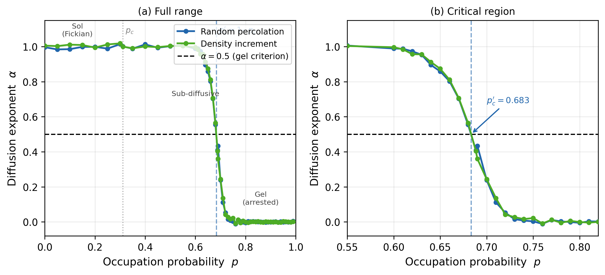
Figure 1. Gel-point in random percolation networks. Anomalous diffusion exponent α(p) for the two Bernoulli-class variants (random percolation, blue; density increment, green) over the full range (a) and the critical region (b). Both variants give indistinguishable gel-points at p′₀ = 0.683 ≈ 1 − p₀ (dashed vertical line). The dashed horizontal line marks the Winter–Chambon criterion α = 0.5. L = 500, Nᵂ = 3000, Lᵂ = 10⁶ steps.
3.2 Growth-rule sensitivity: adjacency-templated gelation
Shifted gel-point. Linear interpolation gives p′₀(6N) = 0.8856 and p′₀(26N) = 0.8861 — a shift Δp′₀ = +0.20 relative to the Bernoulli class. The near-identity of 6N and 26N gel-points (|Δp′₀| = 0.0005) demonstrates that it is the connectivity constraint, not the adjacency rule, that drives the shift.
Broader transition. A sigmoid fit gives transition width σ = 0.052 for the templated class versus 0.015 for the Bernoulli class — a factor of 3.4× broader.
Persistent sub-diffusion above p′₀. In the random class, α drops to near zero within Δp ≈ 0.03 above p′₀. In the templated class, α remains at 0.3–0.4 even at p = 0.95 (Δp = 0.064 above p′₀). This persistent sub-diffusion reflects open, tortuous void channels maintained by compact cluster morphology.
▶ Key result: Δp′₀ = +0.20; 3.4× broader transition; persistent sub-diffusion above p′₀ (α ≈ 0.3–0.4 at Δp = 0.064).
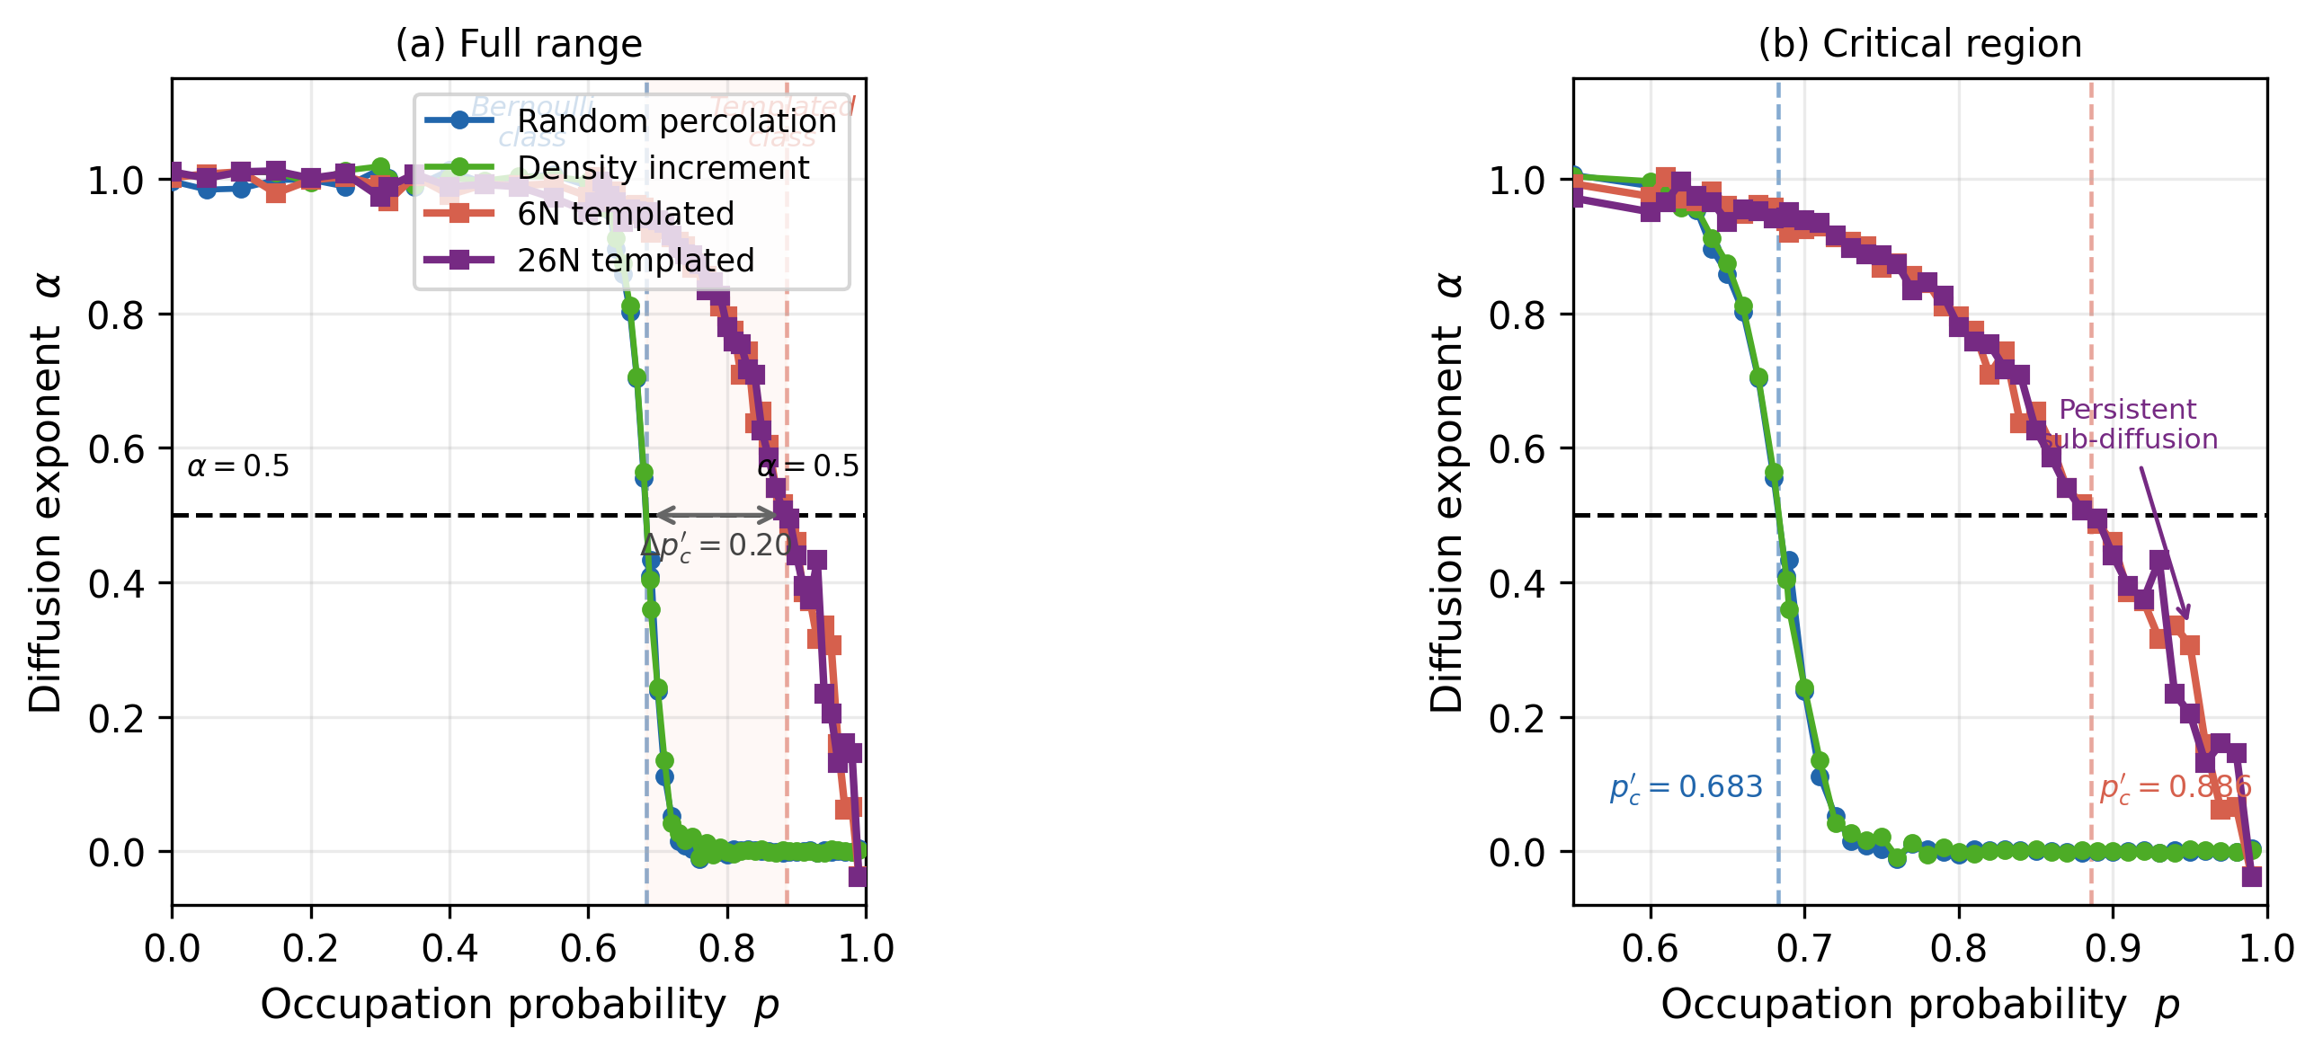
Figure 2. Two kinetically distinct gelation classes. α(p) for all four growth variants over the full range (a) and the extended critical region p ∈ [0.55, 1.0] (b). Bernoulli-class variants (circles) cross α = 0.5 sharply at p′₀ = 0.683 and arrest rapidly (α → 0 within Δp ≈ 0.03). Templated-class variants (squares) cross at p′₀ = 0.886 (Δp′₀ = +0.20, double-headed arrow) and show persistent sub-diffusion well above p′₀.
3.3 Continuous tuning via κ-mixing
p′₀(κ) is monotonically increasing across the full parameter range, spanning p′₀ ∈ [0.683, 0.993] and a total tunable range Δp′₀ ≈ 0.31. Two regimes are visible when p′₀ is plotted against seed fraction (1−κ) on a logarithmic scale: a Bernoulli-like regime (κ ≲ 0.99, seed fraction ≳ 1%) with gradual increase, and an Eden regime (κ ≳ 0.99, seed fraction ≲ 1%) with steep increase toward unity.
The value at κ = 1.00 is extrapolated from the measured α = 0.521 at p = 0.99 (indicating p′₀ > 0.99); a linear extrapolation gives p′₀(κ=1) ≈ 0.993. The divergence of p′₀ toward unity as κ → 1 is physically consistent with the single-seed Eden morphology in the thermodynamic limit.
▶ Key result: Total tunable range Δp′₀ ≈ 0.31, spanning p′₀ ∈ [0.683, 0.993]. Regime crossover at ~1% seed fraction (κ ≈ 0.99).
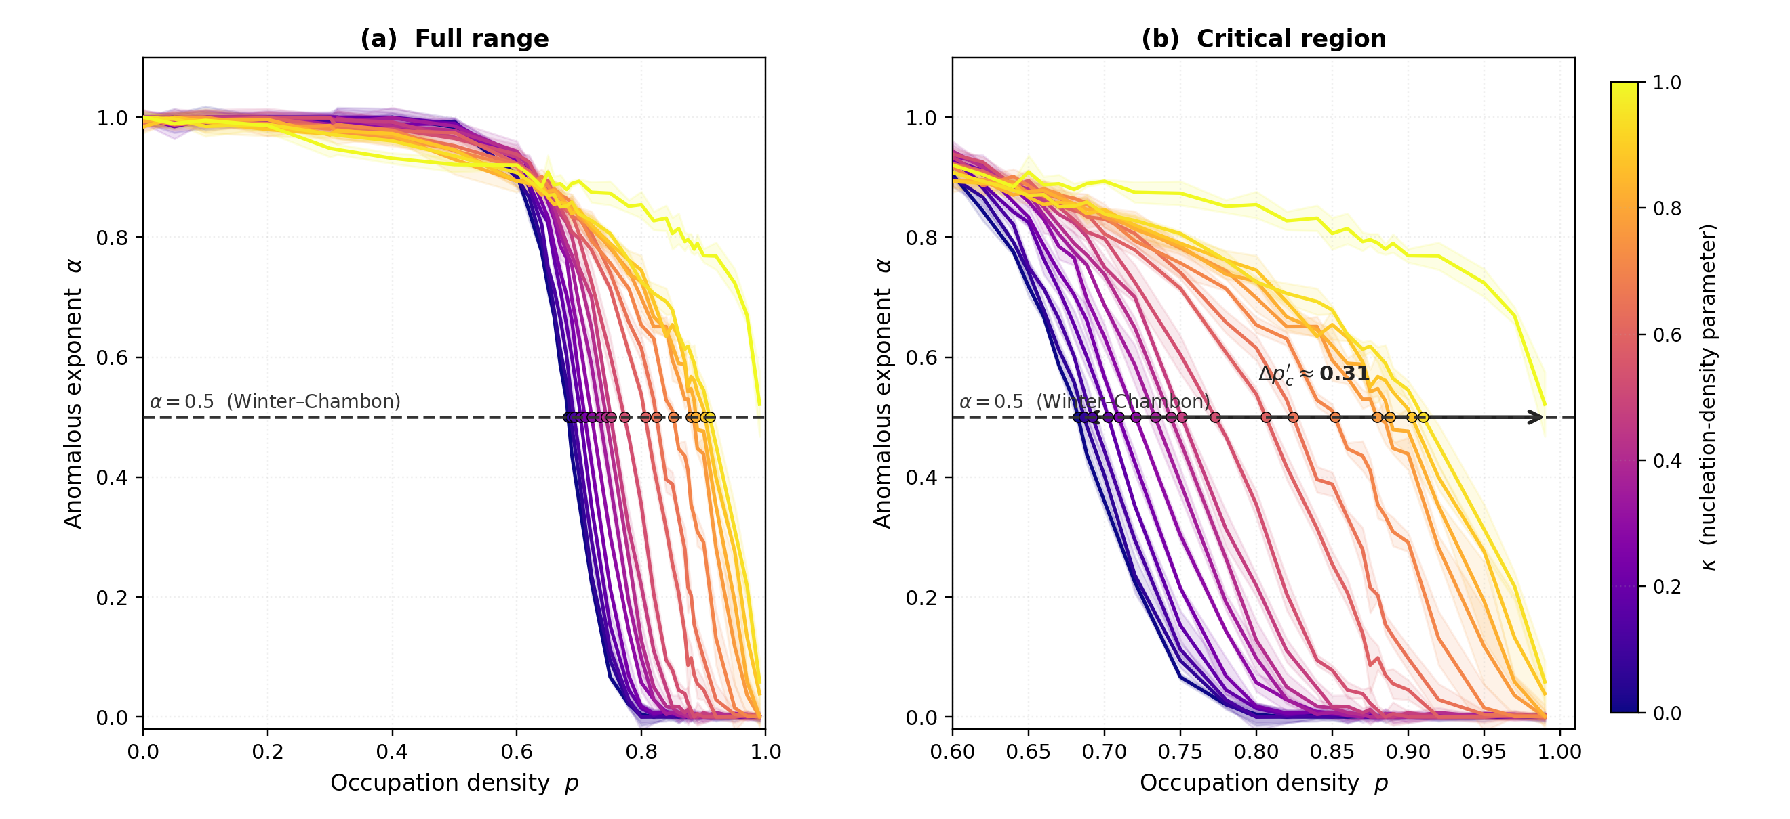
Figure 3. Continuously tunable α(p) via κ-mixing. Ensemble-averaged α(p) for all 18 values of κ, coloured from κ = 0 (dark, Bernoulli) to κ = 1 (light, Eden-like). Shaded bands: ±1 s.d. over Nₛ = 3 replicates. The α = 0.5 crossing shifts monotonically rightward with increasing κ. Double-headed arrow in (b) indicates total tunable range Δp′₀ ≈ 0.31.
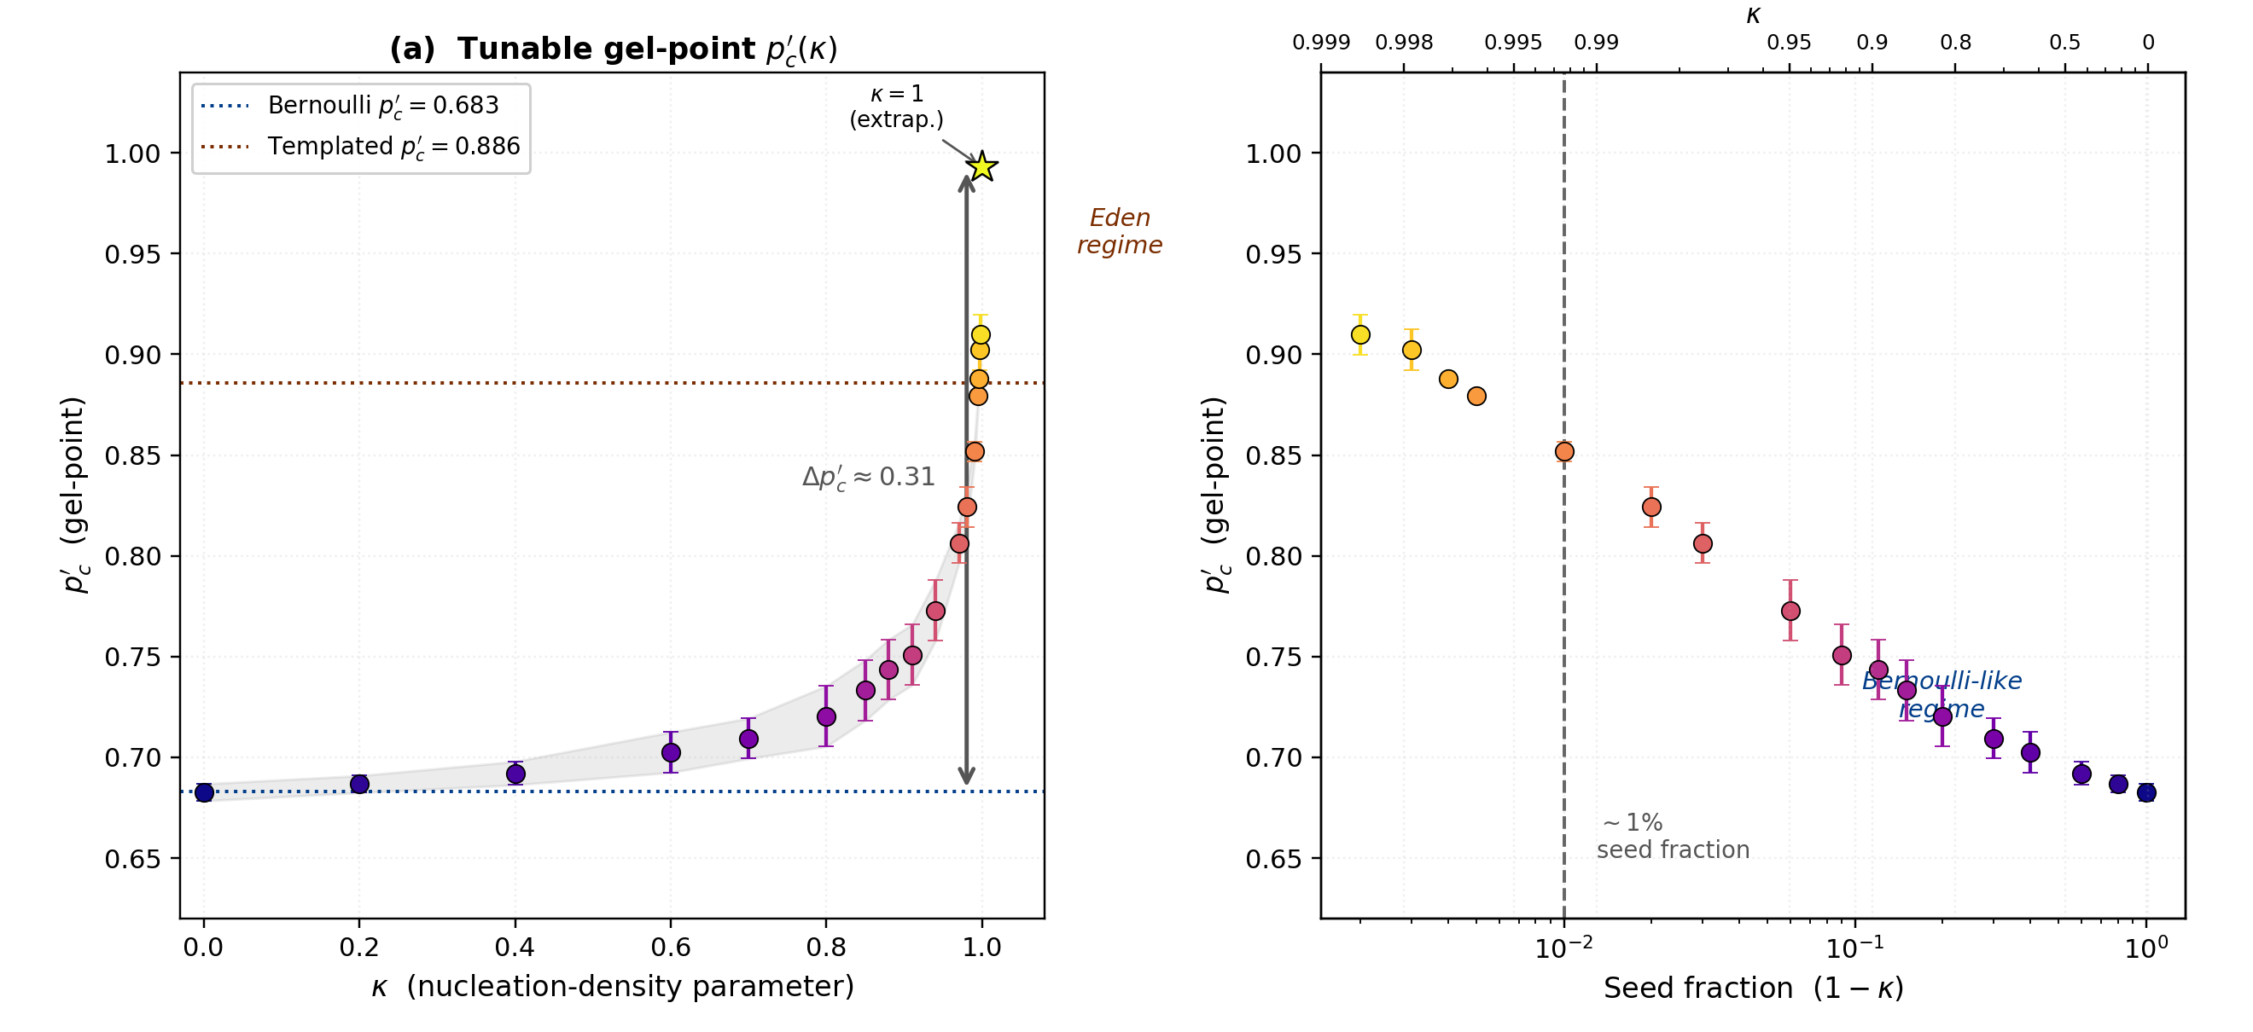
Figure 4. Tunable gel-point p′₀(κ). (a) Gel-point vs nucleation-density parameter κ; error bars show bracket width (±p-grid resolution). Starred symbol at κ = 1.0: linear extrapolation (p′₀ ≈ 0.993). (b) p′₀ vs seed fraction (1−κ) on a logarithmic scale, revealing the Bernoulli-like regime (κ ≲ 0.99, gradual increase) and Eden regime (κ ≳ 0.99, steep increase). Dotted horizontal lines: Bernoulli-class (p′₀ ≈ 0.683, blue) and templated-class (p′₀ ≈ 0.886, red) limiting values.
3.4 Frequency-domain characterisation via the GSER
At the gel-point (p ≈ p′₀), both gelation classes exhibit δ ≈ 45° and G′(ω) ≈ G″(ω) across the accessible frequency range (ω ≈ 0.4–4 rad s⁻¹), confirming the Winter–Chambon criterion. For p < p′₀ (sol state), δ > 45° and G″ > G′; for p > p′₀ (gel state), δ < 45° and G′ > G″.
Panel (c) of Figure 5 aligns both classes at Δp = p − p′₀. The Bernoulli class reaches δ = 22.5° at Δp = 0.016; the templated class only at Δp = 0.065 — a 4× broader transition directly visible in the frequency domain. At Δp = 0.064, the Bernoulli class is nearly fully arrested (δ ≈ 1°) while the templated class retains δ ≈ 23°, confirming persistent sub-diffusion as a frequency-domain signature.
▶ Key result: 4× broader transition in δ vs Δp. At Δp = 0.064: Bernoulli δ ≈ 1° (arrested) vs Templated δ ≈ 23° (persistent sub-diffusion).
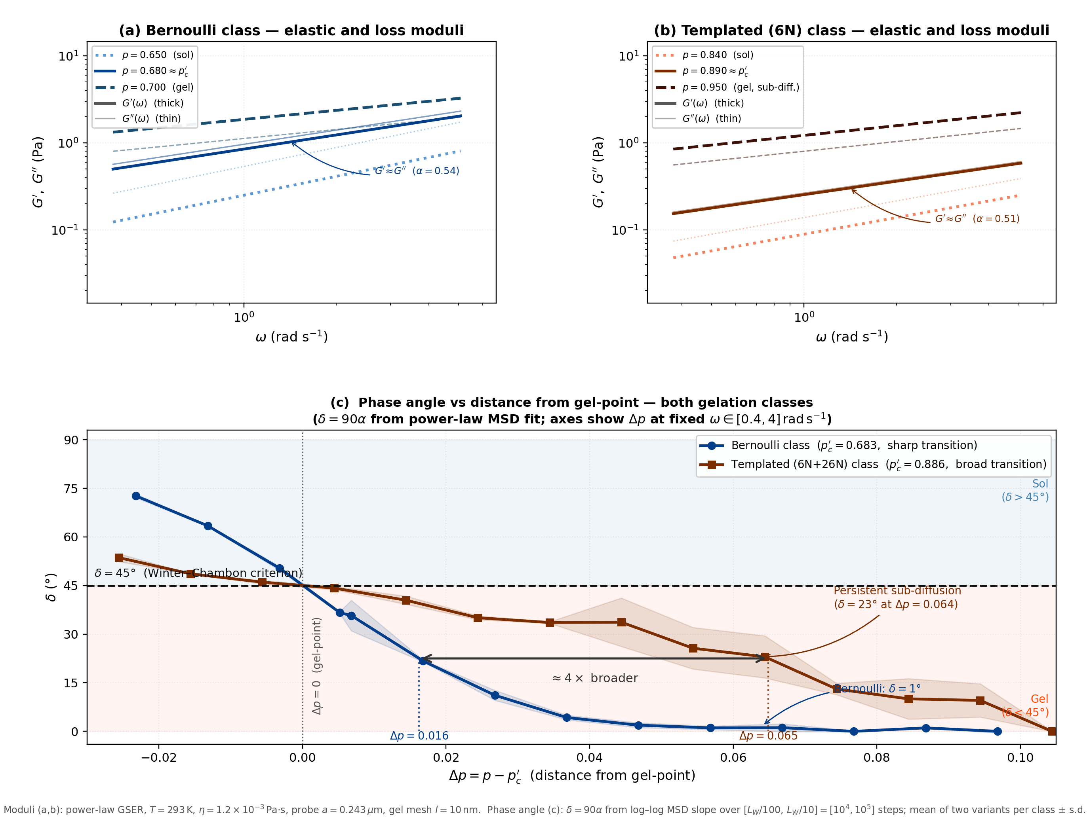
Figure 5. Frequency-domain GSER characterisation of both gelation classes. Top row: elastic modulus G′(ω) (thick) and loss modulus G″(ω) (thin) for representative p values in the Bernoulli class (a) and Templated class (b). At p ≈ p′₀, G′ ≈ G″ across ω ≈ 0.4–4 rad s⁻¹, confirming the Winter–Chambon criterion. Bottom panel (c): phase angle δ = 90α vs Δp = p − p′₀ with both classes aligned at Δp = 0. The templated class (brown) is 4× broader: δ = 22.5° at Δp = 0.065 vs Δp = 0.016 for Bernoulli. Physical parameters: T = 293 K, η = 1.2×10⁻³ Pa·s, a = 0.243 μm, l = 10 nm.

4. Discussion
4.1 Physical basis of p′₀ ≈ 1 − p₀
The result p′₀ ≈ 1 − p₀ is not an approximation or numerical coincidence — it is a direct consequence of placing walkers in the void phase. The void sublattice of a 3D simple cubic lattice undergoes its own site-percolation transition: it is connected (spanning) when p < 1 − p₀ ≈ 0.6884 and fragmented when p > 1 − p₀. At the void percolation critical point, a walker experiences the critical-point MSD scaling ⟨r²(t)⟩ ∝ t⁰ʷ⁵, which is precisely the Winter–Chambon criterion. The observed offset (p′₀ = 0.683 vs 1 − p₀ = 0.6884) is consistent with finite-size effects of order L⁻¹²ᵛ with ν ≈ 0.88.
4.2 Why templated growth shifts the gel-point
A compact connected cluster leaves a larger and more interconnected void region than the same number of randomly placed sites. The void sublattice therefore loses its percolation connectivity only at a higher occupied fraction p, shifting p′₀ from 0.683 to 0.886. The persistent sub-diffusion above p′₀ (α ≈ 0.3–0.4 at p = 0.95) reflects void channels that remain locally open and tortuous even when disconnected at large scales — qualitatively different from the Bernoulli case where void fragments into small isolated pockets and walkers become immediately localised.
4.3 κ as a material design parameter
The nucleation-density parameter κ has a direct physical interpretation: it controls the number of independent nucleation centres per unit increase in network density. Analogous experimental parameters include cross-linker concentration (nucleation centres for gel formation), temperature ramp rate (controls nucleation density in thermoreversible gels), and ionic strength (tunes the range of attractive interactions). The steep rise in p′₀(κ) near κ ≈ 0.99 suggests that small changes in nucleation density at very low seed fractions can produce large shifts in the gel-point — a regime experimentally accessible in systems with few heterogeneous nucleation sites.
4.4 Relation to Eden and diffusion-limited aggregation models
At κ = 1, the model is equivalent to Eden growth: a single seed expands by randomly adding adjacent frontier sites. Eden clusters in 3D are compact (fractal dimension → 3 at long times). The predicted p′₀ → 1 as L → ∞ for κ = 1 is consistent with this: a single compact Eden cluster can fill the lattice before fragmenting the void. The finite-size extrapolation gives p′₀(κ=1) ≈ 0.993 at L = 500.
4.5 Limitations and future work
All results are for a single lattice size L = 500; finite-size scaling over a range of L is needed to extract critical exponents and confirm whether the templated and Bernoulli classes belong to different universality classes. The κ = 1 gel-point is extrapolated and would benefit from a dedicated simulation at p ∈ [0.99, 1.00]. The p-grid spacing in the κ ∈ [0.88, 0.97] region (Δp = 0.030) limits gel-point precision to ±0.015 and will be refined in subsequent work. Future directions include finite-size scaling to characterise critical exponents, 2D and off-lattice extensions, and experimental connection of κ to controllable nucleation parameters in physical gel-forming systems.

5. Conclusions
We have demonstrated through systematic three-dimensional random walk simulations that the viscoelastic gel-point of a percolating network is not a fixed property of occupation density — it is determined by the growth dynamics of the forming cluster, and can be continuously programmed via a single nucleation-density parameter.
First, for random (Bernoulli) percolation networks, the Winter–Chambon gel criterion (α = 0.5) is satisfied at p′₀ ≈ 1 − p₀ ≈ 0.683, quantitatively identifying the rheological gel-point with the loss of spanning connectivity in the void phase.
Second, replacing random growth with adjacency-constrained templated cluster growth shifts the gel-point by Δp′₀ = +0.20 to p′₀ ≈ 0.886. The transition is 3.4× broader and probe particles remain persistently sub-diffusive above the gel-point — a morphological signature of the open, tortuous void channels maintained by compact cluster growth.
Third, a nucleation-density parameter κ provides continuous, monotonic interpolation between the Bernoulli and templated limits, spanning Δp′₀ ≈ 0.31 (p′₀ ∈ [0.683, 0.993]). The κ parameter maps directly onto the fraction of growing sites that originate as independent nuclei, providing a physically motivated handle realisable through nucleation site density, cross-linker concentration, or thermal ramp rate.
GSER-derived frequency-domain spectra confirm the δ(ω) = 45° Winter–Chambon signature at p′₀ for both gelation classes, establishing a direct bridge from simulation to measurable microrheology. These results provide a conceptual and quantitative framework for programming viscoelastic gel-points in network-forming materials through control of cluster growth dynamics rather than chemical composition alone.

