NORTHWEST discovery journey

📋 NORTHWEST DISCOVERY JOURNEY
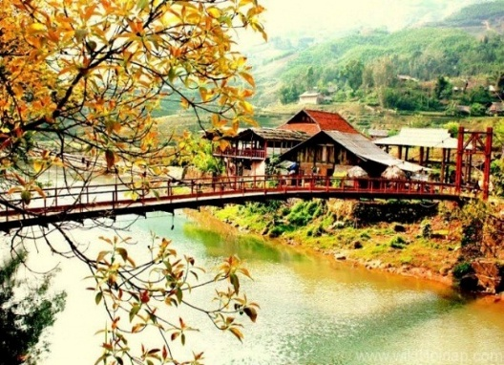
________________________________________
DAY 1: HANOI - SAPA (Breakfast, Lunch, Dinner)
0:00 Gather at the bus station.
0:00 - 6:40: Travel from central Hanoi to Sapa.
6:45 - 7:30: Gather for breakfast at Hoa Phuong Chicken Pho; enjoy a hot bowl of pho in Sapa's chilly early morning fog, replenishing energy for a new day of exploration.

7:30 - 8:30: Travel along the winding Muong Hoa stream to Ta Van village.
8:30 - 10:30: Sightseeing location: Ta Van Village, one of the most famous valleys in Sapa, preserving the pristine, rustic beauty of the Northwest highlands.
- Photo check-in: Rustic wooden houses of the H'Mong and Giay ethnic communities, featuring wooden roofs tiled with yin-yang or palm leaves, surrounded by hand-stacked stone fences that feel peaceful and charming.

- 10:30 - 12:15: Experience indigo dyeing and immerse yourself in Northwest culture at Cham Workshop.

12:15 - 13:15: Specialty lunch at Sailing Sapa.
- Photo check-in: Lunch with a panoramic terraced field view overlooking Ta Van valley, Muong Hoa stream, and the majestic Hoang Lien Son mountain range.

13:15 - 13:30: Travel from the restaurant to La Dao Spa.
13:30 - 15:30: Red Dao herbal bath at La Dao Spa
- Benefits: Soaking in fragrant wooden tubs surrounded by nature helps achieve ultimate relaxation, dispelling all fatigue after a long journey, boosting blood circulation, and warming up in Sapa's cool climate.
15:30 - 16:00: Return to Sapa town center.
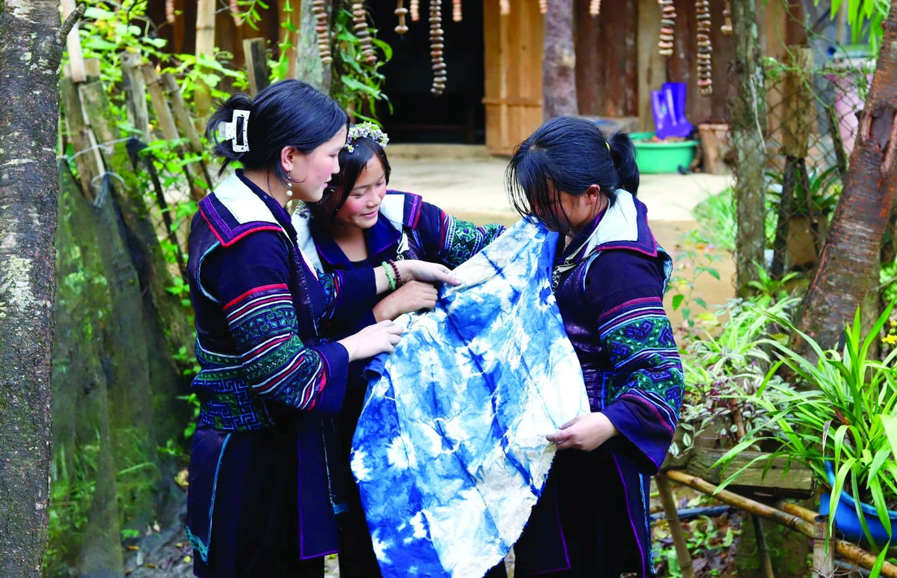

16:00- 18:45 : Check in and relax at Mega View Homestay Sapa.
18:45-18:55: Transfer to Thang Co A Quynh Restaurant.
18:55-19:45: Dinner at Thang Co A Quynh Restaurant, the oldest and most famous culinary hotspot in Sapa town center, specializing in Northwest regional delicacies.
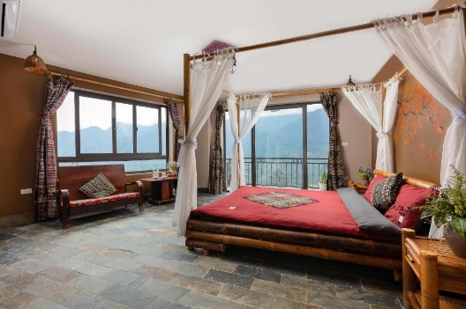

DAY 2: SAPA (Breakfast, Lunch, Dinner)
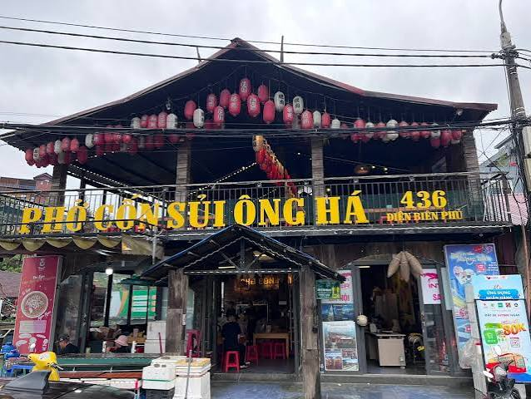
06:45 – 07:30: Breakfast at Con Sui Ong Ha.
• Free time to visit, relax, and take photos against beautiful backdrops across the restaurant grounds.
07:30 – 08:00: Continue along Nguyen Chi Thanh Street (4 km), passing central avenues and major hilltop resorts on the western slope of Sapa town.

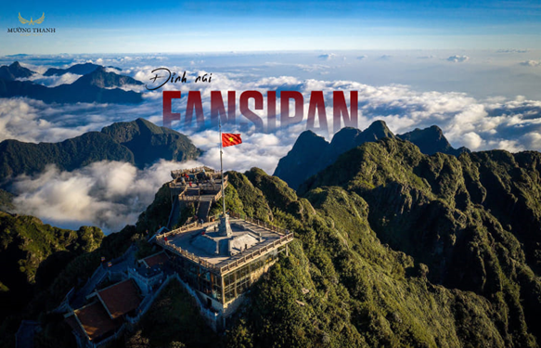
08:00 – 11:00: Visit Fansipan Peak – "The Roof of Indochina", a grand and experience-rich destination in Sapa set amidst the clouds:
  - Photo Check-in: The 3,143 m Fansipan Flagpole, the bronze Amitabha Buddha statue atop the mountain, Thanh Van Cat Heaven's Gate, Arhat Path shrouded in fog, and a 360- degree floating sea of clouds.
Entertainment & Recreation: Ride the Muong Hoa Monorail through vast flower valleys, take the Fansipan Cable Car through the clouds, board the Fansipan Peak Funicular, or immerse yourself in traditional Northwest cultural festivals at May Village.
·
11:00 – 12:15: Lunch at Fansipan.
12:15 – 13:30: Visit Hoang Lien Station and transfer back to the hotel.
13:30 – 15:00: Check-in and rest.
Buổi chiều: Sightseeing at the Square, Stone Church, and Ngoc Mat Lake.
18:30 – 18:45: Transfer from hotel to King Sturgeon Restaurant (Nha hang Ca Tam Vua) for dinner.
18:45 – 20:30: Dinner at King Sturgeon Restaurant (Nha hang Ca Tam Vua).
20:30 – 20:40: Transfer from the restaurant to the town square for evening sightseeing.
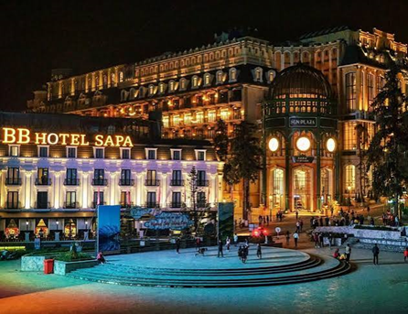
·20:40 – 22:00: Explore the Central Sapa Cluster – "The romantic heart in the misty town", an attractive promenade blending classic French architecture with highland ethnic cultures. Highlights include the European-style Stone Church, vibrant central Square, and Mat Ngoc Lake reflecting the night lights.
22:00 – 22:15: Transfer back to the hotel.
22:15 – End of day: Room rest and relaxation to prepare for tomorrow.

DAY 3: YEN BAI (Breakfast, Lunch, Dinner)
06:45 - 07:30 Breakfast at the hotel. Re-energize for the journey across the majestic Northwest mountains.
07:30 - 08:00 Prepare personal belongings. Tour guide outlines the itinerary, reviews safety precautions, and gathers the group.
08:00 - 08:40 Di chuyển đến đèo Ô Quy Hồ.

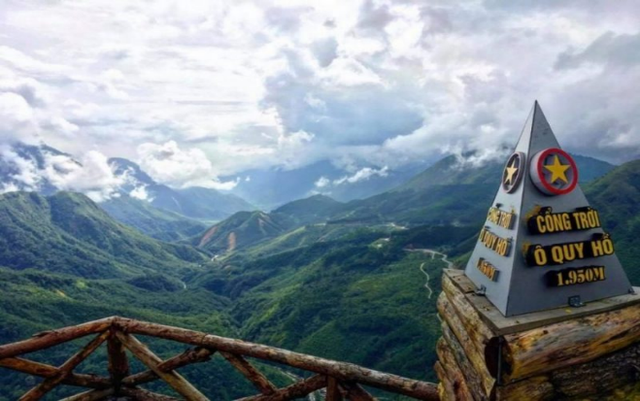
08:40 - 10:15: Visit O Quy Ho Pass Tourist Area. Enjoy free time taking in the mountain pass scenery, cloud hunting, and photography.

10:15 - 12:15 Travel to Tay Bac Xanh Restaurant – Than Uyen.
12:15 - 13:30 Lunch at Tay Bac Xanh Restaurant – Than Uyen. Enjoy regional specialties and socialize.

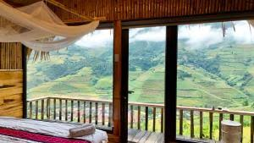
13:30 - 15:15 Travel to Mu Cang Chai Big View Homestay.
15:15 - 16:00 Check-in, rest, and freshen up at Mu Cang Chai Big View Homestay.

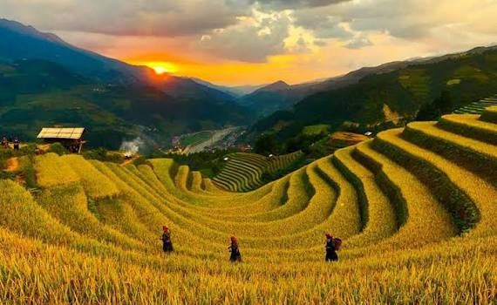
16:00 - 18:00 Visit and watch the sunset at Mong Ngua Hill (Horseshoe Hill), famous for sweeping terraced rice fields.

18:00 - 18:30 Transfer to Quyen Huong Restaurant.
18:30 - 21:30 Dinner and Gala Dinner program. Enjoy dinner, musical performances, and team games.
21:30 - 22:00 Transfer back to Mu Cang Chai Big View Homestay.
22:00 – End Overnight stay at Mu Cang Chai Big View Homestay.

DAY 4: LA PAN TAN VILLAGE

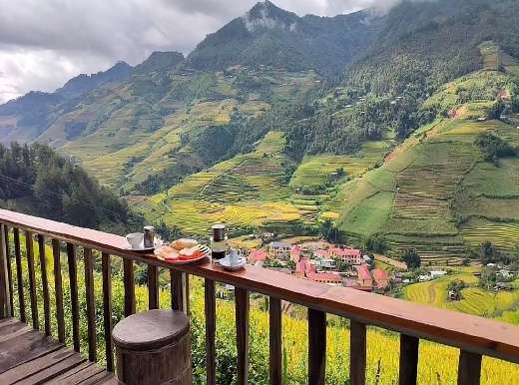
6:45 - 7:30 Breakfast at homestay while admiring Northwest mountain vistas.
7:30 - 8:00 Transfer to La Pan Tan village.
8:00 - 9:40 Visit La Pan Tan village and Mam Xoi Hill (Raspberry Hill). Learn about local ethnic life and admire layered terraced fields.
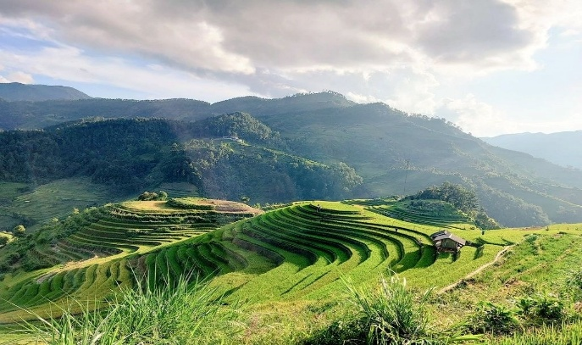

9:40 - 10:35 Travel to Khau Pha Pass.

10:35 - 11:05 Check-in at Khau Pha Pass. View one of the most majestic and challenging passes in Northwest Vietnam.

11:05 - 11:35 Travel to Pho Nui Restaurant.
11:35 - 12:45 Lunch at Pho Nui Restaurant.
12:45 - 19:30/20:30 Return transfer to Hanoi. End of journey. Farewell and see you again!

WISHING YOU A REWARDING AND ENJOYABLE TRIP!

