**Module Name: Internet Programming II**

**Module Code: WAT2117C**

**Cohort: BCNS/ 19A/ FT**

**Student Name:**

**Student ID:**

Table of Contents

How the application run 1

Admin 1

Admin Login 1

Admin Dashboard 2

Search Student 4

Freeze/unfreeze, delete, reset password 5

The same applies to tutors. 5

Crud course category 6

Crud MaterialType 8

Tutor 9

Register a tutor 9

Welcome user 10

View Profile 11

Adding new certification 12

Updating the profile 13

Adding a course 14

View Course Created 16

Update course 17

My Student 18

My Events 19

Adding New Event 19

After Adding Event 20

Student 21

Welcome 21

Search course/Category 22

Subscribe goes into Pending state 23

Tutor Perspective 23

Back to student perspective 25

Student view Events 26

View/Update Profile 26

Ordinary users/All Users 27

Home 27

See Courses 28

See Tutors 28

Special strength 29

Additional functionalities 31

# How the application run

first of all for the admin the dbmanager should manually input the credentials.

## 

## Admin

### Admin Login

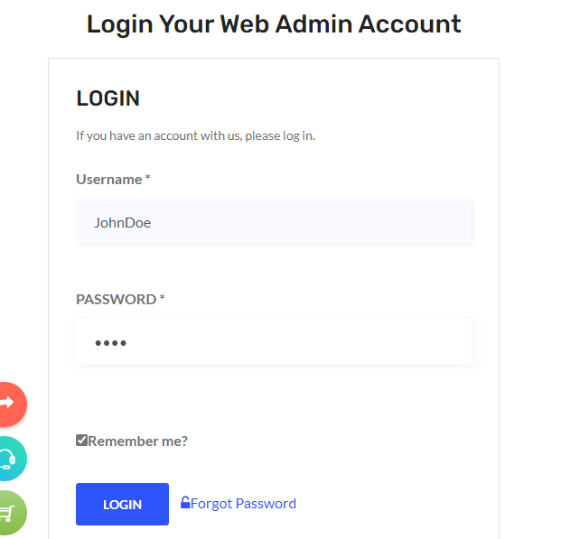

In the login if the remember me checked, the use of cookies will keep the username and password for 100 days

### Admin Dashboard

After successful login, the admin will be redirect to the dashboard where he/she will be greeted. And the navbar will change dynamically according to the user role.



On this page he/she will be able to see statistics as well

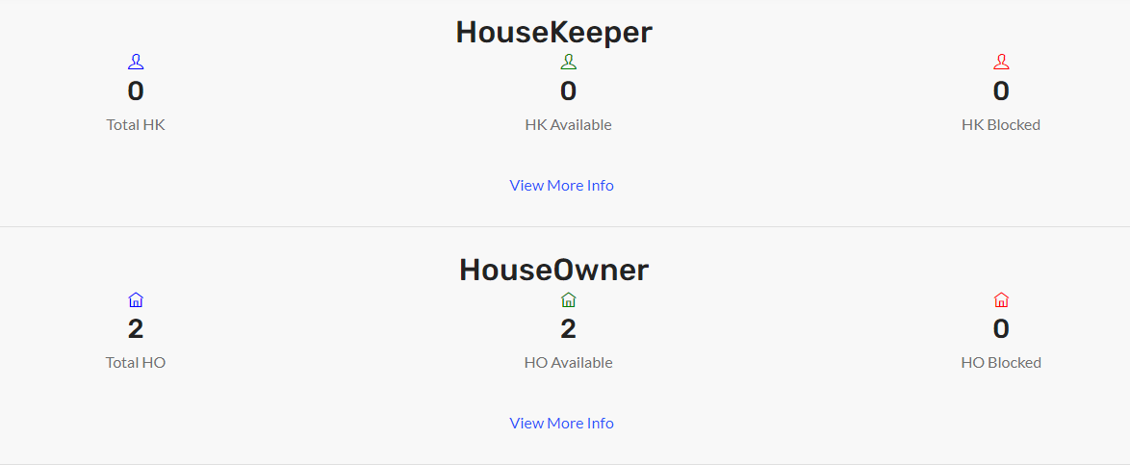

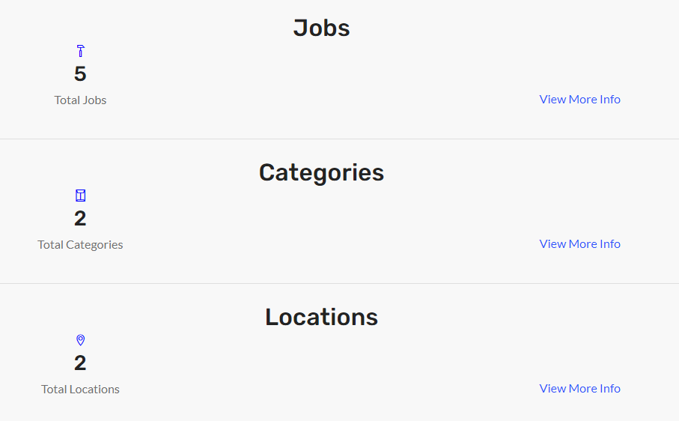



### Search HouseOwner

By clicking on the HouseOwner section view more button or navbar users HouseOwner, the admin can perform advance search as per freeze or unfreeze, or by typing the name.

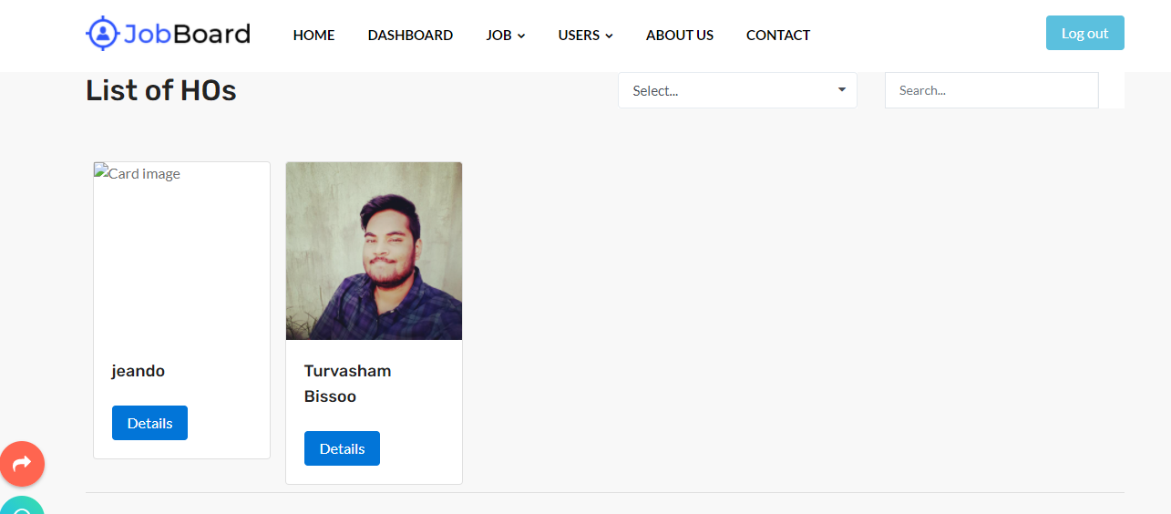

### Freeze/unfreeze, delete, reset password

To perform operations such as freeze/unfreeze, delete or reset password the details button is clicked.

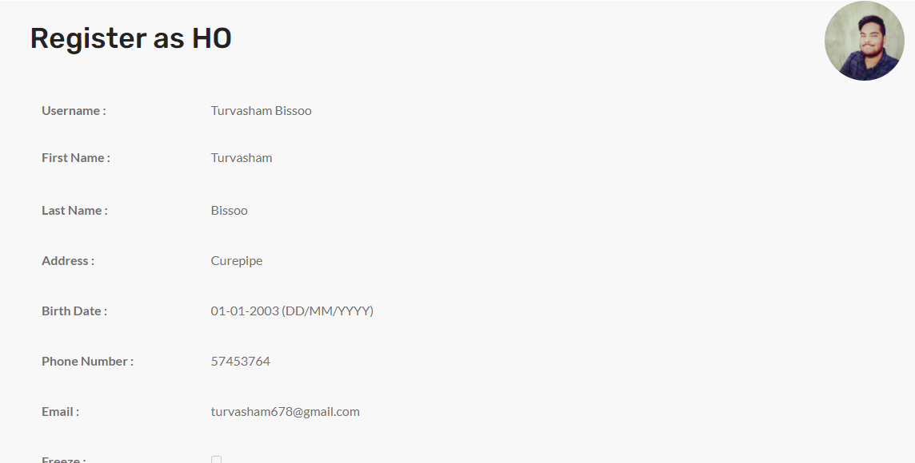

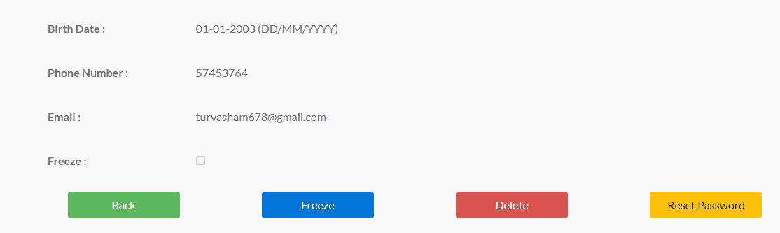

## The same applies to HouseKeeper.

### Crud job category

The admin can add update delete any job category

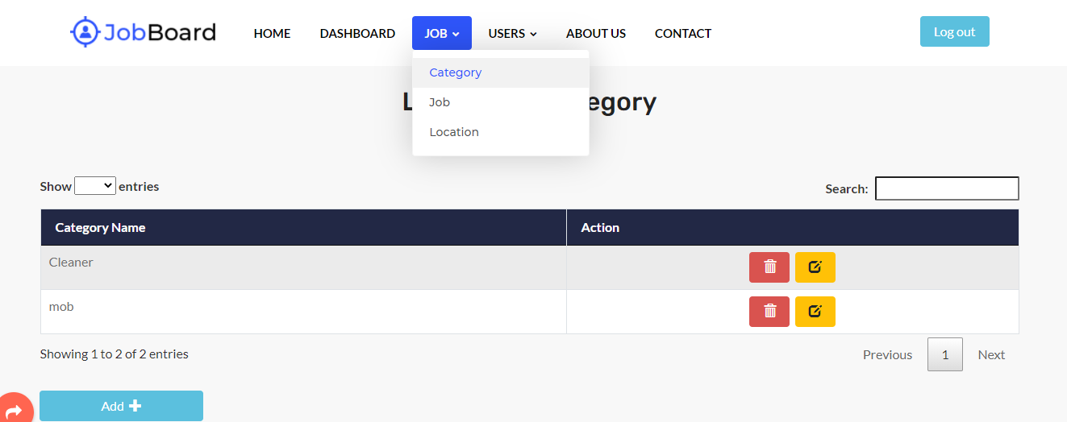

An additional feature would be the use of webservice and ajax to give the message

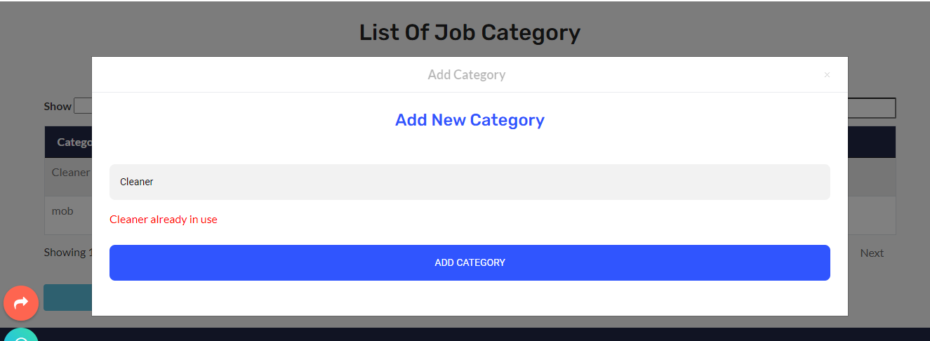

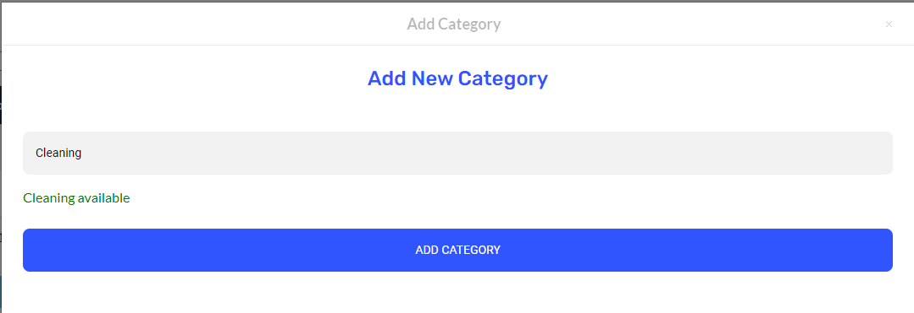 The same message applies for update.

And for delete itis the trash icon

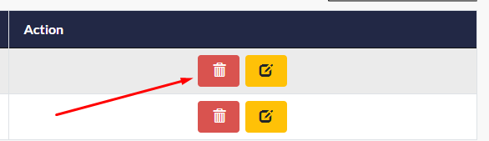

### Crud Location and delete/view jobs

The admin can also perform crud operation on the Location too (same format as job category)

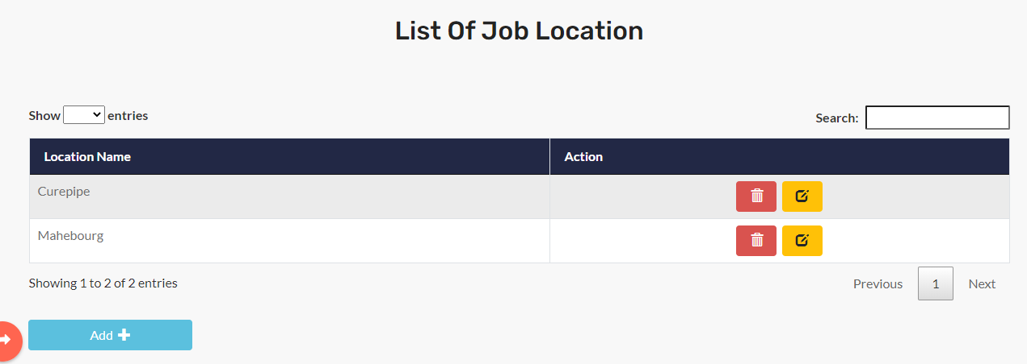

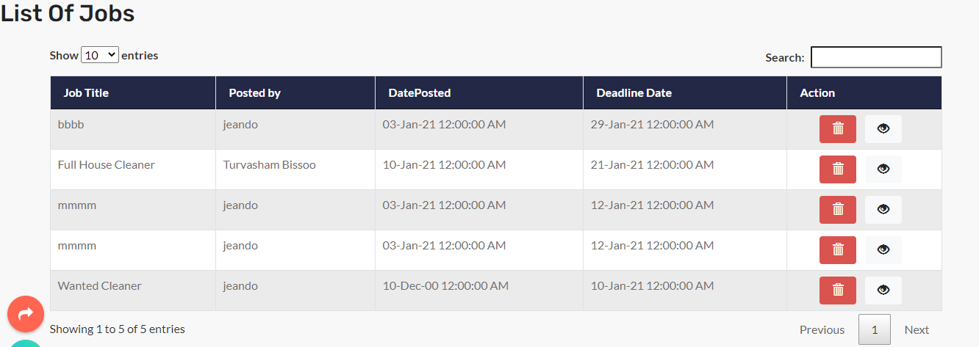

## HouseOwner

### Register a HouseOwner/HouseKeeper

As soon as you click the radio HouseKeeper you will have to insert your certification to proceed which will appear as you click.

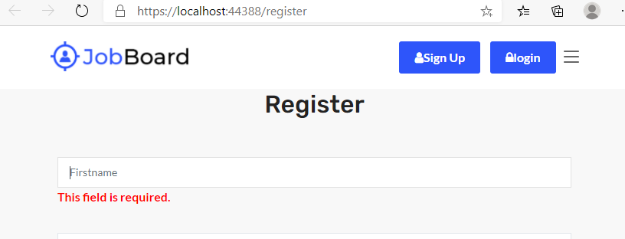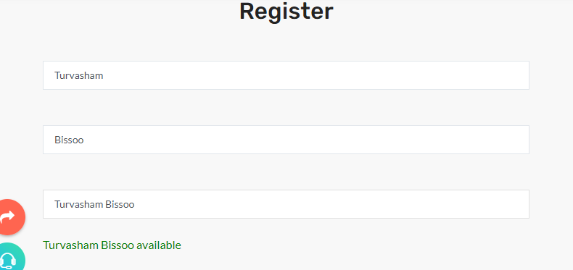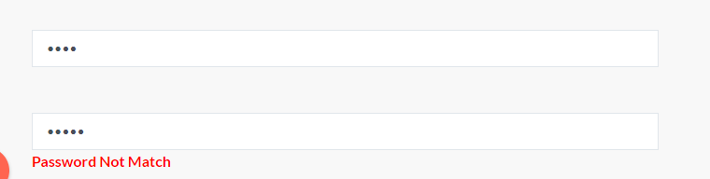 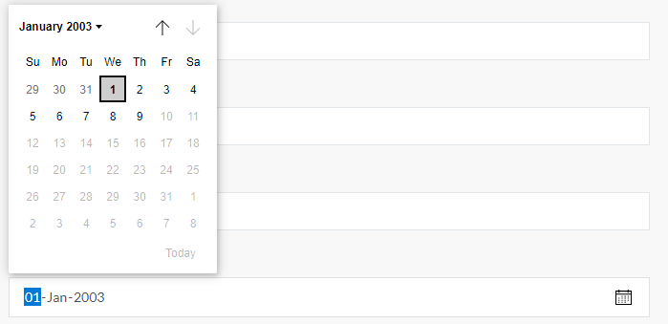

### Welcome user

You are now welcome with a different navbar and interfaces.

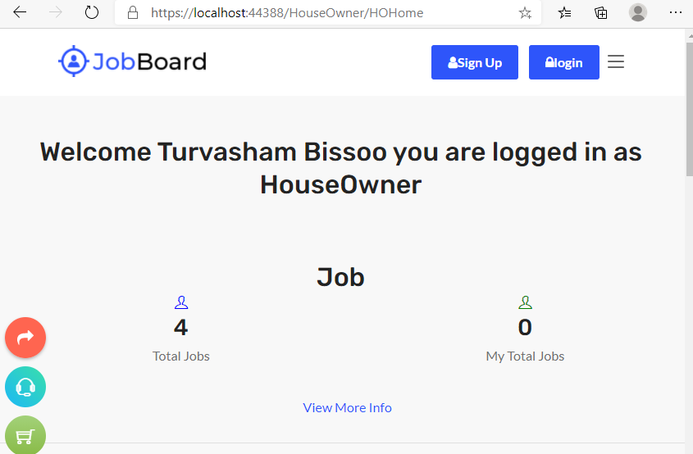You can now perform crud ops on job, and edit your profile

### View Profile

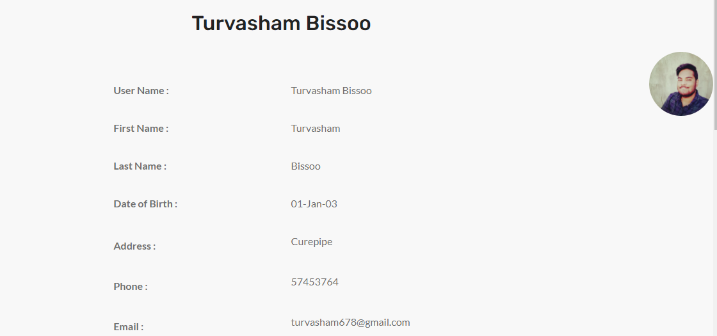 

This page allow you to add new certifications (for HK), delete them, and update the profile

### Updating the profile

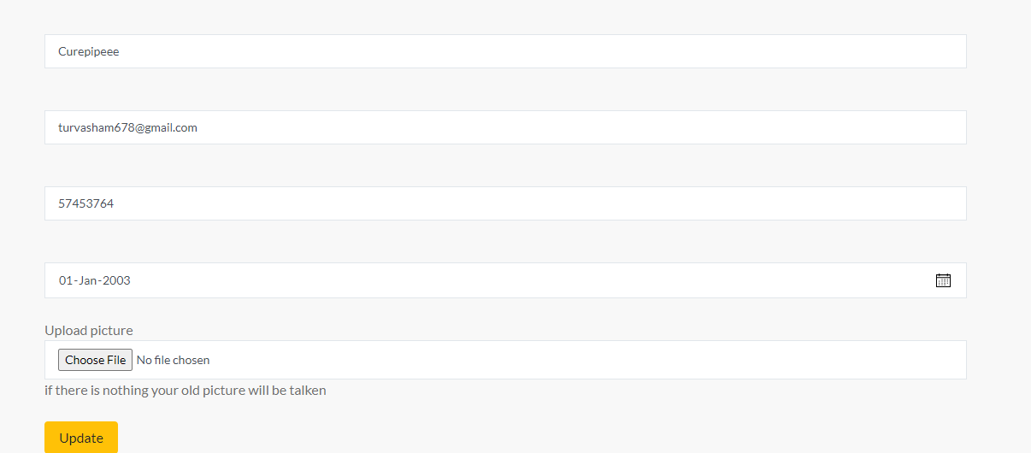

The page register and update profile contain both server and client side validation

### Adding a course



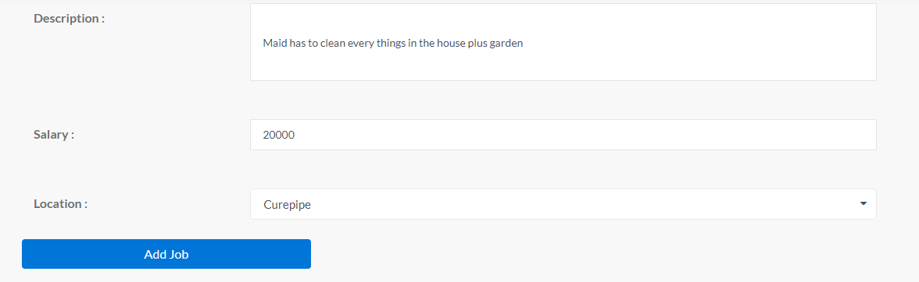

The validations on this page are:

Job title > 3 character

at least 1 category

date > today

files sizes

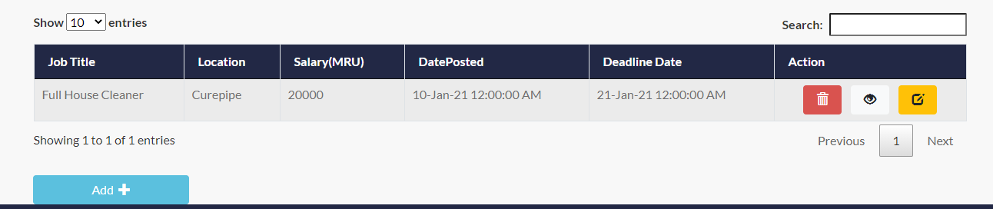

the eye stands for viewing the job

### View job Created

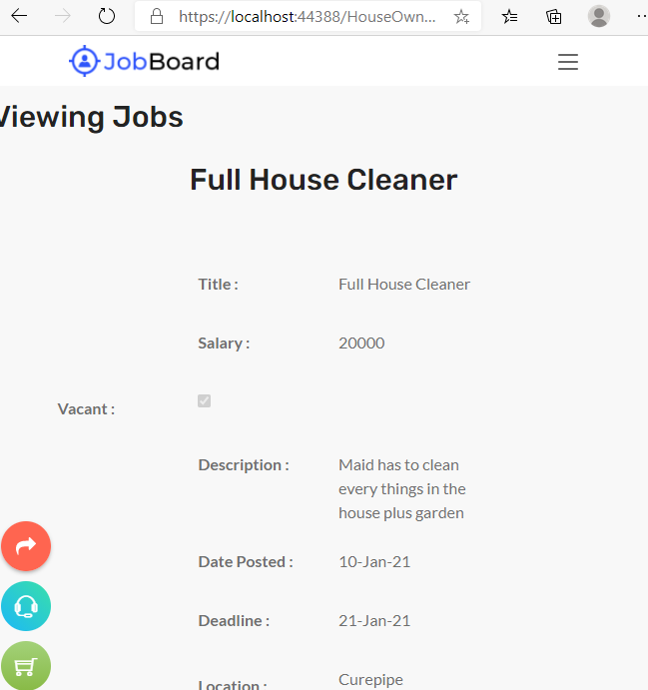 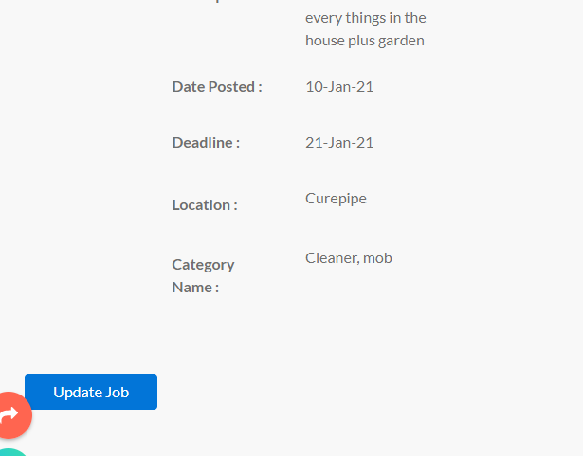

### Update job

This page contains same validations on the create job

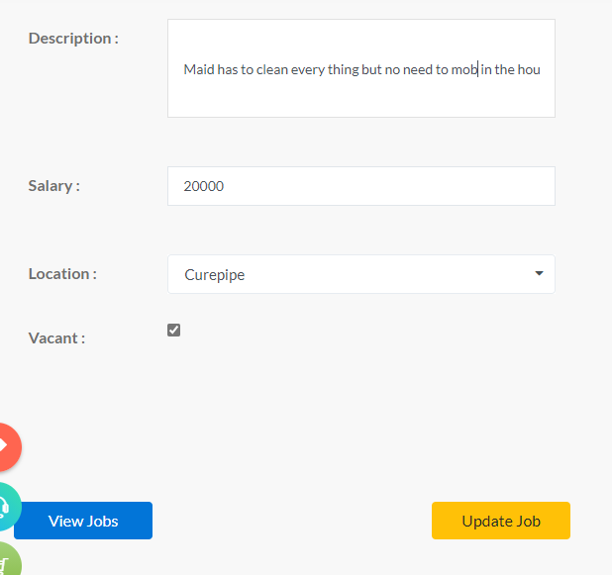

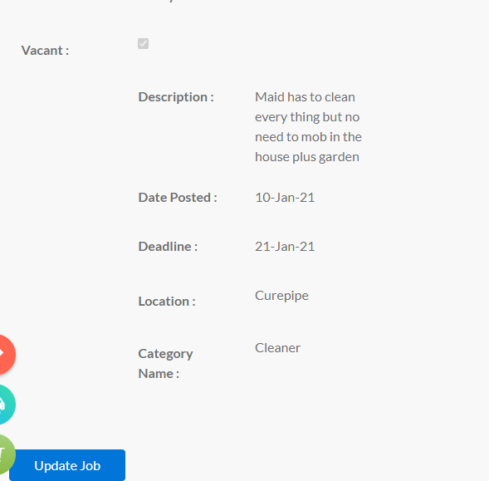

### My HouseKeeper

Can view all HKS in all my jobs the second part is for a specific job

From here you can view the profile of the HK and rate them

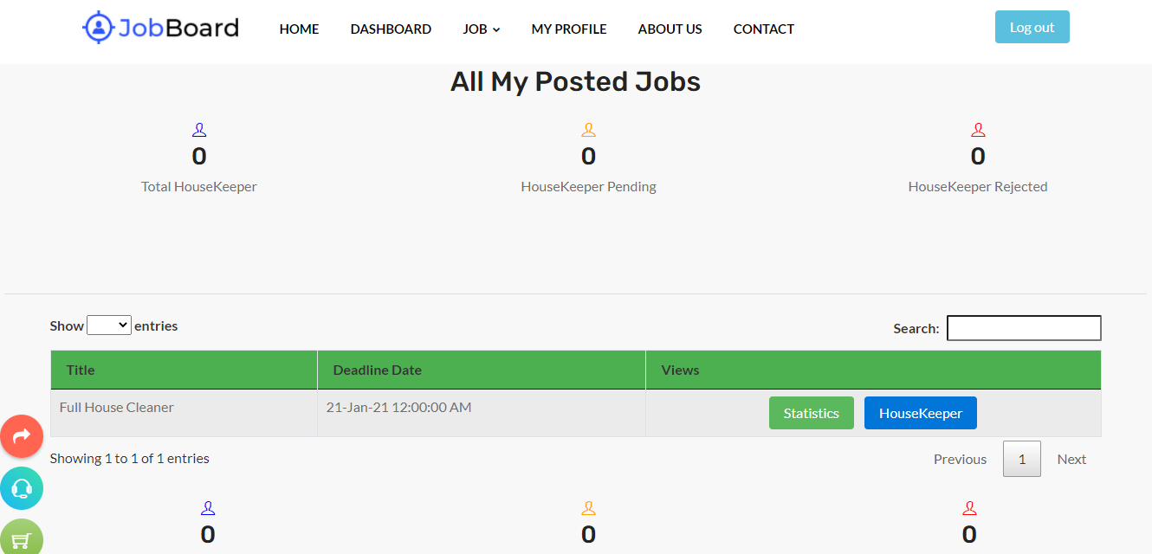

## HouseKeeper

The register will be same as for the houseowner apart from the certification (cert part is present here)

### Welcome

### 

### Search job/Category

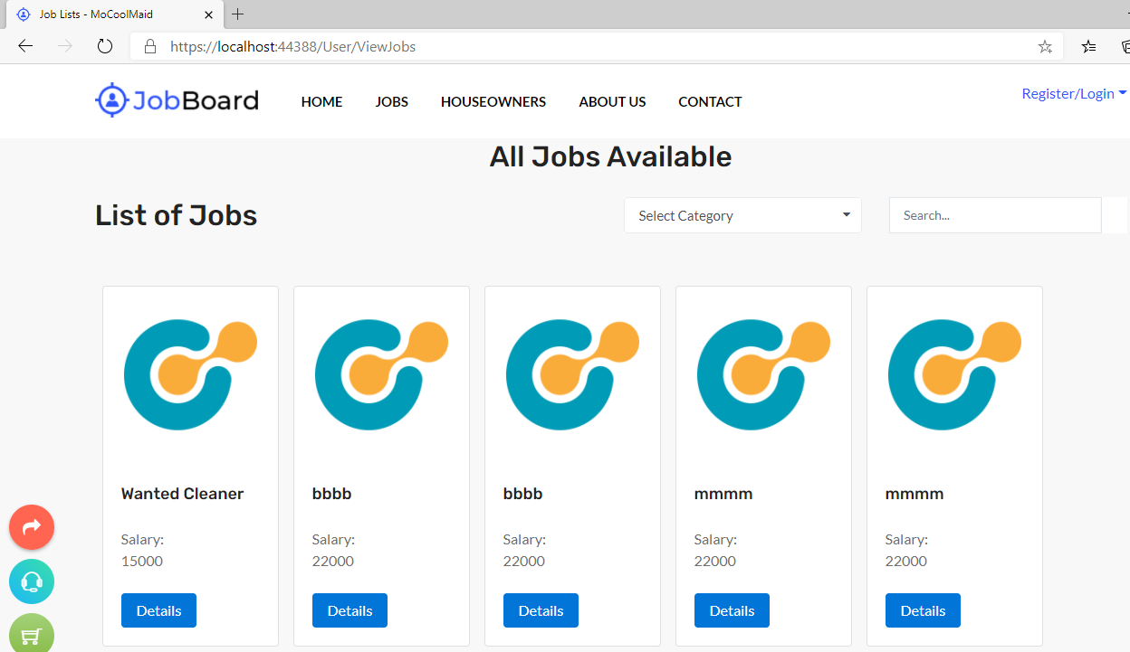

View Job Details

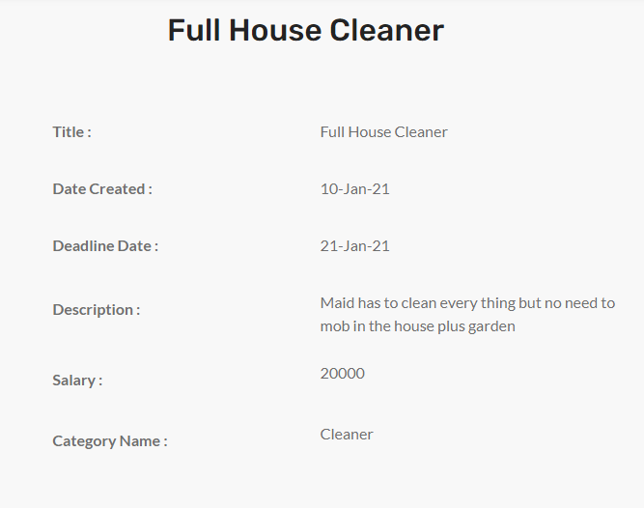

### Application goes into Pending state

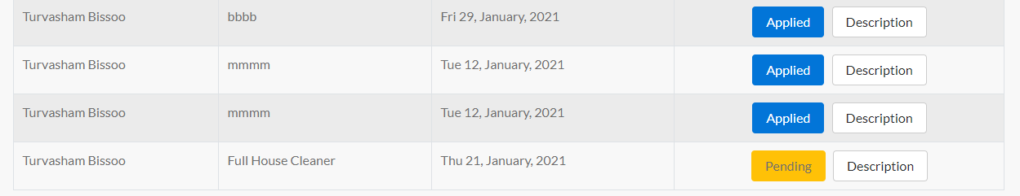This is instantaneous as you click it send a mail and become pending

#### HouseOwner Perspective

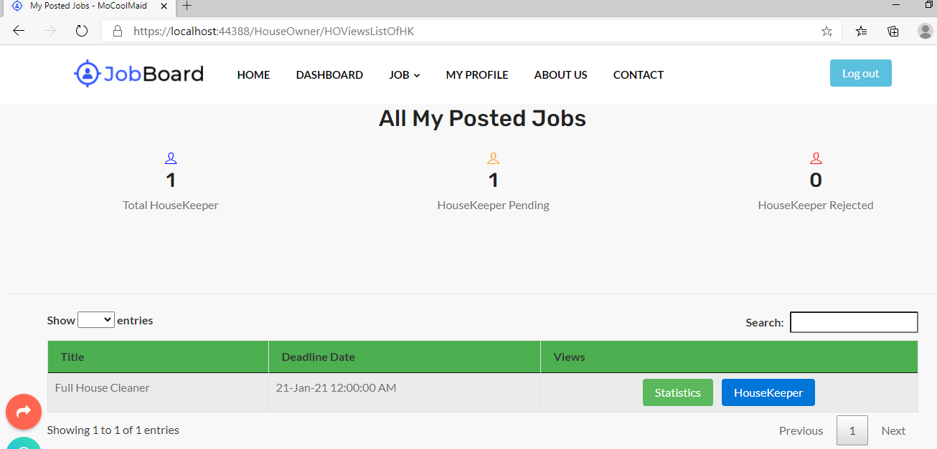 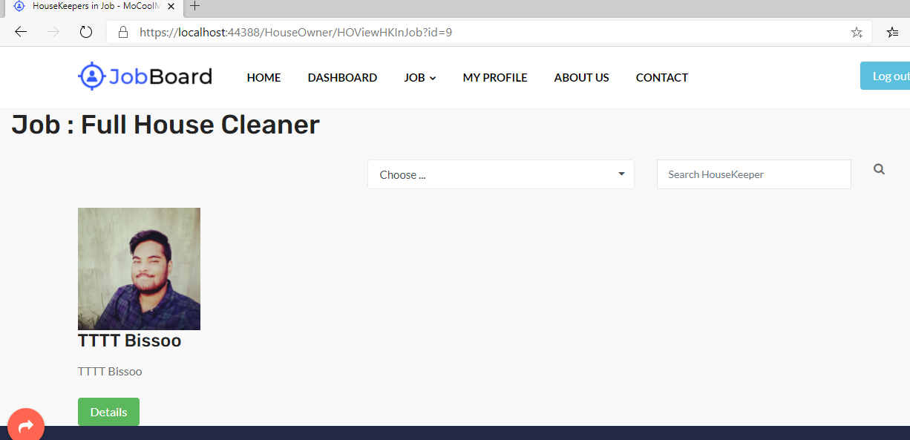

The houseowner can either reject or accept

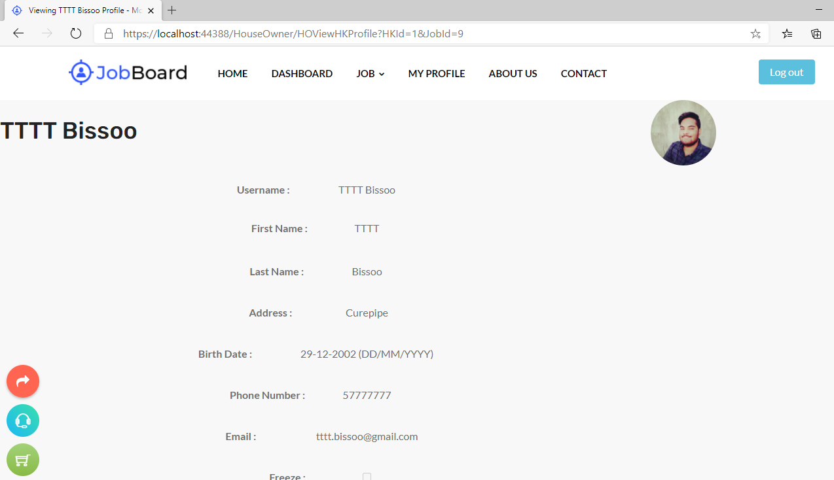

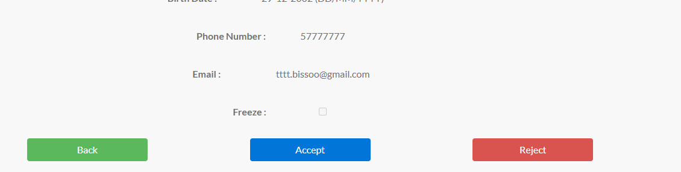

#### Back to HouseKeeper perspective

 

### View/Update Profile

same as for houseowner except that there is certificate

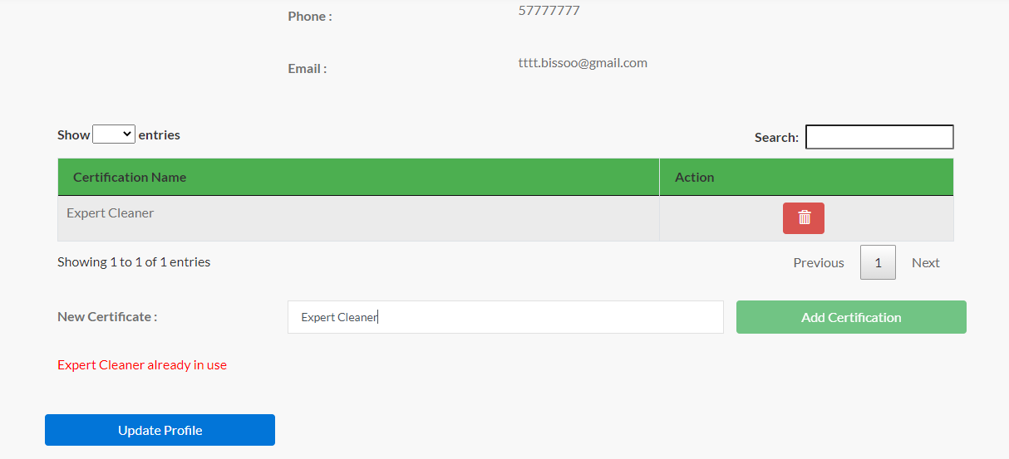

## Ordinary users/All Users

### Home

see some jobs

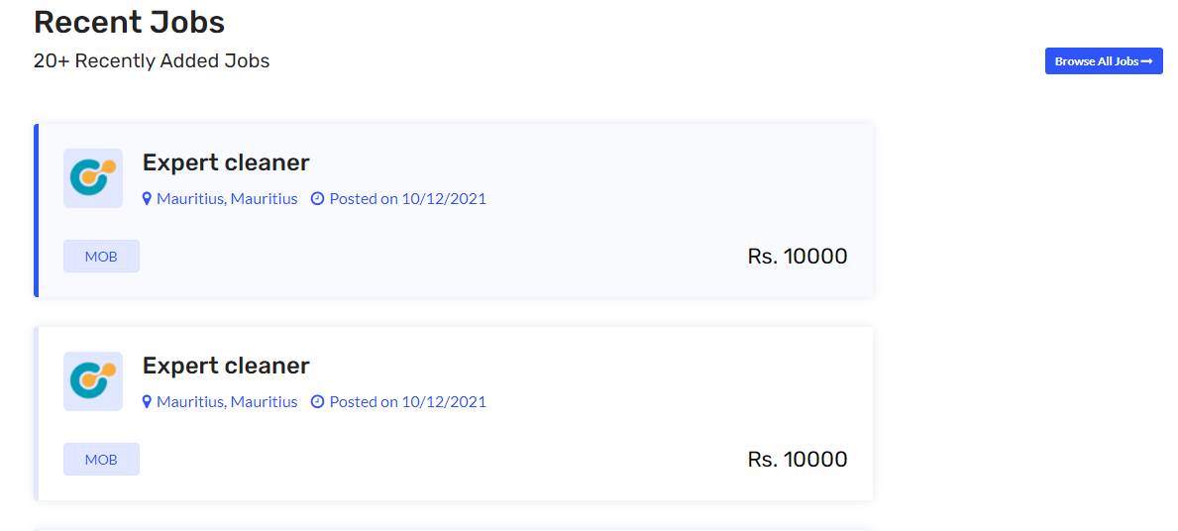

### See jobs

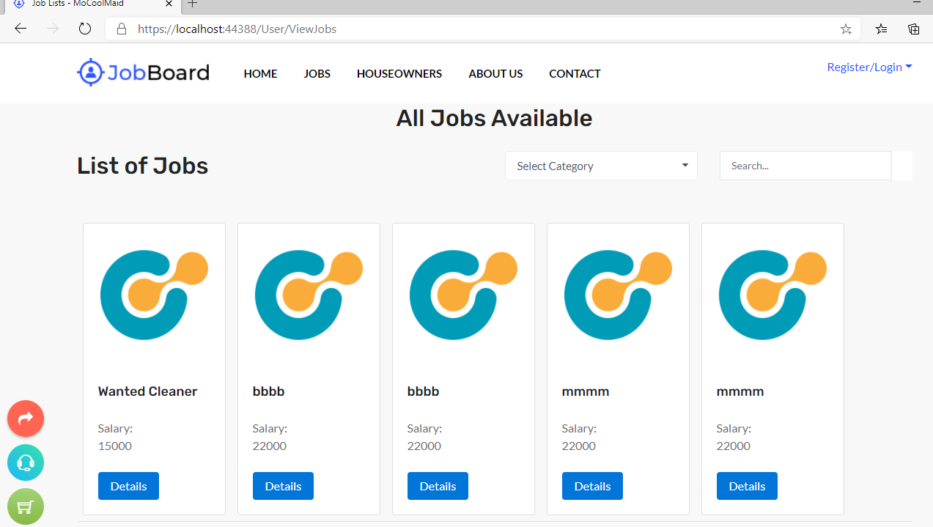

### See houseowners

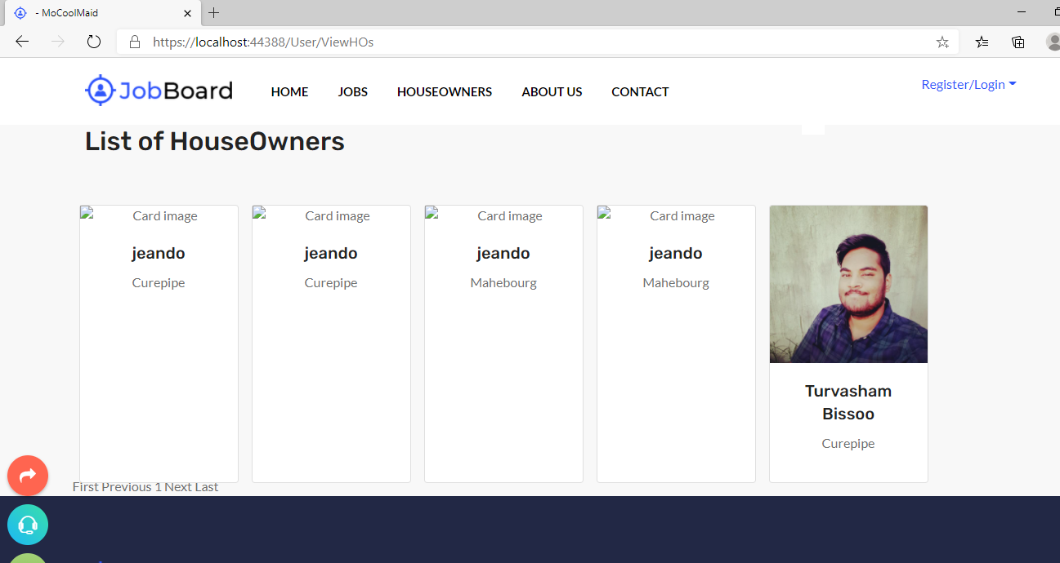

# Special strength

sql—Stored procedures, sql injection prevention, type table, multiple insert at once in stored procedure, data tables to fill procedure

asp—use of ajax, live update on keyup using webservice and ajax and json, jquery validation plugin for all validation client side, encryption, decryption, create controls at runtime(Location and category), send mail, cookies, session, statistics, modal popup, file size validation

**Erd** - additional sql are found in HOHKDB.sql – was used for testing

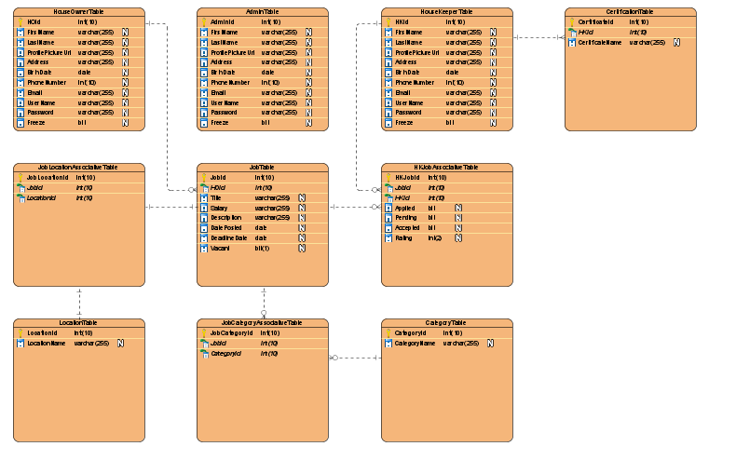 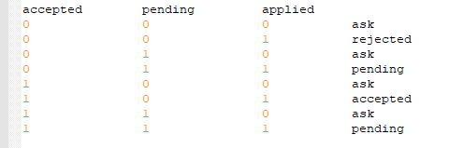

# Additional functionalities

* 1. open checkme.docx