**Module Name: Internet Programming II**

**Module Code: WAT2117C**

**Cohort: BCNS/ 19A/ FT**

**Student Name: Arouven POOLIAN**

**Student ID: 1903_16737**

Table of Contents

How the application run 1

Admin 1

Admin Login 1

Admin Dashboard 2

Search Student 4

Freeze/unfreeze, delete, reset password 5

The same applies to tutors. 5

Crud course category 6

Crud MaterialType 8

Tutor 9

Register a tutor 9

Welcome user 10

View Profile 11

Adding new certification 12

Updating the profile 13

Adding a course 14

View Course Created 16

Update course 17

My Student 18

My Events 19

Adding New Event 19

After Adding Event 20

Student 21

Welcome 21

Search course/Category 22

Subscribe goes into Pending state 23

Tutor Perspective 23

Back to student perspective 25

Student view Events 26

View/Update Profile 26

Ordinary users/All Users 27

Home 27

See Courses 28

See Tutors 28

Special strength 29

Additional functionalities 31

# How the application run

first of all for the admin the dbmanager should manually input the credentials.

## Admin

### Admin Login

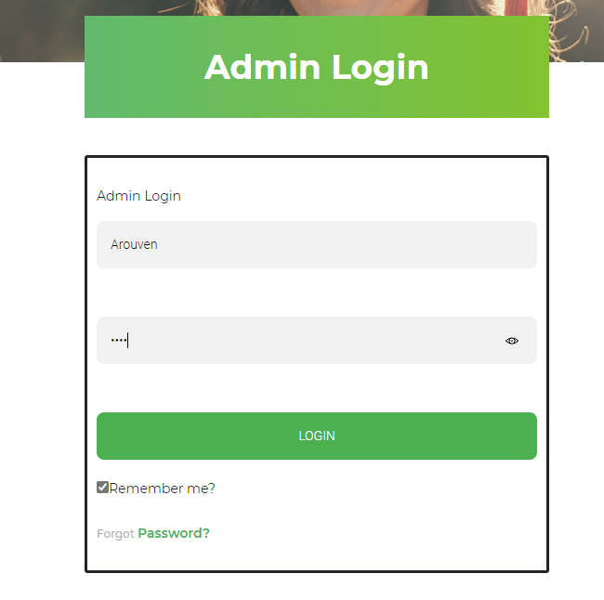

In the login if the remember me checked, the use of cookies will keep the username and password for 100 days

### Admin Dashboard

After successful login, the admin will be redirect to the dashboard where he/she will be greet. And the navbar will change dynamically according to the user role.



On this page he/she will be able to see statistics as well

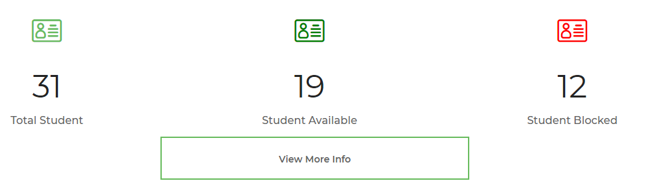

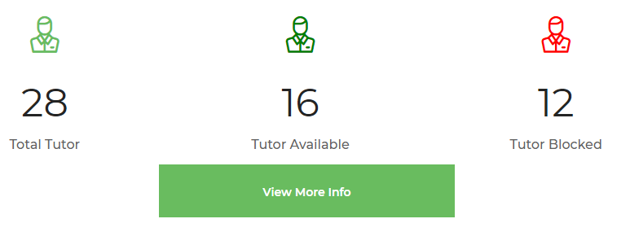







### Search Student

By clicking on the student section view more button or navbar users students, the admin can perform advance search as per freeze or unfreeze, or by typing the name.

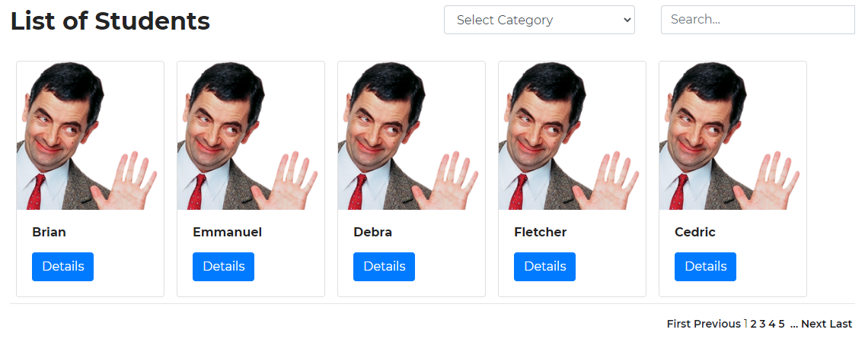

### Freeze/unfreeze, delete, reset password

To perform operations such as freeze/unfreeze, delete or reset password the details button is clicked.

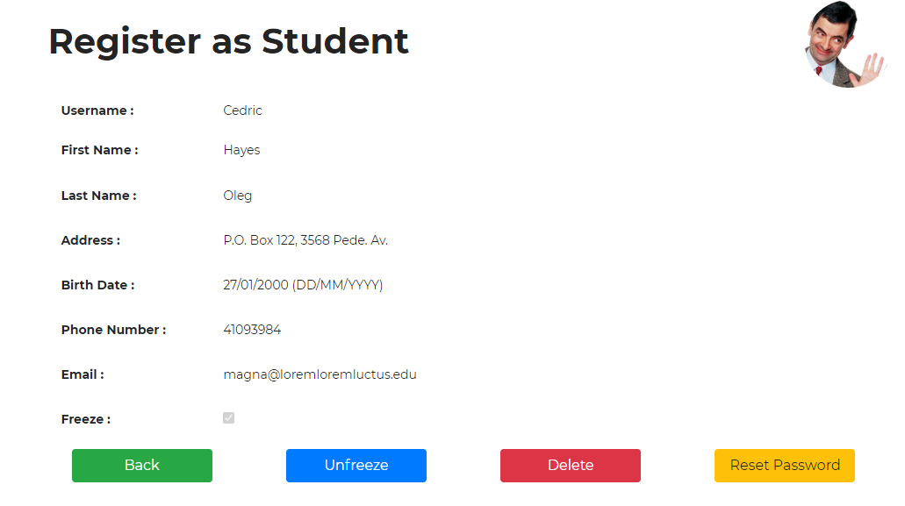

## The same applies to tutors.

### Crud course category

The admin can add update delete any course category

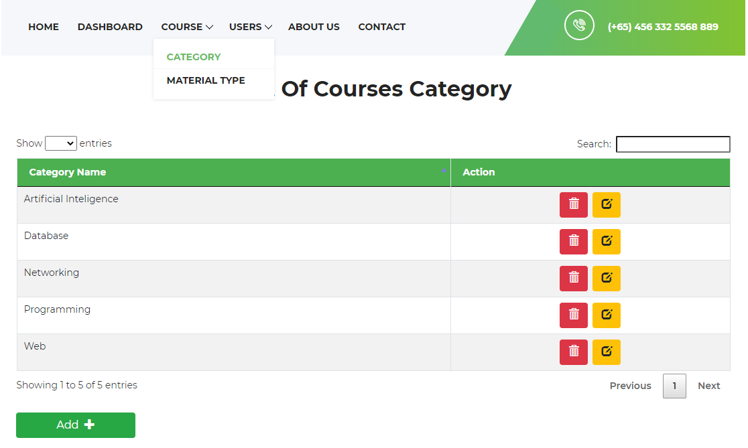

An additional feature would be the use of webservice and ajax to give the message

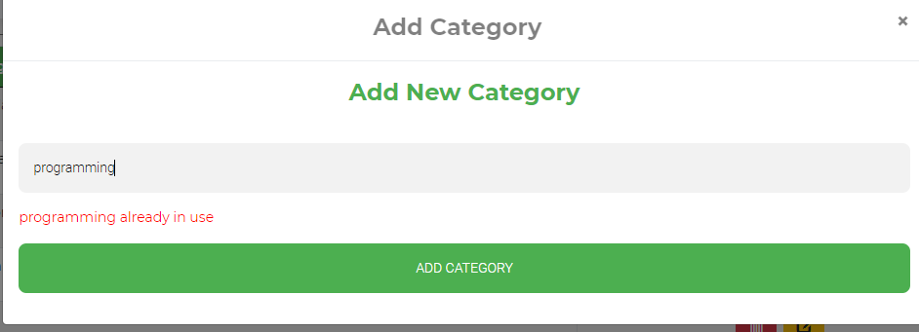

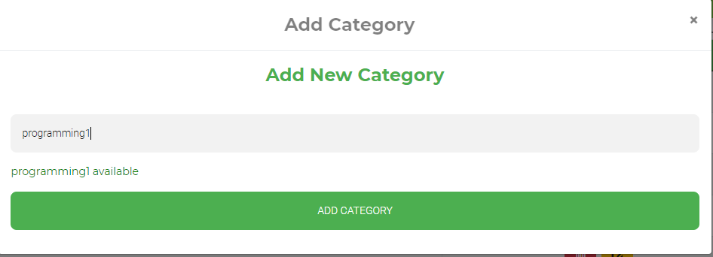The same message applies for update.

And for delete its the trash icon

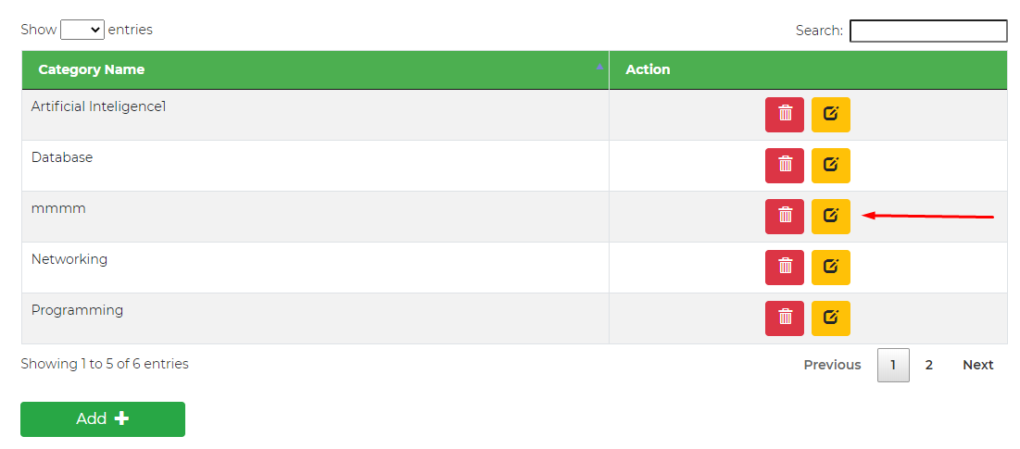

### Crud MaterialType

The admin can also perform crud operation on the materialtype too(same format as course category)

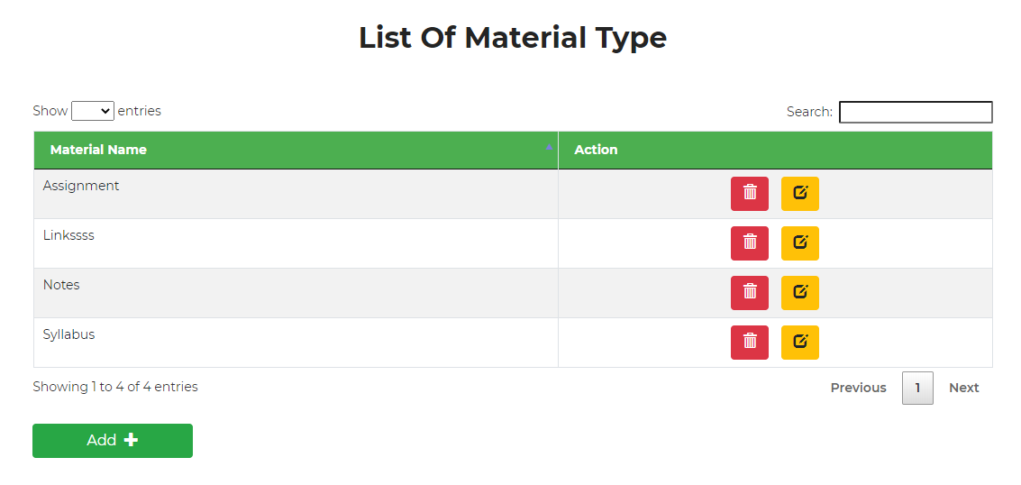

## Tutor

### Register a tutor

As soon as you click the radio tutor you will have to insert your certification to proceed which will appear as you click.

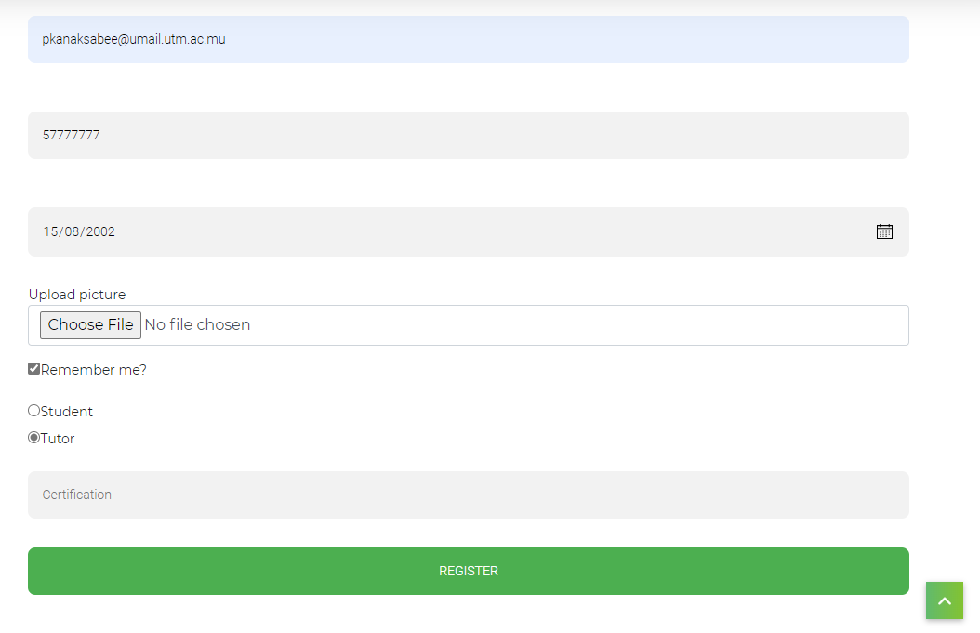

### Welcome user

You are now welcome with a different navbar and interfaces.

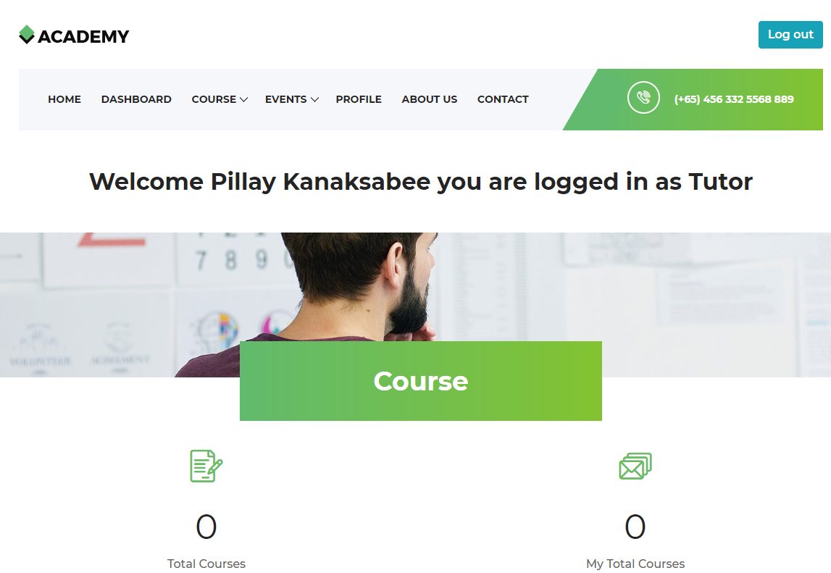You can now perform crud ops on course, and event and edit your profile

### View Profile

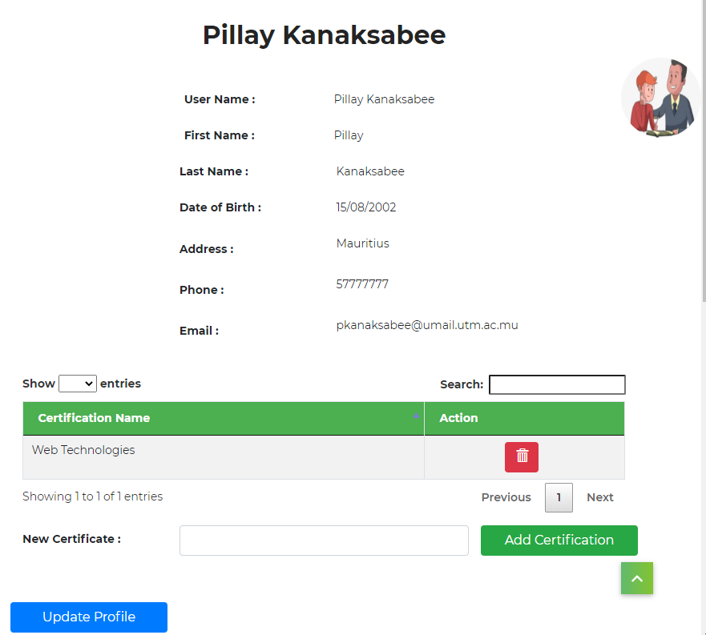

This page allow you to add new certifications, delete them, and update the profile

#### Adding new certification

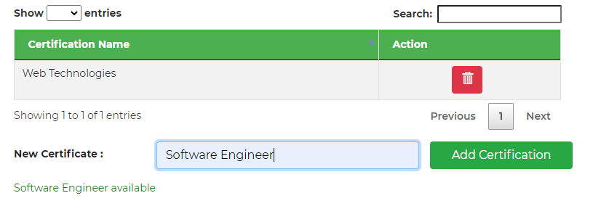

As you click on add certification button, it is added and updated

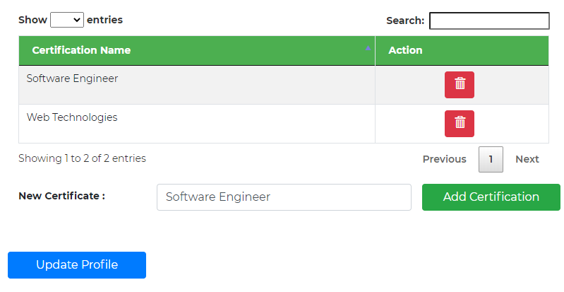

### Updating the profile

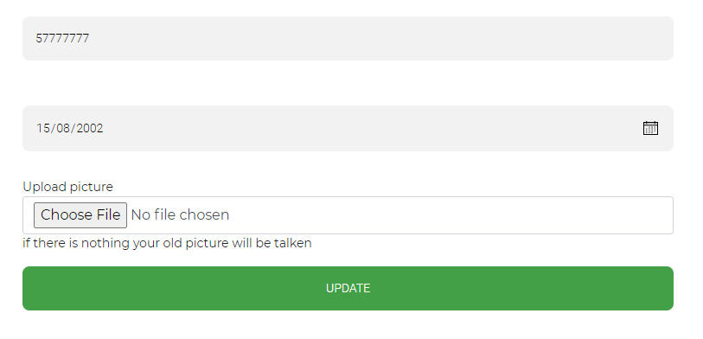

The page register and update profile contain both server and client side validation

### Adding a course



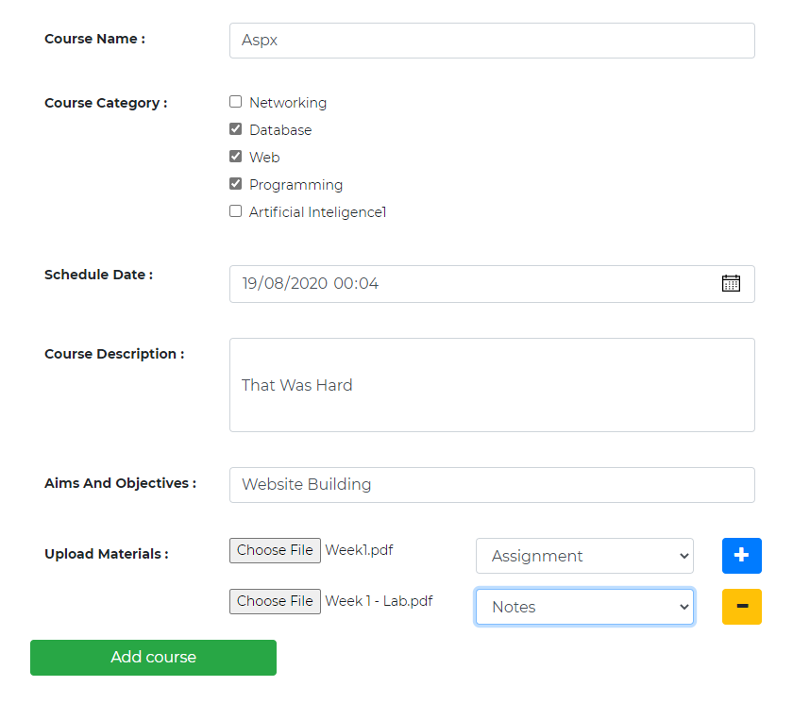

The validations on this page are:

course name > 3 character

at least 1 category

date > today

files sizes



the eye stands for viewing the course

### View Course Created

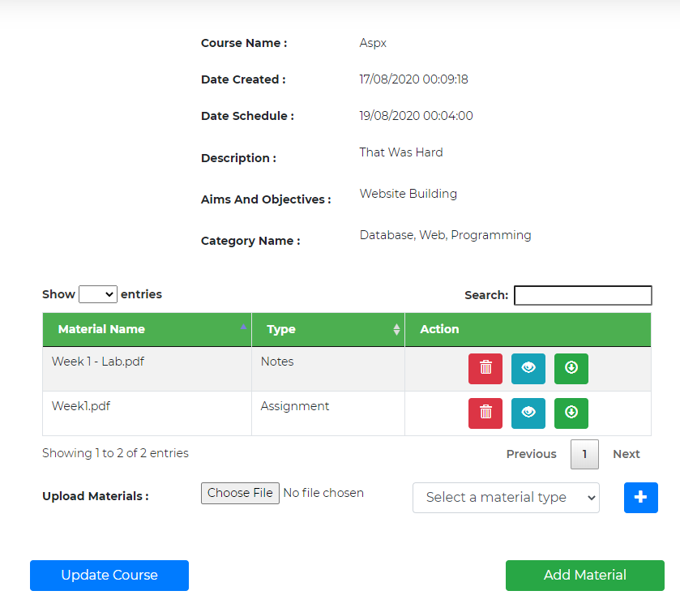

### Update course

This page contain same validations on the create course

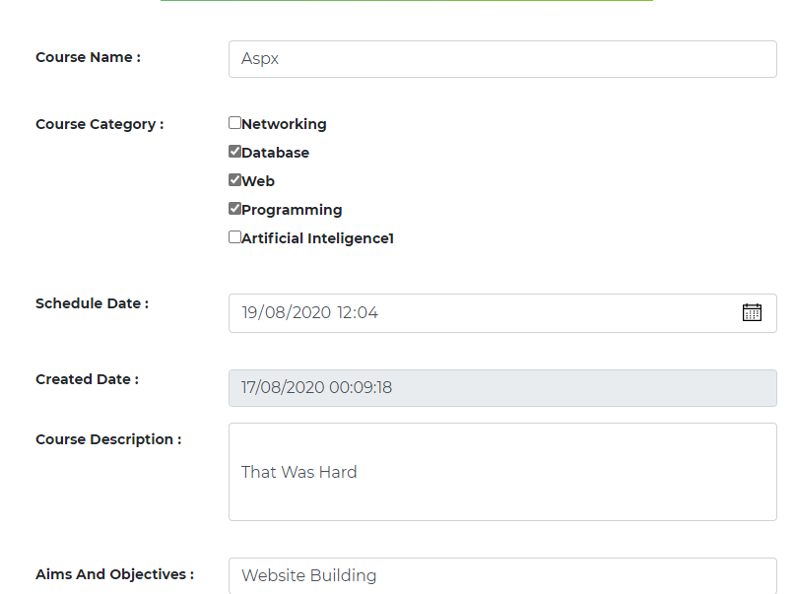

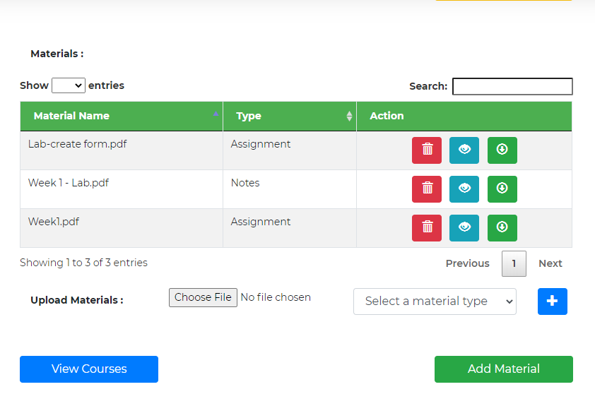

### My Student

Can view all students in all my courses the second part is for a specific course

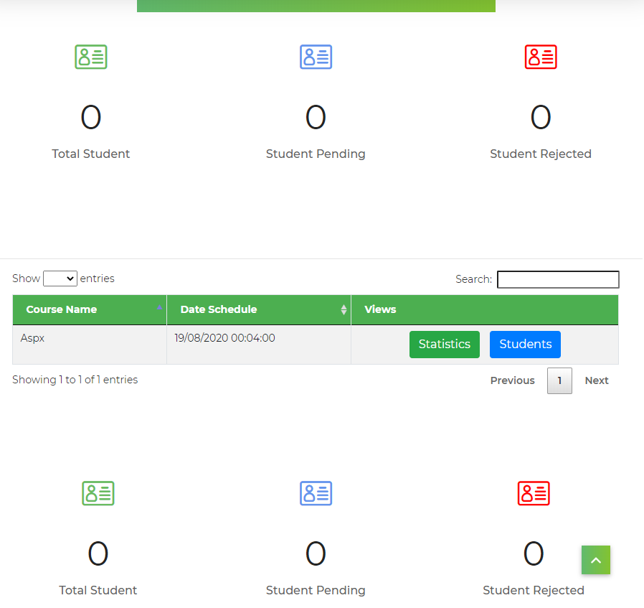

### My Events

Show all events created by the tutor

### Adding New Event

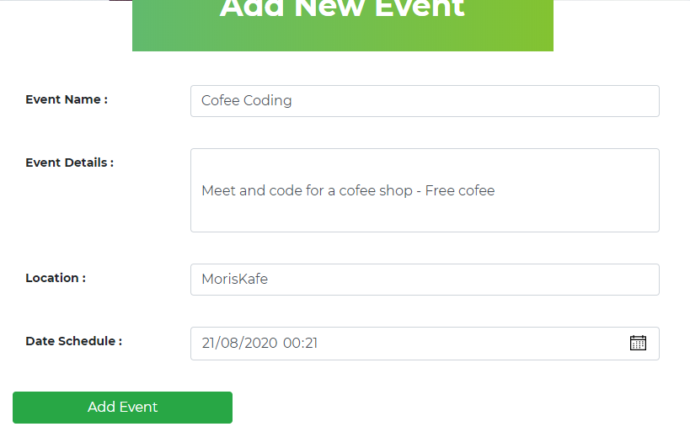

### After Adding Event

Print button will allow the tutor to print all events (if require to show supervisor)

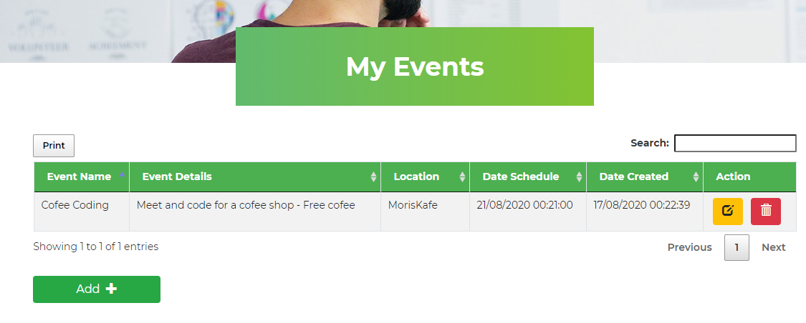more tutors with credential:

Pillay Kanaksabee – 1234

Ajit Gopee - 1234

Tse Dudley-1234

## Student

The register will be same as for the tutor apart from the certification

lavish saulick-1234

Harikeish Fowdur-1234

Pascal Stlouis-1234

### Welcome

### 

### Search course/Category

No access to material unless the tutor accept the students

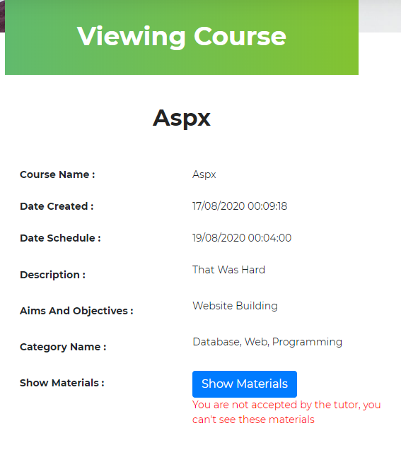

### Subscribe goes into Pending state

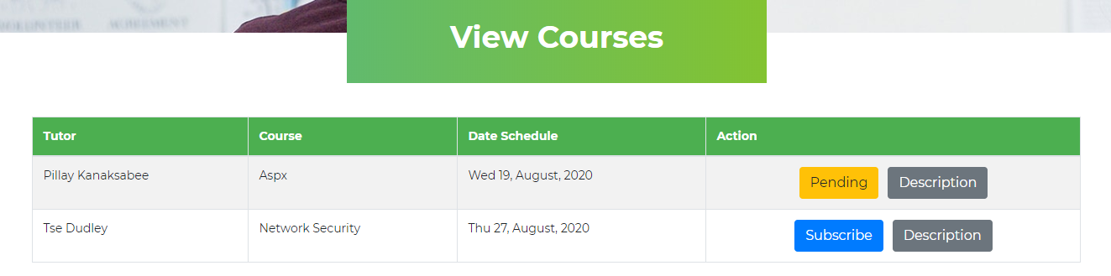This is instantaneous as you click it send a mail and become pending

#### Tutor Perspective

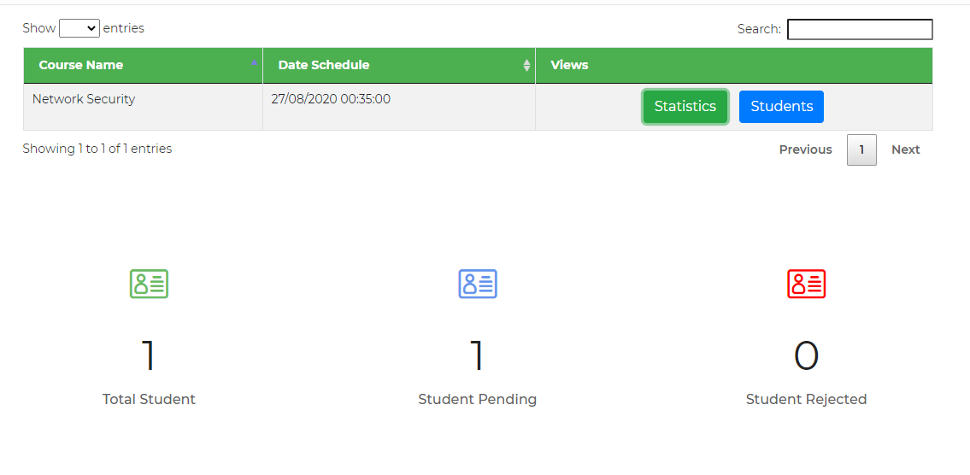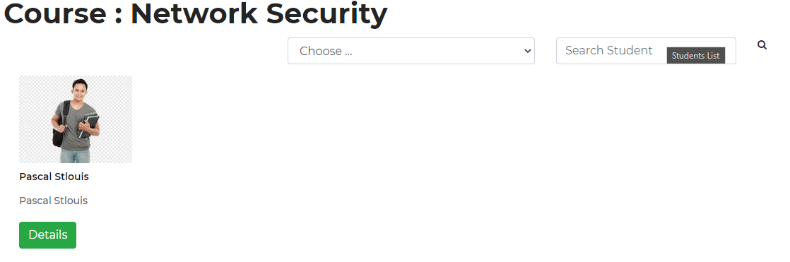

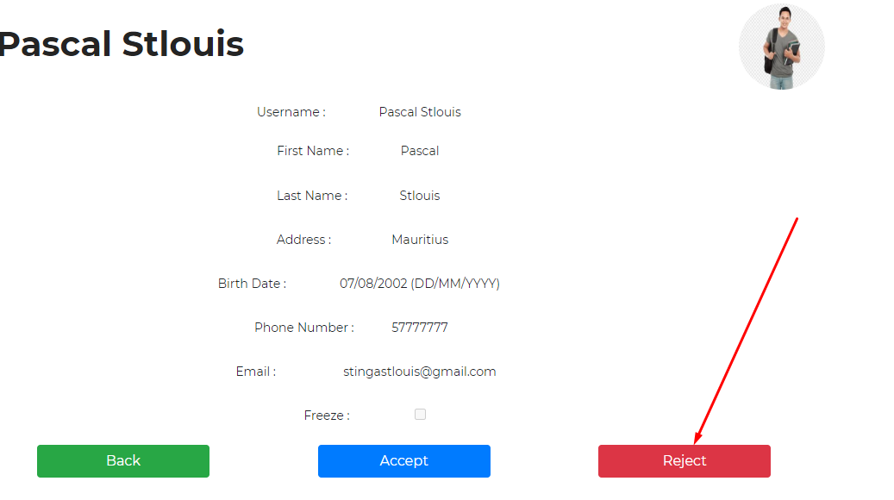Dudley reject

While pillay accept

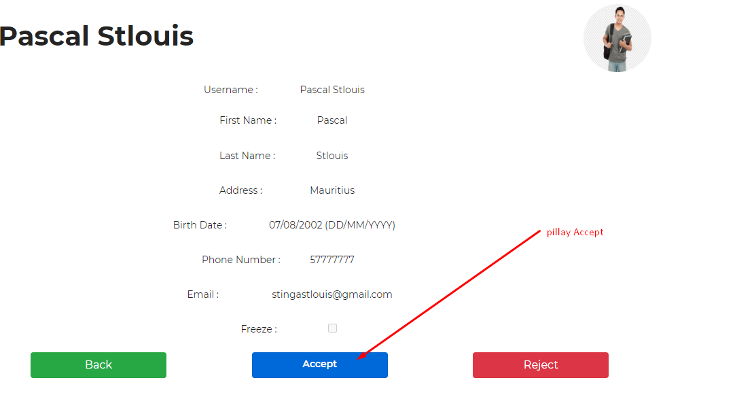

#### Back to student perspective

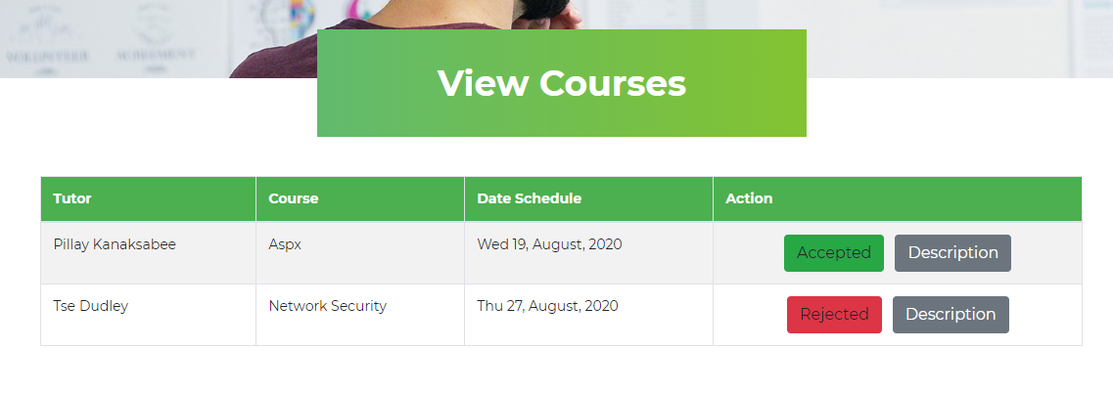Now the student can view the materials

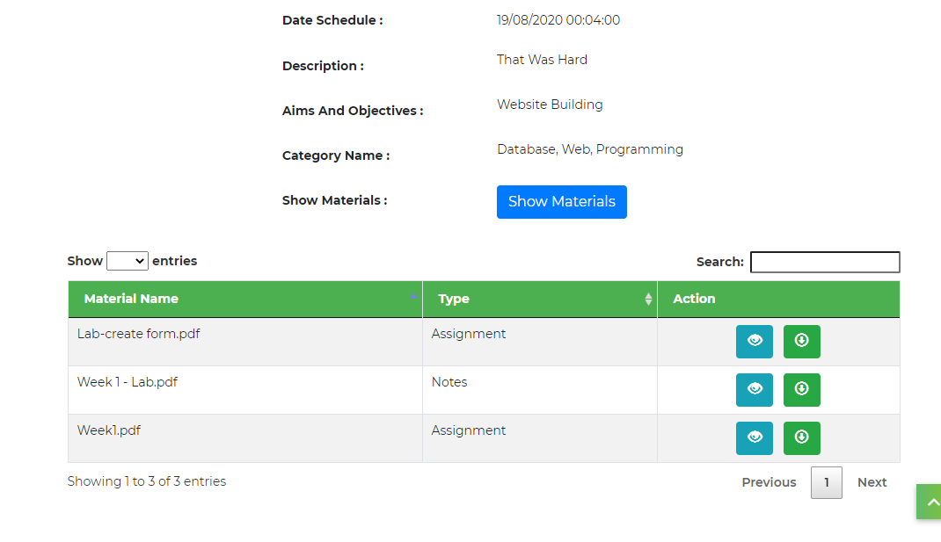

### Student view Events

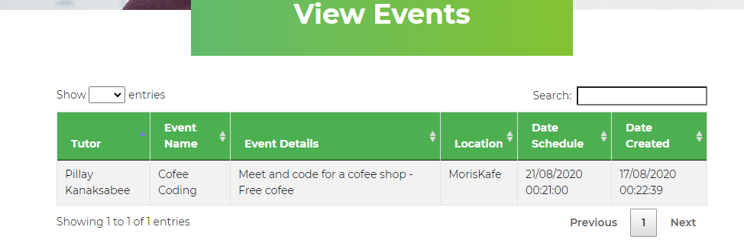

### View/Update Profile

same as for tutor

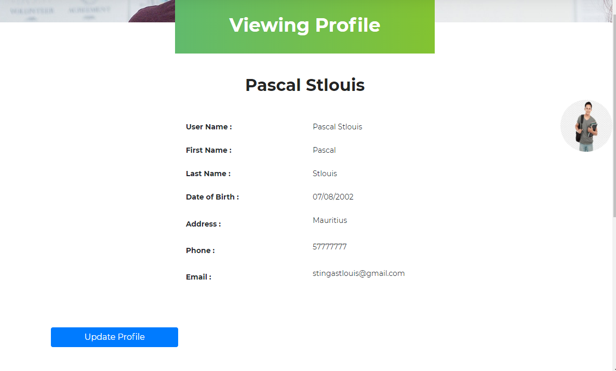

## Ordinary users/All Users

### Home

see some stats



### See Courses



### See Tutors



# Special strength

sql—Stored procedures, sql injection prevention, type table, multiple insert at once in stored procedure, data tables to fill procedure

asp—use of ajax, live update on keyup using webservice and ajax and json, jquery validation plugin for all validation client side, encryption, decryption, download using httphandler .ashx, openfile in new tab, gridview-print button, create controls at runtime(material and category), send mail, cookies, session, statistics, modal popup,file size validation

**Erd** - additional sql are found in TeacherStudentDB.sql – was used for testing

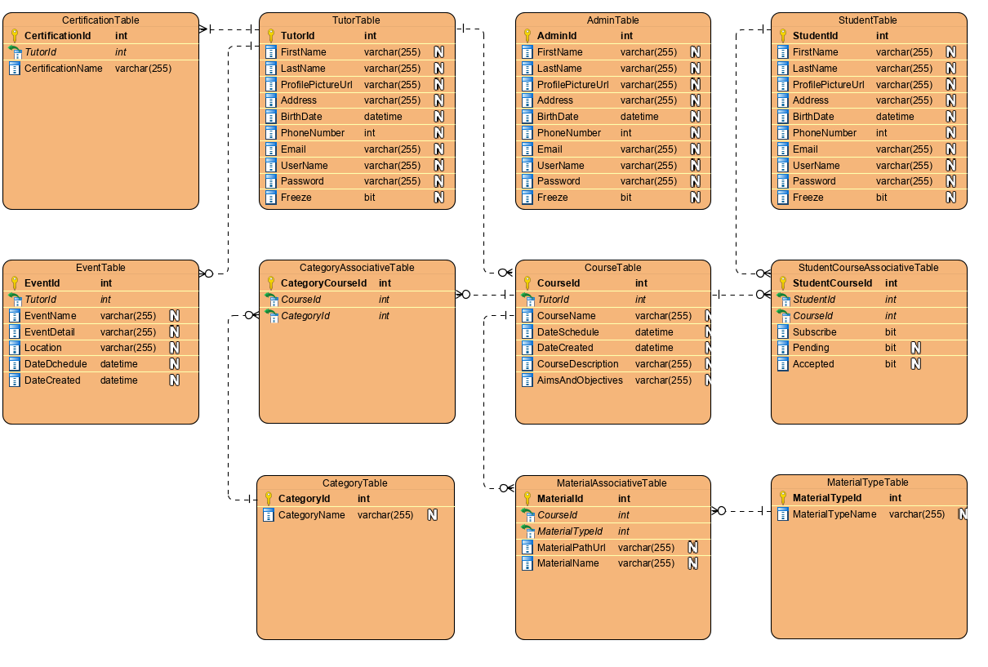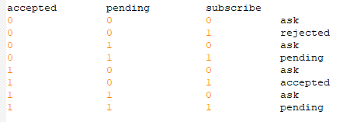

# Additional functionalities

* 1. Real-time check if already exist when Admin adds/updates course

AdminCRUDCourseCategory

* 1. Admin view Tutor/Student details

AdminCRUDCourseCategory

* 1. Tutor Download using httphandler
  2. Tutor CRUD All His Posted Events
  3. AdminCrudMaterialType