**CR Audit**

***By Arouven POOLIAN***

Table of Contents

Chapter 1: Introduction 1

Chapter 2: Research 2

2.1 Programming languages 2

2.2 Structure of the existing system 2

2.2.1 Overview 2

2.2.2 Flow of the system 3

2.3 Conclusion 4

Chapter 3: Design 6

3.1 Flowchart 6

3.1.1 Key(legend) 6

3.1.2 Flowchart Highlight.py 7

3.2 Designing the Excel file 12

3.2.1 Instructions Sheet 12

3.2.2 Example Sheet 13

Chapter 4: Testing 14

4.1 Receive mail testing 14

4.2 Excel Testing 15

4.2.1 Interesting Sheet 16

4.3 Error Testing 17

Chapter 5: Improvements 18

Chapter 6: Appendix 19

6.1 Annex 1: audit-reseau.pl (Before Highlight.py) 19

6.2 Annex 2: CR (Before Highlight.py) 21

6.3 Annex 3: Highlight.py (Final) 24

6.4 Annex 4: CR (Remove first 2 lines and last line) 26

6.5 Annex 5: CR (Remove "<br><b>Backup CKP</b><br><br>") 29

6.6 Annex 6: CR (Remove "<br><b>Backup BIGIP</b><br><br>") 32

6.7 Annex 7: CR (Remove all <br>) 35

6.8 Annex 8: audit-reseau.pl(Final) 38

Table of figures

[Figure 1: Weekly CR Audit mail 1](https://linkbynet365-my.sharepoint.com/personal/ar_poolian_linkbynet_com/Documents/Document.docx#_Toc58509205)

[Figure 2: Clients sending backups to LBN-RIS-WIKI-01 2](https://linkbynet365-my.sharepoint.com/personal/ar_poolian_linkbynet_com/Documents/Document.docx#_Toc58509206)

[Figure 3: crontab of LBN-RIS-WIKI-01 3](https://linkbynet365-my.sharepoint.com/personal/ar_poolian_linkbynet_com/Documents/Document.docx#_Toc58509207)

[Figure 4: Adding Highlight.py in the existing system 5](https://linkbynet365-my.sharepoint.com/personal/ar_poolian_linkbynet_com/Documents/Document.docx#_Toc58509208)

[Figure 5: Symbols used in flowchart 6](https://linkbynet365-my.sharepoint.com/personal/ar_poolian_linkbynet_com/Documents/Document.docx#_Toc58509209)

[Figure 6: Flowchart Highlight.py (part I) 7](https://linkbynet365-my.sharepoint.com/personal/ar_poolian_linkbynet_com/Documents/Document.docx#_Toc58509210)

[Figure 7: Flowchart Highlight.py (part II) 8](https://linkbynet365-my.sharepoint.com/personal/ar_poolian_linkbynet_com/Documents/Document.docx#_Toc58509211)

[Figure 8: Flowchart Highlight.py (part III) 9](https://linkbynet365-my.sharepoint.com/personal/ar_poolian_linkbynet_com/Documents/Document.docx#_Toc58509212)

[Figure 9: Flowchart for getBackUp() 10](https://linkbynet365-my.sharepoint.com/personal/ar_poolian_linkbynet_com/Documents/Document.docx#_Toc58509213)

[Figure 10: Flowchart for writeToExcel() 11](https://linkbynet365-my.sharepoint.com/personal/ar_poolian_linkbynet_com/Documents/Document.docx#_Toc58509214)

Figure 11: Instructions in AuditReport.xlsx 12

Figure 12: Example Sheet 13

[Figure 13: Received mail 14](https://linkbynet365-my.sharepoint.com/personal/ar_poolian_linkbynet_com/Documents/Document.docx#_Toc58509217)

[Figure 14: AuditReport.xlsx 15](https://linkbynet365-my.sharepoint.com/personal/ar_poolian_linkbynet_com/Documents/Document.docx#_Toc58509218)

Figure 15: Interesting sheet (part I) 16

Figure 16: Interesting sheet (part II) 16

[Figure 17: Error Display in MS Outlook 17](https://linkbynet365-my.sharepoint.com/personal/ar_poolian_linkbynet_com/Documents/Document.docx#_Toc58509221)

[Figure 18: Error Display in Google Chrome https://www.w3schools.com/ 17](https://linkbynet365-my.sharepoint.com/personal/ar_poolian_linkbynet_com/Documents/Document.docx#_Toc58509222)

# Introduction

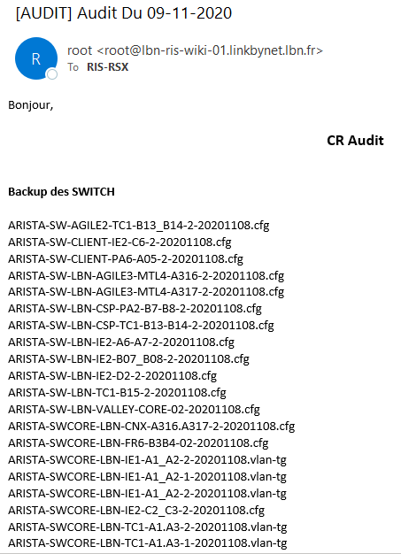Figure 1 shows a picture of the mail received every Monday. The network admin/ engineer/ manager must verify the date of the last backup performed and retrieve the ones that did not back up, which is time-consuming and repetitive. Afterward, investigate why the backups are not being performed and debug.

Figure : Weekly CR Audit mail

On the date that Figure 1 there were: -

* Backup des SWITCH = 89
* Backup CKP = 28
* Backup BIGIP = 37

According to research workers that do repetitive jobs or specialized are: -

* No socializing opportunities
* Loses overall sight
* Gets boring
* The company suffers, etc.…

The benefit of automating those tasks will be: -

* Reduce errors
* Less time consuming
* 1 script works faster than 1 person
* Reduce Risk of human errors and more reliable
* Motivate the workers to learn new tasks
* Ease the workers’ life
* Company evolves

The best way of performing the 1st task (The network admin/ engineer/ manager must verify the date of the last backup performed and retrieve the ones that did not back up) is by adding an excel file with all listed backups. Then apply the desired filters.

# Research

## Programming languages

Programming languages that can manipulate excel: -

* Java,
* Python,
* VBA,
* esProc SPL,
* vb.net, etc…

Cross-platform programming languages: -

* Python,
* Java,
* C++,
* C#,
* JavaScript, etc.…

Best languages for the job: -

* Python (Selected)
* Java

## Structure of the existing system

### Overview

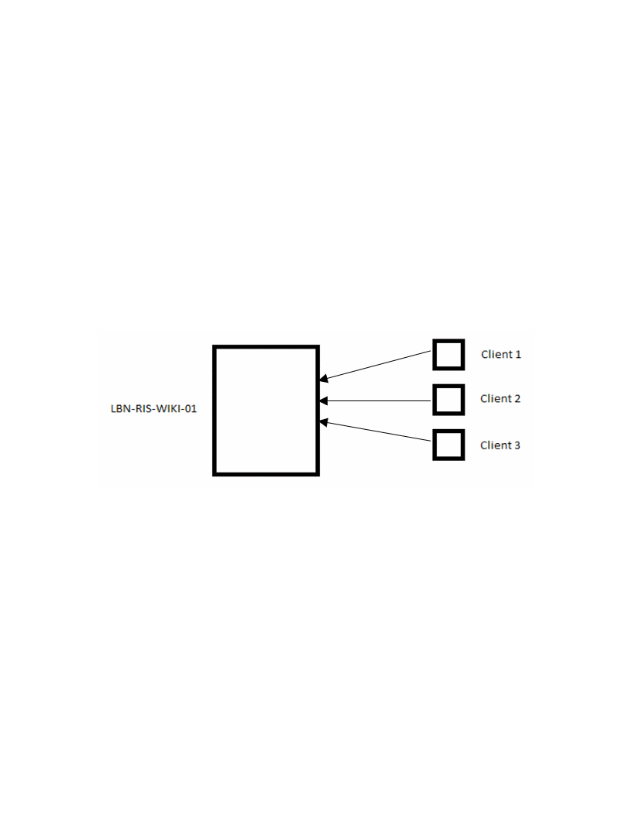

Figure : Clients sending backups to LBN-RIS-WIKI-01

Figure 2 above illustrates how clients’ backups are made and sent to the machine LBN-RIS-WIKI-01.

### Flow of the system

#### Crontab

Figure 3 below shows the crontab (task scheduler) of LBN-RIS-WIKI-01. Our concern is about the “send mail for AUDIT RSX”.

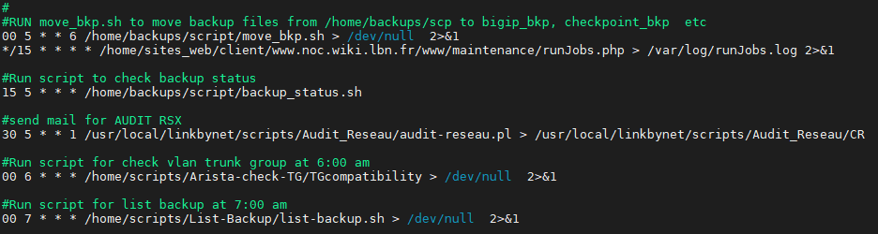The crontab will run the script “audit-reseau.pl” and will send all output from it to the file “CR”. For a better understanding, the script “audit-reseau.pl” must be analyzed.

Figure : crontab of LBN-RIS-WIKI-01

#### audit-reseau.pl

As seen from the Annex 1, the script is outputting a HTML format.

print "Bonjour,<br>\n";

print "<h3 align=center>CR Audit </h3>";

print "<br>";

print "<b> Backup des SWITCH </b><br>";

print "<br>\n";

Get in the following directories: -

$path = "/home/backups/switch_bkp";

$path = "/home/backups/checkpoint_bkp";

$path = "/home/backups/bigip_bkp";

And output their respective latest backup: -

print "$files_latest_hp[$#files_latest_hp]<br>\n";

print "$files_latest_ckp[$#files_latest_ckp]<br>\n";

print "$files_latest_bigip[$#files_latest_bigip]<br>\n";

Followed by the closing: -

print "Bonne journee.<br>";

print "<br>";

print "Cordialement,<br>";

print "Linkbynet <br>";

Then send the mail with a program available in unix system(mutt)

system("/bin/bash /usr/local/linkbynet/scripts/Audit_Reseau/sendmail.sh");

#### sendmail.sh

/usr/bin/mutt -e "set content_type=text/html" admin-rsx@linkbynet.com -s "[AUDIT] Audit Du `/bin/date +%d-%m-%Y`" -i /usr/local/linkbynet/scripts/Audit_Reseau/CR </dev/null

The “sendmail.sh” consist of only one line: -

* -e "set content_type=text/html"
  + -e <command> specify a command to be executed after initialization
  + Specifying that the mail’s type is in text and subtype HTML format
* -i /usr/local/linkbynet/scripts/Audit_Reseau/CR </dev/null
  + -i <file> specify a file which Mutt should include in the body
  + CR is the file to be sent as an HTML body (Annex 2 shows an example of a CR file)
* -s "[AUDIT] Audit Du `/bin/date +%d-%m-%Y`"
  + -s <subj> specify a subject (must be in quotes if it has spaces)
  + The mail subject will be "[AUDIT] Audit Du dd-mm-YYYY"

## Conclusion

|  |  |
| --- | --- |
| **Pseudo code** | **Flowchart** |
| Start   * Lunch crontab task * Run the script “audit-reseau.pl” and output all results in the file CR * Run the script “sendmail.sh” to send the mail   End |  |

The above investigation shows that the best place to extract the backups and put them in an excel file is between “Output the results in CR” and “Process sendmail.sh” as shown in Figure 4 below. In that way, the Highlight.py script will read from “CR” and reduce the impact on the audit-reseau.pl.

As per “CR”, the majority of lines are formatted as “Backup_<Machine’s name>_yyyymmdd(.extension if any)”. There were 21 which did not respect the formatting. The best solution will be following the majority.

Some backups are made each 9 days. Therefore, the best solution will be to highlight the ones that did not backup for the duration of 2 weeks.

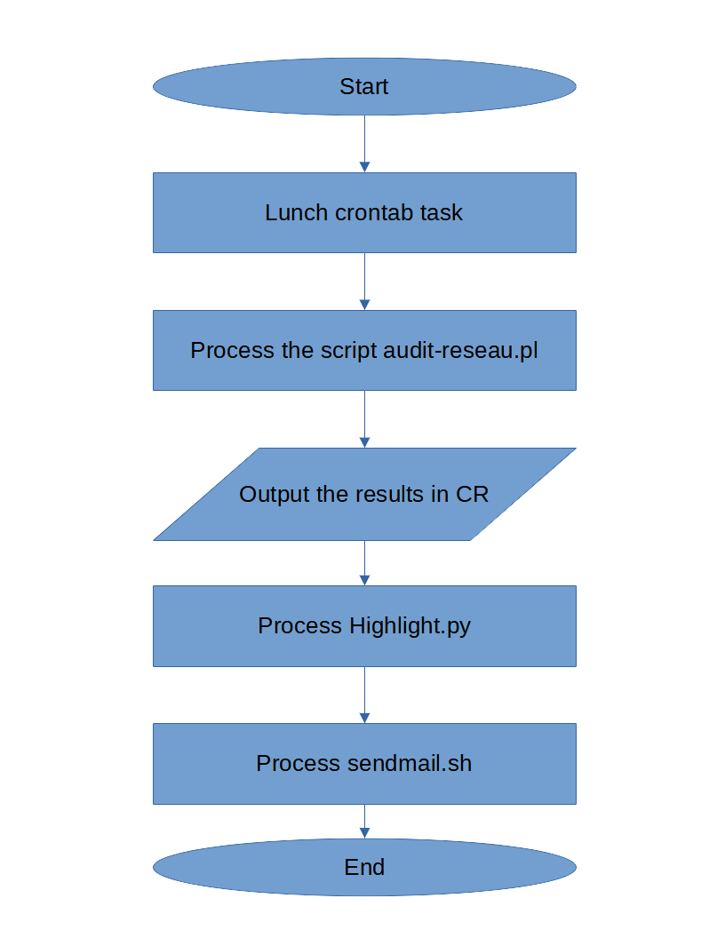

Figure : Adding Highlight.py in the existing system

# Design

## Flowchart

A flowchart will be designed to illustrate clearly the steps performed while programming.

### Key(legend)

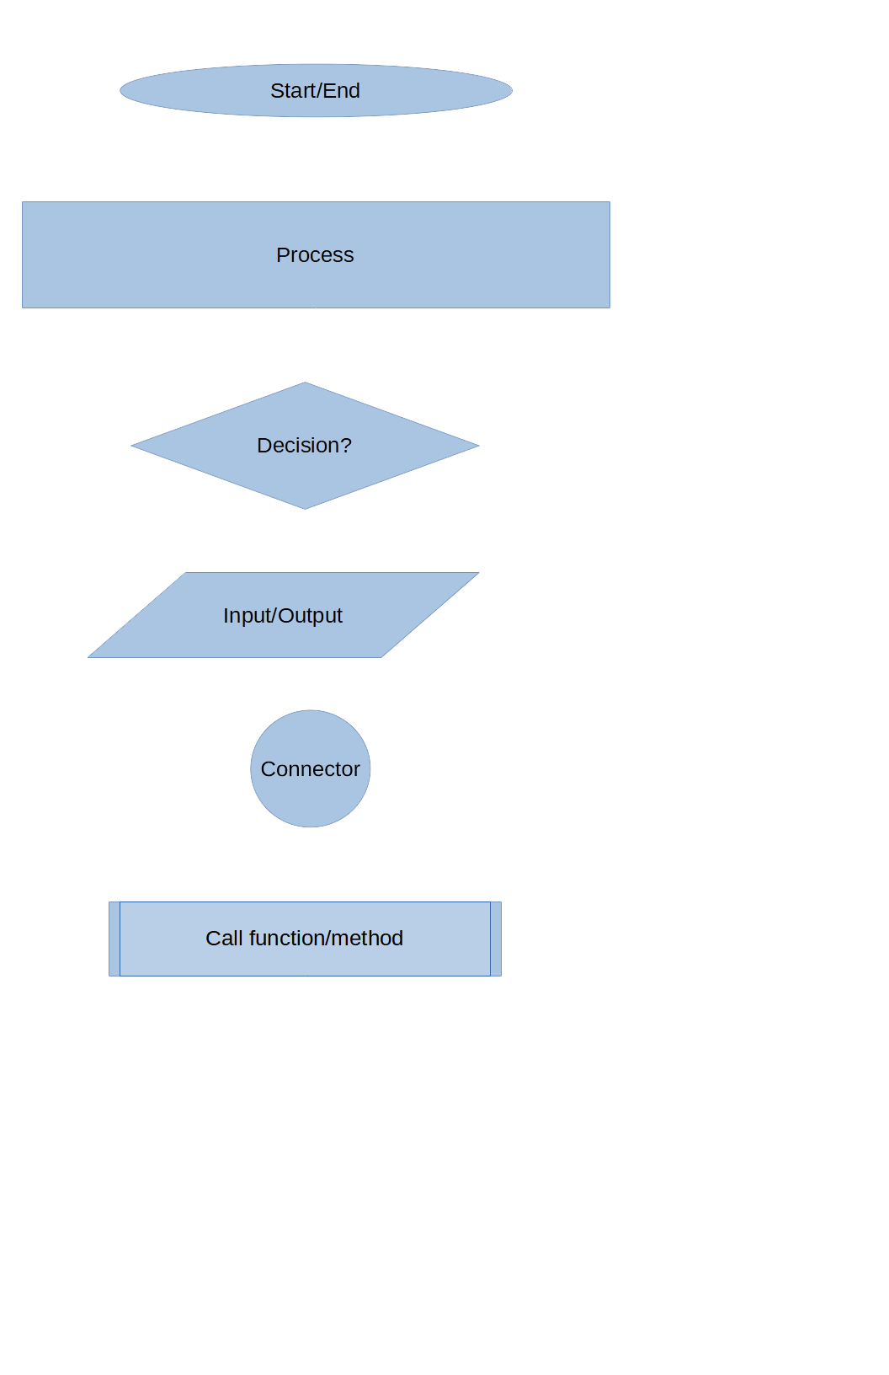

Figure : Symbols used in flowchart

### Flowchart Highlight.py

The flowchart design is the core of this program/script. Someone having that flowchart could easily replicate the program/script in whatever programming language he/she wants.

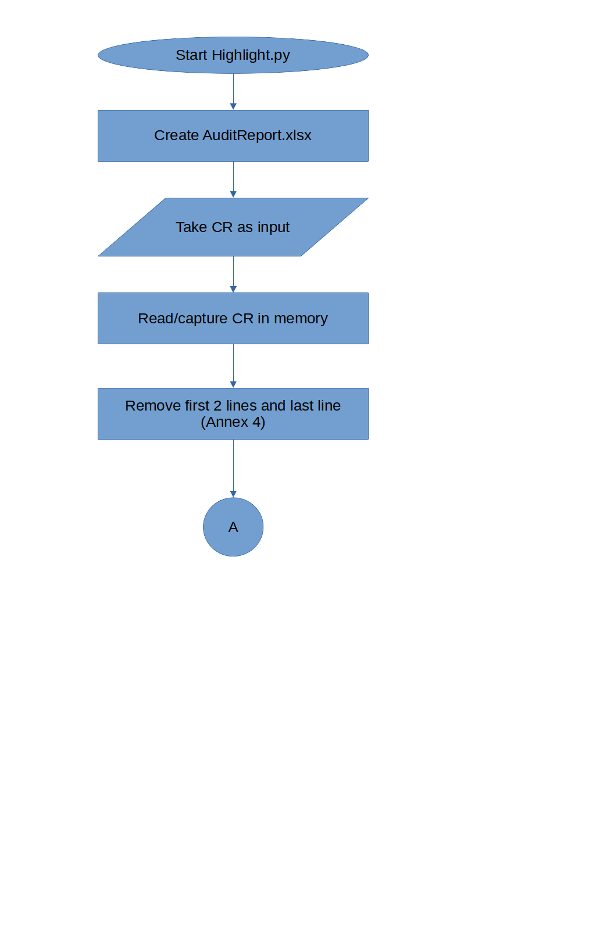

Figure : Flowchart Highlight.py (part I)

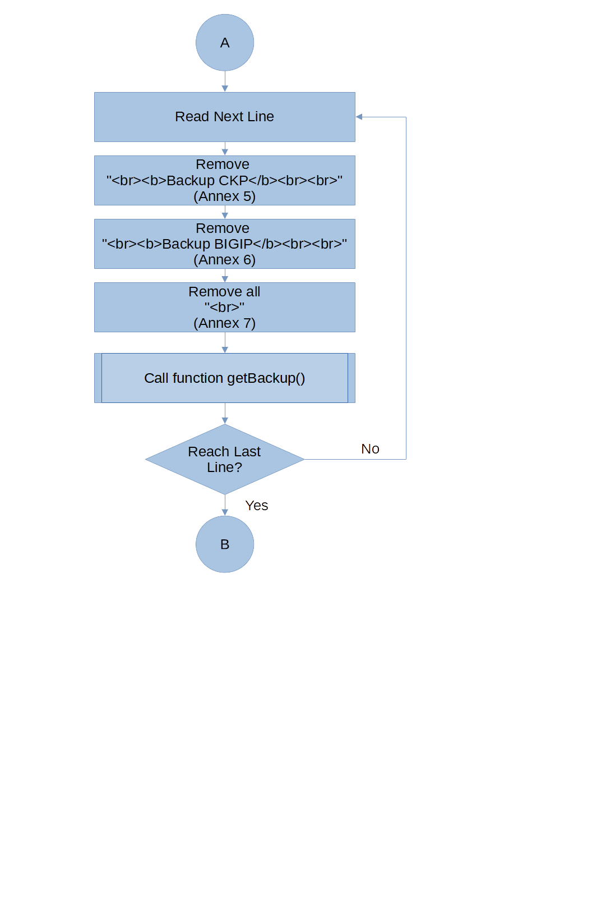

Figure : Flowchart Highlight.py (part II)

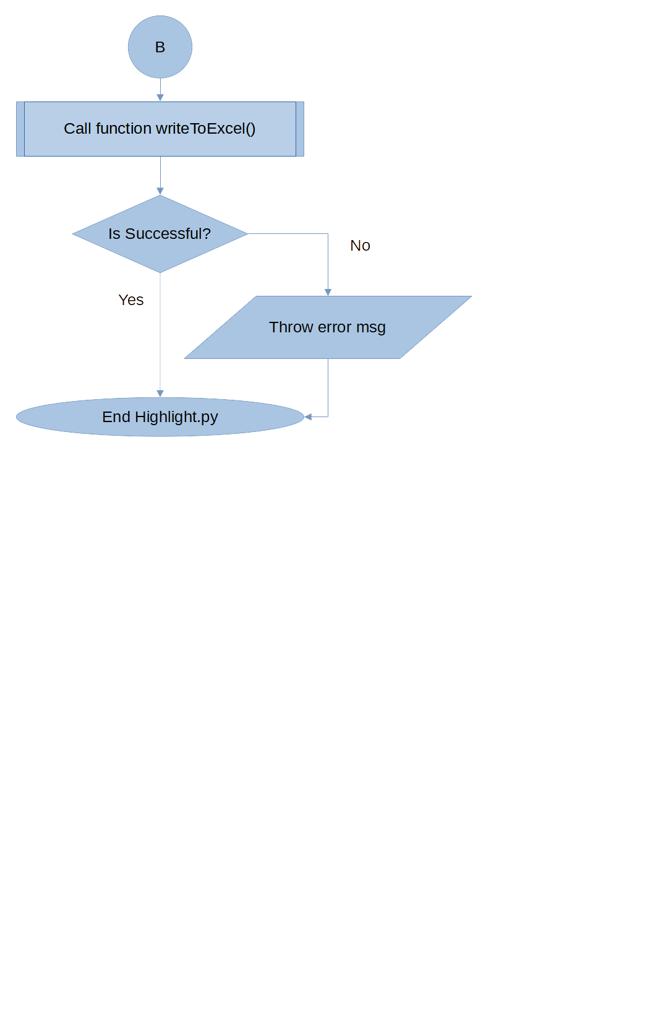

Figure : Flowchart Highlight.py (part III)

#### Flowchart getBackUp() method from Highlight.py

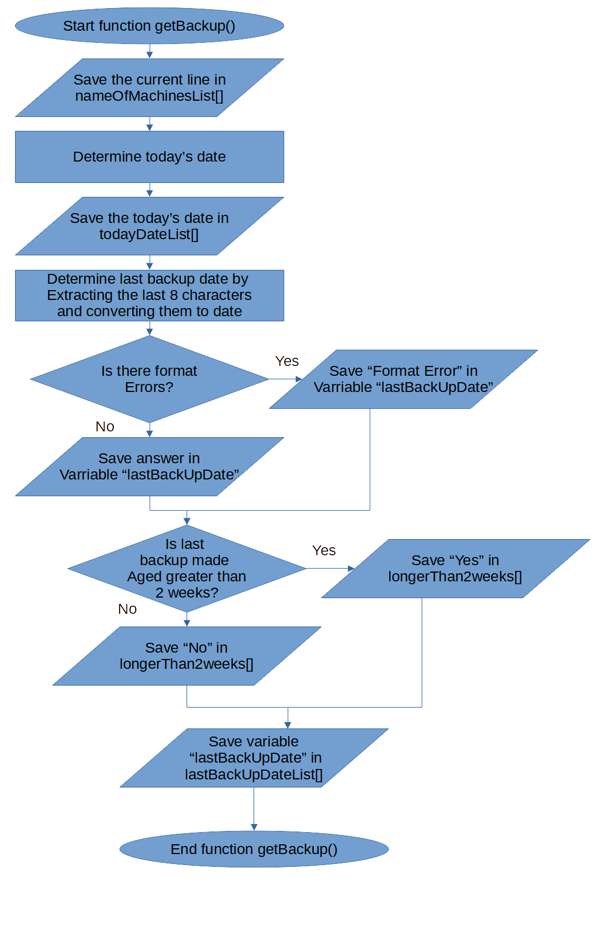

Figure : Flowchart for getBackUp()

#### Flowchart writeToExcel() method from Highlight.py

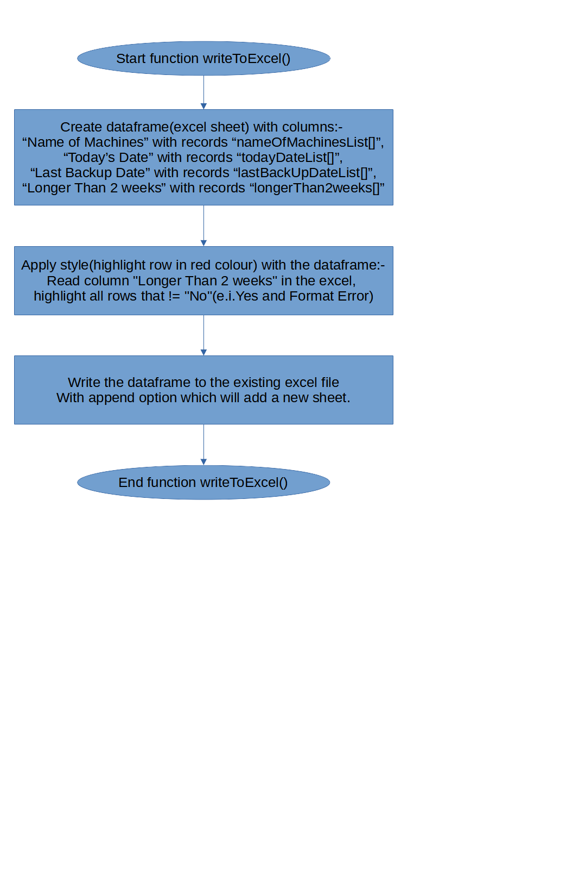

Figure : Flowchart for writeToExcel()

## Designing the Excel file

### Instructions Sheet

For any user to use the program correctly and to be able to locate any problem afterward, an instructions sheet was created. As a bonus, some links were added to help with the use of filters.

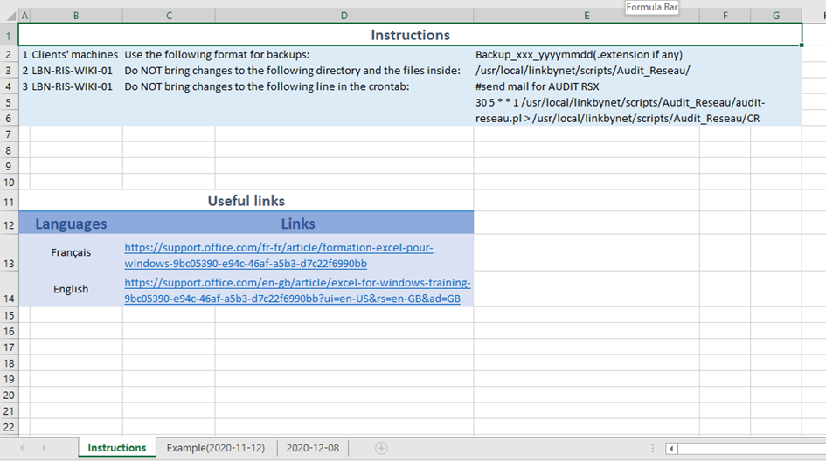

Figure : Instructions in AuditReport.xlsx

### Example Sheet

An example was added to help newcomers in performing the task.

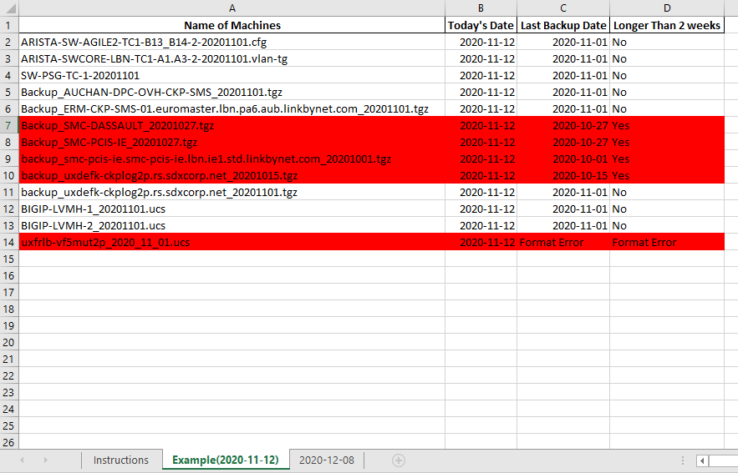

Figure : Example Sheet

The excel file is then copied in the following directory:

/usr/local/linkbynet/script/Audit_Reseau/AuditReport.xlsx.bak

# Testing

## Receive mail testing

To make the script “Highlight.py” run within the script “audit-reseau.pl”, the following line is added just before send mail command as illustrated in Chapter 2 Section 3(Annex 8 contain the fill audit-reseau.pl script):

system("python3 /usr/local/linkbynet/scripts/Audit_Reseau/Highlight.py");

In order not to disturb others, the mail address was changed to [ar.poolian@linkbynet.com](mailto:ar.poolian@linkbynet.com) in the “sendmail.sh” script. The following command was run in LBN-RIS-WIKI-01:

/usr/local/linkbynet/script/Audit_Reseau/audit-reseau.pl > /usr/local/linkbynet/script/Audit_Reseau/CR

Figure 13 below shows the mail received after running the above command. The script sends the attachment successfully.

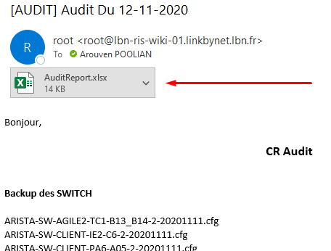

Figure : Received mail

## Excel Testing

Figure 14 shows how the received AuditReport.xlsx looks like. A new sheet was added with the date that the command /usr/local/linkbynet/script/Audit_Reseau/audit-reseau.pl > /usr/local/linkbynet/script/Audit_Reseau/CR was run.

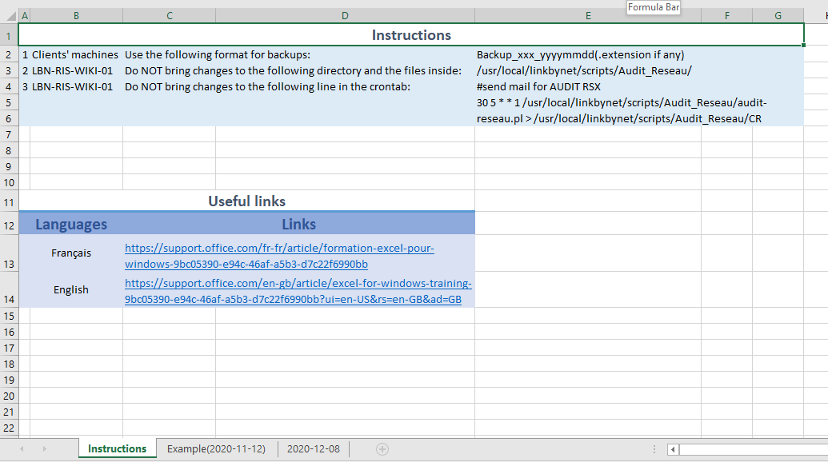

Figure : AuditReport.xlsx

### Interesting Sheet

Figures 15 and 16 show that the script is doing the requested tasks. Reaching here filters will be useful in excel.

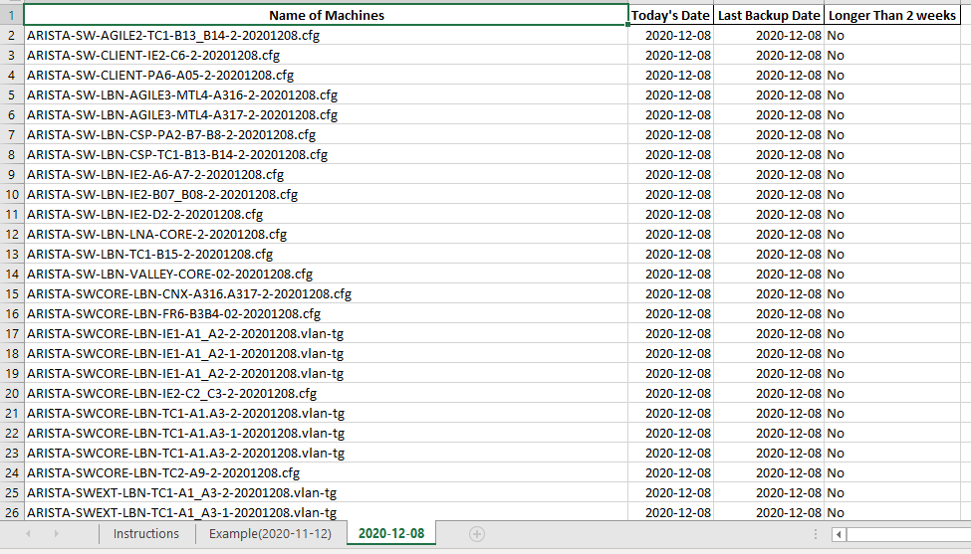

Figure : Interesting sheet (part I)

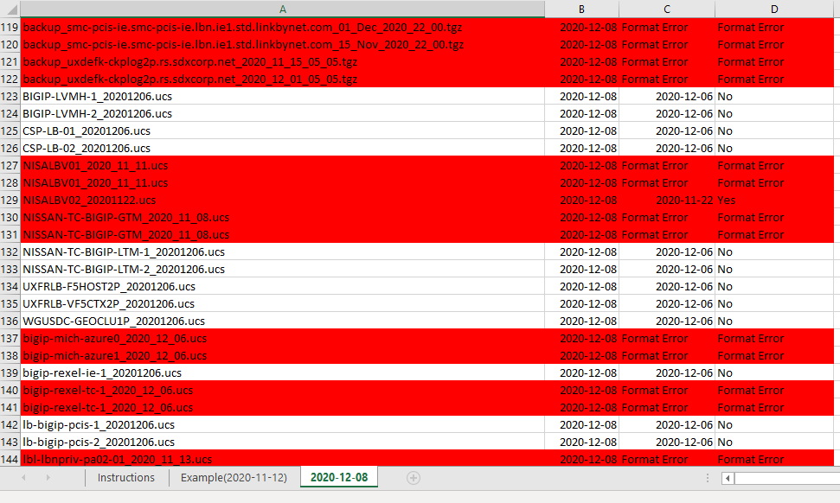

Figure : Interesting sheet (part II)

## Error Testing

Figure 17 below show what will be shown if the script “Highlight.py” fails in some way. An error message will appear in the mail itself.

Unfortunately, Microsoft outlook shows the output below (Figure 17) while the real output should be as displayed in Figure 18(e.i. at the middle of the display container). Maybe it will be there in the future updates.

An improvement could be that no attachment will be sent if there is an error.

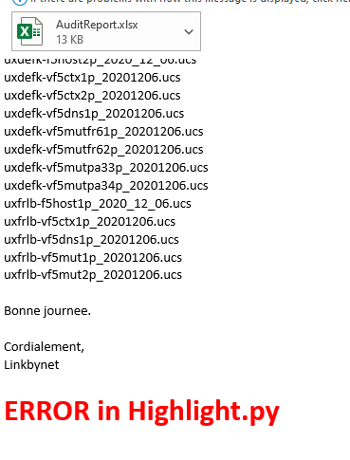

Figure : Error Display in MS Outlook

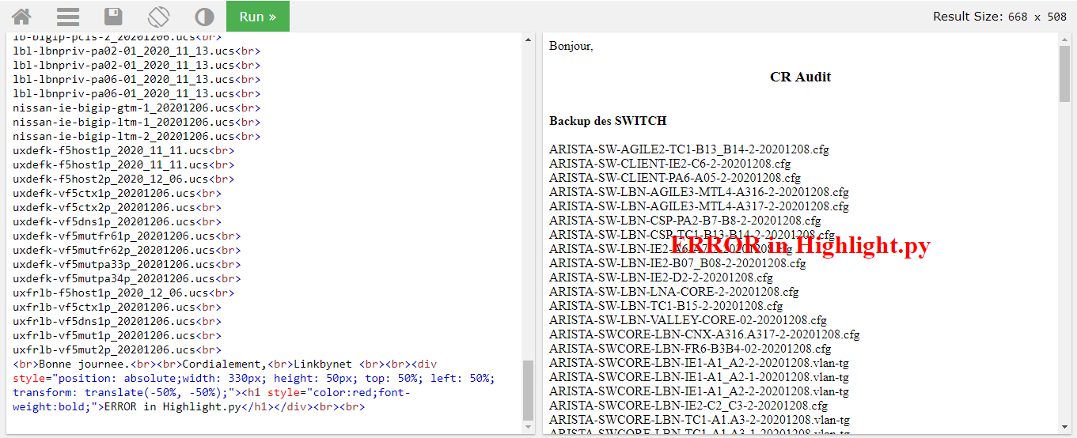

Figure : Error Display in Google Chrome https://www.w3schools.com/

# Improvements

* No attachment will be sent if there are any errors in “Highlight.py”.
* Perform the backups that are not being done (verify route, verify crontab, verify destination IP, …) with another script, and send a report.

# Appendix

## Annex 1: audit-reseau.pl (Before Highlight.py)

#!/usr/bin/perl -w

use DBI;

#Recuperations de la liste des switchs ou les backup sont en échec

#$dbh = DBI->connect('dbi:mysql:netmon','netmon','7zBTtvXEy1')

#or die "Connection Error: $DBI::errstr\n";

#

#$sql = "select host_name from backup where (type='HP Procurve' or type like 'Nortel%') and status='Echec'";

#$sth = $dbh->prepare($sql);

#

#$sth->execute

#

#or die "SQL Error: $DBI::errstr\n";

#

print "Bonjour,<br>\n";

print "<h3 align=center>CR Audit </h3>";

print "<br>";

print "<b> Backup des SWITCH </b><br>";

print "<br>\n";

$path = "/home/backups/switch_bkp";

chdir($path) or die "Cant chdir to $path $!";

my @files_hp = glob("*");

my %files_hp;

foreach my $file_hp (sort @files_hp) {

my $file_name_hp = substr($file_hp,0,-15);

$files_hp{$file_name_hp}=1;

}

foreach (sort keys %files_hp) {

no warnings qw(uninitialized);

my @files_latest_hp = glob("$_*");

print "$files_latest_hp[$#files_latest_hp]<br>\n";

}

#

#if ($sth->rows ==0)

#{

#

# print "Ras<br>\n";

#

#}

#else

#{

# while (@row = $sth->fetchrow_array)

# {

# print "@row<br>\n";

# }

#

#}

#

#Backup des Checkpoint, BigIP, Radware et ISA, on recuperer le dernier fichier du chaque repertoire de Backup

#Backup des firewall checkpoint.

print "<br>";

print "<b>Backup CKP</b><br>";

print "<br>";

$path = "/home/backups/checkpoint_bkp";

chdir($path) or die "Cant chdir to $path $!";

my @files_ckp = glob("*ackup_*");

my %files_ckp;

foreach my $file_ckp (sort @files_ckp) {

my $file_name_ckp = substr($file_ckp,0,-13);

$files_ckp{$file_name_ckp}=1;

}

foreach (sort keys %files_ckp) {

no warnings qw(uninitialized);

my @files_latest_ckp = glob("$_*");

print "$files_latest_ckp[$#files_latest_ckp]<br>\n";

}

#Backup des BIGIP

print "<br>";

print "<b>Backup BIGIP</b><br>";

print "<br>";

$path = "/home/backups/bigip_bkp";

chdir($path) or die "Cant chdir to $path $!";

my @files_bigip = glob("*ucs*");

my %files_bigip;

foreach my $file_bigip (sort @files_bigip) {

my $file_name_bigip = substr($file_bigip,0,-12);

$files_bigip{$file_name_bigip}=1;

}

foreach (sort keys %files_bigip) {

no warnings qw(uninitialized);

my @files_latest_bigip = glob("$_*");

print "$files_latest_bigip[$#files_latest_bigip]<br>\n";

}

print "<br>";

print "Bonne journee.<br>";

print "<br>";

print "Cordialement,<br>";

print "Linkbynet <br>";

#On execute le script sendmail.sh pour l'envoie mail.

system("/bin/bash /usr/local/linkbynet/scripts/Audit_Reseau/sendmail.sh");

## Annex 2: CR (Before Highlight.py)

Bonjour,<br>

<h3 align=center>CR Audit </h3><br><b> Backup des SWITCH </b><br><br>

ARISTA-SW-AGILE2-TC1-B13_B14-2-20201115.cfg<br>

ARISTA-SW-CLIENT-IE2-C6-2-20201115.cfg<br>

ARISTA-SW-CLIENT-PA6-A05-2-20201115.cfg<br>

ARISTA-SW-LBN-AGILE3-MTL4-A316-2-20201115.cfg<br>

ARISTA-SW-LBN-AGILE3-MTL4-A317-2-20201115.cfg<br>

ARISTA-SW-LBN-CSP-PA2-B7-B8-2-20201115.cfg<br>

ARISTA-SW-LBN-CSP-TC1-B13-B14-2-20201115.cfg<br>

ARISTA-SW-LBN-IE2-A6-A7-2-20201115.cfg<br>

ARISTA-SW-LBN-IE2-B07_B08-2-20201115.cfg<br>

ARISTA-SW-LBN-IE2-D2-2-20201115.cfg<br>

ARISTA-SW-LBN-TC1-B15-2-20201115.cfg<br>

ARISTA-SW-LBN-VALLEY-CORE-02-20201115.cfg<br>

ARISTA-SWCORE-LBN-CNX-A316.A317-2-20201115.cfg<br>

ARISTA-SWCORE-LBN-FR6-B3B4-02-20201115.cfg<br>

ARISTA-SWCORE-LBN-IE1-A1_A2-2-20201115.vlan-tg<br>

ARISTA-SWCORE-LBN-IE1-A1_A2-1-20201115.vlan-tg<br>

ARISTA-SWCORE-LBN-IE1-A1_A2-2-20201115.vlan-tg<br>

ARISTA-SWCORE-LBN-IE2-C2_C3-2-20201115.cfg<br>

ARISTA-SWCORE-LBN-TC1-A1.A3-2-20201115.vlan-tg<br>

ARISTA-SWCORE-LBN-TC1-A1.A3-1-20201115.vlan-tg<br>

ARISTA-SWCORE-LBN-TC1-A1.A3-2-20201115.vlan-tg<br>

ARISTA-SWCORE-LBN-TC2-A9-2-20201115.cfg<br>

ARISTA-SWEXT-LBN-TC1-A1_A3-2-20201115.vlan-tg<br>

ARISTA-SWEXT-LBN-TC1-A1_A3-1-20201115.vlan-tg<br>

ARISTA-SWEXT-LBN-TC1-A1_A3-2-20201115.vlan-tg<br>

ARISTA-UXDELB-SWCOREFR6-2P-20201115.cfg<br>

ARISTA-UXDELB-SWTORFR6A1-2P-20201115.cfg<br>

ARISTA-UXDELB-SWTORFR6A2-2P-20201115.cfg<br>

ARISTA-UXDELB-SWTORFR6B1-2P-20201115.cfg<br>

ARISTA-UXDELB-SWWAN-2P-20201115.cfg<br>

ARISTA-UXFRLB-SWCOREPA3-2P-20201115.cfg<br>

ARISTA-UXFRLB-SWTORPA3B4-1P-20201115.cfg<br>

ARISTA-UXFRLB-SWTORPA3B5-1P-20201115.cfg<br>

ARISTA-UXFRLB-SWTORPA3C3-2P-20201115.cfg<br>

ARISTA-UXFRLB-SWTORPA3C4-2P-20201115.cfg<br>

ARISTA-UXFRLB-SWTORPA3E1-2P-20201115.cfg<br>

ARISTA-UXFRLB-SWTORPA3E2-2P-20201115.cfg<br>

ARISTA-UXFRLB-SWTORPA3E3-2P-20201115.cfg<br>

ARISTA-UXFRLB-SWTORPA3E4-2P-20201115.cfg<br>

ARISTA-UXFRLB-SWTORPA3F1-2P-20201115.cfg<br>

ARISTA-UXFRLB-SWTORPA3F2-2P-20201115.cfg<br>

ARISTA-UXFRLB-SWTORPA3F3-2P-20201115.cfg<br>

ARISTA-UXFRLB-SWTORPA3F4-2P-20201115.cfg<br>

ARISTA-UXFRLB-SWTORPA3F5-1P-20201115.cfg<br>

ARISTA-UXFRLB-SWTORPA3F6-2P-20201115.cfg<br>

ARISTA-UXFRLB-SWTORPA3F7-2P-20201115.cfg<br>

ARISTA-UXFRLB-SWTORPA3F8-2P-20201115.cfg<br>

ARISTA-UXFRLB-SWTORPA3G6-2P-20201115.cfg<br>

ARISTA-UXFRLB-SWTORPA3G7-2P-20201115.cfg<br>

ARISTA-UXFRLB-SWWANPA3-2P-20201115.cfg<br>

FL-SW-CORE-01-NORTEL-config-20201115.cfg<br>

FL-SW-CORE-02-NORTEL-config-20201115.cfg<br>

SW-PSG-TC-1-20201115<br>

SW-AGILE2-TC-B4-01-20201115<br>

SW-CHAP-06-20201115<br>

SW-EMASTER-TC-A7-01-20201115<br>

SW-EMASTER-TC-A7-01-20201115<br>

SW-ILO-AGILE-IE-1-20201115<br>

SW-INSTALL-TC2-B1-1-20201115<br>

SW-LBN-AGILE-5-20201115<br>

SW-LBN-CSP-PA3-B05-20201115<br>

SW-LBN-CSP-TC1-A15-20201115<br>

SW-LBN-IE1-ADM-A04-20201115<br>

SW-LBN-RTRCLIENT-TC1-A8-20201115<br>

SW-LBN-VALLEY-DMZ-03-20201114<br>

SW-LBN-VALLEY-DMZ-03-20201114<br>

SW-LBN-VALLEY-102-TEL-20201115<br>

SW-NISSAN-TC-2-20201115<br>

SW-PCIS-STACK-20201115<br>

SW-PSG-TC-1-20201115<br>

SWITCH-ADMIN-TC-A5-01-20201115<br>

SWITCH-ADMIN-TC-A5-01-20201115<br>

SWITCH-CLIENT-TC-B1-01-20201114<br>

SWITCH-CLIENT-IE2-ILO-1-20201115<br>

SWITCH-CLIENT-MUT-IE1-C05-20201115<br>

SWITCH-CLIENT-TC-B1-01-20201114<br>

SWITCH-CNCC-B4-03-20201114<br>

SWITCH-IDEFIX-1-20201115<br>

SWITCH-ILO-TC-AGILE-B4-20201115<br>

SWITCH-LBN-AGILE-V-1-20201115<br>

SWITCH-LBN-ADMIN-TC2-B04-20201115<br>

SWITCH-LBN-AGILE-V-1-20201115<br>

SWITCH-LBN-ILO-MICH-2-20201115<br>

SWITCH-PDU-IE2-C-20201115<br>

SWITCH-SXO-PA3-C4-ILO-20201115<br>

SWITCH-TC-PDU-02-20201115<br>

sw-lbn-veeam-TC-01-20201115<br>

swinstall-lbn-valley-A5-20201115<br>

switch-tc-ilo-b14-01-20201114<br>

<br><b>Backup CKP</b><br><br>Backup_AUCHAN-DPC-OVH-CKP-SMS_2020_11_15.tgz<br>

Backup_ERM-CKP-SMS-01.euromaster.lbn.pa6.aub.linkbynet.com_20201115.tgz<br>

Backup_SMC-DASSAULT_20201109.tgz<br>

Backup_SMC-PCIS-IE_20201109.tgz<br>

Backup_SMC-PCIS-TC_20201115.tgz<br>

Backup_SMS-GREENYELLOW_20201115.tgz<br>

Backup_SMS-LAPOSTE-NEW__20201115.tgz<br>

Backup_SMS-LVMH_1_20201109.tgz<br>

Backup_SMS-NISSAN-IE_20201115.tgz<br>

Backup_SMS-NISSAN-TC_20201115.tgz<br>

Backup_SMS-PANORANET_2020_11_11.tgz<br>

Backup_SMS-PANORANET_2020_11_11.tgz<br>

Backup_SMS-POLIRIS-IE-1_20201109.tgz<br>

Backup_SMS-REXEL-IE_1_20201115.tgz<br>

Backup_SMS-REXEL-TC_20201115.tgz<br>

Backup_SMS-SUEZ_20201115.tgz<br>

Backup_SMS-UXFRLB-CKPLOG1P_20201115.tgz<br>

Backup_SMSAUCHANAZU_2020_11_11.tgz<br>

Backup_SMSAUCHANAZU_2020_11_11.tgz<br>

Backup_TL-SMS-01_20201115.tgz<br>

Backup_UXFRLB-CKPSMS1P.rs.sdxcorp.net_20201109.tgz<br>

Backup_VPN-MUT-SMC-NEW-1_20201115.tgz<br>

backup_SMC-PCIS-EVENTS.smc-pcis-events.lbn.ie1.std.linkbynet.com_01_Nov_2020_22_00.tgz<br>

backup_SMC-PCIS-EVENTS.smc-pcis-events.lbn.ie1.std.linkbynet.com_15_Nov_2020_22_00.tgz<br>

backup_SMC-PCIS-EVENTS.smc-pcis-events.lbn.ie1.std.linkbynet.com_15_Oct_2020_22_00.tgz<br>

backup_UXFRLB-CKPSMS1P.rs.sdxcorp.net_2020_10_15_03_41.tgz<br>

backup_UXFRLB-CKPSMS1P.rs.sdxcorp.net_2020_11_15_03_41.tgz<br>

backup_smc-pcis-ie.smc-pcis-ie.lbn.ie1.std.linkbynet.com_01_Nov_2020_22_00.tgz<br>

backup_smc-pcis-ie.smc-pcis-ie.lbn.ie1.std.linkbynet.com_15_Nov_2020_22_00.tgz<br>

backup_smc-pcis-ie.smc-pcis-ie.lbn.ie1.std.linkbynet.com_15_Oct_2020_22_00.tgz<br>

backup_uxdefk-ckplog2p.rs.sdxcorp.net_2020_10_15_05_05.tgz<br>

backup_uxdefk-ckplog2p.rs.sdxcorp.net_2020_11_15_05_05.tgz<br>

<br><b>Backup BIGIP</b><br><br>BIGIP-LVMH-1_20201115.ucs<br>

BIGIP-LVMH-2_20201115.ucs<br>

CSP-LB-01_20201115.ucs<br>

CSP-LB-02_20201115.ucs<br>

NISALBV01_2020_11_11.ucs<br>

NISALBV01_2020_11_11.ucs<br>

NISALBV02_20201115.ucs<br>

NISSAN-TC-BIGIP-GTM_2020_11_08.ucs<br>

NISSAN-TC-BIGIP-GTM_2020_11_08.ucs<br>

NISSAN-TC-BIGIP-LTM-1_20201115.ucs<br>

NISSAN-TC-BIGIP-LTM-2_20201115.ucs<br>

UXFRLB-F5HOST2P_20201115.ucs<br>

UXFRLB-VF5CTX2P_20201115.ucs<br>

WGUSDC-GEOCLU1P_20201115.ucs<br>

bigip-mich-azure0_2020_11_15.ucs<br>

bigip-mich-azure1_2020_11_15.ucs<br>

bigip-rexel-ie-1_20201115.ucs<br>

bigip-rexel-tc-1_2020_11_11.ucs<br>

bigip-rexel-tc-1_2020_11_11.ucs<br>

lb-bigip-pcis-1_20201115.ucs<br>

lb-bigip-pcis-2_20201115.ucs<br>

lbl-lbnpriv-pa02-01_2020_11_13.ucs<br>

lbl-lbnpriv-pa02-01_2020_11_13.ucs<br>

lbl-lbnpriv-pa06-01_2020_11_13.ucs<br>

lbl-lbnpriv-pa06-01_2020_11_13.ucs<br>

nissan-ie-bigip-gtm-1_20201115.ucs<br>

nissan-ie-bigip-ltm-1_20201115.ucs<br>

nissan-ie-bigip-ltm-2_20201115.ucs<br>

uxdefk-f5host1p_2020_11_11.ucs<br>

uxdefk-f5host1p_2020_11_11.ucs<br>

uxdefk-f5host2p_2020_11_15.ucs<br>

uxdefk-vf5ctx1p_20201115.ucs<br>

uxdefk-vf5ctx2p_20201115.ucs<br>

uxdefk-vf5dns1p_20201115.ucs<br>

uxdefk-vf5mutfr61p_20201115.ucs<br>

uxdefk-vf5mutfr62p_20201115.ucs<br>

uxdefk-vf5mutpa33p_20201115.ucs<br>

uxdefk-vf5mutpa34p_20201115.ucs<br>

uxfrlb-f5host1p_2020_11_15.ucs<br>

uxfrlb-vf5ctx1p_20201115.ucs<br>

uxfrlb-vf5dns1p_20201115.ucs<br>

uxfrlb-vf5mut1p_20201115.ucs<br>

uxfrlb-vf5mut2p_20201115.ucs<br>

<br>Bonne journee.<br><br>Cordialement,<br>Linkbynet <br>

## Annex 3: Highlight.py (Final)

########## importing libraries ##########

import os

import shutil

import pathlib

import datetime

import pandas as pd # pip install pandas

# pip install openpyxl xlsxwriter xlrd

from openpyxl import Workbook, load_workbook, styles

########## writing the methods/functions ##########

def writeToExcel(nameOfMachines, today, lastBackUp, status, sheetName=str(datetime.datetime.date(datetime.datetime.now()))):

df = pd.DataFrame({

# header = "Name of Machines", records = nameOfMachines(from list)

"Name of Machines": nameOfMachines,

# header = "Today's Date", records = today(from list)

"Today's Date": today,

# header = "Last Backup Date", records = lastBackUp(from list)

"Last Backup Date": lastBackUp,

# header = "Longer Than 2 weeks", records = status(from list)

"Longer Than 2 weeks": status,

})

with pd.ExcelWriter(path + destFile, engine="openpyxl", mode="a") as writer:

# writer.sheets['Summary'].column_dimensions['A'].width = 15 #try to set width to all columns

df.style.apply(highlight_diff, axis=None).to_excel(writer, sheet_name=sheetName, index=False) # filling the excel sheet

def highlight_diff(x): # will read column "Longer Than 2 weeks" in the excel, highlight all rows that != "No"(e.i.Yes and Format Error)

c1 = "background-color: red"

c2 = ""

m = x["Longer Than 2 weeks"] != "No"

df1 = pd.DataFrame(c2, index=x.index, columns=x.columns)

df1.loc[m, :] = c1

return df1

def getBackup(myString):

nameOfMachinesList.append(myString)

todayTime = datetime.datetime.now() # get today's date and time

todayDateList.append(datetime.datetime.date(todayTime)) # add the date only to the list

todayMinustwoWeeks = datetime.datetime.date(todayTime) - datetime.timedelta(weeks=2) # remove 2 weeks from today's date

lastBackUpDate = ""

longerThan = ""

try:

lastBackUpDate = datetime.datetime.strptime(((os.path.splitext(myString)[0])[-8:]), "%Y%m%d").date() # retrive last 8 characters and convert them to date

if todayMinustwoWeeks < lastBackUpDate: # if not longer than 2 weeks

longerThan = "No"

else:

longerThan = "Yes"

except:

lastBackUpDate = "Format Error"

longerThan = "Format Error"

longerThan2weeks.append(longerThan) # add the resulted string to the list

# add the resulted string to the list

lastBackUpDateList.append(lastBackUpDate)

########## main task running ##########

# start try except

try:

# vars declaration/and initialisation

nameOfMachinesList = []

lastBackUpDateList = []

todayDateList = []

longerThan2weeks = []

path = "/usr/local/linkbynet/scripts/Audit_Reseau/"

sourceFile = "AuditReport.xlsx.bak"

destFile = "AuditReport.xlsx"

htmlFile = "CR"

shutil.copy(os.path.join(path, sourceFile), os.path.join(path, destFile)) # overwrite the old excel file to new one(keeping instructions and example)

file1 = open(path + htmlFile, "r") # opens the file in read mode

Lines = file1.readlines() # read all lines in file1

# remove first 2 lines and last line

del Lines[0]

del Lines[0]

del Lines[-1]

# start for loop

for line in Lines:

# Strips the newline character

# remove <br><b>Backup CKP</b><br><br>

# remove <br><b>Backup BIGIP</b><br><br>

# remove all remaining <br>

mystr = (line.strip()

.replace("<br><b>Backup CKP</b><br><br>", "")

.replace("<br><b>Backup BIGIP</b><br><br>", "")

.replace("<br>", "")

.strip())

getBackup(mystr) # call method/function

# end for loop

writeToExcel(nameOfMachinesList, todayDateList, lastBackUpDateList, longerThan2weeks) # call method/function

except Exception as e:

print('<br><div style="position:absolute;width:330px;height:50px;top:50%;left:50%;transform:translate(-50%, -50%);"><h1 style="color:red;font-weight:bold;">ERROR in Highlight.py</h1></div><br><br>')

# end try except

## Annex 4: CR (Remove first 2 lines and last line)

ARISTA-SW-AGILE2-TC1-B13_B14-2-20201115.cfg<br>

ARISTA-SW-CLIENT-IE2-C6-2-20201115.cfg<br>

ARISTA-SW-CLIENT-PA6-A05-2-20201115.cfg<br>

ARISTA-SW-LBN-AGILE3-MTL4-A316-2-20201115.cfg<br>

ARISTA-SW-LBN-AGILE3-MTL4-A317-2-20201115.cfg<br>

ARISTA-SW-LBN-CSP-PA2-B7-B8-2-20201115.cfg<br>

ARISTA-SW-LBN-CSP-TC1-B13-B14-2-20201115.cfg<br>

ARISTA-SW-LBN-IE2-A6-A7-2-20201115.cfg<br>

ARISTA-SW-LBN-IE2-B07_B08-2-20201115.cfg<br>

ARISTA-SW-LBN-IE2-D2-2-20201115.cfg<br>

ARISTA-SW-LBN-TC1-B15-2-20201115.cfg<br>

ARISTA-SW-LBN-VALLEY-CORE-02-20201115.cfg<br>

ARISTA-SWCORE-LBN-CNX-A316.A317-2-20201115.cfg<br>

ARISTA-SWCORE-LBN-FR6-B3B4-02-20201115.cfg<br>

ARISTA-SWCORE-LBN-IE1-A1_A2-2-20201115.vlan-tg<br>

ARISTA-SWCORE-LBN-IE1-A1_A2-1-20201115.vlan-tg<br>

ARISTA-SWCORE-LBN-IE1-A1_A2-2-20201115.vlan-tg<br>

ARISTA-SWCORE-LBN-IE2-C2_C3-2-20201115.cfg<br>

ARISTA-SWCORE-LBN-TC1-A1.A3-2-20201115.vlan-tg<br>

ARISTA-SWCORE-LBN-TC1-A1.A3-1-20201115.vlan-tg<br>

ARISTA-SWCORE-LBN-TC1-A1.A3-2-20201115.vlan-tg<br>

ARISTA-SWCORE-LBN-TC2-A9-2-20201115.cfg<br>

ARISTA-SWEXT-LBN-TC1-A1_A3-2-20201115.vlan-tg<br>

ARISTA-SWEXT-LBN-TC1-A1_A3-1-20201115.vlan-tg<br>

ARISTA-SWEXT-LBN-TC1-A1_A3-2-20201115.vlan-tg<br>

ARISTA-UXDELB-SWCOREFR6-2P-20201115.cfg<br>

ARISTA-UXDELB-SWTORFR6A1-2P-20201115.cfg<br>

ARISTA-UXDELB-SWTORFR6A2-2P-20201115.cfg<br>

ARISTA-UXDELB-SWTORFR6B1-2P-20201115.cfg<br>

ARISTA-UXDELB-SWWAN-2P-20201115.cfg<br>

ARISTA-UXFRLB-SWCOREPA3-2P-20201115.cfg<br>

ARISTA-UXFRLB-SWTORPA3B4-1P-20201115.cfg<br>

ARISTA-UXFRLB-SWTORPA3B5-1P-20201115.cfg<br>

ARISTA-UXFRLB-SWTORPA3C3-2P-20201115.cfg<br>

ARISTA-UXFRLB-SWTORPA3C4-2P-20201115.cfg<br>

ARISTA-UXFRLB-SWTORPA3E1-2P-20201115.cfg<br>

ARISTA-UXFRLB-SWTORPA3E2-2P-20201115.cfg<br>

ARISTA-UXFRLB-SWTORPA3E3-2P-20201115.cfg<br>

ARISTA-UXFRLB-SWTORPA3E4-2P-20201115.cfg<br>

ARISTA-UXFRLB-SWTORPA3F1-2P-20201115.cfg<br>

ARISTA-UXFRLB-SWTORPA3F2-2P-20201115.cfg<br>

ARISTA-UXFRLB-SWTORPA3F3-2P-20201115.cfg<br>

ARISTA-UXFRLB-SWTORPA3F4-2P-20201115.cfg<br>

ARISTA-UXFRLB-SWTORPA3F5-1P-20201115.cfg<br>

ARISTA-UXFRLB-SWTORPA3F6-2P-20201115.cfg<br>

ARISTA-UXFRLB-SWTORPA3F7-2P-20201115.cfg<br>

ARISTA-UXFRLB-SWTORPA3F8-2P-20201115.cfg<br>

ARISTA-UXFRLB-SWTORPA3G6-2P-20201115.cfg<br>

ARISTA-UXFRLB-SWTORPA3G7-2P-20201115.cfg<br>

ARISTA-UXFRLB-SWWANPA3-2P-20201115.cfg<br>

FL-SW-CORE-01-NORTEL-config-20201115.cfg<br>

FL-SW-CORE-02-NORTEL-config-20201115.cfg<br>

SW-PSG-TC-1-20201115<br>

SW-AGILE2-TC-B4-01-20201115<br>

SW-CHAP-06-20201115<br>

SW-EMASTER-TC-A7-01-20201115<br>

SW-EMASTER-TC-A7-01-20201115<br>

SW-ILO-AGILE-IE-1-20201115<br>

SW-INSTALL-TC2-B1-1-20201115<br>

SW-LBN-AGILE-5-20201115<br>

SW-LBN-CSP-PA3-B05-20201115<br>

SW-LBN-CSP-TC1-A15-20201115<br>

SW-LBN-IE1-ADM-A04-20201115<br>

SW-LBN-RTRCLIENT-TC1-A8-20201115<br>

SW-LBN-VALLEY-DMZ-03-20201114<br>

SW-LBN-VALLEY-DMZ-03-20201114<br>

SW-LBN-VALLEY-102-TEL-20201115<br>

SW-NISSAN-TC-2-20201115<br>

SW-PCIS-STACK-20201115<br>

SW-PSG-TC-1-20201115<br>

SWITCH-ADMIN-TC-A5-01-20201115<br>

SWITCH-ADMIN-TC-A5-01-20201115<br>

SWITCH-CLIENT-TC-B1-01-20201114<br>

SWITCH-CLIENT-IE2-ILO-1-20201115<br>

SWITCH-CLIENT-MUT-IE1-C05-20201115<br>

SWITCH-CLIENT-TC-B1-01-20201114<br>

SWITCH-CNCC-B4-03-20201114<br>

SWITCH-IDEFIX-1-20201115<br>

SWITCH-ILO-TC-AGILE-B4-20201115<br>

SWITCH-LBN-AGILE-V-1-20201115<br>

SWITCH-LBN-ADMIN-TC2-B04-20201115<br>

SWITCH-LBN-AGILE-V-1-20201115<br>

SWITCH-LBN-ILO-MICH-2-20201115<br>

SWITCH-PDU-IE2-C-20201115<br>

SWITCH-SXO-PA3-C4-ILO-20201115<br>

SWITCH-TC-PDU-02-20201115<br>

sw-lbn-veeam-TC-01-20201115<br>

swinstall-lbn-valley-A5-20201115<br>

switch-tc-ilo-b14-01-20201114<br>

<br><b>Backup CKP</b><br><br>Backup_AUCHAN-DPC-OVH-CKP-SMS_2020_11_15.tgz<br>

Backup_ERM-CKP-SMS-01.euromaster.lbn.pa6.aub.linkbynet.com_20201115.tgz<br>

Backup_SMC-DASSAULT_20201109.tgz<br>

Backup_SMC-PCIS-IE_20201109.tgz<br>

Backup_SMC-PCIS-TC_20201115.tgz<br>

Backup_SMS-GREENYELLOW_20201115.tgz<br>

Backup_SMS-LAPOSTE-NEW__20201115.tgz<br>

Backup_SMS-LVMH_1_20201109.tgz<br>

Backup_SMS-NISSAN-IE_20201115.tgz<br>

Backup_SMS-NISSAN-TC_20201115.tgz<br>

Backup_SMS-PANORANET_2020_11_11.tgz<br>

Backup_SMS-PANORANET_2020_11_11.tgz<br>

Backup_SMS-POLIRIS-IE-1_20201109.tgz<br>

Backup_SMS-REXEL-IE_1_20201115.tgz<br>

Backup_SMS-REXEL-TC_20201115.tgz<br>

Backup_SMS-SUEZ_20201115.tgz<br>

Backup_SMS-UXFRLB-CKPLOG1P_20201115.tgz<br>

Backup_SMSAUCHANAZU_2020_11_11.tgz<br>

Backup_SMSAUCHANAZU_2020_11_11.tgz<br>

Backup_TL-SMS-01_20201115.tgz<br>

Backup_UXFRLB-CKPSMS1P.rs.sdxcorp.net_20201109.tgz<br>

Backup_VPN-MUT-SMC-NEW-1_20201115.tgz<br>

backup_SMC-PCIS-EVENTS.smc-pcis-events.lbn.ie1.std.linkbynet.com_01_Nov_2020_22_00.tgz<br>

backup_SMC-PCIS-EVENTS.smc-pcis-events.lbn.ie1.std.linkbynet.com_15_Nov_2020_22_00.tgz<br>

backup_SMC-PCIS-EVENTS.smc-pcis-events.lbn.ie1.std.linkbynet.com_15_Oct_2020_22_00.tgz<br>

backup_UXFRLB-CKPSMS1P.rs.sdxcorp.net_2020_10_15_03_41.tgz<br>

backup_UXFRLB-CKPSMS1P.rs.sdxcorp.net_2020_11_15_03_41.tgz<br>

backup_smc-pcis-ie.smc-pcis-ie.lbn.ie1.std.linkbynet.com_01_Nov_2020_22_00.tgz<br>

backup_smc-pcis-ie.smc-pcis-ie.lbn.ie1.std.linkbynet.com_15_Nov_2020_22_00.tgz<br>

backup_smc-pcis-ie.smc-pcis-ie.lbn.ie1.std.linkbynet.com_15_Oct_2020_22_00.tgz<br>

backup_uxdefk-ckplog2p.rs.sdxcorp.net_2020_10_15_05_05.tgz<br>

backup_uxdefk-ckplog2p.rs.sdxcorp.net_2020_11_15_05_05.tgz<br>

<br><b>Backup BIGIP</b><br><br>BIGIP-LVMH-1_20201115.ucs<br>

BIGIP-LVMH-2_20201115.ucs<br>

CSP-LB-01_20201115.ucs<br>

CSP-LB-02_20201115.ucs<br>

NISALBV01_2020_11_11.ucs<br>

NISALBV01_2020_11_11.ucs<br>

NISALBV02_20201115.ucs<br>

NISSAN-TC-BIGIP-GTM_2020_11_08.ucs<br>

NISSAN-TC-BIGIP-GTM_2020_11_08.ucs<br>

NISSAN-TC-BIGIP-LTM-1_20201115.ucs<br>

NISSAN-TC-BIGIP-LTM-2_20201115.ucs<br>

UXFRLB-F5HOST2P_20201115.ucs<br>

UXFRLB-VF5CTX2P_20201115.ucs<br>

WGUSDC-GEOCLU1P_20201115.ucs<br>

bigip-mich-azure0_2020_11_15.ucs<br>

bigip-mich-azure1_2020_11_15.ucs<br>

bigip-rexel-ie-1_20201115.ucs<br>

bigip-rexel-tc-1_2020_11_11.ucs<br>

bigip-rexel-tc-1_2020_11_11.ucs<br>

lb-bigip-pcis-1_20201115.ucs<br>

lb-bigip-pcis-2_20201115.ucs<br>

lbl-lbnpriv-pa02-01_2020_11_13.ucs<br>

lbl-lbnpriv-pa02-01_2020_11_13.ucs<br>

lbl-lbnpriv-pa06-01_2020_11_13.ucs<br>

lbl-lbnpriv-pa06-01_2020_11_13.ucs<br>

nissan-ie-bigip-gtm-1_20201115.ucs<br>

nissan-ie-bigip-ltm-1_20201115.ucs<br>

nissan-ie-bigip-ltm-2_20201115.ucs<br>

uxdefk-f5host1p_2020_11_11.ucs<br>

uxdefk-f5host1p_2020_11_11.ucs<br>

uxdefk-f5host2p_2020_11_15.ucs<br>

uxdefk-vf5ctx1p_20201115.ucs<br>

uxdefk-vf5ctx2p_20201115.ucs<br>

uxdefk-vf5dns1p_20201115.ucs<br>

uxdefk-vf5mutfr61p_20201115.ucs<br>

uxdefk-vf5mutfr62p_20201115.ucs<br>

uxdefk-vf5mutpa33p_20201115.ucs<br>

uxdefk-vf5mutpa34p_20201115.ucs<br>

uxfrlb-f5host1p_2020_11_15.ucs<br>

uxfrlb-vf5ctx1p_20201115.ucs<br>

uxfrlb-vf5dns1p_20201115.ucs<br>

uxfrlb-vf5mut1p_20201115.ucs<br>

uxfrlb-vf5mut2p_20201115.ucs<br>

## Annex 5: CR (Remove "<br><b>Backup CKP</b><br><br>")

ARISTA-SW-AGILE2-TC1-B13_B14-2-20201115.cfg<br>

ARISTA-SW-CLIENT-IE2-C6-2-20201115.cfg<br>

ARISTA-SW-CLIENT-PA6-A05-2-20201115.cfg<br>

ARISTA-SW-LBN-AGILE3-MTL4-A316-2-20201115.cfg<br>

ARISTA-SW-LBN-AGILE3-MTL4-A317-2-20201115.cfg<br>

ARISTA-SW-LBN-CSP-PA2-B7-B8-2-20201115.cfg<br>

ARISTA-SW-LBN-CSP-TC1-B13-B14-2-20201115.cfg<br>

ARISTA-SW-LBN-IE2-A6-A7-2-20201115.cfg<br>

ARISTA-SW-LBN-IE2-B07_B08-2-20201115.cfg<br>

ARISTA-SW-LBN-IE2-D2-2-20201115.cfg<br>

ARISTA-SW-LBN-TC1-B15-2-20201115.cfg<br>

ARISTA-SW-LBN-VALLEY-CORE-02-20201115.cfg<br>

ARISTA-SWCORE-LBN-CNX-A316.A317-2-20201115.cfg<br>

ARISTA-SWCORE-LBN-FR6-B3B4-02-20201115.cfg<br>

ARISTA-SWCORE-LBN-IE1-A1_A2-2-20201115.vlan-tg<br>

ARISTA-SWCORE-LBN-IE1-A1_A2-1-20201115.vlan-tg<br>

ARISTA-SWCORE-LBN-IE1-A1_A2-2-20201115.vlan-tg<br>

ARISTA-SWCORE-LBN-IE2-C2_C3-2-20201115.cfg<br>

ARISTA-SWCORE-LBN-TC1-A1.A3-2-20201115.vlan-tg<br>

ARISTA-SWCORE-LBN-TC1-A1.A3-1-20201115.vlan-tg<br>

ARISTA-SWCORE-LBN-TC1-A1.A3-2-20201115.vlan-tg<br>

ARISTA-SWCORE-LBN-TC2-A9-2-20201115.cfg<br>

ARISTA-SWEXT-LBN-TC1-A1_A3-2-20201115.vlan-tg<br>

ARISTA-SWEXT-LBN-TC1-A1_A3-1-20201115.vlan-tg<br>

ARISTA-SWEXT-LBN-TC1-A1_A3-2-20201115.vlan-tg<br>

ARISTA-UXDELB-SWCOREFR6-2P-20201115.cfg<br>

ARISTA-UXDELB-SWTORFR6A1-2P-20201115.cfg<br>

ARISTA-UXDELB-SWTORFR6A2-2P-20201115.cfg<br>

ARISTA-UXDELB-SWTORFR6B1-2P-20201115.cfg<br>

ARISTA-UXDELB-SWWAN-2P-20201115.cfg<br>

ARISTA-UXFRLB-SWCOREPA3-2P-20201115.cfg<br>

ARISTA-UXFRLB-SWTORPA3B4-1P-20201115.cfg<br>

ARISTA-UXFRLB-SWTORPA3B5-1P-20201115.cfg<br>

ARISTA-UXFRLB-SWTORPA3C3-2P-20201115.cfg<br>

ARISTA-UXFRLB-SWTORPA3C4-2P-20201115.cfg<br>

ARISTA-UXFRLB-SWTORPA3E1-2P-20201115.cfg<br>

ARISTA-UXFRLB-SWTORPA3E2-2P-20201115.cfg<br>

ARISTA-UXFRLB-SWTORPA3E3-2P-20201115.cfg<br>

ARISTA-UXFRLB-SWTORPA3E4-2P-20201115.cfg<br>

ARISTA-UXFRLB-SWTORPA3F1-2P-20201115.cfg<br>

ARISTA-UXFRLB-SWTORPA3F2-2P-20201115.cfg<br>

ARISTA-UXFRLB-SWTORPA3F3-2P-20201115.cfg<br>

ARISTA-UXFRLB-SWTORPA3F4-2P-20201115.cfg<br>

ARISTA-UXFRLB-SWTORPA3F5-1P-20201115.cfg<br>

ARISTA-UXFRLB-SWTORPA3F6-2P-20201115.cfg<br>

ARISTA-UXFRLB-SWTORPA3F7-2P-20201115.cfg<br>

ARISTA-UXFRLB-SWTORPA3F8-2P-20201115.cfg<br>

ARISTA-UXFRLB-SWTORPA3G6-2P-20201115.cfg<br>

ARISTA-UXFRLB-SWTORPA3G7-2P-20201115.cfg<br>

ARISTA-UXFRLB-SWWANPA3-2P-20201115.cfg<br>

FL-SW-CORE-01-NORTEL-config-20201115.cfg<br>

FL-SW-CORE-02-NORTEL-config-20201115.cfg<br>

SW-PSG-TC-1-20201115<br>

SW-AGILE2-TC-B4-01-20201115<br>

SW-CHAP-06-20201115<br>

SW-EMASTER-TC-A7-01-20201115<br>

SW-EMASTER-TC-A7-01-20201115<br>

SW-ILO-AGILE-IE-1-20201115<br>

SW-INSTALL-TC2-B1-1-20201115<br>

SW-LBN-AGILE-5-20201115<br>

SW-LBN-CSP-PA3-B05-20201115<br>

SW-LBN-CSP-TC1-A15-20201115<br>

SW-LBN-IE1-ADM-A04-20201115<br>

SW-LBN-RTRCLIENT-TC1-A8-20201115<br>

SW-LBN-VALLEY-DMZ-03-20201114<br>

SW-LBN-VALLEY-DMZ-03-20201114<br>

SW-LBN-VALLEY-102-TEL-20201115<br>

SW-NISSAN-TC-2-20201115<br>

SW-PCIS-STACK-20201115<br>

SW-PSG-TC-1-20201115<br>

SWITCH-ADMIN-TC-A5-01-20201115<br>

SWITCH-ADMIN-TC-A5-01-20201115<br>

SWITCH-CLIENT-TC-B1-01-20201114<br>

SWITCH-CLIENT-IE2-ILO-1-20201115<br>

SWITCH-CLIENT-MUT-IE1-C05-20201115<br>

SWITCH-CLIENT-TC-B1-01-20201114<br>

SWITCH-CNCC-B4-03-20201114<br>

SWITCH-IDEFIX-1-20201115<br>

SWITCH-ILO-TC-AGILE-B4-20201115<br>

SWITCH-LBN-AGILE-V-1-20201115<br>

SWITCH-LBN-ADMIN-TC2-B04-20201115<br>

SWITCH-LBN-AGILE-V-1-20201115<br>

SWITCH-LBN-ILO-MICH-2-20201115<br>

SWITCH-PDU-IE2-C-20201115<br>

SWITCH-SXO-PA3-C4-ILO-20201115<br>

SWITCH-TC-PDU-02-20201115<br>

sw-lbn-veeam-TC-01-20201115<br>

swinstall-lbn-valley-A5-20201115<br>

switch-tc-ilo-b14-01-20201114<br>

Backup_AUCHAN-DPC-OVH-CKP-SMS_2020_11_15.tgz<br>

Backup_ERM-CKP-SMS-01.euromaster.lbn.pa6.aub.linkbynet.com_20201115.tgz<br>

Backup_SMC-DASSAULT_20201109.tgz<br>

Backup_SMC-PCIS-IE_20201109.tgz<br>

Backup_SMC-PCIS-TC_20201115.tgz<br>

Backup_SMS-GREENYELLOW_20201115.tgz<br>

Backup_SMS-LAPOSTE-NEW__20201115.tgz<br>

Backup_SMS-LVMH_1_20201109.tgz<br>

Backup_SMS-NISSAN-IE_20201115.tgz<br>

Backup_SMS-NISSAN-TC_20201115.tgz<br>

Backup_SMS-PANORANET_2020_11_11.tgz<br>

Backup_SMS-PANORANET_2020_11_11.tgz<br>

Backup_SMS-POLIRIS-IE-1_20201109.tgz<br>

Backup_SMS-REXEL-IE_1_20201115.tgz<br>

Backup_SMS-REXEL-TC_20201115.tgz<br>

Backup_SMS-SUEZ_20201115.tgz<br>

Backup_SMS-UXFRLB-CKPLOG1P_20201115.tgz<br>

Backup_SMSAUCHANAZU_2020_11_11.tgz<br>

Backup_SMSAUCHANAZU_2020_11_11.tgz<br>

Backup_TL-SMS-01_20201115.tgz<br>

Backup_UXFRLB-CKPSMS1P.rs.sdxcorp.net_20201109.tgz<br>

Backup_VPN-MUT-SMC-NEW-1_20201115.tgz<br>

backup_SMC-PCIS-EVENTS.smc-pcis-events.lbn.ie1.std.linkbynet.com_01_Nov_2020_22_00.tgz<br>

backup_SMC-PCIS-EVENTS.smc-pcis-events.lbn.ie1.std.linkbynet.com_15_Nov_2020_22_00.tgz<br>

backup_SMC-PCIS-EVENTS.smc-pcis-events.lbn.ie1.std.linkbynet.com_15_Oct_2020_22_00.tgz<br>

backup_UXFRLB-CKPSMS1P.rs.sdxcorp.net_2020_10_15_03_41.tgz<br>

backup_UXFRLB-CKPSMS1P.rs.sdxcorp.net_2020_11_15_03_41.tgz<br>

backup_smc-pcis-ie.smc-pcis-ie.lbn.ie1.std.linkbynet.com_01_Nov_2020_22_00.tgz<br>

backup_smc-pcis-ie.smc-pcis-ie.lbn.ie1.std.linkbynet.com_15_Nov_2020_22_00.tgz<br>

backup_smc-pcis-ie.smc-pcis-ie.lbn.ie1.std.linkbynet.com_15_Oct_2020_22_00.tgz<br>

backup_uxdefk-ckplog2p.rs.sdxcorp.net_2020_10_15_05_05.tgz<br>

backup_uxdefk-ckplog2p.rs.sdxcorp.net_2020_11_15_05_05.tgz<br>

<br><b>Backup BIGIP</b><br><br>BIGIP-LVMH-1_20201115.ucs<br>

BIGIP-LVMH-2_20201115.ucs<br>

CSP-LB-01_20201115.ucs<br>

CSP-LB-02_20201115.ucs<br>

NISALBV01_2020_11_11.ucs<br>

NISALBV01_2020_11_11.ucs<br>

NISALBV02_20201115.ucs<br>

NISSAN-TC-BIGIP-GTM_2020_11_08.ucs<br>

NISSAN-TC-BIGIP-GTM_2020_11_08.ucs<br>

NISSAN-TC-BIGIP-LTM-1_20201115.ucs<br>

NISSAN-TC-BIGIP-LTM-2_20201115.ucs<br>

UXFRLB-F5HOST2P_20201115.ucs<br>

UXFRLB-VF5CTX2P_20201115.ucs<br>

WGUSDC-GEOCLU1P_20201115.ucs<br>

bigip-mich-azure0_2020_11_15.ucs<br>

bigip-mich-azure1_2020_11_15.ucs<br>

bigip-rexel-ie-1_20201115.ucs<br>

bigip-rexel-tc-1_2020_11_11.ucs<br>

bigip-rexel-tc-1_2020_11_11.ucs<br>

lb-bigip-pcis-1_20201115.ucs<br>

lb-bigip-pcis-2_20201115.ucs<br>

lbl-lbnpriv-pa02-01_2020_11_13.ucs<br>

lbl-lbnpriv-pa02-01_2020_11_13.ucs<br>

lbl-lbnpriv-pa06-01_2020_11_13.ucs<br>

lbl-lbnpriv-pa06-01_2020_11_13.ucs<br>

nissan-ie-bigip-gtm-1_20201115.ucs<br>

nissan-ie-bigip-ltm-1_20201115.ucs<br>

nissan-ie-bigip-ltm-2_20201115.ucs<br>

uxdefk-f5host1p_2020_11_11.ucs<br>

uxdefk-f5host1p_2020_11_11.ucs<br>

uxdefk-f5host2p_2020_11_15.ucs<br>

uxdefk-vf5ctx1p_20201115.ucs<br>

uxdefk-vf5ctx2p_20201115.ucs<br>

uxdefk-vf5dns1p_20201115.ucs<br>

uxdefk-vf5mutfr61p_20201115.ucs<br>

uxdefk-vf5mutfr62p_20201115.ucs<br>

uxdefk-vf5mutpa33p_20201115.ucs<br>

uxdefk-vf5mutpa34p_20201115.ucs<br>

uxfrlb-f5host1p_2020_11_15.ucs<br>

uxfrlb-vf5ctx1p_20201115.ucs<br>

uxfrlb-vf5dns1p_20201115.ucs<br>

uxfrlb-vf5mut1p_20201115.ucs<br>

uxfrlb-vf5mut2p_20201115.ucs<br>

## Annex 6: CR (Remove "<br><b>Backup BIGIP</b><br><br>")

ARISTA-SW-AGILE2-TC1-B13_B14-2-20201115.cfg<br>

ARISTA-SW-CLIENT-IE2-C6-2-20201115.cfg<br>

ARISTA-SW-CLIENT-PA6-A05-2-20201115.cfg<br>

ARISTA-SW-LBN-AGILE3-MTL4-A316-2-20201115.cfg<br>

ARISTA-SW-LBN-AGILE3-MTL4-A317-2-20201115.cfg<br>

ARISTA-SW-LBN-CSP-PA2-B7-B8-2-20201115.cfg<br>

ARISTA-SW-LBN-CSP-TC1-B13-B14-2-20201115.cfg<br>

ARISTA-SW-LBN-IE2-A6-A7-2-20201115.cfg<br>

ARISTA-SW-LBN-IE2-B07_B08-2-20201115.cfg<br>

ARISTA-SW-LBN-IE2-D2-2-20201115.cfg<br>

ARISTA-SW-LBN-TC1-B15-2-20201115.cfg<br>

ARISTA-SW-LBN-VALLEY-CORE-02-20201115.cfg<br>

ARISTA-SWCORE-LBN-CNX-A316.A317-2-20201115.cfg<br>

ARISTA-SWCORE-LBN-FR6-B3B4-02-20201115.cfg<br>

ARISTA-SWCORE-LBN-IE1-A1_A2-2-20201115.vlan-tg<br>

ARISTA-SWCORE-LBN-IE1-A1_A2-1-20201115.vlan-tg<br>

ARISTA-SWCORE-LBN-IE1-A1_A2-2-20201115.vlan-tg<br>

ARISTA-SWCORE-LBN-IE2-C2_C3-2-20201115.cfg<br>

ARISTA-SWCORE-LBN-TC1-A1.A3-2-20201115.vlan-tg<br>

ARISTA-SWCORE-LBN-TC1-A1.A3-1-20201115.vlan-tg<br>

ARISTA-SWCORE-LBN-TC1-A1.A3-2-20201115.vlan-tg<br>

ARISTA-SWCORE-LBN-TC2-A9-2-20201115.cfg<br>

ARISTA-SWEXT-LBN-TC1-A1_A3-2-20201115.vlan-tg<br>

ARISTA-SWEXT-LBN-TC1-A1_A3-1-20201115.vlan-tg<br>

ARISTA-SWEXT-LBN-TC1-A1_A3-2-20201115.vlan-tg<br>

ARISTA-UXDELB-SWCOREFR6-2P-20201115.cfg<br>

ARISTA-UXDELB-SWTORFR6A1-2P-20201115.cfg<br>

ARISTA-UXDELB-SWTORFR6A2-2P-20201115.cfg<br>

ARISTA-UXDELB-SWTORFR6B1-2P-20201115.cfg<br>

ARISTA-UXDELB-SWWAN-2P-20201115.cfg<br>

ARISTA-UXFRLB-SWCOREPA3-2P-20201115.cfg<br>

ARISTA-UXFRLB-SWTORPA3B4-1P-20201115.cfg<br>

ARISTA-UXFRLB-SWTORPA3B5-1P-20201115.cfg<br>

ARISTA-UXFRLB-SWTORPA3C3-2P-20201115.cfg<br>

ARISTA-UXFRLB-SWTORPA3C4-2P-20201115.cfg<br>

ARISTA-UXFRLB-SWTORPA3E1-2P-20201115.cfg<br>

ARISTA-UXFRLB-SWTORPA3E2-2P-20201115.cfg<br>

ARISTA-UXFRLB-SWTORPA3E3-2P-20201115.cfg<br>

ARISTA-UXFRLB-SWTORPA3E4-2P-20201115.cfg<br>

ARISTA-UXFRLB-SWTORPA3F1-2P-20201115.cfg<br>

ARISTA-UXFRLB-SWTORPA3F2-2P-20201115.cfg<br>

ARISTA-UXFRLB-SWTORPA3F3-2P-20201115.cfg<br>

ARISTA-UXFRLB-SWTORPA3F4-2P-20201115.cfg<br>

ARISTA-UXFRLB-SWTORPA3F5-1P-20201115.cfg<br>

ARISTA-UXFRLB-SWTORPA3F6-2P-20201115.cfg<br>

ARISTA-UXFRLB-SWTORPA3F7-2P-20201115.cfg<br>

ARISTA-UXFRLB-SWTORPA3F8-2P-20201115.cfg<br>

ARISTA-UXFRLB-SWTORPA3G6-2P-20201115.cfg<br>

ARISTA-UXFRLB-SWTORPA3G7-2P-20201115.cfg<br>

ARISTA-UXFRLB-SWWANPA3-2P-20201115.cfg<br>

FL-SW-CORE-01-NORTEL-config-20201115.cfg<br>

FL-SW-CORE-02-NORTEL-config-20201115.cfg<br>

SW-PSG-TC-1-20201115<br>

SW-AGILE2-TC-B4-01-20201115<br>

SW-CHAP-06-20201115<br>

SW-EMASTER-TC-A7-01-20201115<br>

SW-EMASTER-TC-A7-01-20201115<br>

SW-ILO-AGILE-IE-1-20201115<br>

SW-INSTALL-TC2-B1-1-20201115<br>

SW-LBN-AGILE-5-20201115<br>

SW-LBN-CSP-PA3-B05-20201115<br>

SW-LBN-CSP-TC1-A15-20201115<br>

SW-LBN-IE1-ADM-A04-20201115<br>

SW-LBN-RTRCLIENT-TC1-A8-20201115<br>

SW-LBN-VALLEY-DMZ-03-20201114<br>

SW-LBN-VALLEY-DMZ-03-20201114<br>

SW-LBN-VALLEY-102-TEL-20201115<br>

SW-NISSAN-TC-2-20201115<br>

SW-PCIS-STACK-20201115<br>

SW-PSG-TC-1-20201115<br>

SWITCH-ADMIN-TC-A5-01-20201115<br>

SWITCH-ADMIN-TC-A5-01-20201115<br>

SWITCH-CLIENT-TC-B1-01-20201114<br>

SWITCH-CLIENT-IE2-ILO-1-20201115<br>

SWITCH-CLIENT-MUT-IE1-C05-20201115<br>

SWITCH-CLIENT-TC-B1-01-20201114<br>

SWITCH-CNCC-B4-03-20201114<br>

SWITCH-IDEFIX-1-20201115<br>

SWITCH-ILO-TC-AGILE-B4-20201115<br>

SWITCH-LBN-AGILE-V-1-20201115<br>

SWITCH-LBN-ADMIN-TC2-B04-20201115<br>

SWITCH-LBN-AGILE-V-1-20201115<br>

SWITCH-LBN-ILO-MICH-2-20201115<br>

SWITCH-PDU-IE2-C-20201115<br>

SWITCH-SXO-PA3-C4-ILO-20201115<br>

SWITCH-TC-PDU-02-20201115<br>

sw-lbn-veeam-TC-01-20201115<br>

swinstall-lbn-valley-A5-20201115<br>

switch-tc-ilo-b14-01-20201114<br>

Backup_AUCHAN-DPC-OVH-CKP-SMS_2020_11_15.tgz<br>

Backup_ERM-CKP-SMS-01.euromaster.lbn.pa6.aub.linkbynet.com_20201115.tgz<br>

Backup_SMC-DASSAULT_20201109.tgz<br>

Backup_SMC-PCIS-IE_20201109.tgz<br>

Backup_SMC-PCIS-TC_20201115.tgz<br>

Backup_SMS-GREENYELLOW_20201115.tgz<br>

Backup_SMS-LAPOSTE-NEW__20201115.tgz<br>

Backup_SMS-LVMH_1_20201109.tgz<br>

Backup_SMS-NISSAN-IE_20201115.tgz<br>

Backup_SMS-NISSAN-TC_20201115.tgz<br>

Backup_SMS-PANORANET_2020_11_11.tgz<br>

Backup_SMS-PANORANET_2020_11_11.tgz<br>

Backup_SMS-POLIRIS-IE-1_20201109.tgz<br>

Backup_SMS-REXEL-IE_1_20201115.tgz<br>

Backup_SMS-REXEL-TC_20201115.tgz<br>

Backup_SMS-SUEZ_20201115.tgz<br>

Backup_SMS-UXFRLB-CKPLOG1P_20201115.tgz<br>

Backup_SMSAUCHANAZU_2020_11_11.tgz<br>

Backup_SMSAUCHANAZU_2020_11_11.tgz<br>

Backup_TL-SMS-01_20201115.tgz<br>

Backup_UXFRLB-CKPSMS1P.rs.sdxcorp.net_20201109.tgz<br>

Backup_VPN-MUT-SMC-NEW-1_20201115.tgz<br>

backup_SMC-PCIS-EVENTS.smc-pcis-events.lbn.ie1.std.linkbynet.com_01_Nov_2020_22_00.tgz<br>

backup_SMC-PCIS-EVENTS.smc-pcis-events.lbn.ie1.std.linkbynet.com_15_Nov_2020_22_00.tgz<br>

backup_SMC-PCIS-EVENTS.smc-pcis-events.lbn.ie1.std.linkbynet.com_15_Oct_2020_22_00.tgz<br>

backup_UXFRLB-CKPSMS1P.rs.sdxcorp.net_2020_10_15_03_41.tgz<br>

backup_UXFRLB-CKPSMS1P.rs.sdxcorp.net_2020_11_15_03_41.tgz<br>

backup_smc-pcis-ie.smc-pcis-ie.lbn.ie1.std.linkbynet.com_01_Nov_2020_22_00.tgz<br>

backup_smc-pcis-ie.smc-pcis-ie.lbn.ie1.std.linkbynet.com_15_Nov_2020_22_00.tgz<br>

backup_smc-pcis-ie.smc-pcis-ie.lbn.ie1.std.linkbynet.com_15_Oct_2020_22_00.tgz<br>

backup_uxdefk-ckplog2p.rs.sdxcorp.net_2020_10_15_05_05.tgz<br>

backup_uxdefk-ckplog2p.rs.sdxcorp.net_2020_11_15_05_05.tgz<br>

BIGIP-LVMH-1_20201115.ucs<br>

BIGIP-LVMH-2_20201115.ucs<br>

CSP-LB-01_20201115.ucs<br>

CSP-LB-02_20201115.ucs<br>

NISALBV01_2020_11_11.ucs<br>

NISALBV01_2020_11_11.ucs<br>

NISALBV02_20201115.ucs<br>

NISSAN-TC-BIGIP-GTM_2020_11_08.ucs<br>

NISSAN-TC-BIGIP-GTM_2020_11_08.ucs<br>

NISSAN-TC-BIGIP-LTM-1_20201115.ucs<br>

NISSAN-TC-BIGIP-LTM-2_20201115.ucs<br>

UXFRLB-F5HOST2P_20201115.ucs<br>

UXFRLB-VF5CTX2P_20201115.ucs<br>

WGUSDC-GEOCLU1P_20201115.ucs<br>

bigip-mich-azure0_2020_11_15.ucs<br>

bigip-mich-azure1_2020_11_15.ucs<br>

bigip-rexel-ie-1_20201115.ucs<br>

bigip-rexel-tc-1_2020_11_11.ucs<br>

bigip-rexel-tc-1_2020_11_11.ucs<br>

lb-bigip-pcis-1_20201115.ucs<br>

lb-bigip-pcis-2_20201115.ucs<br>

lbl-lbnpriv-pa02-01_2020_11_13.ucs<br>

lbl-lbnpriv-pa02-01_2020_11_13.ucs<br>

lbl-lbnpriv-pa06-01_2020_11_13.ucs<br>

lbl-lbnpriv-pa06-01_2020_11_13.ucs<br>

nissan-ie-bigip-gtm-1_20201115.ucs<br>

nissan-ie-bigip-ltm-1_20201115.ucs<br>

nissan-ie-bigip-ltm-2_20201115.ucs<br>

uxdefk-f5host1p_2020_11_11.ucs<br>

uxdefk-f5host1p_2020_11_11.ucs<br>

uxdefk-f5host2p_2020_11_15.ucs<br>

uxdefk-vf5ctx1p_20201115.ucs<br>

uxdefk-vf5ctx2p_20201115.ucs<br>

uxdefk-vf5dns1p_20201115.ucs<br>

uxdefk-vf5mutfr61p_20201115.ucs<br>

uxdefk-vf5mutfr62p_20201115.ucs<br>

uxdefk-vf5mutpa33p_20201115.ucs<br>

uxdefk-vf5mutpa34p_20201115.ucs<br>

uxfrlb-f5host1p_2020_11_15.ucs<br>

uxfrlb-vf5ctx1p_20201115.ucs<br>

uxfrlb-vf5dns1p_20201115.ucs<br>

uxfrlb-vf5mut1p_20201115.ucs<br>

uxfrlb-vf5mut2p_20201115.ucs<br>

## Annex 7: CR (Remove all <br>)

ARISTA-SW-AGILE2-TC1-B13_B14-2-20201115.cfg

ARISTA-SW-CLIENT-IE2-C6-2-20201115.cfg

ARISTA-SW-CLIENT-PA6-A05-2-20201115.cfg

ARISTA-SW-LBN-AGILE3-MTL4-A316-2-20201115.cfg

ARISTA-SW-LBN-AGILE3-MTL4-A317-2-20201115.cfg

ARISTA-SW-LBN-CSP-PA2-B7-B8-2-20201115.cfg

ARISTA-SW-LBN-CSP-TC1-B13-B14-2-20201115.cfg

ARISTA-SW-LBN-IE2-A6-A7-2-20201115.cfg

ARISTA-SW-LBN-IE2-B07_B08-2-20201115.cfg

ARISTA-SW-LBN-IE2-D2-2-20201115.cfg

ARISTA-SW-LBN-TC1-B15-2-20201115.cfg

ARISTA-SW-LBN-VALLEY-CORE-02-20201115.cfg

ARISTA-SWCORE-LBN-CNX-A316.A317-2-20201115.cfg

ARISTA-SWCORE-LBN-FR6-B3B4-02-20201115.cfg

ARISTA-SWCORE-LBN-IE1-A1_A2-2-20201115.vlan-tg

ARISTA-SWCORE-LBN-IE1-A1_A2-1-20201115.vlan-tg

ARISTA-SWCORE-LBN-IE1-A1_A2-2-20201115.vlan-tg

ARISTA-SWCORE-LBN-IE2-C2_C3-2-20201115.cfg

ARISTA-SWCORE-LBN-TC1-A1.A3-2-20201115.vlan-tg

ARISTA-SWCORE-LBN-TC1-A1.A3-1-20201115.vlan-tg

ARISTA-SWCORE-LBN-TC1-A1.A3-2-20201115.vlan-tg

ARISTA-SWCORE-LBN-TC2-A9-2-20201115.cfg

ARISTA-SWEXT-LBN-TC1-A1_A3-2-20201115.vlan-tg

ARISTA-SWEXT-LBN-TC1-A1_A3-1-20201115.vlan-tg

ARISTA-SWEXT-LBN-TC1-A1_A3-2-20201115.vlan-tg

ARISTA-UXDELB-SWCOREFR6-2P-20201115.cfg

ARISTA-UXDELB-SWTORFR6A1-2P-20201115.cfg

ARISTA-UXDELB-SWTORFR6A2-2P-20201115.cfg

ARISTA-UXDELB-SWTORFR6B1-2P-20201115.cfg

ARISTA-UXDELB-SWWAN-2P-20201115.cfg

ARISTA-UXFRLB-SWCOREPA3-2P-20201115.cfg

ARISTA-UXFRLB-SWTORPA3B4-1P-20201115.cfg

ARISTA-UXFRLB-SWTORPA3B5-1P-20201115.cfg

ARISTA-UXFRLB-SWTORPA3C3-2P-20201115.cfg

ARISTA-UXFRLB-SWTORPA3C4-2P-20201115.cfg

ARISTA-UXFRLB-SWTORPA3E1-2P-20201115.cfg

ARISTA-UXFRLB-SWTORPA3E2-2P-20201115.cfg

ARISTA-UXFRLB-SWTORPA3E3-2P-20201115.cfg

ARISTA-UXFRLB-SWTORPA3E4-2P-20201115.cfg

ARISTA-UXFRLB-SWTORPA3F1-2P-20201115.cfg

ARISTA-UXFRLB-SWTORPA3F2-2P-20201115.cfg

ARISTA-UXFRLB-SWTORPA3F3-2P-20201115.cfg

ARISTA-UXFRLB-SWTORPA3F4-2P-20201115.cfg

ARISTA-UXFRLB-SWTORPA3F5-1P-20201115.cfg

ARISTA-UXFRLB-SWTORPA3F6-2P-20201115.cfg

ARISTA-UXFRLB-SWTORPA3F7-2P-20201115.cfg

ARISTA-UXFRLB-SWTORPA3F8-2P-20201115.cfg

ARISTA-UXFRLB-SWTORPA3G6-2P-20201115.cfg

ARISTA-UXFRLB-SWTORPA3G7-2P-20201115.cfg

ARISTA-UXFRLB-SWWANPA3-2P-20201115.cfg

FL-SW-CORE-01-NORTEL-config-20201115.cfg

FL-SW-CORE-02-NORTEL-config-20201115.cfg

SW-PSG-TC-1-20201115

SW-AGILE2-TC-B4-01-20201115

SW-CHAP-06-20201115

SW-EMASTER-TC-A7-01-20201115

SW-EMASTER-TC-A7-01-20201115

SW-ILO-AGILE-IE-1-20201115

SW-INSTALL-TC2-B1-1-20201115

SW-LBN-AGILE-5-20201115

SW-LBN-CSP-PA3-B05-20201115

SW-LBN-CSP-TC1-A15-20201115

SW-LBN-IE1-ADM-A04-20201115

SW-LBN-RTRCLIENT-TC1-A8-20201115

SW-LBN-VALLEY-DMZ-03-20201114

SW-LBN-VALLEY-DMZ-03-20201114

SW-LBN-VALLEY-102-TEL-20201115

SW-NISSAN-TC-2-20201115

SW-PCIS-STACK-20201115

SW-PSG-TC-1-20201115

SWITCH-ADMIN-TC-A5-01-20201115

SWITCH-ADMIN-TC-A5-01-20201115

SWITCH-CLIENT-TC-B1-01-20201114

SWITCH-CLIENT-IE2-ILO-1-20201115

SWITCH-CLIENT-MUT-IE1-C05-20201115

SWITCH-CLIENT-TC-B1-01-20201114

SWITCH-CNCC-B4-03-20201114

SWITCH-IDEFIX-1-20201115

SWITCH-ILO-TC-AGILE-B4-20201115

SWITCH-LBN-AGILE-V-1-20201115

SWITCH-LBN-ADMIN-TC2-B04-20201115

SWITCH-LBN-AGILE-V-1-20201115

SWITCH-LBN-ILO-MICH-2-20201115

SWITCH-PDU-IE2-C-20201115

SWITCH-SXO-PA3-C4-ILO-20201115

SWITCH-TC-PDU-02-20201115

sw-lbn-veeam-TC-01-20201115

swinstall-lbn-valley-A5-20201115

switch-tc-ilo-b14-01-20201114

Backup_AUCHAN-DPC-OVH-CKP-SMS_2020_11_15.tgz

Backup_ERM-CKP-SMS-01.euromaster.lbn.pa6.aub.linkbynet.com_20201115.tgz

Backup_SMC-DASSAULT_20201109.tgz

Backup_SMC-PCIS-IE_20201109.tgz

Backup_SMC-PCIS-TC_20201115.tgz

Backup_SMS-GREENYELLOW_20201115.tgz

Backup_SMS-LAPOSTE-NEW__20201115.tgz

Backup_SMS-LVMH_1_20201109.tgz

Backup_SMS-NISSAN-IE_20201115.tgz

Backup_SMS-NISSAN-TC_20201115.tgz

Backup_SMS-PANORANET_2020_11_11.tgz

Backup_SMS-PANORANET_2020_11_11.tgz

Backup_SMS-POLIRIS-IE-1_20201109.tgz

Backup_SMS-REXEL-IE_1_20201115.tgz

Backup_SMS-REXEL-TC_20201115.tgz

Backup_SMS-SUEZ_20201115.tgz

Backup_SMS-UXFRLB-CKPLOG1P_20201115.tgz

Backup_SMSAUCHANAZU_2020_11_11.tgz

Backup_SMSAUCHANAZU_2020_11_11.tgz

Backup_TL-SMS-01_20201115.tgz

Backup_UXFRLB-CKPSMS1P.rs.sdxcorp.net_20201109.tgz

Backup_VPN-MUT-SMC-NEW-1_20201115.tgz

backup_SMC-PCIS-EVENTS.smc-pcis-events.lbn.ie1.std.linkbynet.com_01_Nov_2020_22_00.tgz

backup_SMC-PCIS-EVENTS.smc-pcis-events.lbn.ie1.std.linkbynet.com_15_Nov_2020_22_00.tgz

backup_SMC-PCIS-EVENTS.smc-pcis-events.lbn.ie1.std.linkbynet.com_15_Oct_2020_22_00.tgz

backup_UXFRLB-CKPSMS1P.rs.sdxcorp.net_2020_10_15_03_41.tgz

backup_UXFRLB-CKPSMS1P.rs.sdxcorp.net_2020_11_15_03_41.tgz

backup_smc-pcis-ie.smc-pcis-ie.lbn.ie1.std.linkbynet.com_01_Nov_2020_22_00.tgz

backup_smc-pcis-ie.smc-pcis-ie.lbn.ie1.std.linkbynet.com_15_Nov_2020_22_00.tgz

backup_smc-pcis-ie.smc-pcis-ie.lbn.ie1.std.linkbynet.com_15_Oct_2020_22_00.tgz

backup_uxdefk-ckplog2p.rs.sdxcorp.net_2020_10_15_05_05.tgz

backup_uxdefk-ckplog2p.rs.sdxcorp.net_2020_11_15_05_05.tgz

BIGIP-LVMH-1_20201115.ucs

BIGIP-LVMH-2_20201115.ucs

CSP-LB-01_20201115.ucs

CSP-LB-02_20201115.ucs

NISALBV01_2020_11_11.ucs

NISALBV01_2020_11_11.ucs

NISALBV02_20201115.ucs

NISSAN-TC-BIGIP-GTM_2020_11_08.ucs

NISSAN-TC-BIGIP-GTM_2020_11_08.ucs

NISSAN-TC-BIGIP-LTM-1_20201115.ucs

NISSAN-TC-BIGIP-LTM-2_20201115.ucs

UXFRLB-F5HOST2P_20201115.ucs

UXFRLB-VF5CTX2P_20201115.ucs

WGUSDC-GEOCLU1P_20201115.ucs

bigip-mich-azure0_2020_11_15.ucs

bigip-mich-azure1_2020_11_15.ucs

bigip-rexel-ie-1_20201115.ucs

bigip-rexel-tc-1_2020_11_11.ucs

bigip-rexel-tc-1_2020_11_11.ucs

lb-bigip-pcis-1_20201115.ucs

lb-bigip-pcis-2_20201115.ucs

lbl-lbnpriv-pa02-01_2020_11_13.ucs

lbl-lbnpriv-pa02-01_2020_11_13.ucs

lbl-lbnpriv-pa06-01_2020_11_13.ucs

lbl-lbnpriv-pa06-01_2020_11_13.ucs

nissan-ie-bigip-gtm-1_20201115.ucs

nissan-ie-bigip-ltm-1_20201115.ucs

nissan-ie-bigip-ltm-2_20201115.ucs

uxdefk-f5host1p_2020_11_11.ucs

uxdefk-f5host1p_2020_11_11.ucs

uxdefk-f5host2p_2020_11_15.ucs

uxdefk-vf5ctx1p_20201115.ucs

uxdefk-vf5ctx2p_20201115.ucs

uxdefk-vf5dns1p_20201115.ucs

uxdefk-vf5mutfr61p_20201115.ucs

uxdefk-vf5mutfr62p_20201115.ucs

uxdefk-vf5mutpa33p_20201115.ucs

uxdefk-vf5mutpa34p_20201115.ucs

uxfrlb-f5host1p_2020_11_15.ucs

uxfrlb-vf5ctx1p_20201115.ucs

uxfrlb-vf5dns1p_20201115.ucs

uxfrlb-vf5mut1p_20201115.ucs

uxfrlb-vf5mut2p_20201115.ucs

## Annex 8: audit-reseau.pl(Final)

#!/usr/bin/perl -w

use DBI;

#Recuperations de la liste des switchs ou les backup sont en échec

#$dbh = DBI->connect('dbi:mysql:netmon','netmon','7zBTtvXEy1')

#or die "Connection Error: $DBI::errstr\n";

#

#$sql = "select host_name from backup where (type='HP Procurve' or type like 'Nortel%') and status='Echec'";

#$sth = $dbh->prepare($sql);

#

#$sth->execute

#

#or die "SQL Error: $DBI::errstr\n";

#

print "Bonjour,<br>\n";

print "<h3 align=center>CR Audit </h3>";

print "<br>";

print "<b> Backup des SWITCH </b><br>";

print "<br>\n";

$path = "/home/backups/switch_bkp";

chdir($path) or die "Cant chdir to $path $!";

my @files_hp = glob("*");

my %files_hp;

foreach my $file_hp (sort @files_hp) {

my $file_name_hp = substr($file_hp,0,-15);

$files_hp{$file_name_hp}=1;

}

foreach (sort keys %files_hp) {

no warnings qw(uninitialized);

my @files_latest_hp = glob("$_*");

print "$files_latest_hp[$#files_latest_hp]<br>\n";

}

#

#if ($sth->rows ==0)

#{

#

# print "Ras<br>\n";

#

#}

#else

#{

# while (@row = $sth->fetchrow_array)

# {

# print "@row<br>\n";

# }

#

#}

#

#Backup des Checkpoint, BigIP, Radware et ISA, on recuperer le dernier fichier du chaque repertoire de Backup

#Backup des firewall checkpoint.

print "<br>";

print "<b>Backup CKP</b><br>";

print "<br>";

$path = "/home/backups/checkpoint_bkp";

chdir($path) or die "Cant chdir to $path $!";

my @files_ckp = glob("*ackup_*");

my %files_ckp;

foreach my $file_ckp (sort @files_ckp) {

my $file_name_ckp = substr($file_ckp,0,-13);

$files_ckp{$file_name_ckp}=1;

}

foreach (sort keys %files_ckp) {

no warnings qw(uninitialized);

my @files_latest_ckp = glob("$_*");

print "$files_latest_ckp[$#files_latest_ckp]<br>\n";

}

#Backup des BIGIP

print "<br>";

print "<b>Backup BIGIP</b><br>";

print "<br>";

$path = "/home/backups/bigip_bkp";

chdir($path) or die "Cant chdir to $path $!";

my @files_bigip = glob("*ucs*");

my %files_bigip;

foreach my $file_bigip (sort @files_bigip) {

my $file_name_bigip = substr($file_bigip,0,-12);

$files_bigip{$file_name_bigip}=1;

}

foreach (sort keys %files_bigip) {

no warnings qw(uninitialized);

my @files_latest_bigip = glob("$_*");

print "$files_latest_bigip[$#files_latest_bigip]<br>\n";

}

print "<br>";

print "Bonne journee.<br>";

print "<br>";

print "Cordialement,<br>";

print "Linkbynet <br>";

system("python3 /usr/local/linkbynet/scripts/Audit_Reseau/Highlight.py");

#On execute le script sendmail.sh pour l'envoie mail.

system("/bin/bash /usr/local/linkbynet/scripts/Audit_Reseau/sendmail.sh");