**UNIVERSITY OF TECHNOLOGY, MAURITIUS**

**SCHOOL OF INNOVATIVE TECHNOLOGIES AND ENGINEERING**

**DEPARTMENT OF INDUSTRIAL SYSTEM ENGINEERING**

**Module Name: Web Services**

**Module Code: WAT2124C**

**Cohort: BCNS/ 19A/ FT**

**Student Name: Arouven POOLIAN**

**Student ID: 1903_16737**

Table of Contents

Chapter 1: Introduction 1

Chapter 2: Design and implementation 2

2.1: Core functionalities 2

2.1.2: Xml 3

2.1.3: Json 4

2.2: Additional functionalities 6

2.2.1: Individual Map 6

2.2.2: World map 8

2.2.3: Regional map 11

2.2.4: Highlight magnitude 13

2.2.5: Js url builder 16

2.2.6: Fill elements 20

2.2.7: Details 21

Chapter 3: Testing 22

3.1: Home page 22

3.2: Regional page 25

Chapter 4: Conclusion 27

Annex A: myjs.js 28

Annex B: mycss.css 35

Annex C: display.php 36

Annex D: multiplug.php 40

Annex E: index.php 43

Annex F: regional.php 55

**List of Figures**

Figure 2.1: Data table. 2

Figure 2.2: xml function. 3

Figure 2.3: html record builder. 4

Figure 2.4: json function. 5

Figure 2.5: Data table outputted from xml and json. 5

Figure 2.6: Individual modal map. 6

Figure 2.7: js individual modal map. 7

Figure 2.8: Worldwide map. 8

Figure 2.9: Java script map. 10

Figure 2.10: Java script markers variable outputted from php. 11

Figure 2.11: Query of region. 11

Figure 2.12: Result of regional map. 11

Figure 2.13: Java script to capture location. 12

Figure 2.14: Java script fill elements. 12

Figure 2.15: Function to return css classes from magnitude values. 13

Figure 2.16: html record builder with css class. 14

Figure 2.17: css for magnitudes. 15

Figure 2.18: Output of highlights and css. 15

Figure 2.19: colors and magnitudes. 15

Figure 2.20: Date time picker. 16

Figure 2.21: legend of the date parameters. 16

Figure 2.22: Digital clock. 17

Figure 2.23: Digital clock js code. 17

Figure 2.24: format selector. 18

Figure 2.25: alert level selector. 18

Figure 2.26: legend of the alert levels. 18

Figure 2.27: js url builder. 20

Figure 2.28: js html elements filler. 21

Figure 2.29: Details button. 21

Figure 2.30: redirect to detailed page. 21

Figure 3.1: Home page. 22

Figure 3.2: Testing of the date range. 23

Figure 3.3: Testing of the data table sorting. 23

Figure 3.4: Testing of the data table search. 24

Figure 3.5: Testing of the world wide map. 24

Figure 3.6: Testing regional page. 25

Figure 3.7: Testing of parameters in regional page. 25

Figure 3.8: Testing of regional map. 26

# Introduction

In order to have some functionalities on the same page, a website is built to query a server and receive the json or xml file and display the required data.

# Design and implementation

## Core functionalities

The best way to display the 2 core functionalities is to make use of data table (shown in Figure 2.1) learnt in previous module internet programing ii. In this way, the user can do search, and sorting on any columns.

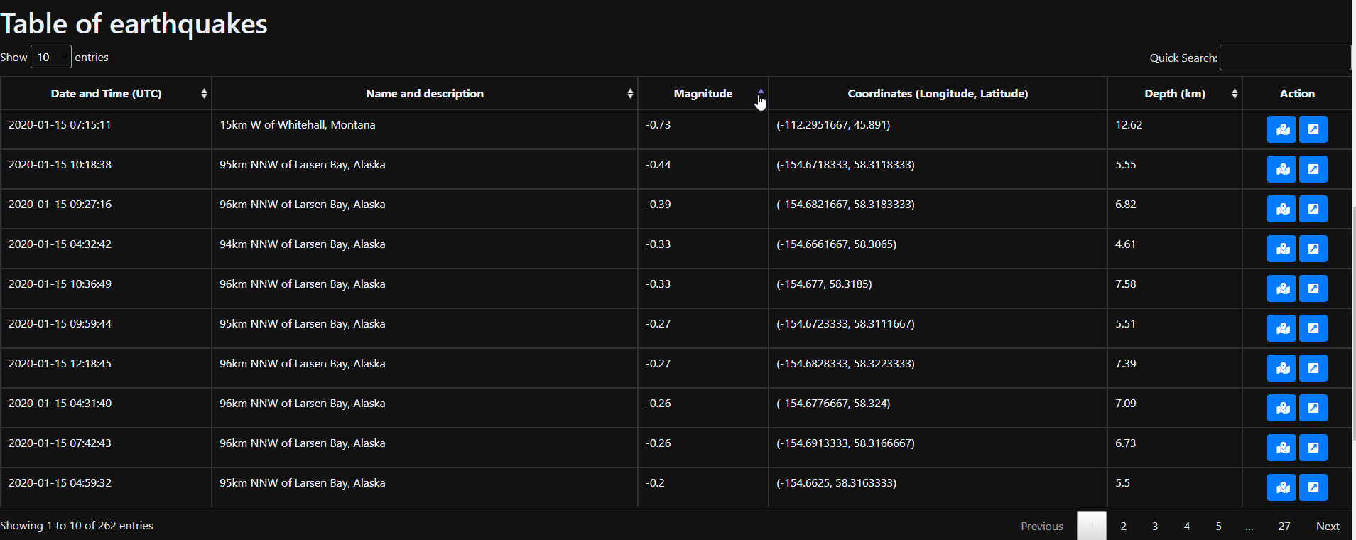

Figure 2.1: Data table.

The steps that will be used are as follows:

Get the file (xml or json) downloaded.

Extract wanted data (description, magnitude…) from the file.

Use the data to add table records through php.

### Xml

OOP approach will be used to reduce the amount of lines of codes. A function for xml url has been made as shown in the snippet below (Figure 2.2). This will gather the xml file from the url and save it in a variable $xml. With a “foreach” loop, the required variables will be retrieved and pass to a function “fillTable” which in its turn will build the html table records as shown in Figure 2.3.

$xml = @simplexml_load_file($this->url);

foreach ($xml->children()->children() as $event) {

    if (empty($event->description->text)) { //skip the one with empty data -- prevent wrong filling of datatable

        break;

    }

    $description = $event->description->text;

    $datetime =  strval(date("Y-m-d H:i:s", strtotime($event->origin->time->value))); // get the date in string and convert it to date

    $magnitude = $event->magnitude->mag->value;

    $longitude = $event->origin->longitude->value;

    $latitude = $event->origin->latitude->value;

    $depth = strval(((float)$event->origin->depth->value) / 1000); //convert to km

    $url_components = parse_url($event['publicID']); // convert the text into url

    parse_str($url_components['query'], $params); // store all queries in $params

    $url = 'https://earthquake.usgs.gov/earthquakes/eventpage/' . $params['eventid'];

    $this->fillTable($datetime, $description, $magnitude, $longitude, $latitude, $depth, $url);

}

Figure 2.2: xml function.

echo '

<tr>

    <td>' . $this->datetime . '</td>

    <td>' . $this->description . '</td>

    <td ' . $this->magnitude . '</td>

    <td>' . strval("($this->longitude, $this->latitude)") . '</td>

    <td>' . $this->depth . '</td>

    <td style="width: 100px;">

        <div style="text-align: center;">

            <button type="button"

            class="btn btn-primary"

            style="width: 40px;"

            data-toggle="modal"

            data-target="#myModal"

            data-lat=' . $this->latitude . '

            data-lng=' . $this->longitude . '

            title="open map ' . $this->description . '">

                <i class="fas fa-map-marked-alt"></i>

            </button>

            <button type="button"

            class="btn btn-primary"

            style="width: 40px;"

            title="Open details"

            onclick="location.href = \'' . $this->url . '\';">

                <i class="fa fa-external-link-square-alt"></i>

            </button>

        </div>

    </td>

</tr>

';

Figure 2.3: html record builder.

### Json

The use of oop has made this task easier. By just adding another function for the json file shown in Figure 2.4, the same output will be received as displayed in Figure 2.5.

$json = file_get_contents($this->url); //get the content in the json file

$data = json_decode($json, true); //get the json out of it and true to be able to use the key in the foreach loop

foreach ($data['features'] as $key => $value) { //key will return the position in the array

    $datetime = date("Y-m-d H:i:s", substr($data['features'][$key]['properties']['time'], 0, 10)); // get the date in string and convert it to date

    $description = $data['features'][$key]['properties']['place'];

    $magnitude = $data['features'][$key]['properties']['mag'];

    $longitude = $data['features'][$key]['geometry']['coordinates'][0];

    $latitude = $data['features'][$key]['geometry']['coordinates'][1];

    $depth = $data['features'][$key]['geometry']['coordinates'][2];

    $url = $data['features'][$key]['properties']['url'];

    $this->fillTable($datetime, $description, $magnitude, $longitude, $latitude, $depth, $url);

}

Figure 2.4: json function.



Figure 2.5: Data table outputted from xml and json.

## Additional functionalities

### Individual Map

On clicking on the map, there will be a modal with the map and the location as shown in Figure 2.6. The modal was made using java script as shown in Figure 2.7. When close, the map is destroyed completely and on the button click, the map is rebuild within the modal.

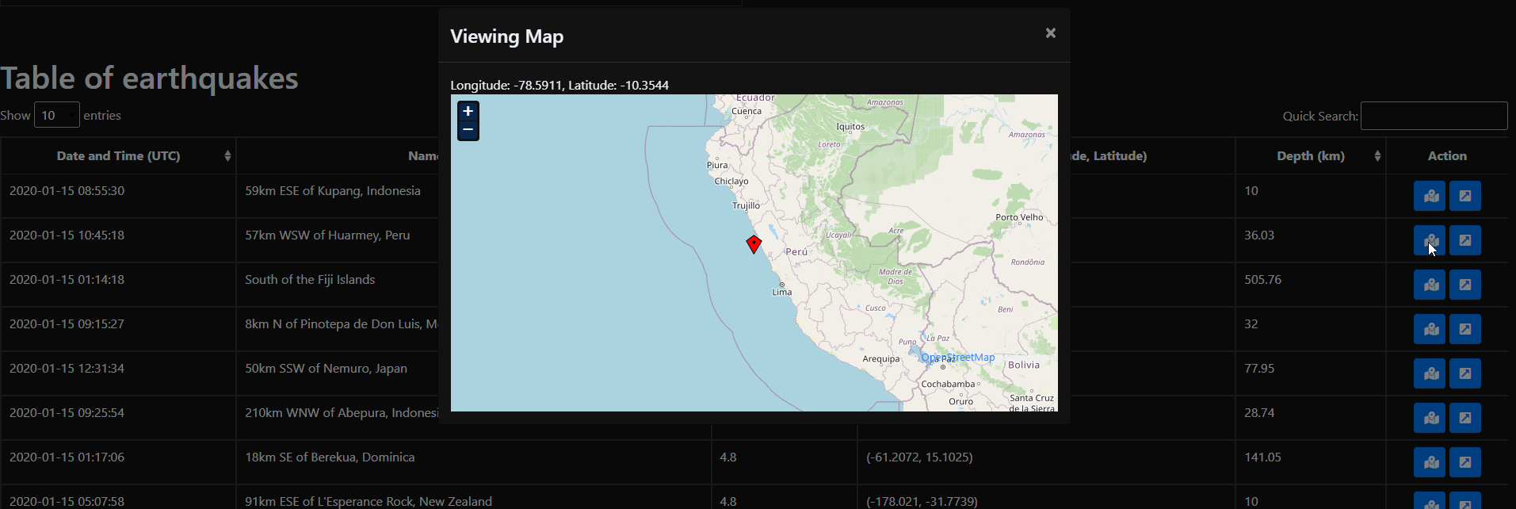

Figure 2.6: Individual modal map.

//start modal map

$(document).ready(function () {

    var map = null;

    function initializeGMap(lat, lon) {

        var zoom = 5;// set the zoom number from 1 to 19

        var fromProjection = new OpenLayers.Projection("EPSG:4326"); // Transform from WGS 1984

        var toProjection = new OpenLayers.Projection("EPSG:900913"); // to Spherical Mercator Projection

        var position = new OpenLayers.LonLat(lon, lat).transform(fromProjection, toProjection);

        map = new OpenLayers.Map("map_canvas");//get the map id

        var mapnik = new OpenLayers.Layer.OSM();

        map.addLayer(mapnik);

        var markers = new OpenLayers.Layer.Markers("Markers");

        map.addLayer(markers);

        markers.addMarker(new OpenLayers.Marker(position));

        map.setCenter(position, zoom);// mark the position and center the map on that position

    }

    // Re-init map before show modal

    $('#myModal').on('show.bs.modal', function (event) {

        var button = $(event.relatedTarget);

        initializeGMap(button.data('lat'), button.data('lng'));

        $("#location-map").css("width", "100%");

        $("#map_canvas").css("width", "100%");

        $("#bodyRow1").html("Longitude: " + button.data('lng') + ", Latitude: " + button.data('lat'));

    });

    $('#myModal').on('shown.bs.modal', function () {

        map.updateSize();//resize the map accordingly once open in modal

    });

    $('#myModal').on('hidden.bs.modal', function () {

        $("#map_canvas").html('');//remove the map from the div

    });

});

//end modal map

Figure 2.7: js individual modal map.

### World map

To accompany the whole data table a map is made with all the locations and markers as displayed in Figure 2.8. Figure 2.9 shows the approach to make the map. Js was used with openstreetmap. Why this map – because it is the most famous and well defined open source map available on the internet. There is even a wiki. The markers are received from php which has built a variable for the js as shown in Figure 2.10.

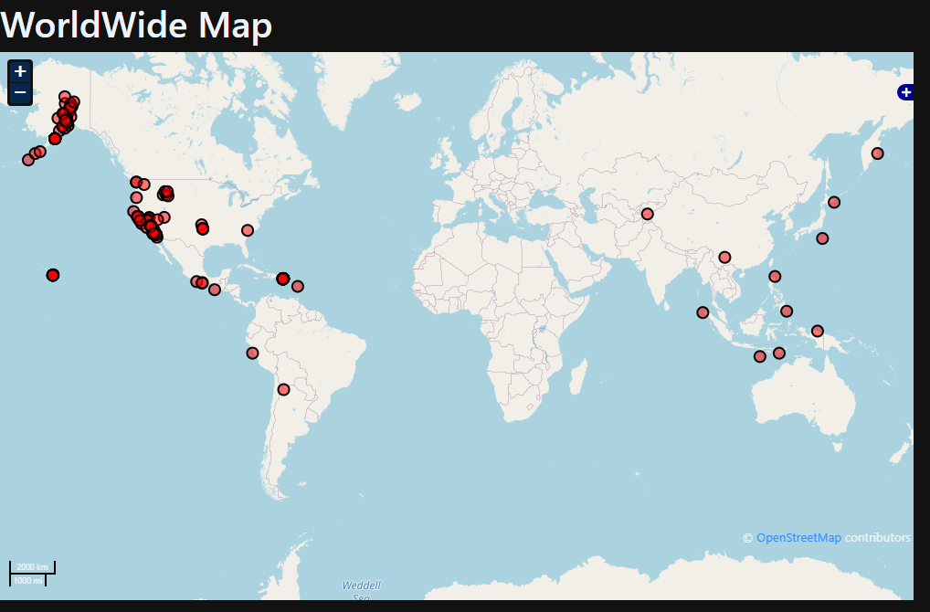

Figure 2.8: Worldwide map.

//start building big map

function detectQueryString() {

    var currentQueryString = window.location.search;

    if (currentQueryString) {

        return true;

    } else {

        return false;

    }

};

function bigMapBuilder() {

    epsg4326 = new OpenLayers.Projection("EPSG:4326")

    bmap = new OpenLayers.Map({

        div: "mapdiv",

        displayProjection: epsg4326 // With this setting, lat and lon are displayed correctly in MousePosition and permanent anchor

    });

    bmap.addLayer(new OpenLayers.Layer.OSM());

    bmap.addLayer(new OpenLayers.Layer.OSM("Wikimedia",

        ["https://maps.wikimedia.org/osm-intl/${z}/${x}/${y}.png"], {

        attribution: "&copy; <a href='http://www.openstreetmap.org/'>OpenStreetMap</a> and contributors, under an <a href='http://www.openstreetmap.org/copyright' title='ODbL'>open license</a>. <a href='https://www.mediawiki.org/wiki/Maps'>Wikimedia's new style (beta)</a>",

        "tileOptions": {

            "crossOriginKeyword": null

        }

    }));

    bmap.addControls([

        new OpenLayers.Control.MousePosition(),

        new OpenLayers.Control.ScaleLine(),

        new OpenLayers.Control.LayerSwitcher(),

        new OpenLayers.Control.Permalink({

            anchor: true

        })

    ]);

    projectTo = bmap.getProjectionObject(); //The map projection (Spherical Mercator)

    var lonLat = new OpenLayers.LonLat(8.0, 50.3).transform(epsg4326, projectTo);

    var zoom = 1;

    if (!bmap.getCenter()) {

        bmap.setCenter(lonLat, zoom);

    }

    var colorList = ["red"];

    var layerName = [markers[0][2]];

    var styleArray = [new OpenLayers.StyleMap({

        pointRadius: 6,

        fillColor: colorList[0],

        fillOpacity: 0.5

    })];

    var vectorLayer = [new OpenLayers.Layer.Vector(layerName[0], {

        styleMap: styleArray[0]

    })]; // First element defines first Layer

    var j = 0;

    for (var i = 1; i < markers.length; i++) {

        if (!layerName.includes(markers[i][2])) {

            j++;

            layerName.push(markers[i][2]); // If new layer name found it is created

            styleArray.push(new OpenLayers.StyleMap({

                pointRadius: 6,

                fillColor: colorList[j % colorList.length],

                fillOpacity: 0.5

            }));

            vectorLayer.push(new OpenLayers.Layer.Vector(layerName[j], {

                styleMap: styleArray[j]

            }));

        }

    }

    //Loop through the markers array

    for (var i = 0; i < markers.length; i++) {

        var lon = markers[i][0];

        var lat = markers[i][1];

        var feature = new OpenLayers.Feature.Vector(

            new OpenLayers.Geometry.Point(lon, lat).transform(epsg4326, projectTo), {

            description: "marker number " + i

        });

        vectorLayer[layerName.indexOf(markers[i][2])].addFeatures(feature);

    }

    for (var i = 0; i < layerName.length; i++) {

        bmap.addLayer(vectorLayer[i]);

    }

};

$(document).ready(function () {//build the big map only if there is a query in the url

    if (!detectQueryString()) {

        xmlCore();

    }

    bigMapBuilder();

});

//end building big map

Figure 2.9: Java script map.

$this->setMarkers($longitude, $latitude); //building js var

//echo the javascript markers variables

function getjsMarkers()

{

    echo "<script>var markers=[$this->markers];</script>";

}

//filling the variable markers

function setMarkers($longitude, $latitude)

{

    $this->markers = $this->markers . "[$longitude,$latitude],";

}

Figure 2.10: Java script markers variable outputted from php.

### Regional map

This regional map follow the same principle of the world map. A map to display a circular ranges of earthquakes. The query was 10000 km with the dates and location set and alert level set as shown in Figure 2.11. The regional map will be marked with a circular range as shown in Figure 2.12.

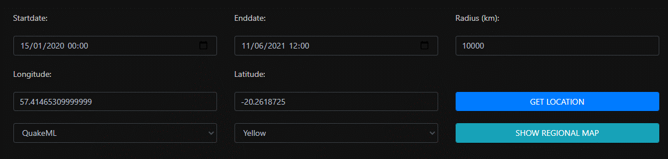

Figure 2.11: Query of region.

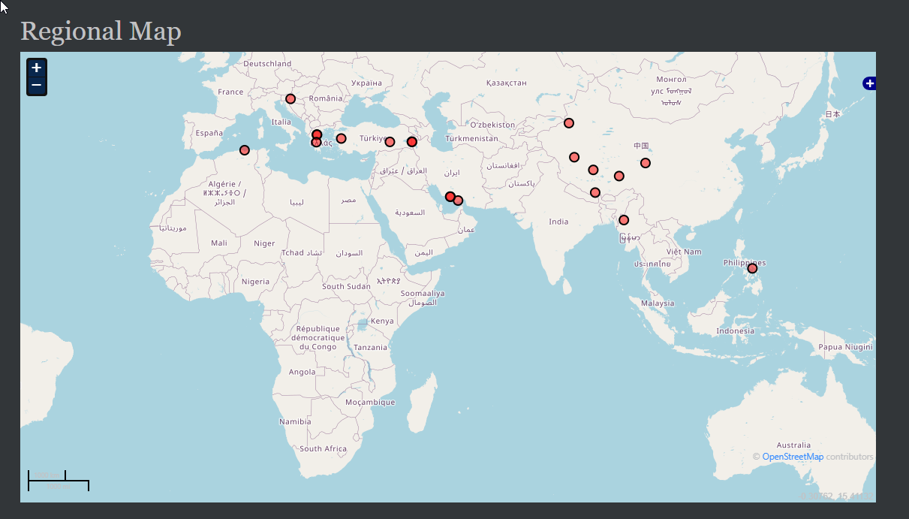

Figure 2.12: Result of regional map.

#### Get location

A button get current location is added rather than to let the user to find it on another site and insert it here. Figure 2.13 and Figure 2.14 show how the location is captured and fill the respective textboxes.

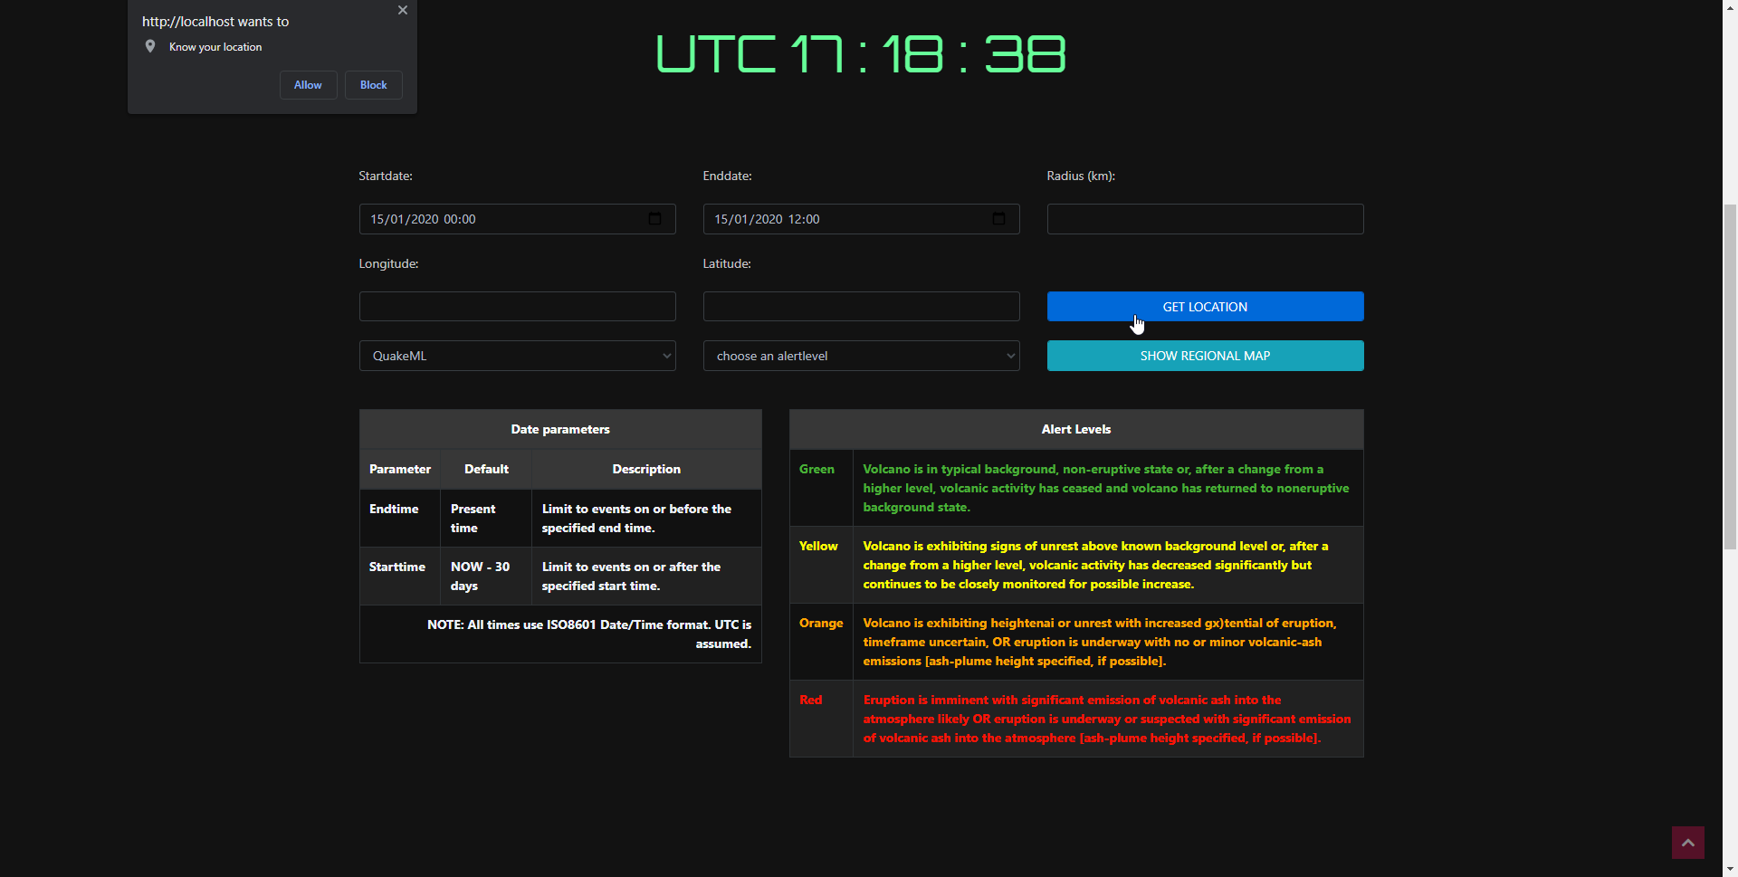

Figure 2.13: Java script to capture location.

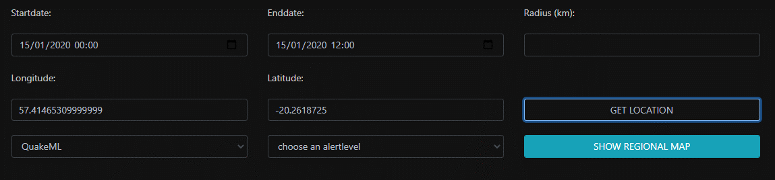

Figure 2.14: Java script fill elements.

### Highlight magnitude

To make the user more at ease with the gravity of the earthquake, colors are added to the magnitudes. This is done using a function (Figure 2.15) that will return a css class and then add the class to the respective magnitude as illustrated in Figure 2.16. The css file is now updated as shown in Figure 2.17.

//get the classes -- to help css

function earthquakeClass(string $value)

{

    // Class    Magnitude

    // Great    8 or more

    // Major    7 - 7.9

    // Strong   6 - 6.9

    // Moderate 5 - 5.9

    // Light    4 - 4.9

    // Minor    3 -3.9

    if ((int)$value >= 8) {

        return 'Great';

    } elseif ((int)$value == 7) {

        return 'Major';

    } elseif ((int)$value == 6) {

        return 'Strong';

    } elseif ((int)$value == 5) {

        return 'Moderate';

    } elseif ((int)$value == 4) {

        return 'Light';

    } elseif ((int)$value == 3) {

        return 'Minor';

    } else {

        return 'Negligible';

    }

}

Figure 2.15: Function to return css classes from magnitude values.

$highlightMagnitudeClasses = $this->earthquakeClass($this->magnitude);

echo '

<tr>

    <td>' . $this->datetime . '</td>

    <td>' . $this->description . '</td>

    <td class="' . $highlightMagnitudeClasses . '">' . $this->magnitude . '</td>

    <td>' . strval("($this->longitude, $this->latitude)") . '</td>

    <td>' . $this->depth . '</td>

    <td style="width: 100px;">

        <div style="text-align: center;">

            <button type="button"

            class="btn btn-primary"

            style="width: 40px;"

            data-toggle="modal"

            data-target="#myModal"

            data-lat=' . $this->latitude . '

            data-lng=' . $this->longitude . '

            title="open map ' . $this->description . '">

                <i class="fas fa-map-marked-alt"></i>

            </button>

            <button type="button"

            class="btn btn-primary"

            style="width: 40px;"

            title="Open details"

            onclick="location.href = \'' . $this->url . '\';">

                <i class="fa fa-external-link-square-alt"></i>

            </button>

        </div>

    </td>

</tr>

';

Figure 2.16: html record builder with css class.

/* css for tables */

.Moderate,

.Strong {

  color: orange;

}

.Moderate,

.Strong,

.Major,.BoldMe,

.Great {

  font-weight: bold;

}

.Major,

.Great {

  color: red;

}

th {text-align: center;}

Figure 2.17: css for magnitudes.

The code added has outputted the desired outcome as illustrated in the magnitude column in Figure 2.18.

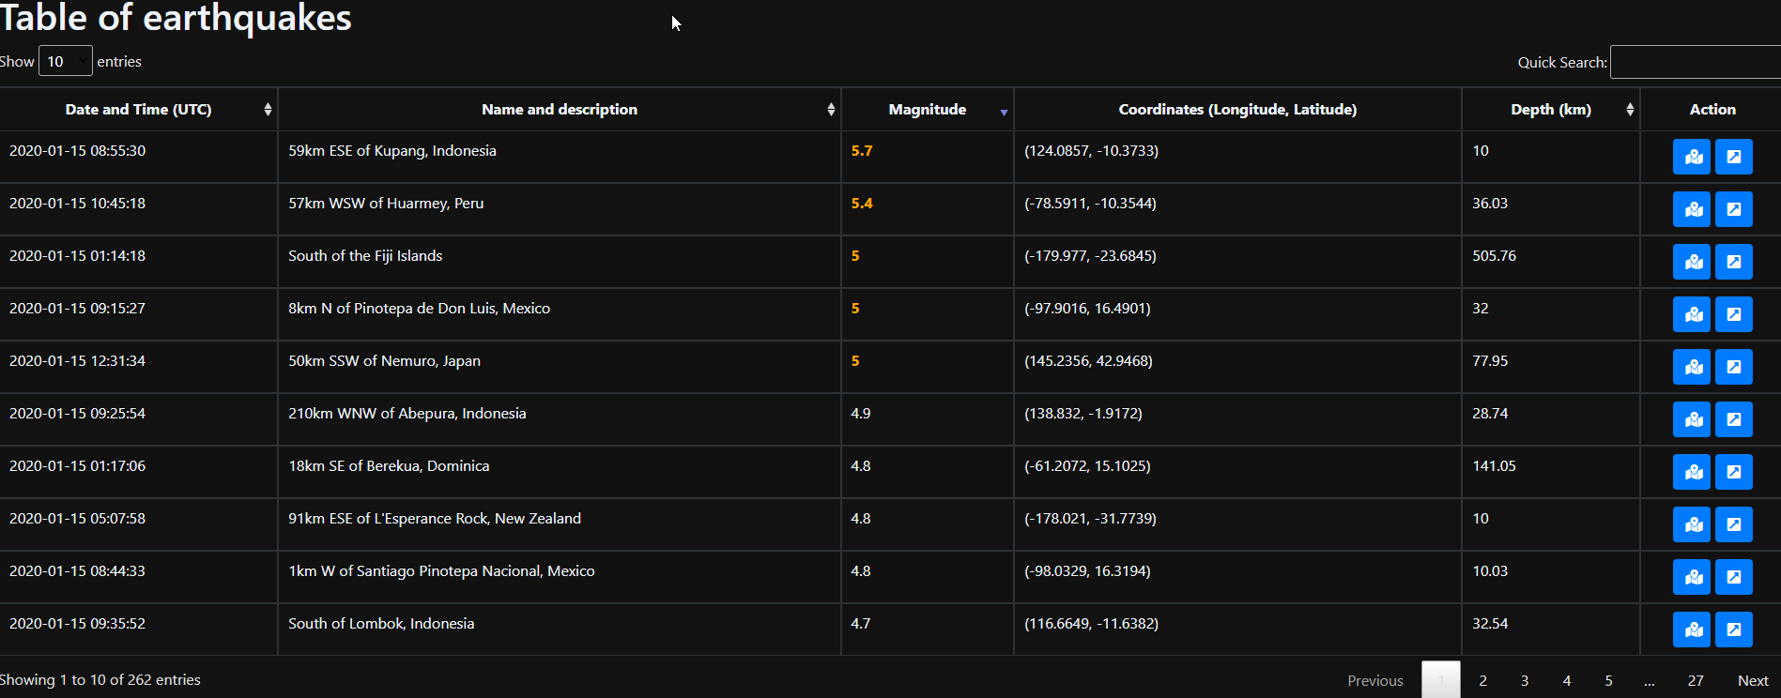

Figure 2.18: Output of highlights and css.

#### Legend of the highlighted magnitudes

A legend of the respective colors highlighted will help the user to make his/her choice while searching for earthquakes.

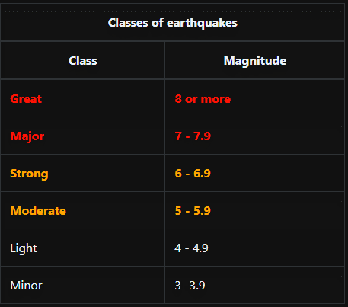

Figure 2.19: colors and magnitudes.

### Js url builder

Java script and jquery were used to build the url as per the user selected search. There are date time filter, format selector, and alert level selector.

#### Date and time filter

A date and time filter will help the user to pick up the wanted date rather than to insert it to the url. Both start and end dates are required to give the user the best experience as shown in Figure 2.20.

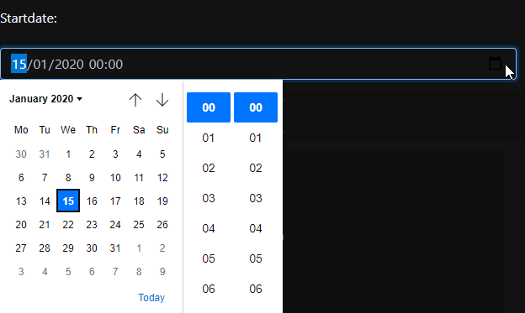

Figure 2.20: Date time picker.

#### Legend of the date parameters

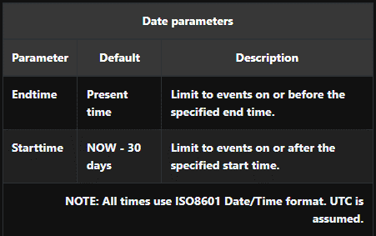

Figure 2.21: legend of the date parameters.

#### Digital UTC clock

As the time in the queried file (xml or json) uses UTC time, the user will have to edit his/her computer time. To avoid this, a clock is put on the website itself.

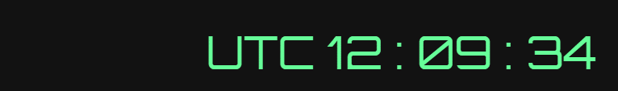

Figure 2.22: Digital clock.

//start clock

function currentTime() {

    var date = new Date(); // creating object of Date class

    var hour = date.getUTCHours();

    var min = date.getUTCMinutes();

    var sec = date.getUTCSeconds();

    hour = updateTime(hour);

    min = updateTime(min);

    sec = updateTime(sec);

    document.getElementById("clock").innerText = "UTC " + hour + " : " + min + " : " + sec; // adding time to the div

    var t = setTimeout(function () {

        currentTime()

    }, 1000); // setting timer

}

function updateTime(k) {

    if (k < 10) {

        return "0" + k;

    } else {

        return k;

    }

}

currentTime();

//end clock

Figure 2.23: Digital clock js code.

#### Format selector

This will make use of different format to query the server and get response in the respective format

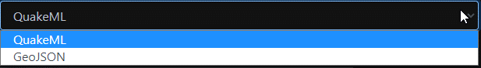

Figure 2.24: format selector.

#### Alert level selector

On selecting the alert it will display the power of the earthquakes

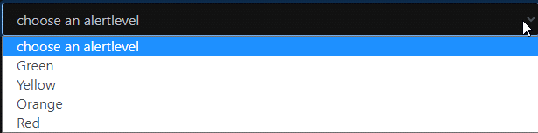

Figure 2.25: alert level selector.

#### Legend of the alert levels

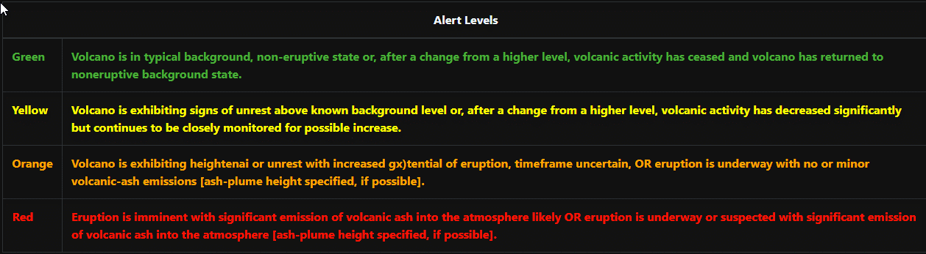

Figure 2.26: legend of the alert levels.

Once the search button is clicked, js will retrieving all the user information, and build the url then redirect to it.

function buildURL() {

    var output = window.location.pathname + "?url='https://earthquake.usgs.gov/fdsnws/event/1/query?";//build the initial url with the file.php followed by the query

    // get appropriate values from elements

    var format = $('#format').val();

    var starttime = $("#start_date").val();

    var endtime = $("#end_date").val();

    var longitude = $("#lon").val();

    var latitude = $("#lat").val();

    var maxradiuskm = $("#rad").val();

    var alertlevel = $('#alertlevel').val();

    var currenttime = new Date();

    //validation

    if ((Date.parse(starttime) > Date.parse(endtime)) || ((Date.parse(endtime) > Date.parse(currenttime)))) {//validation date

        alert("Invalid Date Range");

    } else if ((parseFloat(maxradiuskm) > 20001.6)) {// validation on the max radius

        alert("Invalid radius must be less than 20001.6");

    } else {// build the url

        output += "format=" + format;

        if (starttime) {

            output += "&starttime=" + starttime;

        }

        if (endtime) {

            output += "&endtime=" + endtime;

        }

        if (alertlevel) {

            output += "&alertlevel=" + alertlevel;

        }

        if (longitude) {

            output += "&longitude=" + longitude;

        }

        if (latitude) {

            output += "&latitude=" + latitude;

        }

        if ((maxradiuskm) && (longitude) && (latitude)) {

            output += "&maxradiuskm=" + maxradiuskm;

        }

        output += "'";//closing the url

        window.open(output, "_self");//open the url in the current tab

        //alert(output);

    }

}

Figure 2.27: js url builder.

### Fill elements

The use of js was use to fill each elements in the advance search

//start fill html elements

function fillElements() {

    var url = window.location.href;// get current url

    url = url.substring(url.indexOf('%27') + 0);//reject text before %27

    url = url.replaceAll('%27', '');//remove all %27

    url = new URL(url);//change text to url

    // get appropriate queries from url

    var format = url.searchParams.get("format");

    var starttime = url.searchParams.get("starttime");

    var endtime = url.searchParams.get("endtime");

    var alertlevel = url.searchParams.get("alertlevel");

    var longitude = url.searchParams.get("longitude");

    var latitude = url.searchParams.get("latitude");

    var maxradiuskm = url.searchParams.get("maxradiuskm");

    //set the elements with the appropriate values from the query

    $('#format').val(format);

    if (starttime) {

        $("#start_date").attr('value', starttime);

    }

    if (endtime) {

        $("#end_date").attr('value', endtime);

    }

    if (alertlevel) {

        $('#alertlevel').val(alertlevel);

    }

    if (longitude) {

        $("#lon").val(longitude);

    }

    if (latitude) {

        $("#lat").val(latitude);

    }

    if (maxradiuskm) {

        $("#rad").val(maxradiuskm);

    }

}

//end filling html elements

Figure 2.28: js html elements filler.

### Details

Once detail is clicked, other web page will open with all the details of that earth quake.

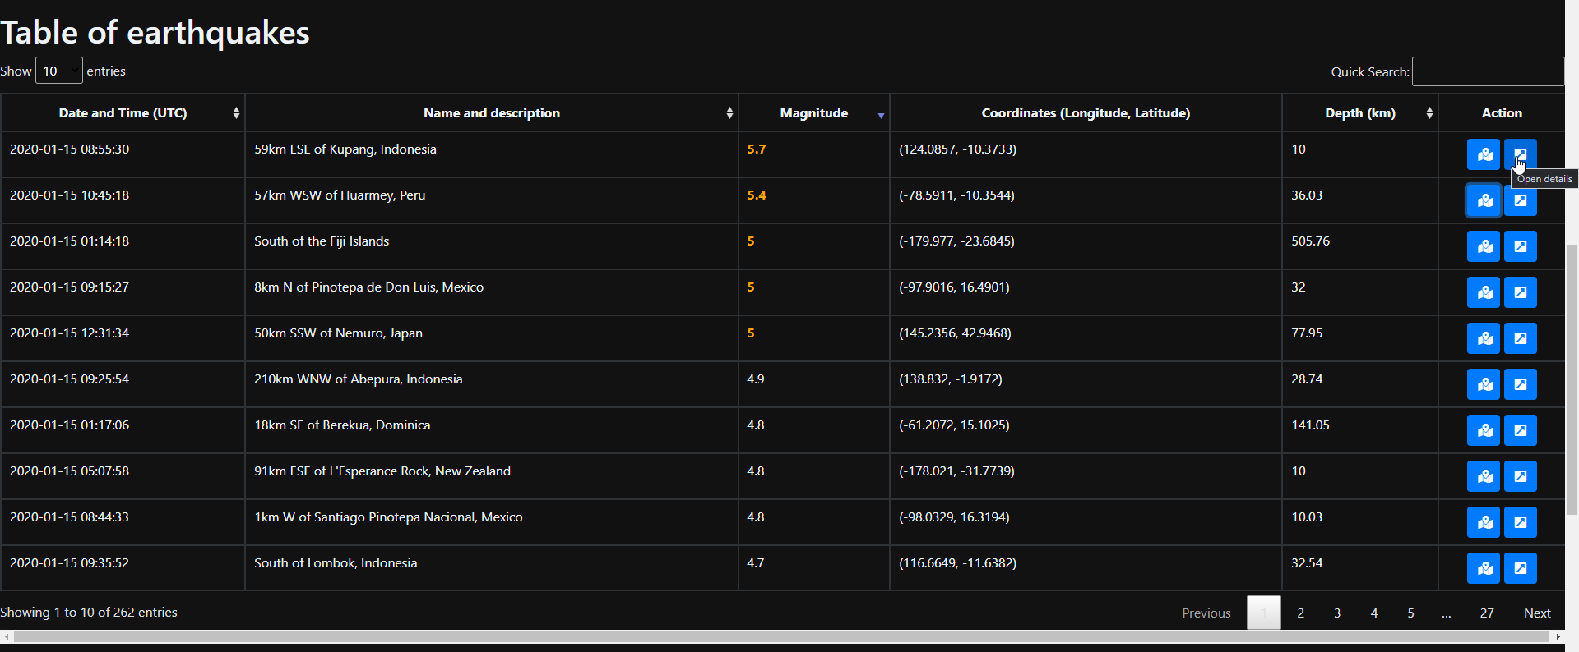

Figure 2.29: Details button.

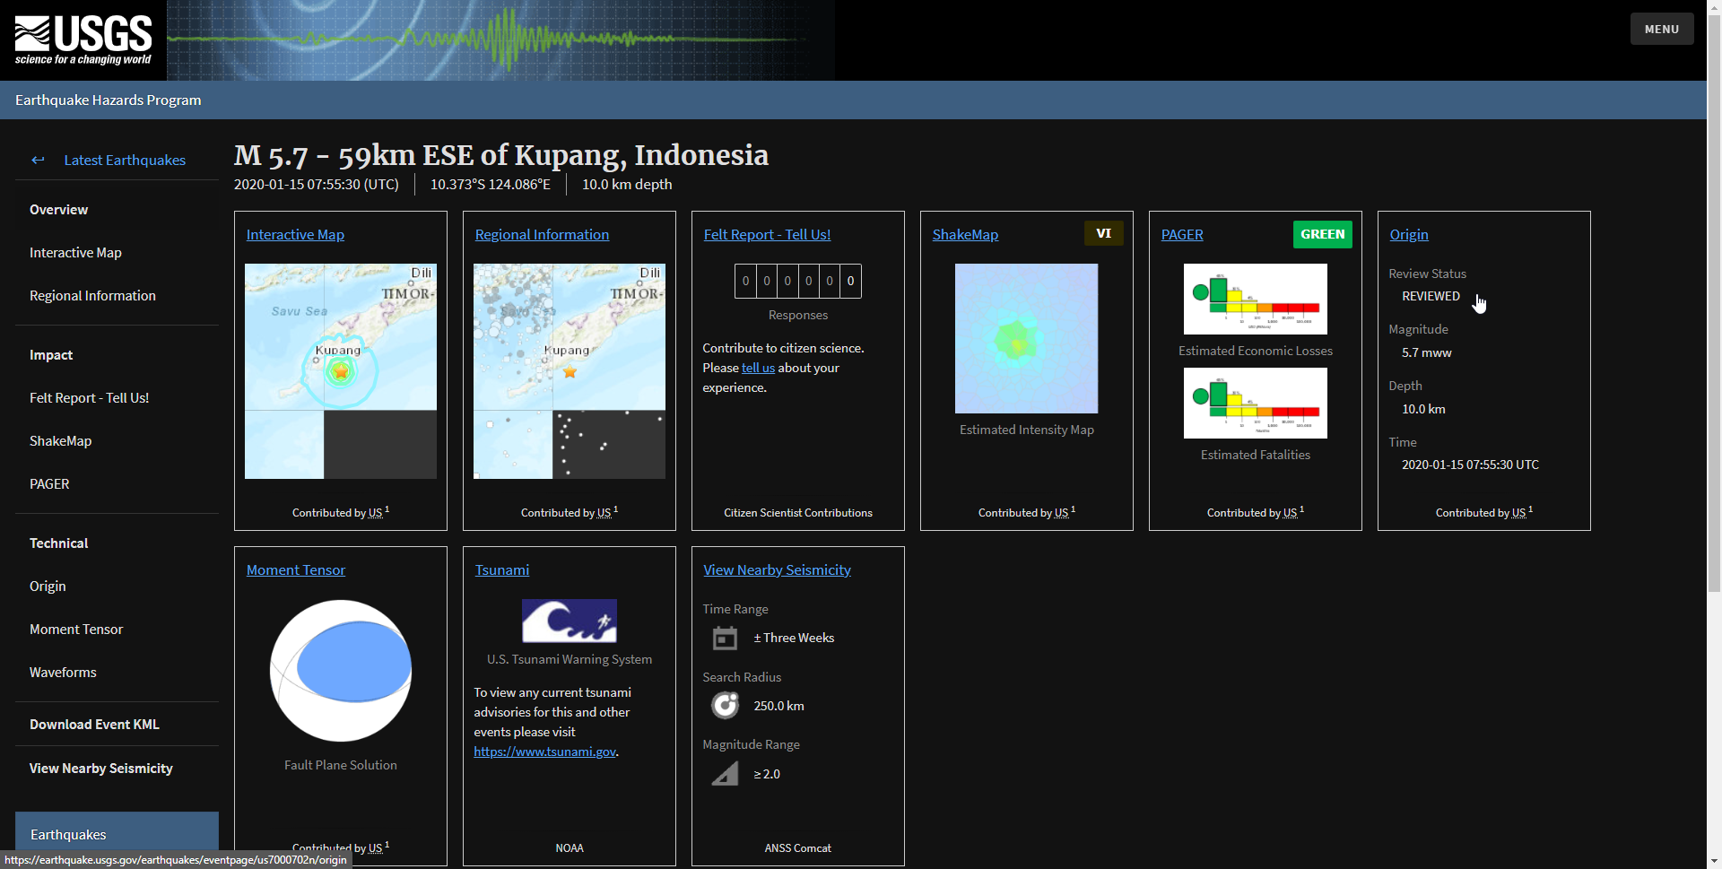

Figure 2.30: redirect to detailed page.

# Testing

## Home page

The page contains the elements discussed before.

|  |
| --- |
|  |
|  |
|  |
|  |

Figure 3.1: Home page.

Testing of the date range: the js outputted the invalid range if the start date exceed the end date.

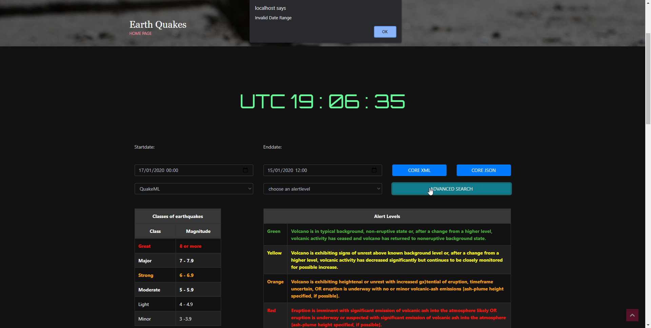

Figure 3.2: Testing of the date range.

The sorting was tested with different columns.

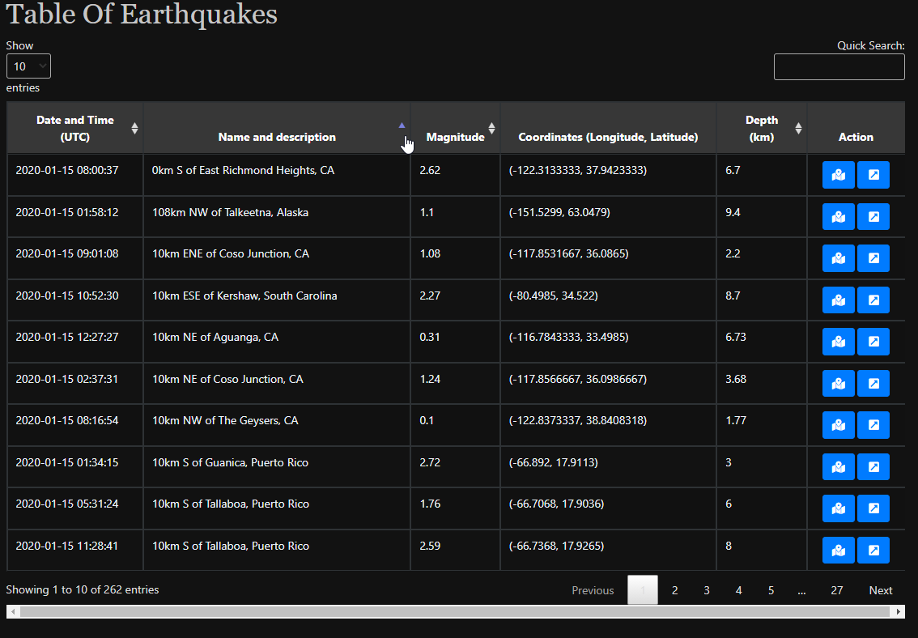

Figure 3.3: Testing of the data table sorting.

The testing of the on press the quick search

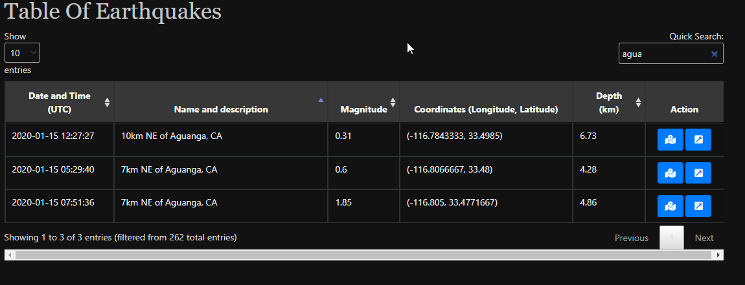

Figure 3.4: Testing of the data table search.

The worldwide map was tested the zoom works well and the movement of the map too.

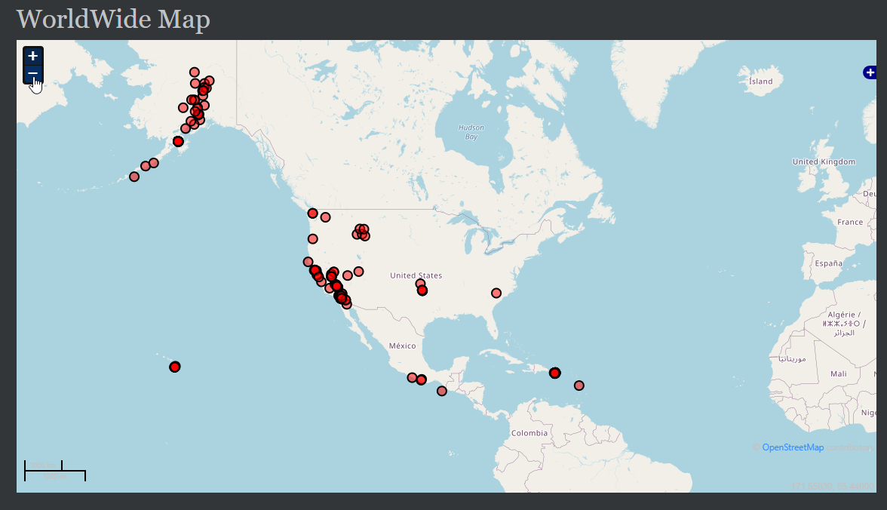

Figure 3.5: Testing of the world wide map.

## Regional page

The page contains the elements discussed before.

|  |
| --- |
|  |
|  |
|  |

Figure 3.6: Testing regional page.

Testing of button get location and other parameters

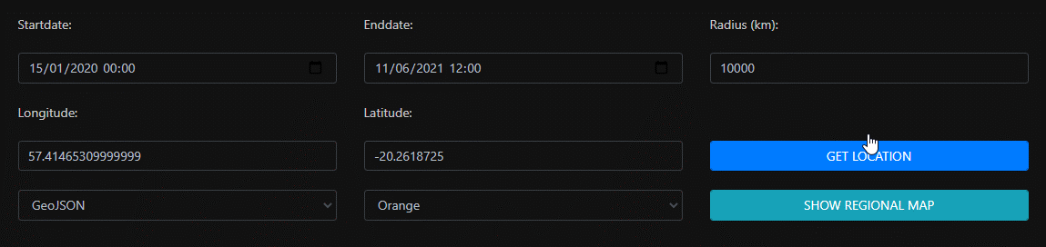

Figure 3.7: Testing of parameters in regional page.

The map works well as it follow the same worldwide map above.

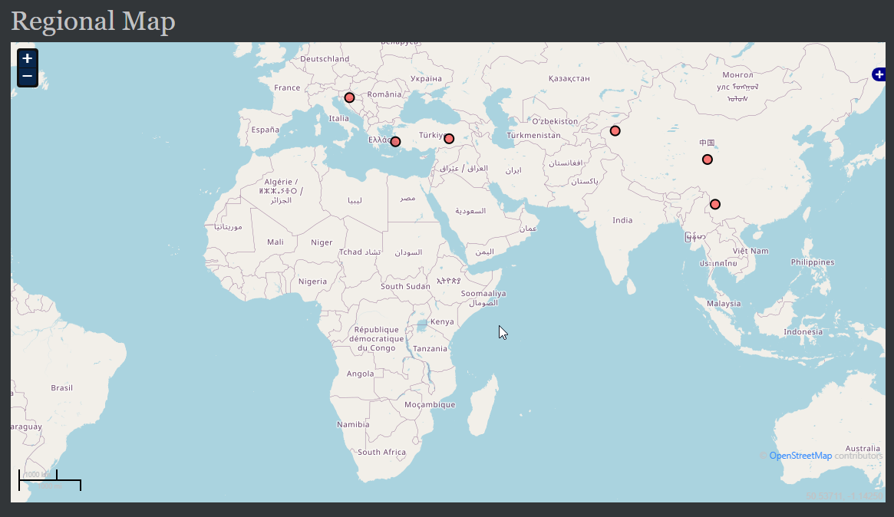

Figure 3.8: Testing of regional map.

# Conclusion

As seen in the Chapter 3: Testing, the whole project works well. As an improvement, a dot on the regional map could be inserted to indicate the location of the place the radius of earthquakes.

The link to GitHub file:

<https://github.com/Arouven/webservices>

Test it yourself:

<http://contacttracing.great-site.net/assignment_1_EarthQuakes/pages/index.php>

# Annex A: myjs.js

//start building big map

function detectQueryString() {

    var currentQueryString = window.location.search;

    if (currentQueryString) {

        return true;

    } else {

        return false;

    }

};

function bigMapBuilder() {

    epsg4326 = new OpenLayers.Projection("EPSG:4326")

    bmap = new OpenLayers.Map({

        div: "mapdiv",

        displayProjection: epsg4326 // With this setting, lat and lon are displayed correctly in MousePosition and permanent anchor

    });

    bmap.addLayer(new OpenLayers.Layer.OSM());

    bmap.addLayer(new OpenLayers.Layer.OSM("Wikimedia",

        ["https://maps.wikimedia.org/osm-intl/${z}/${x}/${y}.png"], {

        attribution: "&copy; <a href='http://www.openstreetmap.org/'>OpenStreetMap</a> and contributors, under an <a href='http://www.openstreetmap.org/copyright' title='ODbL'>open license</a>. <a href='https://www.mediawiki.org/wiki/Maps'>Wikimedia's new style (beta)</a>",

        "tileOptions": {

            "crossOriginKeyword": null

        }

    }));

    bmap.addControls([

        new OpenLayers.Control.MousePosition(),

        new OpenLayers.Control.ScaleLine(),

        new OpenLayers.Control.LayerSwitcher(),

        new OpenLayers.Control.Permalink({

            anchor: true

        })

    ]);

    projectTo = bmap.getProjectionObject(); //The map projection (Spherical Mercator)

    var lonLat = new OpenLayers.LonLat(8.0, 50.3).transform(epsg4326, projectTo);

    var zoom = 1;

    if (!bmap.getCenter()) {

        bmap.setCenter(lonLat, zoom);

    }

    var colorList = ["red"];

    var layerName = [markers[0][2]];

    var styleArray = [new OpenLayers.StyleMap({

        pointRadius: 6,

        fillColor: colorList[0],

        fillOpacity: 0.5

    })];

    var vectorLayer = [new OpenLayers.Layer.Vector(layerName[0], {

        styleMap: styleArray[0]

    })]; // First element defines first Layer

    var j = 0;

    for (var i = 1; i < markers.length; i++) {

        if (!layerName.includes(markers[i][2])) {

            j++;

            layerName.push(markers[i][2]); // If new layer name found it is created

            styleArray.push(new OpenLayers.StyleMap({

                pointRadius: 6,

                fillColor: colorList[j % colorList.length],

                fillOpacity: 0.5

            }));

            vectorLayer.push(new OpenLayers.Layer.Vector(layerName[j], {

                styleMap: styleArray[j]

            }));

        }

    }

    //Loop through the markers array

    for (var i = 0; i < markers.length; i++) {

        var lon = markers[i][0];

        var lat = markers[i][1];

        var feature = new OpenLayers.Feature.Vector(

            new OpenLayers.Geometry.Point(lon, lat).transform(epsg4326, projectTo), {

            description: "marker number " + i

        });

        vectorLayer[layerName.indexOf(markers[i][2])].addFeatures(feature);

    }

    for (var i = 0; i < layerName.length; i++) {

        bmap.addLayer(vectorLayer[i]);

    }

};

$(document).ready(function () {//build the big map only if there is a query in the url

    if (!detectQueryString()) {

        xmlCore();

    }

    bigMapBuilder();

});

//end building big map

//start datatables

$(document).ready(function () {

    $('#earthquakes1').dataTable({

        "columnDefs": [{//remove search on the last column

            "targets": -1,

            "searchable": false

        }, {//remove sorting on last and fourth column -- action and coordinates

            "targets": [-1, 3],

            "orderable": false,

        }],

        "oLanguage": {//rename search to quick search

            "sSearch": "Quick Search:"

        }

    });

});

//end datatables

//start modal map

$(document).ready(function () {

    var map = null;

    function initializeGMap(lat, lon) {

        var zoom = 5;// set the zoom number from 1 to 19

        var fromProjection = new OpenLayers.Projection("EPSG:4326"); // Transform from WGS 1984

        var toProjection = new OpenLayers.Projection("EPSG:900913"); // to Spherical Mercator Projection

        var position = new OpenLayers.LonLat(lon, lat).transform(fromProjection, toProjection);

        map = new OpenLayers.Map("map_canvas");//get the map id

        var mapnik = new OpenLayers.Layer.OSM();

        map.addLayer(mapnik);

        var markers = new OpenLayers.Layer.Markers("Markers");

        map.addLayer(markers);

        markers.addMarker(new OpenLayers.Marker(position));

        map.setCenter(position, zoom);// mark the position and center the map on that position

    }

    // Re-init map before show modal

    $('#myModal').on('show.bs.modal', function (event) {

        var button = $(event.relatedTarget);

        initializeGMap(button.data('lat'), button.data('lng'));

        $("#location-map").css("width", "100%");

        $("#map_canvas").css("width", "100%");

        $("#bodyRow1").html("Longitude: " + button.data('lng') + ", Latitude: " + button.data('lat'));

    });

    $('#myModal').on('shown.bs.modal', function () {

        map.updateSize();//resize the map accordingly once open in modal

    });

    $('#myModal').on('hidden.bs.modal', function () {

        $("#map_canvas").html('');//remove the map from the div

    });

});

//end modal map

//start url

function xmlCore() {// open the core functionality with the current tab and with the url below

    window.open(window.location.pathname + "?url='https://earthquake.usgs.gov/fdsnws/event/1/query?format=quakeml&starttime=2020-01-15T00:00:00&endtime=2020-01-15T12:00:00'", "_self");

}

function jsonCore() {// open the core functionality with the current tab and with the url below

    window.open(window.location.pathname + "?url='https://earthquake.usgs.gov/fdsnws/event/1/query?format=geojson&starttime=2020-01-15T00:00:00&endtime=2020-01-15T12:00:00'", "_self");

}

function buildURL() {

    var output = window.location.pathname + "?url='https://earthquake.usgs.gov/fdsnws/event/1/query?";//build the initial url with the file.php followed by the query

    // get appropriate values from elements

    var format = $('#format').val();

    var starttime = $("#start_date").val();

    var endtime = $("#end_date").val();

    var longitude = $("#lon").val();

    var latitude = $("#lat").val();

    var maxradiuskm = $("#rad").val();

    var alertlevel = $('#alertlevel').val();

    var currenttime = new Date();

    //validation

    if ((Date.parse(starttime) > Date.parse(endtime)) || ((Date.parse(endtime) > Date.parse(currenttime)))) {//validation date

        alert("Invalid Date Range");

    } else if ((parseFloat(maxradiuskm) > 20001.6)) {// validation on the max radius

        alert("Invalid radius must be less than 20001.6");

    } else {// build the url

        output += "format=" + format;

        if (starttime) {

            output += "&starttime=" + starttime;

        }

        if (endtime) {

            output += "&endtime=" + endtime;

        }

        if (alertlevel) {

            output += "&alertlevel=" + alertlevel;

        }

        if (longitude) {

            output += "&longitude=" + longitude;

        }

        if (latitude) {

            output += "&latitude=" + latitude;

        }

        if ((maxradiuskm) && (longitude) && (latitude)) {

            output += "&maxradiuskm=" + maxradiuskm;

        }

        output += "'";//closing the url

        window.open(output, "_self");//open the url in the current tab

        //alert(output);

    }

}

//end url

//start fill html elements

function fillElements() {

    var url = window.location.href;// get current url

    url = url.substring(url.indexOf('%27') + 0);//reject text before %27

    url = url.replaceAll('%27', '');//remove all %27

    url = new URL(url);//change text to url

    // get appropriate queries from url

    var format = url.searchParams.get("format");

    var starttime = url.searchParams.get("starttime");

    var endtime = url.searchParams.get("endtime");

    var alertlevel = url.searchParams.get("alertlevel");

    var longitude = url.searchParams.get("longitude");

    var latitude = url.searchParams.get("latitude");

    var maxradiuskm = url.searchParams.get("maxradiuskm");

    //set the elements with the appropriate values from the query

    $('#format').val(format);

    if (starttime) {

        $("#start_date").attr('value', starttime);

    }

    if (endtime) {

        $("#end_date").attr('value', endtime);

    }

    if (alertlevel) {

        $('#alertlevel').val(alertlevel);

    }

    if (longitude) {

        $("#lon").val(longitude);

    }

    if (latitude) {

        $("#lat").val(latitude);

    }

    if (maxradiuskm) {

        $("#rad").val(maxradiuskm);

    }

}

//end filling html elements

//start clock

function currentTime() {

    var date = new Date(); // creating object of Date class

    var hour = date.getUTCHours();

    var min = date.getUTCMinutes();

    var sec = date.getUTCSeconds();

    hour = updateTime(hour);

    min = updateTime(min);

    sec = updateTime(sec);

    document.getElementById("clock").innerText = "UTC " + hour + " : " + min + " : " + sec; // adding time to the div

    var t = setTimeout(function () {

        currentTime()

    }, 1000); // setting timer

}

function updateTime(k) {

    if (k < 10) {

        return "0" + k;

    } else {

        return k;

    }

}

currentTime();

//end clock

// start fill location

function getLocation() {

    if (navigator.geolocation) {

        navigator.geolocation.getCurrentPosition(showPosition);

    } else {

        alert("Geolocation is not supported by this browser.");

    }

}

function showPosition(position) {

    $('#lat').val(position.coords.latitude);

    $('#lon').val(position.coords.longitude);

}

// end fill location

# Annex B: mycss.css

/* css for the clock */

@import url('https://fonts.googleapis.com/css?family=Orbitron');

#clock {

  font-family: 'Orbitron', sans-serif;

  color: #66ff99;

  font-size: 56px;

  text-align: center;

  padding-top: 40px;

  padding-bottom: 40px;

}

/* css for tables */

.Moderate,

.Strong {

  color: orange;

}

.Moderate,

.Strong,

.Major,.BoldMe,

.Great {

  font-weight: bold;

}

.Major,

.Great {

  color: red;

}

th {text-align: center;}

# Annex C: display.php

<?php

include('multiplug.php');

class display

{

    private $url;

    private $markers;

    private $format;

    private $fillTable;

    //default constructor

    function __construct($format, $url, $fillTable = true)

    {

        $this->url = $url;

        $this->format = $format;

        $this->fillTable = $fillTable;

        if ($this->format == 'quakeml') {

            $this->xmlDisplay();

        } else if ($this->format == 'geojson') {

            $this->jsonDisplay();

        }

    }

    //runs when format is xml

    function xmlDisplay()

    {

        $xml = @simplexml_load_file($this->url); //prevent errors load the xmlfile in the simplexml plugin

        if (false !== $xml) { //remove errors

            if (isset($xml->eventParameters->event)) {

                if ($this->fillTable) { //if there is a datatable

                    foreach ($xml->children()->children() as $event) {

                        if (empty($event->description->text)) { //skip the one with empty data -- prevent wrong filling of datatable

                            break;

                        }

                        $description = $event->description->text;

                        $datetime =  strval(date("Y-m-d H:i:s", strtotime($event->origin->time->value))); // get the date in string and convert it to date

                        $magnitude = $event->magnitude->mag->value;

                        $longitude = $event->origin->longitude->value;

                        $latitude = $event->origin->latitude->value;

                        $depth = strval(((float)$event->origin->depth->value) / 1000); //convert to km

                        $url_components = parse_url($event['publicID']); // convert the text into url

                        parse_str($url_components['query'], $params); // store all queries in $params

                        $url = 'https://earthquake.usgs.gov/earthquakes/eventpage/' . $params['eventid'];

                        $this->fillTable($datetime, $description, $magnitude, $longitude, $latitude, $depth, $url);

                        $this->setMarkers($longitude, $latitude); //building js var

                    }

                } else { //no datatable to fill

                    foreach ($xml->children()->children() as $event) {

                        if (empty($event->description->text)) { //skip the one with empty data -- prevent wrong filling of coordinates

                            break;

                        }

                        $longitude = $event->origin->longitude->value;

                        $latitude = $event->origin->latitude->value;

                        $this->setMarkers($longitude, $latitude); //building js var

                    }

                }

                $this->getjsMarkers(); //output the js var that has been building

            }

        }

    }

    //runs when format is json

    function jsonDisplay()

    {

        $json = file_get_contents($this->url); //get the content in the json file

        $data = json_decode($json, true); //get the json out of it and true to be able to use the key in the foreach loop

        if ($this->fillTable) {

            foreach ($data['features'] as $key => $value) { //key will return the position in the array

                $datetime = date("Y-m-d H:i:s", substr($data['features'][$key]['properties']['time'], 0, 10)); // get the date in string and convert it to date

                $description = $data['features'][$key]['properties']['place'];

                $magnitude = $data['features'][$key]['properties']['mag'];

                $longitude = $data['features'][$key]['geometry']['coordinates'][0];

                $latitude = $data['features'][$key]['geometry']['coordinates'][1];

                $depth = $data['features'][$key]['geometry']['coordinates'][2];

                $url = $data['features'][$key]['properties']['url'];

                $this->fillTable($datetime, $description, $magnitude, $longitude, $latitude, $depth, $url);

                $this->setMarkers($longitude, $latitude); //building js var

            }

        } else {

            foreach ($data['features'] as $key => $value) { //key will return the position in the array

                $longitude = $data['features'][$key]['geometry']['coordinates'][0];

                $latitude = $data['features'][$key]['geometry']['coordinates'][1];

                $this->setMarkers($longitude, $latitude); //building js var

            }

        }

        $this->getjsMarkers(); //output the js var that has been building

    }

    //echo the javascript markers variables

    function getjsMarkers()

    {

        echo "<script>var markers=[$this->markers];</script>";

    }

    //filling the variable markers

    function setMarkers($longitude, $latitude)

    {

        $this->markers = $this->markers . "[$longitude,$latitude],";

    }

    //insert into table

    function fillTable($datetime, $description, $magnitude, $longitude, $latitude, $depth, $url)

    {

        new multiplug($datetime, $description, $magnitude, $longitude, $latitude, $depth, $url);

    }

}

# Annex D: multiplug.php

<?php

class multiplug

{

    private string $datetime;

    private string $description;

    private string $magnitude;

    private string $longitude;

    private string $latitude;

    private string $depth;

    private string $url;

    //default constructor

    function __construct($datetime, $description, $magnitude, $longitude, $latitude, $depth, $url)

    {

        $this->datetime = $datetime;

        $this->description = $description;

        $this->magnitude = $magnitude;

        $this->longitude = $longitude;

        $this->latitude = $latitude;

        $this->depth = $depth;

        $this->url = $url;

        $this->outputting();

    }

    //get the classes -- to help css

    function earthquakeClass(string $value)

    {

        // Class    Magnitude

        // Great    8 or more

        // Major    7 - 7.9

        // Strong   6 - 6.9

        // Moderate 5 - 5.9

        // Light    4 - 4.9

        // Minor    3 -3.9

        if ((int)$value >= 8) {

            return 'Great';

        } elseif ((int)$value == 7) {

            return 'Major';

        } elseif ((int)$value == 6) {

            return 'Strong';

        } elseif ((int)$value == 5) {

            return 'Moderate';

        } elseif ((int)$value == 4) {

            return 'Light';

        } elseif ((int)$value == 3) {

            return 'Minor';

        } else {

            return 'Negligible';

        }

    }

    //insert records in tables

    function outputting()

    {

        $highlightMagnitudeClasses = $this->earthquakeClass($this->magnitude);

        echo '

        <tr>

            <td>' . $this->datetime . '</td>

            <td>' . $this->description . '</td>

            <td class="' . $highlightMagnitudeClasses . '">' . $this->magnitude . '</td>

            <td>' . strval("($this->longitude, $this->latitude)") . '</td>

            <td>' . $this->depth . '</td>

            <td style="width: 100px;">

                <div style="text-align: center;">

                    <button type="button"

                    class="btn btn-primary"

                    style="width: 40px;"

                    data-toggle="modal"

                    data-target="#myModal"

                    data-lat=' . $this->latitude . '

                    data-lng=' . $this->longitude . '

                    title="open map ' . $this->description . '">

                        <i class="fas fa-map-marked-alt"></i>

                    </button>

                    <button type="button"

                    class="btn btn-primary"

                    style="width: 40px;"

                    title="Open details"

                    onclick="location.href = \'' . $this->url . '\';">

                        <i class="fa fa-external-link-square-alt"></i>

                    </button>

                </div>

            </td>

        </tr>

        ';

    }

}

# Annex E: index.php

<!DOCTYPE html>

<!--

Template Name: Wavefire

Author: <a href="https://www.os-templates.com/">OS Templates</a>

Author URI: https://www.os-templates.com/

Copyright: OS-Templates.com

Licence: Free to use under our free template licence terms

Licence URI: https://www.os-templates.com/template-terms

-->

<html lang="en">

<!-- To declare your language - read more here: https://www.w3.org/International/questions/qa-html-language-declarations -->

<head>

  <title>EarthQuakes | Home Page</title>

  <meta charset="utf-8">

  <meta name="viewport" content="width=device-width, initial-scale=1.0, maximum-scale=1.0, user-scalable=no">

  <link href="../layout/styles/layout.css" rel="stylesheet" type="text/css" media="all">

  <link href="../fontawesome-free-5.15.3-web/css/all.css" rel="stylesheet">

  <link href="../bootstrap/4.3.1/css/bootstrap.min.css" rel="stylesheet">

  <link href="../datatables/1.10.24/css/jquery.dataTables.min.css" rel="stylesheet">

  <link href="../layout/styles/mycss.css" rel="stylesheet">

</head>

<!-- when the body load fill the elements with the appropriate details such as date time alertlevel format... -->

<body id="top" onload="fillElements();">

  <!-- ################################################################################################ -->

  <!-- ################################################################################################ -->

  <!-- ################################################################################################ -->

  <div class="wrapper row0">

    <header id="header" class="hoc clear">

      <!-- ################################################################################################ -->

      <div id="logo" class="one_quarter first">

        <h1><a href="index.php"><span>E</span>arth<span>Q</span>uakes</a></h1>

      </div>

      <div class="three_quarter">

        <ul class="nospace clear">

          <li class="one_third first">

            <div class="block clear"><a href="#"><i class="fas fa-phone"></i></a> <span><strong>Give us a call:</strong> +00 (123) 456 7890</span></div>

          </li>

          <li class="one_third">

            <div class="block clear"><a href="#"><i class="fas fa-envelope"></i></a> <span><strong>Send us a mail:</strong> support@domain.com</span></div>

          </li>

          <li class="one_third">

            <div class="block clear"><a href="#"><i class="fas fa-clock"></i></a> <span><strong> Mon. - Sat.:</strong> 08.00am - 18.00pm</span></div>

          </li>

        </ul>

      </div>

      <!-- ################################################################################################ -->

    </header>

  </div>

  <!-- ################################################################################################ -->

  <!-- ################################################################################################ -->

  <!-- ################################################################################################ -->

  <div class="wrapper row1">

    <section class="hoc clear">

      <!-- ################################################################################################ -->

      <nav id="mainav">

        <ul class="clear">

          <li><a href="index.php">Home Page</a></li>

          <li><a href="regional.php">Regional EarthQuakes</a></li>

          <li class="active"><a class="drop" href="#">Pages</a>

            <ul>

              <li class="active"><a href="index.php">Home Page</a></li>

              <li><a href="regional.php">Regional EarthQuakes</a></li>

            </ul>

          </li>

        </ul>

      </nav>

      <!-- ################################################################################################ -->

      <div id="searchform">

        <div>

          <form action="#" method="post">

            <fieldset>

              <legend>Quick Search:</legend>

              <input type="text" placeholder="Enter search term&hellip;">

              <button type="submit"><i class="fas fa-search"></i></button>

            </fieldset>

          </form>

        </div>

      </div>

      <!-- ################################################################################################ -->

    </section>

  </div>

  <!-- ################################################################################################ -->

  <!-- ################################################################################################ -->

  <!-- ################################################################################################ -->

  <div class="wrapper bgded overlay" style="background-image:url('../images/demo/backgrounds/01.png');">

    <div id="breadcrumb" class="hoc clear">

      <!-- ################################################################################################ -->

      <h6 class="heading">Earth Quakes</h6>

      <ul>

        <li><a href="#">Home Page</a></li>

      </ul>

      <!-- ################################################################################################ -->

    </div>

  </div>

  <!-- ################################################################################################ -->

  <!-- ################################################################################################ -->

  <!-- ################################################################################################ -->

  <div class="wrapper row3">

    <main class="hoc container clear">

      <!-- main body -->

      <!-- ################################################################################################ -->

      <div class="content">

        <!-- ################################################################################################ -->

        <div class="row">

          <div class="col-sm-2">

          </div>

          <div class="col-sm-8">

            <div id="clock"></div>

          </div>

        </div>

        <br>

        <br>

        <div class="row">

          <div class="col-sm-4">

            Startdate:

          </div>

          <div class="col-sm-4">

            Enddate:

          </div>

          <div class="col-sm-4">

          </div>

        </div>

        <br>

        <br>

        <div class="row">

          <div class="col-sm-4">

            <input type="datetime-local" value="" name="start_date" id="start_date" class="form-control">

            <span class="add-on"><i class="icon-remove"></i></span>

            <span class="add-on"><i class="icon-th"></i></span>

          </div>

          <div class="col-sm-4">

            <input type="datetime-local" value="" name="end_date" id="end_date" class="form-control">

            <span class="add-on"><i class="icon-remove"></i></span>

            <span class="add-on"><i class="icon-th"></i></span>

          </div>

          <div class="col-sm-2">

            <button onclick='xmlCore();' class="btn btn-primary form-control">core xml</button>

          </div>

          <div class="col-sm-2">

            <button onclick='jsonCore();' class="btn btn-primary form-control">core json</button>

          </div>

        </div>

        <br>

        <div class="row">

          <div class="col-sm-4">

            <select name="format" id="format" class="form-control">

              <option value="quakeml">QuakeML</option>

              <option value="geojson">GeoJSON</option>

            </select>

          </div>

          <div class="col-sm-4">

            <select name="alertlevel" id="alertlevel" class="form-control">

              <option value="">choose an alertlevel</option>

              <option value="green">Green</option>

              <option value="yellow">Yellow</option>

              <option value="orange">Orange</option>

              <option value="red">Red</option>

            </select>

          </div>

          <div class="col-sm-4">

            <!--on click the js will build the url and then request the server -->

            <input type="button" name="search" id="search" value="Advanced Search" class="btn btn-info form-control" onclick="buildURL();" />

          </div>

        </div>

        <br>

        <br>

        <!-- legend tables -->

        <div class="legend">

          <div class="row">

            <div class="col-sm-3">

              <div class="colorCode">

                <table class="table table-bordered table-striped">

                  <thead>

                    <tr>

                      <th colspan="2">Classes of earthquakes</th>

                    </tr>

                    <tr>

                      <th>Class</th>

                      <th>Magnitude</th>

                    </tr>

                  </thead>

                  <tbody>

                    <tr class="Great">

                      <td>Great</td>

                      <td>8 or more</td>

                    </tr>

                    <tr class="Major">

                      <td>Major</td>

                      <td>7 - 7.9</td>

                    </tr>

                    <tr class="Strong">

                      <td>Strong</td>

                      <td>6 - 6.9</td>

                    </tr>

                    <tr class="Moderate">

                      <td>Moderate</td>

                      <td>5 - 5.9</td>

                    </tr>

                    <tr class="Light">

                      <td>Light</td>

                      <td>4 - 4.9</td>

                    </tr>

                    <tr class="Minor">

                      <td>Minor</td>

                      <td>3 -3.9</td>

                    </tr>

                  </tbody>

                </table>

              </div>

            </div>

            <div class="col-sm-1"></div>

            <div class="col-sm-8">

              <div class="colorCode">

                <table class="table table-bordered table-striped">

                  <thead>

                    <tr>

                      <th colspan="2">Alert Levels</th>

                    </tr>

                  </thead>

                  <tbody>

                    <tr style="color:green;" class="BoldMe">

                      <td>Green</td>

                      <td>Volcano is in typical background, non-eruptive state or, after a change from a higher level, volcanic activity has ceased and volcano has returned to noneruptive background state.</td>

                    </tr>

                    <tr style="color:yellow;" class="BoldMe">

                      <td>Yellow</td>

                      <td>Volcano is exhibiting signs of unrest above known background level or, after a change from a higher level, volcanic activity has decreased significantly but continues to be closely monitored for possible increase.</td>

                    </tr>

                    <tr style="color:orange;" class="BoldMe">

                      <td>Orange</td>

                      <td>Volcano is exhibiting heightenai or unrest with increased gx)tential of eruption, timeframe uncertain, OR eruption is underway with no or minor volcanic-ash emissions [ash-plume height specified, if possible].</td>

                    </tr>

                    <tr style="color:red;" class="BoldMe">

                      <td>Red</td>

                      <td>Eruption is imminent with significant emission of volcanic ash into the atmosphere likely OR eruption is underway or suspected with significant emission of volcanic ash into the atmosphere [ash-plume height specified, if possible].</td>

                    </tr>

                  </tbody>

                </table>

              </div>

            </div>

          </div>

          <div class="row">

            <div class="col-sm-3">

            </div>

            <div class="dateCode col-sm-6">

              <table class="table table-bordered table-striped">

                <thead>

                  <tr>

                    <th colspan="3">Date parameters</th>

                  </tr>

                  <tr>

                    <th>Parameter</th>

                    <th>Default</th>

                    <th>Description</th>

                  </tr>

                </thead>

                <tbody>

                  <tr class="BoldMe">

                    <td>Endtime</td>

                    <td>Present time</td>

                    <td>Limit to events on or before the specified end time.</td>

                  </tr>

                  <tr class="BoldMe">

                    <td>Starttime</td>

                    <td>NOW - 30 days</td>

                    <td>Limit to events on or after the specified start time.</td>

                  </tr>

                  <tr class="BoldMe">

                    <td colspan="3" style="text-align: right;">NOTE: All times use ISO8601 Date/Time format. UTC is assumed.</td>

                  </tr>

                </tbody>

              </table>

            </div>

          </div>

        </div>

        <br>

        <br>

        <!-- main table  -->

        <h1>Table of earthquakes</h1>

        <div class="scrollable">

          <div class="table-responsive">

            <table id="earthquakes1" class="table table-bordered table-striped">

              <thead>

                <tr>

                  <th>Date and Time (UTC)</th>

                  <th>Name and description</th>

                  <th>Magnitude</th>

                  <th>Coordinates (Longitude, Latitude)</th>

                  <th>Depth (km)</th>

                  <th>Action</th>

                </tr>

              </thead>

              <tbody>

                <?php

                require('../php_files/display.php'); // allow to use the display class

                if ($_SERVER["QUERY_STRING"] != null) { // check if there is any query in the url

                  $url = trim($_SERVER["QUERY_STRING"]); // remove unwanted white spaces

                  $url = strstr($url, '%27'); // keep the text as from %27 till the end

                  $url = str_replace("%27", "", $url); // remove the %27 in the url

                  // Use parse_url() function to parse the URL

                  // and return an associative array which

                  // contains its various components

                  $url_components = parse_url($url); // convert the text into url

                  // Use parse_str() function to parse the

                  // string passed via URL

                  parse_str($url_components['query'], $params); // store all queries in $params

                  new display($params['format'], $url); //create the display with the constructors parameters

                }

                ?>

              </tbody>

            </table>

          </div>

        </div>

        <br>

        <br>

        <!-- Modal -->

        <div class="modal fade" id="myModal" tabindex="-1" role="dialog" aria-labelledby="myModalLabel">

          <div class="modal-dialog modal-lg" role="document">

            <div class="modal-content">

              <div class="modal-header">

                <h4 class="modal-title" id="myModalLabel">Viewing Map</h4>

                <button type="button" class="close" data-dismiss="modal" aria-label="Close"><span aria-hidden="true">&times;</span></button>

              </div>

              <div class="modal-body">

                <div class="row">

                  <div class="col-md-12 modal_body_content" id="bodyRow1">

                  </div>

                </div>

                <div class="row">

                  <div class="col-md-12 modal_body_map">

                    <div class="location-map" id="location-map">

                      <div style="width: 600px; height: 400px;" id="map_canvas">

                      </div>

                    </div>

                  </div>

                </div>

              </div>

            </div>

          </div>

        </div>

        <!-- ################################################################################################ -->

      </div>

      <!-- ################################################################################################ -->

      <!-- / main body -->

      <div class="clear"></div>

    </main>

  </div>

  <!-- ################################################################################################ -->

  <!-- ################################################################################################ -->

  <!-- ################################################################################################ -->

  <div class="wrapper row4">

    <footer id="footer" class="hoc clear">

      <!-- ################################################################################################ -->

      <h1>WorldWide Map</h1>

      <div id="mapdiv" style="max-width:100%; height: 600px;"></div>

      <!-- ################################################################################################ -->

    </footer>

  </div>

  <!-- ################################################################################################ -->

  <!-- ################################################################################################ -->

  <!-- ################################################################################################ -->

  <div class="wrapper row5">

    <div id="copyright" class="hoc clear">

      <!-- ################################################################################################ -->

      <p class="fl_left">Copyright &copy; 2018 - All Rights Reserved - <a href="#">Domain Name</a></p>

      <p class="fl_right">Template by <a target="_blank" href="https://www.os-templates.com/" title="Free Website Templates">OS Templates</a></p>

      <!-- ################################################################################################ -->

    </div>

  </div>

  <!-- ################################################################################################ -->

  <!-- ################################################################################################ -->

  <!-- ################################################################################################ -->

  <a id="backtotop" href="#top"><i class="fas fa-chevron-up"></i></a>

  <!-- JAVASCRIPTS -->

  <script src="../layout/scripts/jquery-3.5.1.min.js"></script>

  <!-- <script src="../layout/scripts/jquery.min.js"></script> -->

  <script src="../layout/scripts/jquery.backtotop.js"></script>

  <script src="../layout/scripts/jquery.mobilemenu.js"></script>

  <script src="../bootstrap/4.3.1/js/bootstrap.min.js"></script>

  <script src="../datatables/1.10.24/js/jquery.dataTables.min.js"></script>

  <script src="http://www.openlayers.org/api/OpenLayers.js"></script>

  <script src="../layout/scripts/myjs.js"></script>

</body>

</html>

# Annex F: regional.php

<!DOCTYPE html>

<!--

Template Name: Wavefire

Author: <a href="https://www.os-templates.com/">OS Templates</a>

Author URI: https://www.os-templates.com/

Copyright: OS-Templates.com

Licence: Free to use under our free template licence terms

Licence URI: https://www.os-templates.com/template-terms

-->

<html lang="en">

<!-- To declare your language - read more here: https://www.w3.org/International/questions/qa-html-language-declarations -->

<head>

    <title>EarthQuakes | Regional</title>

    <meta charset="utf-8">

    <meta name="viewport" content="width=device-width, initial-scale=1.0, maximum-scale=1.0, user-scalable=no">

    <link href="../layout/styles/layout.css" rel="stylesheet" type="text/css" media="all">

    <link href="../fontawesome-free-5.15.3-web/css/all.css" rel="stylesheet">

    <link href="../bootstrap/4.3.1/css/bootstrap.min.css" rel="stylesheet">

    <link href="../datatables/1.10.24/css/jquery.dataTables.min.css" rel="stylesheet">

    <link href="../layout/styles/mycss.css" rel="stylesheet">

</head>

<!-- when the body load fill the elements with the appropriate details such as date time alertlevel format... -->

<body id="top" onload="fillElements();">

    <!-- ################################################################################################ -->

    <!-- ################################################################################################ -->

    <!-- ################################################################################################ -->

    <div class="wrapper row0">

        <header id="header" class="hoc clear">

            <!-- ################################################################################################ -->

            <div id="logo" class="one_quarter first">

                <h1><a href="index.php"><span>E</span>arth<span>Q</span>uakes</a></h1>

            </div>

            <div class="three_quarter">

                <ul class="nospace clear">

                    <li class="one_third first">

                        <div class="block clear"><a href="#"><i class="fas fa-phone"></i></a> <span><strong>Give us a call:</strong> +00 (123) 456 7890</span></div>

                    </li>

                    <li class="one_third">

                        <div class="block clear"><a href="#"><i class="fas fa-envelope"></i></a> <span><strong>Send us a mail:</strong> support@domain.com</span></div>

                    </li>

                    <li class="one_third">

                        <div class="block clear"><a href="#"><i class="fas fa-clock"></i></a> <span><strong> Mon. - Sat.:</strong> 08.00am - 18.00pm</span></div>

                    </li>

                </ul>

            </div>

            <!-- ################################################################################################ -->

        </header>

    </div>

    <!-- ################################################################################################ -->

    <!-- ################################################################################################ -->

    <!-- ################################################################################################ -->

    <div class="wrapper row1">

        <section class="hoc clear">

            <!-- ################################################################################################ -->

            <nav id="mainav">

                <ul class="clear">

                    <li><a href="index.php">Home Page</a></li>

                    <li><a href="regional.php">Regional EarthQuakes</a></li>

                    <li class="active"><a class="drop" href="#">Pages</a>

                        <ul>

                            <li><a href="index.php">Home Page</a></li>

                            <li class="active"><a href="regional.php">Regional EarthQuakes</a></li>

                        </ul>

                    </li>

                </ul>

            </nav>

            <!-- ################################################################################################ -->

            <div id="searchform">

                <div>

                    <form action="#" method="post">

                        <fieldset>

                            <legend>Quick Search:</legend>

                            <input type="text" placeholder="Enter search term&hellip;">

                            <button type="submit"><i class="fas fa-search"></i></button>

                        </fieldset>

                    </form>

                </div>

            </div>

            <!-- ################################################################################################ -->

        </section>

    </div>

    <!-- ################################################################################################ -->

    <!-- ################################################################################################ -->

    <!-- ################################################################################################ -->

    <div class="wrapper bgded overlay" style="background-image:url('../images/demo/backgrounds/01.png');">

        <div id="breadcrumb" class="hoc clear">

            <!-- ################################################################################################ -->

            <h6 class="heading">Earth Quakes</h6>

            <ul>

                <li><a href="#">Regional Page</a></li>

            </ul>

            <!-- ################################################################################################ -->

        </div>

    </div>

    <!-- ################################################################################################ -->

    <!-- ################################################################################################ -->

    <!-- ################################################################################################ -->

    <div class="wrapper row3">

        <main class="hoc container clear">

            <!-- main body -->

            <!-- ################################################################################################ -->

            <div class="content">

                <!-- ################################################################################################ -->

                <?php

                require('../php_files/display.php'); // allow to use the display class

                if ($_SERVER["QUERY_STRING"] != null) { // check if there is any query in the url

                    $url = trim($_SERVER["QUERY_STRING"]); // remove unwanted white spaces

                    $url = strstr($url, '%27'); // keep the text as from %27 till the end

                    $url = str_replace("%27", "", $url); // remove the %27 in the url

                    // Use parse_url() function to parse the URL

                    // and return an associative array which

                    // contains its various components

                    $url_components = parse_url($url); // convert the text into url

                    // Use parse_str() function to parse the

                    // string passed via URL

                    parse_str($url_components['query'], $params); // store all queries in $params

                    new display($params['format'], $url, false); //create the display with the constructors parameters without the table

                }

                ?>

                <div class="row">

                    <div class="col-sm-2">

                    </div>

                    <div class="col-sm-8">

                        <div id="clock"></div>

                    </div>

                </div>

                <br>

                <br>

                <div class="row">

                    <div class="col-sm-4">

                        Startdate:

                    </div>

                    <div class="col-sm-4">

                        Enddate:

                    </div>

                    <div class="col-sm-4">

                        Radius (km):

                    </div>

                </div>

                <br>

                <div class="row">

                    <div class="col-sm-4">

                        <input type="datetime-local" value="" name="start_date" id="start_date" class="form-control">

                        <span class="add-on"><i class="icon-remove"></i></span>

                        <span class="add-on"><i class="icon-th"></i></span>

                    </div>

                    <div class="col-sm-4">

                        <input type="datetime-local" value="" name="end_date" id="end_date" class="form-control">

                        <span class="add-on"><i class="icon-remove"></i></span>

                        <span class="add-on"><i class="icon-th"></i></span>

                    </div>

                    <div class="col-sm-4">

                        <input type="text" value="" id='rad' class="form-control">

                    </div>

                </div>

                <br>

                <div class="row">

                    <div class="col-sm-4">

                        Longitude:

                    </div>

                    <div class="col-sm-4">

                        Latitude:

                    </div>

                    <div class="col-sm-4">

                    </div>

                </div>

                <br>

                <div class="row">

                    <div class="col-sm-4">

                        <input type="text" value="" id='lon' class="form-control">

                    </div>

                    <div class="col-sm-4">

                        <input type="text" value="" id='lat' class="form-control">

                    </div>

                    <div class="col-sm-4">

                        <!--on click the js will get the clients coordinates and insert in in tge appropriate textbox -->

                        <button onclick='getLocation();' class="btn btn-primary form-control">Get Location</button>

                    </div>

                </div>

                <br>

                <div class="row">

                    <div class="col-sm-4">

                        <select name="format" id="format" class="form-control">

                            <option value="quakeml">QuakeML</option>

                            <option value="geojson">GeoJSON</option>

                        </select>

                    </div>

                    <div class="col-sm-4">

                        <select name="alertlevel" id="alertlevel" class="form-control">

                            <option value="">choose an alertlevel</option>

                            <option value="green">Green</option>

                            <option value="yellow">Yellow</option>

                            <option value="orange">Orange</option>

                            <option value="red">Red</option>

                        </select>

                    </div>

                    <div class="col-sm-4">

                        <!--on click the js will build the url and then request the server -->

                        <input type="button" id="gotomap" value="Show Regional map" class="btn btn-info form-control" onclick="buildURL();" />

                    </div>

                </div>

                <br>

                <br>

                <!-- legend tables -->

                <div class="legend">

                    <div class="row">

                        <div class="dateCode col-sm-5">

                            <table class="table table-bordered table-striped">

                                <thead>

                                    <tr>

                                        <th colspan="3">Date parameters</th>

                                    </tr>

                                    <tr>

                                        <th>Parameter</th>

                                        <th>Default</th>

                                        <th>Description</th>

                                    </tr>

                                </thead>

                                <tbody>

                                    <tr class="BoldMe">

                                        <td>Endtime</td>

                                        <td>Present time</td>

                                        <td>Limit to events on or before the specified end time.</td>

                                    </tr>

                                    <tr class="BoldMe">

                                        <td>Starttime</td>

                                        <td>NOW - 30 days</td>

                                        <td>Limit to events on or after the specified start time.</td>

                                    </tr>

                                    <tr class="BoldMe">

                                        <td colspan="3" style="text-align: right;">NOTE: All times use ISO8601 Date/Time format. UTC is assumed.</td>

                                    </tr>

                                </tbody>

                            </table>

                        </div>

                        <div class="colorCode col-sm-7">

                            <table class="table table-bordered table-striped">

                                <thead>

                                    <tr>

                                        <th colspan="2">Alert Levels</th>

                                    </tr>

                                </thead>

                                <tbody>

                                    <tr style="color:green;" class="BoldMe">

                                        <td>Green</td>

                                        <td>Volcano is in typical background, non-eruptive state or, after a change from a higher level, volcanic activity has ceased and volcano has returned to noneruptive background state.</td>

                                    </tr>

                                    <tr style="color:yellow;" class="BoldMe">

                                        <td>Yellow</td>

                                        <td>Volcano is exhibiting signs of unrest above known background level or, after a change from a higher level, volcanic activity has decreased significantly but continues to be closely monitored for possible increase.</td>

                                    </tr>

                                    <tr style="color:orange;" class="BoldMe">

                                        <td>Orange</td>

                                        <td>Volcano is exhibiting heightenai or unrest with increased gx)tential of eruption, timeframe uncertain, OR eruption is underway with no or minor volcanic-ash emissions [ash-plume height specified, if possible].</td>

                                    </tr>

                                    <tr style="color:red;" class="BoldMe">

                                        <td>Red</td>

                                        <td>Eruption is imminent with significant emission of volcanic ash into the atmosphere likely OR eruption is underway or suspected with significant emission of volcanic ash into the atmosphere [ash-plume height specified, if possible].</td>

                                    </tr>

                                </tbody>

                            </table>

                        </div>

                    </div>

                </div>

                <br>

                <br>

                <!-- ################################################################################################ -->

            </div>

            <!-- ################################################################################################ -->

            <!-- / main body -->

            <div class="clear"></div>

        </main>

    </div>

    <!-- ################################################################################################ -->

    <!-- ################################################################################################ -->

    <!-- ################################################################################################ -->

    <div class="wrapper row4">

        <footer id="footer" class="hoc clear">

            <!-- ################################################################################################ -->

            <h1>Regional Map</h1>

            <div id="mapdiv" style="max-width:100%; height: 600px;"></div>

            <!-- ################################################################################################ -->

        </footer>

    </div>

    <!-- ################################################################################################ -->

    <!-- ################################################################################################ -->

    <!-- ################################################################################################ -->

    <div class="wrapper row5">

        <div id="copyright" class="hoc clear">

            <!-- ################################################################################################ -->

            <p class="fl_left">Copyright &copy; 2018 - All Rights Reserved - <a href="#">Domain Name</a></p>

            <p class="fl_right">Template by <a target="_blank" href="https://www.os-templates.com/" title="Free Website Templates">OS Templates</a></p>

            <!-- ################################################################################################ -->

        </div>

    </div>

    <!-- ################################################################################################ -->

    <!-- ################################################################################################ -->

    <!-- ################################################################################################ -->

    <a id="backtotop" href="#top"><i class="fas fa-chevron-up"></i></a>

    <!-- JAVASCRIPTS -->

    <script src="../layout/scripts/jquery-3.5.1.min.js"></script>

    <!-- <script src="../layout/scripts/jquery.min.js"></script> -->

    <script src="../layout/scripts/jquery.backtotop.js"></script>

    <script src="../layout/scripts/jquery.mobilemenu.js"></script>

    <script src="../bootstrap/4.3.1/js/bootstrap.min.js"></script>

    <script src="../datatables/1.10.24/js/jquery.dataTables.min.js"></script>

    <script src="http://www.openlayers.org/api/OpenLayers.js"></script>

    <script src="../layout/scripts/myjs.js"></script>

</body>

</html>