**UNIVERSITY OF TECHNOLOGY, MAURITIUS**

**SCHOOL OF INNOVATIVE TECHNOLOGIES AND ENGINEERING**

**DEPARTMENT OF INDUSTRIAL SYSTEM ENGINEERING**

**Module Name: Web Services**

**Module Code: WAT2124C**

**Cohort: BCNS/ 19A/ FT**

**Student Name: Arouven POOLIAN**

**Student ID: 1903_16737**

Table of Contents

Core functionalities 1

Xml 1

Json 2

Additional functionalities 3

Highlight magnitude 3

Fill elements 4

Date filter 4

Time filter 5

Map 6

Details 7

Format selector 7

Alert level selector 8

# Introduction

# Design and implementation

# Testing

# Conclusion

As seen in the Chapter 3 Testing above, the whole project works well.

The link to GitHub file <https://github.com/Arouven/webservices>.

## Core functionalities

#### Xml

Once the button core xml is clicked, the server will generate the table as per the link in the url.

Then the information will be automatically inserted into the table as shown below

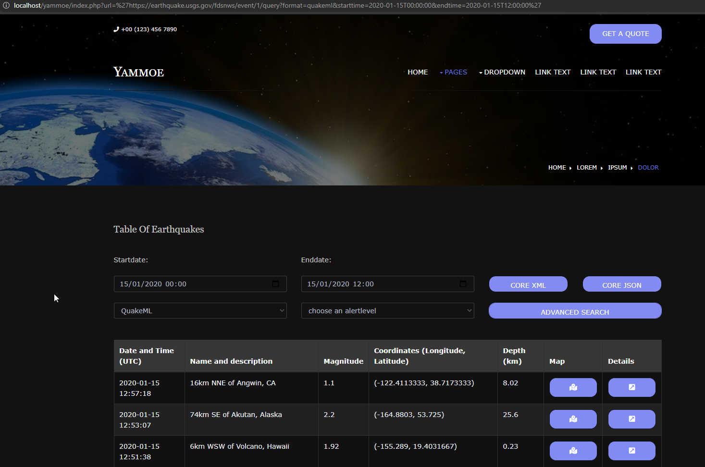

The code will build the url and extract the required information to insert it to the table

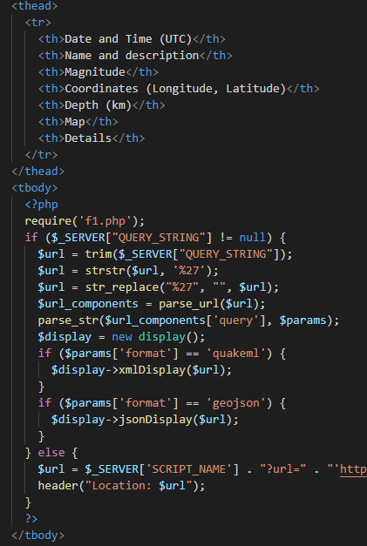

#### Json

The use of oop has made this task easier. By changing the quakeml to geojson the same thing that has happen to the xml core functionality will be done with json.

## Additional functionalities

### Highlight magnitude

The code will add color to the magnitudes

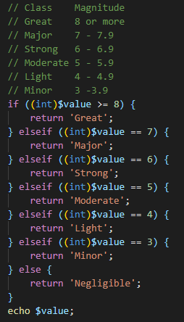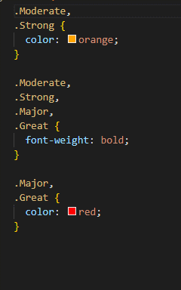

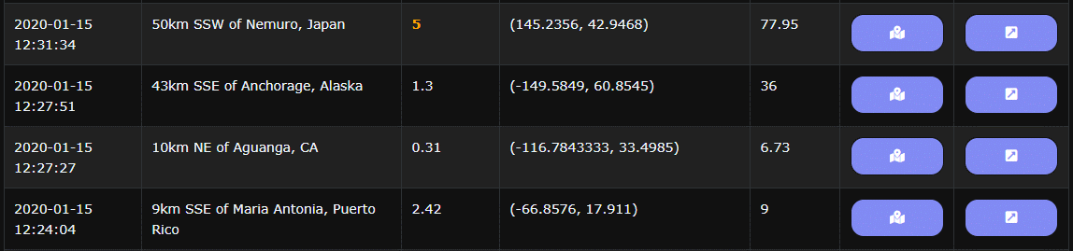

### Fill elements

The use of js was use to fill each elements in the advance search

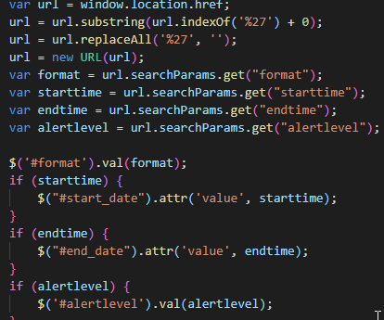

### Date filter

On clicking on the search the url will be build querying the server and display the information.

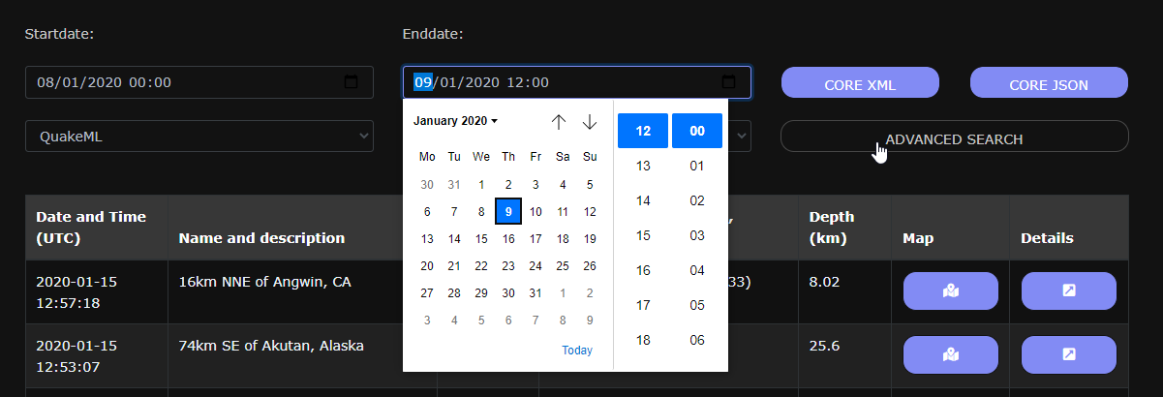

The use of js to build the link

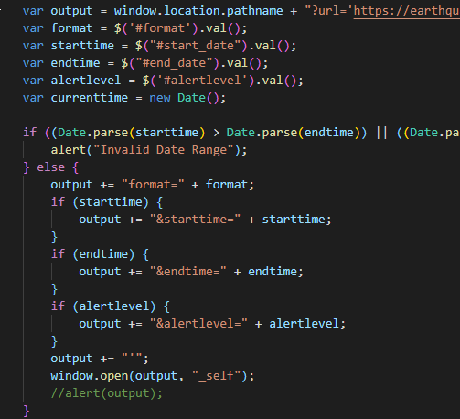

### Time filter

It follows the same principle as the date filter.

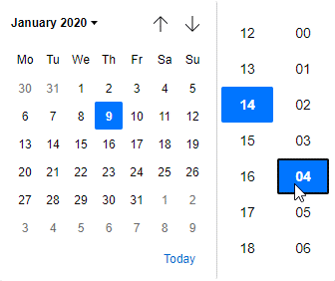

### Map

On clicking on the map, there will be a modal with the map and the location

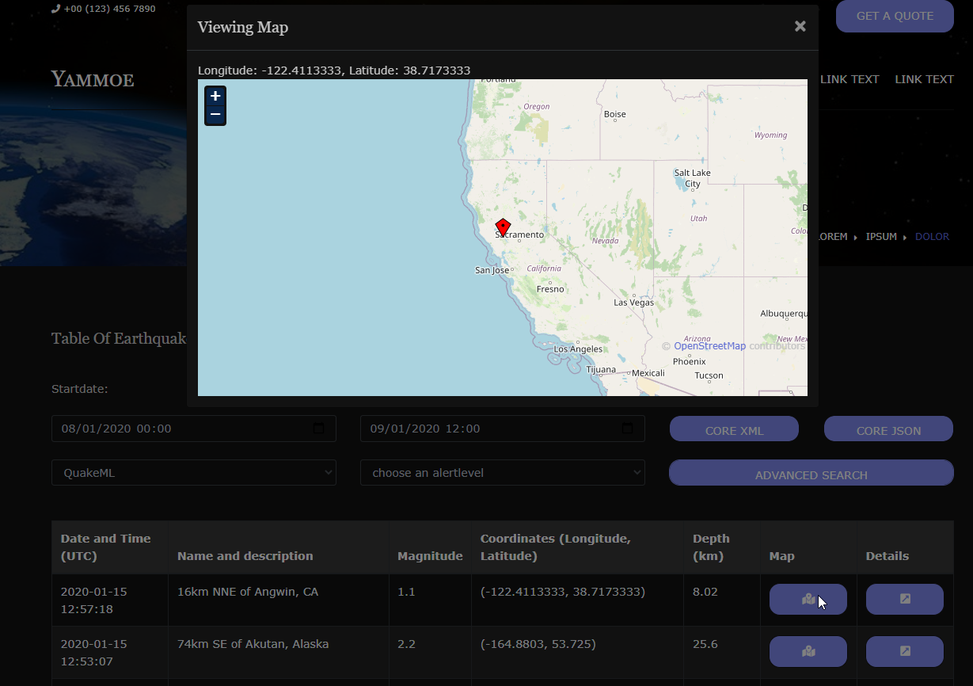

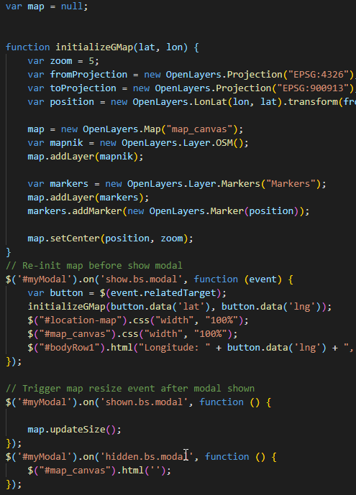

### Details

Once detail is clicked, other web page will open with all the details of that earth quake.

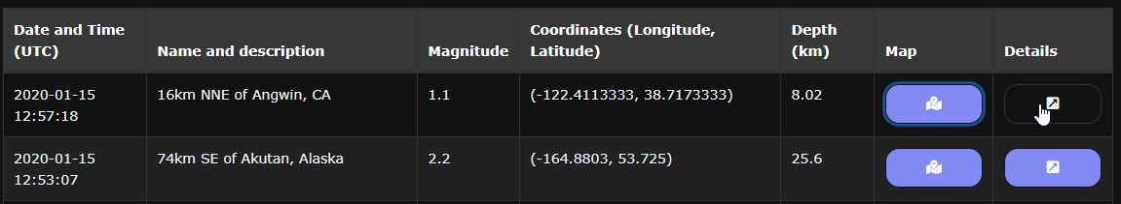

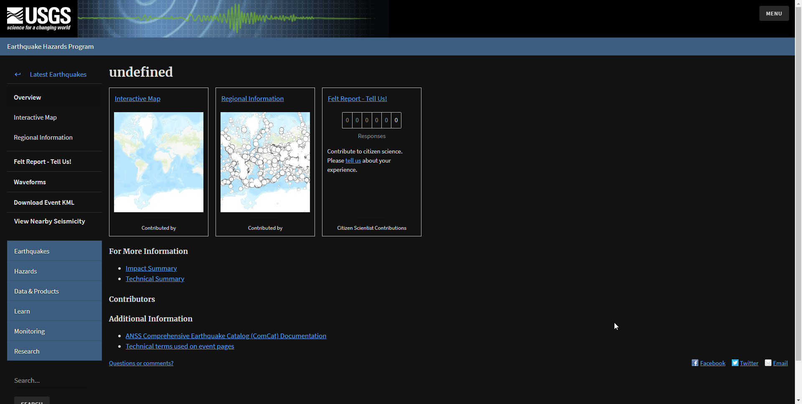

### Format selector

This will make use of different format to query the server and get response in the respective format

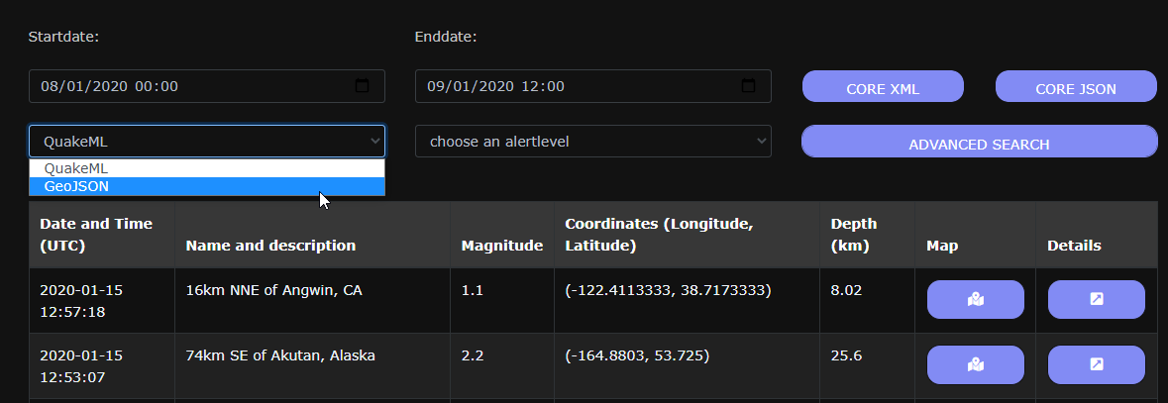

### Alert level selector

On selecting the alert it will display the power of the earthquakes

