UI/UX DESIGN SPECIFICATION
AND MOCK-UP BRIEF
OpenWA Internal Audience, Consent and Campaign Operations Platform
Version 1.0 | 4 August 2026
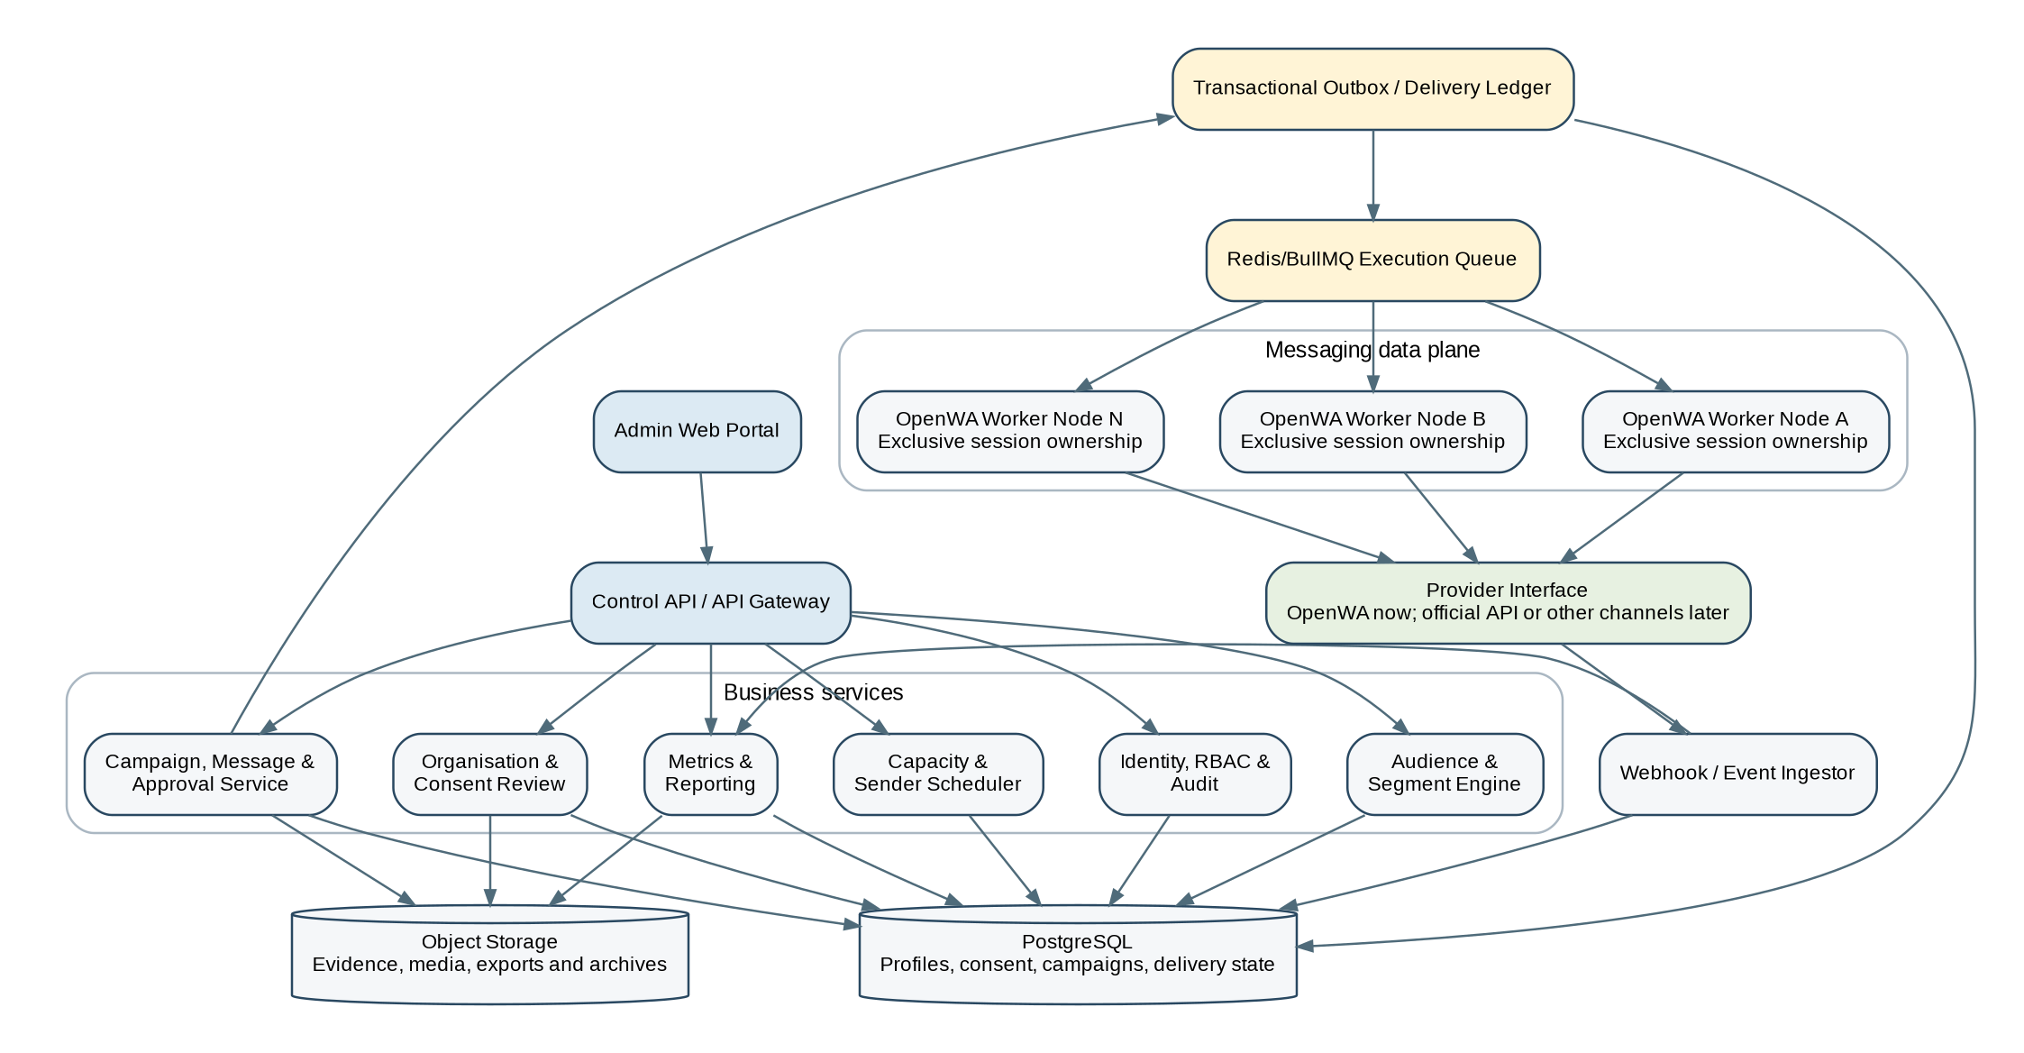
Purpose of this document
This specification converts the approved software requirements into a complete UI/UX blueprint that a product designer can use to create detailed Figma mock-ups and that developers can use to implement the approved experience without inventing workflows, statuses or safeguards.

Classification: Confidential - internal project and approved delivery partners only.

Document Control
Field | Value
Document title | UI/UX Design Specification and Mock-up Brief
Product | OpenWA Internal Audience, Consent and Campaign Operations Platform
Version | 1.0
Status | Design baseline for mock-up production
Primary audience | Product designers, UX researchers, frontend engineers, backend engineers, QA, security and operations
Companion document | OpenWA Internal Campaign Platform SRS v1.0
Initial channel | OpenWA-based WhatsApp transport, isolated behind a provider abstraction
Operating model | Internal managed service; no external organisation login in the initial release

Revision History
Version | Date | Summary | Owner
1.0 | 4 Aug 2026 | Initial detailed UI/UX and mock-up baseline | Product and solution design

How to use this document
- The product designer shall create the mock-ups, components and interactive prototypes described here and shall not add client self-service journeys unless the scope is formally changed.
- The frontend team shall implement the approved mock-ups and preserve all stated permissions, labels, safeguards, states and audit cues.
- The backend team shall expose the data, state transitions and reason codes required to make the UI truthful; the UI must never fabricate a delivery state or consent status.
- Where this document conflicts with the SRS, the product owner and solution architect shall resolve the discrepancy before design or build proceeds.
- Provisional visual tokens may be rebranded later, but interaction patterns, information architecture, safety controls and accessibility requirements remain mandatory.

Contents
1. Product and Experience Overview
2. UX Scope, Users and Roles
3. Experience Principles
4. Information Architecture
5. Global Application Shell
6. Visual Design System
7. Common Interaction Patterns
8. Data-Dense and High-Volume UX
9. Security, Privacy and Consent UX
10. End-to-End User Journeys
11. Detailed Screen Specifications
12. Dashboard and Metrics Design
13. Responsive and Accessibility Requirements
14. Content, Labels and Microcopy
15. Error, Empty, Loading and Exceptional States
16. Mock-up and Prototype Deliverables
17. UI/UX Acceptance Criteria
Appendix A - Screen Register
Appendix B - Component State Matrix
Appendix C - Canonical Status Labels
Appendix D - Design Handoff Checklist

1. Product and Experience Overview

1.1 Product explanation
The product is an internally operated platform for managing organisations, reviewing consent evidence, maintaining a consented audience repository, building demographic and geographic cohorts, approving messages, dispatching campaigns through managed WhatsApp sender sessions, monitoring operational performance and producing defensible campaign reports. External organisations may request campaigns and provide data offline, but they do not access the portal in the initial release.
The experience must therefore resemble a high-control operations console rather than a public marketing application. It must support trained internal users who need to work quickly with large datasets while being prevented from making irreversible or non-compliant mistakes.

1.2 What we are seeking to achieve
- A single, trusted operations workspace from organisation onboarding through campaign reporting.
- Clear separation between consent review, audience eligibility, content approval, commercial approval, technical dispatch and reporting.
- Fast and explainable segmentation of up to 10 million or more contact profiles by attributes such as state, LGA, self-declared age, gender, language, interests and consent scope.
- An exact workflow for a request such as “Lagos residents aged 18 to 35” while transparently handling stale or approximate age data.
- Controlled campaign release using immutable message versions and audience snapshots.
- Truthful metrics that distinguish gateway acceptance, sent acknowledgement, delivered acknowledgement, read acknowledgement, failure and unknown outcome.
- Operational visibility across sender accounts, OpenWA worker nodes, queue depth, throughput, retries, disconnections and completion forecasts.
- A provider-independent user experience so a future official Meta API or other messaging provider can be introduced without redesigning the complete portal.
Experience success definition
A trained operator should be able to understand what requires attention, build a compliant audience, prepare and approve a campaign, monitor its actual status and generate an accurate report without needing access to server logs or direct database queries.

1.3 Explicit experience boundaries
- No public registration, external client dashboard, client wallet, client API-key management or client campaign launch is required in the initial release.
- No screen shall imply that a logical sender label replaces the actual WhatsApp MSISDN. The actual masked sending number remains available to authorised operators.
- No screen shall label an OpenWA HTTP success response as “delivered”.
- No UI pattern shall facilitate IP rotation, account evasion or concealment of unauthorised activity.
- No demographic attribute shall be inferred by the UI. Unknown values remain unknown.
- No saved segment shall be treated as the final send list; campaigns use immutable snapshots with a final suppression and consent recheck.
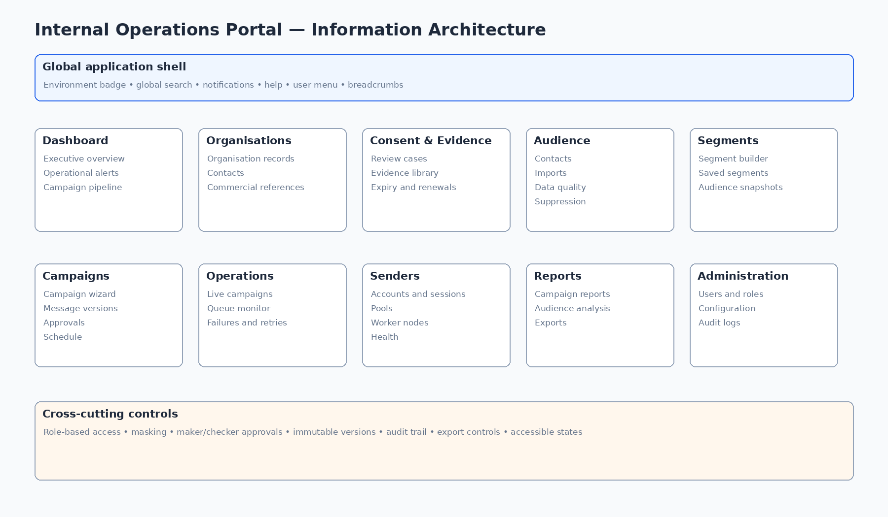
Figure 1 - Proposed internal portal information architecture

2. UX Scope, Users and Roles

2.1 Primary users
Role | Primary tasks | UX restriction
Super Administrator | System-wide configuration, user and role administration, break-glass support. | Must not casually reveal MSISDNs or bypass approvals.
Campaign Operator | Creates organisation records, imports data, builds audiences, prepares campaigns and monitors execution. | Cannot approve own restricted actions where maker/checker is configured.
Consent/Compliance Reviewer | Reviews collection wording, evidence, permitted organisation, purpose, channel and expiry. | Cannot launch campaigns solely because consent review is approved.
Campaign Approver | Reviews audience, message, schedule, sender capacity and pre-flight checks. | Final release requires explicit confirmation and MFA where configured.
Technical Administrator | Manages worker nodes, OpenWA sessions, sender pools, health and operational limits. | Cannot silently alter approved campaign audience or message.
Finance/Commercial User | Records quotation, invoice, payment and commercial approval. | Does not require access to full MSISDN values.
Analyst/Reporter | Views metrics and produces approved reports. | Detailed exports may require additional permission and approval.
Auditor/Read-only Reviewer | Inspects immutable histories and evidence. | No edit, send, reveal or export by default.

2.2 Permission-aware UX
UX-001 Every navigation item, action, field, column, reveal control and export shall respect the authenticated user’s role and scoped permissions.
UX-002 Unavailable actions shall be hidden when discovery would expose sensitive capability; actions that are relevant but currently invalid shall be disabled with an explanatory tooltip or inline reason.
UX-003 Where maker/checker control applies, the creator shall see approval progress but shall not be able to self-approve unless an authorised emergency policy explicitly permits it and records the reason.
UX-004 Read-only users shall see a persistent read-only badge and shall not encounter editable controls that merely fail after submission.
UX-005 Screens shall show the organisation, campaign, environment and data scope currently in context to reduce accidental cross-context work.

2.3 Operating context
- Desktop-first operations environment, normally used on managed laptops and large monitors.
- Users may monitor live campaigns for extended periods; automatic refresh must not disorient them or move controls unexpectedly.
- High-volume tables must support server-side search, filter and pagination/virtualisation rather than loading entire datasets in the browser.
- Sensitive data must be masked by default and copied or revealed only under explicit permission and audit.
- Critical actions may occur under time pressure; confirmations must be clear but not unnecessarily repetitive.

3. Experience Principles
Principle | Design implication
Truth before optimism | Always show the actual known state. “Submitted to gateway” is not “Delivered”. Unknown outcomes remain visible until reconciled.
Safety before speed | Speed matters, but irreversible sends, data exports, consent overrides and emergency actions require proportionate safeguards.
Explain every exclusion | Audience counts must show why profiles were excluded: invalid, duplicate, no matching consent, expired consent, suppression, frequency cap or policy rule.
Progressive disclosure | Summary first, detailed evidence and technical diagnostics on demand. Operators should not be overwhelmed by raw events on every screen.
Stable mental model | The same status, colour, icon and terminology must mean the same thing throughout the portal.
High data density with clarity | Use structured tables, sticky headers, saved views, compact filters and visible totals without reducing legibility.
Configuration, not hard-coding | Labels such as consent purposes, frequency rules, age-data validity and approval policies come from controlled configuration and are shown with versions.
Recovery-oriented design | Interrupted imports, failed jobs, disconnected sessions and stale views must have explicit recovery paths.
Privacy by default | Mask MSISDNs, minimise unnecessary data display, aggregate small demographic groups and log all sensitive access.
Provider independence | Provider-specific details appear in expandable technical sections; core campaign workflows use canonical platform states.

4. Information Architecture

4.1 Primary navigation
Area | Contents
Dashboard | Operational overview, campaign pipeline, alerts, approvals and recent activity.
Organisations | Internal organisation records, contacts, commercial references and status.
Consent & Evidence | Consent review queue, evidence, wording versions, scope, expiry and remediation.
Audience | Contact repository, imports, data quality, suppressions and privacy requests.
Segments | Visual segment builder, saved definitions, estimates, previews and immutable snapshots.
Campaigns | Campaign wizard, drafts, approvals, schedules, live execution and completion.
Messages & Media | Reusable content, immutable versions, test sends and media assets.
Senders | WhatsApp accounts, sessions, pools, workers, health and configured limits.
Operations | Active campaigns, queues, failures, retries, unknown outcomes, inbound replies and alerts.
Reports | Campaign reports, organisation summaries, sender performance and controlled exports.
Administration | Users, roles, configuration, audit, retention, integrations and system status.

4.2 Navigation behaviour
UX-006 The main navigation shall remain visible on standard desktop widths and support a compact collapsed mode that preserves icons and accessible labels.
UX-007 Navigation badges shall be reserved for actionable counts such as pending approvals, critical alerts and failed jobs; they shall not be used for decorative totals.
UX-008 Breadcrumbs shall identify the user’s exact hierarchy and allow return to the parent list without losing filters where feasible.
UX-009 Deep links shall retain the target record identifier but shall re-authorise access on load; a copied URL must not bypass permission checks.
UX-010 The portal shall preserve list filter and sort state when a user opens a record and returns during the same working session.

5. Global Application Shell

5.1 Desktop shell
- Left navigation: primary modules, compact/expanded control and permission-filtered items.
- Top bar: environment badge, global search, system health indicator, notifications, help and user menu.
- Content header: breadcrumb, page title, status badge, contextual metadata and primary action.
- Optional right drawer: record summary, filters, audit detail or operational diagnostics.
- Sticky action bar: reserved for long forms and multi-step workflows where primary actions must remain visible.
- Footer: build version, environment, data freshness and support reference where appropriate.

5.2 Environment awareness
UX-011 Development, test, staging and production shall use visibly distinct environment badges and page accents so users do not mistake test activity for production.
UX-012 Production destructive actions shall display the environment name inside the confirmation, not only elsewhere on the page.
UX-013 A stale-data indicator shall appear when live dashboards have not refreshed within the configured threshold.

5.3 Global search
- Search permitted objects only: organisation name/reference, campaign ID/name, import ID, consent review ID, masked/full MSISDN where authorised, sender label, worker ID and report ID.
- Results grouped by object type with status, owner, date and organisation context.
- No sensitive value in browser history or search URL.
- Exact MSISDN search uses secure server-side lookup and is audited.
- Keyboard shortcut supported, with a visible hint and accessible focus management.

6. Visual Design System

6.1 Visual character
The interface should feel trustworthy, precise, calm and operational. It should avoid consumer-style animation, excessive gradients, decorative illustrations and ambiguous icons. Visual emphasis is reserved for actions, risk and live status.

6.2 Provisional colour tokens
Token | Provisional value | Use
Primary / action | #1D4ED8 | Primary buttons, selected navigation, links and active focus context.
Text / navy | #17324D | Headings and high-emphasis text.
Neutral background | #F8FAFC | Application background and alternating table rows.
Border | #CBD5E1 | Dividers, fields and table borders.
Success | #15803D | Completed, healthy, approved or delivered acknowledgement.
Warning | #B45309 | At risk, stale, degraded, pending exception or approximate data.
Critical | #B91C1C | Failed, blocked, disconnected, rejected or destructive action.
Informational | #6D28D9 | Version, provider-specific or specialist information.

Colour is never the only status signal. Each status shall also have text and, where useful, a distinct icon or shape.

6.3 Typography and spacing
- Use a highly legible sans-serif family available in the implementation environment; Inter is preferred for the web application, with a system sans-serif fallback.
- Base body size: 14–16 px depending on density mode; never below 12 px for operational labels.
- Data tables may use 13–14 px text with 36–44 px row heights in compact mode.
- Use an 8 px spacing system with 4 px increments for dense controls.
- Use sentence case for labels and buttons. Avoid all-caps except very short environment or risk badges.
- Numbers should use tabular numerals where available to reduce movement in live metrics.

6.4 Core components
Component | Required behaviour
Buttons | Primary, secondary, tertiary, danger and icon-only. All require hover, focus, active, disabled and loading states.
Status badges | Canonical platform status text, icon and semantic colour. Avoid abbreviations that are not globally defined.
Form fields | Text, number, select, combobox, date/time, checkbox, radio, segmented control, tag input and query rule.
Data table | Server-side sorting/filtering, sticky header, column chooser, density control, pagination/virtualisation and row selection.
Metric card | Label, canonical value, comparison/forecast, freshness and optional drill-down.
Alert/banner | Info, warning, critical and success; blocking alerts explicitly state required resolution.
Drawer | Contextual detail without losing list state; must be keyboard and screen-reader accessible.
Modal | Only for focused confirmation or short form. Complex forms use pages or drawers.
Stepper | Long workflows, with completion, error and permission states per step.
Timeline | Consent, approval, campaign and delivery history in chronological order.
File uploader | Drag/drop and browse, validation progress, cancellation, retry, malware scan status and rejection reason.
Chart | Accessible labels, table alternative, no 3D, limited colour palette and consistent time axis.

7. Common Interaction Patterns

7.1 Lists and tables
UX-014 All large lists shall use server-side filtering, sorting and pagination or virtualisation; the browser shall not be expected to load millions of rows.
UX-015 Table filters shall be summarised as removable chips and may be saved as a named personal or shared view, subject to permission.
UX-016 Bulk actions shall display the selected count, scope and any records that cannot be acted on before confirmation.
UX-017 Column visibility, order and density may be personalised but exported reports use controlled report definitions.
UX-018 Empty results shall distinguish “no records exist” from “no records match the current filters”.

7.2 Forms
- Use clear section headings and short helper text explaining why sensitive or unusual data is required.
- Validate on blur for local rules and on submission for cross-record/server rules; do not show errors before the user has interacted unless the form is pre-populated with invalid legacy data.
- Place error text beside the field and provide a top error summary that links to each issue.
- Autosave drafts where the workflow is lengthy, but clearly show save status and avoid silently saving approval decisions.
- Warn before navigation when unsaved changes remain.
- Display the authoritative timezone on all schedule and deadline controls.

7.3 Confirmation levels
Action level | Examples | Required confirmation
Low | Save draft, change filters, download non-sensitive aggregate report | Direct action or lightweight toast.
Medium | Approve import mapping, create snapshot, pause one sender | Confirmation drawer/modal showing scope and reversible effect.
High | Launch campaign, reveal/export MSISDNs, override consent warning | Typed confirmation or reason, permission check and audit.
Emergency | Stop all dispatch, revoke sender pool, break-glass access | Persistent critical dialog, MFA/re-authentication, incident reference and immutable audit.

7.4 Notifications
- In-app notification centre categorised by approval, campaign, data quality, sender, security and system.
- Toasts for immediate feedback; persistent banners for conditions requiring resolution.
- Critical operational alerts remain visible until acknowledged or resolved.
- Notification records link to the relevant object and preserve the state that triggered the message.
- Users can configure non-critical preferences, but mandatory security and incident alerts cannot be disabled.

8. Data-Dense and High-Volume UX

8.1 Ten-million-profile audience repository
- Default list views show aggregated counts and paginated results, not a full dump.
- Potentially expensive queries execute asynchronously. The UI shows query status, elapsed time, current stage and an option to continue other work.
- Every count displays its “as at” time and the consent/configuration version used.
- Sample previews are masked, limited and randomly or deterministically sampled according to configured policy.
- Exports are background jobs with permission, reason, expiry and download audit.
- Long-running imports and snapshots survive browser closure and can be resumed from a jobs centre.

8.2 Audience-builder interaction
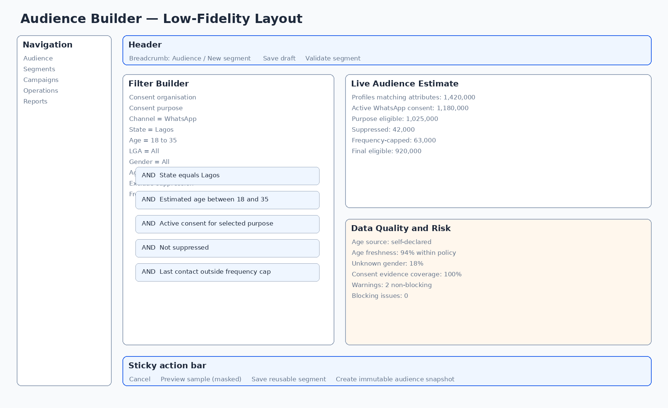
Figure 2 - Audience builder wireframe and information hierarchy
UX-019 The segment builder shall separate profile attributes from mandatory eligibility controls so operators cannot accidentally remove consent and suppression checks from a marketing audience.
UX-020 The builder shall support nested AND/OR groups but shall display a plain-language summary of the final rule.
UX-021 Age filtering shall allow “reported age at collection” or “estimated current age” and shall display the selected policy, freshness threshold and approximation warning.
UX-022 For a Lagos 18–35 segment, the UI shall show state, age basis, age recording date/freshness, active WhatsApp consent, organisation/purpose scope, suppression and frequency rules.
UX-023 The live estimate panel shall show the count after each major eligibility stage, not only the final number.
UX-024 Creation of an immutable audience snapshot shall require a name, purpose, source segment version, consent-policy version and acknowledgement of warnings.

8.3 Data freshness and uncertainty
Condition | UI treatment
Age collected recently | Normal display with source and collection date available.
Age estimated from earlier self-declared value | Approximate badge and calculated range explanation.
Age older than configured validity | Warning or exclusion according to policy; count included in exclusions.
Unknown age/gender/location | Never inferred; may be included only when the filter explicitly allows unknown.
Consent evidence near expiry | Warning with expiry date and renewal link.
Live metrics stale | Stale badge, last refresh timestamp and manual retry.

9. Security, Privacy and Consent UX

9.1 MSISDN display and reveal
- Default display: masked, for example +234 801 *** 1234.
- Exact search and reveal require explicit permission and are logged.
- Copy action is separate from reveal and may require a reason.
- Lists should not offer “reveal all”. Detailed exports use controlled background jobs.
- MSISDN values must never appear in browser URLs, page titles, toast messages or analytics labels.

9.2 Consent eligibility presentation
UX-025 The contact detail screen shall show consent by organisation, purpose and channel rather than a single global “consented” flag.
UX-026 Eligibility shall be presented as a decision with reason codes, evidence reference, effective date, expiry and any later withdrawal or suppression.
UX-027 An override shall never simply change a red indicator to green. It shall create a separate time-bound exception record with reason, approver and audit trail where policy permits an override at all.
UX-028 Consent review evidence shall open in a safe viewer that avoids executing embedded content and that clearly identifies file provenance and scan status.
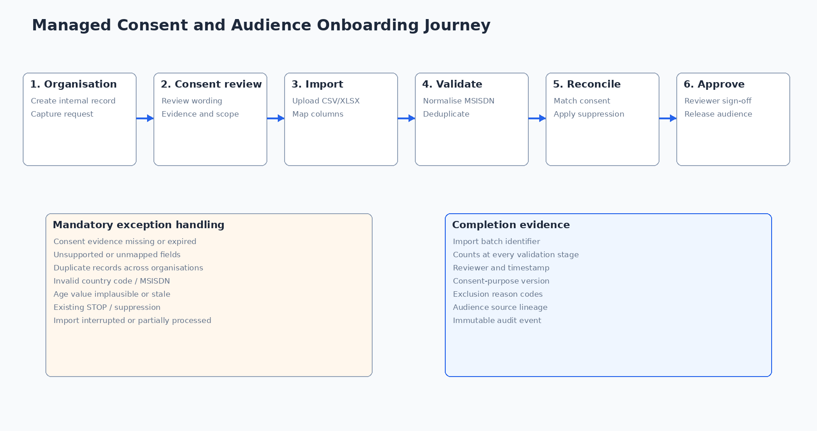
Figure 3 - Consent review and audience onboarding journey

9.3 Export and privacy controls
- Export request shows fields, number of records, organisation, purpose, format, encryption option and retention/expiry.
- High-risk exports require approval and re-authentication.
- Download links expire and cannot be forwarded to unauthorised users.
- Generated reports should use aggregate data by default and suppress very small demographic cells according to configuration.
- Every privacy request screen must show statutory/internal due dates, owner, identity-verification status and completion evidence.

10. End-to-End User Journeys

10.1 Organisation and consent onboarding
- Create or select the organisation; capture request reference, contact and campaign purpose.
- Open a consent review; record collection method, wording version, channel, organisation, purpose, dates and permitted reuse.
- Upload or reference supporting evidence; malware scan and evidence metadata complete.
- Reviewer approves, rejects or requests remediation; approval includes expiry and restrictions.
- Only approved scope becomes available to the audience-import and campaign workflows.

10.2 Audience import and reconciliation
- Start import, select organisation and consent review, upload file and choose source type.
- Map columns to canonical fields; preview transformations and invalid values.
- Run validation and deduplication; show counts and downloadable error file.
- Reconcile with existing contacts, active consent and suppressions.
- Reviewer confirms import outcome; system records lineage and makes eligible records available.

10.3 Lagos age 18–35 cohort
- Open segment builder and select the approved organisation/purpose/channel.
- Add State = Lagos and Estimated current age between 18 and 35.
- Select age freshness policy and confirm how approximate ages are treated.
- Keep mandatory active-consent, suppression and frequency-cap rules enabled.
- Review staged counts, data-quality warnings and masked sample.
- Save reusable segment; create immutable campaign snapshot after approval.

10.4 Campaign preparation and release
- Create campaign from organisation request and approved consent basis.
- Attach frozen audience snapshot; prepare message/media version and test send.
- Select sender pool; system calculates measured capacity and deadline forecast.
- Record commercial approval; complete content, consent and final release approvals.
- Run pre-flight checks; schedule or launch after typed/MFA confirmation.

10.5 Live operations and completion
- Monitor queue, submitted, sent, delivered, read, failed and unknown counts.
- Review required versus actual throughput and forecast completion time.
- Investigate sender degradation, pause/drain sessions or adjust allowed rate within permission.
- Use campaign pause or emergency stop with clear semantics.
- Reconcile unknown outcomes, close campaign and generate approved report.
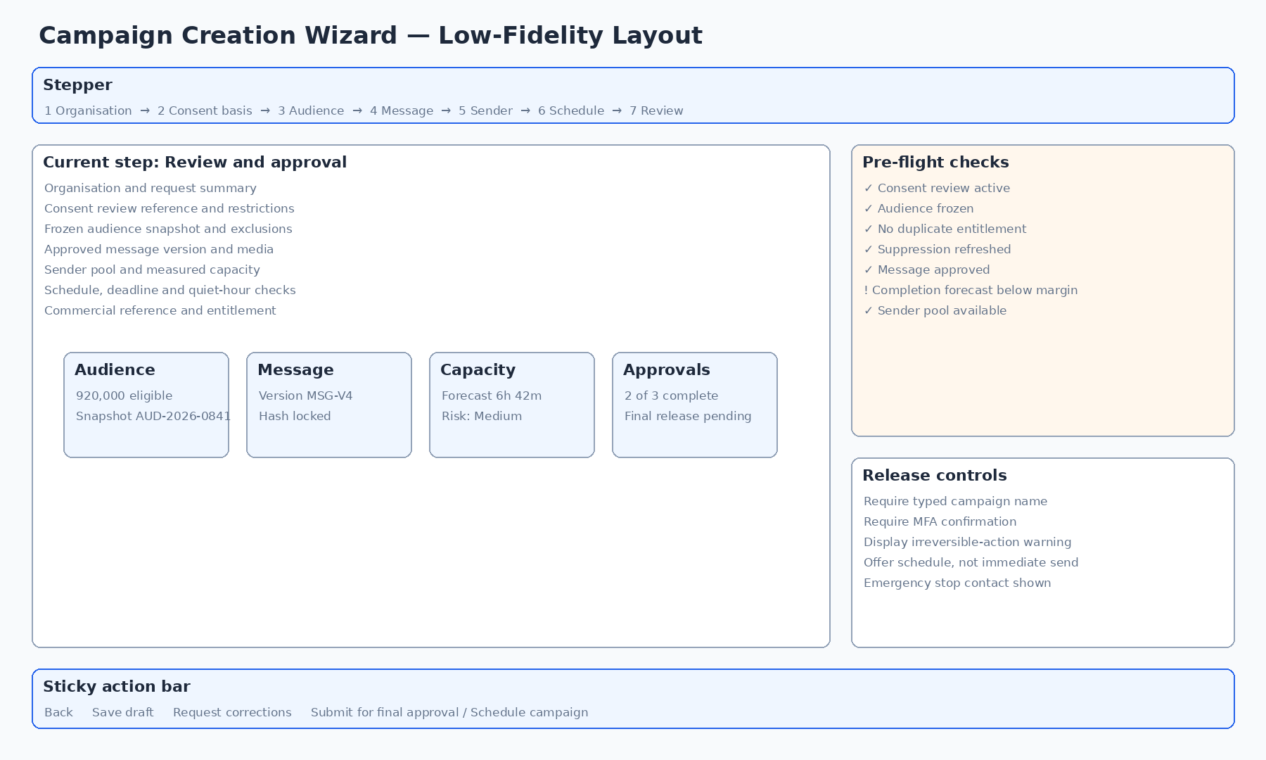
Figure 4 - Campaign wizard review and release layout

11. Detailed Screen Specifications
Each screen specification below is mandatory input to the mock-up. “States” means the designer shall produce either separate frames or component variants demonstrating the relevant conditions.

11.1 Authentication and access

UI-AUTH-01 - Sign in
Element | Specification
Purpose | Authenticate an internal user and communicate environment and security expectations.
Primary users | All internal users
Required content/layout | Email/username; password; environment badge; SSO option if enabled; support link.
Primary actions | Sign in; use SSO; start password recovery.
Required states | Invalid credentials; locked account; disabled account; rate limited; service unavailable; maintenance.
Mock-up and safeguard notes | No organisation data or sensitive counts before authentication. Autofill and password managers supported. Error must not reveal whether an account exists.

UI-AUTH-02 - Multi-factor authentication
Element | Specification
Purpose | Complete MFA or step-up authentication for login or high-risk action.
Primary users | Users with MFA challenge
Required content/layout | Challenge method, masked destination/device, expiry, resend timer, backup-code option.
Primary actions | Verify; resend; choose alternative method; cancel high-risk action.
Required states | Incorrect code; expired code; too many attempts; device unavailable; recovery required.
Mock-up and safeguard notes | Focus starts on code field; support paste; clear indication whether action is login, export, reveal or campaign release.

UI-AUTH-03 - Password and access recovery
Element | Specification
Purpose | Allow controlled recovery without disclosing accounts.
Primary users | Internal users
Required content/layout | Account identifier; neutral confirmation; recovery policy; support escalation.
Primary actions | Submit request; return to sign in.
Required states | Unknown account, email unavailable, policy blocked.
Mock-up and safeguard notes | Always show the same neutral result. Recovery completion may be external to the portal.

UI-AUTH-04 - Session expired / access denied
Element | Specification
Purpose | Recover from expired sessions or explain denied access.
Primary users | All users
Required content/layout | Reason, unsaved-work status, return path, re-authenticate option.
Primary actions | Sign in again; request access; return to safe page.
Required states | Session timeout, permission changed, object out of scope, break-glass expired.
Mock-up and safeguard notes | Do not discard autosaved drafts; never show restricted record details in the denial page.

11.2 Dashboard and work management

UI-DASH-01 - Operations dashboard
Element | Specification
Purpose | Provide a role-aware summary of work, risk and live activity.
Primary users | All authenticated users
Required content/layout | Campaign pipeline, approvals due, active campaigns, critical alerts, import jobs, sender health, recent activity.
Primary actions | Open work item; acknowledge alert; create campaign; start import.
Required states | Healthy, warning-heavy, no active work, stale metrics, partial service outage.
Mock-up and safeguard notes | Cards must display freshness and drill-down. Dashboard composition changes by role.

UI-DASH-02 - My work and approvals
Element | Specification
Purpose | Show tasks assigned to or available to the current user.
Primary users | Reviewers, approvers, operators
Required content/layout | Task type, object, organisation, due date, risk, submitted by, age.
Primary actions | Open; claim; reassign where permitted; approve/reject from detail only.
Required states | No tasks, overdue, reassigned, permission lost.
Mock-up and safeguard notes | Avoid approval from a terse list when evidence must be reviewed; use the detail screen.

UI-DASH-03 - Global search results
Element | Specification
Purpose | Find permitted records across modules.
Primary users | All users
Required content/layout | Grouped results, exact/partial match, masked sensitive values, context and status.
Primary actions | Open result; refine; clear.
Required states | No match, permission-filtered, search service unavailable.
Mock-up and safeguard notes | Exact MSISDN search is audited and requires permission; do not expose result counts across inaccessible scopes.

11.3 Organisations

UI-ORG-01 - Organisation list
Element | Specification
Purpose | Find and manage internal organisation records.
Primary users | Operators, reviewers, finance
Required content/layout | Name, reference, country, status, active consent reviews, campaigns, owner, updated date.
Primary actions | Create; open; filter; save view; export aggregate.
Required states | Empty, archived, duplicates suspected, loading/error.
Mock-up and safeguard notes | No external user-management controls in initial release.

UI-ORG-02 - Create/edit organisation
Element | Specification
Purpose | Capture a complete internal record.
Primary users | Operators
Required content/layout | Legal/trading name, registration/reference, sector, country, contacts, data controller/processor role, risk classification, notes.
Primary actions | Save draft; submit; cancel.
Required states | Duplicate name/reference, invalid contact, restricted sector, unsaved changes.
Mock-up and safeguard notes | Show which fields affect consent scope and reporting; audit material edits.

UI-ORG-03 - Organisation detail
Element | Specification
Purpose | Provide a single internal view of relationship, consent and campaign history.
Primary users | Authorised internal users
Required content/layout | Summary, contacts, consent reviews, data sources, campaigns, commercial refs, alerts, audit timeline.
Primary actions | Start consent review; start campaign; edit; archive.
Required states | Active, suspended, archived, pending remediation.
Mock-up and safeguard notes | Persistent status and restrictions banner. Sensitive contact details permission-aware.

UI-ORG-04 - Organisation contacts and commercial references
Element | Specification
Purpose | Manage operational contacts and offline commercial records.
Primary users | Operators, finance
Required content/layout | Contacts, roles, email/phone, quotation/invoice/payment references, validity.
Primary actions | Add/edit contact; record approval; attach reference.
Required states | Expired quote, unpaid, duplicate contact.
Mock-up and safeguard notes | This is not a public billing portal; do not expose client self-service patterns.

UI-ORG-05 - Suspend/archive organisation
Element | Specification
Purpose | Prevent new work while preserving history.
Primary users | Administrators/approvers
Required content/layout | Impact summary, active campaigns, datasets, reason, effective date.
Primary actions | Suspend; archive; cancel.
Required states | Active campaign prevents archive, legal hold, reactivation.
Mock-up and safeguard notes | Destructive language must distinguish reversible suspension from archival.

11.4 Consent and evidence

UI-CONS-01 - Consent review queue
Element | Specification
Purpose | Prioritise reviews and renewals.
Primary users | Consent reviewers
Required content/layout | Status, organisation, purpose, channel, evidence completeness, expiry, risk, assignee.
Primary actions | Open; assign; filter; escalate.
Required states | Due soon, overdue, missing evidence, rejected, expired.
Mock-up and safeguard notes | Use risk and expiry badges, not colour alone.

UI-CONS-02 - Create consent review
Element | Specification
Purpose | Record the proposed lawful/consent scope and evidence request.
Primary users | Operators/reviewers
Required content/layout | Organisation, collection source, purpose, channel, audience type, wording version, collection period, permitted reuse, expiry proposal.
Primary actions | Save; request evidence; submit for review.
Required states | Incomplete scope, conflicting review, unsupported channel.
Mock-up and safeguard notes | Do not offer a single “marketing consent” checkbox.

UI-CONS-03 - Consent review workspace
Element | Specification
Purpose | Review evidence and record decision.
Primary users | Consent reviewers
Required content/layout | Side-by-side scope summary, evidence checklist/viewer, findings, restrictions, expiry, decision history.
Primary actions | Approve; reject; request remediation; add note.
Required states | Evidence scan pending, file unavailable, conflicting evidence, partial approval.
Mock-up and safeguard notes | Decision controls remain disabled until mandatory review checklist is complete.

UI-CONS-04 - Evidence viewer and library
Element | Specification
Purpose | Safely inspect files and metadata.
Primary users | Reviewers/auditors
Required content/layout | Preview, filename, type, source, checksum, uploader, scan status, version, related reviews.
Primary actions | View; download if permitted; replace/version; flag.
Required states | Malware suspected, unsupported format, missing, superseded.
Mock-up and safeguard notes | Embedded scripts/macros never execute. Sensitive evidence downloads audited.

UI-CONS-05 - Consent purpose and wording versions
Element | Specification
Purpose | Manage controlled consent taxonomy and exact wording.
Primary users | Administrators/reviewers
Required content/layout | Purpose code, description, organisation scope, channels, wording, effective dates, expiry and status.
Primary actions | Create version; retire; compare; approve.
Required states | Draft, active, superseded, invalid date overlap.
Mock-up and safeguard notes | Existing campaigns retain the version used; edits create new versions.

UI-CONS-06 - Expiry and renewal
Element | Specification
Purpose | Renew or close a consent approval.
Primary users | Reviewers
Required content/layout | Current scope, expiry, recent imports/campaigns, new evidence, changes.
Primary actions | Renew; shorten; expire; request remediation.
Required states | Expired while campaign draft exists, partial renewal.
Mock-up and safeguard notes | Renewal never silently expands scope.

UI-CONS-07 - Remediation and rejection detail
Element | Specification
Purpose | Explain why use is blocked and what must change.
Primary users | Operators/reviewers
Required content/layout | Reason codes, narrative, missing evidence, assigned owner, due date, history.
Primary actions | Submit remediation; reopen review; close.
Required states | Repeated rejection, overdue, evidence superseded.
Mock-up and safeguard notes | Reason text should be suitable for internal communication and audit.

11.5 Audience repository and imports

UI-AUD-01 - Contact repository
Element | Specification
Purpose | Search and inspect contact profiles at scale.
Primary users | Operators, analysts, privacy users
Required content/layout | Masked MSISDN, geography, age summary, gender, consent count, suppression, source, updated date.
Primary actions | Filter; open; request export; create segment from filters.
Required states | No records, query running, stale index, permission-limited.
Mock-up and safeguard notes | No bulk reveal; display approximate age marker where applicable.

UI-AUD-02 - Contact detail
Element | Specification
Purpose | Show profile, consent, source and contact history.
Primary users | Authorised users
Required content/layout | Masked identity, attributes with provenance, consent grants, withdrawals, suppressions, imports, campaign history, audit.
Primary actions | Correct data; add suppression; initiate privacy request; reveal if permitted.
Required states | Conflicting attributes, stale age, potential recycled number, legal hold.
Mock-up and safeguard notes | Profile existence does not imply campaign eligibility; show decision per organisation/purpose/channel.

UI-AUD-03 - Import jobs list
Element | Specification
Purpose | Track all audience and suppression imports.
Primary users | Operators
Required content/layout | Import ID, organisation, file, type, counts, status, owner, started/completed, review.
Primary actions | Start import; open; retry permitted stage; cancel.
Required states | Queued, scanning, mapping, validating, reconciling, awaiting approval, failed, complete.
Mock-up and safeguard notes | Status names must match backend state machine.

UI-AUD-04 - Import wizard - source and upload
Element | Specification
Purpose | Initiate a controlled import.
Primary users | Operators
Required content/layout | Organisation, consent review, import type, source system, file, delimiter/sheet, encryption details.
Primary actions | Upload; replace; cancel; continue.
Required states | Oversize, unsupported type, encrypted without key, malware, interrupted.
Mock-up and safeguard notes | Large upload progress is resumable where technically supported; browser closure does not lose server job.

UI-AUD-05 - Import wizard - column mapping
Element | Specification
Purpose | Map source columns to canonical fields and transformations.
Primary users | Operators
Required content/layout | Source preview, target field, required/optional, transformation, validation and examples.
Primary actions | Auto-map; edit; save template; continue.
Required states | Duplicate mapping, missing MSISDN, invalid transformation.
Mock-up and safeguard notes | Show how age, state and LGA will be interpreted; never silently infer gender.

UI-AUD-06 - Import validation results
Element | Specification
Purpose | Explain quality and eligibility outcomes.
Primary users | Operators/reviewers
Required content/layout | Stage counts, invalid reasons, duplicates, existing records, consent mismatch, suppression, warnings.
Primary actions | Download error file; fix mapping; proceed; reject.
Required states | Partial failure, threshold exceeded, validation engine error.
Mock-up and safeguard notes | Counts reconcile from uploaded rows to final eligible rows.

UI-AUD-07 - Duplicate and merge review
Element | Specification
Purpose | Resolve ambiguous contact matches without data loss.
Primary users | Data stewards/operators
Required content/layout | Existing/new values, provenance, timestamps, proposed resolution, consent separation.
Primary actions | Keep existing; accept newer; merge selected; defer.
Required states | Conflicting MSISDN hash, cross-organisation scope, unresolved.
Mock-up and safeguard notes | Consent records are never merged merely because profile attributes match.

UI-AUD-08 - Data-quality dashboard
Element | Specification
Purpose | Monitor completeness, validity and freshness.
Primary users | Data stewards/analysts
Required content/layout | Attribute completeness, invalid geography, stale age, unknown values, duplicate trends, source quality.
Primary actions | Drill down; create remediation job; export aggregate.
Required states | No data, delayed metrics.
Mock-up and safeguard notes | Avoid framing unknown demographic data as an error when it was not collected.

UI-AUD-09 - Suppression management
Element | Specification
Purpose | Manage global, organisation, purpose and channel suppressions.
Primary users | Operators/reviewers/privacy users
Required content/layout | Masked MSISDN, scope, reason, effective date, source, expiry, evidence.
Primary actions | Add; import; revoke where permitted; view history.
Required states | Duplicate suppression, legal hold, irreversible global do-not-contact.
Mock-up and safeguard notes | A removal requires authority and preserves history.

UI-AUD-10 - Privacy/data-subject request
Element | Specification
Purpose | Track access, correction, objection, deletion and restriction requests.
Primary users | Privacy users
Required content/layout | Request type, identity verification, records found, scope, due date, actions and evidence.
Primary actions | Assign; verify; fulfil; extend; close.
Required states | Identity unresolved, legal hold, conflicting request.
Mock-up and safeguard notes | Sensitive exports generated here require step-up authentication and expiry.

11.6 Segments and snapshots

UI-SEG-01 - Saved segments list
Element | Specification
Purpose | Manage reusable query definitions.
Primary users | Operators/analysts
Required content/layout | Name, organisation, purpose, owner, version, last estimate, updated date, status.
Primary actions | Create; open; duplicate; archive.
Required states | Invalid due to retired field/purpose, estimate stale.
Mock-up and safeguard notes | Clearly label dynamic segment versus frozen snapshot.

UI-SEG-02 - Visual segment builder
Element | Specification
Purpose | Build profile and eligibility rules.
Primary users | Operators/analysts
Required content/layout | Rule canvas, mandatory eligibility controls, live estimate, data quality, plain-language summary.
Primary actions | Add group/rule; validate; save; preview; snapshot.
Required states | Query too broad, expensive, invalid nesting, unsupported field.
Mock-up and safeguard notes | Mandatory consent/suppression rules cannot be removed for marketing campaigns.

UI-SEG-03 - Estimate and exclusion analysis
Element | Specification
Purpose | Explain how the final count was derived.
Primary users | Operators/reviewers
Required content/layout | Counts after attributes, consent, expiry, suppression, frequency, duplicate and policy stages.
Primary actions | Drill into aggregate reasons; refresh; compare versions.
Required states | Estimate running, stale, source unavailable.
Mock-up and safeguard notes | Every count has timestamp and configuration version.

UI-SEG-04 - Masked sample preview
Element | Specification
Purpose | Provide confidence without exposing bulk personal data.
Primary users | Authorised operators
Required content/layout | Limited masked sample, attribute provenance, eligibility reason, refresh policy.
Primary actions | Refresh sample; open contact if permitted.
Required states | No eligible sample, permission denied.
Mock-up and safeguard notes | Sampling method and limit shown; no download from preview by default.

UI-SEG-05 - Create and inspect audience snapshot
Element | Specification
Purpose | Freeze the exact campaign audience.
Primary users | Operators/approvers
Required content/layout | Name, segment version, count, exclusions, hash, creator, consent config, warnings, refresh time.
Primary actions | Create; approve; attach to campaign; invalidate before use.
Required states | Consent expiry before send, snapshot superseded, suppression changes.
Mock-up and safeguard notes | Snapshot membership is immutable; final dispatch eligibility recheck is separately reported.

11.7 Campaigns, messages and approvals

UI-CAMP-01 - Campaign list
Element | Specification
Purpose | Find campaigns across lifecycle.
Primary users | All relevant users
Required content/layout | ID/name, organisation, purpose, audience, status, schedule, deadline, owner, risk.
Primary actions | Create; open; filter; clone.
Required states | No campaigns, archived, permission-limited.
Mock-up and safeguard notes | Status and deadline risk visible without opening.

UI-CAMP-02 - Campaign creation wizard
Element | Specification
Purpose | Guide complete campaign preparation.
Primary users | Operators
Required content/layout | Organisation, consent basis, audience, message, sender, schedule, commercial and review steps.
Primary actions | Back/next; save draft; submit.
Required states | Step incomplete, permission lost, source retired.
Mock-up and safeguard notes | Stepper shows errors and approvals; no irreversible action until review step.

UI-CAMP-03 - Campaign overview
Element | Specification
Purpose | Single source of truth for campaign state.
Primary users | Operators, reviewers, analysts
Required content/layout | Summary, audience, message, approvals, schedule, capacity, execution, reports, audit.
Primary actions | Edit allowed draft sections; pause; view report.
Required states | Draft through completed, cancelled, exceptions.
Mock-up and safeguard notes | Locked fields clearly show version and who approved them.

UI-CAMP-04 - Message composer and versioning
Element | Specification
Purpose | Create approved text/media message versions.
Primary users | Operators/content reviewers
Required content/layout | Message body, variables, fallback, media, link, opt-out text, preview, character/size info.
Primary actions | Save version; validate; preview; test; submit.
Required states | Missing fallback, unsupported media, dangerous URL, version locked.
Mock-up and safeguard notes | Editing an approved version creates a new version; old version remains visible.

UI-CAMP-05 - Media library
Element | Specification
Purpose | Manage reusable approved media.
Primary users | Operators/content users
Required content/layout | Thumbnail, type, size, checksum, scan status, rights/expiry, usage.
Primary actions | Upload; version; archive; attach.
Required states | Scan pending/failed, unsupported, rights expired.
Mock-up and safeguard notes | Do not auto-play audio/video in tables.

UI-CAMP-06 - Test send
Element | Specification
Purpose | Send a controlled test to approved internal recipients.
Primary users | Operators/approvers
Required content/layout | Message preview, selected test sender, internal recipient list, variable values, provider response.
Primary actions | Send test; resend after change; record acceptance.
Required states | Session unavailable, invalid test recipient, partial failure.
Mock-up and safeguard notes | Test sends are clearly labelled and excluded from paid campaign metrics.

UI-CAMP-07 - Approval queue
Element | Specification
Purpose | Prioritise campaigns awaiting consent, content, commercial or final release approval.
Primary users | Approvers
Required content/layout | Campaign, organisation, approval type, risk, deadline, submitter, age.
Primary actions | Open; claim; reassign.
Required states | Overdue, prerequisite changed, withdrawn.
Mock-up and safeguard notes | Approval is completed on detail screen with evidence.

UI-CAMP-08 - Approval detail
Element | Specification
Purpose | Make an informed, attributable decision.
Primary users | Approvers
Required content/layout | Side-by-side approved inputs, changes since prior review, warnings, capacity forecast, audit.
Primary actions | Approve; reject; request change; defer.
Required states | Conflicting approvals, stale snapshot, sender risk, self-approval blocked.
Mock-up and safeguard notes | Show exactly what is being approved, including hashes/version IDs.

UI-CAMP-09 - Schedule and pre-flight
Element | Specification
Purpose | Validate readiness and deadline feasibility.
Primary users | Operators/approvers
Required content/layout | Timezone, start/end/deadline, quiet hours, required rate, available safe capacity, checks.
Primary actions | Schedule; reserve capacity; return to fix.
Required states | Insufficient capacity, deadline passed, sender unavailable, consent expires.
Mock-up and safeguard notes | Do not permit a hard deadline promise when measured capacity is insufficient.

UI-CAMP-10 - Live campaign dashboard
Element | Specification
Purpose | Monitor truthful progress and operational risk.
Primary users | Operators, technical users, analysts
Required content/layout | Canonical counts, throughput, forecast, sender health, alerts, breakdowns, freshness.
Primary actions | Pause; inspect failures; adjust approved rate; emergency stop.
Required states | Healthy, at risk, paused, stale, provider degradation, completed.
Mock-up and safeguard notes | Auto-refresh without shifting controls; announce important changes accessibly.

UI-CAMP-11 - Pause, resume and emergency stop
Element | Specification
Purpose | Control dispatch with precise semantics.
Primary users | Authorised operators/technical admins
Required content/layout | Current state, jobs in flight, effect, reason, confirmation, incident reference.
Primary actions | Pause new claims; resume; stop all new dispatch; emergency stop.
Required states | Already paused, in-flight unknown, partial worker outage.
Mock-up and safeguard notes | Explain that in-flight submissions may still complete; never imply recall of delivered messages.

UI-CAMP-12 - Completion and reconciliation
Element | Specification
Purpose | Close a campaign only after state reconciliation.
Primary users | Operators/analysts
Required content/layout | Final counts, pending/unknown, retries, exclusions, duration, approval to close.
Primary actions | Reconcile; mark exception; close; generate report.
Required states | Unknown outcomes remain, late events arrive, report regeneration.
Mock-up and safeguard notes | Closing preserves late-event update policy and report versions.

UI-CAMP-13 - Campaign report and export
Element | Specification
Purpose | Produce organisation-facing and internal reports.
Primary users | Analysts/operators
Required content/layout | Executive summary, methodology, counts, rates, time series, breakdowns, caveats, approval.
Primary actions | Generate; approve; download; share through controlled channel.
Required states | Generation queued/failed, small-cell suppression, stale data.
Mock-up and safeguard notes | Report labels define each canonical metric and identify data cut-off.

UI-CAMP-14 - Clone campaign
Element | Specification
Purpose | Reuse safe structure without copying approvals.
Primary users | Operators
Required content/layout | Source summary, items to copy, new dates, new organisation constraints.
Primary actions | Clone draft; cancel.
Required states | Source uses retired consent/message/sender.
Mock-up and safeguard notes | Never copy audience snapshot, approvals or payment status as valid for new campaign.

11.8 Senders and operations

UI-SEND-01 - Sender/session list
Element | Specification
Purpose | Monitor managed WhatsApp accounts and sessions.
Primary users | Technical admins/operators
Required content/layout | Logical label, masked MSISDN, worker owner, engine, state, health, rate, queue, last success.
Primary actions | Open; filter; pause allocation; connect new account.
Required states | Healthy, degraded, disconnected, quarantined, retired.
Mock-up and safeguard notes | Logical sender pool and actual MSISDN are both clear to authorised users.

UI-SEND-02 - Session detail
Element | Specification
Purpose | Diagnose one sender safely.
Primary users | Technical admins
Required content/layout | Connection/auth state, worker, stable egress, metrics, current campaign, limits, reconnects, events.
Primary actions | Drain; pause; reconnect; edit limits; retire.
Required states | Ownership conflict, auth expired, worker unreachable.
Mock-up and safeguard notes | Redacted technical logs; no secret/session tokens displayed.

UI-SEND-03 - Connect/pair account
Element | Specification
Purpose | Register and pair a genuine WhatsApp account.
Primary users | Technical admins
Required content/layout | Account inventory record, MSISDN, display name, worker, engine, QR/pairing state, recovery owner.
Primary actions | Start pairing; cancel; confirm; test.
Required states | QR expired, already registered, pairing rejected, session conflict.
Mock-up and safeguard notes | Explain that an actual WhatsApp number remains the sender; no arbitrary alphanumeric sender ID.

UI-SEND-04 - Sender pool management
Element | Specification
Purpose | Group eligible sessions for internal routing.
Primary users | Technical admins
Required content/layout | Pool name, brand/logical label, members, geography, limits, status, capacity.
Primary actions | Create; add/remove; drain; retire.
Required states | Member busy, unhealthy, duplicate, no capacity.
Mock-up and safeguard notes | Pool changes do not retroactively alter locked campaign approval without revalidation.

UI-SEND-05 - Worker node list/detail
Element | Specification
Purpose | Operate Hostinger VPS worker nodes.
Primary users | Technical admins
Required content/layout | Node ID, IP, region, version, heartbeat, sessions, CPU/RAM/disk, queue, status.
Primary actions | Drain; restart workflow; schedule maintenance; view logs.
Required states | Heartbeat lost, version mismatch, disk pressure, session ownership conflict.
Mock-up and safeguard notes | Infrastructure detail is permission-restricted and must not expose credentials.

UI-OPS-01 - Active operations centre
Element | Specification
Purpose | Unified view of live campaigns, senders, queues and alerts.
Primary users | Operators/technical admins
Required content/layout | Campaign cards/table, throughput, deadline risk, worker health, critical alerts.
Primary actions | Open campaign; acknowledge; pause; escalate.
Required states | No active campaigns, incident mode, stale telemetry.
Mock-up and safeguard notes | Designed for wallboard and desktop, with readable high-priority status.

UI-OPS-02 - Queue monitor
Element | Specification
Purpose | Inspect queue state without editing raw data.
Primary users | Technical admins/operators
Required content/layout | Ready, delayed, active, retry, dead-letter, lag, throughput by campaign/sender.
Primary actions | Filter; pause queue intake; requeue approved jobs; inspect sample.
Required states | Redis unavailable, counts inconsistent, reconstruction in progress.
Mock-up and safeguard notes | PostgreSQL remains authoritative; UI indicates when queue is being rebuilt.

UI-OPS-03 - Failed delivery workbench
Element | Specification
Purpose | Triage retryable and permanent failures.
Primary users | Operators/technical admins
Required content/layout | Reason, count, campaign, sender, attempt, last error, retry eligibility.
Primary actions | Retry approved set; suppress invalid; export aggregate.
Required states | Retry limit reached, duplicate protection, provider unavailable.
Mock-up and safeguard notes | Bulk retry shows exact scope and duplicate-safety check.

UI-OPS-04 - Unknown outcome reconciliation
Element | Specification
Purpose | Resolve submissions whose final state is uncertain.
Primary users | Technical admins/analysts
Required content/layout | Provider ID, timestamps, sender, event history, confidence, reconciliation source.
Primary actions | Query/reconcile; mark unresolved; close by policy.
Required states | Late event, conflicting event, no provider ID.
Mock-up and safeguard notes | Never automatically classify unknown as delivered.

UI-OPS-05 - Inbound replies and opt-outs
Element | Specification
Purpose | Process replies, STOP and operational responses.
Primary users | Operators/reviewers
Required content/layout | Sender, masked contact, campaign, reply, classification, suppression action, timestamp.
Primary actions | Confirm opt-out; classify; escalate; close.
Required states | Ambiguous STOP, multilingual, duplicate event.
Mock-up and safeguard notes | STOP/suppression action takes precedence over campaign convenience and is immediately visible.

UI-OPS-06 - Alert centre
Element | Specification
Purpose | Track operational and security alerts.
Primary users | All relevant roles
Required content/layout | Severity, source, affected objects, opened/acknowledged/resolved times, owner.
Primary actions | Acknowledge; assign; resolve; open runbook.
Required states | Alert storm, duplicate, stale.
Mock-up and safeguard notes | Critical alerts remain persistent and are not dismissed by a toast alone.

11.9 Reports and administration

UI-REP-01 - Reports library
Element | Specification
Purpose | Find generated and scheduled reports.
Primary users | Analysts/operators
Required content/layout | Report type, campaign/organisation, version, data cut-off, status, approver, expiry.
Primary actions | Generate; open; download; regenerate.
Required states | Queued, failed, expired, revoked.
Mock-up and safeguard notes | Sensitive report links expire; version remains auditable.

UI-REP-02 - Audience and campaign analytics
Element | Specification
Purpose | Explore aggregate performance without exposing raw records.
Primary users | Analysts
Required content/layout | Filters, trend charts, demographic/geographic breakdowns, data-quality caveats.
Primary actions | Save view; export aggregate; drill down within permission.
Required states | Small cell, stale warehouse, no data.
Mock-up and safeguard notes | Charts always have accessible table alternative.

UI-ADMIN-01 - User administration
Element | Specification
Purpose | Manage internal accounts.
Primary users | Super administrators
Required content/layout | User, role, status, MFA, last login, scope, manager, expiry.
Primary actions | Invite/provision; suspend; reset MFA; revoke sessions.
Required states | Duplicate, locked, privileged account.
Mock-up and safeguard notes | No shared accounts; high-risk changes require reason/audit.

UI-ADMIN-02 - Roles and permissions
Element | Specification
Purpose | Configure controlled role definitions.
Primary users | Super administrators/security
Required content/layout | Role matrix by module/action/data scope; assigned users; version.
Primary actions | Create version; compare; approve; activate.
Required states | Privilege escalation, orphaned role, active session impact.
Mock-up and safeguard notes | Deny by default; display effective permissions before activation.

UI-ADMIN-03 - Configuration catalogue
Element | Specification
Purpose | Manage versioned business and operational settings.
Primary users | Authorised administrators
Required content/layout | Consent purposes, age freshness, frequency caps, approval rules, status thresholds, retention, limits.
Primary actions | Create version; validate; approve; schedule.
Required states | Overlapping effective dates, invalid threshold, campaign impact.
Mock-up and safeguard notes | Configuration changes show impacted drafts/campaigns and never silently rewrite history.

UI-ADMIN-04 - Audit log
Element | Specification
Purpose | Inspect tamper-evident activity.
Primary users | Auditors/admins
Required content/layout | Actor, action, object, before/after reference, reason, IP/device, timestamp, correlation ID.
Primary actions | Filter; open; export approved range.
Required states | High volume, archive retrieval, integrity alert.
Mock-up and safeguard notes | Sensitive before/after values masked based on permission.

UI-ADMIN-05 - System health and backup status
Element | Specification
Purpose | Provide operational confidence across services.
Primary users | Technical admins
Required content/layout | API, database, queue, workers, object storage, backups, replication, certificate expiry.
Primary actions | Open incident; run approved check; view restore test.
Required states | Degraded, outage, stale monitoring.
Mock-up and safeguard notes | Do not expose secrets or full infrastructure configuration.

UI-ADMIN-06 - Retention and archive policies
Element | Specification
Purpose | Manage controlled data lifecycle.
Primary users | Privacy/admin users
Required content/layout | Object type, active retention, archive destination, legal hold, next run, impact.
Primary actions | Create version; simulate; approve; hold/release.
Required states | Legal hold conflict, archive failure, deletion blocked.
Mock-up and safeguard notes | Simulation shows counts before destructive execution.

12. Dashboard and Metrics Design
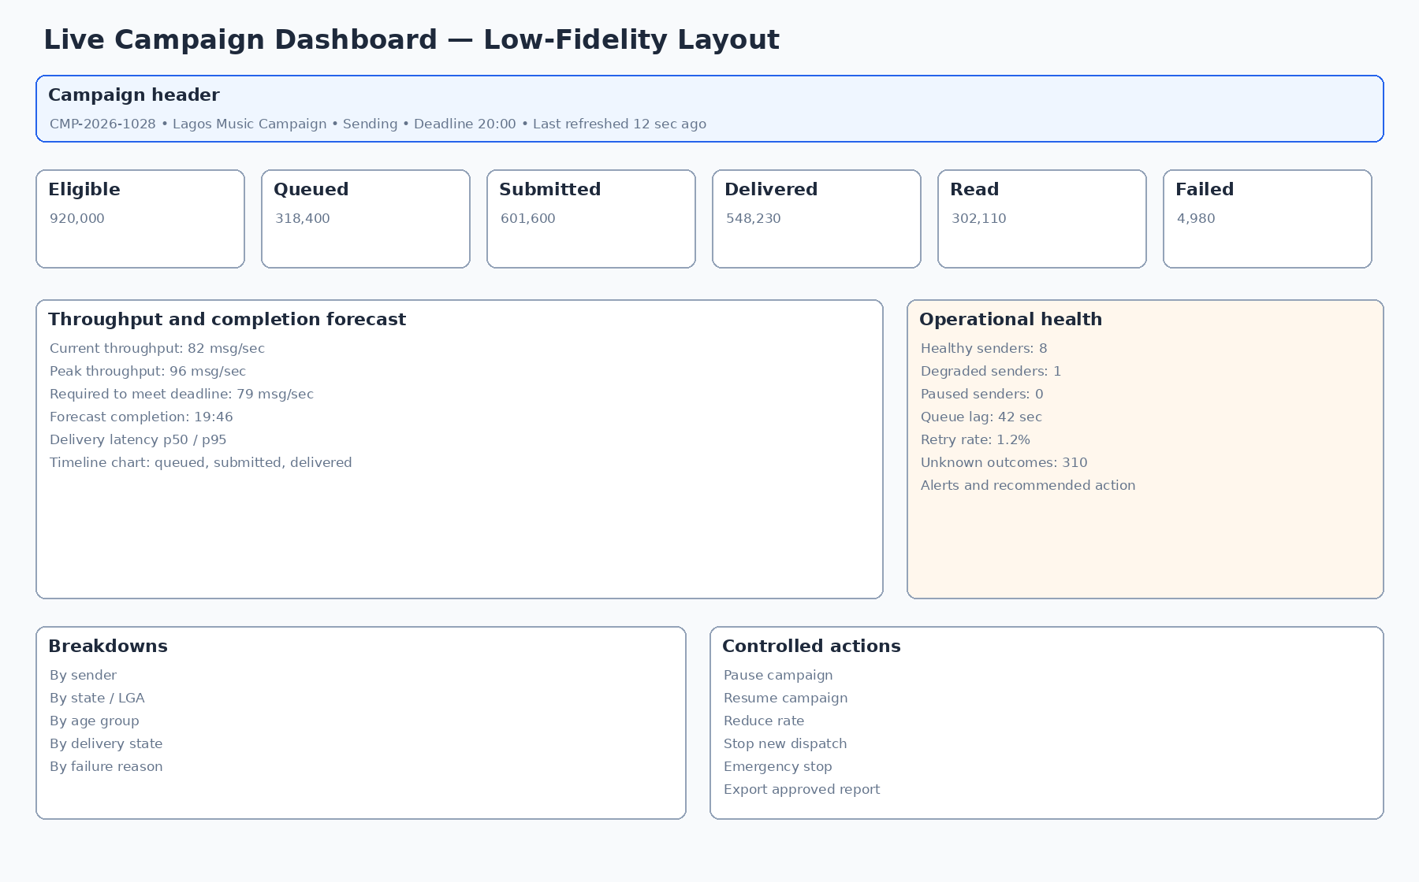
Figure 5 - Live campaign dashboard wireframe

12.1 Canonical campaign metrics
Metric | UI definition
Uploaded | Rows present in the source file before validation.
Valid | Rows passing syntax and required-field validation.
Unique | Valid records after duplicate handling according to import policy.
Eligible | Contacts meeting profile, consent, suppression and frequency rules at the eligibility checkpoint.
Snapshot | Contacts frozen into the approved audience snapshot.
Queued | Authoritative delivery jobs created and available/pending execution.
Submitted | Request passed to the messaging gateway/provider.
Gateway accepted | Gateway returned a successful response/provider identifier; not proof of delivery.
Sent acknowledgement | A sent acknowledgement was observed according to provider capability.
Delivered acknowledgement | A recipient-device delivery acknowledgement was observed.
Read acknowledgement | A read acknowledgement was observed and privacy settings/provider permit it.
Failed | A permanent or retry-exhausted failure.
Unknown | Outcome cannot yet be conclusively classified.
Suppressed | Excluded due to active global, organisation, purpose or channel suppression.
Opt-out | A new withdrawal/STOP event attributed to the campaign or reply stream.

12.2 Metric presentation rules
- Every metric card includes the definition through accessible help text.
- Counts are integers with thousands separators; rates show numerator/denominator on hover or detail.
- Time-series charts display the campaign timezone and data freshness.
- Late-arriving events may update final totals; report versions preserve their data cut-off.
- Forecast completion is labelled as a forecast and shows assumptions: remaining jobs, current/safe rate and reserve margin.
- Demographic and geographic breakdowns show unknown/other categories and small-cell suppression where configured.
- Charts use the same canonical status colours and ordering throughout the portal.

12.3 Sender and worker dashboards
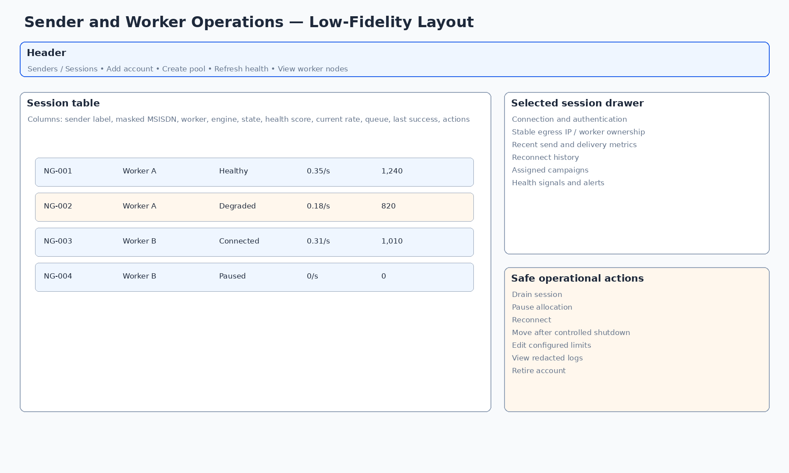
Figure 6 - Sender and worker operations wireframe
- Session health score is accompanied by the underlying signals; it is not an unexplained magic number.
- Worker resource values show thresholds and trends, not only a current snapshot.
- Actual measured sustainable rate is distinct from configured maximum rate.
- Sender pool capacity indicates healthy, reserved and spare capacity.
- Disconnection and reconnect history is visible to technical users but redacted for general operators.

13. Responsive and Accessibility Requirements

13.1 Supported layouts
Viewport | Required experience
1440 px and above | Primary design target. Full navigation, dense tables, side-by-side review and live operations dashboards.
1280–1439 px | Full operational capability with compact navigation and adaptive column visibility.
1024–1279 px | Operational capability with drawers replacing secondary panels; large tables horizontally scroll with frozen key columns.
768–1023 px | Limited tablet support for review, approval, monitoring and emergency controls. Complex segment/import design may require desktop.
Below 768 px | Mobile alert and read-only monitoring experience; high-risk campaign creation/import/export is not required unless separately approved.

13.2 Accessibility target
UX-029 The web application and approved mock-ups shall target WCAG 2.2 AA conformance.
UX-030 All functionality shall be operable by keyboard, with visible focus, logical tab order and no keyboard trap.
UX-031 Status shall not rely on colour alone; charts shall provide accessible summaries and data-table alternatives.
UX-032 Form fields shall have programmatic labels, error associations, required indicators and clear instructions.
UX-033 Live campaign updates shall use polite announcements for significant status changes and shall not continuously overwhelm assistive technology.
UX-034 Modals and drawers shall trap focus appropriately, restore focus on close and expose accessible names/descriptions.
UX-035 The interface shall remain usable at 200% zoom and with browser text enlargement without loss of critical content or action.

13.3 Motion and refresh
- Respect reduced-motion preferences.
- No essential information conveyed through animation alone.
- Live numbers may update with subtle emphasis but must not reorder tables unexpectedly.
- Pause auto-refresh control available on diagnostic tables where updates interfere with inspection.
- Critical new alerts may move into a pinned area but should not steal keyboard focus.

14. Content, Labels and Microcopy

14.1 Tone
Language must be direct, neutral and operational. Avoid marketing superlatives, blame-oriented error messages and vague terms such as “success” when the state is only partially complete.

14.2 Required terminology
Use | Avoid
Submitted to gateway | Sent, when no sent acknowledgement exists
Delivered acknowledgement | Successful delivery, unless the exact metric is defined
Unknown outcome | Probably delivered
Active consent for [organisation/purpose/channel] | Consented user
Suppressed | Deleted, when a suppression record is intentionally retained
Audience snapshot | Final live segment
Logical sender pool | Sender ID, where this could imply alphanumeric WhatsApp identity
Pause new dispatch | Pause all messages, when in-flight messages may continue
Estimated current age | Age, when derived from an earlier self-declared value

14.3 Confirmation microcopy examples
Launch confirmation
You are scheduling campaign CMP-2026-1028 for 920,000 eligible recipients using message version MSG-V4 and sender pool EventNotify Nigeria. OpenWA acceptance is not proof of delivery. Type the campaign name to confirm.

Emergency stop
Stop new dispatch for this campaign? Jobs already submitted or currently in flight may still complete. This action will be recorded against the incident reference.

MSISDN export
This export contains personal data. State the approved purpose, confirm the fields and retention period, and complete step-up authentication.

15. Error, Empty, Loading and Exceptional States
State | Required UX
Loading | Use skeletons for stable page structure; use progress with stages for imports, snapshots, reports and large queries.
Empty - no data | Explain what the module is for and offer the permitted next step.
Empty - filtered | Show active filters and a clear reset action; do not suggest creating a duplicate record.
Permission denied | Explain that access is restricted without exposing record detail; offer request-access route if supported.
Validation error | Inline error plus summary; preserve entered values and upload/mapping state.
Service unavailable | Identify affected capability, preserve work, provide retry and support/correlation ID.
Partial failure | Show succeeded and failed scopes separately and prevent double processing on retry.
Stale data | Display last successful refresh and whether actions are disabled until freshness returns.
Conflict | Show what changed, who/when, and options to reload, compare or create a new version.
Background job | Allow user to leave; provide job centre, notifications and safe retry/cancel semantics.
Late event | Update metrics according to policy and preserve prior report version.
Worker outage | Show affected sessions/campaigns, queue preservation and recovery action; do not imply data loss without evidence.
Session ownership conflict | Block sending, identify nodes, and provide a controlled resolution/runbook link.
Consent expires before send | Block release or require a new valid review; do not rely on a warning alone.
Suppression added after snapshot | Exclude at final dispatch check and report the post-snapshot exclusion.
Duplicate launch attempt | Show existing campaign execution/approval and prevent duplicate entitlement consumption.

16. Mock-up and Prototype Deliverables

16.1 Figma file structure
- 00 - Cover, document links, assumptions and change log.
- 01 - Foundations: colour, typography, spacing, grid, icons, elevation and accessibility.
- 02 - Components: all component variants and interaction states.
- 03 - Information architecture and user-flow diagrams.
- 04 - Desktop screens grouped by module and screen ID.
- 05 - Tablet/mobile monitoring and approval adaptations.
- 06 - Interactive prototypes for mandatory journeys.
- 07 - Developer annotations, content rules and permission notes.
- 08 - Superseded/archive frames; never mixed with approved frames.

16.2 Frame and naming conventions
- Desktop base frame: 1440 px wide; show meaningful viewport height rather than artificially fitting an entire long page into one screenshot.
- Frame name: [Screen ID] [Screen name] - [State] - [Role], for example UI-CAMP-10 Live campaign dashboard - At risk - Operator.
- Component variant names include size, state, semantic status and density.
- Use real-looking but synthetic data; no real MSISDNs, client names, credentials or production metrics.
- Approved frames carry an “Approved for build” status and version; exploratory alternatives remain clearly separated.

16.3 Mandatory interactive prototypes
Prototype | Flow
Prototype A | Create organisation → consent review → approve with restrictions.
Prototype B | Upload 10m-capable audience file → map → validate → reconcile → approve.
Prototype C | Build Lagos 18–35 segment → inspect staged counts → create snapshot.
Prototype D | Create campaign → compose/test message → select sender → pre-flight → approvals → schedule.
Prototype E | Monitor at-risk live campaign → inspect degraded sender → pause/drain → resume.
Prototype F | Process STOP reply → create suppression → confirm campaign exclusion.
Prototype G | Generate and approve campaign report.
Prototype H | Reveal/export sensitive data with permission, reason and step-up authentication.

16.4 Annotation requirements
- Every field: label, type, required/optional, helper text, source, validation and permission.
- Every button: action, state prerequisites, confirmation and resulting system state.
- Every metric: canonical definition, refresh rule and drill-down.
- Every table: columns, default sort, filters, bulk actions, pagination and empty/error states.
- Every status: canonical code/label and allowed transitions.
- Every sensitive value: masking, reveal/copy/export behaviour and audit event.
- Every background job: progress, cancel/retry, notification and recovery behaviour.

17. UI/UX Acceptance Criteria
Area | Acceptance criterion
Completeness | All screen IDs in Appendix A exist as approved frames or are explicitly marked out of scope with owner approval.
Journey coverage | All mandatory prototypes are navigable and show success, validation and exceptional states.
Role accuracy | Screens and actions reflect role permissions and maker/checker restrictions.
Truthful status | No design conflates queued, submitted, gateway accepted, sent, delivered, read, failed or unknown.
Consent clarity | Eligibility is specific to organisation, purpose and channel and includes evidence/expiry/suppression.
High-volume viability | Designs use server-side patterns, background jobs and staged counts; they do not suggest loading 10 million rows client-side.
Safety | Launch, export, reveal, override, pause and emergency stop have proportionate confirmations and audit cues.
Accessibility | Keyboard path, focus, labels, contrast, status alternatives, chart alternatives and zoom behaviour are demonstrated.
Responsive behaviour | Desktop and required tablet/mobile adaptations are provided for relevant screens.
Developer handoff | Tokens, components, states, measurements, assets, copy and API/data assumptions are annotated.
Synthetic data | No real personal or production data appears in design files.
Version control | Approved and superseded designs are unambiguous and linked to change records.

Mock-up approval gate
Development of the production frontend should not begin from unapproved exploratory mock-ups. The product owner, UX lead, solution architect, security/privacy representative and lead engineer should approve the information architecture, component library and mandatory workflows first.

Appendix A - Screen Register
Screen ID | Module | Screen | Priority | Target
UI-AUTH-01 | Authentication and access | Sign in | P0 | Desktop; adaptive where specified
UI-AUTH-02 | Authentication and access | Multi-factor authentication | P1 | Desktop; adaptive where specified
UI-AUTH-03 | Authentication and access | Password and access recovery | P1 | Desktop; adaptive where specified
UI-AUTH-04 | Authentication and access | Session expired / access denied | P1 | Desktop; adaptive where specified
UI-DASH-01 | Dashboard and work management | Operations dashboard | P0 | Desktop; adaptive where specified
UI-DASH-02 | Dashboard and work management | My work and approvals | P1 | Desktop; adaptive where specified
UI-DASH-03 | Dashboard and work management | Global search results | P1 | Desktop; adaptive where specified
UI-ORG-01 | Organisations | Organisation list | P1 | Desktop; adaptive where specified
UI-ORG-02 | Organisations | Create/edit organisation | P1 | Desktop; adaptive where specified
UI-ORG-03 | Organisations | Organisation detail | P1 | Desktop; adaptive where specified
UI-ORG-04 | Organisations | Organisation contacts and commercial references | P1 | Desktop; adaptive where specified
UI-ORG-05 | Organisations | Suspend/archive organisation | P1 | Desktop; adaptive where specified
UI-CONS-01 | Consent and evidence | Consent review queue | P1 | Desktop; adaptive where specified
UI-CONS-02 | Consent and evidence | Create consent review | P1 | Desktop; adaptive where specified
UI-CONS-03 | Consent and evidence | Consent review workspace | P0 | Desktop; adaptive where specified
UI-CONS-04 | Consent and evidence | Evidence viewer and library | P1 | Desktop; adaptive where specified
UI-CONS-05 | Consent and evidence | Consent purpose and wording versions | P1 | Desktop; adaptive where specified
UI-CONS-06 | Consent and evidence | Expiry and renewal | P1 | Desktop; adaptive where specified
UI-CONS-07 | Consent and evidence | Remediation and rejection detail | P1 | Desktop; adaptive where specified
UI-AUD-01 | Audience repository and imports | Contact repository | P1 | Desktop; adaptive where specified
UI-AUD-02 | Audience repository and imports | Contact detail | P1 | Desktop; adaptive where specified
UI-AUD-03 | Audience repository and imports | Import jobs list | P1 | Desktop; adaptive where specified
UI-AUD-04 | Audience repository and imports | Import wizard - source and upload | P0 | Desktop; adaptive where specified
UI-AUD-05 | Audience repository and imports | Import wizard - column mapping | P1 | Desktop; adaptive where specified
UI-AUD-06 | Audience repository and imports | Import validation results | P0 | Desktop; adaptive where specified
UI-AUD-07 | Audience repository and imports | Duplicate and merge review | P1 | Desktop; adaptive where specified
UI-AUD-08 | Audience repository and imports | Data-quality dashboard | P1 | Desktop; adaptive where specified
UI-AUD-09 | Audience repository and imports | Suppression management | P1 | Desktop; adaptive where specified
UI-AUD-10 | Audience repository and imports | Privacy/data-subject request | P1 | Desktop; adaptive where specified
UI-SEG-01 | Segments and snapshots | Saved segments list | P1 | Desktop; adaptive where specified
UI-SEG-02 | Segments and snapshots | Visual segment builder | P0 | Desktop; adaptive where specified
UI-SEG-03 | Segments and snapshots | Estimate and exclusion analysis | P1 | Desktop; adaptive where specified
UI-SEG-04 | Segments and snapshots | Masked sample preview | P1 | Desktop; adaptive where specified
UI-SEG-05 | Segments and snapshots | Create and inspect audience snapshot | P0 | Desktop; adaptive where specified
UI-CAMP-01 | Campaigns, messages and approvals | Campaign list | P1 | Desktop; adaptive where specified
UI-CAMP-02 | Campaigns, messages and approvals | Campaign creation wizard | P0 | Desktop; adaptive where specified
UI-CAMP-03 | Campaigns, messages and approvals | Campaign overview | P1 | Desktop; adaptive where specified
UI-CAMP-04 | Campaigns, messages and approvals | Message composer and versioning | P1 | Desktop; adaptive where specified
UI-CAMP-05 | Campaigns, messages and approvals | Media library | P1 | Desktop; adaptive where specified
UI-CAMP-06 | Campaigns, messages and approvals | Test send | P1 | Desktop; adaptive where specified
UI-CAMP-07 | Campaigns, messages and approvals | Approval queue | P1 | Desktop; adaptive where specified
UI-CAMP-08 | Campaigns, messages and approvals | Approval detail | P0 | Desktop; adaptive where specified
UI-CAMP-09 | Campaigns, messages and approvals | Schedule and pre-flight | P0 | Desktop; adaptive where specified
UI-CAMP-10 | Campaigns, messages and approvals | Live campaign dashboard | P0 | Desktop; adaptive where specified
UI-CAMP-11 | Campaigns, messages and approvals | Pause, resume and emergency stop | P1 | Desktop; adaptive where specified
UI-CAMP-12 | Campaigns, messages and approvals | Completion and reconciliation | P1 | Desktop; adaptive where specified
UI-CAMP-13 | Campaigns, messages and approvals | Campaign report and export | P1 | Desktop; adaptive where specified
UI-CAMP-14 | Campaigns, messages and approvals | Clone campaign | P1 | Desktop; adaptive where specified
UI-SEND-01 | Senders and operations | Sender/session list | P0 | Desktop; adaptive where specified
UI-SEND-02 | Senders and operations | Session detail | P1 | Desktop; adaptive where specified
UI-SEND-03 | Senders and operations | Connect/pair account | P1 | Desktop; adaptive where specified
UI-SEND-04 | Senders and operations | Sender pool management | P1 | Desktop; adaptive where specified
UI-SEND-05 | Senders and operations | Worker node list/detail | P1 | Desktop; adaptive where specified
UI-OPS-01 | Senders and operations | Active operations centre | P1 | Desktop; adaptive where specified
UI-OPS-02 | Senders and operations | Queue monitor | P0 | Desktop; adaptive where specified
UI-OPS-03 | Senders and operations | Failed delivery workbench | P1 | Desktop; adaptive where specified
UI-OPS-04 | Senders and operations | Unknown outcome reconciliation | P1 | Desktop; adaptive where specified
UI-OPS-05 | Senders and operations | Inbound replies and opt-outs | P1 | Desktop; adaptive where specified
UI-OPS-06 | Senders and operations | Alert centre | P1 | Desktop; adaptive where specified
UI-REP-01 | Reports and administration | Reports library | P1 | Desktop; adaptive where specified
UI-REP-02 | Reports and administration | Audience and campaign analytics | P1 | Desktop; adaptive where specified
UI-ADMIN-01 | Reports and administration | User administration | P0 | Desktop; adaptive where specified
UI-ADMIN-02 | Reports and administration | Roles and permissions | P1 | Desktop; adaptive where specified
UI-ADMIN-03 | Reports and administration | Configuration catalogue | P1 | Desktop; adaptive where specified
UI-ADMIN-04 | Reports and administration | Audit log | P1 | Desktop; adaptive where specified
UI-ADMIN-05 | Reports and administration | System health and backup status | P1 | Desktop; adaptive where specified
UI-ADMIN-06 | Reports and administration | Retention and archive policies | P1 | Desktop; adaptive where specified

Appendix B - Component State Matrix
Component | Required variants
Button | Default, hover, focus, active, loading, disabled; primary/secondary/tertiary/danger.
Text input | Empty, populated, focus, valid, warning, error, disabled, read-only, masked.
Select/combobox | Closed, open, search, no result, loading, selected, error, disabled.
Table | Loading, populated, empty, filtered-empty, partial error, stale, permission-limited.
Status badge | Draft, pending, approved, rejected, scheduled, running, paused, complete, exception, cancelled.
Metric card | Normal, improving, deteriorating, stale, unavailable, warning, critical.
File upload | Idle, dragging, uploading, scanning, mapping, validated, warning, rejected, cancelled, retrying.
Background job | Queued, running, waiting for review, completed, partial, failed, cancelled, retrying.
Session health | Connected, healthy, degraded, disconnected, pairing, quarantined, retired, ownership conflict.
Modal/drawer | Opening, active, validation error, submitting, success, failure, close confirmation.
Toast/banner | Info, success, warning, critical; transient vs persistent.
Chart | Loading, normal, empty, partial data, stale, error, accessible table view.

Appendix C - Canonical Status Labels
Domain | Canonical labels
Consent review | Draft; Evidence requested; Under review; Remediation required; Approved; Partially approved; Rejected; Expired; Superseded.
Import | Draft; Uploading; Scanning; Mapping; Validating; Reconciling; Awaiting approval; Completed; Completed with exceptions; Failed; Cancelled.
Segment/snapshot | Draft; Valid; Warning; Invalid; Estimating; Snapshot creating; Snapshot ready; Snapshot invalidated; Archived.
Campaign | Draft; Awaiting consent approval; Awaiting audience; Awaiting content approval; Awaiting commercial approval; Awaiting final approval; Scheduled; Dispatching; Paused; Completing; Completed; Completed with exceptions; Cancelled.
Delivery | Authorised; Queued; Claimed; Submitting; Gateway accepted; Sent acknowledged; Delivered acknowledged; Read acknowledged; Retryable failure; Permanent failure; Unknown; Suppressed.
Sender session | Unregistered; Pairing; Connected; Healthy; Degraded; Draining; Paused; Disconnected; Quarantined; Retired.
Worker | Provisioning; Healthy; Degraded; Draining; Maintenance; Unreachable; Retired.
Report | Requested; Generating; Awaiting approval; Approved; Failed; Expired; Revoked; Superseded.

Appendix D - Design Handoff Checklist
☐ All frames use screen IDs and approved naming.
☐ Information architecture matches the internal-only operating model.
☐ All fields, actions, statuses and permissions are annotated.
☐ Component library includes all states and responsive variants.
☐ Mandatory user journeys are prototyped.
☐ Consent, suppression and age-freshness rules are visible in relevant flows.
☐ Campaign metrics use canonical definitions.
☐ Sender pool does not masquerade as an arbitrary WhatsApp sender ID.
☐ Launch, export, reveal, pause and emergency-stop safeguards are present.
☐ Loading, empty, stale, partial failure, permission and conflict states are designed.
☐ Keyboard focus order and accessible labels are specified.
☐ Synthetic data only; no real MSISDNs or client evidence.
☐ Approved assets are export-ready and linked to implementation tickets.
☐ Product, architecture, security/privacy and engineering approvals are recorded.

End of document
This UI/UX specification is the design baseline for production mock-ups. Any material change to the operating model, consent logic, campaign state model, sender architecture, data exposure or approval process shall be reviewed against the SRS and reflected in a versioned update to this document.

