
UNIVERSITY OF PETROLEUM AND ENERGY STUDIES
(UPES)
School of Computer Science

PROJECT REPORT
On
SALES FLOW PRO
“ The Intelligence Behind Every Transaction."
Course Name | : Object Oriented Programming
Course Code | : CSEG2064
Semester | : IV
Specialization | : Data Science
Supervisor | : Riya Sharma
Month & Year | : April 2026

Group Members
Name | SAP ID | Email | Programme
Arpan Yadav | 590018748 | Arpan.18748@stu.upes.ac.in | Data Science 1
Abhinav Kumar | 590018833 | Abhinav.18833@stu.upes.ac.in | Data Science 1
Arjav Jain | 590012057 | Arjav.12057@stu.upes.ac.in | Data Science 1
Nihita Gupta | 590013029 | NIhita.13029@stu.upes.ac.in | Data Science 1
1. Introduction
Introduction SalesFlow Pro is a computer application that helps small shops manage sales and stock better. Many small shops still use paper and pen which can lead to mistakes, slow checkout lines and trouble keeping track of products and sales.
SalesFlow Pro provides a system to handle products orders and invoices easily. It was built using Java Swing, Spring Boot and PostgreSQL which makes it fast, secure and always up-, to-date.
The goal of SalesFlow Pro is to help small shops make mistakes work more efficiently and make better decisions by using a digital system instead of manual methods. SalesFlow Pro handles product management order processing and invoice generation efficiently.
SalesFlow Pro ensures performance and secure data handling.

2. Project Overview
2.1 Problem Statement
In small and medium retail shops daily operations are still handled manually or using basic tools like notebooks or Excel sheets.. As the business grows this approach starts to create problems. Shop owners often face issues like mismatched inventory, slow billing and difficulty in tracking overall sales performance.
Another big issue is invoicing. Manual bills look unprofessional. Are prone to calculation mistakes. Over time these small inefficiencies can lead to financial and operational problems.

2.2 Objectives of the Project
The main goal of this project is to build a system that simplifies and automates these everyday tasks. Specifically:
• To create a desktop application using Java Swing that works smoothly without internet
• To manage inventory in real time
• To automatically generate PDF invoices
• To provide sales insights
• To ensure authorized access

2.3 Scope of the Project
This project focuses on managing sales and inventory in a retail environment. It covers everything from logging in managing products, processing orders to generating reports.
Now the system is designed for a single store and works offline. However it can be extended in the future to support cloud storage and mobile access.

3. Requirement Analysis
3.1 Functional Requirements
1. User Authentication
The system provides a login feature where different users can access the system based on their roles. Passwords are stored securely using encryption.
2. Inventory Management
Users can add products update existing ones, delete items and search for products easily. The stock gets updated automatically whenever a sale is made.
3. Order Processing
The system allows users to create orders by selecting products. It automatically calculates the price and updates the inventory instantly after the sale.
4. Customer Management
Customer details such as name and contact information can be stored.
5. Reporting
The system can generate reports showing sales, popular products and stock levels.
6. Invoice Generation
After each sale a PDF invoice is generated automatically.

3.2 Non-Functional Requirements
• The system should be fast and responsive
• The interface should be easy to use
• Data should be secure
• The system should be reliable

3.3 Software Requirements
• Java (JDK 17)
• Spring Boot
• Java Swing
• PostgreSQL
• Maven
• iText

4. System Design
4.1 Overall Design
The system is divided into layers:
• Frontend (GUI)
• Backend (Spring Boot)
• Database layer

4.2 Modules
• Authentication Module
• Inventory Module
• Sales Module
• Report Module
• Database Module

4.3 System Flow
Start → Login → Dashboard → Module → Action → Database → Output → Exit

4.4 Database Design
1. Users Table
Stores login and role information
Field Name | Data Type | Description
id | SERIAL (PK) | Unique user ID
name | VARCHAR(100) | User full name
email | VARCHAR(255) | Login email (unique)
password | VARCHAR(255) | Encrypted password
role | VARCHAR(50) | User role (ADMIN, MANAGER, SALES)
created_at | TIMESTAMP | Account creation time

2. Products Table
Stores product details like name, price and stock quantity
Field Name | Data Type | Description
id | SERIAL (PK) | Unique product ID
name | VARCHAR(255) | Product name
sku | VARCHAR(100) | Unique SKU code
stock_quantity | INT | Available stock
price | DECIMAL(10,2) | Selling price
category | VARCHAR(100) | Product category
created_at | TIMESTAMP | Record creation time

3. Customers Table
Field Name | Data Type | Description
id | SERIAL (PK) | Unique customer ID
name | VARCHAR(100) | Customer name
phone | VARCHAR(15) | Contact number
email | VARCHAR(255) | Email address
address | TEXT | Customer address
created_at | TIMESTAMP | Record creation time

4. Orders Table
Field Name | Data Type | Description
id | SERIAL (PK) | Unique order ID
customer_id | INT (FK) | References Customers(id)
user_id | INT (FK) | References Users(id)
total_amount | DECIMAL(10,2) | Total order value
order_date | TIMESTAMP | Date of order
status | VARCHAR(50) | Order status (COMPLETED, CANCELLED)

5. Order_Items Table
Field Name | Data Type | Description
id | SERIAL (PK) | Unique item ID
order_id | INT (FK) | References Orders(id)
product_id | INT (FK) | References Products(id)
quantity | INT | Quantity purchased
price | DECIMAL(10,2) | Price per unit
subtotal | DECIMAL(10,2) | quantity × price

6. Invoices Table
Field Name | Data Type | Description
id | SERIAL (PK) | Unique invoice ID
order_id | INT (FK) | References Orders(id)
invoice_number | VARCHAR(100) | Unique invoice number
total_amount | DECIMAL(10,2) | Final billed amount
generated_at | TIMESTAMP | Invoice generation time

Relationships Summary Users → Orders (One-to-Many)
- Customers → Orders (One-to-Many)
- Orders → Order_Items (One-to-Many)
- Products → Order_Items (One-to-Many)
- Orders → Invoices (One-to-One)

5. Implementation
5.1 Technologies Used
The backend is developed using Spring Boot. The frontend is built using Java Swing.
For database operations Hibernate (JPA) is used with PostgreSQL. The invoices are generated using iText.

5.2 GUI Description
• Login Page
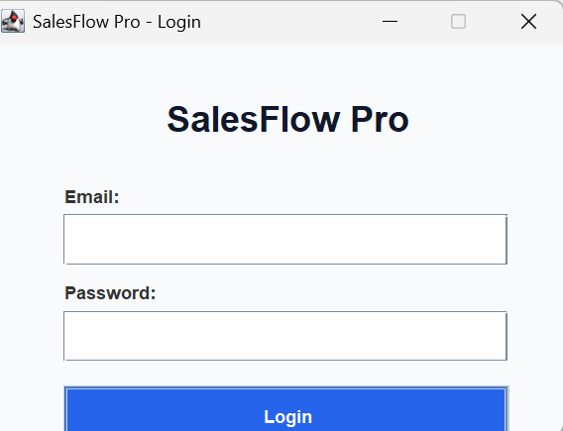

• Dashboard
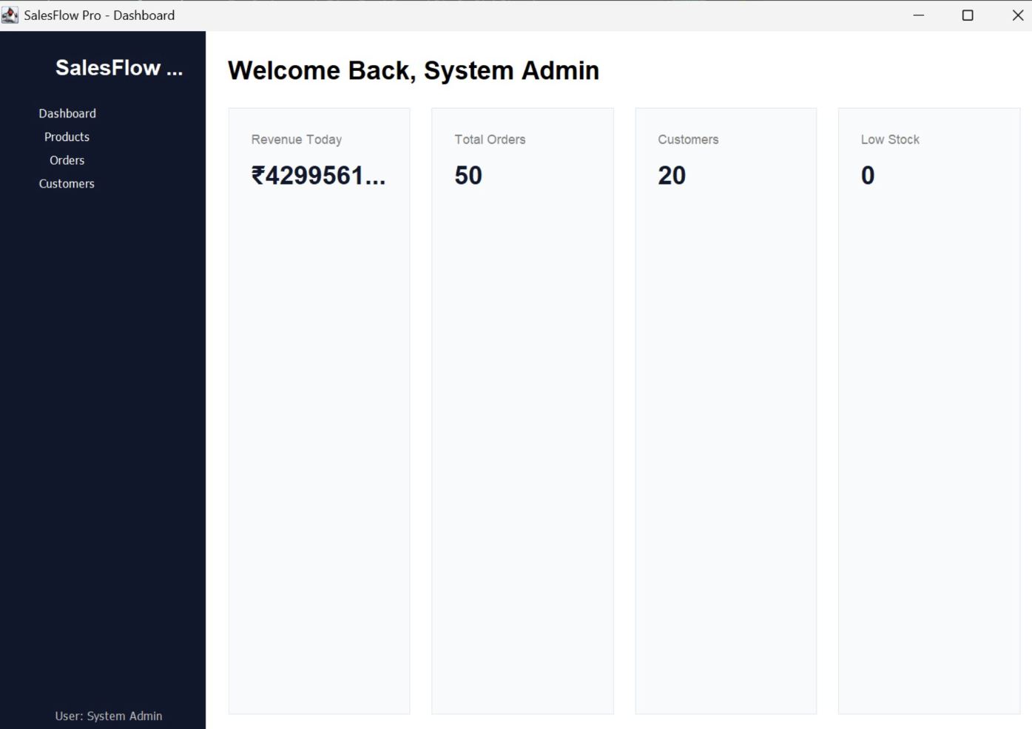
• Order Screen
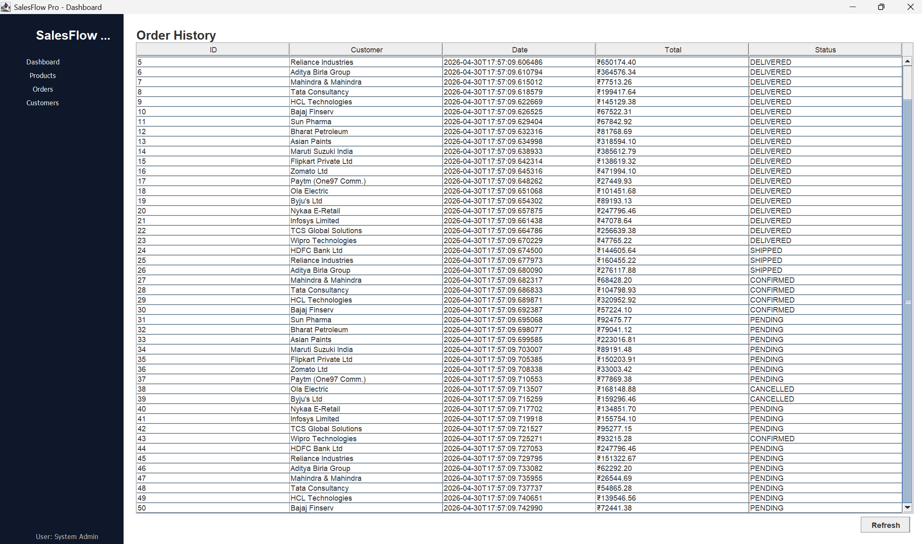

• Database View
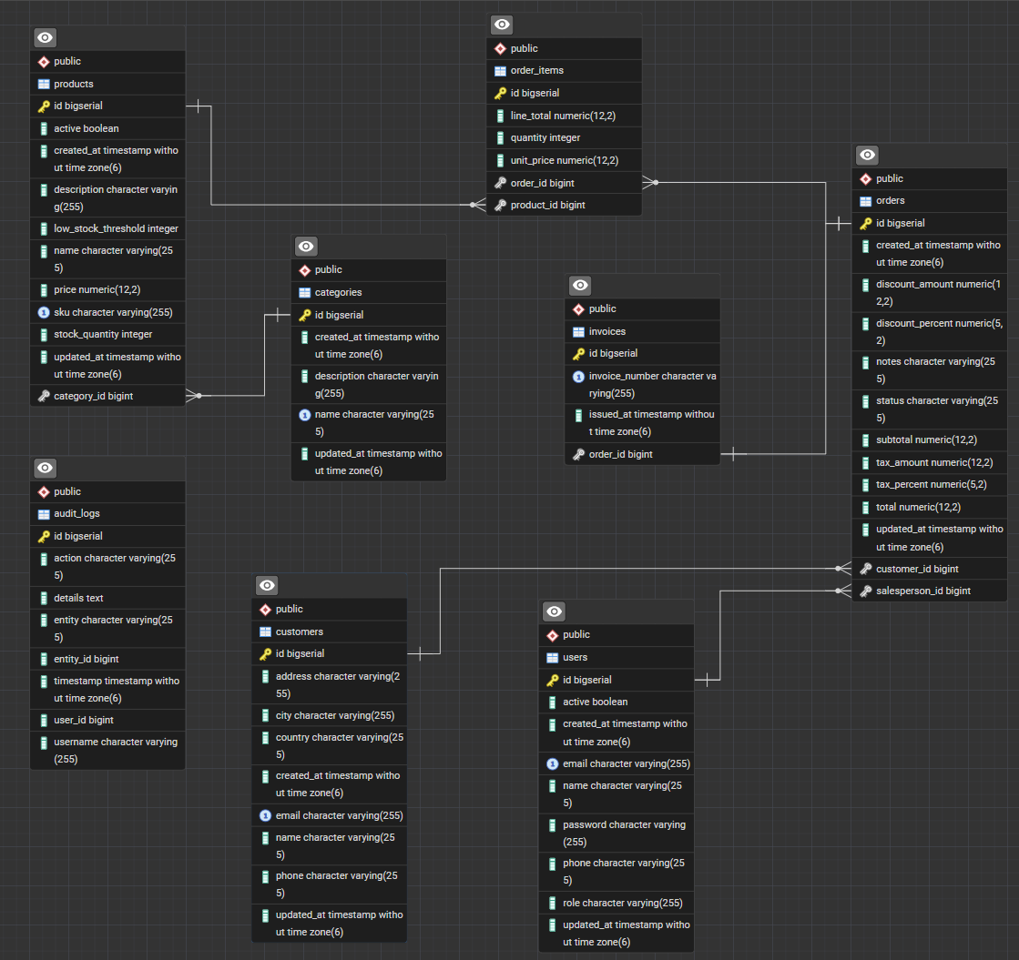
5.3 Code Highlights
• application.properties
• JPA queries
• Service layer
• Swing event listeners

6. Testing
• Unit testing
• Integration testing
• Manual testing
• Performance testing

7. Results
• Billing became faster
• Inventory tracking improved
• Errors were reduced
• Reports provided insights

8. Future Improvements
• Cloud backup
• Barcode scanning
• AI analytics
• Multi-store support

9. Conclusion
This project shows how a software solution can solve real-world problems. By automating billing and inventory management, SalesFlow Pro improves efficiency and accuracy and provides useful insights.

10. GitHub and Version Control
Repository Link :

