**Data Scraping & Wrangling – Assignment**

The goodreads website (<https://www.goodreads.com/choiceawards/best-books-2017>) list downs the “**Best Books of 2017”** under different categories like Fiction, Fantasy, Romance etc. A sample of the categories shown below

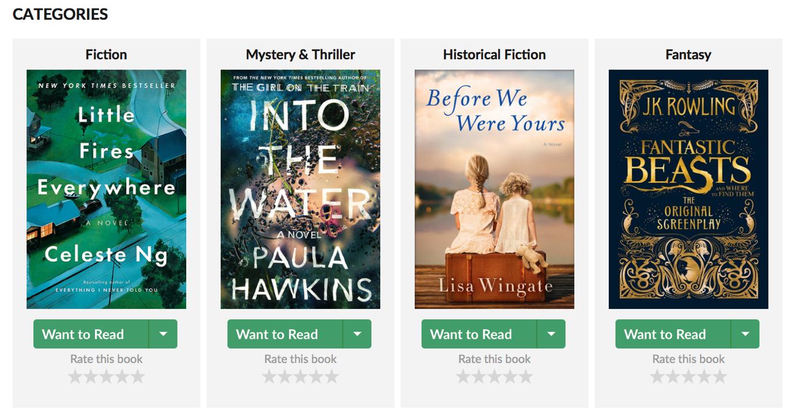

1. From this website, extract the following information in a data frame format
2. Name of the category
3. Book name
4. URL to the book cover image
5. URL to the book description (Clicking on the image, takes you to a new page. Identify this URL)

Clicking on the image, will take redirect you to the respective book web page. Sample shown below.

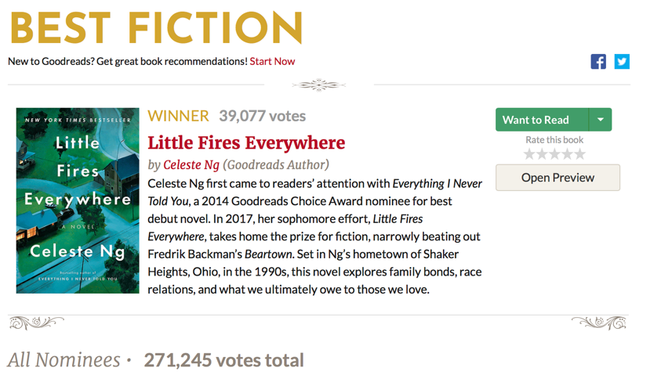

Total votes under this category

Votes received by winner

1. From this webpage for each categories, collect the following information
2. Author name
3. Short description about the book
4. Votes for the winner
5. Total votes for all the books under that category
6. % of votes for the winner
7. Combine all the above mentioned information about each book and create a pandas data frame

Note for submission:

1. Download the html version of the jupyter notebook
2. Print the results wherever necessary
3. Zip the html file
4. Save the file (both jupyter notebook & zip file) in your name, so that it is easy for us to locate your files