Sales and Customer Analysis Using Random Forest for Predictive Analysis

Abhieshek Audurti
Department of Computer Engineering
Bharati Vidyapeeth Deemed to be University College of Engineering
Pune, India
abhieshek06@gmail.com
Viabhaw Chaubey
Department of Computer Engineering
Bharati Vidyapeeth Deemed to be University College of Engineering
Pune, India
email@gmail.com
Arpan Chourasia
Department of Computer Engineering
Bharati Vidyapeeth Deemed to be University College of Engineering
Pune, India
email@gmail.com
Dr Rohini Khalkar
Department of Computer Engineering
Bharati Vidyapeeth Deemed to be University College of Engineering
Pune, India
email@gmail.com
Azure Nectar
Department of Computer Engineering
Bharati Vidyapeeth Deemed to be University College of Engineering
Pune, India
email@gmail.com

Abstract— Modern retail and quick-commerce platforms generate large volumes of sales, customer, product, and outlet data that can be used to support data-driven decision-making. However, extracting meaningful information from such datasets requires effective preprocessing, exploratory analysis, and predictive modelling. This paper presents a web-based retail analytics and machine learning platform that integrates data ingestion, preprocessing, visualization, predictive analysis, and artificial-intelligence-assisted business insights within a unified environment. The system is implemented using a React-based frontend and a Python FastAPI backend. A major feature of the platform is its target-variable selection mechanism, which allows users to upload a compatible retail dataset and select the attribute they want to predict. Depending on the selected target, the system performs either classification or regression analysis. The machine-learning engine implements CART Decision Tree, Random Forest, and Logistic Regression using pure Python without external machine-learning libraries. Random Forest uses a 50-tree bootstrap ensemble and randomized feature selection [1]. The system supports missing-value handling, categorical encoding, IQR-based outlier processing, and feature scaling [6]. Experimental results show classification accuracies ranging from 69% to 97.1%, with Random Forest achieving the highest performance among the evaluated classification models. For sales regression, Random Forest achieved an R² value of 0.548 with an RMSE of 987.6 and MAE of 721.3. The platform demonstrates the applicability of an integrated web-based machine-learning environment for retail analytics and predictive decision support.

Keywords— Machine Learning, Retail Analytics, Random Forest, Predictive Analysis, Data Preprocessing, FastAPI, React.

Introduction

Background and Context
The rapid growth of digital commerce and retail platforms has generated large amounts of sales and customer-related data. These datasets contain information on products, prices, outlets, customer behaviour, product categories, sales quantities, and other business characteristics. Proper analysis of these attributes can provide useful information for understanding sales performance, customer behaviour, product demand, and business operations.

Traditional analytical approaches mainly focus on descriptive statistics and visualisation. Although these methods are useful for understanding historical patterns, they provide limited capabilities for predicting future or previously unseen outcomes. Machine-learning techniques can extend conventional analytics by identifying complex relationships between input variables and prediction targets.

Random Forest is an ensemble learning technique introduced by Breiman that combines multiple decision trees using randomised training samples and feature selection. It can be applied to both classification and regression problems and also provides mechanisms for estimating variable importance [1].

Machine learning has increasingly been applied to retail sales forecasting. For example, Pang applied Random Forest Regression to Walmart weekly sales data and demonstrated its usefulness for retail sales forecasting and identification of important sales-related factors [2]. More recently, Faraji and Jafari investigated Random Forest Regression for Walmart sales forecasting using a Kaggle dataset and evaluated the model using MSE, RMSE, MAE, and R² [3].

Customer-oriented predictive analysis has become an important research area. Chen et al. conducted a systematic review of 98 studies on customer purchase prediction in a B2C e-business and identified machine learning and purchase-feature analysis as important research directions [4].

These studies indicate the usefulness of machine learning for sales and customer analytics. However, many approaches focus on a particular prediction problem or require separate software environments for data preparation, visualization, model training, and prediction. The proposed system addresses this issue by integrating these activities into a single web-based platform.

Problem Statement
Sales and customer datasets contain numerical and categorical attributes, missing values, inconsistent data formats, and outliers. Manually performing feature-specific preprocessing, exploratory analysis, model training, evaluation, and prediction can be time-consuming and requires expertise.
Furthermore, analytical dashboards generally focus on descriptive visualisation, whereas machine-learning environments often require users to work directly with programming libraries and separate development tools.

Therefore, there is a need for an integrated platform that can:
- accept compatible sales and customer datasets;
- preprocess and analyse the uploaded data;
- provide sales, customer, product, and outlet insights;
- train and compare machine-learning models;
- identify important predictive features;
- generate predictions through an interactive web interface.
- generate attribute-specific classifications and predictions

The proposed system, InsightForge Analytics, addresses these requirements through a full-stack web-based analytics and machine-learning platform. The platform supports local CSV files as well as Kaggle dataset imports..

Significance of the Study
The main significance of the proposed system is to integrate descriptive analytics and predictive machine learning into a single platform.
Instead of requiring users to perform data preprocessing, visualisation, model training, and prediction in separate environments, the proposed system provides these capabilities through an interactive web application.
The system is also useful from an educational perspective because its core machine-learning algorithms are implemented in pure Python, allowing the underlying operations of decision trees, Random Forest, and logistic regression to be examined without relying on external machine-learning libraries.

Materials and methedology

System Archtecture
The proposed system follows a layered architecture consisting of:

- User Layer
- Frontend Layer
- Backend API Layer
- Core Processing and Machine-Learning Layer
- External Services Layer

In Fig. 3, the user interacts with the React-based frontend through modules such as Dashboard, Sales Analysis, Customer Analysis, Product Analysis, Outlet Analysis, Data Preprocessing, ML Studio, and Dataset Explorer.

The frontend communicates with the FastAPI backend through REST-based HTTP requests. The backend processes uploaded datasets and dispatches requests to the preprocessing and machine-learning components. The architecture documented in the project follows this request-response workflow (Fig. 1):

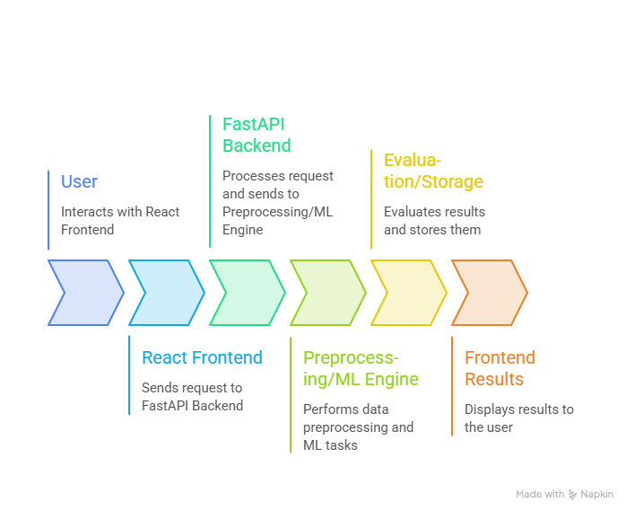
Fig. 1.Workflow

The processed dataset can be stored for later analysis, while trained models are serialised for subsequent prediction. The system also supports AI-generated insights through an external Gemini REST API and dataset acquisition through the Kaggle API.

The complete data flow or the workflow of the proposed system can be shown as (Fig.4.)

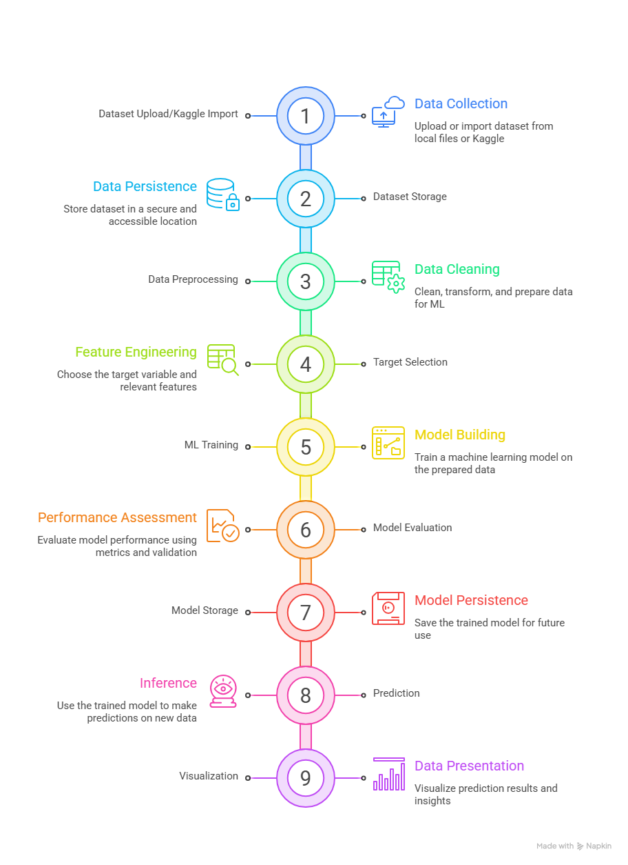
Fig. 2

This architecture (Fig.3) separates data ingestion, preprocessing, model training, prediction, and presentation, allowing the individual components to be modified independently.

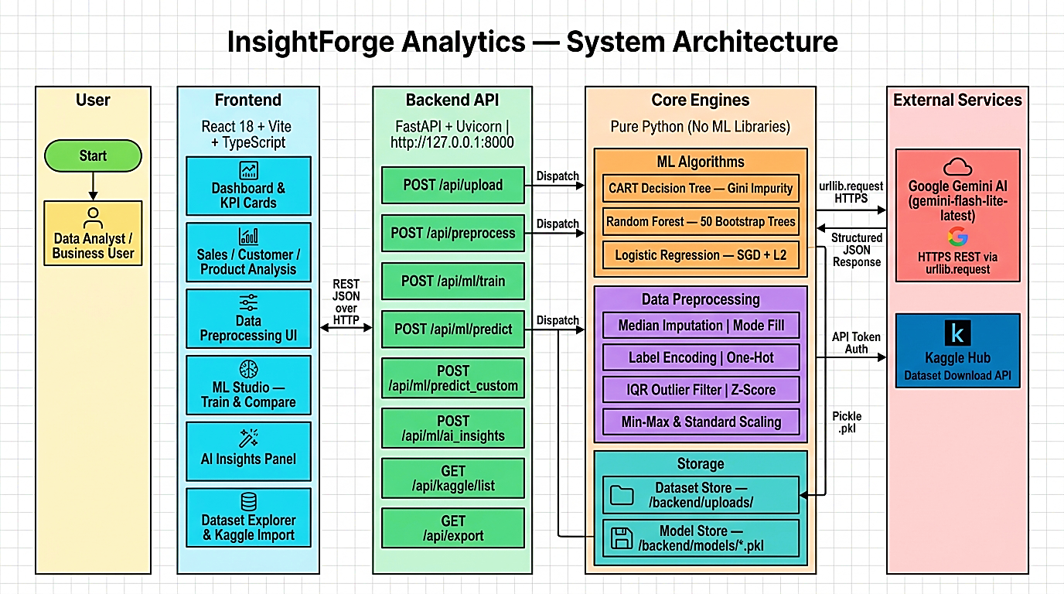
Fig. 3. System Architecture of the Proposed Platform.

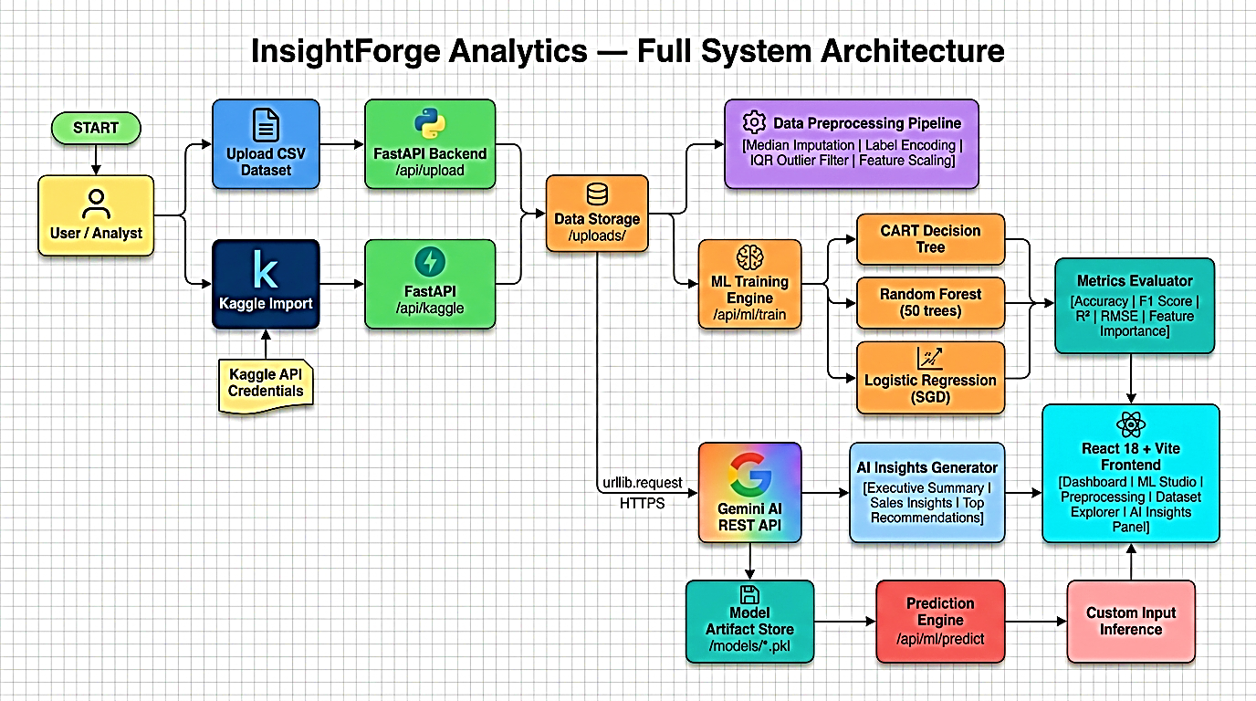
Fig.4. Complete Data Flow of the Proposed System

Implementation Technology
The proposed application uses a full-stack architecture.

Component | Technology
Frontend | React18
Programming language | TypeScript
Build Tool | Vite
Backend | Python
API Framework | FastAPI
Server | Uvicorn
Visualization | Recharts
Machine Learning | Pure python
Model Storage | Pickle
Dataset Source | CSV / Kaggle
AI insights | Google Gemini REST API

The frontend provides interactive dashboards and visualization, while the FastAPI backend performs dataset processing and machine-learning operations.

The system does not rely on major external machine-learning libraries for the core algorithms. The project implements the learning algorithms directly in Python.

Dataset Import
The platform supports two major dataset ingestion methods:

- Local CSV Upload:
Users can upload a sales or customer dataset in CSV format. The backend analyses the dataset and generates schema, preview, statistics, and analytical information.

- Kaggle Dataset Import:
Users can import any dataset from Kaggle
through the Kaggle API and select a CSV file for analysis.

This feature allows the platform to work on different datasets rather than being restricted to one predefined dataset.

Dataset Collection
Before performing actual operations and training of the model, the dataset is preprocessed, which converts raw data into a suitable representation.

The preprocessing includes the following:
- Missing-value detection
- Median imputation for numerical variables
- Mode-based filling for categorical variables
- Label encoding
- One-hot encoding
- IQR-based outlier filtering [5]
- Z-score-based analysis
- Min-Max scaling
- Standard scaling

The preprocessing pipeline follows a fit/transform approach so that transformation parameters can be learned from training data and subsequently applied to testing or prediction data.

This reduces the possibility of information leakage during model evaluation.

Machine Learning Models
The platform trains and compares multiple algorithms. Random Forest is the primary algorithm of this study.

- CART Decision Tree:
The Classification and Regression Tree is used as a baseline model. For classification, the system uses Gini impurity to determine suitable splits. [6]
$$Gini=1- \sum_{i=1}^{K}{{pi}^{2}}$$
Where pi represents probability of an observation belonging to class i.

- Random Forest
Random Forest is the primary algorithm used for prediction in the proposed system.
The system creates an ensemble of 50 bootstrap-sampled decision trees. Random subsets of features are considered during tree construction, reducing correlation between individual trees.
For classification, the final result is determined through majority voting:
$y=mode(T1\left(x\right), T2\left(x\right)…..TB(x)$) [1]
where B is the number of decision trees.
For regression, the average prediction from each tree is calculated:
$y= \frac{1}{B}\sum_{b}^{B}{T_{b}(x)}$ [1]
The Random Forest is based on Breiman's ensemble-learning framework, where randomized trees are combined to improve predictive performance and robustness. The original work also discusses variable-importance estimation and how it is applicable to regression [1].

- Logistic Regression
Logistic Regression is used as an additional classification model. The project uses a one-vs-rest strategy for multiclass classification and gradient-based optimisation with L2 regularisation.
It provides a linear baseline against which the nonlinear tree-based approaches can be compared.
For regression experiments, the project uses a linear-regression approach rather than treating Logistic Regression as a regression algorithm. This distinction is important when interpreting the experimental results.

Model Evaluation
The system uses different evaluation metrics depending on the prediction task and the target value.

Classification
The following metrics are calculated:
- Accuracy
- Precision
- Recall
- Weighted F1-score
- Confusion matrix

Regression
For regression tasks, the evaluation considers:
- R²
- RMSE
- MAE

Result and discussion

Experimental Setup
The proposed system was evaluated using retail datasets representative of sales and customer analytics applications. The documented experiments included:

Dataset | Approx Records | Target | Task
Blinkit Retail Q1 | 85000 | Outlet_ID | Classification
Blinkit Retail Q1 | 8500 | Item_Outlet_Sales | Regression
Blinkit Retail Q2 | 8500 | Item_Type | Classification
Kaggle Grocery | 14000 | Sales | Regression

Classification Results
Table I
Classification Performance for Outlet_ID Prediction
Algorithm | Accuracy | Weighted F1 | Precision | Recall
Random Forest | 0.710 | 0.695 | 0.681 | 0.710
Decision Tree | 0.692 | 0.673 | 0.659 | 0.692
Logistic Regression | 0.690 | 0.670 | 0.655 | 0.690

The Random Forest model produced the highest performance across the reported classification metrics. It achieved an accuracy of 71.0%, compared with 69.2% for the Decision Tree and 69.0% for Logistic Regression

Table II
Classification Performance for Item_type Prediction
Algorithm | Accuracy | Weighted F1
Random Forest | 0.971 | 0.971
Decision Tree | 0.968 | 0.967
Logistic Regression | 0.831 | 0.816

For Item_Type classification, Random Forest achieved 97.1% accuracy and a weighted F1-score of 0.971. Decision Tree produced a similar result at 96.8%, whereas Logistic Regression achieved 83.1%.
The small difference between Random Forest and Decision Tree suggests that the target may already be strongly associated with the available product attributes.

Regression Results
Table III
Regression Performance for Item_Outlet_Sales Prediction

Algorithm | R² | RMSE | MAE
Random Forest | 0.548 | 987.6 | 721.3
Decision Tree | 0.312 | 1204.1 | 890.4
Linear Regression | — | — | —

Random Forest achieved an $R^{2}$ of 0.548, compared with 0.312 for the Decision Tree. It also achieved lower RMSE and MAE values, indicating better predictive performance for the evaluated sales target.

However, an $R^{2}$ value of 0.548 also indicates that a substantial portion of the variation in sales remains unexplained. Factors such as seasonality, promotional activity, demand fluctuations, and other temporal variables could potentially improve the predictive capability if they are available in the dataset.

Feature-Importance Analysis
The feature-importance analysis identified Item_MRP as the strongest reported feature, with an importance of approximately 0.4123. Outlet_Type followed with an importance of approximately 0.2218.
This indicates that product price and outlet characteristics can have substantial influence on sales-related predictions. The feature importance should not be interpreted as a direct influence. Additional factors such as promotions, seasonality, inventory availability, and customer-level information can be used to improve prediction performance.

Overall Discussion
Across the reported classification experiments, Random Forest consistently achieved the best performance among the compared models. Its performance advantage is consistent with the fundamental design of Random Forest, in which multiple decision trees are combined to reducemodel variance [1].

The accuracy for Item_type classification was 97.1% and for Outlet_Id was 71.0%, suggesting that outlet identification is a more difficult prediction task, as multiple outlets may share similar characteristics.

For sales regression, R² was 0.548 with Random Forest, demonstrating moderate prediction capability. Retail Forecasting research has shown that Random Forest and other machine-learning techniques can be applied to sales forecasting problems involving complex retail datasets.[2] [3].

The result also indicates that the available attributes do not completely explain sales variation. Factors such as seasonality, promotional campaigns, customer purchasing frequency, inventory levels, and temporal information could potentially improve future models.

The results demonstrate an important characteristic of the proposed platform: model performance depends on the selected target variable and dataset. The application therefore does not provide a single predetermined prediction output. Instead, users can select a target attribute appropriate to their analytical requirement and obtain the corresponding classification or regression result

Web Based Analytical Result
The web application extends predictive modelling with descriptive analytics. The Dashboard provides high-level KPIs and graphical summaries, while the Sales module provides revenue trends, product-level revenue comparisons, outlet-level rankings, and category-outlet analysis.

The Customer module supports customer segmentation and purchasing behaviour analysis. Customer purchase prediction is an important research area in modern e-commerce and retail analytics [4].

The Product module examines product visibility, pricing, category contributions, and demand-related information. The Outlet module provides analysis based on outlet size, type, location, and revenue.

The ML Studio presents model comparisons, feature importance, prediction distributions, and custom-input predictions. This allows users to move from descriptive analysis to predictive analysis without leaving the application.

F. Limitations
Several limitations remain in the current system.
First, the platform currently processes one primary CSV dataset at a time and does not support complex multi-table joins. Second, the system does not currently provide neural-network-based modelling. Third, time-series algorithms such as ARIMA and LSTM are not included, limiting its ability to model long-term sales patterns.
The preprocessing pipeline is primarily in-memory, which can become slower for extremely large datasets. The current application also does not provide multi-user authentication or a persistent multi-user model registry.

Future development can include neural networks, gradient boosting, time-series forecasting, database-backed storage, authentication, real-time streaming, automated feature engineering, and model versioning.

Conclusion
This paper presented a web-based retail analytics and machine-learning platform for sales, customer, product, and outlet analysis. The proposed system integrates dataset ingestion, preprocessing, visualization, machine-learning model training, prediction, feature-importance analysis, and AI-generated insights within a unified application.
A major contribution of the platform is its dynamic target-selection mechanism. Rather than restricting the application to a predefined prediction target, users can upload compatible datasets and select the attribute they want to predict. Categorical targets are handled as classification tasks, while numerical targets are handled as regression tasks. This makes the system applicable to a wider range of retail analytics requirements.
The machine-learning engine implements CART Decision Tree, Random Forest, and Logistic Regression using pure Python. Random Forest, implemented as a 50-tree bootstrap ensemble, consistently produced the strongest reported results. The effectiveness of Random Forest for structured classification and regression problems is supported by its original ensemble formulation [1] and by previous retail forecasting studies [2] [3].
The platform also demonstrates how machine-learning predictions can be combined with interactive web-based analytics and natural-language AI insights. Customer-oriented predictive analytics and machine-learning approaches have become increasingly relevant in retail and e-commerce research [4]
The overall system can therefore serve both as a practical retail analytics tool and as an educational implementation demonstrating the principles of data preprocessing, machine learning, predictive modelling, and web-based data analytics.
Future improvements involving time-series forecasting, neural networks, automated feature engineering, persistent databases, multi-user authentication, and model versioning can further extend the capabilities of the proposed platform.

REFERENCES

[1] L. Breiman, “Random forests,” Machine Learning, vol. 45, no. 1, pp. 5–32, 2001, doi: 10.1023/A:1010933404324.

[2] S. Pang, “Retail sales forecast based on machine learning methods,” in Proc. 6th Annual International Conference on Data Science and Business Analytics (ICDSBA), 2022, pp. 357–361, doi: 10.1109/ICDSBA57203.2022.00030.

[3] K. Faraji and S. M. Jafari, “Sales forecasting in retail using random forest regression: A case study on Walmart,” in Proc. 4th International Conference on Computing and Information Technology (ICCIT), 2025, pp. 592–597, doi: 10.1109/ICCIT63348.2025.10989314.

[4] S. Chen, Z. Xu, D. Xu, and X. Gou, “Customer purchase prediction in B2C e-business: A systematic review and future research agenda,” Expert Systems with Applications, vol. 252, Art. no. 124261, 2024, doi: 10.1016/j.eswa.2024.124261.

[5] J. W. Tukey, Exploratory Data Analysis. Reading, MA, USA: Addison-Wesley, 1977.

[6] L. Breiman, J. H. Friedman, R. A. Olshen, and C. J. Stone, Classification and Regression Trees. Belmont, CA, USA: Wadsworth International Group, 1984.

[7] G. James, D. Witten, T. Hastie, and R. Tibshirani, An Introduction to Statistical Learning: With Applications in R. New York, NY, USA: Springer, 2013.

[8] I. H. Witten, E. Frank, M. A. Hall, and C. J. Pal, Data Mining: Practical Machine Learning Tools and Techniques, 4th ed. Cambridge, MA, USA: Morgan Kaufmann, 2016.

[9] F. Provost and T. Fawcett, Data Science for Business: What You Need to Know About Data Mining and Data-Analytic Thinking. Sebastopol, CA, USA: O’Reilly Media, 2013.

[10] K. P. Murphy, Machine Learning: A Probabilistic Perspective. Cambridge, MA, USA: MIT Press, 2012.

[11] R. S. Sutton and A. G. Barto, Reinforcement Learning: An Introduction, 2nd ed. Cambridge, MA, USA: MIT Press, 2018.

[12] F. Pedregosa et al., “Scikit-learn: Machine learning in Python,” Journal of Machine Learning Research, vol. 12, pp. 2825–2830, 2011.

[13] W. McKinney, “Data structures for statistical computing in Python,” in Proc. 9th Python in Science Conf. (SciPy), 2010, pp. 56–61.

[14] M. Stone, “Cross-validatory choice and assessment of statistical predictions,” Journal of the Royal Statistical Society: Series B (Methodological), vol. 36, no. 2, pp. 111–147, 1974.

[15] M. Sokolova and G. Lapalme, “A systematic analysis of performance measures for classification tasks,” Information Processing & Management, vol. 45, no. 4, pp. 427–437, 2009.

[16] D. M. W. Powers, “Evaluation: From precision, recall and F-measure to ROC, informedness, markedness and correlation,” Journal of Machine Learning Technologies, vol. 2, no. 1, pp. 37–63, 2011.

[17] J. H. Friedman, “Greedy function approximation: A gradient boosting machine,” The Annals of Statistics, vol. 29, no. 5, pp. 1189–1232, 2001.

[18] K. J. Ferreira, B. H. A. Lee, and D. Simchi-Levi, “Analytics for an online retailer: Demand forecasting and price optimization,” Manufacturing & Service Operations Management, vol. 18, no. 1, pp. 69–88, 2016, doi: 10.1287/msom.2015.0561.

[19] R. Fildes, P. Goodwin, M. Lawrence, and K. Nikolopoulos, “Effective forecasting and judgmental adjustments: An empirical evaluation and strategies for improvement in supply-chain planning,” International Journal of Forecasting, vol. 25, no. 1, pp. 3–23, 2009.

[20] R. Fildes, S. Ma, and S. Kolassa, “Retail forecasting: Research and practice,” International Journal of Forecasting, vol. 38, no. 4, pp. 1283–1318, 2022.

