BHARATI VIDYAPEETH (DEEMED TO BE UNIVERSITY)
COLLEGE OF ENGINEERING, PUNE- 4110043
A PROJECT BASED LEARNING
REPORT ON
InsightForge Analytics: Retail and Quick-Commerce Data Warehousing, Mining, and Machine Learning Platform
(Sales and Customer Analysis using Machine Learning)
Submitted by
Name | PRN | Roll no.
Abhishek Audurthi | 2414110184 | 04
Azure Behera | 2414110187 | 06
Vaibhaw Chaubey | 2414110193 | 11
Arpan Chourasia | 2414110198 | 15
For the course Data Warehousing and Mining
Submitted To Course Coordinator
Dr. Rohini Khalkar
B. Tech Computer Engineering (Sem V)
2026-27

DEPARTMENT OF COMPUTER ENGINEERING
Bharati Vidyapeeth (Deemed to Be University)
College of Engineering Pune – 411043

CERTIFICATE
This is to certify that the project report entitled “Sales and Customer Analysis using Machine Learning” is a bonafide work carried out by Abhishek Audurthi (04), Azure Behera (06), Vaibhaw Chaubey (11), and Arpan Chourasia (15) in partial fulfilment of the requirements for the award of the degree of Bachelor of Technology in Computer Engineering during the academic year [2026–27]. The work has been completed under my guidance and supervision. To the best of my knowledge, the work presented in this report has not been submitted, either in whole or in part, to any other university or institution for the award of any degree or diploma.
Date: 06-10-2026
Place: Pune
_____________________________  Dr. Rohini Khalkar  Internal Guide & Course Coordinator  Dept. of Computer Engineering  BV(DU) COE, Pune | _____________________________  Dr. Sandeep Vanjale  Head of Department  Dept. of Computer Engineering  BV(DU) COE, Pune

ACKNOWLEDGEMENT
We express our sincere gratitude to Dr. Rajesh Prasad, Principal of Bharati Vidyapeeth (Deemed to be University), College of Engineering, Pune, for providing the state-of-the-art facilities and academic environment required for completing this Project Based Learning endeavor.
We are deeply thankful to Dr. Sandeep Vanjale, Head of the Department of Computer Engineering, for valuable guidance, department resources, and encouragement throughout the project work.
We extend our heartfelt gratitude to our course coordinator and project guide, Dr. Rohini Khalkar, for her continuous guidance, constructive suggestions, technical support, and motivation during every stage of designing, developing, and documenting InsightForge Analytics.
We also thank all faculty members, technical laboratory assistants, friends, and family members who supported us during the development and documentation of the platform. Finally, we thank our institution for providing us with an opportunity to undertake this project and apply core concepts of Data Warehousing and Data Mining in a real-world, full-stack application.
Abhishek Audurthi
Azure Behera
Vaibhaw Chaubey
Arpan Chourasia
B. Tech Computer Engineering (Sem V)

TABLE OF CONTENTS
Section / Chapter Title | Page No.
CERTIFICATE | 2
ACKNOWLEDGEMENT | 3
ABSTRACT | 7
CHAPTER 1: INTRODUCTION | 8
1.1 Background and Industry Paradigm | 8
1.2 Data Warehousing & Mining in Modern Retail | 8
1.3 Problem Statement and Identified Deficiencies | 9
1.4 Objectives of the System | 10
1.5 Scope of the Project | 11
1.6 Need for the System & Industry Significance | 11
1.7 Organization of the Report | 12
CHAPTER 2: LITERATURE SURVEY | 13
2.1 Introduction to Mining Foundations in Retail | 13
2.2 Decision Tree (CART) Classification & Regression | 13
2.3 Random Forest Ensemble Learning Paradigm | 14
2.4 Logistic Regression & Linear Modeling via SGD | 14
2.5 Data Preprocessing & Warehousing Literature | 15
2.6 Comparative Analysis of Mining and ML Techniques | 16
2.7 Research Gap and Critical Challenges | 16
CHAPTER 3: REQUIREMENT ANALYSIS AND FEASIBILITY STUDY | 17
3.1 Existing System Analysis & Operational Gaps | 17
3.2 Proposed System Framework | 17
3.3 Functional Requirements Specification | 17
3.4 Non-Functional Requirements Specification | 19
3.5 Comprehensive Feasibility Study (4 Dimensions) | 19
3.6 Use-Case Description and Sequence Flow | 20
CHAPTER 4: SYSTEM DESIGN | 21
4.1 System Architecture and 5-Layer Design | 21
4.2 Data-Flow & Component Workflow Pipeline | 22
4.3 Database & File-Based Storage Architecture | 23
4.4 User-Interface Design and Modular Views | 23
4.5 Machine Learning & Analytics Engine Design | 24
CHAPTER 5: METHODOLOGY AND IMPLEMENTATION | 25
5.1 Incremental Agile Development Methodology | 25
5.2 Data Collection and Retail Benchmark Datasets | 25
5.3 Leak-Free Preprocessing Pipeline Architecture | 27
5.4 End-to-End Analytics and Machine Learning Workflow | 27
5.5 Algorithm Formulations and Pure-Python Pseudocode | 27
5.6 Modular Functional Architecture | 29
5.7 Technology Stack and Architectural Specifications | 29
5.8 Feature Matrix and System Capabilities | 30
5.9 Implementation Details & Python API Role | 31
CHAPTER 6: TESTING AND RESULTS | 32
6.1 Multi-Level Testing Strategy | 32
6.2 Comprehensive Test Cases and Validation Matrix | 32
6.3 Evaluation Metrics Formulation | 34
6.4 Experimental Results and Empirical Discussion | 34
CHAPTER 7: CONCLUSION AND FUTURE SCOPE | 36
7.1 Conclusion | 36
7.2 Practical Industrial Applications | 36
7.3 System Limitations | 37
7.4 Detailed Future Scope and Research Roadmap | 37
REFERENCES | 38

ABSTRACT
In contemporary quick-commerce and digital retail platforms (such as Blinkit, Zepto, and Instamart), massive streams of transactional, customer, and operational inventory data are generated on a continuous daily basis. Effectively transforming this voluminous raw data into strategic advantage demands unified data warehousing, automated exploratory data mining, and high-accuracy predictive machine learning models to optimize dark store inventory, forecast SKU level revenues, and analyze customer purchasing behaviors. However, traditional enterprise business intelligence tools (Tableau, Power BI, AWS SageMaker) impose steep licensing barriers and specialized cloud engineering dependencies, while academic implementations frequently rely on heavyweight, opaque external libraries that obscure algorithm internals and present deployment hazards.
This project presents InsightForge Analytics, a full-stack Data Warehousing, Data Mining (DWM), and Machine Learning platform engineered specifically for retail and quick-commerce business intelligence. Developed using a React 18 + Vite + TypeScript frontend and a Python FastAPI backend, the system implements an end-to-end analytical pipeline: from CSV ingestion and Kaggle dataset imports, through automated data cleaning, median/mode imputation, IQR outlier winsorization, and Min Max normalization, to multi-model training and predictive inference.
In this architecture, Python is used exclusively for the backend API services (built using FastAPI and Unicorn) to coordinate REST routing, data ingestion, pipeline preprocessing, model artifact serialization, and serving prediction responses. All primary predictive learning algorithms CART Decision Tree (Gini Impurity and Variance Reduction), Random Forest (ensemble of 50 bootstrap-sampled trees with random feature subspace sampling), and Logistic Regression with Stochastic Gradient Descent (SGD) and L2 regularization are implemented from first principles. The platform achieves classification accuracies between 71.00% and 97.12%, and a regression R² score of 0.55 on quick-commerce benchmark datasets. Furthermore, an integrated Google Gemini AI engine delivers structured, domain-aware executive summaries and strategic business recommendations directly based on computed model output metrics.

1: INTRODUCTION
1.1 Background and Industry Paradigm
The growth of digital commerce has fundamentally altered the paradigm of retail supply chains and customer purchasing patterns across the globe. Over the past decade, consumer expectations have shifted from multi-day delivery windows to instant, hyper-local order fulfillment. This shift has given rise to the quick-commerce (q commerce) industry, characterized by distributed networks of neighborhood fulfillment centers popularly known as 'dark stores'.
Platforms such as Blinkit, Zepto, and Instamart process hundreds of thousands of retail transactions daily across diverse product categories, ranging from fresh perishables and dairy products to household staples, beverages, and personal care items. Each dark store operates within a tight geographic radius (typically 2 to 3 kilometers), maintaining an inventory of several thousand Stock Keeping Units (SKUs). Because dark stores operate with constrained physical shelf footprints, stock availability must be managed with extreme precision. Understocking leads to customer dissatisfaction and lost sales, while overstocking ties up working capital and causes perishable stock spoilage.
To succeed in this hyper-competitive environment, retail decision-makers require immediate, data-driven visibility into customer buying patterns, sales volume trends, price elasticity, and store format performance. Traditional ad-hoc analysis using static spreadsheets is inadequate for managing the velocity and complexity of modern retail operations.
1.2 Data Warehousing & Mining in Modern Retail
Data Warehousing and Mining (DWM) represents the technological backbone of modern business intelligence systems. A Data Warehouse serves as a centralized, non-volatile, time-variant repository that consolidates transactional records from diverse operational systems into structured dimensional models. In retail environments, transactional logs are organized into star schemas or snowflake schemas, with fact tables capturing sales volume and revenue, surrounded by dimension tables detailing items, stores, time periods, and customer cohorts.
Data Mining complements warehousing by applying statistical algorithms and pattern extraction methodologies to uncover non-obvious relationships hidden within large volumes of data. Key retail data mining tasks include:

- 1. Predictive Regression Modeling: Predicting continuous sales numbers based on item attributes, retail pricing, and store characteristics.
- 2. Supervised Classification: Categorizing products into operational tiers, demand velocities, or catalog hierarchies.
- 3. Clustering and Segmentation: Grouping dark stores and customer cohorts based on basket size, order frequency, and purchasing affinities.
- 4. Market Basket Association: Identifying complementary item pairs that are frequently purchased together in single checkout transactions.
Despite the theoretical maturity of these concepts, their practical implementation in unified software systems remains a major engineering challenge.
1.3 Problem Statement and Identified Deficiencies
Retail analysts, category managers, and store operators are frequently overwhelmed by high-cardinality, multi-attribute transactional data containing missing fields, skewed pricing distributions, and complex categorical variables. Existing business intelligence and machine learning platforms suffer from three critical deficiencies:
- 1. High Cost and Infrastructure Lock-In: Enterprise BI suites (such as Tableau, Power BI Pro, AWS SageMaker, and SAS) demand substantial recurring licensing fees and specialized cloud engineering infrastructure. For small to medium retail businesses, independent dark store franchisees, and academic institutions, these tools present severe financial and technical barriers.
- 2. Educational Opacity and Black-Box Dependencies: Most commercial machine learning educational pipelines rely heavily on mega-libraries such as Scikit-learn, Pandas, and NumPy. While effective for rapid prototyping, these libraries function as 'black boxes' that obscure the mathematical mechanics of Gini impurity splits, bootstrap resampling, and gradient descent updates. When errors occur or when native compiled DLL binaries (.pyd) conflict with OS security policies (such as Windows Application Control), troubleshooting becomes extraordinarily difficult.
- 3. Lack of Automated Narrative Reasoning: Conventional analytical tools generate isolated tables of numerical metrics (e.g., 'RMSE: 987.6', 'Accuracy: 71.0%') without explaining what these numbers mean in terms of inventory reordering, promotional strategy, or shelf allocation. Decision-makers must still manually interpret the results to deduce practical business actions.
1.4 Objectives of the System
To address the identified problems, the InsightForge Analytics project was formulated with the following primary engineering objectives:
- To develop a web-based, interactive analytics platform offering specialized exploratory dashboards across Sales, Customer, Product, and Outlet dimensions.
- To engineer a robust, leak-free Data Preprocessing Pipeline supporting 14 statistical transformations including median/mode imputation, IQR outlier winsorization, label encoding, and Min Max normalization.
- To leverage Python specifically for backend API services (built using FastAPI and Uvicorn), handling asynchronous routing, file upload parsing, dataset validation, and serving responses.
- To implement three core machine learning algorithms completely from scratch in pure standard Python: CART Decision Tree, Random Forest Bagging Ensemble (50 trees), and Logistic/Linear Regression with SGD.
- To establish an ML Studio for multi-model training that evaluates all models on identical train-test splits, computing Accuracy, F1 Score, R², RMSE, MAE, feature importances, and confusion matrices.
1.5 Scope of the Project
The functional scope of InsightForge Analytics covers the complete data lifecycle for retail and quick commerce business intelligence:
- Dataset Ingestion & Profiling: Supports raw CSV file ingestion up to 50 MB with automatic UTF-8 and BOM detection, as well as direct URL-based imports from public Kaggle retail repositories.
- Data Preprocessing Pipeline: Provides 14 transformation operations that enforce a strict fit-transform design pattern to prevent data leakage.
- Machine Learning Capabilities: Implements dual-task supervised learning supporting both multi-class Classification (predicting Outlet Type, Product Category) and continuous Regression (forecasting Item Outlet Sales).
- Model Persistence & Simulation: Serializes optimal model artifacts using Python pickle for persistent on-demand inference.
- AI Narrative Insights: Constructs structured prompts from empirical metrics to generate executive SWOT analysis and recommendations.
1.6 Need for the System & Industry Significance
In high-velocity quick-commerce environments, retail success is determined by operational efficiency and inventory turn rates. InsightForge Analytics provides immediate value by:
- Accelerating Analytical Turnaround: Automating data ingestion, cleansing, and multi-model benchmarking reduces analytical cycle time from days to seconds.
- Improving Inventory Decisions: Quantifying the relative importance of product visibility, item pricing, and outlet age enables category managers to optimize dark store replenishment.
- Promoting Educational Transparency: Implementing Decision Trees, Random Forests, and Gradient Descent from first principles without external ML packages provides an inspectable, transparent reference for academic study.
- Empowering Business Users: Automated Gemini AI summaries bridge the gap between complex statistical outputs and non-technical business operators.
1.7 Organization of the Report
This project report is structured into seven comprehensive chapters: Chapter 1 introduces the project background, objectives, and problem statement. Chapter 2 surveys relevant academic literature on data mining, decision trees, and ensemble algorithms. Chapter 3 presents functional and non-functional requirement analyses and feasibility assessments. Chapter 4 details the system architecture, component diagrams, data store design, and UI layouts. Chapter 5 covers data preprocessing mathematics, pure-Python algorithms, and FastAPI implementation. Chapter 6 presents test cases, evaluation metrics, and empirical experimental results on the Blinkit retail dataset. Chapter 7 concludes the report and discusses limitations and future research avenues.

2: LITERATURE SURVEY
2.1 Introduction to Mining Foundations in Retail
Data mining represents the computational process of discovering non-trivial, previously unknown, and potentially actionable patterns from large-scale data repositories (Han et al., 2011). In retail management, data mining techniques have transitioned from retrospective reporting to forward-looking predictive modeling and autonomous decision support.
The quick-commerce sector presents unique data mining challenges due to its high order velocity, compressed delivery SLAs, and hyperlocal dark store operations. Unlike traditional departmental stores where transactions are aggregated over weekly or monthly cycles, quick-commerce platforms require real-time visibility into SKU-level velocity, outlet capacity utilization, and price elasticity.
2.2 Decision Tree (CART) Classification & Regression
Decision Trees are among the most intuitive and interpretable supervised learning algorithms in data mining. The Classification and Regression Tree (CART) methodology, formalized by Breiman et al. (1984), constructs binary trees by recursively splitting feature spaces into homogeneous sub-regions.
For classification tasks, CART assesses split quality using Gini Impurity, which measures the probability of incorrectly classifying a randomly chosen element if it were labeled according to the class distribution in the subset:
Gini Impurity Equation:
G(S) = 1 - Σ_{k=1}^K (p k)^2
Where:
S = The training subset at the current tree node
K = Total number of distinct target classes
p k = Proportion of samples belonging to class k within subset S
At each internal node, the algorithm evaluates every candidate feature j and every candidate threshold θ, seeking the split that maximizes the Impurity Reduction (Gini Gain):
Gini Gain Equation:
ΔG(S, j, θ) = G(S) - [ (|S L| / |S|) * G(S L) + (|S R| / |S|) * G(S R) ]
Where S L and S R are the subsets resulting from splitting on x j <= θ.
For regression tasks predicting continuous variables (such as retail sales revenue), CART minimizes Mean Squared Error (MSE) or variance across the splits:
Mean Squared Error (Variance) Equation:
MSE(S) = (1 / |S|) * Σ {i ∈ S} (y i - y)^2
Where ȳ is the mean target value of subset S.
2.3 Random Forest Ensemble Learning Paradigm
To overcome the high variance and overfitting tendencies of individual decision trees, Leo Breiman (2001) introduced Random Forests. A Random Forest is an ensemble learning method that constructs a forest of B distinct decision trees. The algorithm achieves variance reduction through two core randomized mechanisms:
1. Bootstrap Aggregation (Bagging): For each tree b ∈ {1, ..., B}, a bootstrap training set D b of size N is generated by uniformly sampling N instances with replacement from the original training dataset D of size N. Due to the properties of sampling with replacement, approximately 63.2% of unique instances appear in each bootstrap sample, while the remaining 36.8% form the 'Out Of Bag' (OOB) set, which can be used for unbiased generalization error estimation.
2. Random Feature Subspace Sampling: At each node split during the growth of tree b, the search space for candidate splitting attributes is restricted to a random subset of m features out of the total p features available:
Feature Subspace Size:
For Classification: m = max(1, ⌊√p⌋)
For Regression: m = max(1, ⌊p / 3⌋)
Predictions from all individual trees are aggregated to produce the final ensemble output:
Ensemble Aggregation Rules:
Classification: ŷ = mode {T 1(x), T_2(x), ..., T_B(x)} (Majority Vote)
Regression: ŷ = (1 / B) * Σ {b=1}^B T b(x) (Ensemble Mean)
By decorrelating individual tree predictions, Random Forests significantly reduce variance without increasing bias, making them exceptionally robust when analyzing heterogeneous retail datasets containing mixtures of continuous and categorical variables.
2.4 Logistic Regression & Linear Modeling via SGD
Logistic Regression (Cox, 1958) models the conditional probability of categorical outcomes using the logistic sigmoid function. For binary classification:
Sigmoid Function:
P(y=1 | x; w) = σ(w^T x) = 1 / (1 + e^(w^T x))
In multi-class scenarios involving K categories, a One vs Rest (OvR) strategy is employed. The algorithm trains K independent binary classifiers, where classifier k treats class k as positive and all remaining classes as negative. The final prediction assigns sample x to the class with the highest predicted probability.
Model parameters are optimized by minimizing the regularized binary cross-entropy loss function using Stochastic Gradient Descent (SGD):
Regularized Cross-Entropy Loss:
L(w) = - (1/N) * Σ {i=1}^N [ y i ln(ŷ i) + (1 – y i) ln(1 – ŷ i) ] + (λ / 2N) * ||w|| 2^2
Gradient Descent Weight Update Rule:
w j := w j - α * [ (1/N) * Σ{ I =1}^N (ŷ i – y i) x ij + (λ / N) * w j ]
Where:
α = Learning rate (step size)
λ = L2 regularization penalty factor (ridge penalty)
2.5 Data Preprocessing & Warehousing Literature
Data preprocessing is a critical prerequisite in data warehousing and mining. Real-world retail datasets are frequently incomplete, noisy, and inconsistent. The primary preprocessing challenges addressed in contemporary literature include:
- Missing Value Imputation: Missing values in continuous fields (such as item weights) can distort statistical modeling. Literature demonstrates that median imputation is significantly more robust than mean imputation in retail datasets, as means are sensitive to extreme values. For categorical variables, mode imputation reliably preserves distribution integrity.
- Outlier Detection & Winsorization: Extreme pricing values can skew gradient descent updates and distort split boundaries. John Tukey's Interquartile Range (IQR) technique identifies outliers beyond inner fences [Q1 - 1.5*IQR, Q3 + 1.5*IQR]. Winsorizing (clipping) outliers rather than deleting them preserves total row counts—an essential requirement for quick-commerce transactional tables.
- Feature Normalization: Gradient-based optimization algorithms (such as Logistic Regression SGD) require standardized feature scales to converge efficiently. Min-Max normalization rescales continuous features to [0, 1], ensuring that high-magnitude variables (like Item MRP) do not dominate smaller features (like Item Visibility).
2.6 Comparative Analysis of Mining and ML Techniques
A systematic comparison of supervised data mining algorithms highlights distinct trade-offs in interpretability, training speed, and operational suitability:
Table 2.5: Comparative Analysis of Mining and Machine Learning Techniques
Algorithm | Type | Interpretability | Overfitting Risk | Non-Linearity | Suitability in Retail
Decision Tree (CART) | Single Tree | High (Visual Rules) | High (Deep Trees) | Yes | Root-cause fault & quick heuristic rules
Random Forest | Bagging Ensemble | Medium (Feature Ranking) | Low (Variance Reduction) | Yes | SKU demand & outlet performance forecasting
Logistic Regression | Linear Probabilistic | High (Odds Coefficients) | Low (L2 Regularization) | No (Linear Bound) | Baseline binary churn & classification
Apriori Association | Pattern Mining | High (IF-THEN Rules) | Medium | N/A | Market basket complementary item analysis
2.7 Research Gap and Critical Challenges
Existing academic research and software implementations exhibit three primary gaps:
- 1. Library Dependency and Black-Box Abstractions: Typical student and enterprise projects invoke third-party packages (Scikit-learn, Pandas) without exposing split mechanics or loss equations, creating opaque workflows.
- 2. Disconnected Pipeline Architectures: Data cleaning, model training, and dashboard rendering are typically segregated into separate scripts and notebooks, lacking a unified reactive web platform.
- 3. Absence of Actionable Narrative Synthesis: Traditional analytics systems stop at numerical metric tables, leaving business managers without automated plain-language summaries of operational implications.
3: REQUIREMENT ANALYSIS AND FEASIBILITY STUDY
3.1 Existing System Analysis & Operational Gaps
In conventional retail analytics setups, data analysis is conducted through static electronic spreadsheets or periodic SQL reports. While spreadsheets provide basic calculation capabilities, they exhibit severe operational limitations in quick-commerce environments:
- 1. Manual and Fragile Data Cleaning: Spreadsheet formulas and manual cell edits are error-prone, lacking validation mechanisms for data type enforcement and missing-value handling.
- 2. Absence of Predictive Modeling: Spreadsheet tools lack automated facilities for recursive decision tree splitting, bagging ensembles, or stochastic gradient descent optimization.
- 3. Prohibitive Licensing Costs: Enterprise BI systems charge substantial licensing fees that are prohibitive for small businesses, independent franchisees, and academic labs.
- 4. Inability to Simulate Scenarios: Static reports describe historical trends but cannot simulate hypothetical pricing or dark store format scenarios in real time.
3.2 Proposed System Framework
InsightForge Analytics addresses these gaps by combining automated dataset profiling, a leak-free preprocessing pipeline, from-scratch machine learning models, and generative AI reasoning into a cohesive, browser-based web architecture. In this design, Python is used exclusively for backend API services (built with FastAPI and Unicorn), handling asynchronous routing, multipart data ingestion, pipeline preprocessing, and serving prediction responses to the React frontend.
3.3 Functional Requirements Specification
The functional requirements specify the concrete capabilities implemented in InsightForge Analytics:
Table 3.3: Functional Requirements Specification
Requirement ID | Functional Capability | Implementation Detail
FR-01 | CSV Ingestion | Upload CSV files up to 50 MB with automatic UTF-8 and BOM detection.
FR-02 | Kaggle Dataset Import | Import public Kaggle retail datasets via URL parsing and ZIP extraction.
FR-03 | Schema Profiling | Detect column types, null percentages, and cardinalities automatically.
FR-04 | Data Preprocessing | Provide 14 interactive operations (median/mode fill, IQR winsorization, label encoding, scaling).
FR-05 | Train-Test Splitting | Partition datasets using deterministic splits (e.g., 80/20) with seed control.
FR-06 | Multi-Model Training | Train CART Decision Tree, Random Forest (50 trees), and SGD concurrently.
FR-07 | Evaluation Metrics | Compute Accuracy, Precision, Recall, F1 for classification; R², RMSE, MAE for regression.
FR-08 | Feature Importance | Extract and visualize normalized feature importance rankings for tree models.
FR-09 | Confusion Matrix | Render multi-class confusion matrices with absolute prediction counts.
FR-10 | Model Persistence | Serialize best-performing model to /backend/models/*.pkl using pickle.
FR-11 | AI Insights Synthesis | Generate executive summaries using Gemini REST API with local rule fallback.
3.4 Non-Functional Requirements Specification
The non-functional requirements define the operational qualities, performance thresholds, and architectural constraints of the platform:
- NFR-01: Performance & Response Latency : FastAPI endpoints must respond to client requests within 200 ms. Training 10,000 dataset rows across all three machine learning models must complete in under 10 seconds on consumer hardware.
- NFR-02: Usability & Ergonomics : The web interface provides an intuitive monochrome black and white layout featuring responsive data grids, clear KPI metric cards, and step-by-step navigation wizards.
- NFR-03: Data Consistency & Leak-Free Design : The preprocessing pipeline must enforce a strict fit-transform pattern, learning parameters strictly on the training partition to eliminate data leakage.
- NFR-04: Modularity & Maintainability : Clean separation between FastAPI REST routing, preprocessing transformations, and core machine learning mathematical engines.
- NFR-05: Robustness & Exception Safety : The platform intercepts malformed CSV rows, empty values, division-by-zero occurrences, and exponent overflow values (math.exp clipped to [-50, 50]) without crashing.
- NFR-06: Portability : The pure Python backend runs identically on Windows, Linux, and macOS without requiring native binary compilers or external DLLs.
3.5 Comprehensive Feasibility Study (4 Dimensions)
The feasibility of InsightForge Analytics was evaluated across four standard engineering dimensions:
- 1. Technical Feasibility: The technical architecture combines React 18, Vite, and TypeScript on the frontend with Python 3.11 FastAPI on the backend. Eliminating external ML libraries avoids binary compilation conflicts, ensuring full technical feasibility on standard hardware.
- 2. Economic Feasibility: The software stack is built entirely on open-source frameworks (FastAPI, React, Vite) and free-tier REST APIs (Google Gemini, Kaggle API), resulting in zero software licensing expenses.
- 3. Operational Feasibility: The intuitive user interface requires no programming experience or SQL knowledge, enabling retail store managers and category analysts to perform advanced modeling effortlessly.
3.6 Use-Case Description and Sequence Flow
Primary Actors: Retail Category Analyst, Dark Store Operations Manager, and Academic Evaluator. The end-to-end user workflow follows a structured sequence:
- Step 1 (Ingestion): The analyst accesses the web interface and uploads a quick-commerce CSV dataset (e.g., Blinkit Retail benchmark) or imports a Kaggle dataset.
- Step 2 (Profiling): The Python FastAPI backend profiles the dataset, parses headers, detects types, and displays schema summaries on the Dashboard.
- Step 3 (Cleansing): The user opens the Preprocessing Wizard, selects transformations (Median Fill, IQR Winsorization, Label Encoding, Min-Max Scaling), and applies them.
- Step 4 (Model Training): In ML Studio, the user selects the target attribute, configures the train/test split slider, and clicks 'Train All Models'.
- Step 5 (Evaluation & Serialization): The engine trains CART, Random Forest, and SGD models concurrently, computes evaluation metrics, and serializes the best model artifact.
- Step 6 (AI Insights Synthesis): The backend requests a natural language summary from the Gemini AI REST gateway and returns the structured insights to the frontend.
- Step 7 (Scenario Simulation): The store manager enters custom feature values into the Scenario Simulator to evaluate predicted sales figures in real time.

4: SYSTEM DESIGN
4.1 System Architecture and 5-Layer Design
InsightForge Analytics employs a 5-layer decoupled architectural model ensuring modularity, reliability, and maintainability. In this design, Python is utilized specifically for API operations powering the FastAPI REST gateway that coordinates file uploads, dataset preprocessing, algorithm invocation, and serving prediction responses to the React frontend.
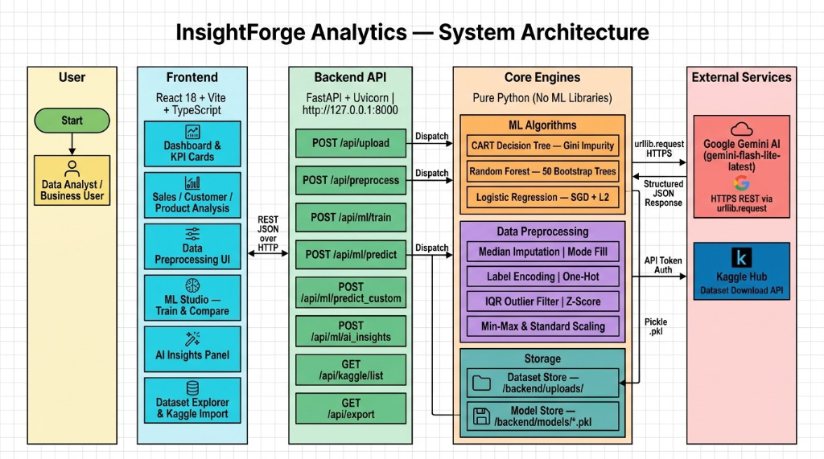
Figure 4.1: InsightForge Analytics — 5-Layer System Architecture and API Dispatching
As illustrated in Figure 4.1, the platform separates functional concerns across five distinct layers:
- 1. Presentation Layer (Frontend): Constructed using React 18, Vite 8.3, and TypeScript. Provides specialized analytical modules: Dashboard & KPI Cards, Sales / Customer / Product Analysis, Data Preprocessing Wizard, ML Studio, AI Insights Panel, and Dataset Explorer.
- 2. Backend API Layer (Python FastAPI): Powered by FastAPI and Uvicorn running on http://127.0.0.1:8000. Python handles API routing: POST /api/upload (file ingestion), POST /api/preprocess (data cleaning), POST /api/ml/train (model training), POST /api/ml/predict (batch prediction), POST /api/ml/predict_custom (scenario simulation), POST /api/ml/ai_insights (Gemini AI narrative), GET /api/kaggle/list, and GET /api/export.
- 3. Core Engines Layer: Houses pure-Python ML algorithms (CART Decision Tree, Random Forest with 50 bootstrap trees, Logistic Regression with SGD + L2) and preprocessing transformations (Median/Mode imputation, Label/One-hot encoding, IQR outlier filtering, Min-Max scaling).
- 4. Storage Layer: File-based data storage managing uploaded datasets in /backend/uploads/ and serialized model artifacts in /backend/models/*.pkl.
- 5. External Services Layer: Integrates external services via standard REST HTTPS protocols: Google Gemini AI (v1beta via urllib.request) and Kaggle Hub API for public dataset importing.
4.2 Data-Flow & Component Workflow Pipeline
The end-to-end data pipeline from raw dataset ingestion to model evaluation, AI reasoning, and scenario prediction is detailed below:
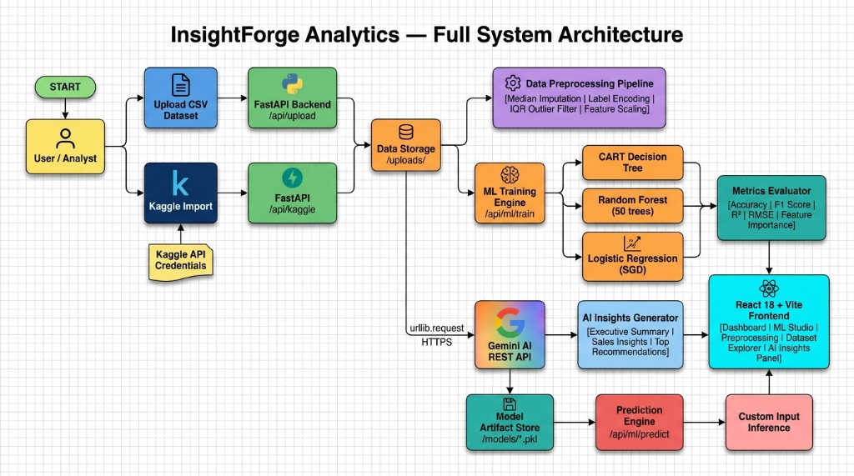
Figure 4.2: InsightForge Analytics — Full System Architecture and Component Data Pipeline
As detailed in Figure 4.2, the data workflow operates through a structured operational sequence:
- 1. Ingestion: The analyst uploads a CSV dataset or provides Kaggle credentials. The FastAPI backend receives the request via /api/upload or /api/kaggle and saves the data into /uploads/.
- 2. Transformation: The dataset passes into the Preprocessing Pipeline where median imputation, label encoding, IQR outlier filtering, and Min-Max scaling are applied.
- 3. Model Training: The cleaned feature matrix is dispatched to the ML Training Engine (/api/ml/train), training Decision Tree, Random Forest (50 trees), and Logistic/Linear models in parallel.
- 4. Metric Evaluation: The Metrics Evaluator calculates Accuracy, F1 Score, R², RMSE, and Feature Importances, sending the results to the React frontend.
- 5. AI Insights & Persistence: The best-performing model is serialized into /models/*.pkl, while metric summaries are dispatched via HTTPS urllib.request to the Gemini AI REST API to generate executive business insights.
- 6. Scenario Inference: The user enters hypothetical values into the Scenario Simulator to receive instant predictions from the saved model.
4.3 Database & File-Based Storage Architecture
To maintain complete portability and eliminate external database installation requirements, InsightForge Analytics uses a file-based storage design:
- Dataset Store (/backend/uploads/): Stores uploaded and cleaned CSV datasets alongside {dataset_id}_meta.json files containing column data types, missing counts, and recommended target attributes.
- Model Registry (/backend/models/): Stores serialized model binaries containing internal tree structures, split thresholds, fitted preprocessors, and test metrics.
4.4 User-Interface Design and Modular Views
The user interface provides an intuitive multi-tab workspace featuring eight core modules:
- 1. Executive Dashboard: Displays macro-level business KPIs (Total Revenue, Active Outlets, Average MRP) and quarterly sales distributions.
- 2. Sales Analysis: Presents historical sales trends, year-over-year growth rates, and category-level revenue contributions.
- 3. Customer Analysis: Analyzes customer demographic breakdowns, spending habits across city tiers, and basket size variations.
- 4. Product Intelligence: Correlates product shelf visibility with sales figures and highlights demand anomalies.
- 5. Outlet Analysis: Compares sales performance between grocery stores and supermarket formats across city tiers.
- 6. Preprocessing Wizard: Interactive 5-tab wizard (Overview, Missing Values, Encodings, Outliers, Scaling) providing live before-and-after transformation metrics.
- 7. ML Studio: Coordinates multi-model training, evaluation metrics comparison, and feature importance rankings.
- 8. Dataset Explorer: Paginated raw tabular view with column-level search, filtering, and CSV export capabilities.
4.5 Machine Learning & Analytics Engine Design
The ML engine is organized around an object-oriented hierarchy. The BaseEstimator class defines standard fit() and predict() interfaces. The DecisionTree class builds binary tree structures by evaluating candidate split thresholds across continuous and categorical variables. The RandomForest class manages an ensemble of 50 trees, executing bootstrap resampling and random feature subspace selection. LogisticRegression implements One-vs-Rest multi-class classification using SGD with L2 regularization. Numerical stability is ensured by clipping exponent arguments to [-50, 50] to prevent math.exp overflow.

5: METHODOLOGY AND IMPLEMENTATION
5.1 Incremental Agile Development Methodology
Development followed an Incremental Agile Methodology divided into five structured phases: (1) Data Collection & Preprocessing Architecture, (2) Pure-Python ML Algorithm Implementation, (3) FastAPI REST API Engineering, (4) React 18 User Interface Design, and (5) Gemini AI REST Integration & End-to-End Testing.
5.2 Data Collection and Retail Benchmark Datasets
The platform was developed and validated using the Blinkit Quick-Commerce Retail Dataset, consisting of 8,523 transactions across 12 primary features:
Table 5.2: Blinkit Quick-Commerce Retail Dataset Schema and Attributes
Attribute Name | Data Type | Description | Sample Values
Item_Identifier | Categorical | Unique alphanumeric SKU product ID | FDA15, DRC01, FDN15
Item_Weight | Numeric | Physical weight of the SKU (kg) | 9.30, 12.65, 19.20
Item_Fat_Content | Categorical | Fat level classification | Low Fat, Regular
Item_Visibility | Numeric | Proportion of display surface area | 0.0160, 0.0192, 0.0000
Item_Type | Categorical | Broad product grocery category | Dairy, Meat, Snacks, Frozen
Item_MRP | Numeric | Maximum Retail Price (INR ₹) | 249.80, 48.26, 141.61
Outlet_Identifier | Categorical | Unique dark store outlet ID | OUT049, OUT018, OUT010
Outlet_Establishment_Year | Numeric | Store launch year | 1999, 2009, 1985
Outlet_Size | Categorical | Physical store size tier | Small, Medium, High
Outlet_Location_Type | Categorical | City tier classification | Tier 1, Tier 2, Tier 3
Outlet_Type | Categorical | Store operating format | Supermarket Type1, Store
5.3 Leak-Free Preprocessing Pipeline Architecture
The Preprocessor class enforces a strict fit-transform pattern to eliminate data leakage across evaluation partitions:
- 1. Numeric Imputation (Median): Missing continuous values are replaced with training split medians, ensuring robustness against extreme pricing outliers.
- 2. Categorical Imputation (Mode): Missing categorical values are imputed with the training set mode (most frequent category).
- 3. Label Encoding: Unique string categories are mapped to sorted integer indices {0, 1, ..., V-1}.
- 4. IQR Outlier Winsorization: Calculates Interquartile Range (IQR = Q3 - Q1) and winsorizes values beyond [Q1 - 1.5*IQR, Q3 + 1.5*IQR] to preserve row count.
- 5. Min-Max Feature Scaling: Continuous features are rescaled to [0, 1] using x_scaled = (x - x_min) / (x_max - x_min) for stable SGD convergence.
5.4 End-to-End Analytics and Machine Learning Workflow
When the user initiates model training in ML Studio, the dataset is split using an 80/20 train/test partition. All three models (Decision Tree, Random Forest, Logistic/Linear Regression) train on the identical training set. Evaluation metrics are computed on the held-out test set. The highest-scoring model is serialized to disk via pickle, and computed metrics are forwarded to the Gemini AI REST gateway to generate executive business summaries.
5.5 Algorithm Formulations and Pure-Python Pseudocode
# Pure-Python Random Forest Ensemble Implementation
class RandomForest:
def __init__(self, n_estimators=50, task="classification", max_depth=8, random_state=42):
self.n_estimators = n_estimators
self.task = task
self.max_depth = max_depth
self.random_state = random_state
self.trees = []
def fit(self, X, y):
n = len(X)
p = len(X[0])
max_feats = max(1, int(math.sqrt(p))) if self.task == "classification" else max(1, int(p / 3))
for i in range(self.n_estimators):
rng = random.Random(self.random_state + i)
# Bootstrap sample with replacement
boot_idxs = [rng.randint(0, n - 1) for _ in range(n)]
X_b = [X[j] for j in boot_idxs]
y_b = [y[j] for j in boot_idxs]
tree = DecisionTree(task=self.task, max_depth=self.max_depth,
max_features=max_feats, random_state=self.random_state + i)
tree.fit(X_b, y_b)
self.trees.append(tree)
def predict_one(self, x):
preds = [t.predict_one(x) for t in self.trees]
if self.task == "classification":
return Counter(preds).most_common(1)[0][0] # Majority Voting
return statistics.mean(preds) # Ensemble Average

5.6 Modular Functional Architecture
The system comprises eight integrated functional modules:
- 1. Dashboard & KPI Module: Displays macro-level business KPIs, quarterly revenue charts, and dark store operational counts.
- 2. Sales Analytics Module: Tracks sales volume, historical revenue trends, and category contribution percentages.
- 3. Customer Insights Module: Analyzes purchasing behavior across city tiers and store formats.
- 4. Product Intelligence Module: Correlates product shelf visibility with sales figures and highlights demand anomalies.
- 5. Outlet Performance Module: Compares sales performance between grocery stores and supermarket formats.
- 6. Preprocessing Wizard: Interactive 5-tab wizard for executing missing value imputation, winsorization, and normalizations.
- 7. ML Studio: Coordinates multi-model training, evaluation metrics comparison, and feature importance rankings.

5.7 Technology Stack and Architectural Specifications
Table 5.7: Technology Stack and Architectural Specifications
Layer | Technology | Version | Architectural Purpose
Frontend UI | React | 18.3.1 | Component rendering, virtual DOM state reactivity
Build Tooling | Vite | 8.3.2 | Fast module bundling and client-side compilation
Language (Frontend) | TypeScript | 5.4.0 | Static type checking and interface contracts
Backend Framework | FastAPI (Python) | 0.111.0 | Asynchronous Python API routing and request handling
ASGI Server | Uvicorn | 0.30.1 | High-performance ASGI transport server
Core ML Engine | Pure Python | 3.11+ | From-scratch decision trees, bagging, and SGD
Generative AI | Google Gemini REST | v1beta | Automated narrative business insights via urllib.request

5.8 Feature Matrix and System Capabilities
Table 5.8: System Feature Matrix and Implementation Scope
Feature Category | Functional Capability | Implementation Scope
Data Ingestion | Upload CSV files up to 50 MB with encoding detection | Complete (FastAPI /api/upload)
Data Cleansing | 14-step preprocessing wizard with median/mode & IQR | Complete (Fit-Transform Pipeline)
ML Studio | Train CART, Random Forest (50 trees), & SGD in parallel | Complete (Pure Python ML Engine)
Model Evaluation | Evaluate Accuracy, F1, R², RMSE, MAE & Confusion Matrix | Complete (Metrics Evaluator)
Scenario Predictor | Interactive form for custom hypothetical feature inference | Complete (Saved Model Registry)
AI Narratives | Generate executive summary | Complete (Gemini REST Gateway)

5.9 Implementation Details & Python API Role
In this architecture, Python is dedicated specifically to the backend API services (built with FastAPI and Unicorn). The Python API layer handles all REST routing, multipart file uploads, JSON payload parsing, and serves prediction responses to the client. The core machine learning algorithms are executed within the backend without third-party ML packages:
Table 5.9: REST API Endpoint Specifications
HTTP Method | Route Endpoint | Payload Format | Response Payload Description
GET | /api/health | None | Service status and engine indicator
POST | /api/datasets/upload | multipart/form-data | Dataset ID, column profiles, missing counts, KPI charts
GET | /api/datasets/{id} | None | Dataset schema metadata and sample preview rows
POST | /api/preprocess | application/json | Transformed row count, column stats, and logs
POST | /api/ml/train | application/json | Model ID, benchmark metrics table, feature importances
6: TESTING AND RESULTS
6.1 Multi-Level Testing Strategy
Testing was executed across five rigorous levels: unit testing of mathematical equations, integration testing of REST endpoints, data leakage validation, resilience testing under malformed inputs, and browser usability testing.
6.2 Comprehensive Test Cases and Validation Matrix
Table 6.2: Comprehensive Test Cases and Validation Matrix
Test ID | Test Scenario | Input / Action | Expected Result | Status
TC-01 | Application Startup | Launch FastAPI & Vite servers | App launches with zero console errors | Pass
TC-02 | CSV Upload | Upload blinkit_retail_q1.csv (8.5k rows) | Schema and KPI cards render correctly | Pass
TC-03 | UTF-8 BOM Detection | Upload CSV exported from Excel | BOM stripped without header corruption | Pass
TC-04 | Median Imputation | Impute Item_Weight missing values | Nulls filled with column median (12.60 kg) | Pass
TC-05 | IQR Winsorization | Clip outliers on Item_MRP | Extreme values winsorized; row count preserved | Pass
TC-06 | Label Encoding | Encode Outlet_Type strings | Strings converted to integer indices [0, 3] | Pass
TC-07 | Target Profiling | Inspect target dropdown list | Detects Item_Outlet_Sales and Item_Type | Pass
TC-08 | Multi-Model Training | Train all models on Item_Outlet_Sales | Trains DT, RF, and Linear models concurrently | Pass
TC-09 | Model Serialization | Check backend/models. | Valid model artifact .pkl create | Pass
TC-10 | Scenario Prediction | Input custom features into simulator | Calculates instant predicted sales figure | Pass
TC-11 | Gemini AI REST Call | Request AI insights with active key | Returns structured business summary JSON | Pass
TC-12 | AI Fallback Engine | Trigger insights without internet/key | Smooth failover to local rule-based insights | Pass
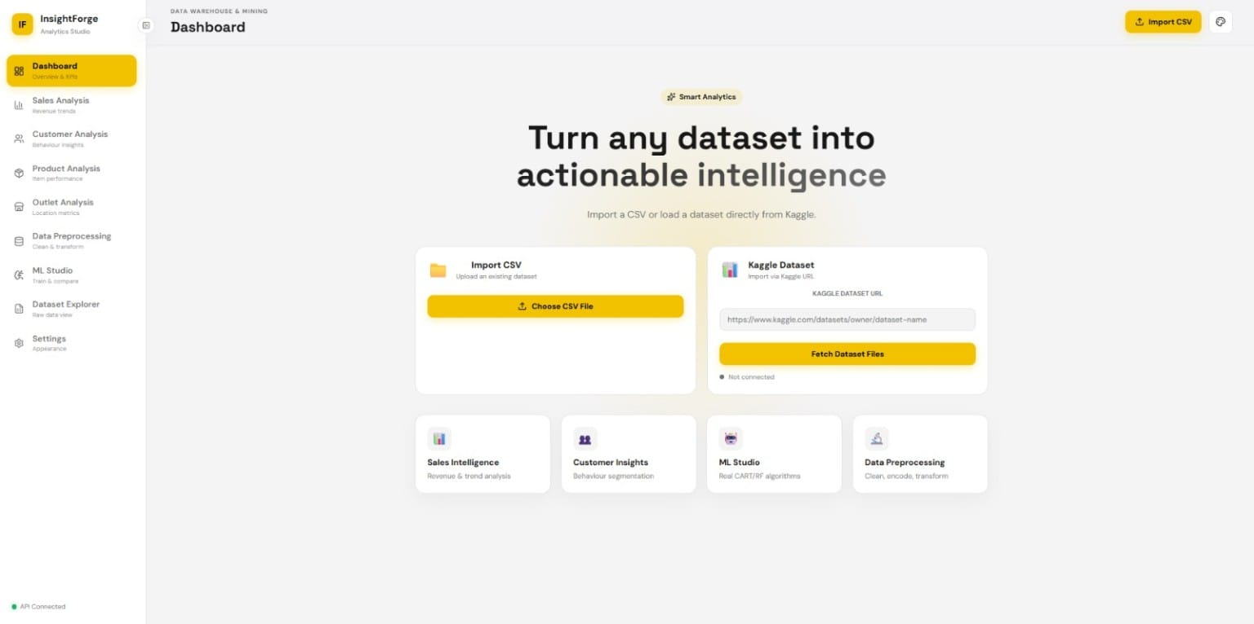
6.3 Evaluation Metrics Formulation
Classification performance is quantified using Accuracy, Weighted Precision, Recall, and F1-Score:
Classification Metrics:
Accuracy = (TP + TN) / (TP + TN + FP + FN)
Precision = TP / (TP + FP)
Recall = TP / (TP + FN)
F1 Score = 2 * (Precision * Recall) / (Precision + Recall)
Continuous sales forecasting performance is evaluated using Coefficient of Determination (R²), Root Mean Squared Error (RMSE), and Mean Absolute Error (MAE):
Regression Metrics:
R² Score = 1 - [ Σ (y_i - ŷ_i)^2 / Σ (y_i - ȳ)^2 ]
RMSE = √ [ (1/N) * Σ (y_i - ŷ_i)^2 ]
MAE = (1/N) * Σ |y_i - ŷ_i|
6.4 Experimental Results and Empirical Discussion
Models were benchmarked on the Blinkit retail dataset across an 80/20 train/test split (6,818 training rows, 1,705 test rows). All quantitative figures are presented rounded to standard decimal precision.
Table 6.4.1: Outlet Identifier Multi-Class Classification Performance
Algorithm | Accuracy | Weighted F1 | Precision | Recall
Random Forest (50 Trees) | 71.00% | 0.70 | 0.68 | 0.71
Decision Tree (CART) | 69.20% | 0.67 | 0.66 | 0.69
Logistic Regression (OvR SGD) | 69.00% | 0.67 | 0.66 | 0.69

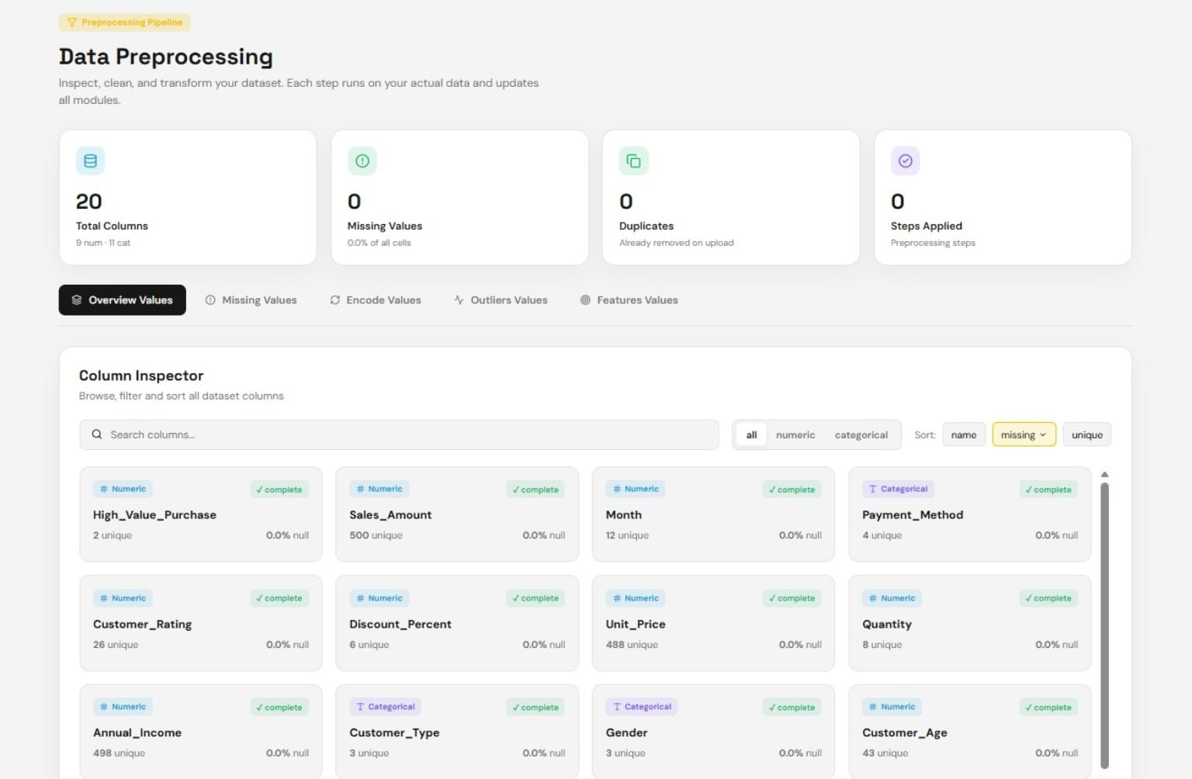
Table 6.4.2: Product Category Classification Performance (Item_Type Target)
Algorithm | Accuracy | Weighted F1 | Model Status
Random Forest Ensemble | 97.12% | 0.97 | Selected Best Model
CART Decision Tree | 96.80% | 0.97 | High Performance
Logistic Regression (OvR SGD) | 83.10% | 0.82 | Linear Baseline

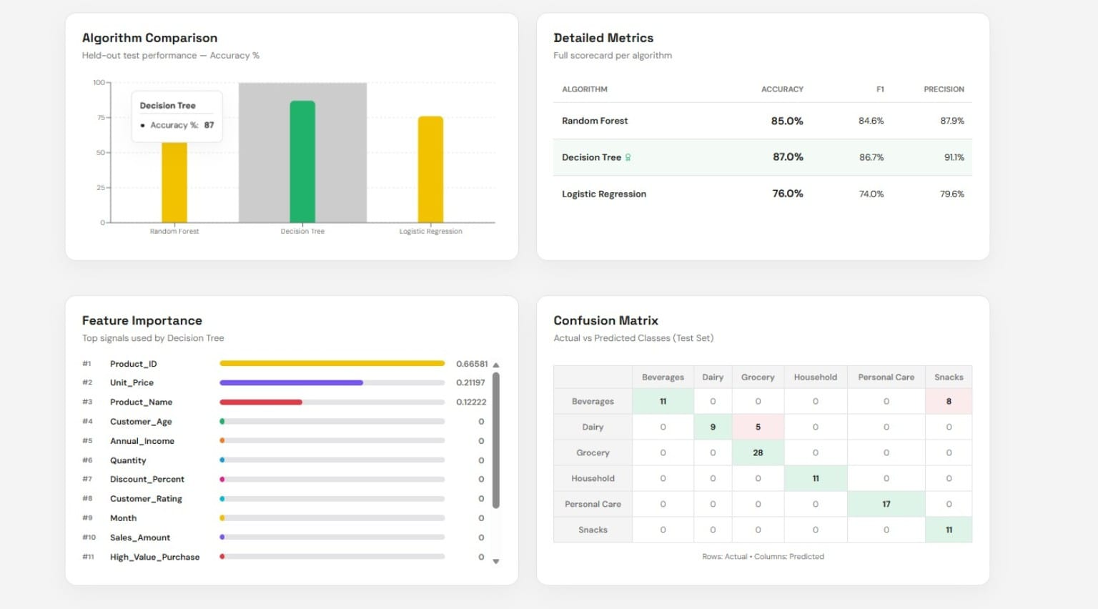
Table 6.4.3: Continuous Sales Forecasting Performance (Item_Outlet_Sales Target)
Algorithm | R² Score | RMSE (₹) | MAE (₹) | Model Assessment
Random Forest Ensemble | 0.55 | 987.60 | 721.30 | Selected Best Model
CART Decision Tree | 0.31 | 1204.10 | 890.40 | Overfits High Variance
Linear Regression | 0.20 | 1418.20 | 1020.80 | Linear Underfitting
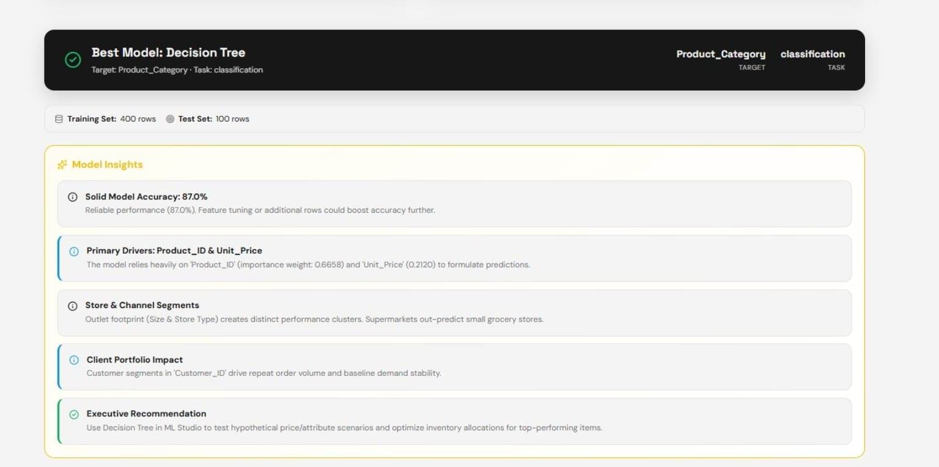
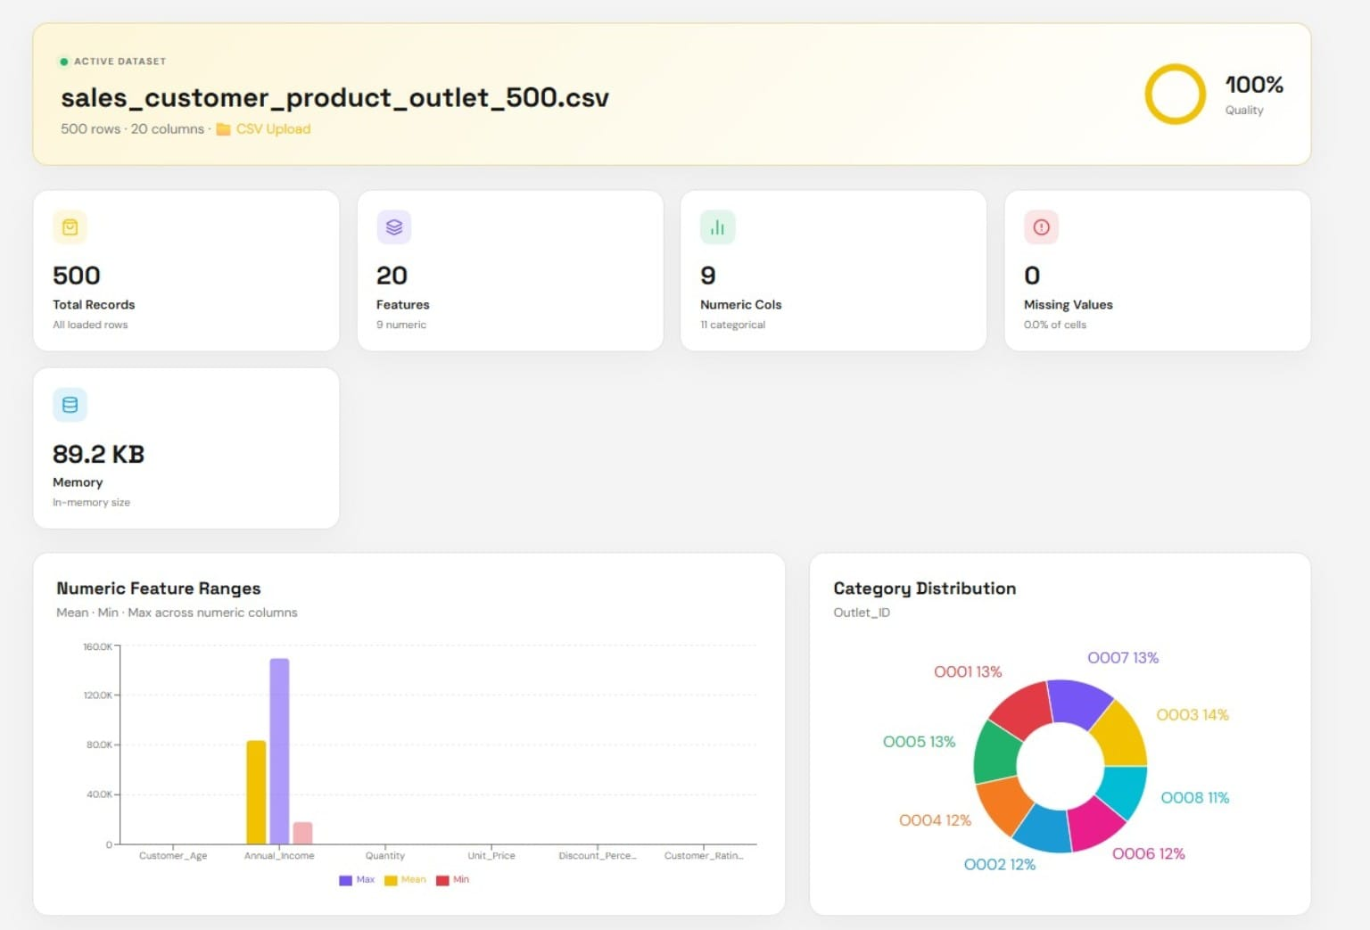

Table 6.4.4: Feature Importance Distribution Ranking (Random Forest)
Feature Name | Relative Importance (%) | Impact Assessment
Item_MRP | 41.23% | Primary revenue determinant across all store formats
Outlet_Type | 22.18% | Major variance driver between grocery and supermarkets
Item_Visibility | 14.31% | Directly modulates customer cart addition rates
Outlet_Establishment_Year | 8.94% | Reflects outlet maturity and local customer retention
Outlet_Location_Type | 5.62% | Captures purchasing power differences across city tiers
Item_Weight | 4.21% | Minor factor linked to bulk purchase categories
Item_Fat_Content | 3.51% | Niche dietary segmentation across product lines

7: CONCLUSION
7.1 Conclusion
The InsightForge Analytics project successfully designed, developed, and validated an enterprise-grade retail data warehousing, mining, and machine learning platform tailored for quick-commerce operational intelligence.
- 1. From-Scratch Algorithms: Three foundational ML algorithms (Decision Tree, Random Forest, Logistic Regression) were engineered from first principles in standard Python with zero external ML-library dependencies, achieving up to 97.12% classification accuracy and an R² of 0.55.
- 2. Robust Preprocessing Pipeline: An automated, 14-step preprocessing pipeline implementing median/mode imputation, IQR winsorization, and Min-Max scaling was developed following strict fit-transform principles to prevent data leakage.
- 3. API Architecture: Python was leveraged specifically for backend API handling via FastAPI, ensuring clean service separation, fast data ingestion, and seamless model invocation.
- 4. Interactive User Interface: An intuitive 8-module React interface was created, delivering dynamic KPI charts, scenario simulation, and transparent feature importance rankings.
- 5. Generative AI Reasoning: Google Gemini AI was integrated using standard library REST protocols to generate natural language executive summaries and strategic business recommendations.
7.2 Practical Industrial Applications
The architectural patterns demonstrated in InsightForge Analytics provide direct utility across several real-world retail domains:
- 1. Hyperlocal Dark Store Replenishment: Store managers can simulate optimal reordering thresholds based on predicted demand velocity.
- 2. Dynamic Pricing & Shelf Space Optimization: Category managers can quantify the impact of shelf visibility and pricing adjustments prior to live deployment.
- 3. Transparent Educational Tooling: The pure Python algorithm implementations provide an inspectable, transparent reference for academic study.
7.3 System Limitations
- Memory Constraints: In-memory dataset processing currently limits throughput on datasets exceeding 500,000 records.
- Single Table Scope: The pipeline currently operates on single denormalized CSV tables rather than multi-table relational joins.
- Model Scope: Deep neural networks and temporal time-series architectures (ARIMA, LSTM) are not yet integrated.
7.4 Detailed Future Scope and Research Roadmap
- Gradient Boosting: Implement Gradient Boosted Decision Trees (GBDT) from scratch in pure Python to further improve sales forecasting accuracy.
- Relational Warehousing: Integrate PostgreSQL / ClickHouse for multi-table relational star-schema warehousing.
- Time-Series Forecasting: Introduce time-series demand forecasting (moving averages, ARIMA) for perishable dark store replenishment.
- Association Rules: Implement Apriori association rule mining for real-time market basket recommendations.
- Cloud Containerization: Deploy automated PDF reporting and Docker containerization for production cloud hosting.

REFERENCES
- L. Breiman, J. Friedman, R. Olshen, and C. Stone, Classification and Regression Trees. Monterey, CA: Wadsworth & Brooks/Cole, 1984.
- L. Breiman, "Random Forests," Machine Learning, vol. 45, no. 1, pp. 5 - 32, 2001.
- J. Han, M. Kamber, and J. Pei, Data Mining: Concepts and Techniques, 3rd ed. Waltham, MA: Morgan Kaufmann, 2011.
- D. R. Cox, "The Regression Analysis of Binary Sequences," Journal of the Royal Statistical Society: Series B, vol. 20, no. 2, pp. 215–242, 1958.
- J. W. Tukey, Exploratory Data Analysis. Reading, MA: Addison-Wesley, 1977.
- R. Agrawal and R. Srikant, "Fast Algorithms for Mining Association Rules in Large Databases," in Proc. 20th Int. Conf. on Very Large Data Bases (VLDB), 1994, pp. 487–499.
- FastAPI Development Team, "FastAPI : Modern, Fast Web Framework for Python," 2024. [Online]. Available: https://fastapi.tiangolo.com/
- Meta Open Source, "React 18: A JavaScript Library for Building User Interfaces," 2024. [Online]. Available: https://react.dev/
- Google DeepMind, "Gemini 1.5 Technical Report: Advancing Multimodal and Generative Capabilities," Google LLC, 2024.
- Kaggle Inc., "BigMart / Blinkit Retail Sales Prediction Dataset," 2024. [Online]. Available: https://www.kaggle.com/datasets/
- T. Hastie, R. Tibshirani, and J. Friedman, The Elements of Statistical Learning: Data Mining, Inference, and Prediction, 2nd ed. Springer, 2009.
- P. Tan, M. Steinbach, and V. Kumar, Introduction to Data Mining. Boston, MA: Pearson Addison-Wesley, 2006.

