**Name: Arpan Srivastava**

**Auburn ID: Azs0239**

**Date: 7/24/2022**

**COMP 4320**

**Introduction to Computer Networks**

**2022 Summer Mini-Semester II**

Homework 2

1. Consider an HTTP client that wants to retrieve a Web document at a given URL. The IP address of the HTTP server is initially unknown. What transport and application-layer protocols besides HTTP are needed in this scenario?

Transport Layer Protocols:  
TCP for HTTP  
UDP for DNS  
  
Application Layer Protocols:  
DNS  
HTTP

1. Suppose within your Web browser you click on a link to obtain a Web page. The IP address for the associated URL is not cached in your local host, so a DNS lookup is necessary to obtain the IP address. Suppose that *N* DNS servers are visited before your host receives the IP address from DNS; the successive visits incur an RTT of *RTT1, …, RTTN*. Further suppose that the Web page associated with the link contains exactly one object, consisting of a small amount of HTML text. Let *RTTs* denote the *RTT* between the local host and the server containing the object. Assume that the transmission time of the object is *Ti*. How much time elapses from when the client clicks on the link until the client receives the object.

Total amount of time to get the IP address: RTT1 + RTT2 + …… + RTTn

After the IP is discovered, RTTs occurs to set up the TCP connection, then another RTTs occurs to request the object, and then Ti to receive the small object.

The total time elapsed would be: 2RTTs + Ti + RTT1 + RTT2 + ……+ RTTn

1. Referring to Problem 2 above, suppose the HTML file references eight very small objects on the same server. Neglecting transmission time, how much time elapses with
   1. Non-persistent HTTP with no parallel TCP connections?

Total elapsed time would be:

Total time = 2RTTs + 8*2RTTs + RTT1 + RTT2 + ……. + RTTN

Total time = 18RTTs + RTT1 + RTT2 + ……. + RTTN

* 1. Non-persistent HTTP with the browser configured for 6 parallel connections?

Total elapsed time would be:

Total time = 2RTTs + 3*2RTTs + RTT1 + RTT2 + ……. + RTTN

Total time = 8RTTs + RTT1 + RTT2 + ……. + RTTN

* 1. Persistent HTTP? (Assume that pipelining is used.)

Total elapsed time would be:

Total time = 2RTTs + RTTs + RTT1 + RTT2 + ……. + RTTN

Total time = 3RTTs + RTT1 + RTT2 + ……. + RTTN

1. Consider a short, 90-meter link, over which a sender can transmit at a rate of 420 bits/sec in both directions. Suppose that packets containing data are 320,000 bits long, and packets containing only control (e.g. ACK or handshaking) are 240 bits long. Assume that *N* parallel connections each get 1/*N* of the link bandwidth. Now consider the HTTP protocol, and assume that each downloaded object is 320 Kbit long, and the initial downloaded object contains 6 referenced objects from the same sender. Would parallel download via parallel instances of nonpersistent HTTP make sense in this case? Now consider persistent HTTP. Do you expect significant gains over the non-persistent case? Justify and explain your answer.

Let Tp denote propagation delay between the client and the server.

Parallel download through parallel instances of non-persistent HTTP is:

$$\left( \frac{240}{420} +Tp + \frac{240}{420} +Tp + \frac{240}{420} +Tp + \frac{320,000}{420}+Tp \right)+\left(\frac{240}{\frac{420}{6}}+Tp+ \frac{240}{\frac{420}{6}}+Tp+ \frac{240}{\frac{420}{6}}+ Tp+ \frac{320,000}{\frac{420}{6}}+Tp\right)$$

= 5345.33 + 8Tp seconds

Persistent HTTP is:

$$\left(\frac{240}{420}+Tp+ \frac{240}{420}+Tp+ \frac{240}{420}+Tp+ \frac{320,000}{420}+Tp\right)+6*\left(\frac{240}{420}+Tp+ \frac{320,000}{420}+Tp\right)=5338.48+16Tp$$

Assuming speed of light: 3 ∗ 108 , 𝑇𝑝 = = 0.0000003 seconds or 0.3 microseconds, thus it is safe to say that Tp is negligible. We can observe that persistent HTTP is 6.85 seconds faster than non-persistent case. Thus, we can conclude that persistent HTTP is not significantly faster than parallel download via parallel instances of nonpersistent HTTP in this scenario.

1. Consider the scenario introduced in Question (4) above. Now suppose that the link is shared by Tom with seven other users. Tom uses parallel instances of non-persistent HTTP, and the other seven users use non-persistent HTTP without parallel downloads.
2. Do Tom’s parallel connections help him get Web pages more quickly? Why or why not?

Yes, Tom's parallel connection help him get Web pages more quickly.

The link is shared by Tom with four other users. Thus, Tom has more connections. Tom can comparatively get more collective bandwidth share out of the total link bandwidth.

1. If all eight users open parallel instances of non-persistent HTTP, then would Tom’s parallel connections still be beneficial? Why or why not?

Yes, if all eight users open eight parallel instances of non-persistent HTTP, Tom’s parallel connection will still be beneficial. Tom still needs to use parallel connections for downloads, otherwise he will obtain less bandwidth share than other users.

6. Consider Figure 1 in which there is an institutional network connected to the Internet. Suppose that the average object size is 675,000 bits and that the average request rate from the institution’s browser to the origin server is 20 requests per second. Also suppose that the amount of time it takes from when the router on the Internet side of the access link forwards an HTTP request until it receives the response is 2.0 seconds on average. Model the total average response time as the sum of the average access delay (that is, the delay from Internet router to institution router) and the average Internet delay.

The average access delay is related to the traffic intensity as given in the following table.

|  |  |  |  |  |  |  |  |  |  |  |
| --- | --- | --- | --- | --- | --- | --- | --- | --- | --- | --- |
| Traffic Intensity | 0.50 | 0.55 | 0.60 | 0.65 | 0.70 | 0.75 | 0.80 | 0.85 | 0.90 | 0.95 |
| Average access delay (msec) | 26 | 33 | 41 | 52 | 64 | 80 | 100 | 137 | 250 | 1000 |

Traffic intensity is calculated as follows: Traffic intensity = *aL/R,* where *a* is the arrival rate, *L* is the packet size and *R* is the transmission rate.

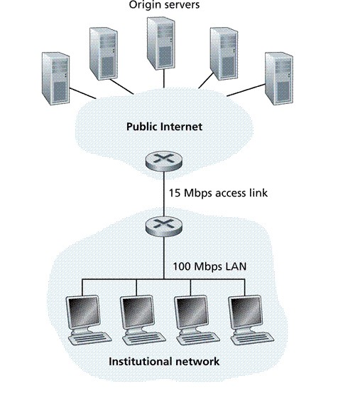

Figure 1. Access Link Connecting an Institutional Network to the Internet

1. Find the total average response time.

The time transmit an object of size L over a link of rate R is L/R,

L/R = $\frac{675,000 bits}{15,000,000 bits/sec}=0.045 seconds$

Traffic Intensity = (20 requests / sec) * (0.045 seconds) = 0.9

Average access delay = $\frac{0.045}{1 - 0.9}=0.45 seconds$

Total average response time = 0.45 + 2 = 2.45 seconds

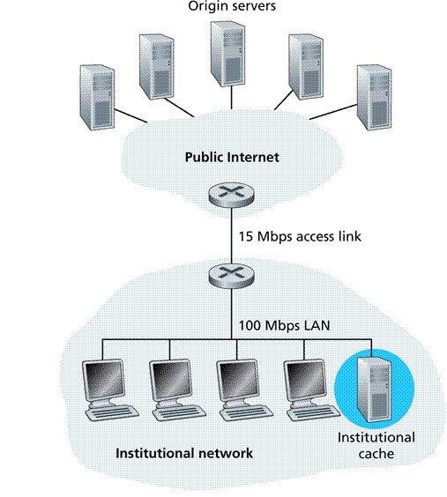

Figure 2. Adding a Cache to the Institutional Network

1. Now suppose a cache is installed in the institutional LAN as shown in Fig. 2. Suppose the hit rate is 0.333. Find the total average response time.

Traffic intensity is reduced by 33% since that is the percent of requests that are handled within in the institutional network.

Average access delay is $\frac{0.045}{1-(0.66)(0.9)}$ = 0.1108 𝑠𝑒𝑐𝑜𝑛𝑑𝑠

The response time is approximately 0 when the request is handled by the cache (which happens with a probability of 0.33).

The average response time is = 2 + 0.1108 = 2.1108 seconds (which happens with a probability of 0.66).

So, the average response time is (0.33)(0 𝑠𝑒𝑐𝑠) + (0.66)(2.1108) = 1.39 sec

Average response time dropped from 2.45 seconds to 1.39 seconds