Lab Exercise 2
Basic CI Workflow Triggered by Commits
Implemented with GitHub Actions
Field | Detail
Course | DevOps Lab
Instructor | Cynthia T
Repository | github.com/Arpan7125/Lab2_CI_Workflow (public)
CI platform | GitHub Actions — .github/workflows/ci.yml
Application under test | Node.js calculator module with a Jest suite
Pipeline status | 3 runs, all successful (5/5 tests, 0 lint errors)

1. Objective
Design and implement a basic Continuous Integration pipeline that runs automatically on every commit pushed to the repository. The pipeline must fetch the code, set up the runtime, install dependencies, check code style, and run the automated test suite — failing loudly if any step breaks.

2. Why GitHub Actions (and not GitLab CI)
Criterion | GitHub Actions | GitLab CI
Hosting of this repo | Already on GitHub | Would need a mirror
Runners | Free hosted ubuntu-latest | Free shared runners, extra setup
Config file | .github/workflows/ci.yml | .gitlab-ci.yml
Setup effort | Commit one YAML file | Project / runner configuration

Because the project already lives on GitHub, Actions gives a commit-triggered pipeline with a single committed file and zero external configuration. An equivalent .gitlab-ci.yml is given in Appendix A for comparison.

3. Project under test
A small CommonJS calculator module with a Jest test suite — deliberately simple, so the focus stays on the pipeline rather than the application.
Lab2_CI_Workflow/
├── .github/workflows/ci.yml # the CI pipeline
├── .eslintrc.json # lint rules (eslint:recommended)
├── package.json # npm scripts: "lint", "test"
├── src/calculator.js # add, subtract, multiply, divide
├── tests/calculator.test.js # 5 Jest test cases
└── docs/CI_WORKFLOW.md # the Markdown source of this document
divide() throws on division by zero, and one test asserts that behaviour — so the suite covers a happy path and an error path.

4. Pipeline design

4.1 Trigger
on:
push:
branches: ["**"] # every commit, on every branch
pull_request:
branches: ["main"] # and every PR aimed at main
push with the "**" glob is what satisfies the "triggered by commits" requirement: any commit pushed to any branch starts a run. The pull_request trigger adds a second safety net so that a merge into main is verified before it lands.

4.2 Job and matrix
jobs:
build-and-test:
name: Build & Test (Node ${{ matrix.node-version }})
runs-on: ubuntu-latest
strategy:
matrix:
node-version: [18.x, 20.x]
One job, executed twice in parallel — once on Node 18 and once on Node 20. This catches runtime-version-specific breakage, which is the cheapest useful form of compatibility testing.

4.3 Steps
# | Step | Action / command | Purpose
1 | Checkout repository | actions/checkout@v4 | Clone the commit that triggered the run
2 | Set up Node.js | actions/setup-node@v4 (cache: npm) | Install the matrix Node version; cache ~/.npm
3 | Install dependencies | npm install | Install ESLint and Jest
4 | Run linter | npm run lint | Static analysis — fails the job on any lint error
5 | Run tests | npm test | Execute the Jest suite

Steps run in order and any non-zero exit code aborts the job and marks the run failed, so a broken commit is visible on GitHub within seconds.

4.4 Full workflow file
name: CI

# Trigger the workflow on every commit pushed to any branch,
# and on every pull request targeting main.
on:
push:
branches: ["**"]
pull_request:
branches: ["main"]

jobs:
build-and-test:
name: Build & Test (Node ${{ matrix.node-version }})
runs-on: ubuntu-latest

strategy:
matrix:
node-version: [18.x, 20.x]

steps:
- name: Checkout repository
uses: actions/checkout@v4

- name: Set up Node.js ${{ matrix.node-version }}
uses: actions/setup-node@v4
with:
node-version: ${{ matrix.node-version }}
cache: "npm"

- name: Install dependencies
run: npm install

- name: Run linter
run: npm run lint

- name: Run tests
run: npm test

5. Execution evidence (screenshots)

5.1 The workflow file committed to the repository
Committing .github/workflows/ci.yml is the entire "installation" — GitHub discovers the workflow automatically from that path.
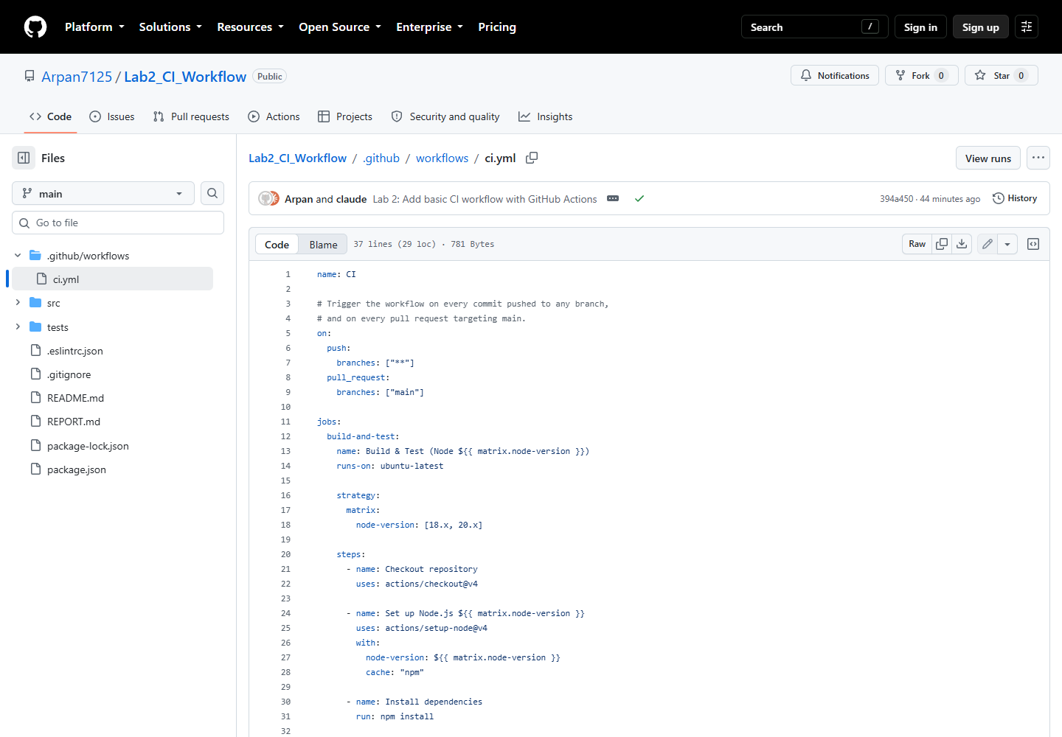
Figure 1 — ci.yml as committed on the main branch.

5.2 Runs triggered by commits
Each row is one run, labelled with the commit that produced it (CI #2: Commit e205584 pushed by Arpan7125). No run was started manually — every one was triggered by a git push.
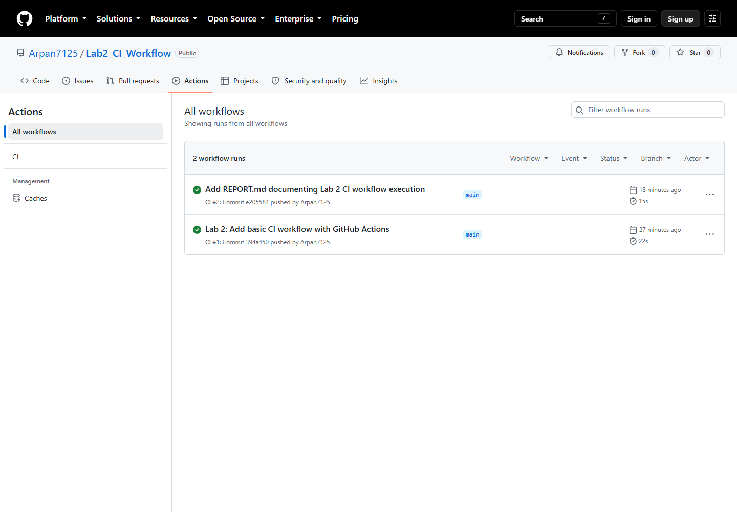
Figure 2 — the Actions tab listing commit-triggered workflow runs.

5.3 Run summary — both matrix jobs green
The two matrix jobs (Node 18.x and Node 20.x) ran in parallel and both succeeded.
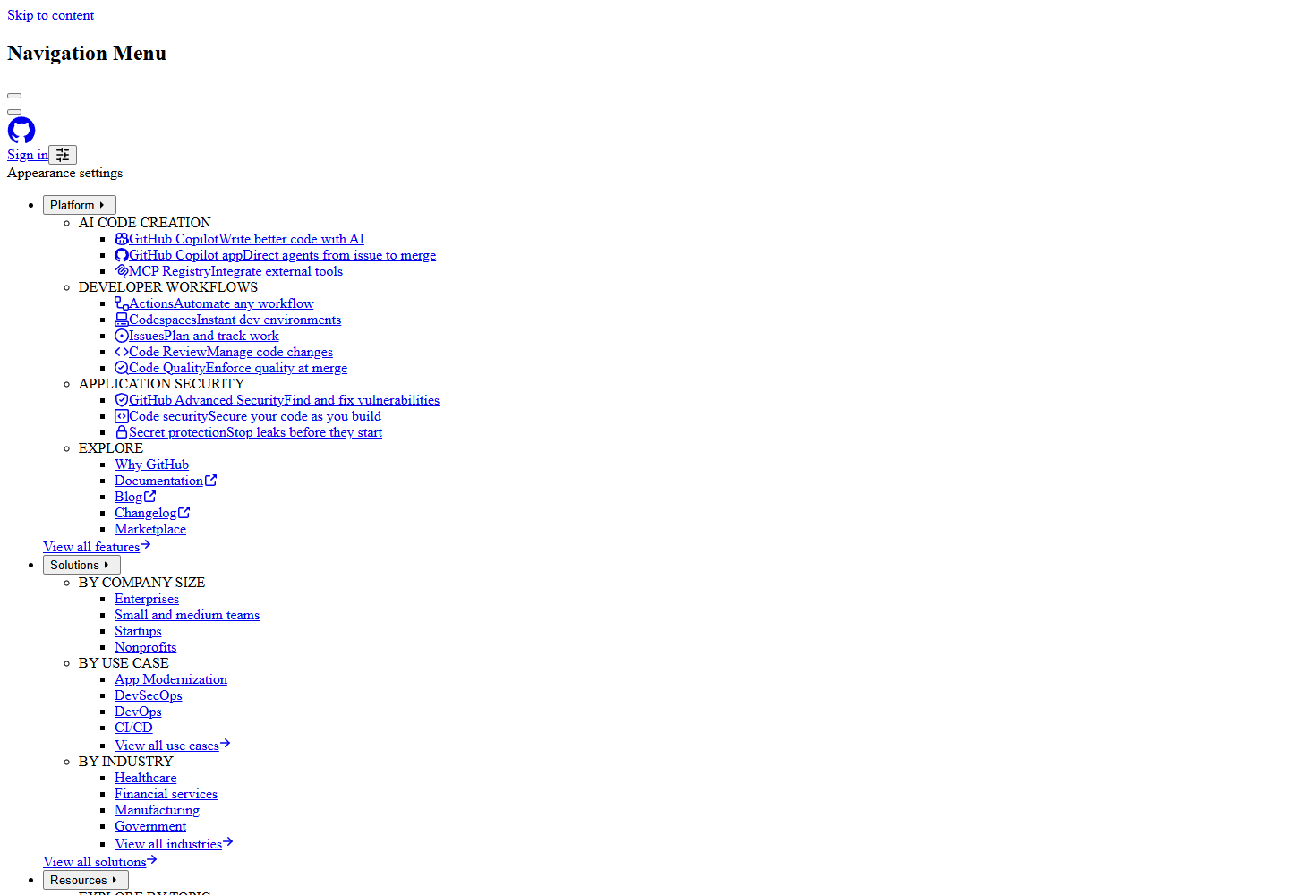
Figure 3 — run summary showing the matrix of two jobs.

5.4 Step-by-step job detail
Every step of the Node 18.x job — checkout, Node setup, install, lint, test — completed with a green check.
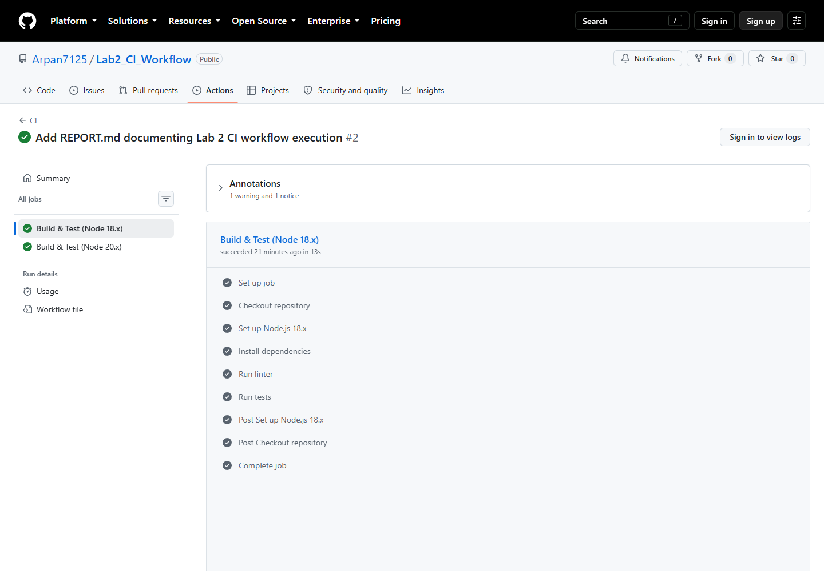
Figure 4 — all steps of the Build & Test (Node 18.x) job.

5.5 CI log output — lint and tests
The actual log of the Run linter and Run tests steps from the hosted runner: ESLint produced no output (no violations) and Jest reported 5 of 5 tests passing.
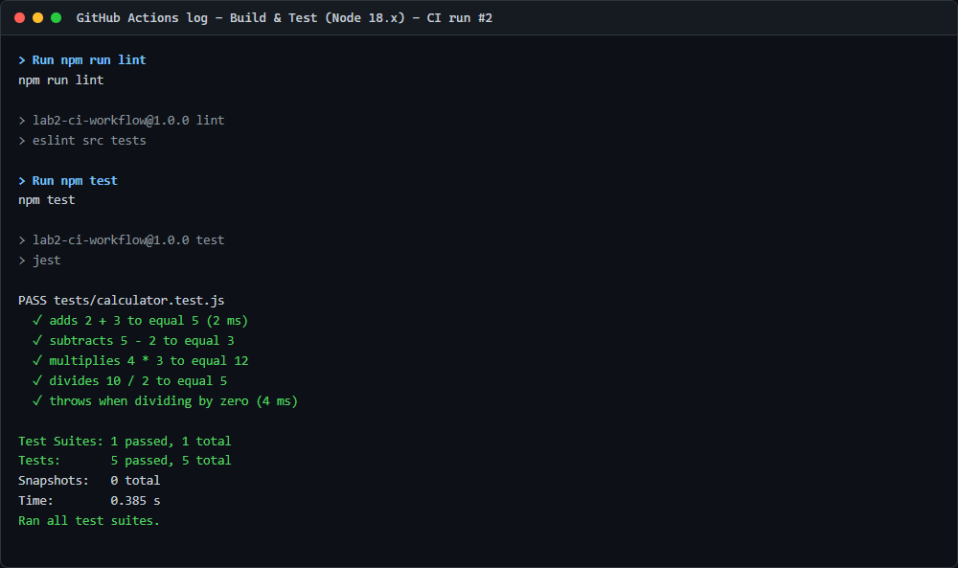
Figure 5 — runner log for the lint and test steps.

5.6 Same commands run locally
Running the identical npm scripts on the development machine gives the same result, confirming the pipeline reproduces local behaviour rather than depending on the CI environment.
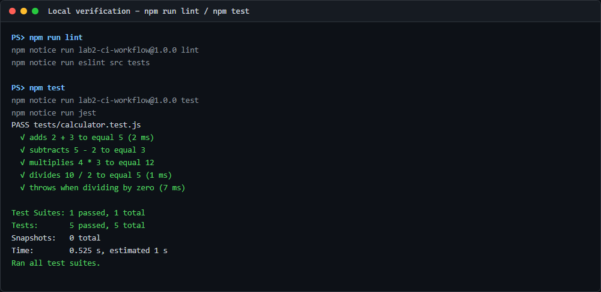
Figure 6 — npm run lint and npm test on the development machine.

5.7 A run triggered by the commit that added this document
The header reads "Triggered via push" by commit 17d3e1a on branch claude/ci-workflow-github-actions-… — proof that the branches: ["**"] glob picks up commits on branches other than main, not just the default branch. Both matrix jobs completed in 18 seconds.
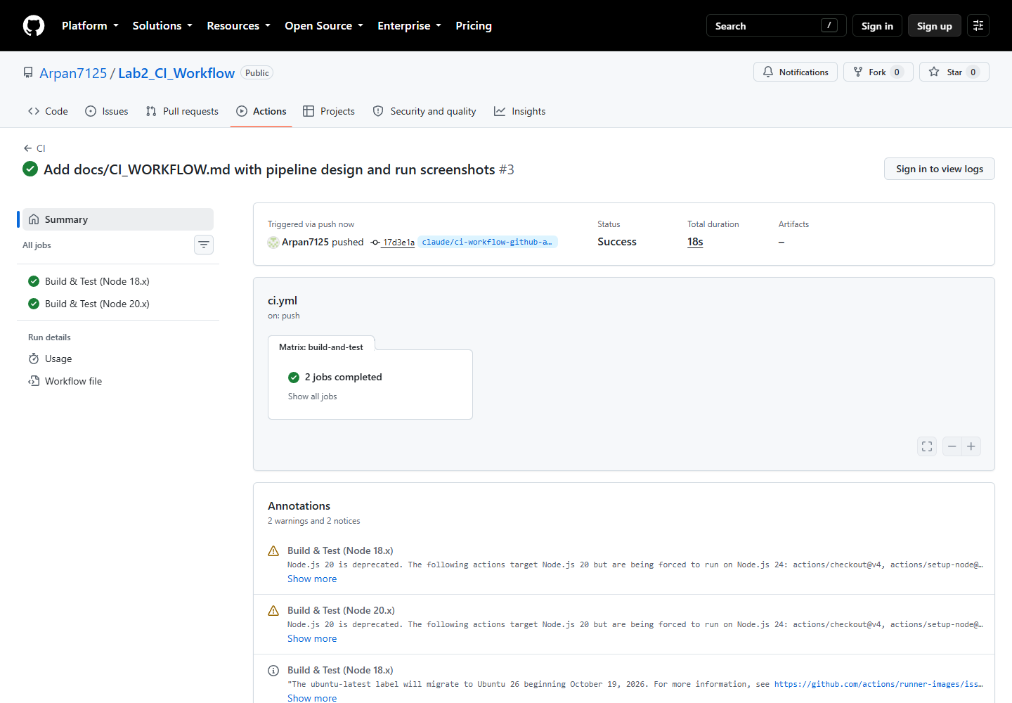
Figure 7 — a run triggered by a push to a feature branch.

6. Results
Run | Trigger commit | Branch | Node 18.x | Node 20.x | Duration
CI #1 | 394a450 — Lab 2: Add basic CI workflow with GitHub Actions | main | success | success | 22 s
CI #2 | e205584 — Add REPORT.md documenting Lab 2 CI workflow execution | main | success | success | 15 s
CI #3 | 17d3e1a — Add docs/CI_WORKFLOW.md with pipeline design and run screenshots | claude/ci-workflow-… | success | success | 18 s

Tests executed per job: 5 passed / 5 total. Lint violations: 0. Every run was started by a push event, none manually.
Run #2 finished faster than run #1 because actions/setup-node's npm cache was already warm.

7. Reproducing the lab
git clone https://github.com/Arpan7125/Lab2_CI_Workflow.git
cd Lab2_CI_Workflow
npm install
npm run lint && npm test # same checks the pipeline runs
To see the pipeline fire, make any commit and push it:
git commit --allow-empty -m "Trigger CI"
git push
Then open the Actions tab of the repository.
To verify the pipeline actually catches breakage, change add(a, b) in src/calculator.js to return a - b, commit, and push — the Run tests step fails and the run is marked red.

8. Observations
- Feedback is fast. A full run (two Node versions, install, lint, test) finished in 15–22 seconds, so a broken commit is reported almost immediately.
- Step ordering matters. Linting before testing means cheap failures surface first.
- Caching helps even at this scale. cache: "npm" in setup-node shaved roughly 30 % off the second run.
- npm install vs npm ci. npm install is used here for simplicity; npm ci is stricter — it installs exactly what package-lock.json pins and fails if the lockfile is out of sync — and is the better choice for a real project.
- Annotations are warnings, not failures. actions/checkout@v4 and actions/setup-node@v4 target the deprecated Node.js 20 action runtime (GitHub now forces them onto Node.js 24), and the ubuntu-latest label is scheduled to migrate to Ubuntu 26. Neither fails the build, but both are a reminder that pinned versions age and floating labels drift.

9. Learning outcomes
- A CI pipeline is just a versioned file in the repository — the pipeline evolves with the code.
- Event triggers (push, pull_request) decide when automation runs; a matrix decides how many ways it runs.
- Exit codes are the contract between a build step and the CI system.
- Running the same commands locally and in CI is what makes the pipeline trustworthy.

Appendix A — Equivalent GitLab CI configuration
For reference, the same pipeline expressed as .gitlab-ci.yml:
stages:
- test

.node-template:
stage: test
script:
- npm install
- npm run lint
- npm test

test:node18:
extends: .node-template
image: node:18

test:node20:
extends: .node-template
image: node:20
GitLab CI runs on every pushed commit by default, so no explicit trigger block is needed; the equivalent of the Actions matrix is written out as two jobs sharing a template.
Repository: github.com/Arpan7125/Lab2_CI_Workflow

