- Health Expenditure

Threshold (Share of Total Consumption) | Percentage of Households | Interpretation
Greater than 10% of real consumption expenditure | 8.9% | Nearly 1 in 11 households spend more than a tenth of their total consumption on health, indicating a noticeable financial burden.
Greater than 15% of real consumption expenditure | 5.6% | About 1 in 18 households face a high health spending burden relative to their total consumption.
Greater than 25% of real consumption expenditure | 3.0% | A smaller but significant share of households devote a quarter or more of their consumption to health, suggesting serious financial strain.
Greater than 40% of real disposable consumption expenditure | 4.6% | Almost 1 in 22 households experience catastrophic health expenditure when measured against non-food (capacity-to-pay) consumption, indicating substantial financial vulnerability.

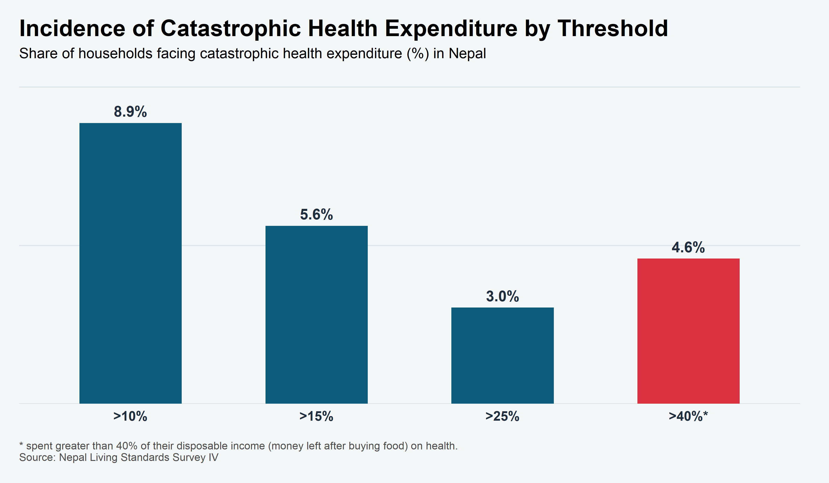

This table shows the average percentage of total household consumption spent on health services.
Expenditure Quintile | Mean Share of Health Spending (%)
1 (Poorest) | 5.1%
2 | 4.2%
3 | 3.9%
4 | 3.9%
5 (Richest) | 3.3%
National Average | 4.1%
Health expenditure as a share of household consumption is highest for the poorest quintile at 5.1%, compared to the national average of 4.1%. The richest quintile spends the smallest share at 3.3%. This inverse relationship demonstrates that the relative financial burden of healthcare is significantly heavier for lower-income households.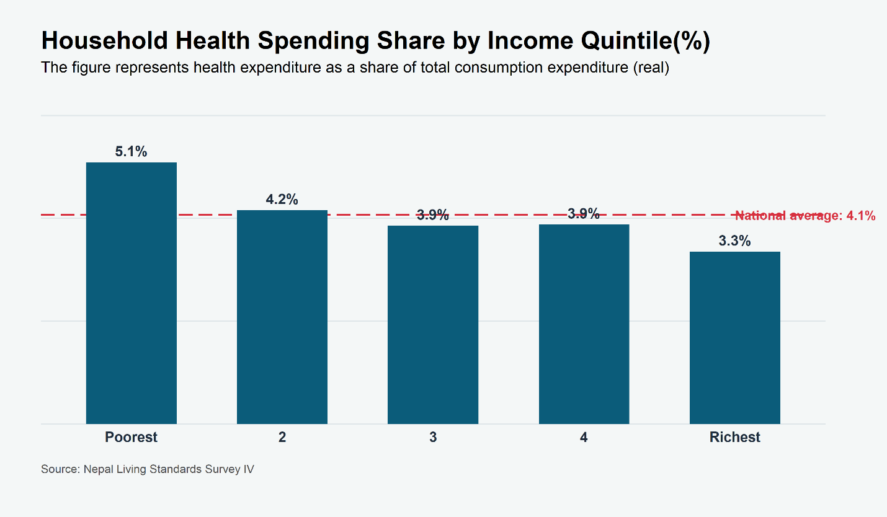

2. Incidence of Catastrophic Health Expenditure at different thresholds

Expenditure Quintile | Catastrophic Incidence at 10% (Headcount %) | Catastrophic Incidence at 15% (Headcount %) | Catastrophic Incidence at 25% (Headcount %) | Catastrophic Incidence at 40% of non-food consumption share (Headcount %)
1 (Poorest) | 11.5 | 7.7 | 5.0 | 7.2
2 | 9.1 | 6.2 | 3.3 | 4.7
3 | 8.6 | 5.1 | 2.5 | 4.5
4 | 9.1 | 5.5 | 2.4 | 4.1
5 (Richest) | 5.9 | 3.7 | 1.9 | 2.5
National Average | 8.9 | 5.6 | 3.0 | 4.6

Health financing in Nepal is fundamentally unfair. The poorest households (Quintile 1) are nearly twice as likely (11.5%) to face catastrophic health costs compared to the richest households (5.9%) at the 10% threshold. This confirms that the financial risk of illness is not shared equally but falls disproportionately on those with the least resources.
The inequality is even sharper when looking at "Capacity to Pay" (excluding food expenses). The poorest are nearly three times more likely (7.2% vs. 2.5%) to spend a catastrophic share of their disposable income on health compared to the rich. This suggests that low-income families are frequently forcing a trade-off between healthcare and other survival essentials like rent or education.
Financial insecurity extends far beyond the absolute poor. Surprisingly, the second-richest group (Quintile 4) faces the exact same rate of catastrophic expenditure (9.1%) as the second-poorest (Quintile 2). This indicates that meaningful financial protection against health shocks is weak for the bottom 80% of the population, with true safety reserved only for the wealthiest top 20%.

Poverty Status (based on NLSS IV) | Catastrophic Incidence at 10% (Headcount %) | Catastrophic Incidence at 15% (Headcount %) | Catastrophic Incidence at 25% (Headcount %) | Catastrophic Incidence at 40% of non-food consumption
Non-Poor | 8.2 | 5.1 | 2.5 | 3.9
Poor | 11.5 | 7.8 | 5.1 | 7.3
Catastrophic health expenditure is consistently higher among poor households across all thresholds. At the 10% threshold, 11.5% of poor households face catastrophic spending compared to 8.2% of non-poor households. The gap widens at higher thresholds, particularly at 25% and at 15% of non-food consumption, indicating that poor households are more likely to experience severe financial strain due to health expenses.
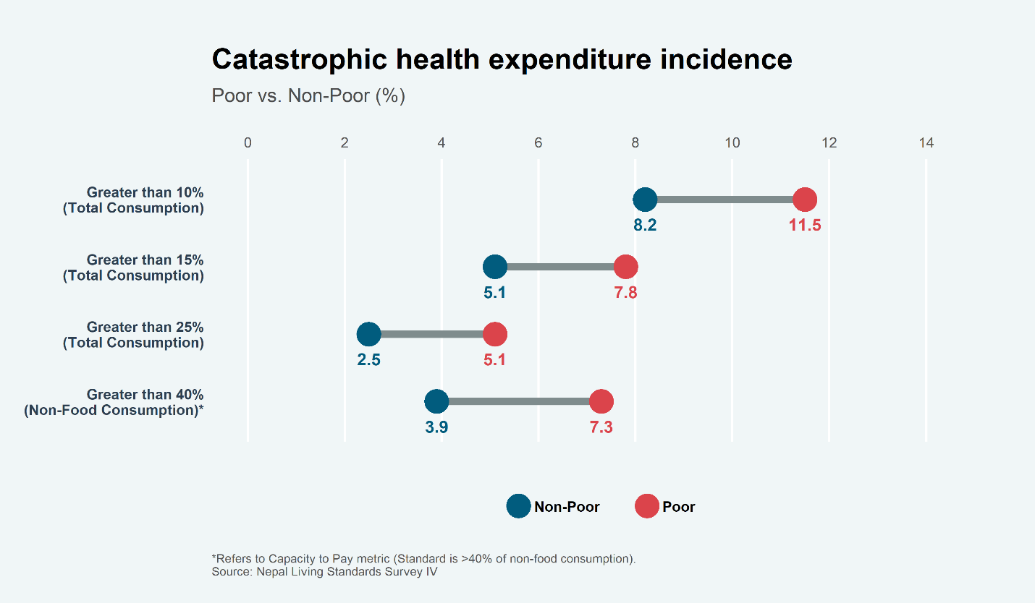

3. Prevalence of Distress Financing
The proportion of households that report borrowing, selling assets, or otherwise mobilizing resources through hardship mechanisms to finance out-of-pocket health expenditures.
This table shows the proportion of households that report borrowing, selling assets, or otherwise mobilizing resources through hardship mechanisms to finance out-of-pocket health expenditures.
Expenditure Quintile | Distress Financing Prevalence (%)
1 (Poorest) | 15.5%
2 | 11.5%
3 | 9.1%
4 | 6.8%
5 (Richest) | 5.5%
National Average | 9.7%
This indicator reveals the most severe inequality. The poorest households are three times more likely (15.5%) to resort to distress financing than the richest households (5.5%). While the rich may face high costs (as seen in Table 2), they likely pay using savings or income. The poor, lacking savings, are forced into debt or asset sales, creating a "Medical Poverty Trap" where an illness today leads to long-term impoverishment.
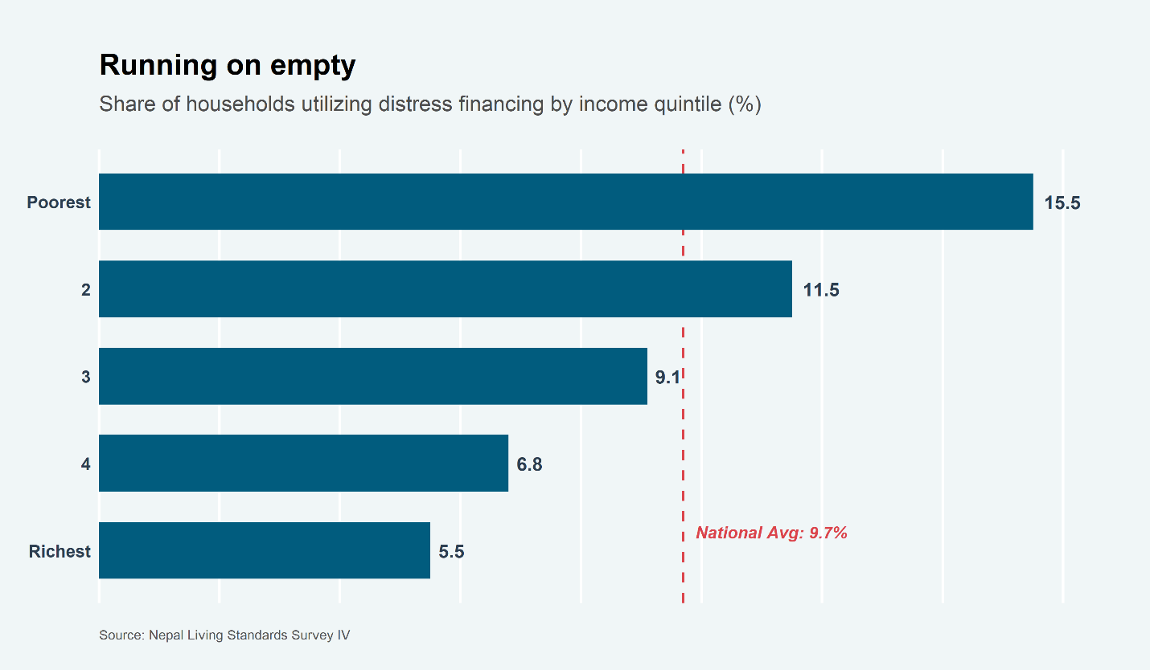
Poverty Status | Household (%) relying on Distress Financing
Non-poor | 8.2%
Poor | 15.5%
Poor households are 1.9 times more likely than the non-poor to sell assets or take out loans to cover health costs. This indicates that for nearly 1 in 6 poor families, a health shock isn't just a medical issue—it's a long-term financial catastrophe that leads to debt traps or the loss of productive land.

3. The Double Burden of Disease
This table compares the prevalence of Chronic (NCDs) vs. Acute (Infectious/Injury) illness across income groups.
Expenditure Quintile | Chronic Illness (NCDs) | Acute Illness (Infections)
1 (Poorest) | 12.7% | 21.0%
2 | 13.1% | 19.9%
3 | 13.7% | 22.7%
4 | 15.1% | 19.7%
5 (Richest) | 18.1% | 18.7%
National Average | 14.4% | 20.5%
There is a clear positive correlation with wealth (rising from 12.7% in the poorest to 18.1% in the richest). This likely reflects an "aging effect" (the rich live longer) and diagnosis bias (the rich can afford doctors to get diagnosed, while the poor remain undiagnosed).
Acute illness remains surprisingly high across all groups, peaking in the middle class (22.7%) but affecting the poor (21.0%) and rich (18.7%) similarly. This suggests widespread environmental risks (pollution, road safety, sanitation) that no income group fully escapes.
The poorest households face a "Double Burden." They are still fighting the highest rates of infectious disease (21.0%) while simultaneously facing a rising tide of chronic illness (12.7%), all while having the least financial capacity to pay for treatment.
