**A**

**Project Report**

**on**

**Smart Healthcare Ecosystem**

**Developed By**

***Arpan [2305102130005]***

***Ankit Goswami [2305112110143]***

**as**

**Partial Fulfilment of Semester IV of**

**Master of Computer Applications & Master of Science in Information Technology**

**for A.Y. 2024 - 2025**

**Under the Guidance of**

**Dr. Hina Chokshi**

**Submitted To**

**Department of MCA/MSc IT**

**Faculty of IT & Computer Science**

**PARUL University**





**CERTIFICATE**

This is to certify that **Mr. Arpan, Enrolment No. 2305102130005**, **Mr. Ankit Goswami, Enrolment No. 2305112110143** students of Master of Computer Applications and/or Master of Science in Information Technology has completed the Major Project on **“Smart Healthcare Ecosystem”** at AccioJob Private Limited as fulfilment of MCA and M.Sc. (IT) Semester IV.

Seat No. _______________ Date of Submission: ____________

_____________ _______________ _____________

Internal Guide Project Coordinator Director - MCA

**Company Certificate**

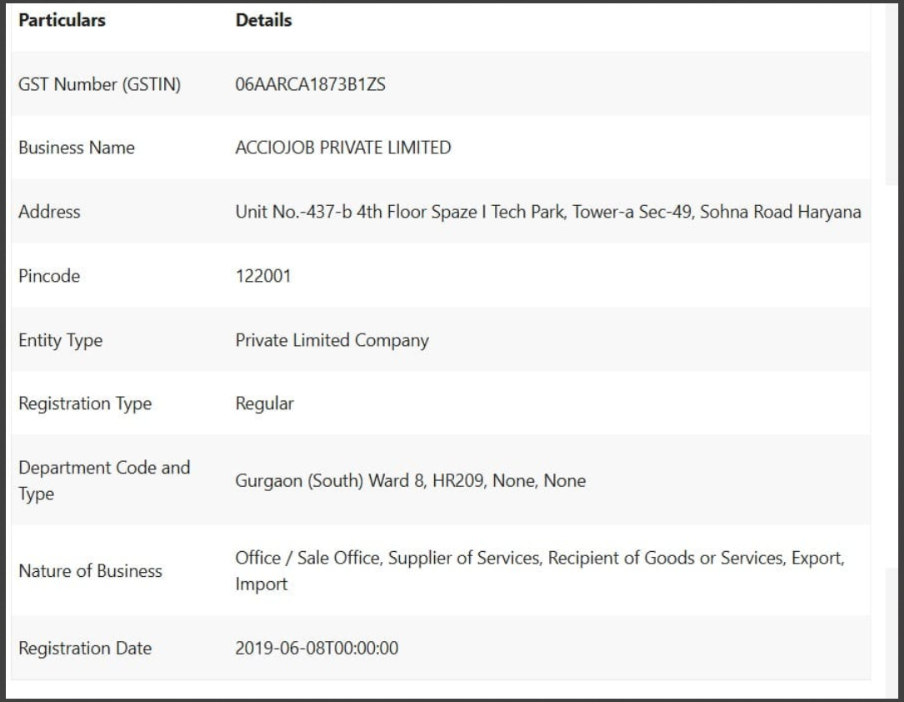

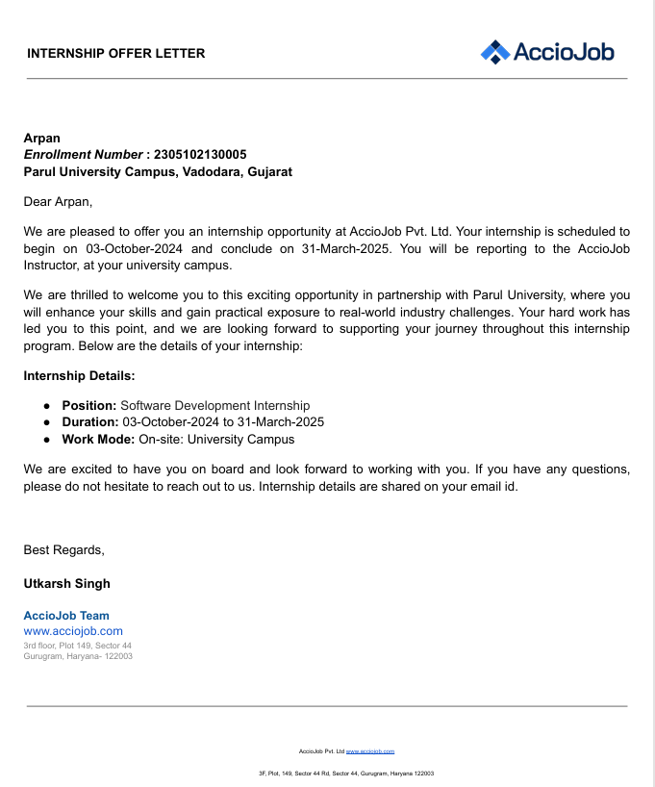

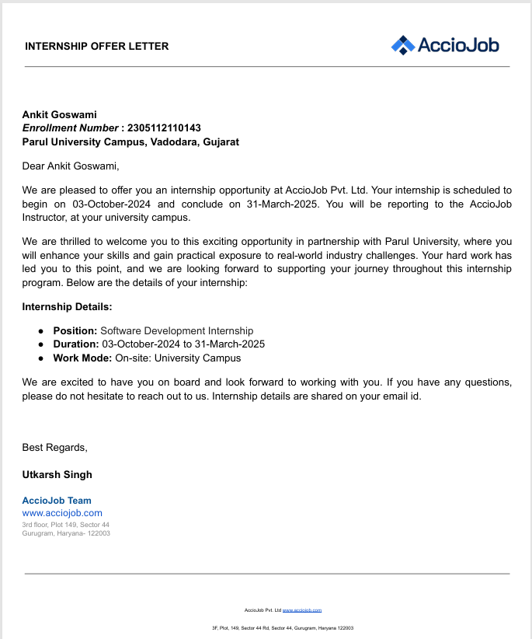

**Preface**

In today's rapidly advancing healthcare landscape, cardiovascular diseases remain a prominent global health concern, responsible for millions of deaths annually. Early detection, timely intervention, and continuous monitoring are crucial elements in combating these life-threatening conditions. With this context, the Smart Healthcare Ecosystem project was conceived and developed as a powerful, integrated healthcare solution designed to predict cardiovascular diseases using advanced machine learning algorithms and intuitive user interfaces.

The Smart Healthcare Ecosystem leverages the capabilities of Flask for backend services, React.js for creating a responsive and interactive frontend, and SQLite for efficient data management. This comprehensive integration ensures seamless performance, scalability, and user-centric functionality. The primary aim is to deliver precise, data-driven predictions that empower patients and healthcare providers to take proactive measures, improving patient outcomes significantly.

The detailed documentation presented here aims to offer an extensive overview of the system's architecture, development workflow, and key functionalities. Each component—from data handling and predictive analytics to secure authentication and personalized user experiences—is meticulously explained to ensure clarity and ease of understanding for developers, researchers, and healthcare professionals alike.

Moreover, this project reflects a broader vision of employing artificial intelligence and robust software engineering practices to transform healthcare delivery. The Smart Healthcare Ecosystem exemplifies how modern technology can be harnessed to address critical health issues proactively, enabling users to access meaningful insights about their health quickly and efficiently.

We believe that the Smart Healthcare Ecosystem represents an essential step forward in digital health innovations, potentially influencing future research and development in health informatics and artificial intelligence-driven healthcare solutions. We invite users and developers to explore, adapt, and expand upon the methodologies and approaches documented here, further enriching the landscape of intelligent healthcare systems.

**Acknowledgement**

The success and outcome of this project required a lot of guidance and assistance from my team members and we are extremely privileged to have got this all along the completion of our project. All that we have done is only due to such supervision and assistance and we would not forget to thank them.

We respect and thank **Dr Priya Swaminarayan, Dean, FITCS** for providing us an opportunity to do the project work in MCA and giving us all support and guidance, which made us complete the project duly. We are extremely thankful to Mam for providing her support and guidance, although she had busy schedule managing the academic affairs.

We would not forget to remember **Prof. Vivek Dave, HOD, MCA** department for her encouragement and more over for her timely support and guidance till the completion of our project work.

We owe our deep gratitude to our project guide **Dr. Hina Chokshi** who took keen interest on our project work and guided us all along, till the completion of our project work by providing all the necessary information for developing a good system.

We are thankful to and fortunate enough to get constant encouragement, support and guidance from our Parents, all Teaching staffs of MCA Department which helped us in successfully completing our project work. Also, we would like to extend our sincere esteems to all staff in laboratory for their timely support.

*Arpan [2305102130005]*

*Ankit Goswami [2305112110143]*

**Faculty of IT & Computer Science**

**PARUL University, Vadodara**

**INDEX**

|  |  |  |
| --- | --- | --- |
| **No.** | **Description** | **Page No.** |
| **1.** | **About Department of MCA/MSc IT** | **9** |
| **2.** | **Project Profile**  2.1 Project Definition  2.2 Project Description  2.3 Existing System / Work Environment  2.4 Problem Statements  2.5 Need for New System  2.6 Proposed System & Features  2.7 Scope  2.8 Outcomes  2.9 Tools & Technology used  2.10 Project Plan | **10** |
| **3.** | **Requirement Analysis**  3.1 Feasibility Study  3.2 Users of the System  3.3 Modules  3.4 Process Model  3.5 Hardware & Software Requirements  3.6 Use Cases  3.7 Use Case Diagram | **13** |
| **4.** | **Design**  4.1 Use Case Scenarios  4.2 Diagrams  4.2.1 UML / DFD Diagrams  4.2.2 Entity Relationship Diagram  4.3 Data Dictionary | **19** |
| **5.** | **Implementation**  5.1 Form Layouts  5.2 Report Layouts  5.3 Coding Convention (Business Logic) | **24** |
| **6.** | **Testing Phase**  6.1 Test Strategy  6.2 Test Cases | **32** |
| **7.** | **Future Enhancement** | **35** |
| **8.** | **Bibliography** | **36** |

**About Department of MCA & M.Sc. IT**

**PARUL University**

Parul University is a legitimate university established under Gujarat Private University Act 2009, after legislation passed by the Government of Gujarat on 26th March 2015 giving University status to Parul Group of Institutes functioning under the aegis of Parul Arogya Seva Mandal Trust.

**Faculty of IT & Computer Science**

Faculty of IT and Computer Science, Parul University has materialized as one of the prime IT education providers at global level. Various departments under Faculty of IT and Computer Science strive in preparing IT-industry ready professionals by means of various skill development courses, vocational courses, co-curricular & extra-curricular activities, industry visits and expert lectures.

**MCA Department**

The Department of Master of Computer Application and Master of Science in Information Technology at Parul University emphasizes on building professionals in the domain of computer applications by providing necessary environment by means of facilitating suitable blend of technical and non-technical learning experience. The department cultivates students in various curricular, co-curricular and extra-curricular activities in order to produce future system analysts, system designers, system programmers, application programmers, testing professionals, system managers, project managers, researchers and other leading positions in systems/IT department.

The departments offer various subjects from diversified technical/non-technical areas such as – core IT domain, management, communication skills, mathematics & logic building and rich pool of elective subjects.

The department of MCA and M.Sc. (IT) focuses on project-based learning, and hence students are motivated to work on tiny hands-on projects in practical oriented subjects to get better exposure. Moreover, throughout their MCA studies, students are required to work on around 3 mini/major projects in individual/team to get enough confidence on software-development and thereby become industry-ready.

**Project Profile**

**2.1 Project Definition**

* **Project Title:** Smart Healthcare Ecosystem
* **Name:** Arpan, Ankit Goswami

**2.2 Project Description**

The Smart Healthcare Ecosystem project focuses on building a predictive system to enhance healthcare services by integrating AI-driven solutions. The two primary modules developed so far include:

1. **Cardiovascular Disease Prediction Model**: A machine learning model that predicts the likelihood of cardiovascular diseases based on user-input health parameters.
2. **Text Generator Model**: An NLP-based chatbot capable of generating conversational responses and health-related information.

Both modules were designed and integrated into a dynamic web application, making the ecosystem user-friendly and efficient.

This project aims to develop a predictive machine learning model that can accurately assess the likelihood of an individual suffering from cardiovascular disease. Heart disease is one of the leading causes of death worldwide, and early detection is critical to preventing fatal outcomes. With advancements in data science and machine learning, it is possible to analyse patterns in medical data to predict potential heart conditions.

The model will take several input parameters, including age, gender, blood pressure, cholesterol levels, and other relevant health indicators, to predict the risk of heart disease. By analysing these inputs, the system will provide a risk score, allowing users to understand their risk level and seek medical advice accordingly.

The primary goal is to create a system that is not only accurate but also user-friendly, allowing healthcare professionals and potentially even patients to use it. The system will integrate both the backend, where the machine learning model resides, and a frontend interface that makes interaction simple and intuitive. This project is particularly relevant in today’s context, where predictive analytics can significantly improve healthcare outcomes.

**2.3 Existing System and/or Work Environment**

* **System 1:** Cleveland Heart Disease Dataset Analysis
  + A common dataset used in academic research for heart disease prediction.
  + Typically uses logistic regression and other basic models.
* **System 2:** Framingham Heart Study
  + A comprehensive study that has been ongoing for decades, providing data for heart disease prediction models.
  + Focuses on a wide array of health indicators.
* **System 3:** Manual Health Risk Assessment Tools
  + Tools used by doctors based on clinical guidelines to assess the risk of heart disease.
  + Involves manual calculations and assessments based on patient history and health metrics.

**2.4 Problem Statements**

* Difficulty in early detection of heart disease, leading to delayed treatment and adverse outcomes.
* Lack of accessible, user-friendly tools that allow individuals to assess their heart disease risk without extensive medical knowledge.
* Manual risk assessment methods are time-consuming and prone to human error.

**2.5 Need for New System**

* **Automation and Accuracy:** A machine learning-based system can automate the risk assessment process, improving accuracy and reducing the burden on healthcare providers.
* **Accessibility:** Such a system can be made available online or via mobile apps, increasing accessibility for individuals seeking to assess their health risks.
* **Data-Driven Decisions:** The system uses historical data to make predictions, offering evidence-based risk assessments.

**2.6 Proposed System & Features**

* **Modules:**
  + **Data Input Module:** Users input personal health data.
  + **Prediction Module:** Utilizes a machine learning model (e.g., logistic regression, random forest) to predict heart disease risk.
  + **User Interface:** Simple and intuitive interface for users to interact with the system.
  + **Reporting Module:** Generates a report on the user’s risk level and provides recommendations.
* **Features:**
  + **Interactive Input Forms:** Easy-to-use forms for entering health data.
  + **Real-Time Predictions:** Instant feedback on risk level after data submission.
  + **Data Security:** Ensuring user data is handled securely and privately.

**2.7 Scope**

* **Where:** The system can be used in hospitals, clinics, or by individuals at home.
* **How:** It will be available as a web application, with potential expansion to mobile platforms.
* **By Whom:** Healthcare professionals, patients, and health-conscious individuals.
* **When:** The system can be used at any stage where risk assessment is necessary, particularly in preventive healthcare settings.

**2.8 Outcomes**

* **Benefits:**
  + Early detection of heart disease risks, leading to timely interventions.
  + Reduced workload for healthcare professionals through automated assessments.
  + Empowerment of individuals to monitor their heart health proactively.

**2.9 Tools & Technology Used**

* **Python:** For data processing and building machine learning models, due to its extensive libraries like Scikit-Learn and Pandas.
* **Flask/Django:** Backend framework to handle web application development.
* **React/CSS/JavaScript:** For building the frontend interface, ensuring it is responsive and user-friendly.
* **SQL/SQLite Database:** To store user data securely and efficiently.

**2.10 Project Plan**

|  |  |
| --- | --- |
| **Task** | **Duration (Days)** |
| Requirement Analysis | 10 |
| Data Collection & Cleaning | 8 |
| Model Development | 15 |
| Frontend Development | 15 |
| Integration & Testing | 7 |
| Documentation | 5 |

**Requirement Analysis**

**3.1 Feasibility Study**

**3.1.1 Technical Feasibility**

The project is technically feasible due to the availability of machine learning libraries, such as Scikit-Learn, TensorFlow, and Keras, which provide robust tools for developing predictive models. Python, as the programming language, is widely supported and well-documented, ensuring that technical challenges can be overcome efficiently. Additionally, the use of web development frameworks like Flask or Django ensures that the system can be built with scalability in mind. The data required for training the model is accessible through public datasets, such as the UCI Heart Disease dataset, making the data collection phase feasible.

**3.1.2 Economic Feasibility**

Developing this system is economically feasible, as it does not require significant financial investment. The necessary development tools, such as Python and its libraries, are open-source and free to use. Hosting the web application can be done on affordable cloud platforms like Heroku or AWS, with minimal costs associated with low-traffic applications. Given the potential benefits of early heart disease detection, the return on investment (ROI) can be substantial, especially if the system is adopted by healthcare institutions or made available to the public.

**3.1.3 Operational Feasibility**

Operationally, the system is feasible because it requires minimal user training. The interface will be designed to be intuitive and user-friendly, ensuring that both healthcare professionals and individuals can use it with ease. The system's backend will handle complex computations, while the frontend will provide a simple, interactive platform for users. Regular maintenance and updates can be easily managed by a small team, making the system operationally sustainable.

**3.1.4 Social Feasibility**

The project is socially feasible as it addresses a significant public health concern. By providing a tool for early detection of heart disease, the system has the potential to save lives and reduce the burden on healthcare systems. It can also raise awareness about heart health, encouraging people to take preventive measures. The system aligns with societal goals of improving public health and can be positively received by both users and the broader community.

**3.2 Users of the System**

**3.2.1 Roles, Rights, and Responsibilities**

* **Admin** 
  + **Roles:** Manage the system, update machine learning models, and oversee user management.
  + **Rights:** Full access to all system modules, including data management and model training.
  + **Responsibilities:** Ensure the system is up-to-date, manage user roles, and maintain data integration.
* **Healthcare Professionals**
  + **Roles:** Use the system to assess patient risk for heart disease.
  + **Rights:** Access to prediction modules, input patient data, and view generated reports.
  + **Responsibilities:** Enter accurate patient data and interpret the results for medical advice.
* **End Users (Patients/Individuals)**
  + **Roles:** Input their health data to assess their own risk of heart disease.
  + **Rights:** Access to personal data entry forms and prediction outcomes.
  + **Responsibilities:** Enter accurate personal health information and follow up with healthcare professionals as needed.

**3.3 Modules of the System**

* **Data Input Module**
  + **Features:** Interactive forms for users to input health data such as age, blood pressure, cholesterol levels, etc.
  + **Functionalities:** Validates user input and passes data to the prediction module.
* **Prediction Module**
  + **Features:** Runs machine learning algorithms to predict heart disease risk.
  + **Functionalities:** Processes input data, applies the trained model, and outputs a risk score.
* **User Interface Module**
  + **Features:** User-friendly interface for interaction with the system.
  + **Functionalities:** Displays input forms, prediction results, and provides navigation across different system features.
* **Reporting Module**
  + **Features:** Generates detailed reports on user risk levels.
  + **Functionalities:** Summarizes the prediction results, offers health advice, and allows for report download or printing.

**3.4 Process Model**

**3.4.1 Development Strategy: Agile Methodology**

Agile methodology is selected for this project due to its iterative nature, allowing for continuous improvement and quick adaptations to changing requirements. The system can be developed incrementally, with regular feedback from users and stakeholders to ensure that the final product meets their needs.

* **Justification:** Agile allows for flexibility, which is crucial when developing machine learning models that may require fine-tuning based on performance metrics. It also facilitates regular testing and integration, ensuring that each module functions correctly before moving on to the next.
* **Diagrams and Scrums:** (Include diagrams such as Sprint Planning, Backlog Management, and Scrum Meetings to visualize the process.)

**3.5 Hardware & Software Requirements**

**3.5.1 Hardware & Software Configuration at Developers’ End**

* **Hardware:**
  + Processor: Intel Core i5 or i7
  + RAM: 8 GB or 16 GB
  + Storage: 500 GB SSD
  + GPU: Optional, for accelerated model training
* **Software:**
  + OS: Windows 10/11 or Ubuntu 20.04
  + Python 3.x with libraries (Pandas, Scikit-Learn, TensorFlow/Keras)
  + IDE: Visual Studio Code, Jupyter Notebook
  + Web Framework: Flask/Django
  + Database: MySQL/PostgreSQL

**3.5.2 Minimum Hardware & Software Requirements at Client’s/User’s End**

* **Hardware:**
  + Processor: Intel Core i3 or i5 or i7
  + RAM: 4 GB or 8 GB or 16 GB
  + Storage: 100 GB HDD/SSD
* **Software:**
  + OS: Windows 10 or macOS Catalina or Linux-based OS
  + Web Browser: Chrome, Firefox, or Edge (latest version)
  + Internet Connection: Required for accessing the web application

**3.6 Use Cases**

**3.6.1 Actors of the System**

* **Healthcare Professional**
* **End User (Patient/Individual)**

**3.6.2 Actor-wise Use Cases**

* **Healthcare Professional**
  + Enter Patient Data
  + View Prediction Results
  + Generate Reports
* **End User (Patient/Individual)**
  + Input Personal Data
  + View Prediction Outcome

**3.7 Use Case Diagram**

* **Diagram:**

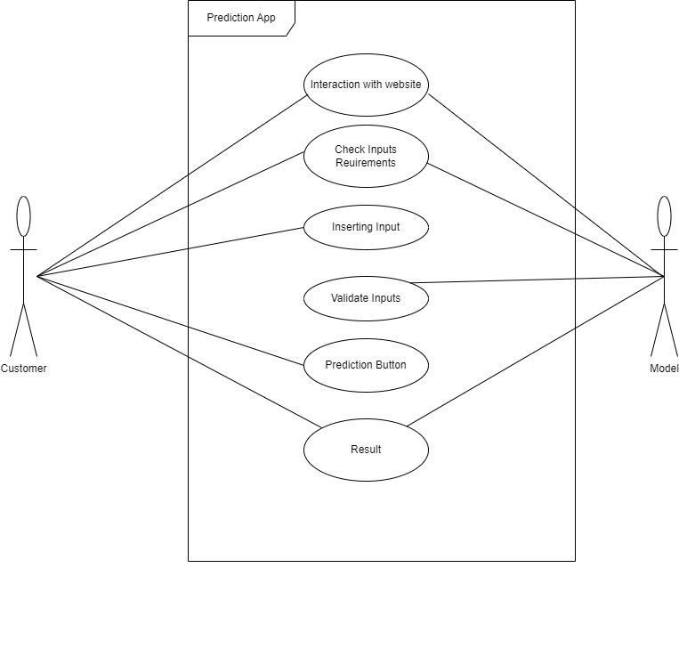

Top of Form

**3.8 Model Diagram**

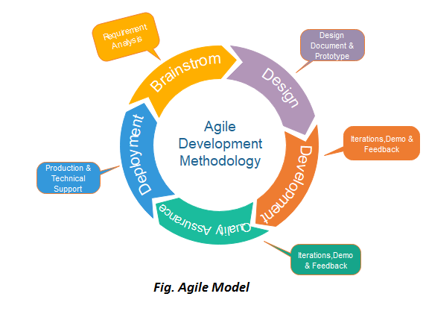

**Design**

**4.1 Use Case Scenarios**

|  |  |  |  |  |
| --- | --- | --- | --- | --- |
| **Use Case ID** | **Use Case Scenario Description** | **Actor(s)** | **Precondition(s)** | **Postcondition(s)** |
| UC1 | User inputs health-related data (age, gender, blood pressure, etc.) via a web form. | User | The user has access to the app and a device to enter data. | The system accepts the input and processes it for prediction. |
| UC2 | The system processes the input data and predicts the likelihood of cardiovascular disease using the trained model. | System | User data has been entered correctly. | The system displays the prediction result on the UI. |
| UC3 | User clears the input fields and prediction output from the form for a new prediction. | User | User has already submitted data and viewed the result. | The form is reset, and all input/output fields are cleared. |
| UC4 | User requests explanation or additional information on the prediction (e.g., factors contributing to the prediction). | User/System | Prediction result is displayed. | System provides insights or explanations based on the model. |
| UC5 | User exits the app or closes the browser after receiving the prediction. | User | Prediction has been delivered. | The session ends, and no data is saved unless explicitly allowed. |

**4.2 Diagrams**

**4.2.1 UML Diagrams (Object-Oriented Analysis and Design - OOAD)**

1. **Class Diagram**: Represents the structure of the app, showing the relationships between different classes (e.g., User, Prediction Model, Data Processor).
2. **Sequence Diagram**: Describes the flow of interaction between the user and the system, such as the sequence of actions for data input, processing, and prediction output.

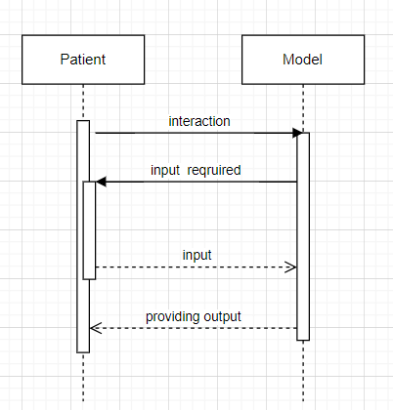

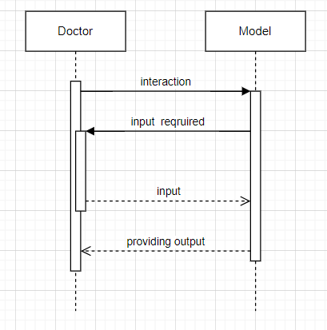

1. **Activity Diagram**: Illustrates the workflow of the app, detailing the process from user input to prediction generation and display.

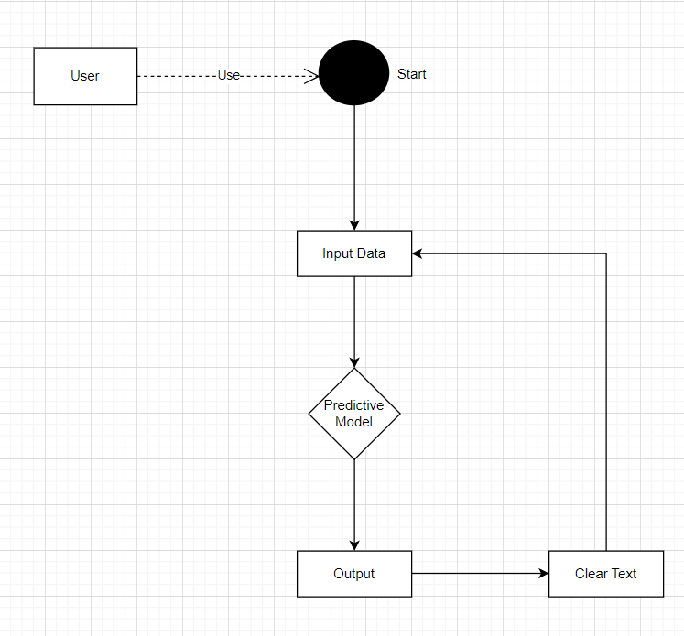

**4.2.2 UML (Class Diagram):**

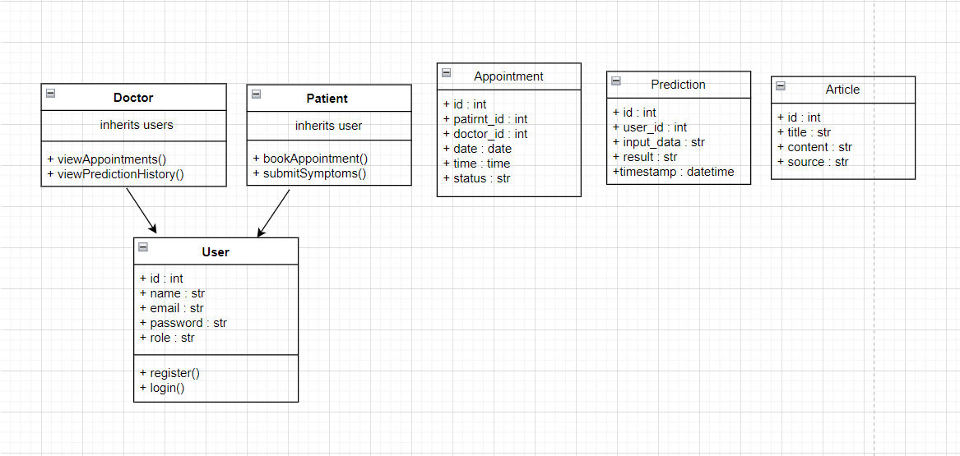

**4.2.2 Use case Diagram:**

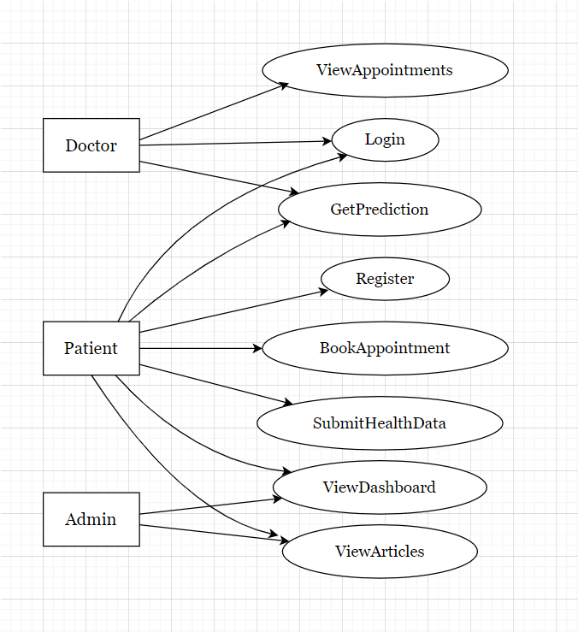

**4.3 Data Dictionary**

* **Database**: The database will store user data, prediction results, and relevant health information.
* **Tables**:

|  |  |  |  |
| --- | --- | --- | --- |
| **User**: Stores user information (ID | name | email | id |
| **Health Data**: Stores input data from users (age | gender | blood pressure | cholesterol |
| **Prediction**: Stores the prediction results along with a timestamp. | output | predicted data | predicted outcome |

**Implementation**

In this section, describing the implementation details of app, including the layout of forms, report views, and business logic.

**5.1 Form Layouts**

This section includes screenshots of form layouts, along with descriptions and operating instructions for each form. The forms are where users enter their health data to predict cardiovascular disease.

**Example Layout:**

* **Screenshot:**

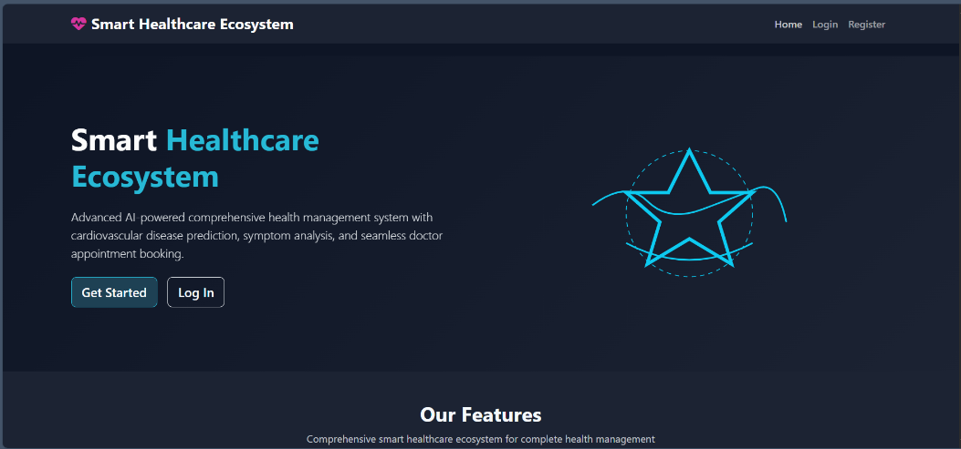

**Figure.1** **Landing Page**

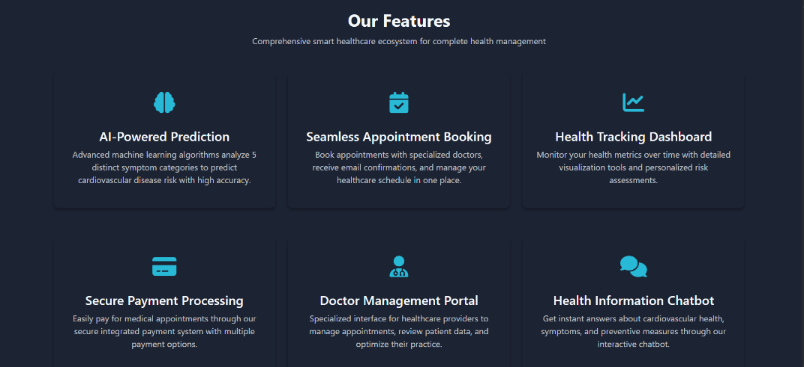

**Figure.2 Landing Page**

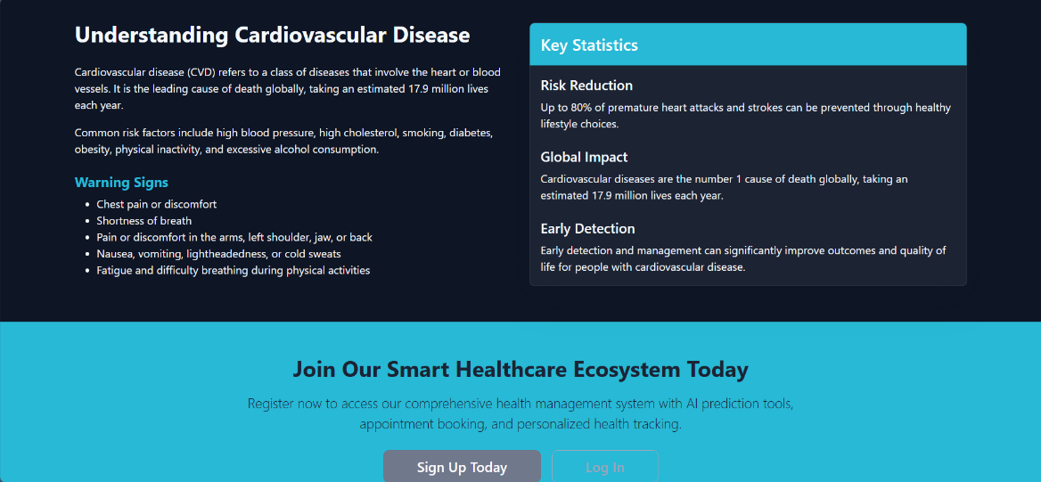

**Figure. 3 Landing Page Footer**

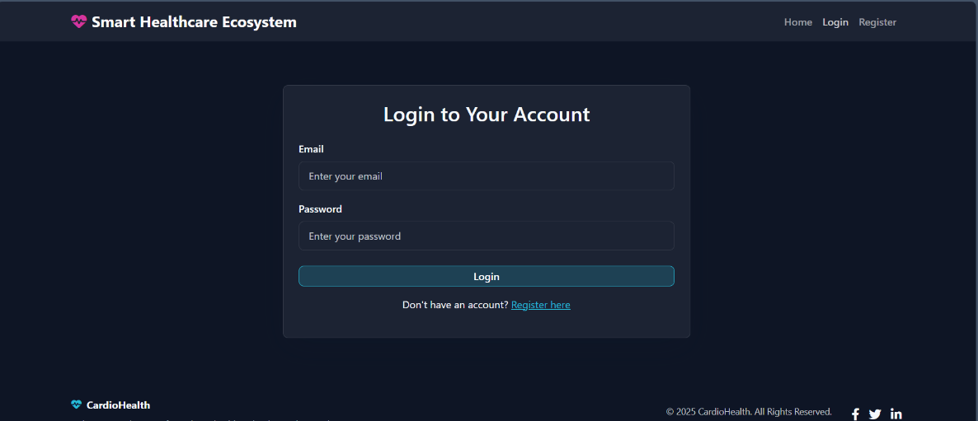

**Figure. 4 Login Form**

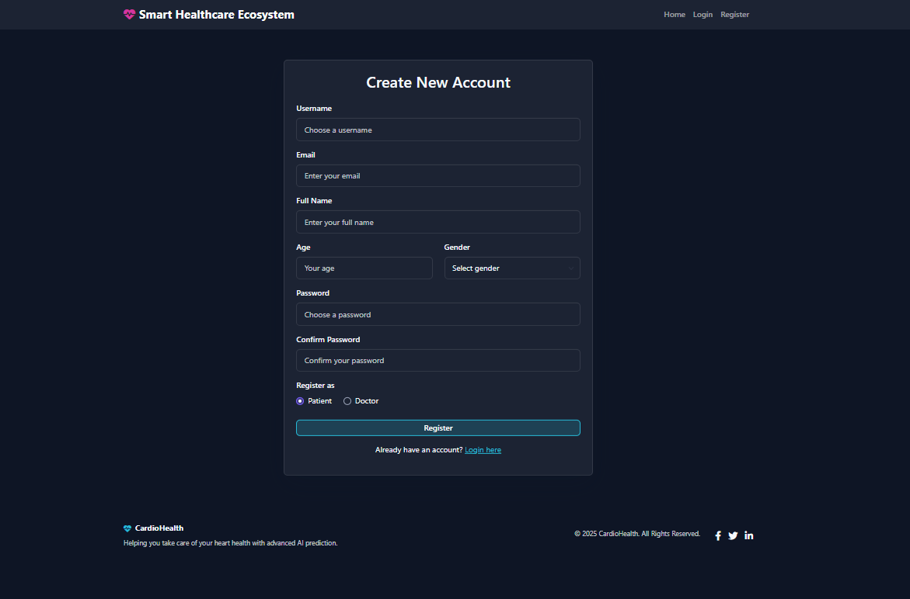

**Figure.5 Registration Form**

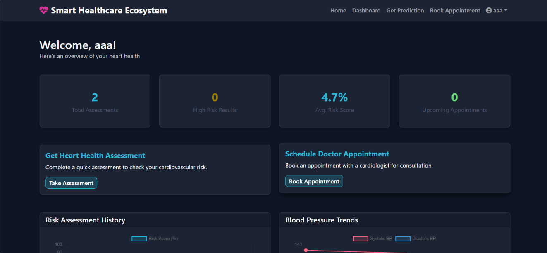

**Figure.6 User Dashboard**

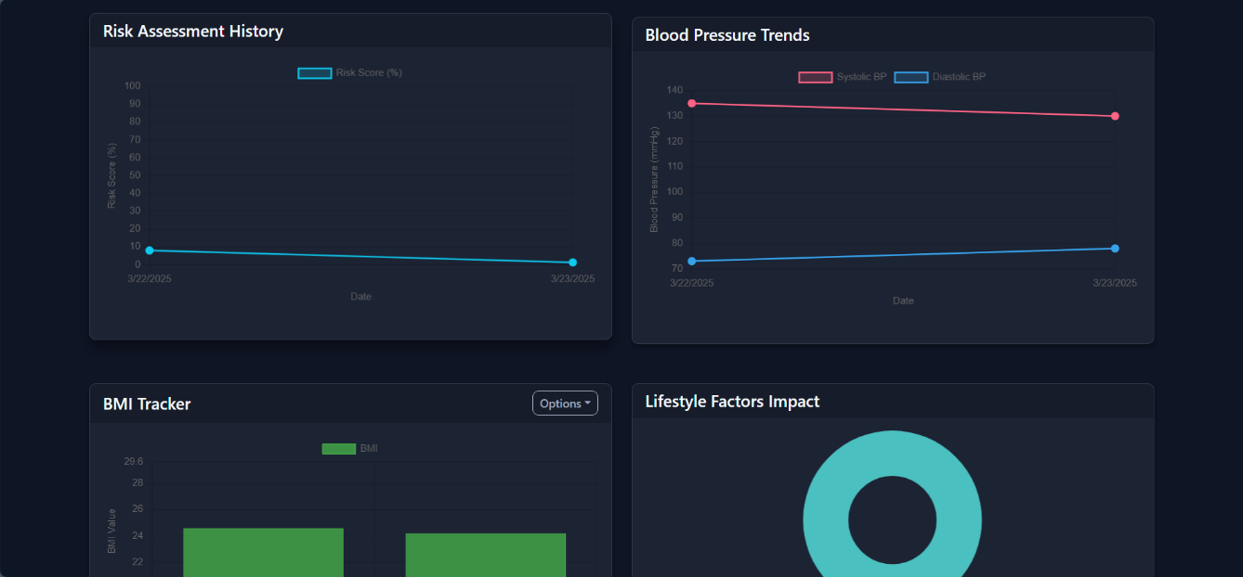

**Figure.7 User Dashboard**

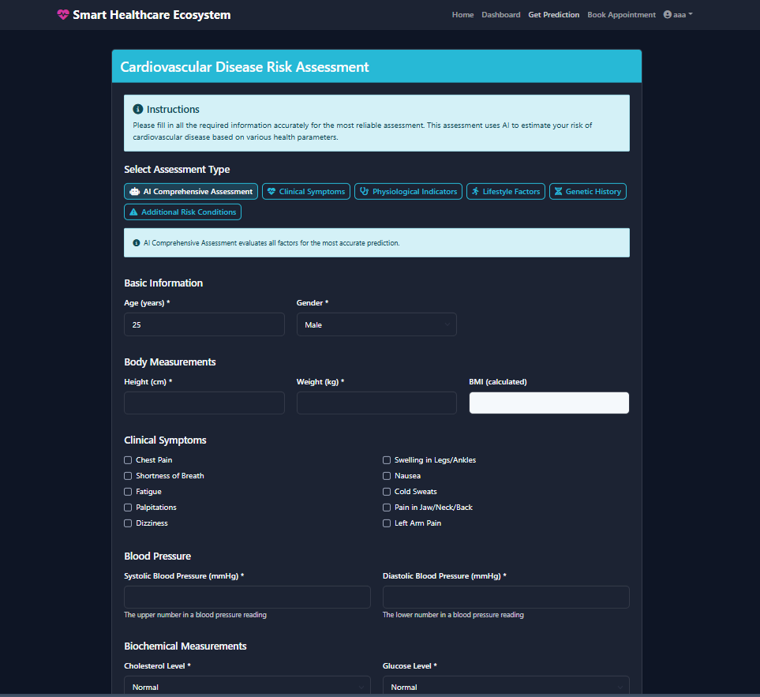

**Figure.8 Prediction Form**

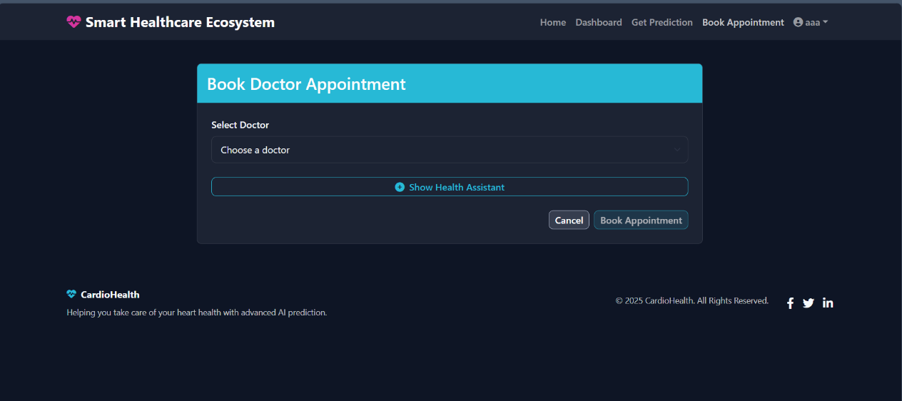

**Figure.9 Appointment Booking**

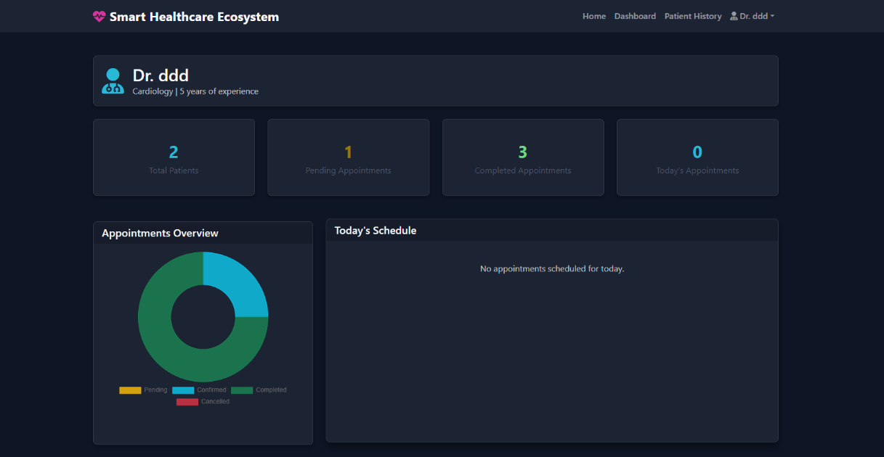

**Figure.10 Doctor Dashboard**

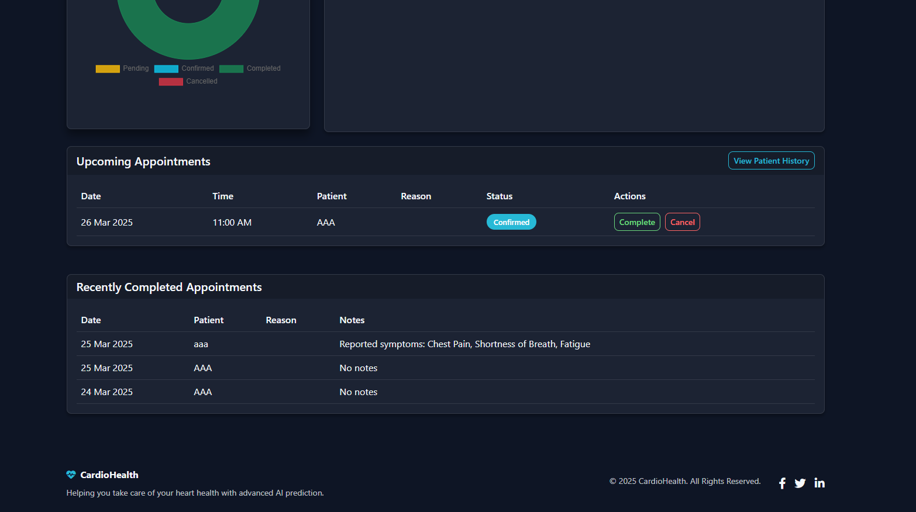**Figure.11 Doctor Dashboard**

* **Description:**
  + This form is the primary interface where users input their health data.
  + Each field is clearly labelled, and dropdown menus are used for categorical data (e.g., gender, cholesterol levels).
  + The form includes validation to ensure all required fields are completed.
* **Operating Instructions:**
  + **Step 1**: Enter your details in the provided fields.
  + **Step 2**: After filling in all the fields, click the **Submit** button to generate predictions.
  + **Step 3**: If any errors occur (e.g., missing fields), an error message will prompt the user to correct the input.
  + **Step 4**: The **Clear Input** button can be used to reset all fields.

**5.2 Report Layouts**

In this section, providing screenshots of the report or result views generated by application.

**Example Report Layout:**

* **Description:**
  + This report layout displays the prediction results.
  + It clearly shows whether the user is predicted to be at risk or not, based on the inputs provided.
* **Operating Instructions:**
  + **Step 1**: After submitting the form, the system will process the data and display the result on this screen.
  + **Step 2**: The user can view the result, which will state either "Patient" or "Not a Patient" based on the prediction.

**5.3 Business Logic**

In this section, explaining the coding conventions, structure, and logic used in the application.

**Example Business Logic Description:**

* **Main Modules:**
  + **Data Input Handling**: This module takes user inputs from the form, validates them, and passes them to the backend for processing.
  + **Model Prediction**: This module uses a machine learning model to predict cardiovascular disease based on the input data.
  + **Result Display**: This module takes the prediction result and displays it on the front-end.
* **Coding Conventions:**
  + **Naming Conventions**: Variable and function names follow the camelCase convention for readability.
  + **Commenting**: Each function is documented with a brief explanation of its purpose.
  + **Error Handling**: Robust error handling is implemented to catch and display user-friendly error messages.

**Example Demo Code:**

**Python**

* **Explanation of Code:**
  + This code snippet handles the prediction functionality of the app.
  + **Input Handling**: The data from the form is captured and converted to a format suitable for the model.
  + **Prediction**: The input data is scaled, passed to the prediction model, and the result is obtained.
  + **Result Display**: The prediction result is then passed back to the front-end and displayed to the user.

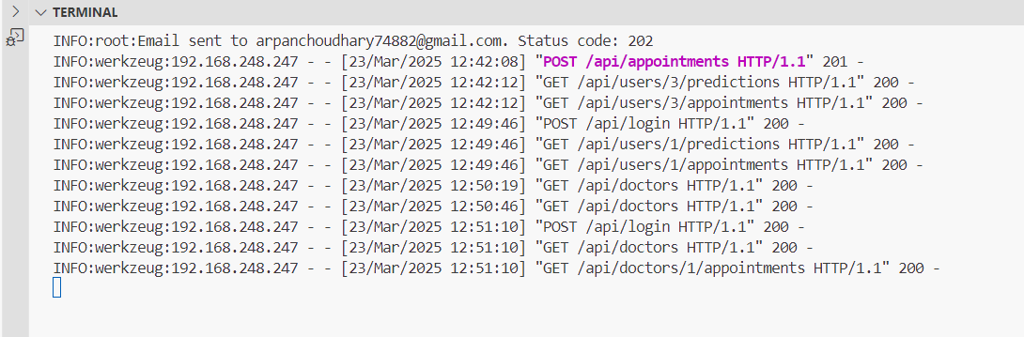

**Figure.12 Backend working**

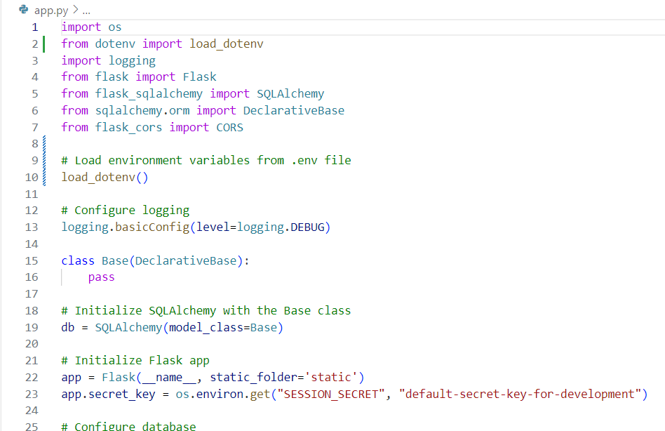

**Figure.13 Api Routes**

**Testing Phase**

This section focuses on testing the application to ensure it functions correctly and meets the requirements. Below is a guide on how to complete this part.

**6.1 Test Strategy**

In this section, testing the application. It involves preparing a test plan, identifying the testing methods, and choosing the tools.

**Test Plan:**

* **Objective:** Ensure that the Cardiovascular Disease Prediction App works as expected, with accurate predictions, proper handling of inputs, and clear output displays.
* **Scope:** The testing will cover form inputs, prediction results, and error handling, ensuring the app functions smoothly across different scenarios.
* **Types of Testing:**
  + **Unit Testing:** Test individual components of the app, such as data validation and prediction logic.
  + **Integration Testing:** Test the interaction between different modules, ensuring that data flows correctly from the form to the backend and back to the front end.
  + **Functional Testing:** Verify that the app meets the specified functional requirements, such as input validation and accurate predictions.
  + **User Acceptance Testing (UAT):** Have end-users test the app to ensure it meets their expectations and is user-friendly.

**Testing Methods/Techniques:**

* **Manual Testing:** For testing the user interface, input validation, and error messages. This will involve entering various inputs manually and checking the output.

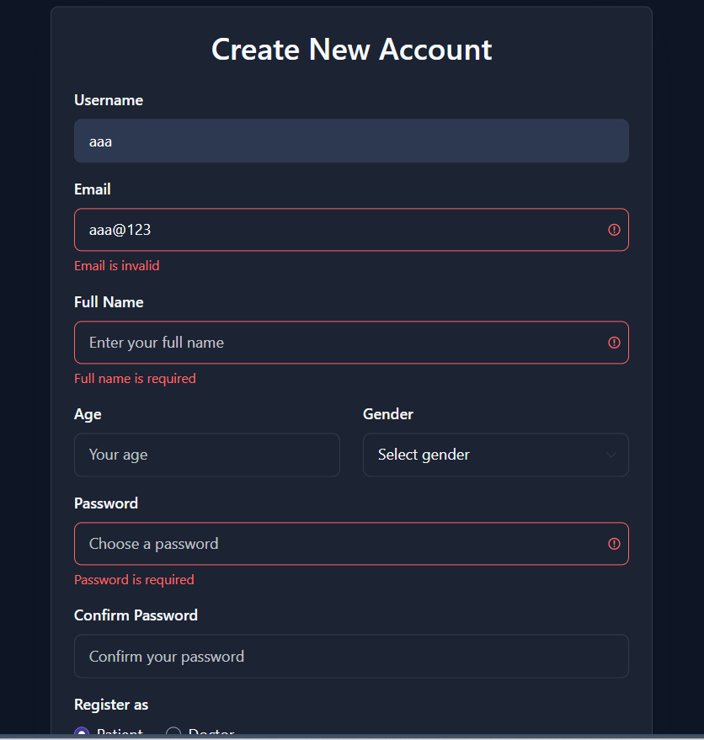

* **Automation Testing:** For classification testing and ensuring that new code changes do not break existing functionality. Tools like Selenium can be used for automating the form input and result checking.

**Tools for Testing:**

* **Selenium:** For automating web-based tests.
* **Py Test/Unit Test:** For running unit tests on Python code.
* **Postman:** For testing API endpoints, ensuring that the backend is functioning correctly.

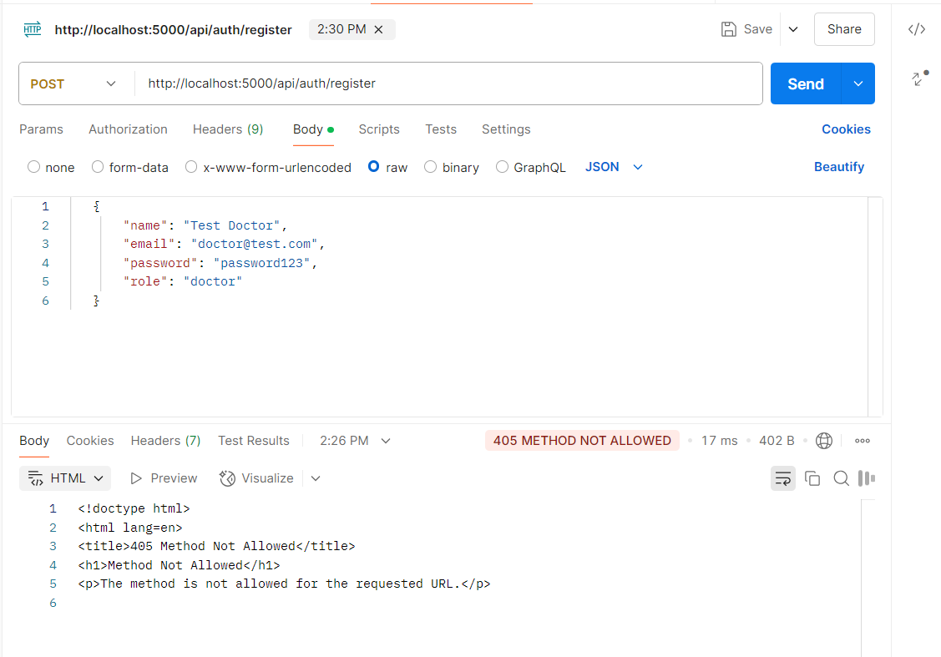

**Future Enhancement**

**1. Integration with Wearable Devices**.

2. **Mobile Application Development**

3. **Multi-Language Support**

4. **Personalized Health Recommendations**

5. **Cloud Integration for Data Storage**

|  |  |  |
| --- | --- | --- |
|  | |  |
|  | |  |
|  | |  |
|  | |  |
|  | |  |
|  |  | | |
|  |  | | |
|  |  | | |

**Bibliography**

**Books:**

1. **Aurélien Géron***Hands-On Machine Learning with Scikit-Learn, Keras, and TensorFlow, O'Reilly Media, 2019*[**https://www.oreilly.com/library/view/hands-on-machine-learning/9781492032632/**](https://www.oreilly.com/library/view/hands-on-machine-learning/9781492032632/)
2. **Miguel Grinberg  
   *Flask Web Development, O'Reilly Media, 2018***[**https://www.oreilly.com/library/view/flask-web-development/9781491991732/**](https://www.oreilly.com/library/view/flask-web-development/9781491991732/)
3. **R. Narasimha Rao  
   *Machine Learning and Artificial Intelligence: Applications in Healthcare, Tata McGraw Hill, 2020***[**https://www.mheducation.co.in/machine-learning-and-artificial-intelligence-applications-in-healthcare-9789389811202-india**](https://www.mheducation.co.in/machine-learning-and-artificial-intelligence-applications-in-healthcare-9789389811202-india)
4. **Rajiv Chopra  
   *Artificial Intelligence and Machine Learning for Healthcare, Pearson India, 2021***[**https://www.pearsonindia.com/artificial-intelligence-and-machine-learning-for-healthcare.html**](https://www.pearsonindia.com/artificial-intelligence-and-machine-learning-for-healthcare.html)
5. **Dinesh Kumar  
   *Data Science and Analytics for Healthcare, Wiley India, 2019*** [**https://www.wileyindia.com/data-science-and-analytics-in-healthcare.html**](https://www.wileyindia.com/data-science-and-analytics-in-healthcare.html)
6. **World Health Organization (WHO)  
   *Cardiovascular Diseases (CVDs) Fact Sheet, 2023*** [**https://www.who.int/health-topics/cardiovascular-diseases**](https://www.who.int/health-topics/cardiovascular-diseases)

**Documentation:**

1. Flask Official Documentation[**https://flask.palletsprojects.com/**](https://flask.palletsprojects.com/)
2. NumPy Official Documentation[**https://numpy.org/doc/**](https://numpy.org/doc/)
3. Pandas Official Documentation

[**https://pandas.pydata.org/docs/**](https://pandas.pydata.org/docs/)

**Tutorials & Courses:**

1. Cardiovascular Disease Prediction using Machine Learning – Data Trained

[**https://www.datatrained.com/**](https://www.datatrained.com/)

1. Machine Learning with Python – Krish Naik

[**https://www.youtube.com/@KrishNaik**](https://www.youtube.com/@KrishNaik)

1. Flask for Beginners – YouTube Tutorials[**https://www.youtube.com/results?search_query=flask+for+beginners**](https://www.youtube.com/results?search_query=flask+for+beginners)

**Videos:**

1. "Building a Machine Learning Web App with Flask" by Corey Schafer[**https://www.youtube.com/watch?v=Z1RJmh_OqeA**](https://www.youtube.com/watch?v=Z1RJmh_OqeA)
2. "Deploying Machine Learning Models as Web Apps using Flask" by Tech with Tim[**https://www.youtube.com/watch?v=UbCWoMf80PY**](https://www.youtube.com/watch?v=UbCWoMf80PY)
3. "Understanding Cardiovascular Disease Risk Factors" – Healthcare Channels[**https://www.youtube.com/results?search_query=understanding+cardiovascular+disease+risk+factors**](https://www.youtube.com/results?search_query=understanding+cardiovascular+disease+risk+factors)

**Additional Book:**

* Wes McKinney*Python for Data Analysis*

[**https://www.oreilly.com/library/view/python-for-data/9781491957653/**](https://www.oreilly.com/library/view/python-for-data/9781491957653/)

**Others:**

* GitHub Repositories (Search for Relevant Projects)[**https://github.com/search?q=cardiovascular+disease+prediction+flask**](https://github.com/search?q=cardiovascular+disease+prediction+flask)

Bottom