**MODULE: 2 (CSS and CSS 3):-**

Q1. What are the benefits of using CSS?

Ans- Benefits of CSS-

* Web designers needs to use few lines of programming for every page improving site speed.
* Cascading sheet not only simplifies website development, but also simplifies the maintenance as a change of one line of code affects the whole web site and maintenance time.
* It is less complex therefore the effort are significantly reduced.
* It helps to form spontaneous and consistent changes.
* CSS changes are device friendly. With people employing a batch of various range of smart

Q2. What are the disadvantages of CSS?

Ans- Disadvantages of CSS-

* With CSS, what works with one browser might not always work with another. The web developers need to test for compatibility, running the program across multiple browsers.
* There exists a scarcity of security.
* After making the changes we need to confirm the compatibility if they appear. The similar change affects on all the browsers.
* CSS works differently on different browsers. IE and Opera supports CSS as different logic.
* There might be cross-browser issues while using CSS.

Q3. What is the difference between CSS2 and CSS3?

Ans- Difference between CSS2 and CSS3:-

|  |  |
| --- | --- |
| **CSS 2** | **CSS 3** |
| CSS splits up different sections of the code into modules | Both CSS and HTML were put into a single file, there was no concept of modules before |
| There is no backward compatibility | Backward compatibility is maintained |
| Only web fonts can be used | Special fonts can be used such as those in Google Fonts and TypeCast |
| Concept of simple selectors were present | Selectors were called as a sequence of simple selectors.com |
| Does not support Border Box property | Support Border Box property |

Q4. Name a few CSS style components

Ans- A few CSS style components:-

* Properties: These are readable numeric IDs that let you specify which style elements you want to change.
* Values: A value is given to each property. This value specifies the property's styling.

Q5. What do you understand by CSS opacity?

Ans- The opacity of an element is controlled by the opacity CSS property. Opacity is the opposite of transparency and refers to how much of an element's content is hidden.

Q6. How can the background color of an element be changed?

Ans- Use the CSS background-color property

Q7. How can image repetition of the backup be controlled?

Ans- To control the repetition of an image in the background, use the background-repeat property.

Q8. What is the use of the background-position property?

Ans- The background-position property sets the starting position of a background image

Q9. Which property controls the image scroll in the background?

Ans- background-attachment property

Q10. Why should background and color be used as separate properties?

Ans- It makes style sheets easier to read. In CSS, the background property is a complex property that becomes even more complicated when combined with color.

Q11. How to center block elements using CSS1?

Ans- By setting the properties margin-left and margin-right to auto and width to some explicit value:

BODY {width: 30em; background: cyan ;}

P {width: 22em; margin-left: auto; margin-right: auto}

Q12. How to maintain the CSS specifications?

Ans- CSS is a stylesheet language used to describe how a document that was written in HTML or XML is presented. CSS specifies how elements should be displayed in various media, including speech, paper, screens, and other media. The World Wide Web Consortium maintains the CSS specifications.

Q13. What are the ways to integrate CSS as a web page?

Ans- CSS can be added to HTML documents in 3 ways: Inline - by using the style attribute inside HTML elements. Internal - by using a <style> element in the <head> section. External - by using a <link> element to link to an external CSS file.

Q14. What is embedded style sheets?

Ans- It allows you to define styles for a particular HTML document as a whole in one place. This is done by embedding the <style></style> tags containing the CSS properties in the head of your document.

Q15. What are the external style sheets?

Ans- A link in the webpage's head section can be used to access an external style sheet, which is a different CSS file. The same link can be used by several websites to access the stylesheet. The head section of the page contains a link to an external style sheet.

Q16. What are the advantages and disadvantages of using external style sheets?

Ans- Advantages of using external style sheets:-

* You can establish classes of styles that can subsequently be used on numerous
* Distinct HTML components, and one modification to the style sheet will modify all linked pages.
* Uniform appearance and experience across many web pages.
* Faster load speeds because each relevant page just needs to have the CSS file downloaded once and applied as necessary.

Disadvantages of using external style sheets:-

* It's possible that until the external CSS is loaded, your pages won't render correctly.
* The download time of your website may increase if you upload or link to multiple CSS files.

Q17. What is the meaning of the CSS selector?

Ans- The first component of a CSS Rule is a CSS selector. It is a set of phrases and patterns that instruct the browser which HTML elements to pick in order to apply the CSS property values contained in the rule to them.

Q18. What are the media types allowed by CSS?

Ans- The media types allowed by CSS are:-

1. all- Suitable for all devices.
2. aural- Intended for speech synthesizers.
3. braille- Intended for braille tactile feedback devices.
4. embossed- Intended for paged braille printers.
5. handheld- Intended for handheld devices (typically small screen, monochrome, limited bandwidth).
6. print- Intended for paged, opaque material and for documents viewed on screen in print preview mode. Please consult the section on paged media.
7. projection- Intended for projected presentations, for example projectors or print to transparencies. Please consult the section on paged media.
8. screen- Intended primarily for color computer screens.
9. tty- Intended for media using a fixed-pitch character grid, such as teletypes, terminals, or portable devices with limited display capabilities.
10. tv- Intended for television-type devices.

Q19. What is the rule set?

Ans- A set of guidelines or benchmarks against which network activity or system activity is compared to decide what action to take, such as forwarding or rejecting a packet, creating an alert, or allowing a system event.

Q20. Create Layouts

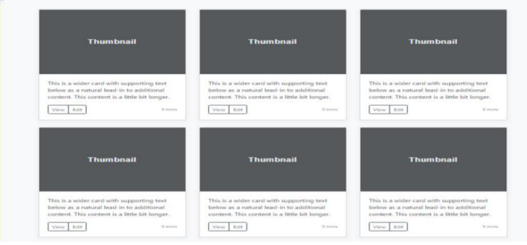

Ans -