**Tagging**

1. **Simple tags, Lightweight tags**

* **$git tag myTag** used to create tags and its basically a marker to a particular commit.
* To see the list of tags we can use command **$git tag –list**

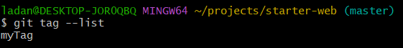

* **$git show myTag** shows the commit at that tag.
* To delete the tag **$git tag –delete myTag.**

1. **Annotated Tag**

* Tags are often used to denote the major milestones or version number in source code.
* **$git tag -a v-1.0** here -a denotes annotated and v-1.0 denotes the name of tag.

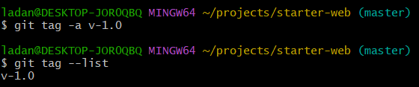

* To see the tag use log command full.

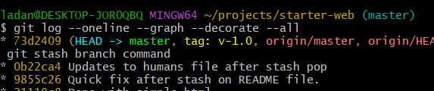

* Now show the annotated tag we get slightly different answer.

In annotated tag it starts with name date.

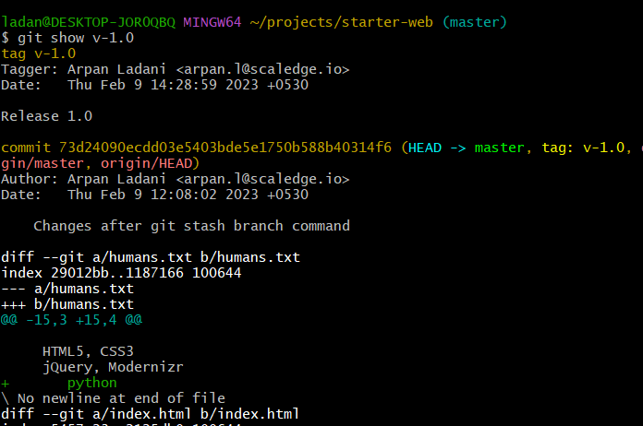

1. **Comparing Tags**

* **$git commit –amend** to amend the commit message.
* Another way is **$git tag v-1.2 -m “Release 1.2”** after tag there is tag name and m means message and then in double quotes the message we want to type.
* 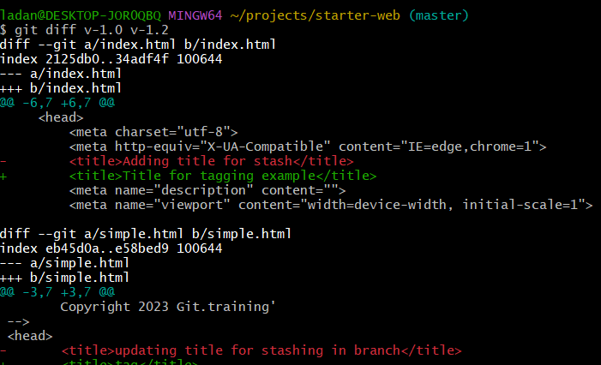**$git diff v-1.0 v-2.0** is used to compare the tag.
* Same with visual diff **$git difftool v-1.0 v-2.0**.

1. **Tagging a specific commit**
   * This is used to tag a specific commit in the log.
   * **$git tag -a v-0.9-beta 67ac33d**
   * Here a is for annotated 67ac33ed is the commit specific number.

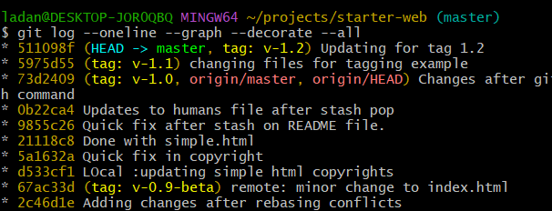

1. **Updating Tags**

* First approach is delete the tag and create a new one second is forcing.
* **$git tag -a v-0.8-alpha -f cb9cfeb**

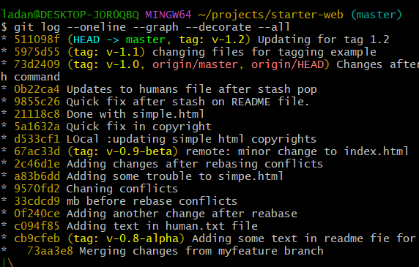

1. **Using tags with GitHub**

* Push a particular tag **$git push origin v-0.9-beta**

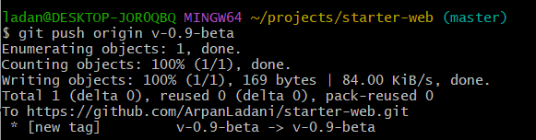

* To push all the tags in a branch.

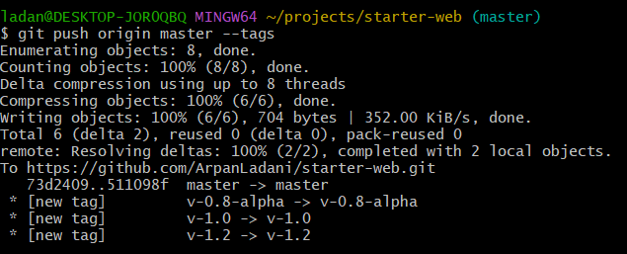

* To delete the tag form GitHub, the tag will remain in local repository even after applying this command it will be just removed from remote repository.

**$git push origin :v-0.-alpha**

