

Module Code & Module Title
CS6PO5NT-Final Year Project
Assessment Weightage & Type
Final Year Project Proposal (5%)
Year and Semester
2025-26 Autumn
Student Name: Arpan Upreti
London Met ID: 23049196
College ID: np05cp4a230146@iic.edu.np
Assignment Submission Date:
Internal Supervisor: Kushal Tamang
External Supervisor: Samuel Sherpa
Title: Gauhatt
I confirm that I understand my coursework needs to be submitted online via Google Classroom under the relevant module page before the deadline for my assignment to be accepted and marked. I am fully aware that late submissions will be treated as non-submission and a mark of zero will be awarded

Table of Contents
1. Introduction 1
1.1 Problem Scenario 1
1.2 The Project as solution 2
2. Aim and Objectives 3
2.1 Aim 3
2.2 Objectives 3
3. Expected Outcome and Deliverables 4
4. Project Risks, Threats and Contingency Plans 6
5. Methodology 7
5.1 Why Scrum is Suitable for GAUHATT 7
5.2 Scrum Framework for GAUHATT 9
6. Resource Requirements 12
6.1 Hardware Requirements 12
6.2 Software Requirements 12
7. Work Breakdown Structure 13
8. Milestone 14
9. Project Gantt chart 16
10. Further Plans 18

Introduction

Agriculture is one of the largest sectors in Nepal, yet farmers often face major challenges in bringing their goods to market. Due to the involvement of middlemen, farmers receive reduced profits while consumers pay inflated prices. In addition, there is a lack of transparency, traceability, digital enablement, and regional accessibility. GAUHATT aims to bridge this gap by digitizing the direct connection between farmers and consumers. Technology can transform the agricultural supply chain by empowering farmers, strengthening trust, and reducing inefficiencies. Through a modern platform built using ASP.NET Core, React, and PostgreSQL, GAUHATT offers a sustainable digital ecosystem where farmers can sell their products without intermediaries

Problem Scenario
The agricultural market in Nepal suffers from multiple structural issues:
• Excessive dependency on middlemen reduces farmer earnings.
• Consumers lack access to fresh produce sourced directly from farms.
• Farmers lack visibility, branding, and a direct marketplace to engage with buyers.
• Limited technological adoption slows down agricultural digitization.
• Crop spoilage due to inefficient, long-distance supply chains.
• Lack of trustworthy channels for farmers to share their stories and establish credibility.
A study by the Nepal Agriculture Market Board reveals that farmers often receive only 30–50% of the final consumer price due to layers of intermediaries. This affects livelihood, pricing stability, and agricultural sustainability.

The Project as solution
GAUHATT is designed as a comprehensive farmer-to-consumer marketplace enabling direct trade, regional delivery, and transparent interactions. Its major features include:
• Farmer KYC verification for authenticity.
• Story sharing for trust-building.
• Regional delivery radius enforcement to minimize spoilage.
• Data-driven insights for both farmers and administrators.
• Secure authentication using OTP and role-based access control.
This project is intended to modernize the agricultural supply chain and empower farmers with digital tools aligned with Nepal’s rural economic development goals.

Aim and Objectives

Aim
To develop a secure, scalable, and user-friendly digital marketplace connecting farmers and consumers directly through an efficient web platform built using ASP.NET Core, React, and PostgreSQL.

Objectives
• Build dedicated portals for Admin, Farmer, and Consumer roles.
• Implement secure authentication using OTP and JWT.
• Allow farmers to upload KYC documents for admin verification.
• Enable farmers to publish stories, upload products, and manage inventory.
• Provide ordering, cart, wishlist, and checkout functionalities for consumers.
• Implement regional delivery radius validation.
• Develop admin dashboards for monitoring sales, trends, and system health.
• Implement a rating and review system for transparency.
• Integrate data analytics for crop trends and revenue tracking.

Expected Outcome and Deliverables
I. GAUHATT Web Platform
• Farmer Module
- Product upload and inventory management
- Story publishing (photos, videos, text)
- Sales analytics and insights
- Order management panel
• Consumer Module
- Product search and filtering
- Ordering and checkout system
- Wishlist management
- Rating and review system
- Regional delivery radius validation
• Admin Module
- Farmer KYC verification
- User and content moderation
- Sales and farmer activity analytics
- System-wide monitoring dashboards
• Employee Engagement Module
To enhance platform communication and gather insights from users:
- Feedback submission system
- Survey creation and participation
- Sentiment tracking dashboard for admin
- Farmer & consumer engagement reports

II. Documentation
- Software Requirements Specification (SRS)
- System Architecture & ERD

Project Risks, Threats and Contingency Plans
A. Technical Risks
Risk: API integration challenges, server load issues.
Mitigation: Early prototyping, caching strategies, async processing.
B. Development Risks
Risk: Delays due to complex modules such as KYC and delivery radius calculations.
Mitigation: Sprint planning and prioritizing core features.
C. Security Risks
Risk: Unauthorized access, data leakage.
Mitigation: HTTPS, JWT, server-side validation, encryption of sensitive data.
D. Scalability Risks
Risk: Performance issues with growing content (images, videos, orders).
Mitigation: CDN usage, database indexing, modular architecture

Methodology
The development of GAUHATT will follow the Scrum methodology, a widely used Agile framework designed to support iterative, incremental, and highly adaptive software development. Scrum emphasizes flexibility, collaboration, continuous feedback, and the delivery of usable increments at the end of each cycle (sprint). This methodology is particularly suitable for dynamic and evolving systems like GAUHATT, where requirements may adapt based on user needs, testing outcomes, and stakeholder feedback.
Scrum divides the project timeline into manageable sprints, typically 1–2 weeks long, during which a focused set of features is planned, developed, tested, and reviewed. Each sprint results in a functional component of the system, ensuring steady progress and early detection of issues. This approach allows the development team to refine priorities, incorporate insights, and continuously strengthen the platform.

Why Scrum is Suitable for GAUHATT
Scrum is selected for this project due to several compelling reasons:
1. High Flexibility & Adaptability
GAUHATT includes a wide range of features such as KYC verification, product management, analytics, story publishing, OTP login, and consumer ordering. Scrum allows these components to be developed in iterative cycles, enabling updates, revisions, and optimizations as new insights arise.
2. Supports Evolving Requirements
Agricultural marketplaces often require adjustments based on:
- Government regulations
- KYC verification needs
- User feedback from farmers and consumers
- Scaling requirements for growing product data
Scrum welcomes changing requirements, ensuring the system remains aligned with real-world needs.
3. Continuous User-Centric Feedback
Since GAUHATT involves three major user roles (Admin, Farmer, Consumer), continuous feedback loops ensure:
- User experiences are optimized early
- Usability issues are identified quickly
- The platform grows in alignment with stakeholders
Sprint reviews at the end of each cycle allow users and supervisors to provide input on the evolving system.
4. Reduced Project Risk
Scrum detects issues early through:
- Frequent testing
- Incremental releases
- Daily standup-style check-ins (adaptive)
This reduces technical risk, avoids large failures at the end, and ensures manageable progress.
5. Higher Product Quality
Because each sprint includes a Testing Phase and Review & Retrospection, quality improves incrementally. Defects are fixed early rather than accumulating.

Scrum Framework for GAUHATT
Scrum consists of several structured activities that ensure clarity, accountability, and productivity throughout the development cycle:
A. Product Backlog
A prioritized list of all features GAUHATT must have, including:
- KYC Module
- Farmer Dashboard
- Consumer Ordering System
- Admin Analytics
- OTP verification
- Reviews module
- Feedback & Survey module
- Story publishing system
This backlog can evolve throughout development.

5.3 Sprint Structure
Each sprint in Scrum follows a clearly defined cycle:
1. Sprint Planning
- The team selects the highest-priority items from the backlog.
- Tasks are broken down into smaller actionable items.
- Time estimation is performed (story points or hours).
- Expected sprint goals are set, such as
“Complete OTP login and Registration module.”
2. Design Phase
- UI/UX wireframes for selected features
- Database schema adjustments
- API contracts (frontend–backend alignment)
- Architecture refinement if needed
For GAUHATT, this may involve designing:
- Product upload screens
- Order flow pages
- Analytics dashboard layout
3. Development Phase
Actual implementation of features begins:
- Backend APIs created using ASP.NET Core
- React components built for UI
- Integration with PostgreSQL
- Role-based security applied
- Validation, file upload, KYC features implemented
4. Testing Phase
Each sprint includes:
- Unit testing
- Integration testing
- API testing with Postman
- UI/UX testing
- Security checks
By testing during each sprint, issues are detected early, improving quality.
5. Sprint Review
- Completed features are demonstrated
- Stakeholders (supervisors, users) review the work
- Feedback is documented for the next sprint
This ensures GAUHATT evolves based on real requirements.
6. Sprint Retrospective
The team reflects on:
- What went well
- What needs improvement
- What impediments were faced
- How productivity can increase next sprint
This continuous improvement is the foundation of Scrum.

Resource Requirements

Hardware Requirements
• Laptop with minimum Intel i5 Processor
• 8GB RAM (16GB recommended)
• Stable internet connection

Software Requirements
• ASP.NET Core SDK
• React.js
• PostgreSQL + pgAdmin
• VS Code / Visual Studio
• Postman for API testing
• Git + GitHub for version control
• Linux VPS for deployment

Work Breakdown Structure
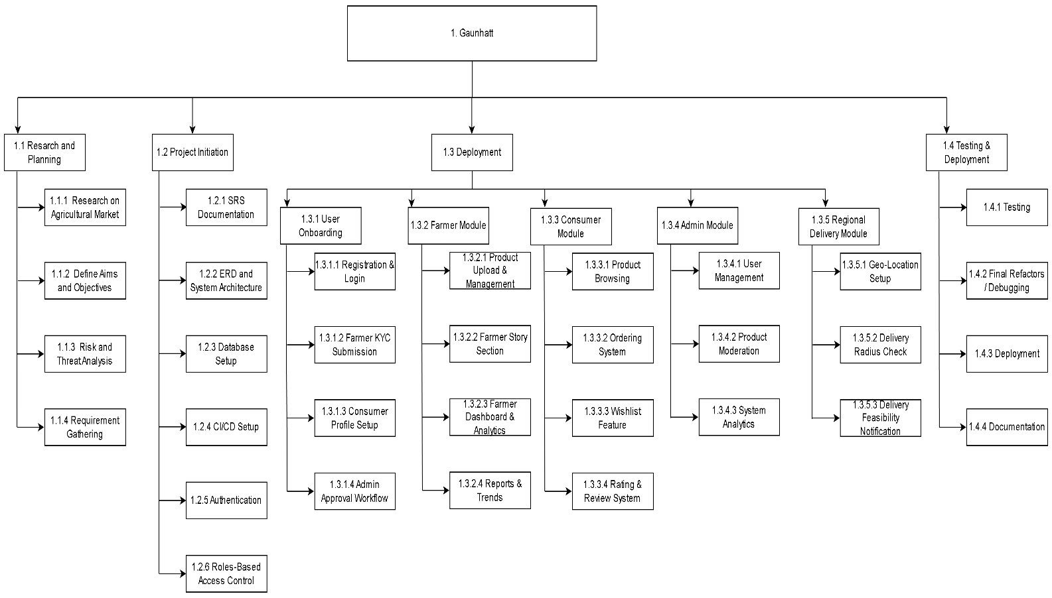
Figure 1 WBS Diagram

Milestone
• M1: Topic Finalization
Finalize project idea, scope, and core objectives after team discussion and supervisor approval.
• M2: Proposal Submission
Prepare and submit the project proposal including problem statement, goals, features, and methodologies.
• M3: SRS Documentation
Draft the Software Requirement Specification detailing functional, non-functional requirements, system flow, and use cases.
• M4: UI/UX Completion
Design wireframes, user flows, and the full UI/UX prototype for all user roles (Farmer, Consumer, Admin).
• M5: Authentication + OTP
Implement user registration, login, password management, and OTP-based verification for secure access.
• M6: Farmer KYC + Dashboard
Develop the farmer onboarding process (KYC), profile verification, and main dashboard with product management features.
• M7: Consumer Ordering
Build consumer-side features such as browsing listings, adding to cart, placing orders, and viewing order history.
• M8: Admin Analytics
Create admin panel with system monitoring, user management, and analytics dashboards (sales, users, trends).
• M9: System Integration
Integrate all modules authentication, farmer features, consumer ordering, and admin tools—into a unified workflow.
• M10: Testing
Conduct unit testing, integration testing, and user acceptance testing; resolve bugs and performance issues.
• M11: Deployment
Deploy the system to a hosting environment (cloud/server), configure environments, and ensure production readiness.
• M12: Final Report Submission
Prepare and submit the final project report summarizing design, implementation, results, and conclusions.

Project Gantt chart
The Gantt chart serves as a widely used project management tool across industries and organizations for planning, scheduling, and tracking project activities. It was originally developed by Henry Laurence Gantt, an American mechanical engineer and management consultant, during the 1910s.
For this project, the Gantt chart is structured according to the Scrum methodology, where the entire development process is divided into a series of iterative sprints. Each sprint focuses on delivering specific components of the system, ensuring continuous progress, flexibility, and timely feedback.
The timeline spans a total duration of five months, with all major development phases including planning, requirement analysis, UI/UX design, module development, integration, testing, and deployment scheduled to be completed by the end of April 2025. This structured timeline helps maintain clarity on task dependencies, resource allocation, and progress tracking throughout the project lifecycle.
The Gantt Chart for this project is attached below:

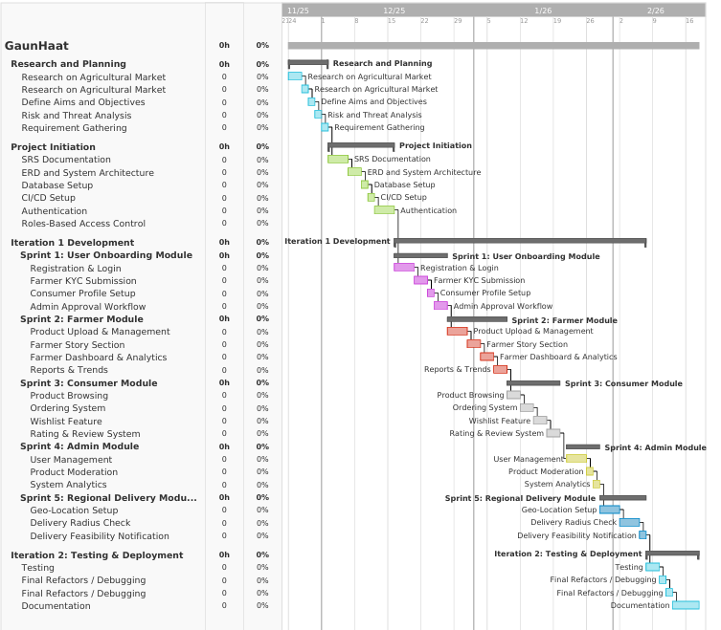
Figure 2 Gantt Chart

Further Plans
The GAUHATT platform is designed with scalability and long-term sustainability in mind.
As agriculture and digital technology continue to evolve, the system will expand to include
additional features aimed at improving user experience, increasing accessibility, and providing
more value to farmers, consumers, and administrators.
1. Mobile Application Development
• Develop dedicated Android and iOS mobile apps.
• Enable farmers to update inventory, track orders, and upload stories on the go.
• Offline-first features for farmers in rural areas with low connectivity.
2. AI-Based Price Prediction and Crop Forecasting
• Integrate machine learning models to help farmers predict optimal pricing.
• Analyze regional climate and historical data for crop forecasting.
• Provide smart suggestions for high-demand products.
3. Integration with Digital Payments
• Add eSewa, Khalti, IME Pay, and bank payment gateways.
• Support secure wallet systems and transaction analytics.
4. Expansion to B2B Marketplace
• Connect farmers directly with hotels, restaurants, and wholesalers.
• Bulk order management, invoices, and recurring order system.
5. Warehouse & Storage Management Module
• Allow farmers to access partner storage centers.
• Enable real-time stock updates and storage analytics.
6. Future International Expansion
• Explore cross-border exports for Nepali organic products.
• Create a global marketplace to promote Nepali agriculture.
These future plans ensure that GAUHATT evolves into a powerful digital ecosystem contributing to
Nepal’s agricultural modernization and strengthening the connection between farmers and consumers.

