Data-Flow Diagram (DFD)
A Data Flow Diagram (DFD) is a conventional visual tool that is employed in structured analysis to represent the flow of information within a system (IBM, 2022). It is concerned with the what of the system but not the how. DFDs are used to show the entry of data into the system (input), processing of this data, storage of data and exit of data out of the system (output).
DFDs have four major symbols:
- External Entities: Data sources or data destinations beyond the system boundaries (e.g. customers).
- Processes: Data transforming actions.
- Data Stores: Data is stored there to be used later.
- Data Flows: Arrows that indicate the direction of data flow.
They are often hierarchical. Level 0 (Context Diagram) represents the system as a whole process, whereas the levels that follow it divide the processes into smaller units.
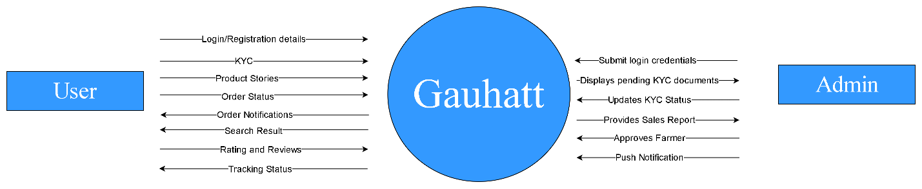
Figure 1: Data Flow Diagram (DFD)

Use-Case Diagram

A Use-Case Diagram is a behavioral diagram in the Unified Modeling Language (UML) that is used to represent the functional requirements of a system (Visual paradigm, 2023). The Use-Case Diagram, unlike the Activity Diagram that gives more specifics of the steps, gives a high-level view of how the system and the users relate to each other. It provides the answer to the question: What can the system do to its users?
Key components include:
- Actors: These are represented in the form of stick figures and they describe the roles of the human users or external systems which interact with the application.
- Use Cases: These are shown as ovals and reflect a particular goal or a functional area (e.g., "Login," "Add to Cart").
- System Boundary: This is a rectangle that determines the extent of the system, everything within the system is included in the system and everything outside the system is external.
- Relationships: Lines between actors and use cases. It also allows higher relationships such as the <<include>> (mandatory behavior) and the <<extend>> (optional behavior).

This diagram is a must in the initial phases of a project to establish scope and convey the requirements to non technical stakeholders without losing track in technicality.

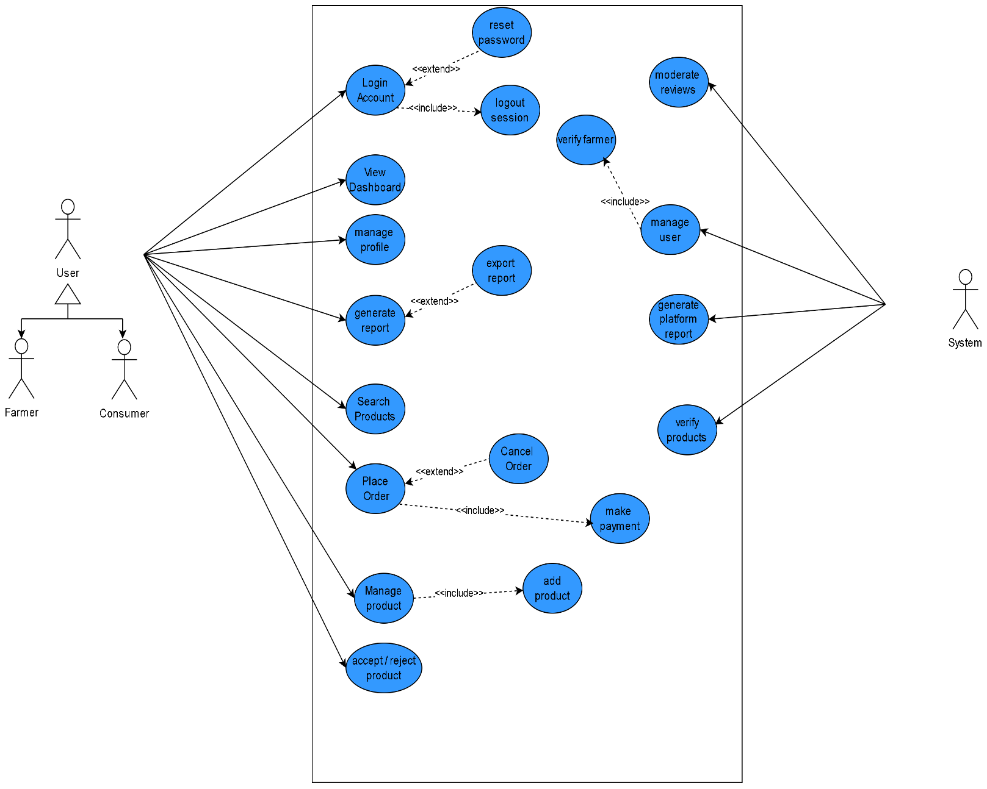
Figure 2 Use Case Diagram

Activity Diagram

Activity Diagram is a behavioral diagram that is stipulated by Unified Modeling Language (UML) (UML Diagram, 2020). The Activity Diagram is concerned with control flow and sequence of operations unlike the DFD which is concerned with data. It is simply a sophisticated flow chart that is employed in modeling the dynamic side of a system.
Activity Diagrams depict:
- Actions: The person acts in a workflow.
- Control Flow: The sequence of actions.
- Branching Nodes: Conditional (if/else logic) points of decision.
- Concurrency: The parallel processing (multithreading or simultaneous business tasks) demonstrated by forks and joins.
These charts are especially helpful in modeling business processes, use cases, and complicated algorithms in which the timing and order of events are vital.

Activity diagram of customer Order
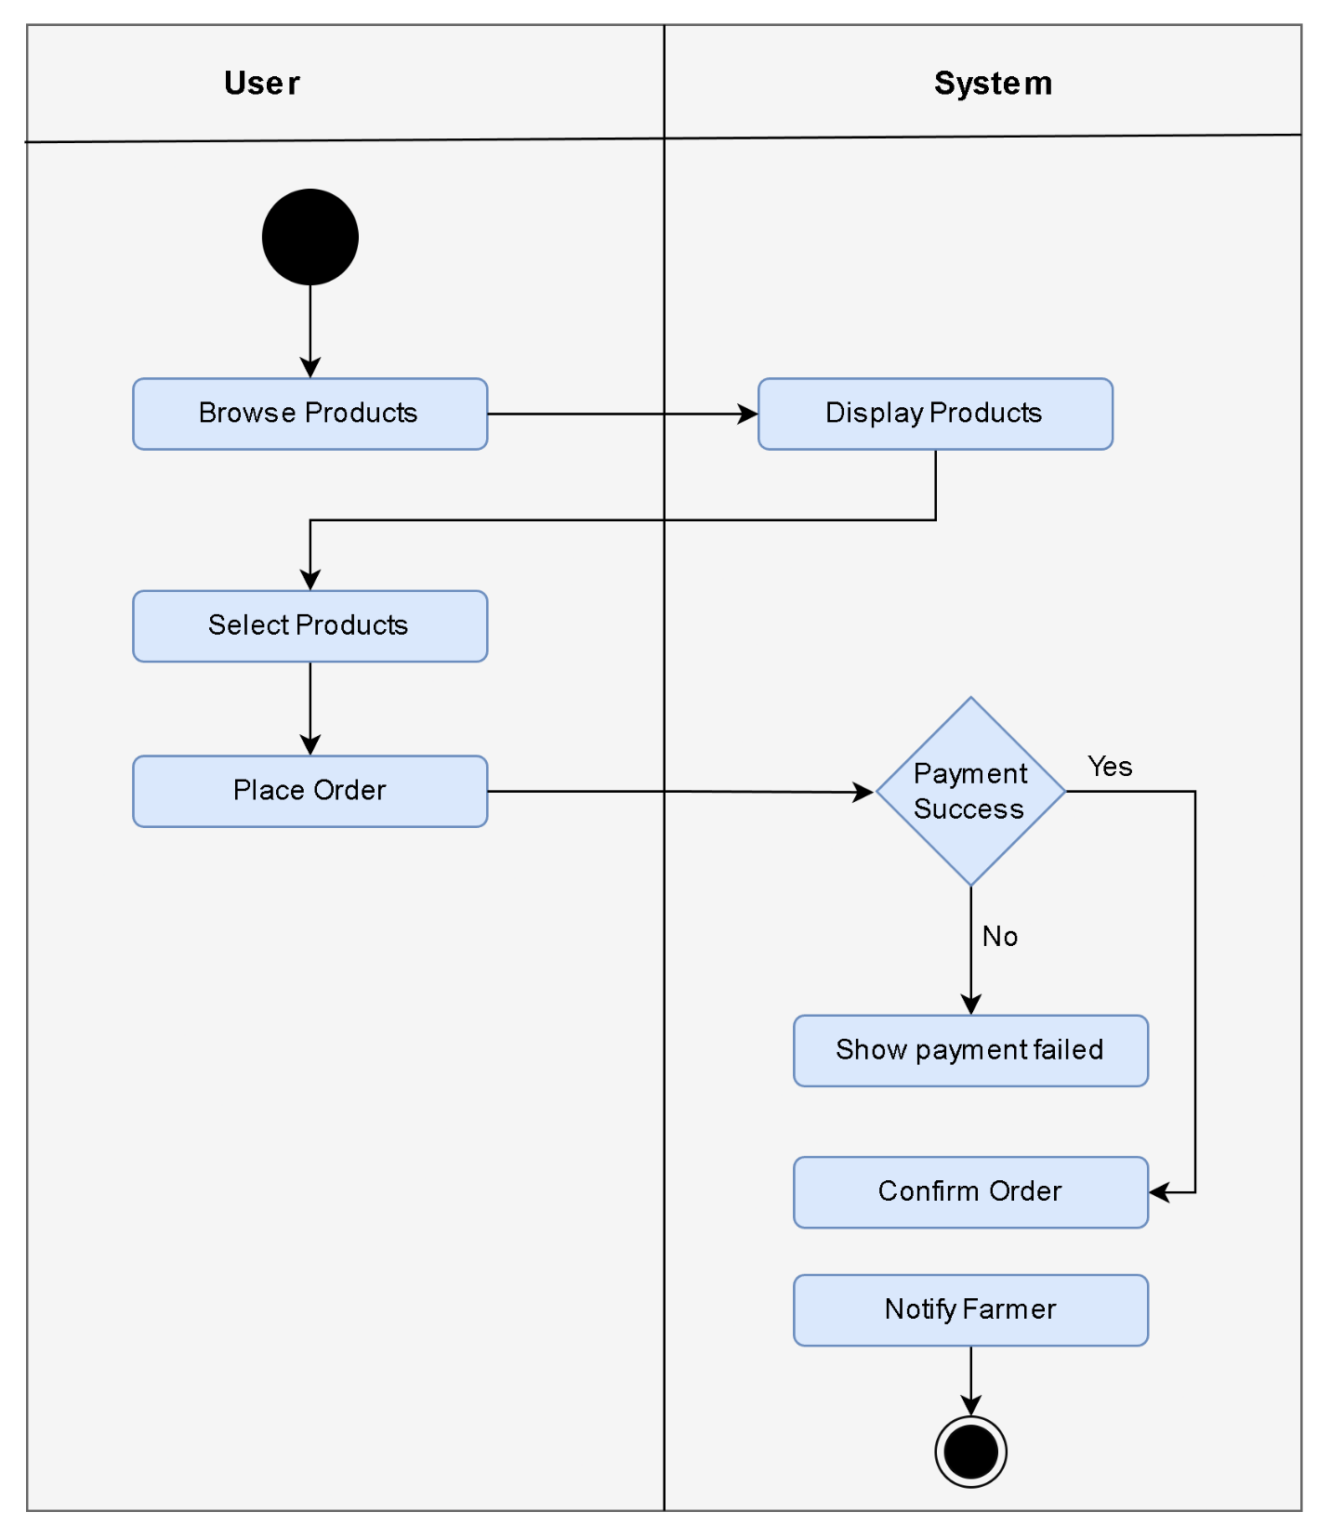
Figure 3 Activity diagram of customer Order

Activity diagram of farmer Order
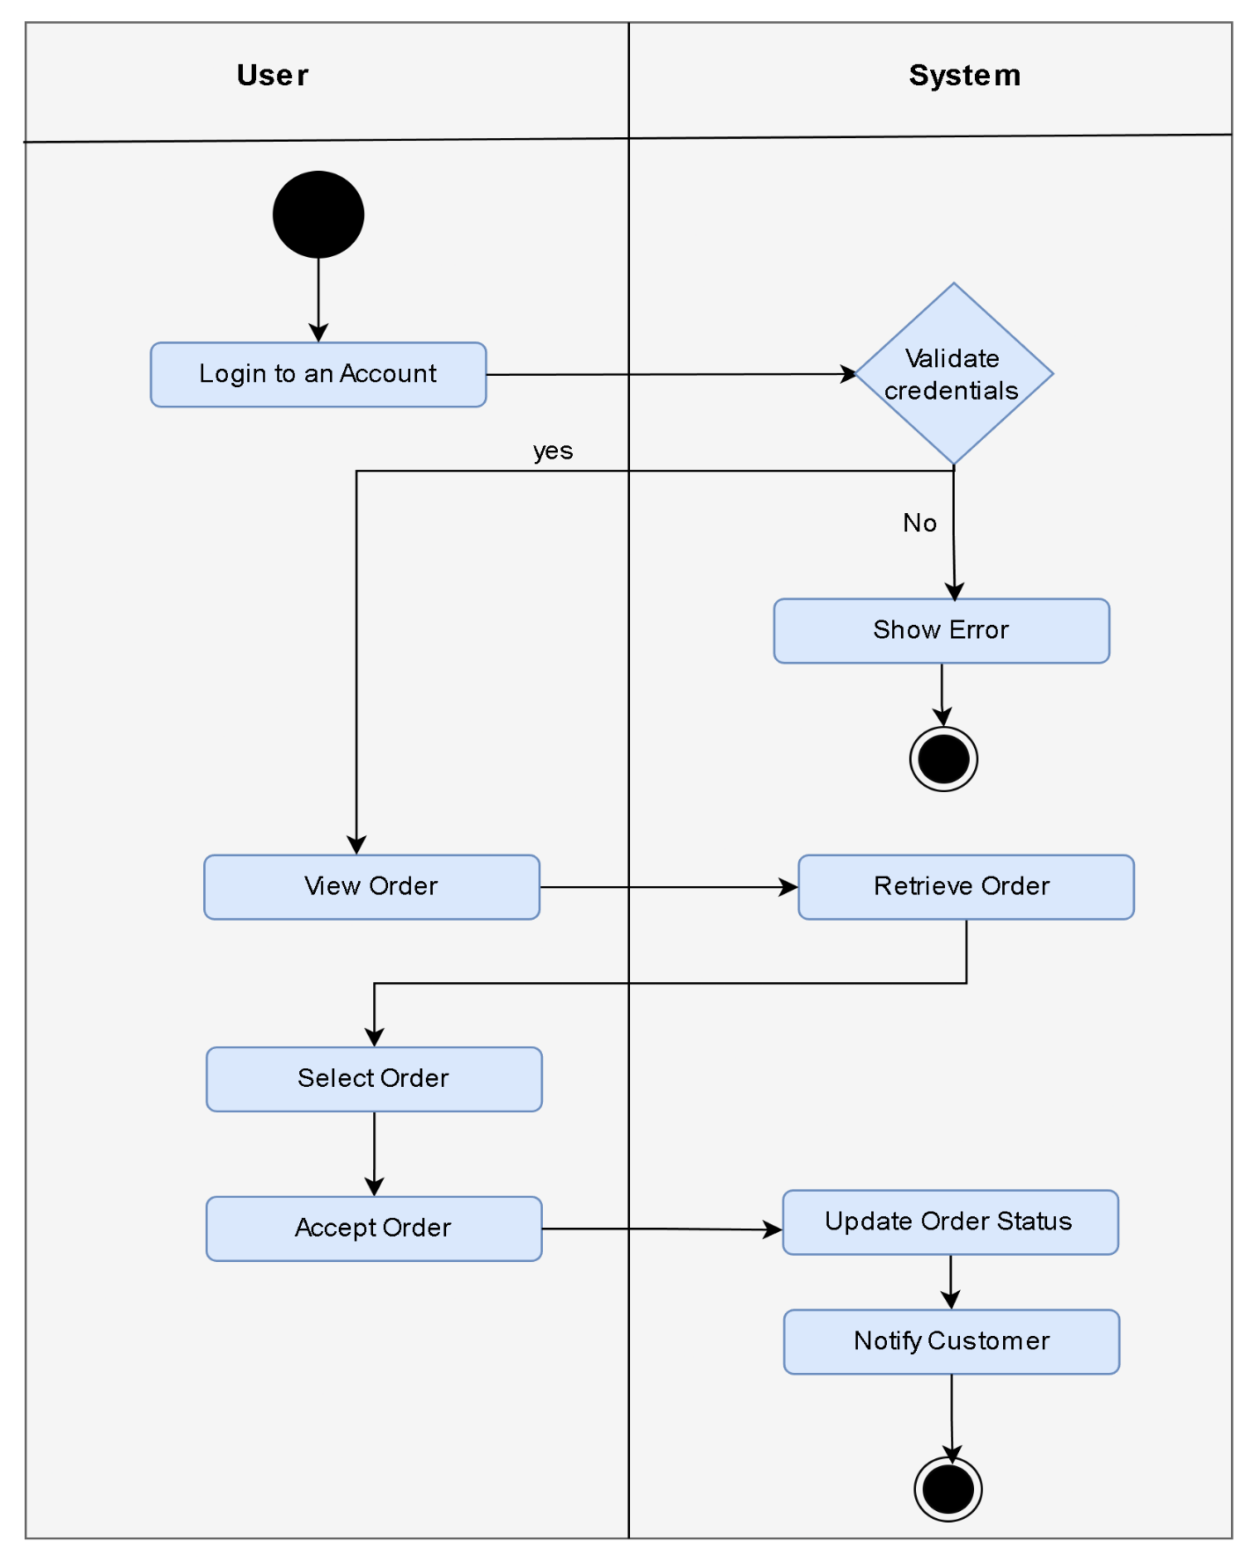
Figure 4 Activity diagram of farmer Order

Activity diagram of report generation
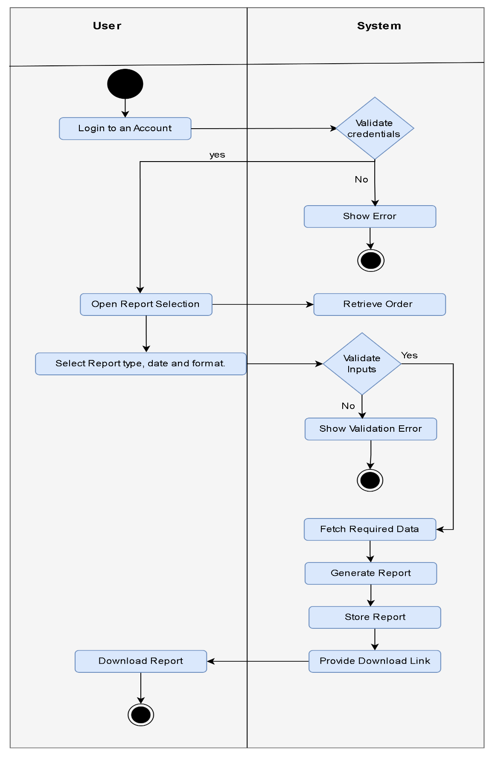
Figure 5 Activity diagram of report generation

Sequence Diagram
A Sequence Diagram is an interaction diagram, where the sequence of messages is highlighted in a time-ordered manner among the objects. It reveals the behavior of processes with each other and in which sequence, thus it is especially effective in modeling the dynamic behavior of a system. Sequence diagrams are utilized extensively at the design stage in which the logic and flow of operations are defined within a system.
The main aim of sequence diagrams is to illustrate the sequence of method invocation and time connection between objects. They can assist the developers to know how various functions in a system interact with time, detect possible bottlenecks, and make sure the behaviors of a system comply with the requirements.
Key Components
The sequence diagrams have a number of different fundamental elements that collaborate to depict interactions:
- Objects/Actors: The objects that are involved in the interaction are represented by the form of a rectangle at the top of the diagram. Actors are external to the system such as users or other external systems.
- Lifelines: Dashed lines that run downward off of every object and symbolize the existence of the objects through time. The lifeline depicts the duration of existence of an object in the interaction.
- Messages: Horizontal arrows between lines that signify communication between objects. Messages may be synchronous (solid arrow), asynchronous (open arrow) and return messages (dashed arrow).
- Activation Bars: Thin rectangles upon lifelines which indicate when an object is active or in operation. They demonstrate the time of method execution.
- Return Messages: Dashed arrows indicating how control is returned to a different object by an object to which an operation is performed on.
- Frames: Optional rectangles which may include fragments such as loops, alternatives (if-else) or parallel executions, which gives conditional logic representation.

Sequence diagram of Register Farmer
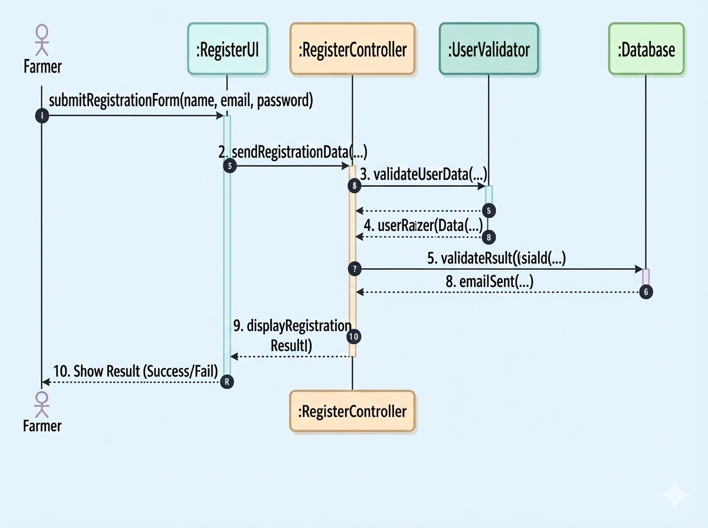
Figure 6 Sequence Diagram of Register Farmer

Sequence diagram of Generate Report

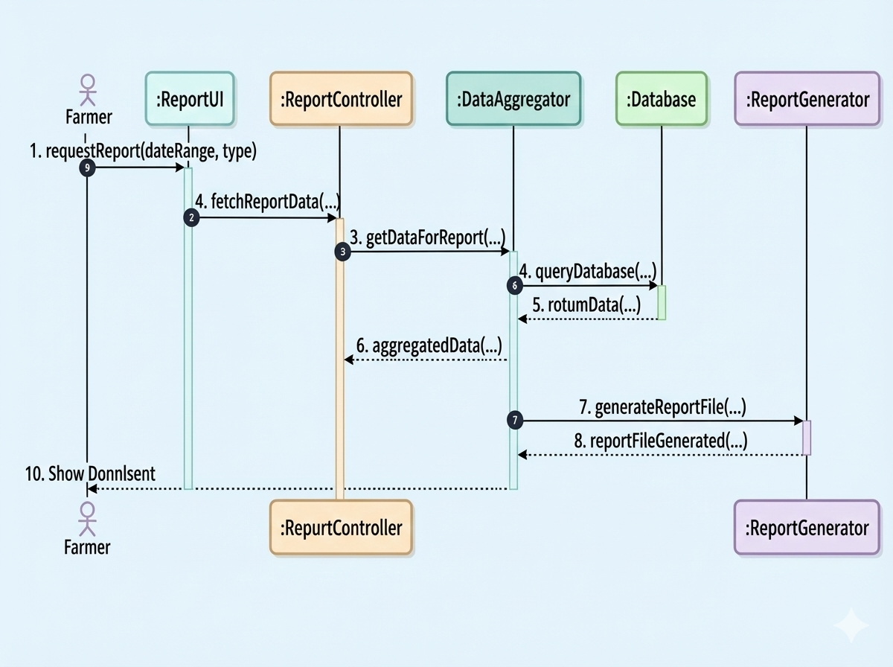
Figure 7 Sequence diagram of generate report

Sequence diagram of Add product
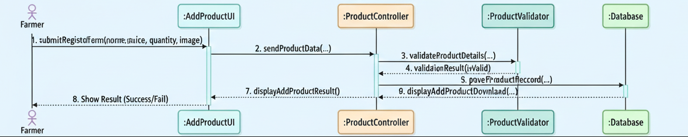
Figure 8 Sequence diagram of add product

