Create a shell script to print the HTTP error code of guvi.in & print, the success/failure message based on the error code response Given a file, replace all occurrence of the word ""give"" with ""learning"" from 5th line till the end in only those lines that contain the word "welcome"

Create a shell script to print the HTTP error code of guvi.in & print, the success/failure message based on the error code response Given a file

Script--

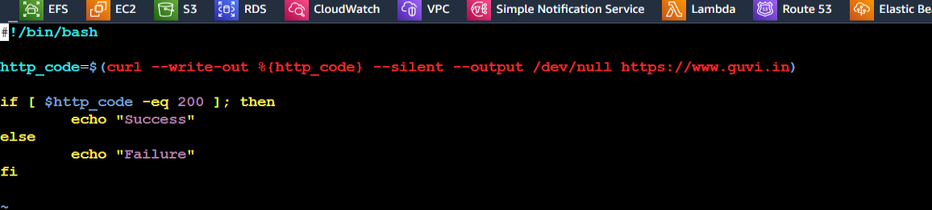

Changing mode of file to executable file

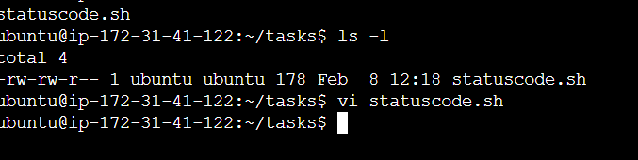

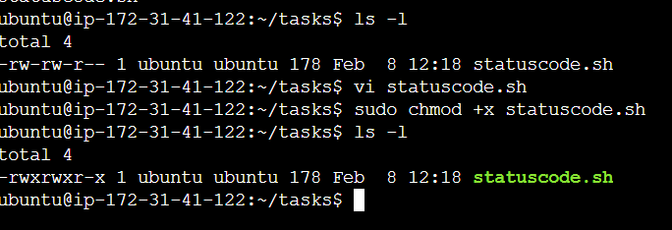

Output:--

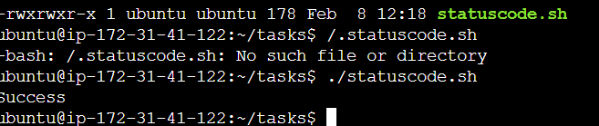

replace all occurrence of the word ""give"" with ""learning"" from 5th line till the end in only those lines that contain the word "welcome"

Text file ‘data.txt’

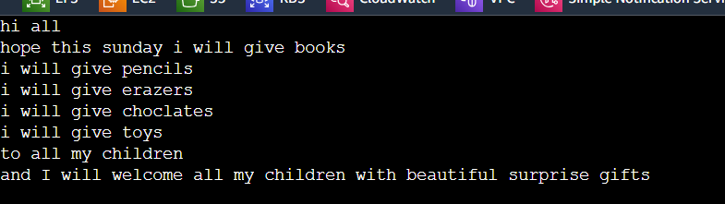

Output:

