Simple Alert:--

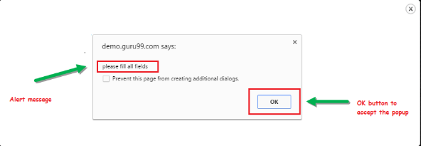

2. Prompt Alert

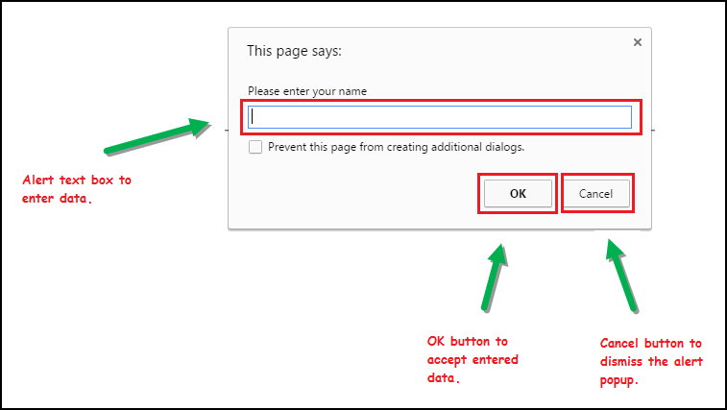

driver.switchTo.alert().sendKeys("jack")

driver.switchto.alert().accept()

driver.switchto.alert().dismiss()

3. Confirmation Alert

