System Testing Life Cycle

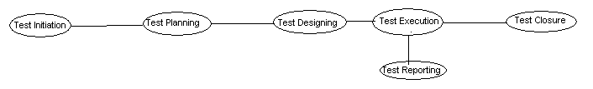

- Test Initiation:-- In general, any s/w system testing process starts with test initiation by project manager/ Test manager. In this stage, the PM or TM can prepare test strategy document w.r.t our testing policy. This test strategy document is also known as Test Methodology or Master Test Plan.

Components in Test Strategy/ Test Methodology/ Master Test plan

- Scope and objective: -- The purpose of testing in our company’s s/w development is specified here.
- Business Issues: -- Regarding budget for development and testing is done here.
- Roles and Responsibilities: -- The names of jobs in testing team and the responsibilities are defined here.
- Communication and status reporting: -- the required negotiation channels in between every 2 jobs in testing team.
- Test Repository matrix/Test Matrix: -- This matrix specifies the reasonable test to applied w.r.t customer requirements, risks involved in that project and scope of that requirement.
- Test Automation and Testing tools: -- The need of testing automation in this project and available testing tools in that company.
- Defect reporting and tracking: -- the purpose of defect tracking team to provide negotiation between developers and testers.
- Risks and assumptions: -- List of analyzed risks and solutions to overcome
- Training Plan: -- The required number of training sessions to understand customer requirements by test engineers.
- Configuration management: -- The process to manage all testing deliverables for future reference.

After completion of test strategy preparation, the project manager or test manager selects test lead. This test lead concentrates on detailed test planning.

- Test Planning: -- The test lead category people prepares detailed test plans in terms of

What to test?
How to Test?
Who to test?
When to test?
To prepare detailed test plans, the test lead follows below approach.
`

- Testing team formation: --In general the test planning starts with testing team formation. In this stage, the test lead depends on below factors.

Project size
Availability of test engineers on bench
Availability of test resources
Availability of test duration

- Identify tactical risks: -- After testing team formation, the test lead concentrates on team level risks analysis and assumptions.
Risk-1: -- Lack of Time
Risk-2: -- Lack of Documentation
Risk-3: -- Lack of Resources
Risk-4: -- Delays in Delivery
Risk-5: -- Lack of development process seriousness (Side effects)
Risk-6: -- Lack of communication
→ Prepare detailed Test Plan: -- After Testing team formation and risks analysis, the test lead concentrates on detailed test plans preparation. In this plans writing, the test lead uses IEEE829 test plan document format.

Format: --

- Test plan id: -- Unique name or number to refer.
- Description/ Introduction: -- About corresponding project
- Test Items: -- Names of modules in project
- Features to be tested: -- New modules to be tested( new version)
- Features not to be tested: -- Old modules already tested( old version)
- Environment:-- SW and HW resources
- Entry criteria: -- a. Build received from developers
b. Test cases prepared
c. Test Environment ready
8. Approach: -- Lists of selected test to be applied by PM or TM
9. Suspension Criteria: -- a. Test Environment not working
b. Project Hanged
c. More pending defects
10. Exit Criteria: --a. testing duration exceeded
b. All modules tested
c. All major defects solved.
11. Test deliverables: -- Names of Testing documents to be prepared by testing team.
Documents: Test Scenarios, Test Cases, Automation Programs, test logs, defect reports, day summary
12. Staff and Training needs: -- Names of selected test engineers for project and the required training sessions to understand requirements.
13. Responsibilities: -- Allocation of work to above selected test engineers. Test engineers are selected to apply specify test on S/W like usability, functional, non-functional
14. Schedule: -- date and time
15. Risks and Assumptions: -- The list of analyze risks and their solutions.
16. Approvals: -- The signatures of test lead and test manager (PM)

→ Review test plans: -- After preparing detailed test plan documentation, the test lead conducts a review meeting to estimate completeness and correctness of that plan doc.

After reviewing test plan meeting, the TL and TM/PM provide training to selected test engineers.

- Test Design: --

After completion of required training, the selected test engineers concentrate on test design to prepare test scenarios and test cases for the respective modules.

Test Scenario: -- Specifies detailed condition to be applied on build
Test Case: -- Specifies detailed procedure to apply the test condition on build.

User interface Testing: --

After completion of writing test scenarios and test cases for functional testing, the test engineer concentrates on test scenarios and test cases writing for usability testing. In this design method prepare test scenarios and cases with respect to usability requirement. These usability scenarios and cases are applicable on GUI application for usability testing.

Example: --
- Verify spelling of all labels and titles in every screen
- Verify init cap in all labels and titles in all screens
- Verify font uniqueness of all labels and titles
- Verify size uniqueness of all labels and titles
- Verify alignments of controls in all screens
- Verify color contrast
- Verify error messages meaning
- Verify Help messages meaning
- Verify space uniqueness
- Verify related objects grouping
- Verify icon symbols meaning
- Verify tool tips
- Verify Shortcut keys of all options
- Verify the placements of all multiple data objects like menus, list boxes, tables etc
- Verify abbreviations and full forms
- Verify order of screens

Note: -- above scenarios are applicable to any GUI applications for usability testing
For above test scenarios and cases test engineers assign “P2” priority.

GUI:-- Graphical User Interface

Test case Format: --

TC name | TC Descript  -ion | Priority | Step name | Step description | Test data | Expected result | Actual result | Status | Comments | QC path/TD path | Created on | Author | Reviewed by | Reviewed on | Reviewer comments

- Test case name: -- unique name or id for future reference
Ex: -- TC01_ProjectName_ModuleName_Functionality Name/Feature name

- Test case Description: -- brief description about the test case. It consists of pre requisites and also consists of documents referred
- Priority: -- Importance of the test case with respect to the customer requirements

It is classified into 3 types:
→ High (P0):-- Basic functionality
→ Medium (P1):-- General functionality
→ Low (P2): --GUI test

- Step name: -- test case divided into multiple steps and every step in the test case will uniquely have a number

Ex: -- Step 1
Step 2
Step 3
etc…

- Step description: -- The required action to be performed by the user on the application
- Test data: -- set of inputs that are required for executing the steps in the test case
- Expected result: --Expected behavior of the application w.r.t user operation or corresponding action
- Actual result: the actual behavior of the application
- Status: -- it describes the current position of the test case

There are four types:--
→ NO RUN
→ NOT Completed
→ PASSED
→FAILED

NORUN: -- Any test case which is not executed at least once
NOT COMPLETED: -- a partially executed test case
PASSED: -- Test case all expected values matched with all Actual values
FAILED: -- If any one steps of test case expected value not matched with actual value

Note: A test case set is to be failed if any one step is failed
Test Set--Collection of Test Cases....
- Comments: -- a set of comments by the tester to the test case
- Created on: -- Date of creation
- Author: --[Created by]
- Reviewed by: --Name of the reviewer
- Reviewed on: -- Date of Reviewed
- Reviewer Comments: -- The set of comments given by the Reviewer

Case Study:--

Customer Information: --
1.
Login

User Name:

Password:

jac

********
OK
Cancel

2.
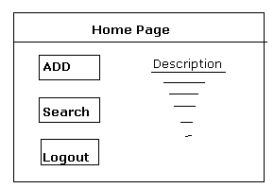

3.

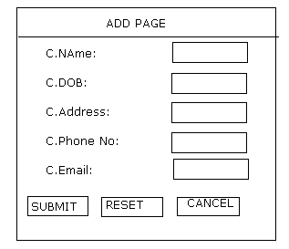
Invalid Details

Invalid Details entered, Record cannot be inserted…
OK
Add

Record Successfully inserted...
OK
Customer Record Exists

Record cannot be inserted…Customer Details Already exists

4.
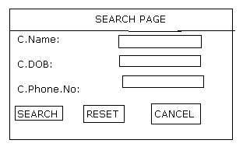
Customer Record Does not Exists
OK
Search Results
5.
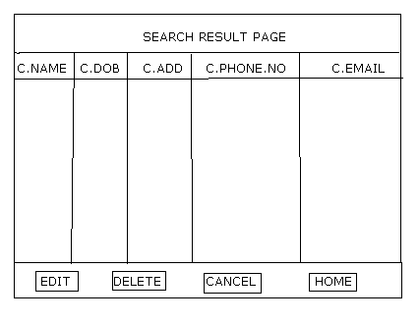

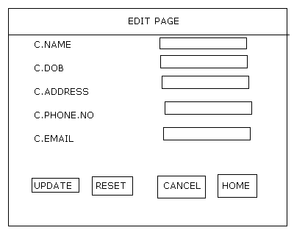
6.

Customer Requirements: --

- User name object allows alphabets in lower case from 4 to 16 characters long
- password object allows alphabets in lower case from 6-10 characters long
- C.NAME object allows alphabets from 6 to 10 characters long and first letter should start with capital letter
- C.DOB object allows numeric in format DD/MM/YY
- C.ADDRESS allows alphabets and numeric and some special characters (., - / #)
- C.PHONE.NO object allows numeric with ten digits

7. C.Email object allows alpha numeric and special characters.(_.@-)

TEST SCENARIO DOCUMENT: --

S.NO | Project Name | Test Scenario | Test Cases
1. | Customer Information | LOGIN | - Verify Login with valid data  - Verify login with invalid data  - Verify cancel  - Verify Login by missing some Mandatory fields  - Verify Ok button
 |  | ADD | - Verify Customer Creation with valid data  - Verify Customer creation with invalid data  - Verify Customer creation by missing some mandatory fields  - Verify Customer creation with duplicate data  - Verify Reset  - Verify Cancel
 |  | SEARCH | - Verify Search with valid data  - Verify Search with invalid data  - Verify Search a record which is not existing in the data base  - Verify Reset  - Verify Cancel
 |  | EDIT | - Verify Update with valid data  - Verify Update with invalid data  - Verify Update by missing some mandatory fields  - Verify Update with duplicate data  - Verify Reset  - Verify Cancel
 |  | DELETE | - Verify Deleting the Record
 |  | CANCEL | - Verify Cancel
 |  | HOME | 1. Verify Home
 |  | LOGOUT | 1. Verify Logout

TEST CASE DOCUMENT: --

Test Case ID | Test Description |  |  |  | Priority |  |  | Step name |  | Step Description |  |  |  | Test Data |  | Expected Result
TC01_CustInfo_Login with_Valid_Data | This test case validates customer information login process with valid data |  |  |  | P0 |  |  | STEP 1 |  | Open Browser Enter URL and click GO |  |  |  | URL |  | Customer information Login page should be displayed
 |  |  |  |  |  |  | STEP 2 |  | Enter Valid UserId and Password click on Ok |  |  |  | User ID  Password |  | Customer Information HOME page should be displayed
TC02_CustInfo_Login with_InValid_Data | This test case validates customer information login process with Invalid data |  | P1 |  |  |  | STEP 1 |  | Open Browser Enter URL and click GO |  |  |  | URL |  | Customer information Login page should be displayed
 |  |  |  |  |  |  | STEP 2 |  | Enter InValid UserId or Password click on Ok |  |  |  | User ID  Password |  | It should display a meaningful error message indicating that “Invalid User name or Password” entered
TC03_CustInfo_Login with_Cancel | This test case validates customer information login process Cancel Button |  | P1 |  |  |  | STEP 1 |  | Open Browser Enter URL and click GO |  |  |  | URL |  | Customer information Login page should be displayed
 |  |  |  |  |  |  | STEP 2 |  | Enter click on UserId and Password Cancel |  |  |  | User ID  Password |  | It should close Customer Login Page
TC04_CustInfo_Add_ValidInputs |  | This test case validates the functionality of the Customer Information page with valid data |  | P0 |  | STEP 1 |  |  | Open Browser Enter URL and click GO |  | URL | Customer information Login page should be displayed
 |  |  |  |  |  |  | STEP 2 |  | Enter Valid UserId and Password click on Ok |  |  |  | User ID  Password |  | Customer Information HOME page should be displayed
 |  |  |  |  |  |  | Step 3 |  | Click on “Add” button |  |  |  |  |  | System should respond with ‘C.Name’,’C.DOB’,’C.Phone No’,’C.Address’,’C.Email’,Submit, cancel, Reset options
 |  |  |  |  |  |  | Step 4 |  | Enter all the Valid data in all the fields and click on Submit button |  |  |  |  |  | System should display a message in a Dialog box saying that “record inserted Successfully”….along with “OK” button
 |  |  |  |  |  |  | Step 5 |  | Click on OK button |  |  |  |  |  | Dialog box should get closed
Test Execution: --

After completion of test case preparation and corresponding reviews, test engineer is receiving initial build from the development people. During execution test engineers are reporting mistakes to the development team if the reported mismatches are reasonable then developers will fix them and release modified build to the testing department.

In this stage test engineers will associate the test cases in to the test cycles. A test cycle defines the mapping of test case with the System under Test (SUT) on which it has to be executed.

The management and test lead decides the number of test cycles to be executed during a phase of system testing, based on time available for the test.

Levels of Test Execution: --

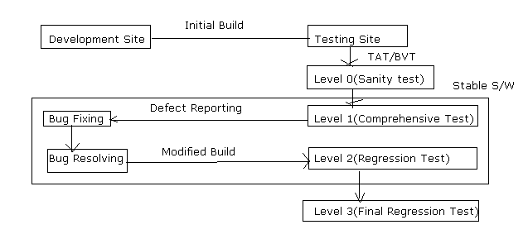

Levels of Test Execution Vs Test Cases: --

- Sanity testing on initial build is for basic functionality
- Comprehensive testing is for entire functionality
- Regression testing on modified build is for modified functionality
- Final regression testing on master build is for selected functionality w.r.t high bug

Level 0: -- after receiving the initial build from the development team, test engineers conduct smoke testing or sanity testing to estimate its stability more clearly. If the build is working properly, the testing team will conduct detailed testing if not they will reject the build

In this sanity /smoke test execution the testing team verifies build in terms of the below factors: --

- Understandable
- Observable
- Operatable
- Controllable
- Simplicity
- Maintainable
- Consistency
- Automatable

Level 1: -- Comprehensive testing

After receiving stable build from developers, the test engineers, concentrate on responsible modules. Test engineers make dependant test cases as batches/ suites

The test engineers execute batch by batch and case by case without missing any step in a case and without missing any case in a batch. In this test execution, the test engineers prepare test log doc.

This test log doc consists of test results like as below

- Passed : when all expected values match with actual values
- Failed : When any of the expected value not matching with actual value
- Blocked : Execution postponed due to previous test case failures

Defect Reporting: --

During test execution testers are reporting mistakes to the development team as defects in Defect Report Format

Defect Report Format: --

- Id: -- unique name or number
- Defect Description: -- Summary of that defect
- Build version id: -- The version number of build
- Feature: -- the name of the module where the defect was detected
- Test case id: -- The failed test case id no where the defect detected.
- Reproducible: -- Yes/No [if yes, defect appears every time in test execution. If no, defect appears rarely while test execution
- Severity: -- The seriousness of the defect in terms of functionality

High: -- Not able to continue test without solving
Medium: -- able to continue test without solving but need to be solved
Low: -- able to continue test, but may/may not to solve
- Priority: -- the importance of defects in terms of a customer ( High, medium, low)
- Detected by: -- test engineers name who detected the defect
- Detected on: -- Date of defect detection and submission
- Status: -- New( Reporting for the first time) or Reopen( same defect got again)
- Send to: -- mail id of defect tracking team
- Suggested fix( optional): -- suggestions to solve that defect after acceptance

By developer: --

Fixed by: -- Name of the programmer
Resolved on: -- Date of the resolved defect
Resolution type: -- Acknowledgement from the development department to the testing department
Approved by: -- Signature of the PM and Team Lead.

Defect Life Cycle: --

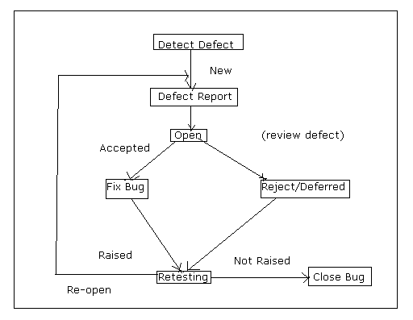

Level 2: Regression Testing: --

After receiving modified build from the development people testers are conducting Re-testing and regression testing to ensure bug fixing work

Case 1: -- if the development team resolved bug severity is High then testers are re-executing all p0 and some p1 and p2 test cases, to ensure bug fixing work on that modified build.

Case 2: -- if the development team resolved bug severity if medium then testers are re-executing some p0,p1 and selected p2 test cases to ensure bug fixing work for that modified build

Case 3: -- if the development team resolved bug severity is low then testers are re-executing selected p0,p1 and p2 test cases. To ensure bug fix on that modified build.

Case 4: -- if the development team release modified build due to sudden changes in customer requirements then testers are re-executing all p0 and some p1,p2 test cases w.r.t that modification

Level 3: Final Regression Testing: --

After completing of test case execution and corresponding bugs resolving test lead is conducting review meeting along with testing team to verify that whether the test engineer meet exit criteria or not.

In this review test lead will concentrate on the below factors: --

→ Coverage analysis
→ Bug Density
→ Analysis of deferred bugs

Coverage Analysis: -- Requirements/ Modules Coverage and Testing topics

Bug Density : -- this can be illustrated by this example: -- Scenario, after performing a complete system testing of all the modules( here A,B,C,D) of the application

The following table lists the corresponding bug percentage in the respective modules: --
Modules Number of Bugs(%)

A 20%
B 20%
C 40%
D 20%
Hence, in this scenario, the module having very high bug density needs to be regressed. Test lead instructs the testing team to conduct postmortem testing on the module C, because that module raised more percentage of bugs.

Analysis of deferred bugs: -- Hence they will check whether the deferred bugs are post ponable or not? After conducting a successful review, the testing team concentrates on level-3 testing/Regression testing/Postmortem testing
User Acceptance Testing: --

After completion of testing and corresponding reviews the project management will concentrate on user acceptance testing (UAT) to collect the feed back of the customers on developed software.

Sign Off: --

After successful completion of UAT , test lead relieves test engineers from the project testing team. In this team, same testers are selected for release team to go to the customer site and then some testers are selected for C.C.B for further maintenance. In this sign off test lead collects all testing deliverables prepared by testing team.

Final Test Summary Report:--

Deliverables | Roles | Completion
Test Strategy | TM/PM | 1-2 days
System test plan | TL | 2-3 days
Training on Requirements | TL/Test Engineers with the involvement of PM | 5-10 days
Test Design | Test Engineers/T.L | 20-30days
Sanity Testing and Test Automation | Test Engineers | 20-30 days
Test Execution including Regression Testing | Test Engineers | 20-30 days
Test Closure and Final Regression Testing | TL with Test Engineers | 3-5 days
U.A.T | Customer site people or Model customer | 4-5 days
Sign off | T.L | 1-2 days

