mowy@gmail.com pw meowykitty user

newgmail@gmail.com newpassword 123 provider

Algorithms
Scheduling conflict detection
What this algorithm does
- Input:
  - providerId → the service provider you want to check.
  - appointmentStart and appointmentEnd → the proposed booking time.
- Checks performed:
  - Basic sanity check – makes sure start and end times are valid and in correct order.
  - Provider availability – checks if the provider exists and is marked as available.
  - Working days – ensures the requested day is one the provider works.
  - Working hours – ensures the requested appointment falls within the provider's daily start/end times.
  - Existing bookings – queries the database for overlapping appointments that are "accepted" or "in-progress".
- Output:
  - true → there is a conflict; appointment cannot be booked.
  - false → no conflict; appointment can be booked
Provider Ranking or Scoring
What this algorithm does
- Input:
  - providers → an array of service providers with stats (ratings, jobs, availability, etc.)
  - options → optional weights to tweak how much each factor affects ranking
- Scoring calculations for each provider:
  - Rating score – normalizes the average rating to a 0–1 scale.
  - Job score – uses the logarithm of completed jobs to reward experienced providers but with diminishing returns.
  - Availability score – 1 if the provider is available now, 0 otherwise.
  - Acceptance rate – percentage of accepted jobs vs total responses, defaults to 0.5 if no data.
  - Recency score – rewards recently active providers, decays over 30 days.
- Weighted sum:
Combines all the above factors using the weights from options to calculate a final ranking score.
- Sort:
  - Providers are sorted descending by rankingScore so the best-scoring providers come first.
- Output:
  - Array of providers with an extra property rankingScore, sorted by that score.
Provider earning calculation algorithm
What this algorithm does
- Input:
  - booking → contains booking details, providers, price per hour, commission %, and provider commissions array.
  - hoursWorked → optional, if the service is billed hourly.
- Steps / Calculations:
  - Determine finalPrice:
    - If hoursWorked is provided → calculate total based on hoursWorked × pricePerHour × number of providers.
    - Otherwise → use booking.finalPrice or fallback to pricePerHour × providerCount.
  - Calculate the platform commission: commissionAmount = finalPrice × commissionPercent / 100.
  - Calculate total provider earnings: providerEarning = finalPrice − commissionAmount.
  - Distribute the commission and earnings among accepted providers:
    - perProviderCommission = commissionAmount / number of accepted providers.
    - perProviderEarning = providerEarning / number of accepted providers.
  - Update booking.providerCommissions to store each provider’s share of earnings and commission.
3.Output:
  - Returns:
{ finalPrice, commissionAmount, providerEarning, booking }
  - Each accepted provider in booking.providerCommissions now has:
    - commissionShare
    - earningShare
    - commissionPaid

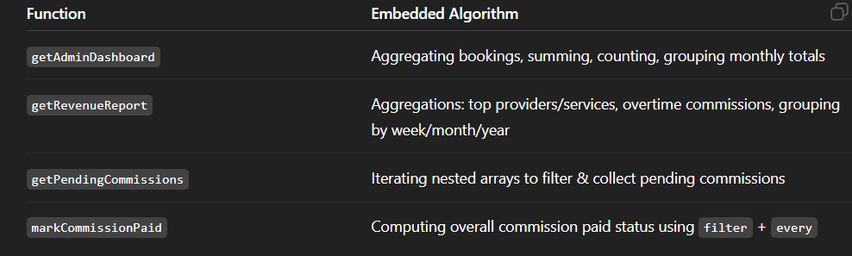
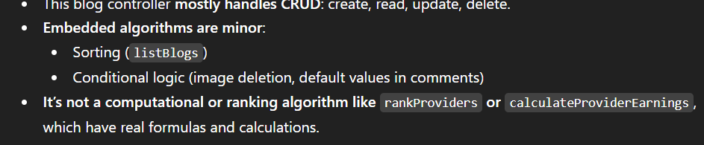
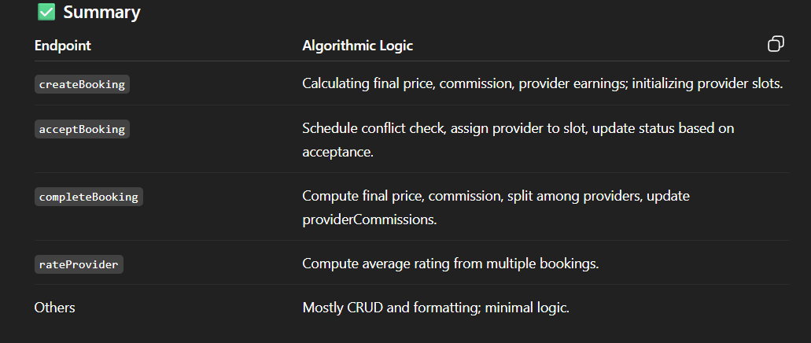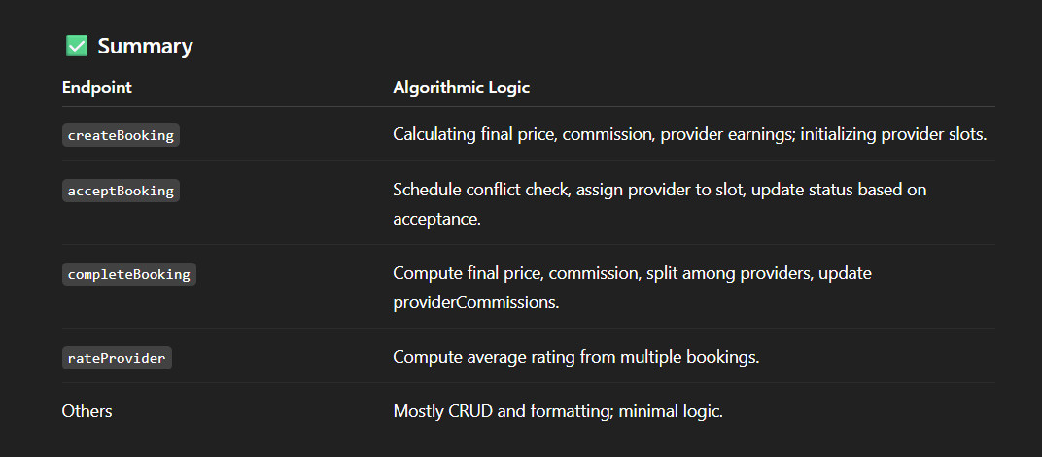
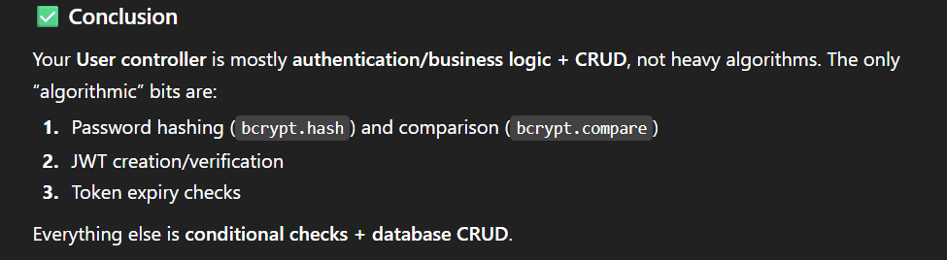
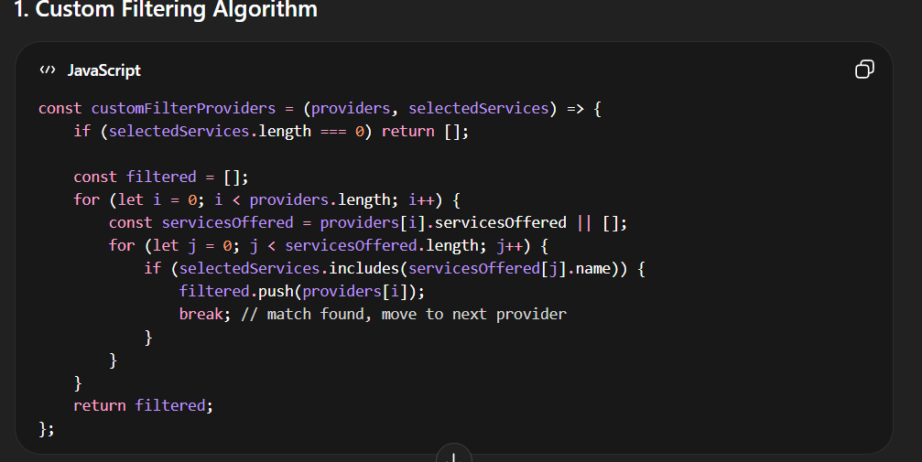
Mechanism Step-by-Step:
- Inputs:
  - providers: Array of all service providers from backend.
  - selectedServices: Array of service names user wants to filter by.
- Outer Loop:
  - Iterates over each provider in providers.
- Inner Loop:
  - Iterates over the services each provider offers (servicesOffered array).
- Matching Check:
  - if (selectedServices.includes(servicesOffered[j].name))
  - If the provider offers at least one of the selected services, include the provider in the filtered array.
- Break Statement:
  - Once a match is found, we break the inner loop to avoid unnecessary iterations (efficiency).
- Return:
  - Returns a new array containing only providers that match at least one selected service.
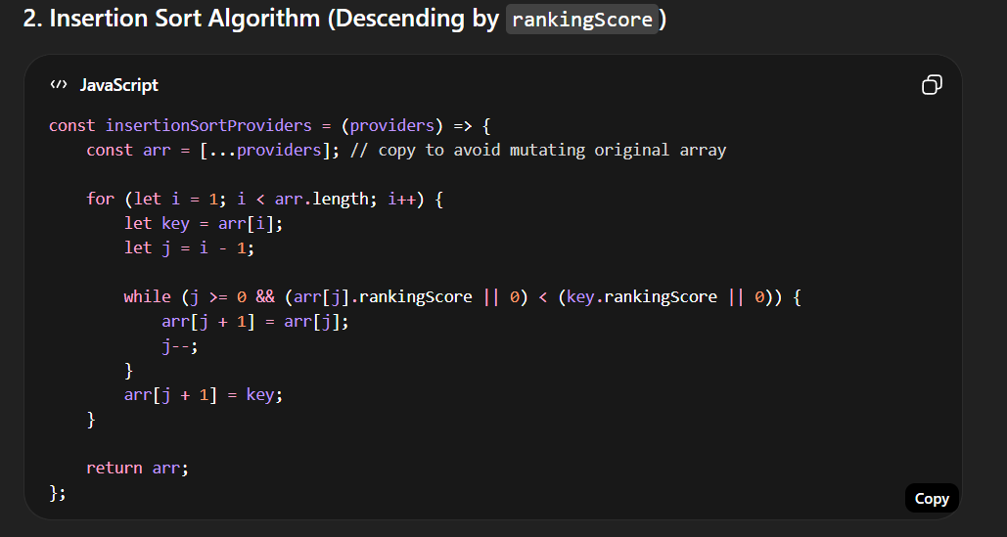
Mechanism Step-by-Step:
- Copy Array:
  - const arr = [...providers] ensures we don’t change the original providers array.
- Outer Loop (i from 1 to n-1):
  - Starts from the second element (i = 1) because the first element is trivially “sorted.”
- Key Selection:
  - key = arr[i] is the element we want to insert in the correct position among the sorted portion of the array.
- Inner Loop (j):
  - Compares key with elements in the sorted portion (indices 0 to i-1).
  - While the sorted element is smaller than key, shift it one position to the right:
arr[j + 1] = arr[j];
j--;
- Insert Key:
  - Place the key in its correct sorted position:
arr[j + 1] = key;
- Repeat:
  - Continue for all elements until the array is sorted descending by rankingScore
jones@gmail.com hello123
lyla@gmail.com lyla0000
walker@gmail.com 1234abc
levi@gmail.com levi1122
logan@gmail.com logannnn
myla@gmail.com 12345678
chasing@gmail.com abcd1234
strong@gmail.com 11223344
ari@gmail.com aricansing
hoover@gmail.com hoover123
cook@gmail.com cook1234
asher@gmail.com asher123
anthony@gmail.com anthony00
ethan@gmail.com ethan1234
ayush@gmail.com ayush1234
james@gmail.com james123
provider@gmail.com provider11
testing@gmail.com Password:what111
cleaner@gmail.com Password: 97585524

