Assignment 9
a)code
#include <stdio.h>
#include <stdlib.h>
#include <sys/types.h>
#include <sys/wait.h>
#include <unistd.h>
#include <pthread.h>

pthread_mutex_t lock;
int var=0;

#define counter 1
#define max 6

void *thread1(void *arg)
{
while(1)
{
pthread_mutex_lock(&lock);

int i;
for(i=0; i<counter; i++)
{
if(var>=max)
goto RETURN;
printf("ab");
var+=1;
}

pthread_mutex_unlock(&lock);
usleep(10);
}
RETURN:
pthread_mutex_unlock(&lock);
return NULL;
}

void *thread2(void *arg)
{
while(1)
{
pthread_mutex_lock(&lock);

int i;
for(i=0; i<counter; i++)
{
if(var>=max)
goto RETURN;
printf("ba");
var+=1;
}

pthread_mutex_unlock(&lock);
usleep(10);
}
RETURN:
pthread_mutex_unlock(&lock);
return NULL;
}

int main()
{
if (pthread_mutex_init(&lock, NULL) !=0)
{
printf("\nmutex init failed");
return 1;
}

pthread_t pthread1, pthread2;

if(pthread_create(&pthread2, NULL, thread2, NULL))
return -1;
if(pthread_create(&pthread1, NULL, thread1, NULL))
return -1;

pthread_join(pthread2, NULL);
pthread_join(pthread1, NULL);

pthread_mutex_destroy(&lock);
printf("\n");
return 0;

}
output ss
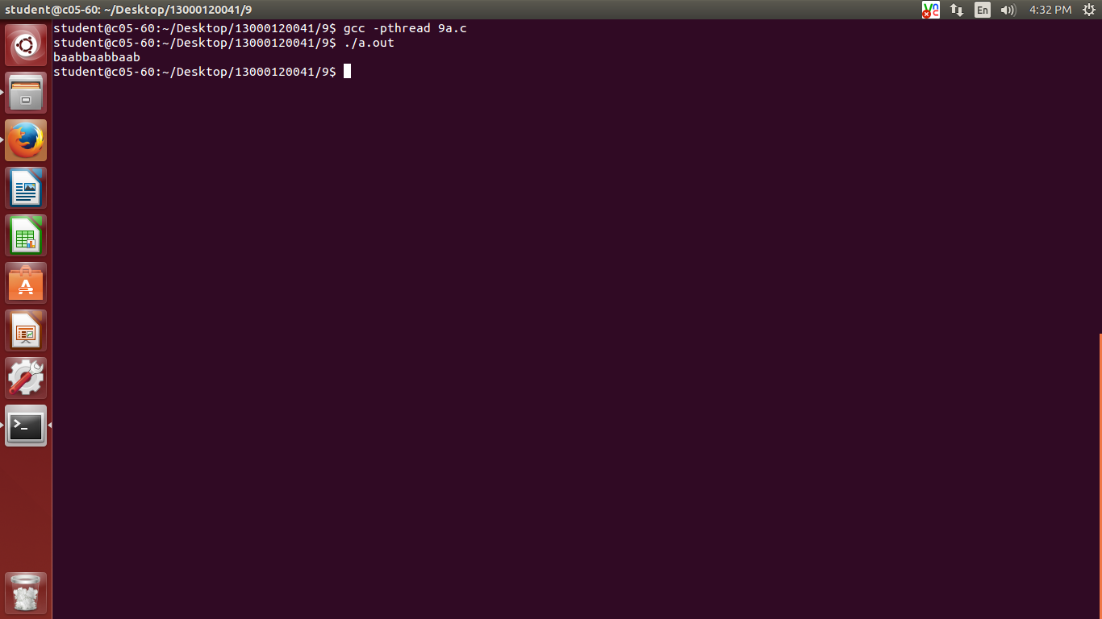
9b)code
#include <unistd.h>
#include <stdio.h>
#include <pthread.h>

void* start_routine(void *);
void* pth_body(void *args){
int count=0,i;
if(*((int*)args)<0)
printf("Enter a natural number\n");
else{
for(i=1;i<=(*(int*)args);i++){
if(*((int*)args)%i==0)
count++;
if(count>2)
break;
}
}
if(count==2)
printf("Prime Number\n");
else
printf("Not prime number\n");
}

int main(){
pthread_t thread;
while(1){
int n;
printf("Enter a number: ");
scanf("%d", &n);
pthread_create(&thread,NULL,&pth_body,&n);
pthread_join(thread, NULL);
sleep(1);
}
}
Output

