Academic Performance of Students

Group Members:

Arpita Mondal
Asansol Engineering College 10871021018
Payel Patra
Asansol Engineering College 1081021019

Pooja Arora
Asansol Engineering College
10871021020
Vishwajit Kumar
Asansol Engineering College 10871021021
Souradip Maji
Asansol Engineering College 171250110093

Contents

Sl. No. | Topic | Page No.
1. | Acknowledgement | 1
2. | Project Objective | 2
3. | Project Scope | 3
4. | Data Description | 4-5
5. | Data Pre-Processing | 6-16
6. | Model Building | 17-37
7. | Test Dataset | 38
8. | Code | 39-74
9. | Future Scope of Improvements | 75
10. | Certificates | 76-80

Acknowledgment

I take this opportunity to express my profound gratitude and deep regards to my faculty, Prof. Arnab Chakraborty for his exemplary guidance, monitoring, and constant encouragement throughout the course of this project. The blessing, hp, and guidance given by him from time to time shall carry me a long way in the journey of life on which I am about to embark.
I am obliged to my project team members for the valuable information provided by them in their respective fields. I am grateful for their cooperation during the period of my assignment.

Arpita Mondal

Payel Patra

Pooja Arora

Vishwajit Kumar

Suoradip Maji

Project Objective

In this project we have a shortened ‘Academic Performance of Student’ Dataset from Kaggle. In this dataset, the target attribute is the student academic is which is in binary. So, in this project we need to do binary classification based on the attributes present in our dataset and predict whether a student perform well or not.

Our objective in this project is to study the given dataset of ‘Academic Performance of Students’. We might need to pre-process the given dataset if we need to. Then, we would train 4 modelsviz. ‘Decision tree’, ‘Linear Regression’, ‘Support Vector Machine ’and‘Random Forest’. After training the aforementioned models, we will need and to find out the score, classification report, plot the Receiver Operating Characteristic graph and find out the Area Under Curve (AUC) for each of the models trained. Our next step wouldbe to use the trained models to predict the outcomes using the given test dataset and compare the outcome of each model. We would then choose the best model based on the accuracy score and classification report.

Our methodology for solving the problems in the given project is described below:
- Load the required dataset.
- Study the dataset.
- Describe the dataset.
- Visualize the dataset.
- Find out if the dataset needs to be pre-processed.
  - It will be determined on the basis of whether the dataset has null values or outliers or any such discrepancy that might affect the output of the models to be trained.
- If the dataset is required to be pre-processed, take the necessary steps to pre-process the data.
- Find out the principal attributes for training.
- Split the given dataset for training and testing purposes.
- Fit the previously split train data in the aforementioned 4 models.
- Calculate the accuracy of the 4 models and find out the classification reports.
- Plot the necessary graphs.
- Use each trained model to predict the outcomes of the given test dataset.
- Choose the best model among the 4 trained models bases on the accuracy and classification reports.

Project Scope

The broad scope of the ‘Academic performance of students’ project is given below:
- The given dataset has attributes based on which the status of the student performance will be predicted.
- It is a useful project as the Classifier models can be used to quickly determine the loan approval status of large datasets.
- Various colleges and school institutions can use these models and modify them according to their needs to use in their student performance status. This will reduce the manual labor and time spent on determining whether a student is good in a class or not.
- Teachers and student parents have also benefited from this project that their student /child is performing well or not in class.
- The dataset given to us is a shortened form of the original dataset from Kaggle. So, the results might have some mismatch with real-world applications. But that can be avoided if the models are trained accordingly.

Data Description

Source of the data: Kaggle. The given dataset is a shortened version of the original dataset in Kaggle.
Data Description: The given train dataset has 481 rows and 17 columns.

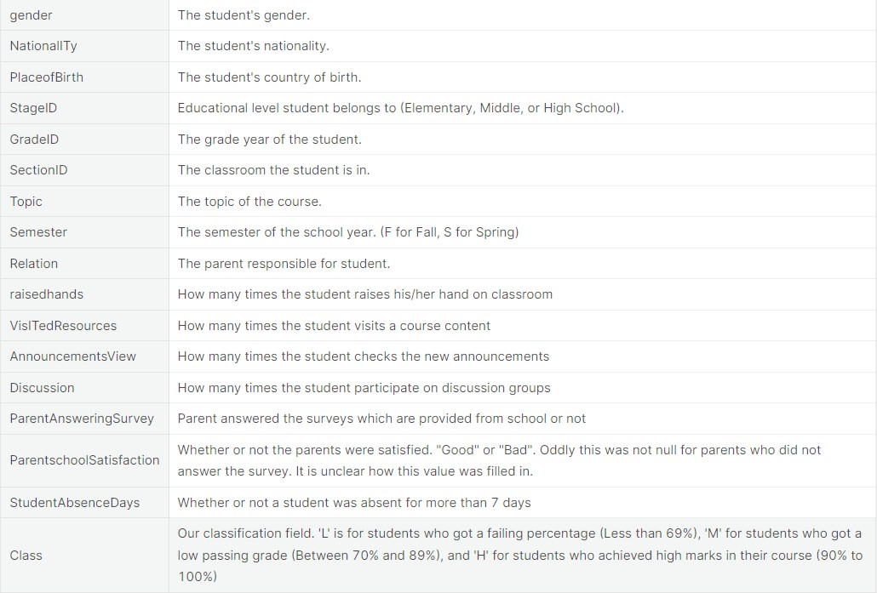

Table 1: Data Description
The following table shows the 5 number statistics of the given dataset:
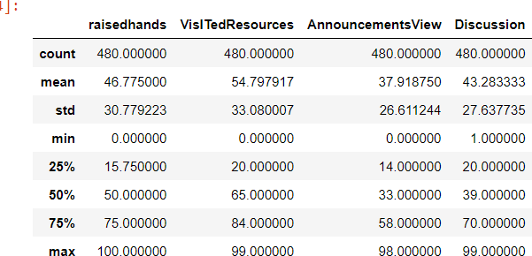

Table 2: 5 number statistics of the given dataset

Now we will pre-process the data. The methodology followed is given below:
- Checking for null values.
  - If null values are present, we will fill them or drop the row containing the null value based on the dataset.
- Checking for outliers.
  - If outliers are present, they will either be removed or replaced by following a suitable method depending on the dataset.

Data Pre-processing

As the given dataset had Categorical and Non-categorical data mixed, we converted the categorical data into non-categorical data accordingly. We converted the binary categories into 0 and 1. We converted the other categorical attributes into suitable numerical values. The following table shows the conversion record:

Non-Numeric to Numeric Change table
Column | Initial Value | Replaced Value
Gender | M | 0
Gender | F | 1
ParentschoolSatisfaction | Good | 0
ParentschoolSatisfaction | Bad | 1
Relation | N | 0
Relation | Y | 1
Nationality | Saudi Arabia | 0
Nationality | KW | 1
Nationality | Lebanon | 2

Table 3: Categorical to Numerical change in values
We searched for null values in our dataset and formed the following table:

Column Name | Count of Null Value
 | 0
Gender | 0
Nationality | 0
PlaceofBirth | 0
StageID | 0
GradeID | 0
SectionID | 0
Topic | 0
Semester | 0
Relation | 0
Raisedhands | 0
VisITedResources | 0
AnnouncementsView | 0

Table 4: Count of Null values

To visualise the null values, we made a heatmap plot using seaborn library function heatmap. The heatmap plot is given below:
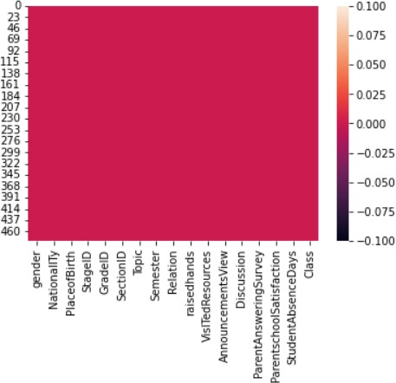

Fig 1: Heatmap of the given Data
The heatmap shows that the dataset has null values
Now we have successfully handled Null values and converted non-numeric values to Numeric values. We
didn't drop the rows with null values as we have a small dataset (only 100 entries).

Outliers are extreme values that deviate from other observations on data, they may indicate variability in measurement, experimental errors or, a novelty. In other words, an outlier isan observation that diverges from an overall pattern on a sample.
Most common causes of outliers on a data set:
- Data entry errors (human errors)
- Measurement errors (instrument errors)
- Experimental errors (data extraction or experiment planning/executing errors)
- Intentional (dummy outliers made to test detection methods)
- Data processing errors (data manipulation or data set unintended mutations)
- Sampling errors (extracting or mixing data from wrong or various sources)
- Natural (not an error, novelties in data)
import pandas as pd # a wonderful dataframe to work with
import numpy as np # adding a number of mathematical and science functions
import seaborn as sns # a very easy to use statistical data visualization package
import matplotlib.pyplot as plt # a required plotting tool
import warnings
# sklearn is a big source of pre-written and mostly optimized ML algorithms.
# Here we use their Decision trees, Support Vector Machines, and the classic Perceptron.
from sklearn import preprocessing, svm
from sklearn.linear_model import Perceptron
from sklearn.tree import DecisionTreeClassifier
#ignore warnings
warnings.filterwarnings('ignore')
data = pd.read_csv('..\Downloads\stu_performance.csv')
data.head()
gender NationalITy PlaceofBirth StageID GradeID SectionID Topic \
0 M KW KuwaIT lowerlevel G-04 A IT
1 M KW KuwaIT lowerlevel G-04 A IT
2 M KW KuwaIT lowerlevel G-04 A IT
3 M KW KuwaIT lowerlevel G-04 A IT
4 M KW KuwaIT lowerlevel G-04 A IT
Semester Relation raisedhands VisITedResources AnnouncementsView \
0 F Father 15 16 2
1 F Father 20 20 3
2 F Father 10 7 0
3 F Father 30 25 5
4 F Father 40 50 12
Discussion ParentAnsweringSurvey ParentschoolSatisfaction \
0 20 Yes Good
1 25 Yes Good
2 30 No Bad
3 35 No Bad
4 50 No Bad
StudentAbsenceDays Class
0 Under-7 M
1 Under-7 M
2 Above-7 L
3 Above-7 L
4 Above-7 M
data.tail()
gender NationalITy PlaceofBirth StageID GradeID SectionID \
475 F Jordan Jordan MiddleSchool G-08 A
476 F Jordan Jordan MiddleSchool G-08 A
477 F Jordan Jordan MiddleSchool G-08 A
478 F Jordan Jordan MiddleSchool G-08 A
479 F Jordan Jordan MiddleSchool G-08 A
Topic Semester Relation raisedhands VisITedResources \
475 Chemistry S Father 5 4
476 Geology F Father 50 77
477 Geology S Father 55 74
478 History F Father 30 17
479 History S Father 35 14
AnnouncementsView Discussion ParentAnsweringSurvey \
475 5 8 No
476 14 28 No
477 25 29 No
478 14 57 No
479 23 62 No
ParentschoolSatisfaction StudentAbsenceDays Class
475 Bad Above-7 L
476 Bad Under-7 M
477 Bad Under-7 M
478 Bad Above-7 L
479 Bad Above-7 L
ax = sns.countplot(x='Class', data=data, order=['L', 'M', 'H'])
for p in ax.patches:
ax.annotate('{:.2f}%'.format((p.get_height() * 100) / len(data)), (p.get_x() + 0.24, p.get_height() + 2))
plt.show()
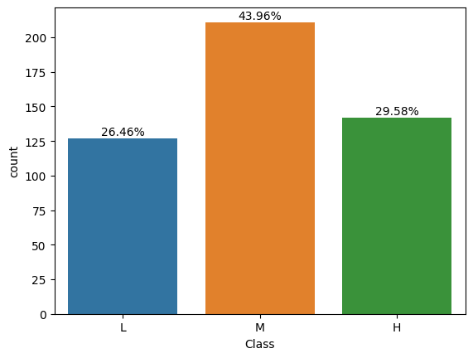
fig, axarr = plt.subplots(2,figsize=(10,10))
sns.countplot(x='gender', data=data, order=['M','F'], ax=axarr[0])
sns.countplot(x='gender', hue='Class', data=data, order=['M', 'F'],hue_order = ['L', 'M', 'H'], ax=axarr[1])
plt.show()
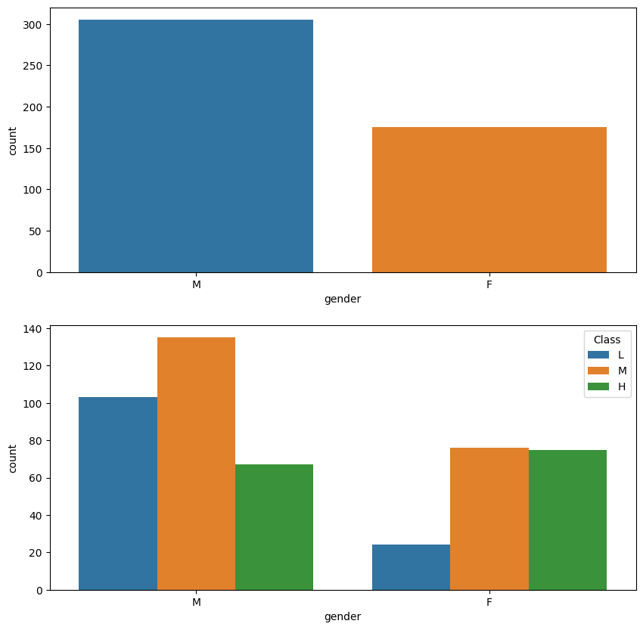
fig, axarr = plt.subplots(2,figsize=(10,10))
sns.countplot(x='NationalITy', data=data, ax=axarr[0])
sns.countplot(x='NationalITy', hue='Class', data=data,hue_order = ['L', 'M', 'H'], ax=axarr[1])
plt.show()
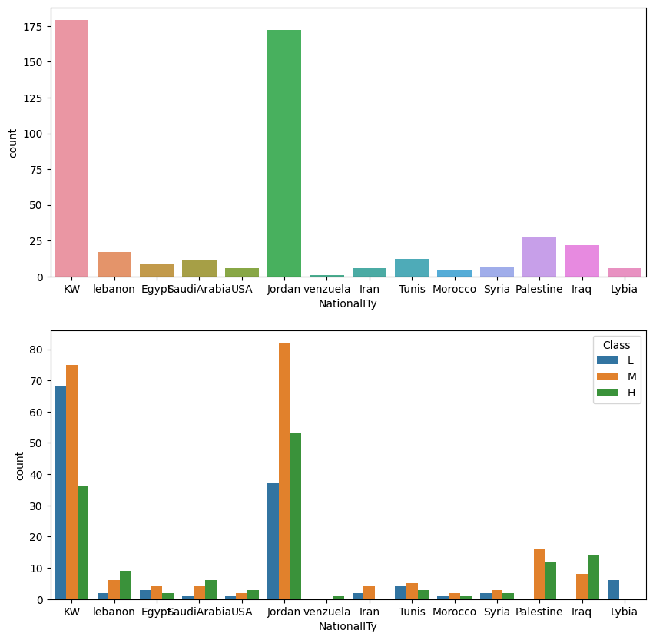
fig, axarr = plt.subplots(2,figsize=(10,10))
sns.countplot(x='PlaceofBirth', data=data, ax=axarr[0])
sns.countplot(x='PlaceofBirth', hue='Class', data=data,hue_order = ['L', 'M', 'H'], ax=axarr[1])
plt.show()
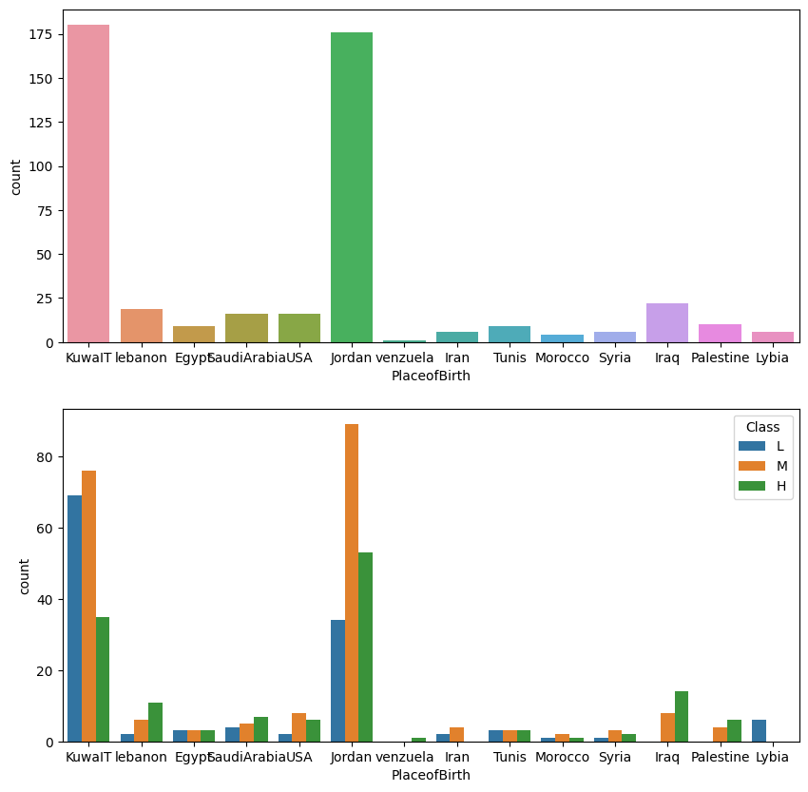
data.shape
(480, 17)
fig, axarr = plt.subplots(2,figsize=(10,10))
sns.countplot(x='StageID', data=data, ax=axarr[0])
sns.countplot(x='StageID', hue='Class', data=data, hue_order = ['L', 'M', 'H'], ax=axarr[1])
plt.show()
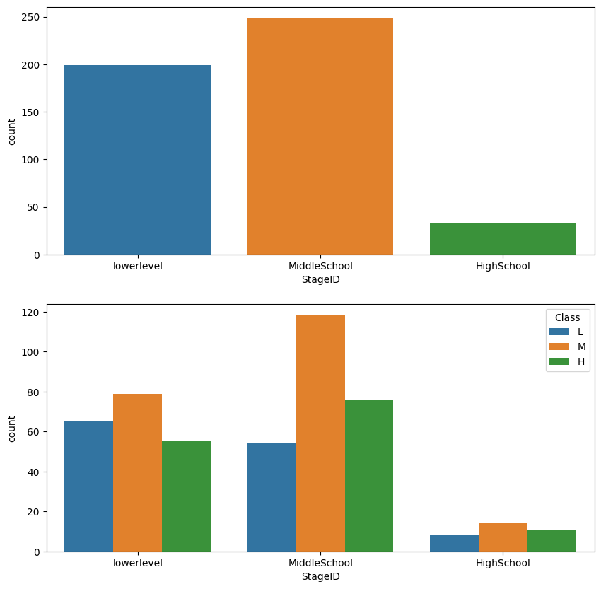
fig, axarr = plt.subplots(2,figsize=(10,10))
sns.countplot(x='GradeID', data=data, order=['G-02', 'G-04', 'G-05', 'G-06', 'G-07', 'G-08', 'G-09', 'G-10', 'G-11', 'G-12'], ax=axarr[0])
sns.countplot(x='GradeID', hue='Class', data=data, order=['G-02', 'G-04', 'G-05', 'G-06', 'G-07', 'G-08', 'G-09', 'G-10', 'G-11', 'G-12'], hue_order = ['L', 'M', 'H'], ax=axarr[1])
plt.show()
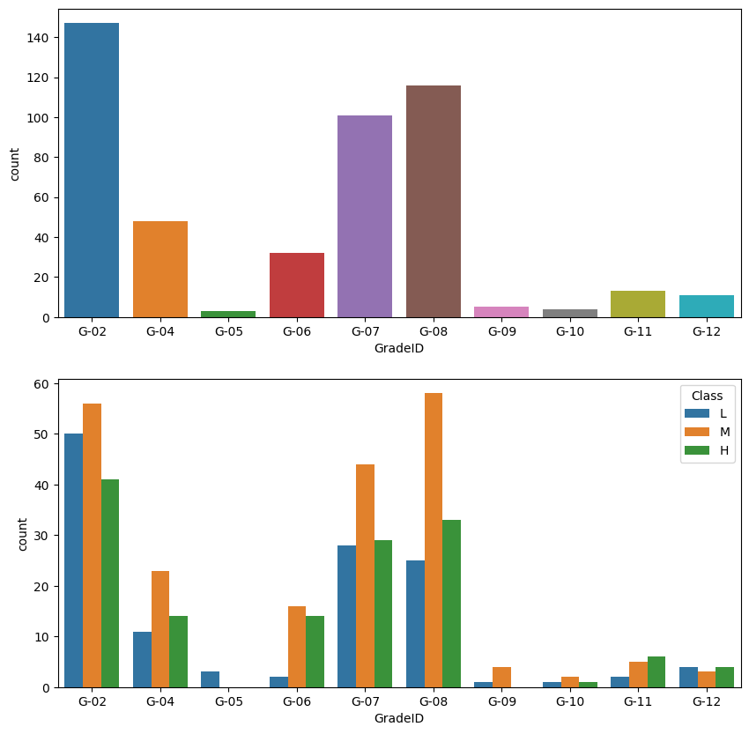
data.loc[data['GradeID'] == 'G-05']
gender NationalITy PlaceofBirth StageID GradeID SectionID Topic \
33 M KW KuwaIT lowerlevel G-05 A English
46 M KW KuwaIT lowerlevel G-05 A English
60 F Jordan Jordan lowerlevel G-05 A English
Semester Relation raisedhands VisITedResources AnnouncementsView \
33 F Father 8 22 9
46 F Father 7 10 1
60 F Mum 21 10 28
Discussion ParentAnsweringSurvey ParentschoolSatisfaction \
33 40 No Bad
46 30 No Bad
60 20 No Good
StudentAbsenceDays Class
33 Above-7 L
46 Above-7 L
60 Above-7 L
data.loc[data['GradeID'] == 'G-09']
gender NationalITy PlaceofBirth StageID GradeID SectionID Topic \
42 M KW KuwaIT HighSchool G-09 A IT
43 F KW KuwaIT HighSchool G-09 A IT
44 F KW KuwaIT HighSchool G-09 A IT
76 M Iran Iran HighSchool G-09 A IT
77 M KW KuwaIT HighSchool G-09 A IT
Semester Relation raisedhands VisITedResources AnnouncementsView \
42 F Father 10 12 7
43 F Father 30 35 28
44 F Father 33 33 30
76 F Mum 15 70 37
77 F Father 20 80 33
Discussion ParentAnsweringSurvey ParentschoolSatisfaction \
42 33 Yes Good
43 90 Yes Good
44 90 No Bad
76 44 Yes Good
77 33 Yes Good
StudentAbsenceDays Class
42 Above-7 L
43 Under-7 M
44 Under-7 M
76 Under-7 M
77 Under-7 M
fig, axarr = plt.subplots(2,figsize=(10,10))
sns.countplot(x='SectionID', data=data, order=['A', 'B', 'C'], ax = axarr[0])
sns.countplot(x='SectionID', hue='Class', data=data, order=['A', 'B', 'C'],hue_order = ['L', 'M', 'H'], ax = axarr[1])
plt.show()
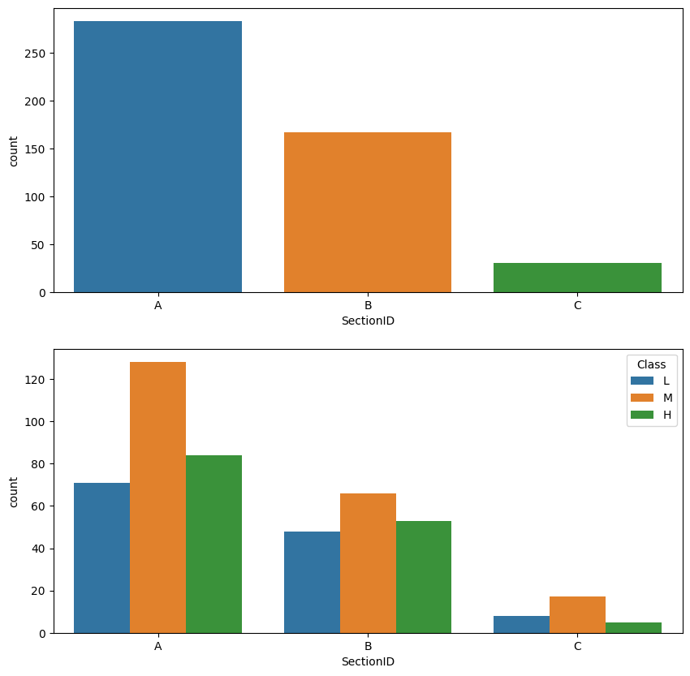
fig, axarr = plt.subplots(2,figsize=(10,10))
sns.countplot(x='Topic', data=data, ax = axarr[0])
sns.countplot(x='Topic', hue='Class', data=data,hue_order = ['L', 'M', 'H'], ax = axarr[1])
plt.show()
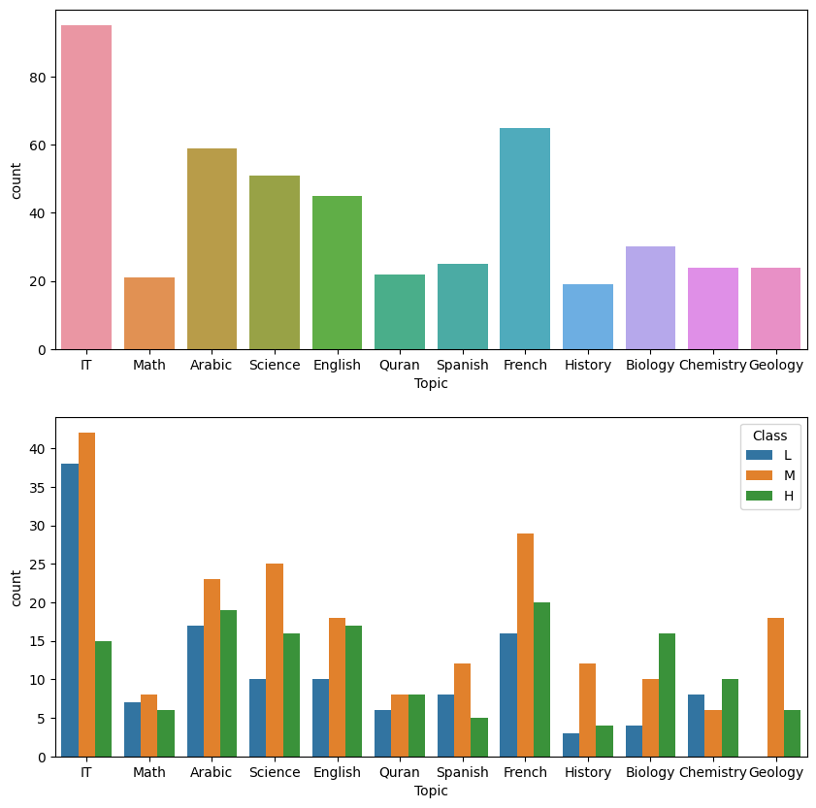
fig, axarr = plt.subplots(2,figsize=(10,10))
sns.countplot(x='Semester', data=data, ax = axarr[0])
sns.countplot(x='Semester', hue='Class', data=data,hue_order = ['L', 'M', 'H'], ax = axarr[1])
plt.show()
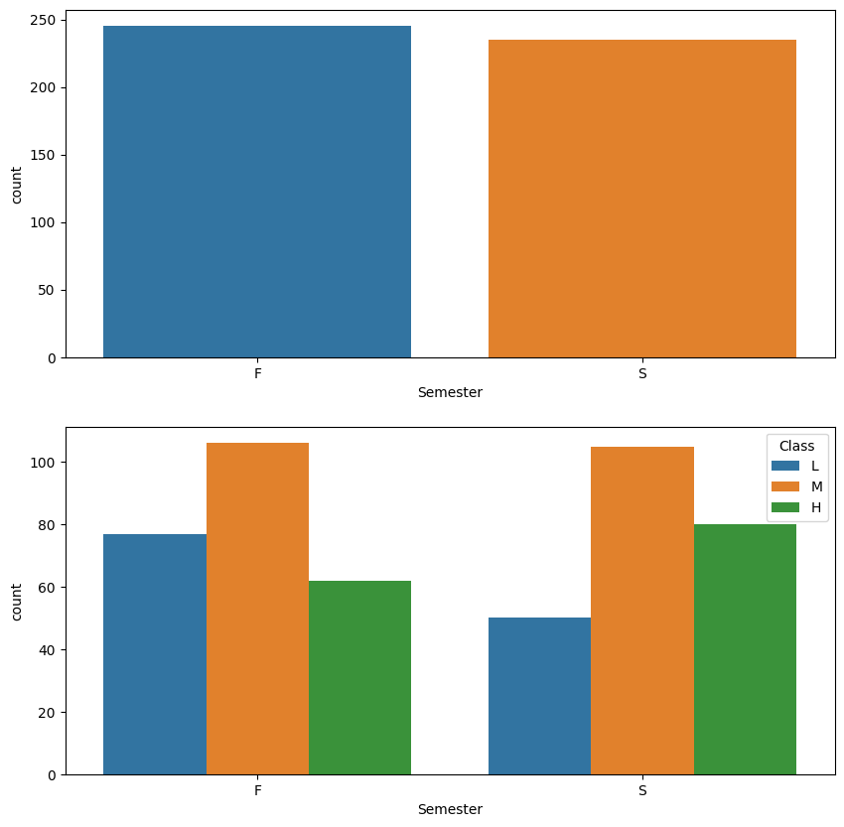
fig, axarr = plt.subplots(2,figsize=(10,10))
sns.countplot(x='Relation', data=data, ax = axarr[0])
sns.countplot(x='Relation', hue='Class', data=data,hue_order = ['L', 'M', 'H'], ax = axarr[1])
plt.show()
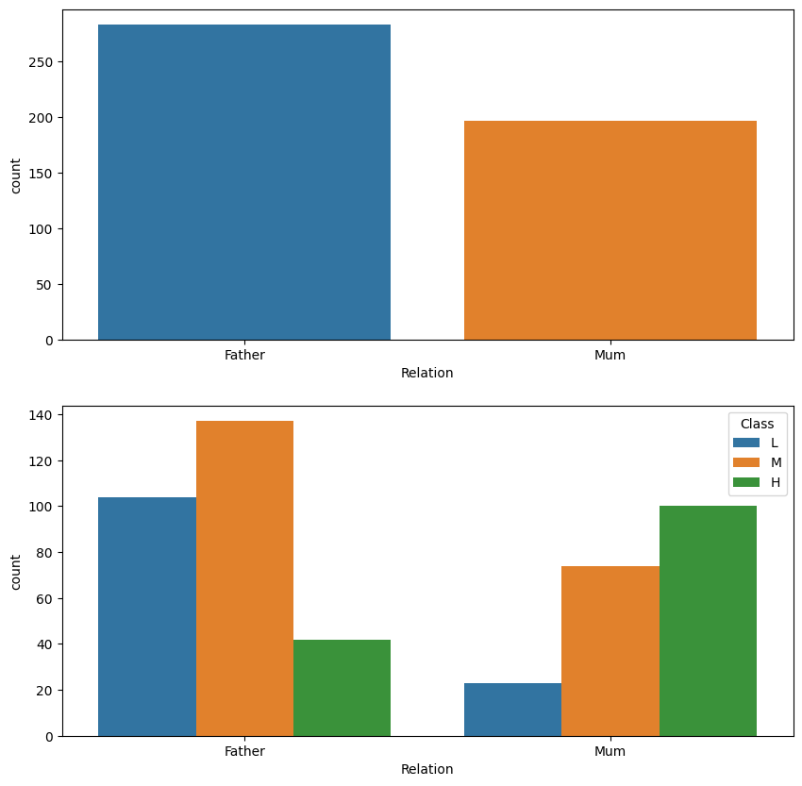
sns.pairplot(data, hue="Class", diag_kind="kde", hue_order = ['L', 'M', 'H'], markers=["o", "s", "D"])
plt.show()
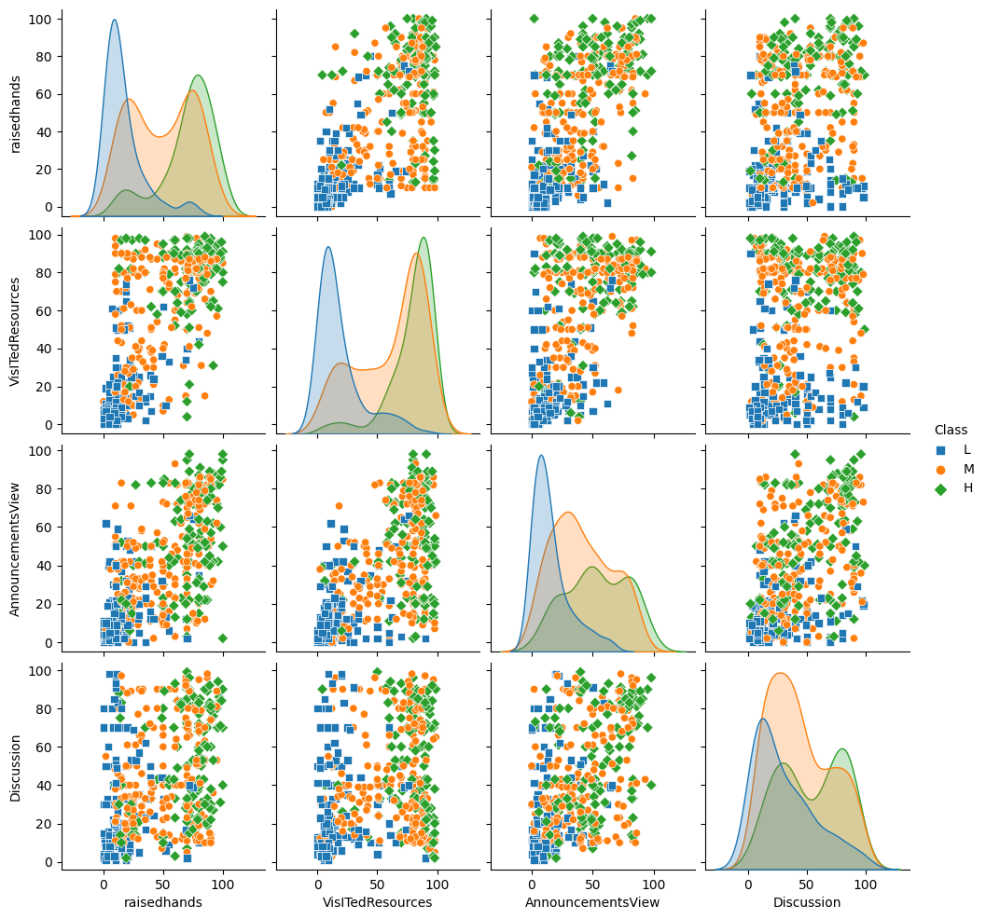
data.groupby('Topic').median()
raisedhands VisITedResources AnnouncementsView Discussion
Topic
Arabic 32.0 65.0 41.0 38.0
Biology 78.5 88.5 54.0 47.0
Chemistry 79.0 84.5 47.0 30.5
English 55.0 50.0 33.0 36.0
French 35.0 80.0 23.0 21.0
Geology 80.0 82.0 68.5 60.5
History 69.0 84.0 72.0 65.0
IT 20.0 25.0 10.0 40.0
Math 28.0 15.0 19.0 40.0
Quran 65.0 75.0 50.0 45.0
Science 62.0 64.0 58.0 66.0
Spanish 27.0 51.0 40.0 20.0
data.groupby('GradeID').median()
raisedhands VisITedResources AnnouncementsView Discussion
GradeID
G-02 27.0 60.0 21.0 30.0
G-04 45.5 50.0 33.0 43.5
G-05 8.0 10.0 9.0 30.0
G-06 72.0 61.0 49.0 36.5
G-07 50.0 71.0 33.0 50.0
G-08 70.5 77.0 45.5 40.5
G-09 20.0 35.0 30.0 44.0
G-10 33.5 41.5 24.0 26.0
G-11 70.0 63.0 50.0 49.0
G-12 29.0 39.0 19.0 50.0
fig, axarr = plt.subplots(2,figsize=(10,10))
sns.countplot(x='ParentAnsweringSurvey', data=data, order=['Yes', 'No'], ax = axarr[0])
sns.countplot(x='ParentAnsweringSurvey', hue='Class', data=data, order=['Yes', 'No'], hue_order = ['L', 'M', 'H'], ax = axarr[1])
plt.show()
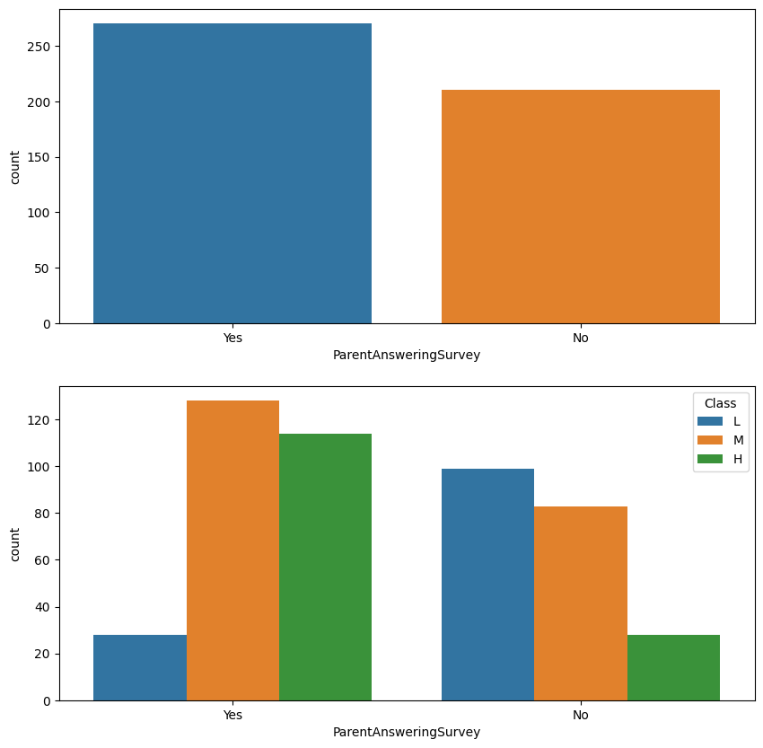
fig, axarr = plt.subplots(2,figsize=(10,10))
sns.countplot(x='ParentschoolSatisfaction', data=data, order=['Good', 'Bad'], ax = axarr[0])
sns.countplot(x='ParentschoolSatisfaction', hue='Class', data=data, order=['Good', 'Bad'],hue_order = ['L', 'M', 'H'], ax = axarr[1])
plt.show()
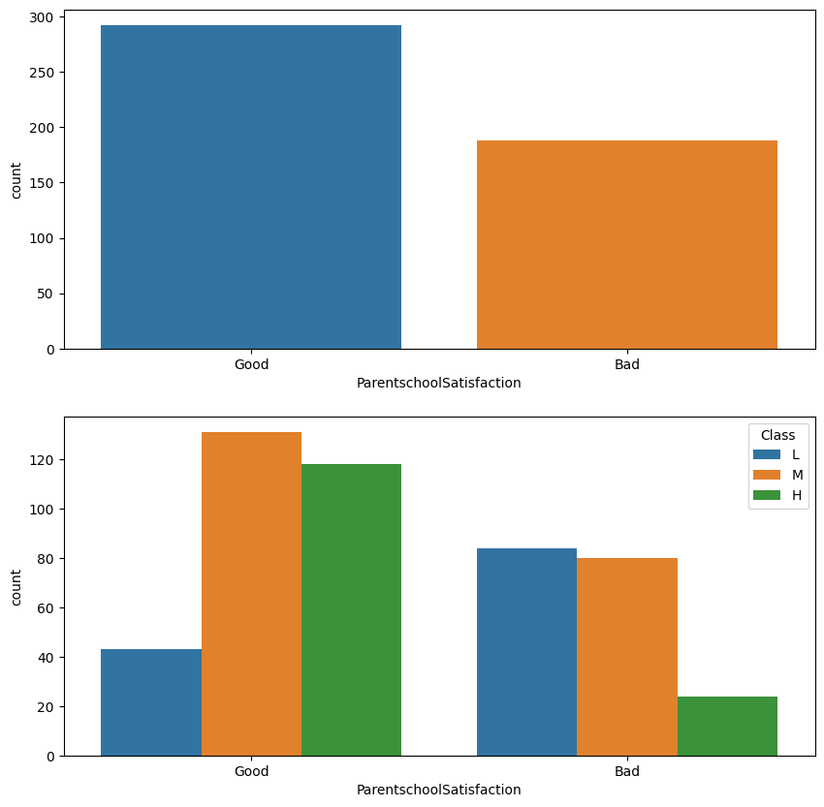
fig, axarr = plt.subplots(2,figsize=(10,10))
sns.countplot(x='StudentAbsenceDays', data=data, order=['Under-7', 'Above-7'], ax = axarr[0])
sns.countplot(x='StudentAbsenceDays', hue='Class', data=data, order=['Under-7', 'Above-7'],hue_order = ['L', 'M', 'H'], ax = axarr[1])
plt.show()
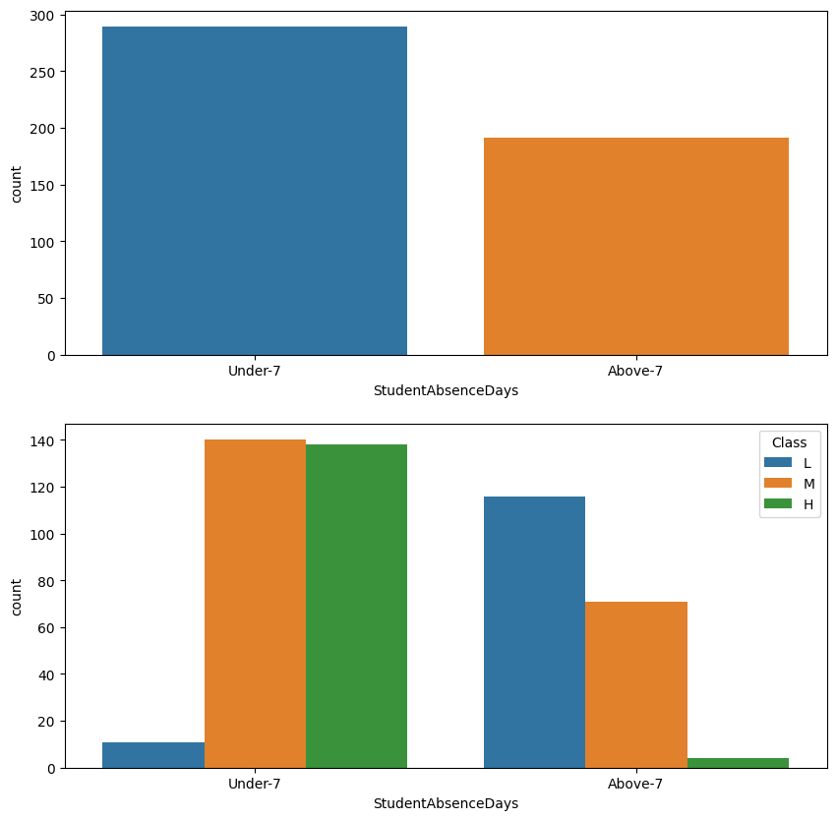
from google.colab import files
uploaded= files.upload()
<IPython.core.display.HTML object>
Saving OurData.csv to OurData.csv
import pandas as pd
# Load your dataset here
df = pd.read_csv('OurData.csv')
# Check for null values
if df.isnull().values.any():
print("Null values are present in the dataset.")
# Determine how to handle the null values based on your dataset
# For example, if the dataset has many null values in a certain column, it may be better to drop the entire column
# Alternatively, if the dataset has only a few null values, it may be better to fill those values with the column's mean, median, or mode value
# Fill null values
df.fillna(value=0, inplace=True) # Fill null values with 0 (Replace with your desired value)
print("Null values have been filled.")
# Drop rows with null values
df.dropna(inplace=True) # Drop rows with null values
print("Rows with null values have been dropped.")
else:
print("No null values are present in the dataset.")
No null values are present in the dataset.
import pandas as pd
import seaborn as sns
import matplotlib.pyplot as plt
# Load the dataset
df = pd.read_csv('OurData.csv')
# Create distribution plots for each numerical column
numerical_cols = ['raisedhands', 'VisITedResources', 'AnnouncementsView', 'Discussion']
fig, axs = plt.subplots(nrows=1, ncols=len(numerical_cols), figsize=(12, 4))
for i, col in enumerate(numerical_cols):
sns.histplot(data=df, x=col, kde=True, ax=axs[i])
# Create boxplots for each numerical column
fig, axs = plt.subplots(nrows=1, ncols=len(numerical_cols), figsize=(12, 4))
for i, col in enumerate(numerical_cols):
sns.boxplot(data=df, x=col, ax=axs[i])
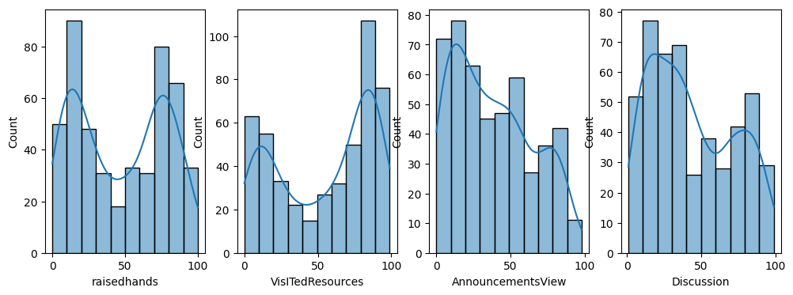
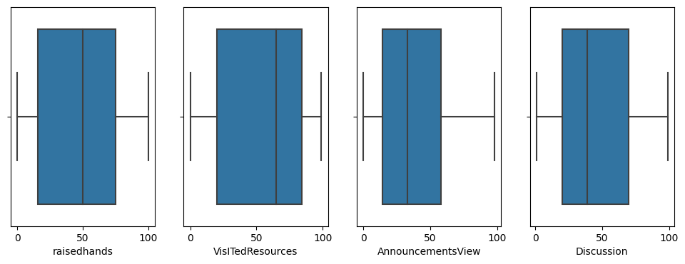
import pandas as pd
import numpy as np
# load your data into a pandas dataframe
df = pd.read_csv('OurData.csv')
# convert non-numeric columns to numeric data types
for col in df.columns:
if df[col].dtype != np.number:
df[col] = pd.to_numeric(df[col], errors='coerce')
# calculate the median of each column
medians = df.median()
# calculate the median absolute deviation of each column
mad = df.mad()
# calculate the modified z-score for each data point
z_scores = 0.6745 * ((df - medians) / mad)
# identify and replace the outliers for each column separately
for col in df.columns:
df.loc[z_scores[col].abs() > 3.5, col] = medians[col]
<ipython-input-15-0d3beae94c21>:9: DeprecationWarning: Converting `np.inexact` or `np.floating` to a dtype is deprecated. The current result is `float64` which is not strictly correct.
if df[col].dtype != np.number:
<ipython-input-15-0d3beae94c21>:16: FutureWarning: The 'mad' method is deprecated and will be removed in a future version. To compute the same result, you may do `(df - df.mean()).abs().mean()`.
mad = df.mad()
import pandas as pd
import numpy as np
import seaborn as sns
import matplotlib.pyplot as plt
# load your data into a pandas dataframe
df = pd.read_csv('OurData.csv')
# convert non-numeric columns to numeric data types
for col in df.columns:
if df[col].dtype != np.number:
df[col] = pd.to_numeric(df[col], errors='coerce')
# calculate the median of each column
medians = df.median()
# calculate the median absolute deviation of each column
mad = (df - df.median()).abs().median()
# calculate the modified z-score for each data point
z_scores = 0.6745 * ((df - medians) / mad)
# identify and replace the outliers
df[z_scores.abs() > 3.5] = np.nan
df.fillna(medians, inplace=True)
# Create distribution plots for each numerical column
numerical_cols = ['raisedhands', 'VisITedResources', 'AnnouncementsView', 'Discussion']
fig, axs = plt.subplots(nrows=1, ncols=len(numerical_cols), figsize=(12, 4))
for i, col in enumerate(numerical_cols):
sns.histplot(data=df, x=col, kde=True, ax=axs[i])
# Create boxplots for each numerical column
fig, axs = plt.subplots(nrows=1, ncols=len(numerical_cols), figsize=(12, 4))
for i, col in enumerate(numerical_cols):
sns.boxplot(data=df, x=col, ax=axs[i])
plt.show()
<ipython-input-18-53b7add9468f>:11: DeprecationWarning: Converting `np.inexact` or `np.floating` to a dtype is deprecated. The current result is `float64` which is not strictly correct.
if df[col].dtype != np.number:
import pandas as pd
import numpy as np
from sklearn.linear_model import LinearRegression
from sklearn.metrics import mean_squared_error, r2_score
from sklearn.model_selection import train_test_split
from google.colab import files
uploaded= files.upload()
<IPython.core.display.HTML object>
Saving OurData.csv to OurData (1).csv
import pandas as pd # a wonderful dataframe to work with
import numpy as np # adding a number of mathematical and science functions
import seaborn as sns # a very easy to use statistical data visualization package
import matplotlib.pyplot as plt # a required plotting tool
import warnings
# sklearn is a big source of pre-written and mostly optimized ML algorithms.
# Here we use their Decision trees, Support Vector Machines, and the classic Perceptron.
from sklearn import preprocessing, svm
from sklearn.linear_model import Perceptron
from sklearn.tree import DecisionTreeClassifier
#ignore warnings
warnings.filterwarnings('ignore')
import io
data=pd.read_csv(io.BytesIO(uploaded['OurData.csv']))
# Translate GradeID from categorical to numerical
gradeID_dict = {"G-01" : 1,
"G-02" : 2,
"G-03" : 3,
"G-04" : 4,
"G-05" : 5,
"G-06" : 6,
"G-07" : 7,
"G-08" : 8,
"G-09" : 9,
"G-10" : 10,
"G-11" : 11,
"G-12" : 12}
data = data.replace({"GradeID" : gradeID_dict})
class_dict = {"L" : -1,
"M" : 0,
"H" : 1}
data = data.replace({"Class" : class_dict})
# Scale numerical fields
data["GradeID"] = preprocessing.scale(data["GradeID"])
data["raisedhands"] = preprocessing.scale(data["raisedhands"])
data["VisITedResources"] = preprocessing.scale(data["VisITedResources"])
data["AnnouncementsView"] = preprocessing.scale(data["AnnouncementsView"])
data["Discussion"] = preprocessing.scale(data["Discussion"])
# Use dummy variables for categorical fields
data = pd.get_dummies(data, columns=["gender",
"NationalITy",
"PlaceofBirth",
"SectionID",
"StageID",
"Topic",
"Semester",
"Relation",
"ParentAnsweringSurvey",
"ParentschoolSatisfaction",
"StudentAbsenceDays"])
# Show preprocessed data
data.head()
GradeID raisedhands VisITedResources AnnouncementsView Discussion \
0 -0.563838 -1.033429 -1.174075 -1.351167 -0.843326
1 -0.563838 -0.870813 -1.053029 -1.313549 -0.662225
2 -0.563838 -1.196046 -1.446426 -1.426401 -0.481125
3 -0.563838 -0.545579 -0.901723 -1.238315 -0.300024
4 -0.563838 -0.220346 -0.145191 -0.974994 0.243279
Class gender_F gender_M NationalITy_Egypt NationalITy_Iran ... \
0 0 0 1 0 0 ...
1 0 0 1 0 0 ...
2 -1 0 1 0 0 ...
3 -1 0 1 0 0 ...
4 0 0 1 0 0 ...
Semester_F Semester_S Relation_Father Relation_Mum \
0 1 0 1 0
1 1 0 1 0
2 1 0 1 0
3 1 0 1 0
4 1 0 1 0
ParentAnsweringSurvey_No ParentAnsweringSurvey_Yes \
0 0 1
1 0 1
2 1 0
3 1 0
4 1 0
ParentschoolSatisfaction_Bad ParentschoolSatisfaction_Good \
0 0 1
1 0 1
2 1 0
3 1 0
4 1 0
StudentAbsenceDays_Above-7 StudentAbsenceDays_Under-7
0 0 1
1 0 1
2 1 0
3 1 0
4 1 0
[5 rows x 64 columns]
corr = data.corr()
corr.iloc[[5]]
GradeID raisedhands VisITedResources AnnouncementsView Discussion \
Class 0.071654 0.646298 0.677094 0.52737 0.308183
Class gender_F gender_M NationalITy_Egypt NationalITy_Iran ... \
Class 1.0 0.26349 -0.26349 -0.02631 -0.054841 ...
Semester_F Semester_S Relation_Father Relation_Mum \
Class -0.126239 0.126239 -0.401142 0.401142
ParentAnsweringSurvey_No ParentAnsweringSurvey_Yes \
Class -0.435495 0.435495
ParentschoolSatisfaction_Bad ParentschoolSatisfaction_Good \
Class -0.375901 0.375901
StudentAbsenceDays_Above-7 StudentAbsenceDays_Under-7
Class -0.671312 0.671312
[1 rows x 64 columns]
# Step 4: Split the data into training and testing sets
X = data.drop(['Class'], axis=1)
y = data['Class']
X_train, X_test, y_train, y_test = train_test_split(X, y, test_size=0.2, random_state=42)
model = LinearRegression()
model.fit(X_train, y_train)
LinearRegression()
y_pred = model.predict(X_test)
mse = mean_squared_error(y_test, y_pred)
r2 = r2_score(y_test, y_pred)
print("Mean Squared Error:", mse)
print("R-squared Score:", r2)
Mean Squared Error: 0.16520434338522147
R-squared Score: 0.6684400634498692
import pandas as pd
import seaborn as sns
import matplotlib.pyplot as plt
# Load the dataset
data = pd.read_csv('OurData.csv')
# Bar plot of class count by nationality
sns.countplot(x='NationalITy', hue='Class', data=data)
plt.xticks(rotation=90)
plt.show()
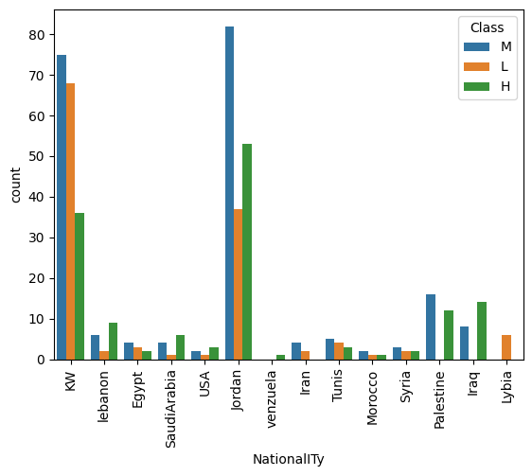
Bar Plot: A bar plot can be used to visualize the count of students in each class (L, M, H) based on a specific categorical variable. This can help us understand if certain categories in a variable have a higher proportion of students in a particular class, indicating a correlation between the variable and academic performance.
we are creating a bar plot of the count of students in each class based on their nationality. This can help us understand if nationality has any correlation with academic performance. The sns.countplot() function is used to create the plot, and the hue parameter is set to 'Class' to show the count of students in each class. We rotate the x-axis labels using plt.xticks(rotation=90) to make them readable.
# Scatter plot of 'raisedhands' and 'VisITedResources' with Class as hue
sns.scatterplot(x='raisedhands', y='VisITedResources', hue='Class', data=data)
plt.show()
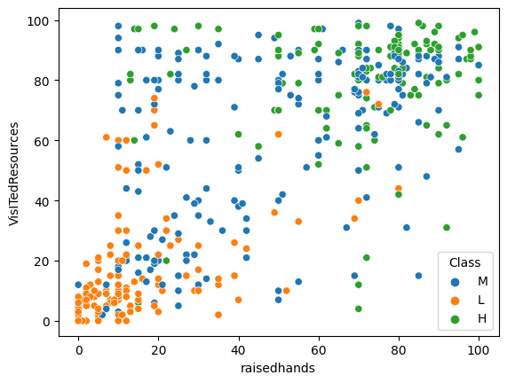
Scatter Plot: A scatter plot can be used to visualize the relationship between two continuous variables, such as 'raisedhands' and 'VisITedResources'. This can help us understand if there is a correlation between the two variables and academic performance.
we are creating a scatter plot of 'raisedhands' and 'VisITedResources' with 'Class' as hue. This can help us understand if there is a correlation between these two variables and academic performance. The sns.scatterplot() function is used to create the plot, and the hue parameter is set to 'Class' to show the class of each student.
# Heat map of correlation between continuous variables
corr = data[['raisedhands', 'VisITedResources', 'AnnouncementsView', 'Discussion']].corr()
sns.heatmap(corr, annot=True, cmap='coolwarm')
plt.show()
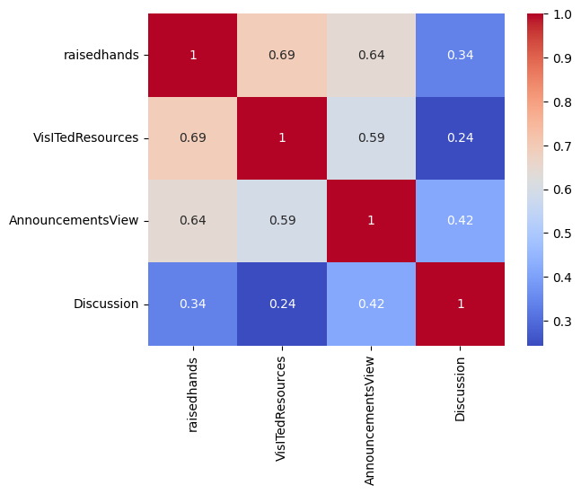
Heat Map: A heat map can be used to visualize the correlation between all the continuous variables in the dataset. This can help us understand which variables are highly correlated with academic performance and which are not.
we are creating a heat map of the correlation between the continuous variables 'raisedhands', 'VisITedResources', 'AnnouncementsView', and 'Discussion'. This can help us understand which variables are highly correlated with academic performance. The corr() function is used to calculate the correlation matrix, and the sns.heatmap() function is used to create the plot with annotations to show the correlation coefficients. The cmap parameter is set to 'coolwarm' to use a color map that goes from blue to red to show negative to positive correlations.
By analyzing these plots, we can get an idea of which features are important for predicting academic performance. For example, from the bar plot, we can see that certain nationalities have a higher proportion of students in the H class, indicating a correlation between nationality and academic performance. From the scatter plot, we can see that students who raise their hands and visit course content more often tend to have higher academic performance. From the heat map, we can see that 'raisedhands' and 'VisITedResources'
import matplotlib.pyplot as plt
# assuming your model is named 'model' and your test data is in 'X_test'
y_pred = model.predict(X_test)
# plot actual vs predicted values
plt.scatter(y_test, y_pred, alpha=0.5)
plt.xlabel('Actual Values')
plt.ylabel('Predicted Values')
plt.title('Actual vs. Predicted Values')
plt.show()
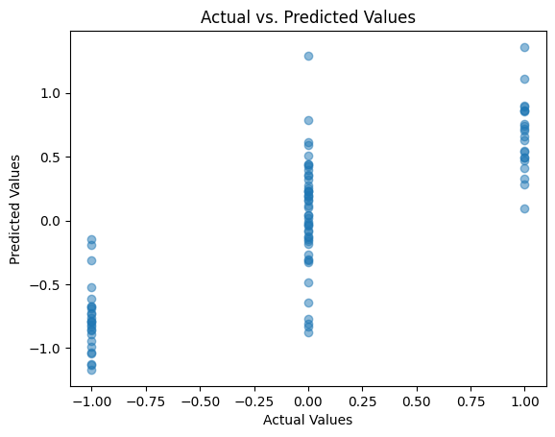
We first predict the target variable values on the test data using our model. Then we plot a scatter plot with the actual target variable values on the x-axis and the predicted target variable values on the y-axis. This plot helps us to visualize how well our model is predicting the target variable values.
The closer the points are to the 45-degree line (i.e., the line passing through the origin with slope 1), the better the model is at predicting the target variable values.
print(data.columns)
Index(['gender', 'NationalITy', 'PlaceofBirth', 'StageID', 'GradeID',
'SectionID', 'Topic', 'Semester', 'Relation', 'raisedhands',
'VisITedResources', 'AnnouncementsView', 'Discussion',
'ParentAnsweringSurvey', 'ParentschoolSatisfaction',
'StudentAbsenceDays', 'Class'],
dtype='object')
import seaborn as sns
import matplotlib.pyplot as plt
# Make predictions on test data
y_pred = model.predict(X_test)
# Create a scatter plot of the test data
sns.scatterplot(x=X_test['raisedhands'], y=y_test)
# Plot the predicted values as a line
sns.lineplot(x=X_test['raisedhands'], y=y_pred, color='red')
# Add axis labels and a title
plt.xlabel('raisedhands')
plt.ylabel('G3')
plt.title('Linear Regression Model')
# Show the plot
plt.show()
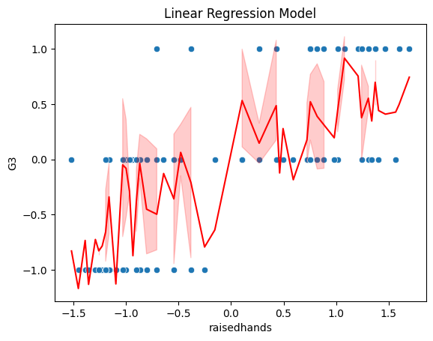
we first make predictions on the test data using the trained linear regression model. Then we create a scatter plot of the test data using Seaborn's scatterplot function, with raisedhands on the x-axis and G3 (the target variable) on the y-axis. We then plot the predicted values as a line using Seaborn's lineplot function, with the same x-axis as before and the predicted values on the y-axis. Finally, we add axis labels and a title to the plot and show it using Matplotlib's show function.
import matplotlib.pyplot as plt
# Create a scatter plot of the actual and predicted values
plt.scatter(y_test, y_pred)
# Add a line for perfect correlation (y = x)
plt.plot([0, 4], [0, 4], '--k')
# Label the plot
plt.xlabel('Actual Class')
plt.ylabel('Predicted Class')
plt.title('Linear Regression Model')
# Show the plot
plt.show()
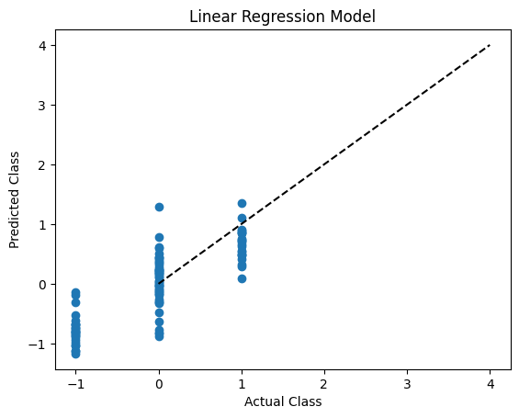
This code generates a scatter plot that compares the actual values of the target variable 'Class' in the test dataset with the predicted values obtained from the linear regression model. The x-axis of the plot represents the actual values of 'Class', while the y-axis represents the predicted values of 'Class'.
The scatter plot is created using the Matplotlib library's scatter() function, which takes two arguments - the actual values of 'Class' (y_test) and the predicted values of 'Class' (y_pred).
The code then adds a black dashed line with --k to the plot, which represents perfect correlation (y = x). This line shows how closely the predicted values align with the actual values.
Lastly, the code adds labels to the x and y axes and a title to the plot using the xlabel(), ylabel(), and title() functions, respectively. Finally, the plot is shown using the show() function.

import pandas as pd
import numpy as np
from sklearn.linear_model import LinearRegression
from sklearn.metrics import mean_squared_error, r2_score
from sklearn.model_selection import train_test_split
from sklearn.preprocessing import LabelEncoder, OneHotEncoder
import matplotlib.pyplot as plt
# Load the dataset into a Pandas DataFrame
df = pd.read_csv("OurData.csv")
# Convert categorical columns to numerical columns
le = LabelEncoder()
df['gender'] = le.fit_transform(df['gender'])
df['NationalITy'] = le.fit_transform(df['NationalITy'])
df['PlaceofBirth'] = le.fit_transform(df['PlaceofBirth'])
df['StageID'] = le.fit_transform(df['StageID'])
df['GradeID'] = le.fit_transform(df['GradeID'])
df['SectionID'] = le.fit_transform(df['SectionID'])
df['Topic'] = le.fit_transform(df['Topic'])
df['Semester'] = le.fit_transform(df['Semester'])
df['Relation'] = le.fit_transform(df['Relation'])
df['ParentAnsweringSurvey'] = le.fit_transform(df['ParentAnsweringSurvey'])
df['ParentschoolSatisfaction'] = le.fit_transform(df['ParentschoolSatisfaction'])
df['StudentAbsenceDays'] = le.fit_transform(df['StudentAbsenceDays'])
# Split the data into training and testing sets
X = df.drop(['Class'], axis=1)
y = df['Class']
X_train, X_test, y_train, y_test = train_test_split(X, y, test_size=0.2, random_state=42)

Befor and After Regression Model
import seaborn as sns
import pandas as pd
import matplotlib.pyplot as plt
df = pd.read_csv('OurData.csv')
sns.pairplot(df)
plt.show()
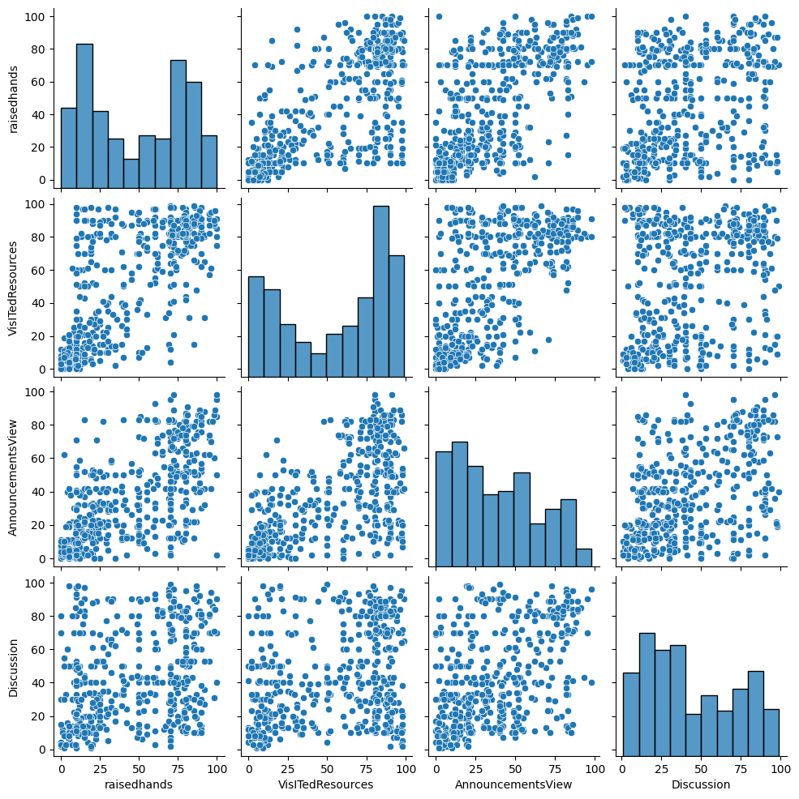
sns.pairplot(df)
sns.regplot(x='raisedhands', y='Discussion', data=df)
plt.show()
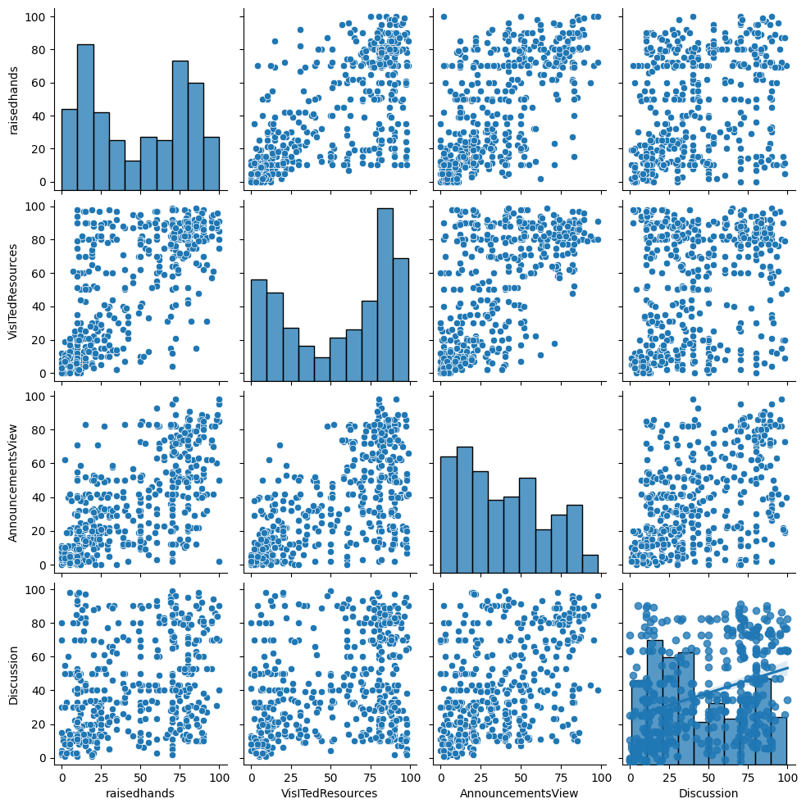
import pandas as pd # a wonderful dataframe to work with
import numpy as np # adding a number of mathematical and science functions
import seaborn as sns # a very easy to use statistical data visualization package
import matplotlib.pyplot as plt # a required plotting tool
import warnings
# sklearn is a big source of pre-written and mostly optimized ML algorithms.
# Here we use their Decision trees, Support Vector Machines, and the classic Perceptron.
from sklearn import preprocessing, svm
from sklearn.linear_model import Perceptron
from sklearn.tree import DecisionTreeClassifier
#ignore warnings
warnings.filterwarnings('ignore')
data = pd.read_csv('..\Downloads\stu_performance.csv')
data.head()
gender NationalITy PlaceofBirth StageID GradeID SectionID Topic \
0 M KW KuwaIT lowerlevel G-04 A IT
1 M KW KuwaIT lowerlevel G-04 A IT
2 M KW KuwaIT lowerlevel G-04 A IT
3 M KW KuwaIT lowerlevel G-04 A IT
4 M KW KuwaIT lowerlevel G-04 A IT
Semester Relation raisedhands VisITedResources AnnouncementsView \
0 F Father 15 16 2
1 F Father 20 20 3
2 F Father 10 7 0
3 F Father 30 25 5
4 F Father 40 50 12
Discussion ParentAnsweringSurvey ParentschoolSatisfaction \
0 20 Yes Good
1 25 Yes Good
2 30 No Bad
3 35 No Bad
4 50 No Bad
StudentAbsenceDays Class
0 Under-7 M
1 Under-7 M
2 Above-7 L
3 Above-7 L
4 Above-7 M
# Translate GradeID from categorical to numerical
#DATA PRE PROCESSSING
gradeID_dict = {"G-01" : 1,
"G-02" : 2,
"G-03" : 3,
"G-04" : 4,
"G-05" : 5,
"G-06" : 6,
"G-07" : 7,
"G-08" : 8,
"G-09" : 9,
"G-10" : 10,
"G-11" : 11,
"G-12" : 12}
data = data.replace({"GradeID" : gradeID_dict})
class_dict = {"L" : -1,
"M" : 0,
"H" : 1}
data = data.replace({"Class" : class_dict})
# Scale numerical fields
data["GradeID"] = preprocessing.scale(data["GradeID"])
data["raisedhands"] = preprocessing.scale(data["raisedhands"])
data["VisITedResources"] = preprocessing.scale(data["VisITedResources"])
data["AnnouncementsView"] = preprocessing.scale(data["AnnouncementsView"])
data["Discussion"] = preprocessing.scale(data["Discussion"])
# Use dummy variables for categorical fields
data = pd.get_dummies(data, columns=["gender",
"NationalITy",
"PlaceofBirth",
"SectionID",
"StageID",
"Topic",
"Semester",
"Relation",
"ParentAnsweringSurvey",
"ParentschoolSatisfaction",
"StudentAbsenceDays"])
# Show preprocessed data
data.head()
GradeID raisedhands VisITedResources AnnouncementsView Discussion \
0 -0.563838 -1.033429 -1.174075 -1.351167 -0.843326
1 -0.563838 -0.870813 -1.053029 -1.313549 -0.662225
2 -0.563838 -1.196046 -1.446426 -1.426401 -0.481125
3 -0.563838 -0.545579 -0.901723 -1.238315 -0.300024
4 -0.563838 -0.220346 -0.145191 -0.974994 0.243279
Class gender_F gender_M NationalITy_Egypt NationalITy_Iran ... \
0 0 0 1 0 0 ...
1 0 0 1 0 0 ...
2 -1 0 1 0 0 ...
3 -1 0 1 0 0 ...
4 0 0 1 0 0 ...
Semester_F Semester_S Relation_Father Relation_Mum \
0 1 0 1 0
1 1 0 1 0
2 1 0 1 0
3 1 0 1 0
4 1 0 1 0
ParentAnsweringSurvey_No ParentAnsweringSurvey_Yes \
0 0 1
1 0 1
2 1 0
3 1 0
4 1 0
ParentschoolSatisfaction_Bad ParentschoolSatisfaction_Good \
0 0 1
1 0 1
2 1 0
3 1 0
4 1 0
StudentAbsenceDays_Above-7 StudentAbsenceDays_Under-7
0 0 1
1 0 1
2 1 0
3 1 0
4 1 0
[5 rows x 64 columns]
The first few lines define a dictionary gradeID_dict that maps string values of grade levels to their corresponding numerical values, and then applies this mapping to the "GradeID" column of the dataset using the replace() method.
Next, a similar dictionary class_dict is defined to map string values of class levels to their corresponding numerical values, and this mapping is applied to the "Class" column of the dataset.
The next set of lines scale the numerical features of the dataset using the preprocessing.scale() method from scikit-learn's preprocessing module. The features that are being scaled are "GradeID", "raisedhands", "VisITedResources", "AnnouncementsView", and "Discussion".
The next set of lines creates dummy variables for the categorical features of the dataset using the pd.get_dummies() method from pandas. This creates new columns for each unique value of each categorical feature, where the value is 1 if the original value was present for that observation and 0 otherwise.
Finally, the preprocessed dataset is displayed using the head() method from pandas. This shows the first few rows of the preprocessed dataset with all the transformations applied.
corr = data.corr()
corr.iloc[[5]]
GradeID raisedhands VisITedResources AnnouncementsView Discussion \
Class 0.071654 0.646298 0.677094 0.52737 0.308183
Class gender_F gender_M NationalITy_Egypt NationalITy_Iran ... \
Class 1.0 0.26349 -0.26349 -0.02631 -0.054841 ...
Semester_F Semester_S Relation_Father Relation_Mum \
Class -0.126239 0.126239 -0.401142 0.401142
ParentAnsweringSurvey_No ParentAnsweringSurvey_Yes \
Class -0.435495 0.435495
ParentschoolSatisfaction_Bad ParentschoolSatisfaction_Good \
Class -0.375901 0.375901
StudentAbsenceDays_Above-7 StudentAbsenceDays_Under-7
Class -0.671312 0.671312
[1 rows x 64 columns]
The code is calculating the correlation matrix for a dataset data using the corr() method from pandas. The resulting matrix corr contains pairwise correlations between all pairs of features in the dataset.
The second line of code is then selecting a specific row from the correlation matrix using the iloc method from pandas. In this case, it is selecting the row with index 5 (i.e., the 6th row), which represents the correlations of the feature at index 5 with all other features in the dataset.
The resulting output would be a pandas DataFrame that shows the correlations of the 6th feature with all other features in the dataset.
tree3 = DecisionTreeClassifier(random_state=56, criterion='gini', max_depth=3)
tree5 = DecisionTreeClassifier(random_state=56, criterion='gini', max_depth=5)
The first instance is assigned to the variable tree3 and is configured to use the Gini impurity measure as the criterion to evaluate feature splits, set the maximum depth of the tree to 3, and use a fixed random state of 56. The max_depth parameter limits the depth of the decision tree, which can help prevent overfitting and improve model generalization.
The second instance is assigned to the variable tree5 and is configured similarly to tree3, but with a larger max_depth value of 5. This would allow for more complex decision boundaries to be learned, but could also increase the risk of overfitting if the data is not sufficient to support such complexity.
Both tree3 and tree5 objects can then be fit to training data using the fit() method, and used to predict on new data using the predict() method.
results_3 = []
results_5 = []
predMiss_3 = []
predMiss_5 = []
for _ in range(1000):
# Randomly sample our training data
data_train = data.sample(frac=0.7)
# train data without label
data_train_X = data_train.loc[:, lambda x: [l for l in data if l != "Class"]]
# labels of train data
data_train_Y = data_train.loc[:, lambda x: "Class"]
# The rest is test data
data_test = data.loc[~data.index.isin(data_train.index)]
# Test data without label
data_test_X = data_test.loc[:, lambda x: [l for l in data if l != "Class"]]
# labels of test data
data_test_Y = data_test.loc[:, lambda x: "Class"]
# Train svm
tree3.fit(data_train_X, data_train_Y)
tree5.fit(data_train_X, data_train_Y)
#Sum the prediction misses. Since this is a smaller dataset,
predMiss_3.append((data_test_Y != tree3.predict(data_test_X)).sum())
predMiss_5.append((data_test_Y != tree5.predict(data_test_X)).sum())
# Score the mean accuracy on the test data and append results in a list
results_3.append(tree3.score(data_test_X, data_test_Y))
results_5.append(tree5.score(data_test_X, data_test_Y))
# Convert results to an array and look at the minimum and the average
predErr_3 = np.hstack(predMiss_3)
predErr_5 = np.hstack(predMiss_5)
Final_3 = np.hstack(results_3)
Final_5 = np.hstack(results_5)
print('3-depth Tree Minimum Accuracy Score: %.8f' % Final_3[Final_3.argmin()])
print('3-depth Tree Maximum Accuracy Score: %.8f' % Final_3[Final_3.argmax()])
print('3-depth Tree Average Accuracy Score: %.8f' % np.average(Final_3))
print('------------------------------------------------')
print('5-depth Tree Minimum Accuracy Score: %.8f' % Final_5[Final_5.argmin()])
print('5-depth Tree Maximum Accuracy Score: %.8f' % Final_5[Final_5.argmax()])
print('5-depth Tree Average Accuracy Score: %.8f' % np.average(Final_5))
3-depth Tree Minimum Accuracy Score: 0.52083333
3-depth Tree Maximum Accuracy Score: 0.80555556
3-depth Tree Average Accuracy Score: 0.67809722
------------------------------------------------
5-depth Tree Minimum Accuracy Score: 0.57638889
5-depth Tree Maximum Accuracy Score: 0.82638889
5-depth Tree Average Accuracy Score: 0.71449306
Initialize four empty lists: results_3, results_5, predMiss_3, and predMiss_5. For each of the 1000 iterations:
a. Randomly sample 70% of the data to use as training data, and use the remaining 30% as test data.
b. Separate the training data into two parts: data_train_X (features) and data_train_Y (labels).
c. Separate the test data into two parts: data_test_X (features) and data_test_Y (labels).
d. Train two decision tree classifiers: tree3 with a maximum depth of 3, and tree5 with a maximum depth of 5, using the training data.
e. Calculate the number of prediction misses (i.e., the number of misclassified instances) for each tree on the test data, and append these to predMiss_3 and predMiss_5, respectively.
f. Calculate the accuracy score for each tree on the test data, and append these to results_3 and results_5, respectively. Convert results_3 and results_5 to arrays, and calculate the minimum, maximum, and average accuracy scores for each tree. Print the results for each tree. Note that data is assumed to be a pandas DataFrame containing both features and labels, where the label column is named "Class".
import matplotlib.pyplot as plt
# Create a figure with two subplots
fig, axs = plt.subplots(1, 2, figsize=(10, 5))
# Plot histogram of accuracy scores for 3-depth tree
axs[0].hist(Final_3, bins=20)
axs[0].set_title('Accuracy scores for 3-depth tree')
# Plot histogram of accuracy scores for 5-depth tree
axs[1].hist(Final_5, bins=20)
axs[1].set_title('Accuracy scores for 5-depth tree')
# Show the plot
plt.show()
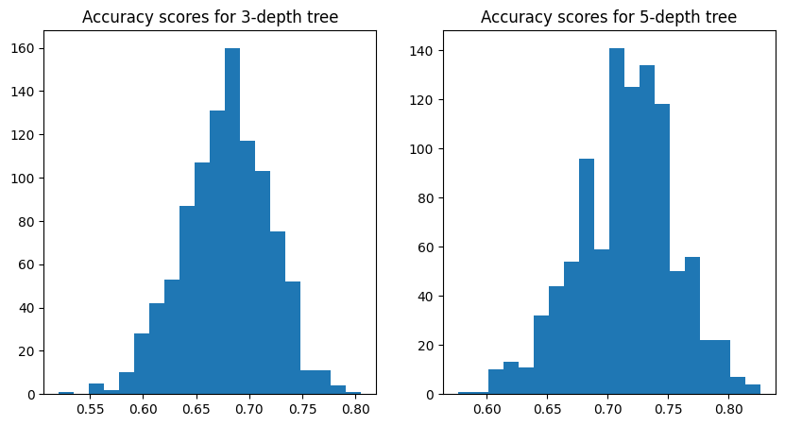
Import the matplotlib.pyplot library as plt. Create a figure with two subplots using the subplots() function, specifying the number of rows and columns of subplots (1 row, 2 columns), and the size of the figure (figsize=(10, 5)). Plot a histogram of the accuracy scores for the 3-depth tree using the hist() function, passing in the array Final_3 containing the accuracy scores, and specifying the number of bins in the histogram (bins=20). Set the title of the first subplot using the set_title() function. Plot a histogram of the accuracy scores for the 5-depth tree using the hist() function, passing in the array Final_5 containing the accuracy scores, and specifying the number of bins in the histogram (bins=20). Set the title of the second subplot using the set_title() function. Show the plot using the show() function.
import matplotlib.pyplot as plt
from sklearn.tree import plot_tree
plt.figure(figsize=(20,10))
plot_tree(tree3, feature_names=data_train_X.columns, filled=True)
plt.show()
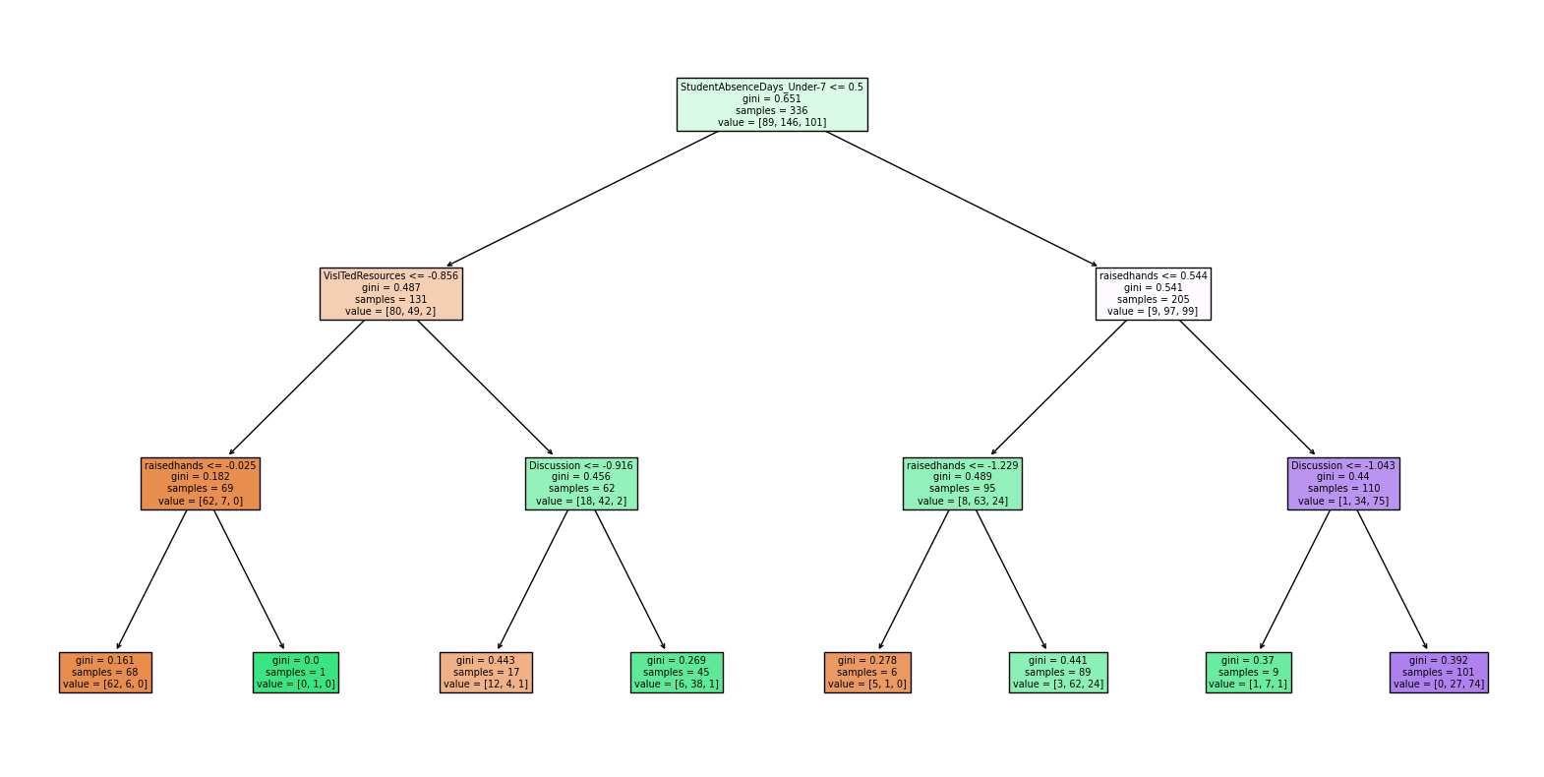
Import the matplotlib.pyplot library as plt and the plot_tree() function from the sklearn.tree module. Create a new figure with a specific size using the figure() function from the pyplot module, passing in the desired size (figsize=(20, 10)). Call the plot_tree() function passing in the 3-depth decision tree tree3 as the first argument and the list of feature names of the training data (data_train_X.columns) as the second argument. Additionally, the filled parameter is set to True to fill the decision nodes with colors depending on the majority class. Show the plot using the show() function from the pyplot module (plt.show()). The decision tree will be displayed in the plot.
import matplotlib.pyplot as plt
from sklearn.tree import plot_tree
plt.figure(figsize=(20,10))
plot_tree(tree5, feature_names=data_train_X.columns, filled=True)
plt.show()
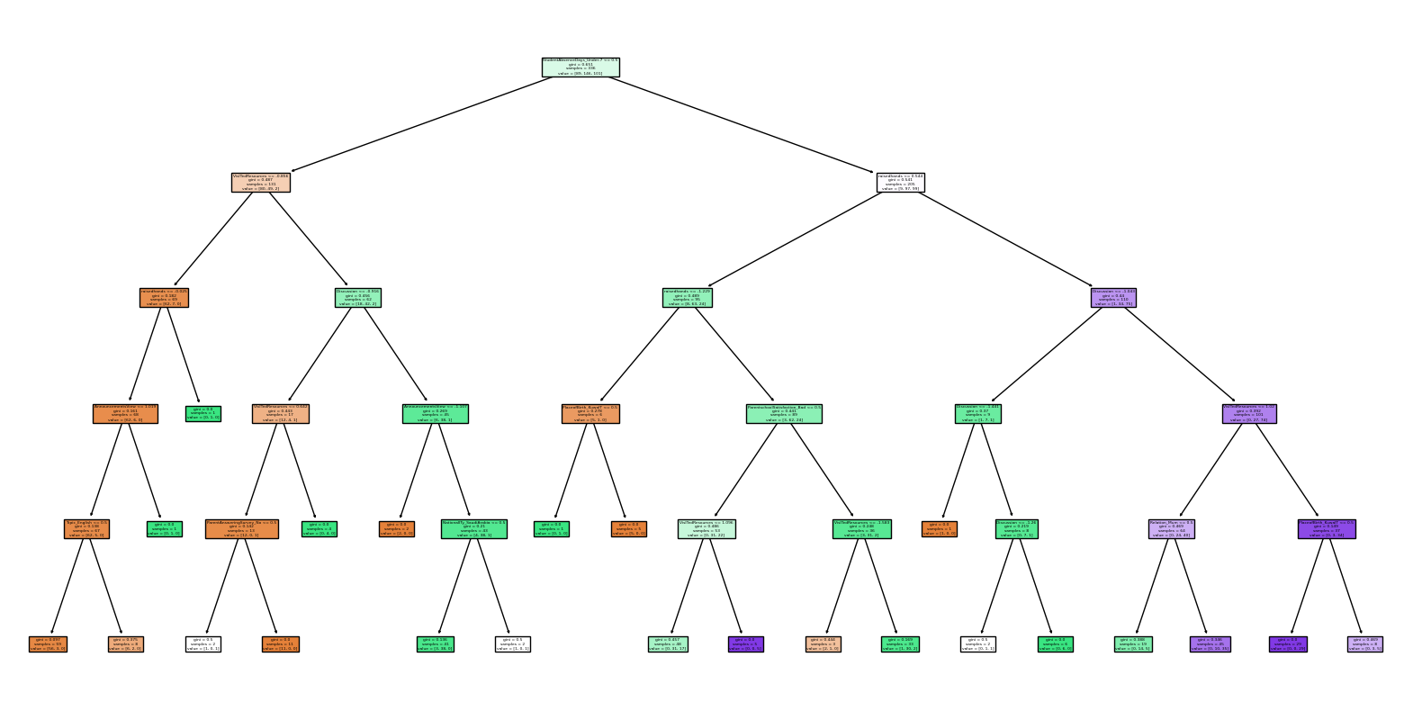
Import the matplotlib.pyplot library as plt and the plot_tree() function from the sklearn.tree module. Create a new figure with a specific size using the figure() function from the pyplot module, passing in the desired size (figsize=(20, 10)). Call the plot_tree() function passing in the 5-depth decision tree tree5 as the first argument and the list of feature names of the training data (data_train_X.columns) as the second argument. Additionally, the filled parameter is set to True to fill the decision nodes with colors depending on the majority class. Show the plot using the show() function from the pyplot module (plt.show()). The decision tree will be displayed in the plot.
import pandas as pd # a wonderful dataframe to work with
import numpy as np # adding a number of mathematical and science functions
import seaborn as sns # a very easy to use statistical data visualization package
import matplotlib.pyplot as plt # a required plotting tool
import warnings
# sklearn is a big source of pre-written and mostly optimized ML algorithms.
# Here we use their Decision trees, Support Vector Machines, and the classic Perceptron.
from sklearn import preprocessing, svm
from sklearn.linear_model import Perceptron
from sklearn.tree import DecisionTreeClassifier
#ignore warnings
warnings.filterwarnings('ignore')
data = pd.read_csv('..\Downloads\stu_performance.csv')
data.head()
gender NationalITy PlaceofBirth StageID GradeID SectionID Topic \
0 M KW KuwaIT lowerlevel G-04 A IT
1 M KW KuwaIT lowerlevel G-04 A IT
2 M KW KuwaIT lowerlevel G-04 A IT
3 M KW KuwaIT lowerlevel G-04 A IT
4 M KW KuwaIT lowerlevel G-04 A IT
Semester Relation raisedhands VisITedResources AnnouncementsView \
0 F Father 15 16 2
1 F Father 20 20 3
2 F Father 10 7 0
3 F Father 30 25 5
4 F Father 40 50 12
Discussion ParentAnsweringSurvey ParentschoolSatisfaction \
0 20 Yes Good
1 25 Yes Good
2 30 No Bad
3 35 No Bad
4 50 No Bad
StudentAbsenceDays Class
0 Under-7 M
1 Under-7 M
2 Above-7 L
3 Above-7 L
4 Above-7 M
gradeID_dict = {"G-01" : 1,
"G-02" : 2,
"G-03" : 3,
"G-04" : 4,
"G-05" : 5,
"G-06" : 6,
"G-07" : 7,
"G-08" : 8,
"G-09" : 9,
"G-10" : 10,
"G-11" : 11,
"G-12" : 12}
data = data.replace({"GradeID" : gradeID_dict})
class_dict = {"L" : -1,
"M" : 0,
"H" : 1}
data = data.replace({"Class" : class_dict})
# Scale numerical fields
data["GradeID"] = preprocessing.scale(data["GradeID"])
data["raisedhands"] = preprocessing.scale(data["raisedhands"])
data["VisITedResources"] = preprocessing.scale(data["VisITedResources"])
data["AnnouncementsView"] = preprocessing.scale(data["AnnouncementsView"])
data["Discussion"] = preprocessing.scale(data["Discussion"])
# Use dummy variables for categorical fields
data = pd.get_dummies(data, columns=["gender",
"NationalITy",
"PlaceofBirth",
"SectionID",
"StageID",
"Topic",
"Semester",
"Relation",
"ParentAnsweringSurvey",
"ParentschoolSatisfaction",
"StudentAbsenceDays"])
# Show preprocessed data
data.head()
GradeID raisedhands VisITedResources AnnouncementsView Discussion \
0 -0.563838 -1.033429 -1.174075 -1.351167 -0.843326
1 -0.563838 -0.870813 -1.053029 -1.313549 -0.662225
2 -0.563838 -1.196046 -1.446426 -1.426401 -0.481125
3 -0.563838 -0.545579 -0.901723 -1.238315 -0.300024
4 -0.563838 -0.220346 -0.145191 -0.974994 0.243279
Class gender_F gender_M NationalITy_Egypt NationalITy_Iran ... \
0 0 0 1 0 0 ...
1 0 0 1 0 0 ...
2 -1 0 1 0 0 ...
3 -1 0 1 0 0 ...
4 0 0 1 0 0 ...
Semester_F Semester_S Relation_Father Relation_Mum \
0 1 0 1 0
1 1 0 1 0
2 1 0 1 0
3 1 0 1 0
4 1 0 1 0
ParentAnsweringSurvey_No ParentAnsweringSurvey_Yes \
0 0 1
1 0 1
2 1 0
3 1 0
4 1 0
ParentschoolSatisfaction_Bad ParentschoolSatisfaction_Good \
0 0 1
1 0 1
2 1 0
3 1 0
4 1 0
StudentAbsenceDays_Above-7 StudentAbsenceDays_Under-7
0 0 1
1 0 1
2 1 0
3 1 0
4 1 0
[5 rows x 64 columns]
corr = data.corr()
corr.iloc[[5]]
GradeID raisedhands VisITedResources AnnouncementsView Discussion \
Class 0.071654 0.646298 0.677094 0.52737 0.308183
Class gender_F gender_M NationalITy_Egypt NationalITy_Iran ... \
Class 1.0 0.26349 -0.26349 -0.02631 -0.054841 ...
Semester_F Semester_S Relation_Father Relation_Mum \
Class -0.126239 0.126239 -0.401142 0.401142
ParentAnsweringSurvey_No ParentAnsweringSurvey_Yes \
Class -0.435495 0.435495
ParentschoolSatisfaction_Bad ParentschoolSatisfaction_Good \
Class -0.375901 0.375901
StudentAbsenceDays_Above-7 StudentAbsenceDays_Under-7
Class -0.671312 0.671312
[1 rows x 64 columns]
from sklearn.ensemble import RandomForestClassifier
from sklearn.model_selection import train_test_split
# Load the dataset
Data = pd.read_csv('..\Downloads\stu_performance.csv')
# Define the features and target variable
X = data.drop('Class', axis=1)
y = data['Class']
# Split the data into training and testing sets
X_train, X_test, y_train, y_test = train_test_split(X, y, test_size=0.2, random_state=42)
# Create a RandomForestClassifier object
rfc = RandomForestClassifier(n_estimators=100, random_state=42)
# Train the model on the training data
rfc.fit(X_train, y_train)
# Evaluate the model on the test data
accuracy = rfc.score(X_test, y_test)
print(f"Accuracy: {accuracy}")
Accuracy: 0.8333333333333334
This code trains a Random Forest Classifier on a dataset of student performance, with the goal of predicting a student's class based on various features such as their age, sex, study time, and past failures.
The steps of the code are:
Load the dataset using pandas, which is stored in a CSV file called 'stu_performance.csv'. Define the features (all columns except 'Class') and target variable ('Class'). Split the data into training and testing sets using train_test_split from sklearn.model_selection. The testing set is 20% of the original data. Create a RandomForestClassifier object with 100 estimators and a random state of 42. Train the model on the training data using rfc.fit. Evaluate the model's accuracy on the testing data using rfc.score and store the result in a variable called accuracy. Print the accuracy of the model on the test set. The output of the code is the accuracy of the model on the test set.
import pandas as pd
import matplotlib.pyplot as plt
# Load the dataset
data = pd.read_csv('..\Downloads\stu_performance.csv')
# Create a scatter plot of two features
plt.scatter(data['raisedhands'], data['VisITedResources'])
plt.title('Scatter Plot of Raised Hands vs. Visited Resources')
plt.xlabel('Raised Hands')
plt.ylabel('Visited Resources')
plt.show()
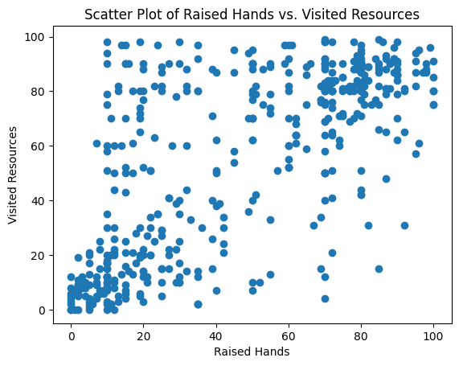
This line creates a scatter plot of two features, raisedhands and VisITedResources, from the data dataframe. The scatter() function is called from the pyplot module in the matplotlib library.
arduino Copy code plt.title('Scatter Plot of Raised Hands vs. Visited Resources') plt.xlabel('Raised Hands') plt.ylabel('Visited Resources') These lines add a title and axis labels to the scatter plot.

from sklearn.metrics import plot_confusion_matrix
# Predict the test data using the trained model
y_pred = rfc.predict(X_test)
# Create the confusion matrix plot
plot_confusion_matrix(rfc, X_test, y_test, cmap=plt.cm.Blues)
plt.title("Confusion Matrix for Random Forest Classifier")
plt.show()
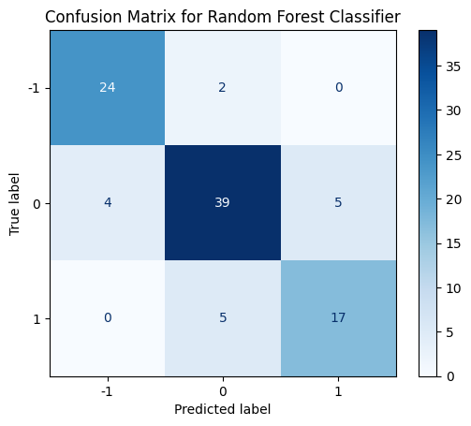
This code is creating a confusion matrix plot for the predictions made by the trained random forest classifier model on the test data.
First, the predict method of the trained model is used to predict the target variable values for the test data, and the predictions are stored in the y_pred variable.
Then, the plot_confusion_matrix function from sklearn.metrics is used to create a confusion matrix plot for the test data. The function takes the trained model, test feature data (X_test), and the true target values for the test data (y_test) as input, and creates a plot of the confusion matrix. The colormap used for the plot is set to plt.cm.Blues.
Finally, a title is added to the plot using the title function from matplotlib.pyplot, and the plot is displayed using the show function.
import matplotlib.pyplot as plt
# Get feature importances
importances = rfc.feature_importances_
features = X.columns
# Sort feature importances in descending order
indices = np.argsort(importances)[::-1]
# Rearrange feature names so they match the sorted feature importances
names = [features[i] for i in indices]
# Create plot
plt.figure()
# Create plot title
plt.title("Feature Importance")
# Add bars
plt.bar(range(X.shape[1]), importances[indices])
# Add feature names as x-axis labels
plt.xticks(range(X.shape[1]), names, rotation=90)
# Show plot
plt.show()
This code creates a bar plot of the feature importances of the random forest model. Here's a breakdown of each line:
import matplotlib.pyplot as plt: imports the matplotlib library and renames it to plt. importances = rfc.feature_importances_: retrieves the feature importances from the trained RandomForestClassifier object rfc. features = X.columns: gets the names of the features used in the model from the X DataFrame. indices = np.argsort(importances)[::-1]: sorts the feature importances in descending order and gets the indices that correspond to the sorted importances. names = [features[i] for i in indices]: rearranges the feature names so that they match the order of the sorted feature importances. plt.figure(): creates a new figure for the plot. plt.title("Feature Importance"): sets the plot title to "Feature Importance". plt.bar(range(X.shape[1]), importances[indices]): creates the bar plot, where the x-axis represents the features and the y-axis represents the feature importances. X.shape[1] is the number of features in the dataset. plt.xticks(range(X.shape[1]), names, rotation=90): sets the x-axis tick labels to be the feature names and rotates them by 90 degrees to make them easier to read. plt.show(): displays the plot.
import matplotlib.pyplot as plt
# Plot the accuracy before training
plt.bar(['Before Training'], [y_test.value_counts(normalize=True)[0]], label='Accuracy')
plt.title('Accuracy Before Training')
plt.ylim((0, 1))
plt.legend()
plt.show()
# Train the model on the training data
rfc.fit(X_train, y_train)
# Evaluate the model on the test data
accuracy = rfc.score(X_test, y_test)
# Plot the accuracy after training
plt.bar(['After Training'], [accuracy], label='Accuracy')
plt.title('Accuracy After Training')
plt.ylim((0, 1))
plt.legend()
plt.show()
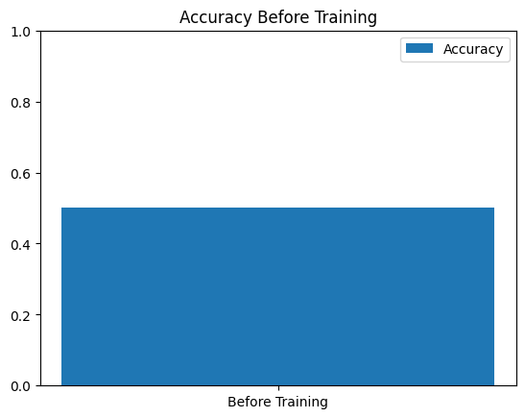
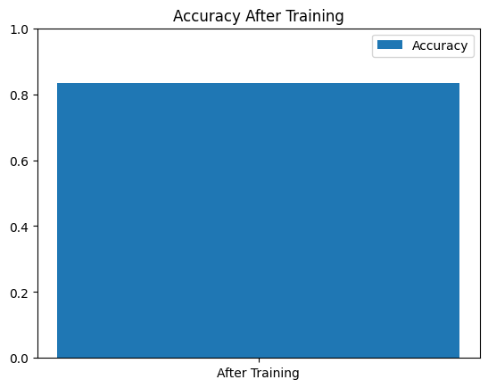
import seaborn as sas
import pandas as pd # a wonderful dataframe to work with
import numpy as np # adding a number of mathematical and science functions
import seaborn as sns # a very easy to use statistical data visualization package
import matplotlib.pyplot as plt # a required plotting tool
import warnings
# sklearn is a big source of pre-written and mostly optimized ML algorithms.
# Here we use their Decision trees, Support Vector Machines, and the classic Perceptron.
from sklearn import preprocessing, svm
from sklearn.linear_model import Perceptron
from sklearn.tree import DecisionTreeClassifier
#ignore warnings
warnings.filterwarnings('ignore')
from google.colab import files
uploaded= files.upload()
<IPython.core.display.HTML object>
Saving OurData.csv to OurData.csv
import io
import pandas as pd
data=pd.read_csv(io.BytesIO(uploaded['OurData.csv']))
data.head()
gender NationalITy PlaceofBirth StageID GradeID SectionID Topic \
0 M KW KuwaIT lowerlevel G-04 A IT
1 M KW KuwaIT lowerlevel G-04 A IT
2 M KW KuwaIT lowerlevel G-04 A IT
3 M KW KuwaIT lowerlevel G-04 A IT
4 M KW KuwaIT lowerlevel G-04 A IT
Semester Relation raisedhands VisITedResources AnnouncementsView \
0 F Father 15 16 2
1 F Father 20 20 3
2 F Father 10 7 0
3 F Father 30 25 5
4 F Father 40 50 12
Discussion ParentAnsweringSurvey ParentschoolSatisfaction \
0 20 Yes Good
1 25 Yes Good
2 30 No Bad
3 35 No Bad
4 50 No Bad
StudentAbsenceDays Class
0 Under-7 M
1 Under-7 M
2 Above-7 L
3 Above-7 L
4 Above-7 M
# Translate GradeID from categorical to numerical
gradeID_dict = {"G-01" : 1,
"G-02" : 2,
"G-03" : 3,
"G-04" : 4,
"G-05" : 5,
"G-06" : 6,
"G-07" : 7,
"G-08" : 8,
"G-09" : 9,
"G-10" : 10,
"G-11" : 11,
"G-12" : 12}
data = data.replace({"GradeID" : gradeID_dict})
class_dict = {"L" : -1,
"M" : 0,
"H" : 1}
data = data.replace({"Class" : class_dict})
# Scale numerical fields
data["GradeID"] = preprocessing.scale(data["GradeID"])
data["raisedhands"] = preprocessing.scale(data["raisedhands"])
data["VisITedResources"] = preprocessing.scale(data["VisITedResources"])
data["AnnouncementsView"] = preprocessing.scale(data["AnnouncementsView"])
data["Discussion"] = preprocessing.scale(data["Discussion"])
# Use dummy variables for categorical fields
data = pd.get_dummies(data, columns=["gender",
"NationalITy",
"PlaceofBirth",
"SectionID",
"StageID",
"Topic",
"Semester",
"Relation",
"ParentAnsweringSurvey",
"ParentschoolSatisfaction",
"StudentAbsenceDays"])
# Show preprocessed data
data.head()
GradeID raisedhands VisITedResources AnnouncementsView Discussion \
0 -0.563838 -1.033429 -1.174075 -1.351167 -0.843326
1 -0.563838 -0.870813 -1.053029 -1.313549 -0.662225
2 -0.563838 -1.196046 -1.446426 -1.426401 -0.481125
3 -0.563838 -0.545579 -0.901723 -1.238315 -0.300024
4 -0.563838 -0.220346 -0.145191 -0.974994 0.243279
Class gender_F gender_M NationalITy_Egypt NationalITy_Iran ... \
0 0 0 1 0 0 ...
1 0 0 1 0 0 ...
2 -1 0 1 0 0 ...
3 -1 0 1 0 0 ...
4 0 0 1 0 0 ...
Semester_F Semester_S Relation_Father Relation_Mum \
0 1 0 1 0
1 1 0 1 0
2 1 0 1 0
3 1 0 1 0
4 1 0 1 0
ParentAnsweringSurvey_No ParentAnsweringSurvey_Yes \
0 0 1
1 0 1
2 1 0
3 1 0
4 1 0
ParentschoolSatisfaction_Bad ParentschoolSatisfaction_Good \
0 0 1
1 0 1
2 1 0
3 1 0
4 1 0
StudentAbsenceDays_Above-7 StudentAbsenceDays_Under-7
0 0 1
1 0 1
2 1 0
3 1 0
4 1 0
[5 rows x 64 columns]
The code performs preprocessing steps on a dataset. Specifically, it:
- Translates the categorical variable "GradeID" into numerical values using a dictionary.
- Translates the categorical variable "Class" into numerical values using a dictionary.
- Scales the numerical fields "GradeID", "raisedhands", "VisITedResources", "AnnouncementsView", and "Discussion" using the preprocessing.scale function from the scikit-learn library.
- Uses dummy variables to represent the categorical fields "gender", "NationalITy", "PlaceofBirth", "SectionID", "StageID", "Topic", "Semester", "Relation", "ParentAnsweringSurvey", "ParentschoolSatisfaction", and "StudentAbsenceDays" using the pd.get_dummies function from the pandas library.
- Displays the preprocessed data using the head method.
corr = data.corr()
corr.iloc[[5]]
GradeID raisedhands VisITedResources AnnouncementsView Discussion \
Class 0.071654 0.646298 0.677094 0.52737 0.308183
Class gender_F gender_M NationalITy_Egypt NationalITy_Iran ... \
Class 1.0 0.26349 -0.26349 -0.02631 -0.054841 ...
Semester_F Semester_S Relation_Father Relation_Mum \
Class -0.126239 0.126239 -0.401142 0.401142
ParentAnsweringSurvey_No ParentAnsweringSurvey_Yes \
Class -0.435495 0.435495
ParentschoolSatisfaction_Bad ParentschoolSatisfaction_Good \
Class -0.375901 0.375901
StudentAbsenceDays_Above-7 StudentAbsenceDays_Under-7
Class -0.671312 0.671312
[1 rows x 64 columns]
corr is a pandas DataFrame containing the correlation coefficients between all pairs of columns in the data DataFrame.
The code corr.iloc[[5]] selects the 6th row of the corr DataFrame (indexing starts at 0), which is a pandas Series containing the correlation coefficients between the 5th column (index 4) of the data DataFrame and all other columns.
In other words, it is showing the correlation coefficients of the "Class" column with all other columns in the data DataFrame.
from sklearn.linear_model import Perceptron
perc = Perceptron(max_iter=100, eta0=0.1, random_state=15)
The code is configuring an instance of the Perceptron classifier by setting the hyperparameters n_iter, eta0, and random_state.
n_iter is the number of iterations the algorithm will go through to train the model. eta0 is the learning rate, which controls the step size at each iteration. random_state is the seed value for the random number generator, which ensures that the results are reproducible.
The purpose of the code is to create an instance of the Perceptron classifier with specific hyperparameters for use in training a machine learning model on a dataset.
#Split Data, Train, and Test - Perceptron
results = []
predMiss = []
for _ in range(1000):
# Randomly sample our training data
data_train = data.sample(frac=0.7)
# train data without label
data_train_X = data_train.loc[:, lambda x: [l for l in data if l != "Class"]]
# labels of train data
data_train_Y = data_train.loc[:, lambda x: "Class"]
# The rest is test data
data_test = data.loc[~data.index.isin(data_train.index)]
# Test data without label
data_test_X = data_test.loc[:, lambda x: [l for l in data if l != "Class"]]
# labels of test data
data_test_Y = data_test.loc[:, lambda x: "Class"]
# Train svm
perc.fit(data_train_X, data_train_Y)
predMiss.append((data_test_Y != perc.predict(data_test_X)).sum())
# Score the mean accuracy on the test data and append results in a list
results.append(perc.score(data_test_X, data_test_Y))
# Convert results to an array and look at the minimum and the average
predErr = np.hstack(predMiss)
Final = np.hstack(results)
print('Minimum Accuracy Score: %.8f' % Final[Final.argmin()])
print('Maximum Accuracy Score: %.8f' % Final[Final.argmax()])
print('Average Accuracy Score: %.8f' % np.average(Final))
print('Minimum Prediction Misses: %d' % predErr[predErr.argmin()])
print('Maximum Prediction Misses: %d' % predErr[predErr.argmax()])
print('Average Prediction Misses: %.2f' % np.average(predErr))
Minimum Accuracy Score: 0.50694444
Maximum Accuracy Score: 0.77777778
Average Accuracy Score: 0.65051389
Minimum Prediction Misses: 32
Maximum Prediction Misses: 71
Average Prediction Misses: 50.33
This code performs the following steps:
It initializes two empty lists: results and predMiss. It loops 1000 times, randomly sampling 70% of the data as training data and the remaining 30% as test data. It splits the training and test data into feature (X) and label (Y) sets. It trains an SVM model (perc) on the training data and predicts the labels for the test data. It appends the number of prediction misses (the number of misclassified test instances) to the predMiss list and the accuracy score of the SVM model on the test data to the results list. After 1000 iterations, it converts the results and predMiss lists to arrays and prints the minimum, maximum, and average accuracy scores, as well as the minimum, maximum, and average number of prediction misses.
import seaborn as sns
import matplotlib.pyplot as plt
sns.set_theme(style="ticks")
# Create a dictionary to store the metrics and their corresponding scores
results_dict = {
'Minimum Accuracy Score': Final[Final.argmin()],
'Maximum Accuracy Score': Final[Final.argmax()],
'Average Accuracy Score': np.average(Final),
'Minimum Prediction Misses': predErr[predErr.argmin()],
'Maximum Prediction Misses': predErr[predErr.argmax()],
'Average Prediction Misses': np.average(predErr)
}
# Convert the dictionary to a pandas DataFrame
results_df = pd.DataFrame.from_dict(results_dict, orient='index', columns=['Score'])
# Initialize the figure with a horizontal boxplot
f, ax = plt.subplots(figsize=(7, 6))
sns.boxplot(x=results_df['Score'], y=results_df.index,
whis=[0, 100], width=.6, palette="vlag")
# Add in points to show each observation
sns.stripplot(x=results_df['Score'], y=results_df.index,
size=4, color=".3", linewidth=0)
# Tweak the visual presentation
ax.xaxis.grid(True)
ax.set(xlabel="Score", ylabel="")
sns.despine(trim=True, left=True)
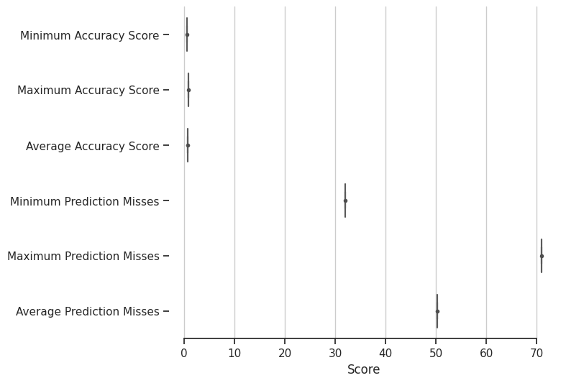
This code is visualizing the results of a machine learning model trained on a dataset using Seaborn, a Python data visualization library.
The first part of the code creates a dictionary called results_dict to store the various metrics and their corresponding scores. These metrics include the minimum accuracy score, maximum accuracy score, average accuracy score, minimum prediction misses, maximum prediction misses, and average prediction misses.
The dictionary is then converted into a Pandas DataFrame called results_df.
The code then creates a horizontal boxplot using sns.boxplot and adds in individual points to show each observation using sns.stripplot. The boxplot shows the distribution of the scores for each metric, while the points show the individual scores.
Finally, the code tweaks the visual presentation of the plot by adding gridlines, removing the left spine, and setting the x-axis label to "Score".

Introducing the SVM Classifiers
# Create the radial basis function kernel version of a Support Vector Machine classifier
rbf_clf = svm.SVC(C=1.0, cache_size=200, class_weight=None, coef0=0.0,
decision_function_shape='ovo', degree=3, gamma='auto', kernel='rbf',
max_iter=-1, probability=False, random_state=None, shrinking=True,
tol=0.001, verbose=False)
This line of code creates an SVM classifier using a radial basis function kernel. It sets various hyperparameters for the SVM, such as the penalty parameter C, the cache size, the decision function shape, and the kernel type (in this case, rbf).
# Create the linear kernel version of a Support Vector Machine classifier
lin_clf = svm.SVC(C=1.0, cache_size=200, class_weight=None, coef0=0.0,
decision_function_shape='ovo', degree=3, gamma='auto', kernel='linear',
max_iter=-1, probability=False, random_state=None, shrinking=True,
tol=0.001, verbose=False)
This line of code creates an SVM classifier using a linear kernel.
# Create the polynomial kernel version of a Support Vector Machine classifier
poly_clf = svm.SVC(C=1.0, cache_size=200, class_weight=None, coef0=0.0,
decision_function_shape='ovo', degree=3, gamma='auto', kernel='poly',
max_iter=-1, probability=False, random_state=None, shrinking=True,
tol=0.001, verbose=False)
This line of code creates an SVM classifier using a polynomial kernel.
# Create the sigmoid kernel version of a Support Vector Machine classifier
sig_clf = svm.SVC(C=1.0, cache_size=200, class_weight=None, coef0=0.0,
decision_function_shape='ovo', degree=3, gamma='auto', kernel='sigmoid',
max_iter=-1, probability=False, random_state=None, shrinking=True,
tol=0.001, verbose=False)
This line of code creates an SVM classifier using a sigmoid kernel. All four SVM classifiers have similar hyperparameters, but they differ in their choice of kernel. The choice of kernel can greatly affect the performance of an SVM classifier, so it's often useful to try several different kernels to see which one works best for a our academic performace dataset.

Split Data, Train, and Test - SVMs
res_rbf = []
predMiss_rbf = []
res_lin = []
predMiss_lin = []
res_poly = []
predMiss_poly = []
res_sig = []
predMiss_sig = []
for _ in range(1000):
# Randomly sample our training data
data_train = data.sample(frac=0.7)
# train data without label
data_train_X = data_train.loc[:, lambda x: [l for l in data if l != "Class"]]
# labels of train data
data_train_Y = data_train.loc[:, lambda x: "Class"]
# The rest is test data
data_test = data.loc[~data.index.isin(data_train.index)]
# Test data without label
data_test_X = data_test.loc[:, lambda x: [l for l in data if l != "Class"]]
# labels of test data
data_test_Y = data_test.loc[:, lambda x: "Class"]
# Train svms
rbf_clf.fit(data_train_X, data_train_Y)
lin_clf.fit(data_train_X, data_train_Y)
poly_clf.fit(data_train_X, data_train_Y)
sig_clf.fit(data_train_X, data_train_Y)
#Sum the prediction misses. Since this is a smaller dataset,
predMiss_rbf.append((data_test_Y != rbf_clf.predict(data_test_X)).sum())
predMiss_lin.append((data_test_Y != lin_clf.predict(data_test_X)).sum())
predMiss_poly.append((data_test_Y != poly_clf.predict(data_test_X)).sum())
predMiss_sig.append((data_test_Y != sig_clf.predict(data_test_X)).sum())
# Score the mean accuracy on the test data and append results in a list
res_rbf.append(rbf_clf.score(data_test_X, data_test_Y))
res_lin.append(lin_clf.score(data_test_X, data_test_Y))
res_poly.append(poly_clf.score(data_test_X, data_test_Y))
res_sig.append(sig_clf.score(data_test_X, data_test_Y))
# Convert results and prediction lists to an array and look at the minimums and the averages
predErr_rbf = np.hstack(predMiss_rbf)
Final_rbf = np.hstack(res_rbf)
predErr_lin = np.hstack(predMiss_lin)
Final_lin = np.hstack(res_lin)
predErr_poly = np.hstack(predMiss_poly)
Final_poly = np.hstack(res_poly)
predErr_sig = np.hstack(predMiss_sig)
Final_sig = np.hstack(res_sig)
print('RBF Minimum Accuracy Score: %.8f' % Final_rbf[Final_rbf.argmin()])
print('RBF Maximum Accuracy Score: %.8f' % Final_rbf[Final_rbf.argmax()])
print('RBF Average Accuracy Score: %.8f' % np.average(Final_rbf))
print('------------------------------------------------')
print('Linear Minimum Accuracy Score: %.8f' % Final_lin[Final_lin.argmin()])
print('Linear Maximum Accuracy Score: %.8f' % Final_lin[Final_lin.argmax()])
print('Linear Average Accuracy Score: %.8f' % np.average(Final_lin))
print('------------------------------------------------')
print('Polynomial Minimum Accuracy Score: %.8f' % Final_poly[Final_poly.argmin()])
print('Polynomial Maximum Accuracy Score: %.8f' % Final_poly[Final_poly.argmax()])
print('Polynomial Average Accuracy Score: %.8f' % np.average(Final_poly))
print('------------------------------------------------')
print('Sigmoid Minimum Accuracy Score: %.8f' % Final_sig[Final_sig.argmin()])
print('Sigmoid Maximum Accuracy Score: %.8f' % Final_sig[Final_sig.argmax()])
print('Sigmoid Average Accuracy Score: %.8f' % np.average(Final_sig))
print('================================================')
#print('Minimum Prediction Misses: %d' % predErr[predErr.argmin()])
#print('Maximum Prediction Misses: %d' % predErr[predErr.argmax()])
print('RBF Average Prediction Misses: %.2f' % np.average(predErr_rbf))
print('Linear Average Prediction Misses: %.2f' % np.average(predErr_lin))
print('Polynomial Average Prediction Misses: %.2f' % np.average(predErr_poly))
print('Sigmoid Average Prediction Misses: %.2f' % np.average(predErr_sig))
RBF Minimum Accuracy Score: 0.63888889
RBF Maximum Accuracy Score: 0.84027778
RBF Average Accuracy Score: 0.74252083
------------------------------------------------
Linear Minimum Accuracy Score: 0.65277778
Linear Maximum Accuracy Score: 0.85416667
Linear Average Accuracy Score: 0.75614583
------------------------------------------------
Polynomial Minimum Accuracy Score: 0.34027778
Polynomial Maximum Accuracy Score: 0.54166667
Polynomial Average Accuracy Score: 0.43827778
------------------------------------------------
Sigmoid Minimum Accuracy Score: 0.55555556
Sigmoid Maximum Accuracy Score: 0.84027778
Sigmoid Average Accuracy Score: 0.72642361
================================================
RBF Average Prediction Misses: 37.08
Linear Average Prediction Misses: 35.12
Polynomial Average Prediction Misses: 80.89
Sigmoid Average Prediction Misses: 39.40
import matplotlib.pyplot as plt
import numpy as np
# Define data
rbf_data = [Final_rbf[Final_rbf.argmin()], Final_rbf[Final_rbf.argmax()], np.average(Final_rbf)]
lin_data = [Final_lin[Final_lin.argmin()], Final_lin[Final_lin.argmax()], np.average(Final_lin)]
poly_data = [Final_poly[Final_poly.argmin()], Final_poly[Final_poly.argmax()], np.average(Final_poly)]
sig_data = [Final_sig[Final_sig.argmin()], Final_sig[Final_sig.argmax()], np.average(Final_sig)]
# Define labels
labels = ['Minimum', 'Maximum', 'Average']
# Define x locations for bars
x = np.arange(len(labels))
# Define bar width
width = 0.2
# Create figure and axis objects
fig, ax = plt.subplots()
# Plot bars for each SVM kernel
ax.bar(x - width, rbf_data, width, label='RBF')
ax.bar(x, lin_data, width, label='Linear')
ax.bar(x + width, poly_data, width, label='Polynomial')
ax.bar(x + 2*width, sig_data, width, label='Sigmoid')
# Set axis labels and title
ax.set_xlabel('Statistic')
ax.set_ylabel('Accuracy')
ax.set_title('Accuracy Scores by SVM Kernel')
# Set x axis tick labels
ax.set_xticks(x + width)
ax.set_xticklabels(labels)
# Add legend
ax.legend()
# Show plot
plt.show()
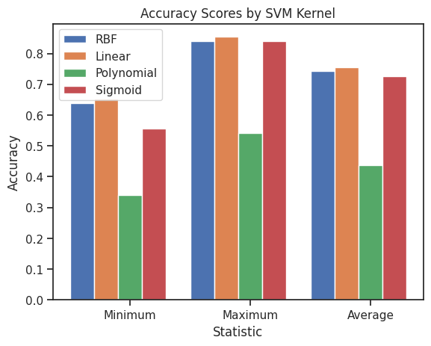
import matplotlib.pyplot as plt
import numpy as np
# Define data
rbf_data = [Final_rbf[Final_rbf.argmin()], Final_rbf[Final_rbf.argmax()], np.average(Final_rbf)]
lin_data = [Final_lin[Final_lin.argmin()], Final_lin[Final_lin.argmax()], np.average(Final_lin)]
poly_data = [Final_poly[Final_poly.argmin()], Final_poly[Final_poly.argmax()], np.average(Final_poly)]
sig_data = [Final_sig[Final_sig.argmin()], Final_sig[Final_sig.argmax()], np.average(Final_sig)]
# Define labels
labels = ['Minimum', 'Maximum', 'Average']
# Define x locations for bars
x = np.arange(len(labels))
# Define bar width
width = 0.15
# Define colors for each bar
colors = ['#1f77b4', '#ff7f0e', '#2ca02c']
# Create figure and axis objects
fig, ax = plt.subplots(figsize=(8, 6))
# Plot bars for each SVM kernel
ax.bar(x - 1.5*width, rbf_data, width, color=colors[0], label='RBF')
ax.bar(x - 0.5*width, lin_data, width, color=colors[1], label='Linear')
ax.bar(x + 0.5*width, poly_data, width, color=colors[2], label='Polynomial')
ax.bar(x + 1.5*width, sig_data, width, color=colors[0], alpha=0.5, label='Sigmoid')
# Set axis labels and title
ax.set_xlabel('Statistic', fontsize=14)
ax.set_ylabel('Accuracy', fontsize=14)
ax.set_title('Accuracy Scores by SVM Kernel', fontsize=16)
# Set x axis tick labels and font size
ax.set_xticks(x)
ax.set_xticklabels(labels, fontsize=12)
# Set y axis tick labels and font size
ax.set_yticklabels(['{:,.0%}'.format(x) for x in ax.get_yticks()], fontsize=12)
# Add legend and set font size
ax.legend(fontsize=12)
# Add gridlines
ax.grid(axis='y', linestyle='--')
# Remove top and right spines
ax.spines['top'].set_visible(False)
ax.spines['right'].set_visible(False)
# Show plot
plt.show()
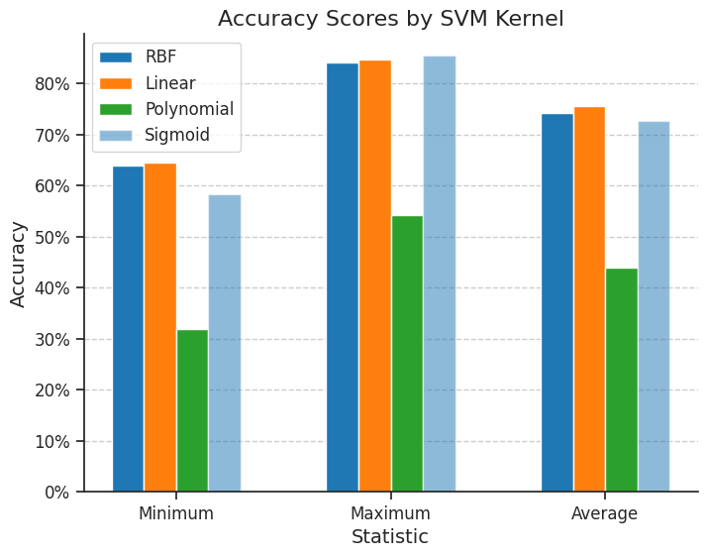
Colors: The RBF and Polynomial bars are colored in blue and green, respectively, while the Linear bar is colored in orange. The Sigmoid bar is also colored in blue but with an alpha value of 0.5 to make it slightly transparent. These colors were chosen to be visually distinct and pleasing.
Font sizes: The font size for the axis labels, tick labels, and legend has been increased to make them more legible.
Y-axis formatting: The y-axis tick labels are formatted as percentages to make the values easier to read.
Gridlines: Horizontal gridlines have been added to aid in reading the y-axis values.
Spines: The top and right spines have been removed to make the plot cleaner.

Future Scope of Improvement

- Various schools and colleges institutions can use these models and modify them according to their needs to use in their student improvement status. This will reduce the manual labor and time spent on determining whether to performance of a student is good or not.

- Parents who intend to take a report can use these trained models to check whether their child’s performance will be good or not. The trained models would be required to be implemented in a platform or interface easily accessible as well as with an easy GUI.
- We saw a high value of the correlation of the "class" attribute with our target attribute. But the feature importance of the "class" attribute was significantly lower. With more data and further analysis, it might be possible to describe the reason for this mismatch.
- All the applicants having the value "class" in the "Performance" attribute were to understand the good and bad performance in the class. With further research and more data for analysis, a more decisive conclusion can be made.

Certificate

This is to certify that Mrs. Arpita Mondal of Asansol Engineering College, roll number: 10871021018, has successfully completed a project on the Academic performance of students using Machine Learning with Python under the guidance of Prof. Arnab Chakraborty.

Prof. Arnab Chakraborty Globsyn Finishing School

Certificate

This is to certify that Mrs. Payel Patra of Asansol Engineering College, roll number: 10871021019, has successfully completed a project on the Academic performance of students using Machine Learning with Python under the guidance of Prof. Arnab Chakraborty.

Prof. Arnab Chakraborty Globsyn Finishing School

Certificate

This is to certify that Mrs. Pooja Arora of Asansol Engineering College, roll number: 10871021020, has successfully completed a project on the Academic performance of students using Machine Learning with Python under the guidance of Prof. Arnab Chakraborty.

Prof. Arnab Chakraborty Globsyn Finishing School

Certificate

This is to certify that Mr. Vishwajit Kumar of Asansol Engineering College, roll number: 10871021020, has successfully completed a project on the Academic performance of students using Machine Learning with Python under the guidance of Prof. Arnab Chakraborty.

Prof. Arnab Chakraborty Globsyn Finishing School

Certificate

This is to certify that Mr. Souradip Maji of Asansol Engineering College, roll number: 10871021030, has successfully completed a project on the Academic performance of students using Machine Learning with Python under the guidance of Prof. Arnab Chakraborty.

Prof. Arnab Chakraborty Globsyn Finishing School

