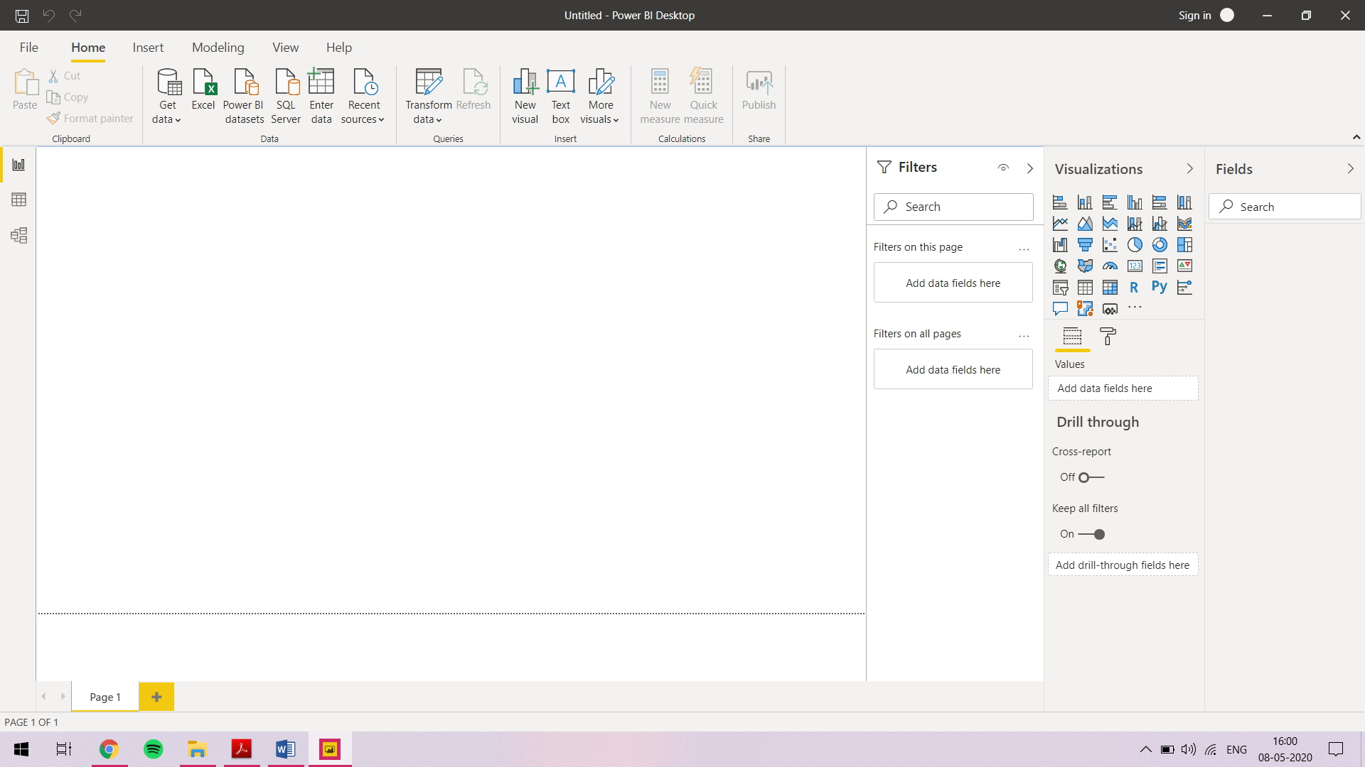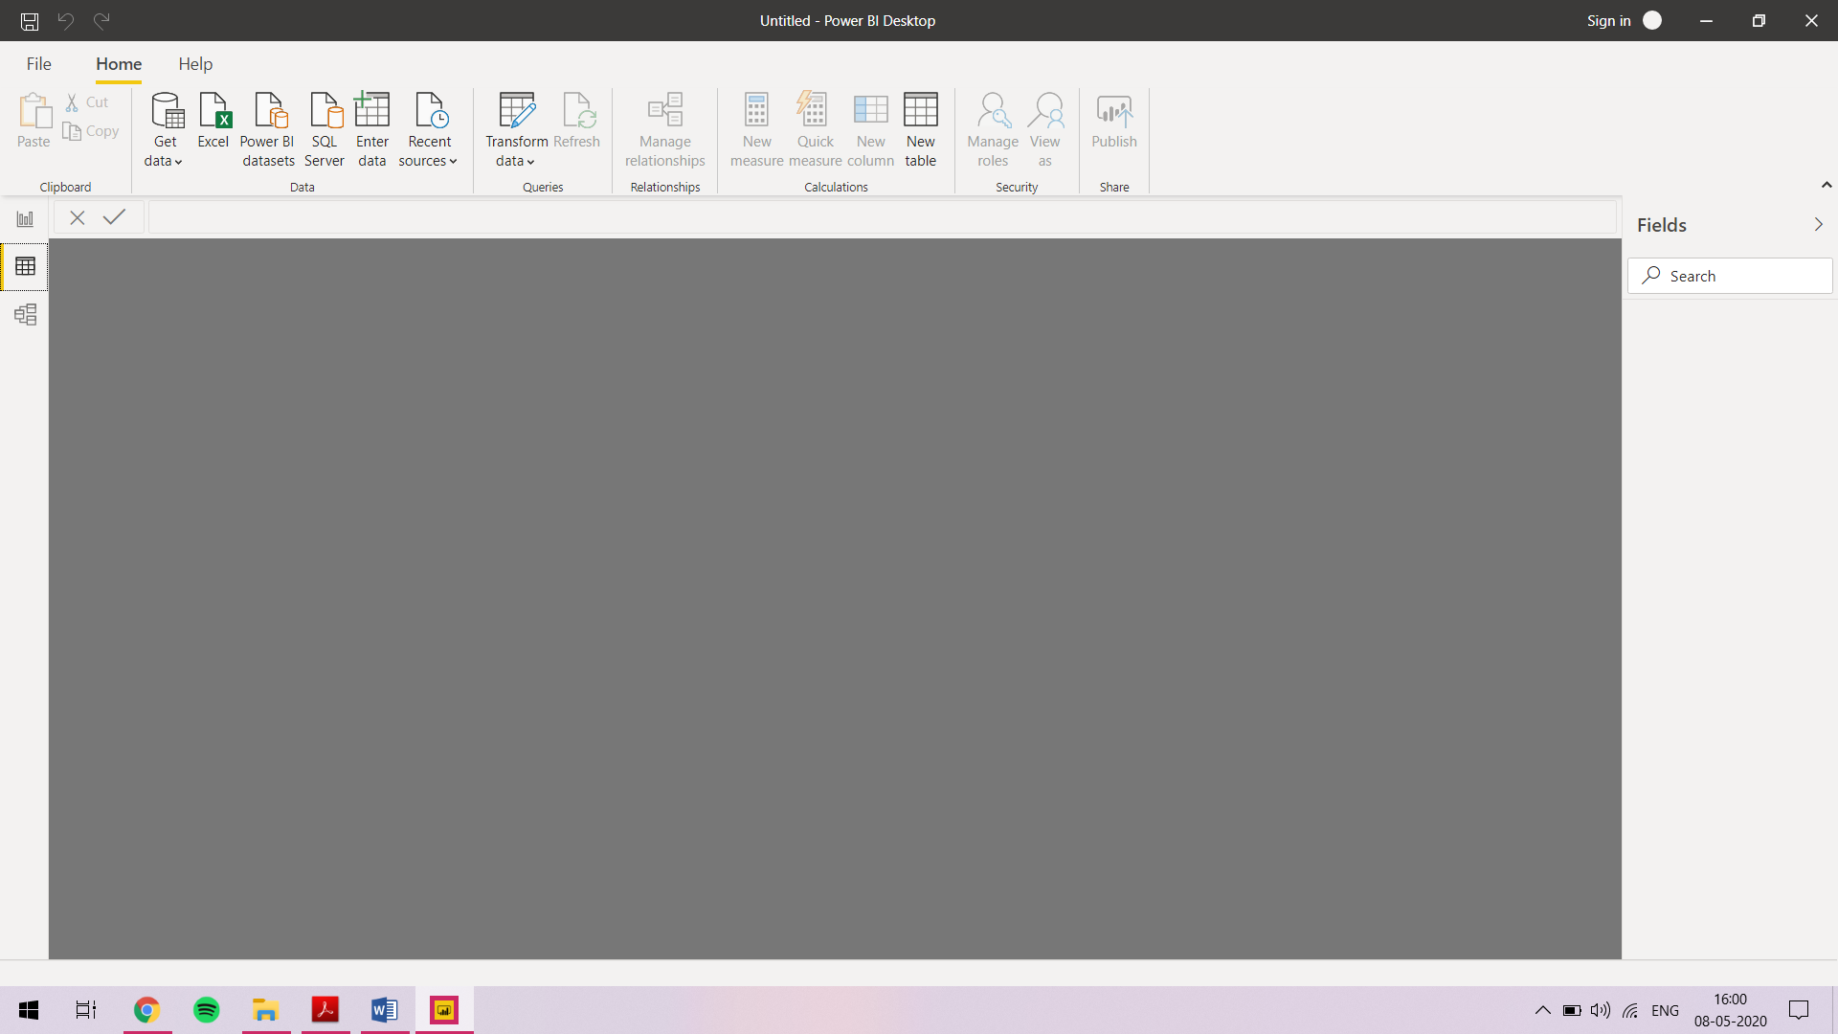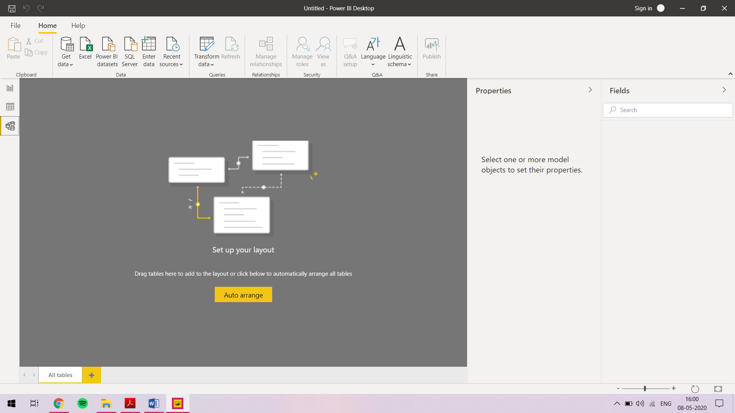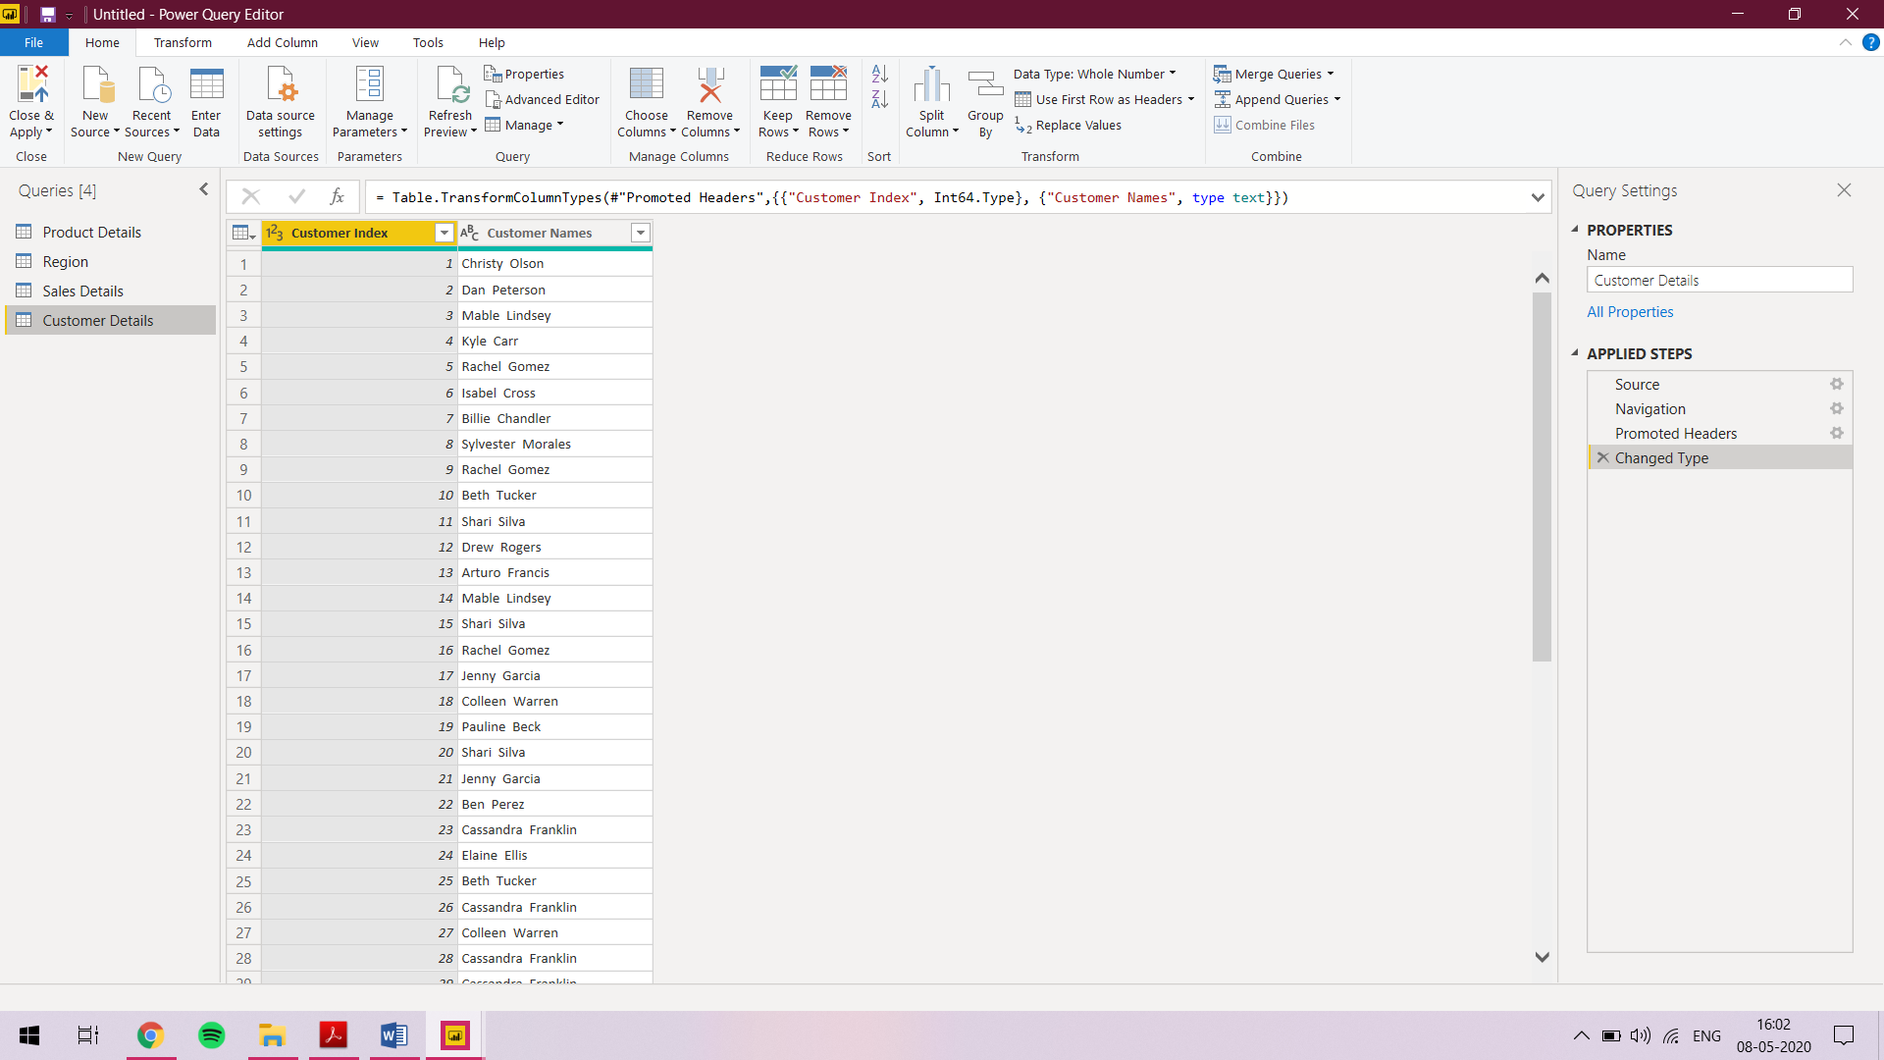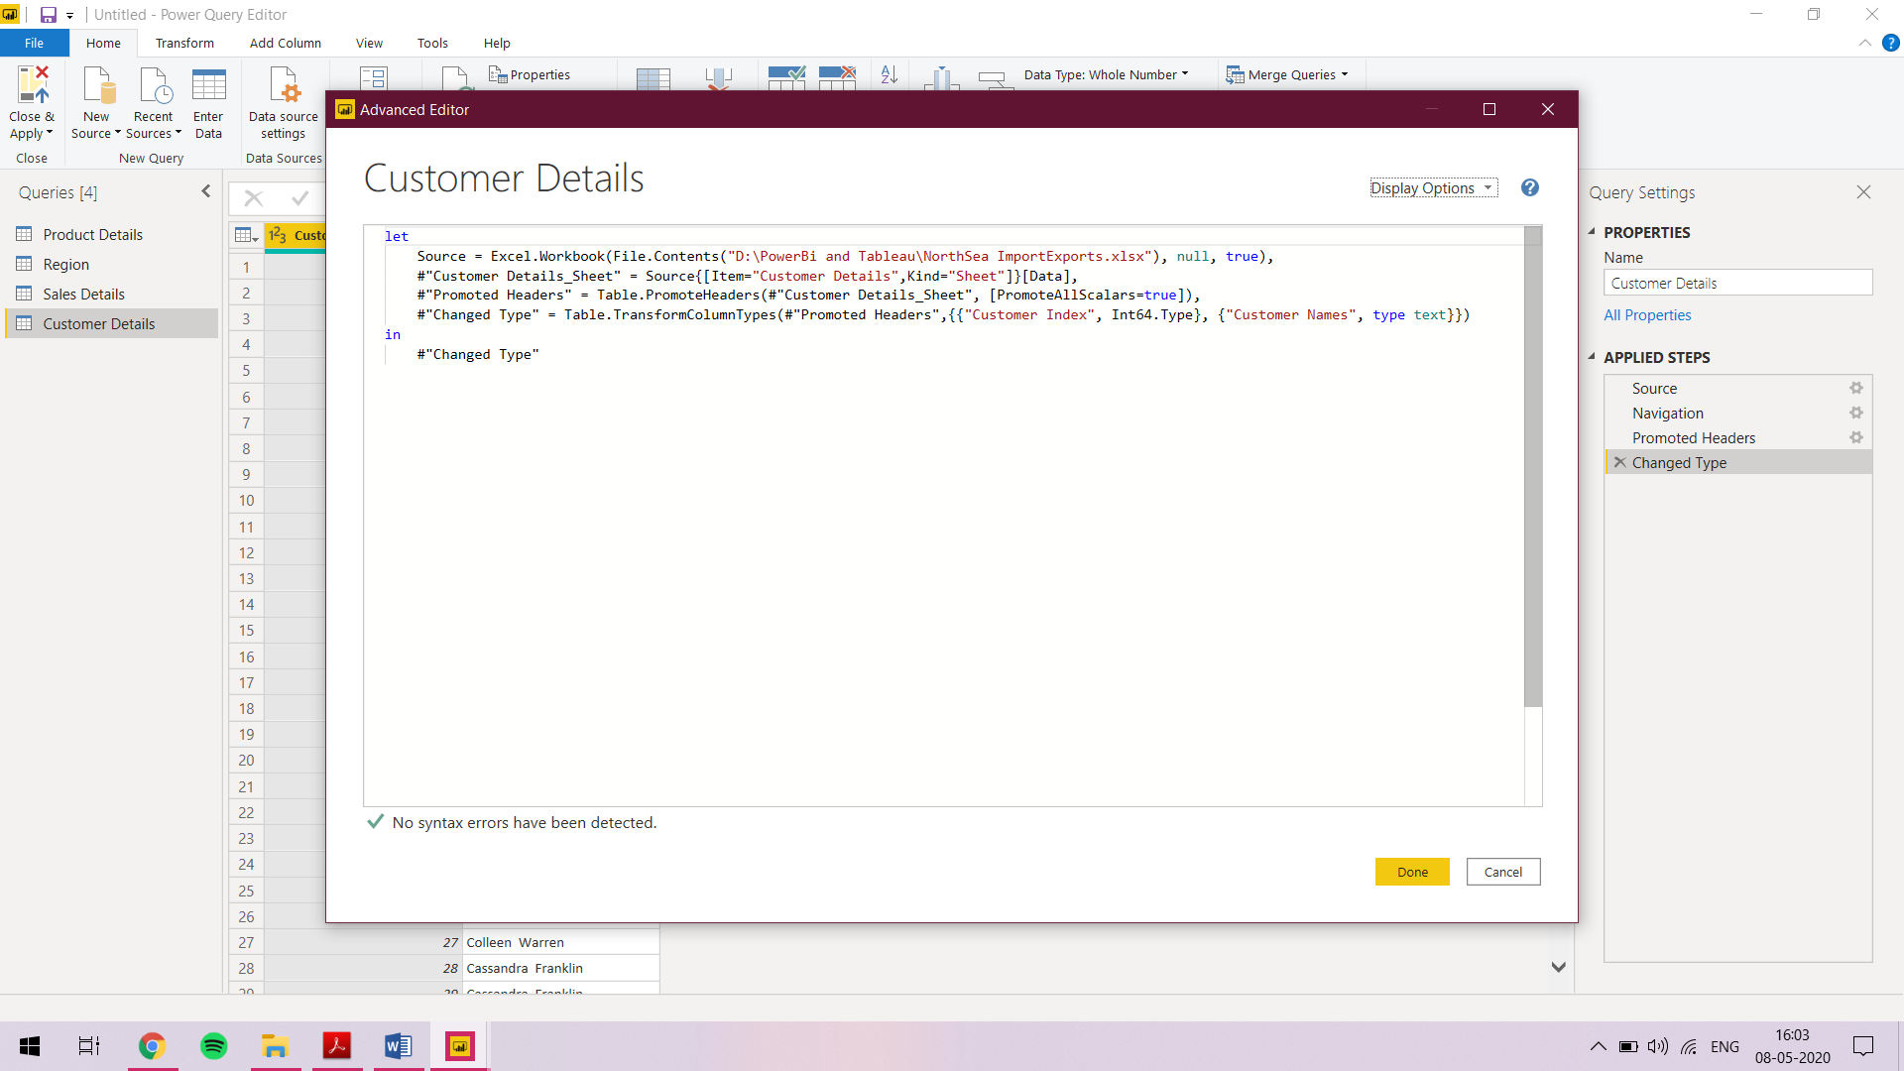

POWER BI:-

**Desktop** version - Power BI Desktop lets you build advanced queries, models, and reports that visualize data. With Power BI Desktop, you can build data models, create reports, and share your work by publishing to the Power BI service. This is free.

**Pro** version - Power BI Pro, users are licensed individually and participate fully in the use of Power BI – both the creation of content and the consumption. All Pro users can connect to hundreds of data sources on-premises and in the cloud, create interactive reports and 360-degree dashboards, share that content with other Pro users, and consume content shared by others. Monthly price per user for pro version is **$9.99**

**Premium** version - Power BI Premium, you are licensing capacity for your content rather than licensing all users of that content. Content (datasets, dashboards, and reports) is stored in Premium and can then be viewed by as many users as you want, without additional per-user costs. These users can only view content, not create it. Viewing includes looking at dashboards and reports on the web, in our mobile apps, or embedded in your organization’s portals or apps. The creators of content in Premium still need their own Pro licenses. Monthly price per dedicated cloud compute and storage resource with annual subscription is **$4,995**