# Setting Up Your Own Branches

* Copy this link: **https://github.com/Bhabishworg/Project-Cleckhuddersfax-Market-Hub.git**
* Go to **Source Control** tab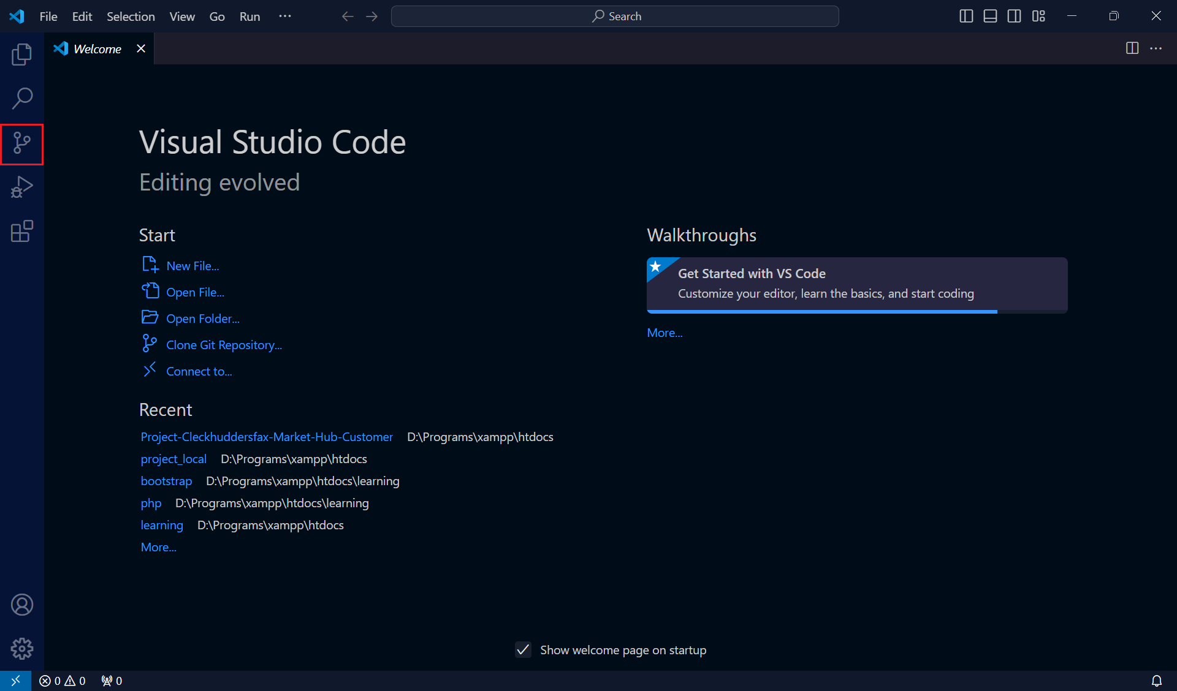
* Click on **Clone Repository**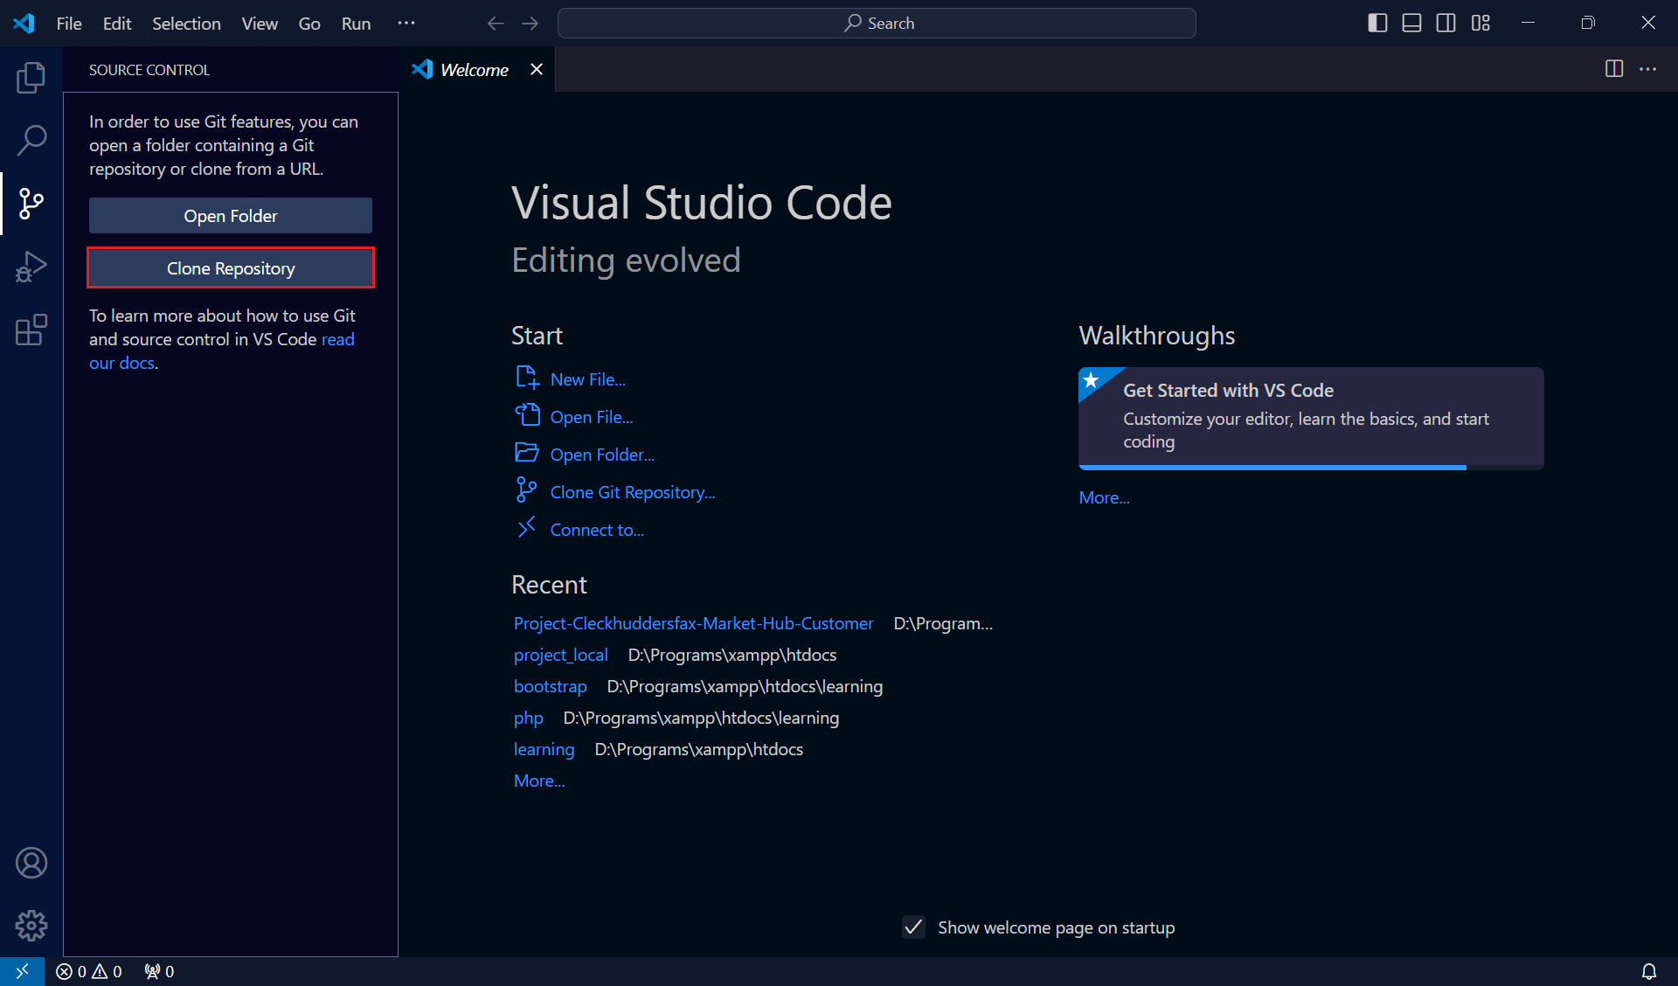
* Paste the link and press Enter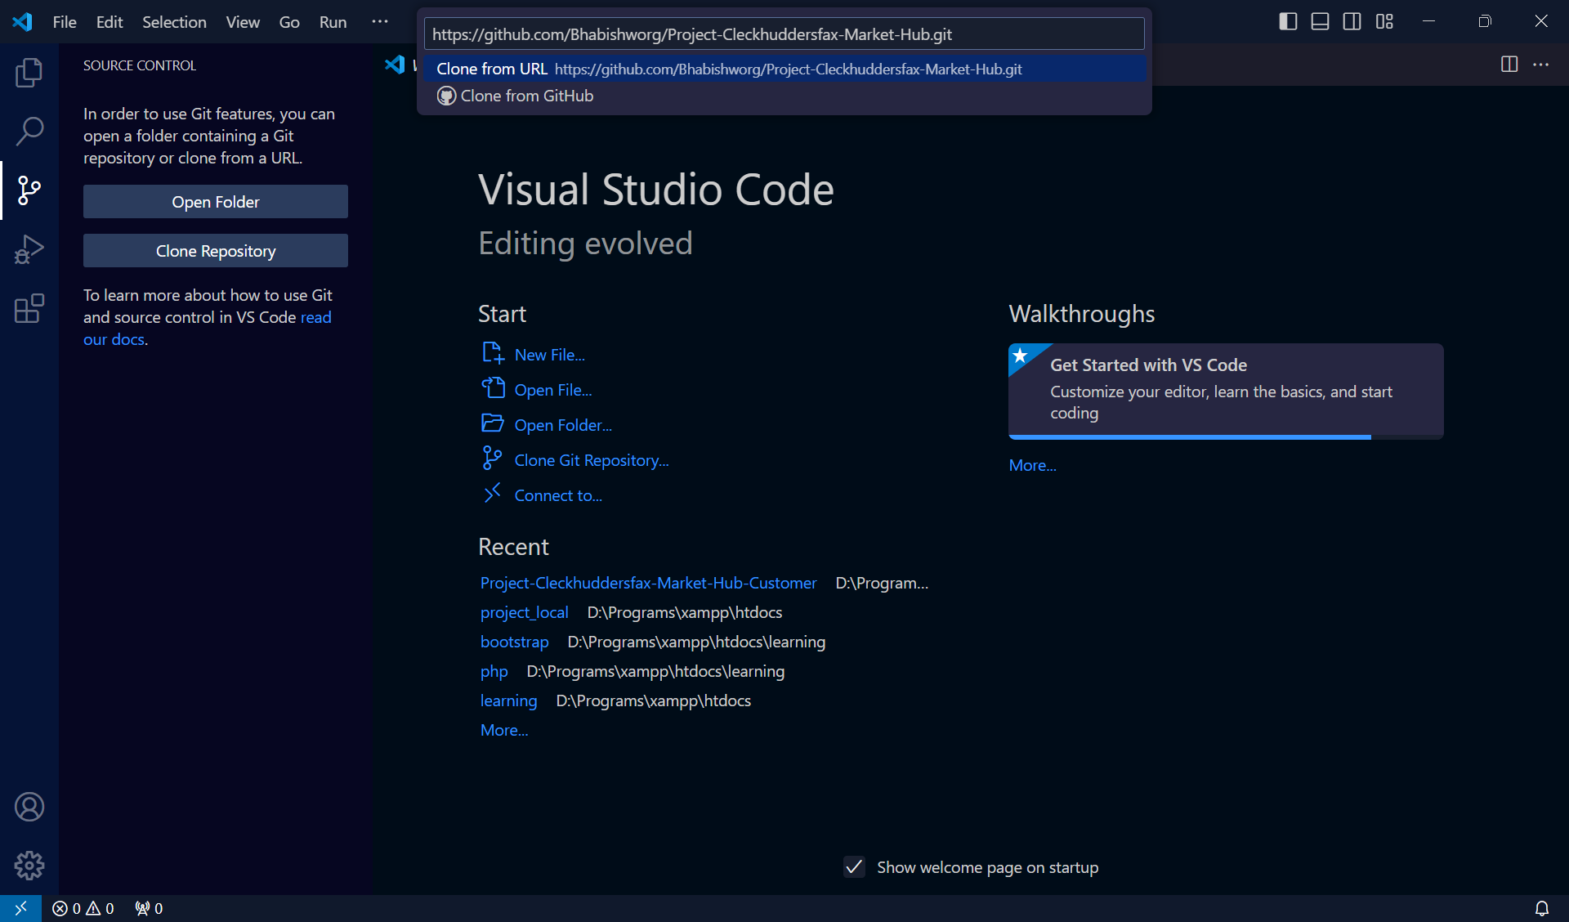
* Choose a location to keep the repository and click **Select as Repository Destination**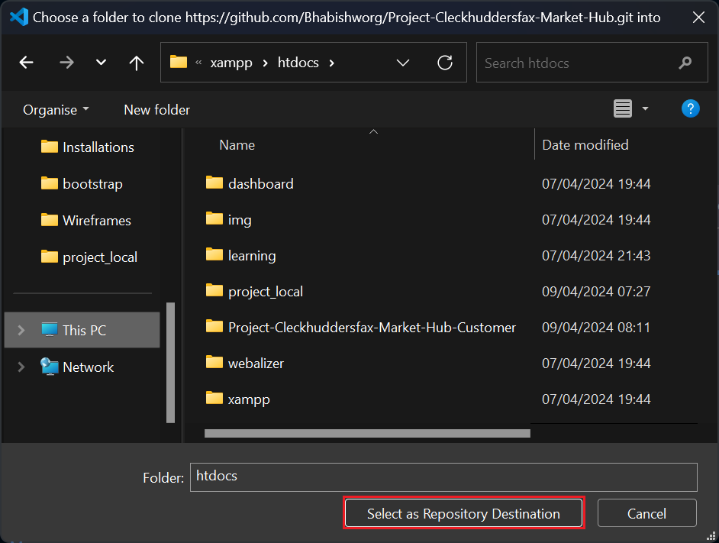
* Click **Open**

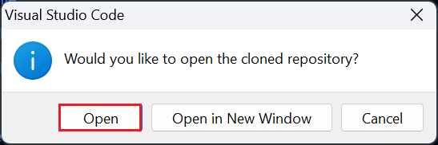

* Click on **master**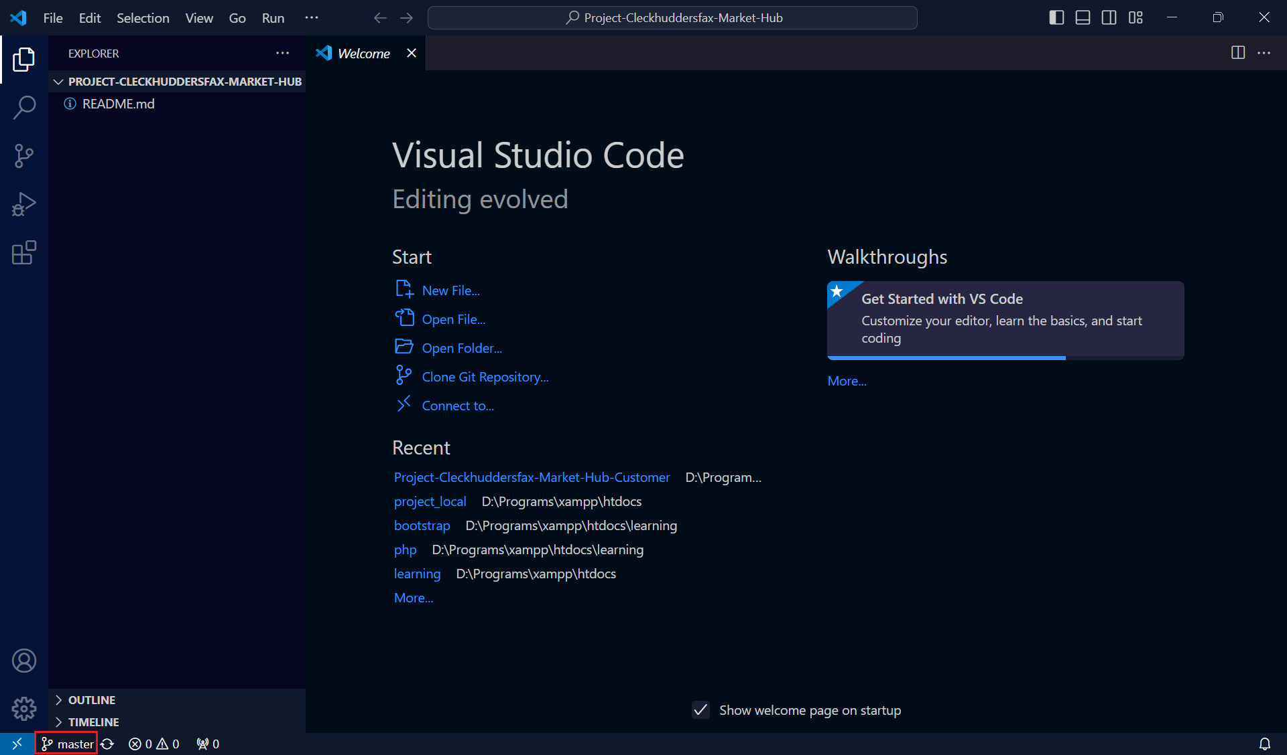
* Click on **origin/Customer**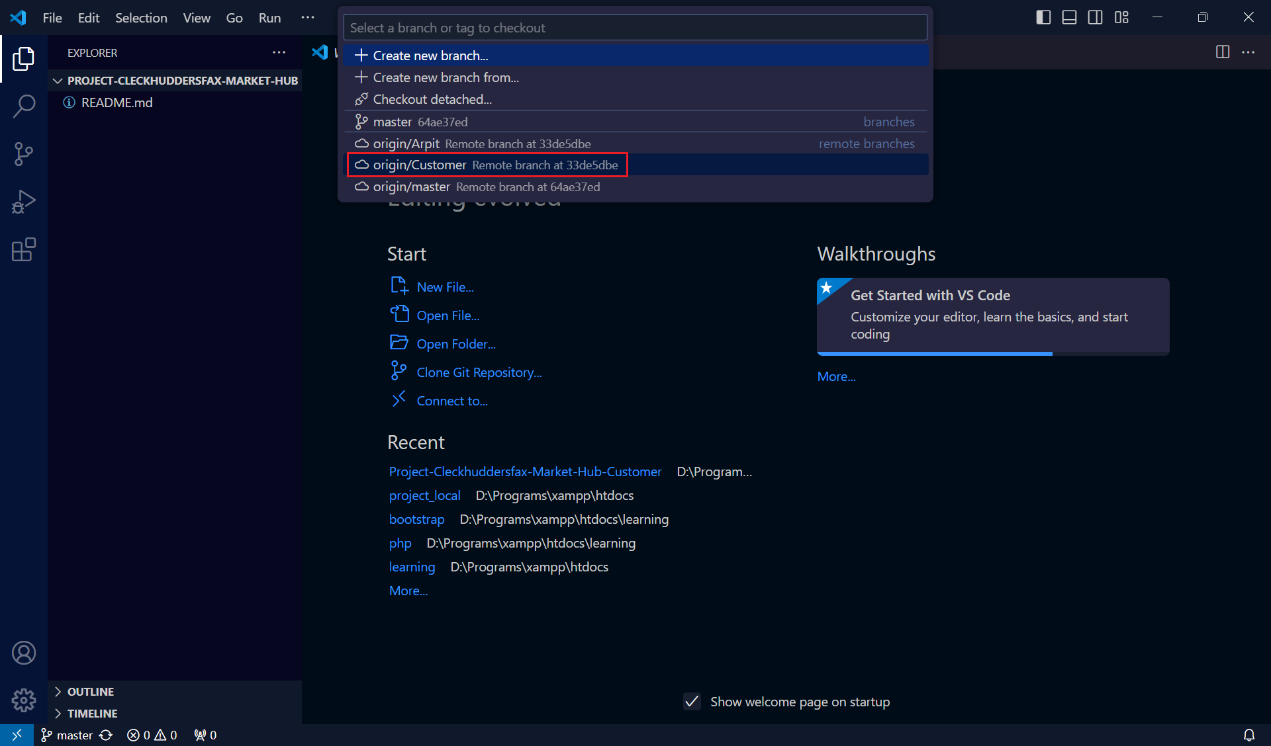
* Click on **Customer**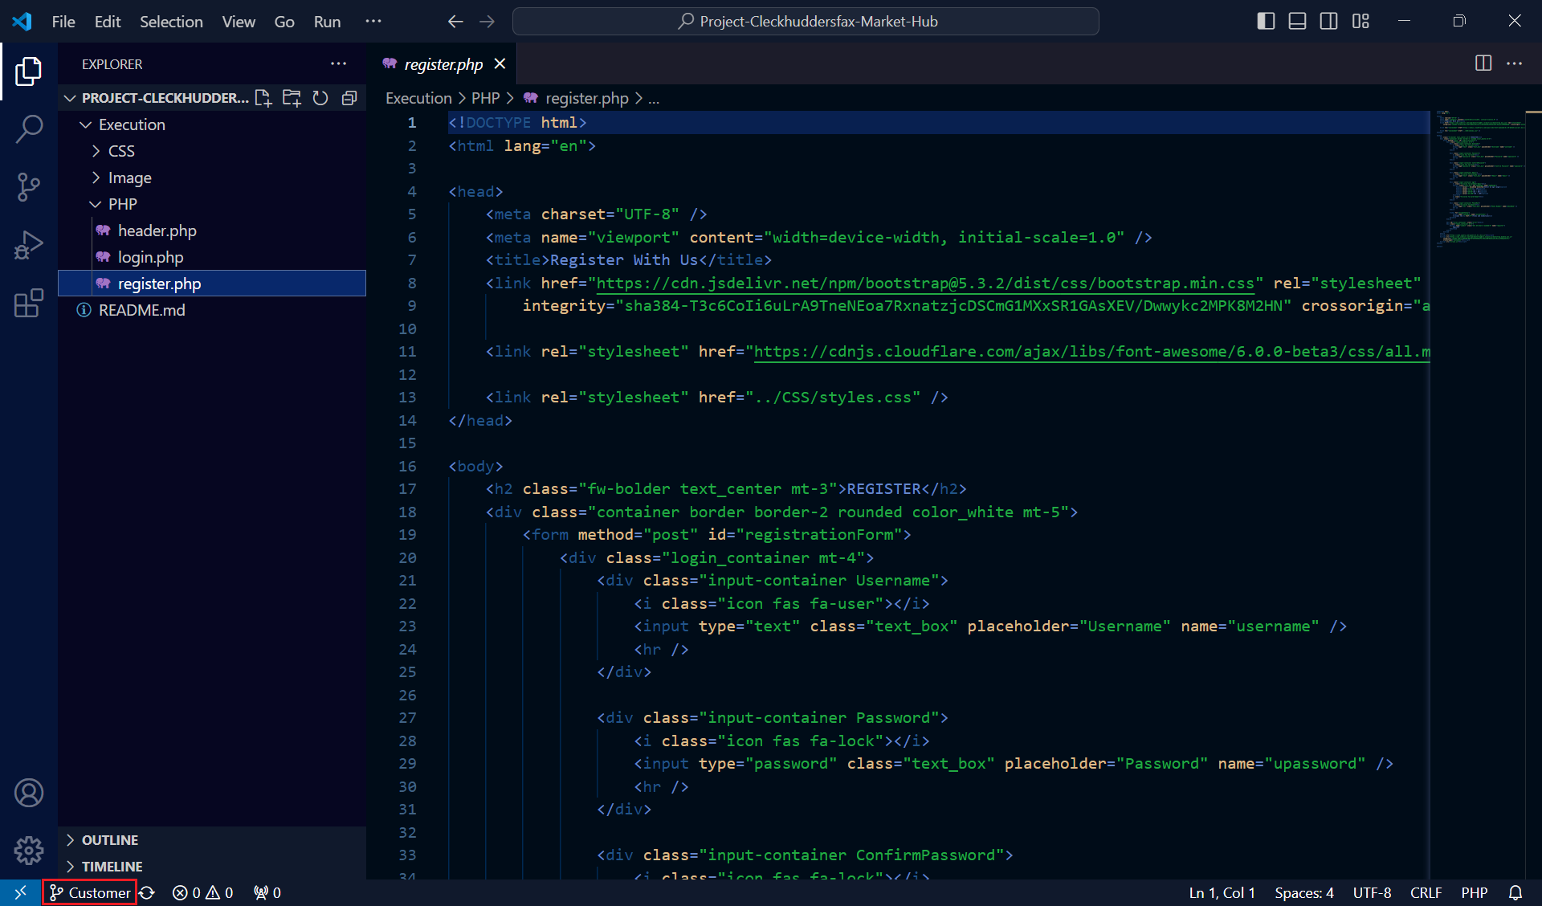
* Click on **Create new branch from…**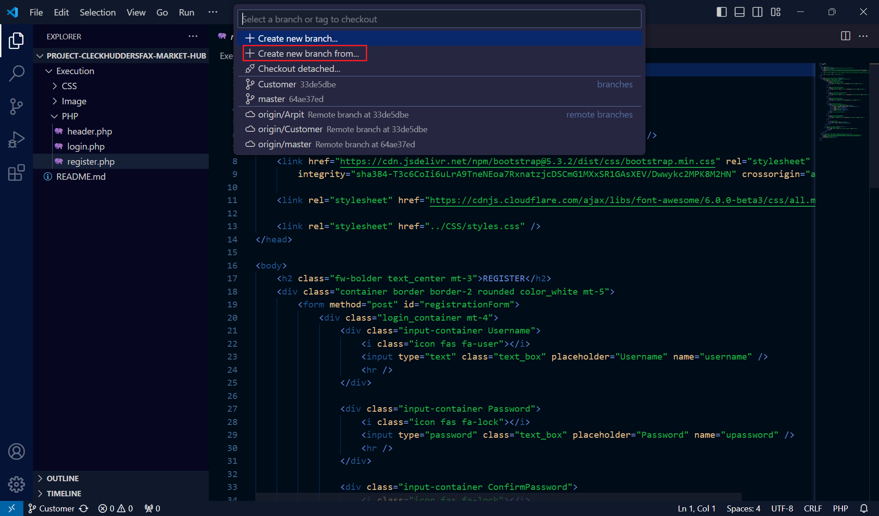
* Click on **Customer**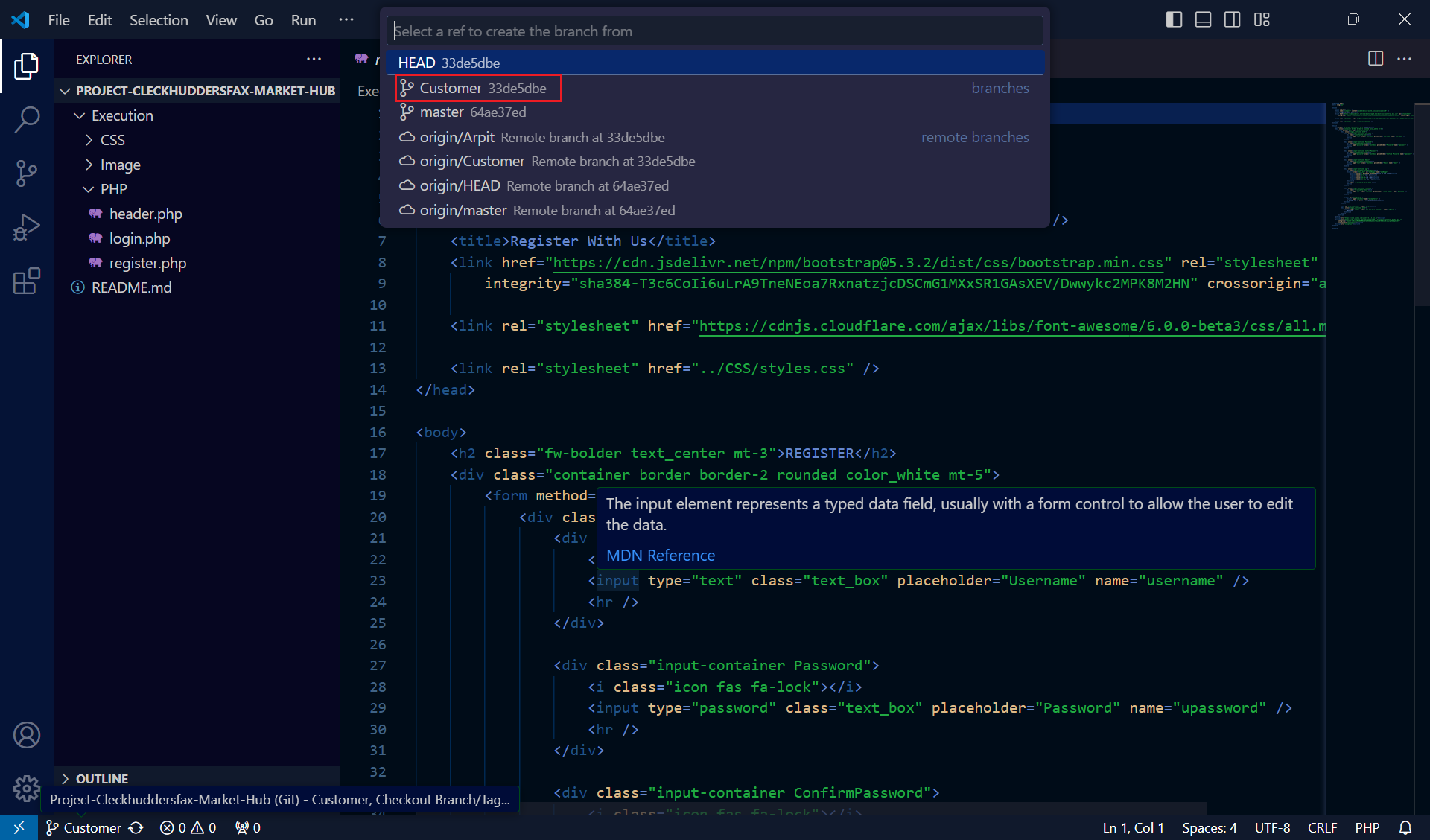
* Write your name and press Enter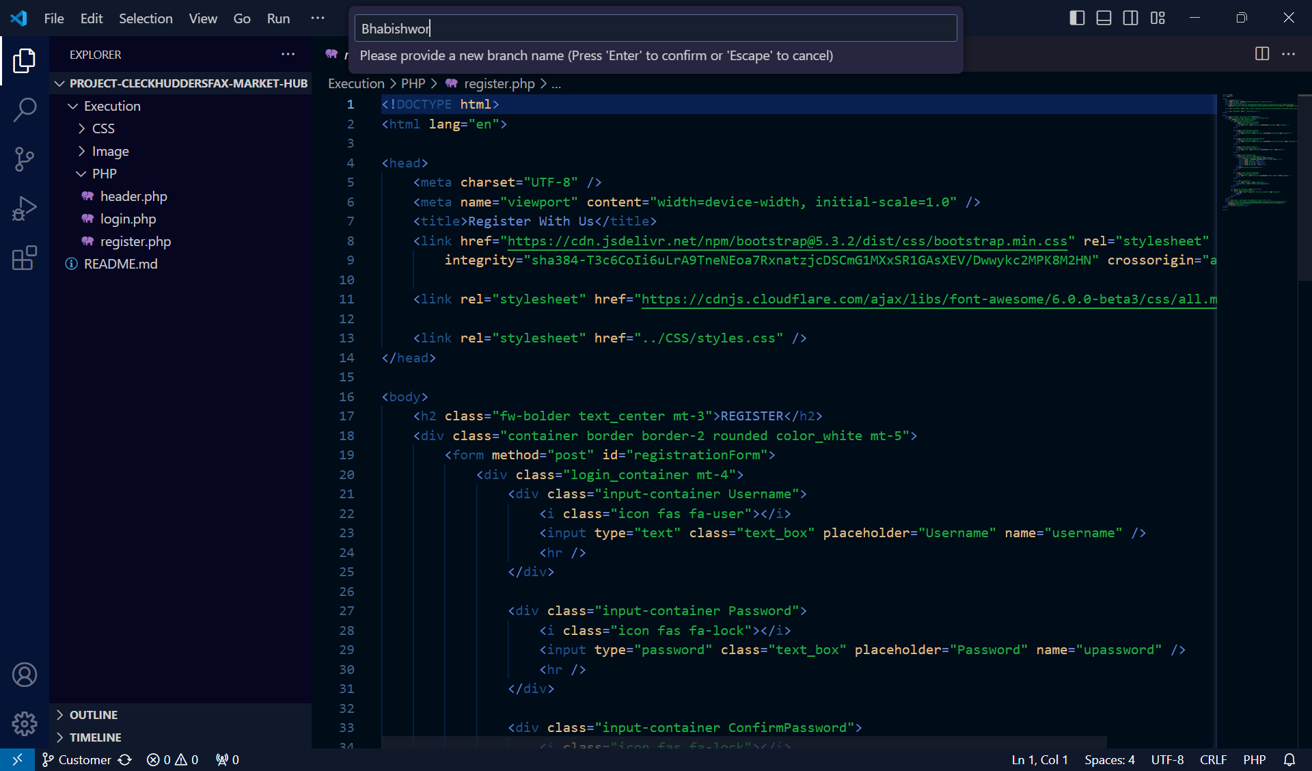
* Press on the icon next to your branch name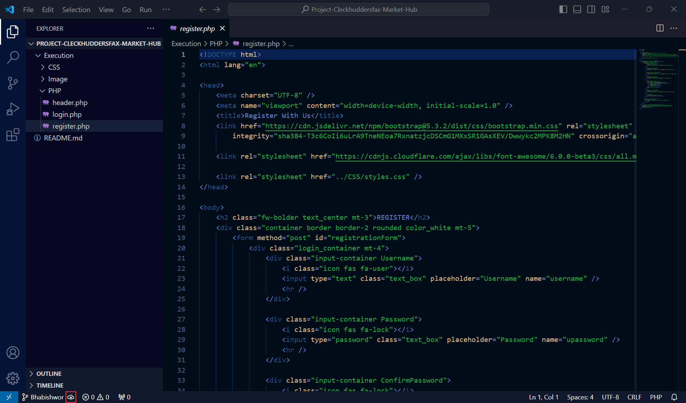
* Sign in

