Name : Shaba Ahmad [JVM]

- Create a directory "exercise" inside your home directory and create nested(dir1/dir2/dir3) directory structure inside "excerise" with single command.
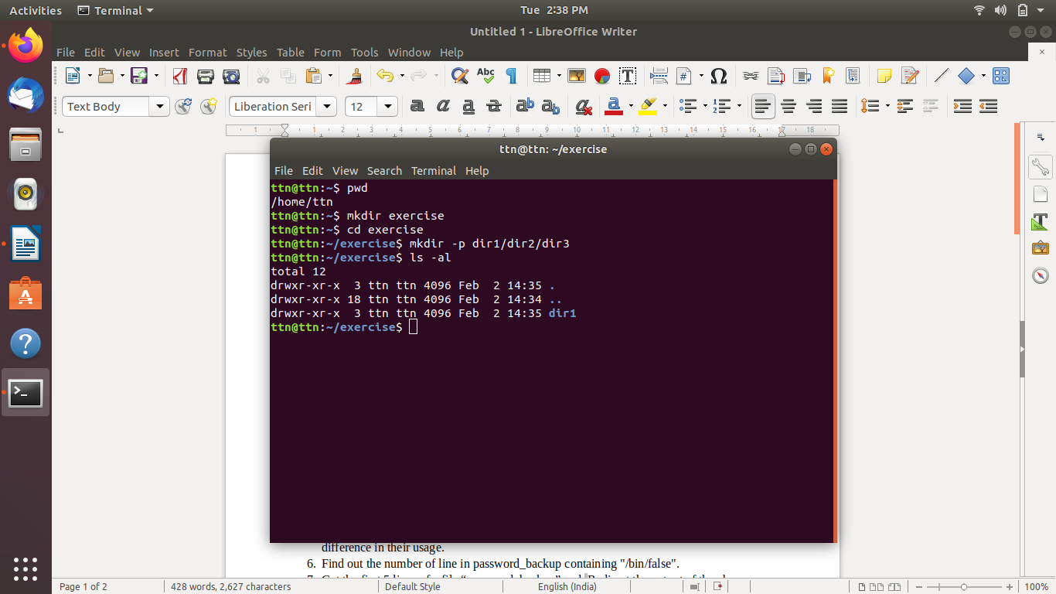
ttn@ttn:~$ pwd
/home/ttn
ttn@ttn:~$ mkdir exercise
ttn@ttn:~$ cd exercise
ttn@ttn:~/exercise$ mkdir -p dir1/dir2/dir3
ttn@ttn:~/exercise$ ls -al
total 12
drwxr-xr-x 3 ttn ttn 4096 Feb 2 14:35 .
drwxr-xr-x 18 ttn ttn 4096 Feb 2 14:34 ..
drwxr-xr-x 3 ttn ttn 4096 Feb 2 14:35 dir1
ttn@ttn:~/exercise$

- Create two empty files inside dir2 directory: emptyFile1,emptyFile2 in single command
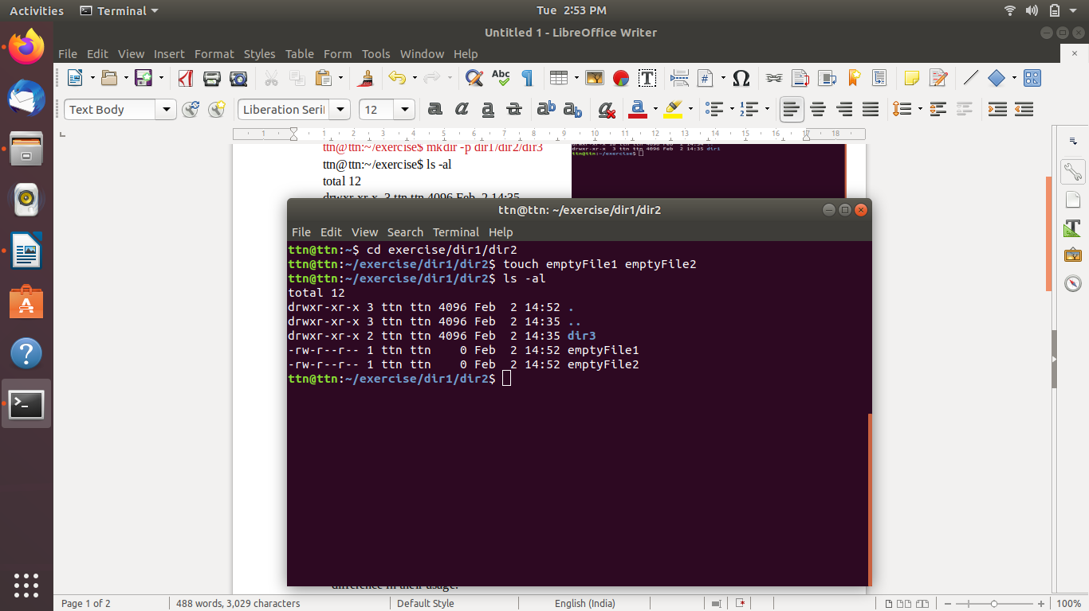
ttn@ttn:~$ cd exercise/dir1/dir2
ttn@ttn:~/exercise/dir1/dir2$ touch emptyFile1 emptyFile2
ttn@ttn:~/exercise/dir1/dir2$ ls -al
total 12
drwxr-xr-x 3 ttn ttn 4096 Feb 2 14:52 .
drwxr-xr-x 3 ttn ttn 4096 Feb 2 14:35 ..
drwxr-xr-x 2 ttn ttn 4096 Feb 2 14:35 dir3
-rw-r--r-- 1 ttn ttn 0 Feb 2 14:52 emptyFile1
-rw-r--r-- 1 ttn ttn 0 Feb 2 14:52 emptyFile2
ttn@ttn:~/exercise/dir1/dir2$

- Create one file file1.txt containing text "hello world" and save it.

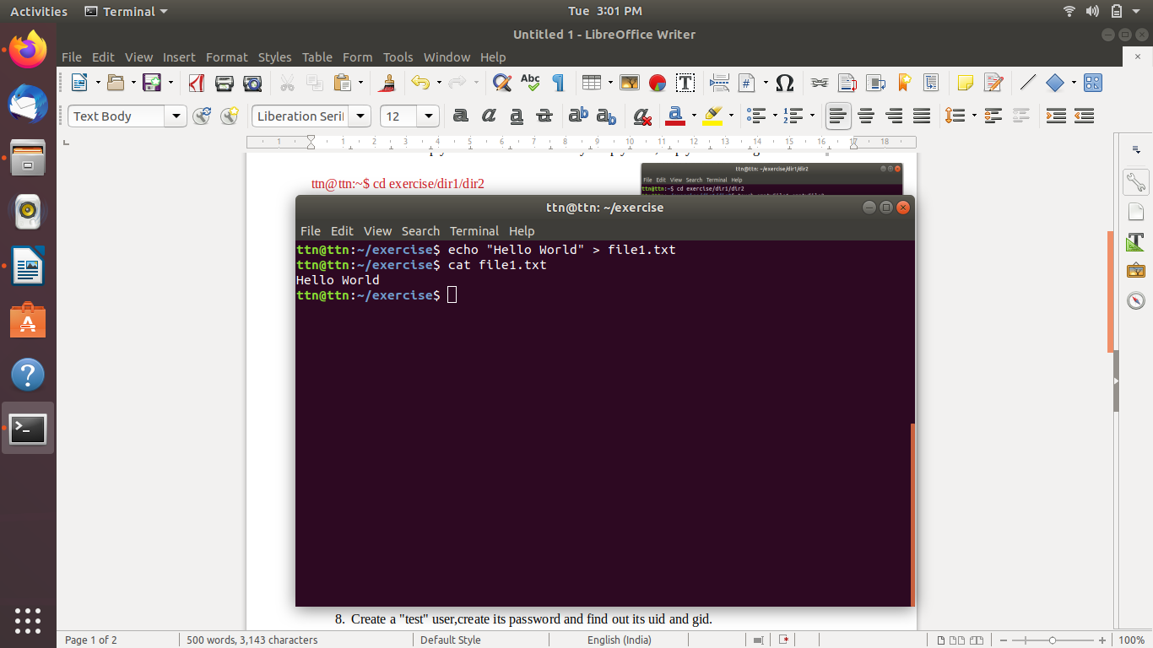
ttn@ttn:~/exercise$ echo "Hello World" > file1.txt
ttn@ttn:~/exercise$ cat file1.txt
Hello World
ttn@ttn:~/exercise$

- Find a "passwd" file using find command inside /etc. copy this files as passwd_copy and then rename this file as passwd_backup.

ttn@ttn:~$ sudo find /etc -name passwd
[sudo] password for ttn:
/etc/cron.daily/passwd
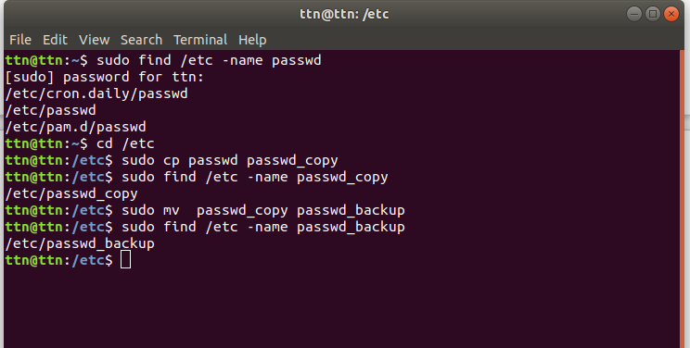
/etc/passwd
/etc/pam.d/passwd
ttn@ttn:~$ cd /etc
ttn@ttn:/etc$ sudo cp passwd passwd_copy
ttn@ttn:/etc$ sudo find /etc -name passwd_copy
/etc/passwd_copy
ttn@ttn:/etc$ sudo mv passwd_copy passwd_backup
ttn@ttn:/etc$ sudo find /etc -name passwd_backup
/etc/passwd_backup
ttn@ttn:/etc$

- Try reading passwd_backup file in multiple tools: less,more,cat,strings etc and find the difference in their usage.

ttn@ttn:~$ cd /etc
ttn@ttn:/etc$ cat passwd_backup
root:x:0:0:root:/root:/bin/bash
daemon:x:1:1:daemon:/usr/sbin:/usr/sbin/nologin
bin:x:2:2:bin:/bin:/usr/sbin/nologin
sys:x:3:3:sys:/dev:/usr/sbin/nologin
sync:x:4:65534:sync:/bin:/bin/sync
games:x:5:60:games:/usr/games:/usr/sbin/nologin
man:x:6:12:man:/var/cache/man:/usr/sbin/nologin
lp:x:7:7:lp:/var/spool/lpd:/usr/sbin/nologin
mail:x:8:8:mail:/var/mail:/usr/sbin/nologin
news:x:9:9:news:/var/spool/news:/usr/sbin/nologin
uucp:x:10:10:uucp:/var/spool/uucp:/usr/sbin/nologin
proxy:x:13:13:proxy:/bin:/usr/sbin/nologin
www-data:x:33:33:www-data:/var/www:/usr/sbin/nologin
backup:x:34:34:backup:/var/backups:/usr/sbin/nologin
list:x:38:38:Mailing List Manager:/var/list:/usr/sbin/nologin
irc:x:39:39:ircd:/var/run/ircd:/usr/sbin/nologin
gnats:x:41:41:Gnats Bug-Reporting System (admin):/var/lib/gnats:/usr/sbin/nologin
nobody:x:65534:65534:nobody:/nonexistent:/usr/sbin/nologin
systemd-network:x:100:102:systemd Network Management,,,:/run/systemd/netif:/usr/sbin/nologin
systemd-resolve:x:101:103:systemd Resolver,,,:/run/systemd/resolve:/usr/sbin/nologin
syslog:x:102:106::/home/syslog:/usr/sbin/nologin
messagebus:x:103:107::/nonexistent:/usr/sbin/nologin
_apt:x:104:65534::/nonexistent:/usr/sbin/nologin
uuidd:x:105:111::/run/uuidd:/usr/sbin/nologin
avahi-autoipd:x:106:112:Avahi autoip daemon,,,:/var/lib/avahi-autoipd:/usr/sbin/nologin
usbmux:x:107:46:usbmux daemon,,,:/var/lib/usbmux:/usr/sbin/nologin
dnsmasq:x:108:65534:dnsmasq,,,:/var/lib/misc:/usr/sbin/nologin
rtkit:x:109:114:RealtimeKit,,,:/proc:/usr/sbin/nologin
cups-pk-helper:x:110:116:user for cups-pk-helper service,,,:/home/cups-pk-helper:/usr/sbin/nologin
speech-dispatcher:x:111:29:Speech Dispatcher,,,:/var/run/speech-dispatcher:/bin/false
whoopsie:x:112:117::/nonexistent:/bin/false
kernoops:x:113:65534:Kernel Oops Tracking Daemon,,,:/:/usr/sbin/nologin
saned:x:114:119::/var/lib/saned:/usr/sbin/nologin
pulse:x:115:120:PulseAudio daemon,,,:/var/run/pulse:/usr/sbin/nologin
avahi:x:116:122:Avahi mDNS daemon,,,:/var/run/avahi-daemon:/usr/sbin/nologin
colord:x:117:123:colord colour management daemon,,,:/var/lib/colord:/usr/sbin/nologin
hplip:x:118:7:HPLIP system user,,,:/var/run/hplip:/bin/false
geoclue:x:119:124::/var/lib/geoclue:/usr/sbin/nologin
gnome-initial-setup:x:120:65534::/run/gnome-initial-setup/:/bin/false
gdm:x:121:125:Gnome Display Manager:/var/lib/gdm3:/bin/false
ttn:x:1000:1000:TTN,,,:/home/ttn:/bin/bash
ttn@ttn:/etc$
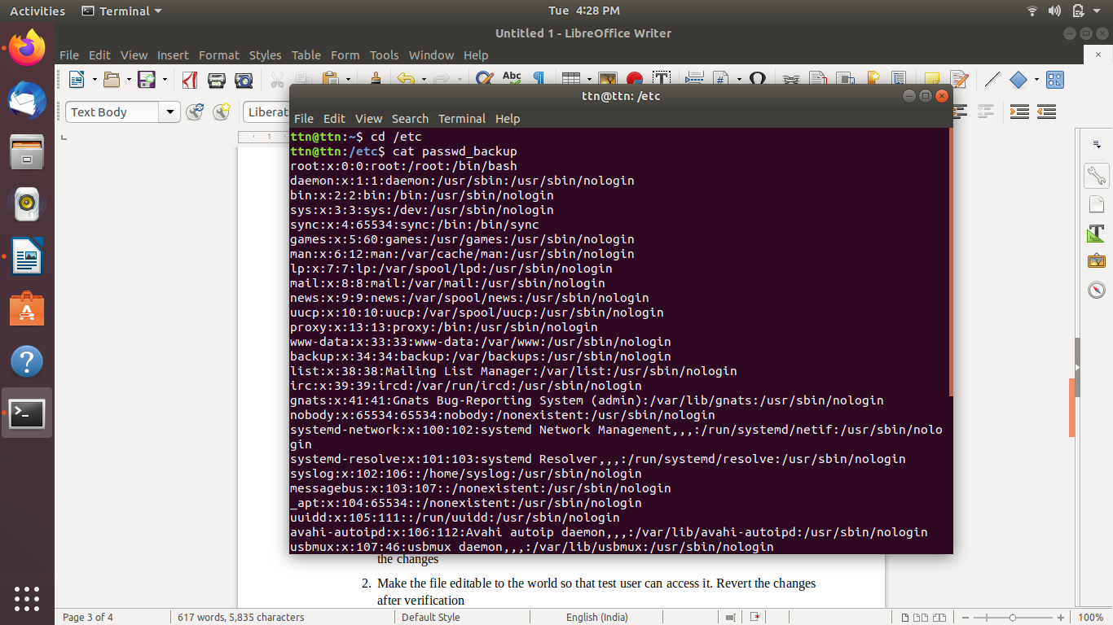
ttn@ttn:/etc$ more passwd_backup
root:x:0:0:root:/root:/bin/bash
daemon:x:1:1:daemon:/usr/sbin:/usr/sbin/nologin
bin:x:2:2:bin:/bin:/usr/sbin/nologin
sys:x:3:3:sys:/dev:/usr/sbin/nologin
sync:x:4:65534:sync:/bin:/bin/sync
games:x:5:60:games:/usr/games:/usr/sbin/nologin
man:x:6:12:man:/var/cache/man:/usr/sbin/nologin
lp:x:7:7:lp:/var/spool/lpd:/usr/sbin/nologin
mail:x:8:8:mail:/var/mail:/usr/sbin/nologin
news:x:9:9:news:/var/spool/news:/usr/sbin/nologin
uucp:x:10:10:uucp:/var/spool/uucp:/usr/sbin/nologin
proxy:x:13:13:proxy:/bin:/usr/sbin/nologin
www-data:x:33:33:www-data:/var/www:/usr/sbin/nologin
backup:x:34:34:backup:/var/backups:/usr/sbin/nologin
list:x:38:38:Mailing List Manager:/var/list:/usr/sbin/nologin
irc:x:39:39:ircd:/var/run/ircd:/usr/sbin/nologin
gnats:x:41:41:Gnats Bug-Reporting System (admin):/var/lib/gnats:/usr/sbin/nologin
nobody:x:65534:65534:nobody:/nonexistent:/usr/sbin/nologin
systemd-network:x:100:102:systemd Network Management,,,:/run/systemd/netif:/usr/sbin/nolo
gin
systemd-resolve:x:101:103:systemd Resolver,,,:/run/systemd/resolve:/usr/sbin/nologin
syslog:x:102:106::/home/syslog:/usr/sbin/nologin
messagebus:x:103:107::/nonexistent:/usr/sbin/nologin
_apt:x:104:65534::/nonexistent:/usr/sbin/nologin
uuidd:x:105:111::/run/uuidd:/usr/sbin/nologin
avahi-autoipd:x:106:112:Avahi autoip daemon,,,:/var/lib/avahi-autoipd:/usr/sbin/nologin
usbmux:x:107:46:usbmux daemon,,,:/var/lib/usbmux:/usr/sbin/nologin
dnsmasq:x:108:65534:dnsmasq,,,:/var/lib/misc:/usr/sbin/nologin
--More--(61%)

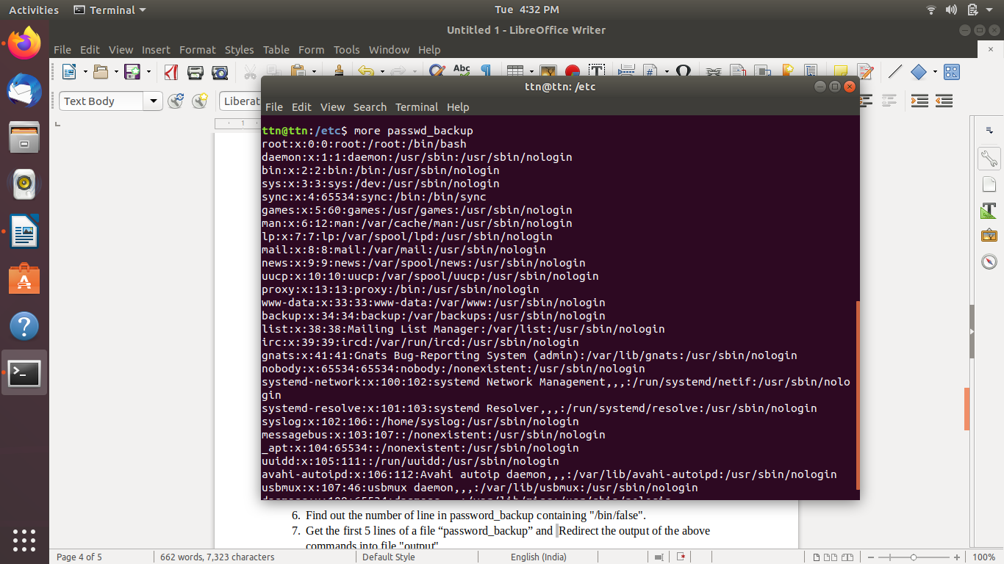
ttn@ttn:/etc$ less passwd_backup

ttn@ttn:/etc$ strings -n 2 passwd_backup
root:x:0:0:root:/root:/bin/bash
daemon:x:1:1:daemon:/usr/sbin:/usr/sbin/nologin
bin:x:2:2:bin:/bin:/usr/sbin/nologin
sys:x:3:3:sys:/dev:/usr/sbin/nologin
sync:x:4:65534:sync:/bin:/bin/sync
games:x:5:60:games:/usr/games:/usr/sbin/nologin
man:x:6:12:man:/var/cache/man:/usr/sbin/nologin
lp:x:7:7:lp:/var/spool/lpd:/usr/sbin/nologin
mail:x:8:8:mail:/var/mail:/usr/sbin/nologin
news:x:9:9:news:/var/spool/news:/usr/sbin/nologin
uucp:x:10:10:uucp:/var/spool/uucp:/usr/sbin/nologin
proxy:x:13:13:proxy:/bin:/usr/sbin/nologin
www-data:x:33:33:www-data:/var/www:/usr/sbin/nologin
backup:x:34:34:backup:/var/backups:/usr/sbin/nologin
list:x:38:38:Mailing List Manager:/var/list:/usr/sbin/nologin
irc:x:39:39:ircd:/var/run/ircd:/usr/sbin/nologin
gnats:x:41:41:Gnats Bug-Reporting System (admin):/var/lib/gnats:/usr/sbin/nologin
nobody:x:65534:65534:nobody:/nonexistent:/usr/sbin/nologin
systemd-network:x:100:102:systemd Network Management,,,:/run/systemd/netif:/usr/sbin/nologin
systemd-resolve:x:101:103:systemd Resolver,,,:/run/systemd/resolve:/usr/sbin/nologin
syslog:x:102:106::/home/syslog:/usr/sbin/nologin
messagebus:x:103:107::/nonexistent:/usr/sbin/nologin
_apt:x:104:65534::/nonexistent:/usr/sbin/nologin
uuidd:x:105:111::/run/uuidd:/usr/sbin/nologin
avahi-autoipd:x:106:112:Avahi autoip daemon,,,:/var/lib/avahi-autoipd:/usr/sbin/nologin
usbmux:x:107:46:usbmux daemon,,,:/var/lib/usbmux:/usr/sbin/nologin
dnsmasq:x:108:65534:dnsmasq,,,:/var/lib/misc:/usr/sbin/nologin
rtkit:x:109:114:RealtimeKit,,,:/proc:/usr/sbin/nologin
cups-pk-helper:x:110:116:user for cups-pk-helper service,,,:/home/cups-pk-helper:/usr/sbin/nologin
speech-dispatcher:x:111:29:Speech Dispatcher,,,:/var/run/speech-dispatcher:/bin/false
whoopsie:x:112:117::/nonexistent:/bin/false
kernoops:x:113:65534:Kernel Oops Tracking Daemon,,,:/:/usr/sbin/nologin
saned:x:114:119::/var/lib/saned:/usr/sbin/nologin
pulse:x:115:120:PulseAudio daemon,,,:/var/run/pulse:/usr/sbin/nologin
avahi:x:116:122:Avahi mDNS daemon,,,:/var/run/avahi-daemon:/usr/sbin/nologin
colord:x:117:123:colord colour management daemon,,,:/var/lib/colord:/usr/sbin/nologin
hplip:x:118:7:HPLIP system user,,,:/var/run/hplip:/bin/false
geoclue:x:119:124::/var/lib/geoclue:/usr/sbin/nologin
gnome-initial-setup:x:120:65534::/run/gnome-initial-setup/:/bin/false
gdm:x:121:125:Gnome Display Manager:/var/lib/gdm3:/bin/false
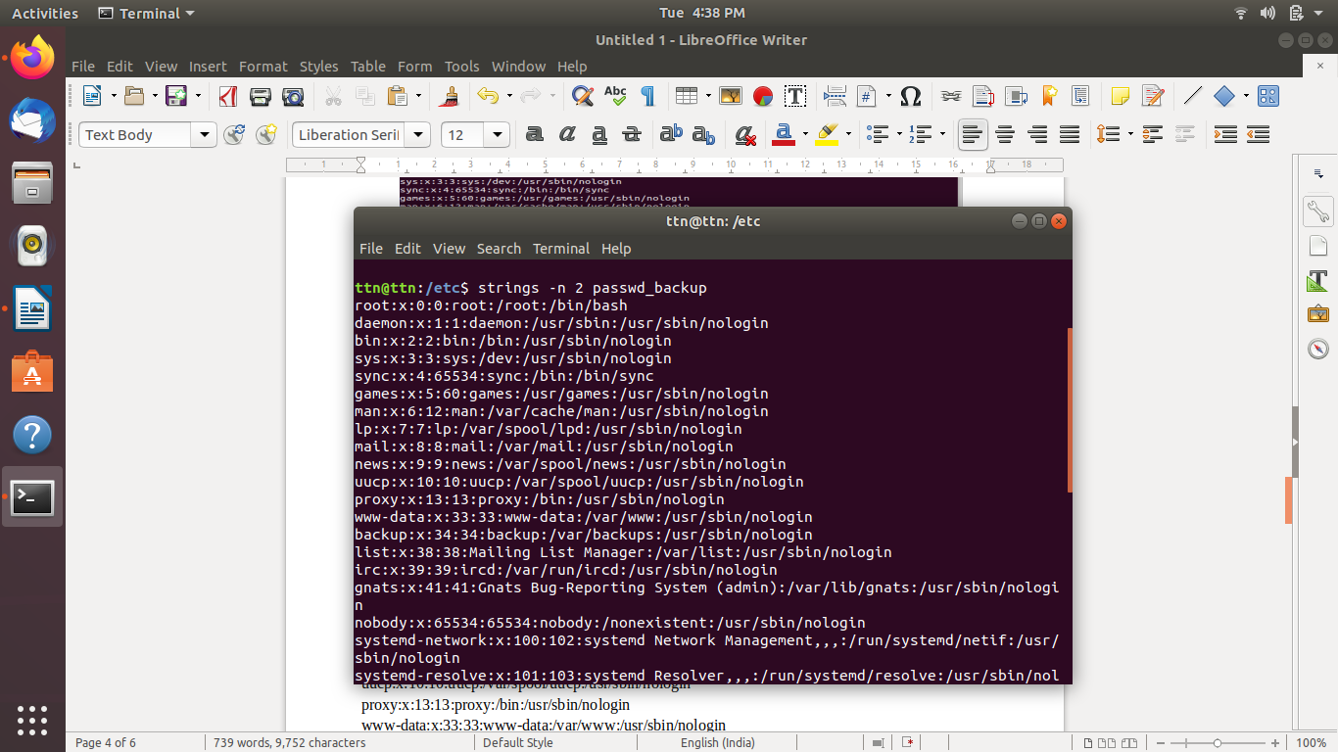
ttn:x:1000:1000:TTN,,,:/home/ttn:/bin/bash

- Find out the number of line in password_backup containing "/bin/false".

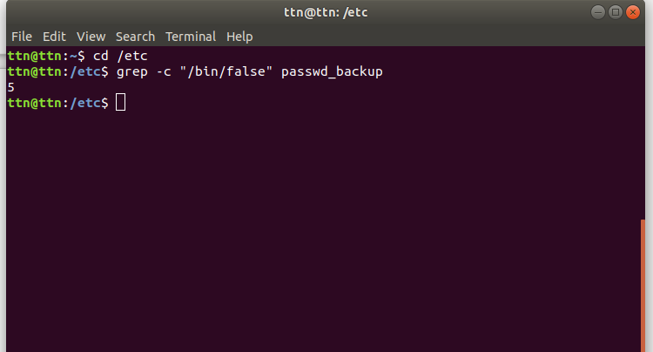
ttn@ttn:~$ cd /etc
ttn@ttn:/etc$ grep -c "/bin/false" passwd_backup
5
ttn@ttn:/etc$

- Get the first 5 lines of a file “password_backup” and Redirect the output of the above commands into file "output".
ttn@ttn:~$ head -n 5 /etc/passwd_backup > output
ttn@ttn:~$ cat output
root:x:0:0:root:/root:/bin/bash
daemon:x:1:1:daemon:/usr/sbin:/usr/sbin/nologin
bin:x:2:2:bin:/bin:/usr/sbin/nologin
sys:x:3:3:sys:/dev:/usr/sbin/nologin
sync:x:4:65534:sync:/bin:/bin/sync
ttn@ttn:~$
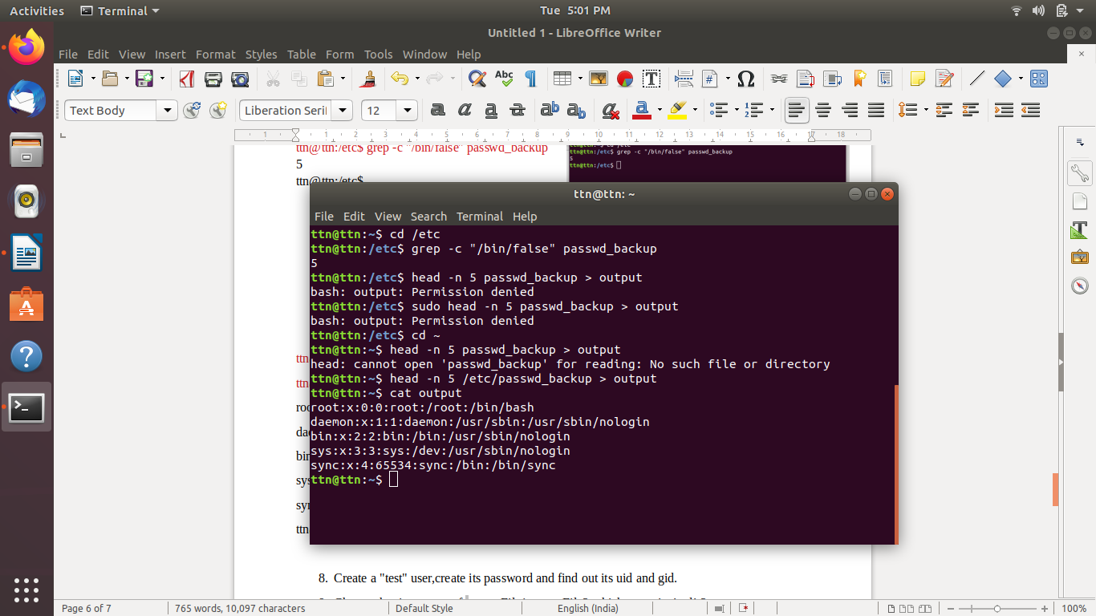

- Create a "test" user,create its password and find out its uid and gid.
ttn@ttn:~$ sudo adduser test
[sudo] password for ttn:
Adding user `test' ...
Adding new group `test' (1001) ...
Adding new user `test' (1001) with group `test' ...
Creating home directory `/home/test' ...
Copying files from `/etc/skel' ...
Enter new UNIX password:
Retype new UNIX password:
passwd: password updated successfully
Changing the user information for test
Enter the new value, or press ENTER for the default
Full Name []:
Room Number []:
Work Phone []:
Home Phone []:
Other []:
Is the information correct? [Y/n] Y
ttn@ttn:~$ sudo id -u test
1001
ttn@ttn:~$ sudo id -g test
1001
ttn@ttn:~$
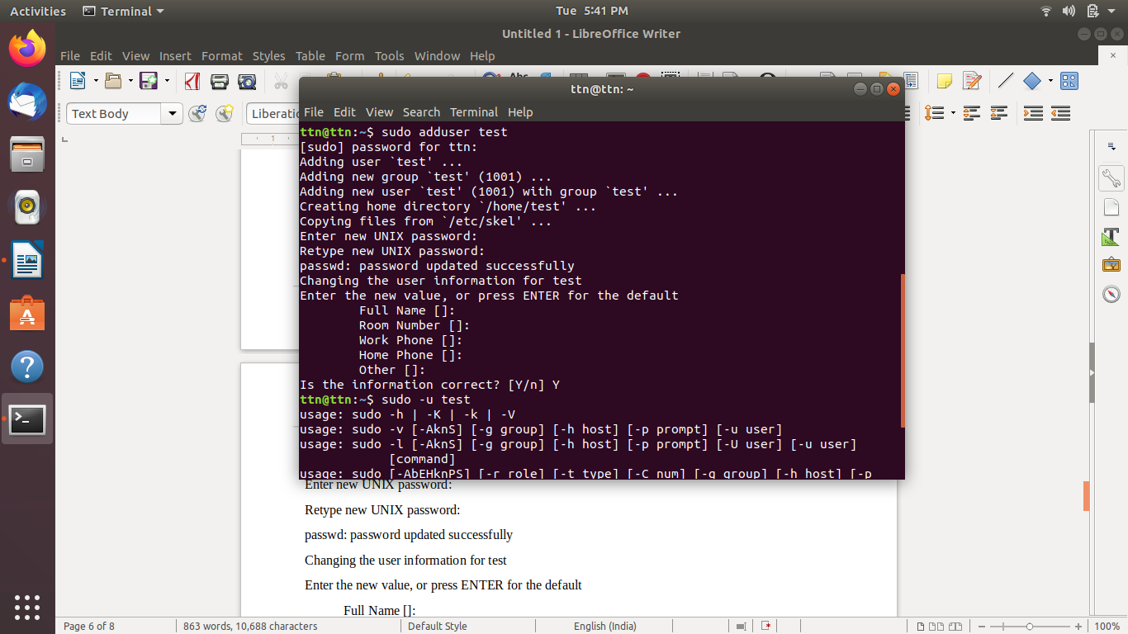
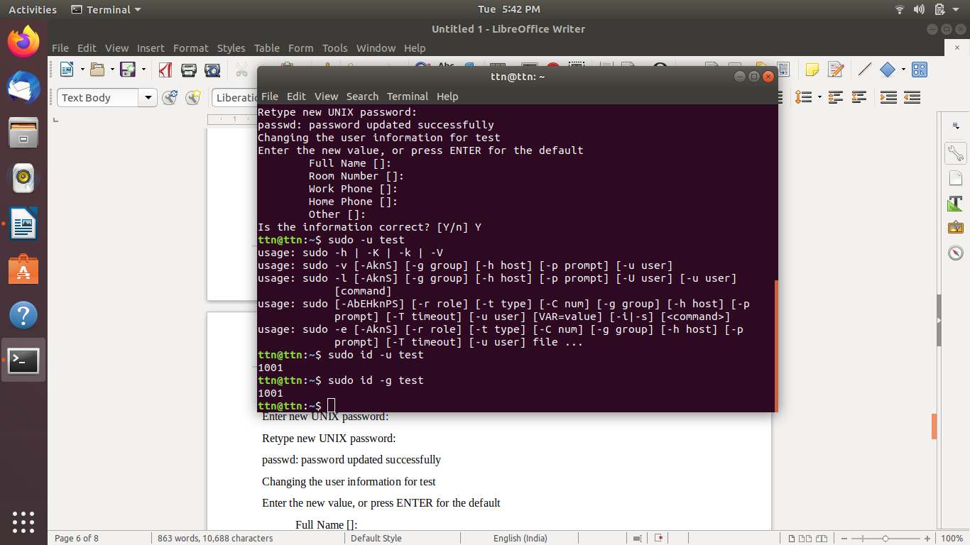

- Change the timestamp of emptyFile1,emptyFile2 which are exist in dir2
ttn@ttn:~$ cd exercise/dir1/dir2
ttn@ttn:~/exercise/dir1/dir2$ ls -al
total 12
drwxr-xr-x 3 ttn ttn 4096 Feb 2 18:03 .
drwxr-xr-x 3 ttn ttn 4096 Feb 2 14:35 ..
drwxr-xr-x 2 ttn ttn 4096 Feb 2 14:35 dir3
-rw-r--r-- 1 ttn ttn 0 Feb 2 18:02 emptyFile1
-rw-r--r-- 1 ttn ttn 0 Feb 2 18:02 emptyFile2
ttn@ttn:~/exercise/dir1/dir2$ touch -c emptyFile1 emptyFile2
ttn@ttn:~/exercise/dir1/dir2$ ls -al
total 12
drwxr-xr-x 3 ttn ttn 4096 Feb 2 18:03 .
drwxr-xr-x 3 ttn ttn 4096 Feb 2 14:35 ..
drwxr-xr-x 2 ttn ttn 4096 Feb 2 14:35 dir3
-rw-r--r-- 1 ttn ttn 0 Feb 2 18:04 emptyFile1
-rw-r--r-- 1 ttn ttn 0 Feb 2 18:04 emptyFile2
ttn@ttn:~/exercise/dir1/dir2$
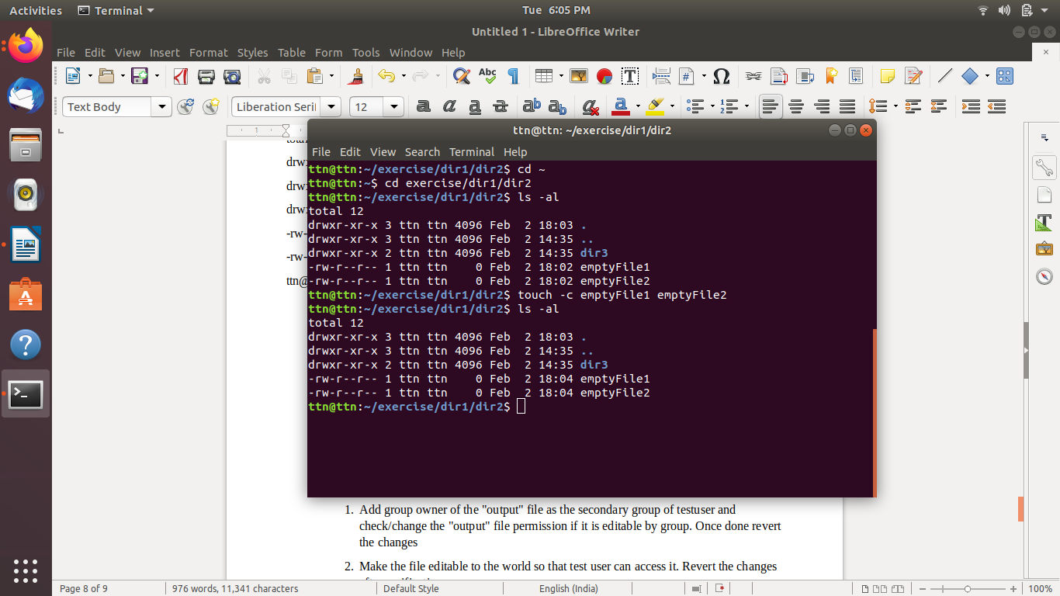

- Login as test user and edit the "output" file created above. Since the permission wont allow you to save the changes. Configure such that test user can edit it.

ttn@ttn:~$ su test
Password:
test@ttn:/home/ttn$ cat output
cat: output: Permission denied
test@ttn:/home/ttn$ cd ~
test@ttn:~$ chmod 777 output
chmod: cannot access 'output': No such file or directory
test@ttn:~$ su ttn
Password:
ttn@ttn:/home/test$ cd ~
ttn@ttn:~$ chmod 777 output
ttn@ttn:~$ cat output
root:x:0:0:root:/root:/bin/bash
daemon:x:1:1:daemon:/usr/sbin:/usr/sbin/nologin
bin:x:2:2:bin:/bin:/usr/sbin/nologin
sys:x:3:3:sys:/dev:/usr/sbin/nologin
sync:x:4:65534:sync:/bin:/bin/sync
ttn@ttn:~$ su test
Password:
test@ttn:/home/ttn$ cat output
root:x:0:0:root:/root:/bin/bash
daemon:x:1:1:daemon:/usr/sbin:/usr/sbin/nologin
bin:x:2:2:bin:/bin:/usr/sbin/nologin
sys:x:3:3:sys:/dev:/usr/sbin/nologin
sync:x:4:65534:sync:/bin:/bin/sync
test@ttn:/home/ttn$

  - Add group owner of the "output" file as the secondary group of testuser and check/change the "output" file permission if it is editable by group. Once done revert the changes
test@ttn:/home/ttn$ su ttn
Password:
ttn@ttn:~$ ls -al
total 120
drwxr-xr-x 18 ttn ttn 4096 Feb 2 22:48 .
drwxr-xr-x 5 root root 4096 Feb 2 17:37 ..
-rw------- 1 ttn ttn 3647 Feb 2 22:54 .bash_history
-rw-r--r-- 1 ttn ttn 220 Jan 28 15:02 .bash_logout
-rw-r--r-- 1 ttn ttn 3771 Feb 2 20:49 .bashrc
drwx------ 17 ttn ttn 4096 Feb 2 22:47 .cache
drwx------ 15 ttn ttn 4096 Feb 2 14:39 .config
drwxr-xr-x 2 ttn ttn 4096 Feb 2 19:44 Desktop
drwxr-xr-x 2 ttn ttn 4096 Feb 2 21:13 Documents
drwxr-xr-x 2 ttn ttn 4096 Jan 28 15:38 Downloads
-rw-r--r-- 1 ttn ttn 8980 Jan 28 15:02 examples.desktop
drwxr-xr-x 3 ttn ttn 4096 Feb 2 19:41 exercise
-rw-r--r-- 1 ttn ttn 1033 Feb 2 18:31 fun.tar.gz
drwx------ 3 ttn ttn 4096 Feb 2 14:10 .gnupg
-rw------- 1 ttn ttn 3978 Feb 2 17:18 .ICEauthority
drwx------ 3 ttn ttn 4096 Jan 28 15:38 .local
drwx------ 5 ttn ttn 4096 Jan 28 16:05 .mozilla
drwxr-xr-x 2 ttn ttn 4096 Jan 28 15:38 Music
-rwxrwxrwx 1 ttn ttn 189 Feb 2 22:48 output
drwxr-xr-x 2 ttn ttn 4096 Feb 2 20:49 Pictures
-rw-r--r-- 1 ttn ttn 807 Jan 28 15:02 .profile
drwxr-xr-x 2 ttn ttn 4096 Jan 28 15:38 Public
drwxr-xr-x 3 ttn ttn 4096 Jan 31 20:43 snap
drwx------ 2 ttn ttn 4096 Feb 2 14:10 .ssh
-rw-r--r-- 1 ttn ttn 0 Jan 28 15:38 .sudo_as_admin_successful
drwxr-xr-x 2 ttn ttn 4096 Jan 28 15:38 Templates
drwxr-xr-x 2 ttn ttn 4096 Jan 28 15:38 Videos
-rw------- 1 ttn ttn 1898 Feb 2 20:49 .viminfo
-rw-r--r-- 1 ttn ttn 169 Feb 2 19:41 .wget-hsts
ttn@ttn:~$ sudo chown ttn:test output
[sudo] password for ttn:
ttn@ttn:~$ ls -al
total 120
drwxr-xr-x 18 ttn ttn 4096 Feb 2 22:48 .
drwxr-xr-x 5 root root 4096 Feb 2 17:37 ..
-rw------- 1 ttn ttn 3647 Feb 2 22:54 .bash_history
-rw-r--r-- 1 ttn ttn 220 Jan 28 15:02 .bash_logout
-rw-r--r-- 1 ttn ttn 3771 Feb 2 20:49 .bashrc
drwx------ 17 ttn ttn 4096 Feb 2 22:47 .cache
drwx------ 15 ttn ttn 4096 Feb 2 14:39 .config
drwxr-xr-x 2 ttn ttn 4096 Feb 2 19:44 Desktop
drwxr-xr-x 2 ttn ttn 4096 Feb 2 21:13 Documents
drwxr-xr-x 2 ttn ttn 4096 Jan 28 15:38 Downloads
-rw-r--r-- 1 ttn ttn 8980 Jan 28 15:02 examples.desktop
drwxr-xr-x 3 ttn ttn 4096 Feb 2 19:41 exercise
-rw-r--r-- 1 ttn ttn 1033 Feb 2 18:31 fun.tar.gz
drwx------ 3 ttn ttn 4096 Feb 2 14:10 .gnupg
-rw------- 1 ttn ttn 3978 Feb 2 17:18 .ICEauthority
drwx------ 3 ttn ttn 4096 Jan 28 15:38 .local
drwx------ 5 ttn ttn 4096 Jan 28 16:05 .mozilla
drwxr-xr-x 2 ttn ttn 4096 Jan 28 15:38 Music
-rwxrwxrwx 1 ttn test 189 Feb 2 22:48 output
drwxr-xr-x 2 ttn ttn 4096 Feb 2 20:49 Pictures
-rw-r--r-- 1 ttn ttn 807 Jan 28 15:02 .profile
drwxr-xr-x 2 ttn ttn 4096 Jan 28 15:38 Public
drwxr-xr-x 3 ttn ttn 4096 Jan 31 20:43 snap
drwx------ 2 ttn ttn 4096 Feb 2 14:10 .ssh
-rw-r--r-- 1 ttn ttn 0 Jan 28 15:38 .sudo_as_admin_successful
drwxr-xr-x 2 ttn ttn 4096 Jan 28 15:38 Templates
drwxr-xr-x 2 ttn ttn 4096 Jan 28 15:38 Videos
-rw------- 1 ttn ttn 1898 Feb 2 20:49 .viminfo
-rw-r--r-- 1 ttn ttn 169 Feb 2 19:41 .wget-hsts
ttn@ttn:~$

  - Make the file editable to the world so that test user can access it. Revert the changes after verification
ttn@ttn:/home/test$ cd ~
ttn@ttn:~$ chmod 777 output
ttn@ttn:~$ cat output
root:x:0:0:root:/root:/bin/bash
daemon:x:1:1:daemon:/usr/sbin:/usr/sbin/nologin
bin:x:2:2:bin:/bin:/usr/sbin/nologin
sys:x:3:3:sys:/dev:/usr/sbin/nologin
sync:x:4:65534:sync:/bin:/bin/sync
ttn@ttn:~$ su test
Password:
test@ttn:/home/ttn$ cat output
root:x:0:0:root:/root:/bin/bash
daemon:x:1:1:daemon:/usr/sbin:/usr/sbin/nologin
bin:x:2:2:bin:/bin:/usr/sbin/nologin
sys:x:3:3:sys:/dev:/usr/sbin/nologin
sync:x:4:65534:sync:/bin:/bin/sync
test@ttn:/home/ttn$ su ttn
Password:
ttn@ttn:~$ ls -al
total 120
drwxr-xr-x 18 ttn ttn 4096 Feb 2 22:48 .
drwxr-xr-x 5 root root 4096 Feb 2 17:37 ..
-rw------- 1 ttn ttn 3647 Feb 2 22:54 .bash_history
-rw-r--r-- 1 ttn ttn 220 Jan 28 15:02 .bash_logout
-rw-r--r-- 1 ttn ttn 3771 Feb 2 20:49 .bashrc
drwx------ 17 ttn ttn 4096 Feb 2 22:47 .cache
drwx------ 15 ttn ttn 4096 Feb 2 14:39 .config
drwxr-xr-x 2 ttn ttn 4096 Feb 2 19:44 Desktop
drwxr-xr-x 2 ttn ttn 4096 Feb 2 21:13 Documents
drwxr-xr-x 2 ttn ttn 4096 Jan 28 15:38 Downloads
-rw-r--r-- 1 ttn ttn 8980 Jan 28 15:02 examples.desktop
drwxr-xr-x 3 ttn ttn 4096 Feb 2 19:41 exercise
-rw-r--r-- 1 ttn ttn 1033 Feb 2 18:31 fun.tar.gz
drwx------ 3 ttn ttn 4096 Feb 2 14:10 .gnupg
-rw------- 1 ttn ttn 3978 Feb 2 17:18 .ICEauthority
drwx------ 3 ttn ttn 4096 Jan 28 15:38 .local
drwx------ 5 ttn ttn 4096 Jan 28 16:05 .mozilla
drwxr-xr-x 2 ttn ttn 4096 Jan 28 15:38 Music
-rwxrwxrwx 1 ttn ttn 189 Feb 2 22:48 output
drwxr-xr-x 2 ttn ttn 4096 Feb 2 20:49 Pictures
-rw-r--r-- 1 ttn ttn 807 Jan 28 15:02 .profile
drwxr-xr-x 2 ttn ttn 4096 Jan 28 15:38 Public
drwxr-xr-x 3 ttn ttn 4096 Jan 31 20:43 snap
drwx------ 2 ttn ttn 4096 Feb 2 14:10 .ssh
-rw-r--r-- 1 ttn ttn 0 Jan 28 15:38 .sudo_as_admin_successful
drwxr-xr-x 2 ttn ttn 4096 Jan 28 15:38 Templates
drwxr-xr-x 2 ttn ttn 4096 Jan 28 15:38 Videos
-rw------- 1 ttn ttn 1898 Feb 2 20:49 .viminfo
-rw-r--r-- 1 ttn ttn 169 Feb 2 19:41 .wget-hsts

  - Change the ownership to edit the file.
ttn@ttn:~$ sudo chown test:test output
ttn@ttn:~$
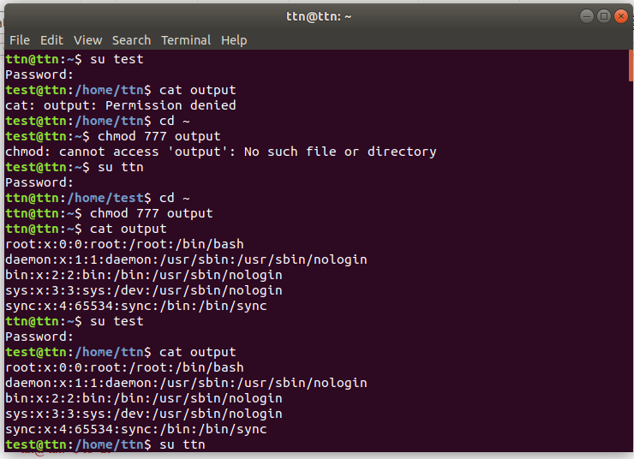
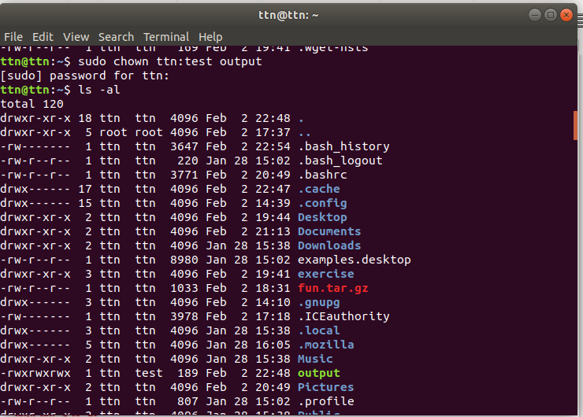

- Create alias with your name so that it creates a file as "/tmp/aliastesting".

ttn@ttn:~$ alias shaba="touch /tmp/aliastesting"
ttn@ttn:~$ ls -shaba
total 108K
4.0K . 4.0K Downloads 4.0K Pictures
4.0K .. 12K examples.desktop 4.0K .profile
4.0K .bash_history 4.0K exercise 4.0K Public
4.0K .bash_logout 4.0K .gnupg 4.0K snap
4.0K .bashrc 4.0K .ICEauthority 4.0K .ssh
4.0K .cache 4.0K .local 0 .sudo_as_admin_successful
4.0K .config 4.0K .mozilla 4.0K Templates
4.0K Desktop 4.0K Music 4.0K Videos
4.0K Documents 4.0K output
ttn@ttn:~$
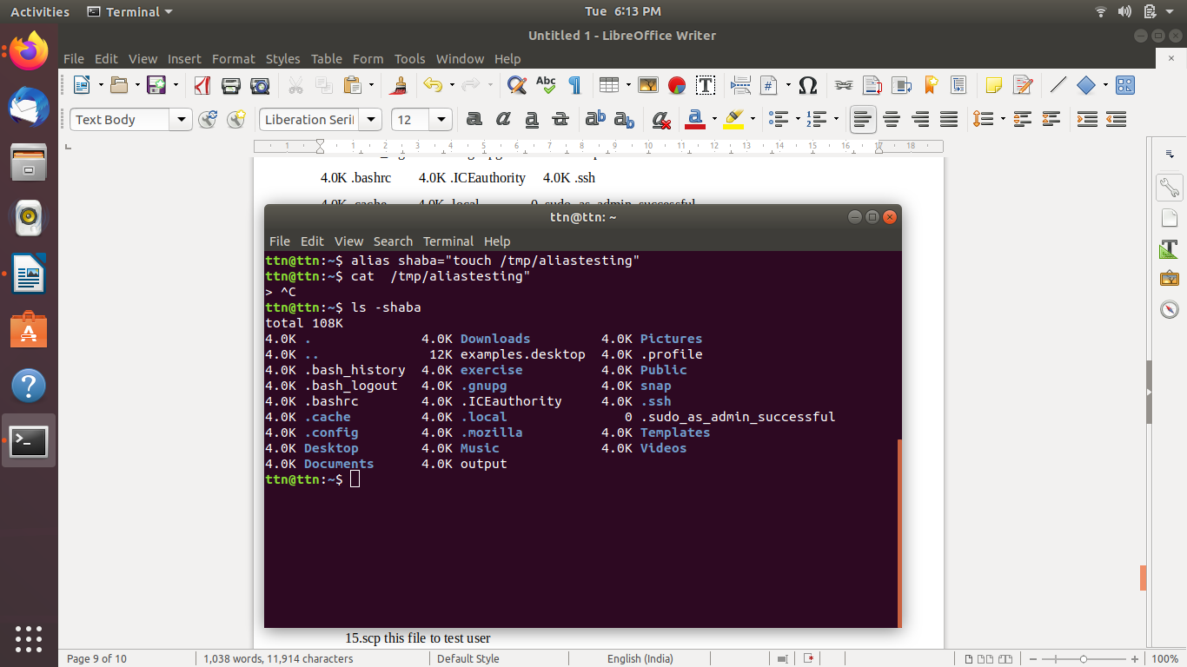

- Edit ~/.bashrc file such that when you change to "test" user it should clear the screen and print "Welcome".
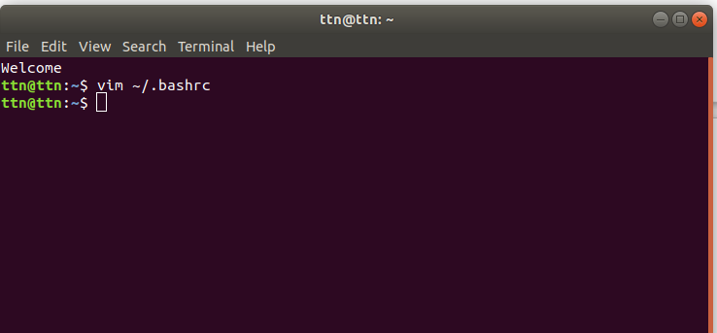
Welcome
ttn@ttn:~$ vim ~/.bashrc
ttn@ttn:~$

- Install “zip” package.

ttn@ttn:~$ sudo apt-get install zip -y
[sudo] password for ttn:
Reading package lists... Done
Building dependency tree
Reading state information... Done
zip is already the newest version (3.0-11build1).
zip set to manually installed.
The following packages were automatically installed and are no longer required:
efibootmgr libegl1-mesa libfwup1 libllvm9 libwayland-egl1-mesa
Use 'sudo apt autoremove' to remove them.
0 upgraded, 0 newly installed, 0 to remove and 3 not upgraded.
ttn@ttn:~$
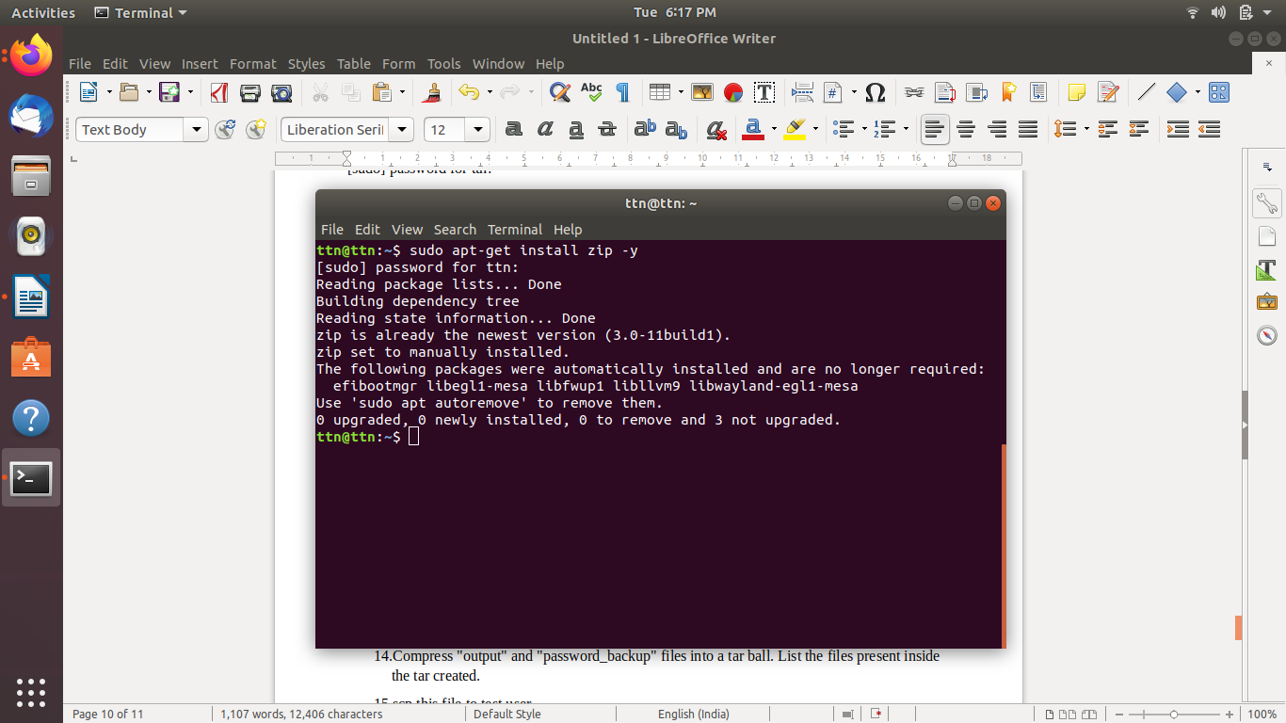

- Compress "output" and "password_backup" files into a tar ball. List the files present inside the tar created.

ttn@ttn:~$ tar -czvf fun.tar.gz output /etc/passwd_backup
output
tar: Removing leading `/' from member names
/etc/passwd_backup
ttn@ttn:~$
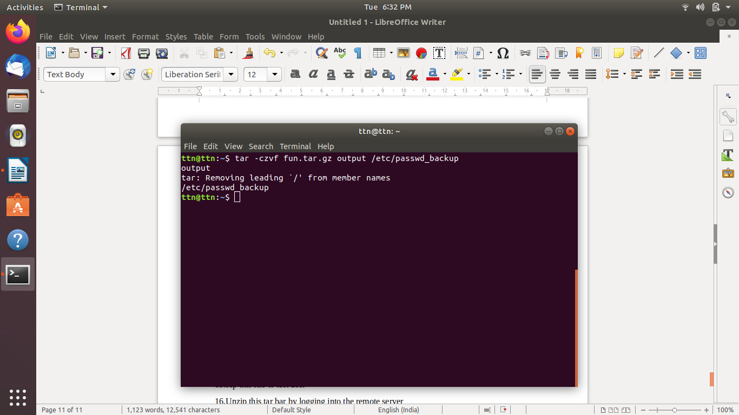

- scp this file to test user
ttn@ttn:~$ scp fun.tar.gz ttn@test:/home

- Unzip this tar bar by logging into the remote server
- Download any image from web and move to desktop

ttn@ttn:~$ cd exercise
ttn@ttn:~/exercise$ wget https://www.python.org/static/apple-touch-icon-144x144-precomposed.png
--2021-02-02 19:41:40-- https://www.python.org/static/apple-touch-icon-144x144-precomposed.png
Resolving www.python.org (www.python.org)... 199.232.20.223, 2a04:4e42:42::223
Connecting to www.python.org (www.python.org)|199.232.20.223|:443... connected.
HTTP request sent, awaiting response... 200 OK
Length: 7382 (7.2K) [image/png]
Saving to: ‘apple-touch-icon-144x144-precomposed.png’

apple-touch-icon-14 100%[===================>] 7.21K --.-KB/s in 0.006s

2021-02-02 19:41:40 (1.15 MB/s) - ‘apple-touch-icon-144x144-precomposed.png’ saved [7382/7382]

ttn@ttn:~/exercise$ cp /home/ttn/exercise/apple-touch-icon-144x144-precomposed.png ~/Desktop
ttn@ttn:~/exercise$
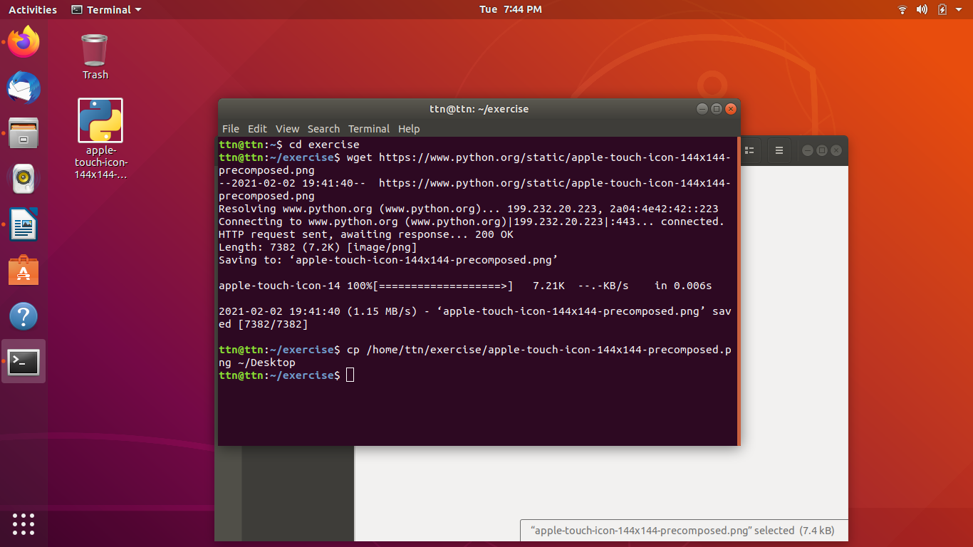

- How to get help of commands usages.

ttn@ttn:~/exercise$ man cp
ttn@ttn:~/exercise$ man daemon
ttn@ttn:~/exercise$ whatis cp
cp (1) - copy files and directories
ttn@ttn:~/exercise$ info cp
ttn@ttn:~/exercise$ cp --h

- Create a symlink of /etc/services into /tmp/ports-info

ttn@ttn:~$ ln -s /etc/services /tmp/ports-info
ttn@ttn:~$ ls -l /tmp/ports-info
lrwxrwxrwx 1 ttn ttn 13 Feb 2 19:15 /tmp/ports-info -> /etc/services
ttn@ttn:~$

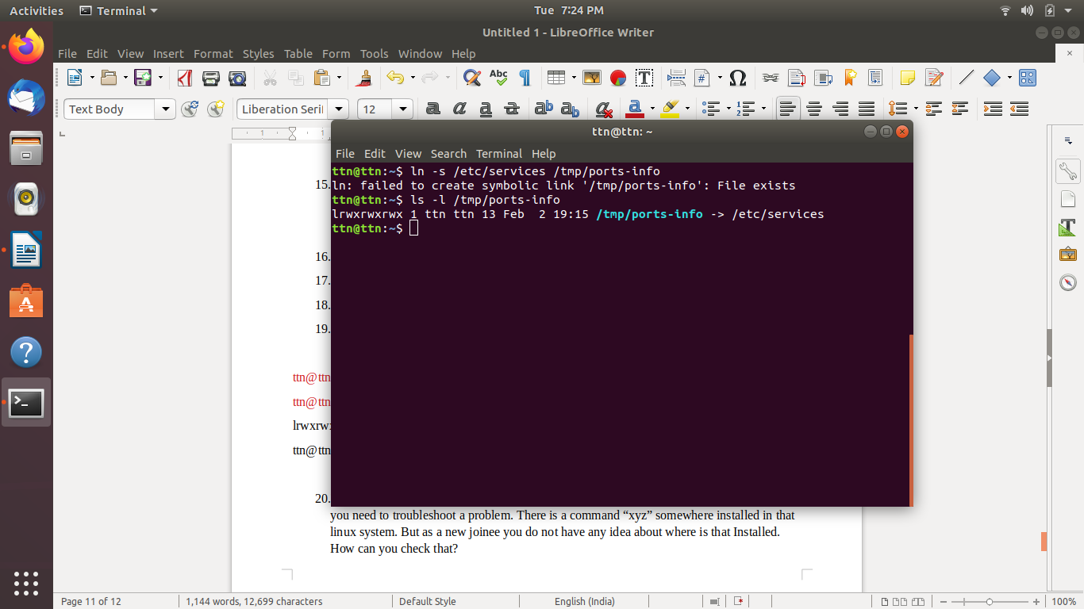

- You are appointed as a Software/DevOps Engineer in ABC media services. On your first day you need to troubleshoot a problem. There is a command “xyz” somewhere installed in that linux system. But as a new joinee you do not have any idea about where is that Installed. How can you check that?

ttn@ttn:~$ whereis xyz
xyz:
ttn@ttn:~$

