Shaba Ahmad [JVM]

- Create Database

mysql> CREATE DATABASE dbexercise;
Query OK, 1 row affected (0.27 sec)

mysql> use dbexercise;
Database changed
mysql>

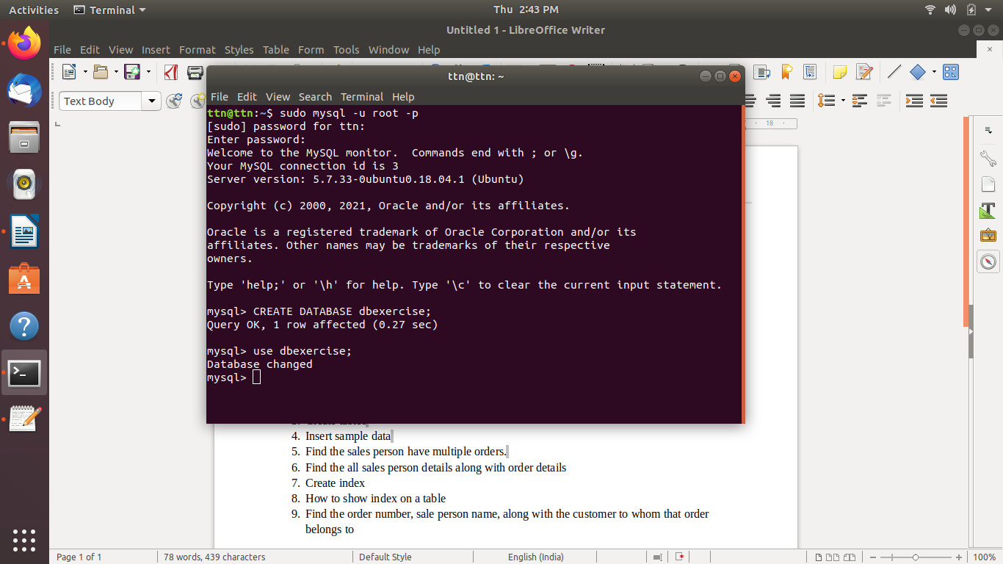

- Design Schema
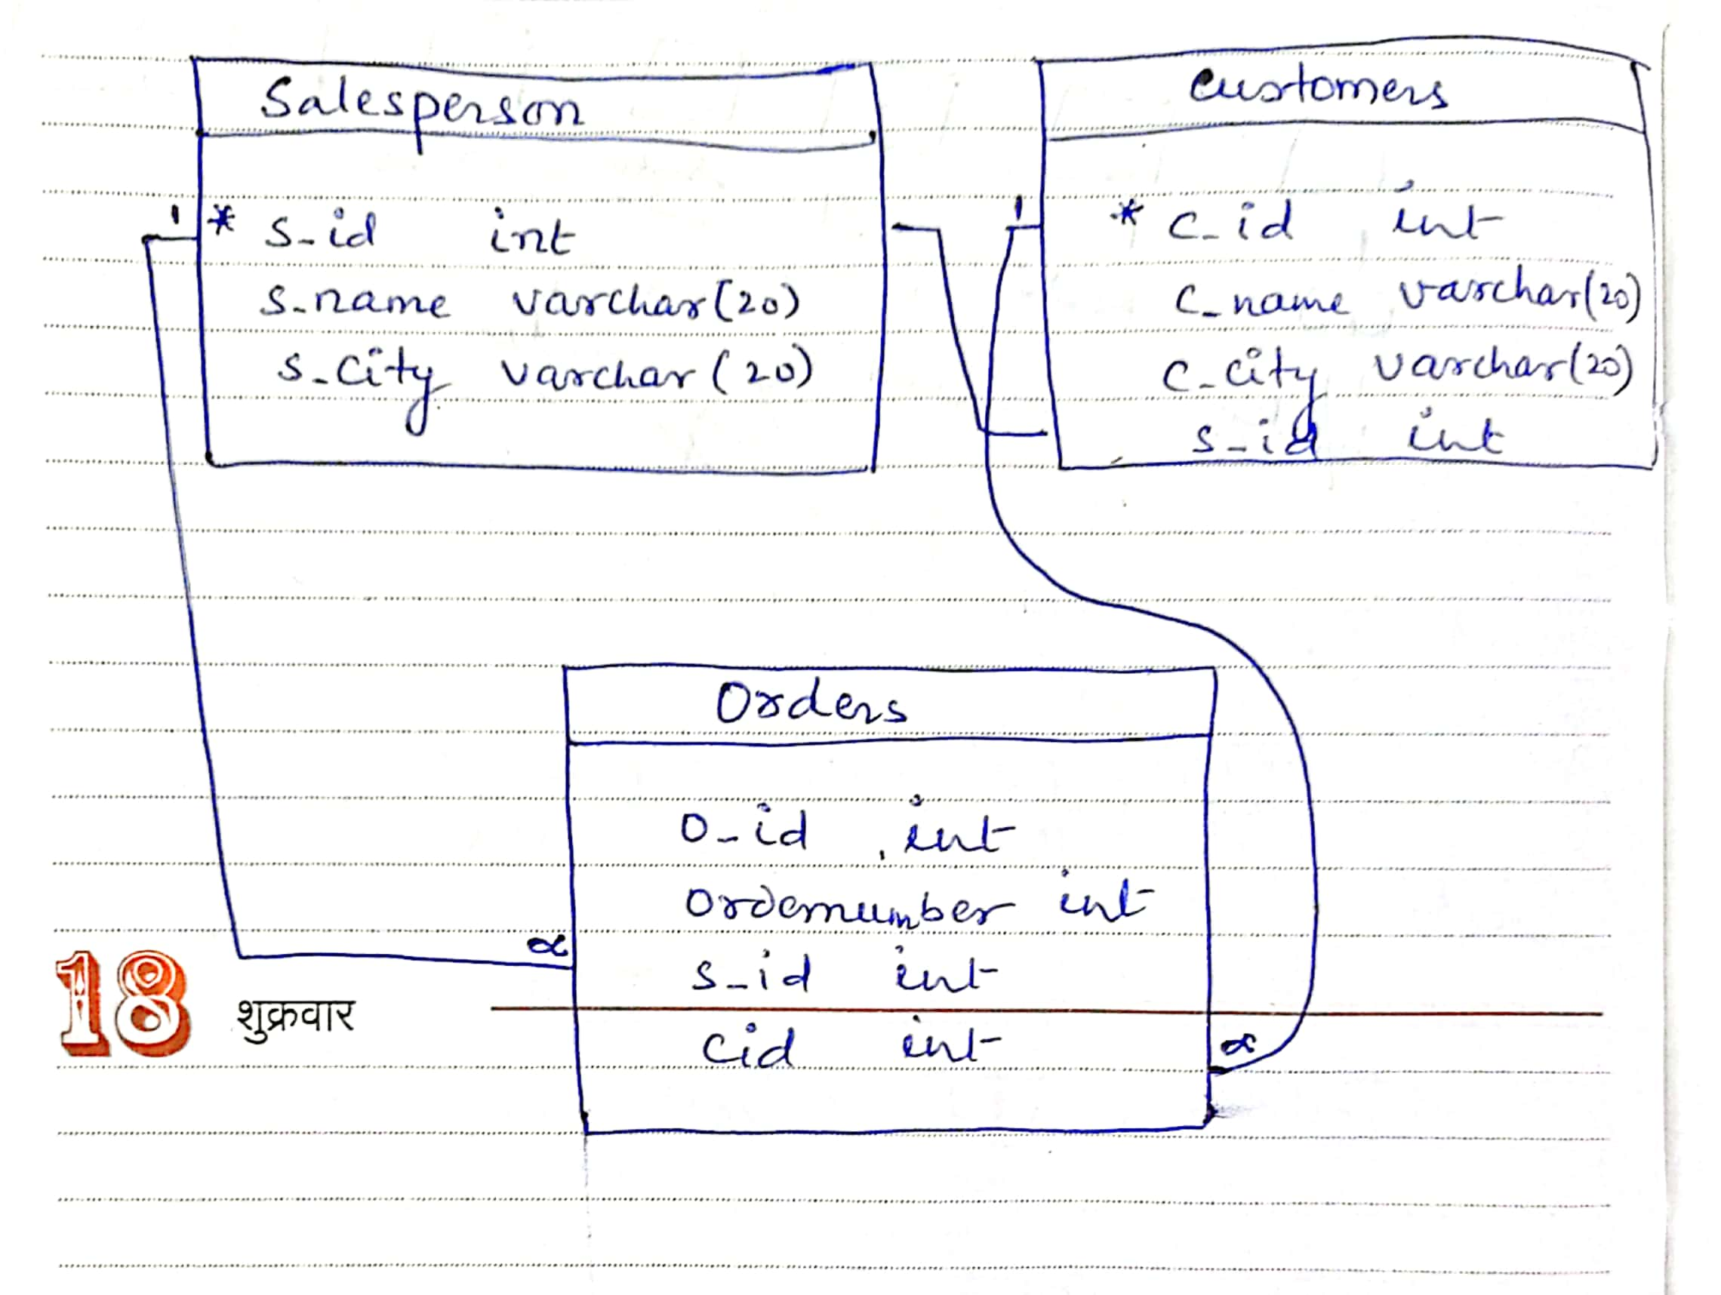

- Create tables

mysql> CREATE TABLE salesperson(
-> s_id int NOT NULL AUTO_INCREMENT,
-> s_name varchar(20) NOT NULL,
-> s_city varchar(20) NOT NULL,
-> PRIMARY KEY (s_id)
-> );
Query OK, 0 rows affected (0.27 sec)

mysql> CREATE TABLE customers (
-> c_id int NOT NULL AUTO_INCREMENT,
-> c_name varchar(20) NOT NULL,
-> c_city varchar(20) NOT NULL,
-> s_id int NOT NULL,
-> PRIMARY KEY (c_id),
-> FOREIGN KEY (s_id) REFERENCES salesperson(s_id)
-> );
Query OK, 0 rows affected (0.45 sec)

mysql> CREATE TABLE orders (
-> o_id int NOT NULL AUTO_INCREMENT,
-> ordernumber int NOT NULL,
-> s_id int NOT NULL,
-> c_id int NOT NULL,
-> PRIMARY KEY (o_id),
-> FOREIGN KEY (s_id) REFERENCES salesperson(s_id),
-> FOREIGN KEY (c_id) REFERENCES customers(c_id)
-> );
Query OK, 0 rows affected (0.36 sec)

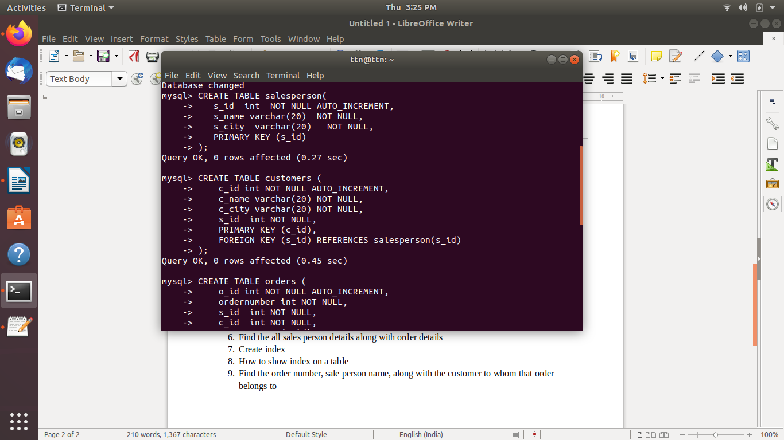

- Insert sample data

mysql> INSERT INTO salesperson (s_id, s_name, s_city) VALUES (1, 'Shaba', 'Noida');
Query OK, 1 row affected (0.10 sec)

mysql> INSERT INTO salesperson (s_id, s_name, s_city) VALUES (2, 'Rajeev', 'Patna');
Query OK, 1 row affected (0.31 sec)

mysql> INSERT INTO salesperson (s_id, s_name, s_city) VALUES (3, 'Shyam', 'Delhi');
Query OK, 1 row affected (0.40 sec)

mysql> INSERT INTO salesperson (s_id, s_name, s_city) VALUES (4, 'Ram', 'Okhla');
Query OK, 1 row affected (0.07 sec)

mysql> INSERT INTO salesperson (s_id, s_name, s_city) VALUES (5, 'Saurabh', 'Noida');
Query OK, 1 row affected (0.07 sec)

mysql> SELECT * from salesperson;
+------+---------+--------+
| s_id | s_name | s_city |
+------+---------+--------+
| 1 | Shaba | Noida |
| 2 | Rajeev | Patna |
| 3 | Shyam | Delhi |
| 4 | Ram | Okhla |
| 5 | Saurabh | Noida |
+------+---------+--------+
5 rows in set (0.00 sec)

mysql> INSERT INTO customers (c_id, c_name,c_city,s_id) VALUES (1, 'Shubham', 'Noida', 5);
Query OK, 1 row affected (0.06 sec)

mysql> INSERT INTO customers (c_id, c_name,c_city,s_id) VALUES (2, 'Nikhil', 'Noida', 5);
Query OK, 1 row affected (0.08 sec)

mysql> INSERT INTO customers (c_id, c_name,c_city,s_id) VALUES (3, 'Pardeep', 'DElhi', 3);
Query OK, 1 row affected (0.09 sec)

mysql> INSERT INTO customers (c_id, c_name,c_city,s_id) VALUES (4, 'Zahid', 'Okhla', 4);
Query OK, 1 row affected (0.08 sec)

mysql> INSERT INTO customers (c_id, c_name,c_city,s_id) VALUES (5, 'Manoj', 'Okhla', 4);
Query OK, 1 row affected (0.08 sec)

mysql> SELECT *from customers
-> ;
+------+---------+--------+------+
| c_id | c_name | c_city | s_id |
+------+---------+--------+------+
| 1 | Shubham | Noida | 5 |
| 2 | Nikhil | Noida | 5 |
| 3 | Pardeep | DElhi | 3 |
| 4 | Zahid | Okhla | 4 |
| 5 | Manoj | Okhla | 4 |
+------+---------+--------+------+
5 rows in set (0.00 sec)

mysql> INSERT INTO orders (o_id,ordernumber,s_id,c_id) VALUES (1,1021,4,5);
Query OK, 1 row affected (0.33 sec)

mysql> INSERT INTO orders (o_id,ordernumber,s_id,c_id) VALUES (2,1025,4,4);
Query OK, 1 row affected (0.08 sec)

mysql> INSERT INTO orders (o_id,ordernumber,s_id,c_id) VALUES (3,1045,3,3);
Query OK, 1 row affected (0.06 sec)

mysql> INSERT INTO orders (o_id,ordernumber,s_id,c_id) VALUES (4,1845,5,2);
Query OK, 1 row affected (0.30 sec)

mysql> INSERT INTO orders (o_id,ordernumber,s_id,c_id) VALUES (5,1829,5,1);
Query OK, 1 row affected (0.08 sec)

mysql> SELECT * from orders;
+------+-------------+------+------+
| o_id | ordernumber | s_id | c_id |
+------+-------------+------+------+
| 1 | 1021 | 4 | 5 |
| 2 | 1025 | 4 | 4 |
| 3 | 1045 | 3 | 3 |
| 4 | 1845 | 5 | 2 |
| 5 | 1829 | 5 | 1 |
+------+-------------+------+------+

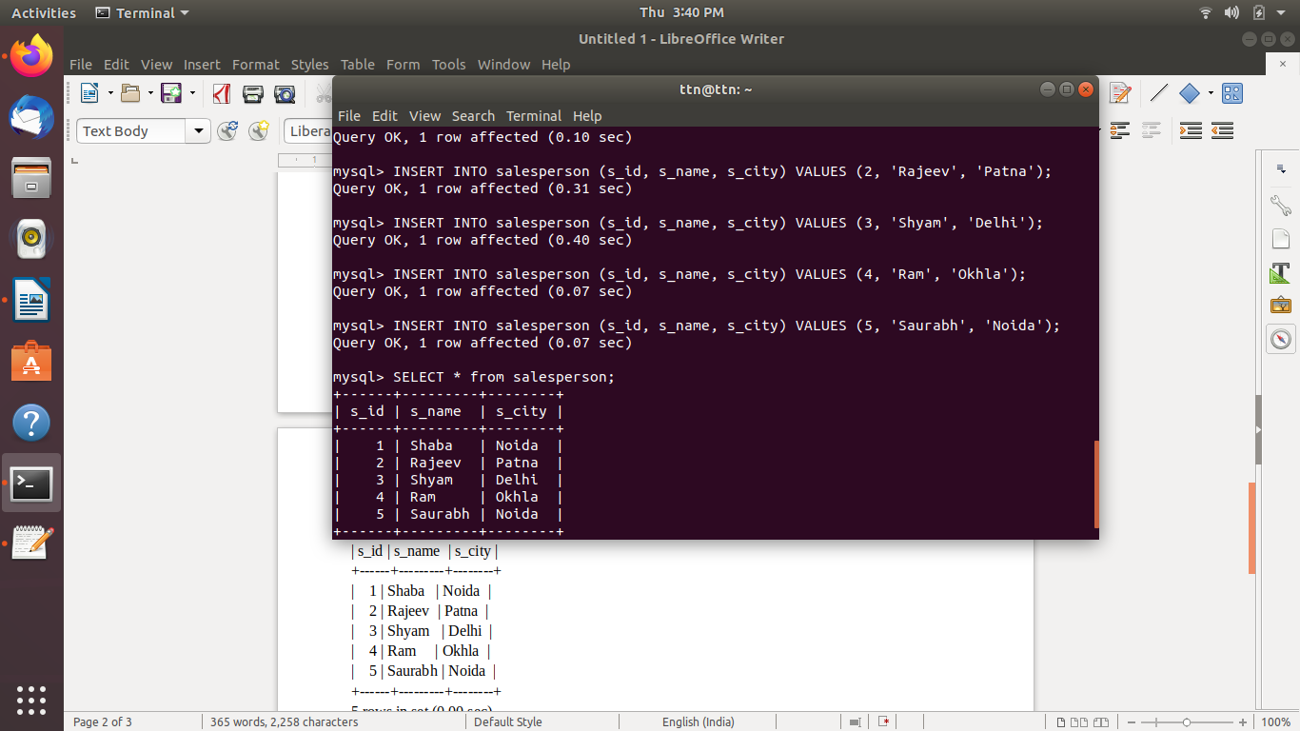
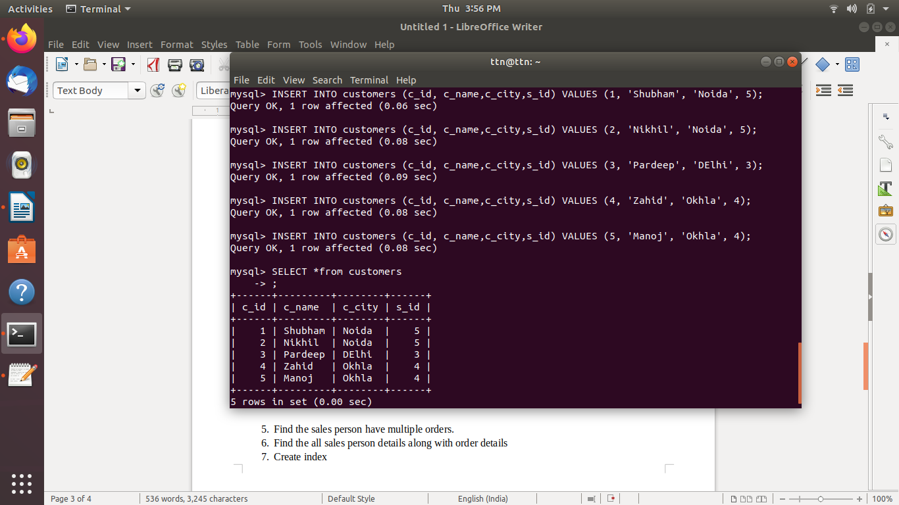

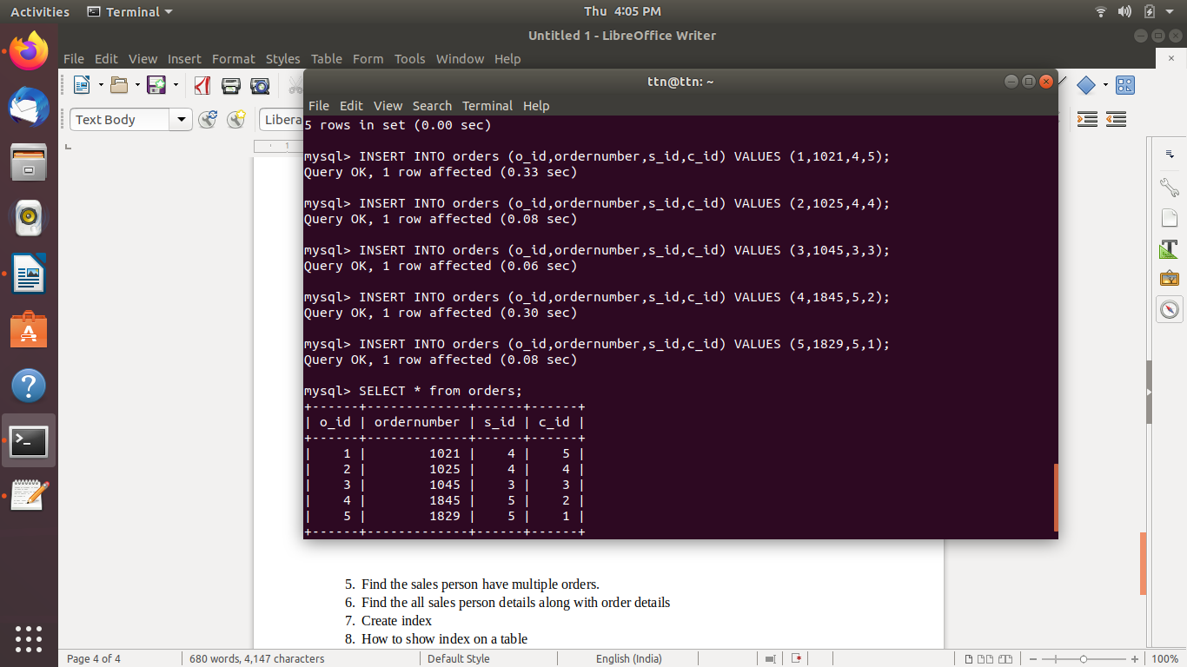

- Find the sales person have multiple orders.

mysql> SELECT *
-> FROM salesperson
-> WHERE s_id IN (
-> SELECT DISTINCT s_id
-> FROM orders a
-> WHERE EXISTS (
-> SELECT *
-> FROM orders b
-> WHERE b.s_id=a.s_id
-> AND b.o_id<>a.o_id));
+------+---------+--------+
| s_id | s_name | s_city |
+------+---------+--------+
| 4 | Ram | Okhla |
| 5 | Saurabh | Noida |
+------+---------+--------+
2 rows in set (0.00 sec)
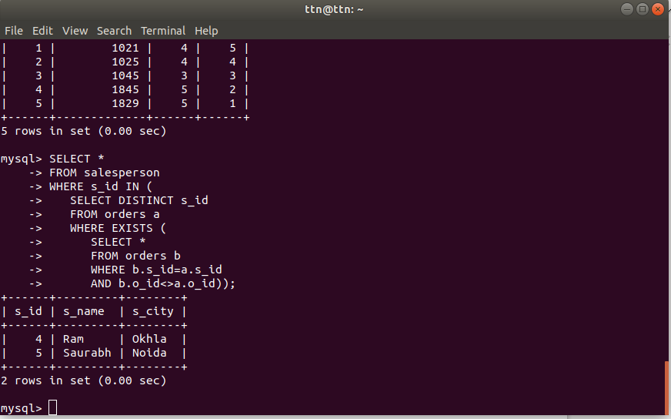

- Find the all sales person details along with order details

mysql> SELECT s.s_id,s.s_name,s.s_city,o.o_id,o.ordernumber FROM salesperson s INNER JOIN orders o ON s.s_id = o.s_id;
+------+---------+--------+------+-------------+
| s_id | s_name | s_city | o_id | ordernumber |
+------+---------+--------+------+-------------+
| 4 | Ram | Okhla | 1 | 1021 |
| 4 | Ram | Okhla | 2 | 1025 |
| 3 | Shyam | Delhi | 3 | 1045 |
| 5 | Saurabh | Noida | 4 | 1845 |
| 5 | Saurabh | Noida | 5 | 1829 |
+------+---------+--------+------+-------------+
5 rows in set (0.00 sec)

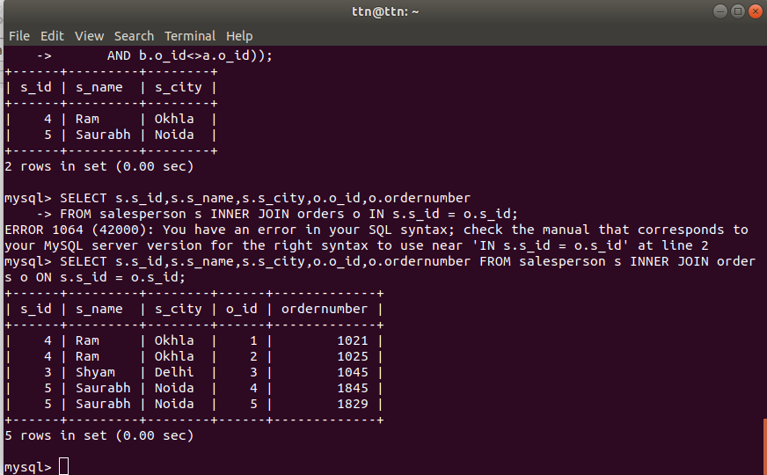

- Create index

mysql> CREATE INDEX idx_city
-> ON salesperson (s_city);
Query OK, 0 rows affected (0.32 sec)
Records: 0 Duplicates: 0 Warnings: 0

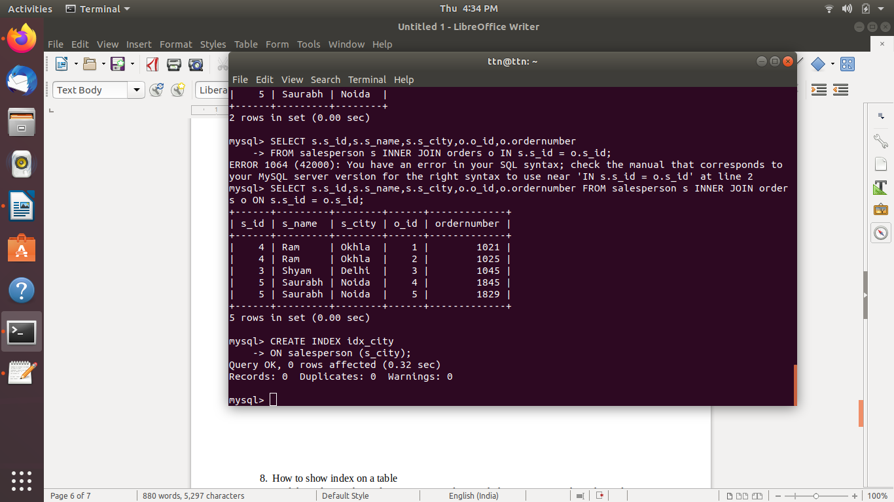

- How to show index on a table

mysql> SHOW INDEXES FROM salesperson;
+-------------+------------+----------+--------------+-------------+-----------+-------------+----------+--------+------+------------+---------+---------------+
| Table | Non_unique | Key_name | Seq_in_index | Column_name | Collation | Cardinality | Sub_part | Packed | Null | Index_type | Comment | Index_comment |
+-------------+------------+----------+--------------+-------------+-----------+-------------+----------+--------+------+------------+---------+---------------+
| salesperson | 0 | PRIMARY | 1 | s_id | A | 4 | NULL | NULL | | BTREE | | |
| salesperson | 1 | idx_city | 1 | s_city | A | 4 | NULL | NULL | | BTREE | | |
+-------------+------------+----------+--------------+-------------+-----------+-------------+----------+--------+------+------------+---------+---------------+
2 rows in set (0.00 sec)

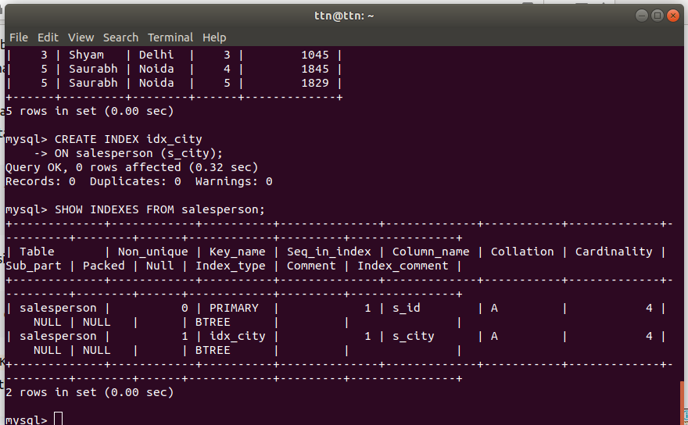

- Find the order number, sale person name, along with the customer to whom that order belongs to
mysql> SELECT o.ordernumber,s.s_name,c.c_name FROM orders o INNER JOIN salesperson s ON o.s_id = s.s_id INNER JOIN customers c ON o.c_id = c.c_id;
+-------------+---------+---------+
| ordernumber | s_name | c_name |
+-------------+---------+---------+
| 1021 | Ram | Manoj |
| 1025 | Ram | Zahid |
| 1045 | Shyam | Pardeep |
| 1845 | Saurabh | Nikhil |
| 1829 | Saurabh | Shubham |
+-------------+---------+---------+
5 rows in set (0.01 sec)

