Shaba Ahmad [ JVM ]

1.How are inline and block elements different from each other?

Block Elements:
- A block-level element takes the full width of the page and begin on a new line.
- Accept width, height, margins, padding, and border.
Examples: <p>, <div>, <li>
Inline Elements:
- An inline element takes up as much width that is required and doesn’t begin on a new line .
- Accept any border or padding.
Examples: <a>, <span>

2.Explain the difference between visibility:hidden and display:none

Visibility:hidden- this property will hide the element but it will occupy the space.
Display:none- it will hide the element and this will allow other elements to sit in the space.

3. Explain the clear and float properties.
Float Property:
The float property is used for positioning and formatting content e.g. let say we want to float an image left to the text in a container then you can add “left” value.
Clear Property :
The clear property specifies what elements can float beside the cleared element and on which side.

4. explain difference between absolute, relative,fixed and static.
- Static - this is the default value, all elements are in order as they appear in the document.
- Relative - the element is positioned relative to its normal position.
- Absolute - the element is positioned absolutely to its first positioned parent.
- Fixed - the element is positioned related to the browser window.

5. Write the HTML code to create a table in which there are 4 columns( ID , Employee Name, Designation, Department) and at least 6 rows. Also do some styling to it.

********q_5.html********

<!DOCTYPE html>
<html>
<head>
<title>Question-5</title>
<meta charset="UTF-8">
<link rel="stylesheet" href="styles.css">
</head>
<body class = "container">
<table >
<caption><b>Employee Records</b></caption>
<tr>
<th>ID</th>
<th>Employee Name</th>
<th>Designation</th>
<th>Department</th>
</tr>
<tr>
<td>1</td>
<td>Shaba</td>
<td>Trainee</td>
<td>JVM</td>
</tr>
<tr>
<td>2</td>
<td>Nikhil</td>
<td>HR</td>
<td>FEEN</td>
</tr>
<tr>
<td>3</td>
<td>Rajeeev</td>
<td>Trainee</td>
<td>MEAN</td>
</tr>
<tr>
<td>4</td>
<td>Zahid</td>
<td>Trainee</td>
<td>IOS</td>
</tr>
<tr>
<td>5</td>
<td>Rajat</td>
<td>Trainee</td>
<td>Java</td>
</tr>
<tr>
<td>6</td>
<td>Rohit</td>
<td>Team Lead</td>
<td>JVM</td>
</tr>

</table>

</body>
</html>

*****styles.css*******
table, th, td {
border: 1px solid black;
border-collapse: collapse;
}
th, td {
padding: 10px;
}
table tr:nth-child(even) {
background-color: #eee;
}
table tr:nth-child(odd) {
background-color: #fff;
}
table th {
color: white;
background-color: gray;
}

caption
{
padding-bottom: 10px;
}
.container
{
margin: 150px 400px;
}

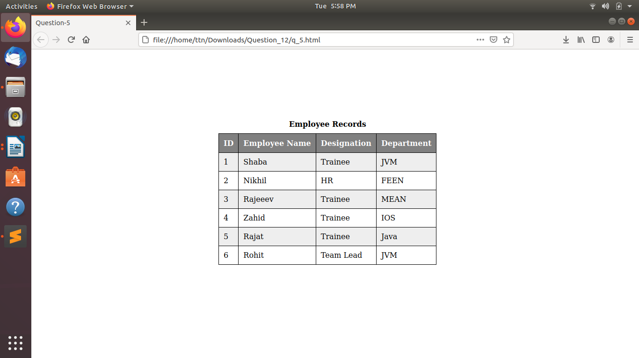

6. Why do we use meta tags?
Meta tags are informaton that will not be parseable or showcased in the DOM when you render content. This is used for things like keywords, the author name, the title of the page, a description, etc. One of the most popular meta tags is:
<meta name="viewport" content="width=device-width, initial-scale=1.0">
and its sole purpose is the scan the size of the screen on the device the page is on and allow the user to set media queries in CSS that make content change position when the screen size gets smaller.

7. Explain box model.
box model is a container which contains multiple properties including borders, margin, padding and the content itself. It is used to create the design and layout of web pages. It can be used as a toolkit for customizing the layout of different elements. The web browser renders every element as a rectangular box according to the CSS box model.

8. What are the different types of CSS Selectors?
There are more than 5 types of selectors CSS selectors :
Element or Selector
h2 {
text-align: center;
color: yellow;
}
#id selector
#box{
width : 250px;
height: 250px;
background : yellow;
}
.class selector
.center{
text-align: center;
color: yellow;
}
Descendant selector
div h2 {
background-color: green;
}
Adjacent and general sibling selectors
div + p {
background-color: red;
}

9. Define Doctype.
DOCTYPE is a type declaration that is used to tell web browsers what version of HTML we are using in our webpage/website.
<!DOCTYPE html>
<html>

<body>
<h1>Shaba Ahmad</h1>
<h2>This is a heading in h2</h2>
</body>

</html>

10. Explain 5 HTML5 semantic tags.
- <article> - Defines an article in the document
- <aside> - Defines content aside from the page content like sidebar.
- <footer> - Defines a footer for the document or a section
- <header> - Defines a header for the document or a section
- <nav> - Defines navigation links in the document
- <section> - Defines a section in the document

