- Git Setup https://confluence.atlassian.com/bitbucket/set-up-git-744723531.html

ttn@ttn:~$ sudo apt-get update
[sudo] password for ttn:
Hit:1 http://in.archive.ubuntu.com/ubuntu bionic InRelease
Get:2 http://in.archive.ubuntu.com/ubuntu bionic-updates InRelease [88.7 kB]
Get:3 http://in.archive.ubuntu.com/ubuntu bionic-backports InRelease [74.6 kB]
Get:4 http://in.archive.ubuntu.com/ubuntu bionic-updates/main i386 Packages [1,214 kB]
Get:5 http://security.ubuntu.com/ubuntu bionic-security InRelease [88.7 kB]
Get:6 http://in.archive.ubuntu.com/ubuntu bionic-updates/main amd64 Packages [1,877 kB]
Get:7 http://in.archive.ubuntu.com/ubuntu bionic-updates/main Translation-en [389 kB]
Get:8 http://in.archive.ubuntu.com/ubuntu bionic-updates/main amd64 DEP-11 Metadata [294 kB]
Get:9 http://in.archive.ubuntu.com/ubuntu bionic-updates/universe i386 Packages [1,559 kB]
Get:10 http://in.archive.ubuntu.com/ubuntu bionic-updates/universe amd64 Packages [1,713 kB]
Get:11 http://security.ubuntu.com/ubuntu bionic-security/main i386 Packages [910 kB]
Get:12 http://in.archive.ubuntu.com/ubuntu bionic-updates/universe Translation-en [362 kB]
Get:13 http://in.archive.ubuntu.com/ubuntu bionic-updates/universe amd64 DEP-11 Metadata [289 kB]
Get:14 http://in.archive.ubuntu.com/ubuntu bionic-updates/multiverse amd64 DEP-11 Metadata [2,468 B]
Get:15 http://in.archive.ubuntu.com/ubuntu bionic-backports/universe amd64 DEP-11 Metadata [9,292 B]
Get:16 http://security.ubuntu.com/ubuntu bionic-security/main amd64 Packages [1,536 kB]
Get:17 http://security.ubuntu.com/ubuntu bionic-security/main Translation-en [297 kB]
Get:18 http://security.ubuntu.com/ubuntu bionic-security/main amd64 DEP-11 Metadata [48.9 kB]
Get:19 http://security.ubuntu.com/ubuntu bionic-security/restricted amd64 Packages [226 kB]
Get:20 http://security.ubuntu.com/ubuntu bionic-security/restricted Translation-en [29.9 kB]
Get:21 http://security.ubuntu.com/ubuntu bionic-security/universe amd64 Packages [1,105 kB]
Get:22 http://security.ubuntu.com/ubuntu bionic-security/universe i386 Packages [974 kB]
Get:23 http://security.ubuntu.com/ubuntu bionic-security/universe Translation-en [247 kB]
Get:24 http://security.ubuntu.com/ubuntu bionic-security/universe amd64 DEP-11 Metadata [59.7 kB]
Get:25 http://security.ubuntu.com/ubuntu bionic-security/multiverse amd64 DEP-11 Metadata [2,464 B]
Fetched 13.4 MB in 24s (555 kB/s)
Reading package lists... Done
ttn@ttn:~$ sudo apt-get install git
Reading package lists... Done
Building dependency tree
Reading state information... Done
The following packages were automatically installed and are no longer required:
efibootmgr libegl1-mesa libfwup1 libllvm9 libwayland-egl1-mesa
Use 'sudo apt autoremove' to remove them.
The following additional packages will be installed:
git-man liberror-perl
Suggested packages:
git-daemon-run | git-daemon-sysvinit git-doc git-el git-email git-gui gitk
gitweb git-cvs git-mediawiki git-svn
The following NEW packages will be installed:
git git-man liberror-perl
0 upgraded, 3 newly installed, 0 to remove and 10 not upgraded.
Need to get 4,741 kB of archives.
After this operation, 34.0 MB of additional disk space will be used.
Do you want to continue? [Y/n] Y
Get:1 http://in.archive.ubuntu.com/ubuntu bionic/main amd64 liberror-perl all 0.17025-1 [22.8 kB]
Get:2 http://in.archive.ubuntu.com/ubuntu bionic-updates/main amd64 git-man all 1:2.17.1-1ubuntu0.7 [804 kB]
Get:3 http://in.archive.ubuntu.com/ubuntu bionic-updates/main amd64 git amd64 1:2.17.1-1ubuntu0.7 [3,915 kB]
Fetched 4,741 kB in 3s (1,405 kB/s)
Selecting previously unselected package liberror-perl.
(Reading database ... 165854 files and directories currently installed.)
Preparing to unpack .../liberror-perl_0.17025-1_all.deb ...
Unpacking liberror-perl (0.17025-1) ...
Selecting previously unselected package git-man.
Preparing to unpack .../git-man_1%3a2.17.1-1ubuntu0.7_all.deb ...
Unpacking git-man (1:2.17.1-1ubuntu0.7) ...
Selecting previously unselected package git.
Preparing to unpack .../git_1%3a2.17.1-1ubuntu0.7_amd64.deb ...
Unpacking git (1:2.17.1-1ubuntu0.7) ...
Setting up git-man (1:2.17.1-1ubuntu0.7) ...
Setting up liberror-perl (0.17025-1) ...
Setting up git (1:2.17.1-1ubuntu0.7) ...
Processing triggers for man-db (2.8.3-2ubuntu0.1) ...
ttn@ttn:~$ git --version
git version 2.17.1
ttn@ttn:~$ git config --global user.name "Shaba Ahmad"
ttn@ttn:~$ git config --global user.email "shaba.ahmad@tothenew.com"
ttn@ttn:~$

ttn@ttn:~$ sudo apt-get install libcurl4-gnutls-dev libexpat1-dev gettext libz-dev libssl-dev asciidoc xmlto docbook2x

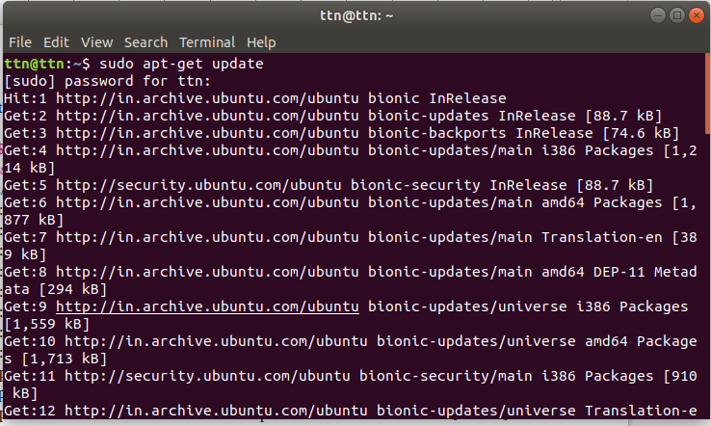
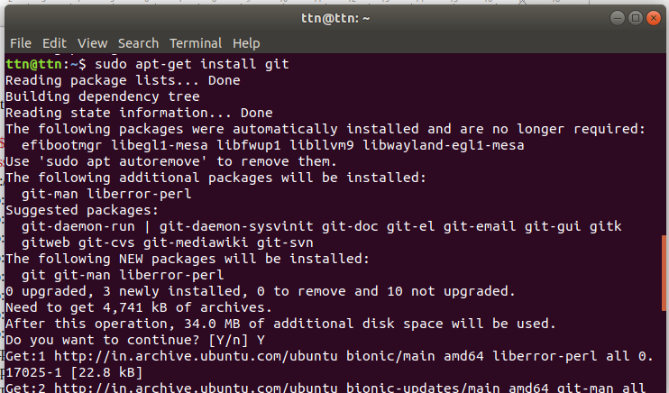

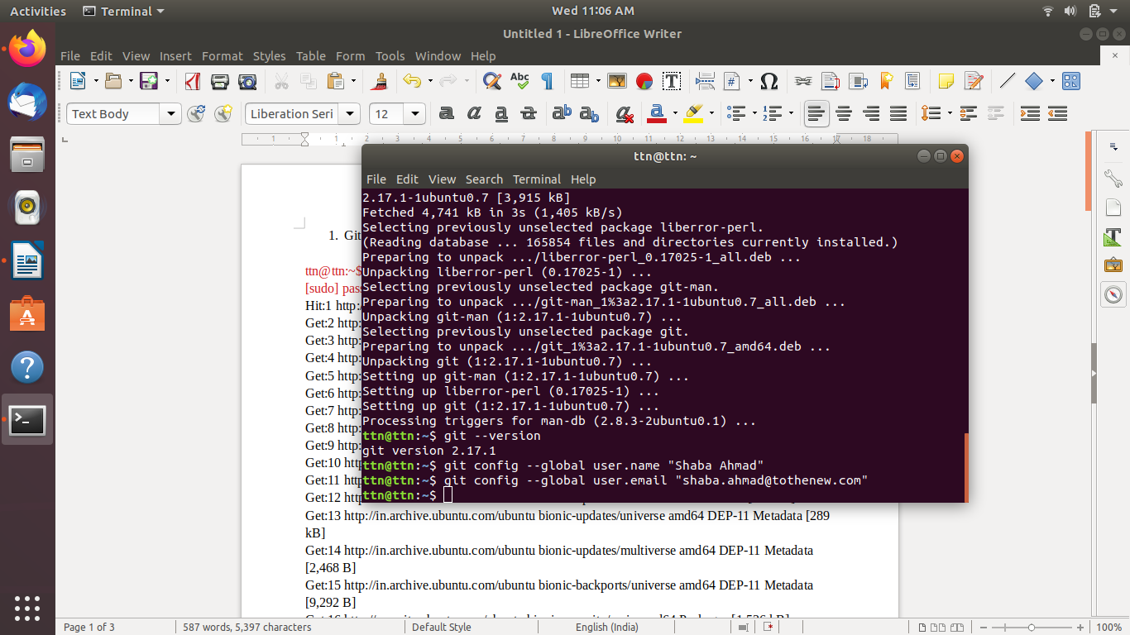

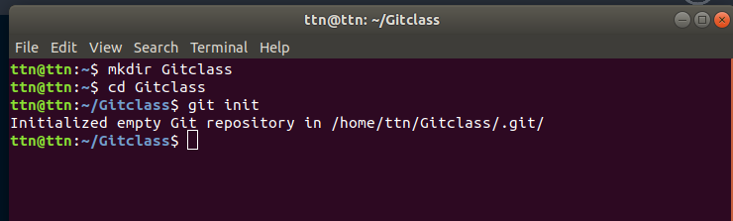
- Initialize a Git Repository

ttn@ttn:~$ mkdir Gitclass
ttn@ttn:~$ cd Gitclass
ttn@ttn:~/Gitclass$ git init
Initialized empty Git repository in /home/ttn/Gitclass/.git/

- Add files to the repository
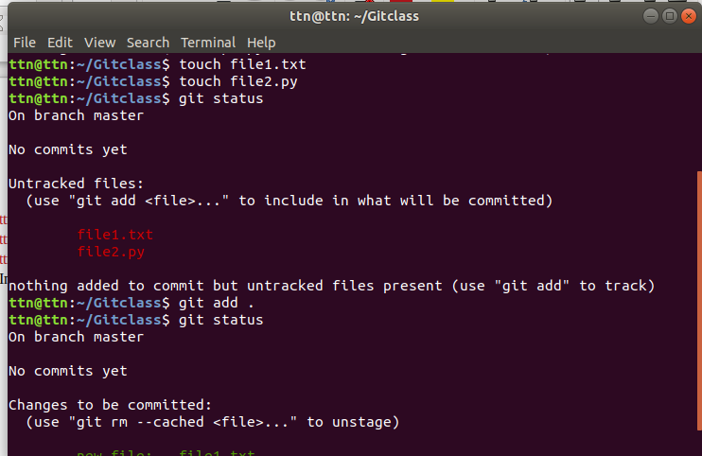
ttn@ttn:~/Gitclass$ touch file1.txt
ttn@ttn:~/Gitclass$ touch file2.py
ttn@ttn:~/Gitclass$ git status
On branch master

No commits yet

Untracked files:
(use "git add <file>..." to include in what will be committed)

file1.txt
file2.py

nothing added to commit but untracked files present (use "git add" to track)
ttn@ttn:~/Gitclass$ git add .
ttn@ttn:~/Gitclass$ git status
On branch master

No commits yet

Changes to be committed:
(use "git rm --cached <file>..." to unstage)

new file: file1.txt
new file: file2.py

ttn@ttn:~/Gitclass$

- Unstage 1 file

ttn@ttn:~/Gitclass$ git status
On branch master

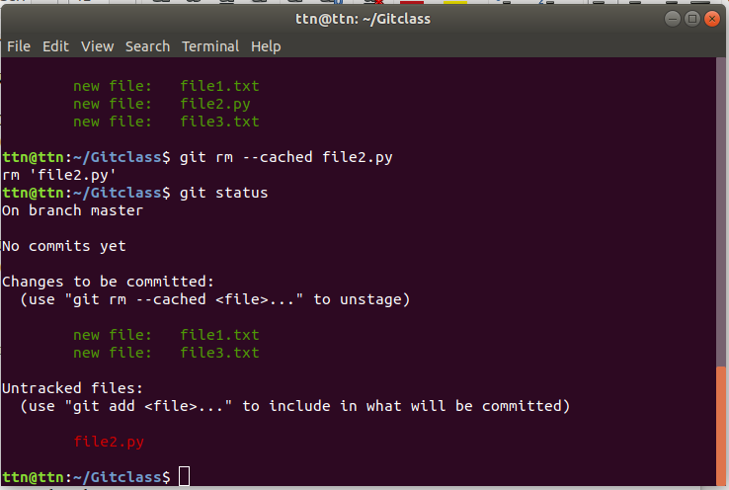
No commits yet

Changes to be committed:
(use "git rm --cached <file>..." to unstage)

new file: file1.txt
new file: file2.py
new file: file3.txt

ttn@ttn:~/Gitclass$ git rm --cached file2.py
rm 'file2.py'
ttn@ttn:~/Gitclass$ git status
On branch master

No commits yet

Changes to be committed:
(use "git rm --cached <file>..." to unstage)

new file: file1.txt
new file: file3.txt

Untracked files:
(use "git add <file>..." to include in what will be committed)

file2.py

ttn@ttn:~/Gitclass$

- Commit the file

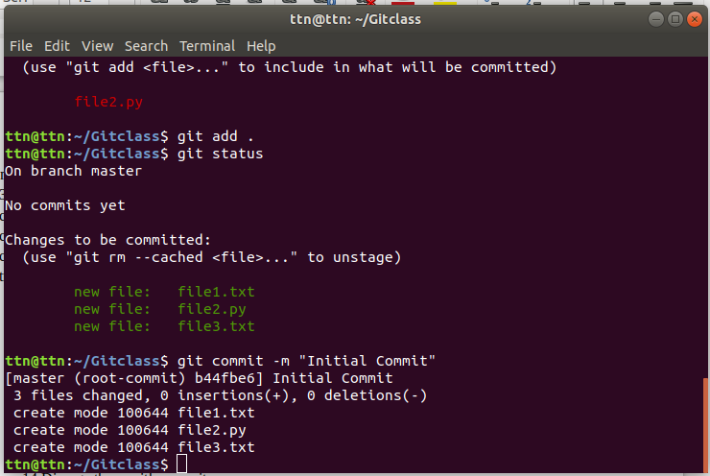
ttn@ttn:~/Gitclass$ git add .
ttn@ttn:~/Gitclass$ git status
On branch master

No commits yet

Changes to be committed:
(use "git rm --cached <file>..." to unstage)

new file: file1.txt
new file: file2.py
new file: file3.txt

ttn@ttn:~/Gitclass$ git commit -m "Initial Commit"
[master (root-commit) b44fbe6] Initial Commit
3 files changed, 0 insertions(+), 0 deletions(-)
create mode 100644 file1.txt
create mode 100644 file2.py
create mode 100644 file3.txt
ttn@ttn:~/Gitclass$

- Add a remote

ttn@ttn:~/Gitclass$ git log
commit b44fbe6d36fe856cde8b26c487856fd26ba386ef (HEAD -> master)
Author: Shaba Ahmad <shaba.ahmad@tothenew.com>
Date: Wed Feb 3 13:01:24 2021 +0530

Initial Commit
ttn@ttn:~/Gitclass$ git remote add origin https://github.com/ShabaAhmadTTN/Demo.git
ttn@ttn:~/Gitclass$ git remote -v
origin https://github.com/ShabaAhmadTTN/Demo.git (fetch)
origin https://github.com/ShabaAhmadTTN/Demo.git (push)
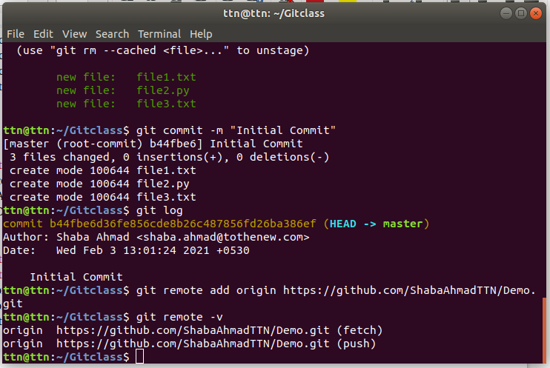

- Undo changes to a particular file

ttn@ttn:~$ cd Gitclass
ttn@ttn:~/Gitclass$ git status
On branch master
Changes to be committed:
(use "git reset HEAD <file>..." to unstage)

deleted: file.txt
modified: file1.txt
modified: file2.txt
modified: file3.txt

ttn@ttn:~/Gitclass$ git add .
ttn@ttn:~/Gitclass$ git status
On branch master
Changes to be committed:
(use "git reset HEAD <file>..." to unstage)

deleted: file.txt
modified: file1.txt
modified: file2.txt
modified: file3.txt

ttn@ttn:~/Gitclass$ git commit -m "commit :5"
[master 5b45caf] commit :5
4 files changed, 21 insertions(+), 4 deletions(-)
delete mode 100644 file.txt
ttn@ttn:~/Gitclass$ git log
commit (HEAD -> master)
Author: Shaba Ahmad <shaba.ahmad@tothenew.com>
Date: Wed Feb 3 19:19:56 2021 +0530

commit :5

commit a69ce68138e45a1607ca9693cd1ed656fbc5fcdc
Author: Shaba Ahmad <shaba.ahmad@tothenew.com>
Date: Wed Feb 3 19:13:07 2021 +0530

commit:4

commit 19fcae00fec8c07180648c6d1b60dea95ef78dc6
Author: Shaba Ahmad <shaba.ahmad@tothenew.com>
Date: Wed Feb 3 18:52:20 2021 +0530

commit:3

commit d62253587139c8cd32d5e700c026e3f8adb7c4e1
Author: Shaba Ahmad <shaba.ahmad@tothenew.com>
Date: Wed Feb 3 18:38:55 2021 +0530

commit:2

commit b44fbe6d36fe856cde8b26c487856fd26ba386ef
Author: Shaba Ahmad <shaba.ahmad@tothenew.com>
Date: Wed Feb 3 13:01:24 2021 +0530

Initial Commit

ttn@ttn:~/Gitclass$ git revert 5b45caf2787cd265f3de76f1df92c959e2f4d3ed

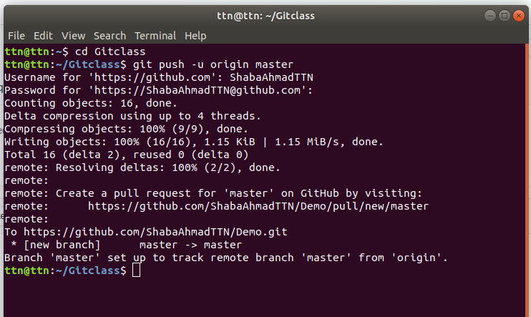
- Push changes to Github

ttn@ttn:~$ cd Gitclass
ttn@ttn:~/Gitclass$ git push -u origin master
Username for 'https://github.com': ShabaAhmadTTN
Password for 'https://ShabaAhmadTTN@github.com':
Counting objects: 16, done.
Delta compression using up to 4 threads.
Compressing objects: 100% (9/9), done.
Writing objects: 100% (16/16), 1.15 KiB | 1.15 MiB/s, done.
Total 16 (delta 2), reused 0 (delta 0)
remote: Resolving deltas: 100% (2/2), done.
remote:
remote: Create a pull request for 'master' on GitHub by visiting:
remote: https://github.com/ShabaAhmadTTN/Demo/pull/new/master
remote:
To https://github.com/ShabaAhmadTTN/Demo.git
* [new branch] master -> master
Branch 'master' set up to track remote branch 'master' from 'origin'.
ttn@ttn:~/Gitclass$

- Clone the repository

ttn@ttn:~/Gitclass$ git clone https://github.com/ShabaAhmadTTN/Demo.git
Cloning into 'Demo'...
remote: Enumerating objects: 22, done.
remote: Counting objects: 100% (22/22), done.
remote: Compressing objects: 100% (9/9), done.
remote: Total 22 (delta 2), reused 16 (delta 2), pack-reused 0
Unpacking objects: 100% (22/22), done.
ttn@ttn:~/Gitclass$
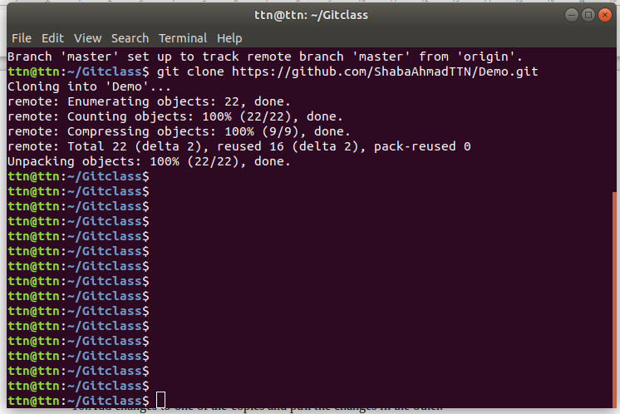

- Add changes to one of the copies and pull the changes in the other.

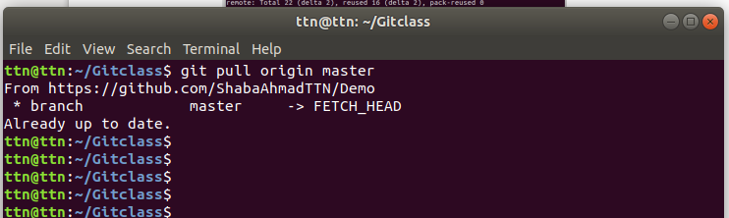
ttn@ttn:~/Gitclass$ git pull origin master
From https://github.com/ShabaAhmadTTN/Demo
* branch master -> FETCH_HEAD

- Check differences between a file and its staged version

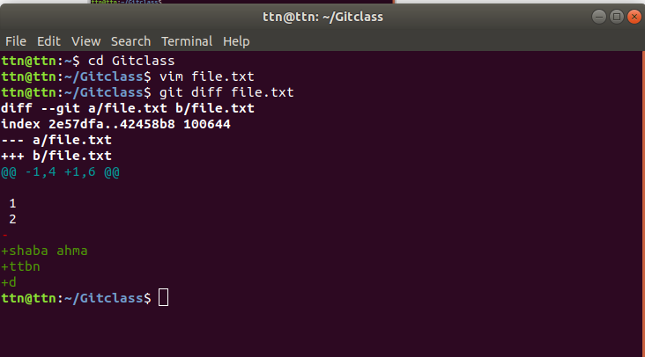
ttn@ttn:~$ cd Gitclass
ttn@ttn:~/Gitclass$ vim file.txt
ttn@ttn:~/Gitclass$ git diff file.txt
diff --git a/file.txt b/file.txt
index 2e57dfa..42458b8 100644
--- a/file.txt
+++ b/file.txt
@@ -1,4 +1,6 @@

1
2
-
+shaba ahma
+ttbn
+d
ttn@ttn:~/Gitclass$

- Ignore a few files to be checked in

ttn@ttn:~/Gitclass$ touch .gitignore
ttn@ttn:~/Gitclass$ vim .gitignore
ttn@ttn:~/Gitclass$ git add .
ttn@ttn:~/Gitclass$ git comment -m "Edited .gitignore"
git: 'comment' is not a git command. See 'git --help'.

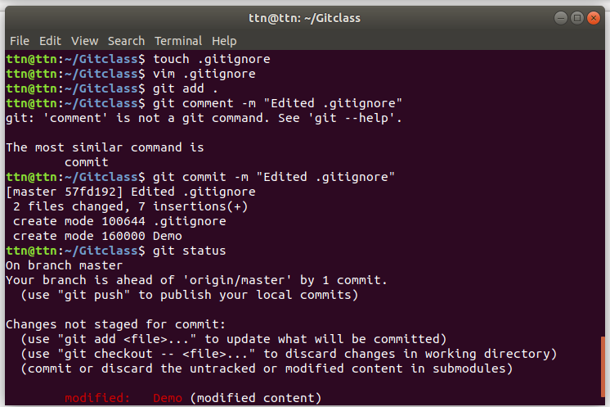
The most similar command is
commit
ttn@ttn:~/Gitclass$ git commit -m "Edited .gitignore"
[master 57fd192] Edited .gitignore
2 files changed, 7 insertions(+)
create mode 100644 .gitignore
create mode 160000 Demo
ttn@ttn:~/Gitclass$ git status
On branch master
Your branch is ahead of 'origin/master' by 1 commit.
(use "git push" to publish your local commits)

Changes not staged for commit:
(use "git add <file>..." to update what will be committed)
(use "git checkout -- <file>..." to discard changes in working directory)
(commit or discard the untracked or modified content in submodules)

modified: Demo (modified content)

- Create a new branch.

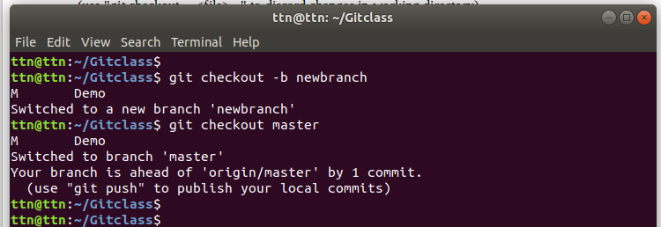
ttn@ttn:~/Gitclass$
ttn@ttn:~/Gitclass$ git checkout -b newbranch
M Demo
Switched to a new branch 'newbranch'
ttn@ttn:~/Gitclass$ git checkout master
M Demo
Switched to branch 'master'
Your branch is ahead of 'origin/master' by 1 commit.
(use "git push" to publish your local commits)

- Diverge them with commits

ttn@ttn:~/Gitclass$ git status
On branch master
Your branch is up to date with 'origin/master'.

nothing to commit, working tree clean
ttn@ttn:~/Gitclass$ vim file.txt
ttn@ttn:~/Gitclass$ git commit -am "Edited"
On branch master
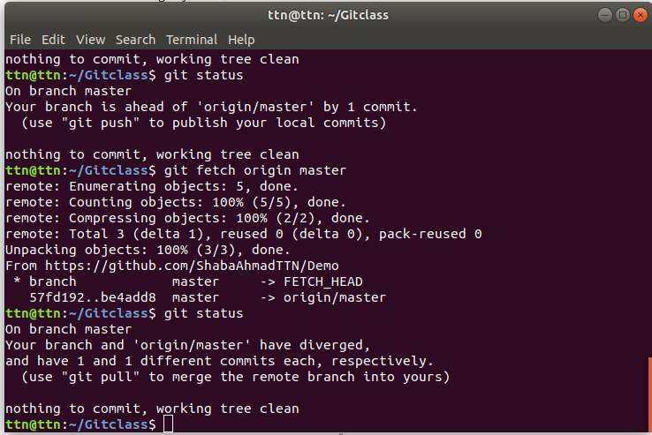
Your branch is up to date with 'origin/master'.

Untracked files:
file.txt

nothing added to commit but untracked files present
ttn@ttn:~/Gitclass$ git add .
ttn@ttn:~/Gitclass$ git commit -am "Edited"
[master 4fa0fb5] Edited
1 file changed, 3 insertions(+)
create mode 100644 file.txt
ttn@ttn:~/Gitclass$ git status
On branch master
Your branch is ahead of 'origin/master' by 1 commit.
(use "git push" to publish your local commits)

nothing to commit, working tree clean
ttn@ttn:~/Gitclass$ git fetch origin master
From https://github.com/ShabaAhmadTTN/Demo
* branch master -> FETCH_HEAD
ttn@ttn:~/Gitclass$ git status
On branch master
Your branch is ahead of 'origin/master' by 1 commit.
(use "git push" to publish your local commits)

nothing to commit, working tree clean
ttn@ttn:~/Gitclass$ git status
On branch master
Your branch is ahead of 'origin/master' by 1 commit.
(use "git push" to publish your local commits)

nothing to commit, working tree clean
ttn@ttn:~/Gitclass$ git fetch origin master
remote: Enumerating objects: 5, done.
remote: Counting objects: 100% (5/5), done.
remote: Compressing objects: 100% (2/2), done.
remote: Total 3 (delta 1), reused 0 (delta 0), pack-reused 0
Unpacking objects: 100% (3/3), done.
From https://github.com/ShabaAhmadTTN/Demo
* branch master -> FETCH_HEAD
57fd192..be4add8 master -> origin/master
ttn@ttn:~/Gitclass$ git status
On branch master
Your branch and 'origin/master' have diverged,
and have 1 and 1 different commits each, respectively.
(use "git pull" to merge the remote branch into yours)

nothing to commit, working tree clean
ttn@ttn:~/Gitclass$

- Edit the same file at the same line on both branches and commit

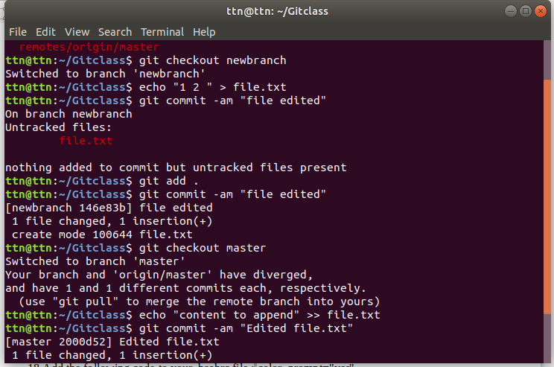
ttn@ttn:~$ cd Gitclass
ttn@ttn:~/Gitclass$ git branch -a
* master
newbranch
remotes/origin/master
ttn@ttn:~/Gitclass$ git checkout newbranch
Switched to branch 'newbranch'
ttn@ttn:~/Gitclass$ echo "1 2 " > file.txt
ttn@ttn:~/Gitclass$ git commit -am "file edited"
On branch newbranch
Untracked files:
file.txt

nothing added to commit but untracked files present
ttn@ttn:~/Gitclass$ git add .
ttn@ttn:~/Gitclass$ git commit -am "file edited"
[newbranch 146e83b] file edited
1 file changed, 1 insertion(+)
create mode 100644 file.txt
ttn@ttn:~/Gitclass$ git checkout master
Switched to branch 'master'
Your branch and 'origin/master' have diverged,
and have 1 and 1 different commits each, respectively.
(use "git pull" to merge the remote branch into yours)
ttn@ttn:~/Gitclass$ echo "content to append" >> file.txt
ttn@ttn:~/Gitclass$ git commit -am "Edited file.txt"
[master 2000d52] Edited file.txt
1 file changed, 1 insertion(+)

- Try merging and resolve merge conflicts

ttn@ttn:~/Gitclass$ git merge newbranch
Auto-merging file.txt
CONFLICT (add/add): Merge conflict in file.txt
Automatic merge failed; fix conflicts and then commit the result.
ttn@ttn:~/Gitclass$ vim file.txt
ttn@ttn:~/Gitclass$ git commit -m "Resolve Conflit"
U file.txt
error: Committing is not possible because you have unmerged files.
hint: Fix them up in the work tree, and then use 'git add/rm <file>'
hint: as appropriate to mark resolution and make a commit.
fatal: Exiting because of an unresolved conflict.
ttn@ttn:~/Gitclass$ git add .
ttn@ttn:~/Gitclass$ git commit -m "Resolve Conflit"
[master e0e9731] Resolve Conflit
ttn@ttn:~/Gitclass$ git status

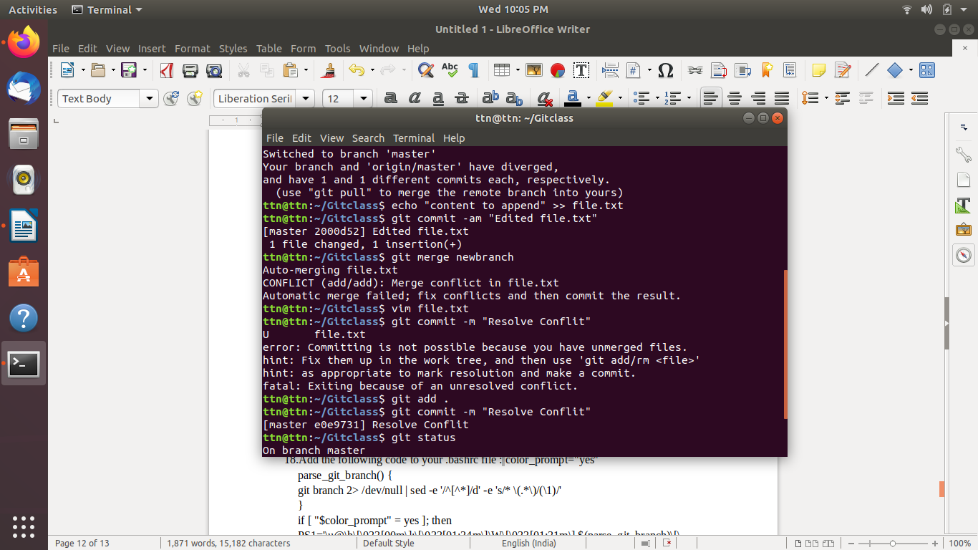

- Stash the changes and pop them

ttn@ttn:~/Gitclass$ vim file.txt
ttn@ttn:~/Gitclass$ git stash
Saved working directory and index state WIP on master: e0e9731 Resolve Conflit
ttn@ttn:~/Gitclass$ git stash list
stash@{0}: WIP on master: e0e9731 Resolve Conflit
ttn@ttn:~/Gitclass$ get stash pop

Command 'get' not found, but there are 18 similar ones.

ttn@ttn:~/Gitclass$ git stash pop
On branch master
Your branch and 'origin/master' have diverged,
and have 4 and 1 different commits each, respectively.
(use "git pull" to merge the remote branch into yours)

Changes not staged for commit:
(use "git add <file>..." to update what will be committed)
(use "git checkout -- <file>..." to discard changes in working directory)

modified: file.txt

no changes added to commit (use "git add" and/or "git commit -a")
Dropped refs/stash@{0} (6e4ceb37d83840deca7d8a837d14736dd84a4d56)

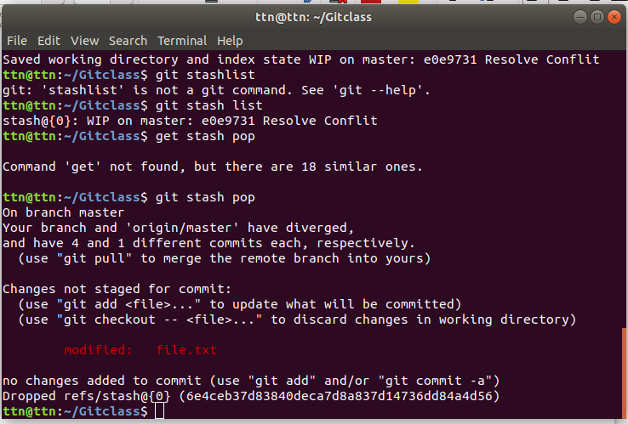

- Add the following code to your .bashrc file : color_prompt="yes"
parse_git_branch() {
git branch 2> /dev/null | sed -e '/^[^*]/d' -e 's/* \(.*\)/(\1)/'
}
if [ "$color_prompt" = yes ]; then
PS1='\u@\h\[\033[00m\]:\[\033[01;34m\]\W\[\033[01;31m\] $(parse_git_branch)\[\033[00m\]\$ '
else
PS1='\u@\h:\W $(parse_git_branch)\$ '
fi
unset color_prompt force_color_prompt

ttn@ttn:~$ vim ~/.bashrc
