Admin will have complete access to all the details of all the users and modules within Institute Management System. An admin will be able to edit, modify and delete the data. Admin module will have further sub-modules as follows:

• Staff Details

• Student Details

• Parent Details

• Examination Manager

• Fee Management, Attendance Management, Library Management, etc

**Student Details**

Admin after logging in and clicking on Student Details button will be able to see all the details of students that they have registered with the Institute Management System by clicking on Student Details and modify them using Edit Selected. Admin can also search for details of a particular student by entering his ID and then clicking Search button. To modify the details of any student he will click on his data row in the table and then click Edit Student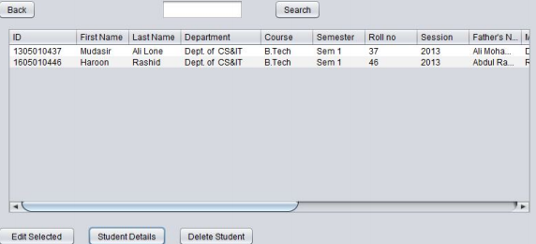

**Staff Details**

The admin will be able to see all the details of teachers that they have registered with the IMS by clicking on Teacher Details and modify them using Edit Selected. Admin can also search for details of a particular teacher by entering his employee ID and then clicking Search button. To modify the details of any teacher he will click on his data row in the table and then click Edit Student. Delete Teacher will delete the selected teacher from the database.

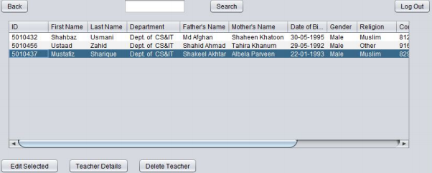

**Parent Details(optional)**

Admin-Parent module will allow the admin to see the details of all the Parents registered with IMS and edit their details and delete them.

**Examination Manager**

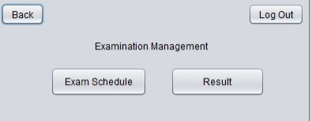

Examination Management System will consist of Exam Schedule and Result Management. An admin will click on Exam Schedule Button to get schedule details and Result button to access Result Management.

**Result Management**

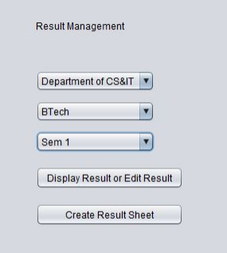

In the Result Management, the Admin will choose the Department, Course and Semester to get the Result Details or to create the result sheet. After choosing, he/she will click on the respective button.

**Result Submit**

After choosing the department, course, semester and then clicking on Create Result 42 Sheet, the Admin will enter the enrolment number of student and then his marks in respective subjects and then click on the submit button. All the marks data will be stored in the respective database of that course and semester.

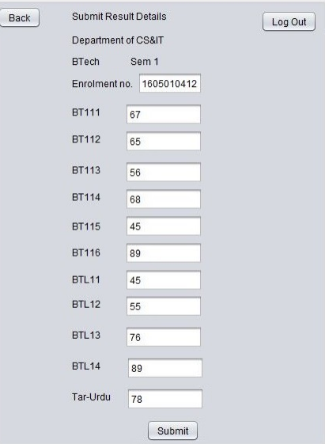

**Result Sheet**

In the Examination Management the admin will choose the department, course and semester, and will then get the result details of all the students of that course and semester after clicking on Get Complete Result Sheet button.

