1. Briefly explain your project experience
2. What are Transaction subtypes?

* Payment, Reserve, Recovery Reserve, Recovery

1. What is the difference between reserve and reserve line?

* Reserve means an amount which is set aside for the loss occurred. Reserve is an entity that records the potential liability. Typically, it is created as soon as a claim is made
* Reserve line represents a unique combination of exposure, cost type, and cost category. It is used to categorize and track transactions. All transactions are created against a reserve line

1. What is the relation between Transaction and Transaction Line item?

* The transaction is the main financial entity in the Claim Center data model. It is an abstract entity with the final subtypes Payment, Reserve, Recovery, and Recovery Reserve.
* Every transaction contains one or more transaction line item objects that hold the monetary amount, or a part of the monetary amount, of the transaction.
* Payments and recoveries can contain more than one transaction line item. Reserves and recovery reserves can contain only one transaction line item.
* The amount of a transaction is the sum of all its transaction line item amounts.
* Each transaction line item contains a line category field that further categorizes the amount beyond the Cost Type and Cost Category of the entire transaction

1. What is the difference between check and payment

* A payment is an entity that represents the money that is paid out.
* A check is an entity that groups the payments made at the same time. Always it is send to external system from CC to be printed.

1. What is the life cycle status of a check?

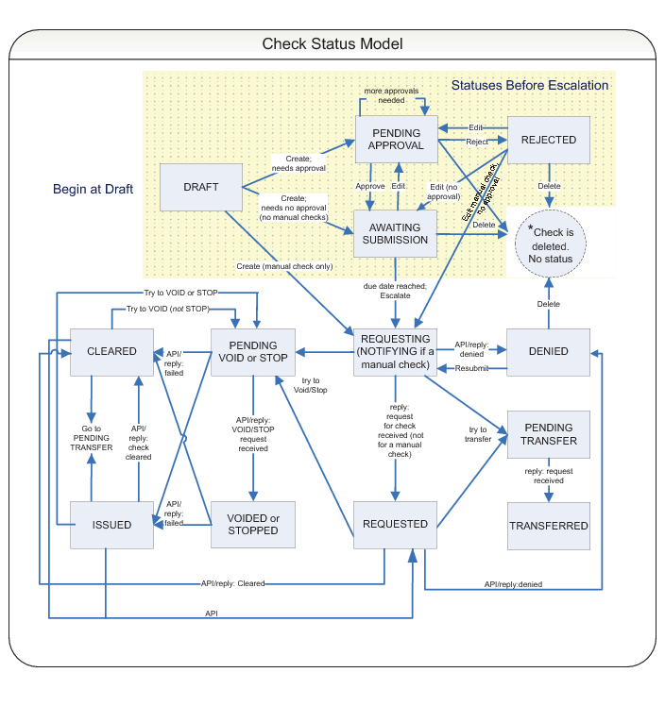

1. After clicking on Finish in the FNOL Wizard, what are the rules that gets executed in orderly fashion?

* Claim loaded
* Claim Pre-setup
* Claim Segmentation
* Claim Assignment
* Claim Workplan
* Claim Post-setup
* Claim pre-update
* Claim Validation

1. What are initial Reserve rule set?

* These are the rules used to determine initial Financial Reserve that are created for a new Exposure

1. When you need to have an automatic exposure creation during claim creation process then at what place the rule should be written?

* Claim Pre-setup. The logical reason is Exposure also have its own segmentation rules which run after Claim Segmentation when an exposure creation is done during claim creation

1. How to create an Array?

* Creation of an Array in Entity: create an array object with arrayentity property as reference entity name and reference entity should contain a foreign key to the original entity

1. How to use an Array in PCF?

* An array is used in LV’s
* An LV should contain a rowIterator
* RowIterator value is an Array object
* toAdd property is entityname.addToArrayObject(ReferenceEntityObject)
* toRemove property is entityname.removeFromArrayObject(ReferenceEntityObject)

1. Explain CC folder structure?

* cc -> modules -> configuration -> config -> Entity Names (.en ‘s are created in this pkg)
* cc -> modules -> configuration -> config -> Extensions -> Entity (custom entity files)
* cc -> modules -> configuration -> config -> Extensions -> Typelist (Custom type list files)
* cc -> modules -> configuration -> config -> Localizations -> lang (display,typelist prop)
* cc -> modules -> configuration -> config -> Messaging -> config.xml, config.xsd files
* cc -> modules -> configuration -> config -> Metadata -> Entity (GW entity files)
* cc -> modules -> configuration -> config -> Metadata -> Typelist (GW typelist files)
* cc -> modules -> configuration -> config -> Page Configuration -> PCF (PCF files)
* cc -> modules -> configuration -> config -> Plugins –> Plugin registry(.gwp files)
* cc -> modules -> configuration -> config -> Rulesets -> rules (presetup….. etc)
* cc -> modules -> configuration -> gsrc -> class files
* cc -> modules -> configuration -> gtest -> Test class files

1. What is the relation between Activity and Activity Pattern?

* Activity patterns are templates that standardize the way Claim Center generates activities
* To create an Activity, we need to use a function createActivityFromPattern(ap)
* For eg, Activity due date is calculated based on the number of days represented in activity pattern