**Problem Statement**:

Predict whether a product will be returned based on purchase amount, review score, and delivery time.

**Name**: ARPIT  
 **Roll No**: 202401100300065

**Introduction**

The aim is to classify whether a product will be returned or not using three features:

* Purchase amount
* Review score
* Days taken for delivery

This is a binary classification task and helps businesses reduce cost by predicting return tendencies early.

**Methodology**

* Data is read from a CSV file.
* Label Encoding converts yes/no in the returned column to 1/0.
* Data is split into 80% training and 20% testing sets.
* A **Random Forest Classifier** is used for prediction.
* Model is evaluated using:
  + **Accuracy**
  + **Precision**
  + **Recall**
  + **Confusion Matrix** (shown as a heatmap)

**Code**

import pandas as pd

from sklearn.model_selection import train_test_split

from sklearn.ensemble import RandomForestClassifier

from sklearn.metrics import confusion_matrix, accuracy_score, precision_score, recall_score

from sklearn.preprocessing import LabelEncoder

import seaborn as sns

import matplotlib.pyplot as plt

df = pd.read_csv('product_return.csv')

df['returned'] = LabelEncoder().fit_transform(df['returned'])

X = df.drop('returned', axis=1)

y = df['returned']

X_train, X_test, y_train, y_test = train_test_split(X, y, test_size=0.2, random_state=42)

clf = RandomForestClassifier(random_state=42)

clf.fit(X_train, y_train)

y_pred = clf.predict(X_test)

print("Accuracy:", round(accuracy_score(y_test, y_pred), 2))

print("Precision:", round(precision_score(y_test, y_pred), 2))

print("Recall:", round(recall_score(y_test, y_pred), 2))

cm = confusion_matrix(y_test, y_pred)

sns.heatmap(cm, annot=True, fmt='d', cmap='Blues', xticklabels=['No', 'Yes'], yticklabels=['No', 'Yes'])

plt.xlabel('Predicted')

plt.ylabel('Actual')

plt.title('Confusion Matrix')

plt.show()

**Output/Result**

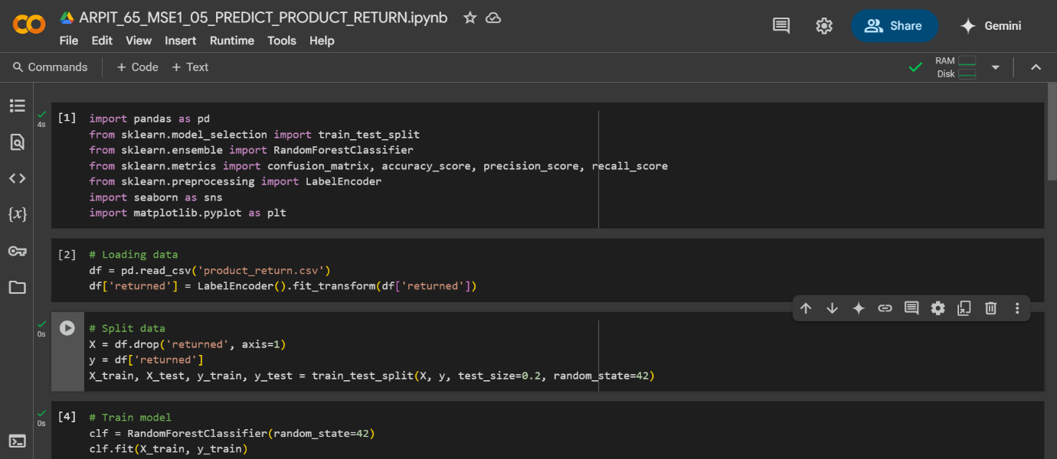

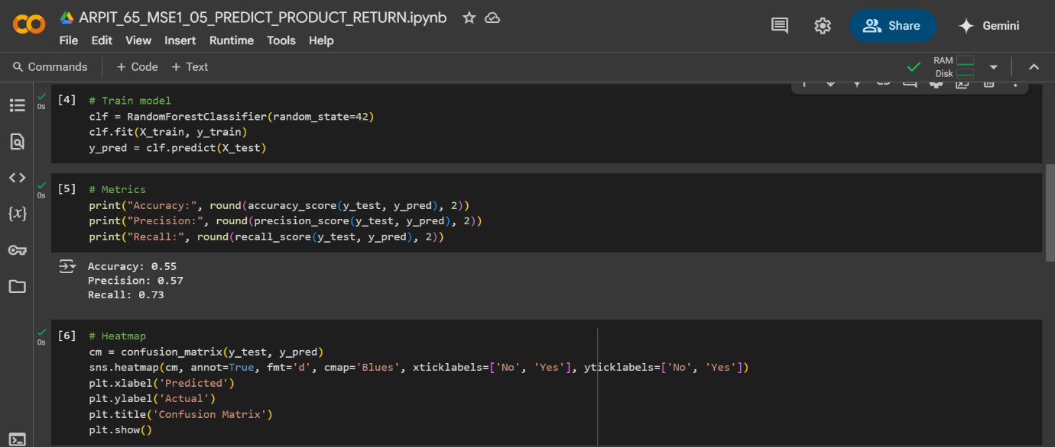

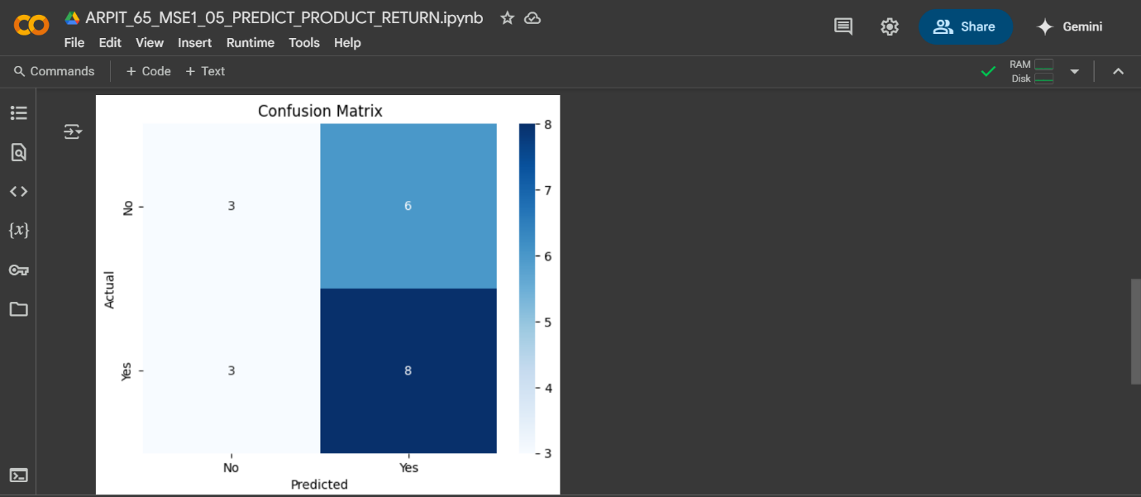

**References/Credits**

* Dataset: Provided by instructor
* Libraries: pandas, sklearn, matplotlib, seaborn
* Classifier: Random Forest (from sklearn.ensemble)