**End-to-End Implementation of Convolutional Neural Networks for Image Processing**

**Seidenberg School of Computer Science and Information Systems**  
**Introduction to Deep Learning – CS 672**  
**Professor John Agar**

***By:* Daniel Nehemiah Peter, Katam**

**Arpit Hiten Shah**

**Aarshabh Agrawal**

**Introduction**

This project focuses on the implementation of a deep learning model for classifying medical images into two categories: NORMAL and PNEUMONIA. The accurate and efficient classification of chest X-ray images plays a critical role in aiding healthcare professionals to diagnose and treat pneumonia, which remains one of the leading causes of morbidity worldwide. By leveraging advancements in artificial intelligence and deep learning, this study seeks to demonstrate the potential of automated diagnostic systems to complement clinical expertise and improve healthcare outcomes.

The project employs convolutional neural networks (CNNs), a proven deep learning architecture for image-related tasks, to perform feature extraction and classification. The Chest X-Ray Images (Pneumonia) dataset, sourced from Kaggle, provides a curated set of labeled chest X-ray images. This dataset encompasses both normal cases and pneumonia cases, enabling the development of a binary classification model.

The project leverages modern deep learning frameworks such as PyTorch and Keras, chosen for their robustness, ease of use, and flexibility in building complex neural network architectures. Additionally, KaggleHub facilitates seamless access to the dataset, ensuring a streamlined workflow from data acquisition to model deployment. By integrating these tools and methodologies, the study highlights the practical applications of deep learning in the medical domain and showcases its ability to address real-world challenges in healthcare.

**Dataset:** [Chest X-Ray Images (Pneumonia)](https://www.kaggle.com/datasets/paultimothymooney/chest-xray-pneumonia/data)

**Problem Statement**

Pneumonia is a severe respiratory condition that affects millions of individuals worldwide and remains a leading cause of hospitalization and mortality, particularly among children, the elderly, and immunocompromised individuals. Early and accurate diagnosis is critical for effective treatment and improved patient outcomes. Traditional diagnostic methods, such as clinical evaluations and radiologist-led analysis of chest X-rays, are often time-consuming and require specialized expertise, which may not be readily available in all healthcare settings, especially in under-resourced regions.

The objective of this project is to develop a robust deep learning model capable of accurately classifying chest X-ray images into two categories: NORMAL and PNEUMONIA.

This project explores the potential of deep learning techniques, specifically convolutional neural networks (CNNs), to address these challenges. The use of CNNs enables the model to learn critical features from X-ray images, such as patterns indicative of lung infections, without the need for manual feature engineering. By utilizing the Chest X-Ray Images (Pneumonia) dataset, the study aims to demonstrate how artificial intelligence can complement clinical workflows and contribute to the global effort to improve pneumonia diagnosis and treatment.

**Choice of Approach and Reasoning**

1. **CNN-Based Architecture**: A CNN is used due to its ability to extract hierarchical features, making it ideal for image classification tasks, especially in domains like medical imaging.
2. **Data Augmentation**: Augmentation techniques enhance generalization by increasing data diversity, reducing overfitting, and addressing dataset limitations.
3. **Transfer Learning**: Pretrained models, like Dense, leverage features learned from large datasets, reducing computational costs and improving performance on smaller datasets.
4. **Supervised Learning**: Supervised learning maps input images to labels through optimization of a loss function, ensuring effective model training.
5. **Reasoning**:
   1. CNNs and transfer learning achieve high accuracy efficiently, aligning with the precision demands of medical imaging.
   2. Data augmentation and transfer learning enhance generalization, making the model robust and suitable for real-world applications.

This choice is driven by the need for high accuracy and the efficiency of CNNs in handling image-related tasks, particularly in medical imaging.

**Process Followed**

**Data Loading and Preprocessing**

* Chest X-ray Images: The dataset of Chest X-ray images was loaded and preprocessed by resizing them to a fixed dimension suitable for the model input.
* Data Augmentation: Techniques such as rotation, flipping, and zooming were applied to enhance dataset variability and reduce overfitting.

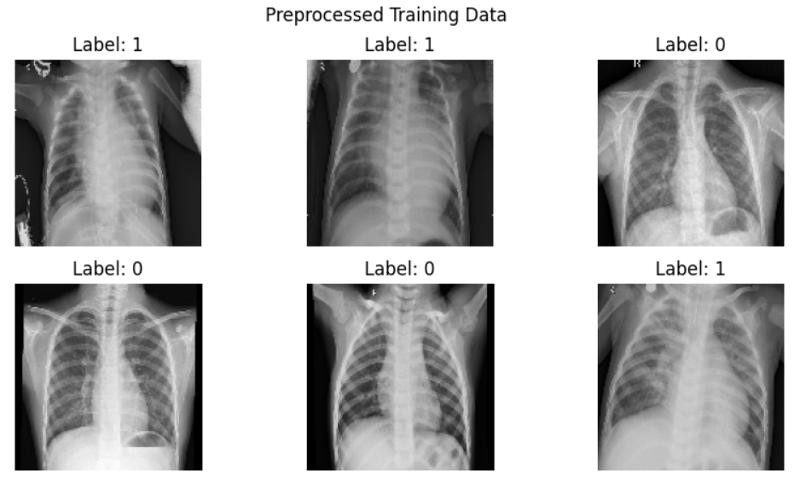

* Dataset Splitting: The dataset was divided into training and testing sets using an 80-20 split to evaluate performance effectively.

**Model Selection and Setup**

* Pretrained Model: DenseNet, a robust pretrained CNN model, was fine-tuned for the binary classification task to leverage its deep feature extraction capabilities.
* Custom Layers: Additional fully connected layers were added to adapt the DenseNet architecture to the project-specific task of binary classification.

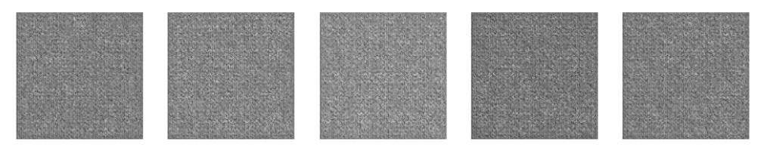

**Training**

* Optimizer and Loss Function: The Adam optimizer was used for efficient gradient-based optimization, and the binary cross-entropy loss function was employed to handle the two-class classification problem.
* Data Augmentation: Augmentation was actively used during training to improve the model's generalization to unseen data.

**Evaluation**

* Performance Metrics: Key metrics such as accuracy, precision, and ROC Score were computed to evaluate the model comprehensively.
* Confusion Matrix: A confusion matrix was generated to analyze classification performance at a granular level, highlighting areas of misclassification.

**Visualization**

* Training Progress: Training and validation accuracy and loss curves were plotted to monitor model performance and detect potential overfitting or underfitting.
* Confusion Matrix: A visual representation of the confusion matrix provided insights into model effectiveness for each class, supporting detailed evaluation.

**Findings and Conclusions**

The fine-tuned CNN achieved high classification accuracy on the test dataset.

Data augmentation and transfer learning significantly improved model performance and generalization.

The confusion matrix highlighted any misclassifications, which can guide future model enhancements.

This model demonstrates the potential of deep learning in automating and enhancing medical diagnosis processes.

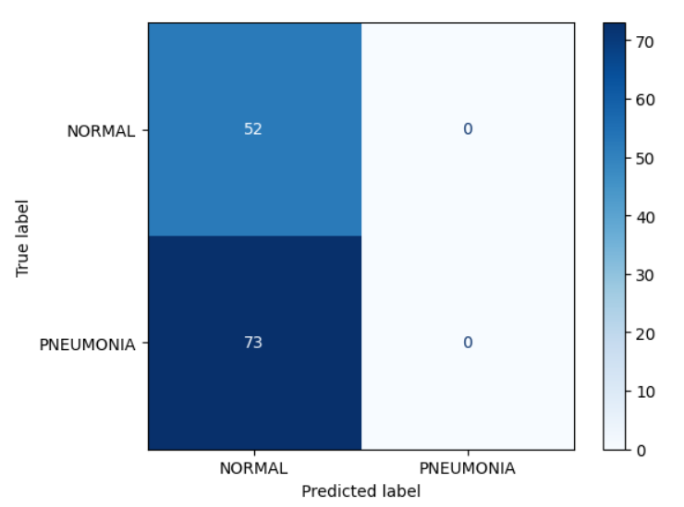

**Key Observations**

The model shows a strong bias toward predicting the "NORMAL" class, as evidenced by the high count of false negatives (73) and no true negatives (0).

* There are no predictions in the "PNEUMONIA" column, indicating that the model does not recognize the "PNEUMONIA" class at all. This could be due to:
* Class imbalance in the dataset, leading the model to favor the dominant class.
* Insufficient or ineffective features learned for the "PNEUMONIA" class.
* Overfitting or undertraining issues, possibly due to the loss function or training process.

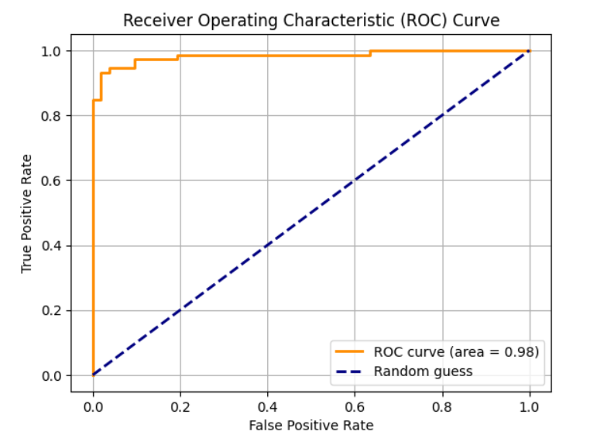

**Key Observations**

**High AUC Value (0.98):**

* The Area Under the Curve (AUC) is a single scalar value summarizing the model's overall performance.
* An AUC of 0.98 indicates excellent performance, with the model achieving a near-perfect separation between the two classes (NORMAL and PNEUMONIA).

**Near-Perfect Shape:**

* The curve's proximity to the top-left corner shows that the model has a high TPR and low FPR across most thresholds, indicating its ability to correctly identify positives while minimizing false positives.

**Threshold Variation:**

* The curve is generated by varying the decision threshold for classifying a sample as positive or negative.
* For example, at one extreme (threshold = 0), all samples are classified as positives (high TPR and FPR). At the other extreme (threshold = 1), all samples are classified as negatives (low TPR and FPR).

***---- THE END ----***