Report
Of
NetSage AI – Applied AI for Network Troubleshooting
Submitted
To
School of Computer Science and Engineering
IILM University, Greater Noida, U.P.
In partial fulfilment of the requirement of degree of
B.Tech CSE

By
ROLL NO.: 25SCS1003002216
ARPIT KUMAR SINGH
Batch: 2025–29
2026–27

CANDIDATE’S DECLARATION
I, Arpit Kumar Singh do hereby declare that the internship report titled “NetSage AI – Applied AI for Network Troubleshooting” has been completed by me to fulfil the requirement for the award of the degree of Bachelor of Technology in Computer Science and Engineering. The work presented in this report describes the project developed and documented during the Cisco–AICTE Virtual Internship Program. All references used in preparing this report have been acknowledged appropriately. I further declare that this report has not been submitted to any other institute for the fulfilment of any degree or diploma requirement. I shall be solely responsible for any copyright violation arising from the submission of this report.

Signature:
Student Name: Arpit Kumar Singh
Roll No.: 25SCS1003002216

ACKNOWLEDGEMENT
I am grateful to everyone who supported me during the Cisco–AICTE Virtual Internship Program and helped me complete the assigned project. The internship provided an opportunity to connect classroom concepts with a practical problem involving computer networks, troubleshooting and applied artificial intelligence.
I sincerely thank Dr. Swati Vashisht, Faculty/Internship Coordinator at IILM University, for her guidance and support throughout the internship. I am also thankful to Cisco and the AICTE Virtual Internship Program for providing the learning environment, industry-oriented problem statement and resources required to work on the project.
Working on NetSage AI helped me understand how network evidence such as VLAN information, routing output, DHCP configuration, ACL rules and connectivity observations can be organised into a structured troubleshooting workflow. The experience also strengthened my understanding of responsible use of AI, particularly the importance of evidence, confidence and human review before applying a corrective action.
Finally, I express my gratitude to my parents for their constant encouragement and support.

Signature:
Student Name: Arpit Kumar Singh
Roll No.: 25SCS1003002216

TABLE OF CONTENTS
1. Candidate’s Declaration i
2. Acknowledgement ii
4. Project Description 1
4.1 Introduction 1
4.2 Organization Profile 1
4.3 Problem Statement 1
4.4 Project Objectives 2
4.5 Scope of the Project 2
4.6 Technologies and Tools Used 3
4.7 System Architecture 3
4.8 Methodology 4
4.9 Expected Outcomes 5
4.10 Certificates of Completion and Other Communication Mail Proof 5
5. Bibliography/References 6

LIST OF FIGURES
Figure 4.1 High-level architecture of NetSage AI 4
Figure 4.2 Evidence-to-diagnosis workflow 5
LIST OF TABLES
Table 4.1 Project scope and boundaries 2
Table 4.2 Technologies and tools used 3

4. PROJECT DESCRIPTION
4.1 Introduction
NetSage AI is an applied AI and network troubleshooting project developed as part of the Cisco–AICTE Virtual Internship Program. The project is designed around a practical network-operations workflow in which a user provides a network symptom and supporting command evidence, and the system organises that evidence into a diagnosis, confidence indication, confirmation command and suggested remediation steps.
The project combines two complementary approaches. A deterministic rule-checking layer identifies configuration patterns that can be directly verified from network evidence, while an AI diagnosis layer explains the likely root cause in a readable troubleshooting format. The application also includes a human-review stage so that a proposed correction is not treated as an automatic action. This makes the workflow suitable for learning, demonstration and controlled troubleshooting rather than unattended network modification.
4.2 Organization Profile
Cisco is a global technology company known for networking, security, collaboration and related digital infrastructure solutions. Cisco Networking Academy provides learning experiences that connect networking concepts with practical skills. The Cisco–AICTE Virtual Internship Program provides students with industry-oriented exposure through structured learning and a project problem statement.
For this internship, the project work was carried out in the academic environment of IILM University under the Cisco–AICTE Virtual Internship Program. The internship period for course completion was from 20 May 2026 to 18 June 2026, with the overall internship engagement extending for approximately two months.
4.3 Problem Statement
Network troubleshooting often requires a technician to inspect several pieces of evidence before deciding what is actually wrong. A single symptom such as loss of connectivity may be caused by a VLAN mismatch, an incorrect trunk configuration, a missing route, DHCP failure, an ACL rule, NAT configuration, DNS behaviour or a wireless setting. The problem is therefore not simply to display a possible answer, but to connect the reported symptom with relevant evidence and produce a diagnosis that can be checked.
The NetSage AI problem is to build a focused troubleshooting assistant that can ingest structured network evidence, identify likely faults across common network categories, explain the reasoning, provide a next command for confirmation and present safe fix guidance. The system must also support deterministic validation and human review so that AI suggestions remain auditable and are not applied blindly.
4.4 Project Objectives
• Develop a web-based interface for browsing and inspecting network troubleshooting cases.
• Represent troubleshooting cases using realistic command-output evidence covering VLAN, routing, gateway, DHCP, DNS, ACL, NAT and wireless faults.
• Provide an AI-assisted diagnosis containing a root cause, confidence level, OSI-layer context, evidence and a next command to confirm the diagnosis.
• Provide deterministic rule checking for configuration issues that can be identified from known evidence patterns.
• Maintain a human-review workflow with Accepted, Edited and Rejected outcomes and a review trail.
• Prevent automatic network changes unless a human review stage has been completed.
• Maintain a reusable case library and diagnosis history suitable for demonstration and evaluation.
4.5 Scope of the Project
Area | Included in Scope | Boundary
Network diagnosis | Evidence-driven diagnosis for common LAN/WAN faults. | Not a replacement for production NOC tooling.
Deterministic checks | Rule-based checks for VLAN, routing, DHCP, DNS, ACL, NAT, gateway and wireless evidence. | Rules depend on the evidence supplied to the case.
AI explanation | Root cause, confidence, evidence and confirmation command. | AI output remains a recommendation and requires review.
Human review | Accept, edit or reject a diagnosis and preserve review state. | No unattended remediation.
Web application | Dashboard, case browser, diagnosis and Responsible AI log. | Local academic demonstration environment.
Table 4.1 Project scope and boundaries 2
4.6 Technologies and Tools Used
Technology/Tool | Purpose | Use in Project
Python | Application and diagnostic logic | Case handling, rule evaluation and backend workflow.
Flask | Web framework | Routes, API endpoints and local web application.
SQLite | Database | Case, diagnosis and review-history storage.
HTML/CSS/JavaScript | User interface | Dashboard, case browser and interactive diagnosis views.
Cisco IOS command evidence | Network domain input | show commands and configuration snippets used as evidence.
Virtual environment / pip | Dependency management | Isolated Python environment and reproducible installation.
Browser developer tools | Testing | API/network request and error inspection during local testing.
Table 4.2 Technologies and tools used 3
4.7 System Architecture
The system follows a layered workflow. Case evidence is stored and presented through the web interface. The AI diagnosis layer interprets the case context, while the deterministic checker evaluates explicit evidence patterns. Results from both layers are shown together so a reviewer can compare an explanatory diagnosis with verifiable findings.
USER / REVIEWER
Select case → inspect symptom and command evidence
WEB APPLICATION
Dashboard → Case Browser → Diagnosis / Review
DIAGNOSIS LAYERS
AI diagnosis + Deterministic rule checker
RESPONSIBLE AI LAYER
Confidence → Evidence → Confirmation command → Human review
STORAGE
Cases → Diagnoses → Review outcomes / history
Figure 4.1 High-level architecture of NetSage AI 4
4.8 Methodology
The methodology used in NetSage AI is evidence-first. Each troubleshooting case begins with a symptom and a collection of command-output evidence. The case is then passed through the diagnosis workflow rather than being treated as a free-form question.
Stage | Description
Case selection | The user selects a case from the Case Browser and reviews the reported symptom and available evidence.
Evidence inspection | Relevant IOS outputs, logs, interface information, routing information or configuration snippets are identified.
AI diagnosis | The AI layer proposes a likely root cause and presents confidence, OSI-layer context, supporting evidence, a command for confirmation and fix steps.
Deterministic verification | The rule checker independently evaluates known evidence patterns and reports findings with severity.
Human review | The reviewer decides whether the diagnosis is Accepted, Edited or Rejected. An edited diagnosis can record the reviewer’s correction instead of silently replacing the original AI result.
Audit trail | Diagnosis and review outcomes are retained so the project can demonstrate how an AI recommendation was handled.
Figure 4.2 Evidence-to-diagnosis workflow 5
The project deliberately keeps diagnosis separate from remediation. The interface communicates that human review is required before any fix is applied. This separation is important because a network configuration change can affect connectivity beyond the immediate case.
4.9 Expected Outcomes
• A working local web application that demonstrates an end-to-end network troubleshooting workflow.
• A structured library of 31 troubleshooting cases across VLAN, Routing, Gateway, DNS, DHCP, ACL, Wireless and NAT categories.
• Two diagnosis perspectives: an AI explanation and deterministic evidence-based findings.
• An auditable Responsible AI workflow in which confidence, evidence and human review are visible to the user.
• A reusable demonstration platform that can be extended with additional cases, rules and network evidence formats.
4.10 Certificates of Completion and Other Communication Mail Proof
The following three Cisco Networking Academy course-completion certificates are attached as supporting evidence of learning completed during the internship period. They are reproduced from the original certificate files supplied for this report.
Certificate 1 – Apply AI: Analyze Customer Reviews (03 June 2026)
Certificate 2 – Introduction to Modern AI (08 June 2026)
Certificate 3 – Data Analytics Essentials (16 June 2026)
5. BIBLIOGRAPHY / REFERENCES
1. Cisco Networking Academy. Course materials and learning resources used during the Cisco–AICTE Virtual Internship Program.
2. Cisco Systems, Inc. Cisco IOS documentation and command-reference material consulted for understanding network configuration and show-command evidence.
3. Python Software Foundation. Python documentation and standard-library references used for project implementation.
4. Pallets Projects. Flask documentation used for the web application structure and routing.
5. SQLite Documentation. SQLite language and database reference used for local project data storage.

Certificate 1 – Apply AI: Analyze Customer Reviews (03 June 2026)
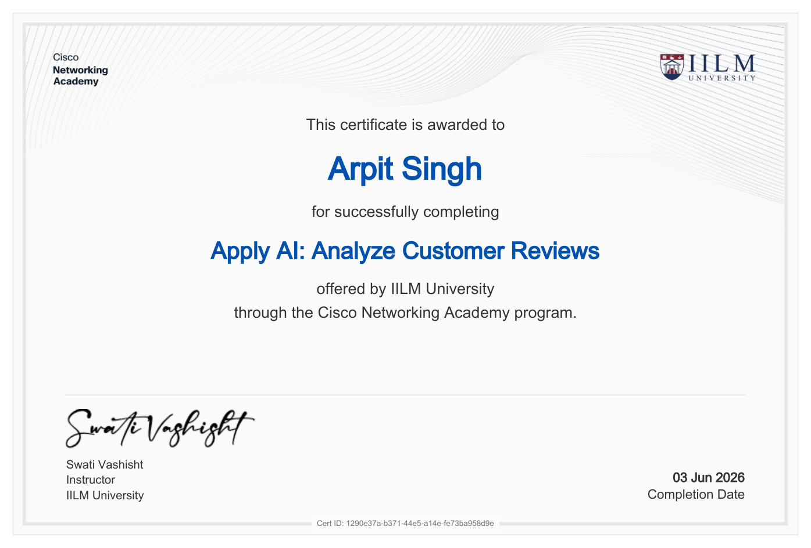

Certificate 2 – Introduction to Modern AI (08 June 2026)
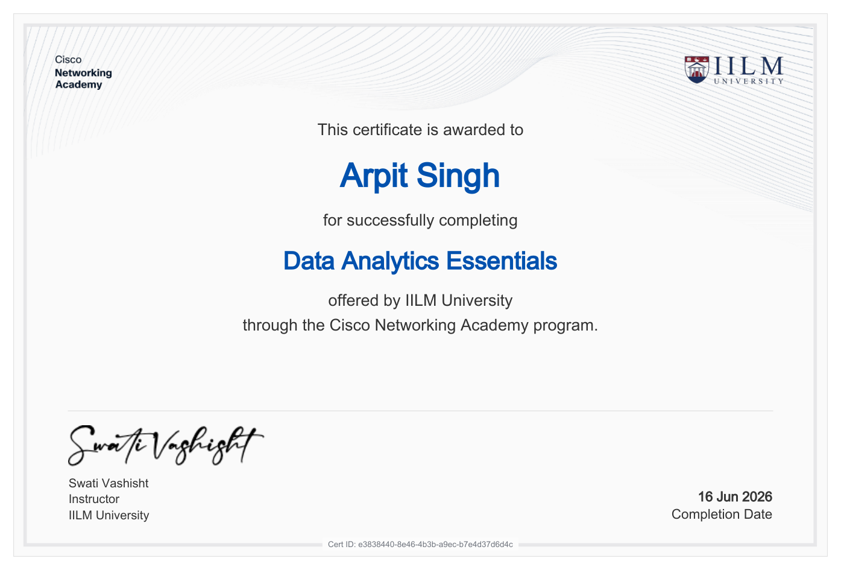

Certificate 3 – Data Analytics Essentials (16 June 2026)
