

**LIBRARY MANAGEMENT SYSTEM**

**A DEVELOPER/TECHNICAL GUIDE**

Created By

* Arpit Gupta
* Lavish Gulati
* Nayanjyoti Deury
* Piyush Gupta
* Tushar Bhutada
* Rythum Singla

**CONTENTS**

1. [Introduction](#Introduction)…………………………………………………………………………………………………………………. 3
2. [System Requirements](#SystemReq) ………………………………………………………………………………………………….. 3
3. [Program Structure](#structure)………………………………………………………………………………………………………….4
4. [Database](#Database)………………………………………………………………………………………………………………………..5
5. [Search and Browse Books](#Search)……………………………………………………………………………………………… 7
6. [Login](#Login)………………………………………………………..…………………………………………………………………… 7
7. [Student/Professor Login Page](#StudentLogin)……….……………………………………………………………………………… 8
8. [Staff/Admin Login Page](#StaffLogin) ………….……………………………………………………………………………….…. 10
9. [Some Added Features](#addedfeatures) ………………..………………………………………………………………………………. 12
10. [References](#references) …………………………………………………………………………………………………………………..12
11. [Future Additions](#todo) ………………………………………………………………………………………………………… 13

**1** **INTRODUCTION**

The Library Management System Software provides a basic and sufficient service to be used in a library for various purposes. The software provides services to the people on the basis of his/her designation like guest, student, professor or a staff member. Some of the basic services include search, browse, issue , renew etc.

This document will provide instructions for using the application and its various features.

**2 SYSTEM REQUIREMENTS**

* Windows 7 or higher
* Visual Studio 2013
* 1.6 GHz or faster processor
* 1 GB of RAM (1.5 GB if running on a virtual machine)
* 20 GB of available hard disk space
* 5400 RPM hard disk drive
* DirectX 9-capable video card that runs at 1024 x 768 or higher display resolution
* KB2883200 (available through Windows Update) is required

**3** **PROGRAM STRUCTURE**

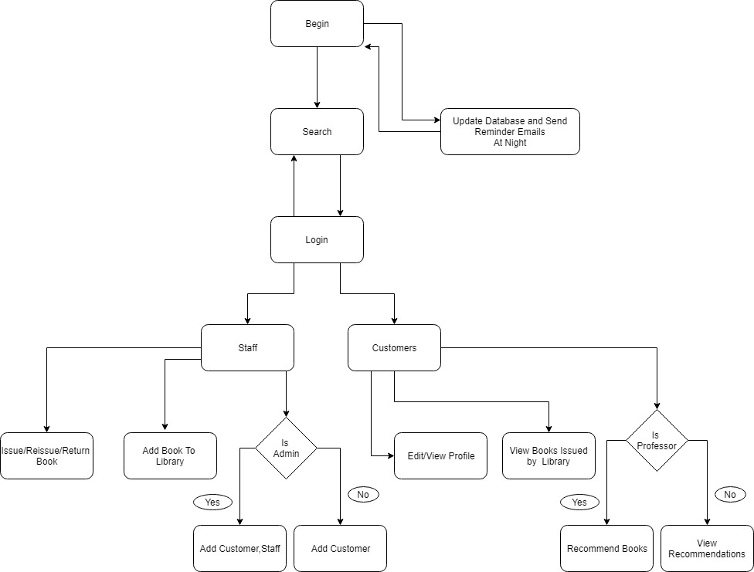

**4**  **DATABASE**

**BOOKS**

ISBN: This stores the valid ISBN of a book.

Total: This stores the total number of books in the library.

Remaining: This stores the total number of books available in the library excluding the issued books.

Location: This stores the location of the book, where it is present in the library.

Publish Year: This stores the year of publishing of the book in MM-DD-YYYY format.

Title: This stores the Title/Name of the book.

Author: This stores the Author of the respective book.

Publisher: This stores the Publisher of the book.

Field: This stores the Field, i.e., the branch to which the book is related to for each book.

Book Image: This stores the directory of the image file of the respective book, or the default image if no book image is available.

Price: This stores the price of the book.

Stars Number: Stores the total number of stars of the book.

Raters: Stores the total number of people who has rated the book.

**BORROWED**

Acc No. : This stores the accession number of each book, which is unique for each book.

ISBN: This stores the ISBN of the book.

BorrowerID: This stores the username of the borrower for each book issued.

IssueDate: This stores the date on which the book was issued to a particular user.

ReturnDate: The date till which the borrower is can return the book without fine.

IsIssued: This is a checkbox, storing true if the book is issued, false if the book is returned or not issued.

Fine: This stores the Fine for a particular book of a particular user, a currency value.

IssueCount: This stores the flag value of 1 or 0 if the book is issued or not.

**USERS**

UserId: Auto-generated serial number for each user.

ProfileName: Stores the name of the username/profile.

UserName: This stores the username of each of the users, unique for each person.

Password: This stores the encrypted value of the password entered by a user.

IsAdmin: A checkbox, that stores true or false depending on the user being admin or not respectively.

Email: This stores the email id of each user.

PhoneNumber: This stores the phone number of each user.

Department: This store the department of each user.

Designation: This identifies if the user is a Student or professor.

TotalFine: Stores the total amount of fine a particular user has.

BooksIssued: This stores the list of all the accession numbers of the books issued.

ProfileImage: Stores the directory of the image of the user’s profile.

Maxbooks: This stores the maximum number of books a user can issue.

**RATINGLIST**

ID: An auto-generated serial number.

ISBN: This stores the ISBN of the book rated by the user.

Username: This stores the username of the user who has rated the book.

Starcount: This stores the number of stars given by the particular user.

**RECOMMENDATIONS**

ID: An auto-generated serial number.

ISBN: This stores the ISBN of the book that is recommended.

Field: This stores the department to which the book is recommended to.

Profilename: This stores the username of the professor who has recommended the book.

RecDate: This stores the date on which the book was recommended.

**5** **SEARCH AND BROWSE BOOKS**

* We have a search bar on the main page through which one can search across books in the library on the basis of various filters like title, author, publisher, ISBN and field.
* One can also browse all books by clicking the “Browse All button”.
* We have used ‘selectstring’ function to get the matching substrings from the database and then used ‘thumbnails’ function to dynamically show the searched books.
* By clicking on the title or the cover photo of the book one can get to know all the details of the book on ‘BookDetails’ form that popups.
* ‘BookDetails’ form takes the ISBN(unique) from the main page as passISBN and searches for the book in ‘Books’ table in database. It specifies all the details like title, author, publisher, publishing year, location , cover photo as well as **rating of that book**.
* It also shows how many books are there and how many and who have checked out that book. The function “Borrowers ()” searches for the books from the ‘Borrowed’ table and then displays the read users details from the ‘Users’ table.

**6** **LOGIN**

* One can login in by clicking on the ‘Login’ button on the mainpage. As one do the login the main page hides and it is only visible when one logs out from the account.
* After the entering the credentials it checks if the credentials are correct from the database and then logs into the account based on the designation of that account field in the database.
* It opens different page on different designation like Student, Professor or Staff member.

**7** **STUDENT/PROFESSOR LOGIN PAGE**

* There are two panels : button panel and content panel
* Button panel controls the content panel by user control for each button. Buttons are:

**My Profile**

This displays the details of the student by reading from the ‘User’ table in database.

The details include: Profile picture, username, email, phone number, department,

designation, fine and maximum number of books allowed to be borrowed.

**Items Checked Out**

The function reads ‘Borrwer Id’ from the ‘Borrowed’ table which matches the login

username (public variable). For each field it matches the ISBN from ‘Borrowed’ table to

that in the ‘Books’ table and thus displays all those books.

On clicking on any book a new form pops up with the book details and rating feature.

RATING: It checks in the ‘Rating’ table if that username has rated earlier or not.

If yes, then it displays the previous rating else it shows blank.

If you update your existing rating then it is updated in the ‘Rating’ table as well

as in the total ‘StarCount’ in the ‘Books’ table.

If you rate that book for the first time then field is inserted in the ‘Rating’ table

and ‘Raters’ is increased by one and ‘StarCount’ is increased in the ‘Books’

table.

**Edit Profile**

One can update name, email, phone number , department as well as profile pic.

It checks that name should contain only alphabets and should not be empty. Using a regular expression, it checks the format of email address. The phone number should contain only numbers and should be 10 digits. Department is selected through a dropdown in the combo box.

If update variable is true i.e. meets all above requirements, then the student’s profile is updated in the ‘Users’ table else error message is displayed.

For uploading a book it opens the file dialog box and checks for the correct extension (jpg, jpeg, png, JPG, JPEG) and updates the the image in the database. The image is saved as (username).jpg in the resources folder of the project.

**Change Password**

It takes in the current password , new password and confirms the new password. Current password can be seen but new password and confirm password cannot be shown(i.e. password char = true). So one cannot copy new password to confirm password.

The text of current password is encrypted and then checked with the database. It checks that any field is not empty, current password should match with that in database , new password should match with confirm password and new password should not be same as current password else an error message will be displayed.

If update variable is true, then the new password is encrypted and saved in the ‘Users’ table in the database.

**Your Recommendations (for student)**

It shows the recommended books by the professors to the department students that he/she belongs to. By clicking on the title one gets directed to the ‘Book Details’ form.

It takes the department from the ‘Users’ table by searching through the login username. Then it checks the fields in ‘Recommendations’ table that match that department. It finds the professor’s full name from the ‘Users’ table through the username of that prof in ‘Recommendations’ table.

**Recommend a Book (for professor)**

It takes ISBN and Department to whom that book is to be referred and checks for duplicates. If not found, then that entry is inserted into the ‘Recommendations’ table.

The professor’s username is checked with the ‘Recommendations’ table and all the entries are shown to tell which books the prof has recommended.

If in the field dropdown(department) the professor selects the ‘Staff’ option then that book is recommended to the staff using same algo.

**Logout**

The button closes the account and shows the Main page.

**8** **STAFF/ADMIN LOGIN PAGE**

* It also has two panels: button panel and content panel
* Button panel controls the content panel by user control for each button. Buttons are:

**Issue Book**

It takes the Book ID i.e. AccNo and the username of the borrower. It checks for the book id and username from the ‘Books’ table and ‘Users’ table, if not, then error message is shown. Checks whether the book is issued earlier or has the maximum limit of user reached.

After this Issue date is entered as well as return date is entered adding 60 days and Is Issued check box is checked in the ‘Borrowed’ table.

It increases the book count for the user in the ‘Users’ table and decreases remaining books in the ‘Books’ table.

**Return Book**

It takes the AccNo and checks if the book exists and is issued in the ‘Books’ table, if not, error message is shown.

The book is returned by putting isIssued = false .

The book count for the user is reduced by one and remaining books is increased by one.

**Re Issue Book**

It checks if that book is issued through AccNo (Book ID) and also the book is issued to the entered username in the ‘Borrowed’ table.

After this issue date and return date is updated by adding 60 days.

**Add/Modify Book**

It first asks for ISBN and then check whether it’s a valid ISBN by checking through an ISBN checking algorithm. Confirm the ISBN and then it checks whether it is already in the database or a new type of book is being added. The fields include: ISBN, Total(inactive), Remaining(inactive), location, publish year, title, author, publisher, field, price and Number of books to add.

It validates all the fields and also checks if any field is null. Total books and remaining are increased by adding in the field ‘Number of books’. Then fields are entered in the ‘Borrowed’ table.

One can upload the cover photo else default image will be previewed.

**Remove Book**

If the input AccNo is present in the database and the book is not issued then only that book is deleted from that the ‘Books’ table else it shows an error message to return the book.

**Add/Modify User**

**For Staff:**

It takes the username and matches it in the ‘Users’ table. If it exists, then it updates the existing details else it inserts the new user. It requires: Name, Email, phone number, department, designation, password.

It validates all the fields and field should not be empty.

**For Admin:**

Admin can add only staff members, the department is fixed to None and designation is fixed to Staff. This will add a staff member in the database.

**Library Recommendations**

It shows the books recommended to the library/staff by any professor. It finds in the ‘Recommendations’ table where field is staff and then takes the professors full name from the ‘Users’ table using the user id in the ‘Recommendations’ table.

Staff can check if that book is already in the library in the ‘View Books table’ and then delete it from the database by checking the checkbox.

**View Books Table**

It shows the book details from the ‘Borrowed’ table. One can see all data by checking the checkbox corresponding to it.

The ‘Acc’ option shows the books that contains the text entered in the textbox as substring in the ’Borrowed’ table. If empty it shows all books.

The ‘Username’ checkbox search the entries containing the entered text in the textbox as substring in the ‘Borrowed’.

The ‘ISBN’ searches by ISBN field in ‘Borrowed’ table by finding the text in textbox as substring. If empty, then all data is shown.

**Logout**

The button closes the account and shows the Main page.

**9** **SOME ADDED FEATURES**

**Mailing System**

First a table ordered by username is obtained from database where return date is 5 days after today. Then all users are sent a mail with a title of Books they have to return and date by which they have to return it .

**Fine Calculator**

The fine function in the BooksReminder.vb file calculates the fine for each user at 12 in the night every day. It takes all those borrower ids that have issued book and their return date is less than today’s date.

It takes all those borrower id as username in the ‘Users’ table and increases the fine by one for each username in the fields read.

**Rating System**

Rating of each book is calculated by dividing the Star count by Raters in the ‘Books’ table. It rounds off the value to the nearest half value and is shown in the ‘Books Detail’ form.

**10** **REFERENCES**

**[8.1 MICROSOFT.NET DOCS](http://www.passwordmeter.com/" \t "_blank)**

We took reference from this website to implement mailing system on regular basis, password encryption and visual basic queries

**[8.2 STACK OVERFLOW](https://www.codeproject.com/Tips/598000/%2FTips%2F598000%2FResizing-Controls-When-Resizing-Form" \t "_blank)**

We took reference from this to implement timer in the code to calculate fine and send emails on regular basis and some other small queries.

**[8.2 ICONS8](https://www.codeproject.com/Tips/598000/%2FTips%2F598000%2FResizing-Controls-When-Resizing-Form" \t "_blank)**

We used this site to get icons for our interface enhancement.

**11** **FUTURE ADDITIONS**

**10.1 FINE PAYMENT**

In future additions we would add portal for fine payment and thus update the fine for the student.

**10.2 A BETTER PASSWORD GENERATION**

At present the staff needs to add the user manually and thus also create the password manually. In future additions we can generate user accounts and password from reading a file.

**10.3 BOOK LOSS**

At present we can only remove books that are not issued. If someone loses a book or tears it then that book has to be removed and fine has to be imposed.