

**LIBRARY MANAGEMENT SYSTEM- USER GUIDE**

**Created By:**

1. **Arpit Gupta (170101012)**
2. **Nayanjyoti Deury (170101042)**
3. **Piyush gupta (170101045)**
4. **Rythum Singla (170101058)**
5. **Tushar Bhutada (170101073)**
6. **Lavish Gulati (170101082)**

**CONTENTS**

1. Introduction
2. Start_Of_The_Software
3. Login_Page
4. Student_And_Professor_Login
5. Staff_Login
6. Troubleshooting

**1****. INTRODUCTION**

This software is a Library Management System which handles the queries and issues of regular Library.

**Basic Features Implemented:**

* Searching Books by various fields such as Title, Author, etc.
* Login Form for Users (Staff, Students and Professors)
* Features like My Profile, Change Password, Edit Profile, books Issued for Students and Professors.
* Features like Add/Modify Books, Add/Modify Users, Issue, Reissue, and Viewing Books Table for staff.
* Email System for warning students about the time they have left for return or reissue of books.
* Password encryption in the database.

In addition to the basic features, some new features have been added to this library management system.

**New Features implemented:**

* **Rating System**: Users can rate a book after issuing it and can change their rating whenever they wish. Also, all users can see the average rating of any book available in the library.
* **Recommendation System**: Professors can recommend a book to the students of any department using this system. As a result, students can see these recommendations in their login profile and have better view about the books relevant for their department.

**2.** **START OF THE SOFTWARE**

On starting the application, you would see a form on the screen as shown below.

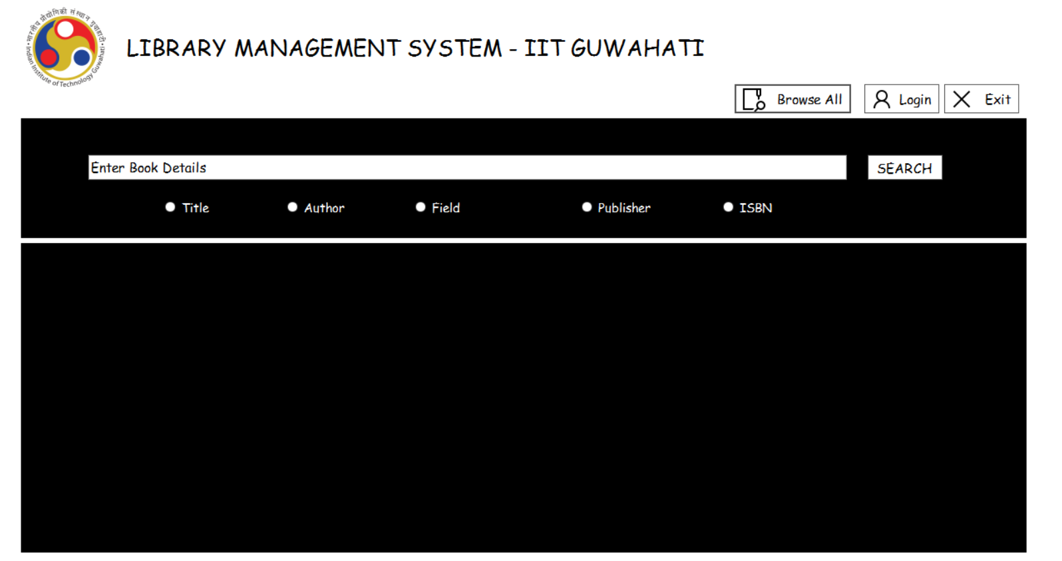

This is the main page of the software. It has the following functionalities.

* **BROWSE ALL**: Clicking on this button would show all the books currently available in the Library (shown in the image).

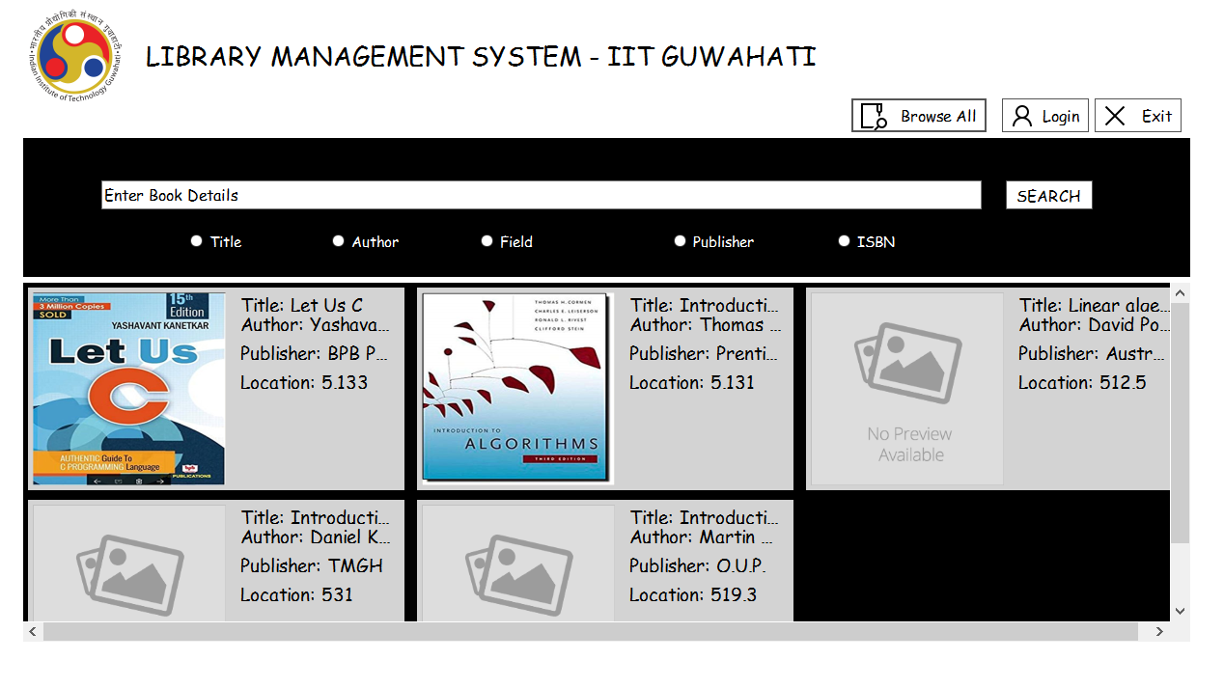

* **Search Textbox**: Type in the textbox with the message “Enter book details” the detail of a book. The details has to be one of the following parameters:
* **Title**: Name of the Book
* **Author**: You can enter any one of the authors of the book in case of multiple authors.
* **Field**: If you want the results to be for a particular department/field of study, select this parameter.
* **Publisher**: Enter the name of publishing house to view books published by the entered publisher.
* **ISBN**: Enter the correct valid ISBN number of a book to get the search.
* **Input Format**: Any non empty string of characters.

Please note that it is not necessary to enter complete details of the selected parameter. You can enter a substring of the detail and the application would show all searches for the entered substring.

* **SEARCH**: After entering the book detail and selecting a parameter, click on this button to see the available books with the details you entered. Please note that if you don’t type anything in the search box or you don’t select a parameter, it would show an error message (shown below).

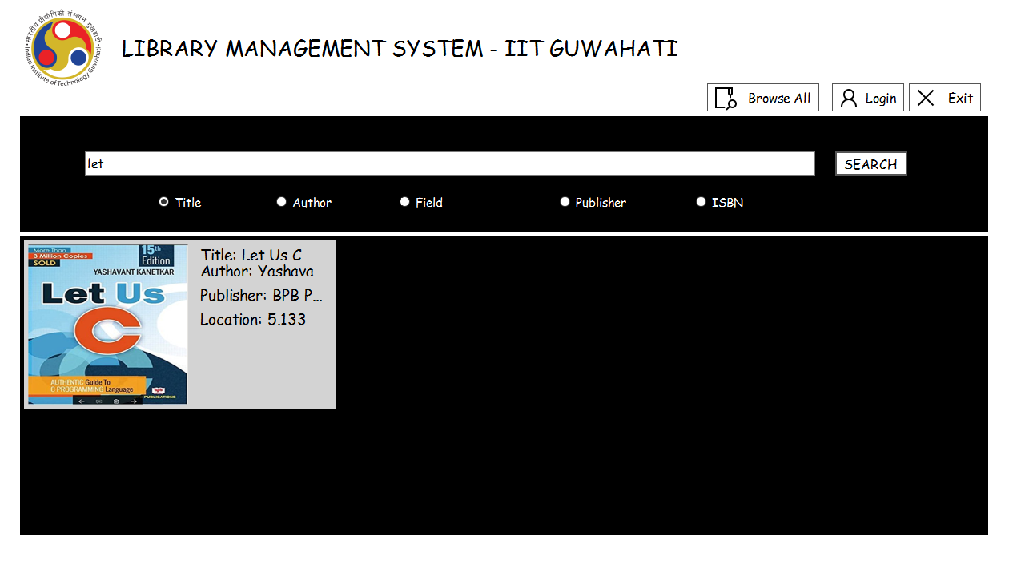

* **LOGIN**: Clicking on this button would lead you to a login form. Details of this have been explained later here .
* **EXIT**: Clicking on this button would close the application and to use the software again, you need to open the application again.
* **Book Details**: After the search results have been displayed, you can click on any book’s title or its image would open up another form. This form would show you all the details of the book as shown in the image below. Also, you can see the average rating of the book out of 5 which has been rated by the borrowers of the book. Below the details of the book, you can also see the details of the people (Name, department, Contact Number and email) who have issued the books currently. You can use this feature to connect to these people and get access to the books if library runs out of books to issue.

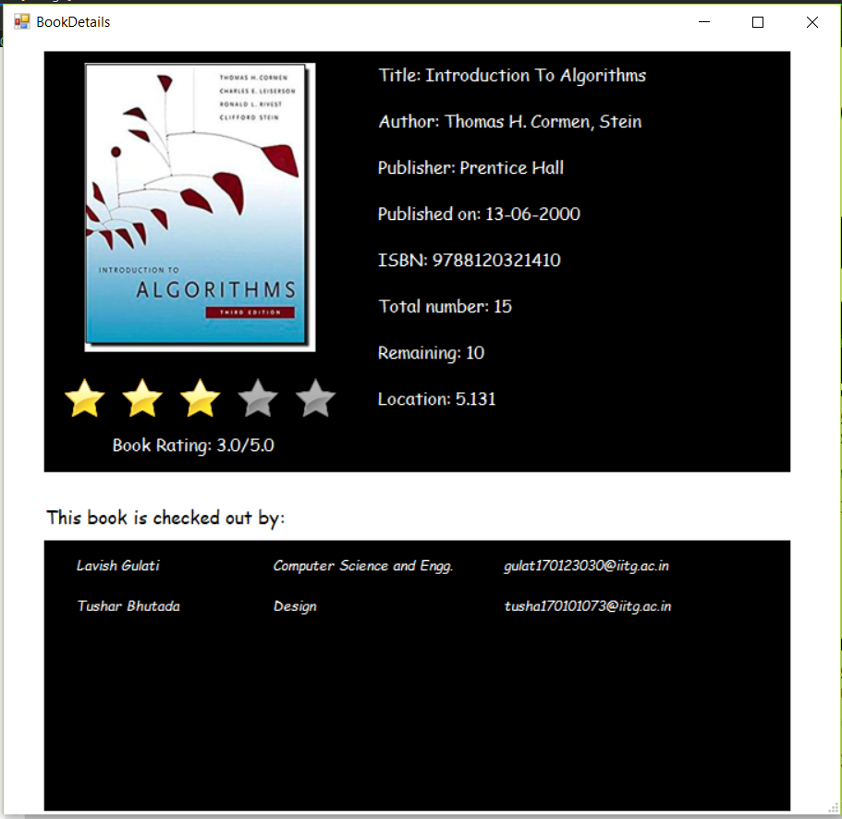

**3. LOGIN PAGE**

After clicking on the login button on the main page as shown in the image below, a login form would pop up (shown below).

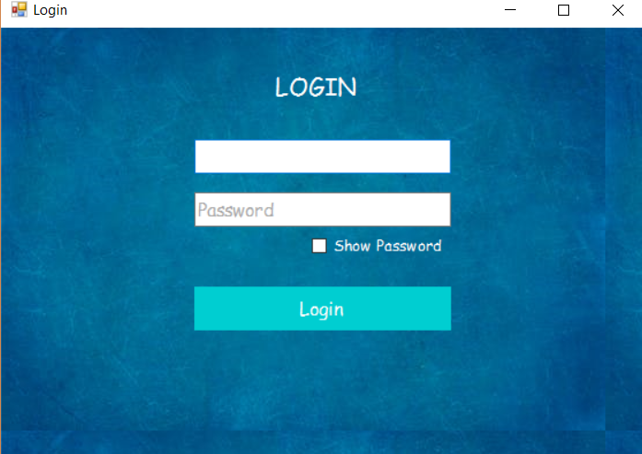

The features of this page are as follows:

* **USERNAME**: The first textbox in the page is for the user to enter his/her username. Leaving this field blank would show an error message after clicking **LOGIN**
* **Input Format**: Any username that is already exists.
* **PASSWORD**: The second textbox in the page is for the user to enter his/her password. Leaving this field blank would show an error message after clicking **LOGIN**
* **Input format**: Correct password corresponding to the entered username, which doesn’t include any blank spaces.
* **Show Password**: Clicking on this checkbox would show the password typed by you. By default this checkbox is not selected and the whole password is shown as a string of dots (**.**).
* **LOGIN**: Finally, after entering the username and password details, if the details are correct, then this page would direct you to another form. The form would be different for different users. If the user is a staff, it would lead to Staff_Login , else for a student/professor if would lead to Student_And_Professor_Login .

Entering incorrect credentials would show an error message box stating **“**Incorrect Username or Password**”**

**4. STUDENT/PROFESOR LOGIN**

After successful login, if the user is a Student/Professor, the following form would pop. Note that the form is different for a student and a professor in the option indicated in the given figures.

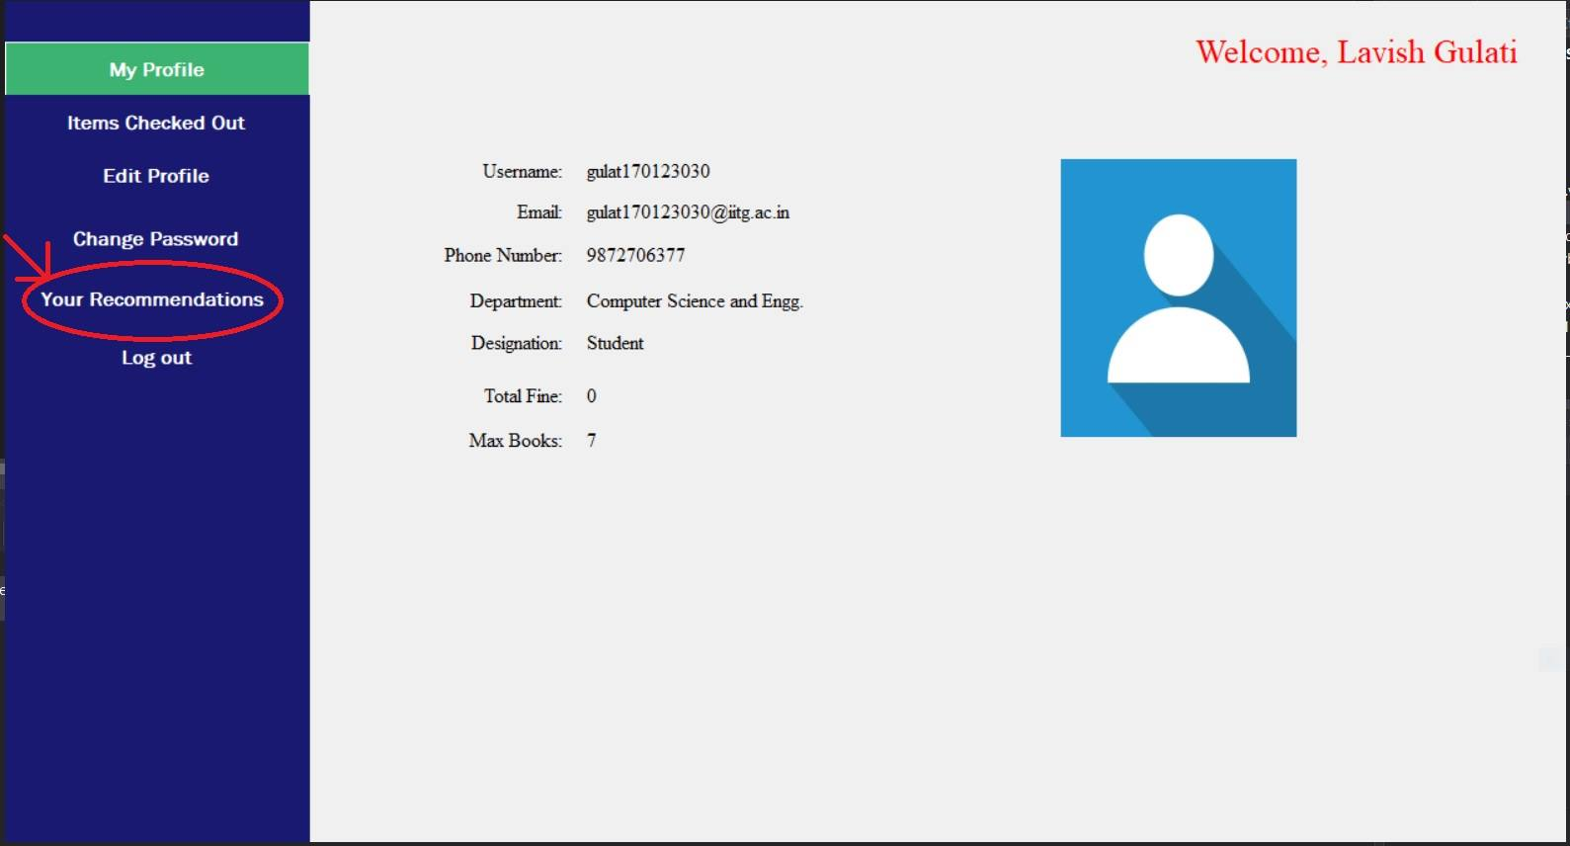

1. Student Login Page

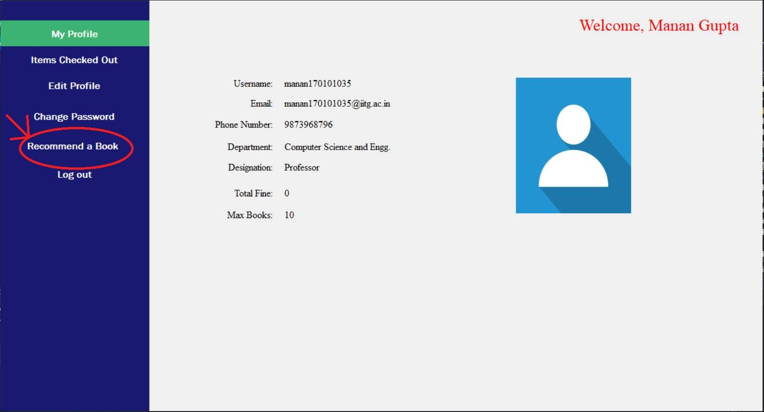

1. Professor Login Page

For the reference, we would be using the student Login page to explain you the features.

* **MY PROFILE**: Clicking in this option would show your details as the library database holds. Following are the details of your profile.
* Username
* Email
* Phone Number
* Department
* Designation: Student/Professor
* Total Fine: The fine that you owe the library due to returning/reissuing books after the expected date
* Max Books: Tells the number of the maximum number of books that can be issued by the user. The limit is 7 for students and 10 for professors.
* Profile Image: Shows a default image if image not uploaded.
* **ITEMS CHECKED OUT**: Click on this option to view the list of books that you currently have issued. Further, you can click on the any book title to view the details of the book. A new form would open up which would show the book details as shown and in this form, you can rate the book as per your wish. Just click on the number of stars you want the rating to be and rating would be successfully submitted. If you have already rated a book, it would show your previous rating of the book.

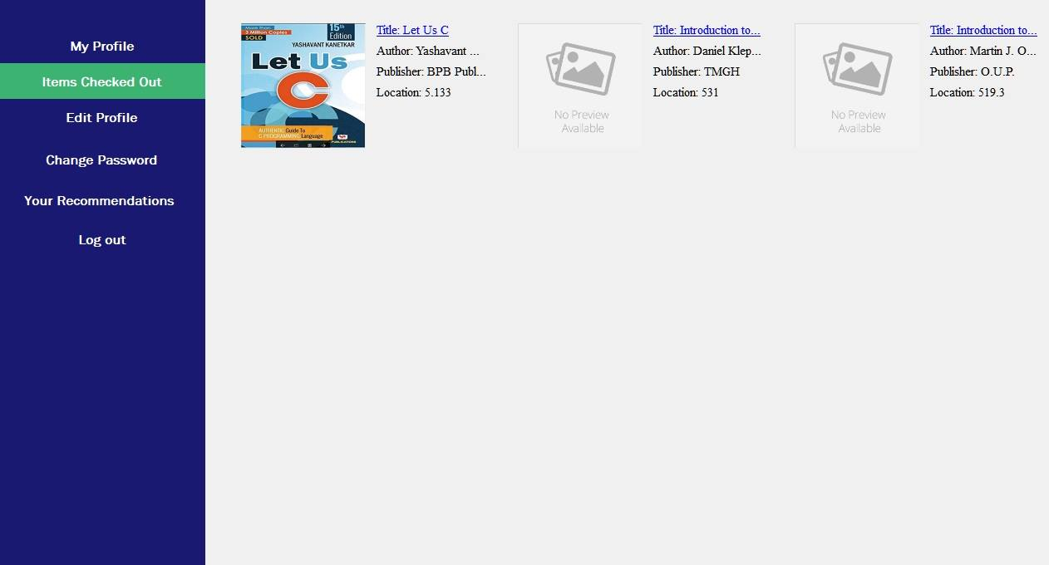

After Clicking on Items Checked Out

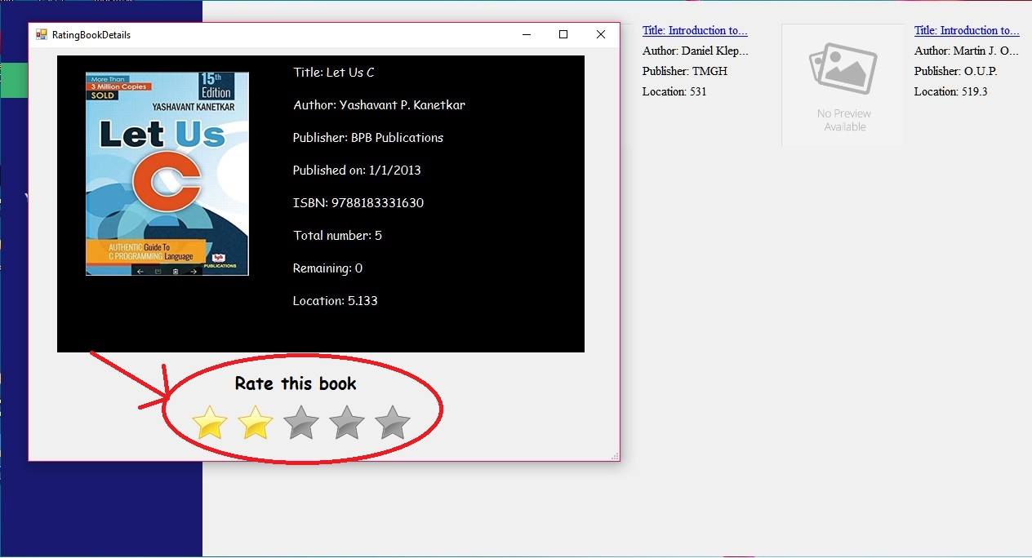

Rate the Book in the encircled portion

* **EDIT PROFILE**: In this option, you can edit your profile details if you wish to change them. You can change your profile image from this page.
* **Change Password**: This feature enables you to change your password. User should enter a password that is non empty without any blankspace character, opposite of which would lead to an error box popping up.
* **Your Recommendations**: This feature is the only difference between a professor page and a student page. In professor page, this option would be titled “Recommend a Book”. This Feature is explained differently for both users below.
* **STUDENTS**: Students can see the books that have been recommended by different professors for the students of his/her department. It would show the name of the professor who recommended the book along with the date of recommendation and title of the book. Clicking on the title of the book would lead the user to a new window where he/she can see the details of the book along with the average rating of the book and current borrowers of the book.

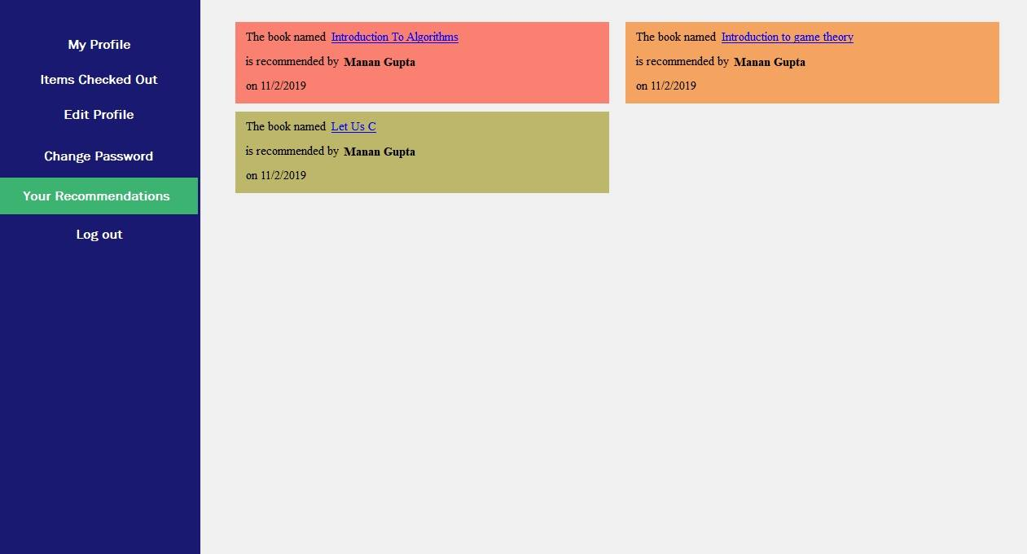

* **PROFESSORS**: Professors have to enter the ISBN of the book and select the department/field to whom he/she wants to recommend the book.

Then click on the Recommend button to submit your recommendation.

Possible Error Messages:

* ISBN number entered is empty or is incorrect/isn’t available in the library.
* Department not selected.
* If the same book is being recommended to the same department

Below this, the professor can see the list of books that have been recommended by him. Clicking on the title of the book would lead the user to a new window where he/she can see the details of the book along with the average rating of the book and current borrowers of the book.

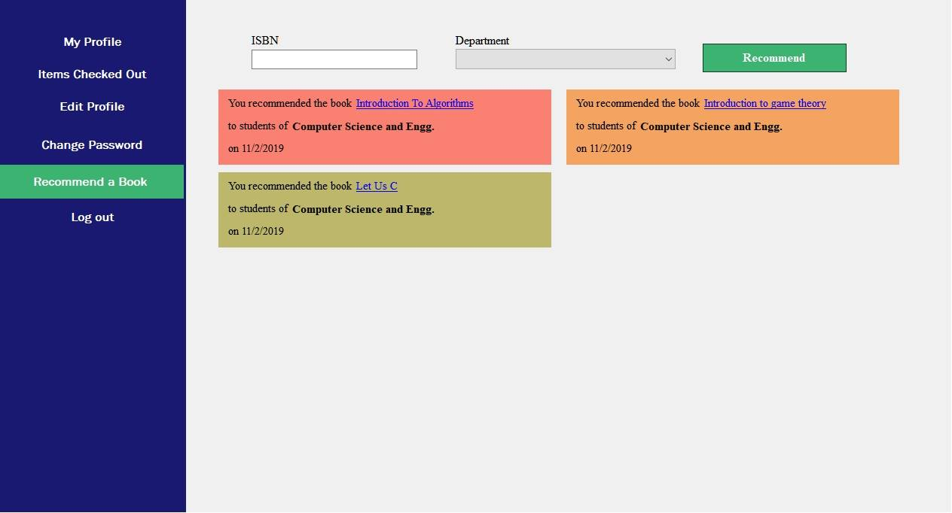

* **LOGOUT**: Clicking on this button would ask for confirmation to logout of your account. Clicking YES would lead you to the main page of software and close the current account.

1. **STAFF LOGIN**

After successful login, if the credentials of the user indicate that he/she is a staff member, following page would pop up.

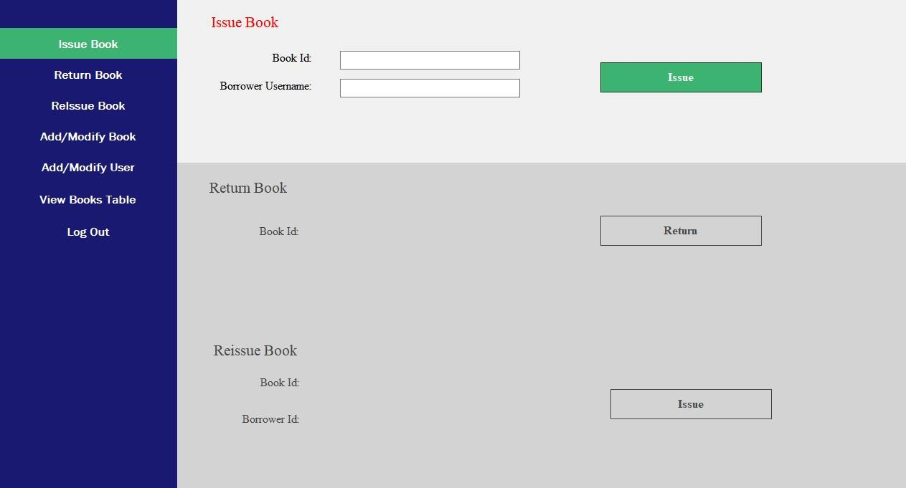

Following is the list of features of this page.

* **ISSUE BOOK**: The staff member needs to enter the book accession number and the username of the borrower and click on ISSUE button for successful issue.

Input format:

* Book Id- A positive integer
* Borrower Username- A string with some letters followed by some numerical digits
* **RETURN BOOK**: Staff member needs to enter a correct accession number of a book that has been issued and click on the return book button for successful return.

**Input Format:**

* **Book Id**- A positive integer

The email system that has been made will start emailing the users everyday about the duration they have left for return.

* **REISSUE BOOK**: The staff member needs to enter the book accession number and the username of the borrower and click on ISSUE button for successful issue.

**Input Format:**

* **Book Id**- A positive integer
* **Borrower Username**- A string with some letters followed by some numerical digits
* **ADD/MODIFY BOOK**: Staff member needs to enter the ISBN number of the book to be added/modified.

**Input Format:**

* **ISBN**: Correct ISBN number according to international standards.

After entering the ISBN, if this book already exists in database, the previous details would appear, else fields will be blanked.

Then the staff member needs to enter details correctly to add the book to the library.

**Input Format:**

* **Location**: Depends on the library system
* **Publish Year**: Select the date from the calendar
* **Title**: Name of the book
* **Author**: Name of the author(s), if multiple prefer separating using commas(,)
* **Publisher**: name of the publisher
* **Field**: Select the field of book from the drop down list
* **Price**: Enter positive decimal number
* **Number of Books to add**: Positive Integer (You can use the counter in the field to increase/decrease).

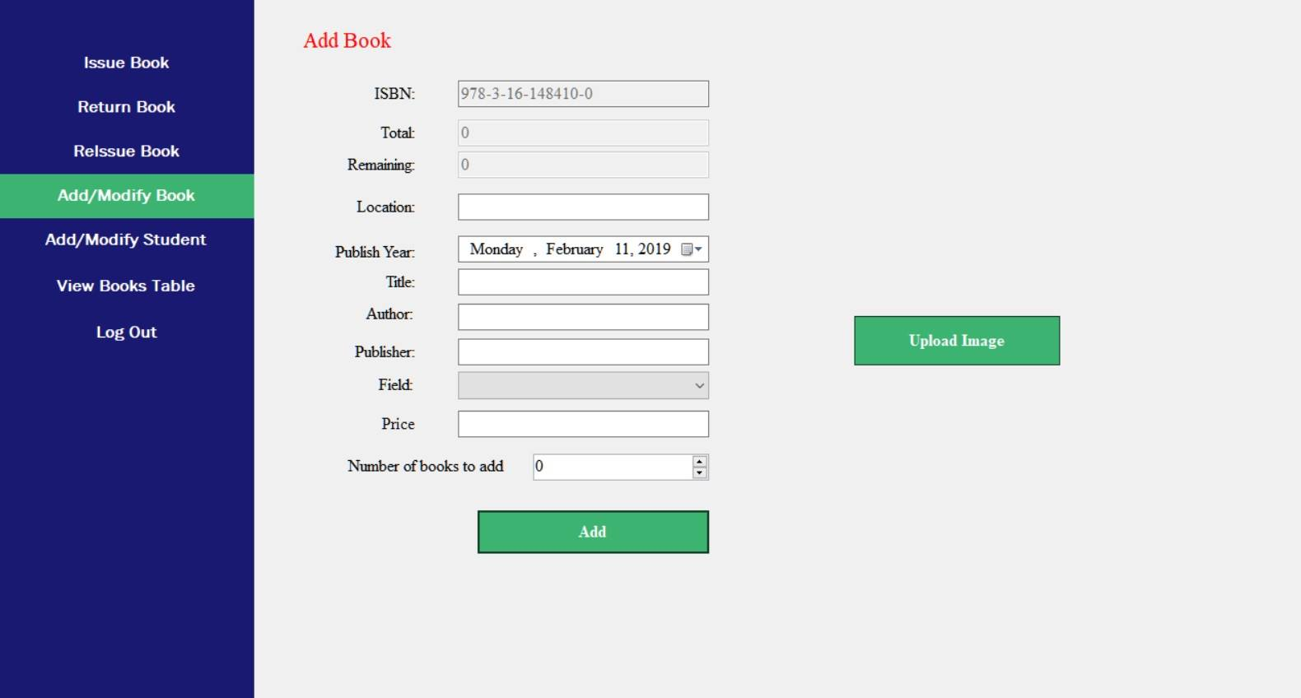

1. If new Book is being added

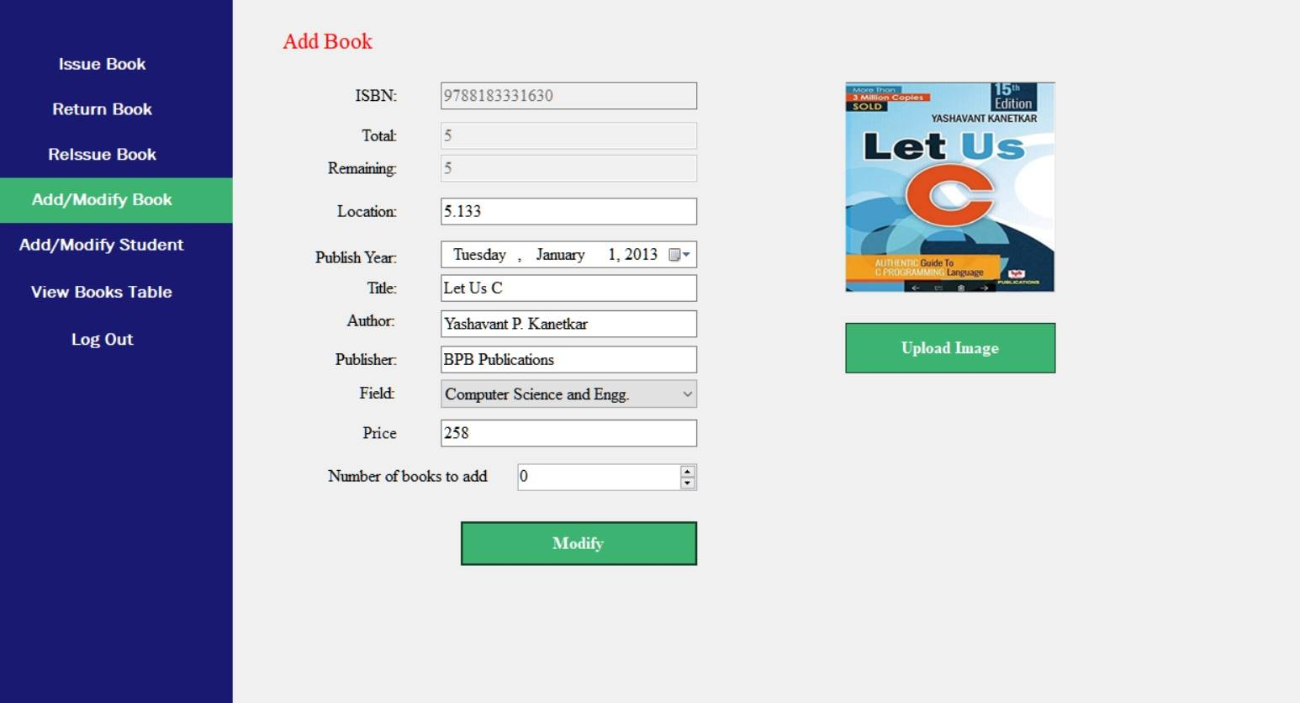

1. If existing book is entered

* **ADD/MODIFY USER**: Staff members need to enter the username of the person whose data is to be edited. It’ll lead to the remaining fields of the form with auto fill if the username already exists.

**Input Format:**

* **Username**: A string with some letters followed by some numerical digits
* **Name**: Letters and spaces only
* **Email**: standard email format
* **Phone Number**: Exactly ten numerical digits.
* **Department**: Any value from the drop-down list.
* **Designation**: Any value from the drop-down list.
* **Password**: Any string of characters that doesn’t include a space.
* **Image**: An optional field which if filled should be an image file

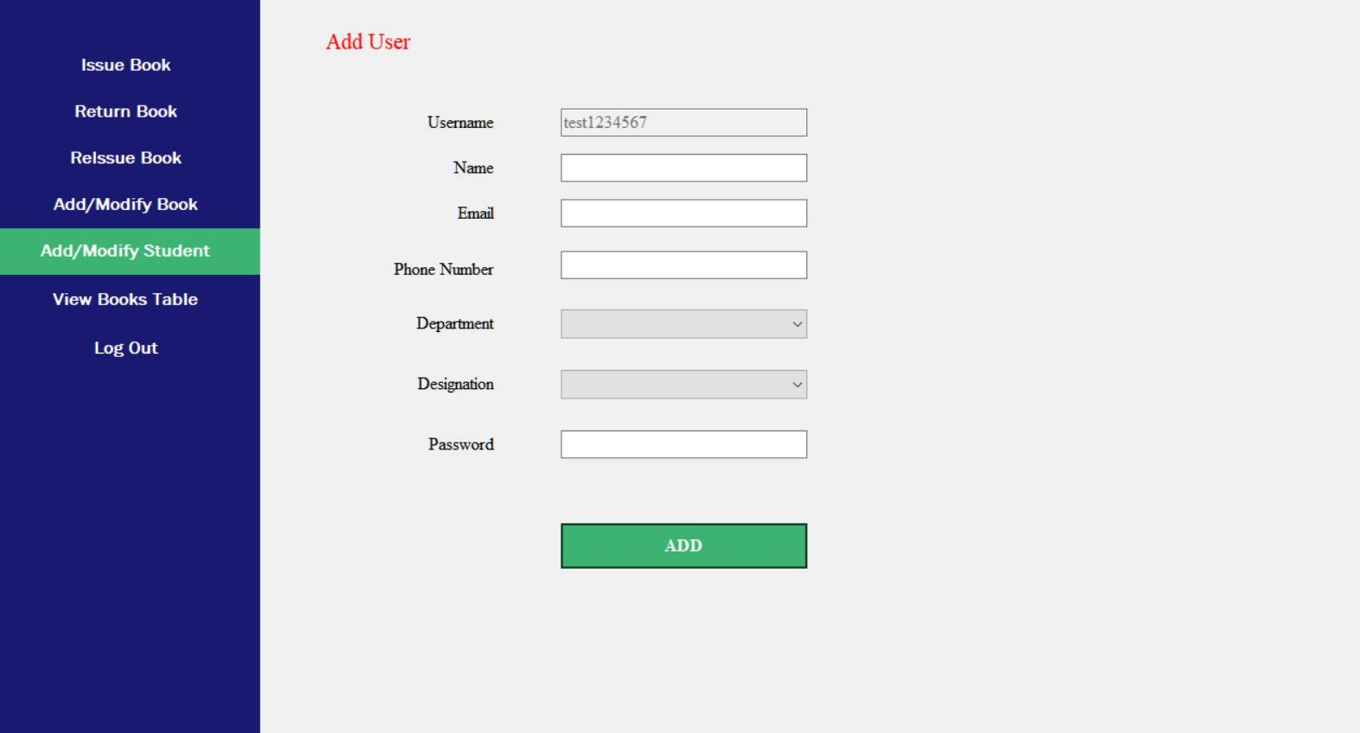

1. If New User is Entered

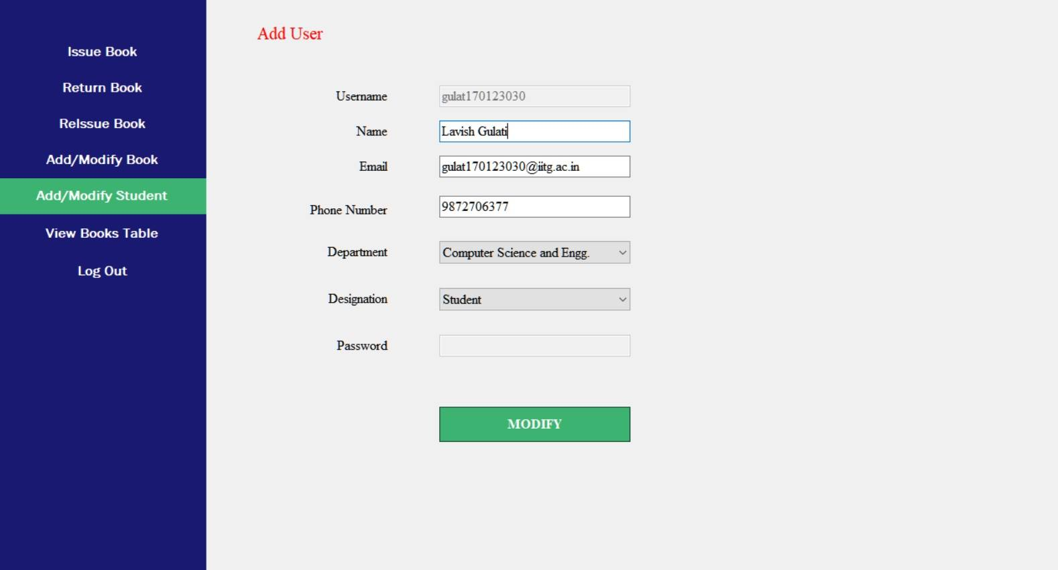

1. If Existing User is Entered

* **VIEW BOOKS TABLE**: Staff members can view the list of books through this. Staff can view all books and also check the status of particular accession number ,ISBN number or username .

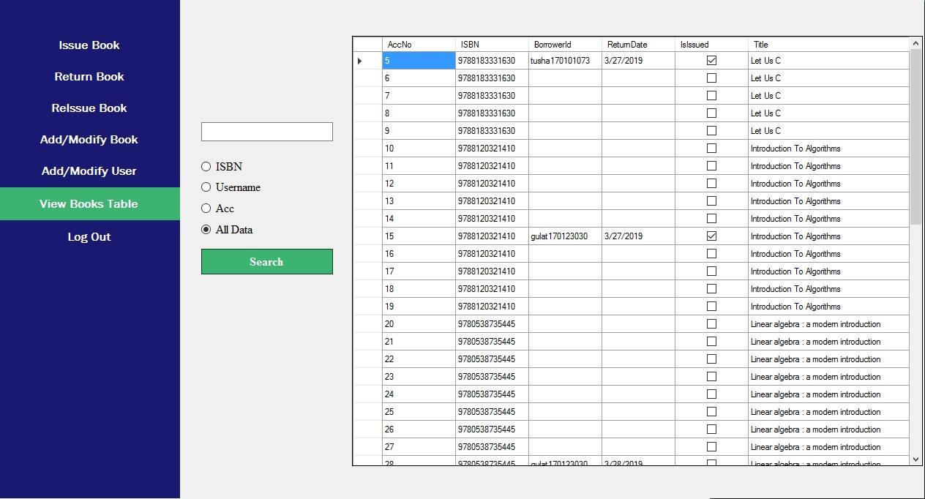

* **LOG OUT**: Clicking on this button would ask for confirmation to logout of your account. Clicking YES would lead you to the main page of software and close the current account.

1. **TROUBLESHOOTING**

Sometimes, you might seem to think that the details you have entered are correct but still error messages might be shown. Here are some of the errors that might have occurred.

* Please check that you have not left any necessary textbox empty or didn’t select any item from a Drop down list.
* Avoid unnecessary spaces in details, specially before and after strings as this could lead to undesirable results.