**Title**

Customer Relationship Manager

**Introduction**

Customer (CRM) is an strategy which helps to build the better relation with our existing and new customers at same it helps to increase the productivity as well as effectiveness in our business.

Customer Relationship Manager project helps in to maintain the information of the client of specific service user. There are lot of problems of accessing and storing the data of different customers location wise .

It will help to manage the customers purchasing the goods from the shop and provide ease to fetch the details of the specified customers within short duration of time .

Like if there is a company with thousands of employees then it will be very difficult for the company to store the data and access it more easily.

As in traditional model there were several problems while storing the data as data can be lost anytime and there was not even a single backup

Any other unauthorized person can able to change the information stored so there were a lot of problems in security.

If users wants to see the statistics of individual user who is using our application they can monitor it .Although this application will resolve the issues of all traditions problems .

This application allows users to grant access whenever they want and they can easily perform the CRUD operations if there is any modification to be done by the user.

Some of the functionality that are inserted inside the applications are listed below

We have to insert the following functionality

1)Add Customer Button

2)update customer details who are already registered

3)delete any customer

4)View Customers

5)Arrange all customers name wise in asc. Order .

We have many more functionality which will make this application user friendly.

**FRONT VIEW OF THE APPLICATION**

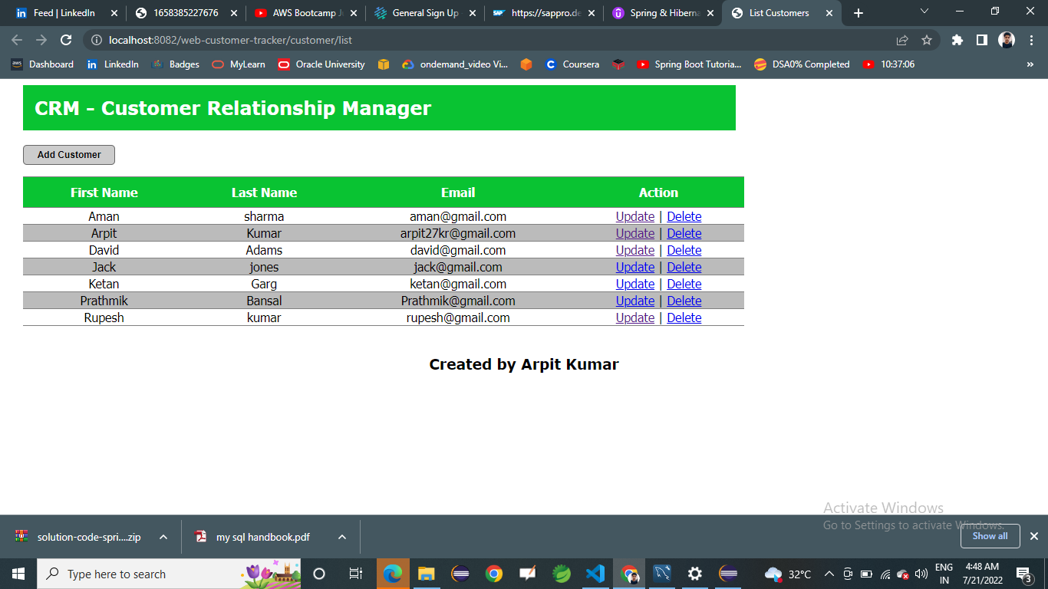

**Literature Review**

This application have two ways to deploy

1. **For small scale uses ->**  Their can be a scenario in which a single user consisting of thousands of customers so this can be easily deploy without any effort . as number of users using the application is quite low .
2. **For large Scale Uses->** Their can be a scenario in which their can be thousands of users having thousands of customers so to manage and monitor this application requires the cloud deployment . So that the multiple users can able to access them easily .

**OBJECTIVE OF STUDY**

1. To understand what Customer Relationship management means
2. To describe the framework of Customer relationship management
3. To deploy this application on cloud .
4. How cloud will going to help the application in vast extent.
5. To analyze the present trends of customer management system
6. To examine the barriers of customer relationship management

**RESEARCH METHODOLOGY**

I have reviewed many literatures research papers and articles like [CUSTOMER RELA TIONS](https://www.studocu.com/row/document/daffodil-international-university/mis/28187307-customer-relationship-management-project-report/10961304) , [Relation with customer project](https://www.managementstudyguide.com/what-is-crm.htm) and many more .

**Requirements-:**

1. We will use Spring tool suite to create the application .
2. Basic knowledge of spring boot.
3. Microservices
4. Core Java

**NEED TO DEPLOY ON CLOUD**

1. Customer relationship manager is a vast application which consist of many users using a specific service so **to manage this huge amount of data** cloud is consider to be better option as there are several users of this application and each user will have 1000’s of customers to to store these all data a large set of database like AWS Dynamo db , RDS (Relation database ) and Redshift now this database can be migrate easily without any extra effort .
2. This application will be used by several other users at same time so to provide multi tenancy feature to the application there is a great use of cloud as common resources will be utilize by different clients of same application users.
3. This application can be run on single click so to provide on demand self service cloud is used application users required to enter the details of new customer so to adding a new customer on single click or to delete the existing customer on single click we can use cloud.
4. As this application is following the multi tenant architecture so by accessing it on public cloud more numbers of users can use it at same time So Resource pooling it an important aspect of CRM application.
5. This application will provide the feature of pay per using the storage to make it cost effective pay per use model is used .
6. Cloud will provide better collaboration with the end user using this application at different places .
7. Automatic Application update is a great advantage of this application we can create a docker file of this application and create the updates of this application inside it and deploy it on private cloud so the local vendors using this application can download this docker file and now these local vendors can deploy the application with all updates to the users on public cloud . so Google Kubernetes Engine can be used to do so.
8. Availability is an important feature of this application due to the large number of users using application at same time there can be faults in application so to avoid this faults automatic load balancing can be used which can shift the load of separate server to other server which is not in use it can be done with help of cloud . Workload can be shift automatically to different availability zones and to different isolated region .

Users can also distribute this workload to across different zones by connecting multiple data centers.

Cloud can be used to low the regional loads so to avoid the single point of failure .

1. To have a broad Network of access cloud can be used to contact the users inside different zones .
2. Cloud provides the security so that unauthorized person can not able to access this application with help of Identity Access Management policies and only authorized peoples can able to access this application .
3. In case if there is lost of data cloud can be an effective way to restore the data as if a data node in cloud is lost it can backup the complete node with help of metadata available . and if master node is lost then secondary master node can be used so availability of data is present at every moment and in case of data loss also .

**FLOWCHART**

1. Requirement Analysis-

This application will overcome all the problems which were faced by the users who were using the CRM Application . Now these users will get the security by proper authentication as well as proper storage of their data. We need to add some functionality like adding customer deleting it modifying if existing aw well as creating a new user .

1. Planning phase –

In this phase we will collect all the Requirements from requirement analysis phase and will plan to perform those requirements like our requirement is to create some functionalities like adding a button to add a new customer so we will code in java to add a new customer we will connect it with help of database which we are going to use .

Other Plans we should made are resource , budget as well as

Staffing .

Other plans we need to made are about Risk . Their can be Risk of data theft , other risk may be increase in active number of users .

1. **Executing Phase -:**

This phase involves how we are going to execute our application . So we will use spring boot to create out application and first we will execute it with small number of users later on we will execute it for a large amount of users .

1. **Monitoring Phase-**

This phase includes Monitoring of CRM application so for monitoring the errors and bugs we will use Spring tool suite application .

1. **Deployement Phase**

So to deploy CRM application we will create a docker file in which all the files as well as base image are mentioned we will create a containers of the application now that docker file will be executed on private cloud of azure for local users and these local users will download this dockerfile and deploy it on public cloud for their users .