- COMMERCE SALES ANALYSIS SQL QUERIES

Total Revenue and Profit-
select sum(sales) as Total_Revenue, sum(profit) as Total_Profit from orders;

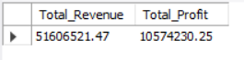

Total Orders-
select count(order_id) as Total_Orders from orders;

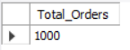

Average Order Value-
select round(sum(sales)/ count(order_id),2) as Average_Order_Value from orders;

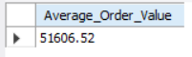

Monthly Sales Trends-
select monthname(order_date) as Months, sum(sales) as Total_Sales from orders
group by monthname(order_date) order by monthname(order_date);

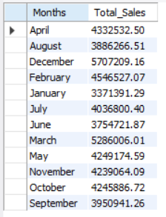

Top 10 Customers by Revenue-
select customers.customer_name as Customer_Name, sum(orders.sales) as Total_Sales
from customers join orders
on customers.customer_id = orders.customer_id
group by customers.customer_name order by sum(orders.sales) desc limit 10;

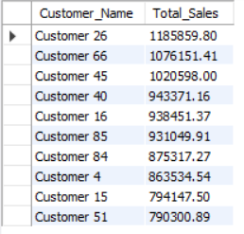

Top 10 Best Selling Products-
select products.product_name as Product_Name, sum(orders.sales) as Total_Sales
from products join orders
on products.product_id = orders.product_id
group by Product_Name order by Total_Sales desc limit 10 ;

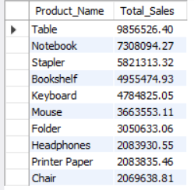

Category-wise Sales-
select products.category as Category, sum(orders.sales) as Total_Sales
from products join orders
on products.product_id = orders.product_id
group by Category order by Total_Sales desc;

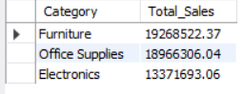

Region-wise Sales-
select customers.region as Region, sum(orders.sales) as Total_Sales
from customers join orders
on customers.customer_id = orders.customer_id
group by region order by Total_Sales desc;

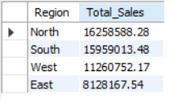

Product Rankings by Sales-
select products.product_name as Product_Name, sum(orders.sales) as Total_Sales,
rank() over(order by sum(orders.sales) desc) as Sales_Rank
from products join orders
on products.product_id = orders.product_id
group by product_name order by total_sales desc;

