PIZZA SALES SQL QUERIES
- KPI’s
- Total Revenue
select round(sum(total_price),2) as Total_Revenue from pizza_sales;
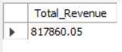
- Average Order Value
select round(sum(total_price) / count(distinct order_id),2) as Avg_Order_Value from pizza_sales;
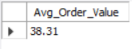
- Total Pizzas Sold
select sum(quantity) as Total_Pizzas_Sold from pizza_sales;
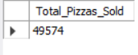
- Total Orders
select count(distinct order_id) as Total_Orders from pizza_sales;
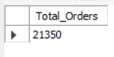
- Average Pizzas Per Order
select round(sum(quantity) / count(distinct order_id),2) as Avg_Pizza_Per_Order from pizza_sales;
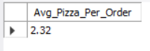

B. Daily Trend for Total Orders
SELECT DAYNAME(order_date) AS Order_Day, COUNT(DISTINCT order_id) AS Total_Orders
FROM pizza_sales GROUP BY DAYNAME(order_date);
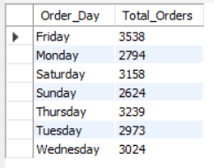
C. Hourly Trend for Orders
select hour(order_time) as Hours, count(distinct order_id) as Total_Orders from pizza_sales
group by hour(order_time);
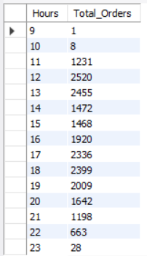

D. Percentage of Sales by Pizza Category
select Pizza_Category, round(sum(total_price),2) as Total_Sales,
round(sum(total_price) * 100 / (select sum(total_price) from pizza_sales),2) as Percentage_of_Sales from pizza_sales group by pizza_category;
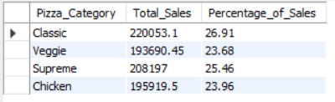
- Percentage of Sales by Pizza Size
select pizza_size, round(sum(total_price),2) as Total_Sales,
round(sum(total_price) * 100 / (select sum(total_price) from pizza_sales),2) as Percentage_of_Sales
from pizza_sales group by pizza_size order by pizza_size;
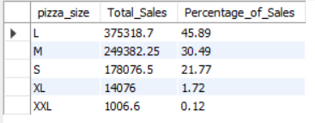
F. Total Pizzas Sold by Pizza Category
select pizza_category as Pizaa_Category, sum(quantity) as Total_Pizzas_Sold from pizza_sales
group by pizza_category order by Total_Pizzas_Sold desc;
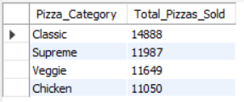

G. Top 5 Best Sellers by Total Pizzas Sold
select pizza_name as Pizza_Name, sum(quantity) as Total_Pizzas_Sold from pizza_sales
group by pizza_name order by sum(quantity) desc limit 5 ;
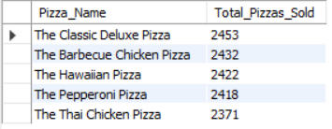
H. Bottom 5 Worst Sellers by Total Pizzas Sold
select pizza_name as Pizza_Name, sum(quantity) as Total_Pizzas_Sold from pizza_sales
group by pizza_name order by sum(quantity) asc limit 5 ;
