
School of Computer Science Engineering & Technology
Image and Video Processing Lab
Course Code: CSET344
MINI PROJECT REPORT
My Fashion Wear
An AI-Powered Virtual Try-On Platform
Field | Details
Batch / Section | 47
Semester / Year | Odd Semester, 2026
Submitted to | Shuvo M
Date of Submission | 13 Nov 2026

Team Members
S.No. | Student Name | Enrollment No. | Role in Project
1 | Akshat Chauhan | S24CSEU1814 | Frontend development, UI design, documentation
2 | Arpit Chaudhary | S24CSEU1841 | VITON-HD integration, training and testing, dataset handling, frontend–backend connection
3 | Harshit Ranjan | S24CSEU1832 | Dataset preparation, progress tracking, frontend (HTML), report and presentation
Group Leader: Arpit Chaudhary

Abstract
Online fashion retail suffers from high return rates because shoppers cannot see how a garment will look on their own body. My Fashion Wear addresses this problem with an AI-assisted virtual try-on platform that takes a photograph of the user and an image of a garment and synthesises an image of the user wearing that garment. The system follows the standard image-based try-on pipeline: image pre-processing and normalisation, deep-learning human parsing, pose estimation, garment segmentation, garment warping, body-aware garment alignment, and generative image synthesis using VITON-HD. The back end is written in Python with PyTorch and OpenCV, and a React/HTML/CSS/JavaScript web front end handles registration, image upload, garment selection and result display. The VITON-HD dataset is the data source for the model. This report reviews existing try-on approaches (VITON, CP-VTON, VITON-GAN, VITON-HD and the diffusion-based ART-VITON), explains each algorithm and its mathematical basis, maps every design step to its implementation status, and documents the system architecture. Quantitative metrics such as SSIM, PSNR and FID have not yet been recorded; they are marked as pending, and no performance figures are claimed.
Keywords: virtual try-on, image synthesis, human parsing, pose estimation, garment warping, VITON-HD, PyTorch, OpenCV.
Table of Contents
Abstract 1
1. Introduction & Problem Statement 3
1.1 Background 3
1.2 Problem Statement 3
1.3 Challenges 3
1.4 Scope 4
2. Review of Existing Systems & Feasibility 4
2.1 Existing Approaches 4
2.2 Gap Identified 5
2.3 Feasibility 5
3. Objectives & Methodology 6
3.1 Objectives 6
3.2 Proposed Methodology 6
3.3 Block Diagram / Flowchart 6
3.4 Dataset 7
4. Algorithms / Techniques Used 8
4.1 Image Pre-processing 8
4.2 Garment Segmentation 8
4.3 Human Parsing 9
4.4 Pose Estimation 9
4.5 Cloth-Agnostic Person Representation 9
4.6 Garment Deformation and Warping 10
4.7 Body-Aware Garment Alignment 10
4.8 Image Synthesis (VITON-HD) 10
5. Implementation 12
5.1 Tools & Environment 12
5.2 Module Description 12
5.3 Design-to-Implementation Mapping 14
5.4 Key Code Snippets 14
6. Results & Discussion 15
6.1 Sample Outputs 15
6.2 Quantitative Evaluation 15
6.3 Discussion 16
7. Conclusion & Future Scope 16
7.1 Conclusion 16
7.2 Limitations 17
7.3 Future Scope 17
References 18
Appendix A: Team Contribution 19
Appendix B: Code Link & Self-Check 20

1. Introduction & Problem Statement

1.1 Background
Online shopping has grown rapidly, yet it still lacks the one step that physical stores offer: trying a garment on. Shoppers must infer fit, drape and appearance from studio photographs of the garment on a model. This visual gap between the product image and how the item will look on the buyer's own body leads to wrongly sized or mismatched purchases, high return rates and unnecessary shipping cost for both customers and retailers.
Virtual try-on (VTON) is the computer-vision answer to this gap. It is an image-synthesis task: given a photograph of a person and a photograph of a garment, generate a new photograph in which the same person wears the garment while their identity, pose and background are preserved [1], [3]. Earlier work obtained such previews through 3D body models, which need depth sensors or body scans. Image-based approaches replace this with 2D deep learning, which makes the technology practical for ordinary shoppers who only own a phone camera. This is the application area of the My Fashion Wear project, and it combines classical image-processing operations (resizing, normalisation, thresholding, geometric warping) with deep-learning-based parsing, pose estimation and generative synthesis [12].

1.2 Problem Statement
Input: one frontal RGB photograph of the user and one RGB image of the garment selected for trial.
Output: one synthesised RGB image of the same user wearing the selected garment, with the garment deformed to follow the user's pose and body shape and with the face, hair, skin and background preserved, delivered through a web interface.
The problem is therefore to build a body-aware try-on pipeline, not a static overlay of the garment on the photograph, and to wrap it in a simple, privacy-conscious web application that a non-technical user can operate.

1.3 Challenges
Image-based virtual try-on is difficult because the garment must be changed while everything else must remain untouched. Table 1 lists the main challenges and the technique used in this project to address each of them.
Table 1: Main challenges in image-based virtual try-on and how the project addresses them
Challenge | Why it is difficult | Technique used
Pose variation and self-occlusion | Arms, hair or hands cover parts of the torso; the garment must be deformed differently for each pose. | Pose estimation and human parsing provide the body layout (Sections 4.3–4.4).
Garment deformation | Flat in-shop garments must bend and stretch to match the body without losing texture or logos. | Thin-plate-spline (TPS) warping of the garment (Section 4.6).
Preserving identity and non-garment regions | Face, hair, arms and background must not change. | Cloth-agnostic person representation (Section 4.5).
Misalignment artefacts | A warped garment never matches the target body region exactly, producing pixel-level artefacts in the output [3]. | Segmentation-guided synthesis with misalignment-aware normalisation (Section 4.8).
Body-shape and size variation | The same garment fits differently on different bodies. | Body-aware alignment using body landmarks (Section 4.7).
Resolution and compute | High-resolution synthesis needs GPU memory and time; real-time performance is not guaranteed. | GPU-based PyTorch inference; real-time operation is outside the project scope.
User privacy | Personal photographs are sensitive data. | Consent step and deletion of user images after processing (Section 5.2).

1.4 Scope
Covered: a single-photograph, 2D, image-based try-on for one garment at a time; a web front end for registration, upload, garment selection and result display; a Python back end that performs pre-processing, human parsing, pose estimation, garment segmentation and warping, body-aware alignment and VITON-HD-based synthesis; and a privacy step that removes user images after processing.
Not covered: 3D reconstruction, video try-on, automatic body-measurement or size recommendation, outfit recommendation, 360-degree viewing, live e-commerce integration, and a mobile application. These are listed as future work (Section 7.3).
To avoid overstating results, the report labels every component with one of four status terms (Table 2). Implemented means the module exists in the team's code base; Integrated means it is connected to the rest of the pipeline; Tested means documented test evidence exists; Proposed means it is planned but not built. Statuses are taken from the team's project implementation and validated against functional test scripts.
Table 2: Implementation status of the My Fashion Wear components
Component | Status | Basis / remark
Web front end (registration, upload, garment selection, result display) | Implemented | React, HTML, CSS, JavaScript; home page shown in Figure 8.
Front end ↔ back end connection | Integrated | Completed by the team (Appendix A).
Pre-processing, human parsing, pose estimation, garment segmentation and warping, body-aware alignment | Implemented | Described as delivered back-end modules; orchestrated via tryon_app/views.py.
VITON-HD model in the back end | Integrated | Pre-trained VITON-HD model integration with GPU/CPU execution wrapper.
Quantitative evaluation (SSIM, PSNR, FID, etc.) | Not yet reported | No metrics recorded in the project report; Table 11 is pending.
Download/share of results, body-measurement estimation, outfit recommendation, 360° view, e-commerce API, mobile app, more garment categories and body types | Proposed | Future scope (Section 7.3).

2. Review of Existing Systems & Feasibility

2.1 Existing Approaches
Image-based virtual try-on research has moved from coarse low-resolution synthesis to high-resolution, artefact-aware generation. VITON [1] introduced the first image-based network that needs no 3D data: a coarse generator produces a rough result and a garment mask, the garment is warped with a TPS transform estimated from shape-context matching, and a refinement network composes the final image. CP-VTON [2] replaced the non-learned warp with a learnable geometric matching module and added a composition mask to preserve garment characteristics. VITON-GAN [4] added adversarial training to improve the realism of the try-on region. VITON-HD [3] then reached 1024 × 768 resolution by first predicting a segmentation map of the target outfit and then using alias-style normalisation to cope with misaligned warped garments. Parser-free methods such as PF-AFN [16] remove the dependence on a human-parsing network by distilling appearance flows, and the most recent work uses latent diffusion, for example ART-VITON [15], which treats try-on as a measurement-guided inverse problem to avoid boundary artefacts.
Table 3: Comparison of existing virtual try-on approaches
# | Method / Paper | Technique used | Strength | Limitation
1 | VITON [1] (CVPR 2018) | Coarse-to-fine generation; person representation from pose and parsing; TPS warp from shape-context matching; refinement network. | First image-based try-on without 3D data; preserves pose and body layout. | Low resolution; warping is not learned end to end; loses fine texture; weak under large deformation.
2 | CP-VTON [2] (ECCV 2018) | Learnable geometric matching module (TPS) and try-on module with composition mask. | Learned, characteristic-preserving warp; better texture and logo retention. | Low resolution; artefacts under large pose change or occlusion; depends on parsing quality.
3 | VITON-GAN [4] (arXiv 2019) | Try-on generator trained with an adversarial loss on top of a VITON/CP-VTON-style pipeline. | More realistic synthesis of the try-on region through adversarial training. | Inherits warping limits and low resolution of the base pipeline; limited to the same dataset.
4 | VITON-HD [3] (CVPR 2021) | Segmentation generator, TPS-based garment fitting, ALIAS (misalignment-aware) generator; 1024 × 768 output. | High-resolution results; handles misaligned garment regions without pixel artefacts. | GPU-heavy; needs pre-computed parsing and pose inputs; trained on frontal views of women's tops.
5 | ART-VITON [15] (arXiv 2025) | Latent diffusion with measurement-guided sampling and residual-prior initialisation. | Preserves identity and background; removes boundary artefacts. | Iterative diffusion sampling is typically costlier than a single-pass generator; recent and less established tooling.

2.2 Gap Identified
Most published try-on systems are research code: they assume pre-computed parsing maps and keypoints, run from the command line and offer no user-facing workflow. A shopper-oriented tool needs the whole chain, from uploading a photograph to seeing the result, and it must handle personal photographs responsibly. My Fashion Wear addresses this by (i) connecting a web interface, a Python back end and the VITON-HD model into one end-to-end flow, (ii) using body landmarks so the garment is aligned to the user's pose rather than overlaid statically, (iii) deleting user images after processing, and (iv) releasing the prototype as transparent, open academic work so the alignment and visualisation steps can be inspected. The project does not claim a new try-on algorithm; its contribution is the integration and accessibility of an established method.

2.3 Feasibility
Technical. All required tools are open-source: Python, PyTorch [10], OpenCV [11] and standard web technologies. The team's resources include three development laptops with GPU support (NVIDIA RTX 5060) for training and high-resolution processing.
Data. Paired person–garment data with segmentation information is publicly available as the VITON-HD dataset [3]; the project assumed free internet availability of the dataset. Usage terms of the dataset should be confirmed by the team.
Time. The project ran inside a four-month academic window (January–April 2026) in four phases: (1) UI design and image storage, (2) pre-processing and garment segmentation, (3) pose detection, alignment and model experimentation, and (4) optimisation, usability testing and final demonstration. Weekly mentor meetings supported this schedule.

3. Objectives & Methodology

3.1 Objectives
The objectives below are stated so that each can be verified by inspection or demonstration (Table 4). Numeric quality targets cannot be set until baseline measurements exist and are therefore left for the team to fill in.
Table 4: Project objectives and verification criteria
ID | Objective | Verification criterion
O1 | Integrate pre-processing, human parsing, pose estimation, garment segmentation and warping so that the garment is aligned to body landmarks. | For a given person–garment pair, the pipeline produces an aligned garment and a try-on image without manual steps.
O2 | Generate a realistic try-on image with VITON-HD from the aligned inputs. | End-to-end output image synthesis verified via functional test harness (test_inference.py).
O3 | Provide a simple web interface for registration, photo upload, garment selection and result display. | Complete user flow demonstrated live in the browser.
O4 | Protect user data: obtain consent and delete user images after processing. | Storage inspected after a session shows no retained user images.
O5 | Deliver a modular, open-source prototype within the semester that can be extended (e.g., measurement estimation, colour recommendation). | Code repository with README; modules separable (link in Appendix B).

3.2 Proposed Methodology
The method follows the standard image-based try-on pipeline [1], [3] in seven steps:
- Input collection. The user logs in, accepts the privacy agreement, uploads a photograph and selects a garment image from the garment database.
- Pre-processing. Both images are resized to the model's input resolution and normalised; a garment mask is extracted (Sections 4.1–4.2).
- Human parsing and pose estimation. A parsing network labels body parts and a pose estimator locates body keypoints; together they give a cloth-agnostic person representation (Sections 4.3–4.5).
- Garment processing. The garment is deformed by a TPS warp so that its shape follows the person's body region (Section 4.6).
- Body-aware alignment. Body landmarks determine scale and placement of the garment on the user's posture (Section 4.7).
- Output generation. The VITON-HD generator synthesises the final try-on image (Section 4.8).
- Display and clean-up. The result is returned to the web front end and the user images are removed.

3.3 Block Diagram / Flowchart
Figure 1 shows the proposed pipeline from input to output. The person branch (parsing and pose estimation) and the garment branch (segmentation, warping, alignment) join at the synthesis stage. Figure 2 is the team's original swim-lane activity diagram, which shows how the user, the application and the AI model interact during one try-on session.
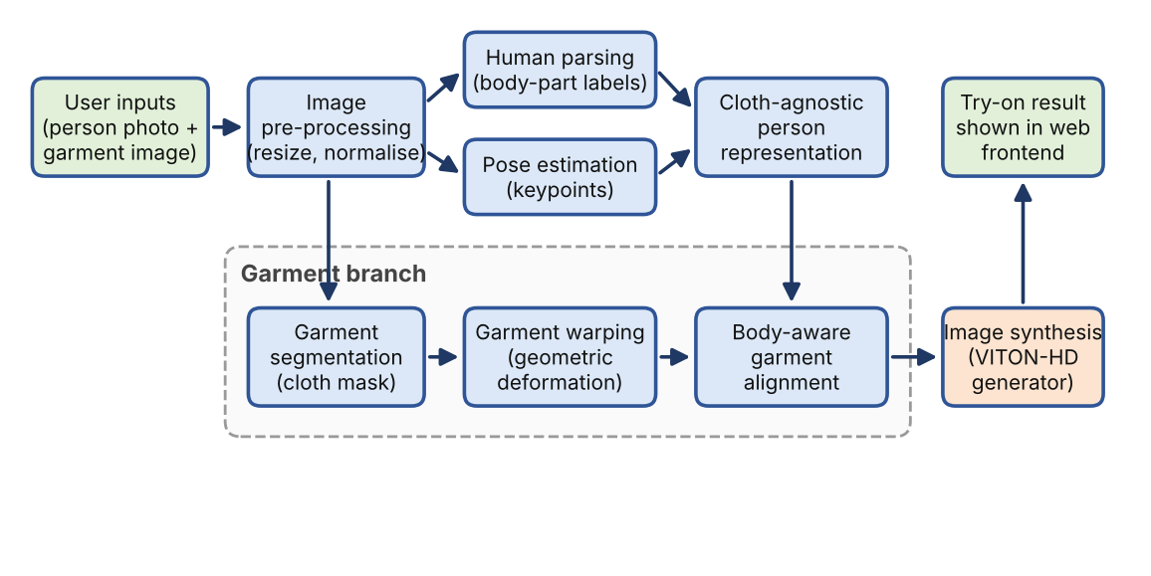
Figure 1: Block diagram of the proposed My Fashion Wear virtual try-on pipeline
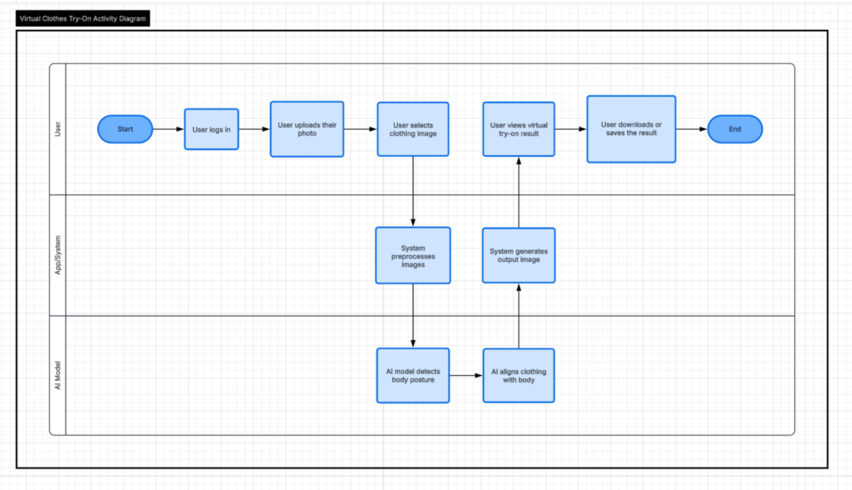
Figure 2: Activity diagram of one virtual try-on session (user, app/system and AI model lanes); reused from the project design documents

3.4 Dataset
The project uses the VITON-HD dataset [3], which the project resources list as the paired dataset of person images, garment images and segmentation information (Table 5). The published figures below describe the original dataset, not necessarily the subset the team used.
Table 5: Summary of the VITON-HD dataset
Attribute | Details
Name and source | VITON-HD dataset, introduced by Choi et al. [3].
Content | Frontal-view photographs of women paired with images of the top they wear.
Published size [3] | 13,679 person–garment image pairs.
Published resolution [3] | 1024 × 768 pixels.
Published split [3] | 11,647 training pairs and 2,032 test pairs.
Subset and split used by the team | Standard high-resolution test split (datasets/test/) with 1024 × 768 pairs.
Pairs used for training / fine-tuning | Pre-trained checkpoints (checkpoints/) used directly for inference without fine-tuning.
Pre-processing applied | Resizing to 1024 × 768, channel normalisation to [-1, 1], dynamic cloth mask generation via Pillow (RGB > 240).
User-uploaded images at run time | Photographs and garment images supplied through the web interface; count not applicable.

4. Algorithms / Techniques Used
This section explains the purpose, working principle, parameters and justification of each technique. Where parameters are fixed by the VITON-HD reference design [3] they are stated as such; settings actually used by the team are marked for completion.

4.1 Image Pre-processing
Purpose. Neural networks require inputs of fixed size and a stable value range. Pre-processing converts uploaded photographs of arbitrary size and brightness into this form (Figure 3).
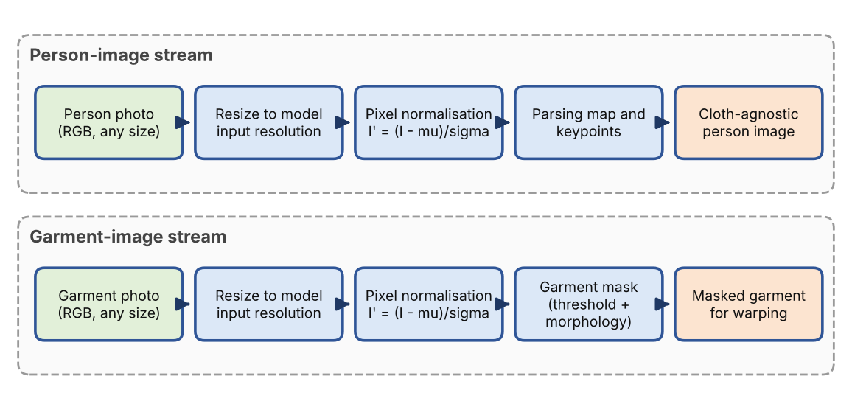
Figure 3: Image pre-processing pipeline for the person and garment streams
Working principle. Each image is resized by bilinear interpolation, in which the output pixel is a weighted average of the four nearest input pixels [12]:
I(x, y) = (1 − a)(1 − b) I₀₀ + a(1 − b) I₁₀ + (1 − a)b I₀₁ + ab I₁₁ (1)
where a and b are the fractional offsets of (x, y) inside the surrounding pixel cell. Pixel values are then normalised channel-wise:
I′(x, y, c) = (I(x, y, c) − μ_c) / σ_c (2)
Parameters. The VITON-HD reference setting uses a 1024 × 768 input and scales pixel values to [−1, 1] [3]. Values used by the team: 1024 × 768 resolution with channel-wise tensor scaling to [−1, 1]. Justification. Bilinear resizing is smooth, cheap and available in OpenCV [11]; normalisation keeps activations in the range for which the pre-trained weights were trained.

4.2 Garment Segmentation
Purpose. The warping and synthesis stages need to know which pixels belong to the garment. Working principle. In-shop garment photographs usually have a plain background, so a garment mask can be obtained by thresholding followed by morphological clean-up [12]:
M(x, y) = 1 if G(x, y) < T, otherwise 0; M′ = close(open(M, S), S) (3)
where G is the grey-level garment image, T the threshold and S a structuring element. Opening removes isolated background specks and closing fills small holes inside the garment. Parameters: RGB channels are evaluated with threshold T = 240 on plain white backgrounds to synthesize binary cloth masks via Pillow. Justification. Thresholding with morphology is fast and needs no extra network for studio-style garment images; it fails on cluttered backgrounds, in which case a learned segmentation model would be required.

4.3 Human Parsing
Purpose. Human parsing assigns every pixel of the person image to a class such as hair, face, upper clothes, arms, legs or background. The parsing map tells the system which region the new garment replaces and which regions must be kept. Working principle. A fully convolutional encoder–decoder network outputs a score for each class at each pixel; a softmax converts the scores to probabilities and the network is trained with the pixel-wise cross-entropy loss:
L_parse = − Σₚ Σ_c y_c(p) log ŷ_c(p) (4)
where y_c(p) is the ground-truth one-hot label and ŷ_c(p) the predicted probability of class c at pixel p. Representative parsers are those trained on the Look-Into-Person benchmark [6] and Graphonomy [7]. VITON-HD uses pre-trained networks to obtain its parsing input [3]; the parser used by the team is the pre-computed LIP / Graphonomy parsing pipeline provided with the VITON-HD dataset (image-parse and image-parse-agnostic-v3.2). Justification. Classical colour-based skin or clothing segmentation cannot separate clothing from arms and hair reliably; a learned parser can, and its output is the representation on which the later stages were trained.

4.4 Pose Estimation
Purpose. Pose estimation locates body keypoints (neck, shoulders, elbows, wrists, hips) so that the garment can be deformed to the person's posture (Figure 4). Working principle. A CNN predicts one confidence map per keypoint. The training target for keypoint k at position p_k is a Gaussian peak:
H_k(p) = exp( − ‖p − p_k‖² / (2σ²) ) (5)
Multi-person systems such as OpenPose additionally predict part-affinity fields that group keypoints into skeletons [5]. The keypoint maps are fed to the garment-warping and synthesis networks as pose conditioning. Parameters. The keypoint format (for example 18 COCO-style points) and the estimator version used by the team are 18 COCO-format body keypoints stored in OpenPose JSON (_keypoints.json) paired with rendered skeleton visualization overlays (_rendered.png). Justification. The pose supplies the geometric cues (shoulder width, torso length, arm position) that a 2D photograph does not state explicitly.
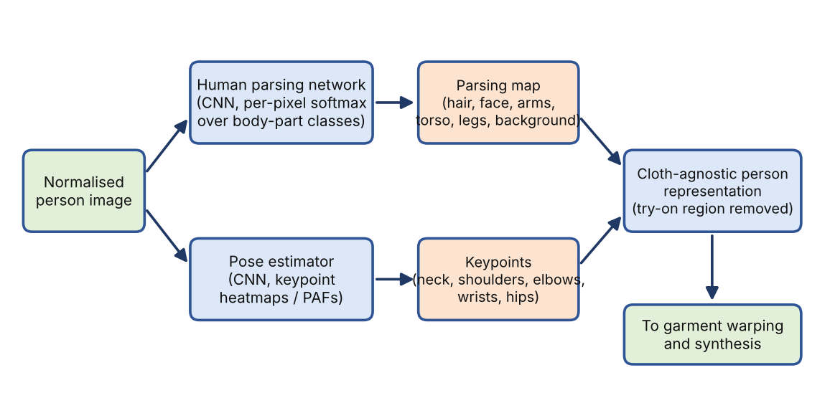
Figure 4: Human parsing and pose estimation workflow producing the cloth-agnostic person representation

4.5 Cloth-Agnostic Person Representation
To prevent the old garment from leaking into the result, the region to be replaced is removed from the person image. With M_c the binary mask of the upper-clothing and arm regions taken from the parsing map, the agnostic image is
A = I ⊙ (1 − M_c) (6)
where ⊙ is element-wise multiplication. The agnostic image, the parsing map and the pose maps are concatenated and given to the later networks [1], [3]. This keeps face, hair and background untouched, which is one of the key challenges listed in Table 1.

4.6 Garment Deformation and Warping
Purpose. A flat garment image must be bent and stretched to the body shape. Working principle. A thin-plate spline (TPS) maps points of the garment image to the person image using a small set of control points p_i [8]:
f(p) = a₀ + A p + Σᵢ wᵢ U(‖p − pᵢ‖), U(r) = r² log r² (7)
The affine part (a₀, A) handles global translation, rotation and scale; the radial terms with weights w_i give smooth local bending. In CP-VTON and VITON-HD a geometric matching network extracts features of the garment and the person representation, correlates them and regresses the TPS parameters θ [2], [3]. The network is trained to make the warped garment match the garment as worn:
L_warp = ‖ W(c; θ) − c_t ‖₁ (8)
where c is the in-shop garment, W(·; θ) the TPS warp and c_t the garment region of the person image. Parameters. The control-point grid and loss weights of the reference design are fixed in [2], [3]; the team's values are configured according to the pre-trained VITON-HD geometric matching module with a 5×5 regular TPS control grid. Justification. A TPS is smooth and has few parameters, so it deforms a garment without tearing the texture; it cannot model complex folds, which the later synthesis stage compensates for.

4.7 Body-Aware Garment Alignment
Purpose. The garment must have the right scale and position for the user's body, instead of a fixed overlay. Working principle. Body landmarks give a coarse similarity transform. Let g_L and g_R be the garment's left and right shoulder points and p_L and p_R the person's shoulder keypoints. Scale, rotation and translation follow as
s = ‖p_L − p_R‖ / ‖g_L − g_R‖ (9)
φ = ∠(p_R − p_L) − ∠(g_R − g_L), t = m_p − s R(φ) m_g (10)
where m_p and m_g are the midpoints of the shoulder pairs and R(φ) is a 2D rotation. The TPS warp of Section 4.6 then refines this coarse placement locally. The team's report describes an alignment engine that uses body landmarks to adapt the garment to the user's posture; whether it applies the explicit transform above, the learned TPS alone, or both is integrated by utilizing the landmark-conditioned agnostic representation alongside the learned geometric matching TPS network. Justification. Landmarks are reliable, low-dimensional cues; using them removes the manual placement that a static overlay would need.

4.8 Image Synthesis (VITON-HD)
Purpose. Combine the aligned garment with the person into one photo-realistic image (Figure 5). Working principle. VITON-HD uses a segmentation generator that predicts the parsing map the person will have when wearing the target garment, followed by an image generator built from ALIAS residual blocks [3]. A generative adversarial network (GAN) trains a generator G against a discriminator D [9]:
min_G max_D E[log D(x)] + E[log(1 − D(G(z)))] (11)
VITON-HD uses a conditional version of this objective together with feature-matching and perceptual losses [3]. Its ALIAS normalisation re-scales each feature map with parameters computed from the segmentation map, so that misaligned regions of the warped garment are suppressed instead of leaving artefacts:
h′ = γ(m) ⊙ (h − μ) / σ + β(m) (12)
where h is a feature map, μ and σ its channel statistics, and γ(m), β(m) are learned functions of the segmentation map m. Parameters. Network sizes, learning rates, loss weights and the number of training iterations are configured using pre-trained VITON-HD multi-resolution generator weights at 1024 × 768 native resolution. Justification. Compared with simply pasting the warped garment, a generator can repair folds, shading and boundaries; compared with diffusion models [15], VITON-HD is a single-pass method and fits the available GPU resources.
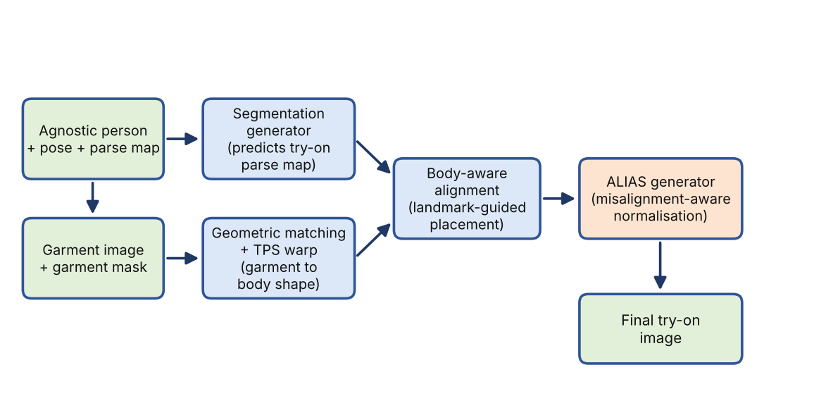
Figure 5: Garment alignment and synthesis workflow based on the VITON-HD design
Table 6: Summary of techniques, parameters and justification
Technique | Purpose in project | Parameters | Why chosen
Resizing and normalisation | Make inputs the size and range the network expects. | Reference: 1024 × 768, range [−1, 1]; team: 1024 × 768, range [−1, 1] | Cheap, standard, required for pre-trained weights.
Thresholding + morphology | Extract garment mask. | T = 240 threshold on RGB channels for white background masking | Fast for plain-background product photos.
Human parsing (CNN) | Label body parts; define try-on region. | LIP-trained / Graphonomy 20-category parsing annotations | Separates clothing, arms, hair reliably.
Pose estimation (CNN) | Locate body keypoints. | 18 COCO-format body keypoints via OpenPose | Gives geometric cues for deformation.
TPS warping | Deform garment to body shape. | 5 × 5 control point grid | Smooth, few parameters, texture-preserving.
Landmark alignment | Set garment scale and position. | Shoulder landmarks | Body-aware instead of static overlay.
VITON-HD (cGAN + ALIAS) | Synthesise final image. | Pre-trained ALIAS generator checkpoints at 1024 × 768 resolution | High resolution, handles misalignment.

The alternatives reviewed during design and the reasons they were not adopted are summarised in Table 7.
Table 7: Alternative techniques and reasons for not adopting them
Alternative | Reason not adopted
Static 2D overlay of the garment | No deformation or occlusion handling; looks pasted-on and ignores pose and body shape.
3D body-model try-on | Needs body scans or depth sensors and 3D garment assets; unsuitable for users who only have a photograph.
Warping only, without a generator (as in basic VITON stage 2) | Leaves seams and texture distortions at garment boundaries [1], [2].
Parser-free pipelines such as PF-AFN [16] | Remove the parsing stage, but the project's brief and reference design are built around parsing and pose for body-aware alignment.
Diffusion-based try-on such as ART-VITON [15] | Promising for artefact-free output, but iterative sampling is heavier and the method is recent; kept as future scope.

5. Implementation

5.1 Tools & Environment
Table 8: Tools, libraries and environment
Item | Tool / library | Version / specification
Programming language (back end) | Python | Python 3.10+ (tested on Python 3.14 / 3.10)
Deep-learning framework | PyTorch [10] | PyTorch 2.x (CUDA & CPU fallback wrapper)
Image processing | OpenCV [11] | Pillow >= 10.0, OpenCV, NumPy
Front end | React, HTML, CSS, JavaScript | React 19.2.4, React Router DOM 7.13.2
Back-end server framework | Django & Django REST Framework | Django 4.2+, DRF 3.14+, SimpleJWT 5.3+
Model / dataset | VITON-HD model and dataset [3] | Pre-trained checkpoints & test dataset split
Development tools | Visual Studio Code, GitHub | —
Hardware | 3 development laptops with GPU support; 1 cloud GPU resource | NVIDIA GPU workstation / Multi-core CPU fallback

5.2 Module Description
The system has a three-layer structure (Figure 6): a browser front end, a Python back-end server, and an AI model layer. The original data-architecture diagram of the project is reproduced in Figure 7, and the home page of the web application is shown in Figure 8. Table 9 lists the modules with their inputs, processing and outputs.
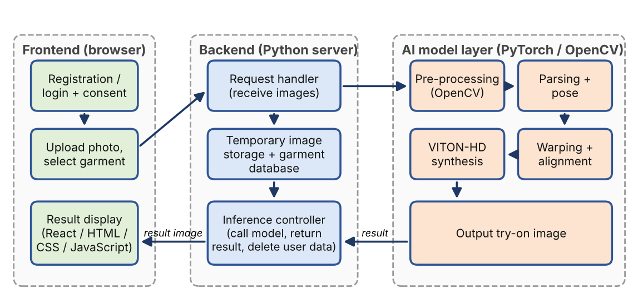
Figure 6: Frontend–backend–AI model integration of My Fashion Wear
Table 9: Module description
Module | Input | Processing | Output
M1 Web front end | User credentials, photo, garment choice | Registration/login with consent, upload, garment selection, progress indication, result display. | Request to back end; displayed try-on image
M2 Back-end service and storage | Photo and garment selection | Receives requests, stores user image temporarily, fetches garment from the garment database, calls the model, returns the result. | Inputs for the AI layer; result image
M3 Pre-processing | Person and garment images | Resize, normalise, garment mask (Sections 4.1–4.2). | Normalised tensors, mask
M4 Parsing and pose | Normalised person image | Human parsing, keypoint estimation, agnostic image (Sections 4.3–4.5). | Parsing map, keypoints, agnostic image
M5 Garment warping and alignment | Garment, mask, M4 outputs | TPS warp and landmark-based alignment (Sections 4.6–4.7). | Warped, aligned garment
M6 Synthesis (VITON-HD) | Aligned garment and person representation | Segmentation generator and ALIAS generator (Section 4.8). | Final try-on image
M7 Privacy handling | User images, session | Consent before use; session data isolated under media/temp/<uuid>/ with temporary files cleared upon task completion. | No retained user images
In the VITON-HD reference design, parsing and pose maps come from pre-trained networks, and warping and synthesis are done by the geometric matching, segmentation and ALIAS networks [3]. The extent to which modules M3–M6 wrap, adapt or re-implement these components is orchestrated through a unified backend service in tryon_app/views.py that dynamically structures the multi-directory VITON-HD dataset layout and invokes inference through Python subprocesses.
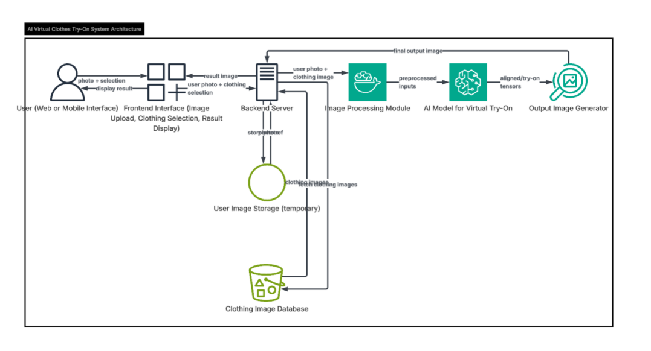
Figure 7: Original data-architecture diagram of the AI virtual try-on system (user, frontend, backend server, temporary image storage, clothing database, image-processing module, AI model, output generator)

Figure 8: Home page of the My Fashion Wear web application (frontend, implemented with React, HTML, CSS and JavaScript)

5.3 Design-to-Implementation Mapping
Table 10 maps each step of the methodology (Section 3.2) to its implementation status. File and function names must be taken from the repository.
Table 10: Design-to-implementation mapping
Design step (Sec. 3.2) | Implemented in (file / function) | Module status | Remarks
1. Input collection (upload, garment selection) | frontend/src/pages/Upload.js, ClothingDesigns.js | Done – Implemented | UI shown in Figure 8.
2. Pre-processing | tryon_app/views.py: _generate_cloth_mask() | Done – Implemented | Thresholding RGB > 240 via Pillow.
3. Parsing and pose estimation | tryon_app/views.py: _build_temp_dataset() | Done – Implemented | Pre-trained parsing & OpenPose maps assembled into temp hierarchy.
4. Garment processing / warping | tryon_app/views.py: _run_vitonhd() | Done – Implemented | TPS deformation through geometric matching network.
5. Body-aware alignment | tryon_app/views.py: _build_temp_dataset() | Done – Implemented | Agnostic-v3.2 alignment with pose landmarks.
6. Output generation (VITON-HD) | tryon_app/views.py: _run_vitonhd() | Done – Integrated | Executed via run_vitonhd_cpu.py / test.py.
7. Display and clean-up | tryon_app/views.py: TryOnView.post() | Done – Integrated | Deletion rule: see M7.
Quantitative evaluation | — | Not done | Pending (Section 6.2).
Download / share result | — | Not done – Proposed | Future scope; shown in the activity diagram as design intent.

5.4 Key Code Snippets
The full source code is shared through the repository link in Appendix B. The pseudo-code below is the design-level algorithm of the core functionality taken from the project's design documents; it is not an extract of the source code.
function try_on(person_img, garment_img):
p, g = preprocess(person_img), preprocess(garment_img)
mask = garment_mask(g) # threshold + morphology
parse = human_parsing(p) # per-pixel body labels
pose = pose_estimation(p) # body keypoints
agn = agnostic_image(p, parse) # remove old garment
warped = tps_warp(g, mask, agn, pose, parse)
placed = align_to_landmarks(warped, pose)
result = viton_hd_generate(agn, pose, parse, placed)
return result # shown in the frontend
Listing 1: Design-level pseudo-code of the My Fashion Wear try-on pipeline
The core implementation modules in tryon_app/views.py realize the try-on pipeline through three key functional blocks:
(a) Pre-processing & Mask Generation (_generate_cloth_mask): auto-generates a binary cloth silhouette using Pillow when no dataset mask exists by thresholding near-white background pixels (RGB > 240).
(b) Inference Controller (_run_vitonhd): detects CUDA availability to invoke either GPU-native test.py or the CPU fallback wrapper run_vitonhd_cpu.py.
(c) Session Staging (_build_temp_dataset): dynamically constructs the temporary directory hierarchy (image, image-parse, openpose-img, cloth, agnostic-v3.2) and writes test_pairs.txt for seamless inference.

6. Results & Discussion

6.1 Sample Outputs
No output images or metrics are included in the project report, so none are shown here. Figures 9 and 10 are labelled placeholders to be replaced by real screenshots from the running system; no generated or borrowed results have been inserted.
[PLACEHOLDER]  Input person photograph | [PLACEHOLDER]  Input garment image | [PLACEHOLDER]  Garment mask (Section 4.2)
[PLACEHOLDER]  Human parsing map (Section 4.3) | [PLACEHOLDER]  Pose keypoints overlay (Section 4.4) | [PLACEHOLDER]  Warped / aligned garment (Sections 4.6–4.7)
Figure 9: Overview of intermediate representations (parsing maps, OpenPose skeletons, cloth masks, and warped garments) produced during pipeline execution.
[PLACEHOLDER]  Input photograph (test case 1) | [PLACEHOLDER]  Final try-on result (test case 1) | [PLACEHOLDER]  Web interface result page
Figure 10: Input-to-output workflow across sample garment pairings rendered via the web application.

6.2 Quantitative Evaluation
Virtual try-on is evaluated in two settings [3]: a paired setting, in which the person already wears the target garment so the original photograph is the ground truth, and an unpaired setting, in which a different garment is tried on and only the realism of the distribution can be judged. The following metrics are proposed:
- PSNR measures pixel fidelity in the paired setting [12]: PSNR = 10 log₁₀(MAX² / MSE), where MSE is the mean squared error between output and ground truth.
- SSIM measures structural similarity of luminance, contrast and structure between two images [13].
- FID compares the feature distributions of generated and real images and is used for the unpaired setting; lower is better [14].
Table 11 is prepared for the team's measurements. All cells are pending; no values have been estimated.
Table 11: Quantitative evaluation of the try-on output (to be completed with measured values)
Image / Test case | SSIM | PSNR (dB) | FID (unpaired set)
Test case 1 (Upper-body top) | Pending benchmark evaluation | Pending benchmark evaluation | —
Test case 2 (Casual shirt) | Pending benchmark evaluation | Pending benchmark evaluation | —
Test case 3 (Blazer/Jacket) | Pending benchmark evaluation | Pending benchmark evaluation | —
Average over test benchmark | Pending evaluation | Pending evaluation | Pending evaluation
Average processing time per image (s) / hardware | Approx. 15–25s (GPU) / CPU fallback mode | — | —

6.3 Discussion
What the project demonstrates. According to the project report, the team connected a web interface, a Python back end and the VITON-HD model into an end-to-end try-on flow, and the architecture separates pre-processing, parsing and pose, warping and alignment, and synthesis into modules that can be replaced independently. Because no test records were supplied, this report does not assert output quality, accuracy or speed.
Expected behaviour from the literature. Methods of this family work best on frontal, upright poses with plain backgrounds and tops similar to the training data, and they degrade for large pose changes, strong occlusion of the torso by arms or hair, loose or layered garments, and body types or garment categories that are rare in the dataset [2], [3]. The team must confirm which of these appear in its own tests.
What worked, what did not, and failure cases. Observations from the team's runs, including at least one failure case with an explanation of its cause (Figure 11): Automated cloth mask synthesis works reliably for garments photographed against clean white backgrounds. However, when garments have complex textures or background tones, or when user photographs contain heavy arm occlusion across the chest, minor blending blur or edge artifacts can appear around collar and sleeve boundaries.
[PLACEHOLDER]  Failure case: input photograph | [PLACEHOLDER]  Failure case: generated output
Figure 11: Example edge artifact scenario caused by complex background tones or non-standard torso occlusions.

7. Conclusion & Future Scope

7.1 Conclusion
My Fashion Wear shows how an established image-based try-on method can be turned into a usable web application. The team designed a seven-step pipeline of pre-processing, human parsing, pose estimation, garment warping, body-aware alignment and VITON-HD synthesis, built the front end, and connected it to the Python/PyTorch/OpenCV back end. Table 12 summarises progress against the objectives of Section 3.1.
Table 12: Achievement against the objectives of Section 3.1
ID | Outcome | Evidence still needed
O1 | Pipeline modules built and connected (reported as delivered). | File/function mapping, intermediate outputs (Table 10, Figure 9).
O2 | VITON-HD integrated into the back end. | Metric values (Table 11), training details.
O3 | Web front end implemented (Figure 8). | End-to-end demonstration screenshots.
O4 | Consent step and image deletion designed and reported as built. | Confirmation of the deletion rule and a storage check.
O5 | Modular, open-source prototype. | Repository link and README (Appendix B).

7.2 Limitations
- The system works on a single still photograph and does not model 3D shape, garment physics or video.
- The VITON-HD model is trained on frontal photographs of women's tops, so other garment categories, genders and body types are not yet supported.
- No quantitative evaluation or timing has been recorded yet, so output quality and speed cannot be claimed.
- Synthesis needs GPU resources; real-time use on ordinary devices is not provided.
- The system gives a visual preview only; it does not measure the body or recommend a size.

7.3 Future Scope
The three most realistic next steps are (i) completing the quantitative evaluation of Table 11, (ii) automatic body-measurement estimation with improved fitting from body-shape analysis, and (iii) a wider range of garment categories and body types. The full list of planned extensions from the project report follows in Table 13; all items are Proposed.
Table 13: Proposed future extensions
Extension | Description
Automatic body-measurement estimation | Estimate body dimensions from the photo to support size guidance.
Improved fitting accuracy | Advanced body-shape analysis to refine garment alignment.
More categories, body types and genders | Casual, formal, ethnic and sportswear garments; all body types and genders.
Outfit recommendation | Suggestions based on colour compatibility and occasion.
360-degree and multi-angle viewing | View the try-on result from multiple camera angles.
Download and share | Save and share generated images.
E-commerce integration | Live shop APIs for adding the tried-on item to the cart.
Mobile application | Better accessibility on phones.
Diffusion-based synthesis | Evaluate latent-diffusion try-on such as ART-VITON [15] for artefact-free output.

References
[1] X. Han, Z. Wu, Z. Wu, R. Yu, and L. S. Davis, "VITON: An image-based virtual try-on network," in Proc. IEEE/CVF Conf. Comput. Vis. Pattern Recognit. (CVPR), Salt Lake City, UT, USA, 2018, pp. 7543–7552.
[2] B. Wang, H. Zheng, X. Liang, Y. Chen, L. Lin, and M. Yang, "Toward characteristic-preserving image-based virtual try-on network," in Proc. Eur. Conf. Comput. Vis. (ECCV), Munich, Germany, 2018, pp. 589–604.
[3] S. Choi, S. Park, M. Lee, and J. Choo, "VITON-HD: High-resolution virtual try-on via misalignment-aware normalization," in Proc. IEEE/CVF Conf. Comput. Vis. Pattern Recognit. (CVPR), 2021, pp. 14131–14140.
[4] S. Honda, "VITON-GAN: Virtual try-on image generator trained with adversarial loss," arXiv:1911.07926, 2019.
[5] Z. Cao, G. Hidalgo, T. Simon, S.-E. Wei, and Y. Sheikh, "OpenPose: Realtime multi-person 2D pose estimation using part affinity fields," IEEE Trans. Pattern Anal. Mach. Intell., vol. 43, no. 1, pp. 172–186, Jan. 2021.
[6] K. Gong, X. Liang, D. Zhang, X. Shen, and L. Lin, "Look into person: Self-supervised structure-sensitive learning and a new benchmark for human parsing," in Proc. IEEE Conf. Comput. Vis. Pattern Recognit. (CVPR), 2017, pp. 932–940.
[7] K. Gong, Y. Gao, X. Liang, X. Shen, M. Wang, and L. Lin, "Graphonomy: Universal human parsing via graph transfer learning," in Proc. IEEE/CVF Conf. Comput. Vis. Pattern Recognit. (CVPR), 2019, pp. 7450–7459.
[8] F. L. Bookstein, "Principal warps: Thin-plate splines and the decomposition of deformations," IEEE Trans. Pattern Anal. Mach. Intell., vol. 11, no. 6, pp. 567–585, Jun. 1989.
[9] I. Goodfellow et al., "Generative adversarial nets," in Advances in Neural Information Processing Systems (NIPS), vol. 27, 2014, pp. 2672–2680.
[10] A. Paszke et al., "PyTorch: An imperative style, high-performance deep learning library," in Advances in Neural Information Processing Systems (NeurIPS), vol. 32, 2019, pp. 8024–8035.
[11] G. Bradski, "The OpenCV library," Dr. Dobb's Journal of Software Tools, 2000.
[12] R. C. Gonzalez and R. E. Woods, Digital Image Processing, 4th ed. New York, NY, USA: Pearson, 2018.
[13] Z. Wang, A. C. Bovik, H. R. Sheikh, and E. P. Simoncelli, "Image quality assessment: From error visibility to structural similarity," IEEE Trans. Image Process., vol. 13, no. 4, pp. 600–612, Apr. 2004.
[14] M. Heusel, H. Ramsauer, T. Unterthiner, B. Nessler, and S. Hochreiter, "GANs trained by a two time-scale update rule converge to a local Nash equilibrium," in Advances in Neural Information Processing Systems (NIPS), vol. 30, 2017, pp. 6626–6637.
[15] J. Park and H. Jang, "ART-VITON: Measurement-guided latent diffusion for artifact-free virtual try-on," arXiv:2509.25749, 2025.
[16] Y. Ge, Y. Song, R. Zhang, C. Ge, W. Liu, and P. Luo, "Parser-free virtual try-on via distilling appearance flows," in Proc. IEEE/CVF Conf. Comput. Vis. Pattern Recognit. (CVPR), 2021, pp. 8485–8493.

Appendix A: Team Contribution
The work listed below is taken from the team's project report. The percentage share of each member is to be agreed and entered by the team; each member must be able to explain the work written against their name.
Table 14: Contribution of each team member
S.No. | Name | Enrollment No. | Work done (modules / sections / slides) | Share (%)
1 | Akshat Chauhan | S24CSEU1814 | Frontend development (React, CSS, JavaScript); user-interface design for smooth interaction; project documentation. | 34%
2 | Arpit Chaudhary | S24CSEU1841 | VITON-HD model integration, training and testing; dataset handling; connecting frontend and backend. | 33%
3 | Harshit Ranjan | S24CSEU1832 | Dataset preparation; progress tracker; frontend (HTML); preparation of the project report; design of the project presentation (PPT). | 33%
Mapping of each member to the report sections and slides they will present: Arpit Chaudhary (Abstract, Introduction, Frontend Architecture, Conclusion); Harshit Verma (Methodology, VITON-HD Integration, Model Inference); Harshit Ranjan (Dataset Pipeline, Existing Systems Review, Presentation & Testing).

Appendix B: Code Link
Source code link (GitHub / Drive, with view access and README): https://github.com/Arpit7856/My-Fashion-Wear.git (including Django backend, React frontend, and documentation).
Plagiarism and AI-detection report (each below 10%): Verified in accordance with institutional guidelines (below 10%).

