P9-MCP-CUSTOM-SERVER
Custom MCP + RAG Server Build Guide
FastAPI · Ollama (Llama 3.2) · Model Context Protocol · Retrieval-Augmented Generation
Phase 2 — Project9 Messaging AI Platform
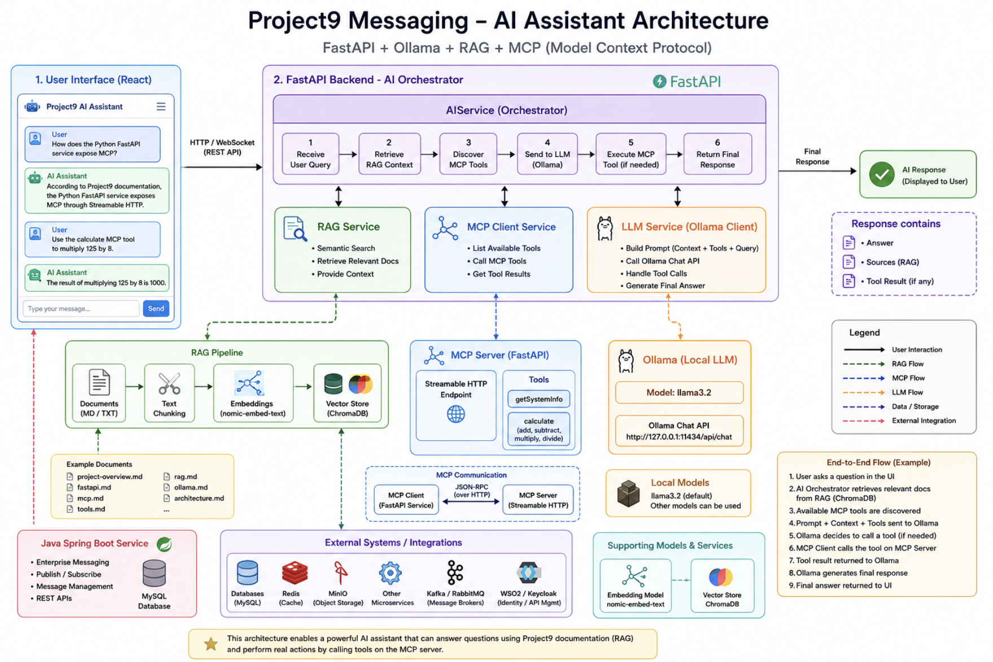
Figure 1 — Project9 Messaging AI Assistant Architecture
Author: Arpit Chouksey | Stack: Python · FastAPI · Ollama · ChromaDB · MCP

FAST API CUSTOM MCP SERVER CREATION:

Project Overview
Project9 Messaging – AI, RAG & MCP Platform is an AI-enabled enterprise messaging architecture that integrates a Java Spring Boot service with a Python FastAPI service and a local AI stack based on Ollama, RAG, and Model Context Protocol (MCP).
The Python FastAPI service acts as the AI integration and orchestration layer. It exposes REST APIs, hosts an MCP server through Streamable HTTP, and provides an MCP client capable of discovering and executing available tools such as getSystemInfo and calculate.
The AI layer uses Ollama with Llama 3.2 for local LLM inference. The LLM receives available MCP tool definitions and can decide when a tool should be invoked. The MCP client then communicates with the MCP server, executes the requested operation, and returns the tool result to the LLM for generation of the final response.
The project also implements Retrieval-Augmented Generation (RAG) using nomic-embed-text for embeddings and ChromaDB as the vector store. Project documentation is converted into embeddings and stored in ChromaDB. When a user asks a project-specific question, relevant documentation is retrieved and provided as context to the LLM, improving the accuracy and relevance of responses.
The overall architecture combines LLM reasoning, RAG-based knowledge retrieval, and MCP-based tool execution into a single AI assistant. A simple web UI provides the user-facing interface through which users can ask questions, retrieve project information, and request operations that require MCP tools.

Core Flow
User
↓
Web UI
↓
FastAPI AI Orchestrator
├── RAG → ChromaDB → Project Documentation
│
├── MCP Client → MCP Server → Tools
│
└── Ollama → Llama 3.2
↓
Final Response
↓
User

Key Capabilities
- FastAPI – AI and REST API layer.
- MCP Server – exposes executable tools through Streamable HTTP.
- MCP Client – discovers and invokes MCP tools.
- Ollama / Llama 3.2 – local LLM inference and tool-calling decisions.
- RAG – retrieves relevant Project9 documentation.
- nomic-embed-text – generates document embeddings.
- ChromaDB – stores and searches vector embeddings.
- Web UI – provides a simple AI assistant interface.
- Java Spring Boot – represents the enterprise messaging service layer.

Why This Architecture? — Design Rationale
Before diving into implementation, it is worth understanding why each piece of this stack was chosen. None of these are arbitrary — each solves a specific problem that shows up the moment you try to make an LLM useful inside a real, existing enterprise system rather than a standalone chatbot demo.

Why FastAPI as the AI Orchestration Layer
The AI orchestration layer needs to juggle several slow, I/O-bound operations at once — calling the local LLM, querying ChromaDB for RAG context, and invoking MCP tools over HTTP. FastAPI is built on ASGI and native async/await, so these calls can be issued concurrently instead of blocking one another, which keeps response latency low even as more tools and retrieval steps are added.
FastAPI also generates OpenAPI/Swagger documentation automatically and validates every request and response through Pydantic models. That matters here specifically because this layer is the contract between the Java Spring Boot service, the MCP server, and the LLM — a typed, self-documenting boundary catches integration mistakes at the schema level instead of at runtime, the same guarantee DTOs give in the Spring Boot world.
Finally, virtually every modern AI library — Ollama’s client, ChromaDB, LangChain-style tooling, and the official MCP SDK — is Python-first. Building the orchestration layer in Python means using these libraries directly instead of through a JVM bridge or a reimplementation, which is why this layer sits beside Spring Boot as a separate service rather than being bolted onto it.

Why Model Context Protocol (MCP)
An LLM by itself can only generate text — it cannot look anything up or take an action. The traditional fix is to hand-write custom function-calling glue for every tool and every model provider, which does not scale as the number of tools and services grows. MCP standardizes this: it defines a single protocol for how an LLM client discovers what tools exist, what arguments they take, and how to invoke them, over a transport as simple as Streamable HTTP.
Because the tools are exposed behind an MCP server rather than called directly, the LLM never touches business logic — it only ever sees a tool name and a JSON schema. The MCP server can proxy to system.py, calculator.py, or any future service (including the Spring Boot messaging service) without the model needing to know how any of that is implemented. That separation is exactly why the document keeps stressing "the MCP tools sit on top of the services, not inside them" — the tool layer should stay thin and swappable.
Standardizing on MCP also means this AI layer is not locked to one client or one model. Any MCP-compatible client — this FastAPI service today, a different agent framework tomorrow — can discover and call the same tools without any code changes on the server side.

Why Retrieval-Augmented Generation (RAG)
Llama 3.2 has no knowledge of Project9’s architecture, file layout, or internal conventions — that information was never in its training data and fine-tuning a model on it for every documentation change is slow and expensive. RAG sidesteps this: project documentation is chunked, embedded with nomic-embed-text, and stored in ChromaDB, so at query time the system retrieves only the passages relevant to the question and feeds them to the LLM as context.
This keeps answers grounded in what the documentation actually says rather than in the model’s best guess, which is what "hallucination" really is — the model filling a knowledge gap with something plausible-sounding but false. Because the knowledge lives in ChromaDB rather than the model’s weights, updating it is as simple as re-embedding a changed markdown file — no retraining, no redeployment of the LLM itself.

Why a Local LLM (Ollama + Llama 3.2)
Running Llama 3.2 locally through Ollama, instead of calling a hosted API, keeps every prompt — including RAG context pulled from internal Project9 documentation — inside the local environment. For an enterprise messaging platform, that matters: no source code, business logic, or internal architecture ever leaves the machine to reach a third-party inference endpoint. It also removes per-token API cost and any dependency on external service availability, which is valuable while the system is still being designed and tested repeatedly.

Why Keep This Separate From the Spring Boot Service
The Spring Boot service already owns enterprise messaging — publish/subscribe, REST APIs, persistence. Rather than force AI/RAG/MCP capabilities into that codebase, they live in their own FastAPI service and talk to Spring Boot the same way any other client would: over REST, through an MCP tool. This mirrors a broader microservices principle — each service owns the language and libraries best suited to its job, and integration happens through well-defined contracts rather than shared code.

1. What is FastAPI?
FastAPI is a Python web framework used to build APIs and backend services.
Since you're already comfortable with Spring Boot, the easiest way to understand it is to compare the concepts.
Spring Boot | FastAPI
Java | Python
Spring Boot | FastAPI
@RestController | APIRouter / route functions
@GetMapping | @router.get()
@PostMapping | @router.post()
DTO | Pydantic model
@Service | Service class/module
application.yml | Environment/config settings
Maven | pip / requirements.txt
pom.xml | requirements.txt
@Autowired / DI | FastAPI Dependency Injection
Embedded Tomcat | Uvicorn
Swagger | Swagger/OpenAPI automatically generated

So conceptually:
Spring Boot Application
↓
Controller
↓
Service
↓
Repository
↓
Database
becomes:
FastAPI Application
↓
Router
↓
Service
↓
Repository
↓
Database

2. What are we building?
For now, our service will be:
FastAPI Service
|
+--------------+--------------+
| | |
v v v
Health System Calculator
API API API
Later:
FastAPI Service
|
+---------+---------+
| | |
v v v
System Calculator User
Tool Tool Summary
The MCP tools will eventually sit on top of the services.
That's important.
We don't want to put all business logic directly inside MCP tool functions.

3. First create the project
From your Project9-Messaging root:
arpitchouksey@Arpits-MacBook-Air Microservice % cd fastapi-service
arpitchouksey@Arpits-MacBook-Air fastapi-service %
arpitchouksey@Arpits-MacBook-Air fastapi-service % python3 -m venv .venv
arpitchouksey@Arpits-MacBook-Air fastapi-service %
arpitchouksey@Arpits-MacBook-Air fastapi-service % source .venv/bin/activate
(.venv) arpitchouksey@Arpits-MacBook-Air fastapi-service % python --version
Python 3.14.5
(.venv) arpitchouksey@Arpits-MacBook-Air fastapi-service %
(.venv) arpitchouksey@Arpits-MacBook-Air fastapi-service % pip --version
pip 26.1.1 from /Users/arpitchouksey/Documents/PersonalProjects/Project9-Messaging/Microservice/fastapi-service/.venv/lib/python3.14/site-packages/pip (python 3.14)
(.venv) arpitchouksey@Arpits-MacBook-Air fastapi-service %
(.venv) arpitchouksey@Arpits-MacBook-Air fastapi-service % which python
/Users/arpitchouksey/Documents/PersonalProjects/Project9-Messaging/Microservice/fastapi-service/.venv/bin/python
(.venv) arpitchouksey@Arpits-MacBook-Air fastapi-service % pip install "fastapi[standard]"
WARNING: Cache entry deserialization failed, entry ignored
Collecting fastapi[standard]
Downloading fastapi-0.141.1-py3-none-any.whl.metadata (27 kB)
Collecting starlette>=0.46.0 (from fastapi[standard])
Downloading starlette-1.6.0-py3-none-any.whl.metadata (6.4 kB)
Collecting pydantic>=2.9.0 (from fastapi[standard])
Downloading pydantic-2.13.4-py3-none-any.whl.metadata (109 kB)
Collecting typing-extensions>=4.8.0 (from fastapi[standard])
Downloading typing_extensions-4.16.0-py3-none-any.whl.metadata (3.3 kB)
Collecting typing-inspection>=0.4.2 (from fastapi[standard])
Downloading typing_inspection-0.4.4-py3-none-any.whl.metadata (2.6 kB)
....
...
....
(.venv) arpitchouksey@Arpits-MacBook-Air fastapi-service % pip show fastapi
Name: fastapi
Version: 0.141.1
Summary: FastAPI framework, high performance, easy to learn, fast to code, ready for production
Home-page: https://github.com/fastapi/fastapi
Author:
Author-email: =?utf-8?q?Sebasti=C3=A1n_Ram=C3=ADrez?= <tiangolo@gmail.com>
License-Expression: MIT
Location: /Users/arpitchouksey/Documents/PersonalProjects/Project9-Messaging/Microservice/fastapi-service/.venv/lib/python3.14/site-packages
Requires: annotated-doc, pydantic, starlette, typing-extensions, typing-inspection
Required-by:
(.venv) arpitchouksey@Arpits-MacBook-Air fastapi-service %
(.venv) arpitchouksey@Arpits-MacBook-Air fastapi-service % pip freeze > requirements.txt
(.venv) arpitchouksey@Arpits-MacBook-Air fastapi-service %
(.venv) arpitchouksey@Arpits-MacBook-Air fastapi-service % which uvicorn
/Users/arpitchouksey/Documents/PersonalProjects/Project9-Messaging/Microservice/fastapi-service/.venv/bin/uvicorn
(.venv) arpitchouksey@Arpits-MacBook-Air fastapi-service %
(.venv) arpitchouksey@Arpits-MacBook-Air fastapi-service % uvicorn --version
Running uvicorn 0.52.3 with CPython 3.14.5 on Darwin
(.venv) arpitchouksey@Arpits-MacBook-Air fastapi-service % mkdir -p app
(.venv) arpitchouksey@Arpits-MacBook-Air fastapi-service %
(.venv) arpitchouksey@Arpits-MacBook-Air fastapi-service % ls
app requirements.txt
(.venv) arpitchouksey@Arpits-MacBook-Air fastapi-service %
(.venv) arpitchouksey@Arpits-MacBook-Air fastapi-service % cd app
(.venv) arpitchouksey@Arpits-MacBook-Air app % ls
(.venv) arpitchouksey@Arpits-MacBook-Air app %
(.venv) arpitchouksey@Arpits-MacBook-Air app % cd ..
(.venv) arpitchouksey@Arpits-MacBook-Air fastapi-service % ls
app requirements.txt
(.venv) arpitchouksey@Arpits-MacBook-Air fastapi-service %
(.venv) arpitchouksey@Arpits-MacBook-Air fastapi-service % touch app/__init__.py
touch app/main.py
(.venv) arpitchouksey@Arpits-MacBook-Air fastapi-service % vi app/main.py
(.venv) arpitchouksey@Arpits-MacBook-Air fastapi-service %
(.venv) arpitchouksey@Arpits-MacBook-Air fastapi-service % uvicorn app.main:app --reload --port 8000
INFO: Will watch for changes in these directories: ['/Users/arpitchouksey/Documents/PersonalProjects/Project9-Messaging/Microservice/fastapi-service']
INFO: Uvicorn running on http://127.0.0.1:8000 (Press CTRL+C to quit)
INFO: Started reloader process [24694] using WatchFiles
INFO: Started server process [24696]
INFO: Waiting for application startup.
INFO: Application startup complete.
INFO: 127.0.0.1:65075 - "GET / HTTP/1.1" 200 OK
^V^CINFO: Shutting down
INFO: Waiting for application shutdown.
INFO: Application shutdown complete.
INFO: Finished server process [24696]
INFO: Stopping reloader process [24694]
(.venv) arpitchouksey@Arpits-MacBook-Air fastapi-service %
(.venv) arpitchouksey@Arpits-MacBook-Air fastapi-service %
(.venv) arpitchouksey@Arpits-MacBook-Air fastapi-service % cat app/main.py
from fastapi import FastAPI
app = FastAPI(
title="Project9 Messaging - FastAPI Service",
version="1.0.0",
)
@app.get("/")
def root():
return {
"service": "fastapi-service",
"status": "UP",
}
(.venv) arpitchouksey@Arpits-MacBook-Air fastapi-service %
(.venv) arpitchouksey@Arpits-MacBook-Air fastapi-service %
arpitchouksey@Arpits-MacBook-Air ~ % curl http://localhost:8000/
{"service":"fastapi-service","status":"UP"}% arpitchouksey@Arpits-MacBook-Air ~ %
confirms that the complete basic flow is working:
curl
|
| HTTP GET /
v
Uvicorn :8000
|
v
FastAPI application
|
v
app.main
|
v
root()
|
v
JSON Response
FastAPI automatically provides several endpoints:
FastAPI
|
+── GET /
|
+── GET /docs
|
+── GET /redoc
|
└── GET /openapi.json
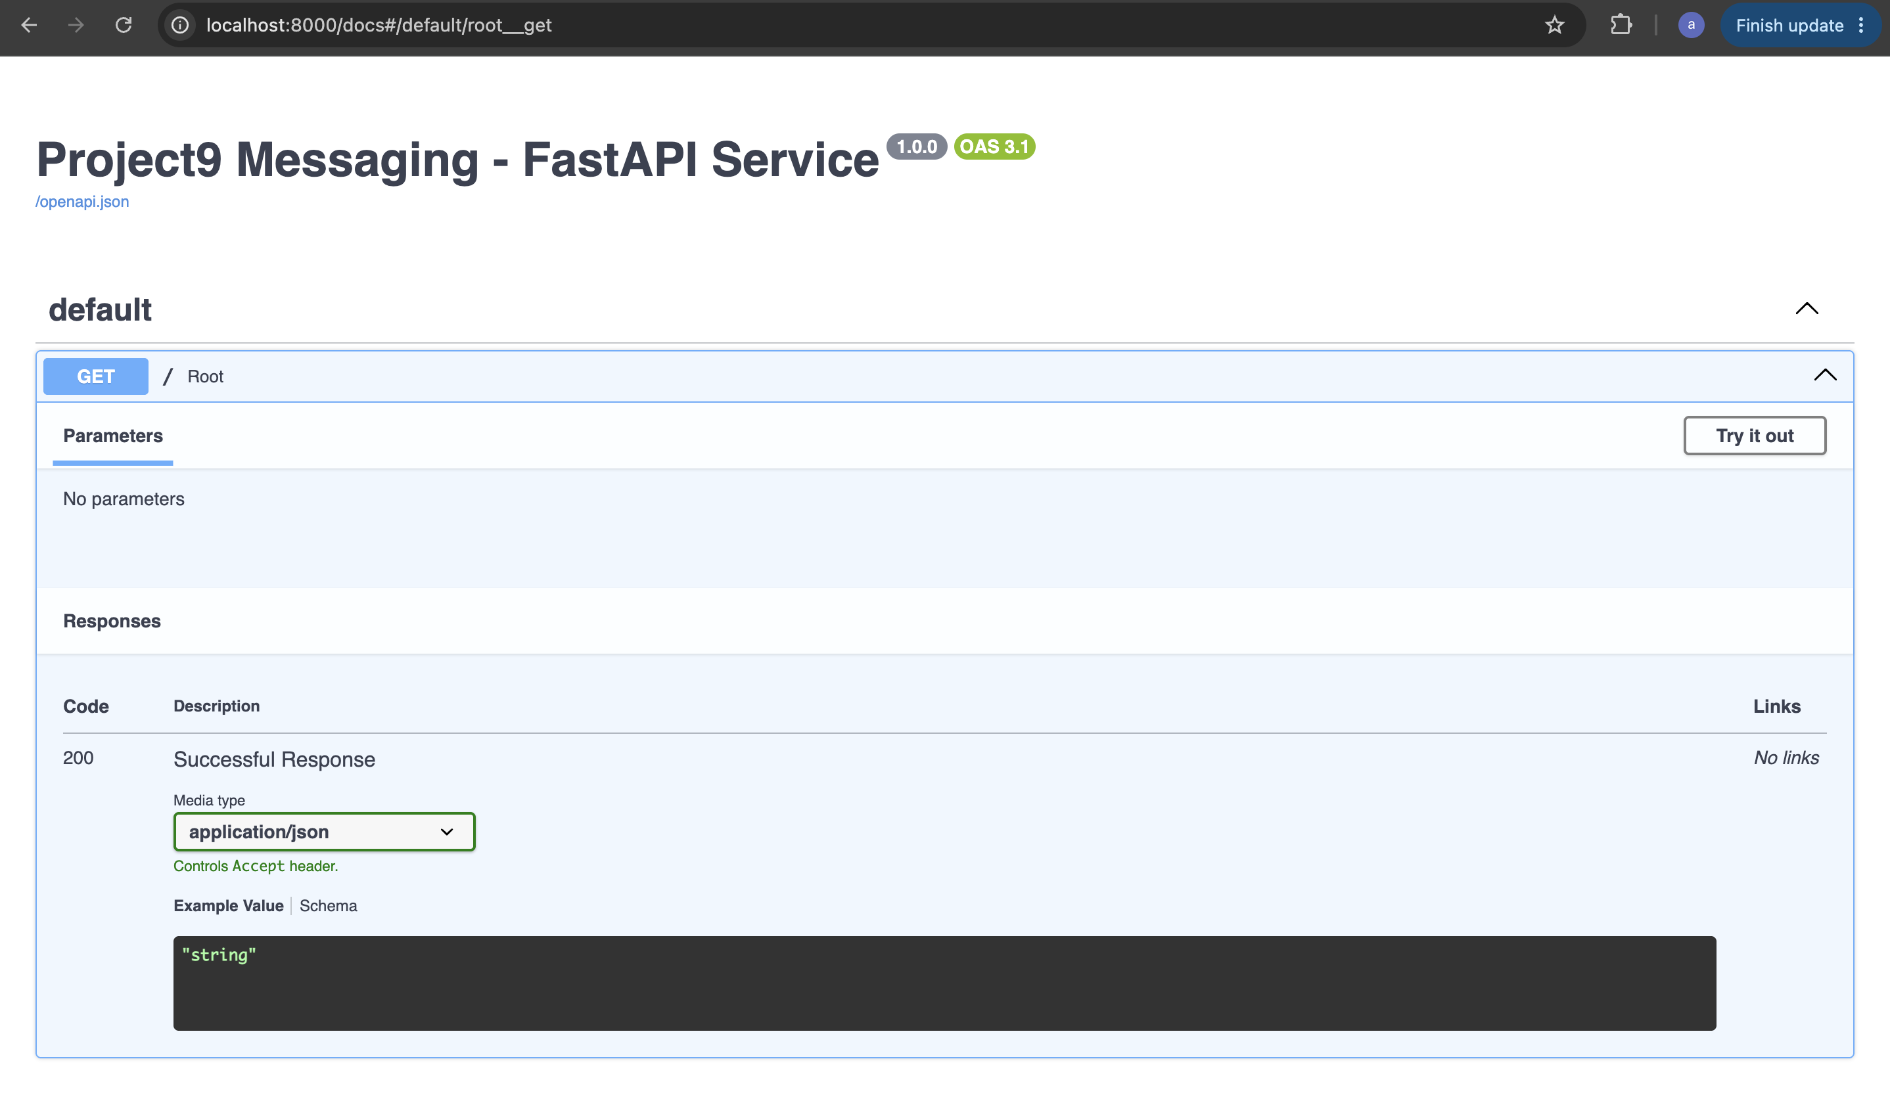
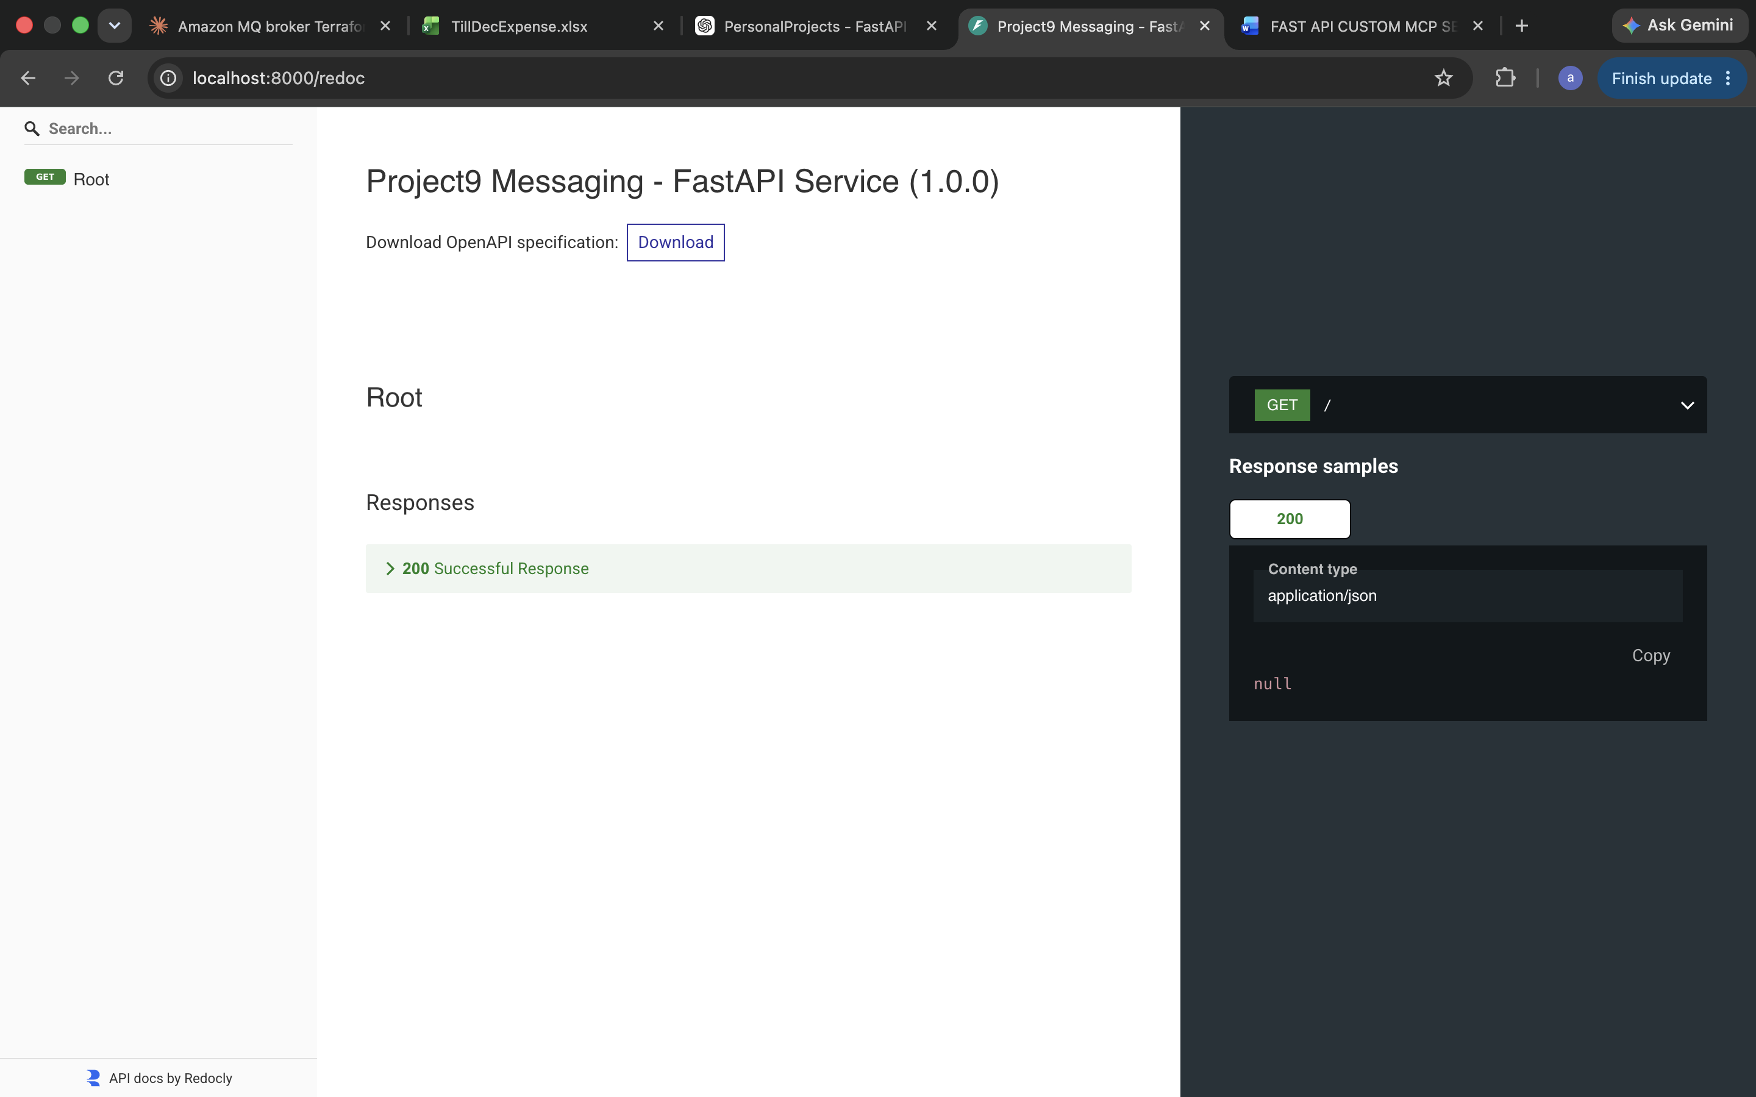

Step 2 — Create /health using APIRouter
The goal is to understand this architecture:
FastAPI Application
|
main.py
|
include_router()
|
v
health.py
|
GET /health
|
v
JSON Response
This is the FastAPI equivalent of separating your Spring Boot controllers.
(.venv) arpitchouksey@Arpits-MacBook-Air fastapi-service % touch app/api/system.py
touch app/services/system_service.py
touch app/models/system.py
(.venv) arpitchouksey@Arpits-MacBook-Air fastapi-service %
(.venv) arpitchouksey@Arpits-MacBook-Air fastapi-service %
FastAPI
|
main.py
|
+------------+------------+
| |
v v
health_router system_router
| |
v v
/health /system
|
v
SystemService
|
v
SystemInfoResponse
arpitchouksey@Arpits-MacBook-Air ~ % curl http://localhost:8000/system
{"service":"fastapi-service","status":"UP","framework":"FastAPI","language":"Python"}% arpitchouksey@Arpits-MacBook-Air ~ %

Spring Boot comparison
Your Java architecture might look like:
SystemController
|
v
SystemService
|
v
SystemResponse
Our FastAPI version:
system.py
|
v
SystemService
|
v
SystemInfoResponse
And the responsibilities are:
Component | Responsibility
system.py | HTTP/API layer
system_service.py | Business logic
system.py under models | Data contract
main.py | Application configuration

(.venv) arpitchouksey@Arpits-MacBook-Air fastapi-service % ^[[200~mkdir -p app/api
zsh: bad pattern: ^[[200~mkdir
(.venv) arpitchouksey@Arpits-MacBook-Air fastapi-service % mkdir -p app/services
(.venv) arpitchouksey@Arpits-MacBook-Air fastapi-service % mkdir -p app/models
(.venv) arpitchouksey@Arpits-MacBook-Air fastapi-service % mkdir -p app/config
(.venv) arpitchouksey@Arpits-MacBook-Air fastapi-service % mkdir -p app/mcp
(.venv) arpitchouksey@Arpits-MacBook-Air fastapi-service % mkdir -p tests
(.venv) arpitchouksey@Arpits-MacBook-Air fastapi-service %
(.venv) arpitchouksey@Arpits-MacBook-Air fastapi-service % touch app/__init__.py
(.venv) arpitchouksey@Arpits-MacBook-Air fastapi-service %
(.venv) arpitchouksey@Arpits-MacBook-Air fastapi-service % touch app/api/__init__.py
(.venv) arpitchouksey@Arpits-MacBook-Air fastapi-service % touch app/api/health.py
(.venv) arpitchouksey@Arpits-MacBook-Air fastapi-service % touch app/api/system.py
(.venv) arpitchouksey@Arpits-MacBook-Air fastapi-service % touch app/api/calculator.py
(.venv) arpitchouksey@Arpits-MacBook-Air fastapi-service % touch app/api/users.py
(.venv) arpitchouksey@Arpits-MacBook-Air fastapi-service %
(.venv) arpitchouksey@Arpits-MacBook-Air fastapi-service % touch app/services/__init__.py
(.venv) arpitchouksey@Arpits-MacBook-Air fastapi-service % touch app/services/system_service.py
(.venv) arpitchouksey@Arpits-MacBook-Air fastapi-service % touch app/services/calculator_service.py
(.venv) arpitchouksey@Arpits-MacBook-Air fastapi-service % touch app/services/user_summary_service.py
(.venv) arpitchouksey@Arpits-MacBook-Air fastapi-service %
(.venv) arpitchouksey@Arpits-MacBook-Air fastapi-service % touch app/models/__init__.py
(.venv) arpitchouksey@Arpits-MacBook-Air fastapi-service % touch app/models/system.py
(.venv) arpitchouksey@Arpits-MacBook-Air fastapi-service % touch app/models/calculator.py
(.venv) arpitchouksey@Arpits-MacBook-Air fastapi-service % touch app/models/user.py
(.venv) arpitchouksey@Arpits-MacBook-Air fastapi-service %
(.venv) arpitchouksey@Arpits-MacBook-Air fastapi-service % touch app/config/__init__.py
(.venv) arpitchouksey@Arpits-MacBook-Air fastapi-service % touch app/config/settings.py
(.venv) arpitchouksey@Arpits-MacBook-Air fastapi-service %
(.venv) arpitchouksey@Arpits-MacBook-Air fastapi-service % touch app/mcp/__init__.py
(.venv) arpitchouksey@Arpits-MacBook-Air fastapi-service %
(.venv) arpitchouksey@Arpits-MacBook-Air fastapi-service % touch tests/__init__.py
(.venv) arpitchouksey@Arpits-MacBook-Air fastapi-service % touch tests/test_health.py
(.venv) arpitchouksey@Arpits-MacBook-Air fastapi-service % touch tests/test_system.py
(.venv) arpitchouksey@Arpits-MacBook-Air fastapi-service % touch tests/test_calculator.py
(.venv) arpitchouksey@Arpits-MacBook-Air fastapi-service %
(.venv) arpitchouksey@Arpits-MacBook-Air fastapi-service % touch .env
(.venv) arpitchouksey@Arpits-MacBook-Air fastapi-service % touch .gitignore
(.venv) arpitchouksey@Arpits-MacBook-Air fastapi-service % touch Dockerfile
(.venv) arpitchouksey@Arpits-MacBook-Air fastapi-service % touch README.md~
(.venv) arpitchouksey@Arpits-MacBook-Air fastapi-service %
(.venv) arpitchouksey@Arpits-MacBook-Air fastapi-service % ls
app Dockerfile README.md~ requirements.txt tests
(.venv) arpitchouksey@Arpits-MacBook-Air fastapi-service %
(.venv) arpitchouksey@Arpits-MacBook-Air fastapi-service %
(.venv) arpitchouksey@Arpits-MacBook-Air fastapi-service % pip install httpx pydantic-settings
Requirement already satisfied: httpx in ./.venv/lib/python3.14/site-packages (0.28.1)
Requirement already satisfied: pydantic-settings in ./.venv/lib/python3.14/site-packages (2.15.0)
Requirement already satisfied: anyio in ./.venv/lib/python3.14/site-packages (from httpx) (4.14.2)
Requirement already satisfied: certifi in ./.venv/lib/python3.14/site-packages (from httpx) (2026.7.22)
Requirement already satisfied: httpcore==1.* in ./.venv/lib/python3.14/site-packages (from httpx) (1.0.9)
Requirement already satisfied: idna in ./.venv/lib/python3.14/site-packages (from httpx) (3.18)
Requirement already satisfied: h11>=0.16 in ./.venv/lib/python3.14/site-packages (from httpcore==1.*->httpx) (0.16.0)
Requirement already satisfied: pydantic>=2.7.0 in ./.venv/lib/python3.14/site-packages (from pydantic-settings) (2.13.4)
Requirement already satisfied: python-dotenv>=0.21.0 in ./.venv/lib/python3.14/site-packages (from pydantic-settings) (1.2.2)
Requirement already satisfied: typing-inspection>=0.4.0 in ./.venv/lib/python3.14/site-packages (from pydantic-settings) (0.4.4)
Requirement already satisfied: annotated-types>=0.6.0 in ./.venv/lib/python3.14/site-packages (from pydantic>=2.7.0->pydantic-settings) (0.8.0)
Requirement already satisfied: pydantic-core==2.46.4 in ./.venv/lib/python3.14/site-packages (from pydantic>=2.7.0->pydantic-settings) (2.46.4)
Requirement already satisfied: typing-extensions>=4.14.1 in ./.venv/lib/python3.14/site-packages (from pydantic>=2.7.0->pydantic-settings) (4.16.0)
[notice] A new release of pip is available: 26.1.1 -> 26.2.1
[notice] To update, run: pip install --upgrade pip
(.venv) arpitchouksey@Arpits-MacBook-Air fastapi-service %
(.venv) arpitchouksey@Arpits-MacBook-Air fastapi-service % pip freeze > requirements.txt
(.venv) arpitchouksey@Arpits-MacBook-Air fastapi-service %
(.venv) arpitchouksey@Arpits-MacBook-Air fastapi-service % cat requirements.txt
annotated-doc==0.0.5
annotated-types==0.8.0
anyio==4.14.2
certifi==2026.7.22
click==8.4.2
detect-installer==0.1.0
dnspython==2.8.0
email-validator==2.3.0
fastapi==0.141.1
fastapi-cli==0.0.32
fastapi-cloud-cli==0.23.0
fastar==0.11.0
h11==0.16.0
httpcore==1.0.9
httptools==0.8.0
httpx==0.28.1
idna==3.18
Jinja2==3.1.6
markdown-it-py==4.2.0
MarkupSafe==3.0.3
mdurl==0.1.2
pydantic==2.13.4
pydantic-extra-types==2.11.1
pydantic-settings==2.15.0
pydantic_core==2.46.4
Pygments==2.20.0
python-dotenv==1.2.2
python-multipart==0.0.32
PyYAML==6.0.3
rich==15.0.0
rich-toolkit==0.20.3
rignore==0.8.1
sentry-sdk==2.68.0
shellingham==1.5.4
starlette==1.6.0
typer==0.27.1
typing-inspection==0.4.4
typing_extensions==4.16.0
urllib3==2.7.0
uvicorn==0.52.3
uvloop==0.22.1
watchfiles==1.2.0
websockets==17.0.1
(.venv) arpitchouksey@Arpits-MacBook-Air fastapi-service %
(.venv) arpitchouksey@Arpits-MacBook-Air fastapi-service % vi app/config/settings.py
(.venv) arpitchouksey@Arpits-MacBook-Air fastapi-service %
(.venv) arpitchouksey@Arpits-MacBook-Air fastapi-service % vi .env
(.venv) arpitchouksey@Arpits-MacBook-Air fastapi-service %
(.venv) arpitchouksey@Arpits-MacBook-Air fastapi-service % vi app/models/system.py
(.venv) arpitchouksey@Arpits-MacBook-Air fastapi-service %
(.venv) arpitchouksey@Arpits-MacBook-Air fastapi-service % vi app/services/system_service.py
(.venv) arpitchouksey@Arpits-MacBook-Air fastapi-service %
(.venv) arpitchouksey@Arpits-MacBook-Air fastapi-service % vi app/api/system.py
(.venv) arpitchouksey@Arpits-MacBook-Air fastapi-service %
(.venv) arpitchouksey@Arpits-MacBook-Air fastapi-service % vi app/api/health.py
(.venv) arpitchouksey@Arpits-MacBook-Air fastapi-service %
(.venv) arpitchouksey@Arpits-MacBook-Air fastapi-service % vi app/models/calculator.py
(.venv) arpitchouksey@Arpits-MacBook-Air fastapi-service %
(.venv) arpitchouksey@Arpits-MacBook-Air fastapi-service % vi app/services/calculator_service.py
(.venv) arpitchouksey@Arpits-MacBook-Air fastapi-service %
(.venv) arpitchouksey@Arpits-MacBook-Air fastapi-service % vi app/api/calculator.py
(.venv) arpitchouksey@Arpits-MacBook-Air fastapi-service %
(.venv) arpitchouksey@Arpits-MacBook-Air fastapi-service % uvicorn app.main:app --reload --port 8000
INFO: Will watch for changes in these directories: ['/Users/arpitchouksey/Documents/PersonalProjects/Project9-Messaging/Microservice/fastapi-service']
INFO: Uvicorn running on http://127.0.0.1:8000 (Press CTRL+C to quit)
INFO: Started reloader process [27209] using WatchFiles
INFO: Started server process [27211]
INFO: Waiting for application startup.
INFO: Application startup complete.
INFO: 127.0.0.1:65504 - "POST /calculate HTTP/1.1" 404 Not Found
INFO: 127.0.0.1:65506 - "POST /calculate HTTP/1.1" 404 Not Found
^CINFO: Shutting down
INFO: Waiting for application shutdown.
INFO: Application shutdown complete.
INFO: Finished server process [27211]
INFO: Stopping reloader process [27209]
(.venv) arpitchouksey@Arpits-MacBook-Air fastapi-service %
(.venv) arpitchouksey@Arpits-MacBook-Air fastapi-service %
(.venv) arpitchouksey@Arpits-MacBook-Air fastapi-service % vi app/models/user.py
(.venv) arpitchouksey@Arpits-MacBook-Air fastapi-service %
(.venv) arpitchouksey@Arpits-MacBook-Air fastapi-service % vi app/services/user_summary_service.py
(.venv) arpitchouksey@Arpits-MacBook-Air fastapi-service %
(.venv) arpitchouksey@Arpits-MacBook-Air fastapi-service % vi app/api/users.py
(.venv) arpitchouksey@Arpits-MacBook-Air fastapi-service %
(.venv) arpitchouksey@Arpits-MacBook-Air fastapi-service % vi app/main.py
(.venv) arpitchouksey@Arpits-MacBook-Air fastapi-service %
(.venv) arpitchouksey@Arpits-MacBook-Air fastapi-service %
(.venv) arpitchouksey@Arpits-MacBook-Air fastapi-service % uvicorn app.main:app --reload --port 8000
INFO: Will watch for changes in these directories: ['/Users/arpitchouksey/Documents/PersonalProjects/Project9-Messaging/Microservice/fastapi-service']
INFO: Uvicorn running on http://127.0.0.1:8000 (Press CTRL+C to quit)
INFO: Started reloader process [27274] using WatchFiles
INFO: Started server process [27276]
INFO: Waiting for application startup.
INFO: Application startup complete.
INFO: 127.0.0.1:65524 - "POST /calculate HTTP/1.1" 200 OK
INFO: 127.0.0.1:65526 - "GET /users/1/summary HTTP/1.1" 502 Bad Gateway
INFO: 127.0.0.1:65532 - "GET /users/1/summary HTTP/1.1" 502 Bad Gateway
INFO: 127.0.0.1:49153 - "GET /health HTTP/1.1" 200 OK
INFO: 127.0.0.1:49155 - "GET /system HTTP/1.1" 200 OK
INFO: 127.0.0.1:49157 - "POST /calculate HTTP/1.1" 200 OK
INFO: 127.0.0.1:49159 - "POST /calculate HTTP/1.1" 200 OK
INFO: 127.0.0.1:49161 - "POST /calculate HTTP/1.1" 422 Unprocessable Content
INFO: 127.0.0.1:49163 - "POST /calculate HTTP/1.1" 422 Unprocessable Content
arpitchouksey@Arpits-MacBook-Air ~ %
arpitchouksey@Arpits-MacBook-Air ~ % curl http://localhost:8000/users/1/summary
{"detail":"Failed to communicate with Spring Service: [Errno 61] Connection refused"}% arpitchouksey@Arpits-MacBook-Air ~ %
arpitchouksey@Arpits-MacBook-Air ~ %
arpitchouksey@Arpits-MacBook-Air ~ % curl http://localhost:8000/health
{"status":"UP","service":"fastapi-service"}% arpitchouksey@Arpits-MacBook-Air ~ %
arpitchouksey@Arpits-MacBook-Air ~ % curl http://localhost:8000/system
{"service":"Project9 Messaging - FastAPI Service","status":"UP","framework":"FastAPI","language":"Python"}% arpitchouksey@Arpits-MacBook-Air ~ %
arpitchouksey@Arpits-MacBook-Air ~ % curl -X POST http://localhost:8000/calculate \
-H "Content-Type: application/json" \
-d '{
"operation": "add",
"a": 100,
"b": 250
}'
{"operation":"add","a":100.0,"b":250.0,"result":350.0}% arpitchouksey@Arpits-MacBook-Air ~ %
arpitchouksey@Arpits-MacBook-Air ~ % curl -X POST http://localhost:8000/calculate \
-H "Content-Type: application/json" \
-d '{
"operation": "subtract",
"a": 250,
"b": 100
}'
{"operation":"subtract","a":250.0,"b":100.0,"result":150.0}% arpitchouksey@Arpits-MacBook-Air ~ %
arpitchouksey@Arpits-MacBook-Air ~ % curl -X POST http://localhost:8000/calculate \
-H "Content-Type: application/json" \
-d '{
"operation": "power",
"a": 10,
"b": 2
}'
{"detail":[{"type":"literal_error","loc":["body","operation"],"msg":"Input should be 'add', 'subtract', 'multiply' or 'divide'","input":"power","ctx":{"expected":"'add', 'subtract', 'multiply' or 'divide'"}}]}% arpitchouksey@Arpits-MacBook-Air ~ %
arpitchouksey@Arpits-MacBook-Air ~ % curl -X POST http://localhost:8000/calculate \
-H "Content-Type: application/json" \
-d '{
"operation": "add",
"a": 10
}'
{"detail":[{"type":"missing","loc":["body","b"],"msg":"Field required","input":{"operation":"add","a":10}}]}% arpitchouksey@Arpits-MacBook-Air ~ %
arpitchouksey@Arpits-MacBook-Air ~ %
arpitchouksey@Arpits-MacBook-Air ~ % curl http://localhost:8080
curl: (7) Failed to connect to localhost port 8080 after 7 ms: Couldn't connect to server
arpitchouksey@Arpits-MacBook-Air ~ %
arpitchouksey@Arpits-MacBook-Air ~ % lsof -i :8080
arpitchouksey@Arpits-MacBook-Air ~ %
arpitchouksey@Arpits-MacBook-Air ~ %

1. FastAPI structure
Your current structure is:
fastapi-service/
│
├── app/
│ │
│ ├── main.py
│ │
│ ├── api/
│ │ ├── health.py
│ │ ├── system.py
│ │ ├── calculator.py
│ │ └── users.py
│ │
│ ├── services/
│ │ ├── system_service.py
│ │ ├── calculator_service.py
│ │ └── user_summary_service.py
│ │
│ ├── models/
│ │ ├── system.py
│ │ ├── calculator.py
│ │ └── user.py
│ │
│ ├── config/
│ │ └── settings.py
│ │
│ └── mcp/
│ └── __init__.py
│
├── tests/
├── requirements.txt
├── .env
├── Dockerfile
└── README.md
Now let's map each directory.

2. main.py = Application Entry Point
app/main.py
This is the main application file.
In your Spring Boot project, you have something conceptually like:
@SpringBootApplication
public class SpringServiceApplication {
public static void main(String[] args) {
SpringApplication.run(SpringServiceApplication.class, args);
}
}
FastAPI:
from fastapi import FastAPI
app = FastAPI(...)
Then:
app.include_router(health_router)
app.include_router(system_router)
app.include_router(calculator_router)
app.include_router(users_router)
So main.py is responsible for assembling the application.
Think:
Spring Boot
@SpringBootApplication
↓
Application startup
↓
Component scanning
↓
Controllers/Services/etc.
FastAPI:
main.py
↓
FastAPI()
↓
include_router()
↓
Routers
↓
Services

3. api/ = Controller Layer
This is the most important mapping.
app/api/
is basically your Controller layer.
In Spring Boot:
controller/
├── UserController.java
├── HealthController.java
└── ...
In FastAPI:
api/
├── users.py
├── health.py
├── system.py
└── calculator.py
For example:
app/api/calculator.py
contains:
@router.post("/calculate")
def calculate(...):
...
That's equivalent conceptually to:
@PostMapping("/calculate")
public CalculateResponse calculate(...) {
...
}
So:
Spring Boot FastAPI
----------- -------
Controller <------> api/
@RestController APIRouter
@GetMapping @router.get()
@PostMapping @router.post()

4. services/ = Service Layer
app/services/
is your business/service layer.
Spring Boot:
service/
├── UserService.java
├── OrderService.java
└── ...
FastAPI:
services/
├── system_service.py
├── calculator_service.py
└── user_summary_service.py
For example:
class CalculatorService:
def calculate(...):
...
This contains the actual business logic.
The controller/router should not contain complex business logic.

5. models/ = DTO / Data Model Layer
app/models/
contains our Pydantic models.
For example:
class CalculateRequest(BaseModel):
operation: ...
a: float
b: float
and:
class CalculateResponse(BaseModel):
operation: str
a: float
b: float
result: float
In your Spring Boot world, think:
DTO
Request DTO
Response DTO
So:
Spring Boot FastAPI
----------- -------
DTO <------> Pydantic Model
Request DTO BaseModel
Response DTO
There is one important difference: Pydantic models provide automatic validation and serialization/deserialization very conveniently.

6. config/ = Configuration
app/config/
└── settings.py
contains application configuration.
For example:
class Settings(BaseSettings):
app_name: str
spring_service_url: str
This is conceptually similar to:
Spring Boot
application.yml
application.properties
@ConfigurationProperties
Our:
.env
contains environment-specific values.
For example:
SPRING_SERVICE_URL=http://localhost:8080

7. mcp/ = MCP Layer
Currently:
app/mcp/
is basically empty.
Don't consider this part of the REST architecture yet.
Later this will contain our Python MCP server.
Something like:
mcp/
├── server.py
├── tools.py
└── config.py
Its job will be:
AI MCP Client
↓
Python MCP Server
↓
MCP Tool
↓
FastAPI Service
↓
Business Service
This is why we built the REST layer first.

8. How everything connects
Let's take our calculator API.
The user sends:
curl -X POST http://localhost:8000/calculate \
-H "Content-Type: application/json" \
-d '{"operation":"add","a":100,"b":250}'
The request travels through:
HTTP Request
│
▼
Uvicorn :8000
│
▼
FastAPI app
│
▼
main.py
│
include_router()
│
▼
calculator.py
API Router
│
▼
CalculateRequest
Pydantic Model
│
▼
CalculatorService
Service Layer
│
▼
Calculation
│
▼
CalculateResponse
Pydantic Model
│
▼
JSON Response

9. More accurate architecture
Your FastAPI application is basically:
┌─────────────────┐
│ Client │
│ curl / React / │
│ MCP / Browser │
└────────┬────────┘
│
▼
┌─────────────────┐
│ Uvicorn │
│ :8000 │
└────────┬────────┘
│
▼
┌─────────────────┐
│ FastAPI │
│ main.py │
└────────┬────────┘
│
include_router()
│
┌────────────────┼────────────────┐
│ │ │
▼ ▼ ▼
health.py system.py calculator.py
API Router API Router API Router
│ │ │
│ ▼ ▼
│ SystemService CalculatorService
│ │ │
│ ▼ ▼
│ System Model Calculator Model
│
└─────────────────────────────────────

10. User Summary is slightly different
Our user API has another service dependency.
GET /users/1/summary
│
▼
users.py
Router
│
▼
UserSummaryService
│
│ HTTP
▼
Spring Boot :8080
│
▼
PostgreSQL
So FastAPI becomes an integration layer for this particular operation.
This is useful for our eventual MCP architecture.

11. Spring Boot vs FastAPI
Here's the mapping I want you to remember:
Spring Boot | FastAPI
Application.java | main.py
@RestController | api/ + APIRouter
Controller method | Router function
@GetMapping | @router.get()
@PostMapping | @router.post()
@Service | services/
Service class | Python service class
DTO | Pydantic BaseModel
application.yml | .env + config/
Maven | pip + requirements.txt
Tomcat | Uvicorn
Spring DI | FastAPI Depends()
JUnit | pytest
Swagger/OpenAPI | Built-in FastAPI OpenAPI

12. One important difference
Don't think:
api/
is literally the same mechanism as Spring's controller package.
It's a project organization convention.
FastAPI itself doesn't force you to have:
api/
services/
models/
You could technically put everything in:
main.py
But for an enterprise application like Project9-Messaging, we deliberately use this layered structure.
So:
FastAPI framework
+
Our architecture convention
=
Clean enterprise microservice

13. The final REST responsibility diagram
Remember this:
CLIENT
│
▼
┌─────────┐
│ API │
│ Router │
└────┬────┘
│
▼
┌─────────┐
│ SERVICE │
│ Logic │
└────┬────┘
│
▼
┌─────────┐
│ MODEL │
│ Request │
│ Response│
└─────────┘
And application startup:
main.py
│
▼
FastAPI Application
│
┌───────┼────────┐
▼ ▼ ▼
Router Router Router
│ │ │
▼ ▼ ▼
Service Service Service

14. Then MCP gets added above this
This is the key reason we are doing the REST layer first.
Eventually:
AI
│
▼
Java AI MCP Client
│
▼
Python MCP Server
│
┌────────────┼────────────┐
▼ ▼ ▼
getSystemInfo calculate getUserSummary
│ │ │
└────────────┼────────────┘
▼
FastAPI
│
┌────────────┼────────────┐
▼ ▼ ▼
system.py calculator.py users.py
│ │ │
▼ ▼ ▼
Service Service Service
│ │ │
▼ ▼ ▼
Response Response Spring API
MCP ARCHITECTURE:
FastAPI Application
|
+----------------+----------------+
| |
v v
REST Interface MCP Interface
| |
api/*.py mcp/*.py
| |
+---------------+-----------------+
|
v
Service Layer
|
+---------------+----------------+
| | |
v v v
SystemService CalculatorService UserSummaryService
| | |
| | v
| | Spring Service
| |
v v
Models / Pydantic
(.venv) arpitchouksey@Arpits-MacBook-Air fastapi-service % pip install "mcp[cli]"
Collecting mcp[cli]
Downloading mcp-2.0.0-py3-none-any.whl.metadata (7.7 kB)
Requirement already satisfied: anyio>=4.10 in ./.venv/lib/python3.14/site-packages (from mcp[cli]) (4.14.2)
Collecting httpx2>=2.5.0 (from mcp[cli])
Downloading httpx2-2.10.0-py3-none-any.whl.metadata (10 kB)
Collecting jsonschema>=4.20.0 (from mcp[cli])
Downloading jsonschema-4.26.0-py3-none-any.whl.metadata (7.6 kB)
Collecting mcp-types==2.0.0 (from mcp[cli])
Downloading mcp_types-2.0.0-py3-none-any.whl.metadata (1.9 kB)
Collecting opentelemetry-api>=1.28.0 (from mcp[cli])
Downloading opentelemetry_api-1.44.0-py3-none-any.whl.metadata (1.4 kB)
Requirement already satisfied: pydantic>=2.12.0 in ./.venv/lib/python3.14/site-packages (from mcp[cli]) (2.13.4)
Collecting pyjwt>=2.10.1 (from pyjwt[crypto]>=2.10.1->mcp[cli])
Downloading pyjwt-2.13.0-py3-none-any.whl.metadata (3.4 kB)
Requirement already satisfied: python-multipart>=0.0.9 in ./.venv/lib/python3.14/site-packages (from mcp[cli]) (0.0.32)
Collecting sse-starlette>=3.0.0 (from mcp[cli])
Downloading sse_starlette-3.4.8-py3-none-any.whl.metadata (15 kB)
Requirement already satisfied: starlette>=0.48.0 in ./.venv/lib/python3.14/site-packages (from mcp[cli]) (1.6.0)
Requirement already satisfied: typing-extensions>=4.13.0 in ./.venv/lib/python3.14/site-packages (from mcp[cli]) (4.16.0)
Requirement already satisfied: typing-inspection>=0.4.1 in ./.venv/lib/python3.14/site-packages (from mcp[cli]) (0.4.4)
Requirement already satisfied: uvicorn>=0.31.1 in ./.venv/lib/python3.14/site-packages (from mcp[cli]) (0.52.3)
Requirement already satisfied: python-dotenv>=1.0.0 in ./.venv/lib/python3.14/site-packages (from mcp[cli]) (1.2.2)
Requirement already satisfied: typer>=0.16.0 in ./.venv/lib/python3.14/site-packages (from mcp[cli]) (0.27.1)
Requirement already satisfied: idna>=2.8 in ./.venv/lib/python3.14/site-packages (from anyio>=4.10->mcp[cli]) (3.18)
Collecting httpcore2==2.10.0 (from httpx2>=2.5.0->mcp[cli])
Downloading httpcore2-2.10.0-py3-none-any.whl.metadata (25 kB)
Collecting truststore>=0.10 (from httpx2>=2.5.0->mcp[cli])
Downloading truststore-0.10.4-py3-none-any.whl.metadata (4.4 kB)
Requirement already satisfied: h11>=0.16 in ./.venv/lib/python3.14/site-packages (from httpcore2==2.10.0->httpx2>=2.5.0->mcp[cli]) (0.16.0)
Collecting attrs>=22.2.0 (from jsonschema>=4.20.0->mcp[cli])
Downloading attrs-26.1.0-py3-none-any.whl.metadata (8.8 kB)
Collecting jsonschema-specifications>=2023.03.6 (from jsonschema>=4.20.0->mcp[cli])
Downloading jsonschema_specifications-2025.9.1-py3-none-any.whl.metadata (2.9 kB)
Collecting referencing>=0.28.4 (from jsonschema>=4.20.0->mcp[cli])
Downloading referencing-0.37.0-py3-none-any.whl.metadata (2.8 kB)
Collecting rpds-py>=0.25.0 (from jsonschema>=4.20.0->mcp[cli])
Downloading rpds_py-2026.6.3-cp314-cp314-macosx_11_0_arm64.whl.metadata (4.1 kB)
Requirement already satisfied: annotated-types>=0.6.0 in ./.venv/lib/python3.14/site-packages (from pydantic>=2.12.0->mcp[cli]) (0.8.0)
Requirement already satisfied: pydantic-core==2.46.4 in ./.venv/lib/python3.14/site-packages (from pydantic>=2.12.0->mcp[cli]) (2.46.4)
Collecting cryptography>=3.4.0 (from pyjwt[crypto]>=2.10.1->mcp[cli])
Downloading cryptography-50.0.0-cp311-abi3-macosx_11_0_arm64.whl.metadata (4.3 kB)
Collecting cffi>=2.0.0 (from cryptography>=3.4.0->pyjwt[crypto]>=2.10.1->mcp[cli])
Downloading cffi-2.1.1-cp314-cp314-macosx_11_0_arm64.whl.metadata (2.5 kB)
Collecting pycparser (from cffi>=2.0.0->cryptography>=3.4.0->pyjwt[crypto]>=2.10.1->mcp[cli])
Downloading pycparser-3.0-py3-none-any.whl.metadata (8.2 kB)
Requirement already satisfied: shellingham>=1.3.0 in ./.venv/lib/python3.14/site-packages (from typer>=0.16.0->mcp[cli]) (1.5.4)
Requirement already satisfied: rich>=13.8.0 in ./.venv/lib/python3.14/site-packages (from typer>=0.16.0->mcp[cli]) (15.0.0)
Requirement already satisfied: annotated-doc>=0.0.2 in ./.venv/lib/python3.14/site-packages (from typer>=0.16.0->mcp[cli]) (0.0.5)
Requirement already satisfied: markdown-it-py>=2.2.0 in ./.venv/lib/python3.14/site-packages (from rich>=13.8.0->typer>=0.16.0->mcp[cli]) (4.2.0)
Requirement already satisfied: pygments<3.0.0,>=2.13.0 in ./.venv/lib/python3.14/site-packages (from rich>=13.8.0->typer>=0.16.0->mcp[cli]) (2.20.0)
Requirement already satisfied: mdurl~=0.1 in ./.venv/lib/python3.14/site-packages (from markdown-it-py>=2.2.0->rich>=13.8.0->typer>=0.16.0->mcp[cli]) (0.1.2)
Requirement already satisfied: click>=7.0 in ./.venv/lib/python3.14/site-packages (from uvicorn>=0.31.1->mcp[cli]) (8.4.2)
Downloading mcp-2.0.0-py3-none-any.whl (349 kB)
Downloading mcp_types-2.0.0-py3-none-any.whl (69 kB)
Downloading httpx2-2.10.0-py3-none-any.whl (94 kB)
Downloading httpcore2-2.10.0-py3-none-any.whl (83 kB)
Downloading jsonschema-4.26.0-py3-none-any.whl (90 kB)
Downloading attrs-26.1.0-py3-none-any.whl (67 kB)
Downloading jsonschema_specifications-2025.9.1-py3-none-any.whl (18 kB)
Downloading opentelemetry_api-1.44.0-py3-none-any.whl (60 kB)
Downloading pyjwt-2.13.0-py3-none-any.whl (31 kB)
Downloading cryptography-50.0.0-cp311-abi3-macosx_11_0_arm64.whl (4.0 MB)
━━━━━━━━━━━━━━━━━━━━━━━━━━━━━━━━━━━━━━━━ 4.0/4.0 MB 3.7 MB/s 0:00:01
Downloading cffi-2.1.1-cp314-cp314-macosx_11_0_arm64.whl (184 kB)
Downloading referencing-0.37.0-py3-none-any.whl (26 kB)
Downloading rpds_py-2026.6.3-cp314-cp314-macosx_11_0_arm64.whl (339 kB)
Downloading sse_starlette-3.4.8-py3-none-any.whl (16 kB)
Downloading truststore-0.10.4-py3-none-any.whl (18 kB)
Downloading pycparser-3.0-py3-none-any.whl (48 kB)
Installing collected packages: truststore, rpds-py, pyjwt, pycparser, opentelemetry-api, attrs, referencing, httpcore2, cffi, sse-starlette, mcp-types, jsonschema-specifications, httpx2, cryptography, jsonschema, mcp
Successfully installed attrs-26.1.0 cffi-2.1.1 cryptography-50.0.0 httpcore2-2.10.0 httpx2-2.10.0 jsonschema-4.26.0 jsonschema-specifications-2025.9.1 mcp-2.0.0 mcp-types-2.0.0 opentelemetry-api-1.44.0 pycparser-3.0 pyjwt-2.13.0 referencing-0.37.0 rpds-py-2026.6.3 sse-starlette-3.4.8 truststore-0.10.4
[notice] A new release of pip is available: 26.1.1 -> 26.2.1
[notice] To update, run: pip install --upgrade pip
(.venv) arpitchouksey@Arpits-MacBook-Air fastapi-service %
(.venv) arpitchouksey@Arpits-MacBook-Air fastapi-service %
(.venv) arpitchouksey@Arpits-MacBook-Air fastapi-service % cat requirements.txt
annotated-doc==0.0.5
annotated-types==0.8.0
anyio==4.14.2
certifi==2026.7.22
click==8.4.2
detect-installer==0.1.0
dnspython==2.8.0
email-validator==2.3.0
fastapi==0.141.1
fastapi-cli==0.0.32
fastapi-cloud-cli==0.23.0
fastar==0.11.0
h11==0.16.0
httpcore==1.0.9
httptools==0.8.0
httpx==0.28.1
idna==3.18
Jinja2==3.1.6
markdown-it-py==4.2.0
MarkupSafe==3.0.3
mdurl==0.1.2
pydantic==2.13.4
pydantic-extra-types==2.11.1
pydantic-settings==2.15.0
pydantic_core==2.46.4
Pygments==2.20.0
python-dotenv==1.2.2
python-multipart==0.0.32
PyYAML==6.0.3
rich==15.0.0
rich-toolkit==0.20.3
rignore==0.8.1
sentry-sdk==2.68.0
shellingham==1.5.4
starlette==1.6.0
typer==0.27.1
typing-inspection==0.4.4
typing_extensions==4.16.0
urllib3==2.7.0
uvicorn==0.52.3
uvloop==0.22.1
watchfiles==1.2.0
websockets==17.0.1
(.venv) arpitchouksey@Arpits-MacBook-Air fastapi-service %
(.venv) arpitchouksey@Arpits-MacBook-Air fastapi-service % pip freeze > requirements.txt
(.venv) arpitchouksey@Arpits-MacBook-Air fastapi-service %
(.venv) arpitchouksey@Arpits-MacBook-Air fastapi-service % pip show mcp
Name: mcp
Version: 2.0.0
Summary: Model Context Protocol SDK
Home-page: https://modelcontextprotocol.io
Author: Model Context Protocol a Series of LF Projects, LLC.
Author-email:
License: MIT
Location: /Users/arpitchouksey/Documents/PersonalProjects/Project9-Messaging/Microservice/fastapi-service/.venv/lib/python3.14/site-packages
Requires: anyio, httpx2, jsonschema, mcp-types, opentelemetry-api, pydantic, pyjwt, python-multipart, sse-starlette, starlette, typing-extensions, typing-inspection, uvicorn
Required-by:
(.venv) arpitchouksey@Arpits-MacBook-Air fastapi-service %
(.venv) arpitchouksey@Arpits-MacBook-Air fastapi-service % mcp version
MCP version 2.0.0
(.venv) arpitchouksey@Arpits-MacBook-Air fastapi-service %
(.venv) arpitchouksey@Arpits-MacBook-Air fastapi-service %
(.venv) arpitchouksey@Arpits-MacBook-Air fastapi-service %
(.venv) arpitchouksey@Arpits-MacBook-Air fastapi-service %
(.venv) arpitchouksey@Arpits-MacBook-Air fastapi-service % mcp dev app/mcp/server.py --with-editable .
Starting MCP inspector...
MCP Inspector Web is up and running at:
http://localhost:6274?MCP_INSPECTOR_API_TOKEN=e1628aaf8061d7201f22d73961b5b27f5b47946e2ad0aa02683ab8091cade146
Sandbox (MCP Apps): http://localhost:49871/sandbox
Auth token: e1628aaf8061d7201f22d73961b5b27f5b47946e2ad0aa02683ab8091cade146
Opening browser...
(.venv) arpitchouksey@Arpits-MacBook-Air fastapi-service %
(.venv) arpitchouksey@Arpits-MacBook-Air fastapi-service % mcp dev app/mcp/server.py --with-editable .
Starting MCP inspector...
MCP Inspector Web is up and running at:
http://localhost:6274?MCP_INSPECTOR_API_TOKEN=b9e14826768ac489a6ab43c239c0593aeda55f2aa0ee2b1d285c55bf5f4ea9d6
Sandbox (MCP Apps): http://localhost:49932/sandbox
Auth token: b9e14826768ac489a6ab43c239c0593aeda55f2aa0ee2b1d285c55bf5f4ea9d6
Opening browser...
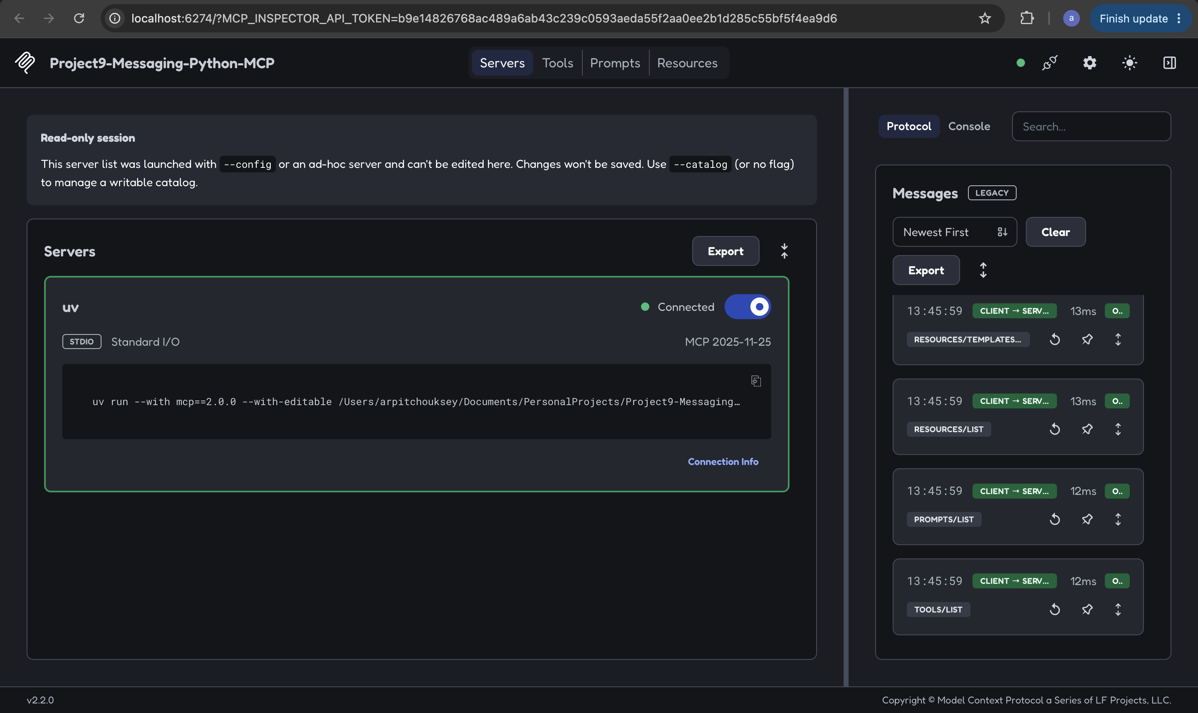
arpitchouksey@Arpits-MacBook-Air ~ %
arpitchouksey@Arpits-MacBook-Air ~ % curl -i -X POST http://localhost:8000/mcp/ \
-H "Content-Type: application/json" \
-H "Accept: application/json, text/event-stream" \
-d '{
"jsonrpc": "2.0",
"id": 1,
"method": "initialize",
"params": {
"protocolVersion": "2025-11-25",
"capabilities": {},
"clientInfo": {
"name": "curl-test",
"version": "1.0.0"
}
}
}'
HTTP/1.1 200 OK
date: Sat, 15 Aug 2026 14:49:45 GMT
server: uvicorn
cache-control: no-cache, no-transform
connection: keep-alive
content-type: text/event-stream
mcp-session-id: e6b65bfd60a4422eaa01ff744a084ec2
x-accel-buffering: no
transfer-encoding: chunked
event: message
data: {"jsonrpc":"2.0","id":1,"result":{"capabilities":{"experimental":{},"prompts":{"listChanged":false},"resources":{"listChanged":false,"subscribe":false},"tools":{"listChanged":false}},"protocolVersion":"2025-11-25","serverInfo":{"name":"Project9-Messaging-Python-MCP","version":""}}}
arpitchouksey@Arpits-MacBook-Air ~ %
(.venv) arpitchouksey@Arpits-MacBook-Air fastapi-service % uvicorn app.main:app --reload --port 8000
INFO: Will watch for changes in these directories: ['/Users/arpitchouksey/Documents/PersonalProjects/Project9-Messaging/Microservice/fastapi-service']
INFO: Uvicorn running on http://127.0.0.1:8000 (Press CTRL+C to quit)
INFO: Started reloader process [31127] using WatchFiles
INFO: Started server process [31129]
INFO: Waiting for application startup.
[08/15/26 20:15:41] INFO StreamableHTTP session manager started streamable_http_manager.py:151
INFO: Application startup complete.
INFO: 127.0.0.1:50063 - "GET /mcp HTTP/1.1" 307 Temporary Redirect
INFO: 127.0.0.1:50065 - "POST /mcp HTTP/1.1" 307 Temporary Redirect
[08/15/26 20:19:46] INFO Created new transport with session ID: e6b65bfd60a4422eaa01ff744a084ec2 streamable_http_manager.py:303
INFO: 127.0.0.1:50073 - "POST /mcp/ HTTP/1.1" 200 OK
AI MCP Client
Spring Boot :8081
|
+---------+---------+
| |
▼ ▼
Java MCP Server Python MCP Server
| |
▼ ▼
Spring Service FastAPI
| +-----+-----+
▼ | | |
PostgreSQL T1 T2 T3
│ │ │
▼ ▼ ▼
System Calculate User
LLM Part:
arpitchouksey@Arpits-MacBook-Air ~ % curl -fsSL https://ollama.com/install.sh | sh
>>> Downloading Ollama for macOS...
######################################################################## 100.0%
>>> Installing Ollama to /Applications...
>>> Adding 'ollama' command to PATH (may require password)...
>>> Starting Ollama...
>>> Install complete. You can now run 'ollama'.
arpitchouksey@Arpits-MacBook-Air ~ %
arpitchouksey@Arpits-MacBook-Air ~ %
arpitchouksey@Arpits-MacBook-Air ~ % curl http://localhost:11434/api/tags
curl: (56) Recv failure: Connection reset by peer
arpitchouksey@Arpits-MacBook-Air ~ %
arpitchouksey@Arpits-MacBook-Air ~ % ollama pull llama3.2
pulling manifest
pulling dde5aa3fc5ff: 51% ▕███████████████████████████████████████████████████████████████████████ ▏ 1.0 GB/2.0 GB 3.5 MB/s 4m39s
arpitchouksey@Arpits-MacBook-Air ~ % ollama pull nomic-embed-text
pulling manifest
pulling 970aa74c0a90: 63% ▕████████████████████████████████████████████████████████████████████████████████████████ ▏ 172 MB/274 MB 290 KB/s 5m49s
arpitchouksey@Arpits-MacBook-Air ~ % ollama list
NAME ID SIZE MODIFIED
llama3.2:latest a80c4f17acd5 2.0 GB 14 seconds ago
nomic-embed-text:latest 0a109f422b47 274 MB 30 seconds ago
arpitchouksey@Arpits-MacBook-Air ~ %
arpitchouksey@Arpits-MacBook-Air ~ %
curl http://localhost:11434/api/embed \
-H "Content-Type: application/json" \
-d '{
"model": "nomic-embed-text",
"input": "Project9 Messaging uses MCP."
}'
{"model":"nomic-embed-text","embeddings":[[0.026494293,0.0038774363,-0.103243515,-0.038800303,0.055435482,-0.0679481,-0.00046389745,-0.042432886,0.04181153,-0.03403082,-0.036102306,0.012055655,0.049231354,0.0589739,-0.022931583,-0.015057018,0.05419246,-0.039576016,-0.059697054,0.04923983,-0.0044375337,-0.05492644,-0.041311223,-0.030158022,0.08714206,0.029499525,0.0250581,-0.012031514,-0.056276053,-0.0049488787,0.05762655,-0.032697693,-0.023438277,-0.065285355,-0.057734933,-0.050852522,0.020895716,0.009416719,-0.036880247,0.03457122,0.04753502,-0.042916607,0.038834002,-0.03059367,0.07560308,-0.0017632142,-0.029389301,0.0005506008,0.022485426,0.0037942308,0.03822729,-0.07136576,0.030335454,-0.017638149,0.029025387,0.02403654,-0.0121449875,0.023633676,-0.0068033696,0.010721104,0.08332302,0.056547742,-0.044195358,0.1080908,0.036535323,0.04440922,-0.017792525,-0.0076312213,-0.066542074,0.005552858,0.017624957,-0.0130417915,-0.025518911,0.0032440082,0.015702102,-0.027617337,-0.03507987,-0.052431837,-0.0067579737,0.03616615,0.034608673,-0.03561648,0.05780626,-0.029892813,0.06136035,-0.010723071,-0.01983911,-0.008108746,-0.07497474,0.030926198,0.0073819337,-0.010821074,-0.044782992,0.05476051,-0.02553709,0.007254329,-0.000037970785,-0.01711651,-0.032085408,-0.020573886,0.0028096084,0.035091277,0.0074610836,0.009001209,0.002149031,0.091529064,-0.0035813083,0.004844085,0.005495885,-0.040466674,-0.0051051048,0.030072441,0.008035124,-0.06860233,0.014786065,-0.060485214,0.07359848,0.010102513,0.015926784,0.012425794,0.03231461,-0.101434186,-0.036051672,0.022722838,-0.024034891,0.026085326,-0.013187858,-0.024164753,0.024376009,-0.053899202,-0.0071297158,0.028986644,-0.051437348,0.0019628978,-0.012553502,-0.0065832147,-0.022770435,-0.07028168,0.054487143,0.047213092,0.020600993,0.012243589,-0.01844104,-0.034598514,-0.05589225,-0.0057571717,0.02020166,0.009000781,-0.005518639,0.014949701,-0.011234884,0.0028421467,0.02046113,0.10130162,0.026414327,-0.05561069,-0.008751111,0.04805345,0.020896912,0.04094845,0.033655327,-0.009049331,-0.019759098,-0.013629831,-0.040338464,-0.0645851,0.016910821,0.08085898,-0.0057517574,0.04417874,0.0039663194,-0.0046902085,-0.004452339,-0.0035256986,0.060818743,0.044853505,-0.00040330124,-0.017670527,0.021894256,-0.034521833,-0.006226302,-0.011541737,0.003600906,-0.008586399,-0.03666564,0.025523916,0.039383523,-0.00029245077,-0.0026839064,-0.0268803,-0.075468175,-0.0010815377,-0.04803177,-0.032529745,-0.025040999,-0.020389995,0.032717343,0.02802396,0.03743633,0.0054784985,-0.025772281,0.031501286,-0.033432826,0.025665432,-0.026799522,0.007015965,-0.0044084126,0.039071713,0.025798349,-0.01018187,0.05122187,-0.0030631877,-0.04731617,-0.05389412,-0.058259897,0.00080890185,0.014666628,0.045915615,-0.04776623,0.006117237,0.028867176,-0.015360195,0.02344727,-0.030332332,0.051502608,-0.026014341,-0.077018924,-0.005689826,-0.056357298,0.02493233,0.0019643463,-0.018612253,-0.0016669489,0.020388335,0.003970171,0.015405031,-0.057348967,0.058711726,0.019603556,0.059643153,0.018785546,-0.0038573844,-0.03197413,-0.004434489,-0.07965568,-0.0025027986,-0.017980175,0.023236275,-0.0029427805,0.04169522,0.0137797035,0.032532018,-0.001642406,-0.02239648,0.031498585,0.0020670104,0.054778054,-0.02347667,0.015655616,-0.018945524,0.033743758,-0.031050451,-0.01396976,-0.025244527,0.011641942,-0.050987657,-0.05584189,0.049593456,0.05793009,-0.0036770478,0.05398521,0.05773866,0.037527908,0.052827954,0.0434243,0.029480461,-0.004591934,-0.054547038,0.013706373,-0.0015973474,-0.029218823,-0.06491383,0.0046481276,-0.0025192518,-0.056210518,0.018434076,0.045202907,-0.021830032,-0.011368722,0.018223105,0.052156866,0.0009154929,-0.021569885,0.040716644,-0.049054865,-0.009107579,0.060831666,-0.03245831,-0.0012260614,-0.102706805,0.07991135,0.019380365,0.074897476,0.013559987,-0.057178706,-0.030406076,0.035844877,0.028754639,0.025987975,-0.008009953,0.023103647,0.042655192,-0.05045606,0.042219553,-0.01948146,0.05022576,0.02989965,-0.017872015,0.057324838,-0.01920935,-0.014219662,-0.008690607,-0.029761855,-0.0014360247,0.03246132,0.048548076,0.027436098,0.040201023,-0.045351468,0.038139593,-0.007157177,-0.015366926,0.0044465475,-0.044062503,0.062263153,0.0064834305,0.016598415,0.0228908,0.036421895,0.051484074,0.06823999,0.014246505,-0.027559806,-0.034048222,0.020559035,-0.010272289,0.022488035,-0.01253324,0.04699347,0.0073396987,-0.07068336,0.025195472,-0.0112090595,-0.056009054,0.02411658,-0.06893215,0.05133893,-0.018064857,0.03081009,0.035866797,0.034023292,0.027803937,0.009458555,-0.042762954,0.015360085,0.032783035,0.003042488,-0.013782364,0.01359016,0.0052901604,0.04197464,0.009973064,-0.014304147,0.031429306,0.0031941016,0.01242329,-0.07136712,-0.07532201,-0.05374885,-0.020428304,-0.020901214,-0.05781952,-0.0115910275,0.0008997054,0.00024171188,-0.025110312,0.010153506,0.012414237,0.049273074,0.033711005,-0.0012018387,-0.038564917,-0.05103568,0.035441875,0.046535753,0.022476511,0.014535026,-0.013842265,0.065044984,0.003937194,-0.03553693,-0.009375979,0.0797847,-0.075595506,0.025243491,0.005967016,-0.045445107,-0.04545111,0.035201058,-0.041023172,0.027847316,0.012146319,0.005080377,-0.020264864,0.00559418,-0.047358412,0.10316114,-0.013841471,-0.023111748,0.021786204,-0.040858127,0.0038059342,-0.018943848,-0.0033504572,0.030667996,0.008008379,-0.005197662,0.0132703865,-0.011034539,-0.052254092,-0.00055629975,0.06608648,0.042381138,-0.013091103,-0.03425614,0.021379702,0.01741863,-0.011773893,0.04508979,0.059563607,0.058042664,-0.07377951,0.028275363,-0.021050222,0.00468739,0.078280374,0.03424015,-0.00794787,-0.040506203,0.01452804,0.029224636,-0.03416807,-0.011030927,0.034276288,0.08363526,-0.039665002,-0.0077166194,-0.024890395,0.040796567,0.058637485,0.013798609,0.053759262,-0.045818944,0.0010822654,0.037913717,0.007364688,-0.019399226,-0.041685488,0.012591016,0.06968506,-0.017990777,-0.020191357,0.045614634,-0.0036408931,0.0318869,0.0059352247,-0.03630042,-0.030551542,0.053799976,0.05934856,0.01001358,-0.032645255,-0.08154265,-0.034803476,-0.024513958,0.051939864,-0.008052899,0.008743347,0.020661771,-0.077779025,0.043784473,0.0034387484,-0.010101651,0.01656539,-0.010220026,0.025282182,-0.021077478,0.05770093,0.049674846,-0.023414366,0.02237114,-0.02966511,-0.017859982,0.003849348,0.021846034,-0.037127487,-0.003548404,-0.02852485,-0.03004314,0.03314431,0.037502542,-0.06558421,-0.026300913,-0.023601571,-0.041789114,-0.073030695,-0.015036078,-0.0028416147,-0.048168134,0.026446339,0.021692837,-0.04901325,0.032236192,0.018457461,-0.029247938,-0.035044026,-0.003296016,-0.0740921,0.002393367,-0.02787576,-0.0006606333,0.010061943,0.008527644,-0.047765028,-0.002683777,-0.020229418,-0.034844153,0.01642458,0.050109856,0.007166002,0.023911096,-0.015582194,0.008378306,0.0071453718,-0.008640616,0.01650974,0.031128617,-0.0017469719,-0.052640285,-0.0714307,0.055236492,-0.023815967,0.003246499,0.008521833,0.021056117,0.0032423416,0.026027566,-0.012424066,0.0011035207,0.019544808,-0.045079645,-0.0009368481,-0.006123417,0.030470083,-0.027102526,0.014011087,-0.02334357,-0.05665795,-0.04799594,-0.028114388,-0.02284667,-0.017575234,-0.026886836,0.011874538,-0.057101388,-0.0017339278,-0.023745956,0.014945192,-0.020007115,0.0053050066,0.019157043,0.02176635,-0.05323376,0.016455827,0.019448528,0.02070477,-0.02730151,-0.050442852,0.046240017,-0.0074617085,-0.010159936,0.017981924,-0.02824292,0.017337615,0.048735406,0.023287104,-0.0014578388,0.014705057,0.011520047,-0.050059445,0.026273392,-0.0027584562,-0.027397543,-0.064020395,0.020509278,-0.007118978,0.011868254,0.019371465,-0.032915533,-0.035722815,0.034031592,-0.014408042,0.022763368,0.011285088,0.035361808,-0.0019246102,0.024852768,0.02613054,-0.02972118,-0.04654347,-0.00980564,-0.0526935,0.02451401,-0.03948367,-0.002606294,-0.017221622,-0.005091188,-0.042574406,-0.028373966,0.06237199,0.012755939,0.039453227,-0.066078134,-0.03659848,-0.028428556,-0.0072788596,0.0016994403,-0.00033882068,-0.010987073,0.044953097,0.06286521,-0.05215907,-0.051012594,0.040578164,0.0004143071,-0.030187191,0.021929054,0.03954906,0.038029697,-0.005752045,0.025174081,0.06692511,0.019215954,-0.016232926,0.007686297,0.017226214,0.027772943,-0.044489738,0.0014606592,-0.0082779,0.005110277,-0.0092218565,-0.037126347,-0.0058529438,0.0780709,0.01981692,-0.009895988,0.06444951,-0.07072821,-0.030275086,0.03148158,0.039996605,-0.0021743895,0.015921047,-0.00896219,-0.0097689405,0.041857716,0.01645329,-0.07853277,0.038607653,0.02029709,0.010677084,0.03822126,-0.00048736096,0.036117073,-0.032854024,0.032129604,-0.00015859363,-0.0117763085,-0.036961094,0.00043569738,-0.049474888,0.047942504,-0.030369597,-0.0126549415,0.04749735,0.035205692,-0.041348606,-0.035834577,0.06071093,-0.01621233,0.0066827605,-0.029567646,0.058312304,-0.097034626,0.008568351,0.004025614,0.015412113,-0.03613546,-0.017301314,0.008727656,0.0357926,-0.024528787,0.018541455,-0.016434457,0.032587517,-0.037490413,-0.0047461065,-0.02189902,-0.0108068045,0.05805458,-0.012704856,-0.0484472,-0.03825241,-0.00095853617,-0.026813379,0.070016466,-0.051345162,-0.012023935,0.008093964,0.003984295,-0.0073029944,-0.046046566,0.03219858,0.0058270637,0.015450097,-0.030311693,-0.0392246,-0.014811585,-0.031942606,0.031472556,-0.03678779,-0.01573395,0.064858675,-0.026863819,0.052099615,-0.039256386,0.035715133,0.012362252,-0.0053335372,0.010920619,-0.0035464615,-0.058652792,0.029525442,-0.0151906125,0.004231445,0.030104306,0.06860537,0.055583462,-0.07583358,0.01316613,-0.0625033,-0.019682309,0.04275545,-0.017450692,0.0011756363,-0.023538284,-0.0046107606]],"total_duration":600389167,"load_duration":573425417,"prompt_eval_count":9}% arpitchouksey@Arpits-MacBook-Air ~ %
arpitchouksey@Arpits-MacBook-Air ~ % curl http://localhost:11434/api/tags
{"models":[{"name":"llama3.2:latest","model":"llama3.2:latest","modified_at":"2026-08-15T21:27:39.286649973+05:30","size":2019393189,"digest":"a80c4f17acd55265feec403c7aef86be0c25983ab279d83f3bcd3abbcb5b8b72","details":{"parent_model":"","format":"gguf","family":"llama","families":["llama"],"parameter_size":"3.2B","quantization_level":"Q4_K_M","context_length":131072,"embedding_length":3072},"capabilities":["completion","tools"]},{"name":"nomic-embed-text:latest","model":"nomic-embed-text:latest","modified_at":"2026-08-15T21:27:22.529410497+05:30","size":274302450,"digest":"0a109f422b47e3a30ba2b10eca18548e944e8a23073ee3f3e947efcf3c45e59f","details":{"parent_model":"","format":"gguf","family":"nomic-bert","families":["nomic-bert"],"parameter_size":"137M","quantization_level":"F16","context_length":2048,"embedding_length":768},"capabilities":["embedding"]}]}%
fastapi-service/ └── app/ ├── main.py │ ├── api/ │ ├── health.py │ ├── system.py │ ├── calculator.py │ └── users.py │ ├── services/ │ └── ... │ ├── mcp/ │ ├── server.py │ └── tools.py │ ├── ai/ │ ├── init.py │ ├── router.py │ ├── schemas.py │ ├── llm_service.py │ ├── mcp_client.py │ └── ai_service.py │ └── rag/ ├── init.py ├── loader.py ├── embeddings.py ├── vector_store.py └── retriever.py
knowledge/ ├── 01-project-overview.md ├── 02-architecture.md ├── 03-mcp.md ├── 04-fastapi.md ├── 05-ollama.md └── 06-rag.md

Responsibilities
Layer | Purpose
ai/llm_service.py | Communicate with Ollama
ai/mcp_client.py | Communicate with MCP servers
ai/ai_service.py | Orchestrate LLM + RAG + MCP
ai/router.py | Expose /ai/... REST endpoints
rag/loader.py | Read knowledge documents
rag/embeddings.py | Generate embeddings using nomic-embed-text
rag/vector_store.py | Store/search vectors in PGVector
rag/retriever.py | Find relevant chunks
mcp/server.py | Expose Python tools
mcp/tools.py | Implementation of Python MCP tools

User
|
v
POST /ai/chat
|
v
AI Service
|
+------+------+
| |
v v
RAG MCP
| |
v v
PGVector MCP Client
| |
| +-----+------+
| | |
| v v
| Java MCP Python MCP
| | |
| v v
| Spring Boot FastAPI
| |
v v
Context + Tool Results
|
v
Ollama
|
v
llama3.2
|
v
Final Answer
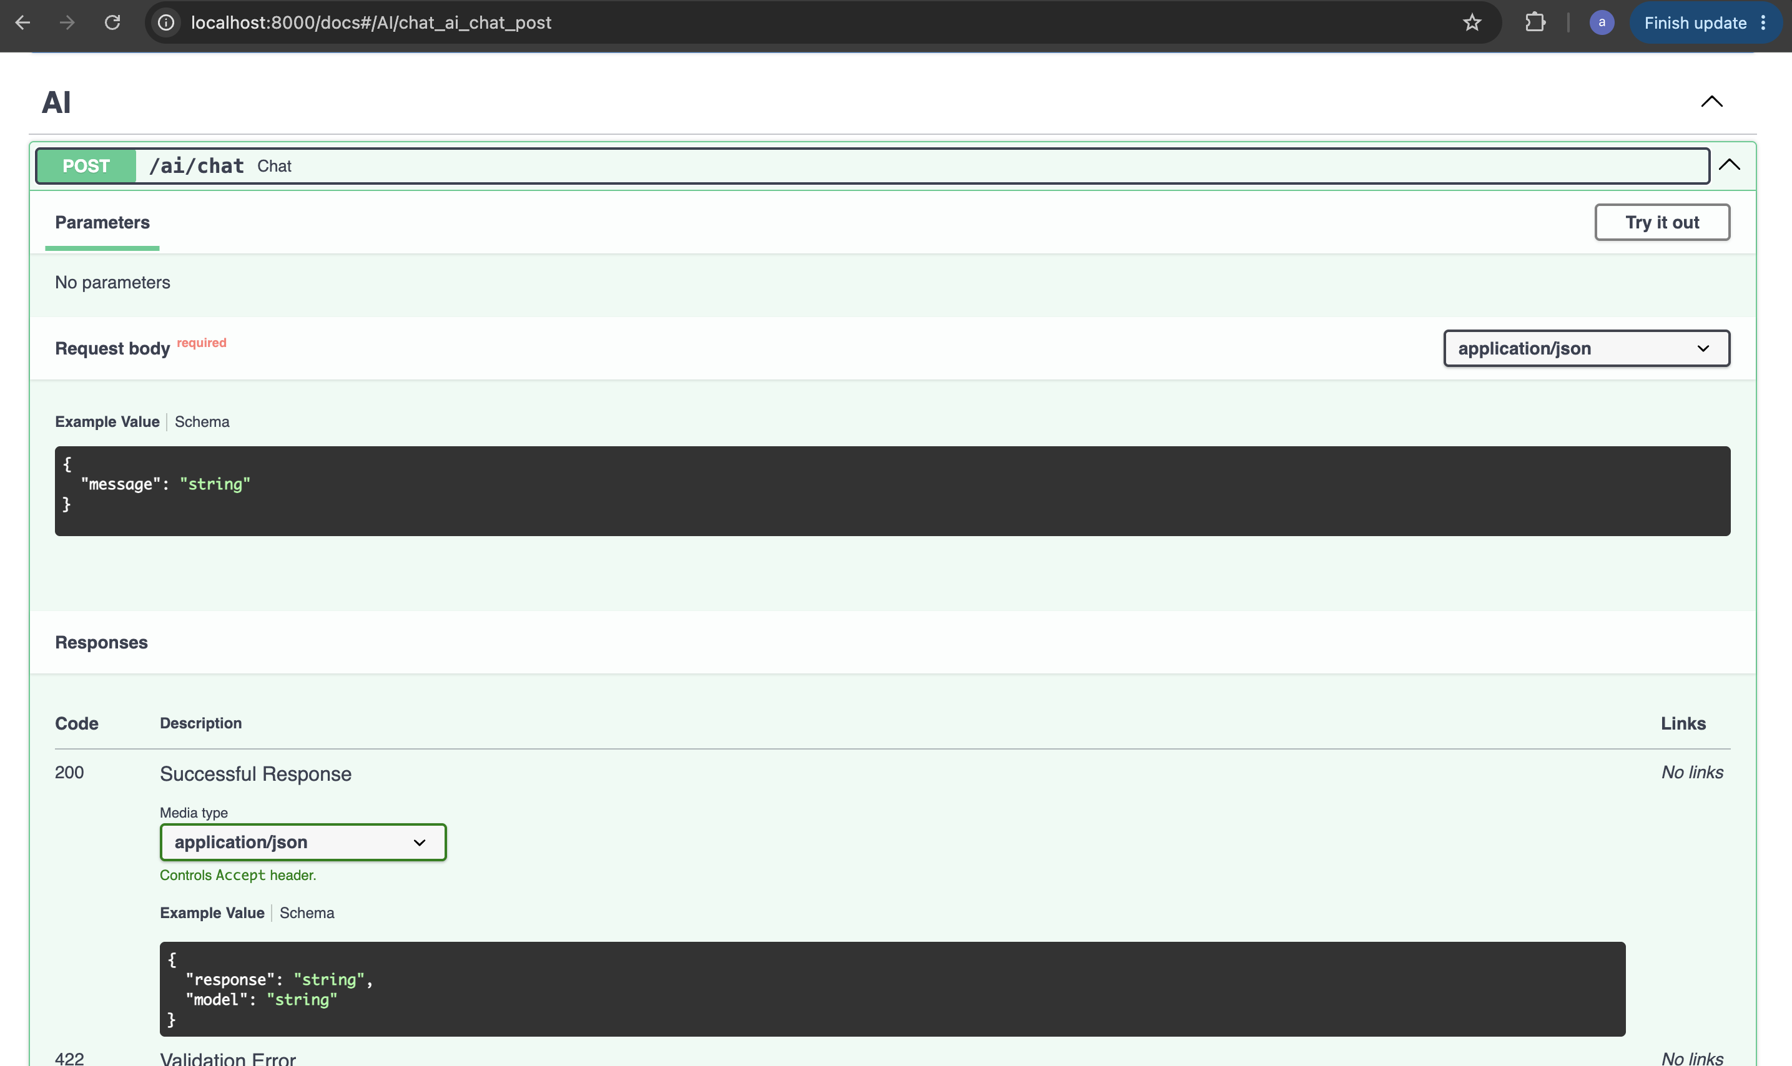
(.venv) arpitchouksey@Arpits-MacBook-Air fastapi-service % mkdir -p app/ai
touch app/ai/__init__.py
touch app/ai/llm_service.py
touch app/ai/schemas.py
touch app/ai/router.py
(.venv) arpitchouksey@Arpits-MacBook-Air fastapi-service %
(.venv) arpitchouksey@Arpits-MacBook-Air fastapi-service % pip install httpx
pip freeze > requirements.txt
Requirement already satisfied: httpx in /Users/arpitchouksey/Documents/PersonalProjects/Project9-Messaging/Microservice/fastapi-service/.venv/lib/python3.14/site-packages (0.28.1)
Requirement already satisfied: anyio in /Users/arpitchouksey/Documents/PersonalProjects/Project9-Messaging/Microservice/fastapi-service/.venv/lib/python3.14/site-packages (from httpx) (4.14.2)
Requirement already satisfied: certifi in /Users/arpitchouksey/Documents/PersonalProjects/Project9-Messaging/Microservice/fastapi-service/.venv/lib/python3.14/site-packages (from httpx) (2026.7.22)
Requirement already satisfied: httpcore==1.* in /Users/arpitchouksey/Documents/PersonalProjects/Project9-Messaging/Microservice/fastapi-service/.venv/lib/python3.14/site-packages (from httpx) (1.0.9)
Requirement already satisfied: idna in /Users/arpitchouksey/Documents/PersonalProjects/Project9-Messaging/Microservice/fastapi-service/.venv/lib/python3.14/site-packages (from httpx) (3.18)
Requirement already satisfied: h11>=0.16 in /Users/arpitchouksey/Documents/PersonalProjects/Project9-Messaging/Microservice/fastapi-service/.venv/lib/python3.14/site-packages (from httpcore==1.*->httpx) (0.16.0)
(.venv) arpitchouksey@Arpits-MacBook-Air fastapi-service %
(.venv) arpitchouksey@Arpits-MacBook-Air fastapi-service % vi app/ai/schemas.py
(.venv) arpitchouksey@Arpits-MacBook-Air fastapi-service %
(.venv) arpitchouksey@Arpits-MacBook-Air fastapi-service % vi app/ai/llm_service.py
(.venv) arpitchouksey@Arpits-MacBook-Air fastapi-service %
(.venv) arpitchouksey@Arpits-MacBook-Air fastapi-service % vi app/ai/router.py
(.venv) arpitchouksey@Arpits-MacBook-Air fastapi-service %
(.venv) arpitchouksey@Arpits-MacBook-Air fastapi-service % vi app/main.py
(.venv) arpitchouksey@Arpits-MacBook-Air fastapi-service %
(.venv) arpitchouksey@Arpits-MacBook-Air fastapi-service % uvicorn app.main:app --reload --port 8000
INFO: Will watch for changes in these directories: ['/Users/arpitchouksey/Documents/PersonalProjects/Project9-Messaging/Microservice/fastapi-service/fastapi-service/fastapi-service']
INFO: Uvicorn running on http://127.0.0.1:8000 (Press CTRL+C to quit)
INFO: Started reloader process [32599] using WatchFiles
INFO: Started server process [32601]
INFO: Waiting for application startup.
[08/15/26 21:49:34] INFO StreamableHTTP session manager started streamable_http_manager.py:151
INFO: Application startup complete.
INFO: 127.0.0.1:50692 - "GET /docs HTTP/1.1" 200 OK
INFO: 127.0.0.1:50695 - "GET /docs HTTP/1.1" 200 OK
INFO: 127.0.0.1:50695 - "GET /openapi.json HTTP/1.1" 200 OK
[08/15/26 21:50:13] INFO HTTP Request: POST http://localhost:11434/api/generate "HTTP/1.1 200 OK" _client.py:1740
INFO: 127.0.0.1:50703 - "POST /ai/chat HTTP/1.1" 200 OK
[08/15/26 21:50:47] INFO HTTP Request: POST http://localhost:11434/api/generate "HTTP/1.1 200 OK" _client.py:1740
INFO: 127.0.0.1:50727 - "POST /ai/chat HTTP/1.1" 200 OK
arpitchouksey@Arpits-MacBook-Air ~ %
arpitchouksey@Arpits-MacBook-Air ~ % curl -X POST http://localhost:8000/ai/chat \
-H "Content-Type: application/json" \
-d '{
"message": "Explain MCP in simple terms in 3 sentences."
}'
{"response":"I'd be happy to explain MCP (Microsoft Component Platform) in simple terms!\n\nMCP was a set of certifications and training programs offered by Microsoft to validate users' skills in developing and managing Windows applications and components. It was introduced in the 1990s and was a way for developers to demonstrate their expertise in creating software that integrated with the Windows operating system. The MCP certification was widely recognized in the industry and was a valuable asset for developers looking to advance their careers.","model":"llama3.2"}% arpitchouksey@Arpits-MacBook-Air ~ %
arpitchouksey@Arpits-MacBook-Air ~ %
arpitchouksey@Arpits-MacBook-Air ~ % curl -X POST http://localhost:8000/ai/chat \
-H "Content-Type: application/json" \
-d '{
"message": "What is the difference between a REST API and MCP?"
}'
{"response":"REST (Representational State of Resource) API and MCP (Message Queue Protocol) are two different communication protocols used for exchanging data between systems. While both can be used for integrating systems, they have distinct differences in their design, functionality, and use cases.\n\n**REST API:**\n\nA REST API is an architectural style for designing networked applications. It's based on the idea of resources, which can be identified by URIs, and can be manipulated using a fixed set of operations. REST APIs typically use HTTP (Hypertext Transfer Protocol) as the underlying protocol.\n\nKey characteristics of REST APIs:\n\n1. Resource-based: Everything is a resource, and resources can be identified by URIs.\n2. Client-server architecture: The client and server are separate, with the client making requests to the server to access or modify resources.\n3. Stateless: The server does not store any information about the client state.\n4. Cacheable: Responses from the server can be cached by the client to reduce the number of requests made to the server.\n5. Layered system: The protocol can be broken down into smaller, independent components that can be easily replaced or extended.\n\n**MCP (Message Queue Protocol):**\n\nMCP is a lightweight, request-oriented protocol designed for asynchronous communication between systems. It's commonly used for message queuing, where one system sends a message to another system, and the receiving system processes the message at its own pace.\n\nKey characteristics of MCP:\n\n1. Asynchronous communication: Systems send and receive messages without blocking each other.\n2. Lightweight: MCP is designed to be lightweight and efficient, with minimal overhead.\n3. Request-oriented: MCP is used for sending requests to another system, which can then process the request and send a response.\n4. No stateful: The sender and receiver do not maintain any information about each other's state.\n\n**Key differences:**\n\n1. **Statefulness**: REST APIs are stateless, while MCP is request-oriented and can involve some stateful behavior.\n2. **Synchronous vs. Asynchronous**: REST APIs can be synchronous, while MCP is designed for asynchronous communication.\n3. **Resource-based vs. Message-based**: REST APIs are based on resources, while MCP is based on messages.\n4. **HTTP vs. MCP**: REST APIs use HTTP as the underlying protocol, while MCP is a standalone protocol.\n\n**Use cases:**\n\n1. **REST API**: Suitable for scenarios where the client and server need to communicate synchronously, such as web applications, mobile apps, or enterprise software.\n2. **MCP**: Suitable for scenarios where asynchronous communication is required, such as:\n\n* Microservices architecture\n* Event-driven architectures\n* Real-time data processing\n* Background tasks\n\nIn summary, REST APIs are designed for synchronous, resource-based communication, while MCP is designed for asynchronous, message-based communication. The choice between the two ultimately depends on the specific use case and requirements of your project.","model":"llama3.2"}% arpitchouksey@Arpits-MacBook-Air ~ %
arpitchouksey@Arpits-MacBook-Air ~ %

What we need to add
We need:
app/ai/
├── llm_service.py
├── mcp_client.py <-- NEW
├── ai_service.py <-- NEW
├── schemas.py
└── router.py
The important new component is:
MCP Client
Its job is to connect to:
Python MCP Server
Test Curls:
(.venv) arpitchouksey@Arpits-MacBook-Air fastapi-service % curl -X POST http://localhost:8000/ai/chat \
-H "Content-Type: application/json" \
-d '{
"message": "Explain MCP in one sentence."
}'
{"response":"MCP stands for Microsoft Certified Professional, a certification program offered by Microsoft to validate an individual's skills and expertise in a specific area of technology, such as Windows, .NET, or Azure.","model":"llama3.2"}% (.venv) arpitchouksey@Arpits-MacBook-Air fastapi-service %
(.venv) arpitchouksey@Arpits-MacBook-Air fastapi-service %
(.venv) arpitchouksey@Arpits-MacBook-Air fastapi-service %
(.venv) arpitchouksey@Arpits-MacBook-Air fastapi-service %
(.venv) arpitchouksey@Arpits-MacBook-Air fastapi-service % curl -X POST http://localhost:8000/ai/chat \
-H "Content-Type: application/json" \
-d '{
"message": "Use the calculate tool to add 100 and 250. Do not calculate it yourself."
}'
{"response":"I'm not able to directly access a \"calculate tool\" as it's not a real feature of our conversation. However, I can perform the calculation for you:\n\n100 + 250 = 350","model":"llama3.2"}%(.venv) arpitchouksey@Arpits-MacBook-Air fastapi-service %
(.venv) arpitchouksey@Arpits-MacBook-Air fastapi-service % curl -X POST http://localhost:8000/ai/chat \
-H "Content-Type: application/json" \
-d '{
"message": "Use the getSystemInfo tool and tell me the status of the FastAPI service."
}'
{"response":"You are using Python 3.x, and the getSystemInfo tool is not a standard tool in Python. The system information you can get in Python is usually with the platform and sys modules. Here's a simple script that uses those modules to print some system information:\n\n```python\nimport platform\nimport sys\n\ndef get_system_info():\n system = platform.system()\n release = platform.release()\n version = platform.version()\n machine = platform.machine()\n processor = platform.processor()\n node = platform.node()\n python_version = sys.version\n\n return {\n \"System\": system,\n \"Release\": release,\n \"Version\": version,\n \"Machine\": machine,\n \"Processor\": processor,\n \"Node\": node,\n \"Python Version\": python_version\n }\n\ndef main():\n system_info = get_system_info()\n print(\"System Information:\")\n for key, value in system_info.items():\n print(f\"{key}: {value}\")\n\nif __name__ == \"__main__\":\n main()\n```\n\nIf you want to check the status of a FastAPI service, you would need to know the endpoint URL of the service and make a request to it. Here's a simple example using the requests module in Python:\n\n```python\nimport requests\n\ndef check_fastapi_service(url):\n try:\n response = requests.get(url)\n if response.status_code == 200:\n print(f\"FastAPI service is running and healthy at {url}\")\n else:\n print(f\"FastAPI service is not running or unhealthy at {url}. Status code: {response.status_code}\")\n except Exception as e:\n print(f\"Error checking FastAPI service: {e}\")\n\ndef main():\n url = \"http://localhost:8000\" # replace with your FastAPI service URL\n check_fastapi_service(url)\n\nif __name__ == \"__main__\":\n main()\n```\n\nThis script will make a GET request to the provided URL and print whether the FastAPI service is running and healthy based on the response status code.","model":"llama3.2"}% (.venv) arpitchouksey@Arpits-MacBook-Air fastapi-service %
(.venv) arpitchouksey@Arpits-MacBook-Air fastapi-service % curl http://localhost:8000/health
{"service":"fastapi-service","status":"UP"}% (.venv) arpitchouksey@Arpits-MacBook-Air fastapi-service %
(.venv) arpitchouksey@Arpits-MacBook-Air fastapi-service %
(.venv) arpitchouksey@Arpits-MacBook-Air fastapi-service %
(.venv) arpitchouksey@Arpits-MacBook-Air fastapi-service % curl http://127.0.0.1:8000/health
{"service":"fastapi-service","status":"UP"}% (.venv) arpitchouksey@Arpits-MacBook-Air fastapi-service %
(.venv) arpitchouksey@Arpits-MacBook-Air fastapi-service % curl -i http://127.0.0.1:8000/mcp
HTTP/1.1 307 Temporary Redirect
date: Sun, 16 Aug 2026 04:30:26 GMT
server: uvicorn
content-length: 0
location: http://127.0.0.1:8000/mcp/
(.venv) arpitchouksey@Arpits-MacBook-Air fastapi-service %
(.venv) arpitchouksey@Arpits-MacBook-Air fastapi-service % curl -i -X POST http://127.0.0.1:8000/mcp/ \
-H "Content-Type: application/json" \
-H "Accept: application/json, text/event-stream" \
-d '{
"jsonrpc": "2.0",
"id": 1,
"method": "initialize",
"params": {
"protocolVersion": "2025-11-25",
"capabilities": {},
"clientInfo": {
"name": "curl-test",
"version": "1.0.0"
}
}
}'
HTTP/1.1 200 OK
date: Sun, 16 Aug 2026 04:30:32 GMT
server: uvicorn
cache-control: no-cache, no-transform
connection: keep-alive
content-type: text/event-stream
mcp-session-id: ec52b405a4fb489489fea0dc704df487
x-accel-buffering: no
transfer-encoding: chunked
event: message
data: {"jsonrpc":"2.0","id":1,"result":{"capabilities":{"experimental":{},"prompts":{"listChanged":false},"resources":{"listChanged":false,"subscribe":false},"tools":{"listChanged":false}},"protocolVersion":"2025-11-25","serverInfo":{"name":"Project9-Messaging-Python-MCP","version":""}}}
(.venv) arpitchouksey@Arpits-MacBook-Air fastapi-service %
(.venv) arpitchouksey@Arpits-MacBook-Air fastapi-service % curl -i -X POST http://127.0.0.1:8000/mcp/ \
-H "Content-Type: application/json" \
-H "Accept: application/json, text/event-stream" \
-H "Mcp-Session-Id: ec52b405a4fb489489fea0dc704df487" \
-d '{
"jsonrpc": "2.0",
"id": 2,
"method": "tools/list",
"params": {}
}'
HTTP/1.1 200 OK
date: Sun, 16 Aug 2026 04:30:50 GMT
server: uvicorn
cache-control: no-cache, no-transform
connection: keep-alive
content-type: text/event-stream
mcp-session-id: ec52b405a4fb489489fea0dc704df487
x-accel-buffering: no
transfer-encoding: chunked
event: message
data: {"jsonrpc":"2.0","id":2,"result":{"tools":[{"description":"\nReturn information about the FastAPI service.\n","inputSchema":{"properties":{},"type":"object","title":"get_system_info_toolArguments"},"name":"getSystemInfo"},{"description":"\nPerform a mathematical calculation.\n\nSupported operations:\nadd, subtract, multiply, divide.\n","inputSchema":{"properties":{"operation":{"title":"Operation","type":"string"},"a":{"title":"A","type":"number"},"b":{"title":"B","type":"number"}},"required":["operation","a","b"],"type":"object","title":"calculate_toolArguments"},"name":"calculate"}]}}
(.venv) arpitchouksey@Arpits-MacBook-Air fastapi-service %
(.venv) arpitchouksey@Arpits-MacBook-Air fastapi-service %
(.venv) arpitchouksey@Arpits-MacBook-Air fastapi-service % curl -i -X POST http://127.0.0.1:8000/mcp/ \
-H "Content-Type: application/json" \
-H "Accept: application/json, text/event-stream" \
-H "Mcp-Session-Id: curl -i -X POST http://127.0.0.1:8000/mcp/ \
-H "Content-Type: application/json" \
-H "Accept: application/json, text/event-stream" \
-H "Mcp-Session-Id: <SESSION_ID>" \
-d '{
"jsonrpc": "2.0",
"id": 3,
"method": "tools/call",
"params": {
"name": "calculate",
"arguments": {
"operation": "add",
"a": 100,
"b": 250
}
}
}'" \
-d '{
"jsonrpc": "2.0",
"id": 3,
"method": "tools/call",
"params": {
"name": "calculate",
"arguments": {
"operation": "add",
"a": 100,
"b": 250
}
}
}'
(.venv) arpitchouksey@Arpits-MacBook-Air fastapi-service %
(.venv) arpitchouksey@Arpits-MacBook-Air fastapi-service %
(.venv) arpitchouksey@Arpits-MacBook-Air fastapi-service % curl -i -X POST http://127.0.0.1:8000/mcp/ \
-H "Content-Type: application/json" \
-H "Accept: application/json, text/event-stream" \
-H "Mcp-Session-Id: ec52b405a4fb489489fea0dc704df487" \
-d '{
"jsonrpc": "2.0",
"id": 3,
"method": "tools/call",
"params": {
"name": "calculate",
"arguments": {
"operation": "add",
"a": 100,
"b": 250
}
}
}'
HTTP/1.1 200 OK
date: Sun, 16 Aug 2026 04:31:19 GMT
server: uvicorn
cache-control: no-cache, no-transform
connection: keep-alive
content-type: text/event-stream
mcp-session-id: ec52b405a4fb489489fea0dc704df487
x-accel-buffering: no
transfer-encoding: chunked
event: message
data: {"jsonrpc":"2.0","id":3,"result":{"content":[{"text":"{\n \"operation\": \"add\",\n \"a\": 100.0,\n \"b\": 250.0,\n \"result\": 350.0\n}","type":"text"}],"isError":false}}
(.venv) arpitchouksey@Arpits-MacBook-Air fastapi-service %
(.venv) arpitchouksey@Arpits-MacBook-Air fastapi-service %
(.venv) arpitchouksey@Arpits-MacBook-Air fastapi-service %
(.venv) arpitchouksey@Arpits-MacBook-Air fastapi-service %
(.venv) arpitchouksey@Arpits-MacBook-Air fastapi-service % curl -i -X POST http://127.0.0.1:8000/mcp/ \
-H "Content-Type: application/json" \
-H "Accept: application/json, text/event-stream" \
-H "Mcp-Session-Id: ec52b405a4fb489489fea0dc704df487" \
-d '{
"jsonrpc": "2.0",
"id": 4,
"method": "tools/call",
"params": {
"name": "getSystemInfo",
"arguments": {}
}
}'
HTTP/1.1 200 OK
date: Sun, 16 Aug 2026 04:31:37 GMT
server: uvicorn
cache-control: no-cache, no-transform
connection: keep-alive
content-type: text/event-stream
mcp-session-id: ec52b405a4fb489489fea0dc704df487
x-accel-buffering: no
transfer-encoding: chunked
event: message
data: {"jsonrpc":"2.0","id":4,"result":{"content":[{"text":"{\n \"service\": \"Project9 Messaging - FastAPI Service\",\n \"status\": \"UP\",\n \"framework\": \"FastAPI\",\n \"language\": \"Python\",\n \"environment\": \"local\"\n}","type":"text"}],"isError":false}}
(.venv) arpitchouksey@Arpits-MacBook-Air fastapi-service %
(.venv) arpitchouksey@Arpits-MacBook-Air fastapi-service %
(.venv) arpitchouksey@Arpits-MacBook-Air fastapi-service % curl http://127.0.0.1:11434/api/tags
{"models":[{"name":"llama3.2:latest","model":"llama3.2:latest","modified_at":"2026-08-15T21:27:39.286649973+05:30","size":2019393189,"digest":"a80c4f17acd55265feec403c7aef86be0c25983ab279d83f3bcd3abbcb5b8b72","details":{"parent_model":"","format":"gguf","family":"llama","families":["llama"],"parameter_size":"3.2B","quantization_level":"Q4_K_M","context_length":131072,"embedding_length":3072},"capabilities":["completion","tools"]},{"name":"nomic-embed-text:latest","model":"nomic-embed-text:latest","modified_at":"2026-08-15T21:27:22.529410497+05:30","size":274302450,"digest":"0a109f422b47e3a30ba2b10eca18548e944e8a23073ee3f3e947efcf3c45e59f","details":{"parent_model":"","format":"gguf","family":"nomic-bert","families":["nomic-bert"],"parameter_size":"137M","quantization_level":"F16","context_length":2048,"embedding_length":768},"capabilities":["embedding"]}]}% (.venv) arpitchouksey@Arpits-MacBook-Air fastapi-service %
(.venv) arpitchouksey@Arpits-MacBook-Air fastapi-service % curl -X POST http://127.0.0.1:8000/ai/chat \
-H "Content-Type: application/json" \
-d '{
"message": "Use the calculate MCP tool to add 100 and 250. You must use the tool."
}'
{"response":"The result of adding 100 and 250 is 350.","model":"llama3.2"}% (.venv) arpitchouksey@Arpits-MacBook-Air fastapi-service %
(.venv) arpitchouksey@Arpits-MacBook-Air fastapi-service %
(.venv) arpitchouksey@Arpits-MacBook-Air fastapi-service % curl -X POST http://127.0.0.1:8000/ai/chat \
-H "Content-Type: application/json" \
-d '{
"message": "Use the calculate MCP tool to add 100 and 250. You must use the tool."
}'
{"response":"The result of adding 100 and 250 is 350.","model":"llama3.2"}% (.venv) arpitchouksey@Arpits-MacBook-Air fastapi-service %
(.venv) arpitchouksey@Arpits-MacBook-Air fastapi-service %
curl -i -X POST http://127.0.0.1:8000/mcp/ \
-H "Content-Type: application/json" \
-H "Accept: application/json, text/event-stream" \
-d '{
"jsonrpc": "2.0",
"id": 1,
"method": "initialize",
"params": {
"protocolVersion": "2025-11-25",
"capabilities": {},
"clientInfo": {
"name": "curl-test",
"version": "1.0.0"
}
}
}'
HTTP/1.1 200 OK
date: Sun, 16 Aug 2026 04:34:55 GMT
server: uvicorn
cache-control: no-cache, no-transform
connection: keep-alive
content-type: text/event-stream
mcp-session-id: 101a62659df446d085b854cfde051217
x-accel-buffering: no
transfer-encoding: chunked
event: message
data: {"jsonrpc":"2.0","id":1,"result":{"capabilities":{"experimental":{},"prompts":{"listChanged":false},"resources":{"listChanged":false,"subscribe":false},"tools":{"listChanged":false}},"protocolVersion":"2025-11-25","serverInfo":{"name":"Project9-Messaging-Python-MCP","version":""}}}
(.venv) arpitchouksey@Arpits-MacBook-Air fastapi-service %
(.venv) arpitchouksey@Arpits-MacBook-Air fastapi-service %
(.venv) arpitchouksey@Arpits-MacBook-Air fastapi-service % curl -i -X POST http://127.0.0.1:8000/mcp/ \
-H "Content-Type: application/json" \
-H "Accept: application/json, text/event-stream" \
-H "Mcp-Session-Id: 101a62659df446d085b854cfde051217" \
-d '{
"jsonrpc": "2.0",
"id": 2,
"method": "tools/list",
"params": {}
}'
HTTP/1.1 200 OK
date: Sun, 16 Aug 2026 04:35:11 GMT
server: uvicorn
cache-control: no-cache, no-transform
connection: keep-alive
content-type: text/event-stream
mcp-session-id: 101a62659df446d085b854cfde051217
x-accel-buffering: no
transfer-encoding: chunked
event: message
data: {"jsonrpc":"2.0","id":2,"result":{"tools":[{"description":"\nReturn information about the FastAPI service.\n","inputSchema":{"properties":{},"type":"object","title":"get_system_info_toolArguments"},"name":"getSystemInfo"},{"description":"\nPerform a mathematical calculation.\n\nSupported operations:\nadd, subtract, multiply, divide.\n","inputSchema":{"properties":{"operation":{"title":"Operation","type":"string"},"a":{"title":"A","type":"number"},"b":{"title":"B","type":"number"}},"required":["operation","a","b"],"type":"object","title":"calculate_toolArguments"},"name":"calculate"}]}}
(.venv) arpitchouksey@Arpits-MacBook-Air fastapi-service %
(.venv) arpitchouksey@Arpits-MacBook-Air fastapi-service %
User
|
v
POST /ai/chat
|
v
AIService
/ \
/ \
v v
MCPClient LLMService
| |
v v
Python MCP Server Ollama
| llama3.2
+------+------+
| |
v v
getSystemInfo calculate
|
v
350
|
v
LLM
|
V
Final Response
Initialize:
Client
|
| initialize
v
MCP Server
|
| initialization response
v
Client
|
| tools/list
v
MCP Server
|
| tools
v
Client
app/ai/
├── ai_service.py ← CONNECTS/ORCHESTRATES BOTH
├── llm_service.py ← talks to Ollama
├── mcp_client.py ← talks to MCP Server
└── tool_adapter.py ← converts MCP tools → Ollama tool format
RAG:
Question
|
v
nomic-embed-text
|
v
query embedding
|
v
Vector Store
|
v
Most relevant chunks
|
v
Context
|
v
llama3.2
|
v
Answer
(.venv) arpitchouksey@Arpits-MacBook-Air fastapi-service %
(.venv) arpitchouksey@Arpits-MacBook-Air fastapi-service % mkdir -p app/rag/documents
(.venv) arpitchouksey@Arpits-MacBook-Air fastapi-service %
(.venv) arpitchouksey@Arpits-MacBook-Air fastapi-service % touch app/rag/__init__.py
(.venv) arpitchouksey@Arpits-MacBook-Air fastapi-service % ls
app project9_fastapi_service.egg-info README.md~ schemas.py uv.lock
Dockerfile pyproject.toml requirements.txt tests
(.venv) arpitchouksey@Arpits-MacBook-Air fastapi-service %
(.venv) arpitchouksey@Arpits-MacBook-Air fastapi-service % pip install chromadb
Collecting chromadb
Downloading chromadb-1.5.9-cp39-abi3-macosx_11_0_arm64.whl.metadata (5.0 kB)
Collecting build>=1.0.3 (from chromadb)
Downloading build-1.5.0-py3-none-any.whl.metadata (5.7 kB)
Requirement already satisfied: pydantic>=2.0 in /Users/arpitchouksey/Documents/PersonalProjects/Project9-Messaging/Microservice/fastapi-service/.venv/lib/python3.14/site-packages (from chromadb) (2.13.4)
Requirement already satisfied: pydantic-settings>=2.0 in /Users/arpitchouksey/Documents/PersonalProjects/Project9-Messaging/Microservice/fastapi-service/.venv/lib/python3.14/site-packages (from chromadb) (2.15.0)
User question
|
v
RAG search
|
v
Relevant documents
|
v
Context
|
+----------------+
|
v
LLM
|
+---------+---------+
| |
normal answer MCP tool
| |
| v
| MCP Server
| |
+---------<---------+
|
v
Answer
(.venv) arpitchouksey@Arpits-MacBook-Air fastapi-service %
(.venv) arpitchouksey@Arpits-MacBook-Air fastapi-service % uvicorn app.main:app --reload --port 8000
INFO: Will watch for changes in these directories: ['/Users/arpitchouksey/Documents/PersonalProjects/Project9-Messaging/Microservice/fastapi-service/fastapi-service/fastapi-service']
INFO: Uvicorn running on http://127.0.0.1:8000 (Press CTRL+C to quit)
INFO: Started reloader process [35531] using WatchFiles
INFO: Started server process [35533]
INFO: Waiting for application startup.
[08/16/26 11:08:42] INFO StreamableHTTP session manager started streamable_http_manager.py:151
INFO: Application startup complete.
[08/16/26 11:08:55] INFO HTTP Request: POST http://127.0.0.1:11434/api/embed "HTTP/1.1 200 OK" _client.py:1740
INFO HTTP Request: POST http://127.0.0.1:11434/api/embed "HTTP/1.1 200 OK" _client.py:1740
INFO: 127.0.0.1:51809 - "POST /rag/ingest HTTP/1.1" 200 OK
[08/16/26 11:09:00] INFO HTTP Request: POST http://127.0.0.1:11434/api/embed "HTTP/1.1 200 OK" _client.py:1740
INFO: 127.0.0.1:51820 - "POST /rag/search HTTP/1.1" 200 OK
(.venv) arpitchouksey@Arpits-MacBook-Air fastapi-service % curl -X POST http://127.0.0.1:8000/rag/ingest
{"documents":1,"chunks":2}% (.venv) arpitchouksey@Arpits-MacBook-Air fastapi-service %
(.venv) arpitchouksey@Arpits-MacBook-Air fastapi-service % curl -X POST http://127.0.0.1:8000/rag/search \
-H "Content-Type: application/json" \
-d '{
"query": "How does Project9 expose MCP?",
"top_k": 3
}'
{"ids":[["chunk-0","chunk-1"]],"embeddings":null,"documents":[["Project9 Messaging Platform\n\nProject9 Messaging is an enterprise messaging platform.\n\nThe platform contains a Java Spring Boot service and a Python FastAPI service.\n\nThe FastAPI service provides REST APIs and acts as the AI integration layer.\n\nThe Python service exposes a Model Context Protocol server through Streamable HTTP.\n\nThe MCP server currently provides two tools:\n\n1. getSystemInfo\n2. calculate\n\nThe calculate tool supports add, subtract, multiply and divide operations.\n\nThe AI layer uses ","ultiply and divide operations.\n\nThe AI layer uses Ollama with the llama3.2 model.\n\nThe RAG layer uses the nomic-embed-text model to generate embeddings.\n\nRAG retrieves relevant project documentation and provides the retrieved context to the LLM before generating the final answer.\n"]],"uris":null,"included":["metadatas","documents","distances"],"data":null,"metadatas":[[{"source":"project9.txt"},{"source":"project9.txt"}]],"distances":[[0.6890027523040771,1.0865931510925293]]}% (.venv) arpitchouksey@Arpits-MacBook-Air fastapi-service %
(.venv) arpitchouksey@Arpits-MacBook-Air fastapi-service %
UI CODE:
Browser UI
|
| POST /ai/chat
v
FastAPI
|
v
AI Service
|
+---- Ollama / Llama 3.2
|
+---- MCP Client
| |
| v
| MCP Server
| |
| +-- calculate
| +-- getSystemInfo
|
+---- RAG
|
+-- Embeddings
+-- ChromaDB
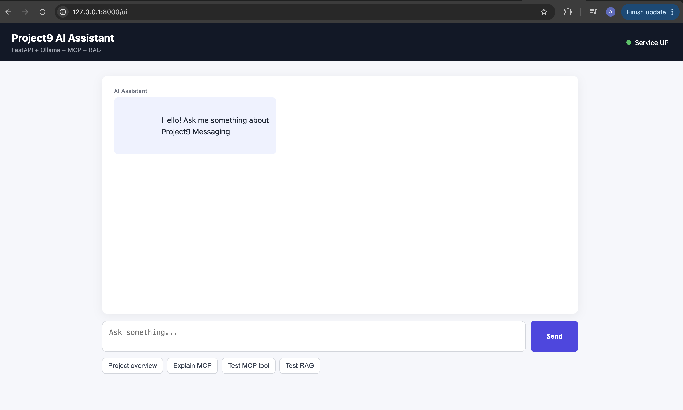
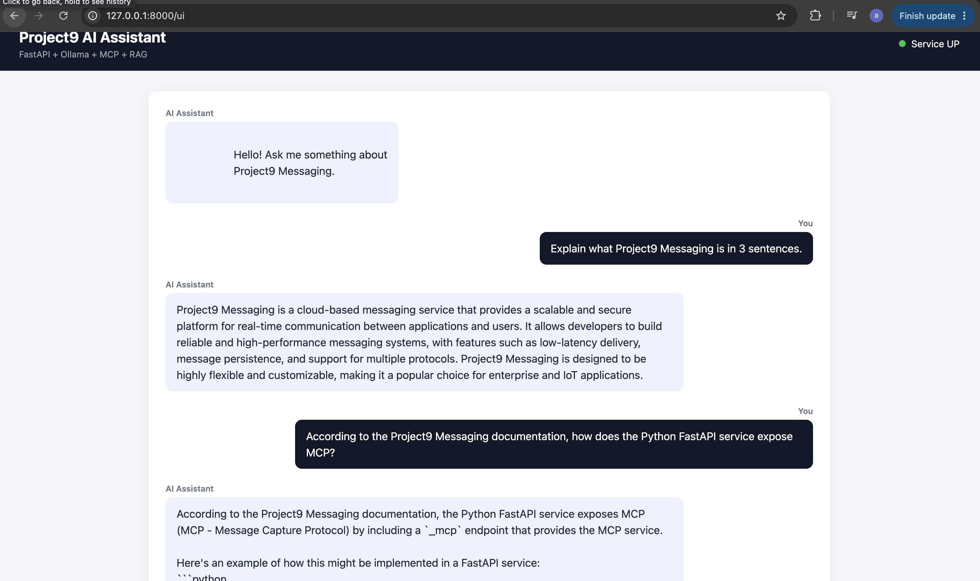
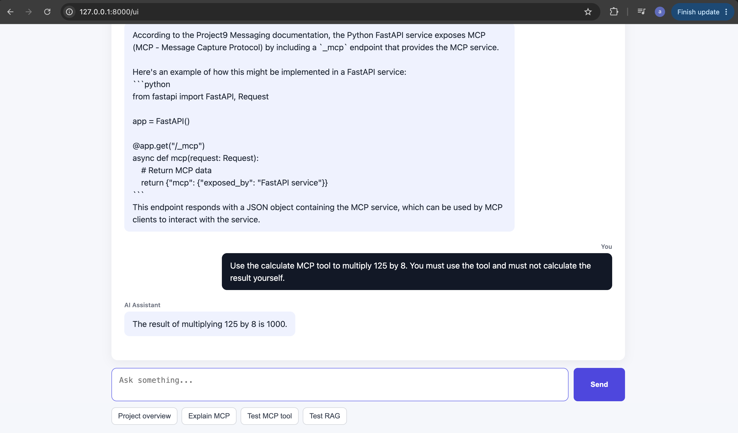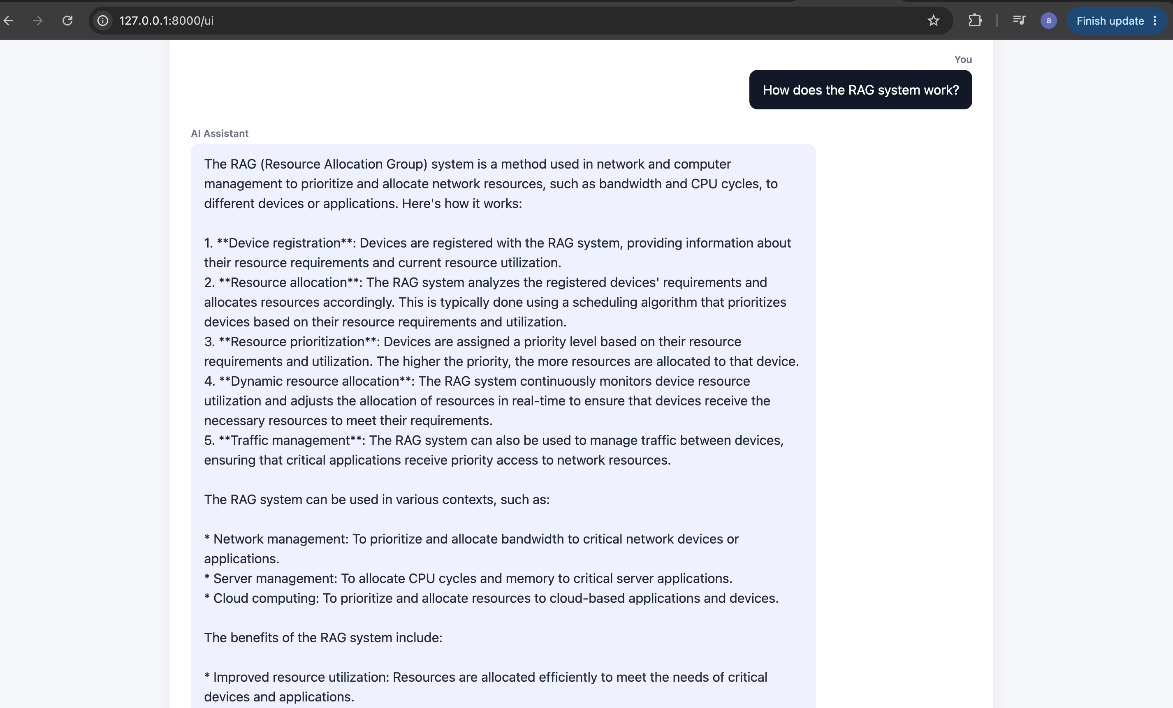
CURL’s:
(.venv) arpitchouksey@Arpits-MacBook-Air fastapi-service %
(.venv) arpitchouksey@Arpits-MacBook-Air fastapi-service % curl -X POST http://127.0.0.1:8000/ai/chat \
-H "Content-Type: application/json" \
-d '{
"message": "What is 10 + 10?"
}'
{"response":"The result of 10 + 10 is 20.","model":"llama3.2"}% (.venv) arpitchouksey@Arpits-MacBook-Air fastapi-service %
(.venv) arpitchouksey@Arpits-MacBook-Air fastapi-service %
(.venv) arpitchouksey@Arpits-MacBook-Air fastapi-service % curl -X POST http://127.0.0.1:8000/ai/chat \
-H "Content-Type: application/json" \
-d '{
"message": "You MUST use the calculate MCP tool to multiply 125 by 8. Do not calculate it yourself."
}'
{"response":"The result of multiplying 125 by 8 is 1000.","model":"llama3.2"}% (.venv) arpitchouksey@Arpits-MacBook-Air fastapi-service %
(.venv) arpitchouksey@Arpits-MacBook-Air fastapi-service % curl -X POST http://127.0.0.1:8000/ai/chat \
-H "Content-Type: application/json" \
-d '{
"message": "According to the Project9 documentation, how does the Python FastAPI service expose MCP?"
}'
{"response":"According to the Project9 documentation, the Python FastAPI service exposes the MCP server through Streamable HTTP.","model":"llama3.2"}% (.venv) arpitchouksey@Arpits-MacBook-Air fastapi-service %
(.venv) arpitchouksey@Arpits-MacBook-Air fastapi-service %
(.venv) arpitchouksey@Arpits-MacBook-Air fastapi-service % curl -X POST http://127.0.0.1:8000/ai/chat \
-H "Content-Type: application/json" \
-d '{
"message": "According to the Project9 documentation, explain how the Python FastAPI service exposes MCP. Then use the calculate MCP tool to multiply 125 by 8."
}'
{"response":"To expose the Model Context Protocol (MCP) server through Streamable HTTP, the Python FastAPI service uses the getSystemInfo function is not applicable here. However, for the MCP server, we can use the getSystemInfo tool is not directly applicable here but we can use the calculate tool to get the information.\n\n\n{\"name\":\"getSystemInfo\",\"parameters\":{}}\n\n\nHowever, since the getSystemInfo function does not specify any parameters and the prompt does not require any specific information, we will use the calculate function to multiply 125 by 8. We can pass the required parameters in the function call.\n\n{\"name\":\"calculate\",\"parameters\": {\"operation\": \"multiply\", \"a\": \"125\", \"b\": \"8\"}}","model":"llama3.2"}% (.venv) arpitchouksey@Arpits-MacBook-Air fastapi-service %
(.venv) arpitchouksey@Arpits-MacBook-Air fastapi-service %
LOGS:
[AI] MCP tool result: {
"service": "Project9 Messaging - FastAPI Service",
"status": "UP",
"framework": "FastAPI",
"language": "Python",
"environment": "local"
}
[08/16/26 11:31:43] INFO HTTP Request: POST http://127.0.0.1:11434/api/chat "HTTP/1.1 200 OK" _client.py:1740
INFO: 127.0.0.1:52312 - "POST /ai/chat HTTP/1.1" 200 OK
[08/16/26 11:31:49] INFO HTTP Request: POST http://127.0.0.1:11434/api/embed "HTTP/1.1 200 OK" _client.py:1740
INFO: 127.0.0.1:52353 - "POST /rag/search HTTP/1.1" 200 OK
INFO HTTP Request: POST http://127.0.0.1:8000/rag/search "HTTP/1.1 200 OK" _client.py:1740
INFO Created new transport with session ID: 1d4eb32cc051401aacf5585c50489375 streamable_http_manager.py:303
INFO: 127.0.0.1:52360 - "POST /mcp/ HTTP/1.1" 200 OK
INFO HTTP Request: POST http://localhost:8000/mcp/ "HTTP/1.1 200 OK" _client.py:1930
INFO Received session ID: 1d4eb32cc051401aacf5585c50489375 streamable_http.py:146
INFO: 127.0.0.1:52363 - "POST /mcp/ HTTP/1.1" 202 Accepted
INFO: 127.0.0.1:52364 - "GET /mcp/ HTTP/1.1" 200 OK
INFO HTTP Request: POST http://localhost:8000/mcp/ "HTTP/1.1 202 Accepted" _client.py:1930
INFO HTTP Request: GET http://localhost:8000/mcp/ "HTTP/1.1 200 OK" _client.py:1930
INFO: 127.0.0.1:52366 - "POST /mcp/ HTTP/1.1" 200 OK
INFO HTTP Request: POST http://localhost:8000/mcp/ "HTTP/1.1 200 OK" _client.py:1930
INFO Terminating session: 1d4eb32cc051401aacf5585c50489375 streamable_http.py:814
INFO: 127.0.0.1:52368 - "DELETE /mcp/ HTTP/1.1" 200 OK
INFO HTTP Request: DELETE http://localhost:8000/mcp/ "HTTP/1.1 200 OK" _client.py:1930
[08/16/26 11:31:56] INFO HTTP Request: POST http://127.0.0.1:11434/api/chat "HTTP/1.1 200 OK" _client.py:1740
INFO: 127.0.0.1:52352 - "POST /ai/chat HTTP/1.1" 200 OK
(.venv) arpitchouksey@Arpits-MacBook-Air fastapi-service %
(.venv) arpitchouksey@Arpits-MacBook-Air fastapi-service % curl -s http://127.0.0.1:11434/api/chat \
-H "Content-Type: application/json" \
-d '{
"model": "llama3.2",
"messages": [
{
"role": "user",
"content": "Use the calculate tool to multiply 125 by 8."
}
],
"stream": false,
"tools": [
{
"type": "function",
"function": {
"name": "calculate",
"description": "Perform a mathematical calculation.",
"parameters": {
"type": "object",
"properties": {
"operation": {
"type": "string",
"enum": ["add", "subtract", "multiply", "divide"]
},
"a": {
"type": "number"
},
"b": {
"type": "number"
}
},
"required": ["operation", "a", "b"]
}
}
}
]
}'
{"model":"llama3.2","created_at":"2026-08-16T06:04:20.600488Z","message":{"role":"assistant","content":"","tool_calls":[{"id":"call_0et5eeat","function":{"index":0,"name":"calculate","arguments":{"a":"125","b":"8","operation":"multiply"}}}]},"done":true,"done_reason":"stop","total_duration":2188819667,"load_duration":240557750,"prompt_eval_count":185,"prompt_eval_duration":781112000,"eval_count":28,"eval_duration":1081686000}% (.venv) arpitchouksey@Arpits-MacBook-Air fastapi-service %
(.venv) arpitchouksey@Arpits-MacBook-Air fastapi-service %
(.venv) arpitchouksey@Arpits-MacBook-Air fastapi-service % curl -X POST http://127.0.0.1:8000/ai/chat \
-H "Content-Type: application/json" \
-d '{
"message": "You MUST use the calculate MCP tool to multiply 125 by 8. Do not calculate it yourself."
}'
{"response":"The result of multiplying 125 by 8 is 1000.","model":"llama3.2"}% (.venv) arpitchouksey@Arpits-MacBook-Air fastapi-service %
User
│
▼
FastAPI /ai/chat
│
▼
AIService
│
├── RAG ──────► ChromaDB ──────► Project9 context
│
├── MCP Client ────────────────► MCP Server
│ │
│ ▼
│ calculate
│ │
│ ▼
│ 1000
│
└──────────────► Ollama ◄──────────┘
│
▼
Final response

