nprod Automated Patching Pipeline
AWS Systems Manager + Step Functions + Lambda — Design Summary and Test Validation

1. Problem Statement
nprod (Windows, tagged environment=nprod) instances required a fully automated patching process that could not rely on manual intervention for routine runs, but also had to be safe enough for a production environment. The requirement, specified the following mandatory outcomes:
- All tagged instances must be scanned and, when authorized, patched on a defined schedule.
- After every run, a report must be emailed to server owners and the relevant stakeholder, showing patch success or failure per instance.
- Where a patch fails, the report must include root cause analysis (RCA) at the OS level — not just a console-level success/failure flag.
- Transient failures (network blips, agent hiccups) must be retried automatically, with backoff, before being treated as a real failure.
- A pre-patch backup must be available, with a human-approved restore path if a patch causes unrecoverable damage.
- Cost and blast radius must be controllable — the ability to run a compliance Scan only, without installing anything, and to skip the backup step when not needed.
- The entire solution had to be delivered as Terraform, in a modular structure, with no hardcoded values.

Plain AWS Systems Manager (SSM) Patch Manager, on its own, only covers the simplest slice of this: it can scan and install patches on a schedule and report basic compliance. It has no native concept of retry-with-backoff, OS-level RCA, pre-patch backup, or human-in-the-loop restore approval. Meeting the full requirement meant building an orchestration layer on top of SSM — which is where Step Functions and Lambda came in.

2. What We Achieved — Summary
The final solution is a Terraform-managed pipeline with three logical layers, wired together so that a single scheduled trigger produces one final, complete report:

2.1 Policy layer (AWS Systems Manager)
- A custom Windows Patch Baseline (auto-approves Critical/Security/UpdateRollup classifications, MSRC severity Critical/Important) registered as the account's default baseline for Windows.
- A Maintenance Window reserved for the schedule concept only — it deliberately has no patch task attached, so SSM never patches instances directly and in parallel with the pipeline.
- A custom SSM diagnostic document (PowerShell) that pulls disk space, Windows Update history, SSM Agent log tail, pending-reboot status, and Windows Update error events — this is the OS-level RCA source.
- Two live control flags in Parameter Store — operation (Scan / Install) and takeBackup (true / false) — read fresh by the pipeline on every run, so behavior can be changed without a redeploy.

2.2 Compute layer (Lambda)
- A single dispatcher Lambda function handling seven jobs, routed internally by a task field in its event payload: compliance_check, patch_instance_start / patch_instance_check, classify_failure, rca_collector, pre_backup_snapshot, backup_restore, and report_builder.
- An S3 bucket archiving every RCA log and every report, with a 90-day lifecycle expiry.
- An SNS topic used only for the human restore-approval step.
- SES identities (sender and recipients) managed as Terraform resources rather than manual console setup.

2.3 Orchestration layer (Step Functions)
- A state machine that reads the two control flags, checks compliance, and — only in Install mode — patches every non-compliant instance with native retry/backoff, waits out Windows reboots without any timeout risk, classifies failures, collects RCA when needed, and routes to a human-approved restore when a backup exists.
- A single EventBridge rule tied to the real production cadence (cron(0 22 ? * SAT *)) starts the state machine directly — this is the only thing that triggers a production run.

2.4 Reporting
Every run — Scan or Install — ends in exactly one report, covering every instance in scope: instance ID and name, installed/missing/failed counts, compliance status, execution status, RCA summary, backup/restore status, execution ID, and generation timestamp. The report is delivered as a CSV attachment by email and archived to S3, so it can be opened directly in Excel/Sheets for further analysis.

3. Why Step Functions Was Needed
The instinct to keep this simple — trigger a Lambda directly from EventBridge, patch, and email a report — was tried and reconsidered, because it runs into hard technical limits, not just style preferences. Three specific requirements cannot be satisfied by a bare Lambda function:
AWS Lambda has a hard 900-second (15-minute) maximum timeout. There is no way to make a single Lambda invocation wait longer than that, regardless of how the code is written. Windows patch install plus a reboot plus post-reboot verification routinely takes 10–20+ minutes — a Lambda polling for that result risks being killed mid-patch, with no way to know afterward whether the patch actually completed.
Retry-with-backoff needs real elapsed time between attempts. The requirement calls for retrying transient failures with a backoff schedule (roughly 60s, then 120s, then 240s) before giving up. That waiting time, stacked across up to 47 instances, quickly exceeds what a single Lambda invocation can hold open.
A human-approved restore step has no upper bound on how long it takes. Waiting for an engineer to click "approve" or "reject" could take minutes or days. A Lambda function cannot sit idle for an unbounded, human-driven decision — it will always eventually be killed by its own timeout.
Step Functions solves all three by moving from a bare Lambda call to an explicit state machine:
- A native Wait/Choice loop (WaitForPatchCommand → CheckPatchStatus → PatchCompleteChoice) checks patch status every 30 seconds indefinitely, with no timeout ceiling — this is what makes waiting out a Windows reboot safe.
- A native Retry block on the patch-attempt state handles transient infrastructure errors with exponential backoff automatically, without hand-rolled retry counters.
- The waitForTaskToken integration pauses the whole execution — for hours if necessary — until a person runs an approve or reject command from the email notification, something no Lambda invocation could do on its own.
- Step Functions also holds all of the execution state (which instance is on which step, how many retries have been used, whether a backup was taken) automatically and visibly in its own console — removing the need to hand-build a DynamoDB-backed state tracker to replicate the same thing.
In short: Step Functions is not decorative architecture — it is the specific piece that lets the pipeline wait as long as a Windows reboot or a human decision actually takes, and retry failures intelligently, without being bound by what a single Lambda invocation can do in 15 minutes.

4. End-to-End Process Flow
Every run — whether triggered by the Saturday schedule or manually for testing — follows the same sequence:
- EventBridge (schedule) starts a new Step Functions execution.
- The execution reads the current operation and takeBackup values live from Parameter Store.
- compliance_check queries SSM for every environment=nprod instance and splits them into compliant / non-compliant lists.
- If operation = Scan, the pipeline goes straight to the report and ends — no instance is touched.
- If operation = Install, each non-compliant instance is processed (optionally backed up first, patched with retry/backoff, and waited out through any reboot).
- A failed patch is classified as transient (bounded retry), permission_denied (blocked, no RCA), or a real failure (full RCA collected).
- If a backup exists for a failed instance, a human is asked — by email, with ready-to-run CLI commands — whether to restore it; the execution waits for that answer.
- Once every instance has reached a final state, one CSV report is built covering the whole run and emailed to the configured recipients, with a copy archived to S3.

5. Testing and Validation
The pipeline was validated end to end in a live AWS test environment (region us-east-1) using local Terraform state, before being intended for integration into the target environment. Validation covered:
- Terraform plan/apply producing the expected resource set with zero unplanned changes.
- Windows-specific patch baseline filters (CLASSIFICATION and MSRC_SEVERITY, not the Linux-style values used in an early draft).
- Registration of the custom baseline as the account default, confirming AWS-RunPatchBaseline actually uses it rather than silently falling back to AWS's built-in default.
- A real Windows EC2 test instance, tagged environment=nprod, registered with SSM, scanned, and run through both Scan and Install executions.
- SES sender/recipient verification and successful email delivery, first as HTML and then converted to a CSV attachment per the final reporting requirement.
- Manual Step Functions executions (console and AWS CLI) confirming both the Scan branch (fast, read-only) and the Install branch (patch attempt, wait loop, completion) behave as designed.

6. Reference Material
The following pages reproduce the project's directory structure and console screenshots captured during setup and validation, for traceability.

6.1 Repository Structure
.
├── nprod-patching
│ ├── code
│ │ └── patching_dispatcher
│ │ └── lambda_function.py
│ ├── modules
│ │ ├── ssm-lambda
│ │ │ ├── main.tf
│ │ │ ├── outputs.tf
│ │ │ └── variables.tf
│ │ ├── ssm-policy
│ │ │ ├── main.tf
│ │ │ ├── outputs.tf
│ │ │ └── variables.tf
│ │ └── ssm-stepfunctions
│ │ ├── main.tf
│ │ ├── outputs.tf
│ │ ├── patching_state_machine.asl.json.tpl
│ │ └── variables.tf
│ └── tosca
│ └── us-east-1
│ ├── main.tf
│ ├── terraform.tfvars
│ └── variables.tf

6.2 Console Validation Screenshots
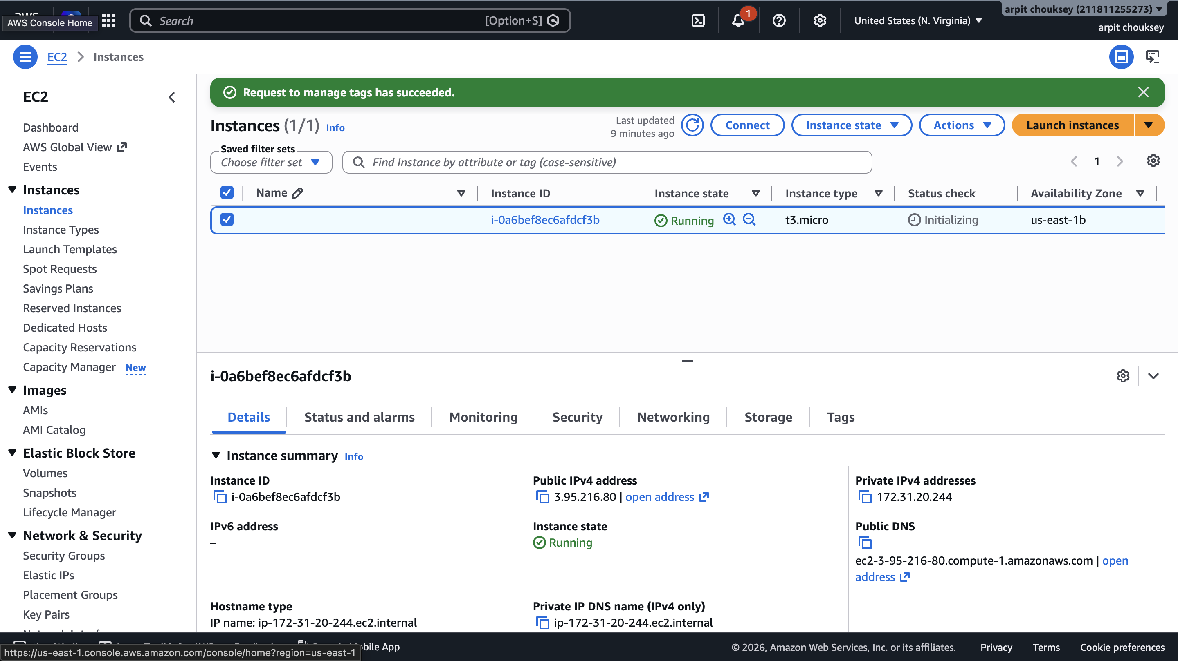
Figure 1 — AWS console validation during setup and testing
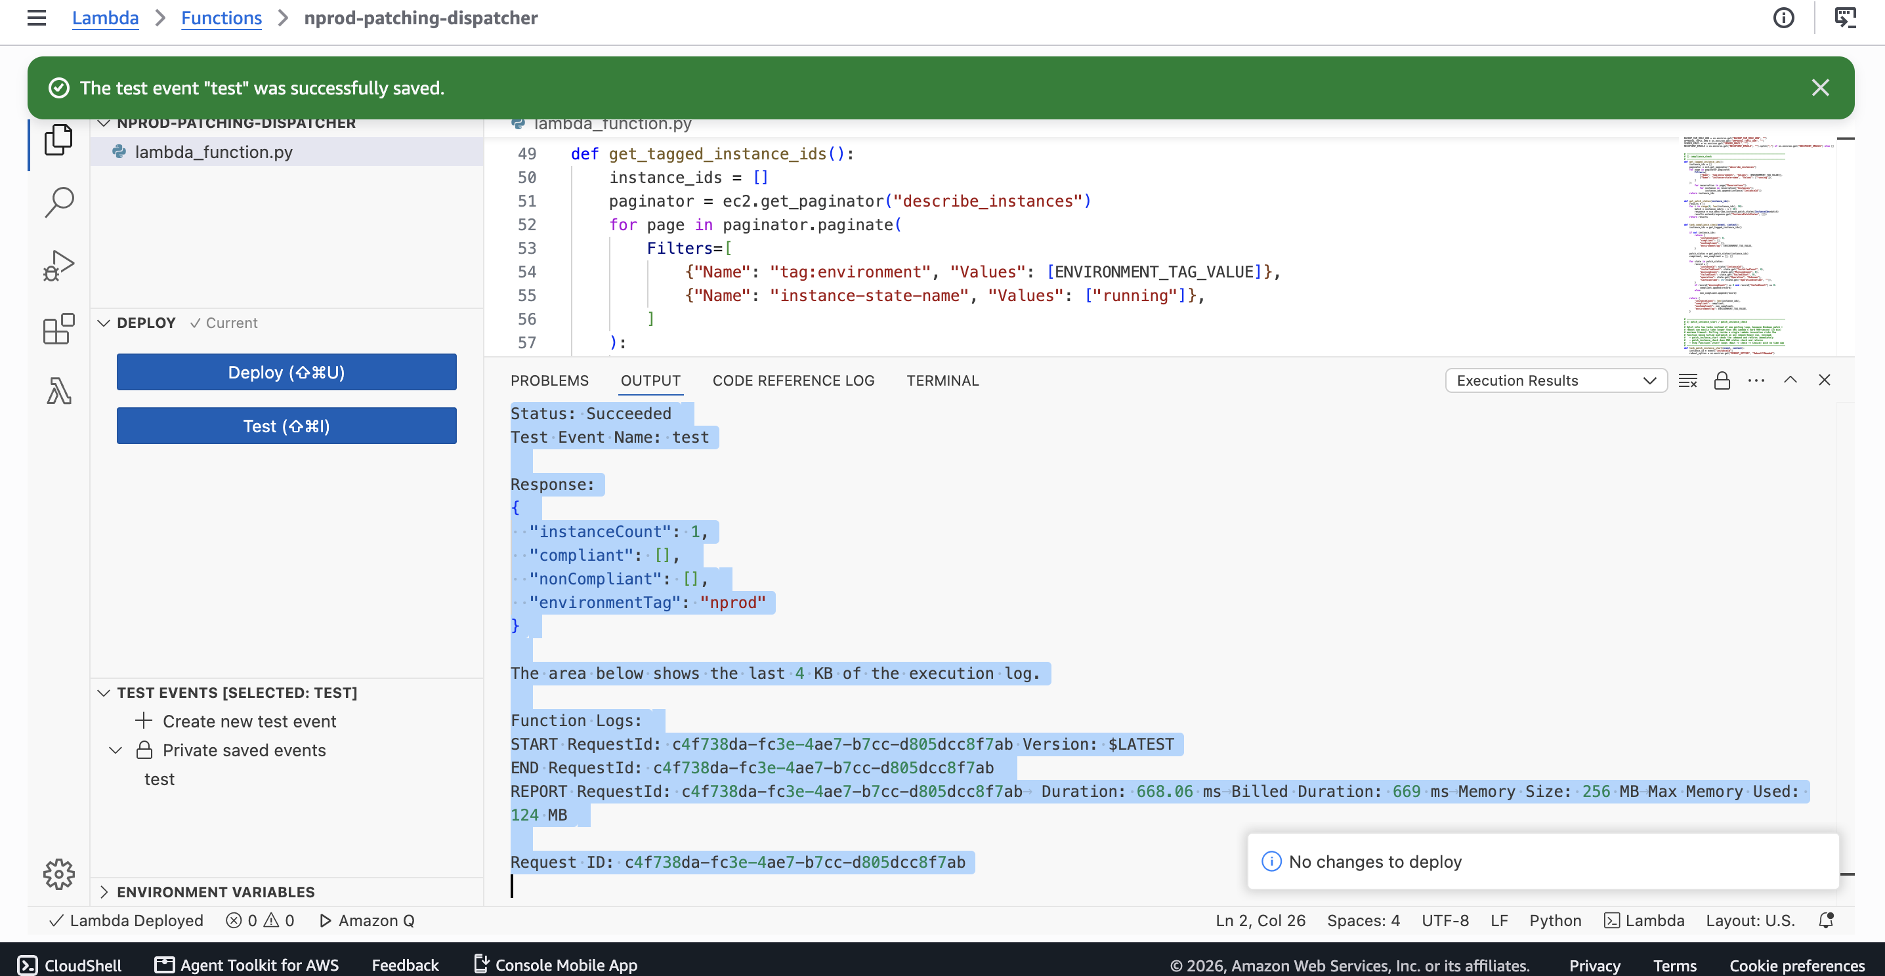
Figure 2 — AWS console validation during setup and testing
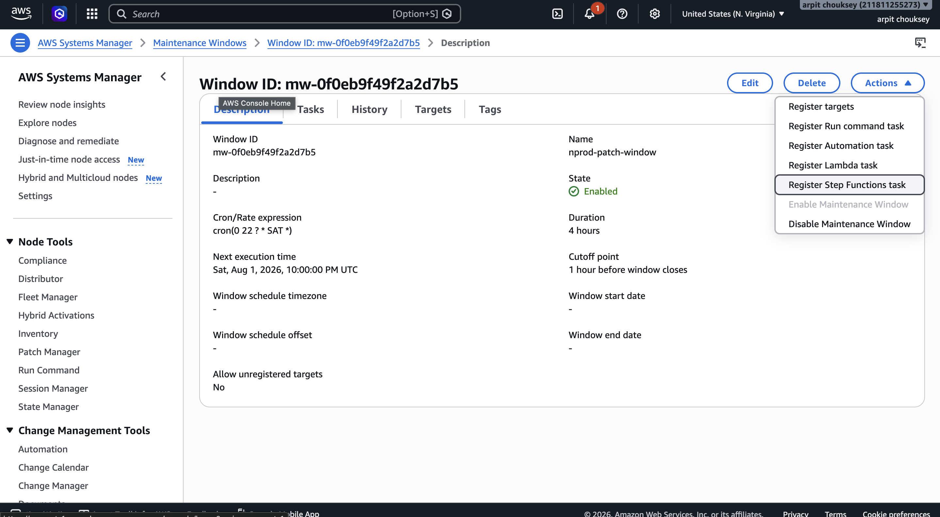
Figure 3 — AWS console validation during setup and testing
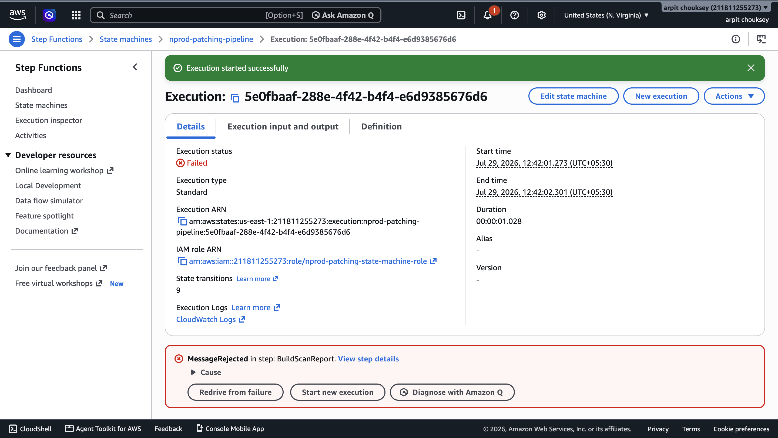
Figure 4 — AWS console validation during setup and testing
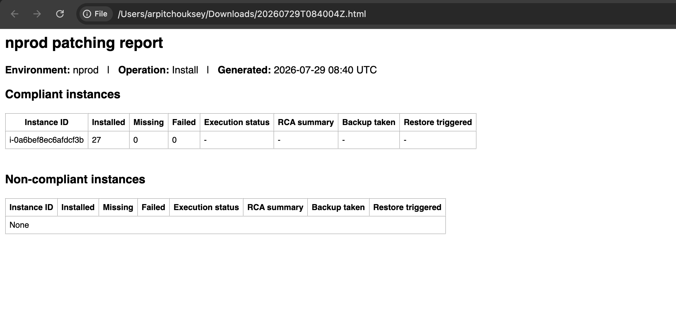
Figure 5 — AWS console validation during setup and testing

