📋 STEP-BY-STEP EXECUTION
Session 1 — Multi-Account Foundation
Create AWS Organization with management, dev, and prod accounts along with cross-account IAM role setup for Terraform access.

Session Overview
This document covers the live execution of Session 1 — Multi-Account Foundation. Every step below includes the exact CLI commands and screenshots taken during live creation.

Sessions covered in this Phase 1 guide:
- Session 1 — Multi-Account Foundation: Create AWS Organization with management, dev, and prod accounts along with cross-account IAM role setup for Terraform access.
- Session 2 — Production VPC Architecture: Design and create production-grade VPC networking with public/private subnets, route tables, IGW, and NAT Gateway.
- Session 3 — Security Layer Setup: Implement Security Groups, IAM roles, and controlled access policies for ALB, Bastion, and private EC2 instances.
- Session 4 — ALB + Launch Template + ASG Setup: Deploy scalable compute architecture using Application Load Balancer, Launch Template, and Auto Scaling Group.
- Session 5 — HPA-like Auto Scaling Configuration: Configure CPU-based target tracking policies for dynamic scale-in and scale-out behavior.
- Session 6 — Bastion Host Access Setup: Configure Bastion Host for secure SSH access to private EC2 instances using restricted IP-based access.
- Session 7 — AWS WAF Security Integration: Implement AWS WAF with IP allow-listing and managed protection rules for external traffic filtering.
- Session 8 — API Gateway Integration: Configure API Gateway in front of ALB for centralized API routing, throttling, and layered security.
- Session 9 — Terraform Remote Backend Setup: Configure S3 backend and DynamoDB state locking for secure and centralized Terraform state management.
- Session 10 — Terraform Module Architecture: Build reusable Terraform modules for networking, security, compute, WAF, and API Gateway components.
- Session 11 — Terraform Import (Brownfield Infrastructure): Import manually created AWS resources into Terraform state for production-style infrastructure management.
- Session 12 — Drift Detection & Reconciliation: Simulate infrastructure drift and detect configuration changes using Terraform plan and reconciliation workflows.
- Session 13 — GitLab CI/CD Pipeline Setup: Implement GitLab CI/CD pipelines for Terraform fmt, validate, plan, and controlled apply workflows.
- Session 14 — Production Security Hardening: Apply encryption, least-privilege IAM, restricted access controls, and infrastructure security best practices.
- Session 15 — Failure Recovery & Operational Validation: Test state lock recovery, partial deployment failures, rollback handling, and operational resilience scenarios.
- Session 16 — Documentation & Interview Mapping: Prepare architecture diagrams, operational runbooks, Terraform workflow documentation, and interview Q&A mapping.

Session 1 — Multi-Account Foundation
Create AWS Organization with management, dev, and prod accounts along with cross-account IAM role setup for Terraform access.

🟢 STEP 1 — Create Management (Root) Account
Go to AWS signup and fill in the following details:
- Email: yourmail@gmail.com
- Account name: management-account
Complete the following:
- Email verification
- Add card
- Choose Basic Support (Free)

🟢 STEP 2 — Login & Set Region
- Login to AWS Console
- Set region: ap-south-1 (Mumbai)

🟡 STEP 3 — Enable AWS Organizations
Navigate: AWS Console → AWS Organizations
Click: Create organization
⚠️ IMPORTANT: Select "Enable ALL FEATURES"

Screenshot — AWS Organizations Console:
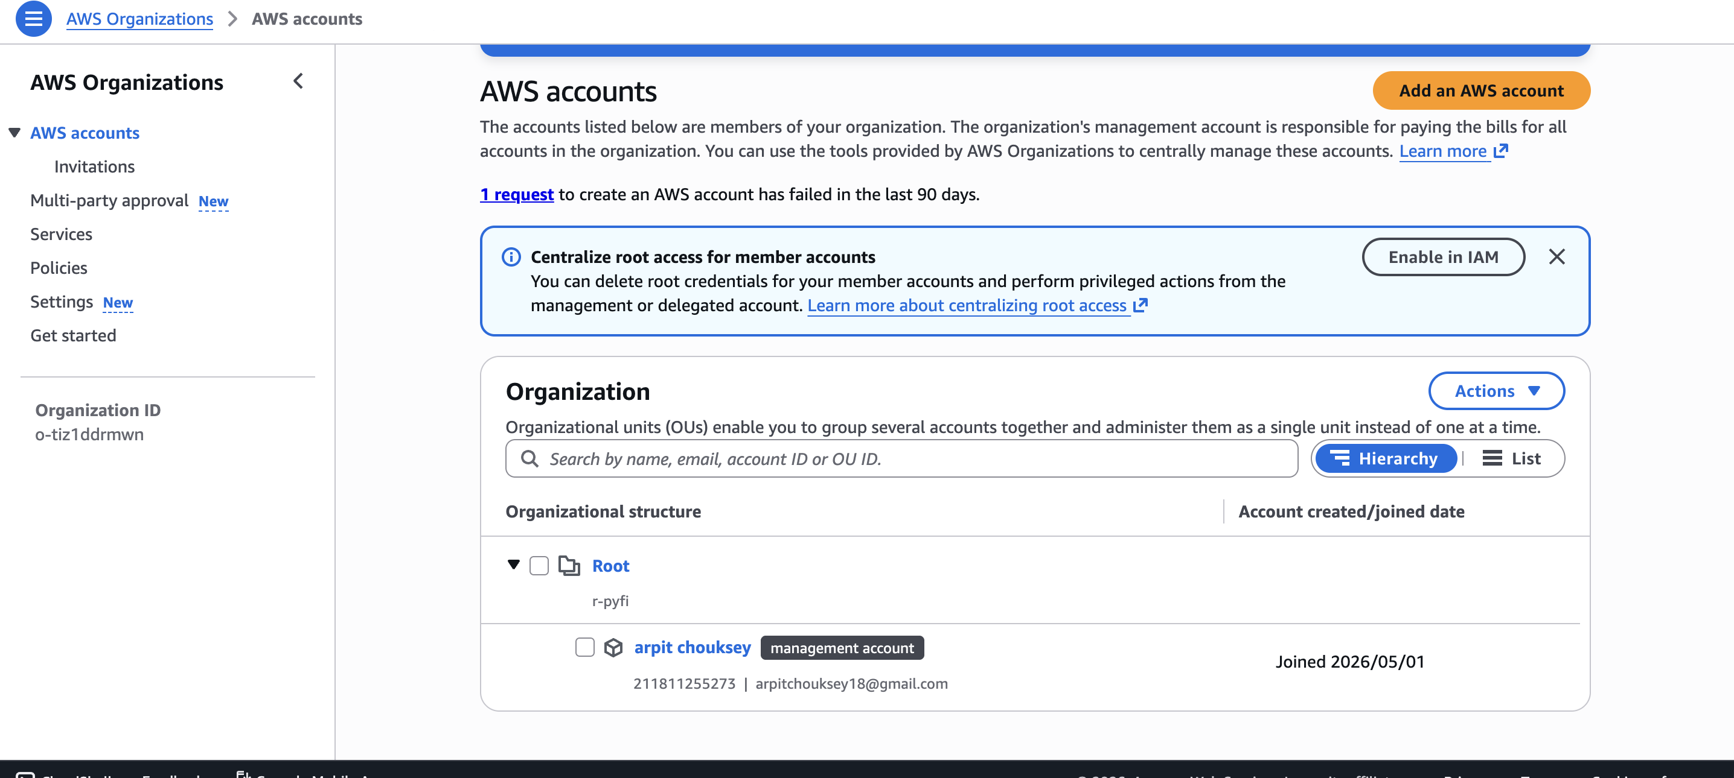

🟡 STEP 4 — Create DEV Account (From Organization)
Go to: AWS Organizations → Accounts → Add account
Choose: Create account
Fill in the following details:
- Account name: dev-account
- Email: yourmail+dev@gmail.com
- IAM Role name (auto or custom): OrganizationAccountAccessRole
Click Create. Wait 1–2 minutes → account will be created.

Screenshot — DEV Account Creation:
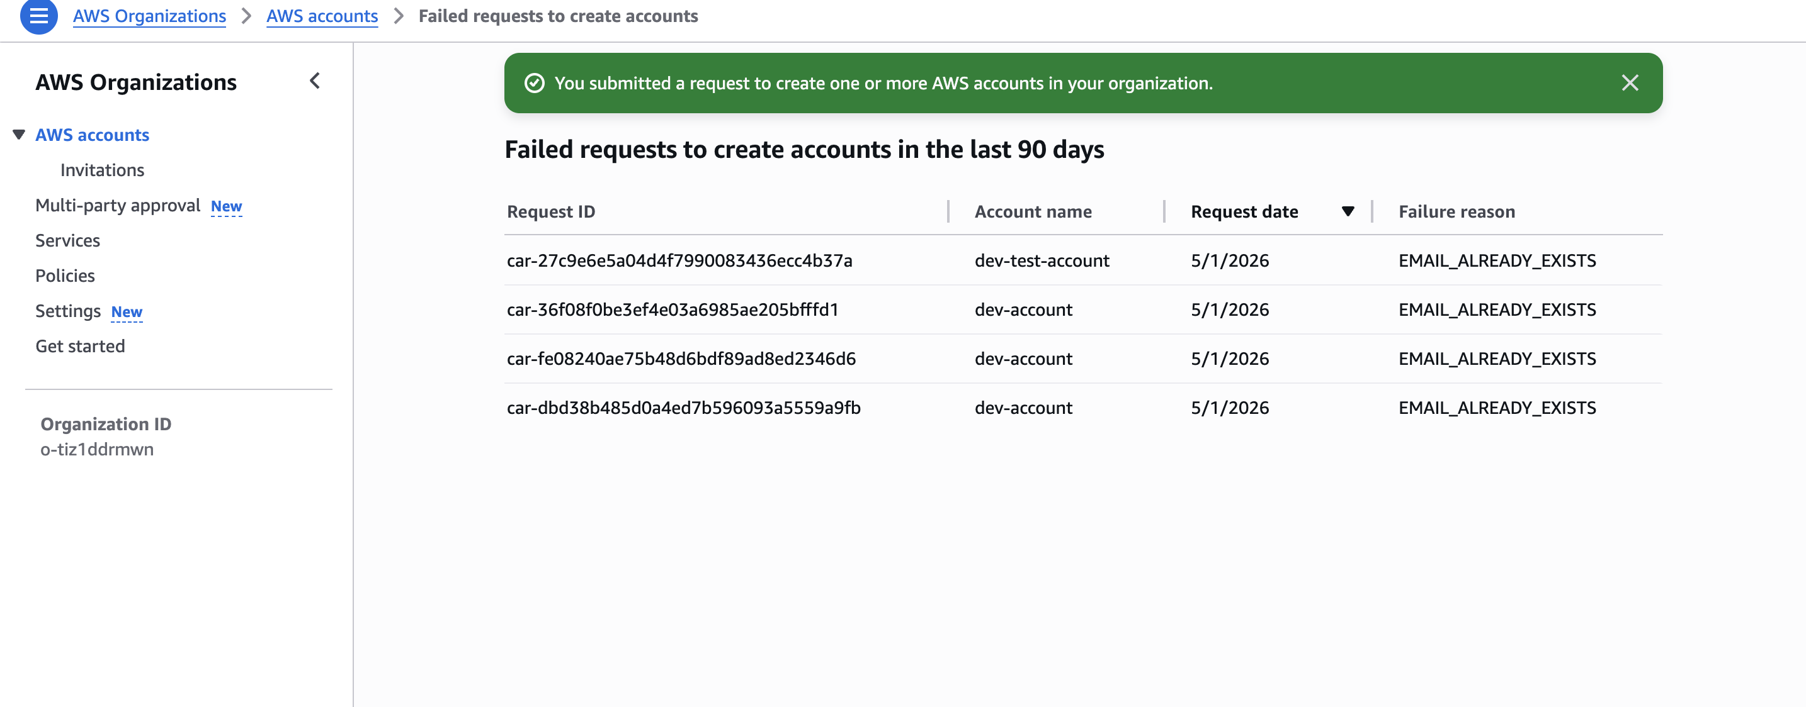

🟡 STEP 5 — Create PROD Account (Same Way)
Repeat with the following:
- Account name: prod-account
- Email: yourmail+prod@gmail.com
Both accounts have been created. Now we create one IAM admin user with Administrator permissions.

After account creation, we are able to switch roles. Now we want to create an IAM user for Terraform.

Screenshot — Current accounts view:
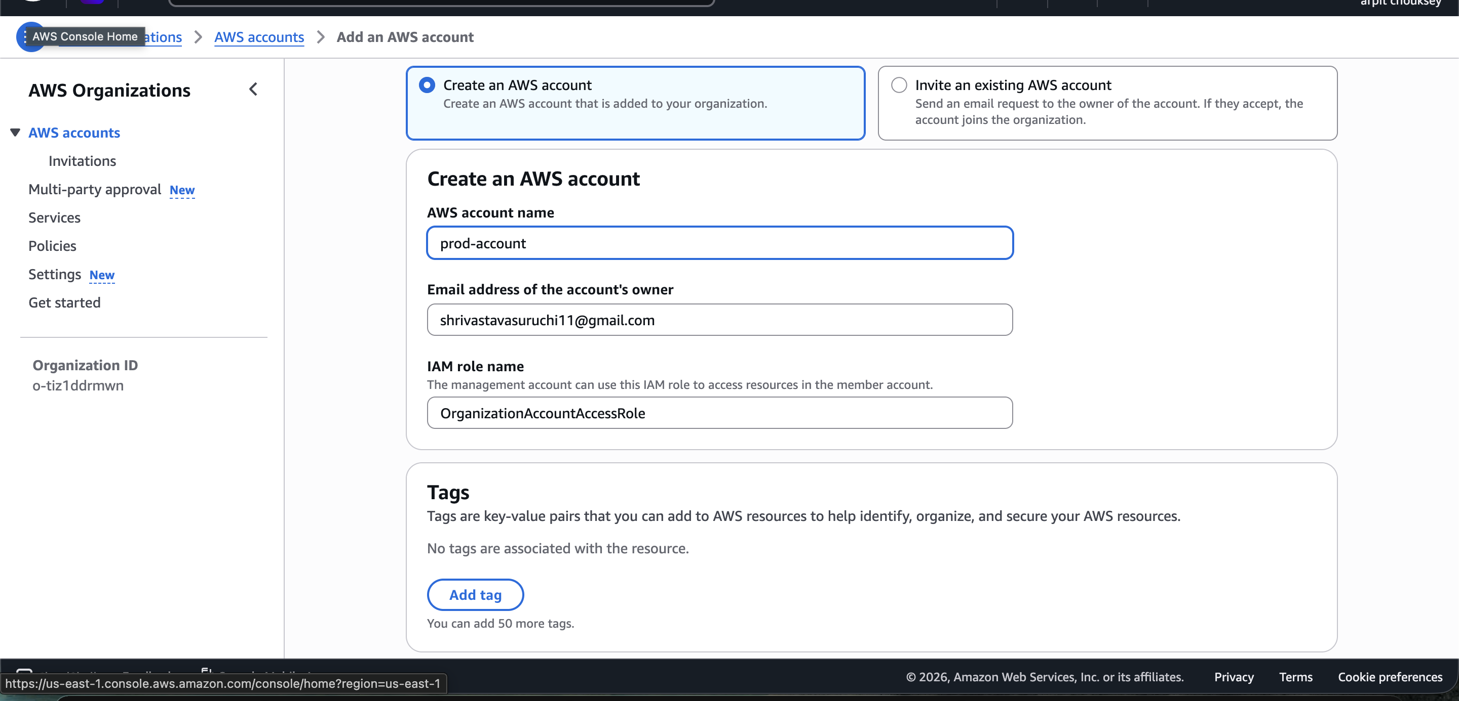

Create IAM Admin User for Root Account
Create admin user in the root/management account:
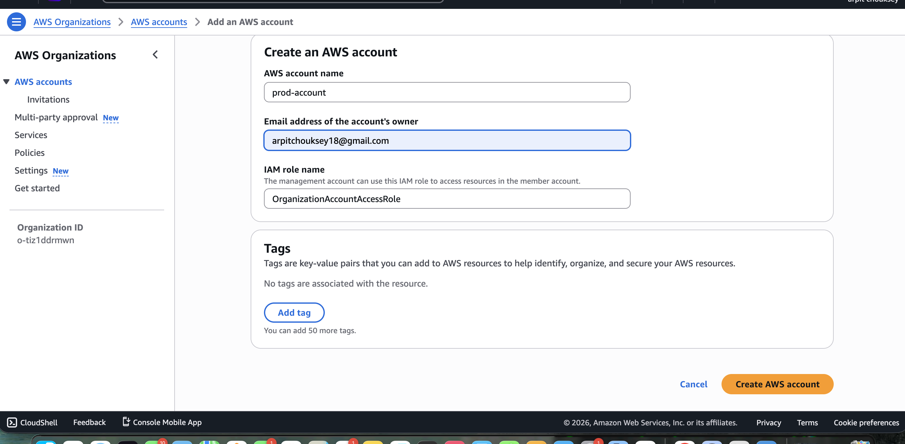

User is created. Now sign out of root user, and login again with the created admin user:
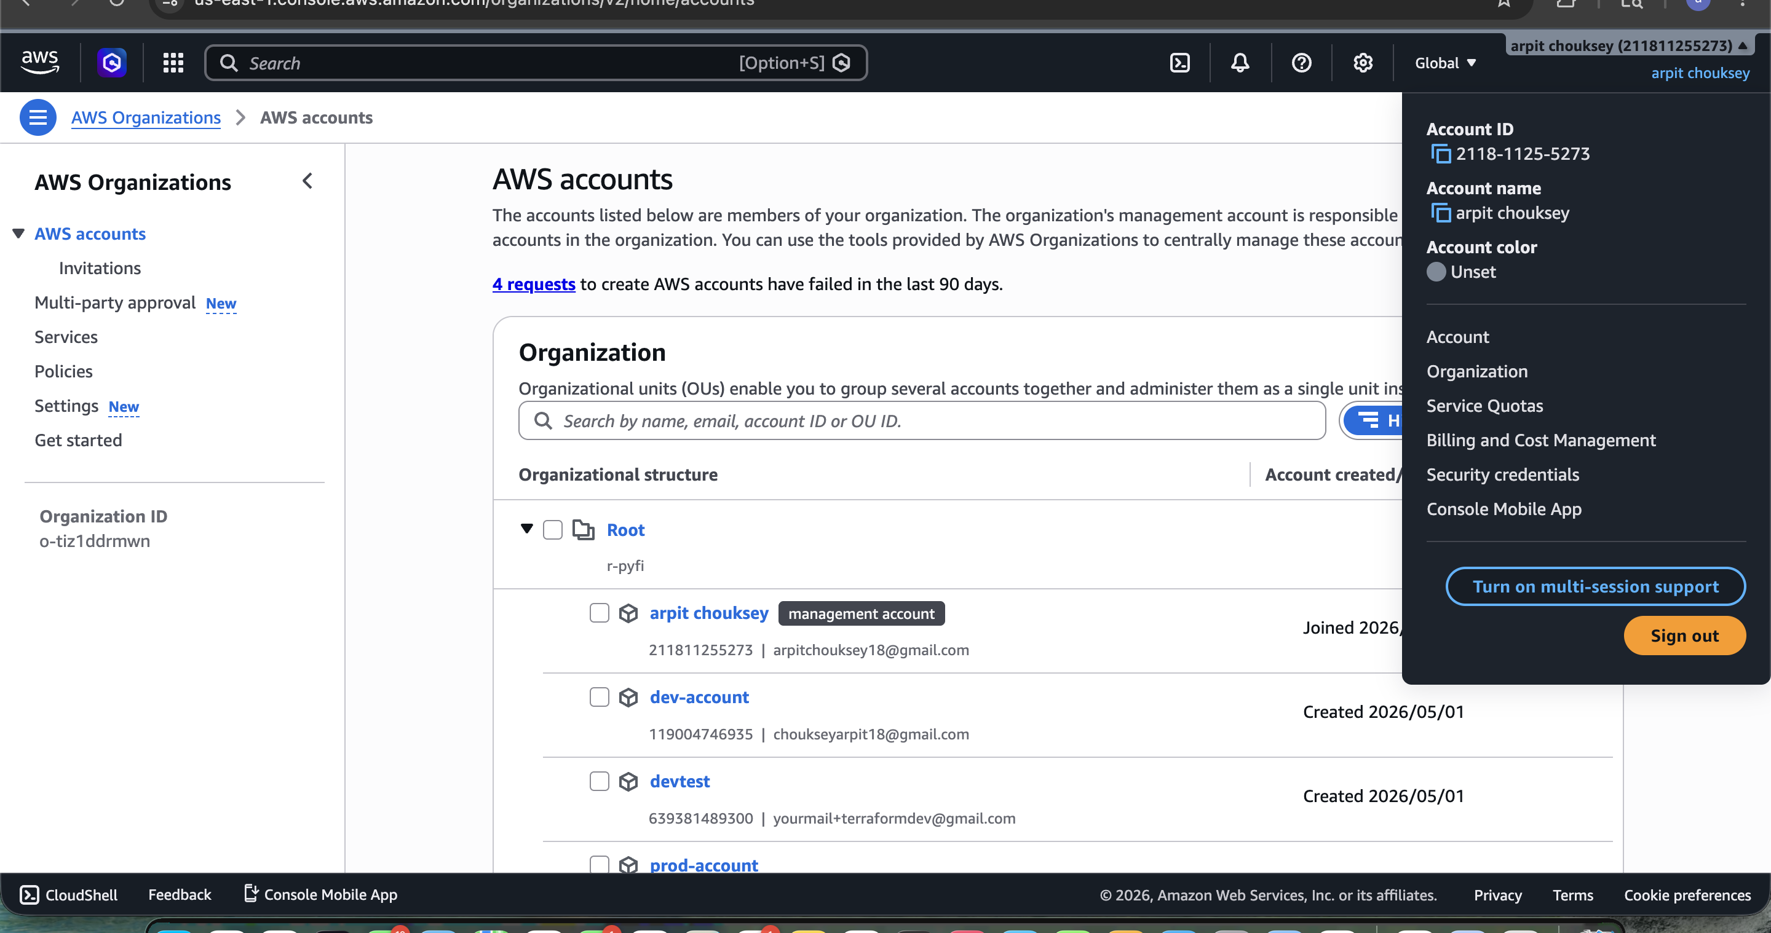

Now we are able to see the Switch Role option:
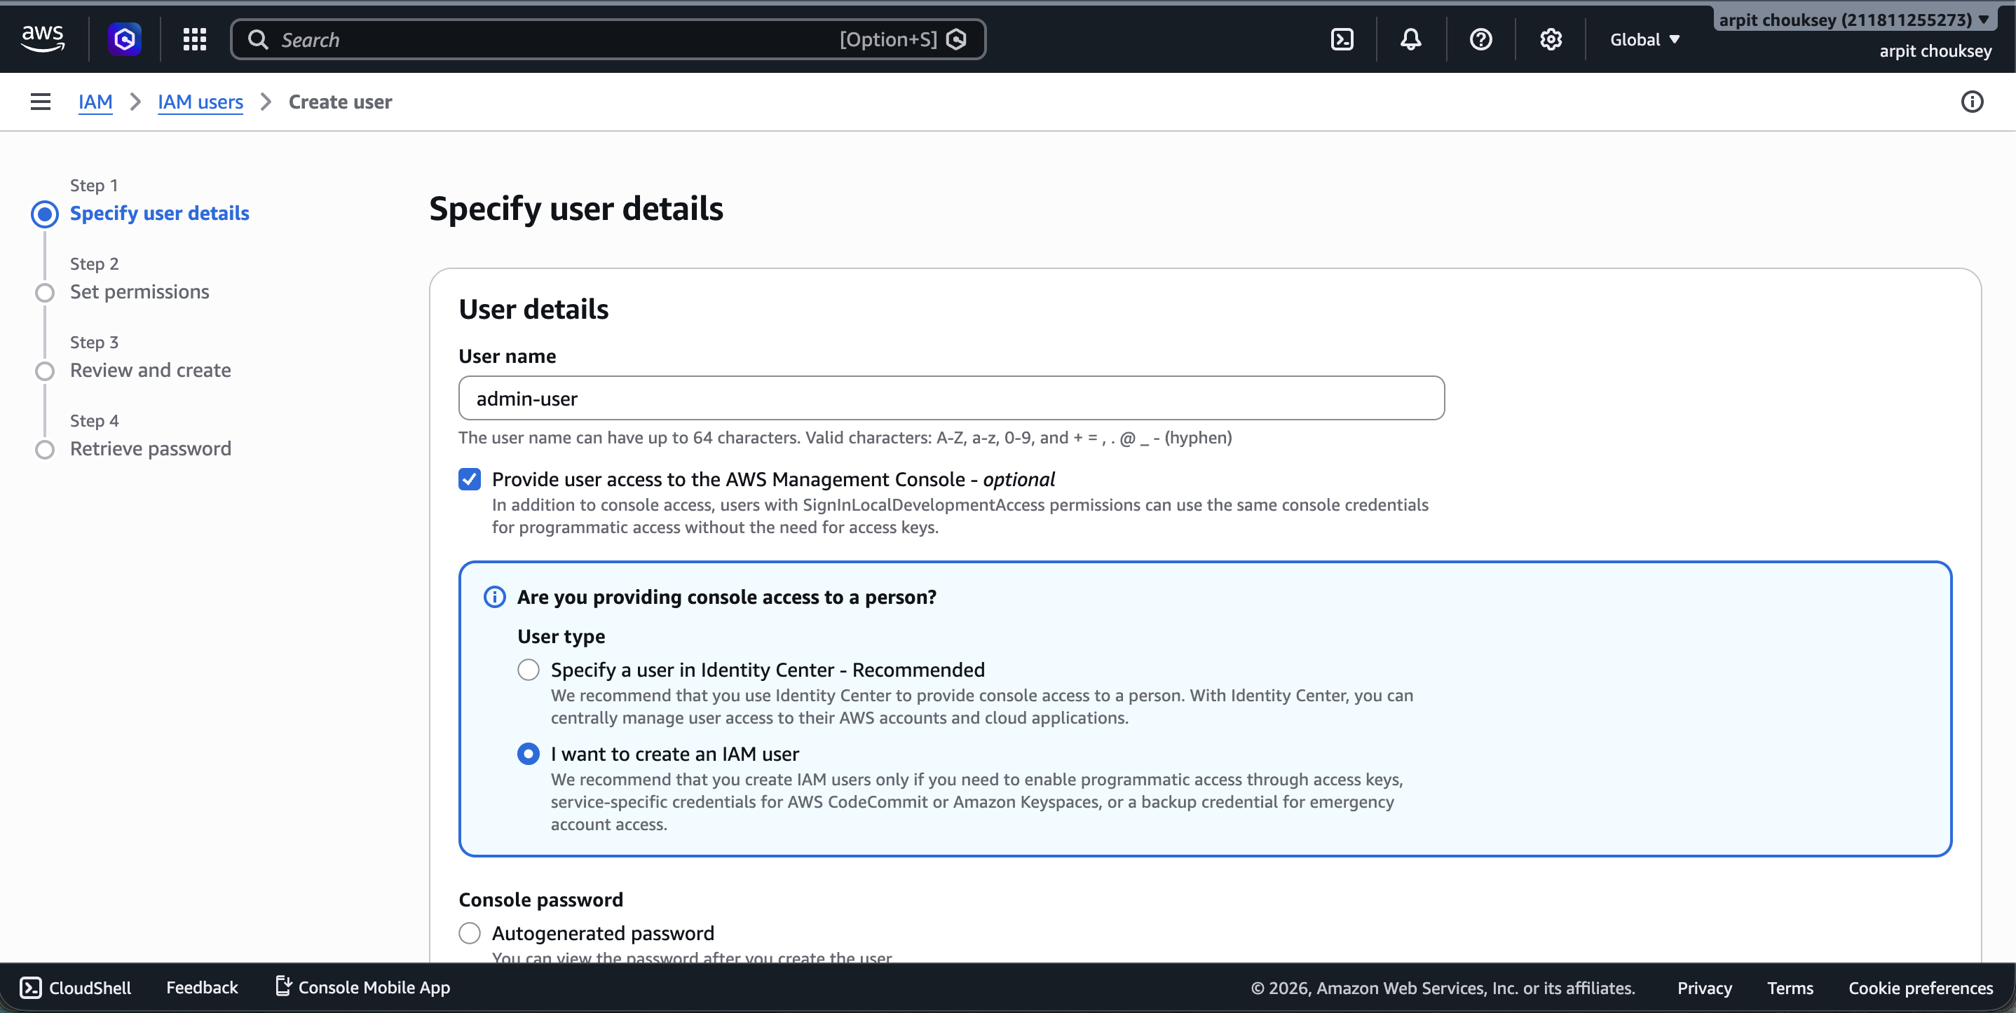

Switch Role to DEV Account
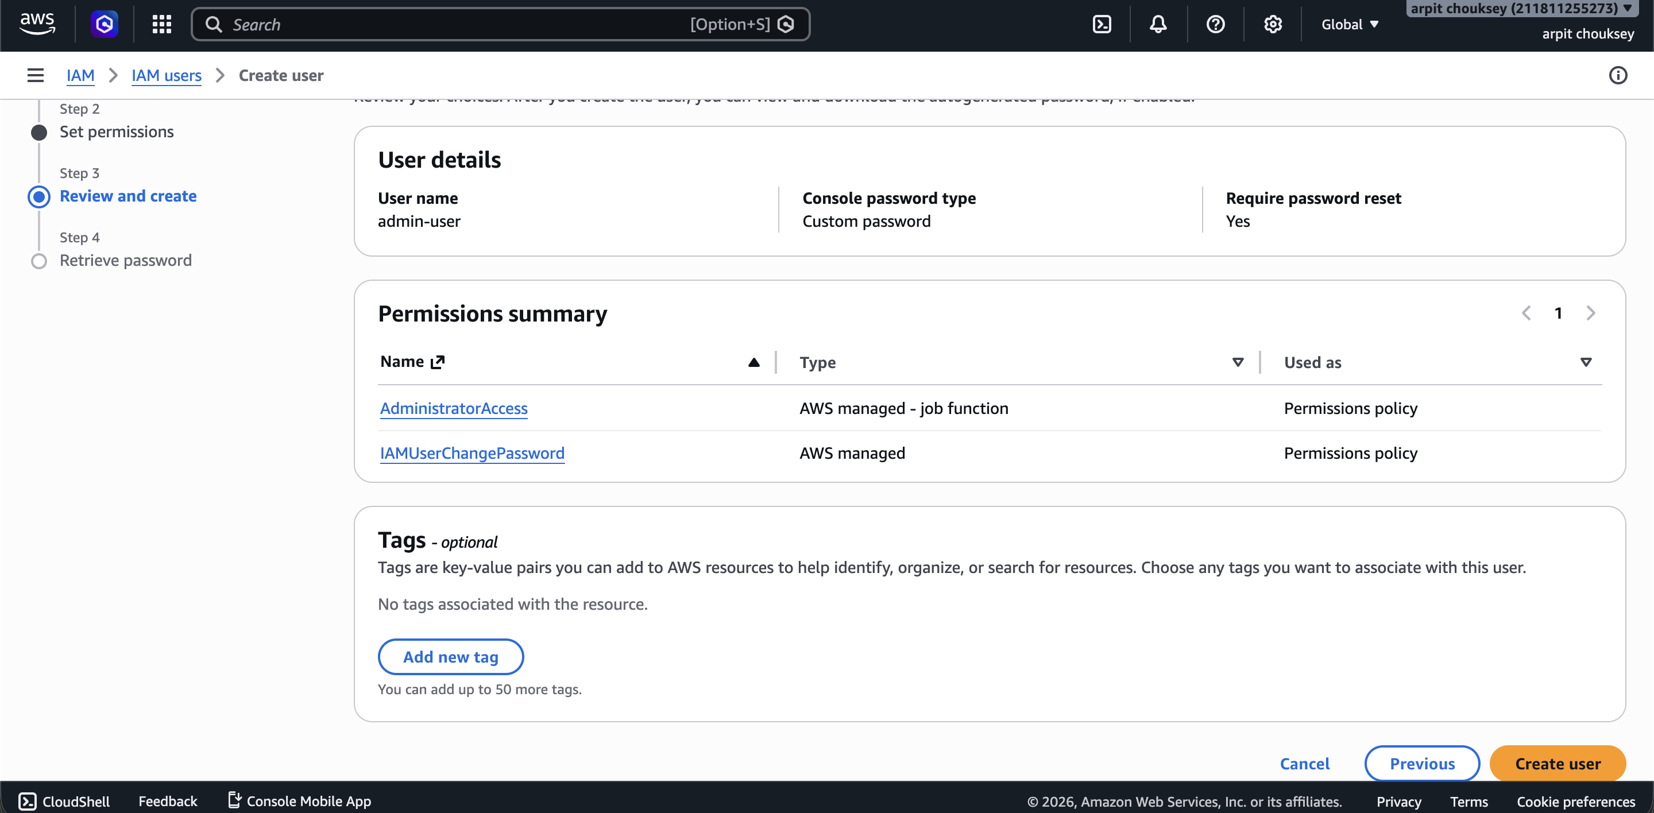

Error Encountered During Dev Account Setup
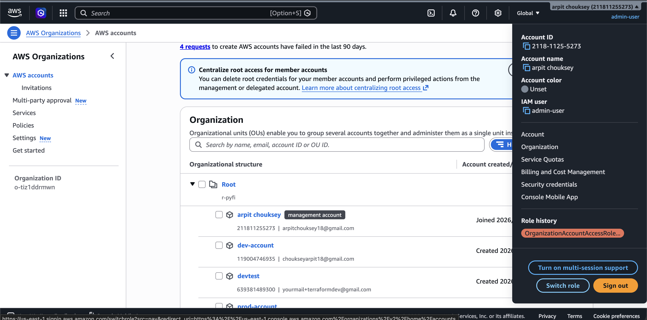

We are in the dev-account. Now create the Terraform user. Give management account here because:

Management Account
|
| AssumeRole
v
TerraformExecutionRole (Dev Account)

Only the management account is allowed to use this role.

Screenshot — Terraform user creation in dev-account:
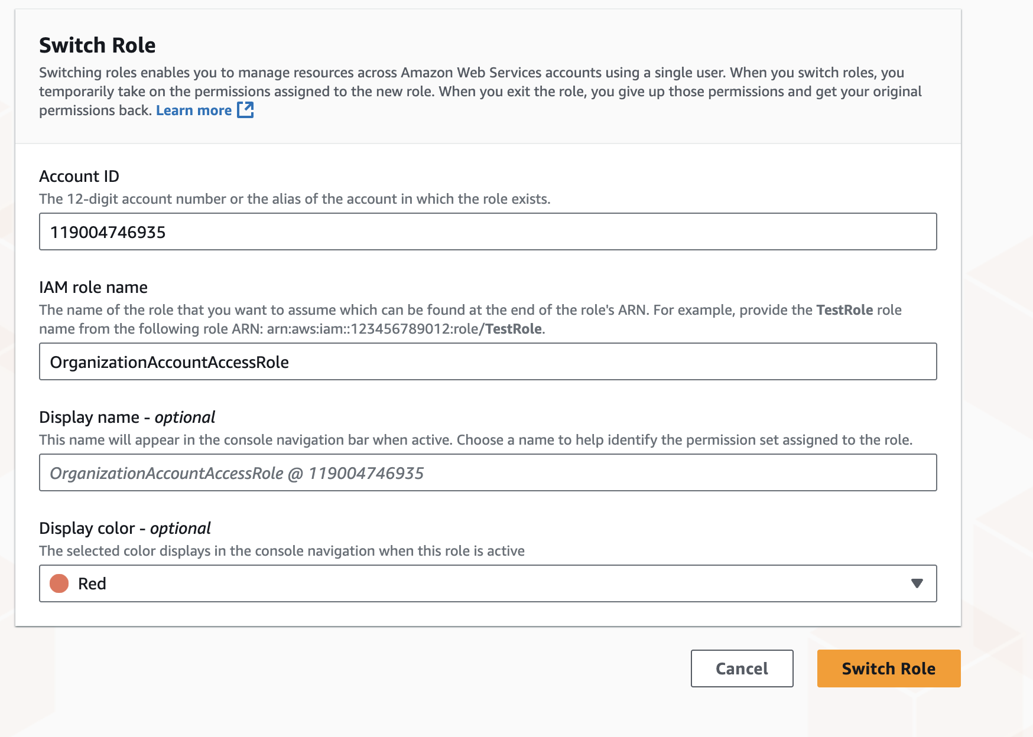

Switch to PROD Account — Create TerraformExecutionRole
Now switch to the prod account and create the role there:
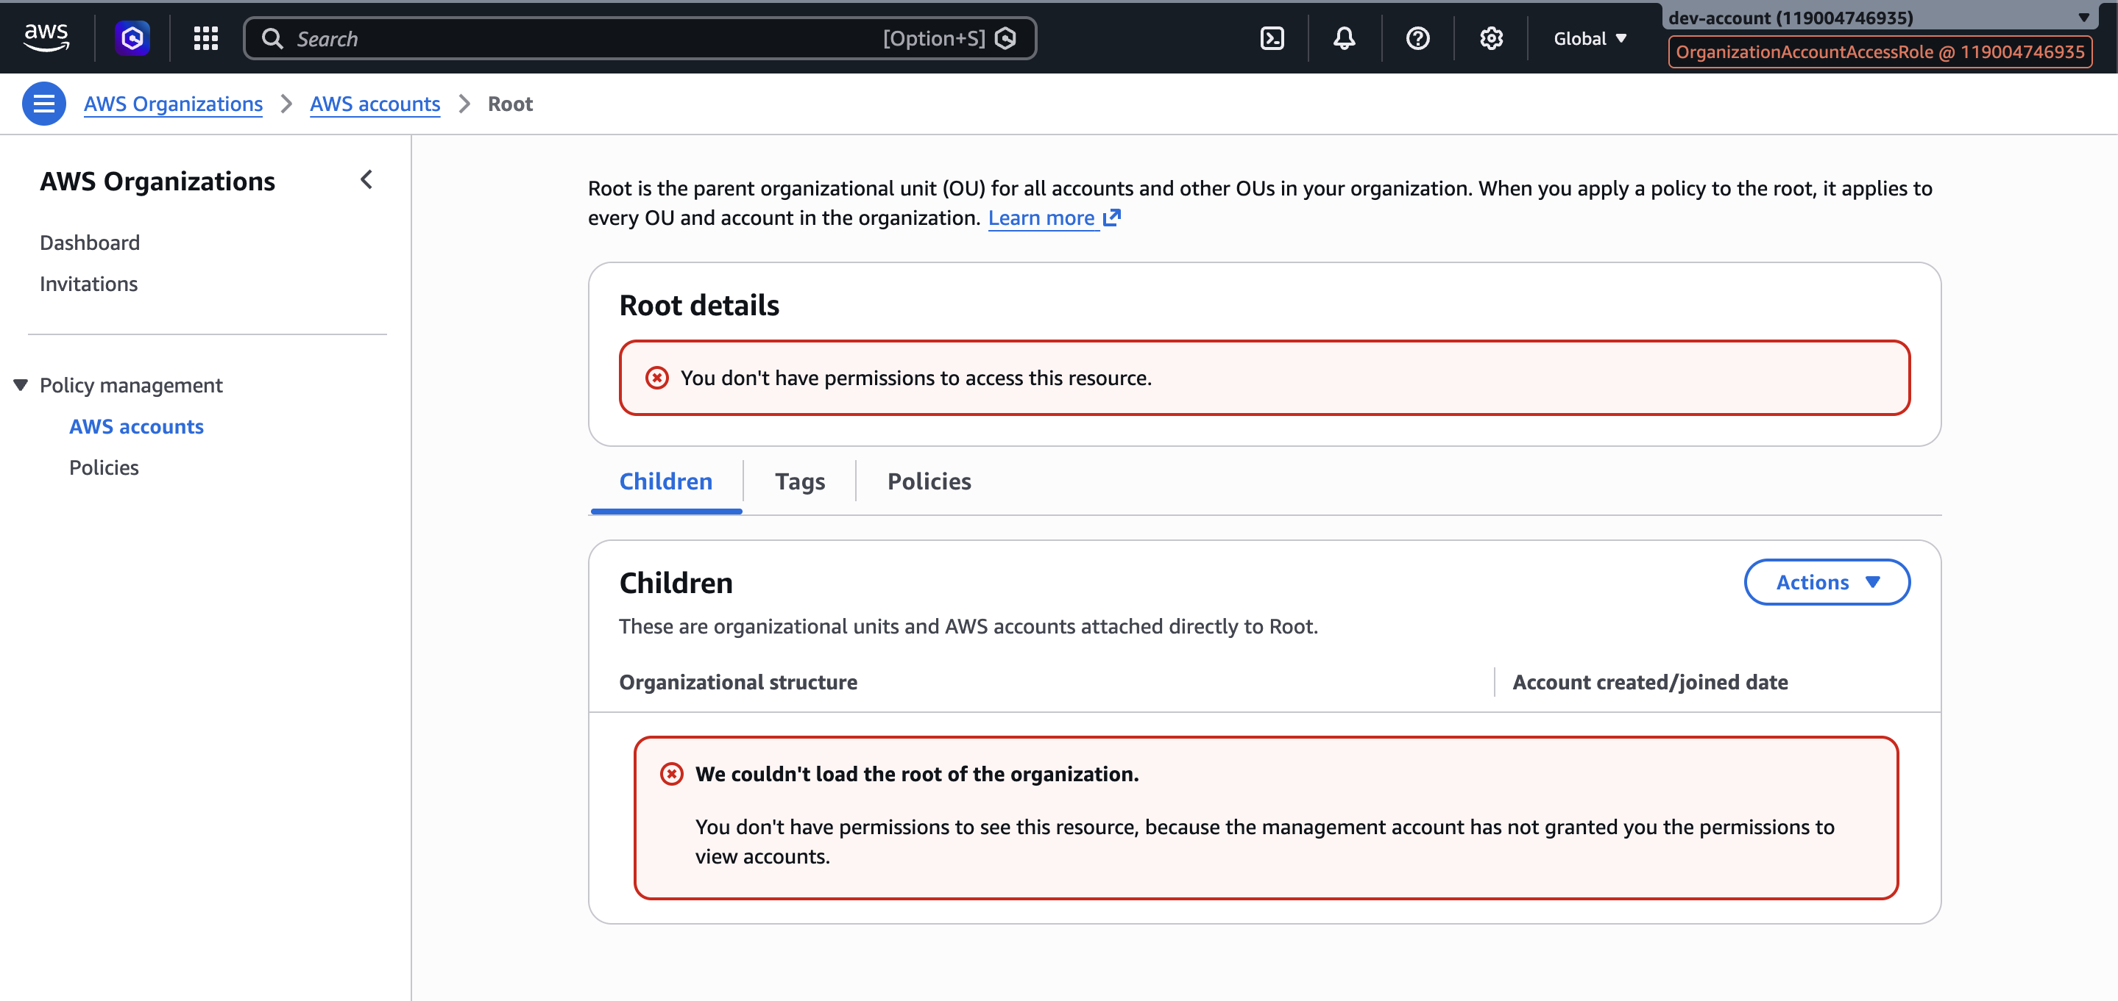

TerraformExecutionRole is now created in both accounts.

Automate Setup via Terraform

bootstrap.sh — Project Structure
#!/bin/bash
set -e
PROJECT="terraform-multi-env"

mkdir -p $PROJECT/modules/{iam-user,terraform-role,vpc,security,alb,launch-template,asg,waf,api-gateway}
mkdir -p $PROJECT/environments/{management,dev,prod}

for env in management dev prod
do
touch $PROJECT/environments/$env/main.tf
touch $PROJECT/environments/$env/provider.tf
touch $PROJECT/environments/$env/variables.tf
touch $PROJECT/environments/$env/terraform.tfvars
touch $PROJECT/environments/$env/backend.tf
done

echo "Terraform enterprise structure created successfully"

Project Directory Tree
.
├── bootstrap.sh
└── terraform-multi-env
├── environments
│ ├── dev
│ │ ├── backend.tf
│ │ ├── main.tf
│ │ ├── provider.tf
│ │ ├── terraform.tfvars
│ │ └── variables.tf
│ ├── management
│ │ ├── backend.tf
│ │ ├── main.tf
│ │ ├── provider.tf
│ │ ├── terraform.tfstate
│ │ ├── terraform.tfvars
│ │ └── variables.tf
│ └── prod
│ ├── backend.tf
│ ├── main.tf
│ ├── provider.tf
│ ├── terraform.tfvars
│ └── variables.tf
└── modules
├── alb
├── api-gateway
├── asg
├── iam-user
│ ├── main.tf
│ └── variables.tf
├── launch-template
├── security
├── terraform-role
├── vpc
└── waf

16 directories, 19 files

provider.tf — Management Environment
terraform {
required_version = ">= 1.5"
required_providers {
aws = {
source = "hashicorp/aws"
version = "~> 5.0"
}
}
}

provider "aws" {
region = "ap-south-1"
default_tags {
tags = {
Project = "terraform-multi-env"
Environment = "management"
ManagedBy = "terraform"
}
}
}

main.tf — Management Environment
module "admin_user" {
source = "../../modules/iam-user"
user_name = "admin-user"
environment = "management"
}

terraform init — Management
arpitchouksey@Arpits-MacBook-Air management % terraform init
Initializing the backend...
Initializing modules...
- admin_user in ../../modules/iam-user
Initializing provider plugins...
- Reusing previous version of hashicorp/aws from the dependency lock file
- Using previously-installed hashicorp/aws v5.100.0

Terraform has been successfully initialized!

terraform import — admin-user IAM User
arpitchouksey@Arpits-MacBook-Air management % terraform import module.admin_user.aws_iam_user.this admin-user
module.admin_user.aws_iam_user.this: Importing from ID "admin-user"...
module.admin_user.aws_iam_user.this: Import prepared!
Prepared aws_iam_user for import
module.admin_user.aws_iam_user.this: Refreshing state... [id=admin-user]

Import successful!
The resources that were imported are shown above. These resources are now in
your Terraform state and will henceforth be managed by Terraform.

terraform import — IAM Policy Attachment (AdministratorAccess)
arpitchouksey@Arpits-MacBook-Air management % terraform import \
module.admin_user.aws_iam_user_policy_attachment.admin_attach \
admin-user/arn:aws:iam::aws:policy/AdministratorAccess

module.admin_user.aws_iam_user_policy_attachment.admin_attach: Importing from ID ...
module.admin_user.aws_iam_user_policy_attachment.admin_attach: Import prepared!
Prepared aws_iam_user_policy_attachment for import
module.admin_user.aws_iam_user_policy_attachment.admin_attach: Refreshing state...

Import successful!

Error — Resource Already Managed by Terraform
arpitchouksey@Arpits-MacBook-Air management % terraform import \
module.admin_user.aws_iam_user_policy_attachment.admin_attach \
admin-user/arn:aws:iam::aws:policy/IAMUserChangePassword

╷
│ Error: Resource already managed by Terraform
│
│ Terraform is already managing a remote object for
│ module.admin_user.aws_iam_user_policy_attachment.admin_attach.
│ To import to this address you must first remove the existing object from the state.
╵

terraform plan — After Import
arpitchouksey@Arpits-MacBook-Air management % terraform plan
module.admin_user.aws_iam_user.this: Refreshing state... [id=admin-user]
module.admin_user.aws_iam_user_policy_attachment.admin_attach: Refreshing state...

Terraform will perform the following actions:

# module.admin_user.aws_iam_user.this will be updated in-place
~ resource "aws_iam_user" "this" {
+ force_destroy = false
id = "admin-user"
name = "admin-user"
~ tags = {
+ "Environment" = "management"
+ "Project" = "terraform-multi-env"
}
}

Plan: 0 to add, 1 to change, 0 to destroy.

terraform apply — admin-user
arpitchouksey@Arpits-MacBook-Air management % terraform apply
...
Do you want to perform these actions?
Only 'yes' will be accepted to approve.

Enter a value: yes

module.admin_user.aws_iam_user.this: Modifying... [id=admin-user]
module.admin_user.aws_iam_user.this: Modifications complete after 1s [id=admin-user]

Apply complete! Resources: 0 added, 1 changed, 0 destroyed.

Organization Module — Terraform

Create Organization Module Files
arpitchouksey@Arpits-MacBook-Air modules % mkdir organization
arpitchouksey@Arpits-MacBook-Air modules % cd organization
arpitchouksey@Arpits-MacBook-Air organization % vi main.tf
arpitchouksey@Arpits-MacBook-Air organization % vi variables.tf
arpitchouksey@Arpits-MacBook-Air organization % vi outputs.tf

modules/organization/main.tf
resource "aws_organizations_organization" "this" {
aws_service_access_principals = [
"cloudtrail.amazonaws.com",
"config.amazonaws.com"
]
feature_set = "ALL"
lifecycle {
prevent_destroy = true
}
}

resource "aws_organizations_account" "accounts" {
for_each = var.accounts
name = each.value.name
email = each.value.email
role_name = "OrganizationAccountAccessRole"
lifecycle {
prevent_destroy = true
ignore_changes = [role_name]
}
}

modules/organization/variables.tf
variable "accounts" {
type = map(object({
name = string
email = string
}))
}

modules/organization/outputs.tf
output "organization_id" {
value = aws_organizations_organization.this.id
}

output "accounts" {
value = aws_organizations_account.accounts
}

terraform init — Organization Module
arpitchouksey@Arpits-MacBook-Air management % terraform init
Initializing the backend...
Initializing modules...
- organization in ../../modules/organization
Initializing provider plugins...
- Reusing previous version of hashicorp/aws from the dependency lock file
- Using previously-installed hashicorp/aws v5.100.0

Terraform has been successfully initialized!

terraform import — Organization & Accounts
# Import the Organization
arpitchouksey@Arpits-MacBook-Air management % terraform import \
module.organization.aws_organizations_organization.this o-tiz1ddrmwn
Import successful!

# Import DEV account (ID: 119004746935)
arpitchouksey@Arpits-MacBook-Air management % terraform import \
'module.organization.aws_organizations_account.accounts["dev"]' 119004746935
Import successful!

# Import PROD account (ID: 796761618375)
arpitchouksey@Arpits-MacBook-Air management % terraform import \
'module.organization.aws_organizations_account.accounts["prod"]' 796761618375
Import successful!

# Import DEVTEST account (ID: 639381489300)
arpitchouksey@Arpits-MacBook-Air management % terraform import \
'module.organization.aws_organizations_account.accounts["devtest"]' 639381489300
Import successful!

Screenshot — After import of all accounts:
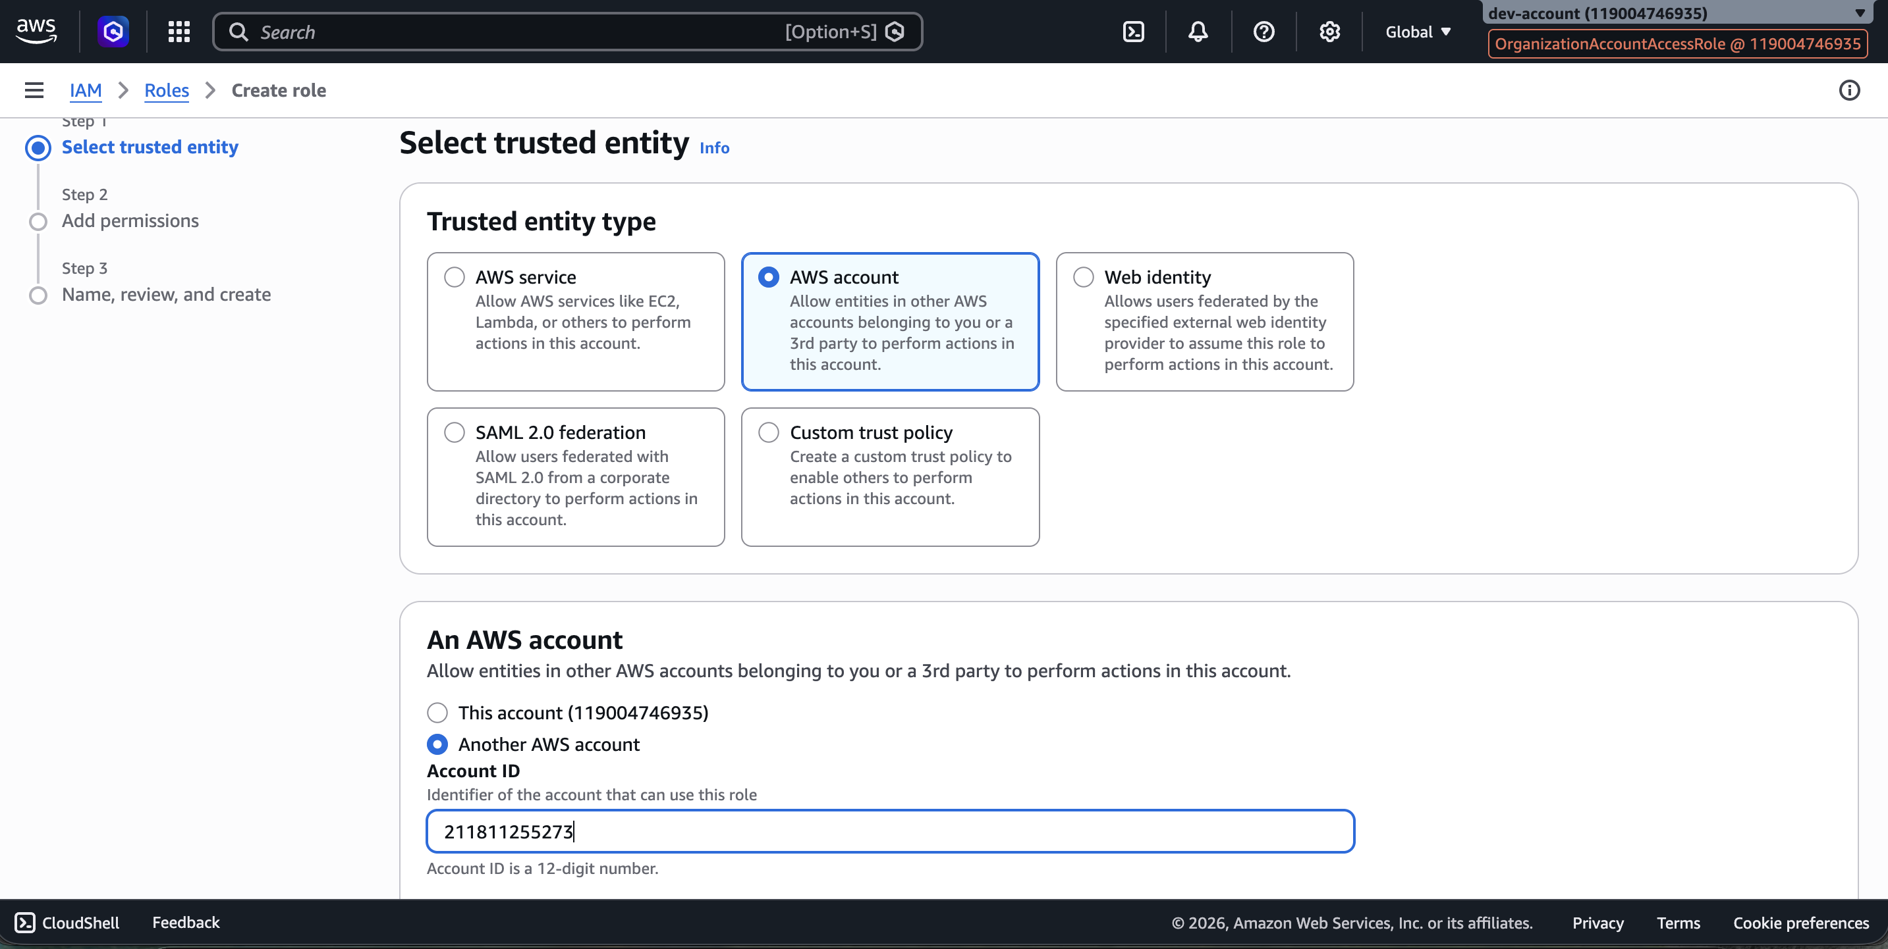

environments/management/main.tf — With Organization Module
module "admin_user" {
source = "../../modules/iam-user"
user_name = "admin-user"
environment = "management"
}

module "organization" {
source = "../../modules/organization"
accounts = {
dev = {
name = "dev-account"
email = "choukseyarpit18@gmail.com"
}
prod = {
name = "prod-account"
email = "shrivastavasuruchi11@gmail.com"
}
devtest = {
name = "devtest"
email = "yourmail+terraformdev@gmail.com"
}
}
}

terraform plan — Organization
arpitchouksey@Arpits-MacBook-Air management % terraform plan
module.admin_user.aws_iam_user.this: Refreshing state... [id=admin-user]
module.organization.aws_organizations_account.accounts["prod"]: Refreshing state... [id=796761618375]
module.organization.aws_organizations_account.accounts["dev"]: Refreshing state... [id=119004746935]
module.organization.aws_organizations_account.accounts["devtest"]: Refreshing state... [id=639381489300]
module.organization.aws_organizations_organization.this: Refreshing state... [id=o-tiz1ddrmwn]
module.admin_user.aws_iam_user_policy_attachment.admin_attach: Refreshing state...

Plan: 0 to add, 4 to change, 0 to destroy.

terraform apply — Organization
arpitchouksey@Arpits-MacBook-Air management % terraform apply
...
Enter a value: yes

module.organization.aws_organizations_account.accounts["dev"]: Modifying... [id=119004746935]
module.organization.aws_organizations_account.accounts["prod"]: Modifying... [id=796761618375]
module.organization.aws_organizations_account.accounts["devtest"]: Modifying... [id=639381489300]
module.organization.aws_organizations_organization.this: Modifying... [id=o-tiz1ddrmwn]
module.organization.aws_organizations_account.accounts["dev"]: Modifications complete after 2s
module.organization.aws_organizations_account.accounts["prod"]: Modifications complete after 2s
module.organization.aws_organizations_account.accounts["devtest"]: Modifications complete after 2s
module.organization.aws_organizations_organization.this: Modifications complete after 3s

Apply complete! Resources: 0 added, 4 changed, 0 destroyed.

TerraformExecutionRole — DEV Account Import

environments/dev/main.tf
module "terraform_execution_role" {
source = "../../modules/terraform-role"
role_name = "TerraformExecutionRole"
management_account_id = "211811255273"
environment = "dev"
}

terraform init — DEV
arpitchouksey@Arpits-MacBook-Air dev % terraform init
Initializing the backend...
Initializing modules...
- terraform_execution_role in ../../modules/terraform-role
Initializing provider plugins...
- Finding hashicorp/aws versions matching "~> 5.0"...
- Installing hashicorp/aws v5.100.0...
- Installed hashicorp/aws v5.100.0 (signed by HashiCorp)

Terraform has been successfully initialized!

terraform import — TerraformExecutionRole in DEV
# Import the IAM Role
arpitchouksey@Arpits-MacBook-Air dev % terraform import \
module.terraform_execution_role.aws_iam_role.terraform_execution_role TerraformExecutionRole

module.terraform_execution_role.aws_iam_role.terraform_execution_role: Import prepared!
Import successful!

# Import the policy attachment
arpitchouksey@Arpits-MacBook-Air dev % terraform import \
module.terraform_execution_role.aws_iam_role_policy_attachment.admin_attach \
TerraformExecutionRole/arn:aws:iam::aws:policy/AdministratorAccess

Import successful!

terraform plan — DEV Role
arpitchouksey@Arpits-MacBook-Air dev % terraform plan

# module.terraform_execution_role.aws_iam_role.terraform_execution_role will be updated in-place
~ resource "aws_iam_role" "terraform_execution_role" {
~ assume_role_policy = jsonencode(
~ {
~ Statement = [
~ {
- Condition = {}
# (3 unchanged attributes hidden)
},
]
}
)
id = "TerraformExecutionRole"
name = "TerraformExecutionRole"
~ tags = {
+ "Environment" = "dev"
+ "ManagedBy" = "terraform"
+ "Project" = "terraform-multi-env"
}
}

Plan: 0 to add, 1 to change, 0 to destroy.

terraform apply — DEV Role
arpitchouksey@Arpits-MacBook-Air dev % terraform apply
Enter a value: yes

module.terraform_execution_role.aws_iam_role.terraform_execution_role: Modifying... [id=TerraformExecutionRole]
module.terraform_execution_role.aws_iam_role.terraform_execution_role: Modifications complete after 3s

Apply complete! Resources: 0 added, 1 changed, 0 destroyed.

Screenshot — DEV environment files:
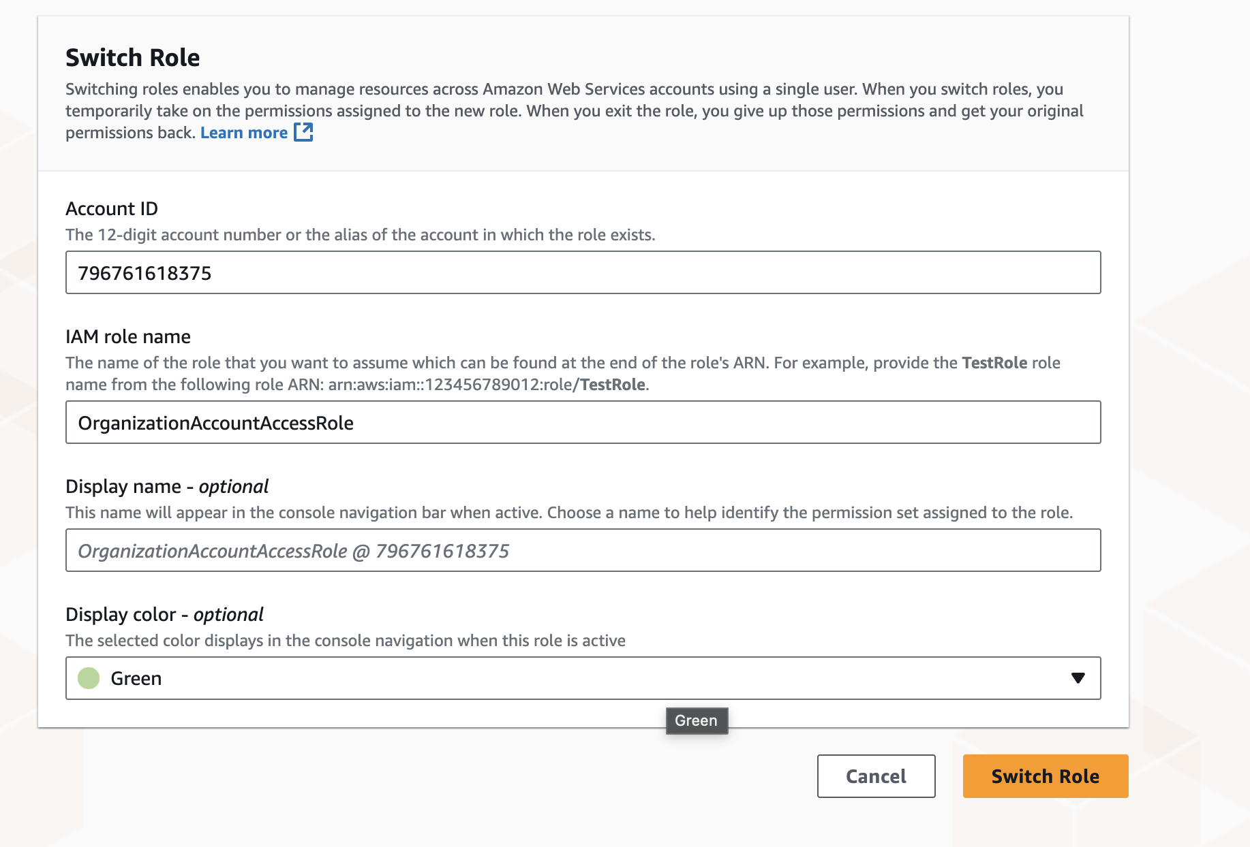

TerraformExecutionRole — PROD Account Import

environments/prod/main.tf
module "terraform_execution_role" {
source = "../../modules/terraform-role"
role_name = "TerraformExecutionRole"
management_account_id = "211811255273"
environment = "prod"
}

terraform init — PROD
arpitchouksey@Arpits-MacBook-Air prod % terraform init
Initializing the backend...
Initializing modules...
- terraform_execution_role in ../../modules/terraform-role
Initializing provider plugins...
- Installing hashicorp/aws v5.100.0...
- Installed hashicorp/aws v5.100.0 (signed by HashiCorp)

Terraform has been successfully initialized!

terraform import — TerraformExecutionRole in PROD
arpitchouksey@Arpits-MacBook-Air prod % terraform import \
module.terraform_execution_role.aws_iam_role.terraform_execution_role TerraformExecutionRole
Import successful!

arpitchouksey@Arpits-MacBook-Air prod % terraform import \
module.terraform_execution_role.aws_iam_role_policy_attachment.admin_attach \
TerraformExecutionRole/arn:aws:iam::aws:policy/AdministratorAccess
Import successful!

terraform plan — PROD Role
Plan: 0 to add, 1 to change, 0 to destroy.
(Tags to be added: Environment=prod, ManagedBy=terraform, Project=terraform-multi-env)

terraform apply — PROD Role
arpitchouksey@Arpits-MacBook-Air prod % terraform apply
Enter a value: yes

module.terraform_execution_role.aws_iam_role.terraform_execution_role: Modifying... [id=TerraformExecutionRole]
module.terraform_execution_role.aws_iam_role.terraform_execution_role: Modifications complete after 3s

Apply complete! Resources: 0 added, 1 changed, 0 destroyed.

Architecture Summary — After Session 1

Account Hierarchy (Basic)
Management Account
|
├── admin-user
├── AWS Organization
│ ├── dev-account
│ ├── prod-account
│ └── devtest
└── Terraform
├── AssumeRole → Dev
└── AssumeRole → Prod

Enhanced Multi-Account Structure
We create multiple specialized accounts for production-grade architecture:
- Connectivity Account
- Logging Account
- Audit Account

Enhanced Account Hierarchy
Management Account
|
|------------------------------------------------
| | | |
Connectivity Logging Audit Workloads
Account Account Account
|------------|
| |
Dev Prod

TerraformExecutionRole is created in every account using the same process as DEV and PROD above.

terraform init — After Adding New Modules
arpitchouksey@Arpits-MacBook-Air management % terraform init
Initializing the backend...
Initializing modules...
- admin_user in ../../modules/iam-user
- organization in ../../modules/organization
Initializing provider plugins...
- Reusing previous version of hashicorp/aws from the dependency lock file
- Installing hashicorp/aws v5.100.0...
- Installed hashicorp/aws v5.100.0 (signed by HashiCorp)

Terraform has been successfully initialized!

terraform import — Connectivity, Logging, Audit Accounts
# Import Connectivity account (ID: 526860034893)
terraform import 'module.organization.aws_organizations_account.accounts["connectivity"]' 526860034893
Import successful!

# Import Logging account (ID: 389656352098)
terraform import 'module.organization.aws_organizations_account.accounts["logging"]' 389656352098
Import successful!

# Import Audit account (ID: 288947332919)
terraform import 'module.organization.aws_organizations_account.accounts["audit"]' 288947332919
Import successful!

terraform plan — After Enhanced Accounts
arpitchouksey@Arpits-MacBook-Air management % terraform plan
module.admin_user.aws_iam_user.this: Refreshing state... [id=admin-user]
module.organization.aws_organizations_account.accounts["audit"]: Refreshing state... [id=288947332919]
module.organization.aws_organizations_account.accounts["dev"]: Refreshing state... [id=119004746935]
module.organization.aws_organizations_account.accounts["devtest"]: Refreshing state... [id=639381489300]
module.organization.aws_organizations_account.accounts["connectivity"]: Refreshing state... [id=526860034893]
module.organization.aws_organizations_account.accounts["prod"]: Refreshing state... [id=796761618375]
module.organization.aws_organizations_account.accounts["logging"]: Refreshing state... [id=389656352098]
module.organization.aws_organizations_organization.this: Refreshing state... [id=o-tiz1ddrmwn]
module.admin_user.aws_iam_user_policy_attachment.admin_attach: Refreshing state...

Plan: 0 to add, 3 to change, 0 to destroy.
(Tags to be added on connectivity, logging, and audit accounts)

terraform apply — Enhanced Accounts
arpitchouksey@Arpits-MacBook-Air management % terraform apply
Enter a value: yes

module.organization.aws_organizations_account.accounts["audit"]: Modifying... [id=288947332919]
module.organization.aws_organizations_account.accounts["connectivity"]: Modifying... [id=526860034893]
module.organization.aws_organizations_account.accounts["logging"]: Modifying... [id=389656352098]
module.organization.aws_organizations_account.accounts["audit"]: Modifications complete after 2s
module.organization.aws_organizations_account.accounts["logging"]: Modifications complete after 2s
module.organization.aws_organizations_account.accounts["connectivity"]: Modifications complete after 2s

Apply complete! Resources: 0 added, 3 changed, 0 destroyed.

Screenshot — After enhanced accounts apply:
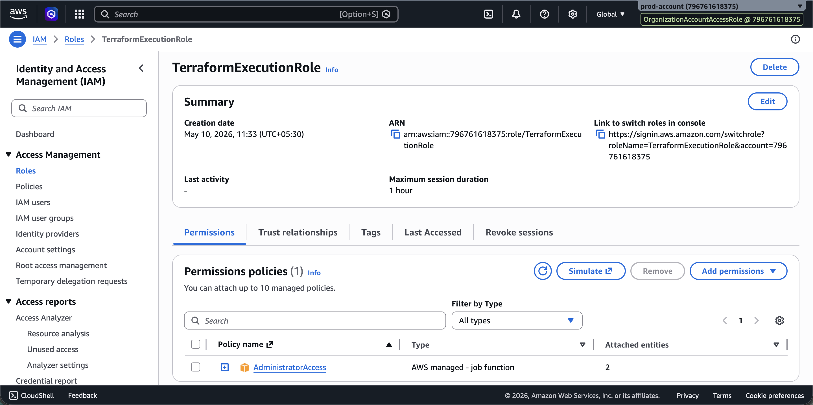

Connectivity Environment Setup

Create Environment Directories
arpitchouksey@Arpits-MacBook-Air environments % mkdir connectivity
arpitchouksey@Arpits-MacBook-Air environments % mkdir logging
arpitchouksey@Arpits-MacBook-Air environments % mkdir audit
arpitchouksey@Arpits-MacBook-Air environments % ls
audit connectivity dev logging management prod

environments/connectivity/provider.tf
terraform {
required_version = ">= 1.5"
required_providers {
aws = {
source = "hashicorp/aws"
version = "~> 5.0"
}
}
}

provider "aws" {
region = "ap-south-1"
assume_role {
role_arn = "arn:aws:iam::526860034893:role/TerraformExecutionRole"
}
default_tags {
tags = {
Project = "terraform-multi-env"
Environment = "connectivity"
ManagedBy = "terraform"
}
}
}

environments/connectivity/main.tf
module "terraform_execution_role" {
source = "../../modules/terraform-role"
role_name = "TerraformExecutionRole"
management_account_id = "211811255273"
environment = "connectivity"
}

terraform init — Connectivity
arpitchouksey@Arpits-MacBook-Air connectivity % terraform init
Initializing the backend...
Initializing modules...
- terraform_execution_role in ../../modules/terraform-role
Initializing provider plugins...
- Installing hashicorp/aws v5.100.0...
- Installed hashicorp/aws v5.100.0 (signed by HashiCorp)

Terraform has been successfully initialized!

terraform plan & apply — Connectivity
arpitchouksey@Arpits-MacBook-Air connectivity % terraform plan
Plan: 0 to add, 1 to change, 0 to destroy.

arpitchouksey@Arpits-MacBook-Air connectivity % terraform apply
Enter a value: yes

module.terraform_execution_role.aws_iam_role.terraform_execution_role: Modifying... [id=TerraformExecutionRole]
module.terraform_execution_role.aws_iam_role.terraform_execution_role: Modifications complete after 2s

Apply complete! Resources: 0 added, 1 changed, 0 destroyed.

Screenshot — Connectivity environment apply:
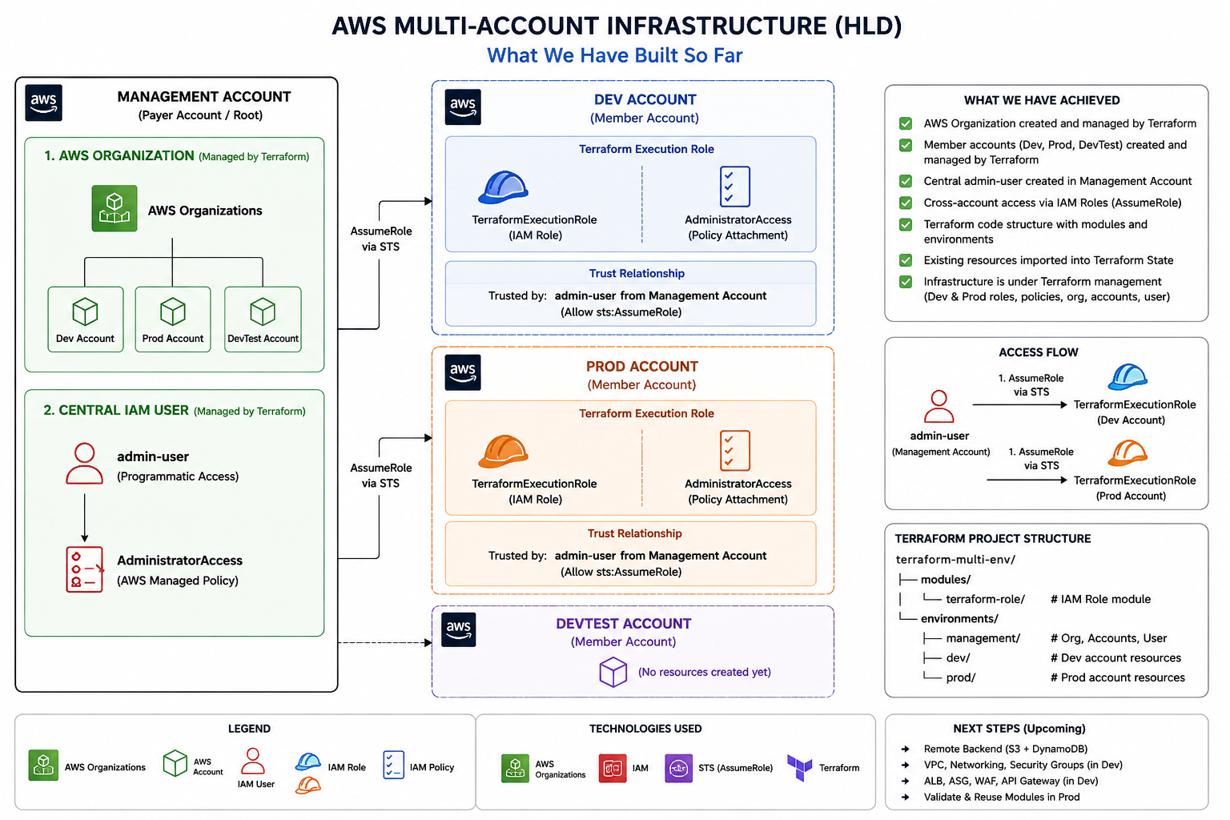

Logging & Audit Environments Setup

terraform import — Logging Role
arpitchouksey@Arpits-MacBook-Air logging % terraform import \
module.terraform_execution_role.aws_iam_role_policy_attachment.admin_attach \
TerraformExecutionRole/arn:aws:iam::aws:policy/AdministratorAccess

Import successful!

terraform plan — Logging
arpitchouksey@Arpits-MacBook-Air logging % terraform plan
Plan: 0 to add, 1 to change, 0 to destroy.
(Tags: Environment=logging, ManagedBy=terraform, Project=terraform-multi-env)

terraform apply — Logging
arpitchouksey@Arpits-MacBook-Air logging % terraform apply
Enter a value: yes

module.terraform_execution_role.aws_iam_role.terraform_execution_role: Modifying... [id=TerraformExecutionRole]
module.terraform_execution_role.aws_iam_role.terraform_execution_role: Modifications complete after 2s

Apply complete! Resources: 0 added, 1 changed, 0 destroyed.

Screenshot — Logging environment final state:
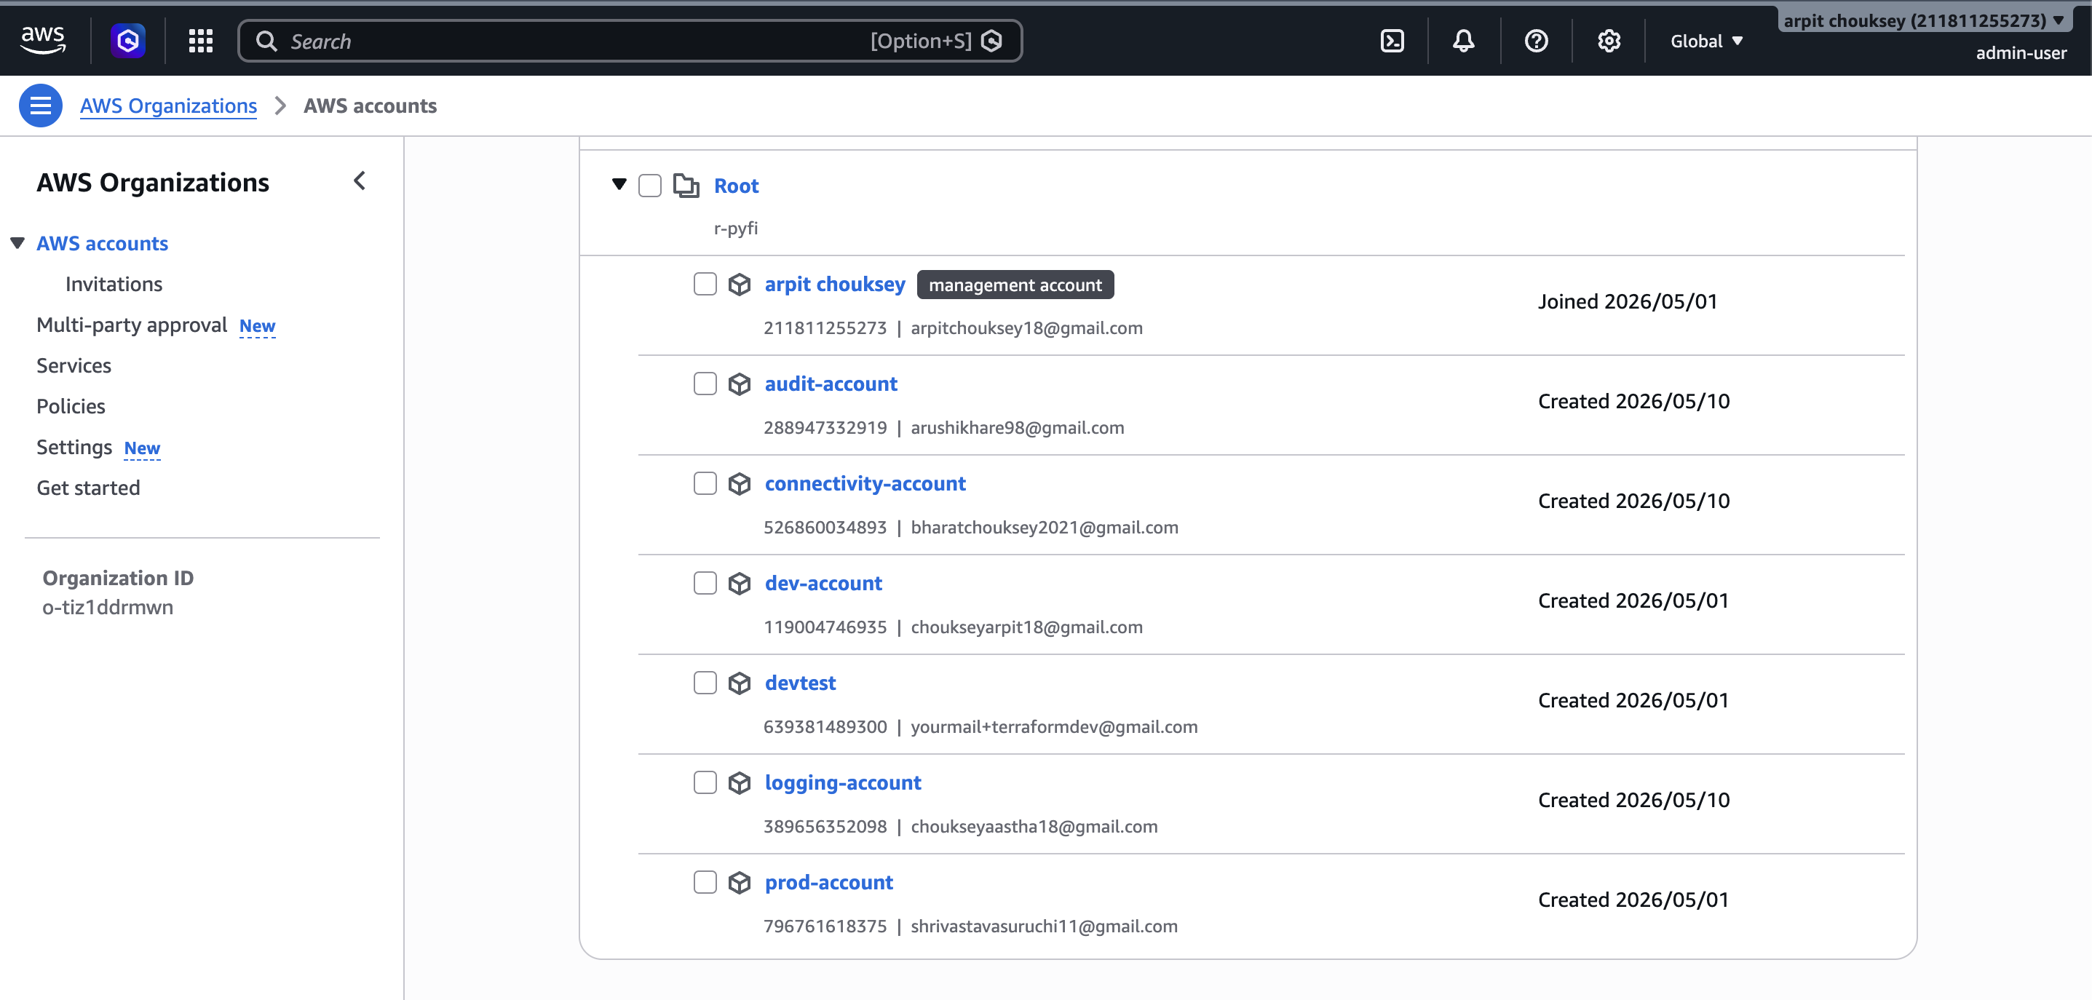

Screenshot — Final environments list:
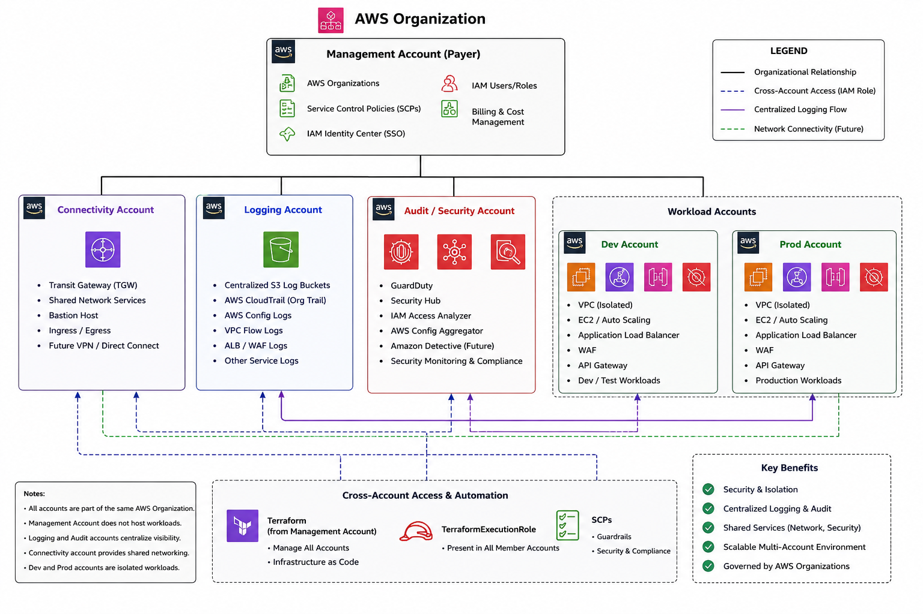

Session 1 Complete — What Was Accomplished
Session 1 Multi-Account Foundation is now complete. The following was achieved:
- AWS Organization created with ALL FEATURES enabled
- Management account set up with admin IAM user
- DEV, PROD, DEVTEST accounts created under the organization
- Connectivity, Logging, and Audit accounts created for enhanced architecture
- TerraformExecutionRole created in DEV, PROD, Connectivity, Logging, and Audit accounts
- All resources imported into Terraform state using terraform import
- Terraform applied cleanly with 0 resources to destroy across all environments
- Cross-account role assumption from management account verified
- Reusable Terraform module structure established under terraform-multi-env/

✅ Session 1 — Multi-Account Foundation COMPLETE
Next: Session 2 — Production VPC Architecture

