Phase 2: Connectivity Set-Up
Production VPC Architecture — Live Execution
Region: us-east-1 | Account: connectivity-account (526860034893)

Overview — What This Phase Covers
This document covers the live, step-by-step creation of production-grade VPC networking in the Connectivity Account, followed by Terraform import of all resources. Every screenshot and CLI command is from the actual live session.

Components created in this phase:
- VPC (connectivity-vpc)
- Public Subnets — 2 AZs (public-subnet-az1, public-subnet-az2)
- Private Subnets — 2 AZs (private-subnet-az1, private-subnet-az2)
- Internet Gateway (connectivity-igw)
- Public Route Table with IGW route
- Private Route Table
- Elastic IP for NAT Gateway
- NAT Gateway (connectivity-nat)
- Private route to NAT Gateway
- Route Table Associations (public & private)
- Bastion Host EC2 + Security Group
- AWS RAM subnet sharing with dev-account

STEP 1 — Create VPC
Screenshot — VPC creation in AWS Console:
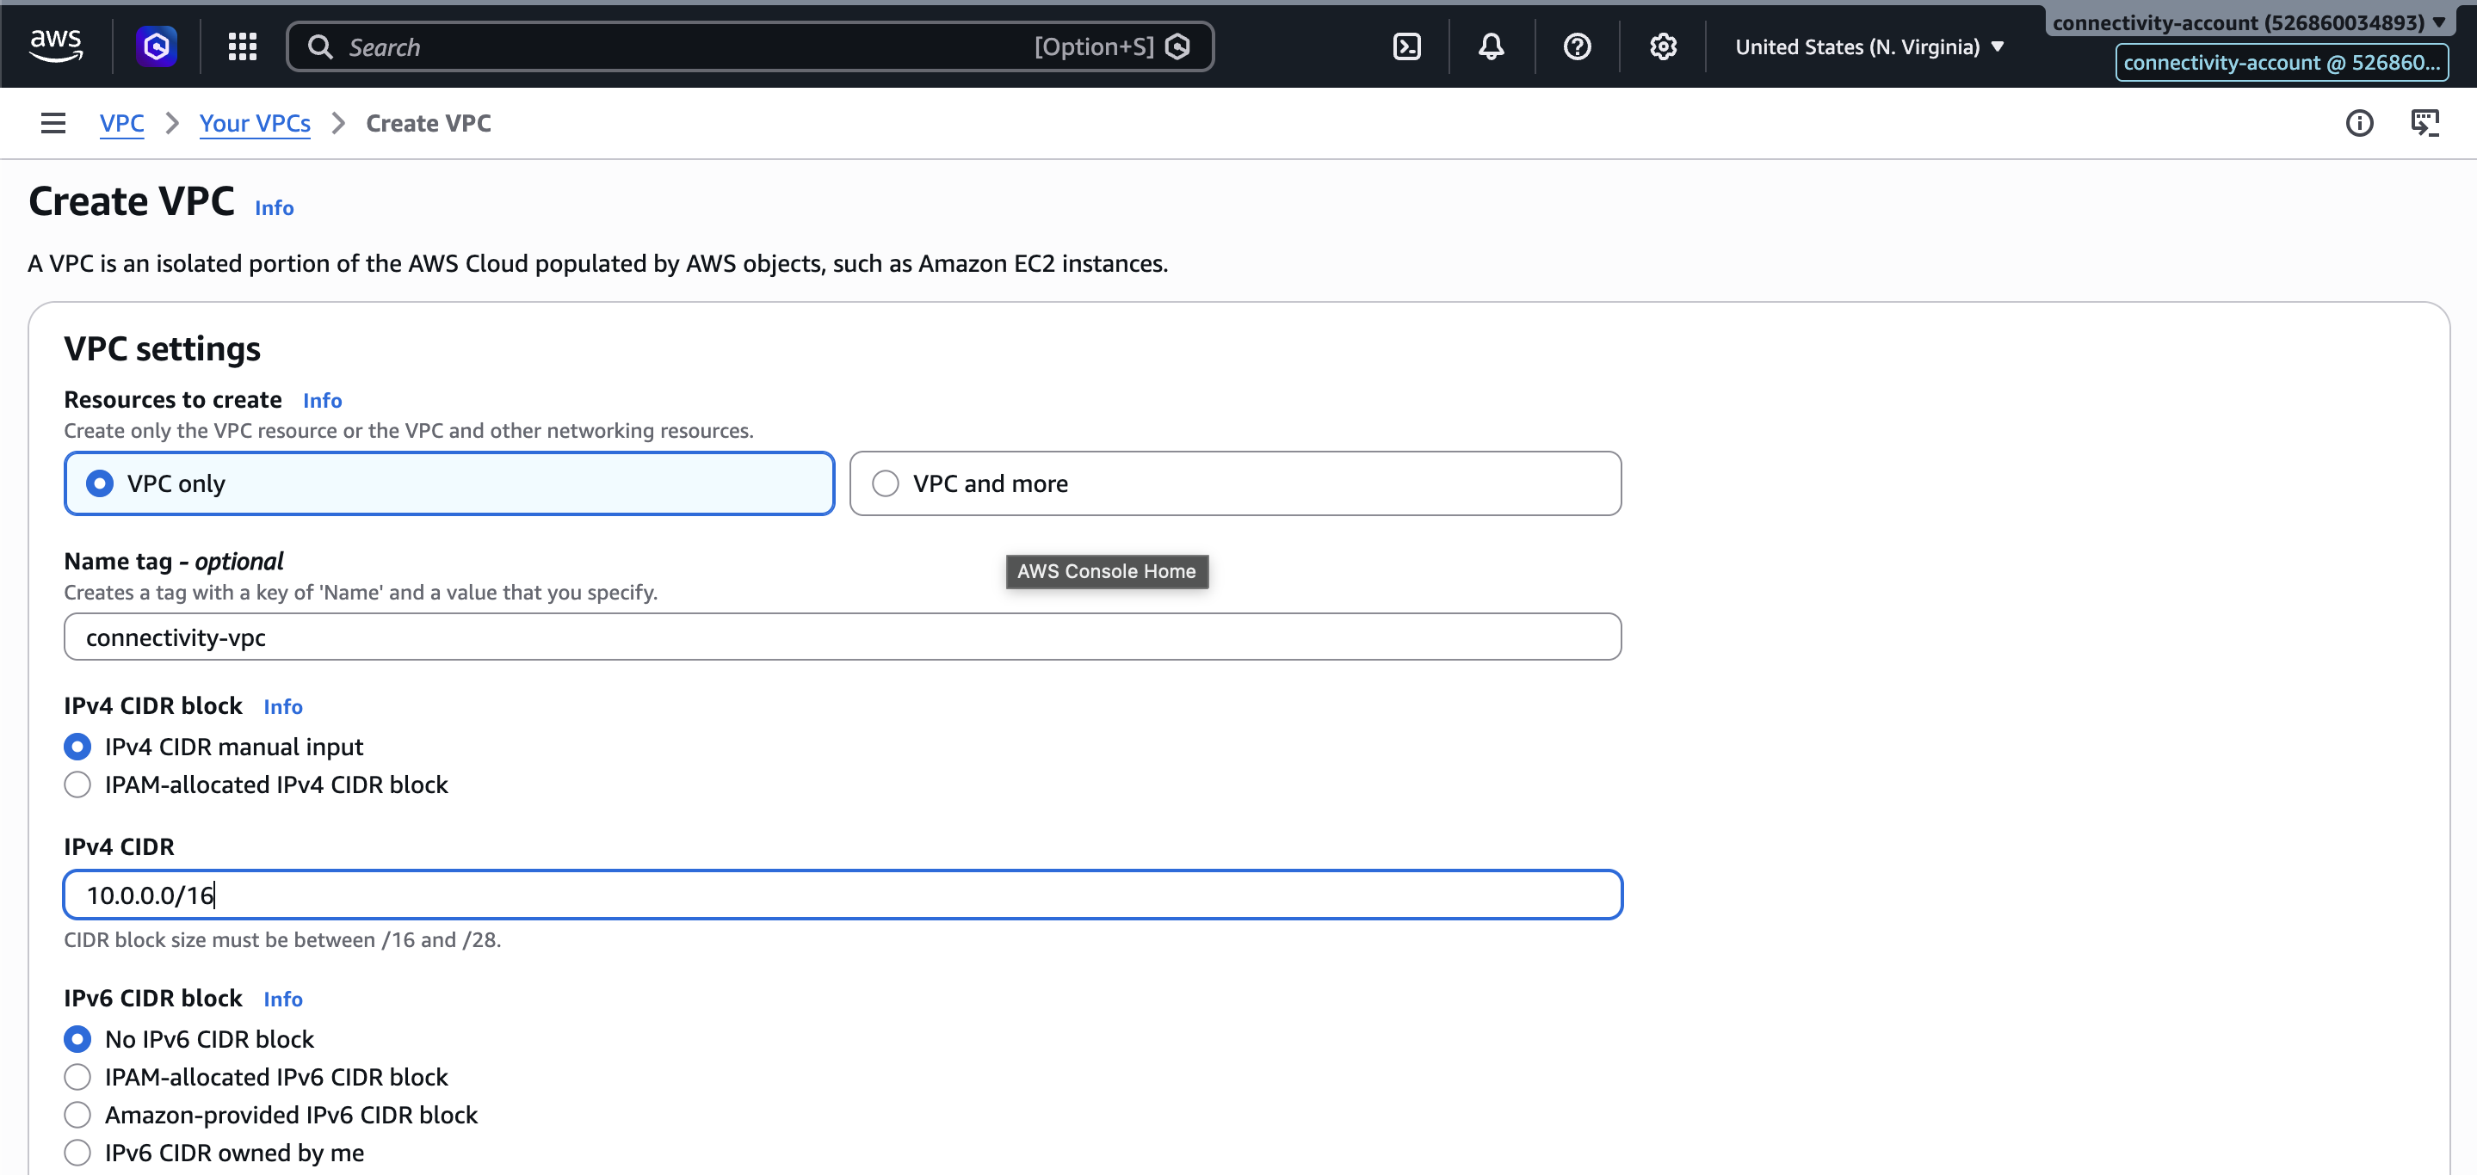

Screenshot — VPC created (connectivity-vpc):
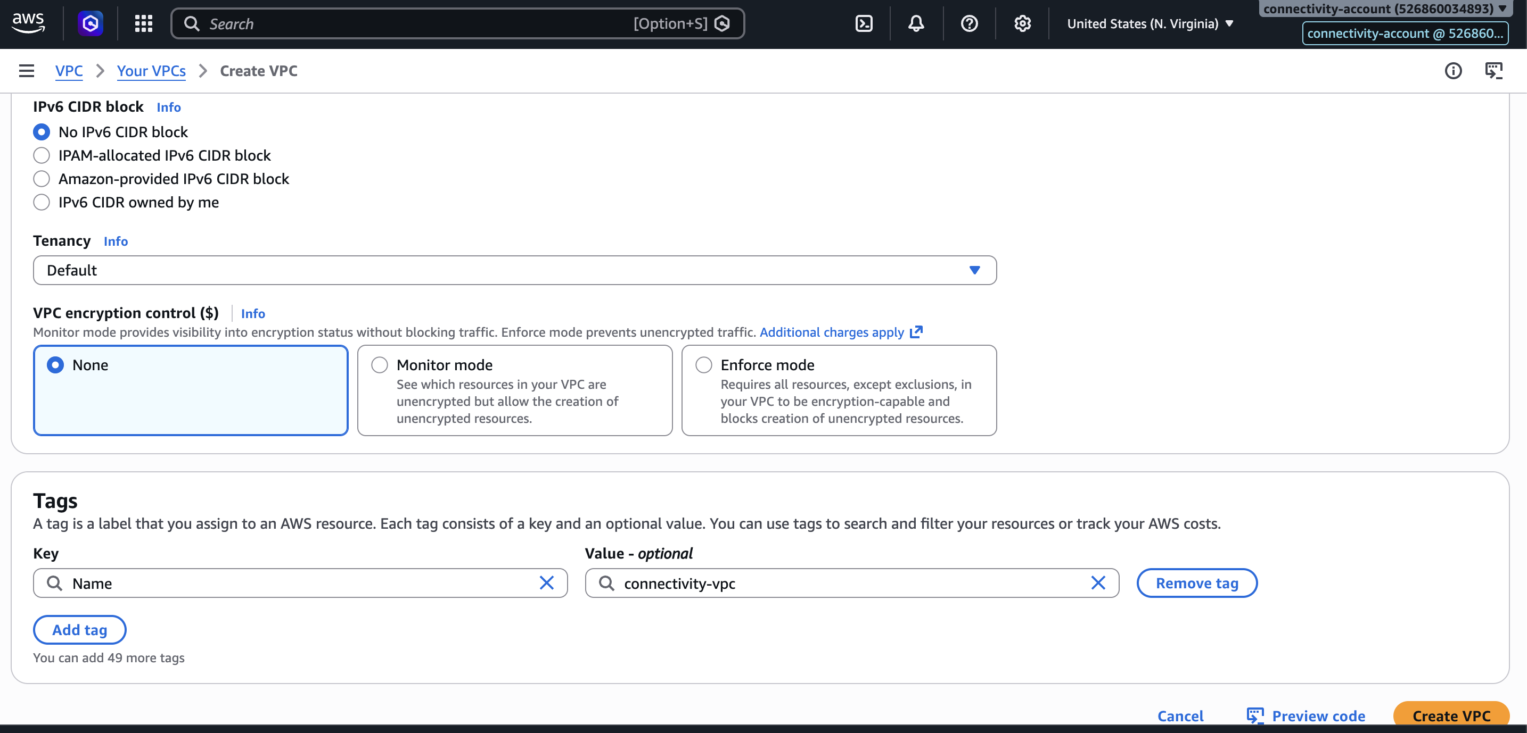

STEP 2 — Create Public Subnet AZ
Create 2 public and 2 private subnets across 2 Availability Zones:
- public-subnet-az1 (AZ1)
- public-subnet-az2 (AZ2)
- private-subnet-az1 (AZ1)
- private-subnet-az2 (AZ2)

Screenshot — Public subnet creation:
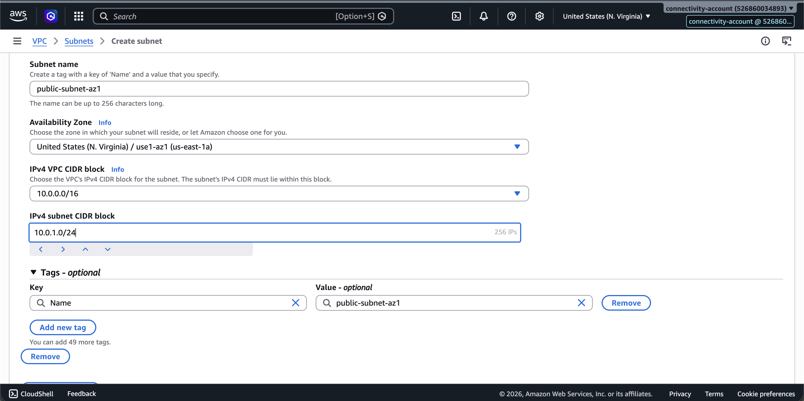

Screenshot — All subnets created:
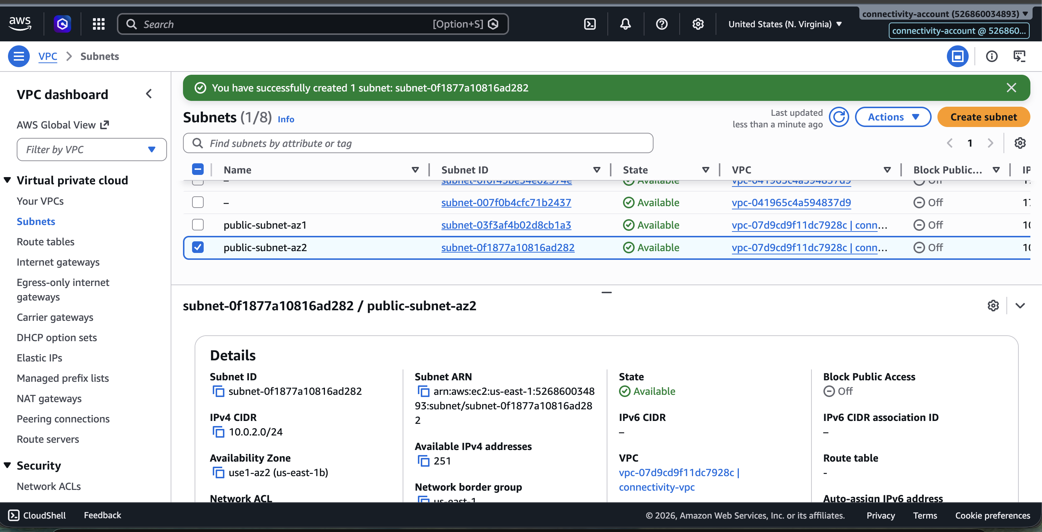

Create Internet Gateway
Screenshot — Internet Gateway creation:
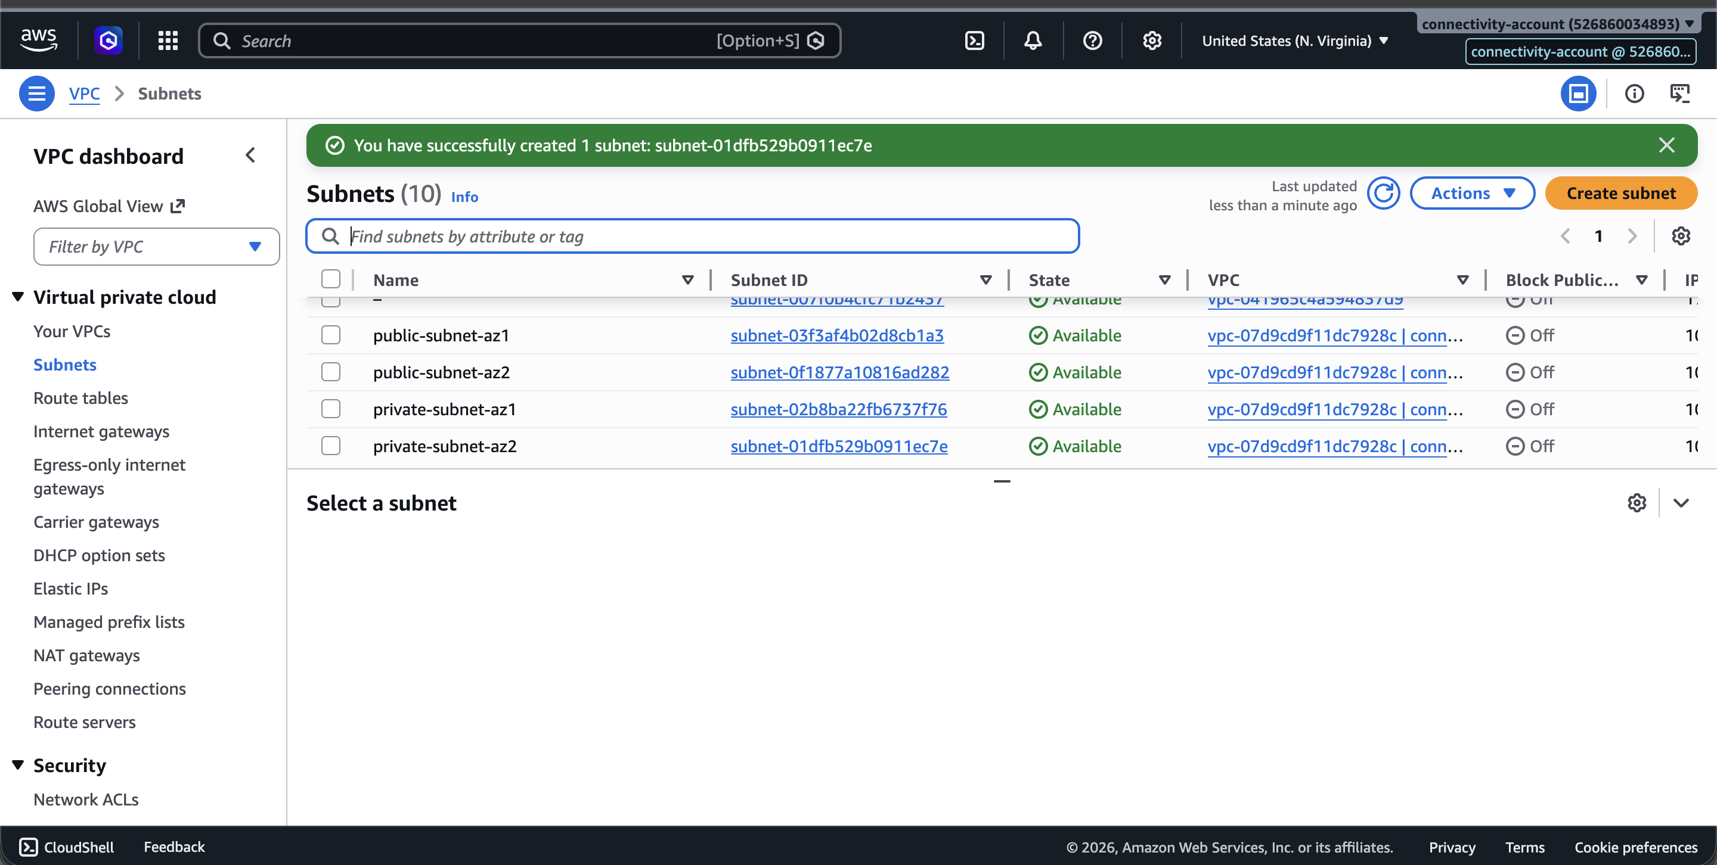

Screenshot — IGW attached to VPC:
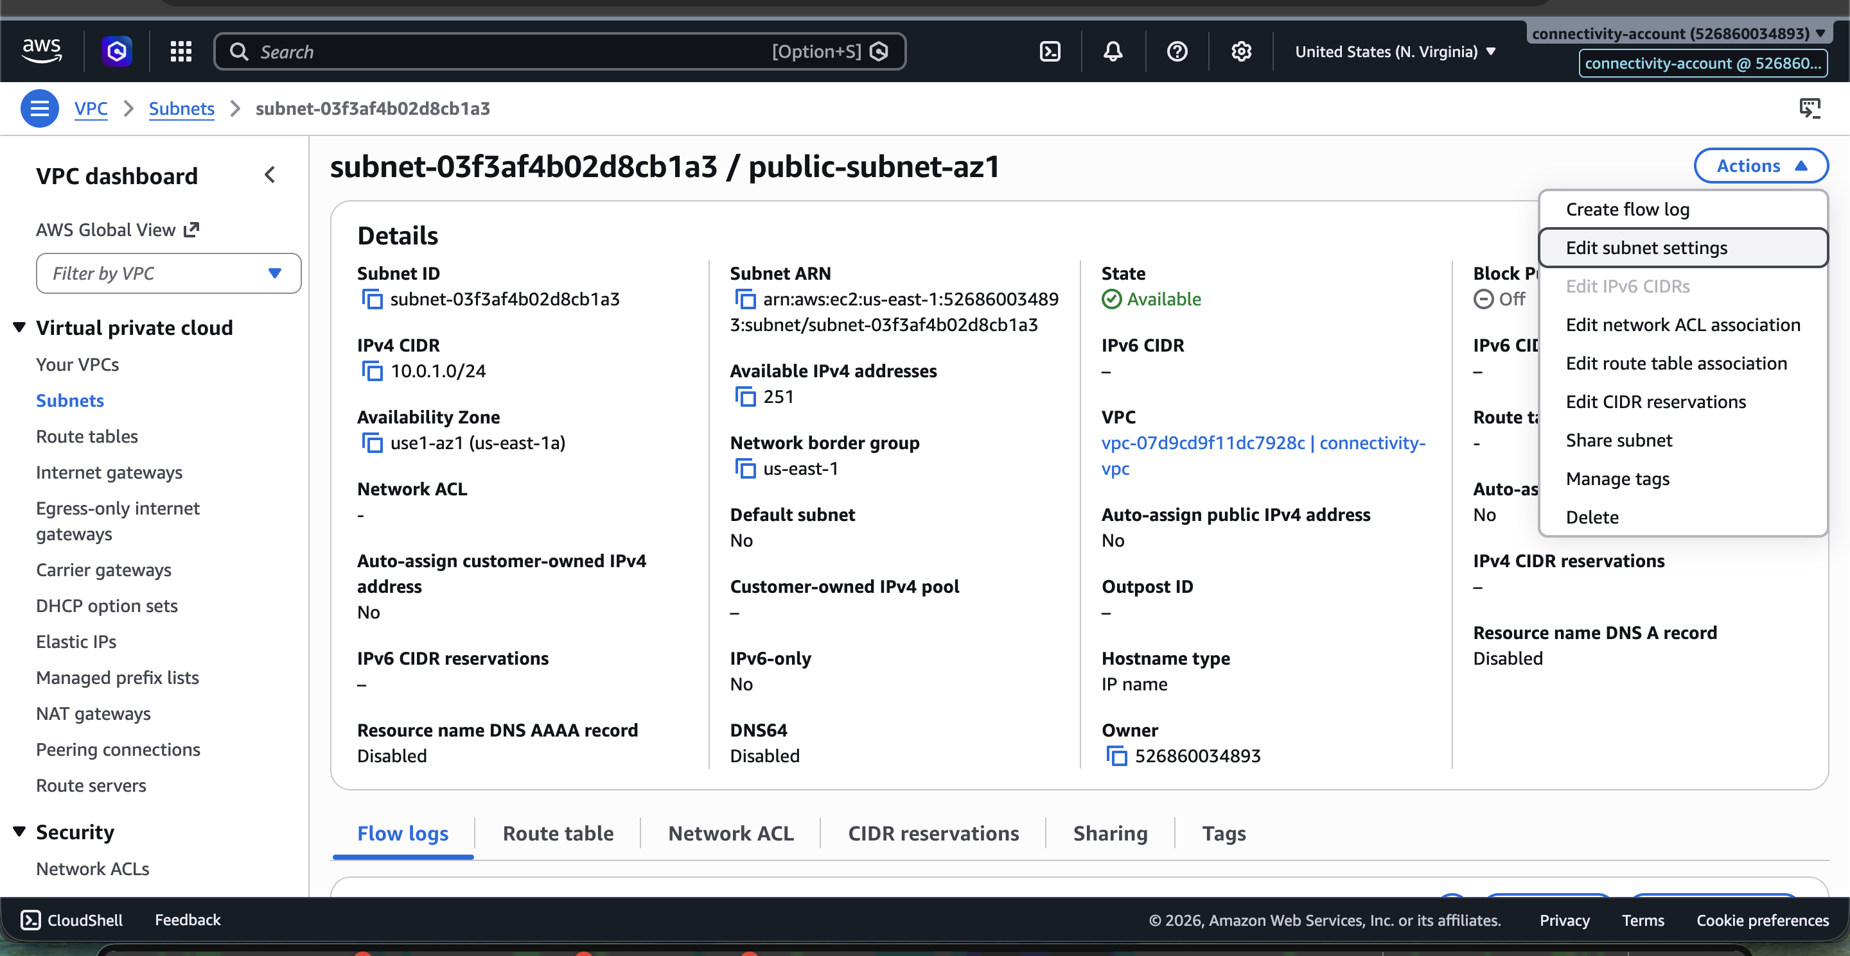

Create Public Route Table
Screenshot — Public Route Table created:
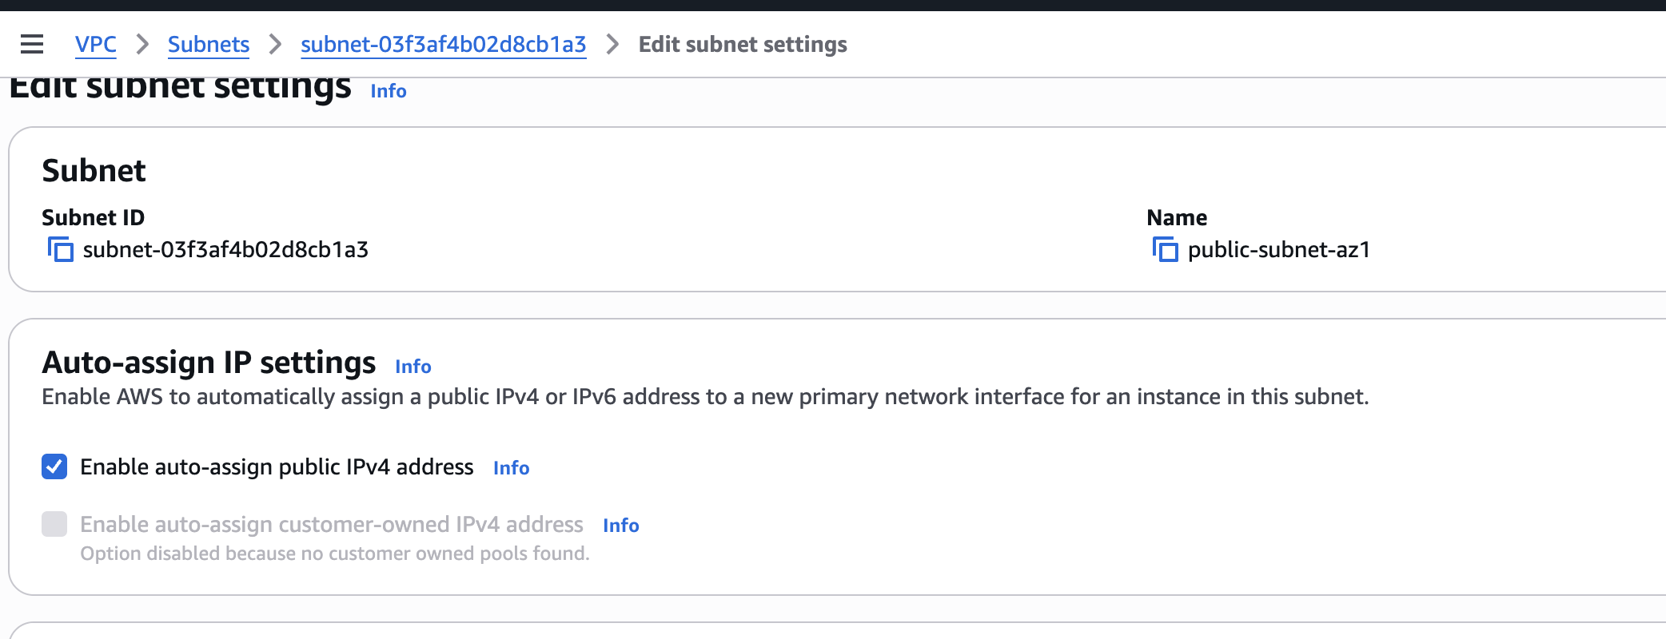

Add Internet Route
Screenshot — Adding 0.0.0.0/0 → IGW route:
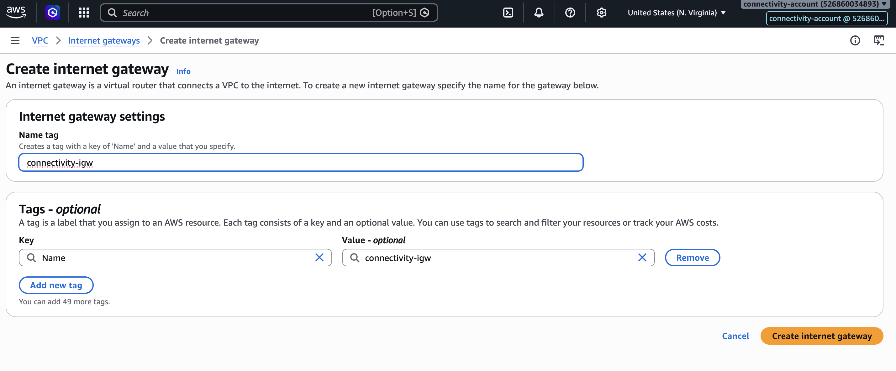

Associate Public Subnets
Screenshot — Public subnets associated with public route table:
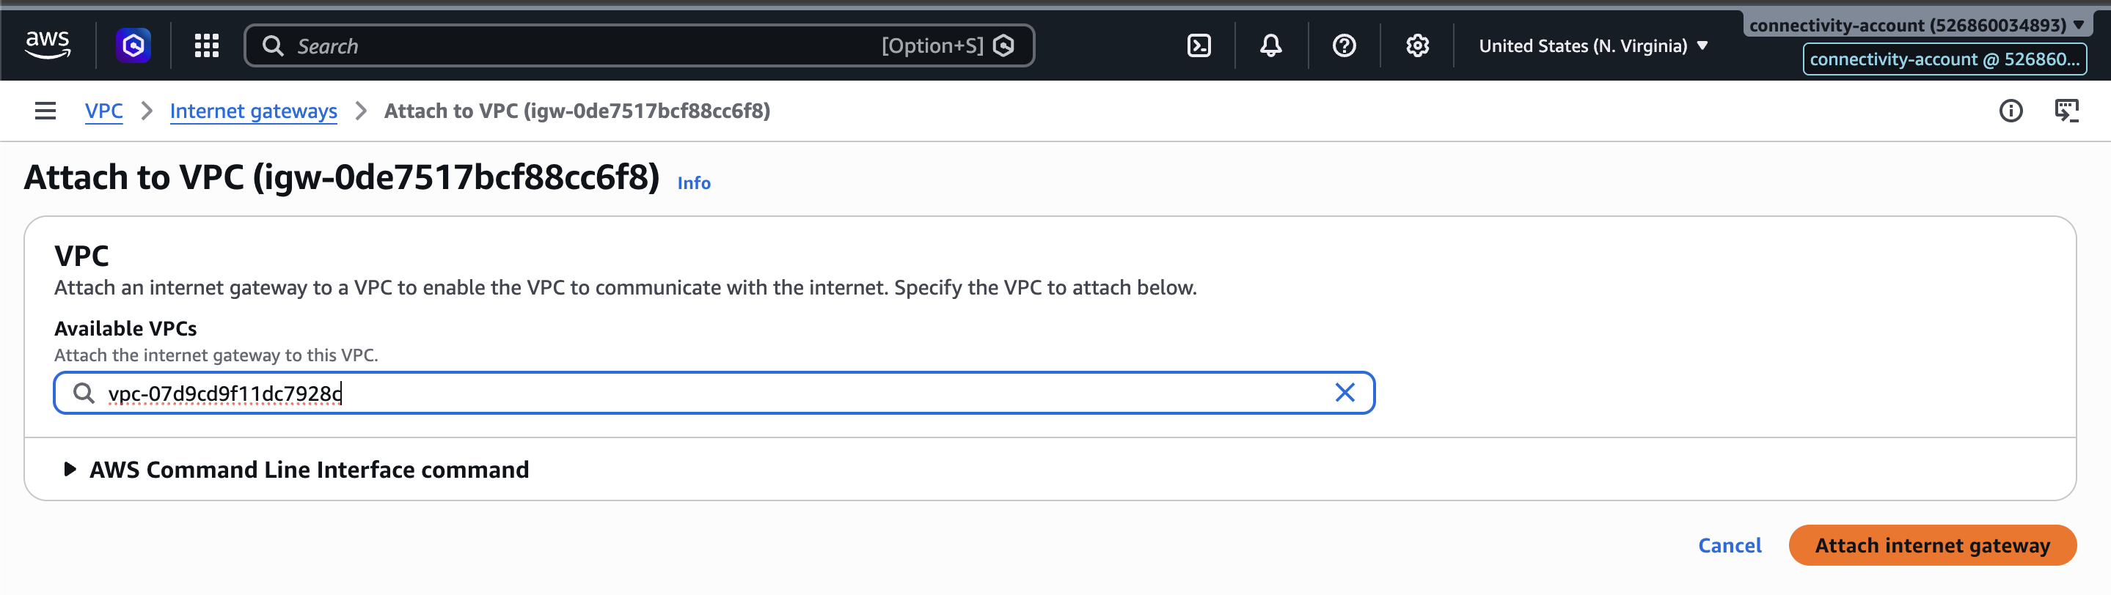

Create Private Route Table
Screenshot — Private Route Table created:
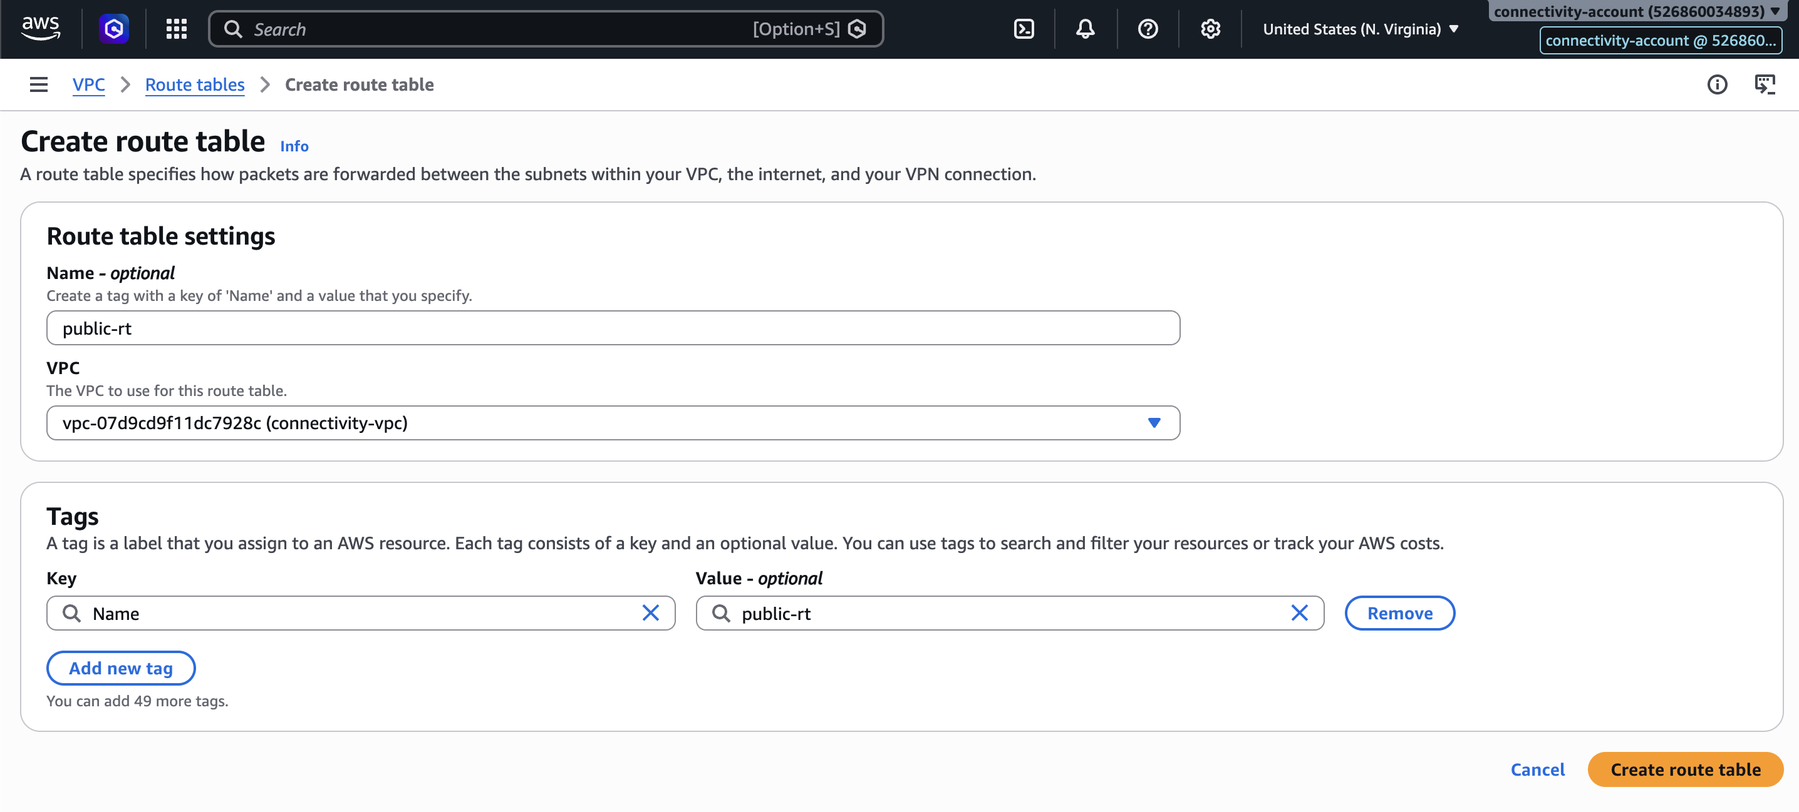

Associate Private Subnets
Screenshot — Private subnets associated with private route table:
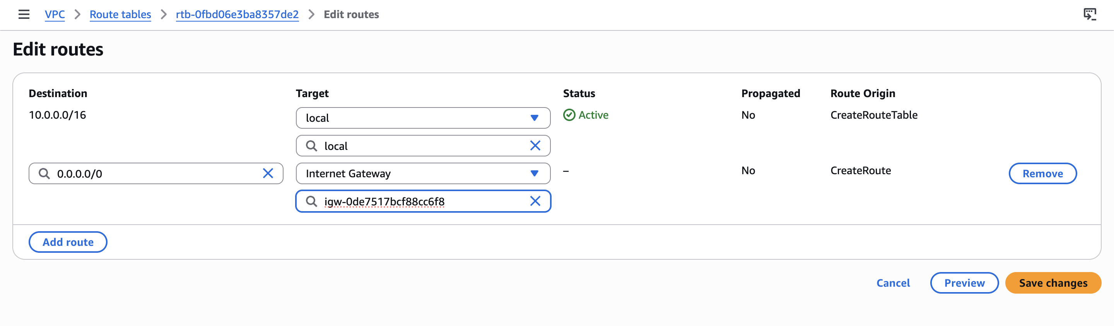

Network Architecture — After Route Tables
Internet
|
IGW
|
Public Route Table
|
|-------------------------|
| |
Public Subnet AZ1 Public Subnet AZ2
|
NAT (later)
|
Private Route Table
|
|-------------------------|
| |
Private Subnet AZ1 Private Subnet AZ2

Allocate Elastic IP (Required for NAT Gateway)
Elastic IP must be allocated before creating the NAT Gateway. Wait until IP Allocation & Status is available.

Screenshot — Elastic IP allocation:
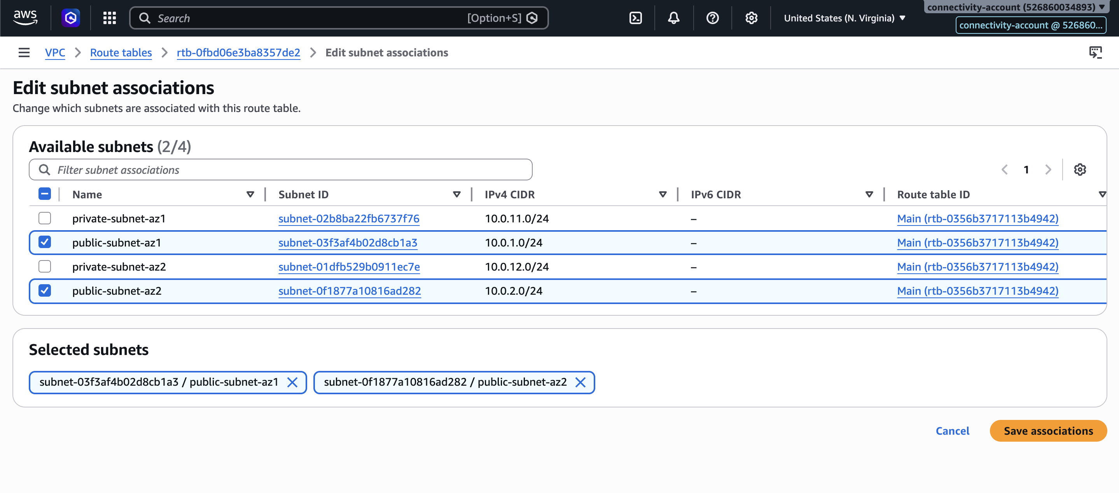

Screenshot — EIP allocated and available:
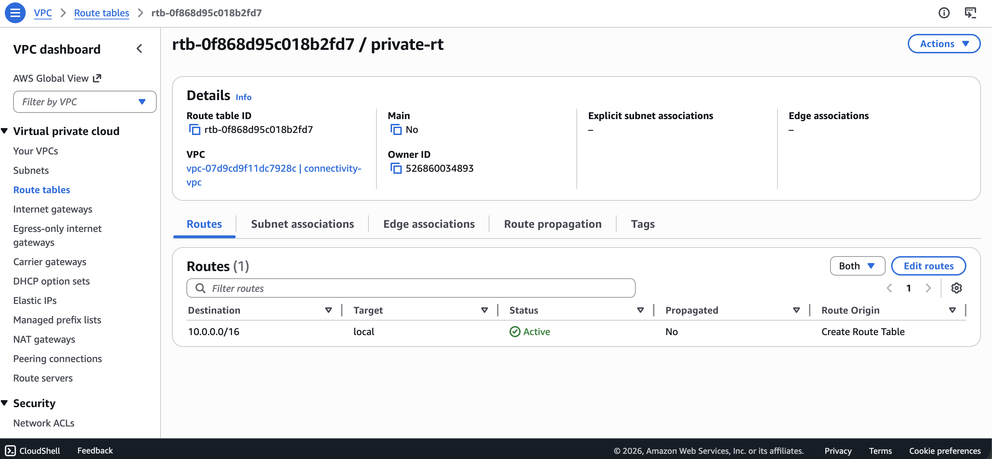

Create NAT Gateway
NAT Gateway is placed in the public subnet with the allocated Elastic IP.

Screenshot — NAT Gateway creation:
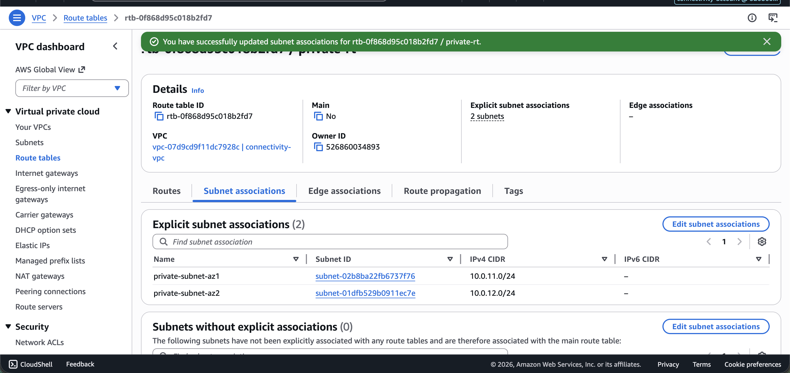

Screenshot — NAT Gateway active:
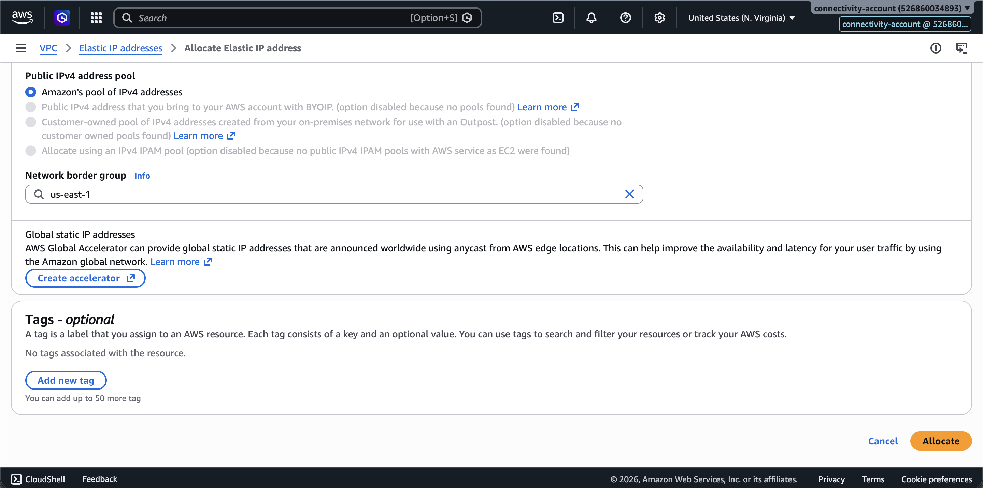

Add NAT Route to Private Route Table
Screenshot — Adding 0.0.0.0/0 → NAT GW to private route table:
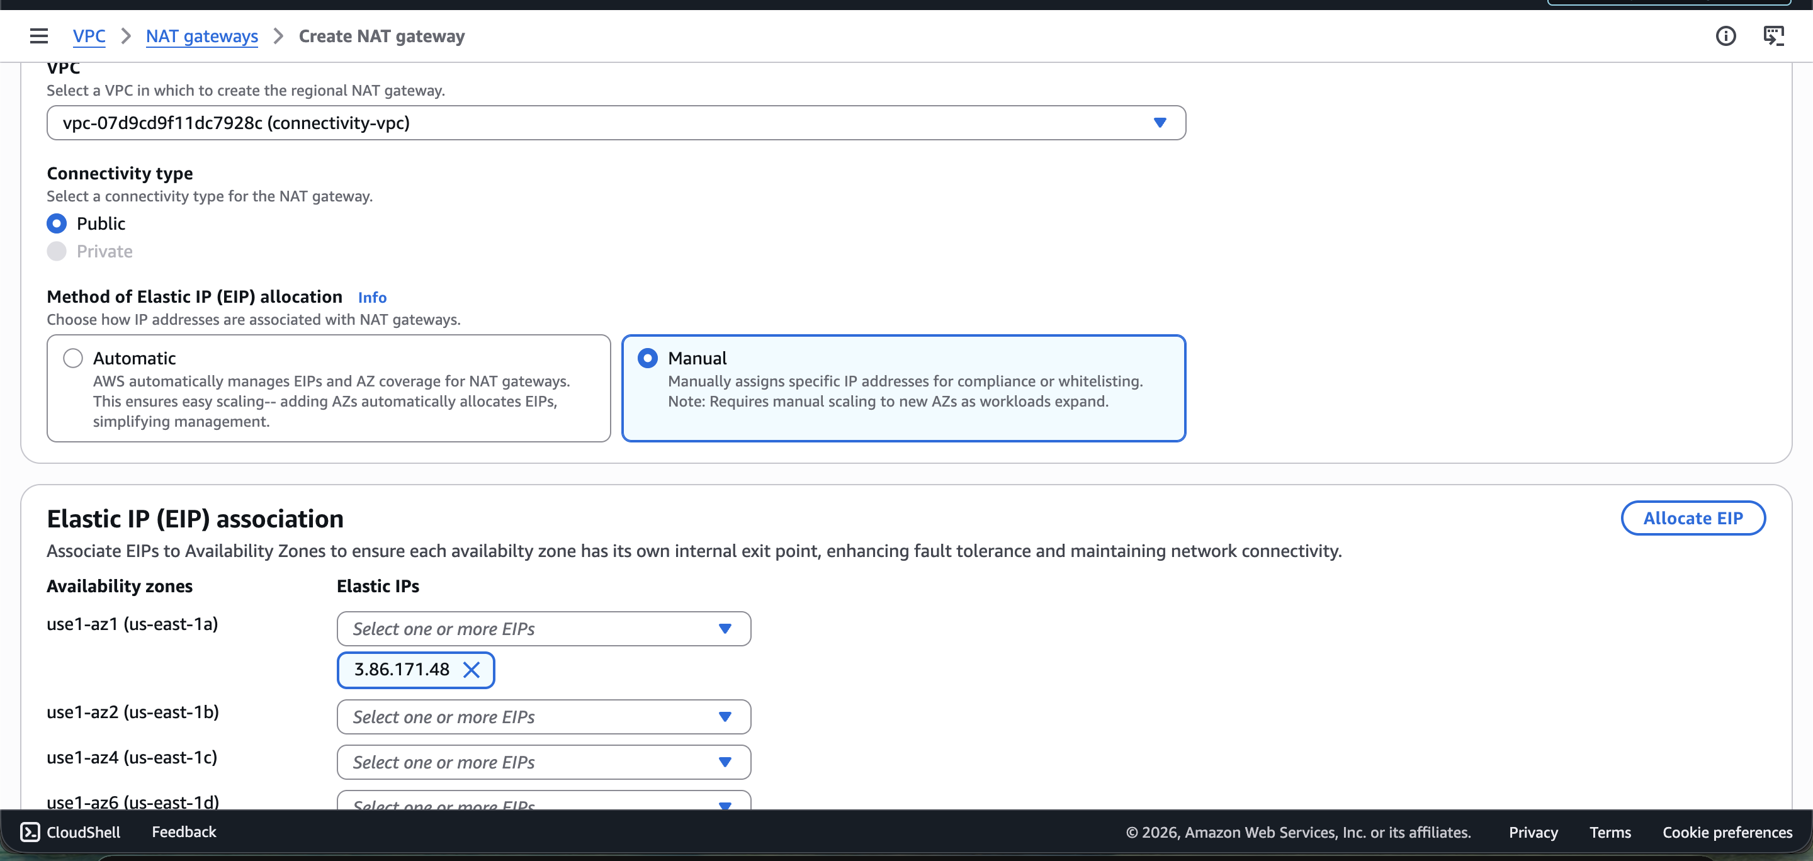

Screenshot — Private route table with NAT route:
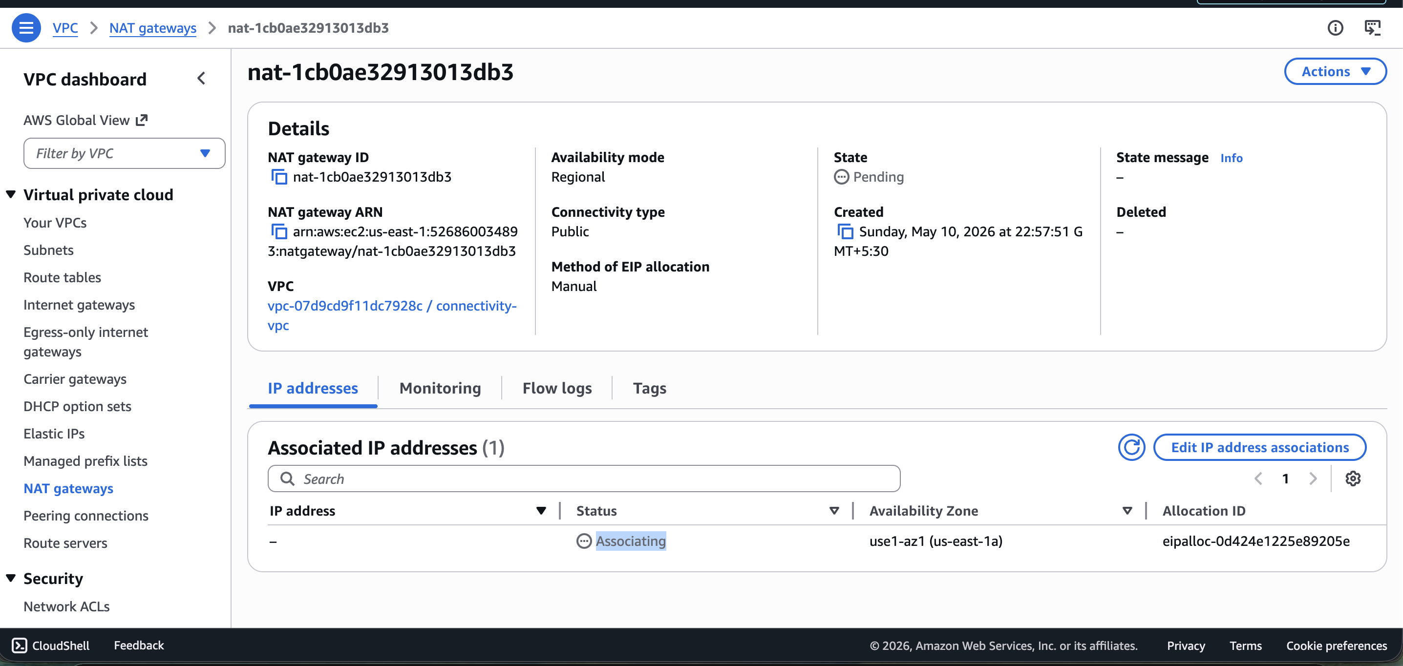

Final Network Architecture
Internet
|
IGW
|
Public Route Table
|--------------------------------|
| |
Public Subnet AZ1 Public Subnet AZ2
|
NAT Gateway
|
Private Route Table
|--------------------------------|
| |
Private Subnet AZ1 Private Subnet AZ2

Start Importing for Terraform
I create Terraform code for all networking components in the connectivity module. Then we import every resource that was created manually.

Screenshot — Terraform code structure for connectivity:
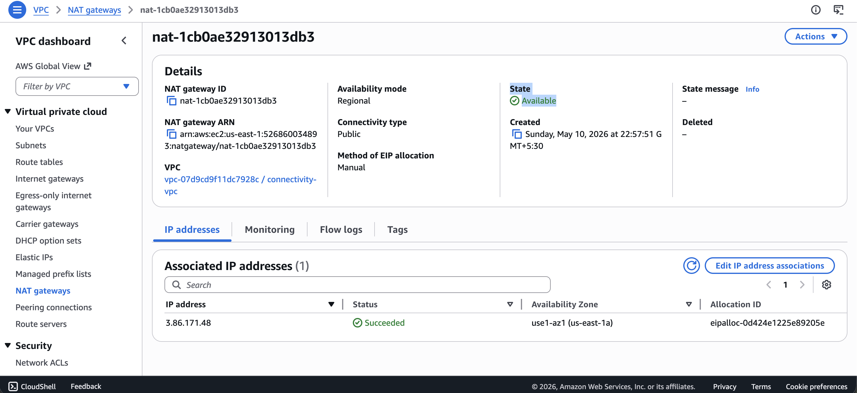

terraform init — Connectivity Environment
arpitchouksey@Arpits-MacBook-Air connectivity % terraform init
Initializing the backend...
Initializing modules...
- terraform_execution_role in ../../modules/terraform-role
Initializing provider plugins...
- Finding hashicorp/aws versions matching "~> 5.0"...
- Installing hashicorp/aws v5.100.0...
- Installed hashicorp/aws v5.100.0 (signed by HashiCorp)

Terraform has created a lock file .terraform.lock.hcl to record the provider
selections it made above. Include this file in your version control repository
so that Terraform can guarantee to make the same selections by default when
you run "terraform init" in the future.

Terraform has been successfully initialized!

You may now begin working with Terraform. Try running "terraform plan" to see
any changes that are required for your infrastructure.

All Terraform commands should now work. If you ever set or change modules or
backend configuration for Terraform, rerun this command to reinitialize your
working directory. If you forget, other commands will detect it and remind you
to do so if necessary.

terraform import — VPC
arpitchouksey@Arpits-MacBook-Air connectivity % terraform import aws_vpc.connectivity_vpc vpc-07d9cd9f11dc7928c
aws_vpc.connectivity_vpc: Importing from ID "vpc-07d9cd9f11dc7928c"...
aws_vpc.connectivity_vpc: Import prepared!
Prepared aws_vpc for import
aws_vpc.connectivity_vpc: Refreshing state... [id=vpc-07d9cd9f11dc7928c]

Import successful!
The resources that were imported are shown above. These resources are now in
your Terraform state and will henceforth be managed by Terraform.

terraform import — Public Subnet AZ1
arpitchouksey@Arpits-MacBook-Air connectivity % terraform import aws_subnet.public_subnet_az1 subnet-03f3af4b02d8cb1a3
aws_subnet.public_subnet_az1: Importing from ID "subnet-03f3af4b02d8cb1a3"...
aws_subnet.public_subnet_az1: Import prepared!
Prepared aws_subnet for import
aws_subnet.public_subnet_az1: Refreshing state... [id=subnet-03f3af4b02d8cb1a3]

Import successful!

terraform import — Public Subnet AZ2
arpitchouksey@Arpits-MacBook-Air connectivity % terraform import aws_subnet.public_subnet_az2 subnet-0f1877a10816ad282
aws_subnet.public_subnet_az2: Importing from ID "subnet-0f1877a10816ad282"...
aws_subnet.public_subnet_az2: Import prepared!
Prepared aws_subnet for import
aws_subnet.public_subnet_az2: Refreshing state... [id=subnet-0f1877a10816ad282]

Import successful!

terraform import — Private Subnet AZ1
arpitchouksey@Arpits-MacBook-Air connectivity % terraform import aws_subnet.private_subnet_az1 subnet-02b8ba22fb6737f76
aws_subnet.private_subnet_az1: Importing from ID "subnet-02b8ba22fb6737f76"...
aws_subnet.private_subnet_az1: Import prepared!
Prepared aws_subnet for import
aws_subnet.private_subnet_az1: Refreshing state... [id=subnet-02b8ba22fb6737f76]

Import successful!

terraform import — Private Subnet AZ2
arpitchouksey@Arpits-MacBook-Air connectivity % terraform import aws_subnet.private_subnet_az2 subnet-01dfb529b0911ec7e
aws_subnet.private_subnet_az2: Importing from ID "subnet-01dfb529b0911ec7e"...
aws_subnet.private_subnet_az2: Import prepared!
Prepared aws_subnet for import
aws_subnet.private_subnet_az2: Refreshing state... [id=subnet-01dfb529b0911ec7e]

Import successful!

terraform import — Internet Gateway
arpitchouksey@Arpits-MacBook-Air connectivity % terraform import aws_internet_gateway.connectivity_igw igw-0de7517bcf88cc6f8
aws_internet_gateway.connectivity_igw: Importing from ID "igw-0de7517bcf88cc6f8"...
aws_internet_gateway.connectivity_igw: Import prepared!
Prepared aws_internet_gateway for import
aws_internet_gateway.connectivity_igw: Refreshing state... [id=igw-0de7517bcf88cc6f8]

Import successful!

terraform import — Public Route Table
arpitchouksey@Arpits-MacBook-Air connectivity % terraform import aws_route_table.public_rt rtb-0fbd06e3ba8357de2
aws_route_table.public_rt: Importing from ID "rtb-0fbd06e3ba8357de2"...
aws_route_table.public_rt: Import prepared!
Prepared aws_route_table for import
aws_route_table.public_rt: Refreshing state... [id=rtb-0fbd06e3ba8357de2]

Import successful!

terraform import — Private Route Table
arpitchouksey@Arpits-MacBook-Air connectivity % terraform import aws_route_table.private_rt rtb-0f868d95c018b2fd7
aws_route_table.private_rt: Importing from ID "rtb-0f868d95c018b2fd7"...
aws_route_table.private_rt: Import prepared!
Prepared aws_route_table for import
aws_route_table.private_rt: Refreshing state... [id=rtb-0f868d95c018b2fd7]

Import successful!

terraform import — Elastic IP (First Attempt — Error)
arpitchouksey@Arpits-MacBook-Air connectivity % terraform import aws_eip.nat_eip 3.86.171.48
aws_eip.nat_eip: Importing from ID "3.86.171.48"...
aws_eip.nat_eip: Import prepared!
Prepared aws_eip for import
aws_eip.nat_eip: Refreshing state... [id=3.86.171.48]
╷
│ Error: with the retirement of EC2-Classic standard domain EC2 EIPs are no longer supported
│
╵

⚠️ Fix: Use the allocation ID (eipalloc-...) instead of the IP address.

terraform import — Elastic IP (Correct — Using Allocation ID)
arpitchouksey@Arpits-MacBook-Air connectivity % terraform import aws_eip.nat_eip eipalloc-0d424e1225e89205e
aws_eip.nat_eip: Importing from ID "eipalloc-0d424e1225e89205e"...
aws_eip.nat_eip: Import prepared!
Prepared aws_eip for import
aws_eip.nat_eip: Refreshing state... [id=eipalloc-0d424e1225e89205e]

Import successful!

terraform import — NAT Gateway (First Attempt — Incomplete Command)
arpitchouksey@Arpits-MacBook-Air connectivity % terraform import aws_nat_gateway.connectivity_nat
(missing NAT ID — command incomplete)

terraform import — NAT Gateway (Correct)
arpitchouksey@Arpits-MacBook-Air connectivity % terraform import aws_nat_gateway.connectivity_nat nat-1cb0ae32913013db3
aws_nat_gateway.connectivity_nat: Importing from ID "nat-1cb0ae32913013db3"...
aws_nat_gateway.connectivity_nat: Import prepared!
Prepared aws_nat_gateway for import
aws_nat_gateway.connectivity_nat: Refreshing state... [id=nat-1cb0ae32913013db3]

Import successful!

terraform plan — First Run (After Initial Imports)
arpitchouksey@Arpits-MacBook-Air connectivity % terraform plan
aws_vpc.connectivity_vpc: Refreshing state... [id=vpc-07d9cd9f11dc7928c]
module.terraform_execution_role.aws_iam_role.terraform_execution_role: Refreshing state... [id=TerraformExecutionRole]
aws_eip.nat_eip: Refreshing state... [id=eipalloc-0d424e1225e89205e]
module.terraform_execution_role.aws_iam_role_policy_attachment.admin_attach: Refreshing state...
aws_internet_gateway.connectivity_igw: Refreshing state... [id=igw-0de7517bcf88cc6f8]
aws_subnet.public_subnet_az1: Refreshing state... [id=subnet-03f3af4b02d8cb1a3]
aws_route_table.private_rt: Refreshing state... [id=rtb-0f868d95c018b2fd7]
aws_subnet.private_subnet_az1: Refreshing state... [id=subnet-02b8ba22fb6737f76]
aws_subnet.public_subnet_az2: Refreshing state... [id=subnet-0f1877a10816ad282]
aws_subnet.private_subnet_az2: Refreshing state... [id=subnet-01dfb529b0911ec7e]
aws_route_table.public_rt: Refreshing state... [id=rtb-0fbd06e3ba8357de2]
aws_nat_gateway.connectivity_nat: Refreshing state... [id=nat-1cb0ae32913013db3]

Terraform will perform the following actions:

# aws_eip.nat_eip will be updated in-place
~ resource "aws_eip" "nat_eip" {
id = "eipalloc-0d424e1225e89205e"
~ tags = {
+ "Name" = "connectivity-nat-eip"
}
~ tags_all = {
+ "Environment" = "connectivity"
+ "ManagedBy" = "Terraform"
+ "Name" = "connectivity-nat-eip"
+ "Project" = "terraform-multi-env"
}
}

# aws_nat_gateway.connectivity_nat must be replaced
-/+ resource "aws_nat_gateway" "connectivity_nat" {
~ association_id = "eipassoc-00efe79e348ce8cf5" -> (known after apply)
~ id = "nat-1cb0ae32913013db3" -> (known after apply)
+ subnet_id = "subnet-03f3af4b02d8cb1a3" # forces replacement
~ tags = {
+ "Name" = "connectivity-nat"
}
}

# aws_route.private_nat_route will be created
+ resource "aws_route" "private_nat_route" {
+ destination_cidr_block = "0.0.0.0/0"
+ nat_gateway_id = (known after apply)
+ route_table_id = "rtb-0f868d95c018b2fd7"
}

# aws_route_table_association.private_az1_assoc will be created
# aws_route_table_association.private_az2_assoc will be created
# aws_route_table_association.public_az1_assoc will be created
# aws_route_table_association.public_az2_assoc will be created

(plus subnet and VPC tag updates)

Plan: 6 to add, 9 to change, 1 to destroy.

Changes to Outputs:
~ nat_gateway_id = "nat-1cb0ae32913013db3" -> (known after apply)

terraform import — Route Table Associations

Import Public AZ1 Association
arpitchouksey@Arpits-MacBook-Air connectivity % terraform import \
aws_route_table_association.public_az1_assoc subnet-03f3af4b02d8cb1a3/rtb-0fbd06e3ba8357de2
aws_route_table_association.public_az1_assoc: Importing from ID "subnet-03f3af4b02d8cb1a3/rtb-0fbd06e3ba8357de2"...
aws_route_table_association.public_az1_assoc: Import prepared!
Prepared aws_route_table_association for import
aws_route_table_association.public_az1_assoc: Refreshing state... [id=rtbassoc-0a7c10bea5924f27c]

Import successful!

Import Public AZ2 Association
arpitchouksey@Arpits-MacBook-Air connectivity % terraform import \
aws_route_table_association.public_az2_assoc subnet-0f1877a10816ad282/rtb-0fbd06e3ba8357de2
aws_route_table_association.public_az2_assoc: Importing from ID "subnet-0f1877a10816ad282/rtb-0fbd06e3ba8357de2"...
aws_route_table_association.public_az2_assoc: Import prepared!
aws_route_table_association.public_az2_assoc: Refreshing state... [id=rtbassoc-096d4adfb8205d7d5]

Import successful!

Import Private AZ1 Association
arpitchouksey@Arpits-MacBook-Air connectivity % terraform import \
aws_route_table_association.private_az1_assoc subnet-02b8ba22fb6737f76/rtb-0f868d95c018b2fd7
aws_route_table_association.private_az1_assoc: Importing from ID "subnet-02b8ba22fb6737f76/rtb-0f868d95c018b2fd7"...
aws_route_table_association.private_az1_assoc: Import prepared!
aws_route_table_association.private_az1_assoc: Refreshing state... [id=rtbassoc-03b9e836aa73a1d23]

Import successful!

Import Private AZ2 Association
arpitchouksey@Arpits-MacBook-Air connectivity % terraform import \
aws_route_table_association.private_az2_assoc subnet-01dfb529b0911ec7e/rtb-0f868d95c018b2fd7
aws_route_table_association.private_az2_assoc: Importing from ID "subnet-01dfb529b0911ec7e/rtb-0f868d95c018b2fd7"...
aws_route_table_association.private_az2_assoc: Import prepared!
aws_route_table_association.private_az2_assoc: Refreshing state... [id=rtbassoc-0fd4a1d73b73e04da]

Import successful!

terraform import — Private NAT Route (First Attempt — Typo)
arpitchouksey@Arpits-MacBook-Air connectivity % terraform import aws_route.private_nat_route terraform import aws_route.private_nat_route rtb-0f868d95c018b2fd7_0.0.0.0/0
(typo — "terraform import" repeated in the argument)

terraform import — Private NAT Route (Correct)
arpitchouksey@Arpits-MacBook-Air connectivity % terraform import aws_route.private_nat_route rtb-0f868d95c018b2fd7_0.0.0.0/0
aws_route.private_nat_route: Importing from ID "rtb-0f868d95c018b2fd7_0.0.0.0/0"...
aws_route.private_nat_route: Import prepared!
Prepared aws_route for import
aws_route.private_nat_route: Refreshing state... [id=r-rtb-0f868d95c018b2fd71080289494]

Import successful!

terraform plan — After All Imports (Second Run)
Screenshot — Second terraform plan output:
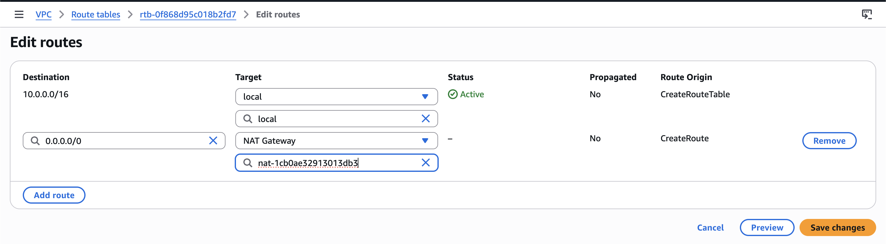

arpitchouksey@Arpits-MacBook-Air connectivity % terraform plan
aws_eip.nat_eip: Refreshing state... [id=eipalloc-0d424e1225e89205e]
aws_vpc.connectivity_vpc: Refreshing state... [id=vpc-07d9cd9f11dc7928c]
module.terraform_execution_role.aws_iam_role.terraform_execution_role: Refreshing state... [id=TerraformExecutionRole]
module.terraform_execution_role.aws_iam_role_policy_attachment.admin_attach: Refreshing state...
aws_subnet.public_subnet_az2: Refreshing state... [id=subnet-0f1877a10816ad282]
aws_internet_gateway.connectivity_igw: Refreshing state... [id=igw-0de7517bcf88cc6f8]
aws_route_table.private_rt: Refreshing state... [id=rtb-0f868d95c018b2fd7]
aws_subnet.private_subnet_az2: Refreshing state... [id=subnet-01dfb529b0911ec7e]
aws_subnet.public_subnet_az1: Refreshing state... [id=subnet-03f3af4b02d8cb1a3]
aws_subnet.private_subnet_az1: Refreshing state... [id=subnet-02b8ba22fb6737f76]
aws_route_table.public_rt: Refreshing state... [id=rtb-0fbd06e3ba8357de2]
aws_nat_gateway.connectivity_nat: Refreshing state... [id=nat-1cb0ae32913013db3]
aws_route_table_association.private_az2_assoc: Refreshing state... [id=rtbassoc-0fd4a1d73b73e04da]
aws_route_table_association.public_az2_assoc: Refreshing state... [id=rtbassoc-096d4adfb8205d7d5]
aws_route_table_association.public_az1_assoc: Refreshing state... [id=rtbassoc-0a7c10bea5924f27c]
aws_route_table_association.private_az1_assoc: Refreshing state... [id=rtbassoc-03b9e836aa73a1d23]
aws_route.private_nat_route: Refreshing state... [id=r-rtb-0f868d95c018b2fd71080289494]

# aws_nat_gateway.connectivity_nat must be replaced
-/+ resource "aws_nat_gateway" "connectivity_nat" {
+ subnet_id = "subnet-03f3af4b02d8cb1a3" # forces replacement
}

Plan: 1 to add, 10 to change, 1 to destroy.

Changes to Outputs:
~ nat_gateway_id = "nat-1cb0ae32913013db3" -> (known after apply)

Screenshot — Plan details with replace:
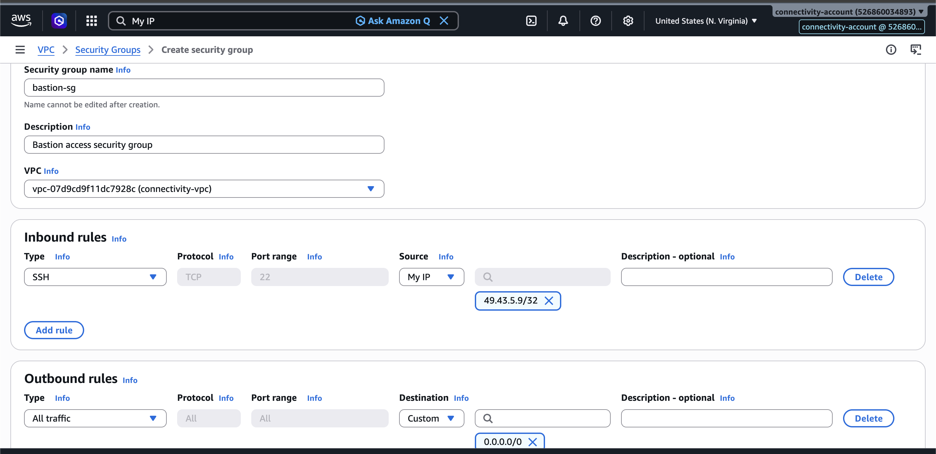

Screenshot — Plan details continued:
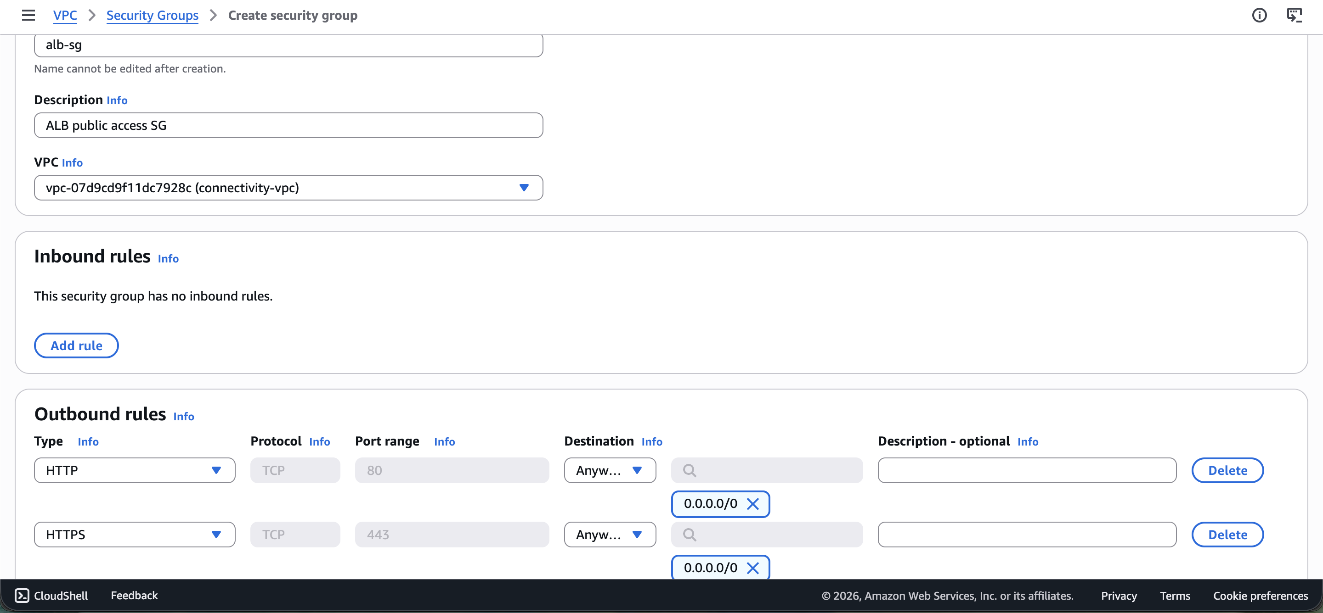

Screenshot — Plan details continued:
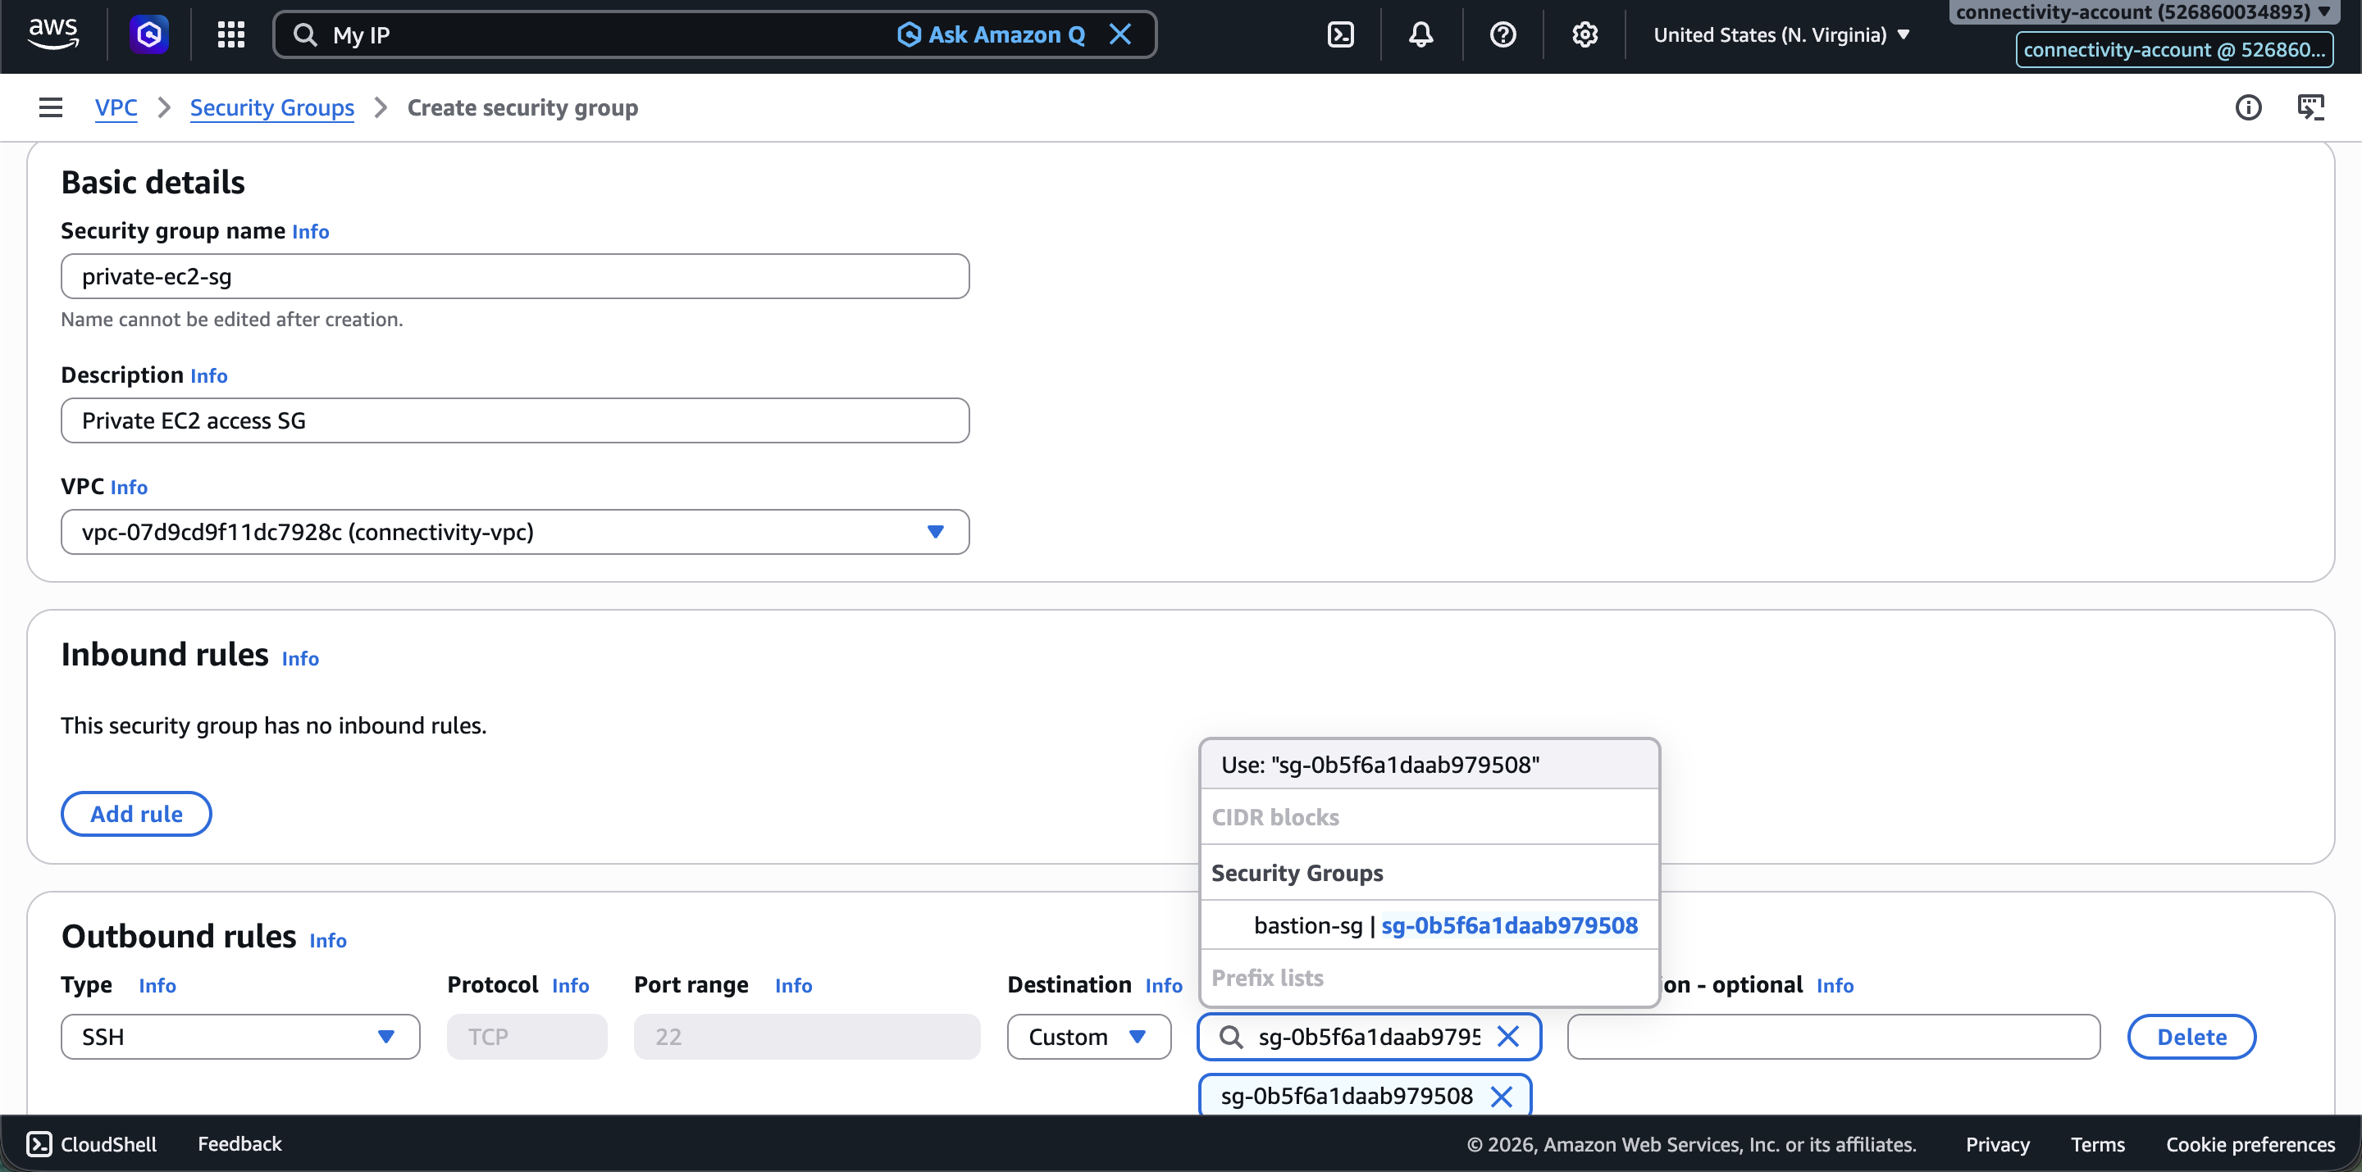

terraform apply — First Apply
arpitchouksey@Arpits-MacBook-Air connectivity % terraform apply
...
Plan: 0 to add, 10 to change, 0 to destroy.

Do you want to perform these actions?
Only 'yes' will be accepted to approve.
Enter a value: yes

aws_eip.nat_eip: Modifying... [id=eipalloc-0d424e1225e89205e]
aws_vpc.connectivity_vpc: Modifying... [id=vpc-07d9cd9f11dc7928c]
aws_eip.nat_eip: Modifications complete after 2s [id=eipalloc-0d424e1225e89205e]
aws_vpc.connectivity_vpc: Still modifying... [id=vpc-07d9cd9f11dc7928c, 00m10s elapsed]
aws_vpc.connectivity_vpc: Modifications complete after 15s [id=vpc-07d9cd9f11dc7928c]
aws_internet_gateway.connectivity_igw: Modifying... [id=igw-0de7517bcf88cc6f8]
aws_subnet.private_subnet_az1: Modifying... [id=subnet-02b8ba22fb6737f76]
aws_subnet.public_subnet_az2: Modifying... [id=subnet-0f1877a10816ad282]
aws_subnet.public_subnet_az1: Modifying... [id=subnet-03f3af4b02d8cb1a3]
aws_subnet.private_subnet_az2: Modifying... [id=subnet-01dfb529b0911ec7e]
aws_route_table.private_rt: Modifying... [id=rtb-0f868d95c018b2fd7]
aws_internet_gateway.connectivity_igw: Modifications complete after 1s [id=igw-0de7517bcf88cc6f8]
aws_nat_gateway.connectivity_nat: Modifying... [id=nat-1cb0ae32913013db3]
aws_route_table.public_rt: Modifying... [id=rtb-0fbd06e3ba8357de2]
aws_subnet.private_subnet_az1: Modifications complete after 1s [id=subnet-02b8ba22fb6737f76]
aws_subnet.public_subnet_az1: Modifications complete after 1s [id=subnet-03f3af4b02d8cb1a3]
aws_route_table.private_rt: Modifications complete after 1s [id=rtb-0f868d95c018b2fd7]
aws_subnet.public_subnet_az2: Modifications complete after 2s [id=subnet-0f1877a10816ad282]
aws_subnet.private_subnet_az2: Modifications complete after 2s [id=subnet-01dfb529b0911ec7e]
aws_route_table.public_rt: Modifications complete after 1s [id=rtb-0fbd06e3ba8357de2]
aws_nat_gateway.connectivity_nat: Modifications complete after 1s [id=nat-1cb0ae32913013db3]

Apply complete! Resources: 0 added, 10 changed, 0 destroyed.

Outputs:
nat_gateway_id = "nat-1cb0ae32913013db3"
private_subnet_az1_id = "subnet-02b8ba22fb6737f76"
private_subnet_az2_id = "subnet-01dfb529b0911ec7e"
public_subnet_az1_id = "subnet-03f3af4b02d8cb1a3"
public_subnet_az2_id = "subnet-0f1877a10816ad282"
vpc_id = "vpc-07d9cd9f11dc7928c"

Screenshot — terraform apply output:
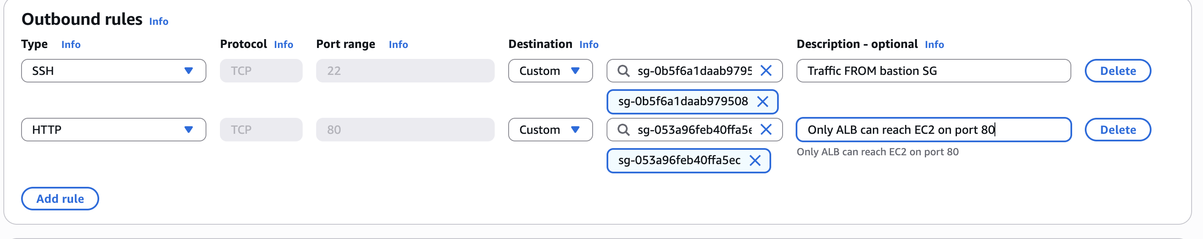

NAT Gateway Deleted to Save Cost — Then Recreated via Terraform
The NAT Gateway was deleted to avoid charges during non-active periods. It was recreated via terraform apply when needed.

Screenshot — NAT Gateway deleted:
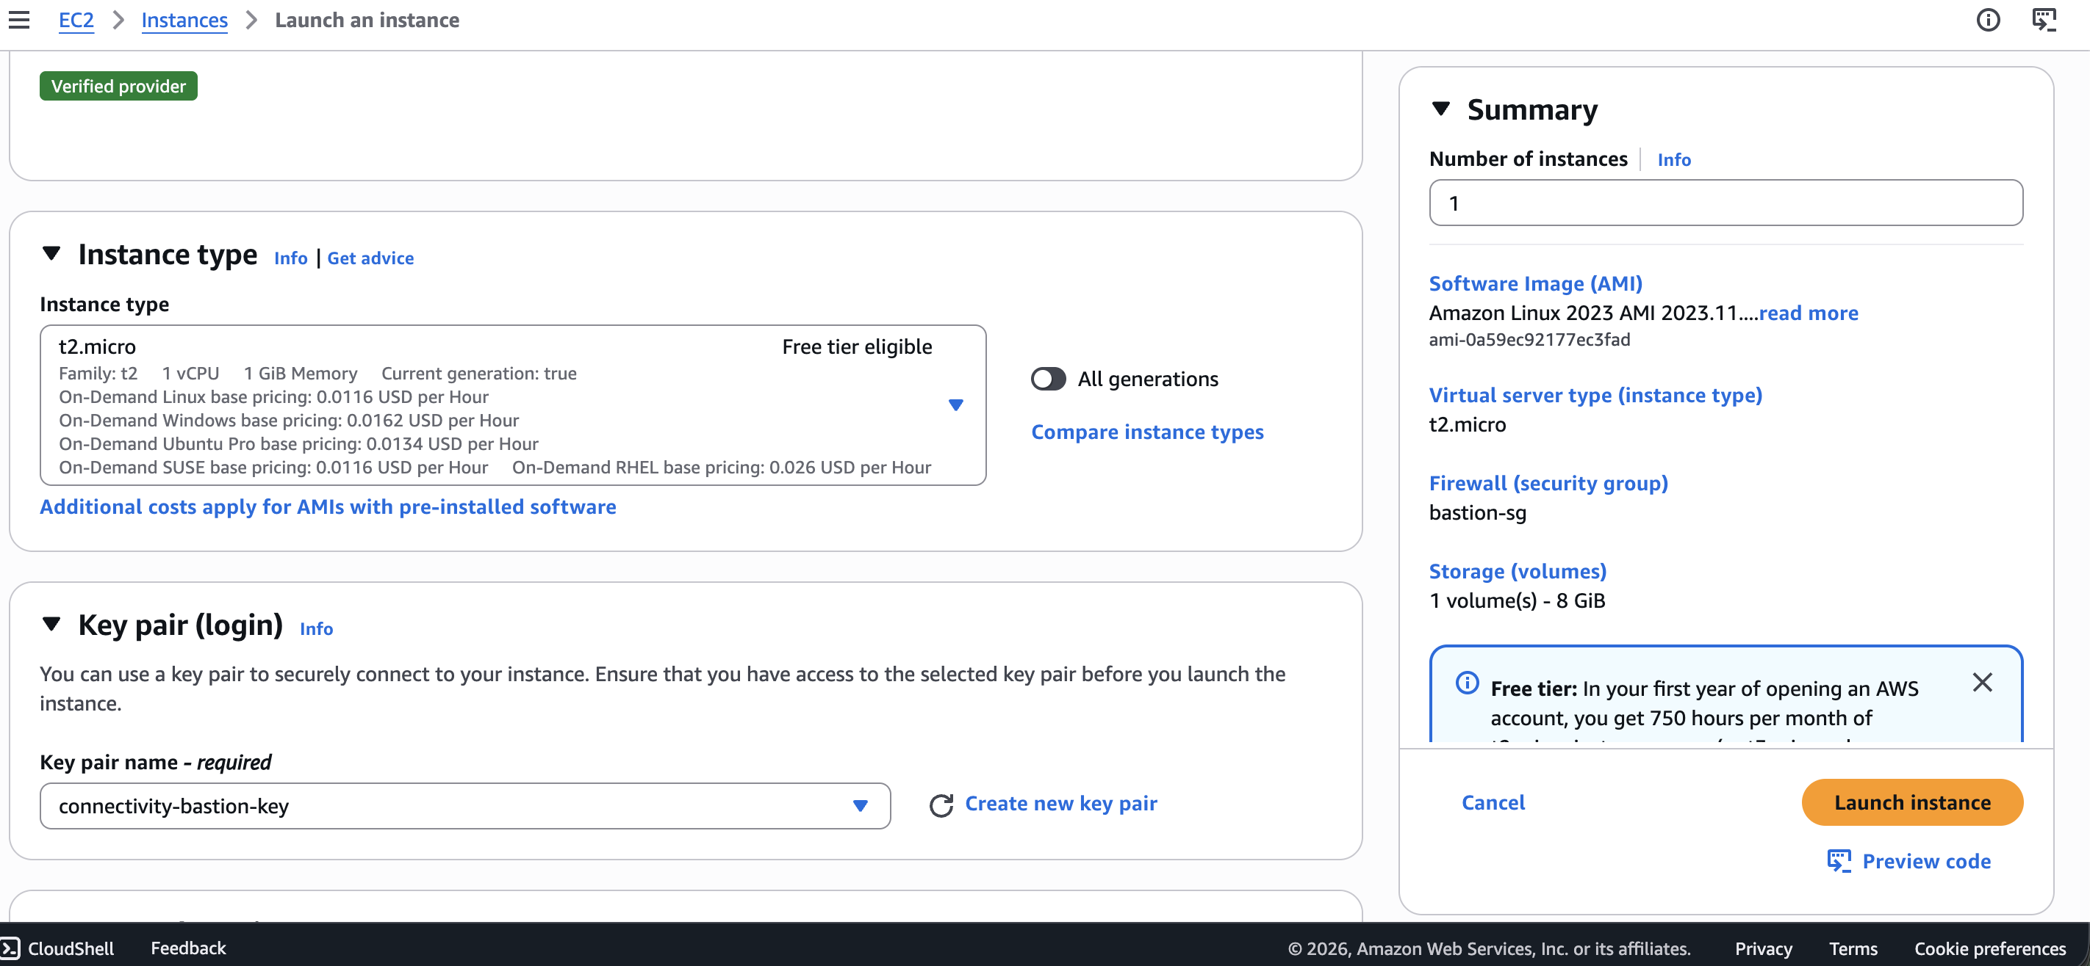

Screenshot — NAT Gateway recreated via terraform:
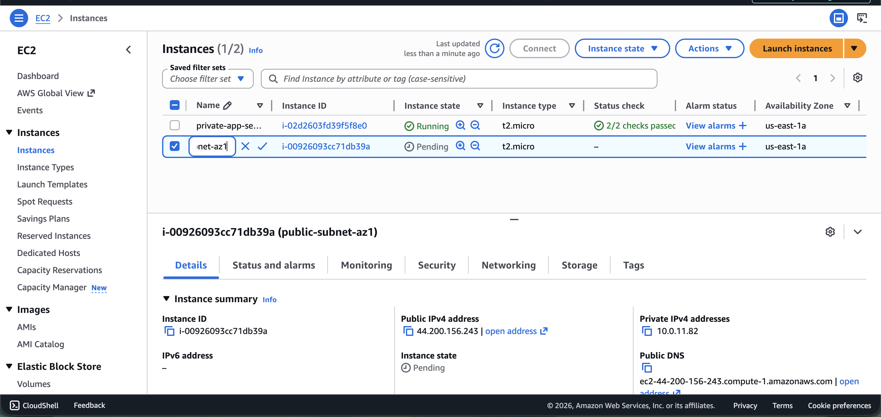

Security Groups Setup
Three security groups are required:
- bastion-sg — SSH access to Bastion Host
- alb-sg — Public internet traffic to ALB
- private-ec2-sg — Internal traffic to private EC2 instances

Security Group Architecture
Laptop
|
bastion-sg
|
Bastion EC2
|
private-ec2-sg
|
Private EC2

Internet
|
alb-sg
|
ALB
|
private-ec2-sg
|
Private EC2

Screenshot — Security group creation in console:
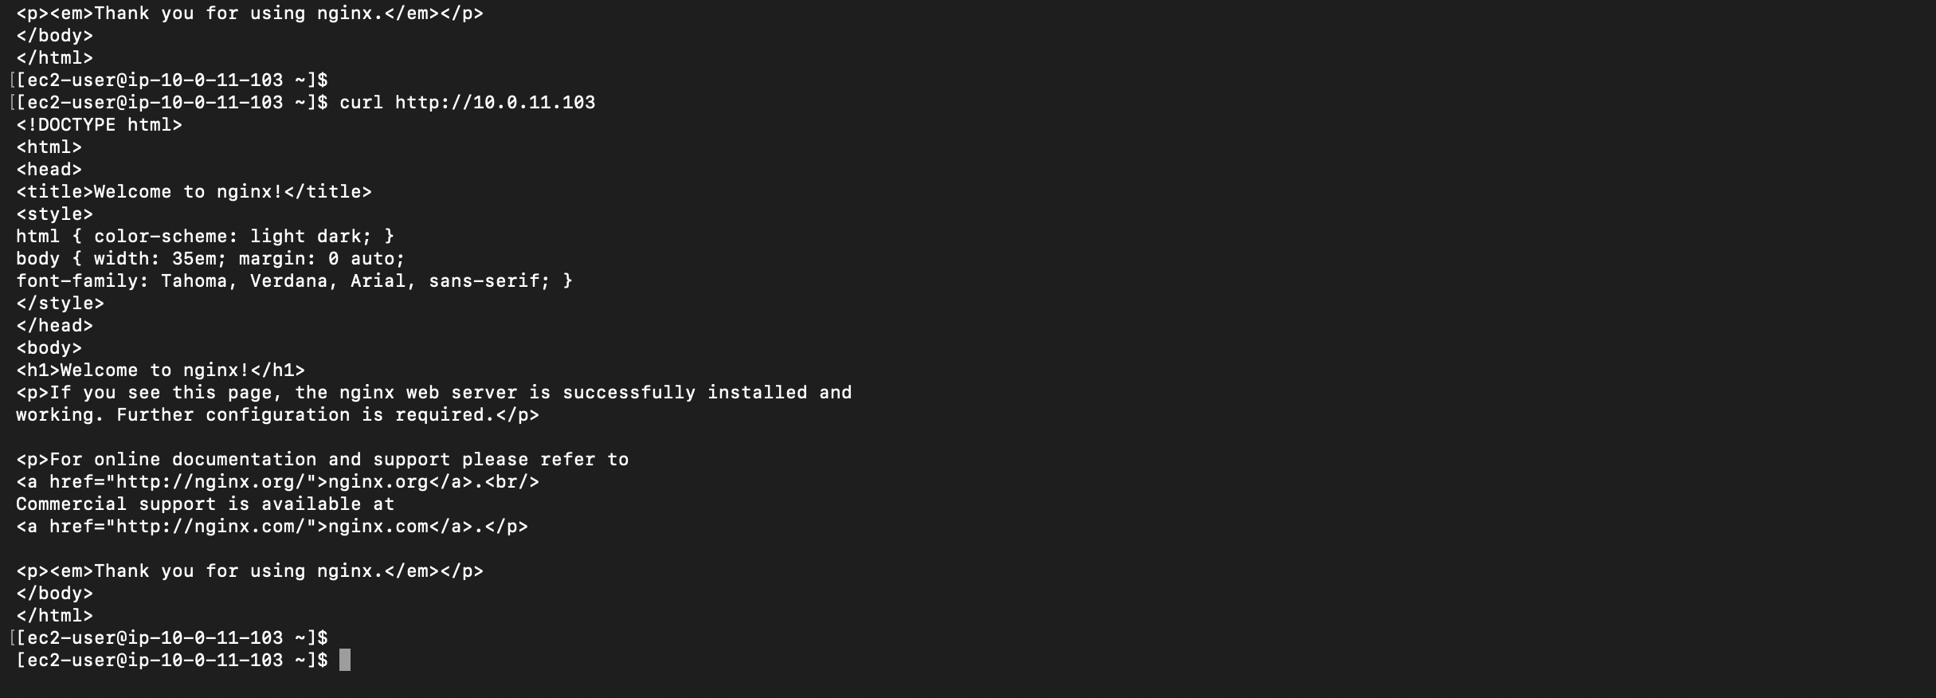

Screenshot — Bastion SG rules:
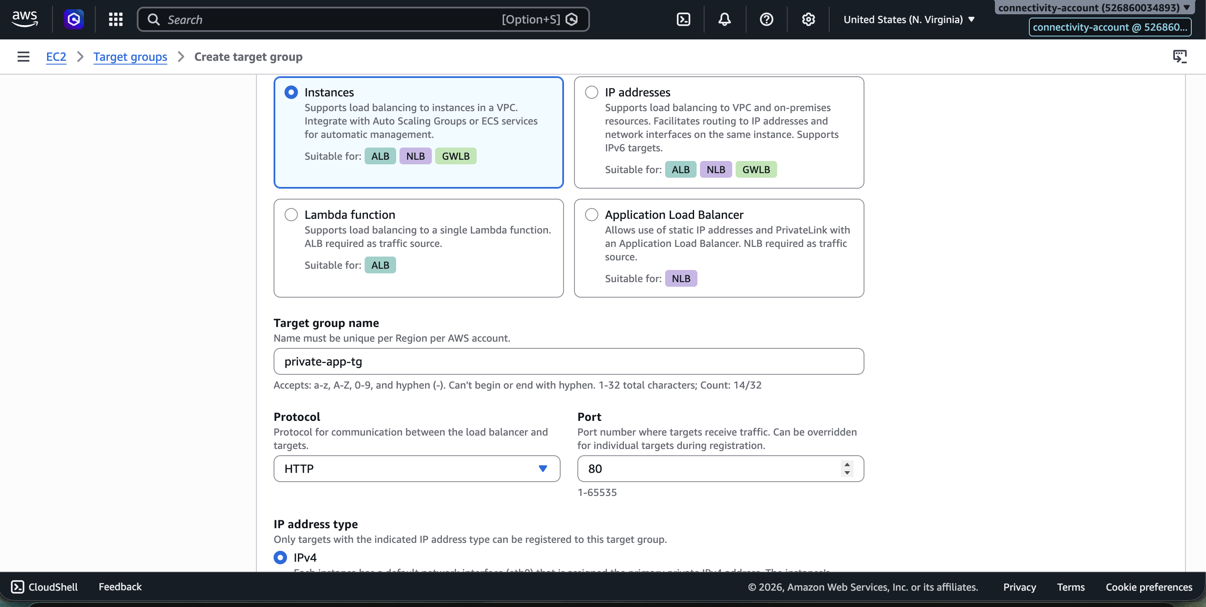

Screenshot — ALB SG rules:
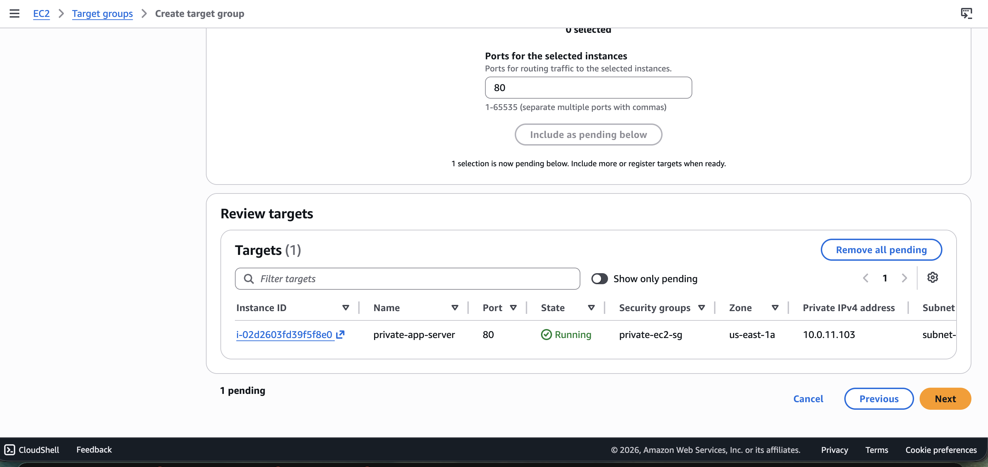

Screenshot — Private EC2 SG rules:
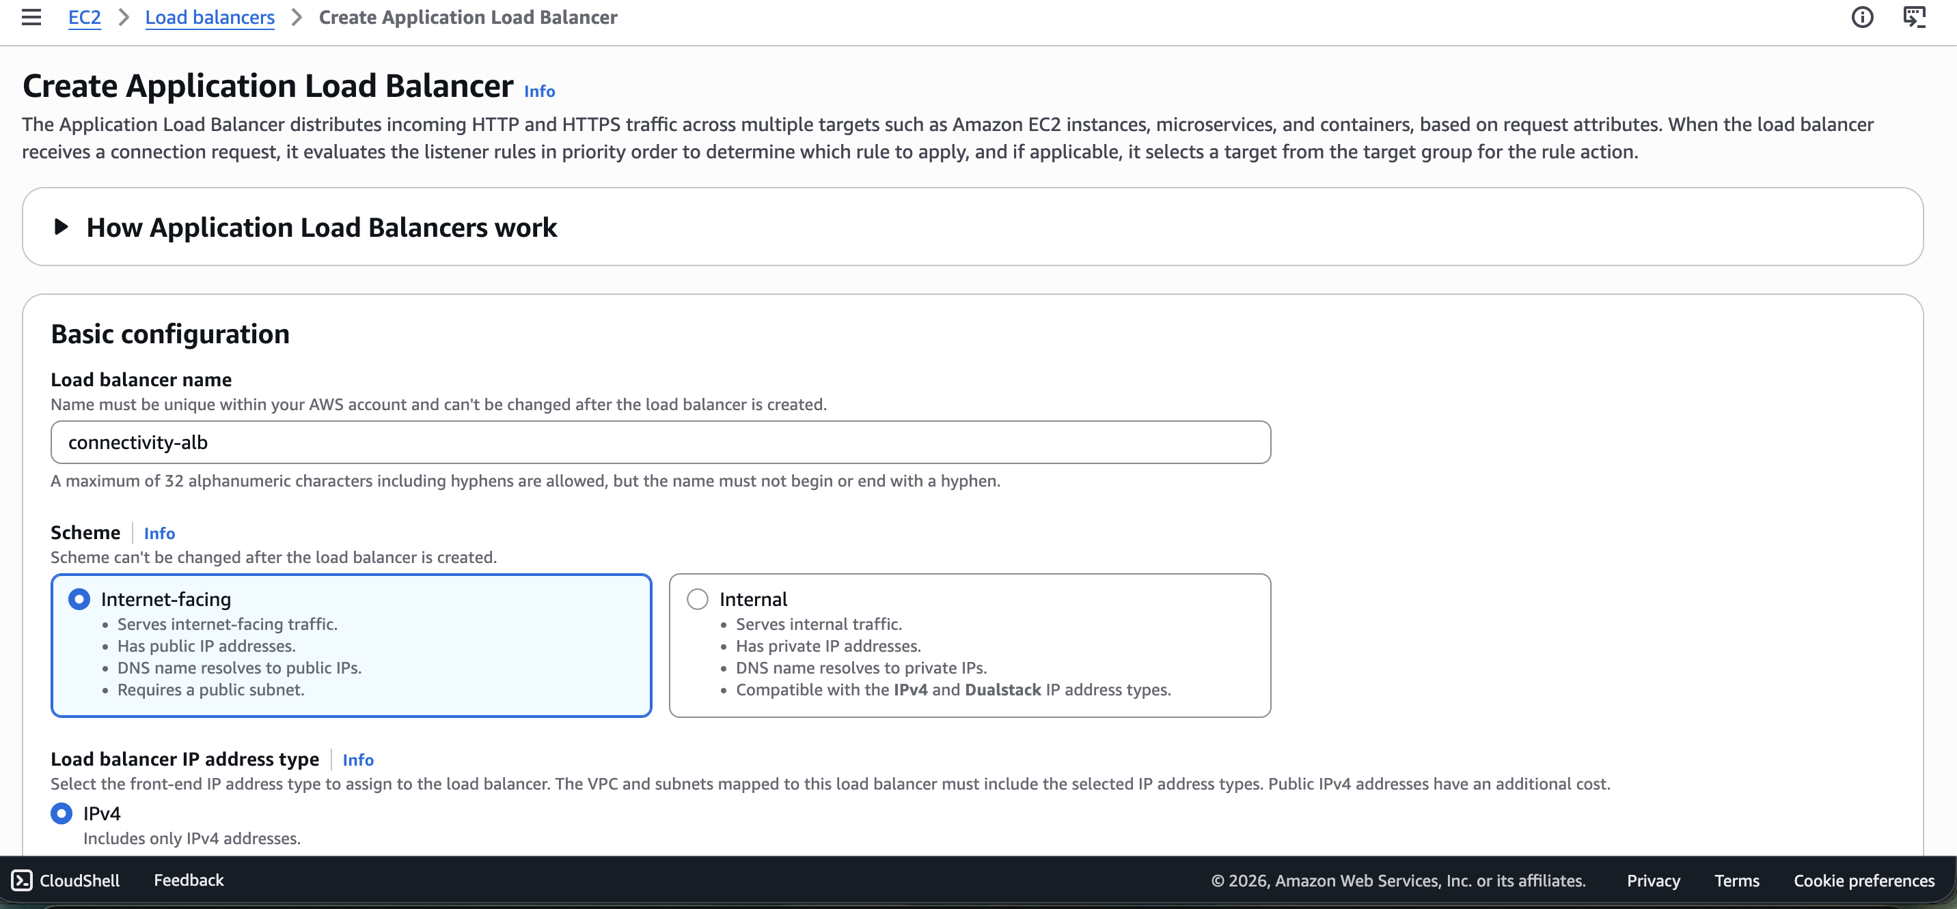

terraform import — Bastion Security Group (Error — Module Not Installed)
arpitchouksey@Arpits-MacBook-Air connectivity % terraform import aws_security_group.bastion_sg sg-0b5f6a1daab979508
╷
│ Error: Module not installed
│
│ on main.tf line 5:
│ 5: module "terraform_execution_role" {
│
│ This module is not yet installed. Run "terraform init" to install all modules
│ required by this configuration.
╵

Fix: Run terraform init first.

terraform init (After Adding New Resources to main.tf)
arpitchouksey@Arpits-MacBook-Air connectivity % terraform init
Initializing the backend...
Initializing modules...
- terraform_execution_role in ../../modules/terraform-role
Initializing provider plugins...
- Finding hashicorp/aws versions matching "~> 5.0"...
- Installing hashicorp/aws v5.100.0...
- Installed hashicorp/aws v5.100.0 (signed by HashiCorp)

Terraform has been successfully initialized!

terraform import — Bastion Security Group (Correct)
arpitchouksey@Arpits-MacBook-Air connectivity % terraform import aws_security_group.bastion_sg sg-0b5f6a1daab979508
aws_security_group.bastion_sg: Importing from ID "sg-0b5f6a1daab979508"...
aws_security_group.bastion_sg: Import prepared!
Prepared aws_security_group for import
aws_security_group.bastion_sg: Refreshing state... [id=sg-0b5f6a1daab979508]

Import successful!

terraform import — Bastion Host EC2
arpitchouksey@Arpits-MacBook-Air connectivity % terraform import aws_instance.bastion_host i-0a63005c4707827ba
aws_instance.bastion_host: Importing from ID "i-0a63005c4707827ba"...
aws_instance.bastion_host: Import prepared!
Prepared aws_instance for import
aws_instance.bastion_host: Refreshing state... [id=i-0a63005c4707827ba]

Import successful!

Screenshot — Bastion host imported:
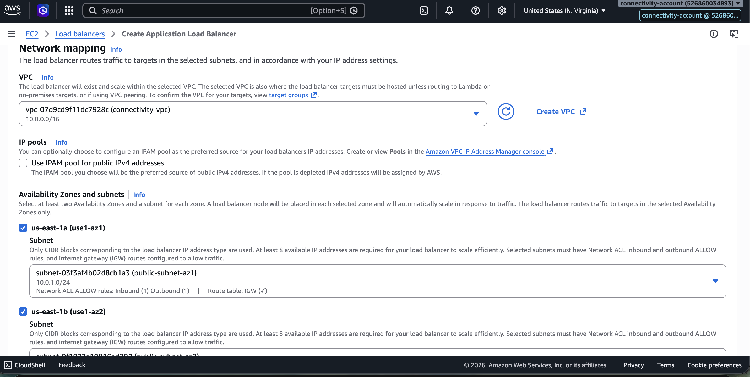

terraform plan — With Bastion Host (Error: Instance Cannot Be Destroyed)
Terraform planned the following actions:

# aws_instance.bastion_host must be replaced
-/+ resource "aws_instance" "bastion_host" {
~ associate_public_ip_address = false -> true # forces replacement
~ availability_zone = "us-east-1a" -> (known after apply)
id = "i-0a63005c4707827ba"
~ instance_state = "stopped" -> (known after apply)
~ private_dns = "ip-10-0-1-208.ec2.internal" -> (known after apply)
~ private_ip = "10.0.1.208" -> (known after apply)
~ tags = {
+ "Environment" = "connectivity"
"Name" = "bastion-host"
}
~ vpc_security_group_ids = [
- "sg-0b5f6a1daab979508",
] -> (known after apply)
}

# aws_security_group.bastion_sg must be replaced
-/+ resource "aws_security_group" "bastion_sg" {
~ description = "Bastion access security group" -> "Bastion Security Group" # forces replacement
}

Plan: 2 to add, 1 to change, 2 to destroy.

╷
│ Error: Instance cannot be destroyed
│
│ on bastion.tf line 1:
│ 1: resource "aws_instance" "bastion_host" {
│
│ Resource aws_instance.bastion_host has lifecycle.prevent_destroy set, but the
│ plan calls for this resource to be destroyed. To avoid this error and continue
│ with the plan, either disable lifecycle.prevent_destroy or reduce the scope of
│ the plan using the -target option.
╵

Screenshot — Plan error with prevent_destroy:
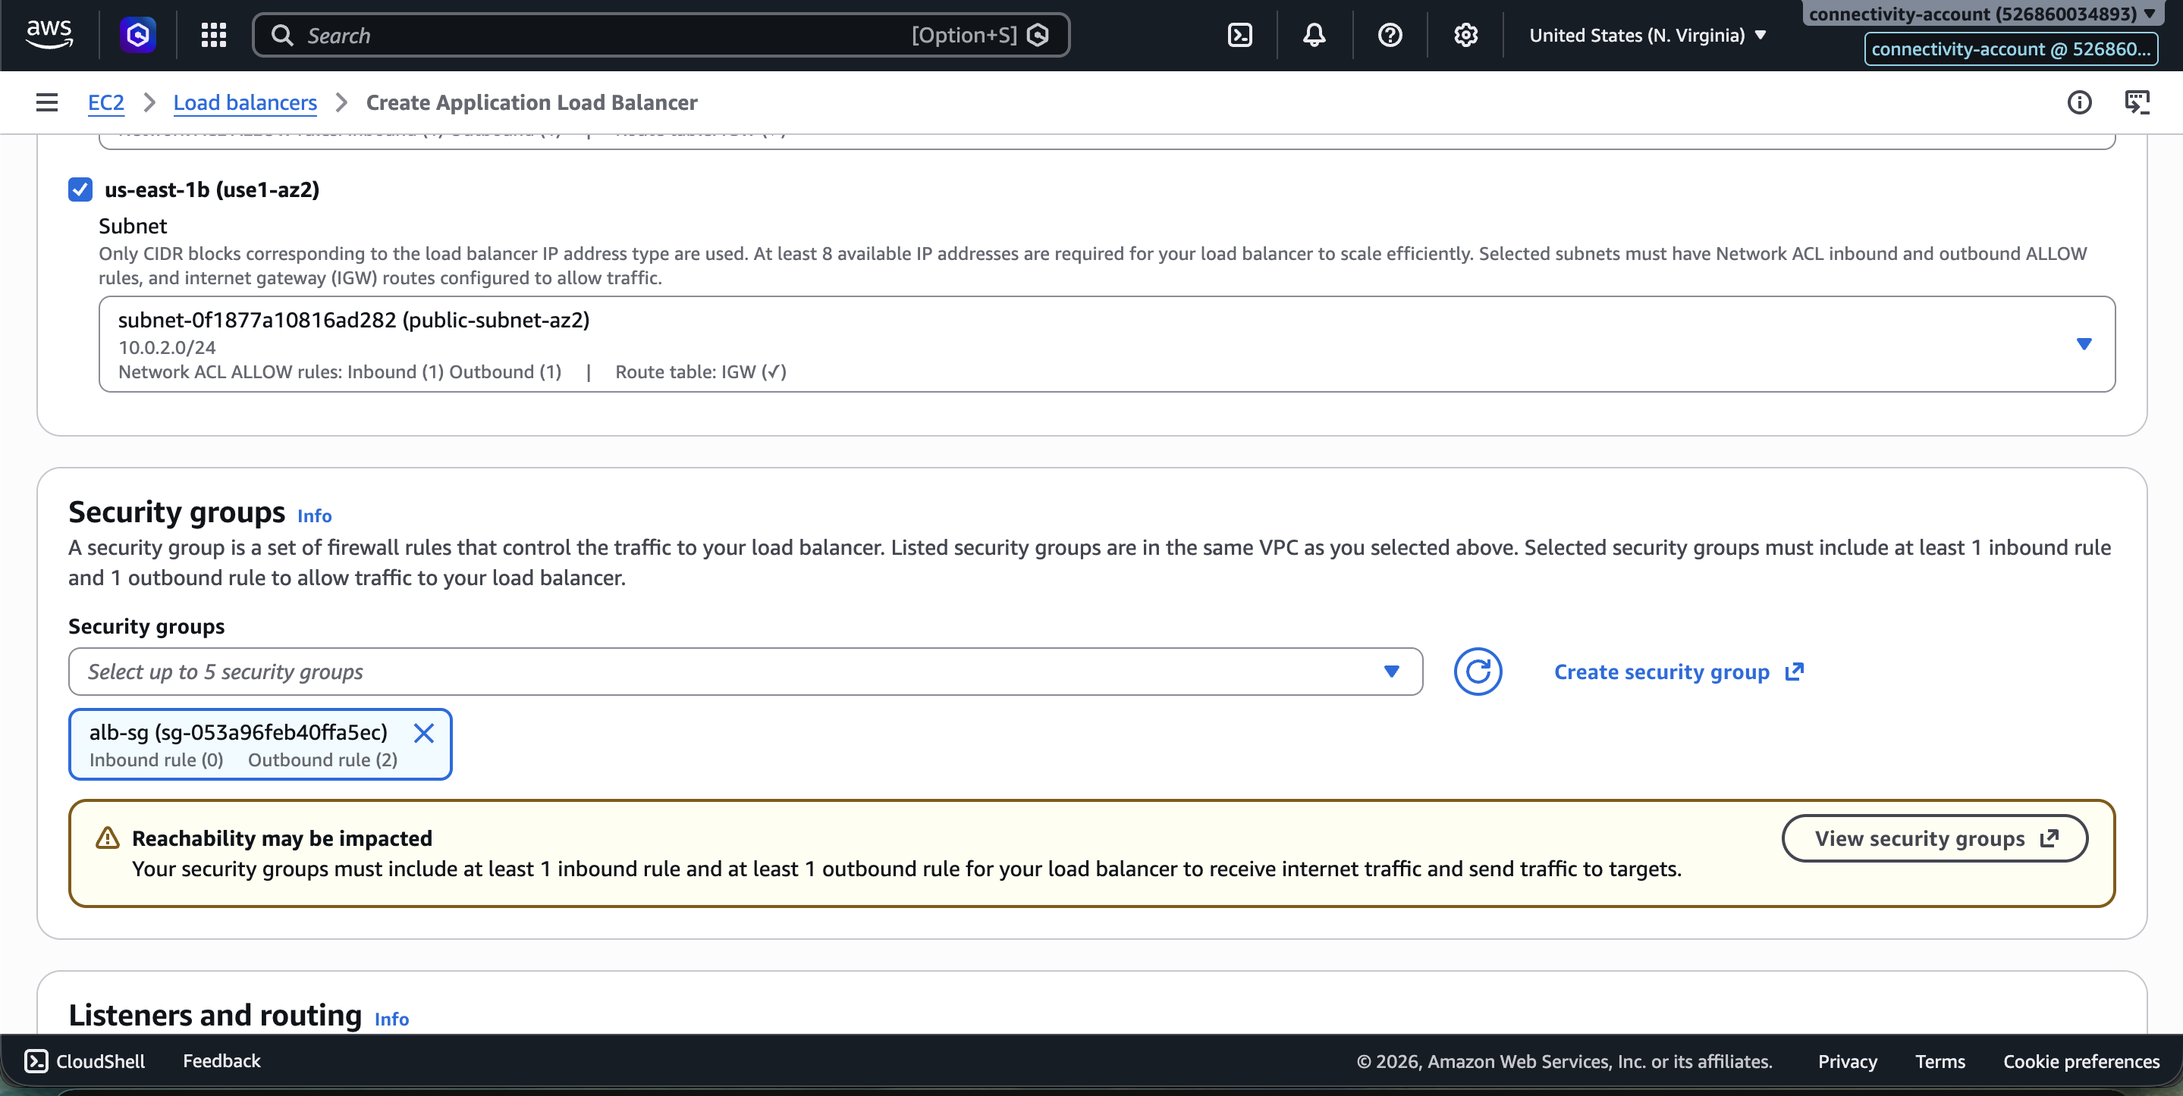

Creating Site-to-Site VPN (Architecture Plan)
Corporate Network / On-Prem
|
Site-to-Site VPN
|
Connectivity Account
|
Transit Gateway
|
|-------------|
| |
Dev VPC Prod VPC

Screenshot — Site to Site VPN architecture:
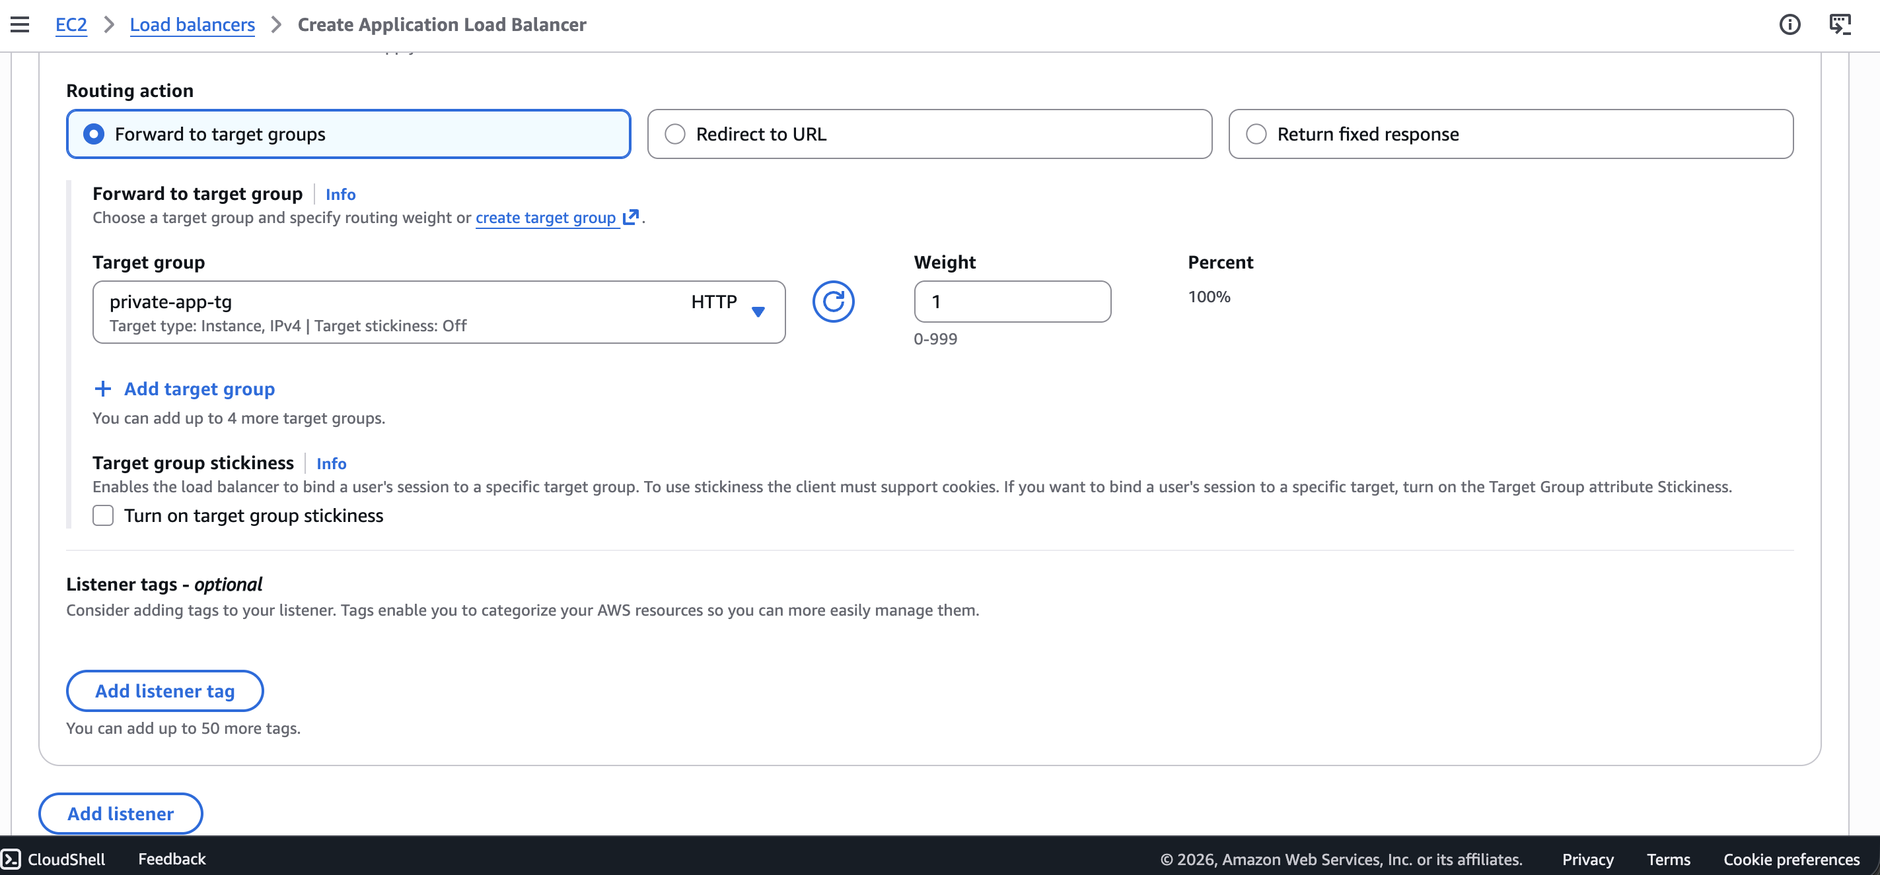

Create Bastion Host
Screenshot — Bastion host EC2 in console:
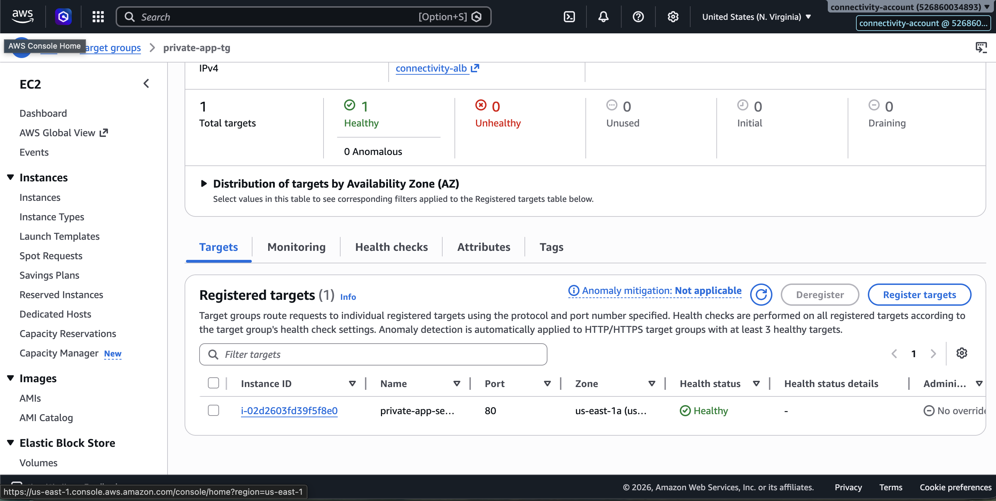

Screenshot — Bastion host details:
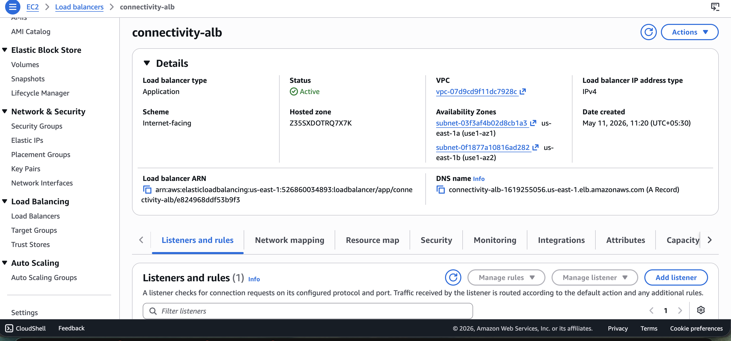

Testing Bastion Host
Screenshot — SSH test to bastion host:
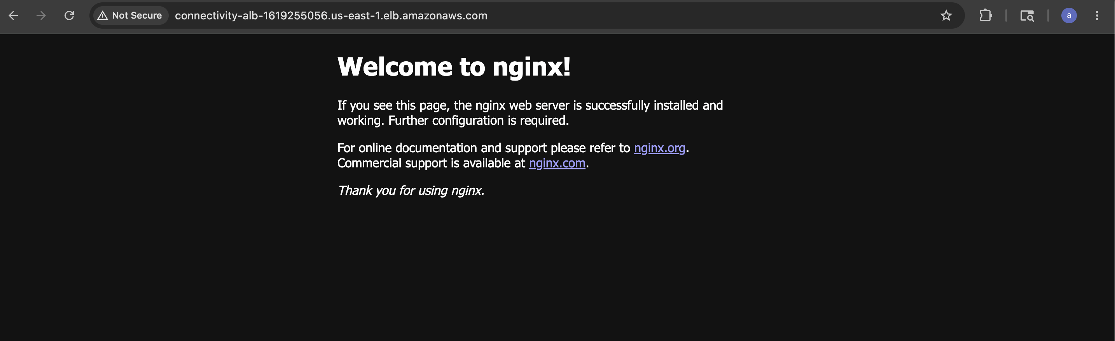

Creating Target Group for ALB
Screenshot — Target group creation:
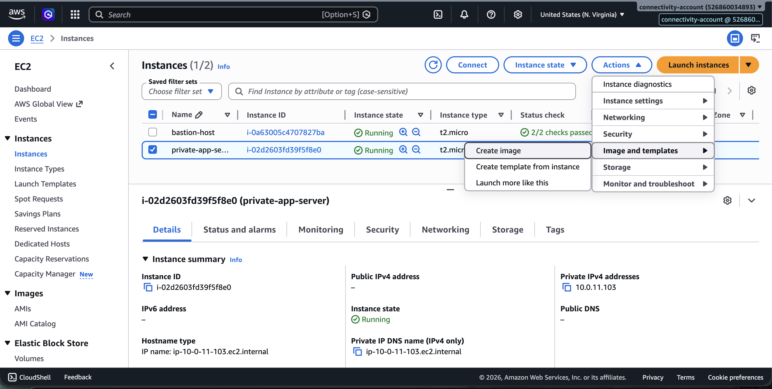

Screenshot — Target group configured:
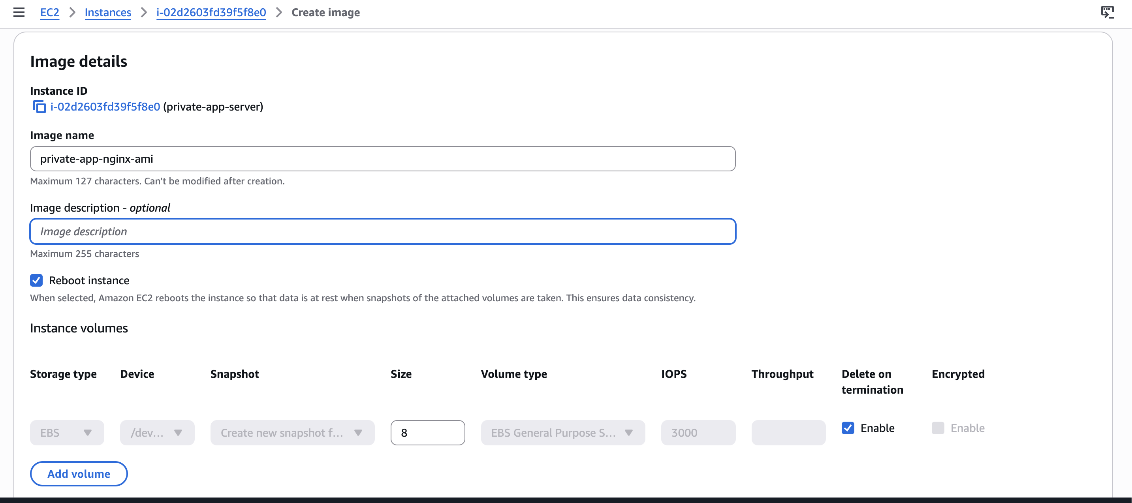

HPA — Horizontal Pod Autoscaler Configuration
Screenshot — HPA setup:
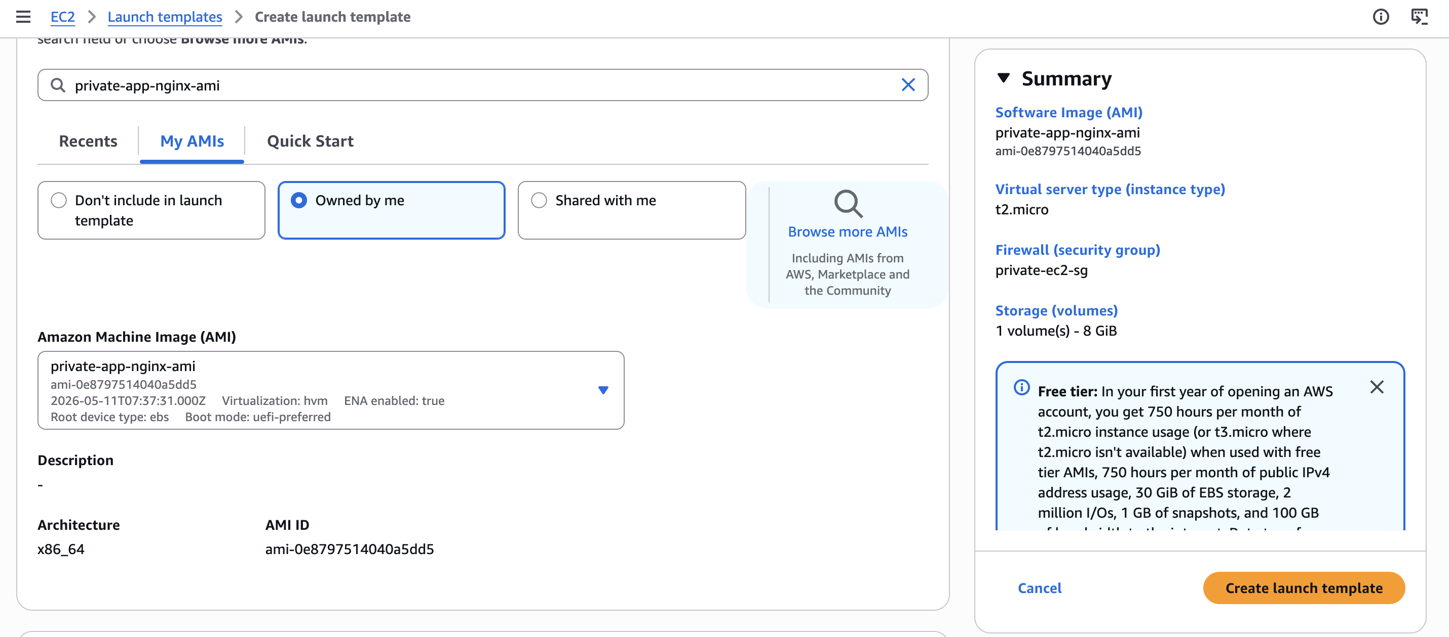

PHASE 2 — Enable AWS RAM Organization Sharing
AWS RAM (Resource Access Manager) allows sharing of VPC subnets from the Connectivity Account with the Dev Account.

⚠️ Note: Your AWS Organization must be using "All Features" mode for RAM sharing to work.
Go to: AWS Organizations → All Features Enabled (from management-account)

Screenshot — AWS Organizations All Features:
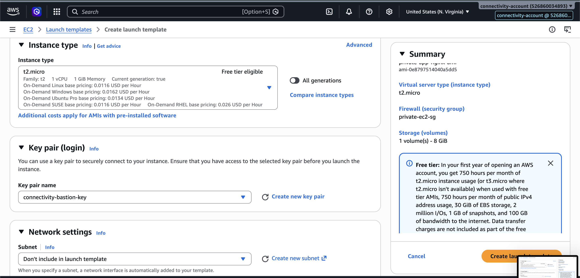

ram-sharing.tf — Terraform Code
resource "aws_ram_resource_share" "shared_network" {
name = "shared-network-subnets"
allow_external_principals = true
tags = {
Name = "shared-network-subnets"
}
}

resource "aws_ram_principal_association" "dev_account" {
principal = "119004746935"
resource_share_arn = aws_ram_resource_share.shared_network.arn
}

resource "aws_ram_resource_association" "public_subnet_az1" {
resource_arn = aws_subnet.public_subnet_az1.arn
resource_share_arn = aws_ram_resource_share.shared_network.arn
}

resource "aws_ram_resource_association" "public_subnet_az2" {
resource_arn = aws_subnet.public_subnet_az2.arn
resource_share_arn = aws_ram_resource_share.shared_network.arn
}

resource "aws_ram_resource_association" "private_subnet_az1" {
resource_arn = aws_subnet.private_subnet_az1.arn
resource_share_arn = aws_ram_resource_share.shared_network.arn
}

resource "aws_ram_resource_association" "private_subnet_az2" {
resource_arn = aws_subnet.private_subnet_az2.arn
resource_share_arn = aws_ram_resource_share.shared_network.arn
}

terraform import — RAM Resource Share (Error — Module Not Installed)
terraform import aws_ram_resource_share.shared_network arn:aws:ram:us-east-1:526860034893:resource-share/8b1bb064-ba4a-4f11-bea3-b3676e0882d1
╷
│ Error: Module not installed
│ on main.tf line 5:
│ 5: module "terraform_execution_role" {
│ This module is not yet installed. Run "terraform init" to install all modules.
╵

terraform init (Before RAM Import)
arpitchouksey@Arpits-MacBook-Air connectivity % terraform init
Initializing the backend...
Initializing modules...
- terraform_execution_role in ../../modules/terraform-role
Initializing provider plugins...
- Finding hashicorp/aws versions matching "~> 5.0"...
- Installing hashicorp/aws v5.100.0...
- Installed hashicorp/aws v5.100.0 (signed by HashiCorp)

Terraform has been successfully initialized!

terraform import — RAM Resource Share
arpitchouksey@Arpits-MacBook-Air connectivity % terraform import \
aws_ram_resource_share.shared_network \
arn:aws:ram:us-east-1:526860034893:resource-share/8b1bb064-ba4a-4f11-bea3-b3676e0882d1

aws_ram_resource_share.shared_network: Importing from ID "arn:aws:ram:us-east-1:526860034893:resource-share/8b1bb064-ba4a-4f11-bea3-b3676e0882d1"...
aws_ram_resource_share.shared_network: Import prepared!
Prepared aws_ram_resource_share for import
aws_ram_resource_share.shared_network: Refreshing state... [id=arn:aws:ram:us-east-1:526860034893:resource-share/8b1bb064-ba4a-4f11-bea3-b3676e0882d1]

Import successful!

Screenshot — RAM resource share imported:
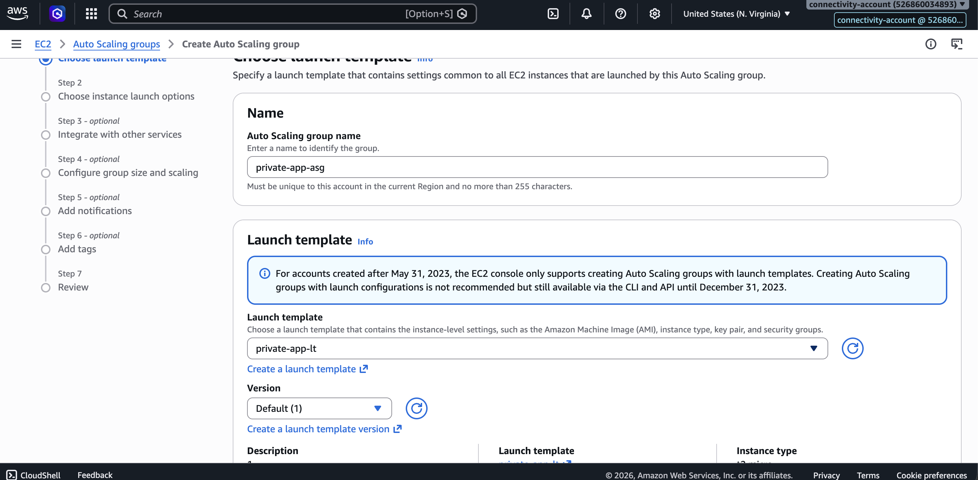

terraform import — RAM Principal Association (First Attempt — Error)
arpitchouksey@Arpits-MacBook-Air connectivity % terraform import \
aws_ram_principal_association.dev_account \
arn:aws:ram::aws:permission/AWSRAMDefaultPermissionSubnet,119004746935

aws_ram_principal_association.dev_account: Importing from ID "arn:aws:ram::aws:permission/AWSRAMDefaultPermissionSubnet,119004746935"...
aws_ram_principal_association.dev_account: Import prepared!
╷
│ Error: reading RAM Principal Association: operation error RAM: GetResourceShareAssociations,
│ https response error StatusCode: 400, RequestID: e06f39b7-c812-4132-8aaa-2e196a2377be,
│ MalformedArnException: The specified resource share ARN is not valid. Verify the ARN and try again.
╵

Fix: Use the resource-share ARN, not the permission ARN.

terraform import — RAM Principal Association (Correct)
arpitchouksey@Arpits-MacBook-Air connectivity % terraform import \
aws_ram_principal_association.dev_account \
arn:aws:ram:us-east-1:526860034893:resource-share/8b1bb064-ba4a-4f11-bea3-b3676e0882d1,119004746935

aws_ram_principal_association.dev_account: Importing from ID "arn:...,119004746935"...
aws_ram_principal_association.dev_account: Import prepared!
aws_ram_principal_association.dev_account: Refreshing state... [id=arn:...,119004746935]

Import successful!

terraform import — RAM Resource Association Public Subnet AZ1 (Error — Already Managed)
arpitchouksey@Arpits-MacBook-Air connectivity % terraform import \
aws_ram_principal_association.dev_account \
arn:aws:ram:us-east-1:526860034893:resource-share/8b1bb064-ba4a-4f11-bea3-b3676e0882d1,arn:aws:ec2:us-east-1:526860034893:subnet/subnet-03f3af4b02d8cb1a3
╷
│ Error: Resource already managed by Terraform
│ Terraform is already managing a remote object for aws_ram_principal_association.dev_account.
│ To import to this address you must first remove the existing object from the state.
╵

terraform import — RAM Resource Association public_subnet_az1
arpitchouksey@Arpits-MacBook-Air connectivity % terraform import \
aws_ram_resource_association.public_subnet_az1 \
arn:aws:ram:us-east-1:526860034893:resource-share/8b1bb064-ba4a-4f11-bea3-b3676e0882d1,arn:aws:ec2:us-east-1:526860034893:subnet/subnet-03f3af4b02d8cb1a3

aws_ram_resource_association.public_subnet_az1: Import prepared!
aws_ram_resource_association.public_subnet_az1: Refreshing state... [id=arn:...,arn:aws:ec2:...:subnet/subnet-03f3af4b02d8cb1a3]

Import successful!

Screenshot — RAM resource associations imported:
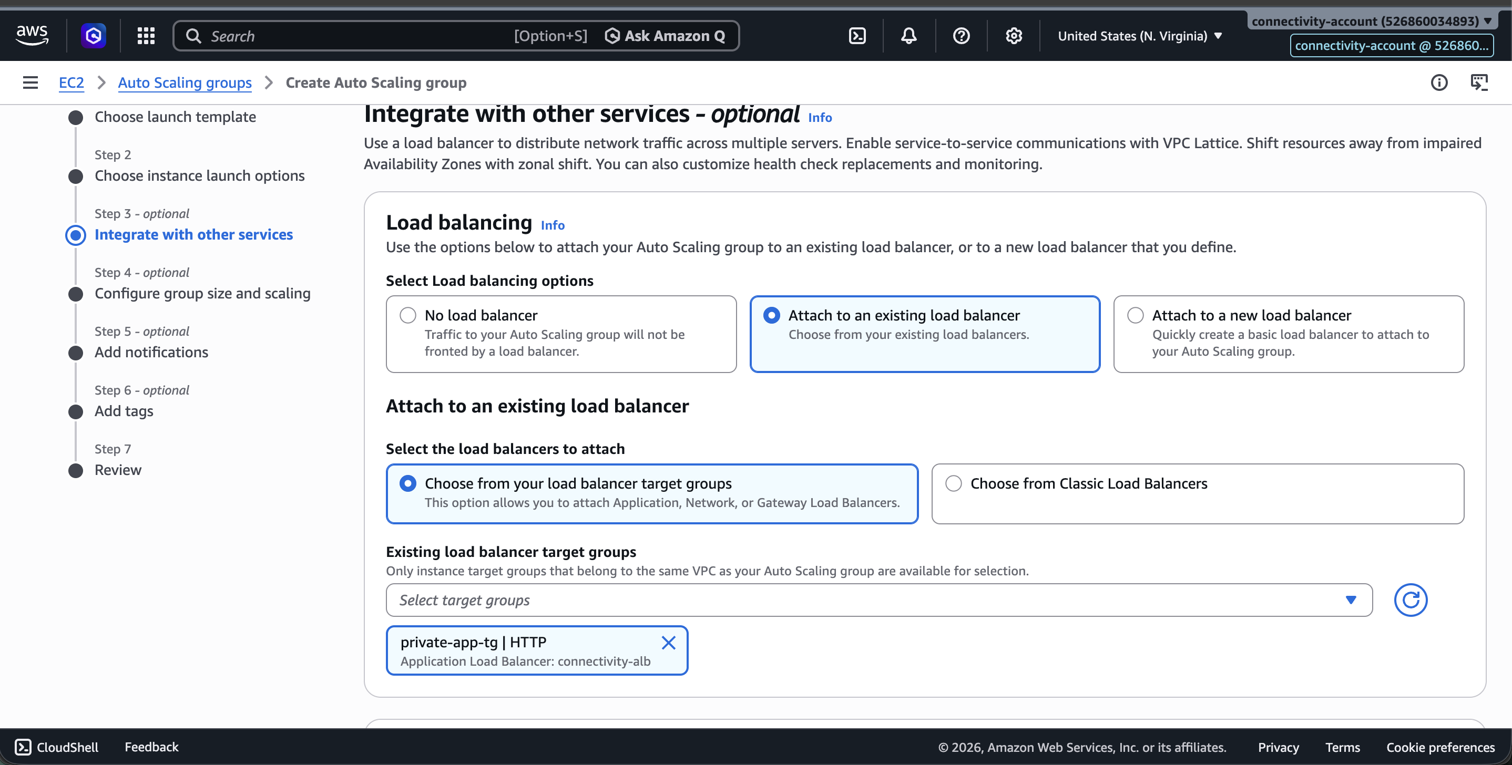

terraform import — RAM Resource Association public_subnet_az2 (Error — Already Managed Then Fix)
# First attempt imported wrong subnet ARN (az1 instead of az2)
arpitchouksey@Arpits-MacBook-Air connectivity % terraform import \
aws_ram_resource_association.public_subnet_az2 \
arn:aws:ram:us-east-1:526860034893:resource-share/8b1bb064-ba4a-4f11-bea3-b3676e0882d1,arn:aws:ec2:us-east-1:526860034893:subnet/subnet-03f3af4b02d8cb1a3
(imported wrong — used az1 subnet ID)

# Error in subsequent re-import:
╷
│ Error: Resource already managed by Terraform
╵

terraform import — RAM public_subnet_az2 (Fixed via state rm + re-import)
arpitchouksey@Arpits-MacBook-Air connectivity % terraform state rm aws_ram_resource_association.public_subnet_az2
Removed aws_ram_resource_association.public_subnet_az2
Successfully removed 1 resource instance(s).

arpitchouksey@Arpits-MacBook-Air connectivity % terraform import \
aws_ram_resource_association.public_subnet_az2 \
arn:aws:ram:us-east-1:526860034893:resource-share/8b1bb064-ba4a-4f11-bea3-b3676e0882d1,arn:aws:ec2:us-east-1:526860034893:subnet/subnet-0f1877a10816ad282

aws_ram_resource_association.public_subnet_az2: Import prepared!
aws_ram_resource_association.public_subnet_az2: Refreshing state... [id=arn:...,arn:aws:ec2:...:subnet/subnet-0f1877a10816ad282]

Import successful!

terraform import — RAM private_subnet_az1
arpitchouksey@Arpits-MacBook-Air connectivity % terraform import \
aws_ram_resource_association.private_subnet_az1 \
arn:aws:ram:us-east-1:526860034893:resource-share/8b1bb064-ba4a-4f11-bea3-b3676e0882d1,arn:aws:ec2:us-east-1:526860034893:subnet/subnet-02b8ba22fb6737f76

Import successful!

terraform import — RAM private_subnet_az2
arpitchouksey@Arpits-MacBook-Air connectivity % terraform import \
aws_ram_resource_association.private_subnet_az2 \
arn:aws:ram:us-east-1:526860034893:resource-share/8b1bb064-ba4a-4f11-bea3-b3676e0882d1,arn:aws:ec2:us-east-1:526860034893:subnet/subnet-01dfb529b0911ec7e

Import successful!

Screenshot — All RAM associations imported:
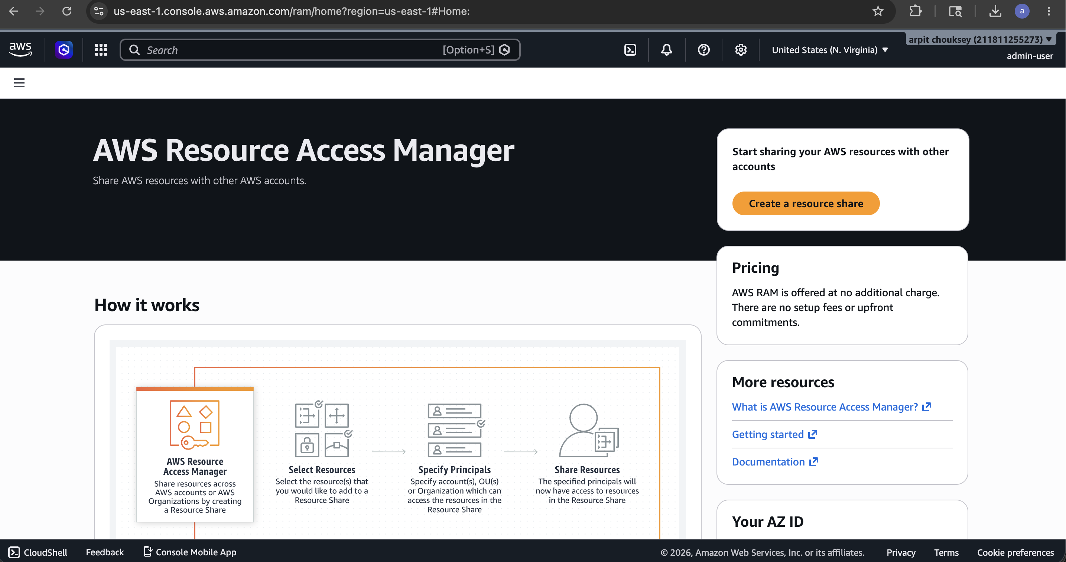

terrafrom plan — Typo (Command Not Found)
arpitchouksey@Arpits-MacBook-Air connectivity % terrafrom plan
zsh: command not found: terrafrom

terraform plan — Final (After All RAM Imports)
arpitchouksey@Arpits-MacBook-Air connectivity % terraform plan
aws_ram_resource_share.shared_network: Refreshing state... [id=arn:aws:ram:us-east-1:526860034893:resource-share/8b1bb064-ba4a-4f11-bea3-b3676e0882d1]
aws_vpc.connectivity_vpc: Refreshing state... [id=vpc-07d9cd9f11dc7928c]
module.terraform_execution_role.aws_iam_role.terraform_execution_role: Refreshing state... [id=TerraformExecutionRole]
aws_eip.nat_eip: Refreshing state... [id=eipalloc-0d424e1225e89205e]
aws_ram_principal_association.dev_account: Refreshing state... [id=arn:...,119004746935]
module.terraform_execution_role.aws_iam_role_policy_attachment.admin_attach: Refreshing state...
aws_subnet.private_subnet_az2: Refreshing state... [id=subnet-01dfb529b0911ec7e]
aws_subnet.public_subnet_az2: Refreshing state... [id=subnet-0f1877a10816ad282]
aws_internet_gateway.connectivity_igw: Refreshing state... [id=igw-0de7517bcf88cc6f8]
aws_subnet.private_subnet_az1: Refreshing state... [id=subnet-02b8ba22fb6737f76]
aws_subnet.public_subnet_az1: Refreshing state... [id=subnet-03f3af4b02d8cb1a3]
aws_route_table.private_rt: Refreshing state... [id=rtb-0f868d95c018b2fd7]
aws_security_group.bastion_sg: Refreshing state... [id=sg-0b5f6a1daab979508]
aws_ram_resource_association.public_subnet_az2: Refreshing state...
aws_ram_resource_association.private_subnet_az1: Refreshing state...
aws_ram_resource_association.public_subnet_az1: Refreshing state...
aws_ram_resource_association.private_subnet_az2: Refreshing state...
aws_nat_gateway.connectivity_nat: Refreshing state... [id=nat-032a43b353930abb7]
aws_route_table.public_rt: Refreshing state... [id=rtb-0fbd06e3ba8357de2]
aws_route_table_association.private_az2_assoc: Refreshing state...
aws_route_table_association.private_az1_assoc: Refreshing state...
aws_instance.bastion_host: Refreshing state... [id=i-0a63005c4707827ba]
aws_route.private_nat_route: Refreshing state...
aws_route_table_association.public_az1_assoc: Refreshing state...
aws_route_table_association.public_az2_assoc: Refreshing state...

# aws_ram_resource_association.public_subnet_az2 must be replaced
-/+ resource "aws_ram_resource_association" "public_subnet_az2" {
~ resource_arn = "arn:...subnet-03f3af4b02d8cb1a3" -> "arn:...subnet-0f1877a10816ad282" # forces replacement
}

# aws_ram_resource_share.shared_network will be updated in-place
~ resource "aws_ram_resource_share" "shared_network" {
~ tags = {
+ "Name" = "shared-network-subnets"
}
}

Plan: 1 to add, 1 to change, 1 to destroy.

Screenshot — Final terraform plan:
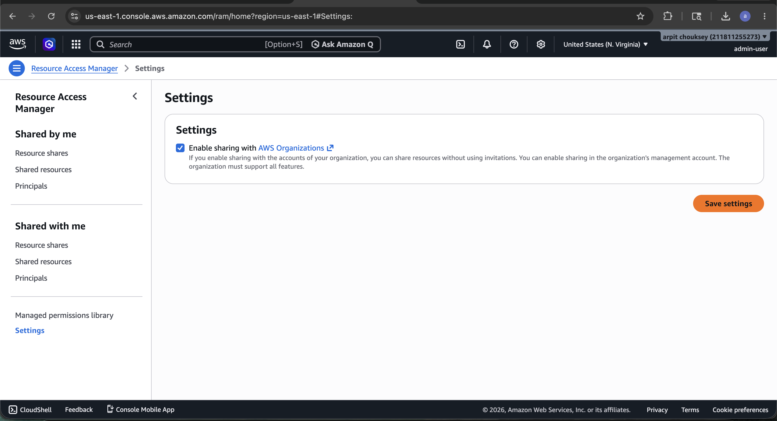

Screenshot — Final plan details:
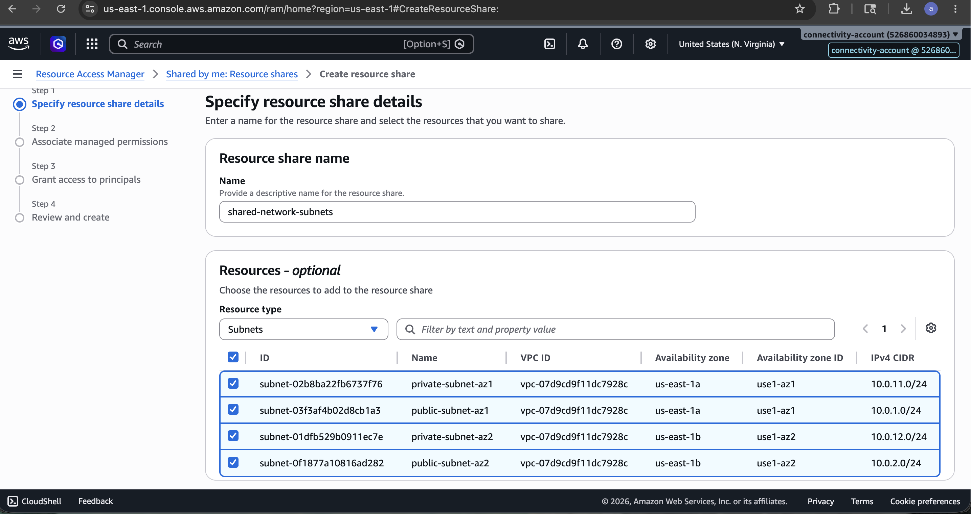

terraform plan — After terraform state rm Fix (Clean Plan)
Plan: 0 to add, 1 to change, 0 to destroy.
(Only aws_ram_resource_share.shared_network tag update remaining)

Screenshot — Clean plan (0 destroy):
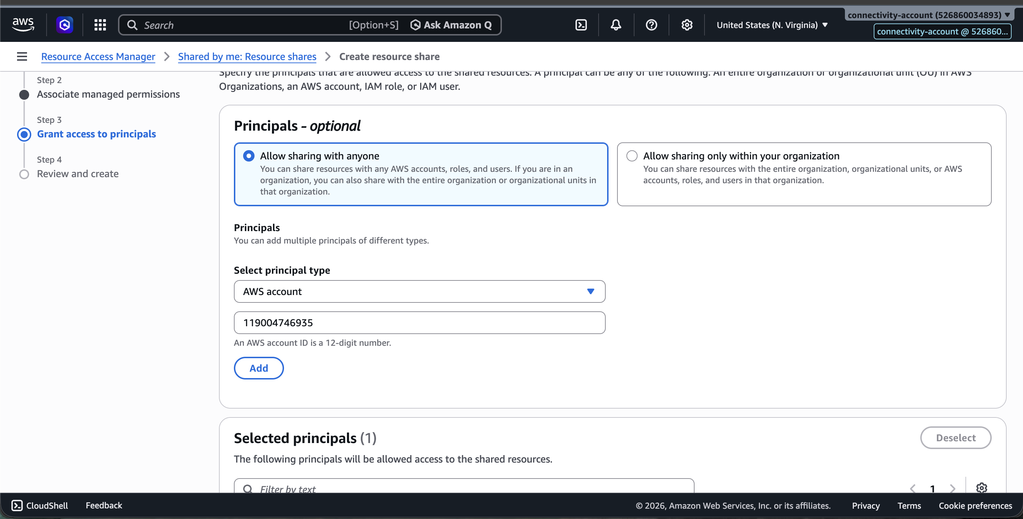

terraform apply — Final Apply
arpitchouksey@Arpits-MacBook-Air connectivity % terraform apply
module.terraform_execution_role.aws_iam_role.terraform_execution_role: Refreshing state...
aws_vpc.connectivity_vpc: Refreshing state... [id=vpc-07d9cd9f11dc7928c]
aws_eip.nat_eip: Refreshing state... [id=eipalloc-0d424e1225e89205e]
aws_ram_resource_share.shared_network: Refreshing state...
aws_ram_principal_association.dev_account: Refreshing state...
(all resources refreshing...)

Plan: 0 to add, 1 to change, 0 to destroy.

Do you want to perform these actions?
Only 'yes' will be accepted to approve.
Enter a value: yes

aws_ram_resource_share.shared_network: Modifying... [id=arn:aws:ram:us-east-1:526860034893:resource-share/8b1bb064-ba4a-4f11-bea3-b3676e0882d1]
aws_ram_resource_share.shared_network: Modifications complete after 2s

Apply complete! Resources: 0 added, 1 changed, 0 destroyed.

Outputs:
bastion_public_ip = ""
internet_gateway_id = "igw-0de7517bcf88cc6f8"
nat_gateway_id = "nat-032a43b353930abb7"
private_subnet_az1_id = "subnet-02b8ba22fb6737f76"
private_subnet_az2_id = "subnet-01dfb529b0911ec7e"
public_subnet_az1_id = "subnet-03f3af4b02d8cb1a3"
public_subnet_az2_id = "subnet-0f1877a10816ad282"
vpc_id = "vpc-07d9cd9f11dc7928c"

Screenshot — Final terraform apply complete:
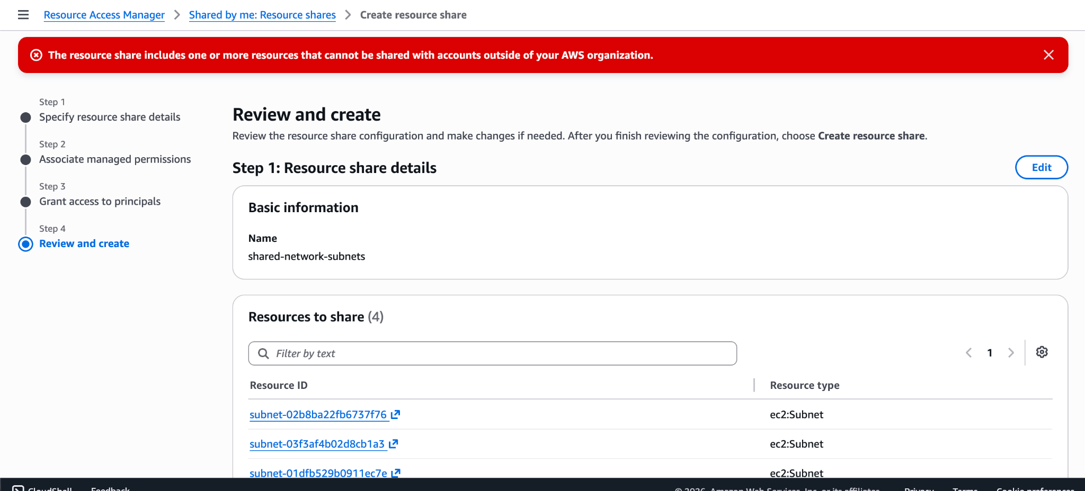

Screenshot — Apply output details:
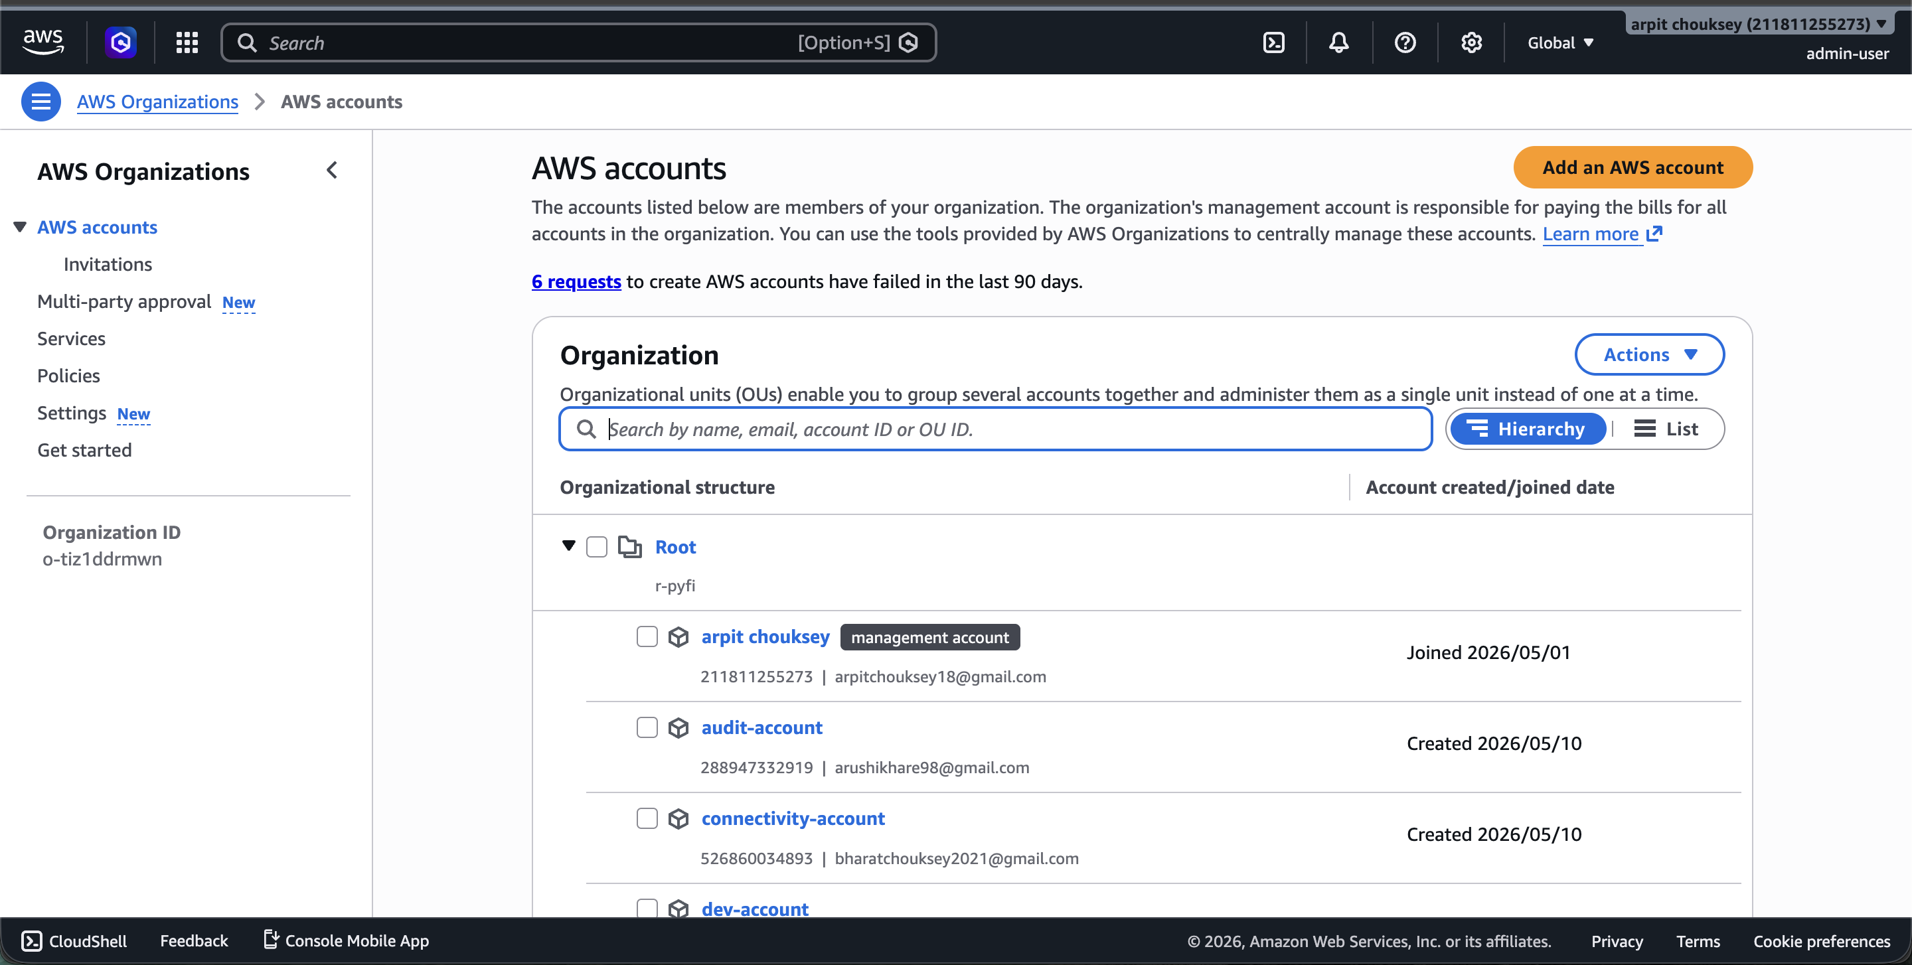

Screenshot — Outputs verified:
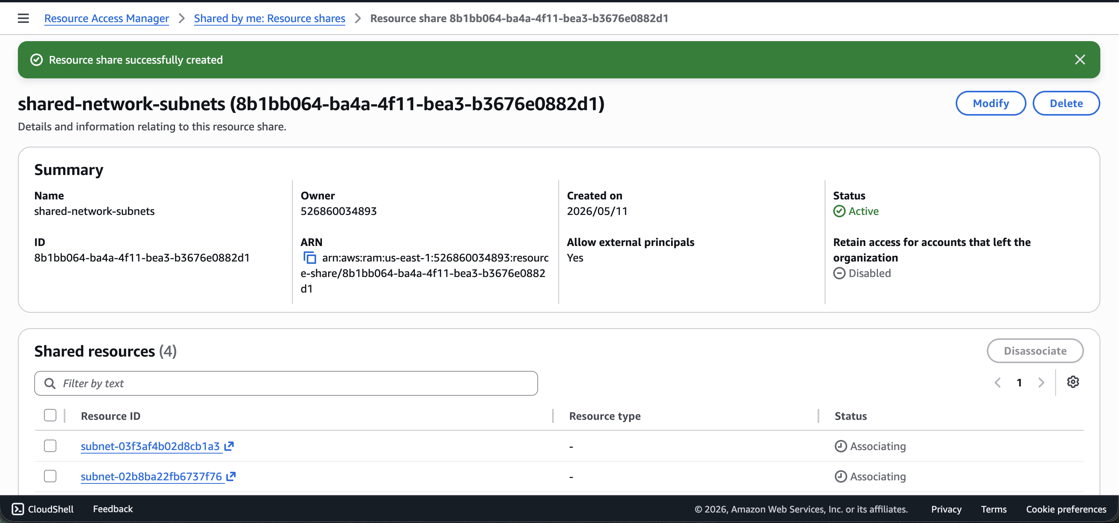

Screenshot — AWS Console — VPC final state:
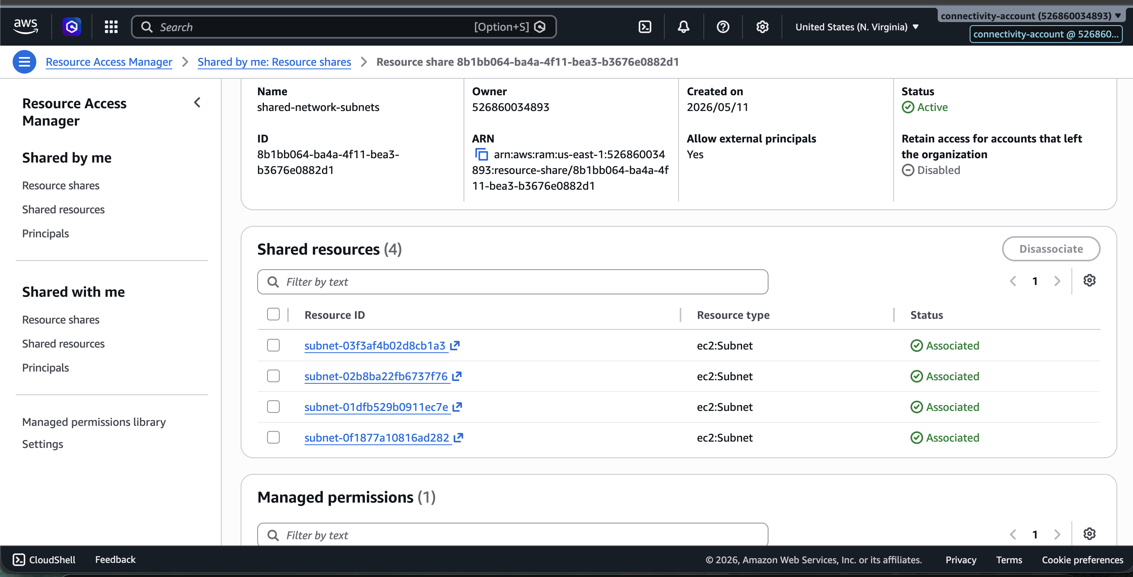

Screenshot — AWS Console — Subnets final state:
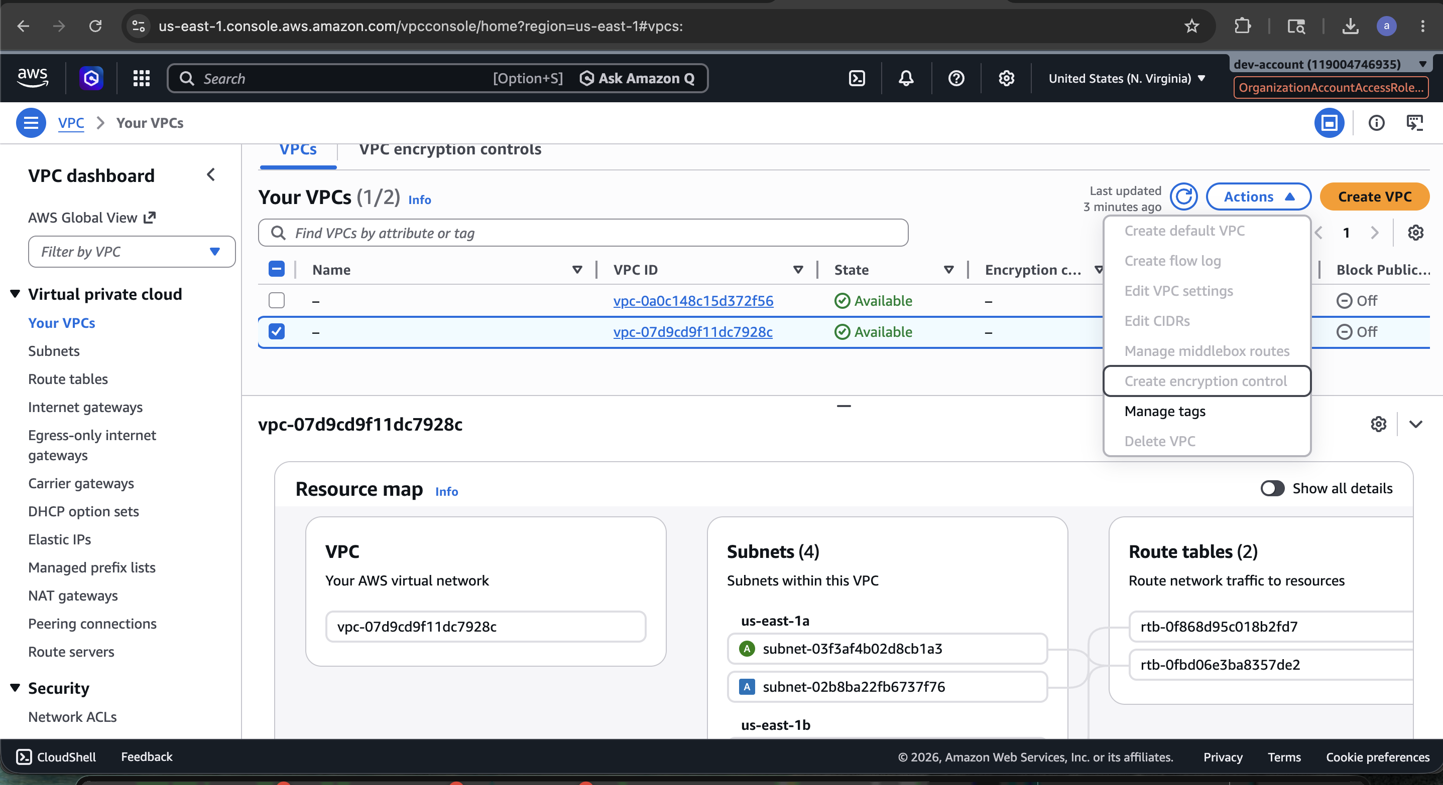

Screenshot — Final state summary:
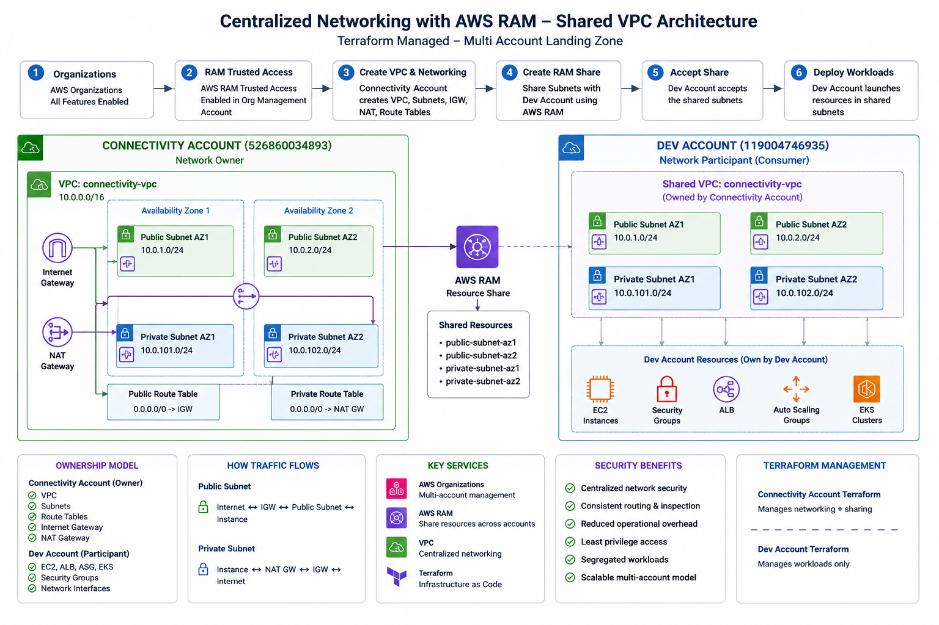

Phase 2 Complete — What Was Accomplished

Final Resource Summary — connectivity-account (526860034893)
connectivity-account
|
├── connectivity-vpc (vpc-07d9cd9f11dc7928c)
├── public-subnet-az1 (subnet-03f3af4b02d8cb1a3)
├── public-subnet-az2 (subnet-0f1877a10816ad282)
├── private-subnet-az1 (subnet-02b8ba22fb6737f76)
├── private-subnet-az2 (subnet-01dfb529b0911ec7e)
├── IGW (igw-0de7517bcf88cc6f8)
├── NAT Gateway (nat-032a43b353930abb7)
├── EIP (eipalloc-0d424e1225e89205e)
├── Public Route Table (rtb-0fbd06e3ba8357de2)
├── Private Route Table(rtb-0f868d95c018b2fd7)
├── Bastion SG (sg-0b5f6a1daab979508)
├── Bastion Host (i-0a63005c4707827ba)
├── RAM Share (arn:aws:ram:...:8b1bb064-...)
└── RAM Subnets shared → dev-account (119004746935)

↓
dev-account (next phase workloads)

All resources imported successfully into Terraform state. Phase 2 — Connectivity Set-Up is complete.

✅ Phase 2 — Connectivity Set-Up COMPLETE
Next: Phase 3 — Security Layer + ALB + ASG

