Phase 3: Dev-Account Setup
Launch EC2 Instance and Use Connectivity Account Resources
Region: us-east-1 | Dev Account: 119004746935 | Management Account: 211811255273

Final Target Architecture
Internet
↓
ALB (public shared subnet)
↓
Target Group
↓
Auto Scaling Group
↓
Private EC2 instances
↓
Register Targets

⚠️ IMPORTANT: DO NOT manually add EC2 instances to Target Group.

Deployment order:
- LaunchTemplate → Install NGINX
- TargetGroup
- LoadBalancer (Attached TG)
- AutoScaling Group

Terraform Code — Dev Environment Setup

Navigate to Dev Environment
arpitchouksey@Arpits-MacBook-Air environments % cd dev
arpitchouksey@Arpits-MacBook-Air dev % ls
backend.tf main.tf provider.tf terraform.tfstate terraform.tfvars variables.tf

Create versions.tf
arpitchouksey@Arpits-MacBook-Air dev % vi versions.tf

Edit provider.tf
arpitchouksey@Arpits-MacBook-Air dev % vi provider.tf

ls — After Adding versions.tf
arpitchouksey@Arpits-MacBook-Air dev % ls
backend.tf main.tf provider.tf terraform.tfstate terraform.tfvars variables.tf versions.tf

cat provider.tf
arpitchouksey@Arpits-MacBook-Air dev % cat provider.tf
terraform {
required_version = ">= 1.5"
required_providers {
aws = {
source = "hashicorp/aws"
version = "~> 5.0"
}
}
}

provider "aws" {
region = "ap-south-1"
assume_role {
role_arn = "arn:aws:iam::119004746935:role/TerraformExecutionRole"
}
default_tags {
tags = {
Project = "terraform-multi-env"
Environment = "dev"
ManagedBy = "terraform"
}
}
}

Screenshot — provider.tf in editor:
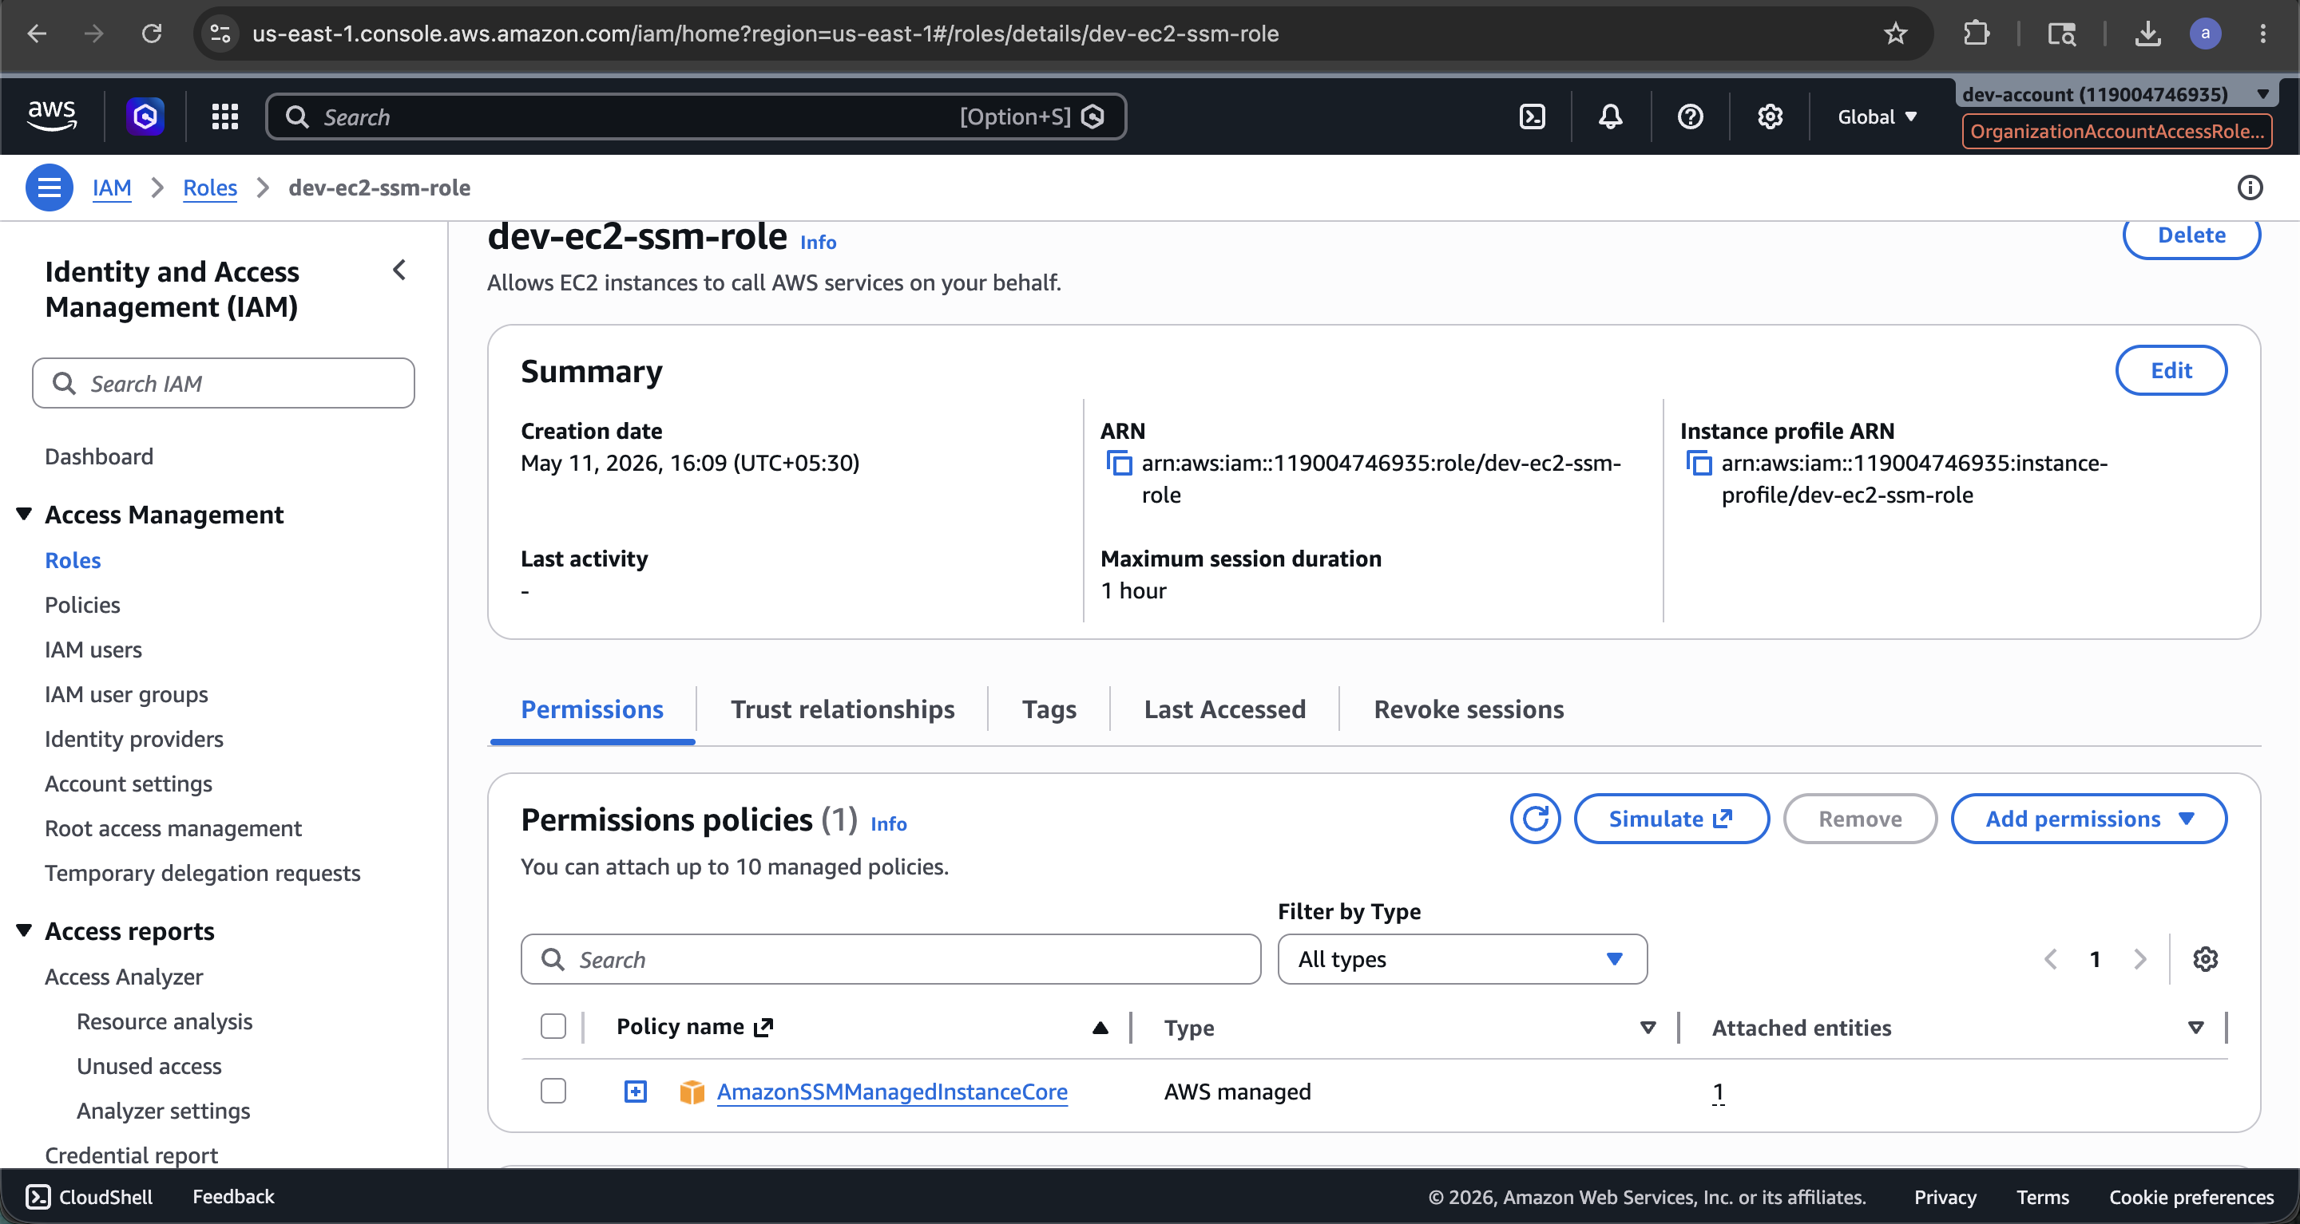

Create Remaining Terraform Files
arpitchouksey@Arpits-MacBook-Air dev % vi variables.tf
arpitchouksey@Arpits-MacBook-Air dev % vi terraform.tfvars
arpitchouksey@Arpits-MacBook-Air dev % vi terraform.tfvars
arpitchouksey@Arpits-MacBook-Air dev % vi data.tf
arpitchouksey@Arpits-MacBook-Air dev % vi security-groups.tf
arpitchouksey@Arpits-MacBook-Air dev % vi target-group.tf
arpitchouksey@Arpits-MacBook-Air dev % vi alb.tf
arpitchouksey@Arpits-MacBook-Air dev % vi launch-template.tf
arpitchouksey@Arpits-MacBook-Air dev % vi asg.tf
arpitchouksey@Arpits-MacBook-Air dev % vi outputs.tf

Screenshot — Dev environment file structure:
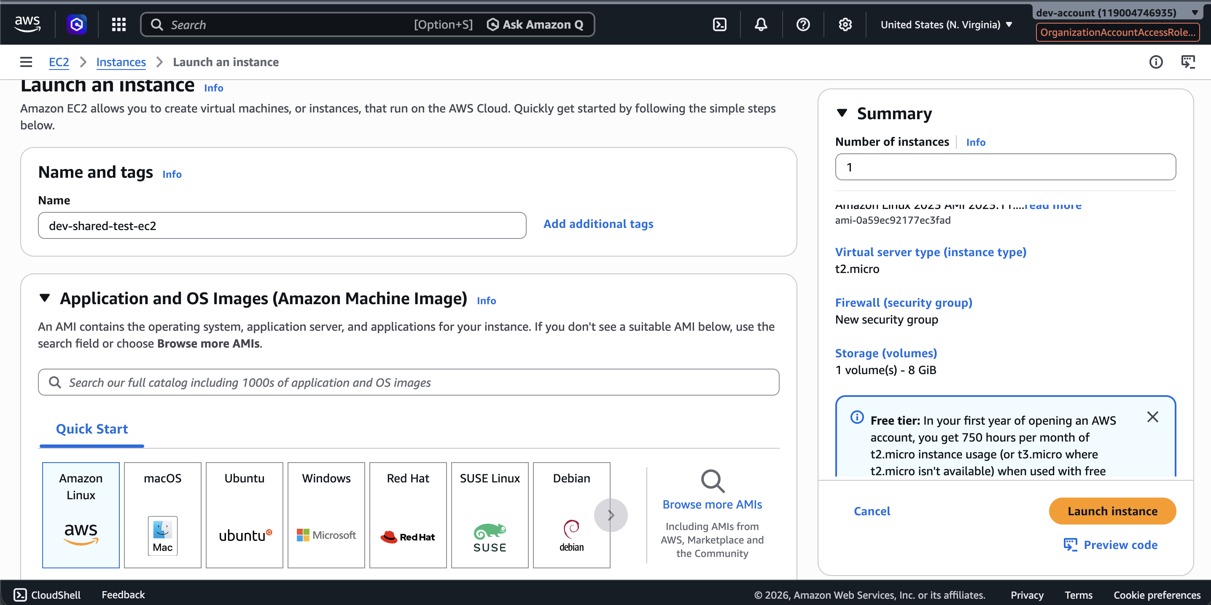

terraform init — First Attempt (Error: Duplicate required_providers)
arpitchouksey@Arpits-MacBook-Air dev % terraform init
Initializing the backend...
Initializing modules...
- terraform_execution_role in ../../modules/terraform-role
╷
│ Error: Duplicate required providers configuration
│
│ on versions.tf line 4, in terraform:
│ 4: required_providers {
│
│ A module may have only one required providers configuration. The required
│ providers were previously configured at provider.tf:4,3-21.
╵

⚠️ Fix: versions.tf and provider.tf both declare required_providers — delete versions.tf.

cat versions.tf (Duplicate Block)
arpitchouksey@Arpits-MacBook-Air dev % cat versions.tf
terraform {
required_version = ">= 1.5.0"
required_providers {
aws = {
source = "hashicorp/aws"
version = "~> 5.0"
}
}
}

cat provider.tf (Also Has required_providers — Conflict)
arpitchouksey@Arpits-MacBook-Air dev % cat provider.tf
terraform {
required_version = ">= 1.5"
required_providers {
aws = {
source = "hashicorp/aws"
version = "~> 5.0"
}
}
}

provider "aws" {
region = "ap-south-1"
assume_role {
role_arn = "arn:aws:iam::119004746935:role/TerraformExecutionRole"
}
default_tags {
tags = {
Project = "terraform-multi-env"
Environment = "dev"
ManagedBy = "terraform"
}
}
}

rm versions.tf (Fix)
arpitchouksey@Arpits-MacBook-Air dev % rm versions.tf

terraform init — Success (After Removing versions.tf)
arpitchouksey@Arpits-MacBook-Air dev % terraform init
Initializing the backend...
Initializing modules...
Initializing provider plugins...
- Finding hashicorp/aws versions matching "~> 5.0"...
- Installing hashicorp/aws v5.100.0...
- Installed hashicorp/aws v5.100.0 (signed by HashiCorp)

Terraform has created a lock file .terraform.lock.hcl to record the provider
selections it made above. Include this file in your version control repository
so that Terraform can guarantee to make the same selections by default when
you run "terraform init" in the future.

Terraform has been successfully initialized!

You may now begin working with Terraform. Try running "terraform plan" to see
any changes that are required for your infrastructure.

All Terraform commands should now work. If you ever set or change modules or
backend configuration for Terraform, rerun this command to reinitialize your
working directory. If you forget, other commands will detect it and remind you
to do so if necessary.

Screenshot — terraform init success:
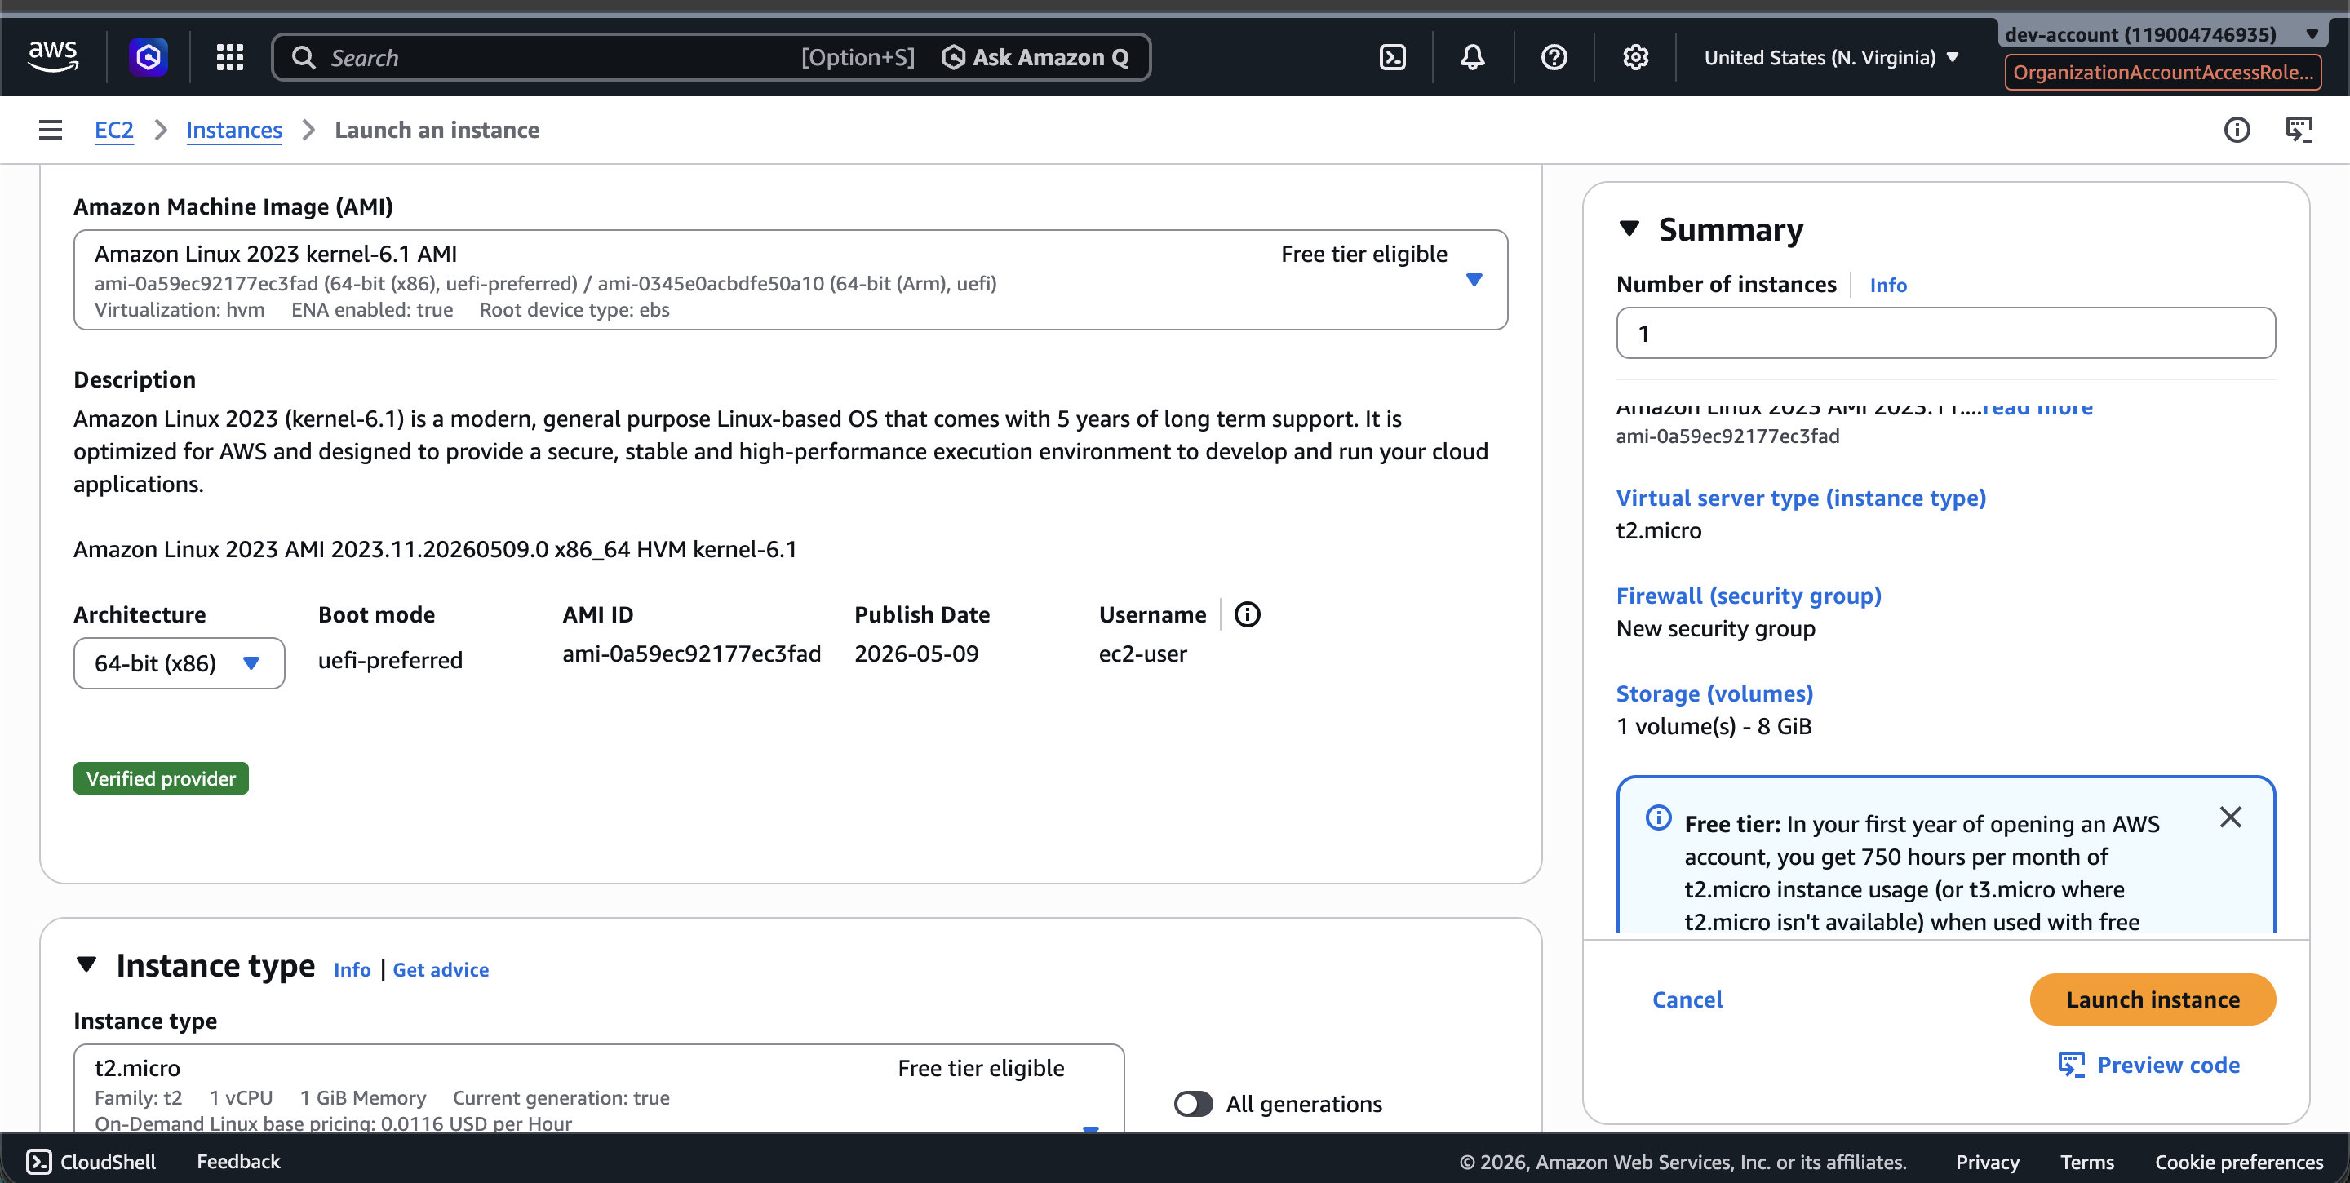

terraform import — ALB Security Group (First Attempt — Error: Non-Existent + No VPC)
arpitchouksey@Arpits-MacBook-Air dev % terraform import aws_security_group.dev_alb_sg sg-0c8239266e982132f
aws_security_group.dev_alb_sg: Importing from ID "sg-0c8239266e982132f"...
aws_security_group.dev_alb_sg: Import prepared!
Prepared aws_security_group for import
data.aws_vpc.shared_vpc: Reading...
aws_security_group.dev_alb_sg: Refreshing state... [id=sg-0c8239266e982132f]
╷
│ Error: Cannot import non-existent remote object
│
│ While attempting to import an existing object to "aws_security_group.dev_alb_sg",
│ the provider detected that no object exists with the given id. Only pre-existing
│ objects can be imported; check that the id is correct and that it is associated
│ with the provider's configured region or endpoint, or use "terraform apply" to
│ create a new remote object for this resource.
╵
╷
│ Error: no matching EC2 VPC found
│
│ with data.aws_vpc.shared_vpc,
│ on ...dev/data.tf line 1, in data "aws_vpc" "shared_vpc":
│ 1: data "aws_vpc" "shared_vpc" {
╵

Screenshot — Import error (non-existent + VPC not found):
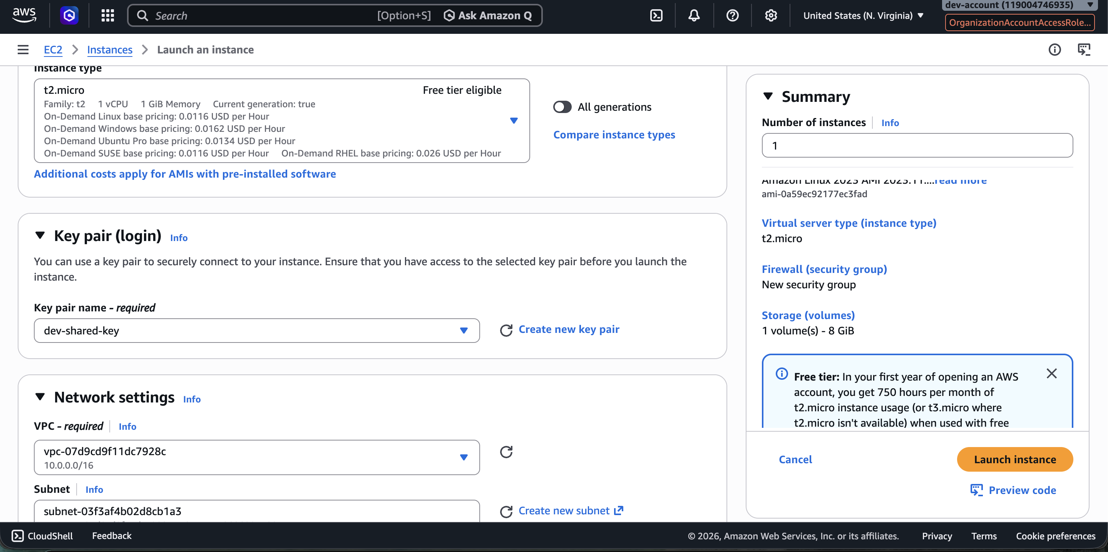

Debugging AWS Profile / Identity

aws sts get-caller-identity — Current Identity (Management Account)
arpitchouksey@Arpits-MacBook-Air dev % aws sts get-caller-identity
{
"UserId": "AIDATCUHPIPU2NRYN52QO",
"Account": "211811255273",
"Arn": "arn:aws:iam::211811255273:user/admin-user"
}

Problem: Currently authenticated as the management account (211811255273), but need to be in the dev account (119004746935).

Edit provider.tf
arpitchouksey@Arpits-MacBook-Air dev % vi provider.tf

aws sts get-caller-identity --profile dev-account (Profile Not Found)
arpitchouksey@Arpits-MacBook-Air dev % aws sts get-caller-identity --profile dev-account
The config profile (dev-account) could not be found

aws configure list-profiles
arpitchouksey@Arpits-MacBook-Air dev % aws configure list-profiles
default

Only "default" profile exists — need to create a "dev" profile.

Screenshot — aws configure list-profiles output:
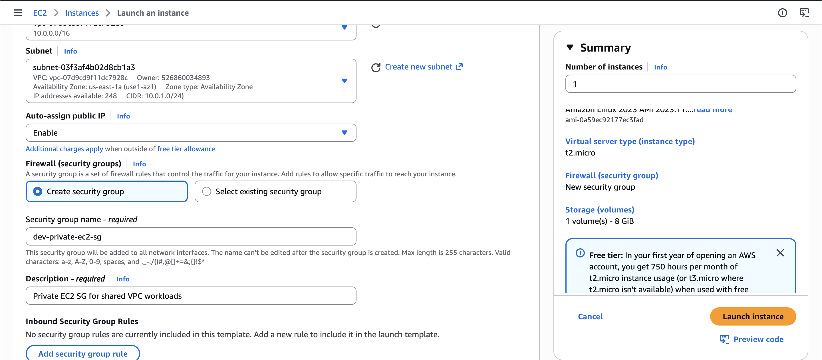

Edit ~/.aws/config — Add Dev Profile
arpitchouksey@Arpits-MacBook-Air dev % vi ~/.aws/config

aws sts get-caller-identity --profile dev (AccessDenied — Wrong Role ARN)
arpitchouksey@Arpits-MacBook-Air dev % aws sts get-caller-identity --profile dev
An error occurred (AccessDenied) when calling the AssumeRole operation: User:
arn:aws:iam::211811255273:user/admin-user is not authorized to perform:
sts:AssumeRole on resource: arn:aws:iam::211811255273:role/TerraformExecutionRole

⚠️ Error: Role ARN was pointing to management account (211811255273) instead of dev account (119004746935).

cat ~/.aws/config (Wrong role_arn)
arpitchouksey@Arpits-MacBook-Air dev % cat ~/.aws/config
[profile dev]
role_arn = arn:aws:iam::211811255273:role/TerraformExecutionRole
source_profile = default
region = us-east-1

Screenshot — ~/.aws/config with wrong account ID:
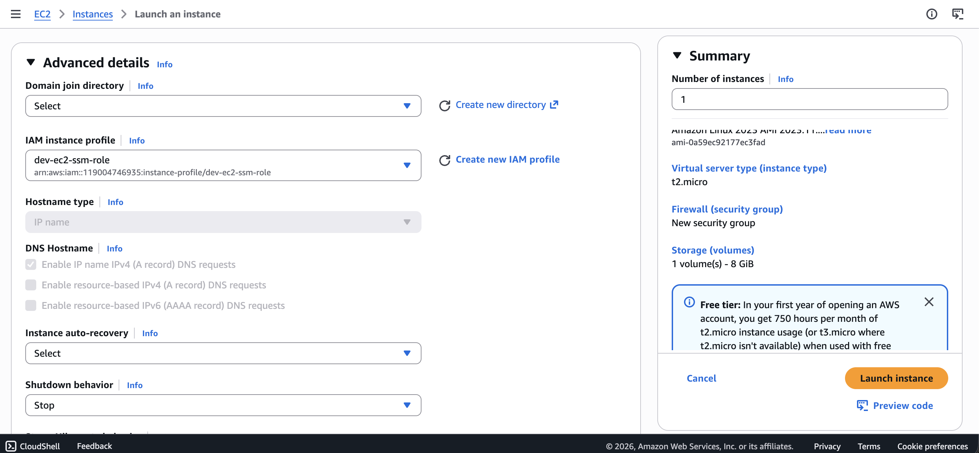

vi ~/.aws/config — Fix role_arn to Dev Account
arpitchouksey@Arpits-MacBook-Air dev % vi ~/.aws/config
# Fix: change 211811255273 → 119004746935

aws sts get-caller-identity --profile dev (Success — Dev Account)
arpitchouksey@Arpits-MacBook-Air dev % aws sts get-caller-identity --profile dev
{
"UserId": "AROARXNJ4KS34E6FCOJLJ:botocore-session-1778500125",
"Account": "119004746935",
"Arn": "arn:aws:sts::119004746935:assumed-role/TerraformExecutionRole/botocore-session-1778500125"
}

Screenshot — Correct identity (dev account 119004746935):
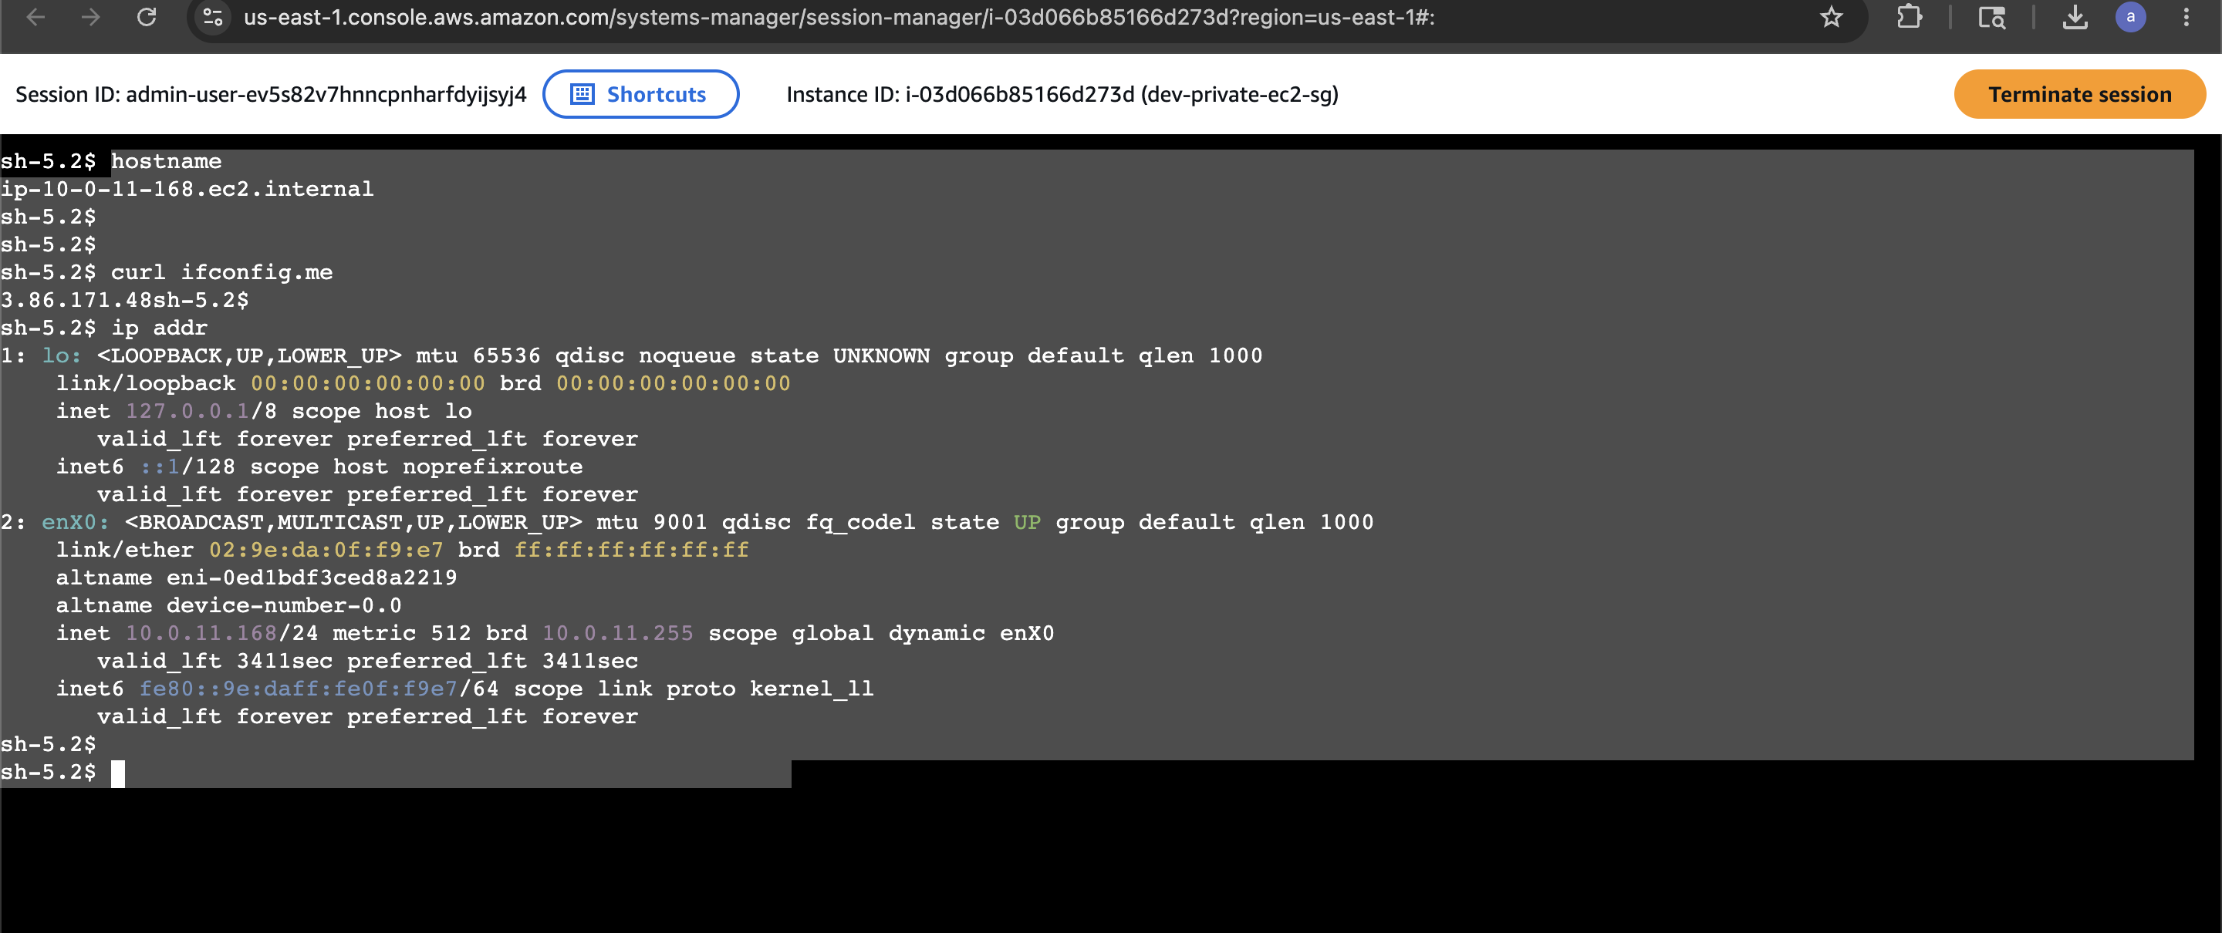

terraform import — ALB SG (Second Attempt — Errors in provider.tf)

Error: failed to get shared config profile, dev-account
arpitchouksey@Arpits-MacBook-Air dev % terraform import aws_security_group.dev_alb_sg sg-0c8239266e982132f
╷
│ Error: failed to get shared config profile, dev-account
│
│ with provider["registry.terraform.io/hashicorp/aws"],
│ on ...dev/provider.tf line 12, in provider "aws":
│ 12: provider "aws" {
╵

vi provider.tf (Fix profile name)
arpitchouksey@Arpits-MacBook-Air dev % vi provider.tf

Error: Cannot assume IAM Role (Circular AssumeRole)
arpitchouksey@Arpits-MacBook-Air dev % terraform import aws_security_group.dev_alb_sg sg-0c8239266e982132f
╷
│ Error: Cannot assume IAM Role
│
│ with provider["registry.terraform.io/hashicorp/aws"],
│ on ...dev/provider.tf line 12, in provider "aws":
│ 12: provider "aws" {
│
│ IAM Role (arn:aws:iam::119004746935:role/TerraformExecutionRole) cannot be assumed.
│
│ There are a number of possible causes of this - the most common are:
│ * The credentials used in order to assume the role are invalid
│ * The credentials do not have appropriate permission to assume the role
│ * The role ARN is not valid
│
│ Error: operation error STS: AssumeRole, https response error StatusCode: 403,
│ RequestID: cce013b1-d9a0-49c3-9265-1d8d1e01293d, api error AccessDenied:
│ User: arn:aws:sts::119004746935:assumed-role/TerraformExecutionRole/aws-go-sdk-...
│ is not authorized to perform: sts:AssumeRole on resource:
│ arn:aws:iam::119004746935:role/TerraformExecutionRole
╵

⚠️ Fix: The provider was trying to assume the role USING the already-assumed role (circular). Remove the profile-based assume_role from provider.tf and rely on direct credentials.

Screenshot — Cannot assume IAM Role error:
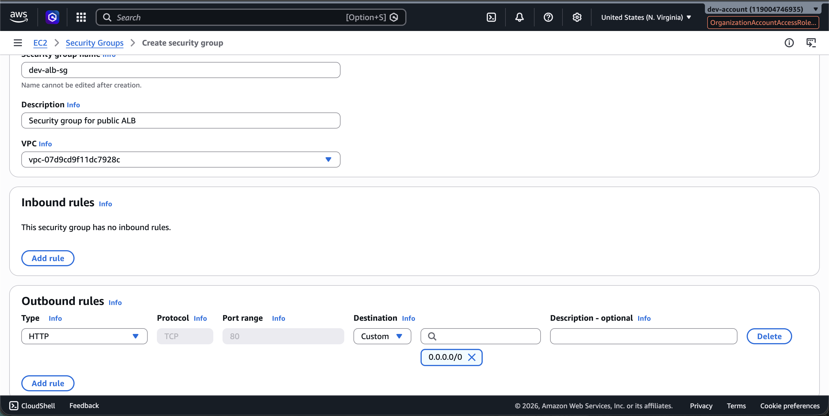

vi provider.tf (Final Fix)
arpitchouksey@Arpits-MacBook-Air dev % vi provider.tf

Screenshot — provider.tf after fix:
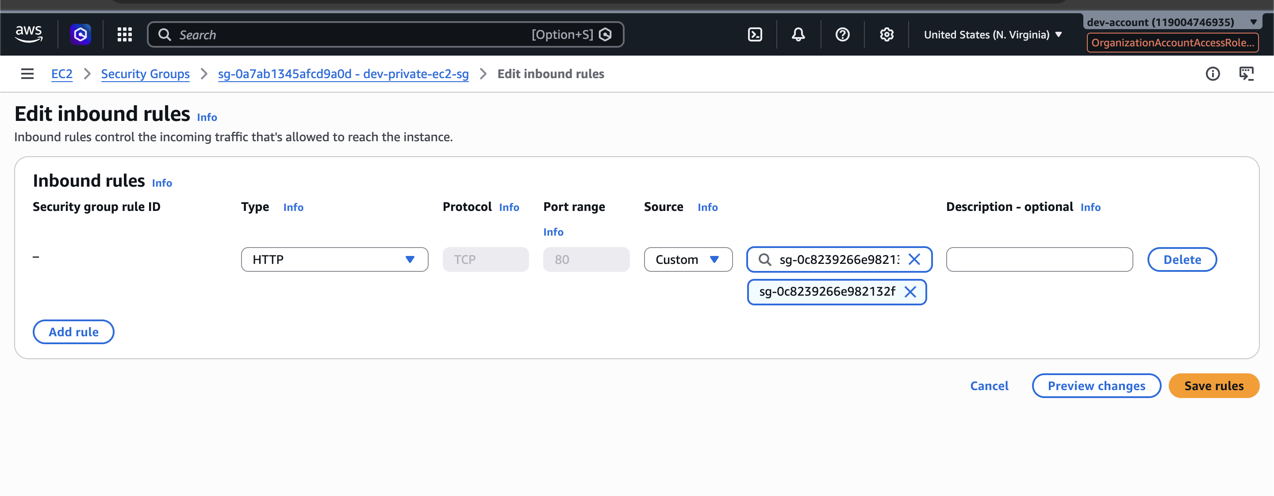

terraform import — All Resources (After Provider Fix)

Import ALB Security Group — Success
arpitchouksey@Arpits-MacBook-Air dev % terraform import aws_security_group.dev_alb_sg sg-0c8239266e982132f
aws_security_group.dev_alb_sg: Importing from ID "sg-0c8239266e982132f"...
aws_security_group.dev_alb_sg: Import prepared!
Prepared aws_security_group for import
data.aws_vpc.shared_vpc: Reading...
aws_security_group.dev_alb_sg: Refreshing state... [id=sg-0c8239266e982132f]
data.aws_vpc.shared_vpc: Read complete after 2s [id=vpc-07d9cd9f11dc7928c]

Import successful!

Screenshot — ALB SG imported successfully:
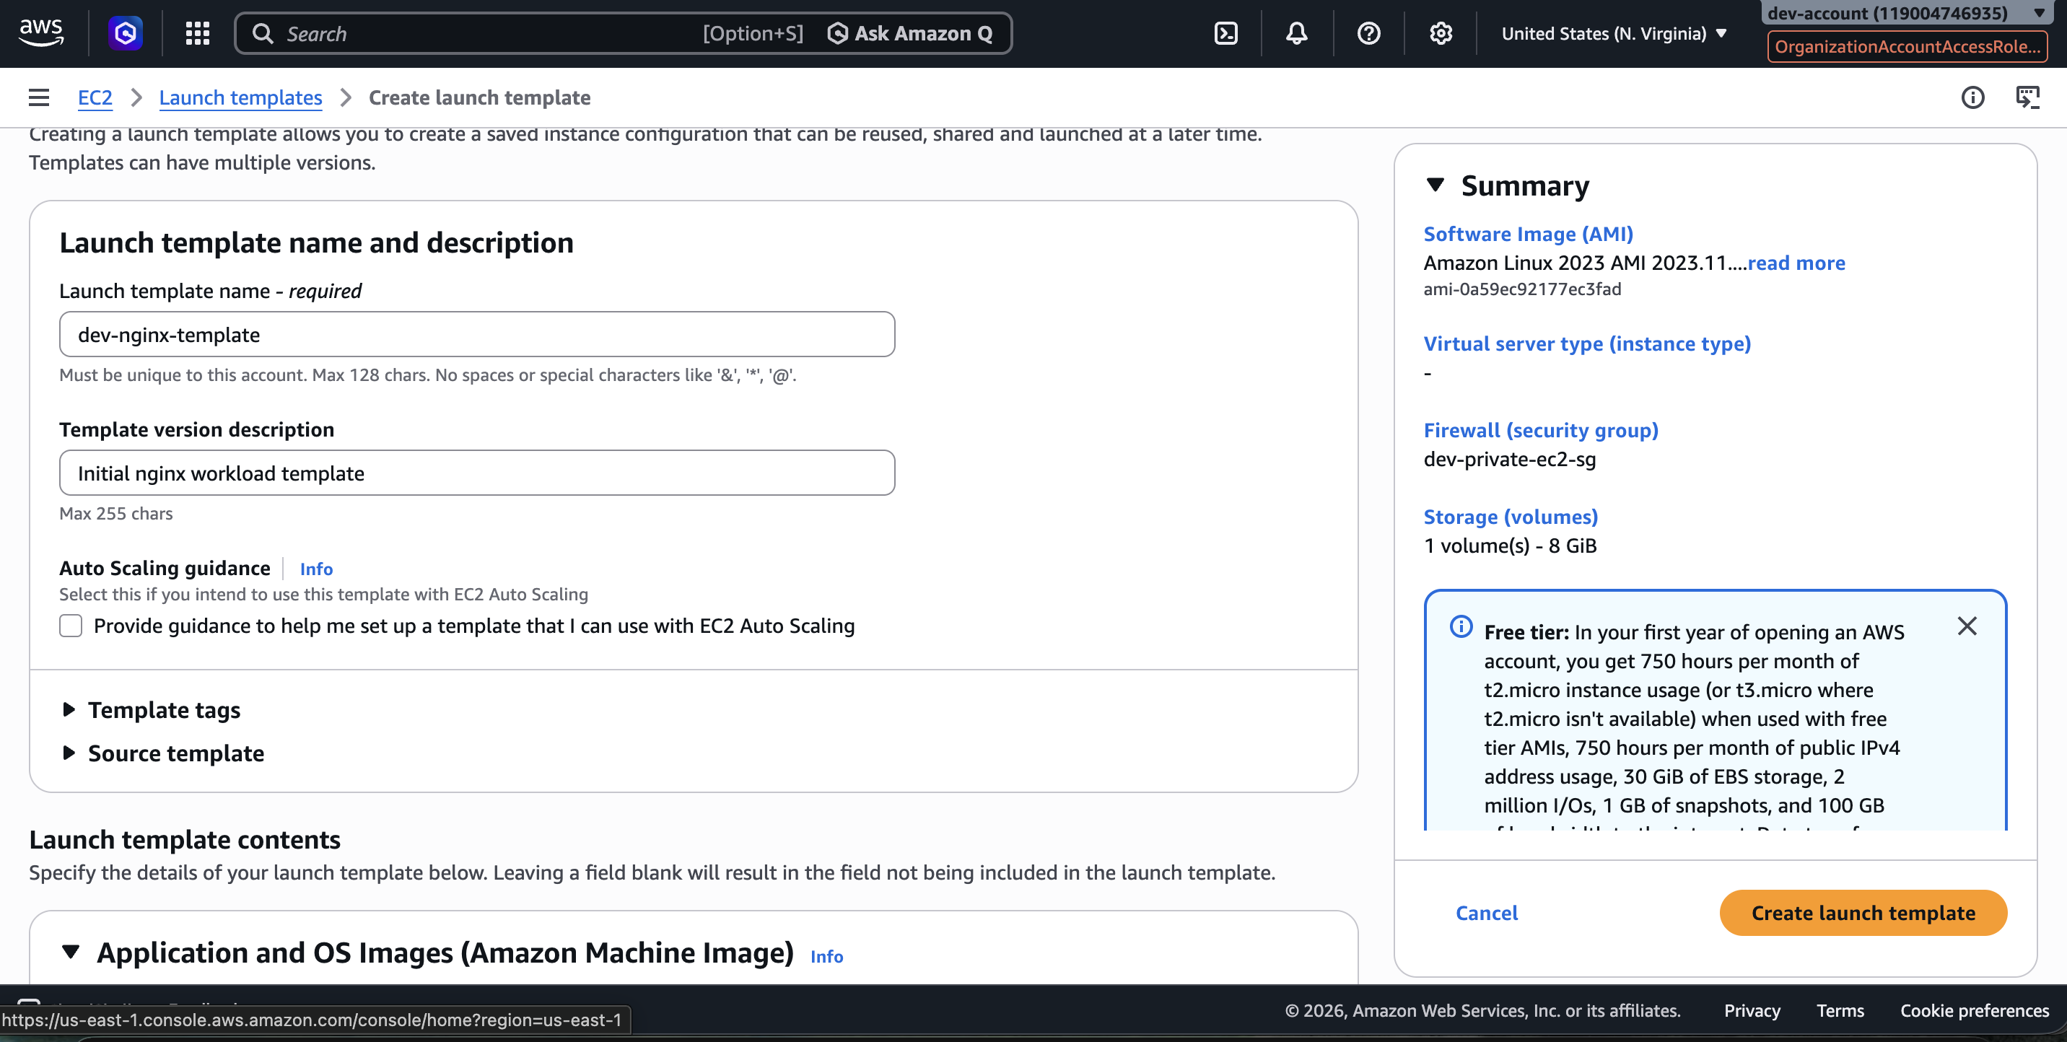

Import Private EC2 Security Group
arpitchouksey@Arpits-MacBook-Air dev % terraform import aws_security_group.dev_private_ec2_sg sg-0a7ab1345afcd9a0d
data.aws_vpc.shared_vpc: Reading...
aws_security_group.dev_private_ec2_sg: Importing from ID "sg-0a7ab1345afcd9a0d"...
aws_security_group.dev_private_ec2_sg: Import prepared!
Prepared aws_security_group for import
aws_security_group.dev_private_ec2_sg: Refreshing state... [id=sg-0a7ab1345afcd9a0d]
data.aws_vpc.shared_vpc: Read complete after 2s [id=vpc-07d9cd9f11dc7928c]

Import successful!

Import Target Group
arpitchouksey@Arpits-MacBook-Air dev % terraform import aws_lb_target_group.dev_nginx_tg \
arn:aws:elasticloadbalancing:us-east-1:119004746935:targetgroup/dev-nginx-tg/68ff93673b4553bb
aws_lb_target_group.dev_nginx_tg: Importing from ID "arn:aws:elasticloadbalancing:us-east-1:119004746935:targetgroup/dev-nginx-tg/68ff93673b4553bb"...
data.aws_vpc.shared_vpc: Reading...
aws_lb_target_group.dev_nginx_tg: Import prepared!
Prepared aws_lb_target_group for import
aws_lb_target_group.dev_nginx_tg: Refreshing state... [id=arn:aws:elasticloadbalancing:us-east-1:119004746935:targetgroup/dev-nginx-tg/68ff93673b4553bb]
data.aws_vpc.shared_vpc: Read complete after 2s [id=vpc-07d9cd9f11dc7928c]

Import successful!

Import ALB
arpitchouksey@Arpits-MacBook-Air dev % terraform import aws_lb.dev_shared_alb \
arn:aws:elasticloadbalancing:us-east-1:119004746935:loadbalancer/app/dev-shared-alb/e77a0027fa9e7782
data.aws_vpc.shared_vpc: Reading...
aws_lb.dev_shared_alb: Importing from ID "arn:aws:elasticloadbalancing:us-east-1:119004746935:loadbalancer/app/dev-shared-alb/e77a0027fa9e7782"...
aws_lb.dev_shared_alb: Import prepared!
Prepared aws_lb for import
aws_lb.dev_shared_alb: Refreshing state... [id=arn:aws:elasticloadbalancing:us-east-1:119004746935:loadbalancer/app/dev-shared-alb/e77a0027fa9e7782]
data.aws_vpc.shared_vpc: Read complete after 3s [id=vpc-07d9cd9f11dc7928c]

Import successful!

Screenshot — ALB imported:
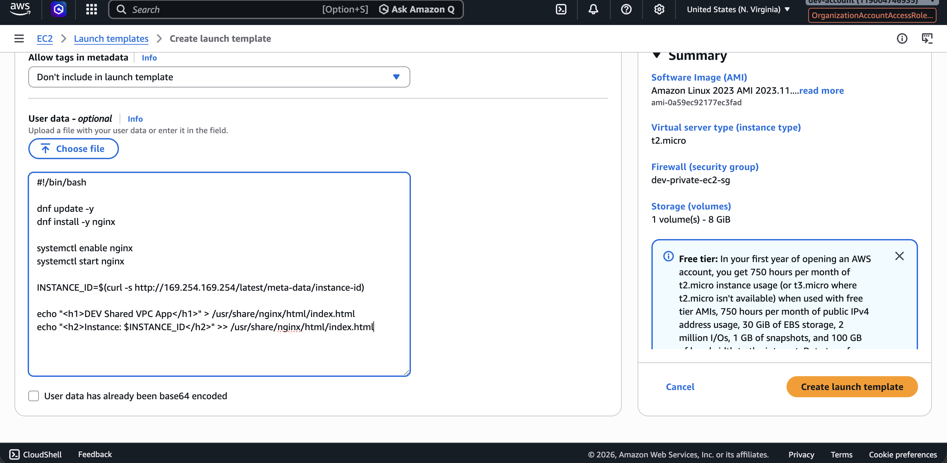

Import ALB Listener
arpitchouksey@Arpits-MacBook-Air dev % terraform import aws_lb_listener.http_listener \
arn:aws:elasticloadbalancing:us-east-1:119004746935:listener/app/dev-shared-alb/e77a0027fa9e7782/7a1b03a00bc3f8be
data.aws_vpc.shared_vpc: Reading...
aws_lb_listener.http_listener: Importing from ID "arn:aws:elasticloadbalancing:us-east-1:119004746935:listener/app/dev-shared-alb/e77a0027fa9e7782/7a1b03a00bc3f8be"...
aws_lb_listener.http_listener: Import prepared!
Prepared aws_lb_listener for import
aws_lb_listener.http_listener: Refreshing state... [id=arn:aws:elasticloadbalancing:us-east-1:119004746935:listener/app/dev-shared-alb/e77a0027fa9e7782/7a1b03a00bc3f8be]
data.aws_vpc.shared_vpc: Read complete after 2s [id=vpc-07d9cd9f11dc7928c]

Import successful!

Import Launch Template — Wrong ID (AMI ID Used — Error)
arpitchouksey@Arpits-MacBook-Air dev % terraform import aws_launch_template.dev_nginx_template ami-0a59ec92177ec3fad
data.aws_vpc.shared_vpc: Reading...
aws_launch_template.dev_nginx_template: Importing from ID "ami-0a59ec92177ec3fad"...
aws_launch_template.dev_nginx_template: Import prepared!
Prepared aws_launch_template for import
aws_launch_template.dev_nginx_template: Refreshing state... [id=ami-0a59ec92177ec3fad]
data.aws_vpc.shared_vpc: Read complete after 3s [id=vpc-07d9cd9f11dc7928c]
╷
│ Error: Cannot import non-existent remote object
│
│ While attempting to import an existing object to "aws_launch_template.dev_nginx_template",
│ the provider detected that no object exists with the given id. Only pre-existing objects
│ can be imported; check that the id is correct and that it is associated with the
│ provider's configured region or endpoint, or use "terraform apply" to create a new
│ remote object for this resource.
╵

⚠️ Fix: ami-... is the AMI ID, not the Launch Template ID. Use the lt-... ID instead.

Import Launch Template — Correct (lt-... ID)
arpitchouksey@Arpits-MacBook-Air dev % terraform import aws_launch_template.dev_nginx_template lt-060b1d79c7eb9c4f7
data.aws_vpc.shared_vpc: Reading...
aws_launch_template.dev_nginx_template: Importing from ID "lt-060b1d79c7eb9c4f7"...
aws_launch_template.dev_nginx_template: Import prepared!
Prepared aws_launch_template for import
aws_launch_template.dev_nginx_template: Refreshing state... [id=lt-060b1d79c7eb9c4f7]
data.aws_vpc.shared_vpc: Read complete after 2s [id=vpc-07d9cd9f11dc7928c]

Import successful!

Screenshot — Launch template imported with correct lt- ID:
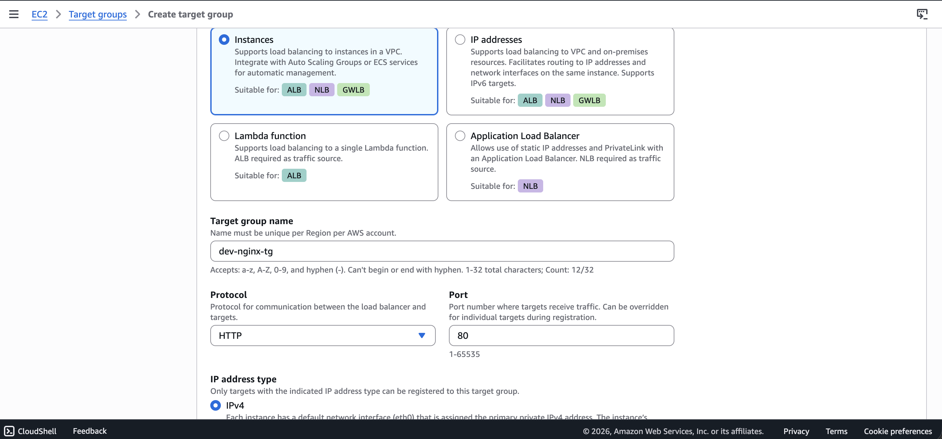

Import Auto Scaling Group
arpitchouksey@Arpits-MacBook-Air dev % terraform import aws_autoscaling_group.dev_nginx_asg dev-nginx-asg
data.aws_vpc.shared_vpc: Reading...
aws_autoscaling_group.dev_nginx_asg: Importing from ID "dev-nginx-asg"...
aws_autoscaling_group.dev_nginx_asg: Import prepared!
Prepared aws_autoscaling_group for import
aws_autoscaling_group.dev_nginx_asg: Refreshing state... [id=dev-nginx-asg]
data.aws_vpc.shared_vpc: Read complete after 2s [id=vpc-07d9cd9f11dc7928c]

Import successful!

Screenshot — ASG imported:
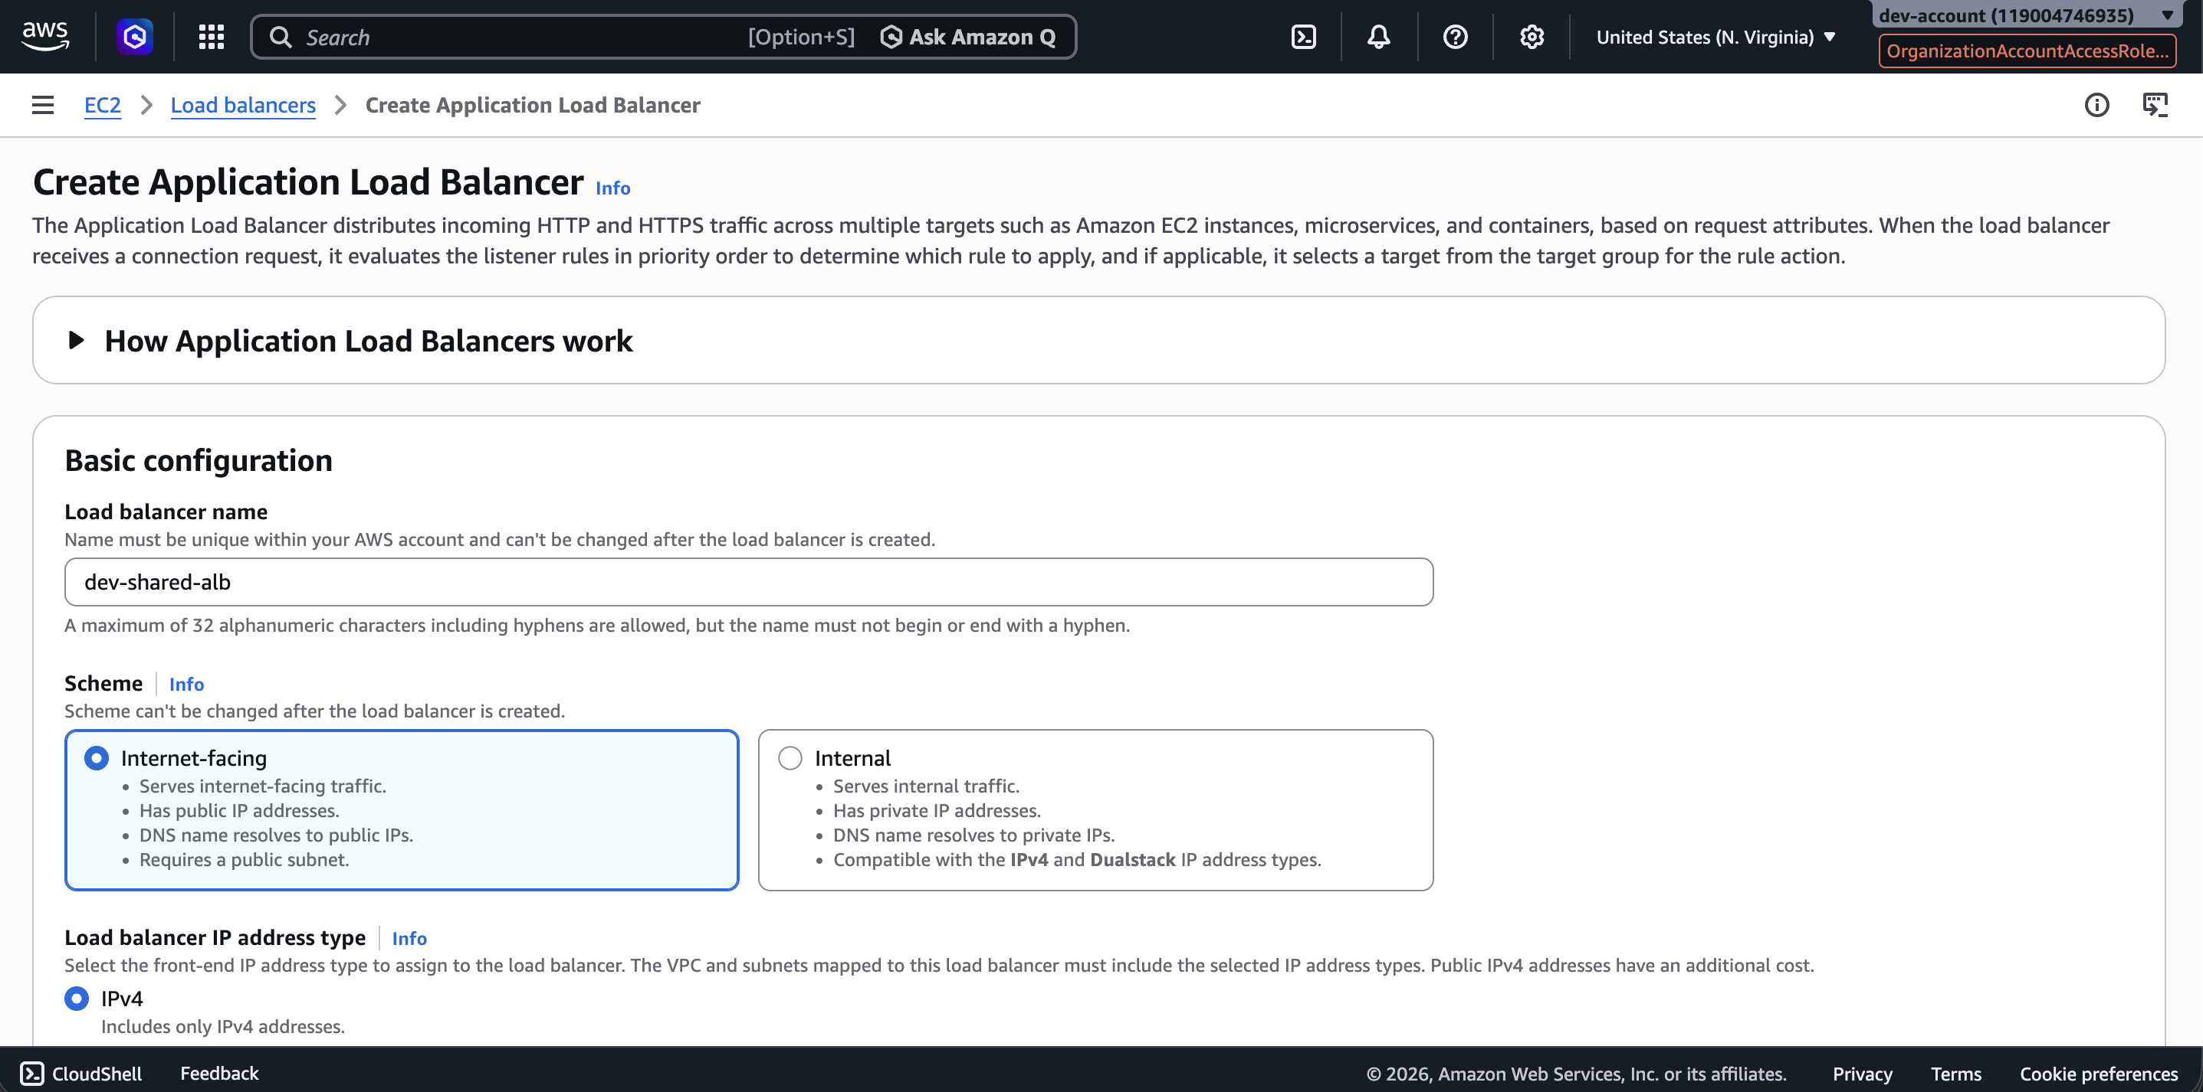

Resource Names Accidentally Typed as Shell Commands (Error)
arpitchouksey@Arpits-MacBook-Air dev % aws_security_group.dev_alb_sg
zsh: command not found: aws_security_group.dev_alb_sg
arpitchouksey@Arpits-MacBook-Air dev % aws_security_group.dev_private_ec2_sg
zsh: command not found: aws_security_group.dev_private_ec2_sg
arpitchouksey@Arpits-MacBook-Air dev % aws_lb.dev_shared_alb
zsh: command not found: aws_lb.dev_shared_alb
arpitchouksey@Arpits-MacBook-Air dev % aws_lb_listener.http_listener
zsh: command not found: aws_lb_listener.http_listener
arpitchouksey@Arpits-MacBook-Air dev % aws_lb_target_group.dev_nginx_tg
zsh: command not found: aws_lb_target_group.dev_nginx_tg
arpitchouksey@Arpits-MacBook-Air dev % aws_launch_template.dev_nginx_template
zsh: command not found: aws_launch_template.dev_nginx_template
arpitchouksey@Arpits-MacBook-Air dev % aws_autoscaling_group.dev_nginx_asg
zsh: command not found: aws_autoscaling_group.dev_nginx_asg

(Resource names were mistakenly typed directly into the terminal — not actual commands.)

terraform state list — Verify All Resources Imported
arpitchouksey@Arpits-MacBook-Air dev % terraform state list
data.aws_vpc.shared_vpc
aws_autoscaling_group.dev_nginx_asg
aws_launch_template.dev_nginx_template
aws_lb.dev_shared_alb
aws_lb_listener.http_listener
aws_lb_target_group.dev_nginx_tg
aws_security_group.dev_alb_sg
aws_security_group.dev_private_ec2_sg
module.terraform_execution_role.aws_iam_role.terraform_execution_role
module.terraform_execution_role.aws_iam_role_policy_attachment.admin_attach

Screenshot — terraform state list output:
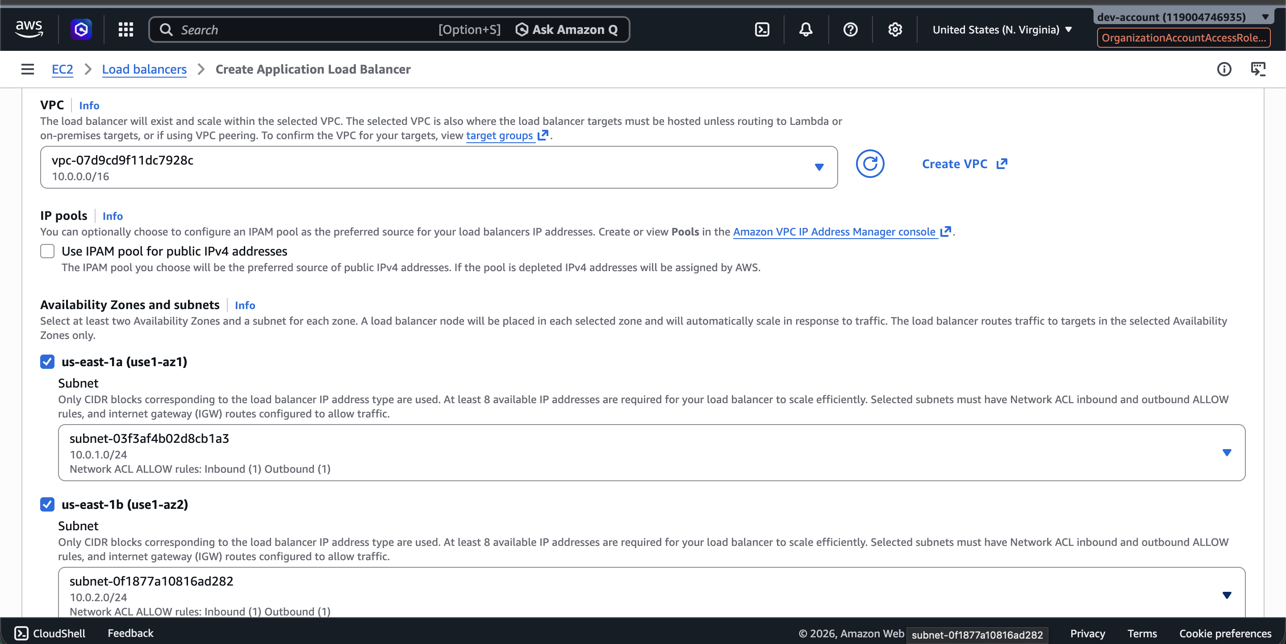

terraform plan — Full Plan Output
arpitchouksey@Arpits-MacBook-Air dev % terraform plan
data.aws_vpc.shared_vpc: Reading...
module.terraform_execution_role.aws_iam_role.terraform_execution_role: Refreshing state... [id=TerraformExecutionRole]
aws_security_group.dev_alb_sg: Refreshing state... [id=sg-0c8239266e982132f]
aws_lb_target_group.dev_nginx_tg: Refreshing state... [id=arn:aws:elasticloadbalancing:us-east-1:119004746935:targetgroup/dev-nginx-tg/68ff93673b4553bb]
aws_security_group.dev_private_ec2_sg: Refreshing state... [id=sg-0a7ab1345afcd9a0d]
aws_lb.dev_shared_alb: Refreshing state... [id=arn:aws:elasticloadbalancing:us-east-1:119004746935:loadbalancer/app/dev-shared-alb/e77a0027fa9e7782]
aws_launch_template.dev_nginx_template: Refreshing state... [id=lt-060b1d79c7eb9c4f7]
module.terraform_execution_role.aws_iam_role_policy_attachment.admin_attach: Refreshing state...
aws_autoscaling_group.dev_nginx_asg: Refreshing state... [id=dev-nginx-asg]
data.aws_vpc.shared_vpc: Read complete after 2s [id=vpc-07d9cd9f11dc7928c]
aws_lb_listener.http_listener: Refreshing state... [id=arn:aws:elasticloadbalancing:us-east-1:119004746935:listener/app/dev-shared-alb/e77a0027fa9e7782/7a1b03a00bc3f8be]

Screenshot — terraform plan output page 1:
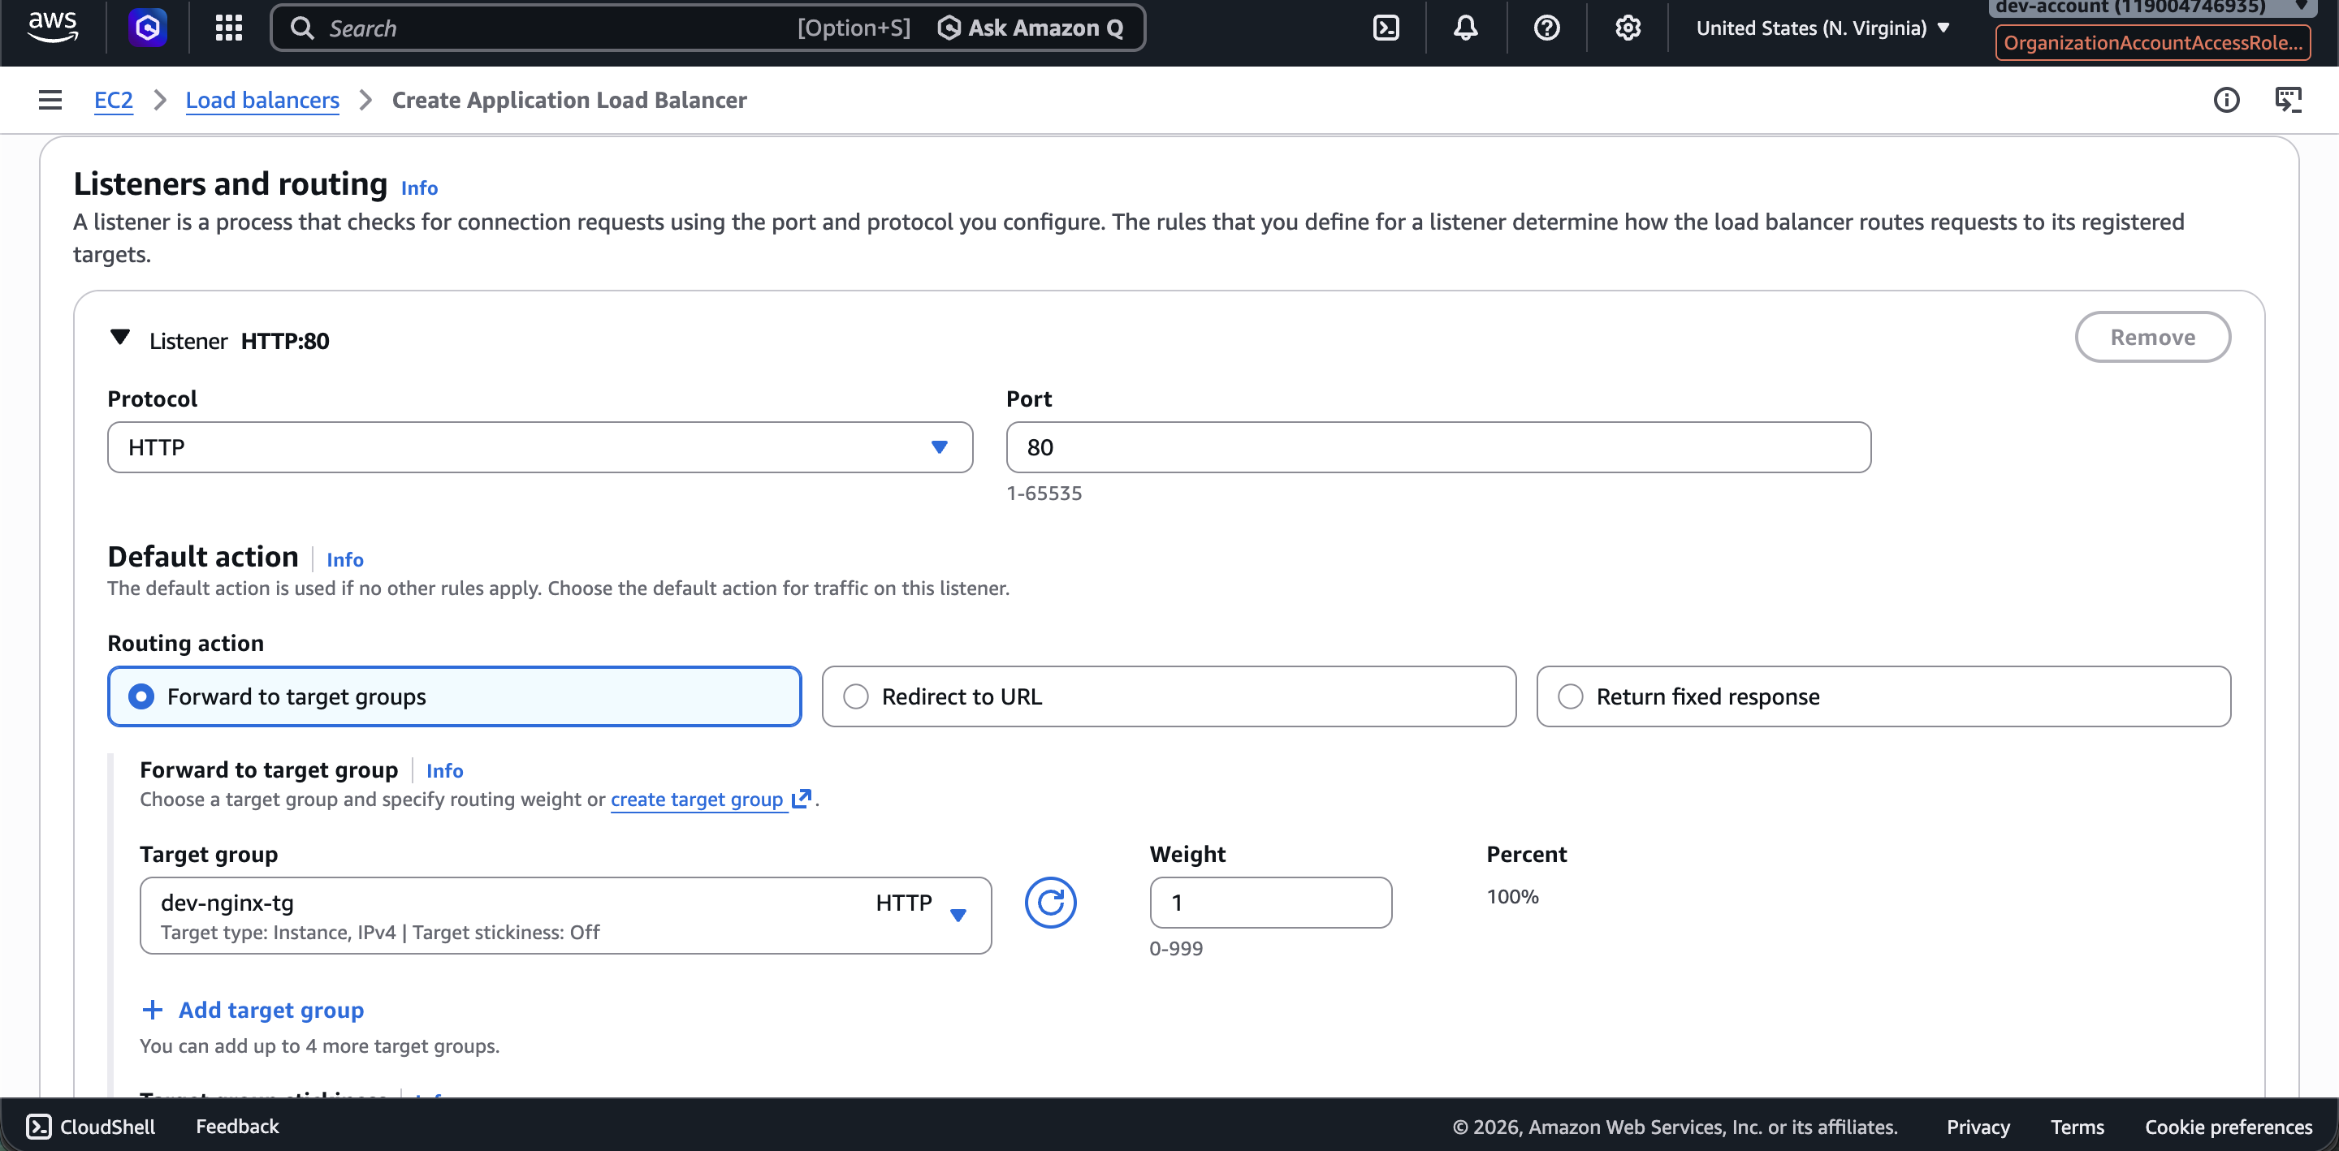

Screenshot — terraform plan output page 2:
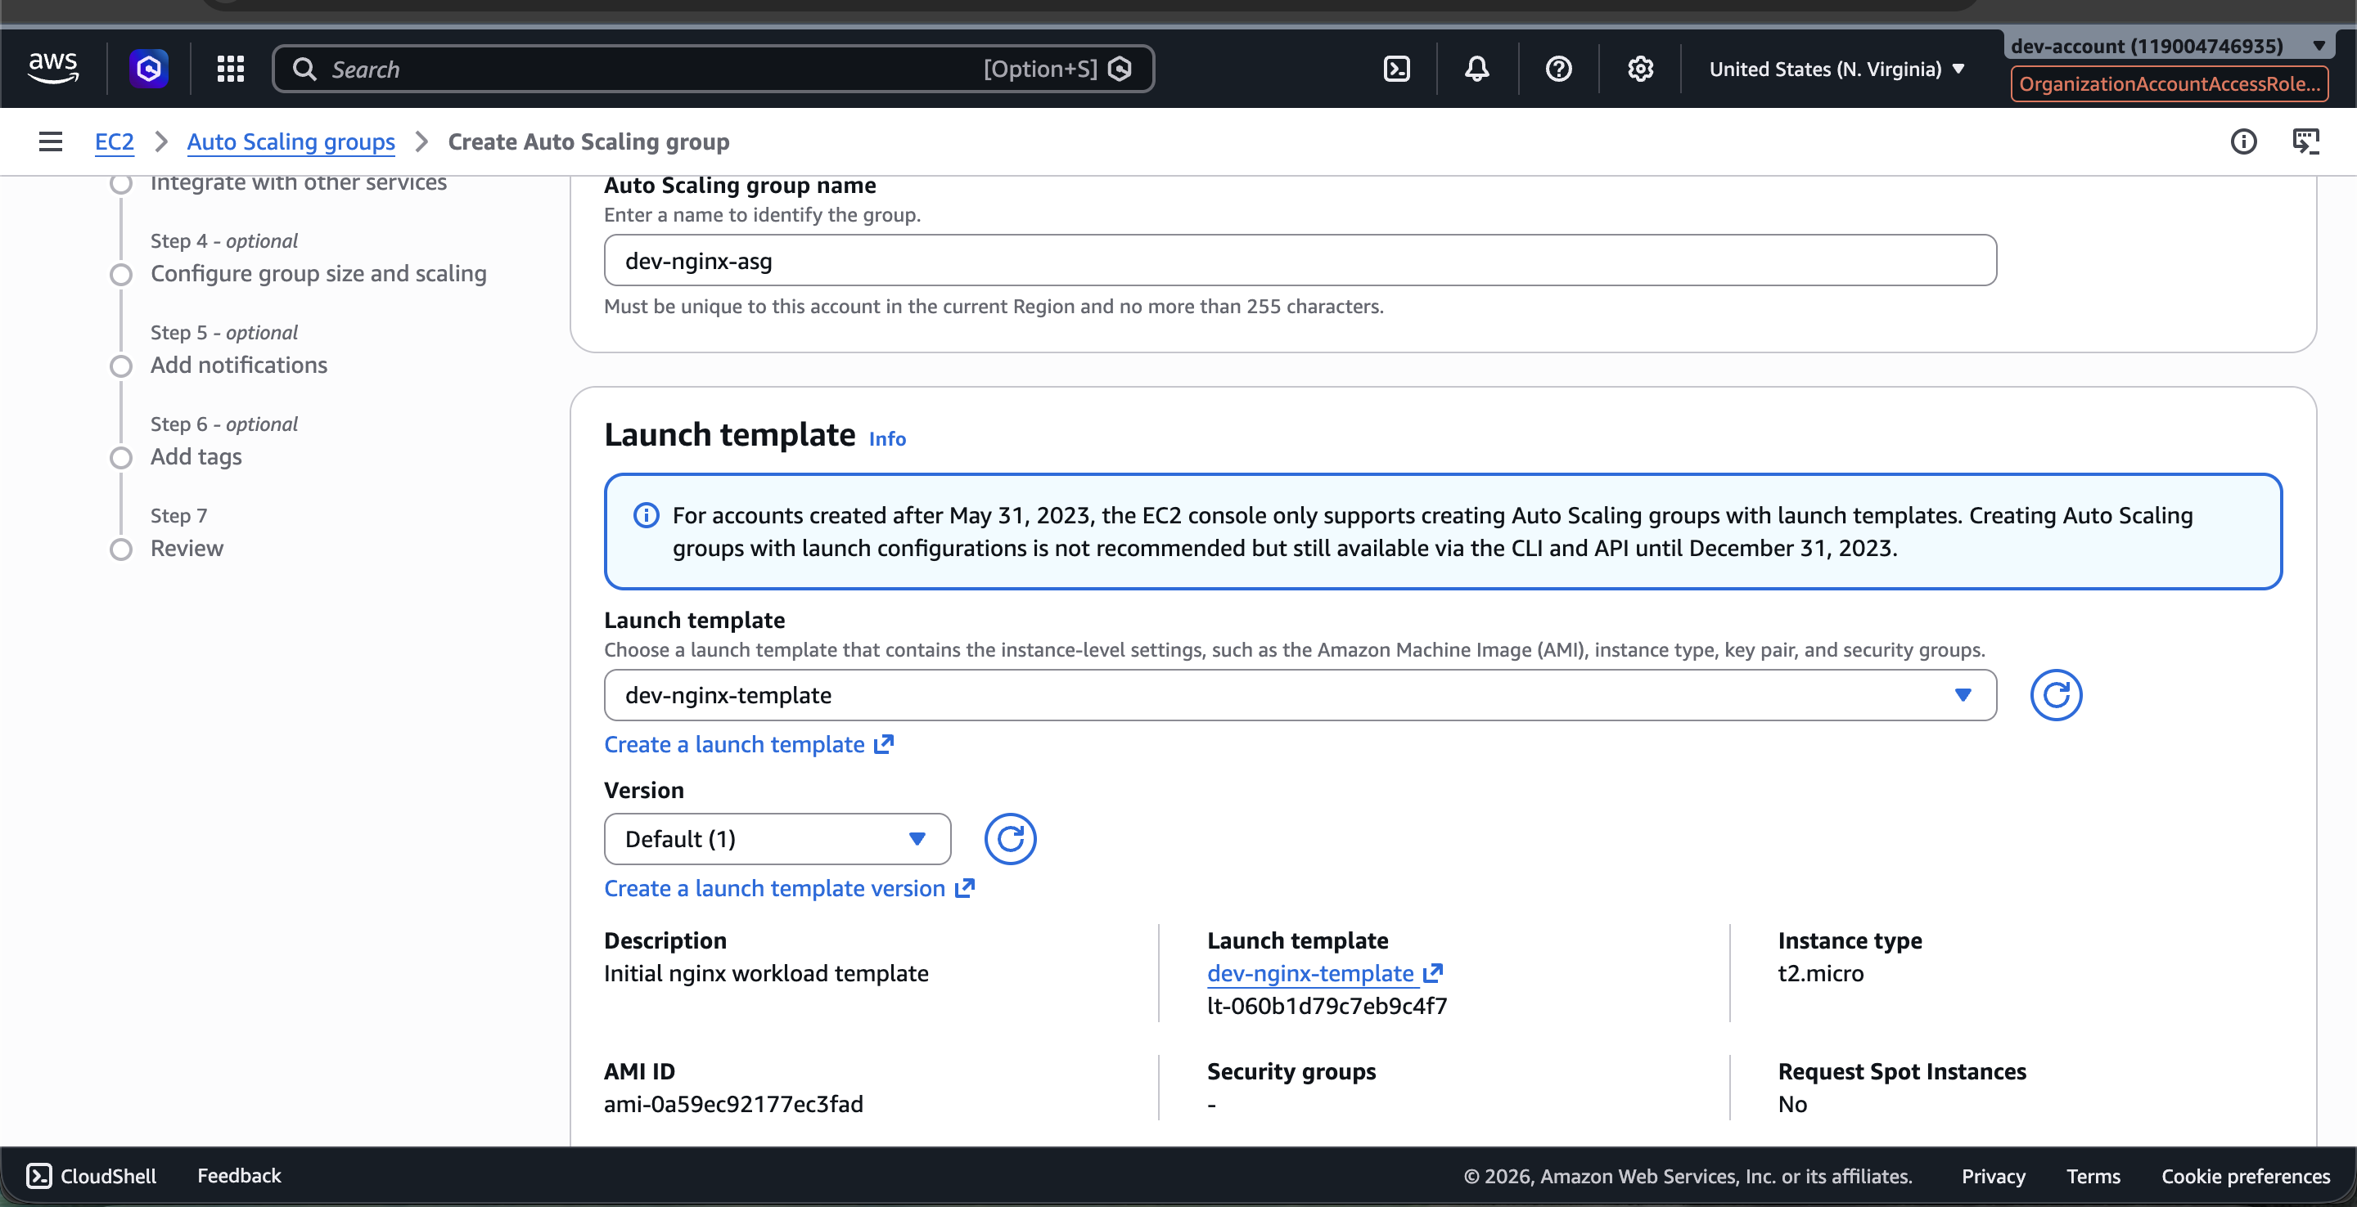

Screenshot — terraform plan output page 3:
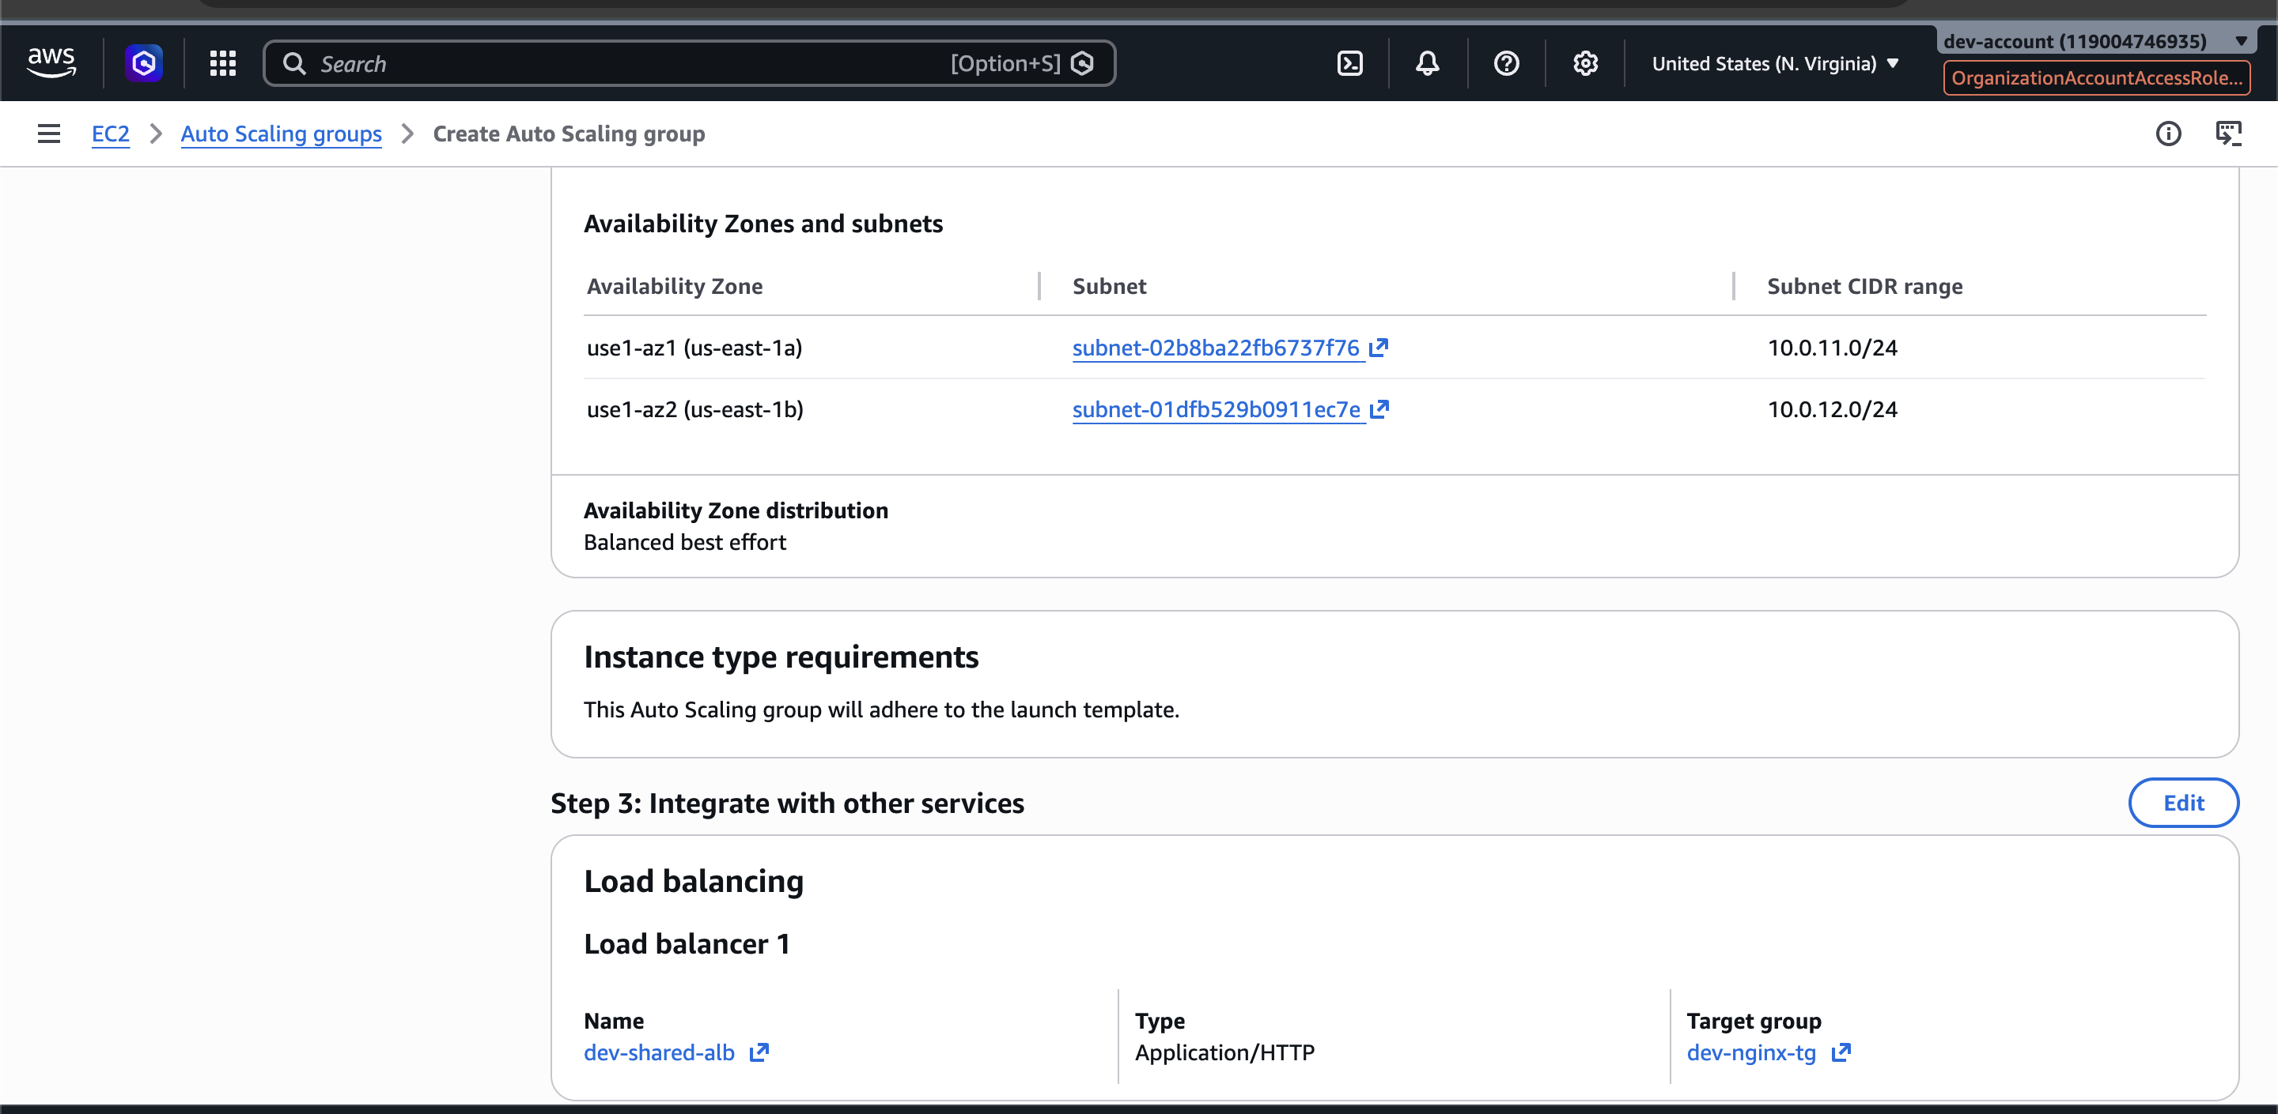

# aws_autoscaling_group.dev_nginx_asg will be updated in-place
~ resource "aws_autoscaling_group" "dev_nginx_asg" {
+ force_delete = false
+ force_delete_warm_pool = false
~ health_check_type = "EC2" -> "ELB"
id = "dev-nginx-asg"
+ ignore_failed_scaling_activities = false
name = "dev-nginx-asg"
+ wait_for_capacity_timeout = "10m"
~ launch_template {
id = "lt-060b1d79c7eb9c4f7"
name = "dev-nginx-template"
~ version = "$Default" -> "$Latest"
}
+ tag {
+ key = "Name"
+ propagate_at_launch = true
+ value = "dev-nginx-instance"
}
}

# aws_launch_template.dev_nginx_template will be updated in-place
~ resource "aws_launch_template" "dev_nginx_template" {
- description = "Initial nginx workload template" -> null
id = "lt-060b1d79c7eb9c4f7"
~ image_id = "ami-0a59ec92177ec3fad" -> "ami-0c101f26f147fa7fd"
name = "dev-nginx-template"
~ user_data = "IyEvYmluL2Jhc2gK..." -> "IyEvYmluL2Jhc2gK..."
~ vpc_security_group_ids = [
- "sg-0a7ab1345afcd9a0d",
] -> (known after apply)
~ iam_instance_profile {
- arn = "arn:aws:iam::119004746935:instance-profile/dev-ec2-ssm-role" -> null
+ name = "dev-ec2-ssm-role"
}
+ tag_specifications {
+ resource_type = "instance"
+ tags = {
+ "Name" = "dev-nginx-instance"
}
}
}

# aws_lb.dev_shared_alb will be updated in-place
~ resource "aws_lb" "dev_shared_alb" {
~ tags = {
+ "Name" = "dev-shared-alb"
}
}

# aws_lb_listener.http_listener will be updated in-place
~ resource "aws_lb_listener" "http_listener" {
~ default_action {
- forward {
- stickiness { duration = 3600 -> null; enabled = false -> null }
- target_group { arn = "...dev-nginx-tg..." -> null; weight = 1 -> null }
}
}
}

# aws_lb_target_group.dev_nginx_tg will be updated in-place
~ resource "aws_lb_target_group" "dev_nginx_tg" {
~ health_check {
~ healthy_threshold = 5 -> 2
}
~ tags = {
+ "Name" = "dev-nginx-tg"
}
}

# aws_security_group.dev_alb_sg will be updated in-place
~ resource "aws_security_group" "dev_alb_sg" {
~ ingress = [
+ { description = "HTTP from internet"; from_port = 80; ... }
]
}

# aws_security_group.dev_private_ec2_sg must be replaced
-/+ resource "aws_security_group" "dev_private_ec2_sg" {
~ description = "Private EC2 SG for shared VPC workloads" -> "Private application EC2 SG" # forces replacement
~ ingress = [
+ { description = "HTTP from ALB"; ... }
]
}

Plan: 1 to add, 6 to change, 1 to destroy.

Screenshot — plan summary (1 add, 6 change, 1 destroy):
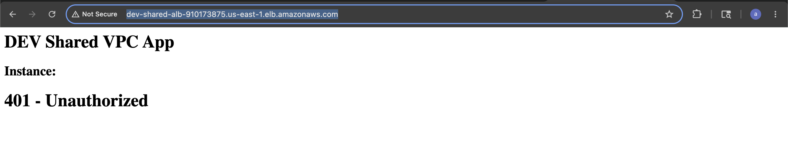

terraform apply — Full Apply Output
arpitchouksey@Arpits-MacBook-Air dev % terraform apply
data.aws_vpc.shared_vpc: Reading...
module.terraform_execution_role.aws_iam_role.terraform_execution_role: Refreshing state... [id=TerraformExecutionRole]
aws_security_group.dev_alb_sg: Refreshing state... [id=sg-0c8239266e982132f]
aws_lb_target_group.dev_nginx_tg: Refreshing state...
aws_security_group.dev_private_ec2_sg: Refreshing state... [id=sg-0a7ab1345afcd9a0d]
aws_lb.dev_shared_alb: Refreshing state...
aws_launch_template.dev_nginx_template: Refreshing state... [id=lt-060b1d79c7eb9c4f7]
module.terraform_execution_role.aws_iam_role_policy_attachment.admin_attach: Refreshing state...
aws_autoscaling_group.dev_nginx_asg: Refreshing state... [id=dev-nginx-asg]
data.aws_vpc.shared_vpc: Read complete after 2s [id=vpc-07d9cd9f11dc7928c]
aws_lb_listener.http_listener: Refreshing state...

Plan: 0 to add, 7 to change, 0 to destroy.

Do you want to perform these actions?
Only 'yes' will be accepted to approve.
Enter a value: yes

aws_security_group.dev_alb_sg: Modifying... [id=sg-0c8239266e982132f]
aws_lb_target_group.dev_nginx_tg: Modifying... [id=arn:aws:elasticloadbalancing:us-east-1:119004746935:targetgroup/dev-nginx-tg/68ff93673b4553bb]
aws_lb_target_group.dev_nginx_tg: Modifications complete after 3s
aws_security_group.dev_alb_sg: Modifications complete after 3s [id=sg-0c8239266e982132f]
aws_security_group.dev_private_ec2_sg: Modifying... [id=sg-0a7ab1345afcd9a0d]
aws_lb.dev_shared_alb: Modifying... [id=arn:aws:elasticloadbalancing:us-east-1:119004746935:loadbalancer/app/dev-shared-alb/e77a0027fa9e7782]
aws_security_group.dev_private_ec2_sg: Modifications complete after 2s [id=sg-0a7ab1345afcd9a0d]
aws_launch_template.dev_nginx_template: Modifying... [id=lt-060b1d79c7eb9c4f7]
aws_lb.dev_shared_alb: Still modifying... [id=arn:aws:elasticloadbalancing:us-east-1:...dev-shared-alb/e77a0027fa9e7782, 00m10s elapsed]
aws_launch_template.dev_nginx_template: Modifications complete after 8s [id=lt-060b1d79c7eb9c4f7]
aws_autoscaling_group.dev_nginx_asg: Modifying... [id=dev-nginx-asg]
aws_autoscaling_group.dev_nginx_asg: Modifications complete after 2s [id=dev-nginx-asg]
aws_lb.dev_shared_alb: Still modifying... [id=...dev-shared-alb/e77a0027fa9e7782, 00m20s elapsed]
aws_lb.dev_shared_alb: Still modifying... [id=...dev-shared-alb/e77a0027fa9e7782, 00m30s elapsed]
aws_lb.dev_shared_alb: Modifications complete after 31s
aws_lb_listener.http_listener: Modifying...
aws_lb_listener.http_listener: Modifications complete after 2s

Apply complete! Resources: 0 added, 7 changed, 0 destroyed.

Outputs:
alb_dns_name = "dev-shared-alb-910173875.us-east-1.elb.amazonaws.com"
target_group_arn = "arn:aws:elasticloadbalancing:us-east-1:119004746935:targetgroup/dev-nginx-tg/68ff93673b4553bb"

Screenshot — terraform apply in progress:
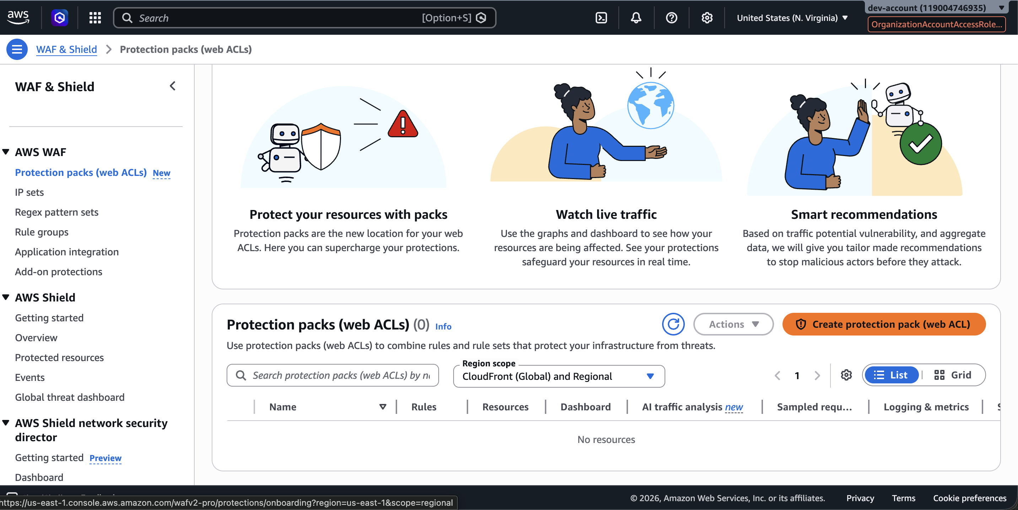

Screenshot — terraform apply complete with outputs:
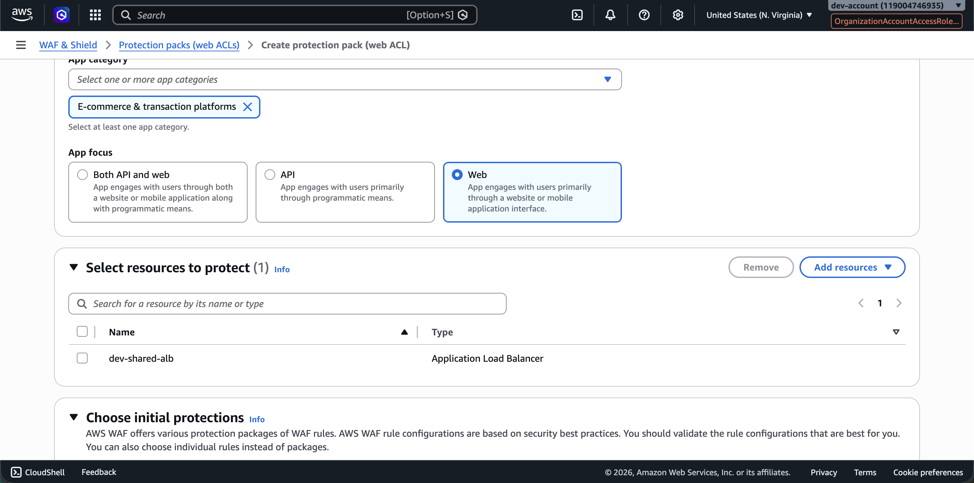

Next Target Architecture — WAF + HTTPS ALB
Internet
↓
WAF
↓
HTTPS ALB
↓
Target Group
↓
Private ASG

WAF Integration — waf.tf

vi waf.tf
arpitchouksey@Arpits-MacBook-Air dev % vi waf.tf

terraform import — WAF Web ACL (First Attempt — Wrong Format)
arpitchouksey@Arpits-MacBook-Air dev % terraform import aws_wafv2_web_acl.dev_alb_waf \
arn:aws:wafv2:us-east-1:119004746935:regional/webacl/dev-alb-waf/3f4d233a-f929-4f81-af37-489f1dafd285
aws_wafv2_web_acl.dev_alb_waf: Importing from ID "arn:aws:wafv2:us-east-1:119004746935:regional/webacl/dev-alb-waf/3f4d233a-f929-4f81-af37-489f1dafd285"...
data.aws_vpc.shared_vpc: Reading...
data.aws_vpc.shared_vpc: Read complete after 2s [id=vpc-07d9cd9f11dc7928c]
╷
│ Error: Unexpected format of ID ("arn:aws:wafv2:us-east-1:119004746935:regional/webacl/dev-alb-waf/3f4d233a-f929-4f81-af37-489f1dafd285"),
│ expected ID/NAME/SCOPE
╵

⚠️ Fix: WAF import requires format: ID/NAME/SCOPE — not the full ARN.

terraform import — WAF Web ACL (Correct Format: ID/NAME/SCOPE)
arpitchouksey@Arpits-MacBook-Air dev % terraform import aws_wafv2_web_acl.dev_alb_waf \
3f4d233a-f929-4f81-af37-489f1dafd285/dev-alb-waf/REGIONAL
aws_wafv2_web_acl.dev_alb_waf: Importing from ID "3f4d233a-f929-4f81-af37-489f1dafd285/dev-alb-waf/REGIONAL"...
data.aws_vpc.shared_vpc: Reading...
aws_wafv2_web_acl.dev_alb_waf: Import prepared!
Prepared aws_wafv2_web_acl for import
aws_wafv2_web_acl.dev_alb_waf: Refreshing state... [id=3f4d233a-f929-4f81-af37-489f1dafd285]
data.aws_vpc.shared_vpc: Read complete after 2s [id=vpc-07d9cd9f11dc7928c]

Import successful!

Screenshot — WAF imported with correct ID/NAME/SCOPE format:
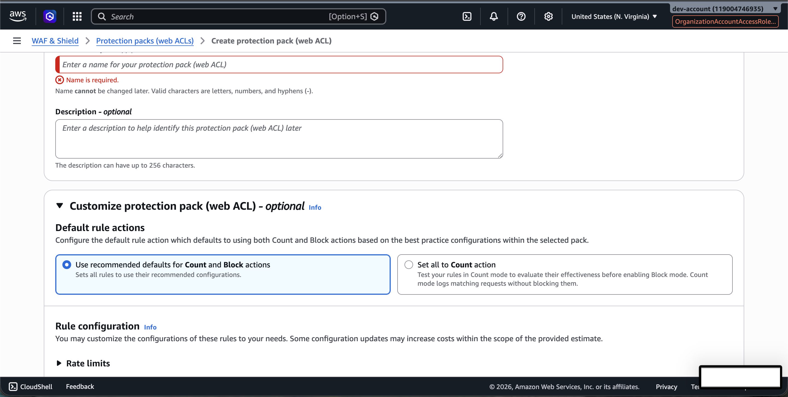

cat waf.tf
arpitchouksey@Arpits-MacBook-Air dev % cat waf.tf
resource "aws_wafv2_web_acl" "dev_alb_waf" {
name = "dev-alb-waf"
scope = "REGIONAL"

default_action {
allow {}
}

visibility_config {
cloudwatch_metrics_enabled = false
metric_name = "devAlbWaf"
sampled_requests_enabled = false
}
}

terraform plan — After WAF Import (Shows All Existing WAF Rules to Be Removed)
arpitchouksey@Arpits-MacBook-Air dev % terraform plan
(all resources refreshing...)

# aws_wafv2_web_acl.dev_alb_waf will be updated in-place
~ resource "aws_wafv2_web_acl" "dev_alb_waf" {
- description = "WAF protection for shared VPC ALB" -> null
id = "3f4d233a-f929-4f81-af37-489f1dafd285"
name = "dev-alb-waf"
~ tags_all = {
+ "Environment" = "dev"
+ "ManagedBy" = "Terraform"
+ "Project" = "shared-vpc-platform"
}

- rule { name = "dev-alb-waf_IPV4_Allow"; priority = 1; action { allow {} } }
- rule { name = "dev-alb-waf_IPV6_Allow"; priority = 2; action { allow {} } }
- rule { name = "GeoRule"; priority = 5; action { block {} } }
- rule { name = "dev-alb-waf_IPV4_Block"; priority = 3; action { block {} } }
- rule { name = "dev-alb-waf_IPV6_Block"; priority = 4; action { block {} } }
- rule { name = "BodySizeRestrictionRule"; priority = 9; action { count {} } }
- rule { name = "GlobalRateBasedRule"; priority = 6; action { count {} } }
- rule { name = "ManagedIPDDoSRateLimit"; priority = 11; action { count {} } }
- rule { name = "RateBasedRuleGET"; priority = 7; action { count {} } }
- rule { name = "RateBasedRulePOST"; priority = 8; action { count {} } }
- rule { name = "AWS-AWSManagedRulesAdminProtectionRuleSet"; priority = 17 }
- rule { name = "AWS-AWSManagedRulesAmazonIpReputationList"; priority = 10 }
- rule { name = "AWS-AWSManagedRulesAnonymousIpList"; priority = 12 }
- rule { name = "AWS-AWSManagedRulesAntiDDoSRuleSet"; priority = 0 }
- rule { name = "AWS-AWSManagedRulesBotControlRuleSet"; priority = 18 }
- rule { name = "AWS-AWSManagedRulesCommonRuleSet"; priority = 13 }
- rule { name = "AWS-AWSManagedRulesKnownBadInputsRuleSet"; priority = 14 }
- rule { name = "AWS-AWSManagedRulesPHPRuleSet"; priority = 15 }
- rule { name = "AWS-AWSManagedRulesSQLiRuleSet"; priority = 16 }

~ visibility_config {
~ cloudwatch_metrics_enabled = true -> false
~ metric_name = "dev-alb-waf" -> "devAlbWaf"
~ sampled_requests_enabled = true -> false
}
}

Plan: 0 to add, 1 to change, 0 to destroy.

Screenshot — terraform plan WAF rules to be removed:
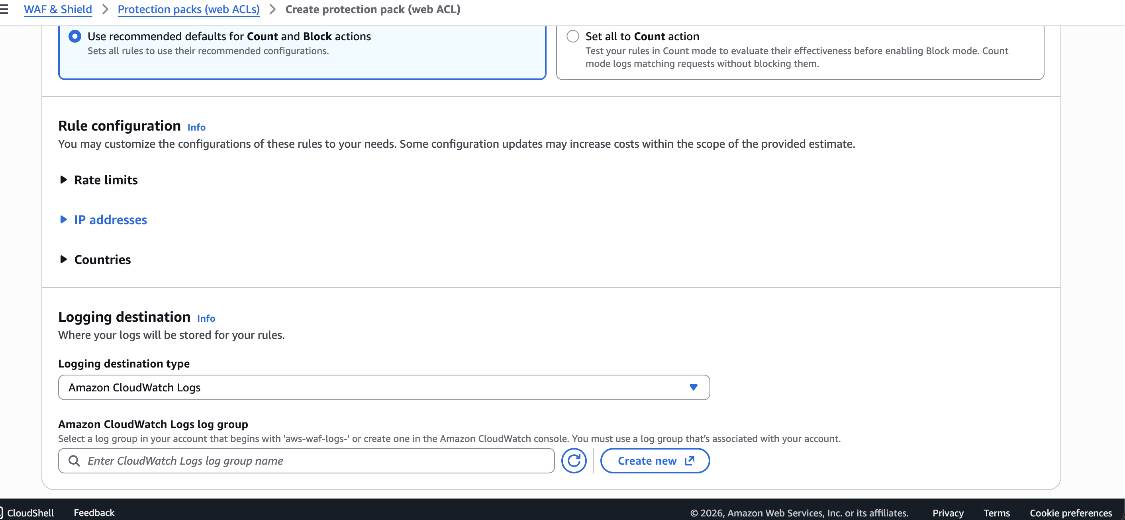

Screenshot — terraform plan WAF continued:
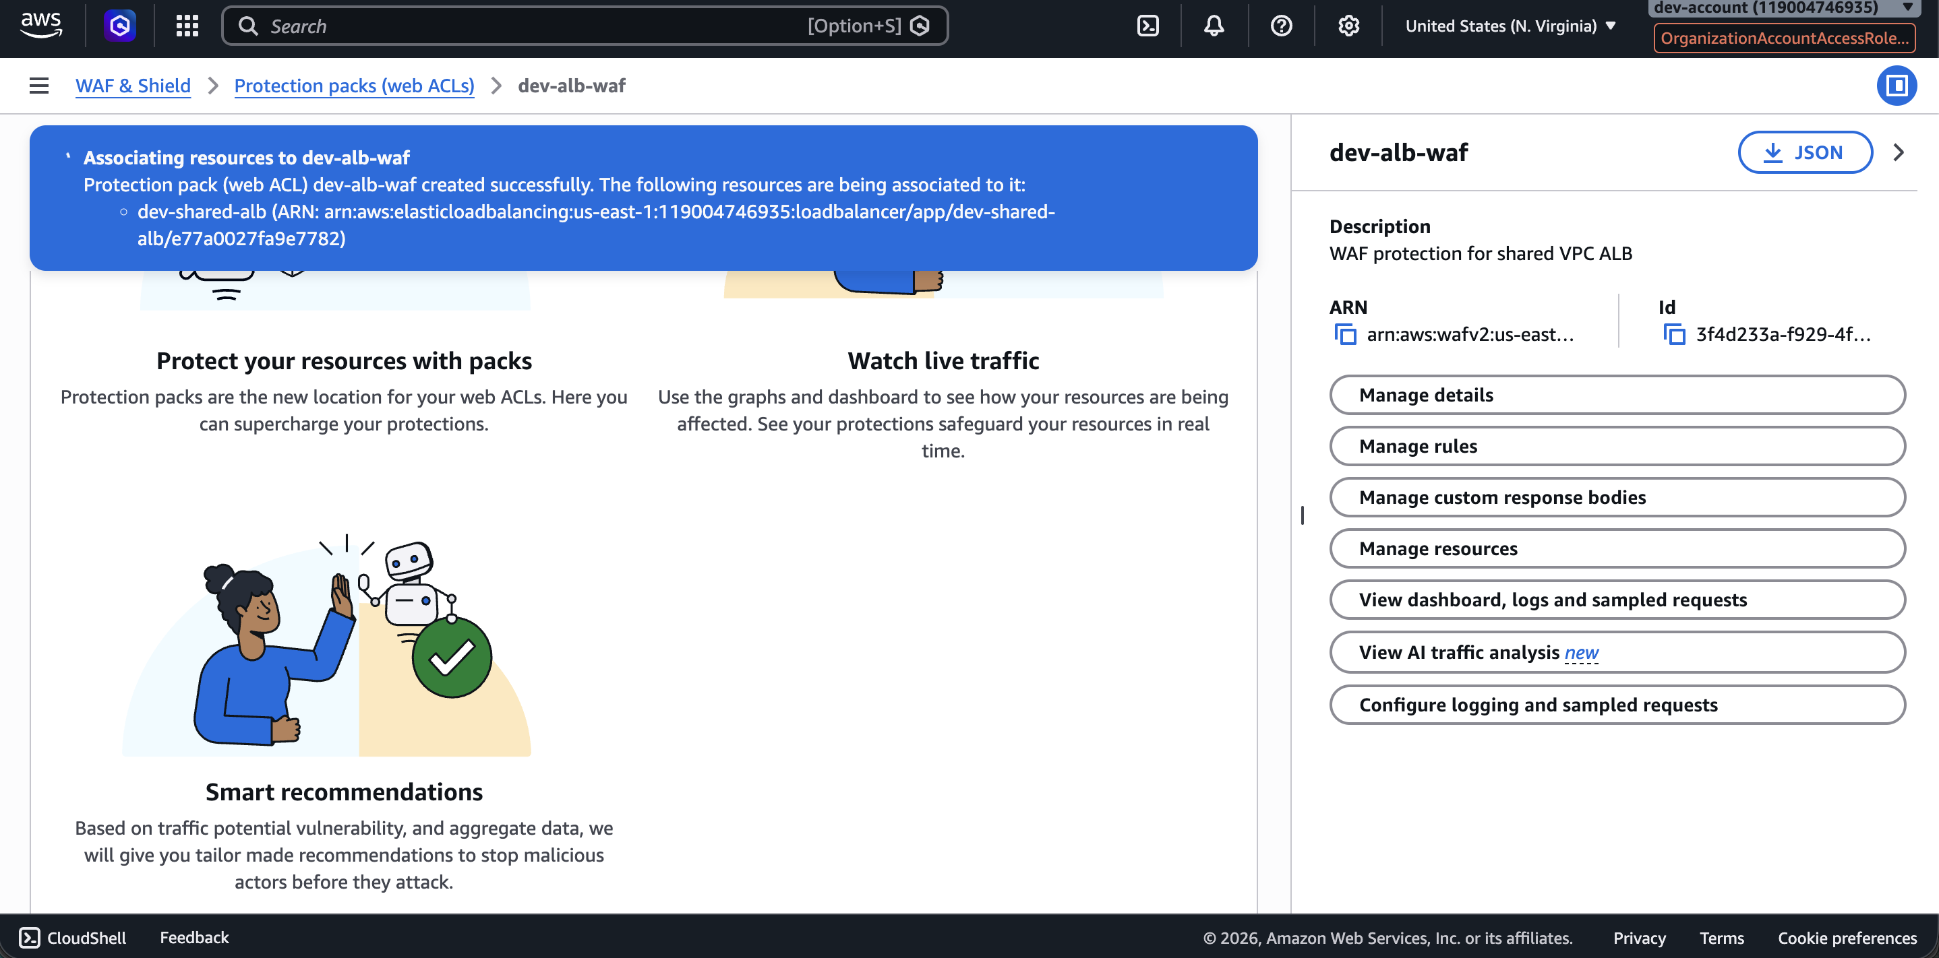

Screenshot — terraform plan WAF continued:
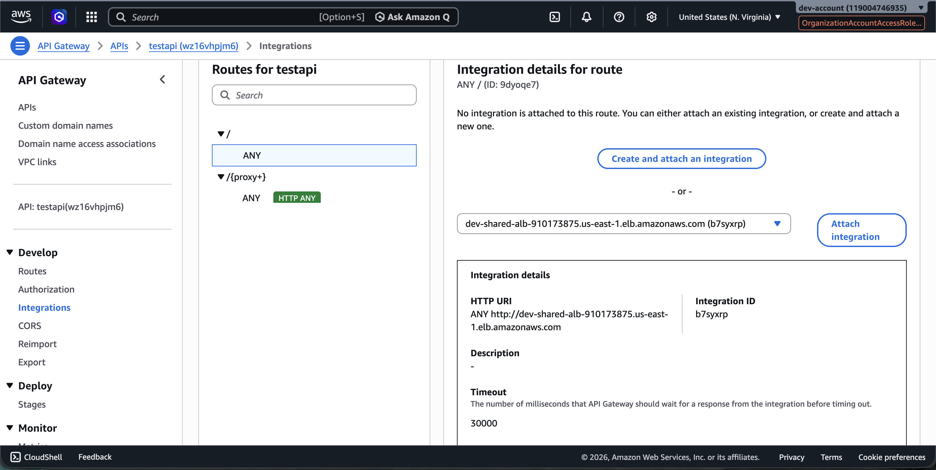

Screenshot — terraform plan WAF final summary:
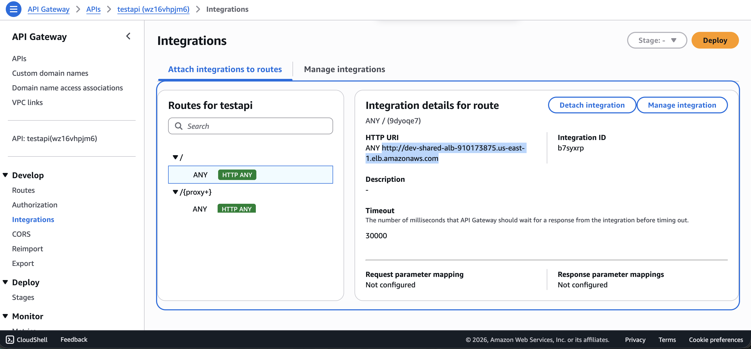

API Gateway Integration — apigateway.tf

vi apigateway.tf
arpitchouksey@Arpits-MacBook-Air dev % vi apigateway.tf

terraform import — API Gateway
arpitchouksey@Arpits-MacBook-Air dev % terraform import aws_apigatewayv2_api.dev_api wz16vhpjm6
aws_apigatewayv2_api.dev_api: Importing from ID "wz16vhpjm6"...
aws_apigatewayv2_api.dev_api: Import prepared!
Prepared aws_apigatewayv2_api for import
data.aws_vpc.shared_vpc: Reading...
aws_apigatewayv2_api.dev_api: Refreshing state... [id=wz16vhpjm6]
data.aws_vpc.shared_vpc: Read complete after 3s [id=vpc-07d9cd9f11dc7928c]

Import successful!

Screenshot — API Gateway imported:
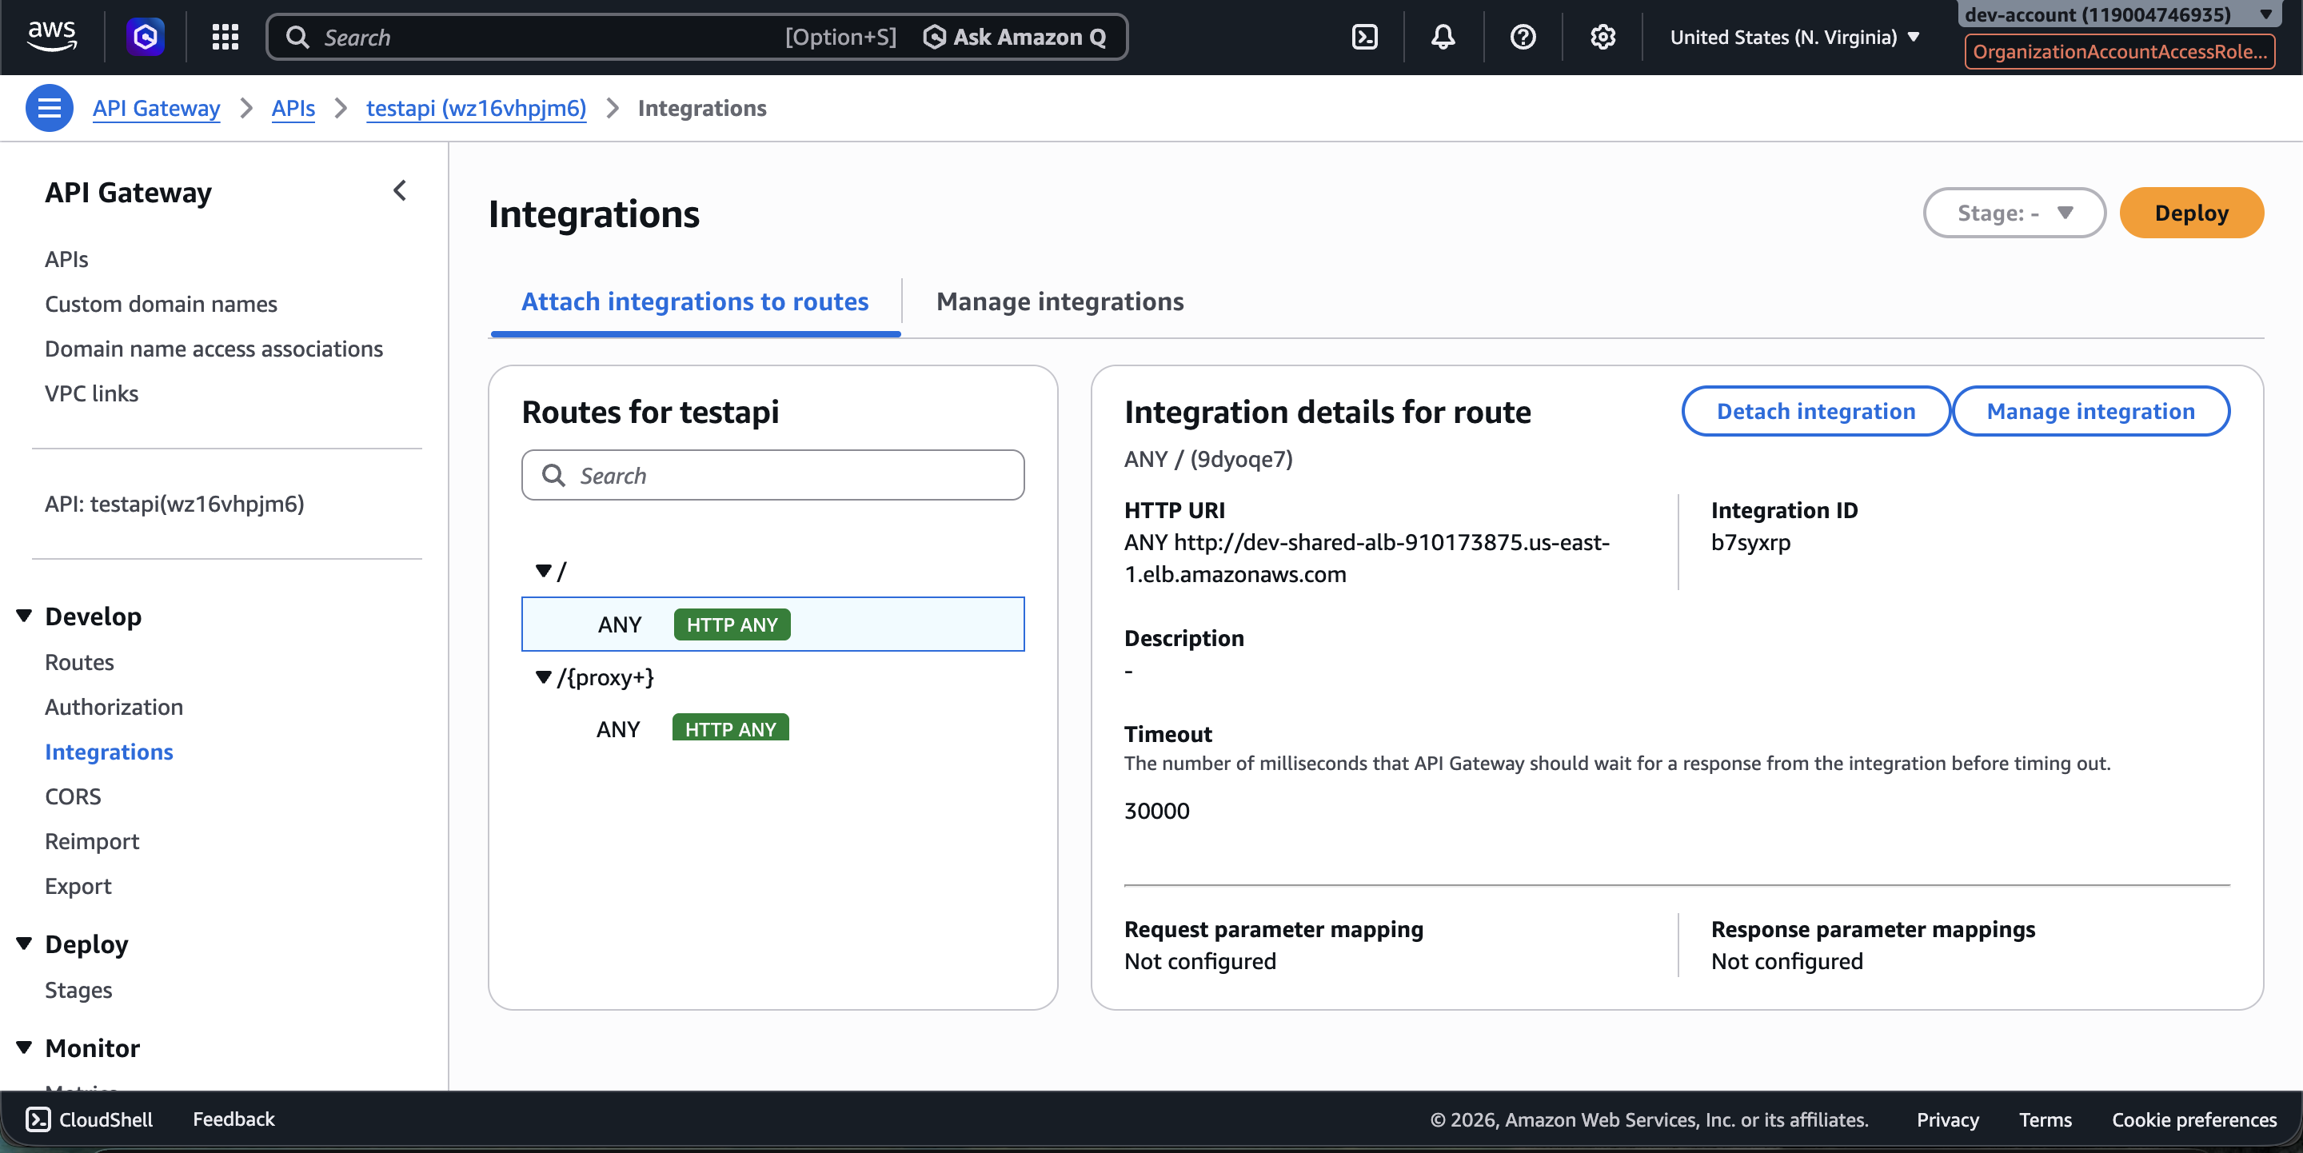

terraform plan — After API Gateway Import
arpitchouksey@Arpits-MacBook-Air dev % terraform plan
data.aws_vpc.shared_vpc: Reading...
module.terraform_execution_role.aws_iam_role.terraform_execution_role: Refreshing state... [id=TerraformExecutionRole]
aws_apigatewayv2_api.dev_api: Refreshing state... [id=wz16vhpjm6]
aws_security_group.dev_alb_sg: Refreshing state... [id=sg-0c8239266e982132f]
aws_lb_target_group.dev_nginx_tg: Refreshing state...
aws_security_group.dev_private_ec2_sg: Refreshing state... [id=sg-0a7ab1345afcd9a0d]
aws_lb.dev_shared_alb: Refreshing state...
aws_launch_template.dev_nginx_template: Refreshing state... [id=lt-060b1d79c7eb9c4f7]
module.terraform_execution_role.aws_iam_role_policy_attachment.admin_attach: Refreshing state...
aws_autoscaling_group.dev_nginx_asg: Refreshing state... [id=dev-nginx-asg]
data.aws_vpc.shared_vpc: Read complete after 3s [id=vpc-07d9cd9f11dc7928c]
aws_lb_listener.http_listener: Refreshing state...

# aws_apigatewayv2_api.dev_api will be updated in-place
~ resource "aws_apigatewayv2_api" "dev_api" {
id = "wz16vhpjm6"
name = "testapi"
~ tags_all = {
+ "Environment" = "dev"
+ "ManagedBy" = "Terraform"
+ "Project" = "shared-vpc-platform"
}
}

Plan: 0 to add, 1 to change, 0 to destroy.

Screenshot — API Gateway plan:
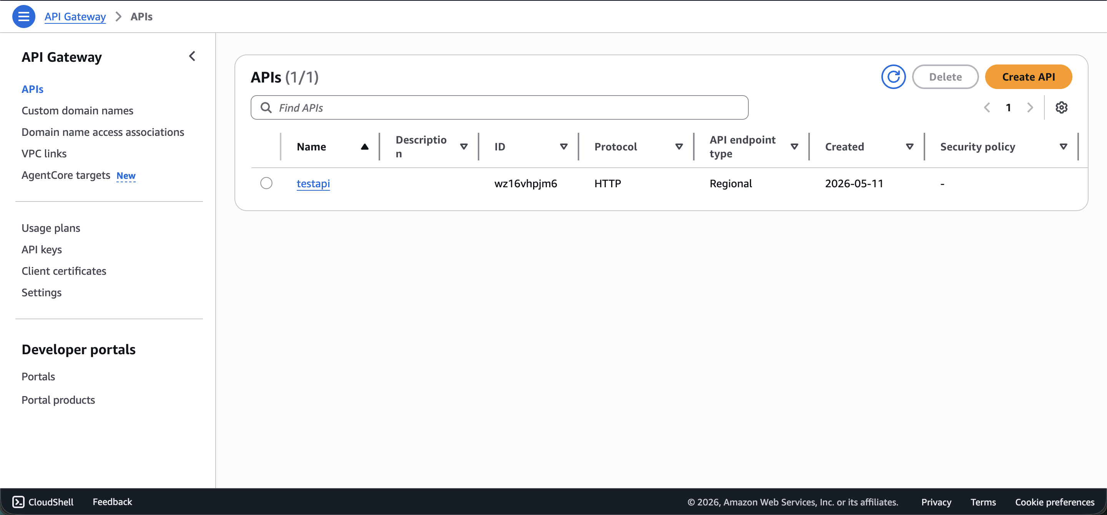

cat apigateway.tf
arpitchouksey@Arpits-MacBook-Air dev % cat apigateway.tf
resource "aws_apigatewayv2_api" "dev_api" {
name = "testapi"
protocol_type = "HTTP"
}

terraform apply — API Gateway
arpitchouksey@Arpits-MacBook-Air dev % terraform apply
data.aws_vpc.shared_vpc: Reading...
aws_apigatewayv2_api.dev_api: Refreshing state... [id=wz16vhpjm6]
module.terraform_execution_role.aws_iam_role.terraform_execution_role: Refreshing state...
aws_security_group.dev_alb_sg: Refreshing state... [id=sg-0c8239266e982132f]
aws_lb_target_group.dev_nginx_tg: Refreshing state...
aws_security_group.dev_private_ec2_sg: Refreshing state... [id=sg-0a7ab1345afcd9a0d]
aws_lb.dev_shared_alb: Refreshing state...
module.terraform_execution_role.aws_iam_role_policy_attachment.admin_attach: Refreshing state...
aws_launch_template.dev_nginx_template: Refreshing state... [id=lt-060b1d79c7eb9c4f7]
aws_autoscaling_group.dev_nginx_asg: Refreshing state... [id=dev-nginx-asg]
data.aws_vpc.shared_vpc: Read complete after 3s [id=vpc-07d9cd9f11dc7928c]
aws_lb_listener.http_listener: Refreshing state...

Plan: 0 to add, 1 to change, 0 to destroy.

Do you want to perform these actions?
Only 'yes' will be accepted to approve.
Enter a value: yes

aws_apigatewayv2_api.dev_api: Modifying... [id=wz16vhpjm6]
aws_apigatewayv2_api.dev_api: Modifications complete after 2s [id=wz16vhpjm6]

Apply complete! Resources: 0 added, 1 changed, 0 destroyed.

Outputs:
alb_dns_name = "dev-shared-alb-910173875.us-east-1.elb.amazonaws.com"
target_group_arn = "arn:aws:elasticloadbalancing:us-east-1:119004746935:targetgroup/dev-nginx-tg/68ff93673b4553bb"

Screenshot — API Gateway apply complete:
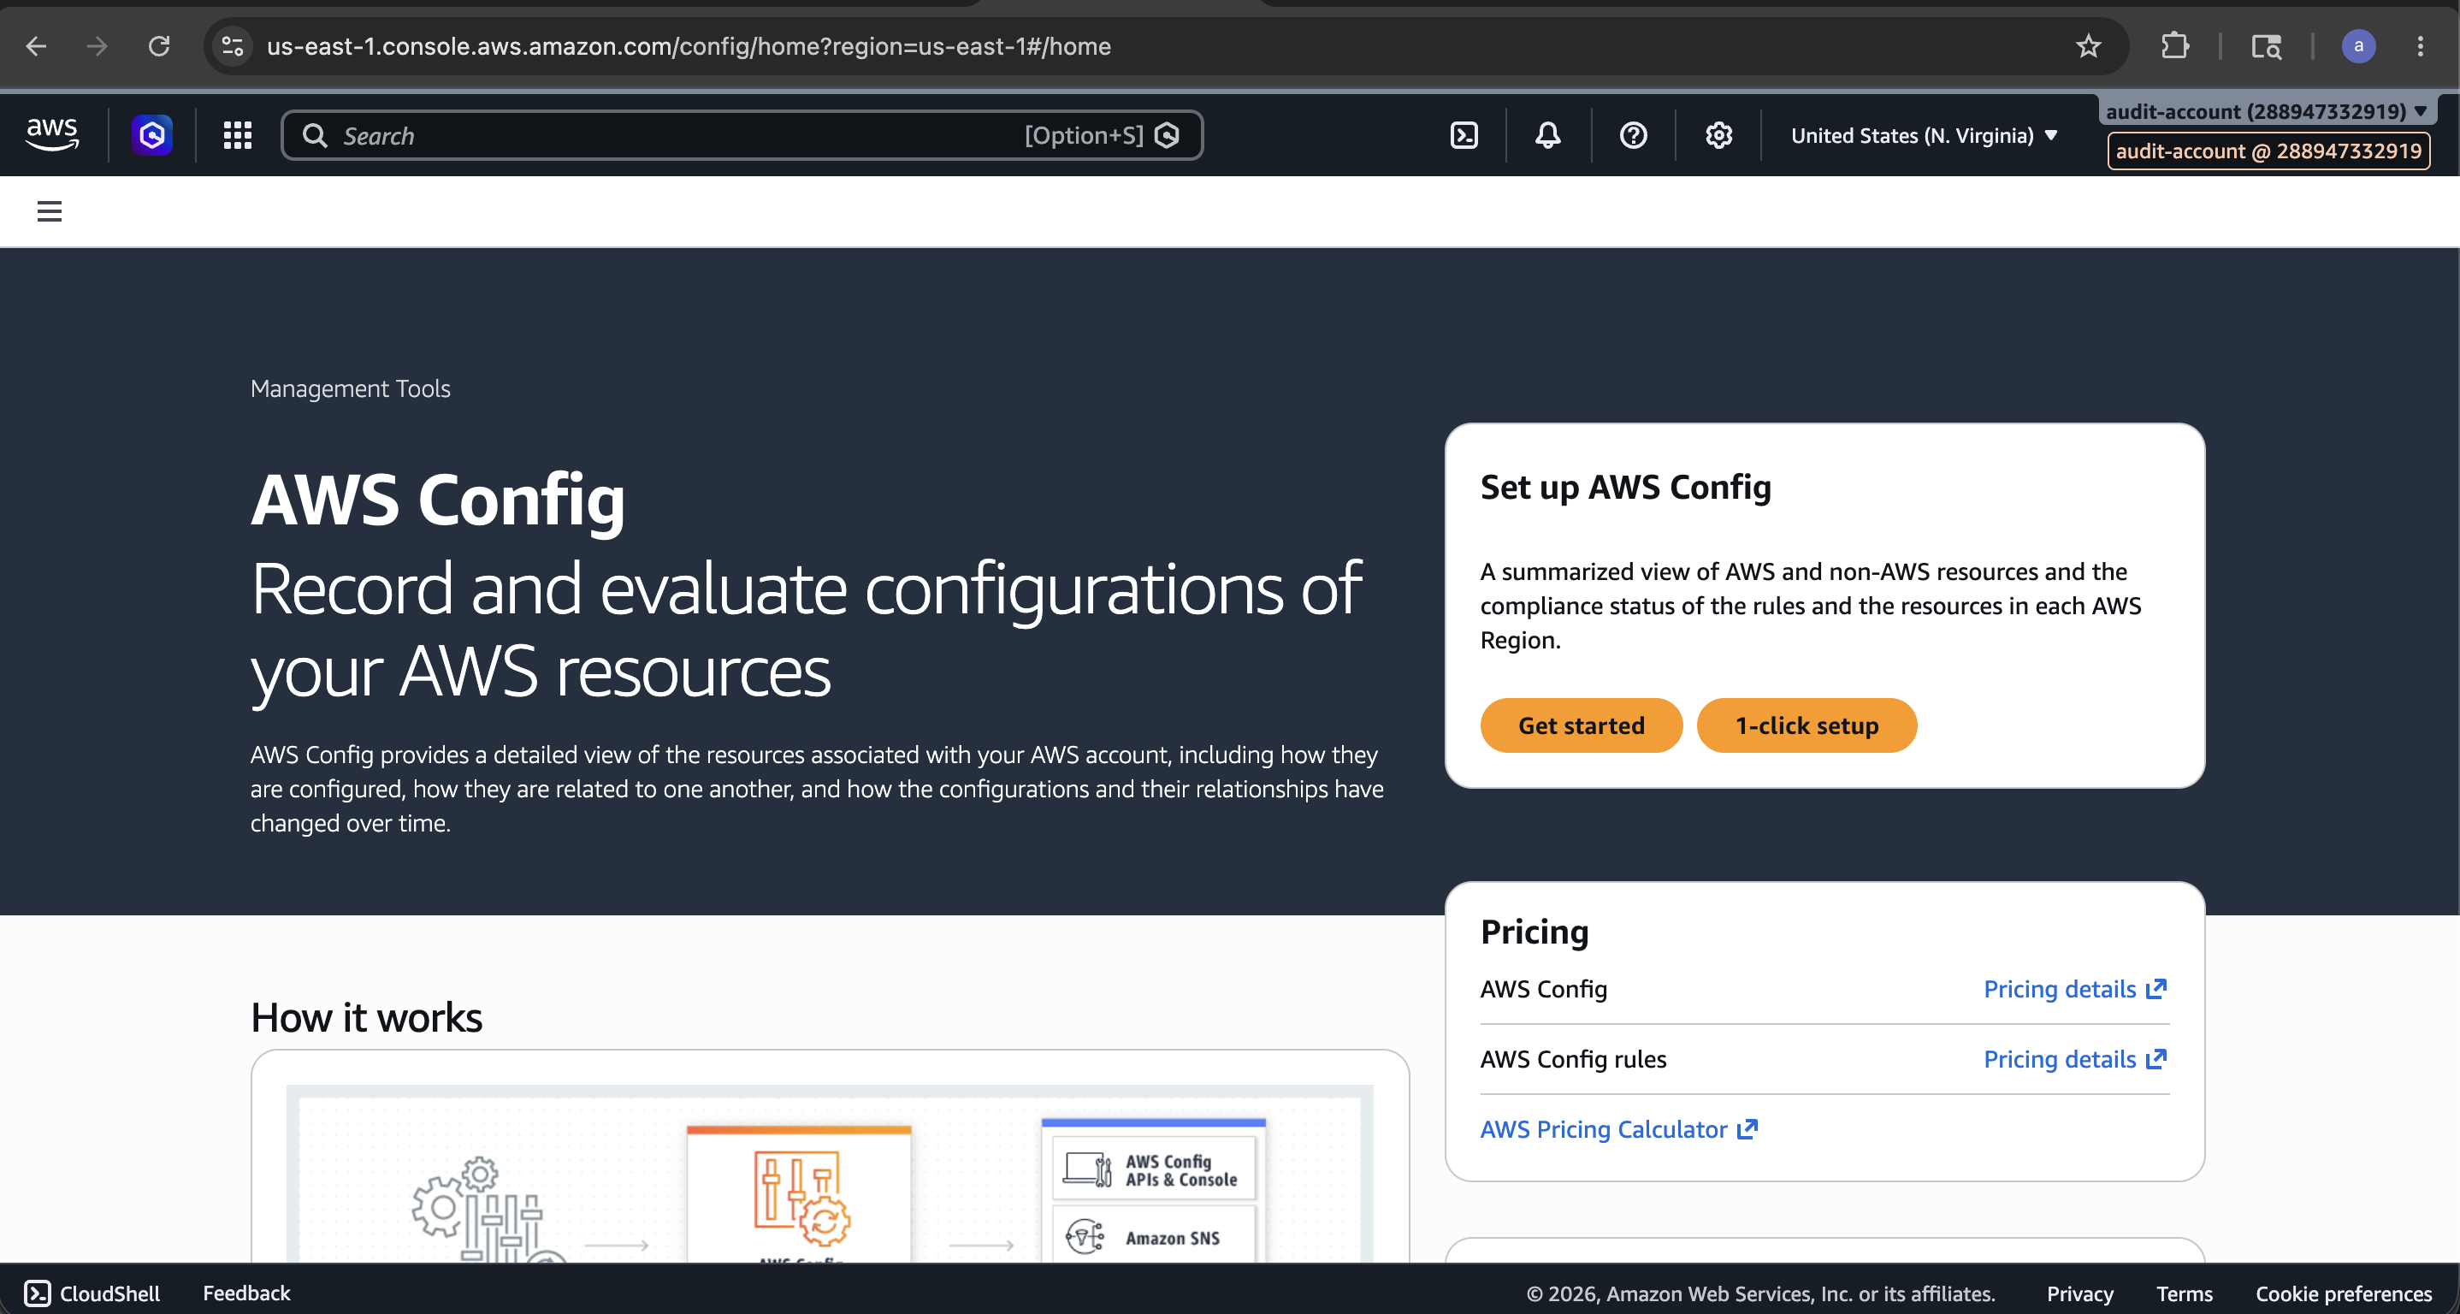

Screenshot — apply outputs:
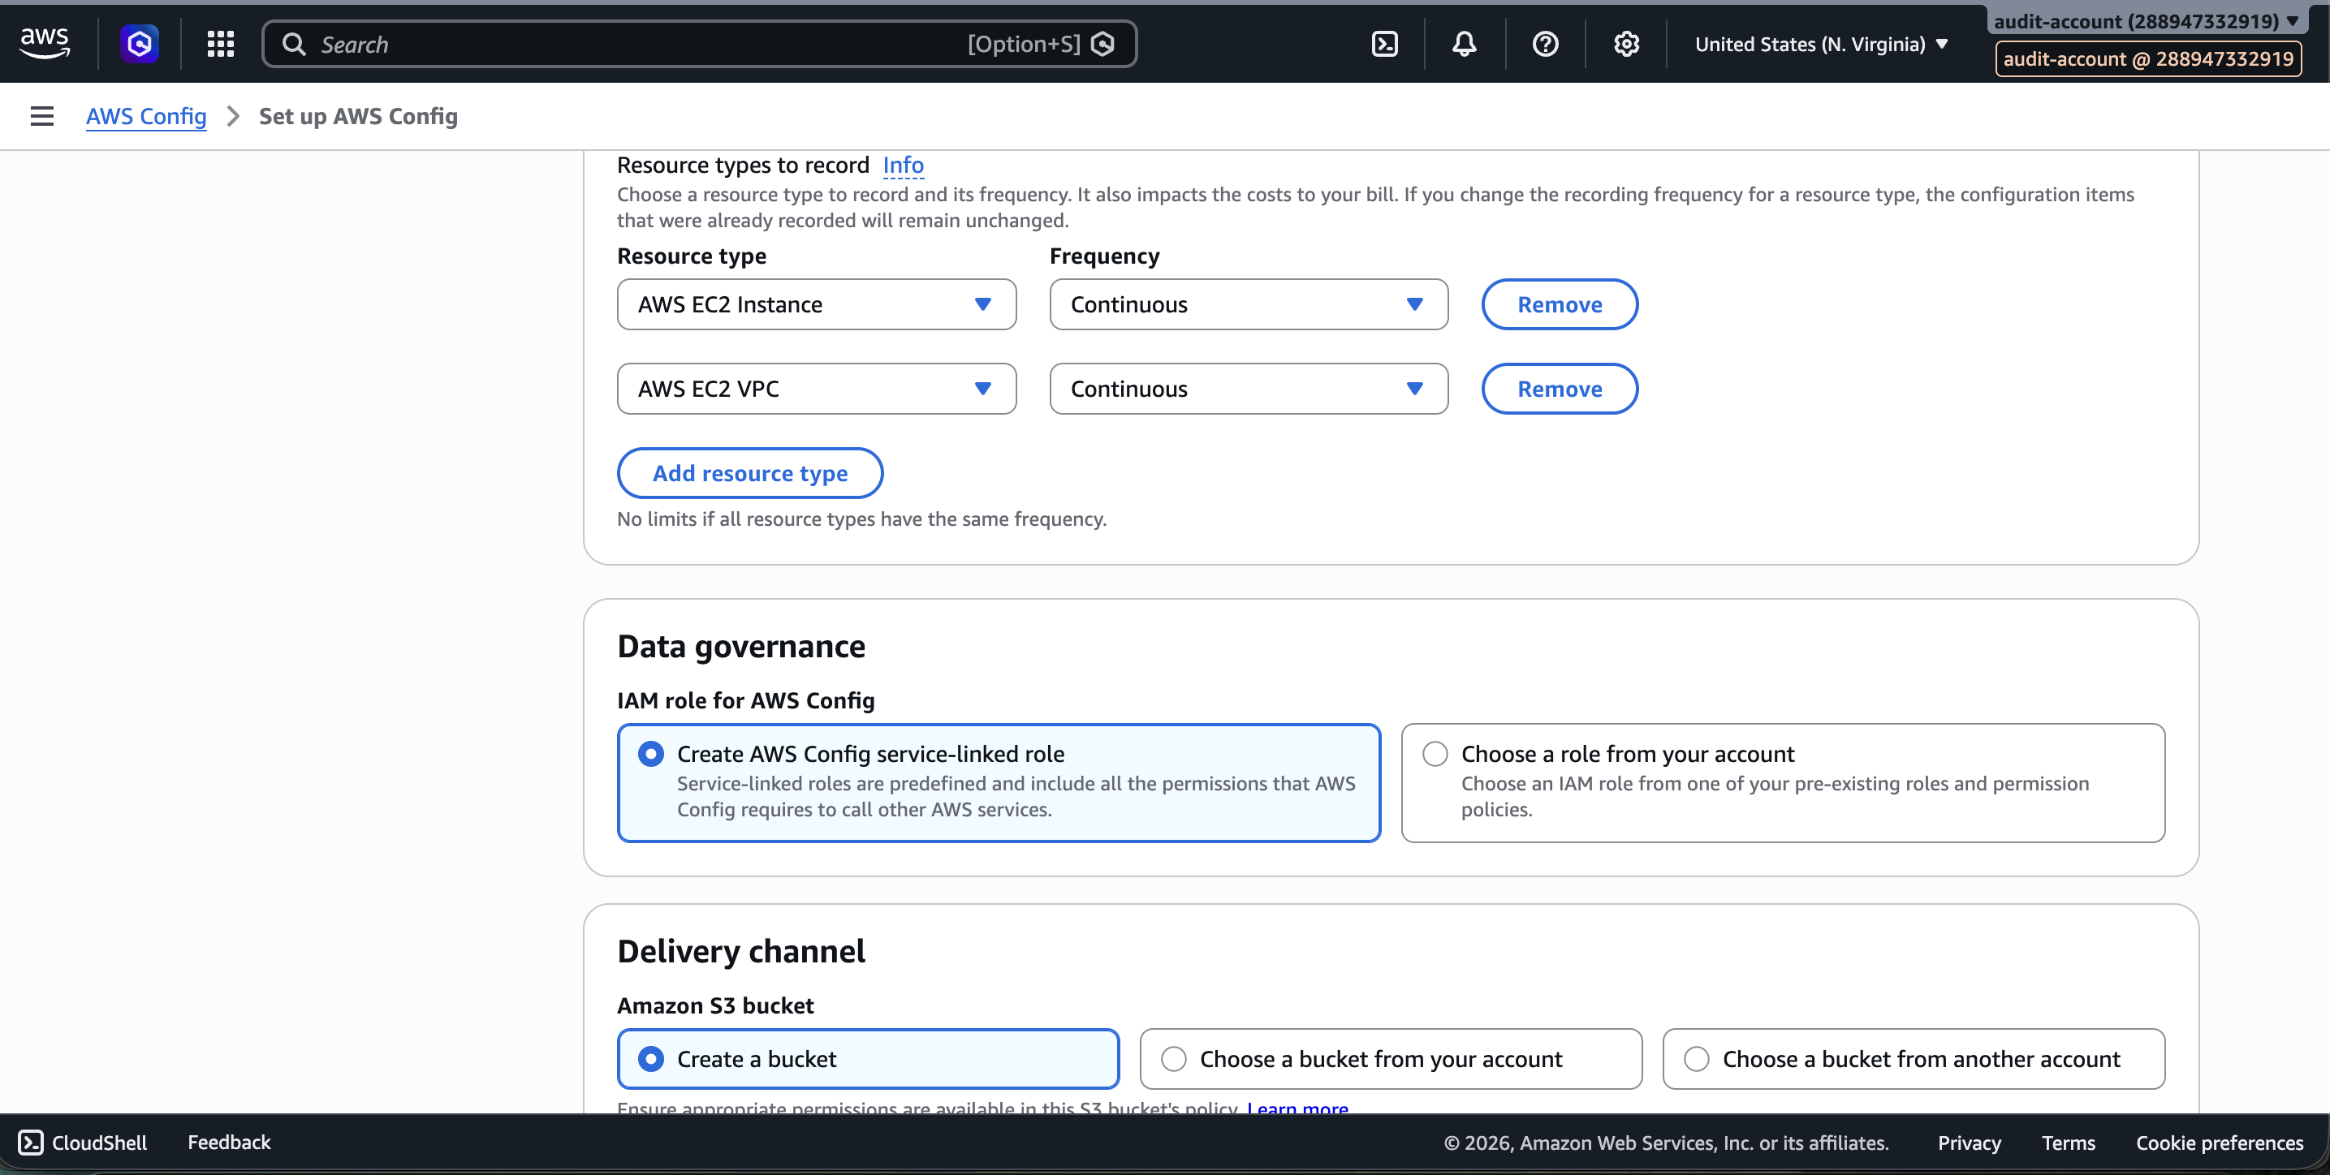

Audit Accounts — AWS Config Setup

Enable AWS Config in All Accounts
AWS Config is enabled in all three accounts:
- Dev Account → Config Enabled
- Connectivity Account → Config Enabled
- Audit Account → Config Enabled

Aggregator is created in the management account to collect Config data from all accounts.

Screenshot — AWS Config enabled in Dev Account:
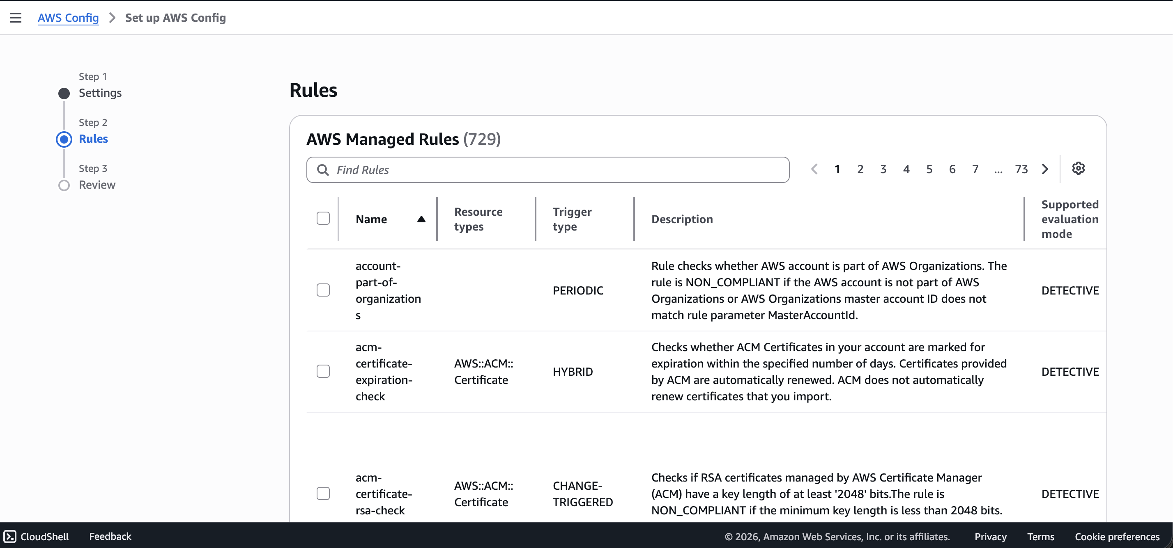

Screenshot — AWS Config enabled in Connectivity Account:
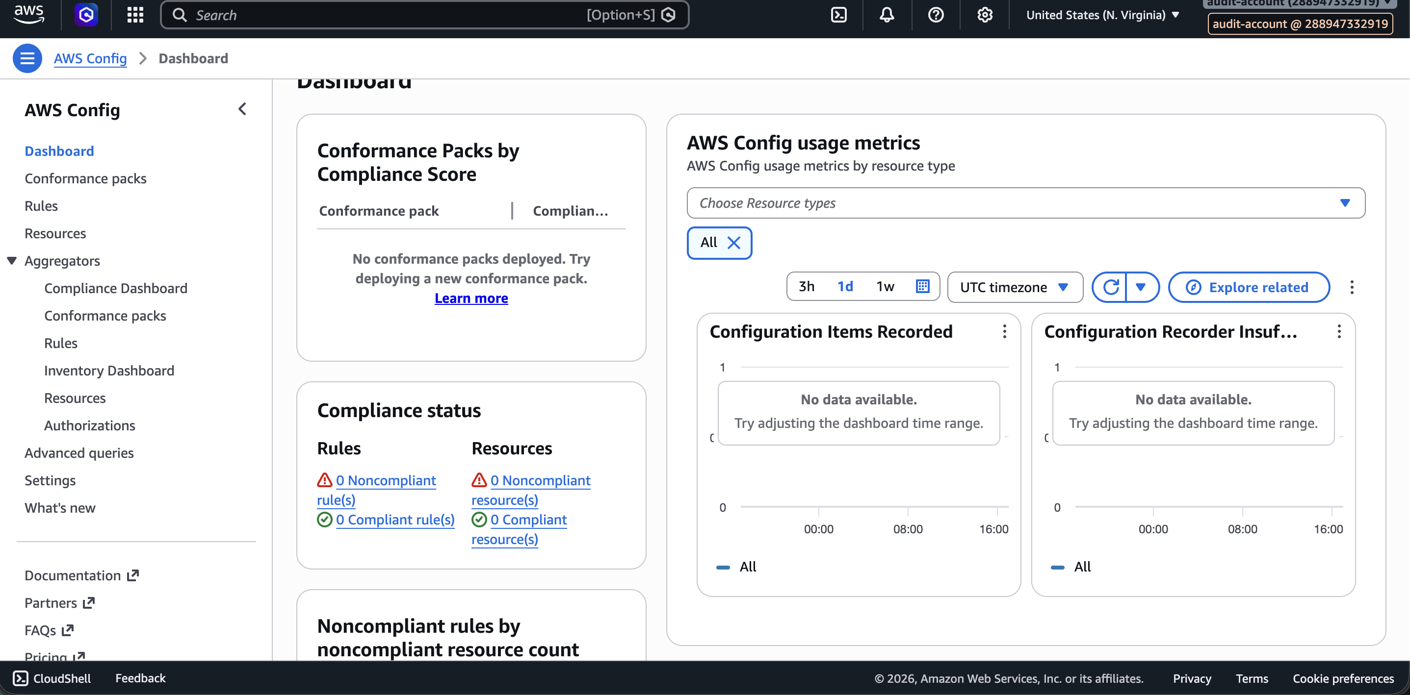

Screenshot — AWS Config aggregator in Management Account:
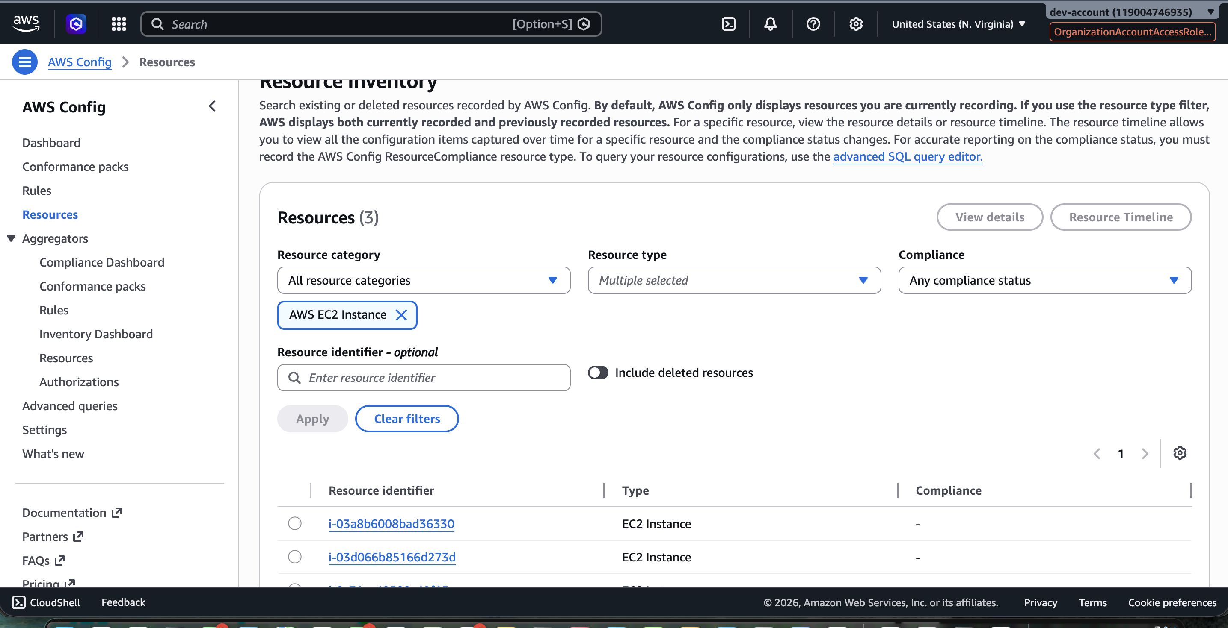

Screenshot — Config aggregator details:
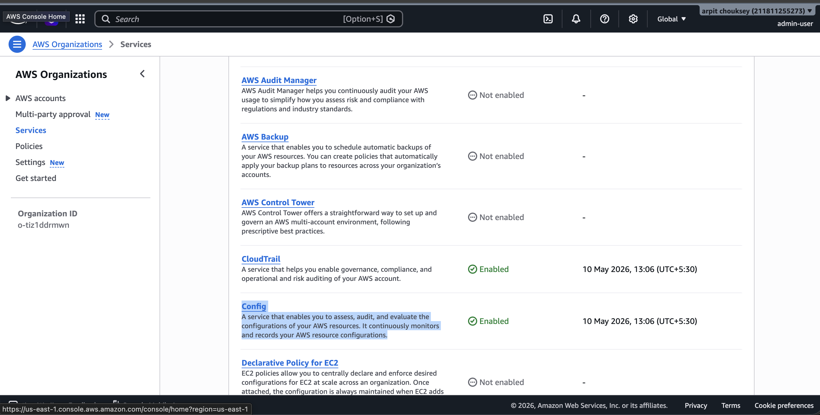

GuardDuty — Multi-Account Security Setup
Screenshot — GuardDuty enabled across accounts:
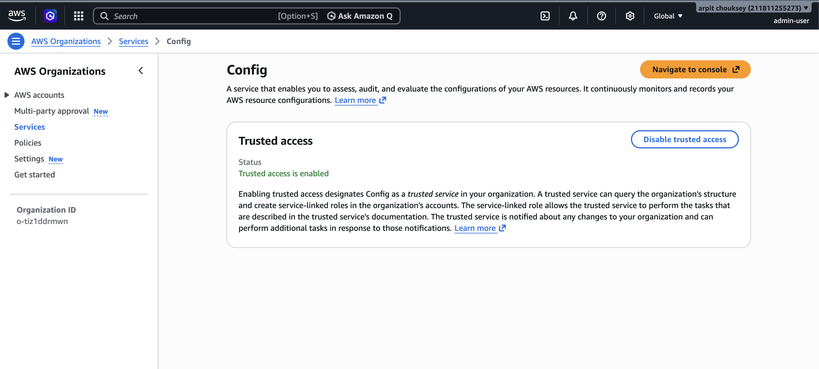

Screenshot — GuardDuty findings view:
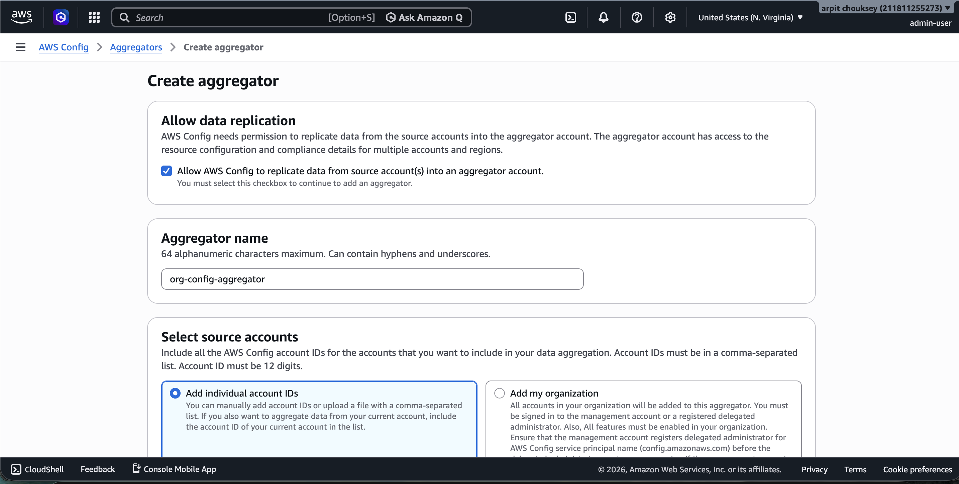

Screenshot — GuardDuty delegated admin (Audit Account):
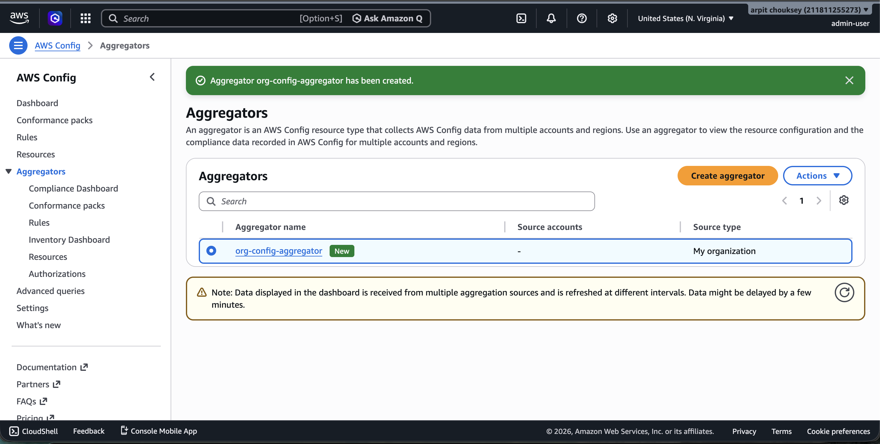

Screenshot — GuardDuty member accounts:
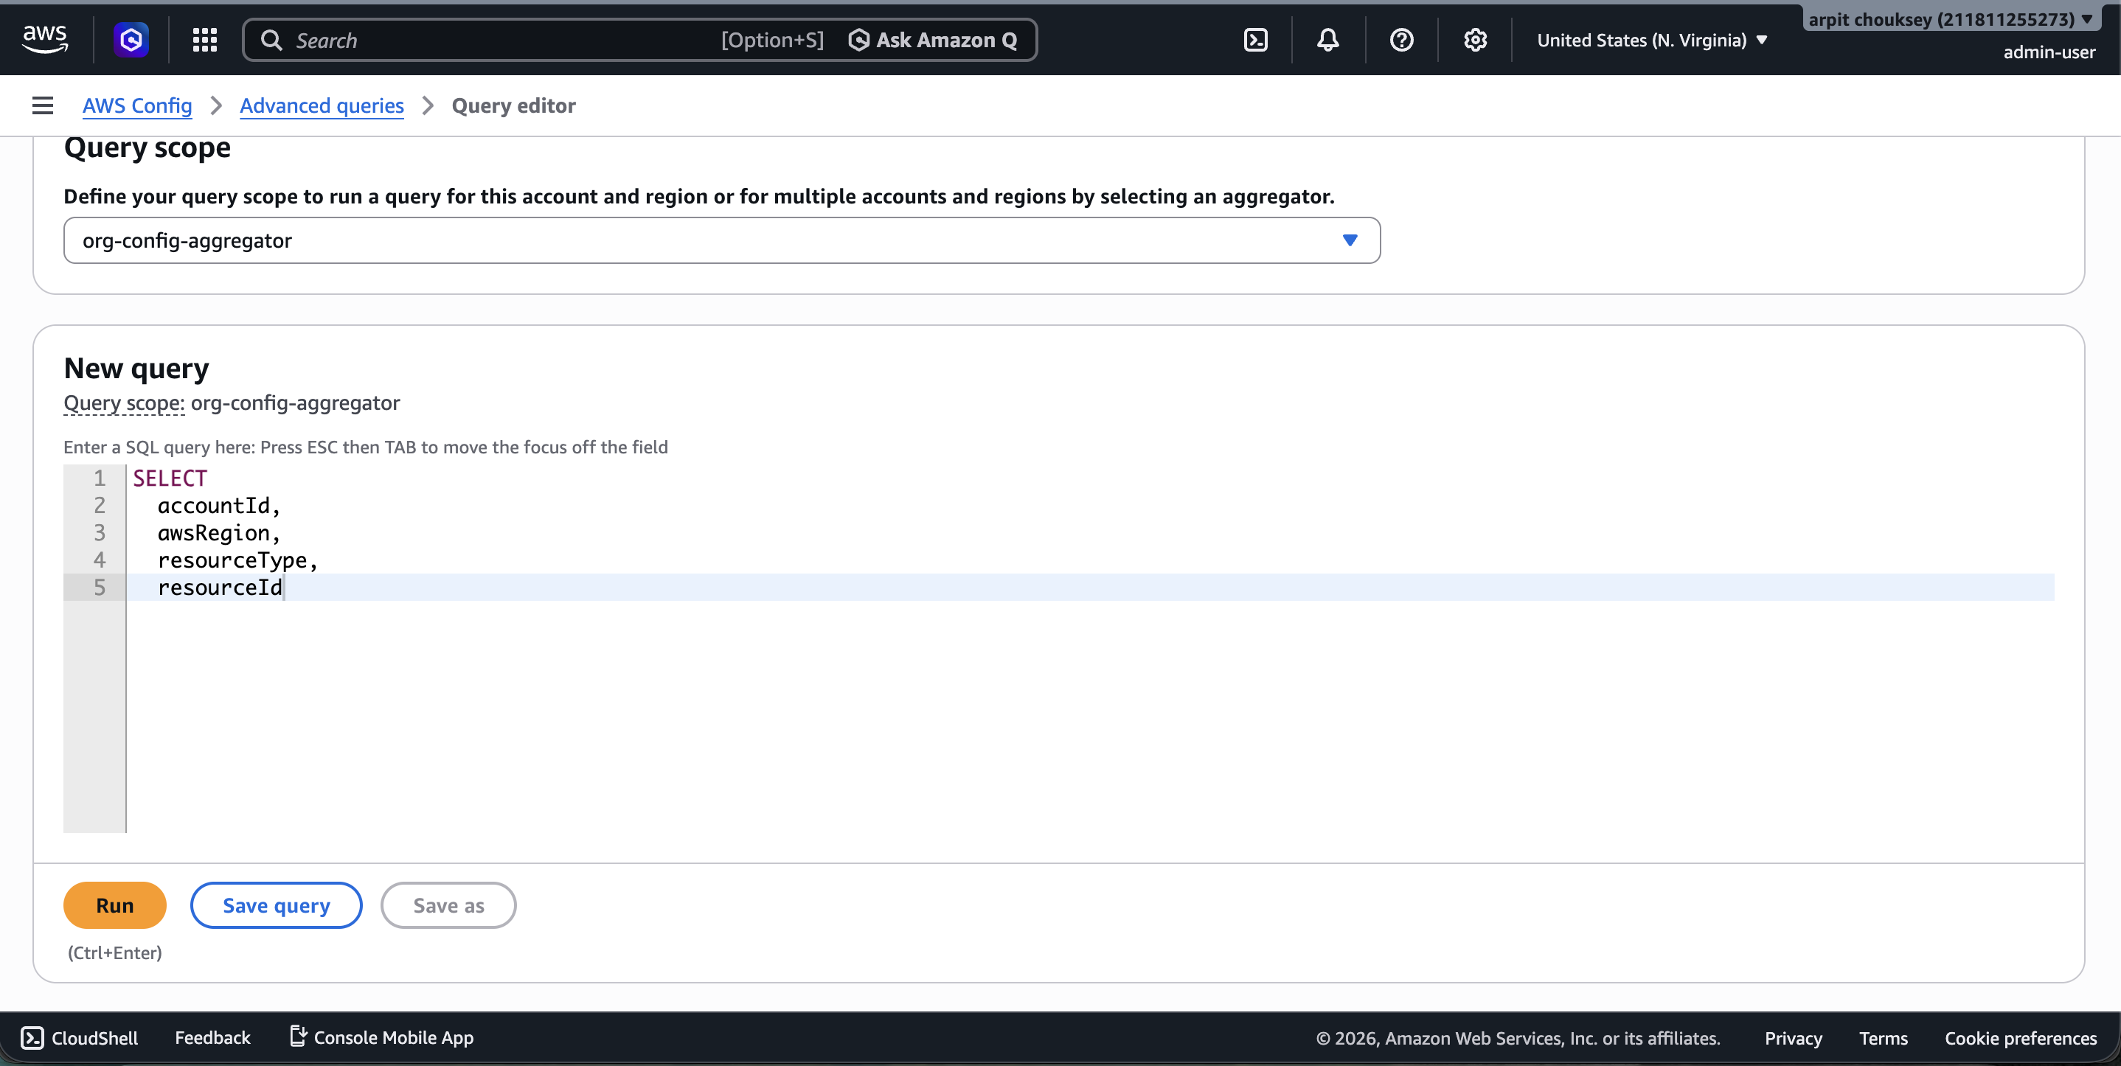

Screenshot — GuardDuty organization settings:
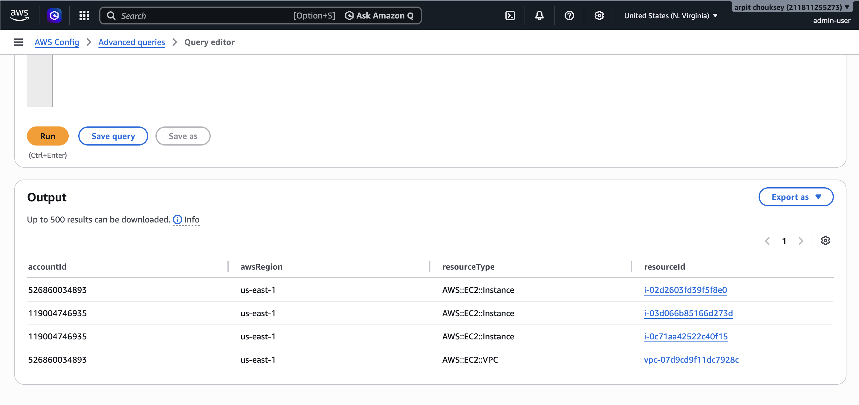

Final AWS Multi-Account Security + Shared Services Architecture
AWS ORGANIZATION
┌────────────────────────────────────────────────────────────────────┐
│ │
│ Management Account │
│ ───────────────────── │
│ • AWS Organizations │
│ • Billing │
│ • Central governance │
│ • GuardDuty Delegated Admin Registration │
│ • AWS Config Trusted Access │
│ │
└────────────────────────────────────────────────────────────────────┘
│
┌────────────────────┴────────────────────┐
│ │
┌──────────────────────────────┐ ┌──────────────────────────────────┐
│ Audit Account │ │ Connectivity Account │
│──────────────────────────────│ │──────────────────────────────────│
│ • Central Security Account │ │ • Shared Networking │
│ • GuardDuty Admin │ │ • Shared VPC │
│ • AWS Config Aggregator │ │ • Transit / Shared Routing │
│ • Central Findings │ │ • Central ingress/egress │
│ • Multi-account visibility │ │ │
│ │ │ │
│ Receives: │ │ │
│ • GuardDuty findings │ │ │
│ • AWS Config inventory │ │ │
│ • Compliance data │ │ │
└──────────────────────────────┘ └──────────────────────────────────┘
│
Shared VPC
▼
┌─────────────────────────────────────────┐
│ Dev Account │
│─────────────────────────────────────────│
│ │
│ Application Layer │
│ ───────────────────────── │
│ • API Gateway │
│ • WAF (Web ACL) │
│ • Application Load Balancer │
│ • Auto Scaling Group │
│ • EC2 NGINX Instances │
│ │
│ Security & Compliance │
│ ───────────────────────── │
│ • GuardDuty Enabled │
│ • AWS Config Enabled │
│ • Resources sent to Audit Account │
│ │
└─────────────────────────────────────────┘

Screenshot — Final multi-account architecture in AWS Console:
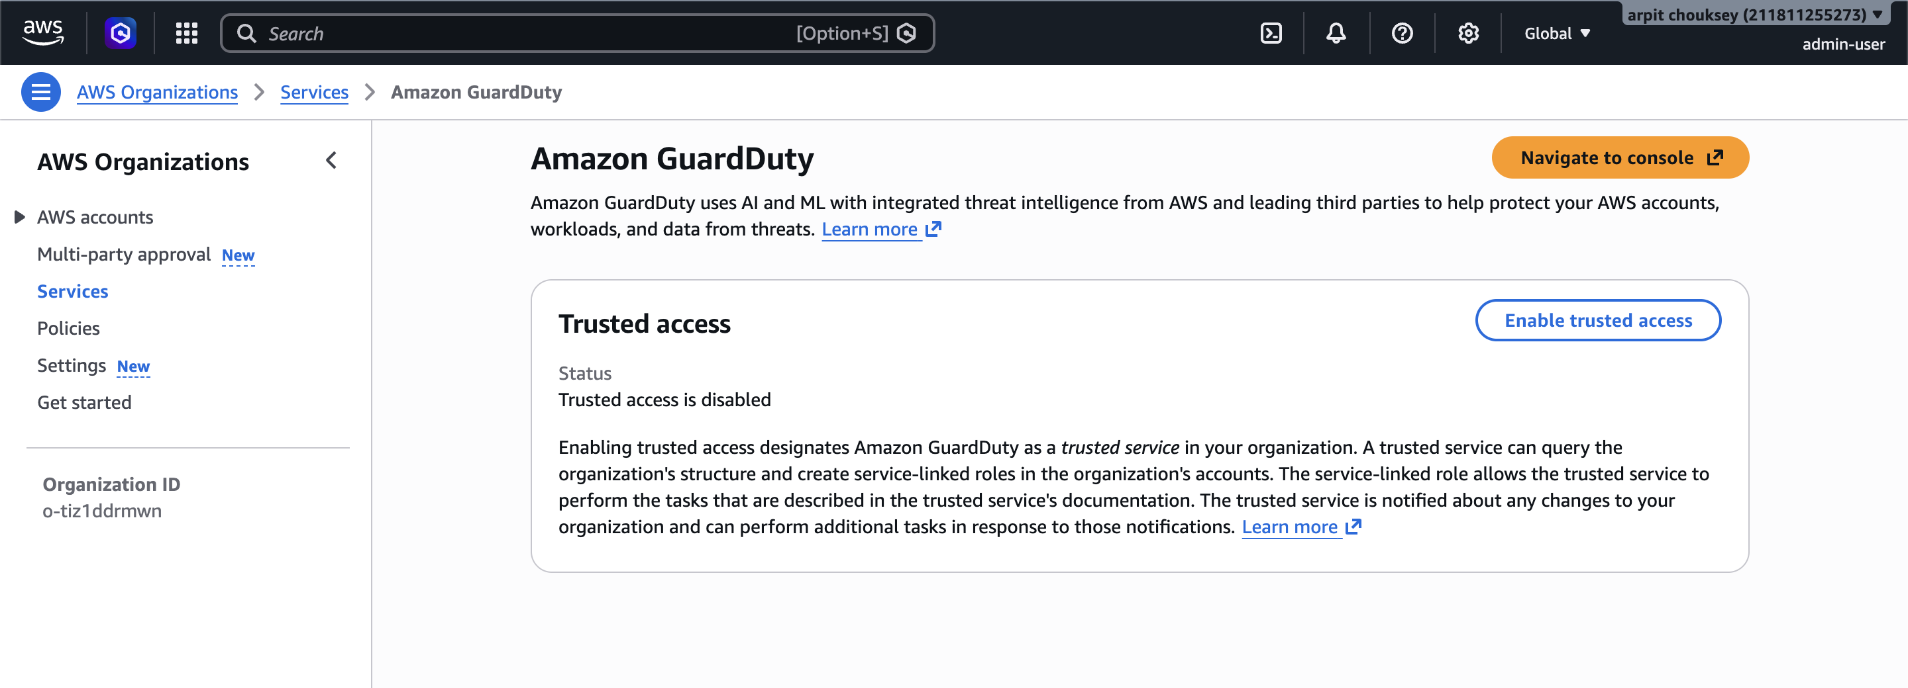

Screenshot — Architecture overview:
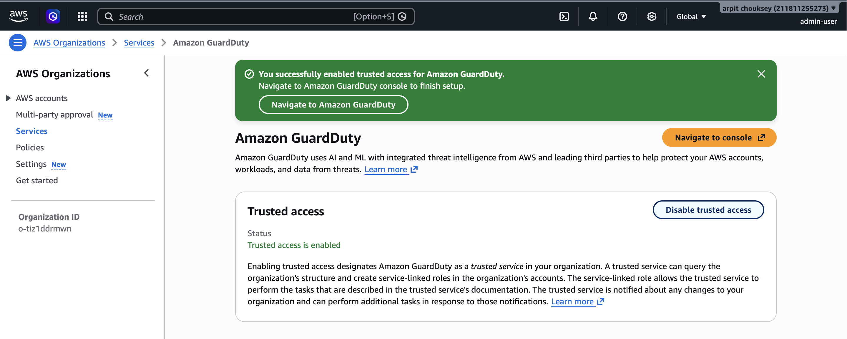

Screenshot — Dev account resources final state:
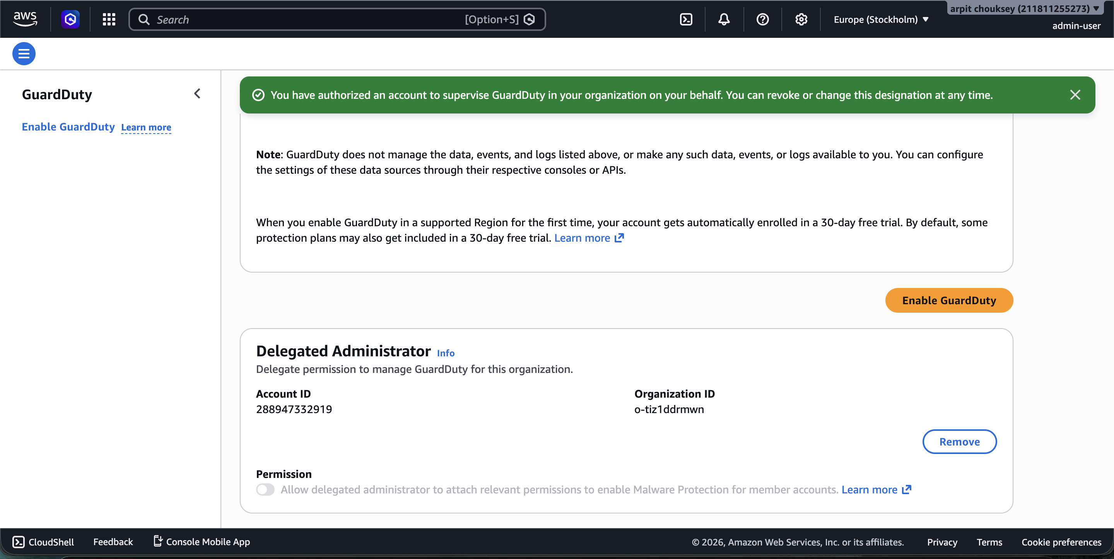

Screenshot — Final terraform state summary:
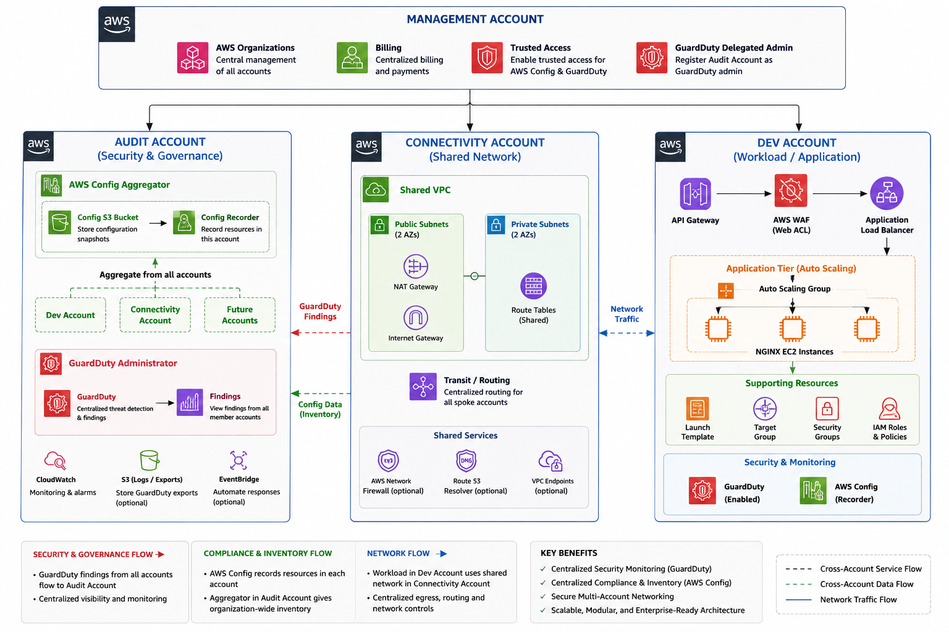

Phase 3 Complete — What Was Accomplished
All resources for the Dev Account have been created, imported into Terraform, and applied cleanly. Security and compliance tooling is now active across all accounts.

Resources managed in Terraform state:
- data.aws_vpc.shared_vpc (from Connectivity Account via RAM)
- aws_security_group.dev_alb_sg (sg-0c8239266e982132f)
- aws_security_group.dev_private_ec2_sg (sg-0a7ab1345afcd9a0d)
- aws_lb_target_group.dev_nginx_tg
- aws_lb.dev_shared_alb
- aws_lb_listener.http_listener
- aws_launch_template.dev_nginx_template (lt-060b1d79c7eb9c4f7)
- aws_autoscaling_group.dev_nginx_asg
- aws_wafv2_web_acl.dev_alb_waf
- aws_apigatewayv2_api.dev_api
- module.terraform_execution_role.aws_iam_role.terraform_execution_role
- module.terraform_execution_role.aws_iam_role_policy_attachment.admin_attach

Outputs:
- alb_dns_name = "dev-shared-alb-910173875.us-east-1.elb.amazonaws.com"
- target_group_arn = "arn:aws:elasticloadbalancing:us-east-1:119004746935:targetgroup/dev-nginx-tg/68ff93673b4553bb"

✅ Phase 3 — Dev-Account Setup COMPLETE
Next: Phase 4 — Production Account + Security Hardening

