Docker Agent
AI-Powered Docker & Linux Operations Assistant
Project Summary & Documentation
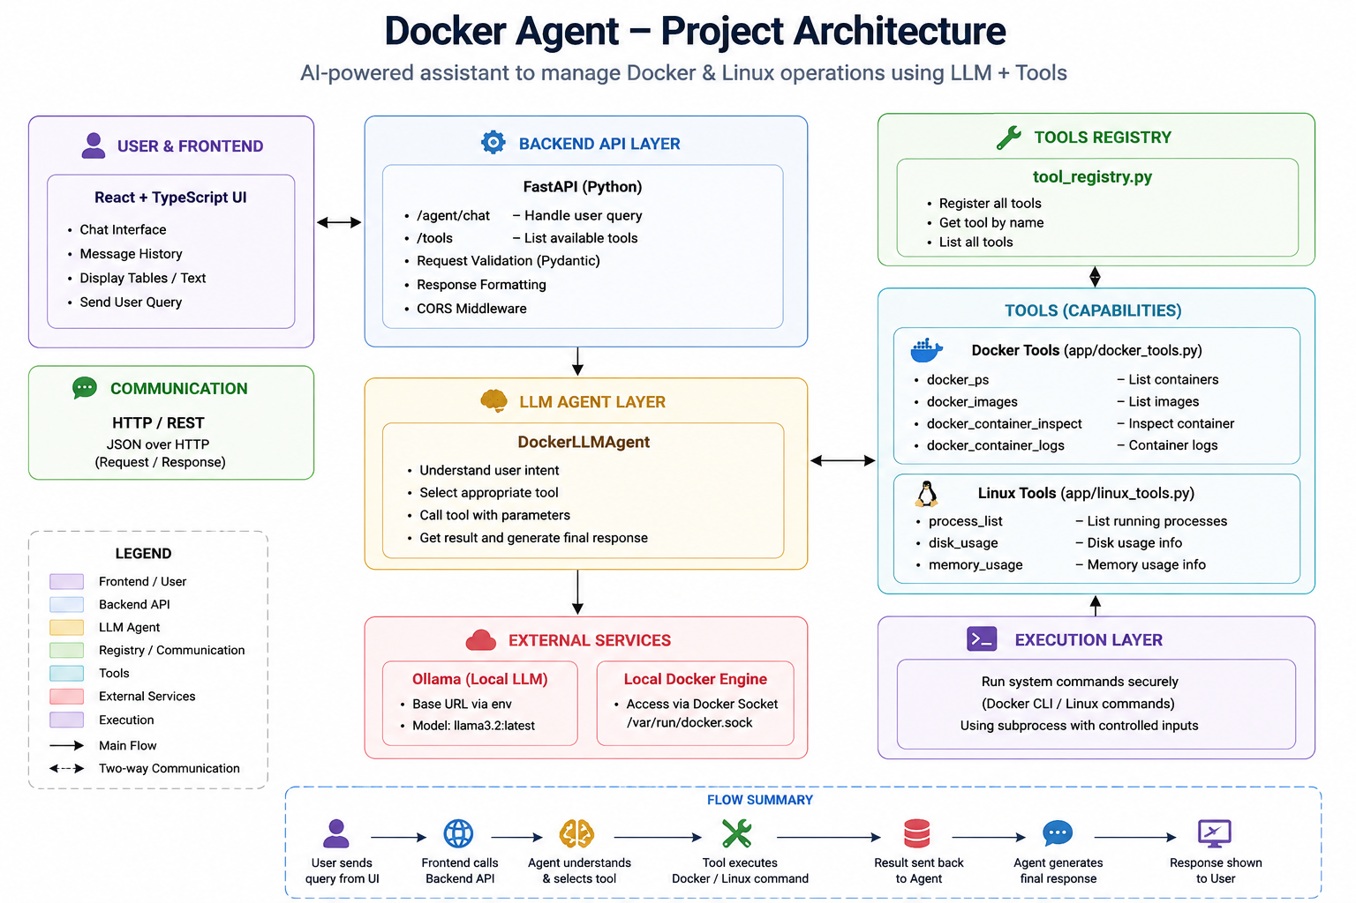
Fig. 1 — Docker Agent system architecture

1. What Is Docker Agent?
Docker Agent is an AI-powered assistant that lets a user manage and inspect Docker containers, Docker images, and basic Linux system resources by simply typing what they want in plain English — instead of remembering exact Docker or Linux commands.
For example, instead of typing "docker ps -a", the user can just ask the chat assistant something like "show me all running containers" or "how much memory is being used", and the agent understands the request, picks the right tool, runs it, and replies with a clean, readable answer.
In short
User types a question in plain English in the chat UI.
The AI agent figures out which Docker/Linux command is needed.
The command actually runs on the machine, and the real result is shown back to the user — the AI never makes up data.

2. How It Works — Step by Step
Every request made by the user goes through the same simple flow:
Step 1 — User sends a message
The user types a request in the chat interface (e.g., "show all docker images").
Step 2 — Frontend calls the backend
The React chat UI sends the message to the FastAPI backend over a REST API call (POST /agent/chat).
Step 3 — Agent understands the request
The backend passes the message to the LLM Agent, which asks the local LLM (Ollama, running llama3.2) to decide which single tool best matches the request.
Step 4 — Tool is selected and executed
The chosen tool (for example docker_ps) runs the real Docker or Linux command on the host using Python's subprocess module.
Step 5 — Result is formatted
If the command returns structured data (like a list of containers), it is converted into a clean Markdown table. Otherwise, the raw command output is returned as text.
Step 6 — Response is shown to the user
The formatted answer is sent back to the frontend and displayed in the chat window.

3. Technology Stack
Layer | Technology Used
Frontend | React (JavaScript) + Vite, built and served with Nginx
Backend API | FastAPI (Python), with Pydantic request validation and CORS enabled
AI / LLM | Ollama running the llama3.2 model locally (no external AI API used)
Command Execution | Python subprocess module calling the Docker CLI and Linux shell commands
Deployment | Docker containers for both frontend and backend (separate Dockerfiles)

4. Tools Currently Available
The agent currently ships with 7 working tools, split into two groups. These are the only tools that are actually wired into the application today.

4.1 Docker Tools (app/docker_tools.py)
Tool Name | What It Does
docker_ps | Lists all Docker containers, running and stopped, with image, status and ports.
docker_images | Lists all Docker images available on the local machine.
docker_container_inspect | Returns full inspect details of a specific container by name.
docker_container_logs | Fetches recent logs (last N lines) of a specific container.

4.2 Linux Tools (app/linux_tools.py)
Tool Name | What It Does
process_list | Lists currently running processes on the host (like ps aux).
disk_usage | Shows filesystem disk usage (like df -h).
memory_usage | Shows current memory usage (like free -h).

5. API Endpoints
Endpoint | Purpose
GET / | Basic root check — confirms the API is running.
GET /health | Health check endpoint.
GET /tools | Returns the list of all tools currently registered in the agent.
POST /agent/chat | Main endpoint — accepts a user message and returns the agent's reply.

6. Demo — Agent In Action
A few real screenshots from testing the running application, showing the chat UI talking to the live backend and Docker engine.
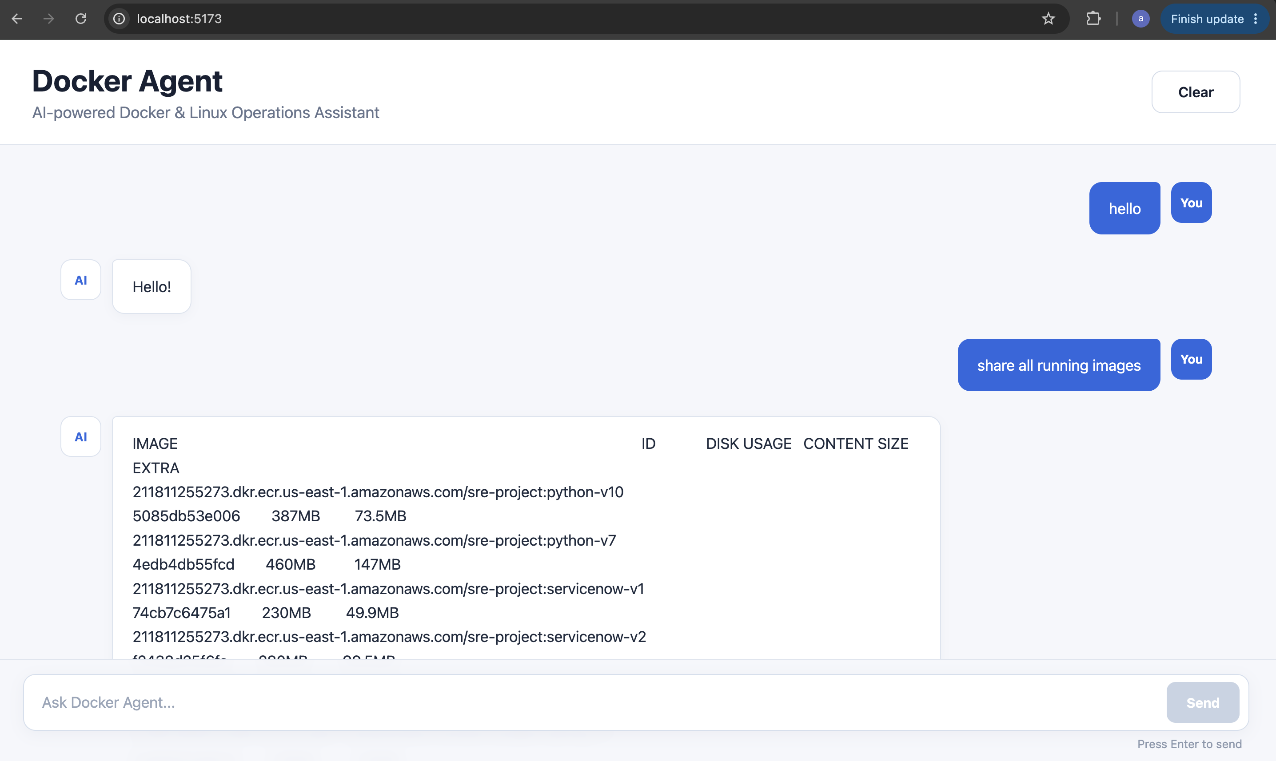
Fig. 2 — Chat UI: asking the agent to list running images
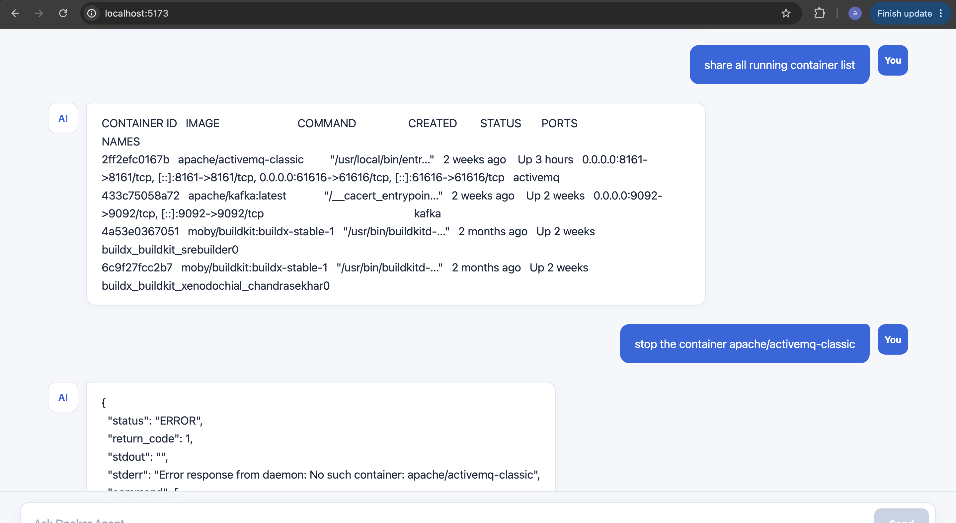
Fig. 3 — Chat UI: listing containers, and a graceful error when trying to stop a container that doesn't exist
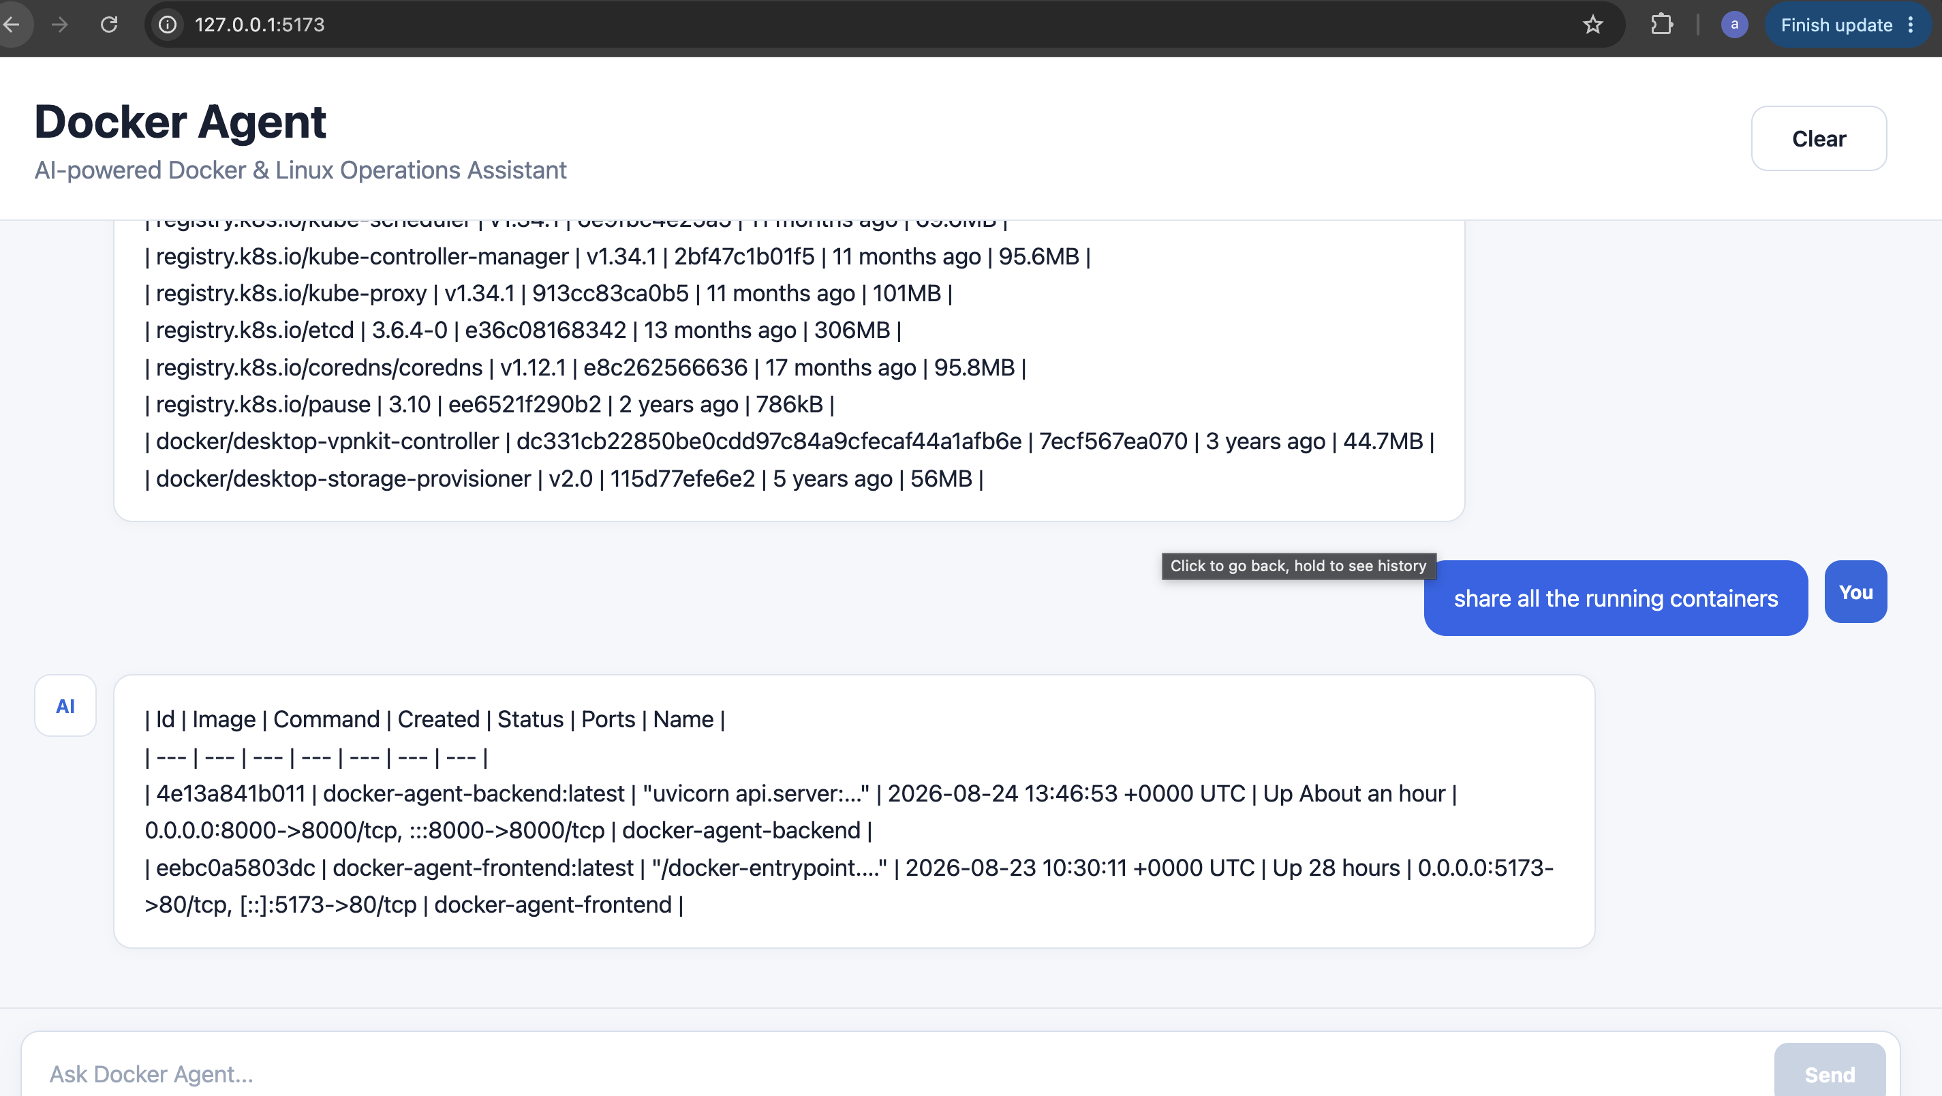
Fig. 4 — Chat UI: agent formatting Docker data into a Markdown table
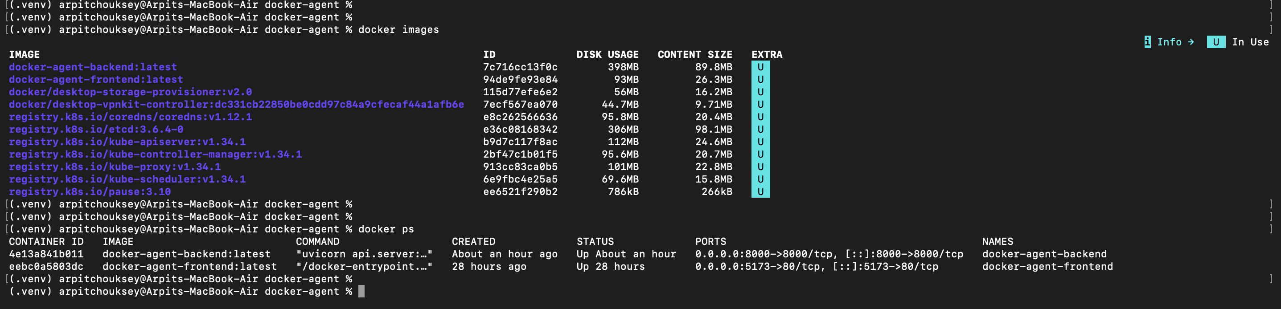
Fig. 5 — Terminal view: docker images and docker ps output used to verify the agent's answers

7. Limitations — What This Project Does Today
This is an early, working version of the agent. It is genuinely functional, but scoped narrowly on purpose. Current limitations:
- Only 7 read-focused tools exist today (4 Docker + 3 Linux). There is no image building, no pushing to a registry, no vulnerability scanning, no Dockerfile generation, and no Compose file generation yet — even though these were part of the original vision.
- Tool selection depends on the local LLM (Ollama / llama3.2) correctly returning JSON. If the model's response can't be parsed, a simple keyword-based fallback is used instead, which can occasionally pick the wrong tool for unusual or ambiguous phrasing.
- The agent has no memory of earlier messages — every request is handled independently, so it cannot yet handle multi-turn follow-up questions like "now show me its logs" referring to a container mentioned earlier.
- There is no authentication or access control on the API — anyone who can reach the backend can run any of the available Docker/Linux commands.
- The tools currently exposed are read-only in nature (list, inspect, logs). There is no confirmation step or safeguard built yet for destructive actions such as stopping or removing a container.
- The agent only talks to the local Docker Engine on the same host (via the Docker socket) — it cannot manage containers on a remote server or across multiple environments.
- Only one LLM provider (local Ollama) is supported; there is no fallback to a cloud LLM if Ollama is unavailable.

8. Future Scope
Planned direction for the next phases of this project:
- Add the remaining tool categories from the original architecture — image building, registry push, vulnerability scanning, Dockerfile & Compose generation, network and volume management.
- Add conversation memory so the agent can handle multi-step, contextual troubleshooting conversations.
- Add authentication and role-based access control (e.g., read-only users vs. admin users who can perform write/destructive actions).
- Add a confirmation step in the UI before any destructive operation (stop, remove, prune) is executed.
- Support additional LLM providers as pluggable backends, so the agent isn't limited to a single local model.
- Add streaming responses in the chat UI for a faster, more real-time feel.
- Extend support to remote Docker hosts and multi-environment / multi-server setups.

End of Document

